Chapter X
Associative learning: What it is and what it can explain
Deon T. Benton
Department of Psychology and Human Development, Vanderbilt University

Address correspondence to Deon T. Benton (deon.benton@vanderbilt.edu) Department of Psychology and Human Development, Vanderbilt University, Peabody College, 230 Appleton Place #552, Nashville, TN 37235

We have gathered evidence for what I would like to call the “law of uphill analysis and downhill invention.” What I mean is this. . . . Analysis is more difficult than invention in the sense in which, generally, induction takes more time to perform than deduction: in induction one has to search for the way, whereas in deduction one follows a straightforward path. (Braitenberg, 1984, p. 20)

This quote can be found in the book Vehicles by neuroscientist and cyberneticist Valentino Braitenberg. In it, Braitenberg introduces a series of fictional vehicles and describes their behavior. Some of these vehicles come to rest whenever they are near another vehicle. Others accelerate toward vehicles in their vicinity. Others still move in a manner that increases the physical distance between themselves and other vehicles. The first vehicle’s behavior might cause an onlooker to conclude that it has “affection” or even “love” for other vehicles—after all, it appears to have a desire to be close to them. That same observer might use the word “aggression” to describe the behavior of the second vehicle—it seems to want to inflict harm on other vehicles—and the word “cowardice” to describe the behavior of the third vehicle—it seemingly dreads being near other vehicles.
Figure 1
Architecture of a Braitenberg vehicle
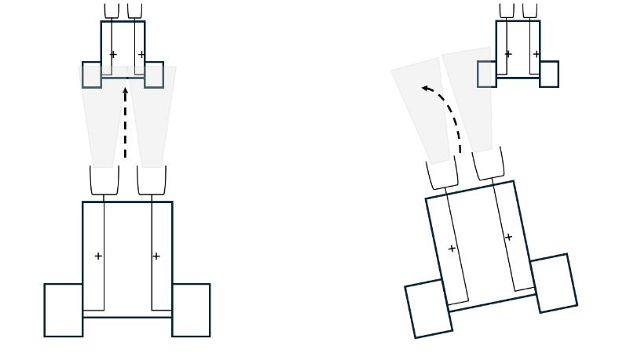

One may wonder terms like “desire,” “want,” and “dread” to describe veridically each vehicle’s behavior. As Braitenberg discusses at length, a veridical description of each vehicle’s behavior does not require the invocation of such psychologically rich notions; simpler principles and mechanisms are sufficient to explain them. To understand why, it is necessary first to consider the basic structure of a Braitenberg vehicle. As shown in Figure 1, a basic Braitenberg vehicle consists of a body, two small rectangular motors, and two sensors. The motors are located on each side of the body, and each is connected to a single sensor “programmed” to respond to different kinds of external stimulation (e.g., light, sound, temperature, or even another vehicle). If the sensors receive increasing amounts of external stimulation and the connection between them and the motors is positive or excitatory—as depicted in Figure 1—then the vehicle will move in the direction of the external stimulus. However, if the connection between the sensors and motors is negative or inhibitory, then for the same amount of external stimulation, the vehicle will reduce its speed as it approaches the external stimulus.
It turns out that these components—that is, the sensorimotor connections among the motors and sensors—are all that is needed to explain the behavior of a Braitenberg vehicle. A vehicle with the pattern of connectivity that mirrors that in Figure 1 will If a stimulus is located directly in front of the vehicle in Figure 1, it will approach the vehicle directly in front of it along a straight line.

