Chapter #
Associative learning: What it is and what it can explain
Deon T. Benton
Department of Psychology and Human Development, Vanderbilt University

Address correspondence to Deon T. Benton (deon.benton@vanderbilt.edu) Department of Psychology and Human Development, Vanderbilt University, Peabody College, 230 Appleton Place #552, Nashville, TN 37235

We have gathered evidence for what I would like to call the “law of uphill analysis and downhill invention.” What I mean is this. . . . Analysis is more difficult than invention in the sense in which, generally, induction takes more time to perform than deduction: in induction one has to search for the way, whereas in deduction one follows a straightforward path. (Braitenberg, 1984, p. 20)

This quote can be found in the book Vehicles by neuroscientist and cyberneticist Valentino Braitenberg. In it, Braitenberg introduces a series of fictional vehicles and describes their behavior. Some of these vehicles come to rest whenever they are near another vehicle. Others accelerate toward vehicles in their vicinity. Others still move in a manner that increases the physical distance between themselves and other vehicles. The first vehicle’s behavior might cause an onlooker to conclude that it has “affection” or even “love” for other vehicles—after all, it appears to have a desire to be close to them. That same observer might use the word “aggression” to describe the behavior of the second vehicle—it seems to want to inflict harm on other vehicles—and the word “cowardice” to describe the behavior of the third vehicle—it seemingly dreads being near other vehicles.
One may wonder terms like “desire,” “want,” and “dread” to describe veridically each vehicle’s behavior. As is discussed at length in Vehicles, a veridical description of each vehicle’s behavior does not require that psychologically rich notions be invoked; simpler principles and mechanisms are sufficient to explain them. To understand why, it is necessary first to consider the architecture and core components of a Braitenberg vehicle. Figure 1 depicts one of the simpler Braitenberg vehicles.

Figure 1
Basic architecture of a Braitenberg Vehicle
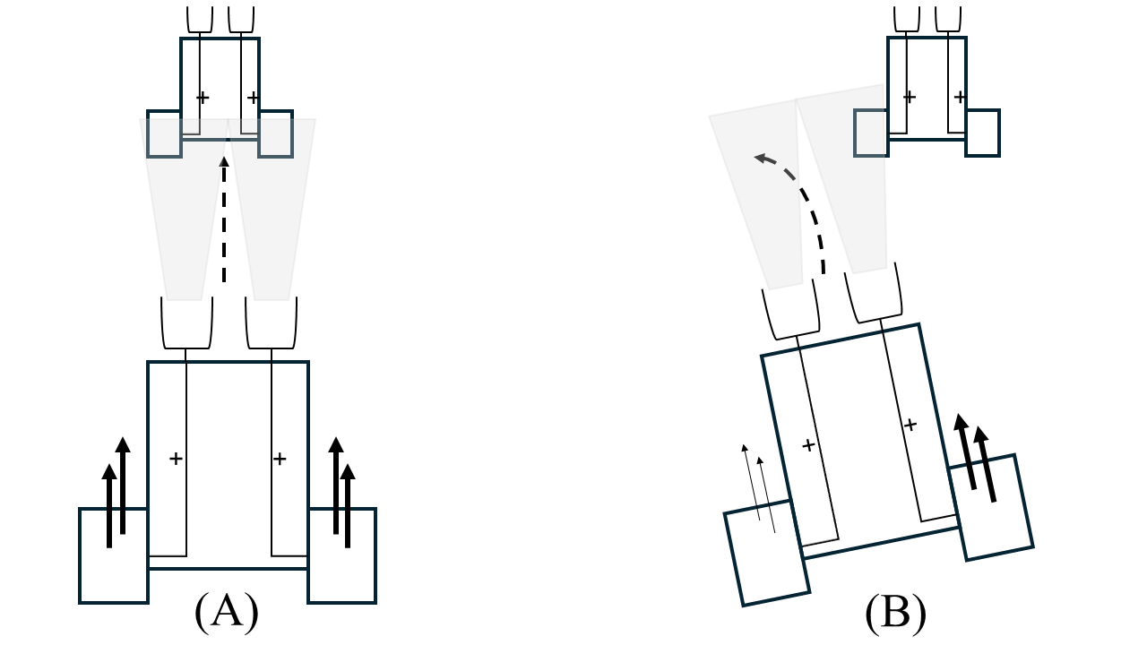
Note. The double tiered arrows correspond to the speed of the engine. Thicker arrows correspond to faster speed; thinner ones correspond to slower speed. The transparent trapezoids correspond to the sensor signals. The dotted arrowheads depict the direction of the vehicle. (A) The first vehicle is approaching the second one. (B) The first video is moving away from the second one.

As can be seen, these vehicles consist of a body, two small rectangular motors, and two sensors. The motors are located on each side of the body, and each is connected to a single sensor “programmed” to respond to different kinds of external stimulation (e.g., light, sound, temperature, or even another vehicle). If the sensors receive increasing amounts of external stimulation and the connection between them and the motors is positive (i.e., excitatory)—as shown in the figure—then the vehicle will move towards the external stimulus. If, instead, the connection between the sensors and motors is negative (i.e., inhibitory), then the vehicle will slow down as it approaches the external stimulus.
The sensorimotor connections among the vehicle’s motors and sensors, together with its physical distance from an external stimulus, as it turns out, are sufficient to explain the behavior of a Braitenberg vehicle fully. For example, a vehicle with the pattern of sensorimotor connectivity depicted in Figure 1 will move towards an external stimulus located directly ahead of it along a straight path until, at some point, it overtakes that stimulus, at which point it will begin to slow down. In contrast, that same vehicle will turn away from a stimulus positioned to one side of the vehicle. This is because the sensor closest to the stimulus receives more stimulation than the sensor farther away, thereby causing the right motor to rotate faster than the left one. This difference in rotational speed—illustrated by the different sizes of the double-tiered arrows in Figure 1B—is what causes the vehicle to turn away from the stimulus. Invoking cowardice—a psychologically laden word that one might naively use to describe this vehicle’s behavior—adds nothing whatsoever to the description.
This example reveals a deep—but perhaps nonobvious—insight: Behaviors that look goal-directed and like it was produced by sophisticated underlying mechanisms may, in fact, emerge from simpler principles and mechanisms. This insight is easy to miss when working backwards, from behavior to mechanism, not least because behavior underdetermines mechanism; that is, the very same behavior may well be produced by different mechanisms. This means that it may not be possible to identify a behavior’s true generating mechanism, and even if one can be found, the time it takes to do so may be orders of magnitude than what is available. This is what “Analysis is more difficult than invention” and that “induction takes more time than deduction” in the opening quote.
Although the solution to this problem is to choose a mechanism and then characterize the behaviors it produces, this approach is rarely taken in the human sciences. In the developmental cognitive sciences, for example, it is customary for infancy researchers to go from behavior to mechanism. A corollary of this is that sophisticated cognitive abilities, abstract knowledge, and specialized mechanisms are routinely ascribed—arguably wrongly—to developing infants based, in some cases, on their looking behaviors alone. In the number domain, for example, some have interpreted the fact that 5-month-olds sometimes look longer at numerically incongruous (e.g., $1+1=1$) than at numerically congruous ($1+1=2$) outcomes (e.g., Wynn, 1992) to mean that they possess innately an accumulator-like mechanism that continuously tracks and outputs the number of discrete elements in a scene (e.g., Meck & Church, 1983; Wynn, 1995). The problem with this conclusion is that this pattern of looking may have emerged for reasons other than an inborn ability “to calculate the precise results of simple arithmetical operations” (Wynn, 1992, p. 750). For example, a simple preference for familiar stimulus configurations and displays containing more items could explain this pattern (e.g., Cohen & Marks, 2002).
This example is a nice illustration of why, when inferring underlying mechanisms from observable behaviors, it is easy to overlook the possibility that ostensibly complex behaviors may be the result of simple operating principles and mechanisms. The goal of this chapter is to demonstrate how one specific kind of simple mechanism—in this case, domain-general associative learning—adequately accounts for and children’s behavior across a variety of cognitive domains. I will begin by defining associative learning. I will rely on four case studies to make this case. The first case study will focus on how infants learn about the causal properties of people and objects. The second study will focus on the question of how infants determine relationship closeness. The final case study will focus on the question of how children reason causally. The chapter will conclude with a brief discussion of why computational modeling is vital to associative explanations of early cognition given that computational modeling will factor heavily in each of these discussions.
Although a good deal of the work covered in this chapter comes from my own research program and a circumscribed set of cognitive domains, I see both as speaking to two broader theoretical points. The first point should be well understood at this point, and it is that the generative abilities of simple mechanisms should not be overlooked or underestimated. The second point is that to the extent that associative learning—a simple mechanism—can explain the findings described in this chapter, there is no reason a priori to assume that the same cannot be true for cognitive domains that are not covered in this chapter. Indeed, similar arguments to the current ones have been advanced to explain young children’s behaviors in cognitive domains such as imitation (e.g., Heyes & Ray, 2000), theory of mind (e.g., Perner & Ruffman, 2005), morality (e.g., Benton & Lapan, 2021), causality (e.g., Rakison & Lupyan, 2008), categorization (e.g., Quinn & Eimas, 1997), word learning (e.g., Colunga & Smith, 2005), among others (e.g., Adolph & Joh, 2009; Mermier et al., 2022; Scott & Arcaro, 2023).

Defining associative learning
Associative learning itself has to be defined before the case can be made that infants’ and children’s behaviors across cognitive domains is governed by it. Associative learning can be defined broadly as any “learning in which an excitatory or inhibitory link is formed between representations of events” (Heyes, 2018, p. 67). One difficulty with this definition is that, although it likely captures what most people intuitively have in mind when the term is used, it fails to distinguish between different forms of associative learning. One type involves forming associations between one’s behavior and the consequences that follow from it, whereas the other type involves forming associations between two (or more) external stimuli. The former type of associative learning is called operant conditioning and was made popular by B.F. Skinner (Skinner, 1957); the latter type of associative learning is called classical conditioning and was made popular by Ivan Pavlov (Pavlov, 1927) and J.B. Watson (Watson, 1930). A consequence of both kinds of associative learning is that, for sufficiently strong associations, the presence of one component of the association will call to mind the other component, even if that other component is absent.

