Causal perception—or the capacity to appreciate agent-patient relations between objects and entities—is a key cognitive ability. This capacity not only enables human beings to determine which objects and entities are causally efficacious and which object and entities are causally inefficacious, but it is ultimately an ability that enables human beings to understand how the world works and how to navigate it.
There is now considerable evidence that the ability to perceive causal relations emerges by 10 months of age (e.g., Belanger & Desrochers, 2001; Oakes, 1994; Oakes & Cohen, 1990; cf., Mascalzoni, Regolin, Vallortigara, & Simion, 2013; Rakison & Krogh, 2012). For example, Leslie and Keeble (1987) habituated 7½-month-olds either to a direct-launching sequence or to a delayed-launching sequence. In the direct-launching sequence, a first object ostensibly caused a second object immediately to move through direct, physical contact. The delayed-launching sequence was like the direct-launching sequence except that the second object began to move only after a short delay following contact from the first object (Figure 1). Infants were then tested with the reversal of their respective habituation sequences. The results revealed that infants habituated to the direct-launching sequence showed greater dishabituation to the reversal of that sequence than did infants habituated to and tested on the reversal of the delayed-launching sequence. These findings suggest that the ability to perceive cause-and-effect relations in simple launching sequences emerges by 6½ months of age.
Developmental mechanisms that underlie infant causal perception
Despite considerable research on infant causal perception of simple launching sequences, relatively little is known about when and how infants learn that people and objects possess distinct causal properties. For example, human beings can cause other human beings to act at a distance as well as on contact, whereas inanimate objects require physical contact to act (i.e., the move from one place to another). Understanding that people and inanimate objects possess distinct causal properties is important because it not only underlies our knowledge of how the world works but it may support our knowledge about how appropriately to interact with people and inanimate objects.
One prominent theory that attempted to address how infants understand the causal properties of people and objects is the Core Knowledge perspective (e.g., Spelke, 2022; Spelke & Kinzler, 2006, 2007; see Carey, 2009 for a related Core Cognition account). The crux of this account is that from birth or shortly thereafter infants possess a small number of separable “core” systems. These systems enable infants to know that people and inanimate objects behave differently in the real world. For example, the core system for agents enables infants to know that agents are goal-directed, self-propelled, can move on linear and non-linear trajectories, and can cause action in other agents both at a distance and on contact. In contrast, the core system for objects allows infants to know that objects do not move in the absence of physical contact from other objects or agents, are bounded and cohesive, and tend to move on linear trajectories.
Support for this theory was garnered by Spelke, Phillips, and Woodward (1995; see also Woodward, Phillips, & Spelke, 1995). This study used the logic of the launching-event paradigm to investigate whether 7-month-olds understand that people, but not inanimate objects, can cause other people to move in the absence of physical contact (i.e., action-at-a-distance causality). Using a between-subjects design, infants were habituated to one of two live events that used real, three-dimensional inanimate objects and people. These two events corresponded to the Inanimate Object and People conditions, respectively. In one event, a first person entered the stage from the left and traveled a short distance until it disappeared behind a screen that was located at the center of the stage. A second person—who initially was half-covered by the screen—then emerged from behind the screen and exited the stage to the right. The second event was identical to the first one except that it used two inanimate objects (i.e., a red box with a jagged top edge and a blue cylinder). At test all infants were shown two events but without the screen. In the Contact test event, the first person (or object) moved toward and contacted the other person (or object) located at the center of the stage. In the No Contact test event, the first person or object moved toward, but ultimately stopped short of, the other person or object. At this point the second person or object moved until it was off stage. The results revealed that infants in the Inanimate Object condition, but not those in the People condition, looked longer at the No Contact test event than at the Contact test event. Spelke et al. (1995) interpreted these findings to mean that infants possess core-knowledge systems for objects and people and understand that people, but not inanimate objects, can cause action at a distance in other people.
Although this theoretical account can explain infants' looking patterns in Spelke et al. (1995; see also Woodward, Spelke, & Phillips, 1993), it is limited in several notable ways. First, Spelke et al.'s (1995) study was never published in a peer-reviewed journal despite being cited over 800 times and appearing in prominent Introduction to Cognitive Development textbooks (e.g., Flavell, Miller, & Miller, 2001; Goswami, 2008). Thus, it remains an open question whether the original findings are replicable. Second, although the Core Knowledge account assumes that infants possess innate knowledge about the causal properties of people and objects, Spelke et al. (1995) only tested 7-month-olds. This is problematic because the infants' looking behaviors in Spelke et al. (2007) could have been based on seven months of extensive, real-world experience that involved observing and learning about the causal properties that distinguish people from inanimate objects rather than on innate knowledge about those properties. This study neither tested infants younger than 7 months of age to determine to what extent infants’ causal knowledge about people and inanimate objects is innate nor did they test infants at different ages to determine whether this knowledge undergoes a developmental progression during the first year of life.
A particularly pernicious limitation of Spelke et al. (1995) is that some of the stimuli that were used were imbued with animacy cues. In particular, prior to habituation, all infants were familiarized with the people and object stimuli as well as with the central screen. Infants assigned to the Inanimate Object condition were shown two inanimate objects—one to the right of and the other to the left of the central screen. Infants assigned to the People condition were shown two people that stood on either side of the central screen. These people danced and wiggled slightly throughout the familiarization phase. In contrast, the two objects remained motionless during the familiarization phase. Thus, the two conditions differed not only in terms of the stimuli that were used (i.e., people vs. inanimate objects) but also in terms of the cues to animacy that were provided (i.e., the people, but not the inanimate objects, danced and wiggled). If infants learned in the real world that entities—which may or may not include human beings—which may or may not include human beings—can cause action-at-a-distance

it is impossible to know from this study whether infants’ responses to the Contact and No Contact test events across experimental conditions was due to these animacy cues or to their innate knowledge about the causal properties of people and inanimate objects.
In general, it may not be necessary to assume that infants are born with innate knowledge about the causal properties of people and inanimate objects to account for the findings in Spelke et al. (1995) specifically or to explain infants’ developing causal knowledge about people and inanimate objects generally. This is because infants may learn about the causal properties of people and inanimate object via domain-general associative learning in conjunction with a small number of inherent perceptual biases, such as biases for face-like stimuli over non-face-like stimuli (e.g., Morton & Johnson, 1991) and for movement over non-movement (e.g., Slater, 1989; Vallortigara, Regolin, & Marconato, 2005), among others (e.g., Rakison & Lupyan, 2008). These biases serve to emphasize certain regions of the perceptual array and to deemphasize other regions. The idea is that infants' knowledge about the causal properties of people and objects develops via an associative-learning mechanism. This process begins when infants first notice—either incidentally or intentionally—that a link exists between certain salient perceptual features (e.g., eyes, legs, etc.) and different kinds of causal action (e.g., action-at-a-distance causality and contact causality). Infants may come to notice and then encode this link in the first place based on the fact that some perceptual features tend to co-occur across time and space with different kinds of causal action. For example, infants may learn that entities with legs can cause other entities with legs to act both at a distance and on contact. Infants may be attuned to this relation in the first place—that is, that legs “go with” two kinds of causal action—based on an innate or early emerging bias to attend to movement over non-movement. In other words, the reason infants are drawn to an action-at-a-distance event or to a contact event at all is because both events involve movement, which serves to “grab” infants’ attention. Once infants have oriented to these events, they might come subsequently to notice that legs tend to be included in these movement events. This act of noticing that contact causality and action-at-a-distance causality tend to include legs may serve to establish a nascent link between legs and these two kinds of causality, which becomes ever strengthened as the components of the relation (i.e., legs and the two kinds of causality) are experienced repeatedly together. The consequence of this developmental mechanism is that the presence of one of the features alone (e.g., legs) will come eventually to trigger an expectation for the other feature (e.g., action-at-a-distance causality), even if the other feature is not physically present. However, if one but not both of the features is physically present (as is the case for the No Collision event of the Inanimate Object condition in which action-at-a-distance causality is present without legs), this may cause infants to show heightened or increased looking, as if to be looking for or expecting the second feature (i.e., legs) given the first feature (i.e., action-at-a-distance causality). This may explain why infants looked longer at the No Collision test event relative to the Collision test event in the Inanimate Object condition but not in the People condition; the No Collision event (i.e., action-at-a-distance event) triggered an expectation for legs that ultimately was not met. This, in turn, may have caused an increase in looking. Note that because inanimate objects tend to lack legs and tend only to move on contact from other objects or entities, infants may learn that a link, which becomes strengthened with time, exists between things without legs and contact causality only.
Based on these limitations and of the lack of research on infants' developing causal knowledge of people and inanimate objects, this project has two broad goals. First, the proposed series of studies are designed to address each of the identified weaknesses of Spelke et al. (1995). Second, this project will extend Spelke et al. (1995) in at least two critical ways. First, these studies are designed to examine to what extent infants’ looking behavior in Spelke et al. (1995) were influenced by the animacy cues of the human actors rather than by their innate knowledge about the causal properties of people and objects. Second, these studies will be the first to examine whether domain-general associative learning rather than Core Knowledge underlies infants' knowledge about people’s and inanimate objects’ causal properties. I will examine this question via two behavioral studies and a computational model. These converging approaches will provide greater insight into the developmental mechanism by which infants learn that people and objects possess distinct causal properties, and specifically insight into whether infants use associative learning to learn about these different properties without recourse to innate knowledge or specialized systems. My extensive experience conducting experiments with infants and young children (e.g., Benton, 2016; Benton, Rakison, & Sobel, 2021; Rakison & Benton, 2019) combined with my extensive experience building connectionist computational models and applying them successfully to different aspects of cognitive development (e.g., Benton, 2022; Benton & Rakison, 2018; Benton, Rakison, & Sobel, 2021; Benton & Lapan, 2022; Rakison & Benton, 2019) makes me well qualified and suited to carry out and ensure the success of this project.
Innovation
The proposed series of studies are innovative in at least five ways. First, they are the first to replicate Spelke et al. (1995). A direct replication is needed because this study was never published in a peer-reviewed academic journal. This means that it remains unknown whether infants understand from birth or shortly thereafter that people and inanimate object possess different causal properties. Second, these studies will extend Spelke et al. (1995) to address its animacy cue confound. It is difficult to conclude that infants’ knowledge about the causal properties of people and objects is robust if it can be shown that this knowledge depends on subtle movement cues. Third, they are the first closely to examine the developmental mechanism by which infants learn that people and inanimate object possess distinct causal properties. Fourth, the project combines behavioral experimentation with computational modeling further to elucidate those mechanisms. Computational modeling offers an advantage over verbal theories because they allow researchers to “run” verbal theories as computer simulations to determine whether they can explain change in infants and young children (e.g., Benton, 2022b; Benton & Rakison, 2018). Fifth, although the proposed studies are not intervention or treatment studies, the results from this project can inform interventions designed to improve learning in atypically developing populations. For example, pediatricians and pediatric psychologists could use the results from this project to design novel interventions that target key aspects of the target mechanism to improve the learning outcomes for atypically developing populations, especially for those individuals whose disorders and deficits tend to cause profound social deficits such as individuals diagnosed with an autism spectrum disorder.
Study 1
Purpose. This habituation study is designed to replicate Spelke et al. (1995) and to extend it by using artificial stimuli rather than realistic, three-dimensional stimuli. Four-, 7-, and 11-month-old infants will be tested. By testing different ages, it is possible to examine whether infants possess innate knowledge about the causal properties of people and objects (by testing 4-month-olds) or whether this knowledge undergoes a developmental progression (by testing a range of ages).
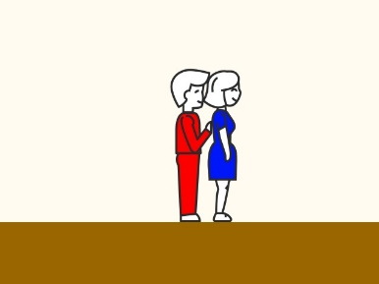
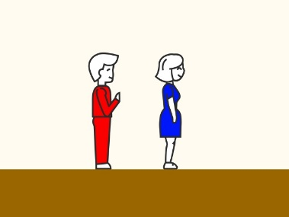
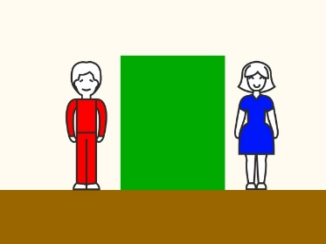
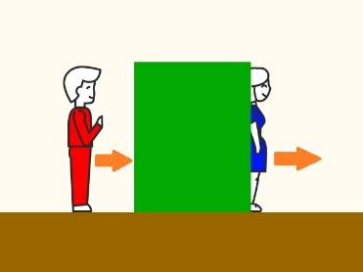
Design and procedure. Participants will be 32 infants at 4, 7, and 11 months of age (96 infants total). A power analysis suggested that a final sample of 32 infants would be sufficient to detect a moderate-to-large within-subjects effect. Infants will be assigned either to the People condition or to the Inanimate Object condition. Infants assigned to the People condition will briefly be familiarized with the two people (i.e., a man and a woman) on either side of the central screen whereas infants in the Inanimate Object condition will be familiarized for 30 s with the two object (a red square with a jagged top edge and a blue cylinder) stimuli on either side of the central screen. Following this brief familiarization phase, infants will be habituated to an event in which a first person (or object) will enter the stage, travel horizontally for some distance, and then disappear behind the central screen. A second, initially half-occluded person (or object) will then emerge from behind the screen and move until it has left the stage. The identity of the first and second person or object in the two conditions will be counterbalanced. Following habituation, infants will be shown two test events but without the screen. In the Contact test event, a first person or object will move until it contacts and subsequently causes a second person or object immediately to move. The No Contact test event will be similar except that the first person or object will stop short of the second person or object before it begins to move (see Figure 1 for what an infant assigned to the People condition would be familiarized, habituated, and tested on).
No Collision test event
Collision test event
Habituation
Figure 1
Familiarization
During the habituation phase, the stimuli will be presented until the infant looks away from the monitor for over 1 s or until 30 s of continuous looking has elapsed. The habituation phase ends when an infant's looking time decreases to a set criterion level (a block of three trials in which total looking is 50% of the first three trials) or until 16 trials are presented. Infants who fail to habituate within 16 trials will be eliminated from the final analysis. A green expanding and contracting circle on a dark background and a synchronous bell sound will be presented on the screen prior to the first habituation trial and between each habituation and test trial. The experimenter, who is blind to the trial being presented, will code the looking-time behavior online by pressing and releasing a preset keyboard key. Looking time measured in this way is accurate to within 1/10th of a second. In this and all of the studies proposed here, a second judge (who is also blind to trial) will recode the looking times for 25% of the infants from video recordings.
One potential limitation of this study is that infants may look equally long at the Collision and No-Collision events in the Inanimate Object conditions not because of a lack of innate knowledge about the causal properties of people and objects but because the stimuli used in Experiment 1 were too impoverished given that they were presented in two dimensions and lacked animacy cues. I would address this possibility by conducting a closer replication of Spelke et al. (1995) but again with three ages. This study would mirror Spelke et al. (1995) by using live, three-dimensional people and objects. However, to remove animacy cues none of the stimuli would move during the brief familiarization period (or throughout the experiment).
Measures and analyses. The dependent variable will be looking time measured in seconds. Data will be entered into a linear mixed-effects model (LMM) with condition (People, Inanimate Object) and age (4, 7, 11) as the between-subjects predictors and test trial (Contact, No Contact) as the within-subjects predictor. Subjects will be entered into the model as a random-effect factor. Significant interactions will be followed up with additional LMMs and Bonferroni-corrected post-hoc t-tests.
Predictions. If infants’ knowledge that people are unconstrained in their causal actions (i.e., they can cause action in other agents both at a distance and on contact) undergoes a developmental progression, then the 7- or 11-month-olds in the People condition should look equally long at the Contact and No Contact test events. The 4-month-olds in the People condition should also look equally long at both test events but not because they understand that people are unconstrained in their causal actions. Rather, it may be due to them not having yet learned that people are unconstrained in their actions. Likewise, if infants’ knowledge that inanimate objects cannot cause other inanimate objects to move at a distance undergoes a developmental progression, then the 7- or 11-month-olds but not the 4-month-olds in the Inanimate Object condition should look longer at the No-Collision test event than at the Collision test event. The 4-month-olds would be expected to look equally at both test events. Note that 4-month-olds’ looking behaviors are only interpretable by considering together their looking times in the People and Inanimate Object conditions. Finally, if the Core Knowledge account is correct that infants know from birth (or shortly thereafter) that people and inanimate objects possess distinct causal properties, then infants at all three ages should look longer when an object, but not when a person, appears to cause action at a distance in another object.
Study 2
Purpose. Study 1 will examine whether infants understand that people and objects possess distinct causal properties as well as whether this knowledge develops. However, study 1 cannot address whether domain-general associative learning underpins infants' causal knowledge of people and objects. Study 2 is designed to address this possibility by examining whether learned associations among different human body parts and different kinds of causality (i.e., contact and action at a distance causality) can explain infants’ developing causal knowledge about people and objects.
Design and procedure. Infants will be assigned randomly to one of 6 conditions: People with Inanimate Object Legs, Inanimate Objects with People Legs, People with Object Heads, Inanimate Objects with People Heads, People with Inanimate Object torsos, Inanimate Objects with People arms (see Figure 2 for an example of a modified and unmodified stimulus). Six conditions will be used because it is unclear which people and object surface features infants may have associated with the different kinds of causality. All other aspects of this study will be identical to Study 1. In other words, all infants will be familiarized with the stimuli that correspond to their condition, habituated to an event with a central screen, and then tested on Collision and No-Collision test events.
Measures and analyses. The analyses for this study will be identical to study 1 except that condition will now be treated as a six-level factor rather than a two-level factor.
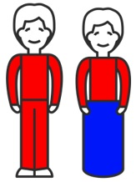
Predictions. If associative learning rather than Core Knowledge underpinned infants' looking behavior in Study 1 (as well as in Spelke et al. [1995]) specifically and their developing causal knowledge of people and objects generally, then infants' looking behavior should reflect the operation of such a mechanism. For example, if infants learned in the real world that legs are associated with contact and action-at-a-distance causality and that the bottom-halves of inanimate objects are associated with contact causality only, then infants assigned to the People with an Inanimate Object Bottom Half condition should look longer at the No Collison test event than at the Collision test event. This may be based on a learned association between legs and the two types of causality. In contrast, infants assigned to the Inanimate Object with People Legs condition should look equally long at the two test events. In general, if infants' knowledge about the causal properties of people and objects is based on learned associations between different perceptual features and different types of causality, then infants should treat as "human beings" objects with people parts (whatever those parts may be) and as “objects” people with objects parts.
Figure 2
One potential complication with this study is that in general it is difficult to know what infants' looking behavior means if they look equally long at the two test events (assuming sufficient statistical power). For example, if infants in any of the Objects with People Parts conditions look equally long at the two test events, this could be due to one of (at minimum) three possibilities. One possibility is that infants may not see the object stimuli with people parts appended to them as objects at all. Instead, they may view the entire stimulus set (i.e., the objects with people parts and people with object parts) as people whose limbs have been occluded by different object parts (but because they are perceived as people, infants understand that they are unconstrained in their causal actions). This predicts that infants in the People with Object Parts condition should also look equally long at the two test events. Interestingly, infants may also look equally long at the Collision and No Collision test events because they failed to learn anything in the experiment. This predicts that infants in the People with Object Parts condition should also be at chance in their looking towards the two test events. There are two ways to address what equal looking toward the two test events could mean for infants assigned to any of the people conditions. The first and perhaps most straightforward way is to recognize that if infants viewed the modified stimuli as people whose external parts have been obscured, then infants in the unmodified object conditions (i.e., the object conditions that did not involve or use people parts) should look longer at the No Collision test event than at the Collision test event. This pattern of responses would not be predicted if infants failed to learn anything at all in these experiments. Instead, if infants failed to learn anything at all in this experiment, they should be at chance in their looking to the two test events across all of the experimental conditions. A second way that this could be addressed is to run a separate experiment in which infants are habituated to a single modified stimulus (e.g., a man whose top half [above the torso] has been replaced with the top half of the cylinder). Following habituation, infants would then be shown two test events. In the Full View" test event, the man will be shown, but this time his entire body will be fully visible and in plain view. In the other Disembodied test event, only the man's legs will be shown. If infants looked equally long at both test events in the Objects with People Parts condition because they saw the stimuli as people whose limbs were occluded, then infants should look longer at the disembodied test event than at the full view test event. In contrast, if infants looked equally long at the Collision and No Collision test event because they failed to learn anything during the experiment, then they should also look equally long at the full and disembodied test events in this follow-up experiment. It should be noted that this follow-up experiment would only be run if infants look equally long at the Collision and No Collision test events across the experimental conditions in Study 2.
A third possibility is that infants in the Object with People Parts condition may look equally long at the Collision and No Collision test events because they associated those people parts with contact and action-at-a-distance causality. This predicts that infants in the People with Object Parts condition should not be at chance in their looking towards these two test events. In this condition, infants should look longer at the No Collision test event than at the Collision test event. This is because infants will have learned that object parts are only associated with contact causality; people parts, in contrast, are associated with both contact causality as well as action-at-a-distance causality. Thus, infants should look longer when they are shown an action-at-a-distance event without the requisite people parts.
If this last possibility underlies infants' looking behavior in Experiment 2, there should also be a developmental progression. Such a developmental progression is predicted because the strength of the association between two (or more) things necessarily depends on how frequently those things have been presented and encountered together; in other words, the strength of the relation (or association) between two things that have been encountered only a small number of times should be smaller than that between two things that have been encountered a larger number of times. Thus, 4-month-olds who presumably have had less experience with the causal properties of people and objects than 7- and 11-month-olds would be expected to be at chance in their looking towards the Contact and No Contact events in all of the conditions. In contrast, because 7- and 11-month-olds have accrued much more real-world experience with the causal properties of people and inanimate objects, they should treat as "human beings" objects with people parts (whatever those parts may be) and people with objects parts as "objects."
Computational model
Figure 3
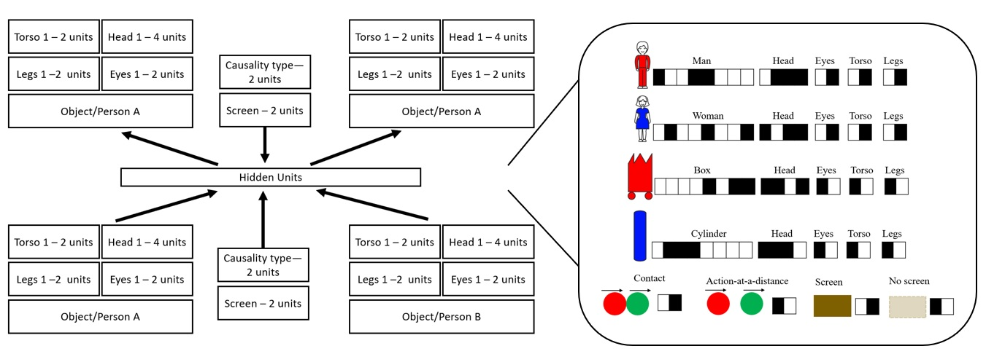
Purpose: Study 2 only indirectly tested whether associative learning underpinned infants' early causal knowledge about people and inanimate objects. To address directly this issue, I will instantiate my associative learning account for how infants learn about the causal properties of people and inanimate object in an artificial neural network. The goal of the computational model is twofold. First, it is designed to account for infants' looking behavior in Study 1. Second, the model that is used to simulate infants' looking responses in Study 1 will be used subsequently to predict infants' responses in Study 2.
Artificial neural networks are computer programs that consist of simple, neuron-like processing units. Typically, these networks are organized into distinct layers. The bottom layer is the input layer, the middle layer is the hidden layer, and the top layer is the output layer, and each layer is connected to the layer immediately below and above it via a set of “weights”. Artificial neural networks learn to solve tasks—that is, to produce some desired output given some input—by finding the right configuration of weights via an internal learning procedure. These models are ideal for simulating cognitive development because they make minimal assumptions about the starting state of the infant (e.g., Benton & Rakison, 2018; Yermolayeva & Rakison, 2016) and because these systems are fundamentally associative-learning devices, which is a key tenet of the theoretical account outlined at the beginning of this document.
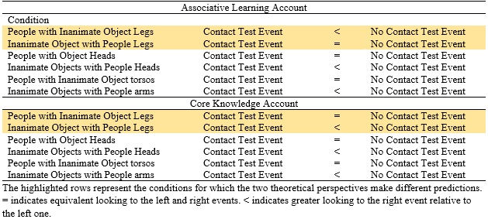
Design. The stimuli, training events, test events, and experimental conditions for this study will be modeled after Study 1 and then extended to model Study 2. The network will be a standard three-layer network (Figure 3). I have used these kinds of networks successfully in previous published studies (e.g., Benton & Lapan, 2022; Benton, Rakison, & Sobel, 2021; Rakison & Benton, 2019) and have written extensively about them elsewhere (e.g., Benton, 2022a, 2022b; Benton & Rakison, 2018). The input layer of the model will consist of a pattern of activity across 4 units that corresponds to whether an item has a male head, a female head, the "head" region of a box, or the "head" region of a cylinder, a pattern of activity across 2 units that corresponds to whether or not an item has arms, a pattern of activity across 2 units that corresponds to whether an item has legs, a pattern of activity across 2 units that corresponds to the type of causality that is being presented (i.e., either contact causality or action-at-a-distance causality), and a pattern of activity that corresponds to whether a screen is present. There will be a final pattern of activity across 50 units that corresponds to the unique identity of an object or entity. This final group implements that idea that no two individuals or objects are identical in their perceptual features. Each of these input groups will connect to a hidden layer. This hidden layer, in turn, will connect to an output layer. The groups that comprise the input and output layer will be identical. This means that the network’s task is to learn a compact representation of the input—along the hidden layer—that enables it to “copy” what is presented along the input layer at the output layer (e.g., Mareschal, French, & Quinn, 2000; Mareschal, Quinn, & French, 2002).
Table 1
Crucially, the network will be trained across two phases in accordance with the major features of my theoretical account: pretraining and habituation. The pretraining phase will correspond to the network's "real world" experience. During this phase, networks will learn that some human body part (or a series of parts) is associated with contact causality and action-at-a-distance causality. The specific body part (or parts) on which the network will be trained will be informed by the infant experimental data. For example, if Study 2 suggests that infants learned in the real world that legs are associated with both kinds of causality—based on the fact that infants in the Objects with Human Legs condition looked equally long at the Collision and No Collision test events, whereas infants in the People with Object Bottom Halves looked longer at the No Collision test event than at the Collision test event—then the network’s “real-world” pretraining experience will involve learning that legs are equally associated with contact and action-at-a-distance causality. In addition, during pretraining networks will learn that inanimate objects are only associated with contact causality. It is worth mentioning that in these simulations, an object is defined by the absence of a human torso, legs, eyes, and a human (male or female) head. Subsequent simulations will explore whether varying the proportion of inanimate objects that possess people parts influences how models “treat” unmodified people and inanimate objects as well as modified people and inanimate objects, but this is not a central focus of this model. Given that Studies 1 and 2 will test infants at different ages, age will be simulated here by manipulating the amount of pretraining experience that a network receives. This is how I have modeled age in previous simulation work (e.g., Benton, Rakison, & Sobel, 2021; Rakison & Benton, 2019). Specifically, networks that correspond to 11-month-old infants will receive the most pretraining experience, followed by networks that correspond to 7-month-old infants, followed by networks that correspond to 4-month-old infants. In addition, and consistent with my prior simulation research (e.g., Benton, Rakison, & Sobel, 2021; Rakison & Benton, 2019), I will simulate age by manipulating a parameter called “weight decay”. This parameter corresponds roughly to the amount of information that a network retains as it is trained—the larger the value of weight decay the less information is retained across training. The numerical value of this parameter will be the smallest for oldest models, somewhat larger for the slightly younger models, and still larger for the youngest models. Together, these two parameters implement a very simple model of age and development.
Following pretraining, all networks will be “habituated” to screened events. To simulate Study 1 (i.e., Simulation 1), networks will be assigned randomly either to the People condition or to the Inanimate Object condition. To simulate Study 2 (i.e., Simulation 2), networks will be assigned randomly to one of the six conditions to which infants will be assigned. Across all conditions the habituation phase will be like the pretraining events except that a novel pair of people (for networks in the People condition) or a novel pair of objects (for networks in the Inanimate Object condition) will be used, and the unit that corresponds to the presence of a screen will be turned on (this unit will have been turned off during the pretraining phase). Following habituation, all networks, regardless of condition, will be tested on a Contact and a No Contact test event but without the screen (as is true with human infants in Studies 1 and 2). I will use sum-squared error (SSE) to assess how incongruous networks find a given test event. Networks should show greater error for those test events that are perceived as inconsistent. The rationale for using SSE as a measure of learning is that previous simulation studies have established a relationship between network SSE and infant looking time such that increases in looking time are related to increases in network SSE (e.g., Mareschal, French, & Quinn, 2000; Mareschal, Quinn, French, 2002; Rakison & Benton, 2019). The full predictions are laid out in Table 1 for networks (and perhaps by extension, infants) that learned a link between legs and the two types of causality, but in brief it is predicted that networks assigned to the People Condition should show equivalent SSE towards the Contact and No Contact test events. In contrast, networks assigned to the Inanimate Object condition should show greater SSE towards the No Contact test event than the Contact test event. This should only be true if networks learned that people (i.e., entities with people parts), but not inanimate objects, can cause action on contact as well as at a distance. In contrast, networks assigned to the Inanimate Object with People Parts condition in Simulation 2 should show equivalent error towards the Contact and No Contact test events if they learned that some human part (the exact human part will, again, be based on data from Study 2) is equally associated with contact and action-at-a-distance causality, whereas networks assigned to the People with Object Parts condition should show greater error towards the No Contact test event than the Contact test event. This latter result would be predicted if networks learned that objects can only cause action on contact. Thus, observing an event in which a person with object parts causes action-at-a-distance should violate the part-causal correlations that networks could have extracted during the pretraining phase. Preliminary simulations revealed that the difference in “looking time” (i.e., difference in SSE) between the No Contact and Contact test events was greater for models assigned to the Inanimate Object condition (M_{No-Collision} = 11.55, M_{Collision} = 8.73) than models assigned to the People condition (M_{No-Collision} = 8.6, M_{Collision} = 8.3), t(62) = 57.58, p < .0001. Importantly, in a follow-up simulation in which objects were given legs and people were given the bottom-halves of objects, the difference in “looking time” between the No Contact and Contact test events was greater for models assigned to the People with Object Legs condition (M_{No-Collision} = 16.47, M_{Collision} = 12.08) than models assigned to the People condition (M_{No-Collision} = 14.71, M_{Collision} = 13.57), t(62) = -63.72, p < .0001. These results suggest that infants’ looking behaviors could be based on learned associations between particular surface features and different kinds of causality. Crucially, these modeling results will be treated as key predictions for Study 2.
Measures and analyses. The analyses for this study will be identical to studies 1 and 2.

