Chapter #
Associative learning: What it is and what it can explain
Deon T. Benton
Department of Psychology and Human Development, Vanderbilt University

Address correspondence to Deon T. Benton (deon.benton@vanderbilt.edu) Department of Psychology and Human Development, Vanderbilt University, Peabody College, 230 Appleton Place #552, Nashville, TN 37235

We have gathered evidence for what I would like to call the “law of uphill analysis and downhill invention.” What I mean is this. . . . Analysis is more difficult than invention in the sense in which, generally, induction takes more time to perform than deduction: in induction one has to search for the way, whereas in deduction one follows a straightforward path. (Braitenberg, 1984, p. 20)

This quote can be found in the book Vehicles by neuroscientist and cyberneticist Valentino Braitenberg. In it, Braitenberg introduces a series of fictional vehicles and describes their behavior. Some of these vehicles come to rest whenever they are near another vehicle. Others accelerate toward vehicles in their vicinity. Others still move in a manner that increases the physical distance between themselves and other vehicles. The first vehicle’s behavior might cause an onlooker to conclude that it has “affection” or even “love” for other vehicles—after all, it appears to have a desire to be close to them. That same observer might use the word “aggression” to describe the behavior of the second vehicle—it seems to want to inflict harm on other vehicles—and the word “cowardice” to describe the behavior of the third vehicle—it seemingly dreads being near other vehicles.
One may wonder terms like “desire,” “want,” and “dread” to describe veridically each vehicle’s behavior. As is discussed at length in Vehicles, a veridical description of each vehicle’s behavior does not require that psychologically rich notions be invoked; simpler principles and mechanisms are sufficient to explain them. To understand why, it is necessary first to consider the architecture and core components of a Braitenberg vehicle. Figure 1 depicts one such vehicle.

Figure 1
Basic architecture of a Braitenberg Vehicle
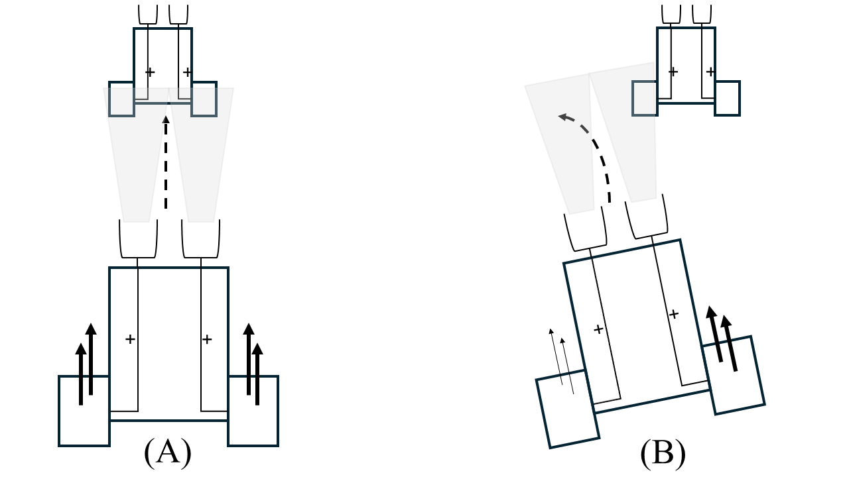
Note. The double tiered arrows correspond to the speed of the engine. Thicker arrows correspond to faster speed; thinner ones correspond to slower speed. The transparent trapezoids correspond to the sensor signals. The dotted arrowheads depict the direction of the vehicle. (A) The first vehicle is approaching the second one. (B) The first video is moving away from the second one.

As shown in the figure, Braitenberg vehicles consist of a body, two small rectangular motors, and two sensors. The motors—which are located on each side of the body—are connected to sensors that respond to different kinds of external stimulation (e.g., light, sound, temperature, or even another vehicle). If the sensors receive increasing amounts of that stimulation and the connection between them and the motors is positive (i.e., excitatory), as depicted in the figure, then the vehicle will move towards the stimulus. If, instead, the connection between the sensors and motors is negative (i.e., inhibitory), then the vehicle will slow down as it approaches the stimulus.
As it turns out, the sensorimotor connections among the vehicle’s motors and sensors, together with its physical distance from an external stimulus, are all that is needed to explain fully the behavior of a Braitenberg vehicle. A vehicle with the pattern of sensorimotor connectivity depicted in Figure 1, for example, will move along a straight path towards an external stimulus that is located directly ahead of it until, at some point, it overtakes that stimulus, at which point it will begin to slow down as the distance between it and the stimulus increases. In contrast, that same vehicle will turn away from a stimulus positioned to one side of the vehicle. This is because the sensor closest to the stimulus receives more stimulation than the sensor further away. This has the consequence of causing the right motor to rotate faster than the left one. This difference in rotational speed, in turn, is what causes the vehicle to turn away from rather than towards the stimulus. Invoking cowardice to describe the vehicle’s behavior adds precisely nothing to the description.
This example reveals a deep—but perhaps nonobvious—insight: Behaviors that, at first blush, look goal-directed and like they were produced by sophisticated underlying mechanisms may instead be the product of simpler principles and mechanisms. This insight is easy to miss when attempting to infer mechanism from behavior, not least because behavior radically underdetermines mechanism such that the very same behavior can be produced by different mechanisms. The consequence of this is that it may not be possible to identify a behavior’s true generating mechanism, and even if one can be found, the time it takes to do so may be orders of magnitude than what is practical or feasible. This is what Braitenberg means when he says that “analysis is more difficult than invention” and that “induction takes more time than deduction.”
Although the solution to this problem is to choose a mechanism and then characterize the behaviors it produces either their mental or computational simulations, this approach is rarely taken in the human sciences. In the developmental cognitive sciences, for example, it is customary for infancy researchers to ascertain mechanism from behavior. A corollary of this is that sophisticated cognitive abilities, abstract knowledge, and specialized mechanisms are routinely ascribed—in my view wrongly—to developing infants based in part on inherently impoverished measures like looking time (Mix, 2002). In the number domain, for example, some have interpreted 5-month-olds’ tendency to look longer at numerically incongruous outcomes (e.g., $1+1=1$) than at numerically congruous ones ($1+1=2$; e.g., McCrink & Wynn, 2004; Wynn, 1992) to mean that “humans innately possess the capacity to perform simple arithmetical calculations, which may provide the foundations for the development of further arithmetical knowledge” (Wynn, 1992, p. 750). A similar conclusion was reached by Uller et al. (2001) based on converging evidence with cotton-top tamarins. She concluded that “it is likely that these numerical representations are spontaneously available to a variety of primate species and could provide a foundation on which humans’ number sense was constructed over evolution and development” (Uller et al., 2001, p. 248). Wynn (1995; see also Meck & Church, 1983) that the basis of this number sense is an evolutionarily ancient accumulator-like mechanism that continuously tracks and outputs the number of discrete elements in a scene (e.g., Meck & Church, 1983; Wynn, 1995). The problem with this conclusion is that there may be other explanations for these putatively precocious findings. Cohen and Marks (2002), for example, contended that simple preferences for familiar stimulus configurations and displays containing more items could explain this looking pattern.
This example is a nice illustration of why, when reasoning backwards from behavioral outcomes to their underlying mechanism, it is easy to overlook the possibility that ostensibly complex behaviors may be the result of simple operating principles and mechanisms. The fact that a complex behavioral pattern is subserved by a complex behavioral pattern should not be treated as a foregone conclusion. The goal of this chapter is to demonstrate how one specific kind of simple mechanism—namely, domain-general associative learning—adequately accounts for infants’ and children’s behavior in different cognitive domains. will rely on four case studies to make this case. The first case study will focus on how infants learn about the causal properties of people and objects. The second study will focus on the question of how infants determine relationship closeness. The final case study will focus on the question of how children reason causally. The chapter will conclude with a brief discussion of why computational modeling is vital to associative explanations of early cognition given that computational modeling will factor heavily in each of these discussions.
Although a good deal of the work discussed in this chapter comes from my own research program and from a circumscribed set of cognitive domains, I see both as speaking to two broader theoretical points. The first point should be well understood at this point, and it is that the generative abilities of simple mechanisms should not be overlooked or underestimated. The second point is that to the extent that associative learning—a simple mechanism—can explain the findings described in this chapter, there is no reason a priori to assume that the same cannot be true for cognitive domains that are not covered in this chapter. Indeed, similar arguments to the current ones have been advanced to explain young children’s behaviors in cognitive domains such as imitation (e.g., Heyes & Ray, 2000), theory of mind (e.g., Perner & Ruffman, 2005), morality (e.g., Benton & Lapan, 2021), causality (e.g., Rakison & Lupyan, 2008), categorization (e.g., Quinn & Eimas, 1997), word learning (e.g., Colunga & Smith, 2005), among others (e.g., Adolph & Joh, 2009; Mermier et al., 2022; Scott & Arcaro, 2023).

Defining associative learning
Before it can be argued that infants’ and children’s behavior in the cognitive domains discussed here—and perhaps in others—is underpinned by associative learning, the term itself must first be defined. One definition of associative learning was put forward by Heyes (2018, p. 67), who defined it as any “learning in which an excitatory or inhibitory link is formed between representations of events.” Similarly, Rakison (2003, p. 170) defined associative learning as a process that establishes a “mental representation of correlations that exist between spatially and temporally co-occurring attributes objects [sic], properties, or events in the world.” Although both definitions likely capture what most people intuitively have in mind when the term is used, one difficulty with them is that they fail to distinguish between different types of associative learning. One type involves forming associations between one’s behavior and the consequences that follow from it. This form of associative learning is called operant conditioning and was made popular by B.F. Skinner (Skinner, 1957). The other type of associative learning involves forming associations between two (or more) external stimuli. This form of associative learning is called classical conditioning and was made popular by Ivan Pavlov (Pavlov, 1927) and John Watson (Watson, 1924). Both types share the commonality that, for sufficiently strong associations, the presence of one component of the relation will evoke a representation of the other component, even if that other component is absent.
In the developmental sciences, the Little Albert experiment is a paradigmatic example of classical conditioning (e.g., Watson & Rayner, 1920), and Carolyn Rovee-Collier’s mobile conjugate reinforcement paradigm is a paradigmatic example of operant conditioning (e.g., Rovee-Collier, 1999). Although both types of learning operate throughout development and play important roles in cognitive development, of the two, classical conditioning is closest in meaning to the current use of the term associative learning. The reason is simply that in none of the current studies were infants required to learn about the consequences of their behaviors based on contingency and reinforcement schedules. At the same time, there are certain difficulties with even this type of learning that make it an inexact match to the kind of representation-based associative learning that I argue underpins the various findings discussed in this chapter.
One especially notable difficulty—one that becomes evident only when classical conditioning is formalized mathematically (e.g., Rescorla & Wagner, 1972; Widrow & Hoff, 1960)—is that this form of learning establishes direct associations between representations of external stimuli rather than associations mediated by learned internal representations. This limitation is severe and means that models that implement classical conditioning—such as the Rescorla-Wagner model (e.g., Rescorla & Wagner, 1972) or the Delta rule (Widrow & Hoff, 1960—are unable to solve so-called linearly inseparable problems. A problem is linearly separable if representations of external stimuli that are associated with one class of stimuli (e.g., present-tense English regular verbs and their -ed past-tense forms) can be distinguished, on the basis of their existing features, from representations associated with another class (e.g., present-tense English irregular verbs and their idiosyncratic past-tense forms). A problem is linearly inseparable if this distinction is not possible. The XOR problem is perhaps the most well-known example of a linearly inseparable problem (e.g., Minksy & Papert, 1969). The details of this well-known problem matter less for the purposes of the present discussion than what it requires of classical conditioning and models that implement it: distinct representations must be linked to similar stimuli and overlapping representations to dissimilar stimuli. The reason this problem is insurmountable for classical conditioning and models that implement it is that its solution requires these models to behave in ways that conflict with their desired behavior, which is to map similar representations to similar classes of stimuli and dissimilar representations to dissimilar classes.
Although it has long been recognized that learned internal representations are needed to solve this problem, it was not until the 1980s that a solution—called backpropagation (e.g., Rumelhart et al., 1986; Werbos, 1974)—was developed. The reason learned internal representations solve this problem is that they allow external stimuli that must be mapped to the same class to be represented more similarly internally and external stimuli that must be mapped to different classes to be represented more dissimilarly internally. A problem that began as linearly inseparable can therefore be transformed into a linearly separable one when learned internal representations are introduced. It is this representation-based notion of associative learning that I have in mind throughout the discussion that follows.

Case study 1: How infants learn about the causal action of people and objects
Few challenges are more daunting for the developing infant than learning about all the ways that people differ from objects. One such difference is that people can cause each other to act through direct physical contact, but they can also instigate action at a distance, in the absence of physical contact. An example of contact causality would be Lindsey pushing her daughter Alena out of the path of a rapidly approaching vehicle. An example of action-at-a-distance causality would be Lindsey exhorting Alena to “watch out” to ensure that Alena is not struck. By contrast, inanimate objects typically require physical contact to move. Our understanding of how the world works or how to interact with things in it requires that we appreciate these fundamental differences. A person who understands that people and objects possess different causal abilities, for instance, would know that it is appropriate to request a favor from another person but incongruous to request one from a box.
How do infants acquire this knowledge? The Core Knowledge perspective offers one intriguing answer (e.g., Spelke, 2022; see also Carey, 2009, for a related account). This theory posits that infants are endowed with a small number of “core knowledge” systems. These domain-specific systems are argued to support reasoning about geometry and space, agents, inanimate objects, number, and social relationships. These systems are “domain specific” because they support learning in particular content domains and are triggered by particular kinds of input. Of these systems, the two most relevant to the question posed above are the core systems for reasoning about agents and objects. The core agent system enables infants to know that agents are goal-directed, self-propelled, can move along irregular paths, and can cause action to occur in other agents both at a distance and through direct contact. The core object system, in contrast, allows infants to know that objects do not move in the absence of physical contact from other objects or agents, are cohesive and bounded, and move along connected paths.
Initial support for this theory was obtained by Spelke et al. (1995; see also Woodward et al., 1993, and Kosugi & Fujita, 2002). Seven-month-olds were assigned either to the People condition or to the Object condition. Infants in the People condition were then shown an event in which a first person entered the stage from the left and traveled a short distance until it was fully blocked by a centrally located opaque screen. A second initially half-covered person then emerged from behind the right side of the screen and traveled a short distance until it was off-stage. Infants were shown this event until they habituated to it (i.e., until their looking time decreased by some criteria). A red box with a jagged top edge and a blue cylinder replaced the people in the Object condition. This condition was otherwise identical to the People condition. All infants were then shown two screenless test events. In the Contact test event, the first person (or object) moved towards the other person (or object) until it contacted it at the center of the stage. In the No Contact test event, the first person or object moved towards, but ultimately stopped short of, the other person or object, at which point the second person or object moved until it was off stage.
Spelke et al. (2007) reasoned that if understand that people and objects possess distinct causal properties, then they should have different expectations about what occurred behind the screen between the two people or two objects. For example, if infants—like adults—understand that objects generally cannot move in the absence of physical contact from other objects or agents, then, to explain that the second object’s movement, they should infer that the first one contacted it. This should manifest as longer looking at the No Contact test event than at the Contact test event. Their expectations about what occurred between the two people, however, should be more equivocal. The second person could have moved by choice, or it could have been pushed or contacted in some way by the first person. This should manifest in an equivalent amount of looking at both test events.
This is precisely what Spelke et al. (1995) found. In other words, infants in the Inanimate Object condition, but not those in the People condition, looked longer at the No Contact test event than at the Contact test event. This finding—combined with evidence that infants between 7 and 10 months of age ostensibly are surprised when an inanimate object is revealed to have caused another object’s earlier motion and rapidly encode the motion characteristics of animates and inanimates (e.g., Markson & Spelke, 2006; Saxe et al., 2005; Saxe et al., 2007)—would seem to suggest that, indeed, infants possess core knowledge systems for reasoning about objects and agents and understand that people, but not inanimate objects, can cause other people to act from afar. As the opening example made clear, however, such a conclusion may ultimately be unnecessary if a simpler mechanism and explanation can account for these findings.

Figure 2
Associative learning account of infants’ developing knowledge of people and object causal action.
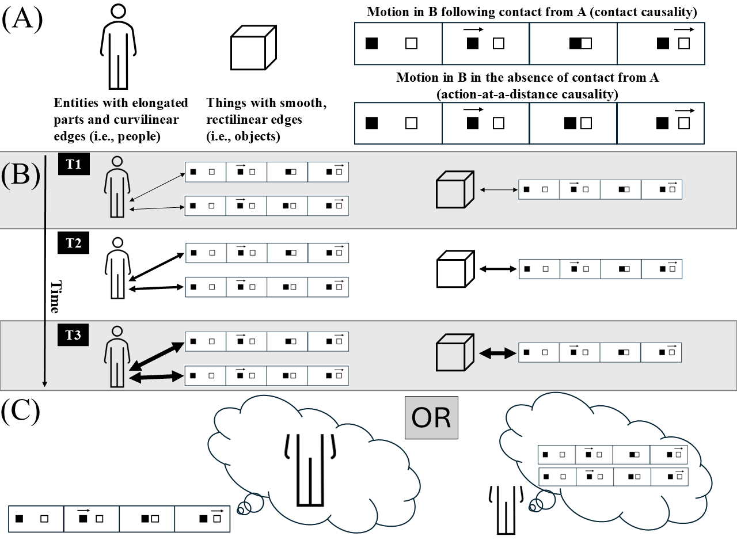
Note. (A) The four core elements of the theoretical account: people, objects, contact causality, and action-at-a-distance causality. (B) The core learning account: associations (depicted as doubled-headed line arrows) between particular perceptual features and particular patterns of motion gradually increase in strength with experience. (C) The consequence of a robust association: the presence of one feature activates a representation of the other.

I offered one such alternative proposal in a series of recently published papers (Benton, 2023, 2025; depicted schematically in Figure 1). The crux of my proposal is that—in conjunction with a small number of inherent perceptual biases, such as preferences for faces over non-faces (e.g., Morton & Johnson, 1991) and movement or non-movement (e.g., Slater, 1989; Vallortigara, Regolin, & Marconato, 2005)—domain-general associative learning can explain infants’ looking behaviors in studies designed to evaluate their knowledge about people and object causal action. I argued that the perceptual biases themselves serve to emphasize certain regions of the perceptual array while simultaneously deemphasizing other regions. This idea should not be controversial. By training their attention on one aspect of the perceptual array, it will necessarily be the case that infants are not attending to other aspects.
In terms of the associative-learning process itself, this process begins the moment that infants detect—either incidentally or intentionally—that a correlation exists between certain salient low-level features (e.g., elongated appendage-like extensions [e.g., adult-defined legs or arms]) and the surface-based kinematics of different kinds of motion (e.g., action-at-a-distance causality and contact causality). The rationale for describing these features and actions in this manner is to reflect my assumption that infants represent them in fundamentally perceptual rather abstract, conceptual terms. I argued that the reason infants might notice and then encode this link in the first place is because some perceptual features will tend to co-occur across time and space with the kinematics of different kinds of actions. For example, infants may learn that entities with appendage-like, hinged extensions sometimes move in the absence of physical contact with other entities that possess similar extensions but move following direct contact with those same entities on other occasions.
One reason infants may be attuned to this associative relation at all—that is, that elongated appendages are linked to the kinematics of distinct actions—is that they possess an early emerging, or perhaps even innate, bias to attend to moving rather than stationary objects. In other words, the attention-grabbing nature of the dynamic action-at-a-distance or contact events is, I argue, what causes infants to attend to them at all. Whatever the reason may be that infants are drawn to these events, once they have oriented to them, infants might come subsequently to notice that elongated appendages (what an adult might describe as legs) tend to be present during these movement events. This, in turn, may establish a nascent link between these appendages and the kinematics of both kinds of action (T1 on the left side of Figure 2B). At the same time, because objects tend only to move when contact is applied to them, a third nascent association will be established between things with smooth rectilinear edges (what an adult would describe as objects) and motion following direct, physical contact (what an adult might describe as contact causality; T1 on the right side of Figure 2B). Crucially, these associative relations will grow in strength each time infants encounter them in the real world (T2 and T3 in Figure 2B).
A well-established consequence of associative learning is that once a robust association has formed between its components, the presence of one of those components will activate a representation of the other, even if that other component is physically absent (e.g., Heyes, 2018). The same principle applies here. The presence of motion at a distance will activate a representation of elongated appendages (left side of Figure 2C). Crucially, this process is, in all likelihood, bidirectional. This means that the presence of elongated appendages will activate a representation of movement through physical contact and movement at a distance. A consequence of this process is that if one component of a learned relation is present (e.g., smooth, rectilinear edges) but the other is not (e.g., motion through contact), this may cause infants to show heightened looking because they are actively seeking out the missing component.
It turns out that this is all that is needed to explain infants’ looking behaviors in studies that evaluate what knowledge, if any, they have about the causal abilities of people and objects; the stipulation of innate knowledge or core knowledge systems is not necessary. For example, this account suggests that the reason infants in the Inanimate Object condition in Spelke et al. (1995) looked longer at the No Collision test event than at the Collision event is because the motion depicted in this event—namely, movement at a distance—triggered an unfulfilled expectation for elongated appendages; the Collision event elicited less looking because the motion-feature relation depicted in this event was consistent with that observed in the real world. By contrast, the reason infants in the People condition looked equally long at both test events is that the depicted motion-feature relations were consistent with that acquired in the real world. because the people possessed the surface features that infants learned were associated reliably with the kinematics of both kinds of action in the real world.
To demonstrate that this account could indeed reproduce the pattern of looking among infants in Spelke et al. (1995), I subsequently instantiated it in a computational model. The computational formalism I adopted were connectionist artificial neural network models. These models—much like the human brain on which they are loosely based—consist of simple “neuron-like” processing units that are organized into layers. Units in one layer in the model interact with units in adjacent layers via a set of interconnected, synapse-like, real-valued, weighted connections. Thus, units in the bottom-most, or input, layer interact with units in an intermediate, or “hidden”, layer via one set of weighted connections, whereas units in the hidden layer interact with units in the final, or “output”, layer via a second set of connections. There are many reasons to adopt this formalism like this, but here I focus on four.
First, compared to other modeling formalisms (e.g., Bayesian inference), connectionist models are uniquely and fundamentally developmental (Benton, 2022, 2023, 2025; Benton et al., 2024; Mareschal & Thomas, 2007; Rakison & Lupyan, 2008). As is true for human infants and children, learning occurs through gradual adjustments to the weights throughout the network. Second, connectionist models are fundamentally constructive. One sense in which these systems are constructive is that simpler units of knowledge and information beget more complex units of knowledge (e.g., Cohen et al., 2002). Another sense in which these systems are constructive is that, for certain types of connectionist models, it is possible for the system itself to grow in complexity based on experience (e.g., Shultz & Sirois, 2008).
Third, connectionist models are fundamentally associative-learning devices. Given that the current account assumes that associative learning underlies infants’ putative causal knowledge about people and objects, it is essential that the model used to simulate the basis of that knowledge instantiate the same learning mechanism. Fourth, connectionist models are mechanistic (Benton, 2026). If it can be shown that a well-specified model can capture some behavioral phenomena, then this demonstrates that the implemented mechanism is sufficient to capture that phenomenon. This is critical here because the crux of my proposal is that associative learning, rather than innate knowledge or core knowledge systems, is sufficient to reproduce infants’ looking behaviors in studies that evaluate what they know about causal action in people and objects. I will return to this fourth reason in the next section.

At the same time, the model’s task was to predict the location of each person or object at the moment in time based on their position at the current moment. Thus, if an entity was in the first position at the beginning of an action event—such as the person in the first cell of the Motion input group in Figure 3—the network’s task was to predict that it would be in the second position at the very next point in time. During contact events, the first entity was spatially contiguous with the second entity when the former stopped moving and the latter began to move. During action-at-a-distance events, by contrast, the two entities were separated by one cell when the first stopped moving and the second began to move. To achieve both of these goals, networks needed to develop hidden representations that captured the most essential aspects of the input while also encoding sequential regularities as it related to the relative positions of people and objects as different events unfolded. These representations were acquired through gradual adjustments to the weights throughout the network via the backpropagation algorithm.
To implement the theoretical assumption about the kinds of action that infants experience in the world, networks learned—during a phase that approximated infants’ lived, real-world experience—that things that possessed features typical of inanimate objects cause movement in other objects through physical contact. For things that possessed features typical of people, networks learned that they can can cause other people to move through direct contact as well as at a distance.
To implement developmental differences in experience, networks corresponding to older infants were exposed to a greater number of action events than networks corresponding to younger infants. “Older” networks also differed from “younger” networks in their speed of learning, rate of forgetting, and information-storage capacity. Learning speed was implemented through the learning rate parameter, forgetting rate through the weight decay parameter, and storage capacity through the number of hidden units.
The habituation phase followed this “real world” phase. The length of this phase was shorter than that of networks’ real-world experience. Networks—like the infants in Spelke et al. (1995)—were assigned either to the Inanimate Object condition or to the People condition. The people and objects that networks observed during habituation differed from those experienced in the real world. To simulate the fact that infants were not provided specific motion information during habituation, motion information was omitted during habituation. This meant that the network’s only task during this phase was to reproduce at the output layer the patterns of activation presented across the surface appearance and feature groups at the input layer.
To evaluate the network’s ability to reproduce the pattern of looking observed in Spelke et al. (1995), all networks were then shown Contact and No Contact events during a subsequent test phase. The discrepancy (or “error”) that was just mentioned served as a proxy for looking time; the greater this discrepancy, the longer networks were assumed to have looked at an event. This operationalization is consistent with that used in developmental models like this one (e.g., Benton & Hoch, 2026; Benton & Lapan, 2021; Mareschal et al., 2000). The results revealed that older networks in the Inanimate Object condition produced more error in response to the No Contact event than to the Contact event, whereas older networks in the People condition produced comparable error to both events. Younger networks showed a different pattern of results: They produced comparable errors to both test events irrespective of the condition to which they were assigned. It is worth noting that it need not be the case that objects in the real world only move following contact from other objects for networks to show this pattern of results. These results have two implications. First, they suggest that that innate knowledge about the causal behaviors of people and objects that is grounded in core knowledge systems is not necessary to explain Spelke et al.’s (1995) findings; associative learning is clearly sufficient. Second, they suggest that infants’ looking behaviors in Spelke et al. (1995) may be the end product of a developmental progression. In other words, these results suggest that it is only with sufficient experience that infants develop expectations about how things with people-like surface features and things with object-like surface features behave in causal interactions.
Nevertheless, two potential objections to these findings are worth considering. One is that the model might have succeeded in reproducing Spelke et al.’s (1995) findings simply because it never experienced instances of objects moving on their own in its simulated real world. By contrast, infants probably do experience at least some amount of spontaneous object motion, even if, in aggregate, they experience it less than caused-object motion. An infant turning around just seconds after a wind-up toy has been set in motion is an example of this. I addressed this concern in a subsequent simulation by manipulating the ratio of objects moving following contact to objects moving at a distance. The results of this simulation indicated that this model’s ability to capture Spelke et al.’s (1995) finding did not depend on a perfect correspondence between inanimate surface features and motion through contact: Networks continued to show the characteristic pattern of looking observed by Spelke et al. (1995) even when they experienced many instances of objects moving in the absence of physical contact from other objects.
Another potential objection is that the model succeeded in capturing Spelke et al.’s (1995) results only because the surface features that distinguished people from objects were specified in advance; the model was not itself required to discover the causally relevant features like an infant might in the real world. I addressed this concern in a subsequent simulation by presenting the model with multiple surface features that differed in their perceptual salience. Despite the fact that all surface features occurred equally often with the different kinds of causal action, networks readily discovered the causally predictive ones; that is, stronger associations developed between salient surface features and the different patterns of causal action than between less salient features and those same patterns. This finding captures a key assumption of the foregoing associative-learning account: Infants’ visual attention is pulled naturally toward some surface features and away from others. As a consequence, stronger associations develop between attended, salient features and the patterns of causal action with which they reliably co-occur than between unattended, less salient surface features and those same patterns.
Subsequent simulations demonstrated that this model also succeeded in reproducing the results of other classic studies on this topic. The model not only captured Saxe et al.’s (2005) finding that 10- and 12-month-olds looked longer when a human hand, but not a toy truck, appeared on the opposite side of the stage from which a beanbag had previously emerged (Simulation 2), but it also reproduced Markson and Spelke’s (2006) finding that 7-month-olds looked longer at a previously self-propelled toy animal than at one whose movement had been caused by a human hand (Simulation 4), as well as Saxe et al.’s (2007) finding that 7- and 10-month-olds looked longer when a bean bag emerged from behind a screen concealing a toy truck than from behind one concealing a human hand or puppet (Simulation 3). In addition to reproducing these findings, the model generated several testable predictions. One is that infants younger than 7 months of age should look equally long at both test events regardless of the condition to which they are assigned. Another is that infants’ looking behaviors should depend on the perceptual features of the entities involved: Objects that possess salient people-like features (e.g., a cylinder with legs appended to its base) should elicit looking patterns similar to those elicited by people. Conversely, people that possess salient object-like features should elicit looking patterns similar to those elicited by inanimate objects.
Each of these predictions are presumably at odds with what would be predicted under the Core Knowledge account. Because this perspective assumes that infants’ knowledge about the causal actions of people and objects is innate, it should not be the case that infants younger than 7 months of age exhibit qualitatively different patterns of looking from those of older infants.

predictions that, at present, remain to be tested. One of the predictions was the developmental one that was just discussed. One of the predictions was that

