Associative learning is sufficient to explain infants’ putative action efficiency understanding
Deon T. Benton
Vanderbilt University

Address correspondence to Deon T. Benton, Department of Psychology and Human Development, Vanderbilt University, Peabody College, 230 Appleton Place #552, Nashville, TN 37235

Data availability statement: The simulation data for these simulations can be found here https://osf.io/9eqpf/?view_only=62f752417a9141c7b0509a998039ad13.
Conflicts of interests: none

“Associative learning is sufficient to explain infants’ putative efficiency understanding”

Abstract
Developmental scientists have long debated how infants determine whether an action is efficient. Nativists argue that infants possess conceptually rich, domain-specific systems for representing actions in terms of goals, costs, efficiency, and rationality. Empiricists instead maintain that preverbal infants’ looking behaviors reflect domain-general learning mechanisms operating over perceptually grounded event representations. The present paper instantiates this latter proposal in a new connectionist model called ALIAS (for Associative Learning in Action Studies) and shows that it reproduces key findings in this literature previously taken as evidence for the nativist position. Analyses of ALIAS’s internal dynamics indicate that its responses emerge from learned associations between action kinematics and their associated visible surface features. The model also generates novel predictions for future experiments. Together, these findings suggest that a domain-general associative learning mechanism operating over perceptually grounded event representations is sufficient to account for the principal findings in the infant action-efficiency literature without recourse to specialized, early-emerging, and action-centered representations.
“Associative learning over differentially salient surface features is sufficient to explain infants’ action efficiency understanding”
A daunting challenge faced by young learners is distinguishing efficient from inefficient actions. For instance, a child may learn that stairs provide a safer and more efficient route to the top after observing another child tumble down one. In general, determining an action’s efficiency—a capacity referred to here as action efficiency understanding—is crucial for navigating the world competently. An open question then concerns when, and importantly how, this capacity develops in preverbal infants with limited mobility and first-hand action experience.
Developmental cognitive scientists have typically studied the origins of this capacity via the violation-of-expectation paradigm, in which infants are habituated to an event in which an object jumps over a barrier to reach another one and then tested on events that differ in their efficiency (see Figure 1). In the Efficient event, the first object moves along a straight path to reach the second object. In the Inefficient event, the first object continues to move along the familiar, but now inefficient, curved or arced motion path to reach the second object.

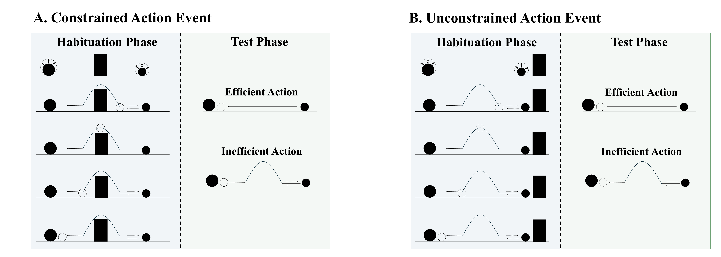
Figure 1. Schematic depiction of a typical constrained and unconstrained action event used in studies assessing action efficiency understanding in infants. In the constrained action event (A), the first object jumps over the barrier before it comes to rest next to the second object; in the unconstrained action event (B), the first object jumps beside the barrier before coming to rest next to the second one. The barrier is removed at test for both events, and infants observe either an efficient straight-path action or an inefficient arced-path action. Data for the first target finding discussed in the text derived from this paradigm.

Several important findings have emerged from the use of this method. Figure 2 provides a visualization of their corresponding paradigms. One is that 9- to 12-month-olds looked longer at inefficient than efficient actions if the first object’s habituation movement was constrained (Figure 1A) but not unconstrained (Figure 1B; Gergely et al., 1995; see also Phillips & Wellman, 2005; Schwier et al., 2006; Sodian et al., 2004; Woodward & Sommerville, 2000). Importantly, the agent did not need to be self-propelled for infants to show this pattern (Figure 2A; e.g., Csibra et al., 1999; Kamewari et al., 2005).

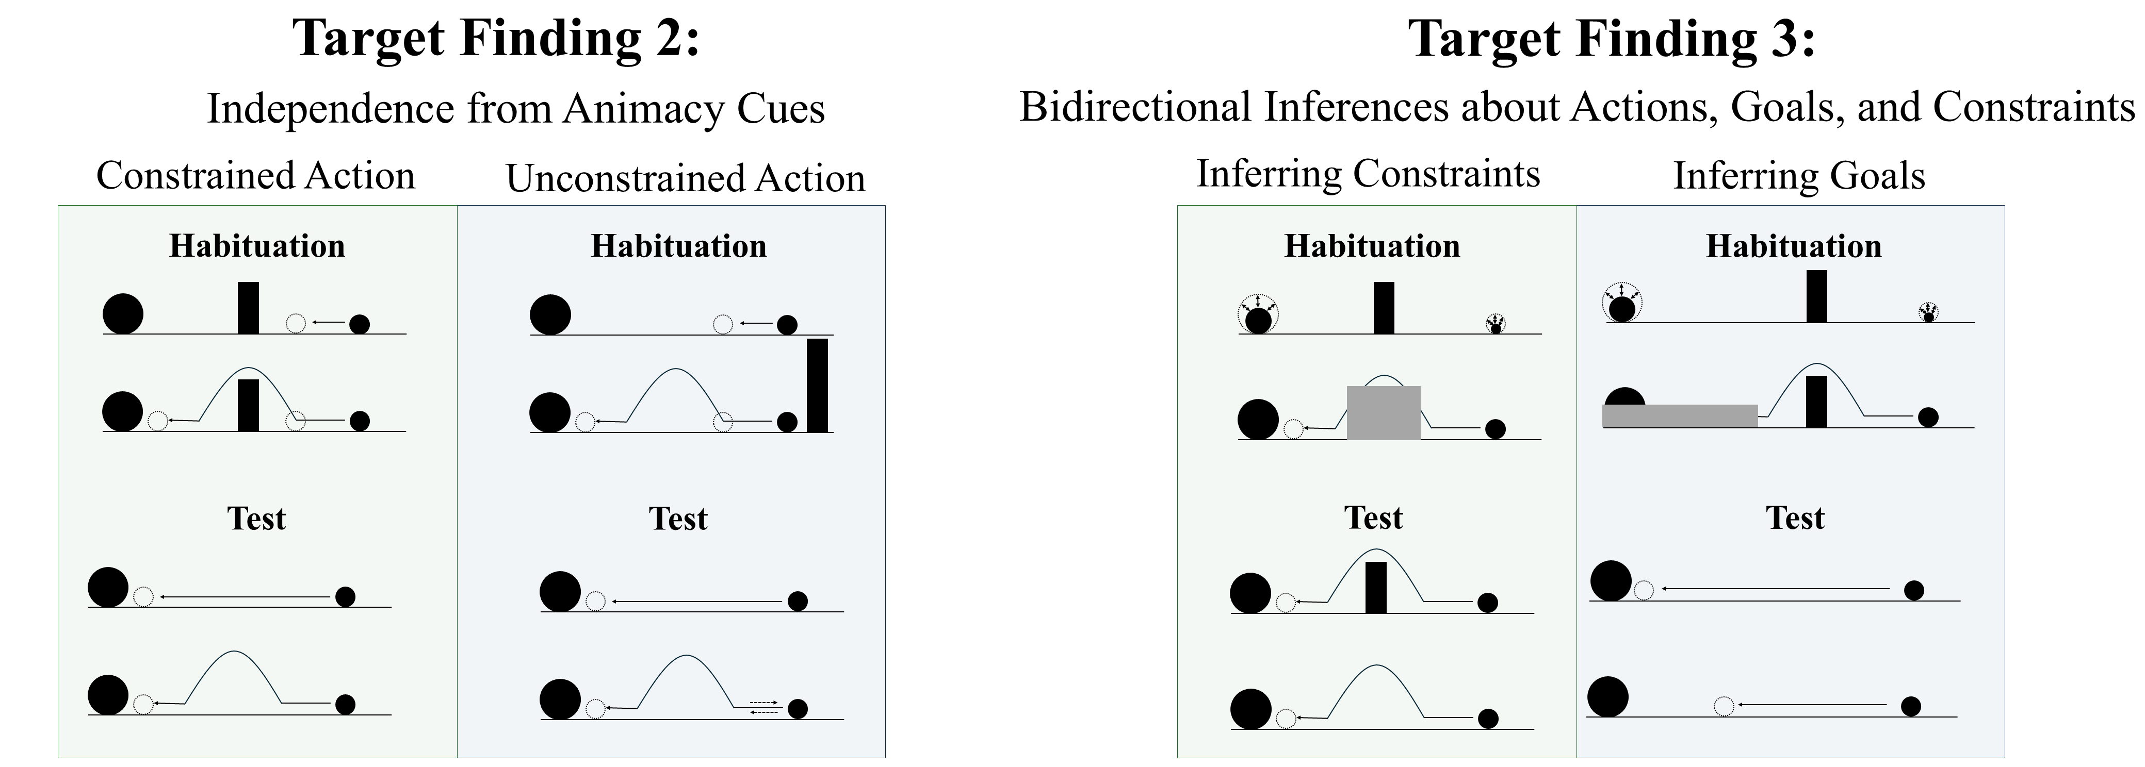
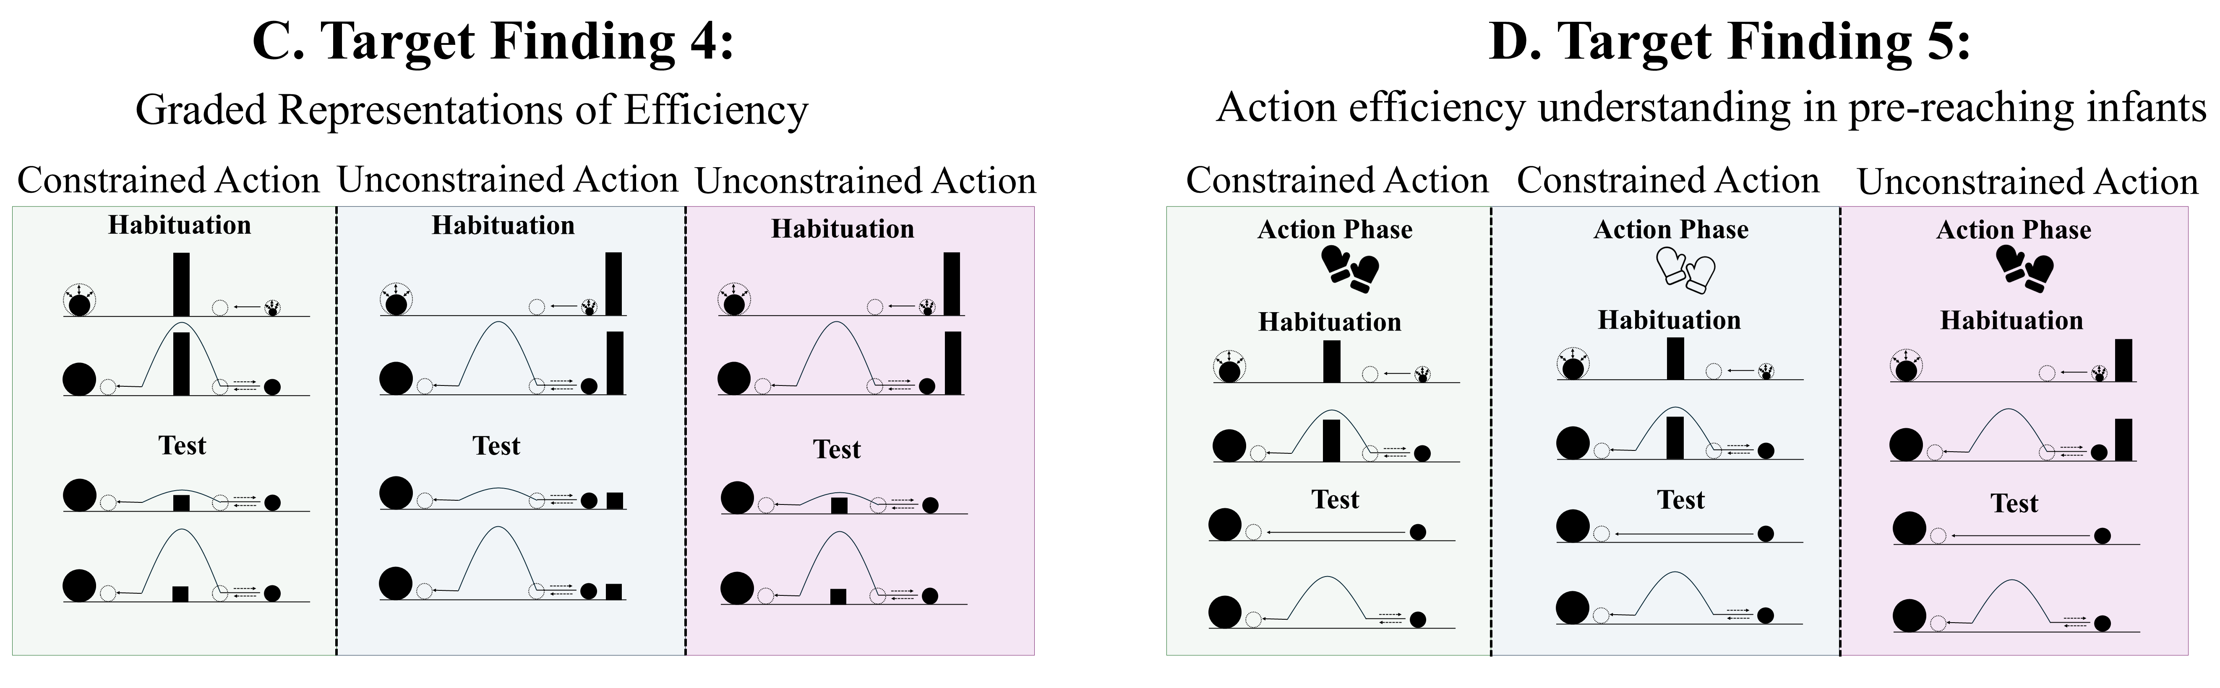
Figure 2. Schematic overview of the paradigms from which Target Findings 2–5 derive. Panels A–D depict, respectively, the experimental paradigms showing (A) the independence of action efficiency understanding from animacy cues, (B) bidirectional inferences about actions, goals, and constraints, (C) graded representations of efficiency, and (D) action efficiency understanding in pre-reaching infants. Note that closed gloves correspond to the sticky-mittens condition, whereas open gloves correspond to the non-sticky-mittens condition. The paradigm underlying Target Finding 1 is shown in Figure 1.

Beyond identifying inefficient actions across different types of entities, previous research suggests that infants can also reason about the relations among actions, goals, and environmental constraints (Figure 2B). For example, Csibra et al. (2003; see also Wagner & Carey, 2005) showed that 12-month-olds can make bidirectional inferences among these factors: they can use information about an agent’s actions and the constraints under which those actions are performed to infer the agent's goal, and they can use information about an agent’s goal and actions to infer the presence of environmental constraints. Infants looked longer at the test events that violated these inferred relations. Finally, infants appear sensitive to graded differences in action efficiency. Liu and Spelke (2017) found that infants looked longer at substantially inefficient than mildly inefficient events, and they generalized these expectations across changes in environmental constraints (Figure 2C).
A final notable finding is that infants with minimal object-manipulation experience show sensitivity to action efficiency when they are given direct action experience (e.g., Skerry et al., 2013; see also Liu et al., 2019). Skerry et al. (2013) showed that providing pre-reaching 3-month-olds with direct-action experience via “sticky mittens” enabled them to distinguish efficient from inefficient actions (Figure 2D); this pattern was absent in infants fitted with non-sticky mittens or given no mittens training whatsoever. Although this research suggests that action efficiency understanding is in place sometime in the second half of the first year of life, an open question that it raises concerns its mechanistic basis.

Rich proposals for the origins of infant action efficiency understanding
Two kinds of proposals have been offered to explain the origins of infant action efficiency understanding. Rich proposals maintain that infants possess early emerging, domain-specific mechanisms that support abstract and conceptually rich knowledge about how the various objects and entities in the world behave and act. For example, the teleological stance (Csibra & Gergely, 1998; Gergely & Csibra, 2003) holds that if an agent pursues some end state efficiently given the physical context—and thus satisfies the “rationality principle”—then the end state will be treated as the agent’s goal, the agent's behavior as a goal-directed “means” to it, and the physical context as a set of “constraints”. The naïve utility calculus casts this in Bayesian terms (Jara-Ettinger et al., 2016, 2020): agents choose minimally costly actions. More recently, Liu et al. (2026) argued that action efficiency understanding emerges from a naïve psychology system (in which agents are represented as goal-directed reward-maximizers) that receives input from a naïve physics system (in which objects are represented as bounded and solid).
These perspectives have real strengths: they address foundational questions at the heart of the developmental cognitive sciences, have generated a substantial body of research, and enjoy some degree of empirical support. Yet, each shares a common limitation: None specify the origins of the relevant primitives. The teleological stance does not explain from where goal, constraint, efficiency, or rationality notions originate. The naïve utility calculus is similarly silent about the basis of such notions as reward, cost, and subjective utility and does not address how the proposed computations are implemented mechanistically. And Liu et al.’s proposal presupposes the very agent and object concept explains (e.g., Benton, 2025).

Lean proposals for the origins of infant action efficiency understanding
Lean proposals instead explain infants’ looking behaviors as the product of domain-general learning over perceptual regularities (e.g., Blumberg & Adolph, 2023; Cohen et al., 2002; Cohen & Oakes, 1993; Colunga & Smith, 2005; Heyes, 2018, 2024; Jones & Smith, 1993; Quinn & Eimas, 1997; Rakison & Lupyan, 2008; Sloutsky, 2010). Although lean proposals abound for a range of cognitive capacities (Benton, 2025; Benton & Hoch, 2026; Benton & Lapan, 2021; Berthiaume et al., 2013; Bogartz et al., 2000; Clearfield & Mix, 1999; Cohen et al., 2002; Cohen & Marks, 2002; McClelland & Thompson, 2007; McMahon & Isik, 2023; Munakata, 1998; Munakata et al., 1997; Perner & Ruffman, 2005; Scarf et al., 2012a, 2012b; Simon, 1997; Rakison & Lupyan, 2008), efforts to explain action efficiency remain scarce.
Van Overwalle (2010; hereafter, VOM10) is an exception to this. He argued that as infants observe agents moving toward their goals, internal representations develop capturing the visible state of the world at points along the trajectory. He showed that a connectionist model implementing this “forward model” reproduced the finding that infants looked longer at inefficient than efficient actions following habituation to constrained motion only.
VOM10 is nevertheless limited in key respects. First, it received no action observation experience prior to the simulated habituation phase and thus could not draw on prior exposure the way findings like that by Csibra et al. (2003) requires. Second, implementing agent and object units meant that the model built in the very concepts lean accounts should explain. Finally, it departed from Gergely et al.’s (1995) study by omitting barrier information from its simulation of the Control condition (Figure 1B) and allowing the curved trajectory to overshoot the barrier.
Given these limitations, I develop and computationally instantiate an alternative lean account that captures the five benchmark findings discussed in the opening. Importantly, this theory, dubbed ALIAS, is not an account of how action efficiency understanding per se develops. It is an account of the mechanistic basis of infants’ looking behaviors in studies on this topic. How genuine action efficiency may develop is described in the General Discussion.

An experienced-based associative learning account of infants’ looking behavior in action efficiency understanding studies

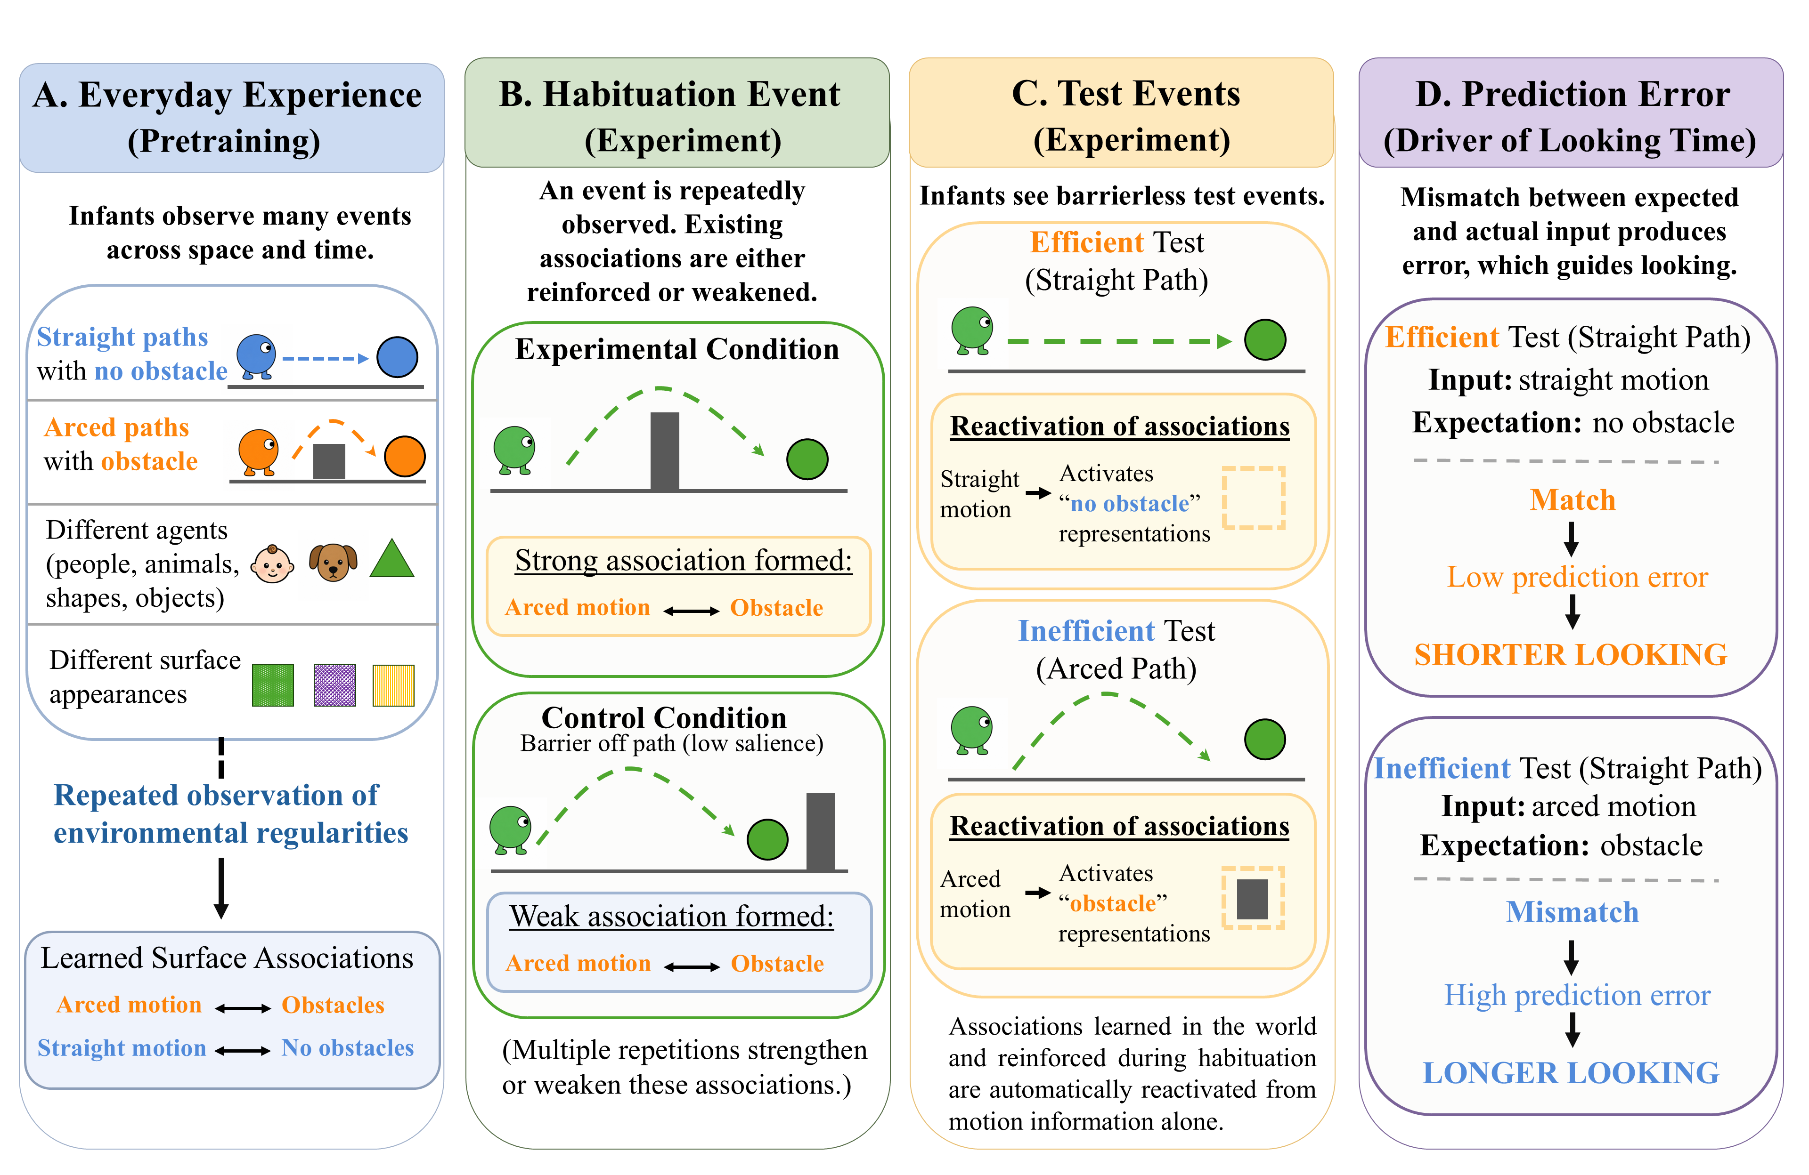
Figure 3. Overview of the account instantiated by ALIAS. (A) In the real world, infants learn associations among action kinematics and visible event features. (B) Habituation either reinforces or weakens these associations, and (C) test events that omit expected features (D) elicit prediction error.

As Figure 3 illustrates, ALIAS’s central thesis is that infants’ looking patterns are governed by learned associations among the kinematics of different actions and the visible surface features of the objects involved and the physical environments in which those actions occur. The critical associations for the present phenomena link obstacles with arced trajectories and absent obstacles with straight motion. Crucially, the resulting representations are entirely perceptually grounded. Nothing in them reflects goals, constraints, efficiency, cost, or rationality.
Habituation events that align with these associations reinforce them; those that do not weaken them. A corollary of this learning process is that test events that present one component of a learned relation should produce greater prediction error than those presenting both components. Greater looking to inefficient actions relative to efficient ones thus arises because inefficient actions violate a learned association between arced trajectories and obstacles.
The effect disappears following unconstrained habituation because the barrier is peripheral to the arced trajectory, making it less salient and less likely to be encoded. If infants nevertheless manage to notice it in this configuration, any new association formed between it and arced motion will tend to weaken the stronger one between arced trajectories and obstacles. In either case, inefficient and efficient actions should be treated equivalently.
This account can also explain why pre-reaching infants show the effect only after direct action experience. Sticky-mittens experience may temporarily heighten infants’ attention to the geometry and trajectory of successful reaches (for evidence consistent with this, see Needham et al., 2002 and Sommerville et al., 2005). Because successful reaches approximate a straight path, sticky-mittens experience should selectively strengthen the association between no obstacles and straight trajectories. The consequence is that efficient actions should produce less prediction error—and thus less looking—than inefficient ones.
ALIAS’s central claim is that the five target findings emerge from these learned associations. The simulations reported next provide direct support for this claim as well as show that ALIAS provides a better account of these findings than modified versions of each. As the primary comparison model, however, the next section begins with a brief discussion of VOM10. Following this is a discussion of ALIAS. Five simulations are then reported, each corresponding to one of the target findings. The paper concludes with two additional simulations. The results of these final simulations serve as predictions for how infants would perform in analogous experiments. In all simulations, only the most critical aspects of the experiments from which the target findings were derived were preserved. Reasonable assumptions were made when methodological details were unavailable. Simulations were run using the Lens neural network simulator (Rohde, 1999). All training, testing, and data files are are available for download at https://osf.io/9eqpf/?view_only=62f752417a9141c7b0509a998039ad13.

General Method
Models
VOM10
This model was a one-layer recurrent connectionist model consisting of 27 fully interconnected units—25 of these units implemented a 5 × 5 spatial grid and the remaining two represented an agent and goal object. Training involved networks observing action trajectories that unfolded across a series of discrete time step and corresponded to habituation. Figure 4 illustrates such an action sequence. VOM10-2 was identical except that the agent no longer overshot the barrier by one cell (seen in middle cell of the middle row in Figure 4). Additionally, the barrier and goal remained continuously visible throughout the agent’s arced trajectory.

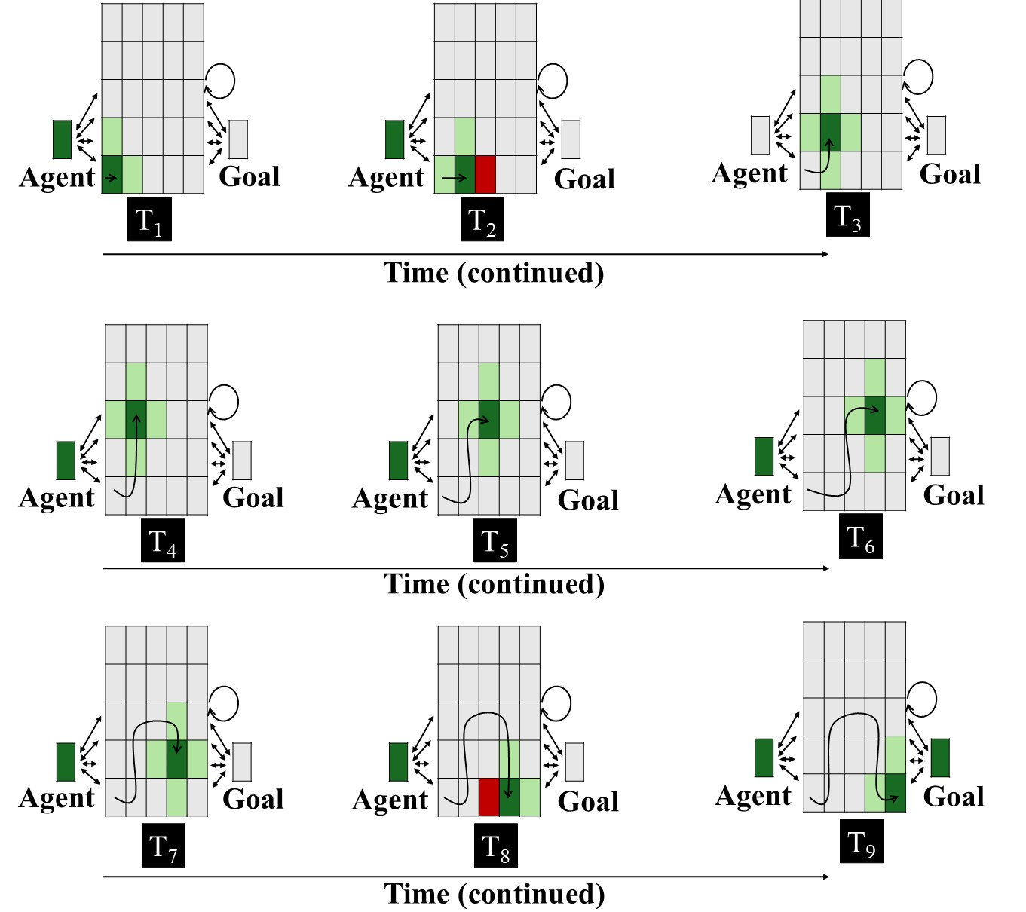
Figure 4. Input patterns shown to VOM10 networks in the Experimental condition across nine steps. Each panel represents the input to the network at a given time step. The central 5 × 5 array corresponds to the spatial grid; the two units flanking the spatial grid to the right and left of it correspond, respectively, to the agent and goal objects. Dark green indicates the agent’s current position (+1), light green indicates adjacent cells (+0.5), red indicates the presence of the barrier (-1), and gray indicates no activation (0). The goal unit is activated only at the final step. The barrier is present only when the agent occupies a position immediately adjacent to it (see Van Overwalle, 2010). The overlaid curved path in each panel depicts the amount of arc motion the agent has completed through that time step. Two-headed arrows and the circular arrow denote bidirectional connectivity. As in Overwalle (2010), the critical units for arced arced were the three units comprising its apex; the bottommost middle cell was the critical unit for the straight path. See the online article for a color version of this figure.

ALIAS
Method
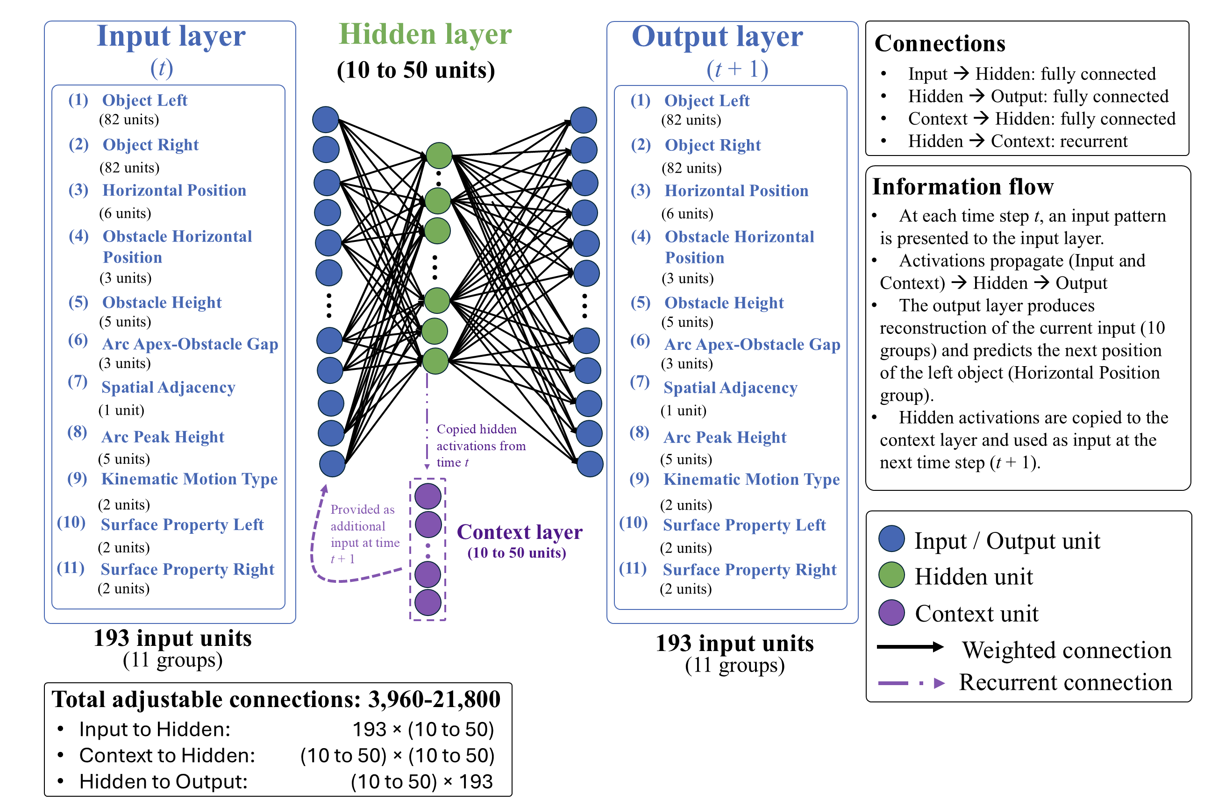
Figure 5. Architecture of the ALIAS model. The model consisted of input, hidden, context, and output layers. Input and output layers consisted of 193 units spread across 11 groups. The number of hidden units ranged from 10-50 across simulations. The model combined an autoencoder (Groups 1-2 and 4-11) and a simple recurrent network (Group 3). The autoencoder copied the input activity to the output layer; the SRN predicted left object’s next position given its current one.

Network Architecture. Figure 5 shows the model architecture. The model consisted of three layers of units. The input and output layers contained 193 input and output units. These units were divided into 11 groups corresponding to different visible surface features. Between the input and output layers were 10 to 50 hidden and context units depending on the simulation. The input and context units were fully connected to the hidden units. These units, in turn, were fully connected to the output units. Weights were initialized to small random values and were sampled uniformly between ±0.1. Bias connections were not included in any of the reported simulations. In total, the network contained 21,800 adjustable connections.
The activation values of input units were set externally to reflect the input appropriate to the current time step. The activation values for units elsewhere in the model depended on their net input from other units. Net input to hidden units was calculated as follows:

${net}_{j}=\sum_{i}{a_{i}w_{ij}}$, | (1)

where $a_{i}$ is the activation of unit i and $w_{ij}$is the weight on the connection from input unit i to hidden unit j. To prevent vanishing error derivatives, hidden unit activations were based on the rectified linear unit activation function (Nair & Hinton, 2010) and were calculated as follows:

$a_{j}=max⁡(0, {net}_{j})$, | (2)

where $a_{j}$ is the activation of hidden unit j, ${net}_{j}$ is its net input, and $max$ denotes the maximum of its two arguments. Net input to output units was calculated as follows:

${net}_{k}=\sum_{j}{a_{j}w_{jk}}$, | (3)

where $a_{j}$ is the activation of hidden unit j and $w_{jk}$is the weight on the connection from hidden unit j to output unit k. Output unit activations were a smooth, logistic function of this net input and was calculated as follows:

$a_{k}=\frac{1}{1+exp⁡(-{net}_{k})}$, | (4)

where $a_{k}$ is activation of output unit k, ${net}_{k}$ is its net input, $w_{jk}$ is the weight on the connection from hidden unit j to output unit k, and $exp⁡(∙)$ is the exponential function. Finally, as is true in simple recurrent networks (SRNs; Elman, 1990), the activation of the hidden units at time $t$ was copied to the context units and made available as input at time$t+1$. This provided the model with a rudimentary form of memory such that information from earlier time steps influences processing at later ones.
Representations and Task. At each time step, a linear or arced motion event was presented to the network as a pattern of activation distributed across the 11 input and output groups (Figure 5). Each group corresponded to a different visible surface feature, and the units within each group, to different manifestations of that feature. A localist encoding scheme was used for two reasons. First, it ensured that the model’s responses reflected learned regularities among actions and the visible surface features of the objects and entities involved. Second, it facilitated interpretation of the mechanism producing those responses. Table 1 lists each group and the features represented by each unit within it. The naming convention used for each group was intended to emphasize their semantically neutral, surface-based nature and to reflect the present account’s assumption that infants represent action events in terms of their low-level perceptual features rather than concepts such as goals, constraints, efficiency, or rationality.

Table 1
ALIAS’s input and output groups
Group | Num | Represents | Unit Meaning
Object Left | 82 | Identity of left object | Each unit corresponds to a unique object identity
Object Right | 82 | Identity of right object | Each unit corresponds to a unique object identity
Horizontal Position | 6 | Left object’s position relative to the right one | Position 1–6 in network space
Obstacle Horizontal Position | 3 | Horizontal location of obstacle | Missing, Middle, Periphery
Obstacle Height | 5 | Height of obstacle | No Obstacle, Heights 1–4
Arc Apex–Obstacle Gap | 3 | Vertical distance between an obstacle and the apex of the arced motion trajectory | No Separation, Small Vertical Separation, Large Vertical Separation
Spatial Adjacency | 1 | Whether the two objects are adjacent | Spatially Contiguous, Spatially Separated
Arc Peak Height | 5 | Maximum height of arced trajectory | No arc, Heights 1–4
Kinematic Motion Type | 2 | Type of motion | Linear, Arced
Surface Property Left | 2 | Surface features of left object | Animate-like, Inanimate-like
Surface Property Right | 2 | Surface features of right object | Animate-like, Inanimate-like
Note. Group names correspond to those shown in Figure 5. Each group represented a different visible surface feature; units within a group represented different manifestations of that feature. A localist encoding scheme was adopted for each group.

Input units corresponding to the features present during a given time step of an action event had their activation set to 1.0; all other input units had their activation set to 0.0. A small amount of Gaussian noise (M = 0, SD = 0.3) was then applied to these activations to instantiate the notion that infants’ learning and processing are noisy functions of experience. The network’s task at each time step was twofold. First, it was required to reproduce at the output layer the activation pattern presented across 10 of the 11 groups. Second, it was required to predict the subsequent position of the left object via the Horizontal Position group. The reason Horizontal Position was the only group whose future state the network was required to predict is that movement itself is dynamic and necessarily unfolds over time. Thus, if the first unit in the Horizontal Position group was active (i.e., had an activation value of 1.0) at time $t$, the network’s task was to activate the second unit in the corresponding output group at time $t+1$. This captured the idea that the left object moved from one location in network space to the next. Movement trajectory (e.g., linear or arced) was represented separately. The first task was accomplished via an autoencoder (e.g., Mareschal et al., 2000); the second, via an SRN. Autoencoders learn compact internal representations that are sufficient to reproduce the current input pattern at the output layer. In contrast, SRNs learn to predict upcoming states from prior states by extracting sequential regularities in the input. More generally, both model types were used because they employ self-supervised learning, which aligns with prominent theories of how infants learn and do not require an explicit teaching signal (e.g., Cohen, 1973; Sokolov, 1963).
Training procedure. Learning in the model unfolded across two phases: Pretraining and Habituation. The duration of the pretraining phase and the specific nature of the habituation experience are described in the relevant simulation sections. During pretraining, networks experienced two broad classes of events: Linear Path Events and Arced Path Events. These events—whose encodings are illustrated in Table 2—implemented the assumption that infants’ looking behaviors in action efficiency studies are shaped by prior experience processing these actions. In Linear Path Events, one object moved unobstructed along a straight, horizontal trajectory toward another object. In Arced Path Events, one object moved along an arced trajectory toward the other object. Half of the objects in both event types possessed surface features commonly associated with animate entities; the remaining half possessed surface features commonly associated with inanimate objects. This implemented the assumption that entities possessing either class of surface features can engage in both actions.

Table 2
Example encodings of linear and arced motion events
Group | Linear Path Event | Arced Path Event
Object Left | Unit 1 | Unit 1
Object Right | Unit 2 | Unit 2
Horizontal Position | Position 1 | Position 1
Obstacle Horizontal Position | Missing | Middle
Obstacle Height | No Obstacle | Height 2
Arc Apex–Obstacle Gap | No Separation | Small Vertical Separation
Spatial Adjacency | Spatially Contiguous | Spatially Contiguous
Arc Peak Height | No Arc | Height 2
Kinematic Motion Type | Linear | Arced
Surface Property Left | Animate-like | Animate-like
Surface Property Right | Animate-like | Animate-like
Note. Values are illustrative of each event type at a single time step. Cell entries identify the units whose states were clamped during that time step. Bolded text reflects features on which the two event types differed.
At each time step, an action event was presented to the network by clamping the states of the units corresponding to that event’s surface features. Activity then propagated from the input layer to the hidden layer and then from the hidden layer to the output layer. The resulting pattern of activity over the output units represented the network’s attempt at reproducing the input activity and predicting the subsequent position of the left object. A version of recurrent backpropagation through time, adapted to the simple recurrent network architecture (Williams & Zipser, 1995), was used to modify the connection weights. These adjustments were designed to reduce the discrepancy between the network's target and output patterns after each full pass through the training patterns. The error measure was cross-entropy error:

$$C=-\sum_{p}{\sum_{t}{\sum_{k}{t_{k,t}^{p}}\log_{2}(a_{k,t}^{p}})+(1-t_{k,t}^{p})\log_{2}(1-a_{k,t}^{p})}$$ | (5)

where $t_{k,t}^{p}$ is the target activation of output unit k in training pattern p at time t, $a_{k,t}^{p}$ is the observed activation of that unit, and the summation is computed across all output units, time steps, and training patterns. Weight changes were then calculated as follows:

$∆w_{ij}=-$η$(\frac{∂C}{∂w_{ij}})$ | (6)

where η is the learning rate and $\frac{∂C}{∂w_{ij}}$ is the function’s derivative with respect to weight $w_{ij}$.
Testing procedure. No further learning occurred at test and network weights were frozen. The specific testing procedure depended on the simulation but generally involved presenting two action events: one consistent with prior experience and one inconsistent with that experience. Test events were presented to the network in the same manner as training events.
Salience manipulation. To implement the assumption that peripherally located obstacles have reduced salience, the learning rate was reduced and weight decay was increased on the incoming and outgoing weights associated with the Obstacle Height and Obstacle Position groups. The specific value used for the learning rate—which, importantly, was distinct from that used to simulate developmental age (see below)—was 1×10⁻⁴; the value used for the weight decay was 0.1. As mentioned above, this manipulation did not apply to ALIAS-2. These values were kept constant across all simulations. This way of implementing salience aligns with past connectionist modeling work (e.g., Benton, 2025). Additional simulations—reported in the Supplementary Materials—indicated that the present results were robust to specific values of the age- and salience-based learning rates as well as the salience-based weight decay.
A second instantiated assumption was that arced trajectories clear obstacles by relatively small margins. This assumption was implemented by clamping the state of the Small Vertical Separation unit for constrained action events during pretraining.

Common Simulation Procedures
Participants. In all simulations, “participants” corresponded to independent model runs, each with different initial random weights. Each condition consisted of 20 participants.
Developmental age. Networks corresponding to “older” infants received proportionally more pretraining than those corresponding to “younger” infants. Thus, the pretraining phase was 900 epochs for simulations whose target findings derived from studies testing 12-month-olds; for simulations whose findings derived from studies testing 9-, 6-, and 3-month-olds, respectively, it was 675, 450, and 225. Additionally, older networks possessed larger learning rates and more hidden units, respectively, than younger ones. These were 0.1 and 50 for the 12-month-old networks, 0.0875 and 40 for the 9-month-olds, 0.0875 and 30 for the 6-month-olds, and 0.01 and 10 for the 3-month-olds. Larger learning rates capture more substantial weight adjustments and, thus, more rapid learning; more hidden units support enhanced information storage.
Simulation structure. All simulations followed the same general structure: (1) pretraining, (2) habituation, and (3) test. Unless otherwise noted, test trials contrasted barrierless straight- and curved- path events. Throughout the simulations, the former were referred to as Efficient test events; the latter, as Inefficient events.
Dependent measures. For ALIAS and ALIAS-2, the dependent measure was network cross-entropy error. Greater error corresponded to longer looking, an interpretation consistent with that made in prior developmental connectionist models (e.g., Benton, 2025; Mareschal et al., 2000; Quinn & Johnson, 2000; Rakison & Lupyan, 2008).
For VOM10 and VOM10-2, the dependent measure was activation of the critical units; lower activation corresponded to longer looking, as in Overwalle (2010).
Habituation length and stimuli. For ALIAS and ALIAS-2, habituation lasted between 8 and 12 epochs, in increments of one. Different numbers were used to ensure that the present results were robust to variation in this parameter. Results are shown both collapsed across habituation length and separately for each habituation duration. Novel objects were always used and differently sized barriers always shown during habituation and test.
Evaluation of Model Performance. Inferential statistics were not used because the goal of the present simulations was not quantitatively to fit infant looking responses or reproduce the precise magnitude of empirical effects. The goal was instead to determine whether the qualitative pattern of model responses aligned with the patterns observed in infants. This emphasis on assessing whether the model’s behavior qualitatively matches that of infants is consistent with prior connectionist modeling work in the cognitive sciences (e.g., Benton, 2024; Mareschal et al., 2000; Mareschal & Schultz, 1999; McClelland & Thompson, 2007; Plaut & Vande Velde, 2017).

Simulation 1a: Selective longer looking to inefficient actions.
Simulation 1a modeled the first target finding: Infants look longer at a barrierless curved test event than at a barrierless straight-path event following habituation to a constrained event. Networks were 12 months old and were assigned either to the Experimental or Control condition. An arced trajectory was shown during habituation in both conditions. Finally, the objects shown during habituation possessed animate-typical features.

Results and Discussion
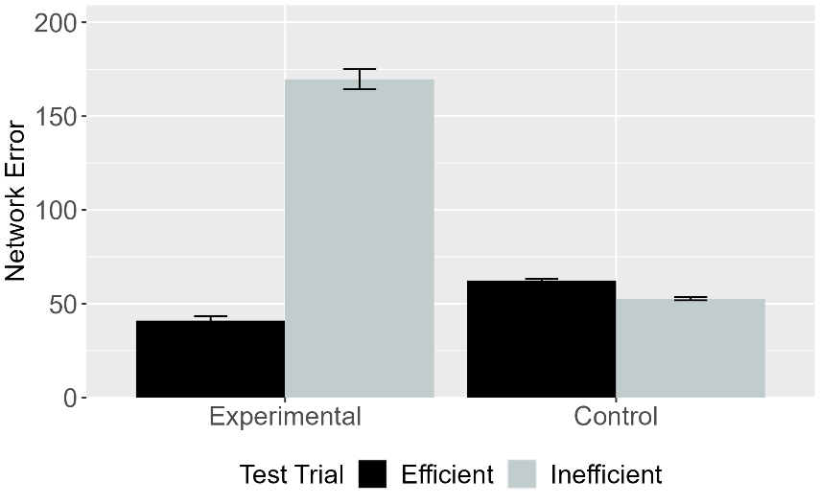 | 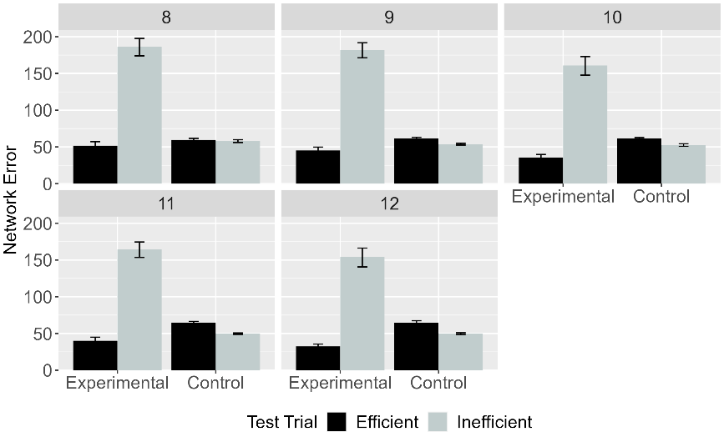
Figure 6. Mean network error produced to the Efficient and Inefficient test events in the Experimental and Control conditions. (Left) Network error collapsed across habituation lengths. (Right) Error as a function of habituation length. Data shown were generated by ALIAS.

Figure 6 shows error data for ALIAS overall (left) and for different amounts of habituation (right). ALIAS successfully reproduced the first target finding: Networks in the Experimental condition produced greater error to the Inefficient test event than at the Efficient one. Networks in the Control condition looked equally long at both test events.

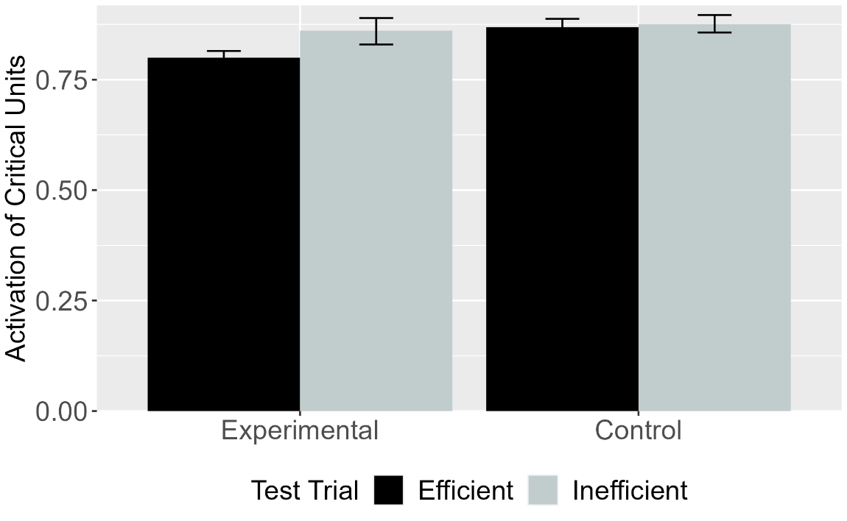
Figure 7. Mean activation of the critical units for Efficient and Inefficient test events in the Experimental and Control conditions for VOM10. Error bars represent standard errors.

Figure 7 shows that VOM10 also reproduced the first target finding. At the same time, comparing these responses to ALIAS’s reveals that the error difference in the Experimental condition was substantially attenuated for VOM10 compared to ALIAS.

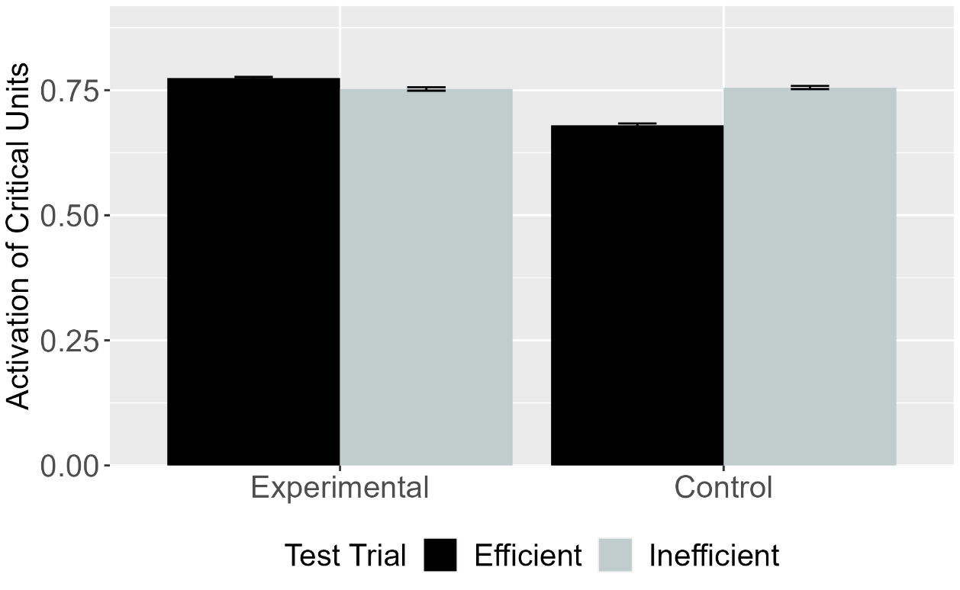
Figure 8. Mean activation of the critical units for Efficient and Inefficient test events in the Experimental and Control conditions for VOM10-2. Error bars represent standard errors.

To determine whether VOM10’s success depended on specific implementational details, its performance was compared to VOM10-2. Figure 8 shows that VOM10-2 failed to capture the first target finding: VOM10-2’s activation is the exact opposite of VOM10’s pattern.

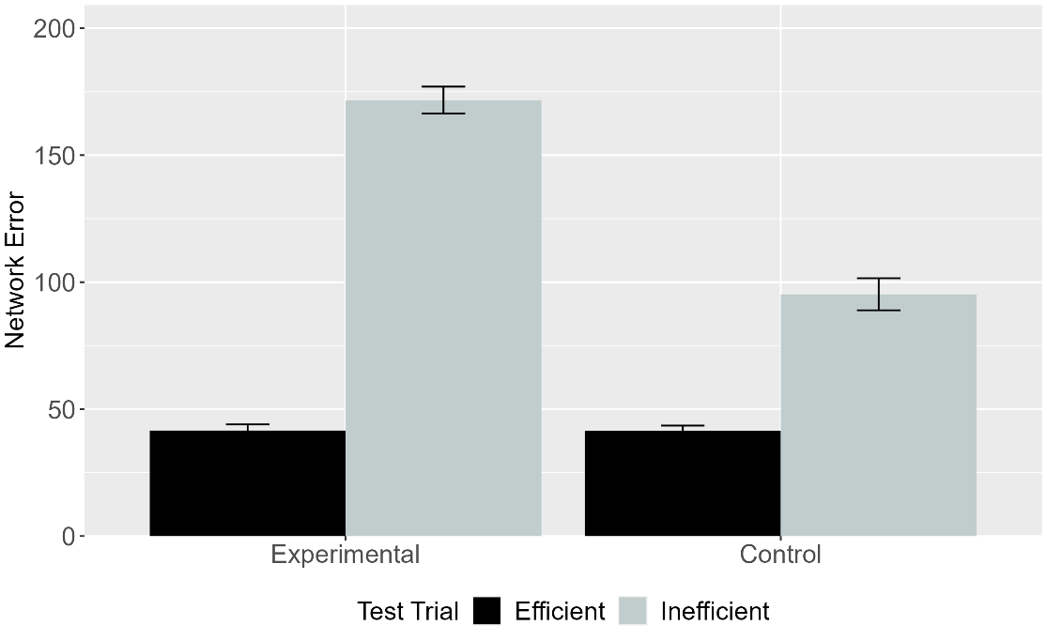
Figure 9. Mean network error produced to the Efficient and Inefficient test events in the Experimental and Control conditions. Data shown were generated by ALIAS-2. Error bars represent standard errors.

The final analysis focused on ALIAS-2’s responses. These are shown in Figure 9. This version of ALIAS omits differential obstacle salience. Although both models showed similar error patterns in the Experimental condition, only ALIAS-2 produced more error to the Inefficient test event.
The results presented thus far suggest that associative learning, at least in part, underpinned ALIAS’s success in reproducing the first target finding. To confirm that this was in fact that case, it was necessary to explicate the precise mechanism through which it successfully reproduced the first target finding by tracing the model’s internal dynamics at various points during processing. Such processing began during the pretraining phase. Note that the following discussion, although based on a single model run, is illustrative of the mechanism that emerged across model runs more generally and it not idiosyncratic to this particular network.
The pattern of activation produced by the straight and arced events across the input groups propagated to the hidden layer via the weights that connect each of the input groups to the hidden layer. At the beginning of training, this pattern of activity does not capture or reflect anything meaningful about the input to the model because the model’s weights themselves are small, meaningless, random values. This activity nonetheless then propagates to and elicits a pattern of activity across the groups comprising the output layer. Any discrepancy between the observed and target patterns is treated as error that model seeks to reduce.
The key insight is that, from the outset of training, the pattern of error that both motion types produce distinct patterns of error across the output groups A corollary of this is that the network weights move in different directions for both events such that, over time, meaningfully distinct hidden representations for each action emerge. These representations will also come to capture learned associations among specific surface features.
To illustrate how these learned features impact networks’ behavior at test, consider the habituation events networks in the Experimental condition. Two of the presented features were novel (i.e., Obstacle Height 4 and Arc Peak Height 4); the remaining four were familiar (i.e., Horizontal Spatial Position Middle, Arc Apex-Obstacle Gap minimal separation, Spatially Contiguous, and Arc Path). At the beginning of the habituation phase, the familiar features activate—via the hidden layer—the features with which they co-occurred during pretraining. By contrast, new associations must be formed among the novel features. Thus, networks must associate a higher jump with a taller barrier. Although the habituation phase is shorter in length than the pretraining phase, the network had little difficulty learning these associations due to its enhanced processing capacity.

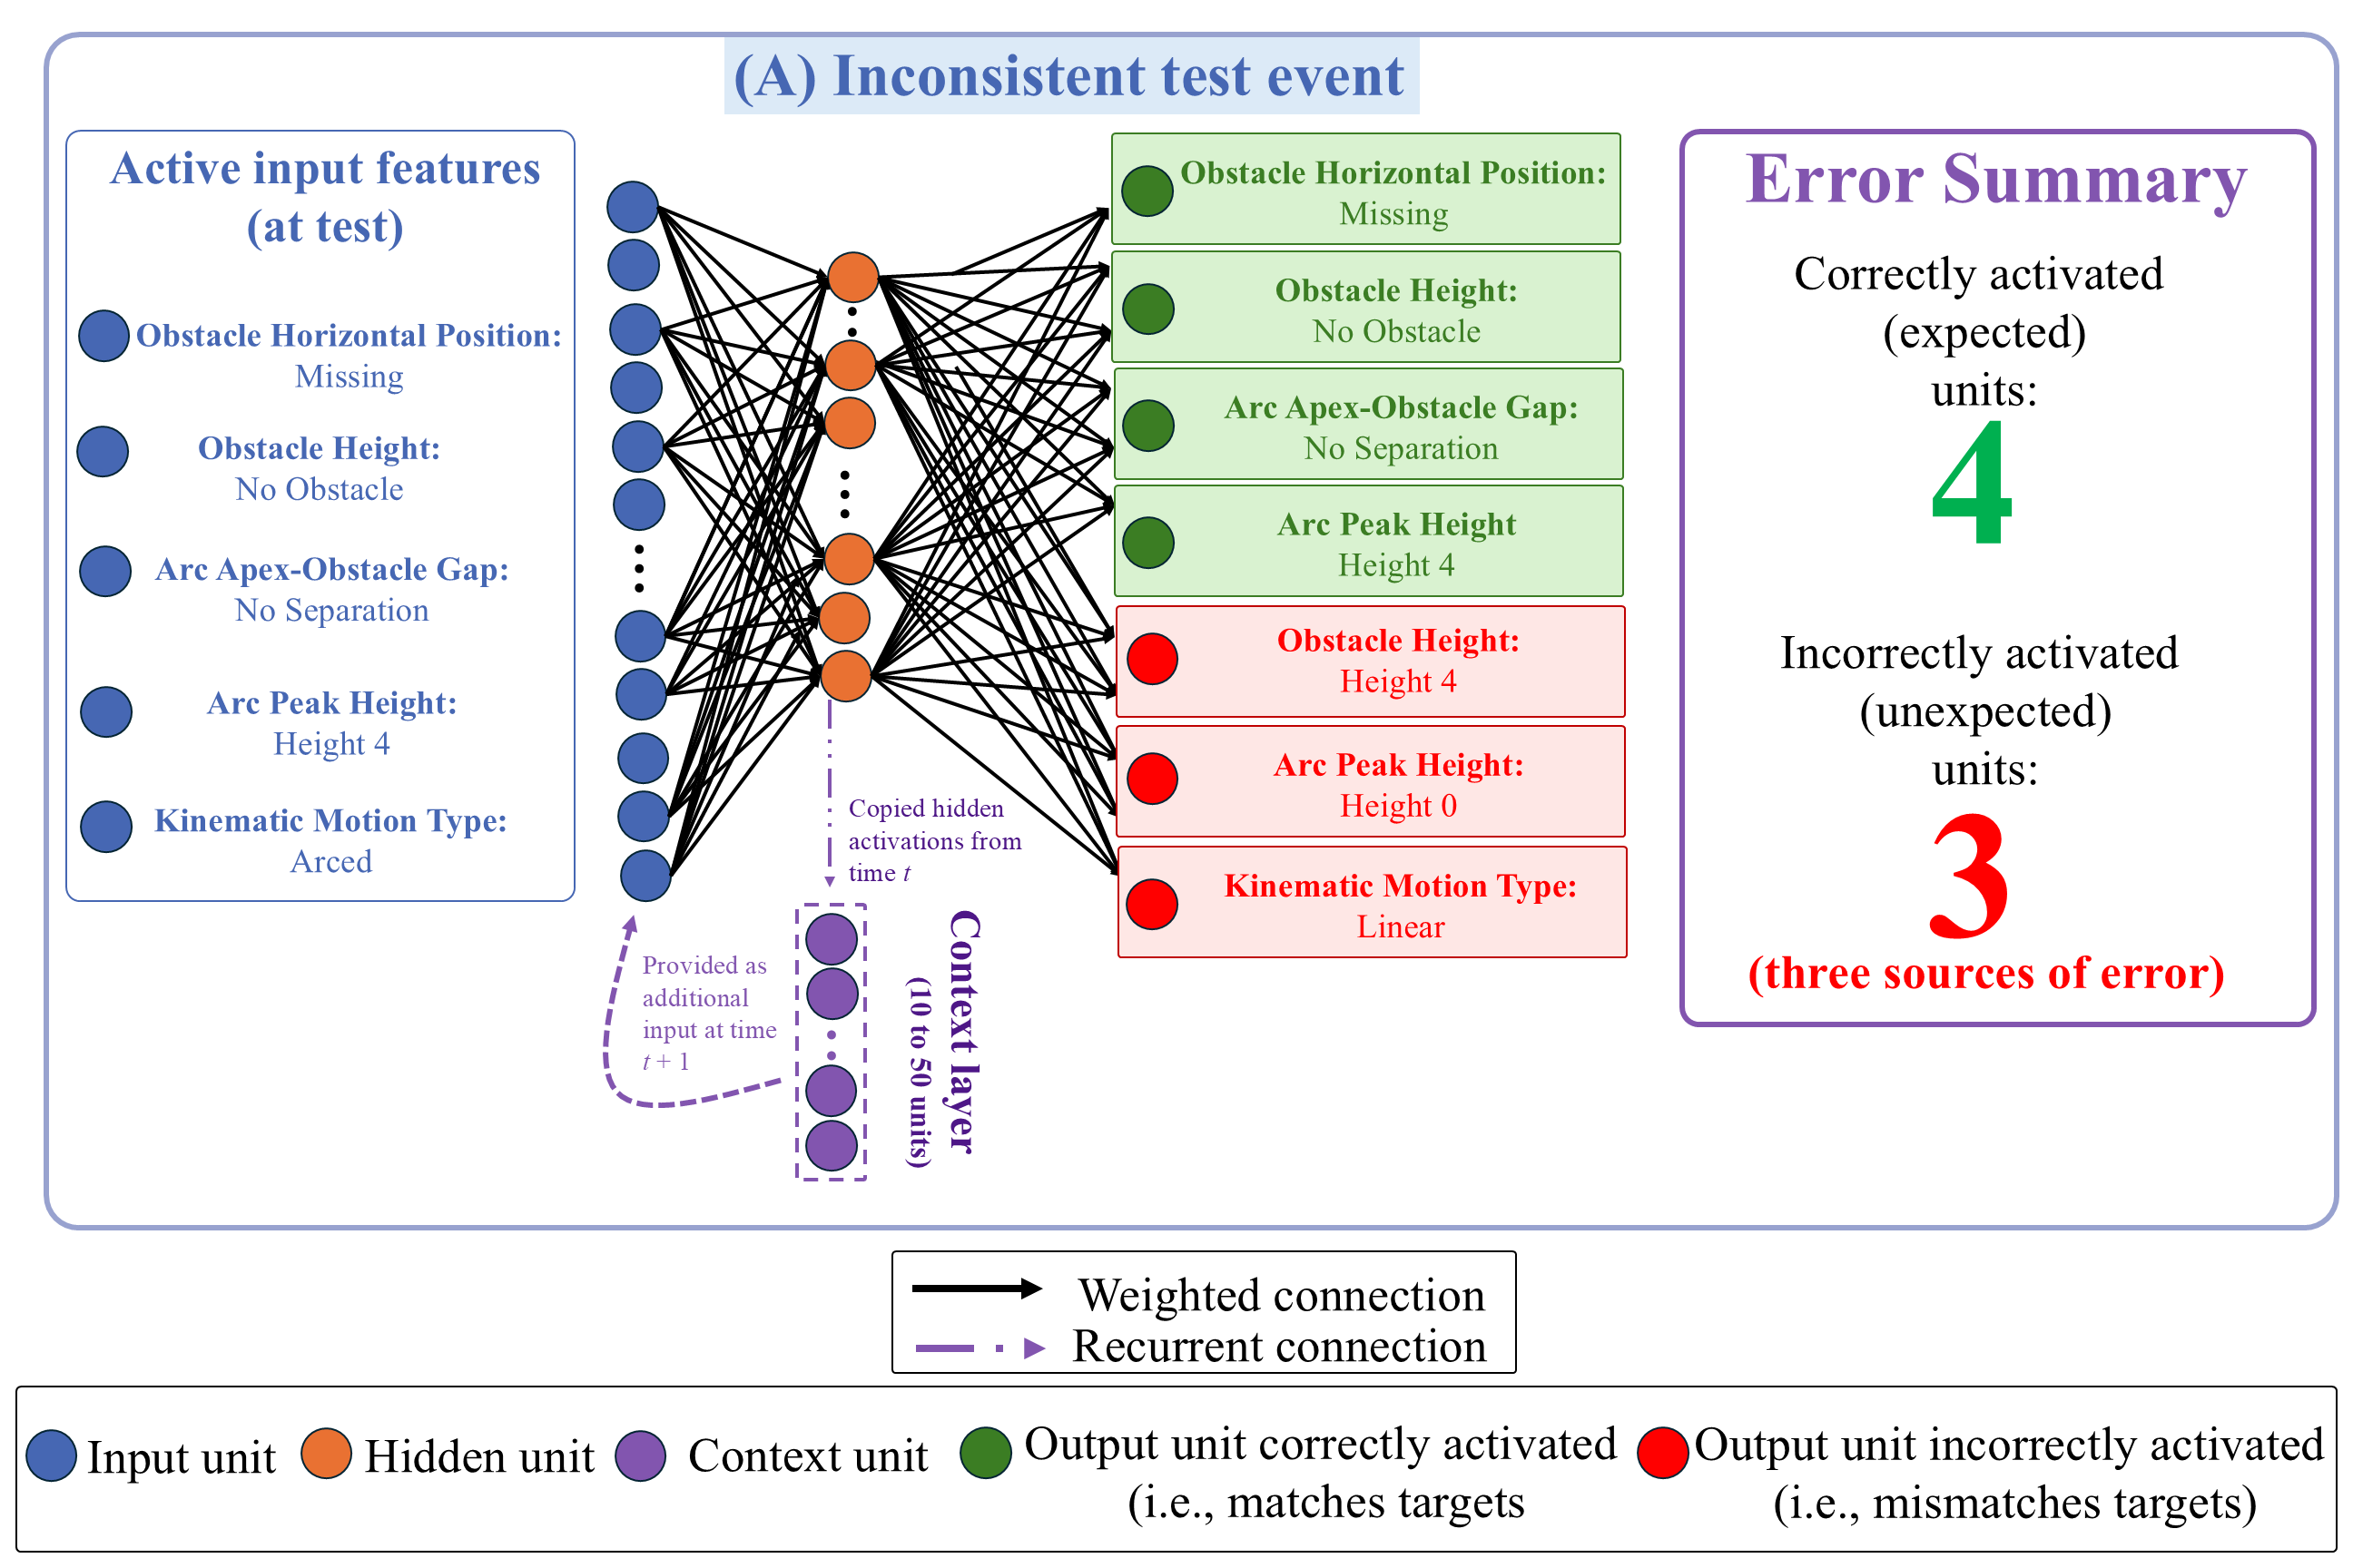
Figure 10. Mechanism underpinning ALIAS’s responses during the Inconsistent test event in the Experimental condition. Active input features presented at test reactivated learned associations acquired during pretraining and habituation. Although the network correctly activated four of those features, it also incorrectly activated the Obstacle Height 4, Arc Peak Height 0, and Linear Motion units. These three erroneously activated units constituted the primary sources of error and looking during this event. Shown here: Units necessary to explain the basis of ALIAS’s responses during the Inconsistent test event.

These facts help to explain the network’s responses to the barrierless test events. As shown in Figure 10, during the Inconsistent test event ALIAS correctly activated the Missing unit in the Obstacle Horizontal Position output group, the No Obstacle unit in the Obstacle Height output group, the No Separation Unit in the Arc Apex-Obstacle Gap group, and the Arc Peak Height 4 unit in the Arc Peak Height output group. The first three were activated due to associations formed during pretraining; the last was activated due to associations formed with itself during habituation. At the same time, the network incorrectly activated the Obstacle Height 4, Arc Height 0, and Linear Path output units. This response is also expected: The Arc Peak Height 0 and Linear Path units were associated with each unit’s input counterpart during pretraining, and the Obstacle Height 4 unit was associated with Arc Peak Height 4 and Obstacle Height 4 input units, among others, during habituation. Thus, three output units (i.e., Obstacle Height 4, Arc Peak Height 0, and Linear Path) contributed to the network’s error during the Inconsistent test event. This pattern of activation is precisely what the present theory predicts. Specifically, if infants, like the network, learn that a particular obstacle height is associated with a specific type of motion, then presenting one of these features at test (e.g., Arc Path and Arc Peak Height 4) should reactivate the other (e.g., Obstacle Height 4). If that associated feature is absent, as is the case with the Obstacle Height 4 unit in the Inconsistent test event, then the network should detect a discrepancy and show increased error.

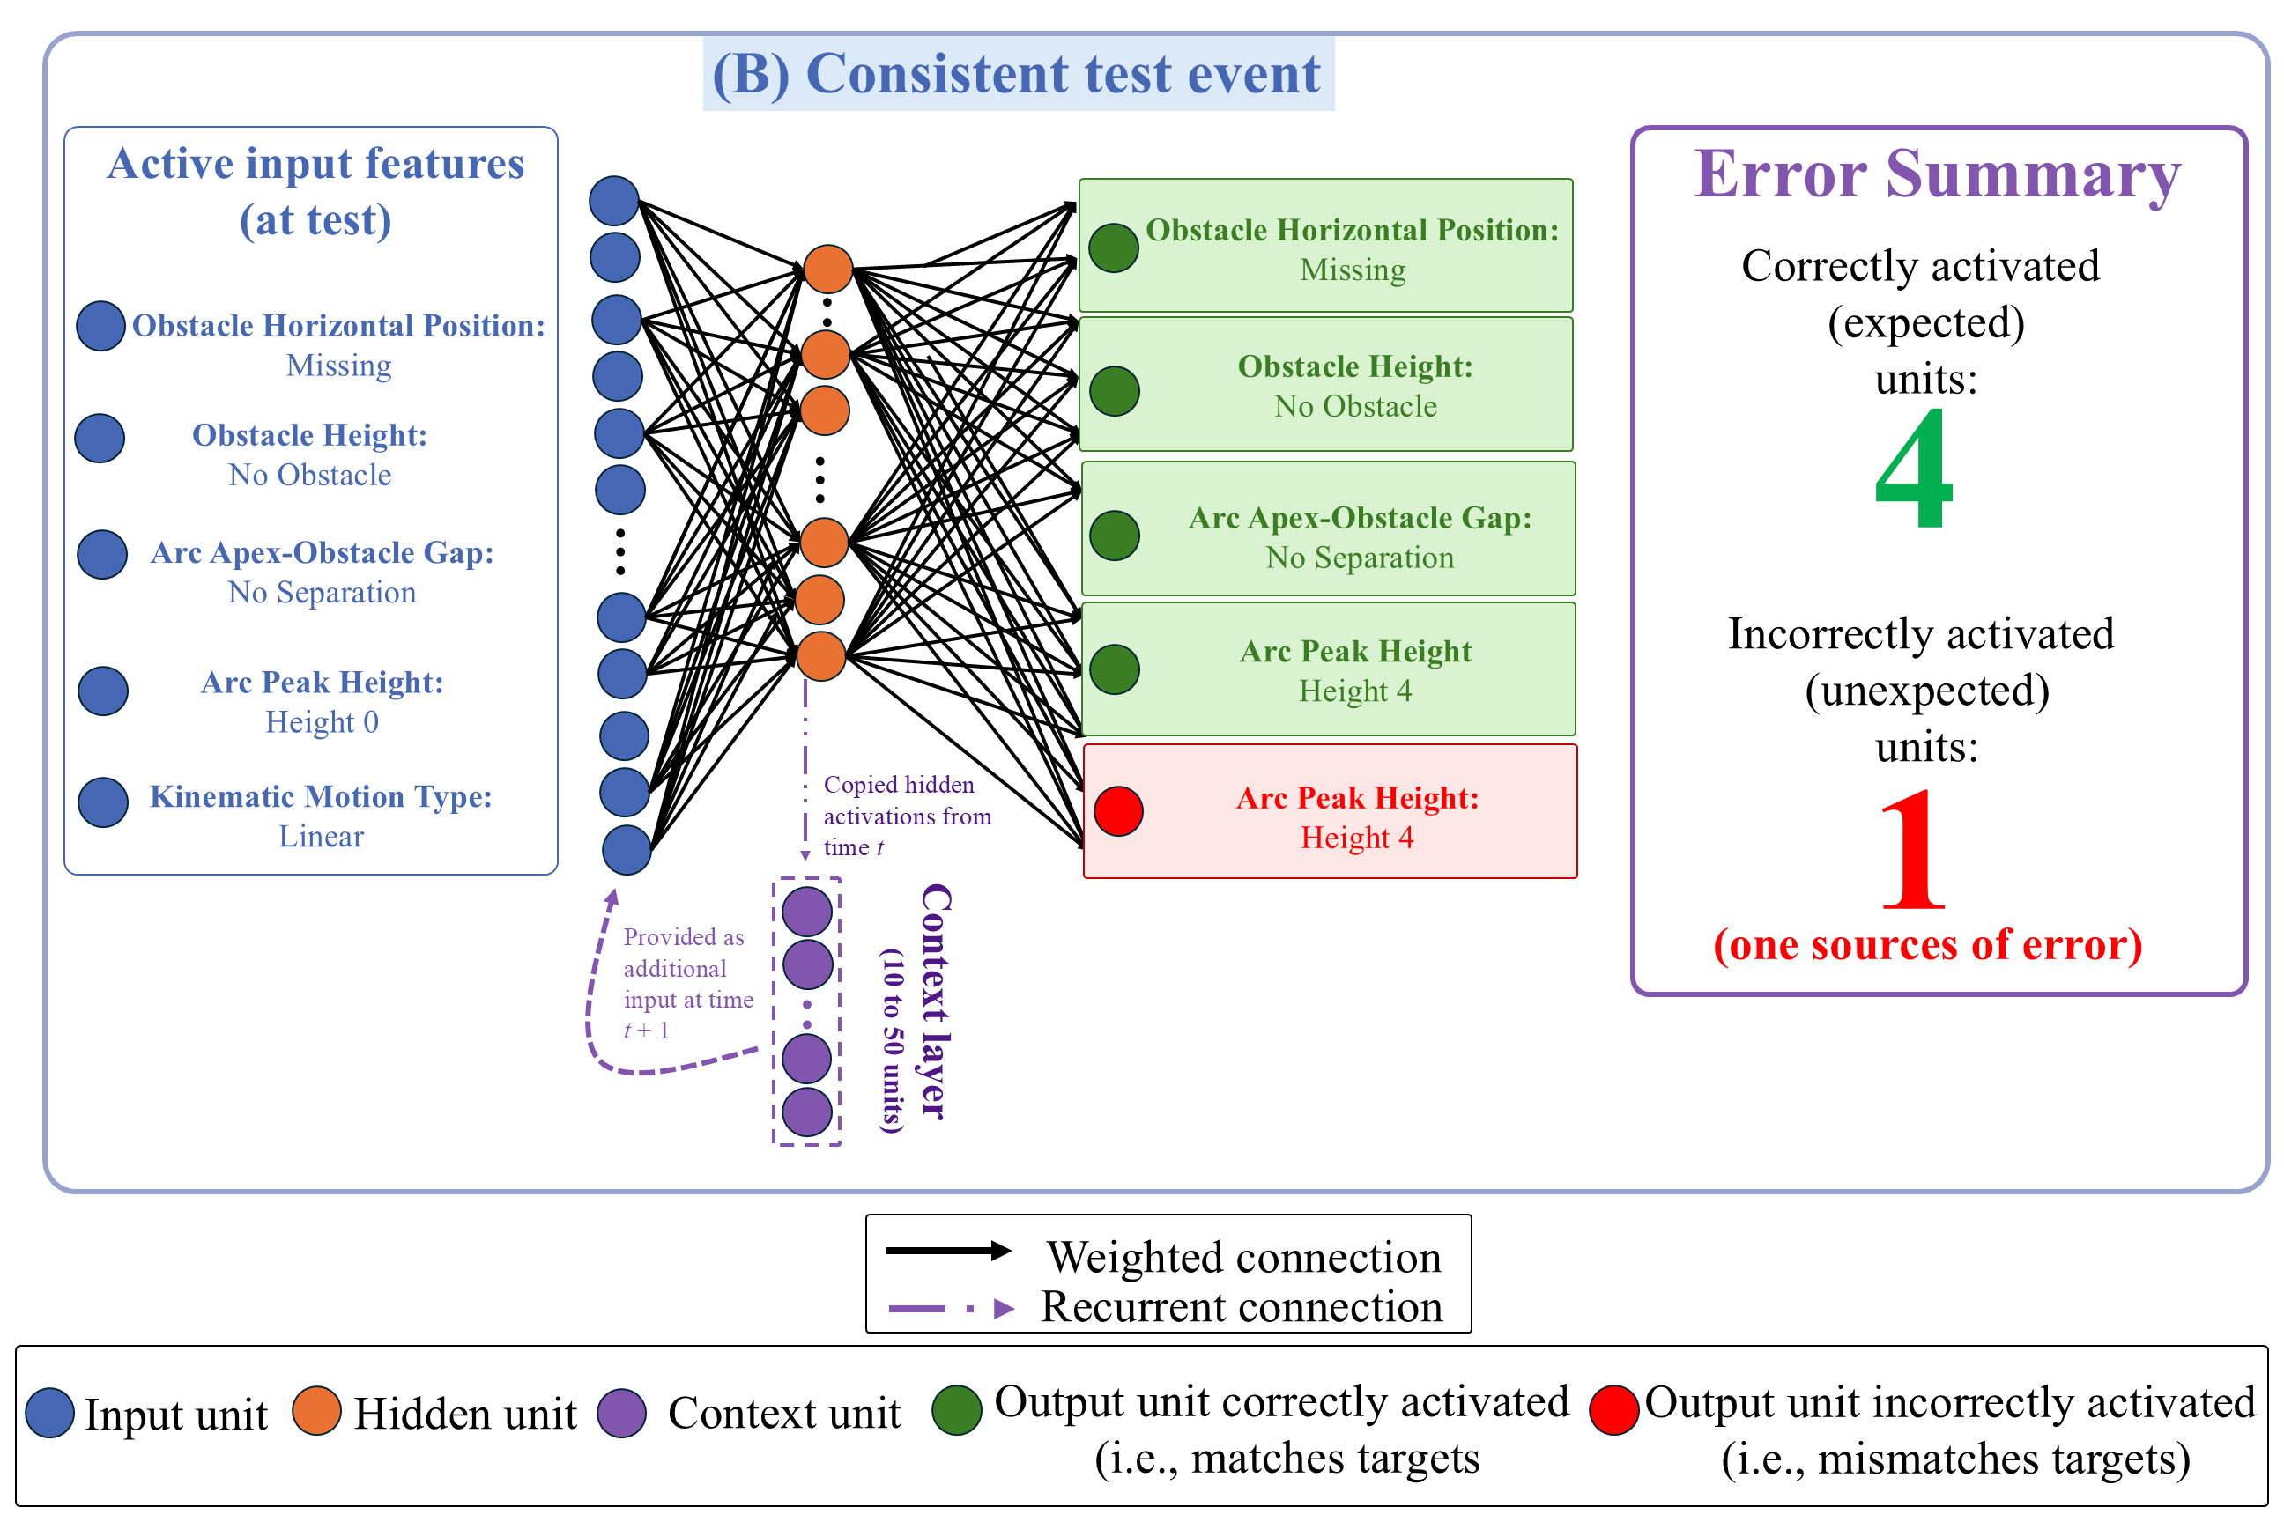
Figure 11. Mechanism underpinning ALIAS’s responses during the Consistent test event in the Experimental condition. Active input features reactivated many of the same learned associations observed in the Inconsistent event. However, here only the Arc Peak Height 4 output unit was incorrectly activated. This one erroneously activated unit constituted the primary source of error and looking during this event. Shown here: Units necessary to explain the basis of ALIAS’s responses during the Inconsistent test event.

Now consider the Consistent test event. This event was implemented in the same manner except that the Linear Path and Arc Peak Height 0 input units were turned on. As shown in Figure 11, the network activated the same units as those in the Inconsistent test event. However, because it correctly activated four of these units and incorrectly activated the remaining unit via the same associative processes described above, one rather than four output units contributed to this event’s error. The fact that one fewer unit contributed to error in the Consistent test event means the network looked for less time at this event than at the Inconsistent one.
The same associative principles also explain how ALIAS came to respond more similarly to the two test events in the Control condition. Because peripherally located barriers were less salient than central ones as stipulated by the current theory, the network largely failed to associate the Obstacle Height 4 and Periphery units with the three other critical input features (Arced Path, Arc Peak Height 4, and Small Separation) that these units were associated with—via adjustments to the weights connecting these units—during habituation. Thus, the network did not activate both obstacle units when presented with two of the three associated features (Arced Path and Arc Peak Height 4) during the Inconsistent test event. This is the correct response.
In contrast, because the Arc Peak Height group was not subjected to the same visual salience manipulation as the obstacle groups, the network developed a sufficiently strong association to activate correctly the Arc Peak Height 4 output unit in response to some of the input features it was associated with during habituation (i.e., itself and Arced Path). This again was the correct response. Combined with the fact that all five features were activated correctly during the Consistent test event meant that both events produced equivalent error.
It might nonetheless be argued that these results and this analysis are undermined by the fact that the model’s pretraining experience poorly approximated infants’ real-world experience. The basis for this potential objection is that whereas infants see at some instances of unconstrained arced motion, such motion never occurred during pretraining for networks. Simulation 1b addressed this issue head-on by testing ALIAS’s ability to reproduce the first target finding when the pretraining ratio of constrained to unconstrained arced motion varied..

Simulation 1b
To test whether ALIAS’s performance in Simulation 1a depended on not seeing unconstrained arced motion during pretraining, the ratio of this motion to arced motion was varied during pretraining. The ratios used were: 90% constrained vs. 10% unconstrained to 50% constrained vs. 50% unconstrained, in step sizes of 10%. A sixth ratio—100% constrained vs. 0% unconstrained—was also used to test the robustness of Simulation 1a. In each ratio, the first and second numbers corresponded to the proportion of time that constrained motion occurred during pretraining; the second number corresponded to the proportion of time that unconstrained motion occurred during this phase. Parametric variation was used here because the true proportion of constrained-to-unconstrained arced motion in the real world is unknown. Given the goal of this simulation, ALIAS was not compared to the competitor models.

Results
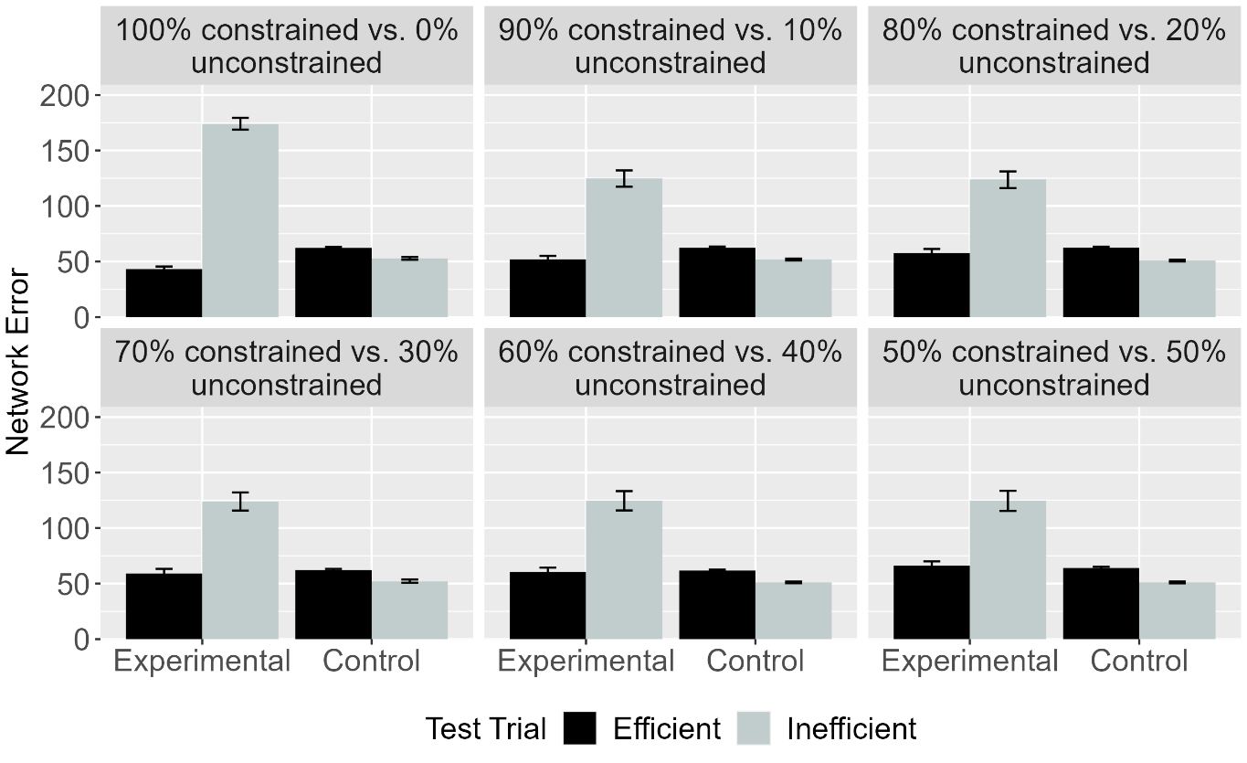Figure 12. Mean network error produced to the Efficient and Inefficient test events in the Experimental and Control conditions across different ratios. Error bars represent standard errors.

As shown in Figure 12, ALIAS reproduced the first target finding irrespective of the ratio of each kind of motion.

Discussion
This simulation showed that ALIAS’s success in reproducing the first target finding was robust to variation in the amount of constrained and unconstrained motion experienced during pretraining Varying the ratio of constrained and unconstrained actions during pretraining had little effect because all networks were habituated to constrained action immediately before test.
Simulation 2 took a first step toward assessing the explanatory breadth of ALIAS by examining whether it can capture the second target finding: Infants’ looking responses in action efficiency understanding studies do not depend on the entities involved possessing animate features. Simulation 2 was identical Simulation 1a except that the objects possessed features typical of inanimate objects. Simulation 2 only focused on the behavior of ALIAS and ALIAS-2 because neither VOM10 nor VOM10-2 had a means for representing whether an object possessed animate- or object-typical surface features.

Simulation 2: Independence from animacy.
Simulation 2 tested whether ALIAS’s performance in Simulations 1a and 1b hinged in the objects possessing animate-typical features. To that end, the objects used here possessed inanimate-typical features. Networks were 9 months old.

Results
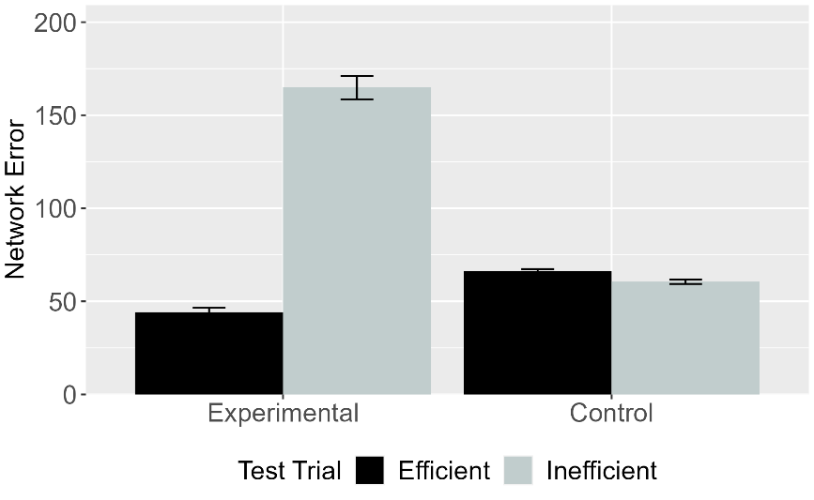 | 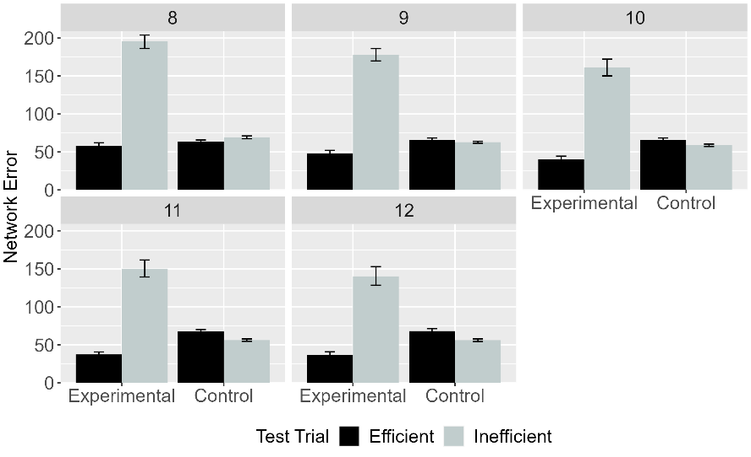
Figure 13. Mean network error produced to the Efficient and Inefficient test events in Simulation 2 across conditions overall (left panel) and different habituation epochs (right panel). Error bars represent standard errors.

Figure 13 shows that ALIAS’s responses did not hinge on animate-typical features.

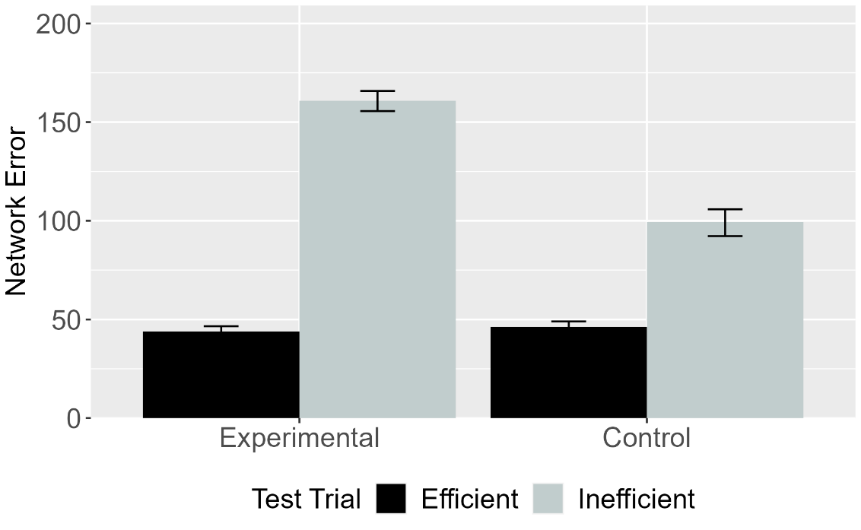
Figure 14. Mean network error produced to Efficient and Inefficient test events in the Experimental and Control conditions for ALIAS-2. Error bars represent standard errors.

Figure 14 shows that as was the case in Simulation 1a, ALIAS-2 failed to capture infants’ looking behavior across conditions. These findings suggest that associative learning alone is insufficient to reproduce the first two target findings; differential barrier salience must additionally be included.

Discussion
These findings indicate that differential obstacle salience is necessary. Nonetheless, a potential objection to the simulations presented thus far is that demonstrating that ALIAS’s performance is robust to whether objects possess animate-typical features only weakly demonstrate its explanatory breadth. Simulation 3 took this criticism seriously by testing whether ALIAS could capture a more substantively different target finding. This simulation examined whether ALIAS could capture Csibra et al.’s (2003) finding that 12-month-olds can make bidirectional inferences among goals, actions, and constraints. In their first experiment, infants were habituated to an event in which a large circle appeared to be chasing a small circle. However, before the large circle reached the small one, the small circle moved through a narrow gap between two bars and disappeared from the screen; the width of the gap forced the larger circle to move around one of the bars. The fact that the large circle never reached the small one before it disappeared from the screen meant that the large circle’s goal of reaching the small one had to be inferred. The authors found that when the gap was widened such that the large circle could fit through, infants looked longer when it continued moving around one of the barriers than when it passed through it. Note that although this experiment did not employ a standard Gergely paradigm, it can readily be recast within it by, for instance, terminating the habituation event after the first object clears the barrier but before it reaches the second object. This leaves the first object’s goal unclear. This was the approach taken in Simulation 3 to model this experiment.
In a second experiment, infants were habituated to a constrained action event except that the barrier was hidden behind an opaque screen. Infants could nonetheless see the second object and parts of the first object’s arced motion path. Csibra et al. (2003) found that infants looked longer when the first object followed the same curved path in the absence of an obstacle than when it did so in the presence of one. These findings were argued to support the teleological stance. Simulation 3 tested whether ALIAS could capture these findings and thereby challenge the necessity of this assumption. Its performance was also compared to the competitor models.

Simulation 3: Bidirectional inferences about actions, goals, and constraints.
Simulation 3 tested whether ALIAS could explain the finding that 12-month-old infants putatively can infer goals from constraints and behavior as well as constraints from goals and behaviors. All networks were assigned either to the Inferring Goals condition or to the Inferring Constraints condition. The events shown to networks in this condition were identical to those shown to networks in the Experimental condition in Simulation 1a except that they could not know whether the first object stopped next to the second one (its goal). The Inferring Constraints condition was implemented by removing all barrier information during habituation. All other aspects of this simulation were identical to Simulation 1a.

Results and Discussion
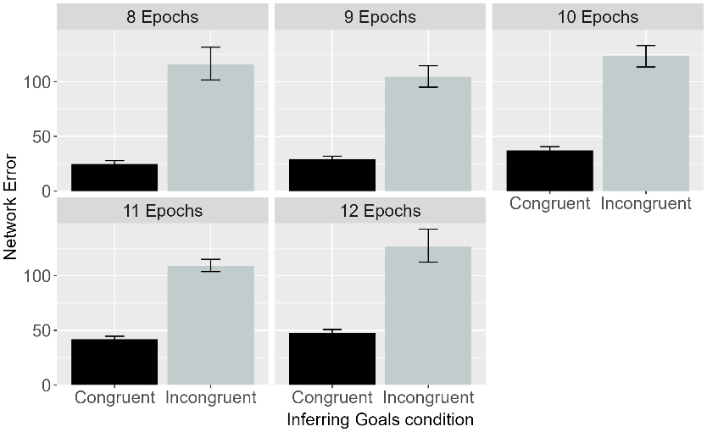 | 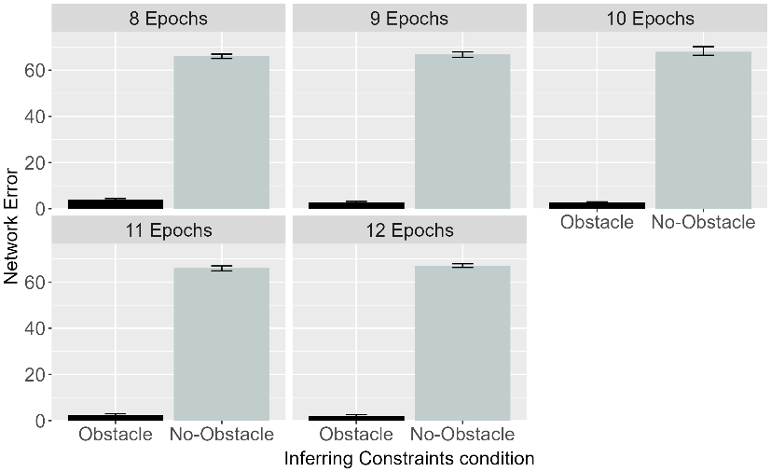
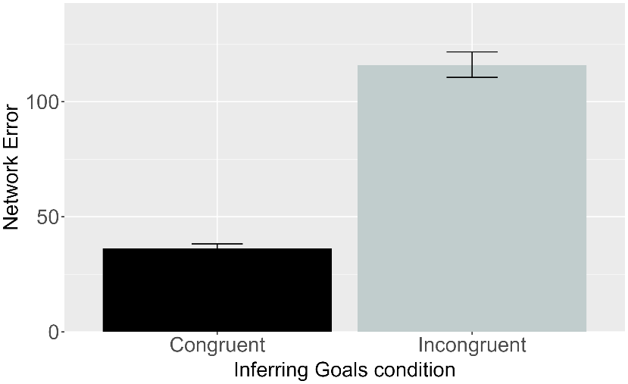 | 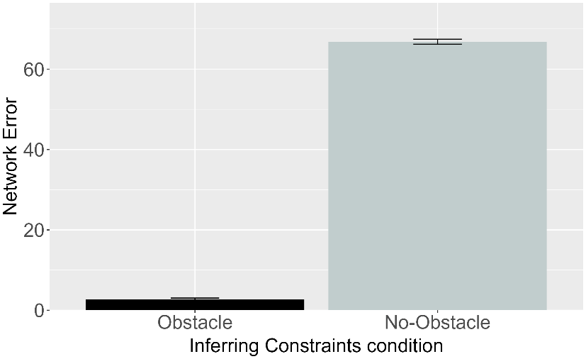

Figure 15. Performance of ALIAS. Plotted is the mean network error produced to the Congruent and Incongruent test events for networks in the Inferring Goals condition (left column) and to the Obstacle and No-Obstacle test events for networks in the Inferring Constraints condition across habituation epochs (top row) and overall (bottom row).

Figure 12 shows the performance of ALIAS in the Inferring Goals and Inferring Constraints conditions. Networks in the Inferring Goals condition produced more error to the Incongruent than to the Congruent test event. Networks in the Inferring Constraints condition produced more error to the No-Obstacle than to the Obstacle test event. These patterns were true both across different habituation lengths as well as overall. The basis for these findings is similar to that in Simulation 1a. In the Inferring Goals condition, the Incongruent test event violated a learned association between arced motion with over a small barrier and spatial contiguity between the two objects. In the Inferring Constraints condition, the No-Obstacle event violated a learned association between arced motion and obstacles. Less error was produced in the comparison conditions due to fewer violations.

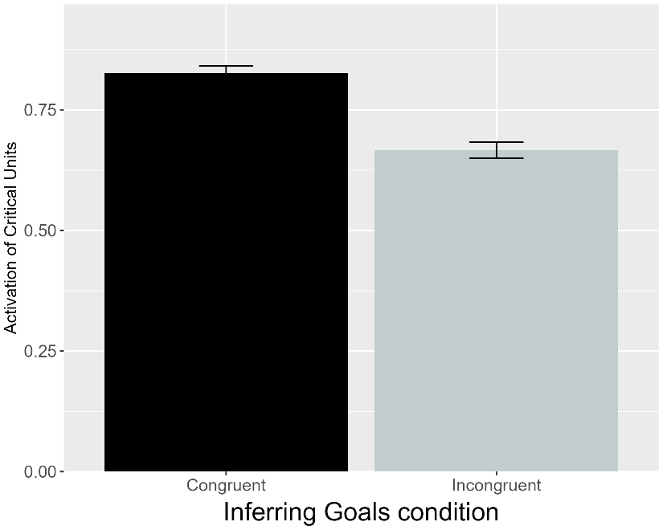 | 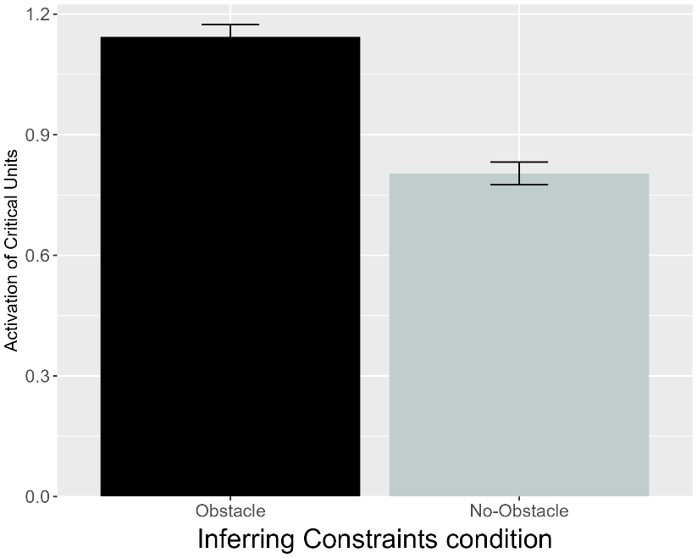
Figure 16. Performance of VOM10. Plotted is the mean activation of the critical units produced to the Congruent and Incongruent test events for networks in the Inferring Goals condition (left) and to the Obstacle and No-Obstacle test events for networks assigned to the Inferring Constraints condition (right).

As shown in Figure 16, VOM10’s responses were exactly opposite those of ALIAS. These results indicate that VOM10 cannot reproduce the third target finding.

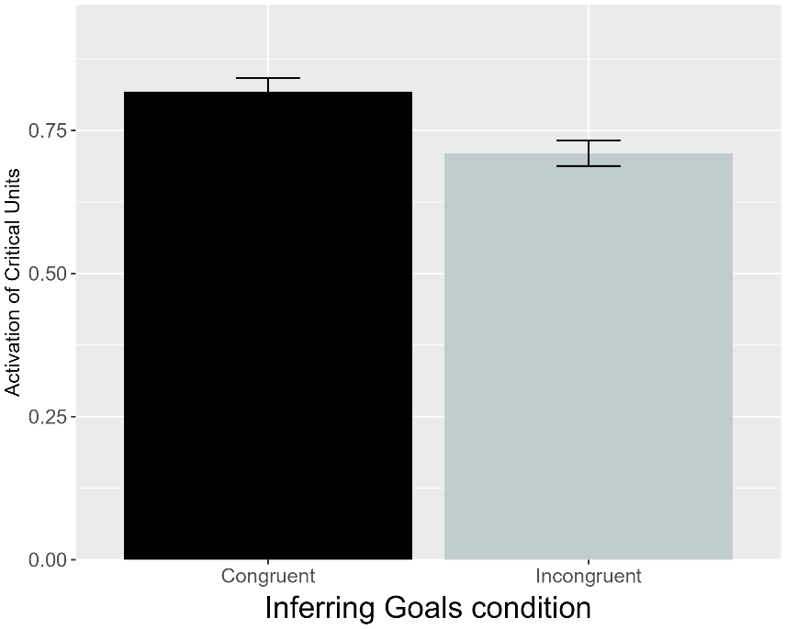 | 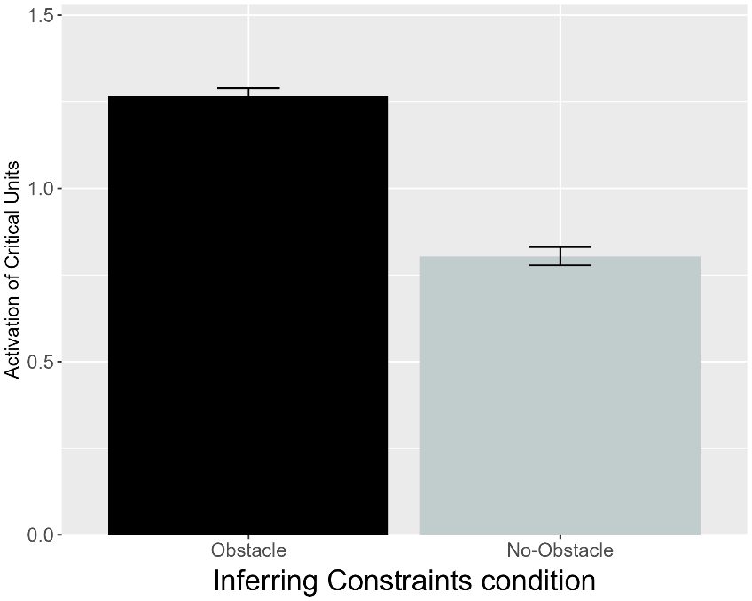
Figure 17. Performance of VOM10-2. Plotted is the mean activation of the critical units produced to the Congruent and Incongruent test events for networks in the Inferring Goals condition and to the Obstacle and No-Obstacle test events for networks assigned to the Inferring Constraints condition (right).

Figure 17 shows that VOM10-2 also failed to replicate the third target finding. These failures reflect a fundamental inability of both versions of VOM10 to simulate infant action efficiency understanding outside of Gergely et al. (1995).

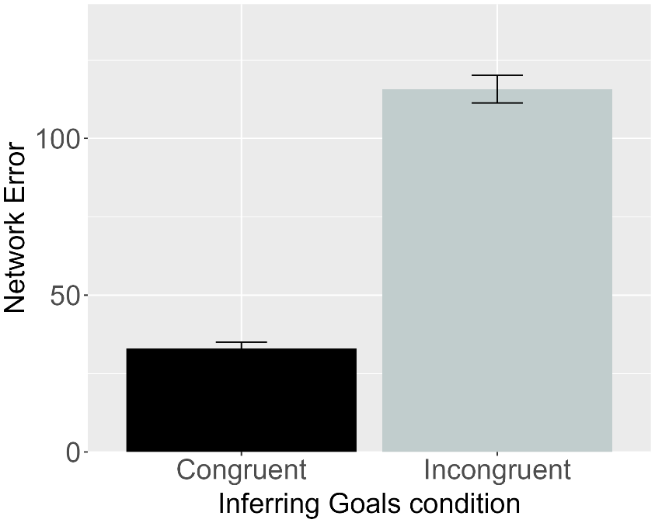 | 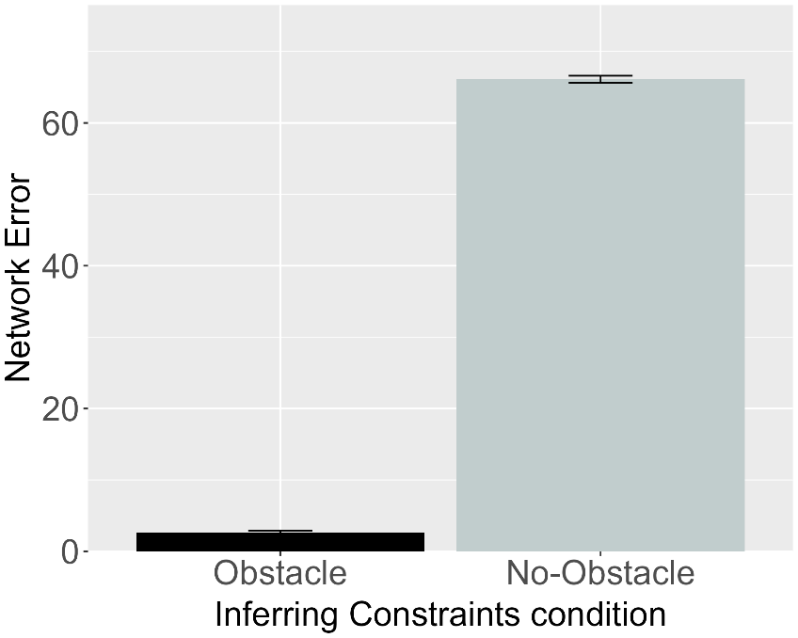
Figure 18. Performance of ALIAS-2. Plotted is the mean network error produced to the Congruent and Incongruent test events for networks assigned to the Inferring Goals condition (left) and to the Obstacle and No-Obstacle test events for networks in the Inferring Constraints condition (right).

Figure 15 shows that, like ALIAS, ALIAS-2 captured the third target finding. This suggests that, at least here, associative learning alone is sufficient to reproduce this finding. ALIAS’s and ALIAS-2’s success in reproducing the third target finding undermines the claim that infants use a teleological stance to reason productively about goals, actions, and constraints. Instead, these results indicate that an associative learning mechanism operating over the low-level kinematics of action and the surface features of the entities involved is clearly sufficient.
It might nonetheless be argued that the third target finding does not pose a sufficiently strong enough challenge to ALIAS and that a more compelling test of its explanatory scope is to demonstrate that it can capture Liu and Spelke’s (2017) finding that infants apparently represent efficiency continuously rather than in an all-or-none fashion. Six-month-olds were habituated either to a constrained action event (Experiment 1) or to an unconstrained one (Experiment 2). Infants were then tested either on constrained Low, efficient and constrained High, inefficient test events (Experiment 1) or on unconstrained versions of these events (Experiment 2). The constrained High, inefficient test event was so called because the agent jumped much higher than needed to clear the barrier. Liu and Spelke (2017) found that infants in Experiment 1 looked longer at the High, inefficient test event than at the Low, efficient one; infants in Experiment 2 looked numerically, but not significantly, longer at the Low, efficient test event.
In a final experiment, Liu and Spelke (2017) tested whether infants expect agents whose actions were inefficient in the past to continue behaving inefficiently in a new situation with a different set of constraints. Infants were habituated to the event used in Experiment 2 and then tested on the constrained events used in Experiment 1. Here, infants looked longer at the High, inefficient test event than at the Low, efficient one. These findings have since been interpreted as support for naïve psychology and naïve physics systems (Liu et al., 2026). Simulation 4 tested whether such systems are necessary to capture these findings or whether associative learning, either alone or in combination with differential obstacle salience, is sufficient to explain them.

Simulation 4: Graded representations of efficiency.
This simulation tested whether ALIAS could capture the fourth target finding. Networks were 6 months old. Networks were habituated to and tested on events analogous to those in Experiments 1-3 in Liu and Spelke (2017). ALIAS’s performance was compared only to VOM10-2 and ALIAS-2. VOM10 was not included because its original implementation omitted barrier information during the prediction (i.e., test) phase. Modifying VOM10 to include obstacle information during test would have represented a substantial departure from its implementation in the previous simulations and Van Overwalle’s (2010) original formulation.

Results
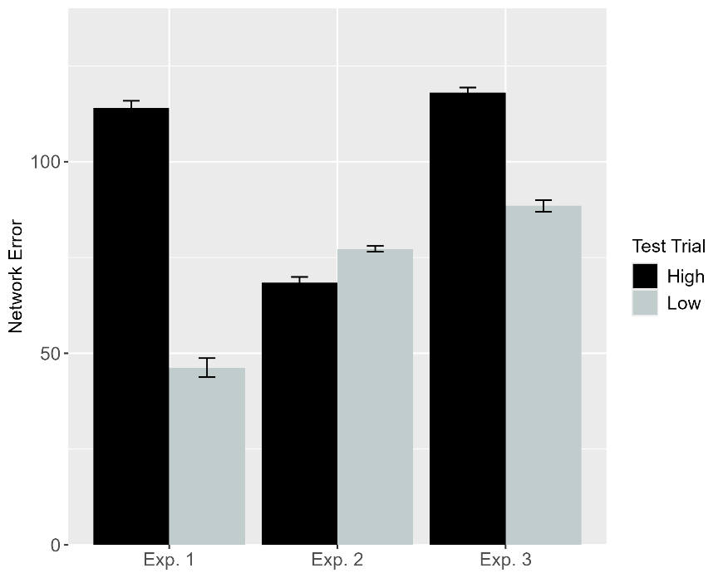 | 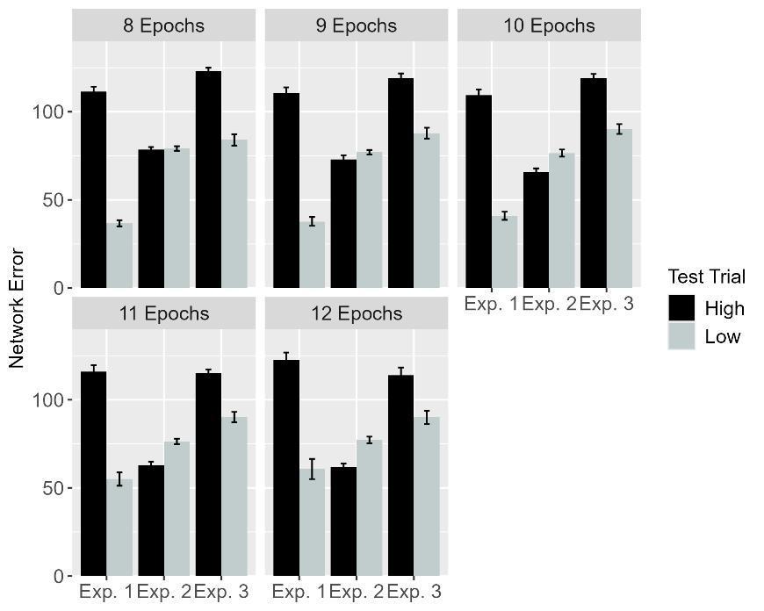
Figure 19. Performance of ALIAS. Plotted is networks’ mean error to the High, inefficient and Low, efficient test events across experiments overall (left) and across different habituation epochs (right). These experiments correspond to those in Liu and Spelke (2017).

Figure 19 shows that ALIAS reproduced the fourth target finding. ALIAS’s treatment of the High, inefficient and Low, efficient test events across the three experiments. Networks in Experiments 1 and 3 produced more error to the High, inefficient than to the Low, efficient one. Networks in Experiment 2 produced numerically more error to the Low, efficient than to the High, inefficient test event.

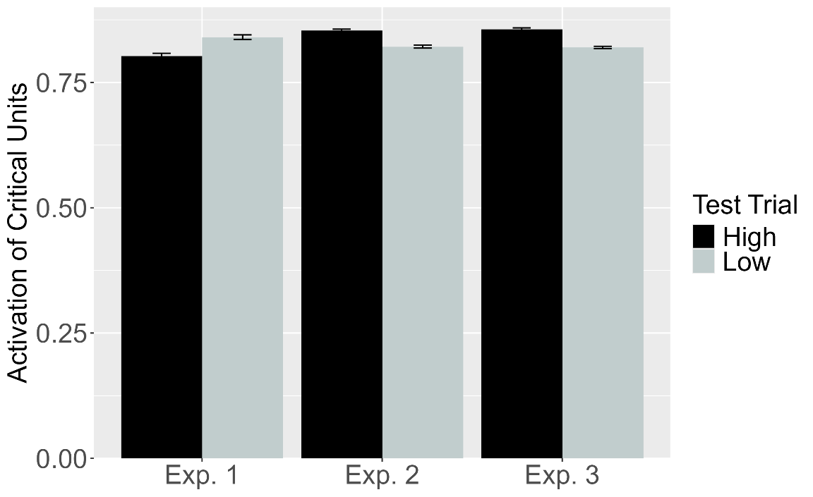
Figure 20. Performance of VOM10-2. Plotted is the mean activation of the critical units produced to the High, inefficient and Low, efficient test events for networks in Experiment 1-3.

As shown in Figure 20, although VOM10-2 captured infants’ looking responses in Experiment 3—showing slightly more critical unit activation following the High, inefficient test event than the Low, efficient test event—its responses in Experiments 1 and 2 did not match those of infants in the corresponding behavioral experiments.

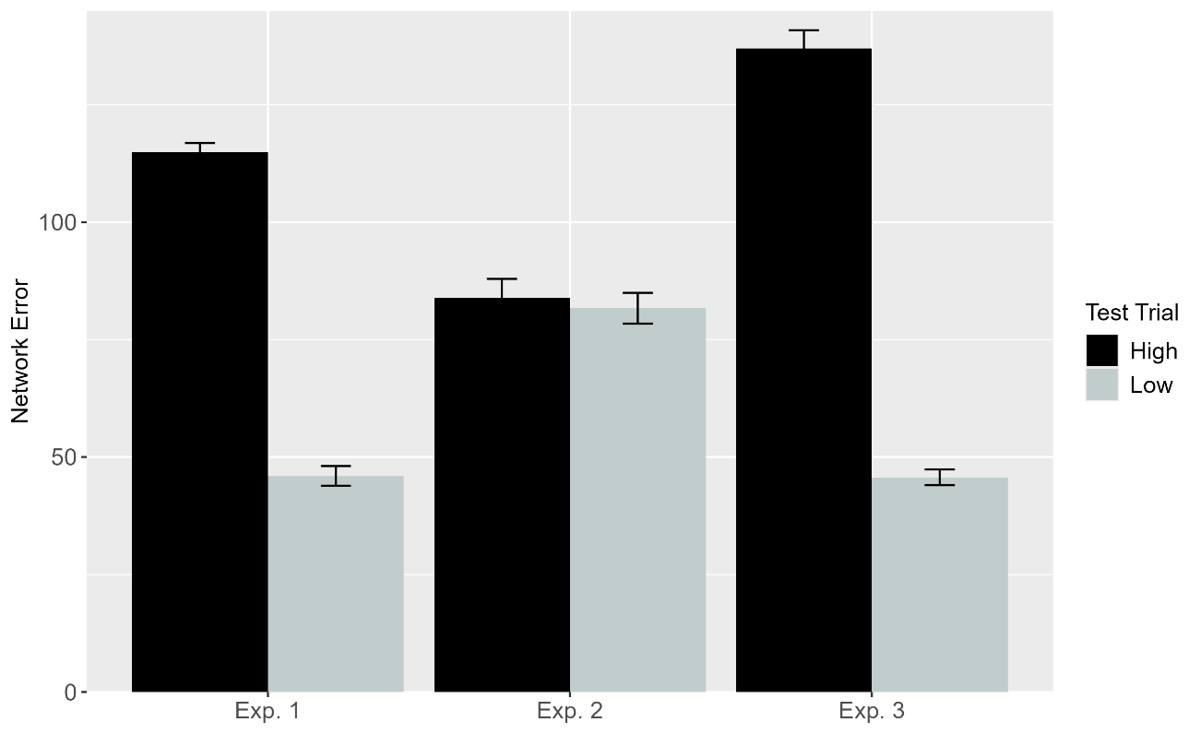
Figure 21. Performance of ALIAS-2. Plotted is networks’ overall mean error to the High, inefficient and Low, efficient test events across experiments.

Figure 21 demonstrates that ALIAS-2 largely reproduced the fourth target finding. It captured infants’ responses in Experiments 1 and 3 but deviated from their responses in Experiment 2. This latter result conflicts with ALIAS’s and infants’ tendency to produce more error to and look numerically longer at the Low, efficient than at the High, inefficient test event.
The basis for ALIAS’s behavior was again analogous to that in Simulation 1a. The High, inefficient test event violated associations formed during pretraining and habituation among a small obstacle, a low jump, and minimal vertical clearance. These associations were largely preserved in the Low, efficient test event. Error was thus lower for the former test event.
The finding that ALIAS provided a slightly better qualitative fit to the data than ALIAS-2 suggests that associative learning needs to be combined with the assumption that peripherally located obstacles have reduced salience to capture the fourth target finding. More broadly, ALIAS’s success in capturing the first four target findings suggests that it possesses substantial explanatory scope. At the same time, the current simulations all correspond to behavioral studies that tested infants with considerable real-world action observation experience. For ALIAS to constitute a viable alternative to domain-specific proposals of infant action processing, it must also reproduce findings suggesting that much younger infants are sensitive to action efficiency.
Of particular note is Skerry et al.’s (2013) discovery that a small amount of sticky-mitten reaching experience was sufficient for 3-month-olds to show looking patterns that resembled those of older infants. Simulation 5 tested whether ALIAS could overcome minimal prior action processing experience if the effective action experience it is given temporarily heightens its attention to and encoding of its own straight reaching trajectories. This simulation focused on ALIAS and ALIAS-2 because they were the only models capable of simulating development.

Simulation 5: Action efficiency understanding in pre-reaching infants.
The primary goal of this simulation was to assess whether ALIAS can reproduce the looking behavior of pre-reaching infants when its attention is heightened during a phase analogous to the action phase in Skerry et al. (2013). Networks were 3 months old. Unlike the previous simulations, this one included an “action phase” that immediately followed the pretraining phase (Figure 2D). Because Skerry et al. (2013) did not indicate the length of this phase, their lengths phases were equated here. The assumption that infants’ reaches approximate a linear path during the action was implemented by showing networks straight motion during it.
Networks were assigned to one of three conditions: Effective Action, Ineffective Action, or No Training. The Effective Action condition was further divided into either the Experimental or the Control conditions. The assumption that effective sticky mittens experience temporarily heightens infants’ attention was implemented by increasing the learning rate on all connections to 0.175 during the action phase for networks in the Effective Action condition only. To implement the assumption that this attentional enhancement is short-lived, the learning rate returned to its developmental value at the start of habituation. For the Ineffective Action and No Training conditions, the learning rate maintained its pretraining value throughout learning. In all other respects, these two conditions were identical.

Results
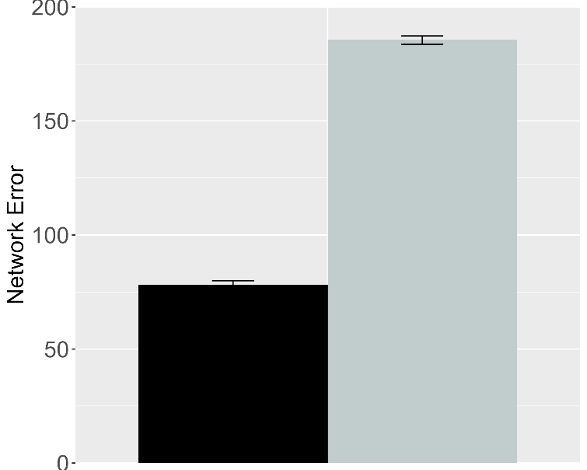 | 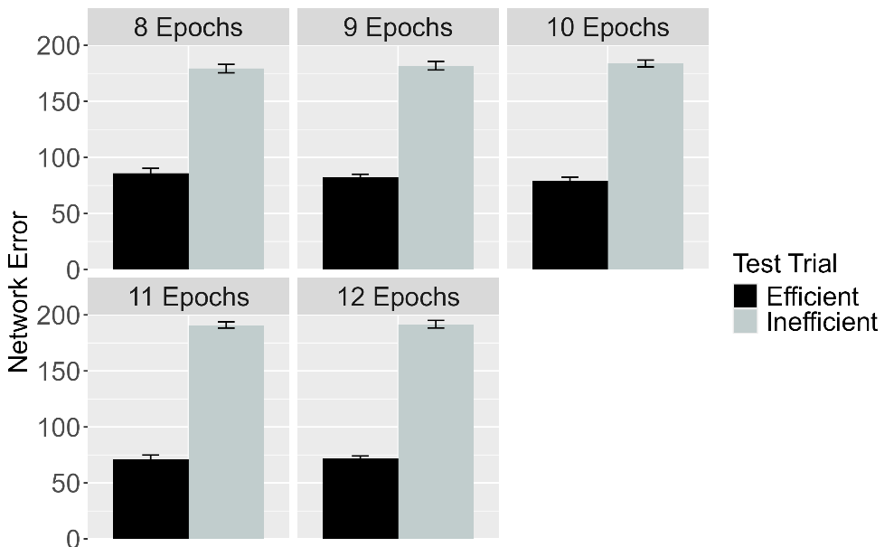
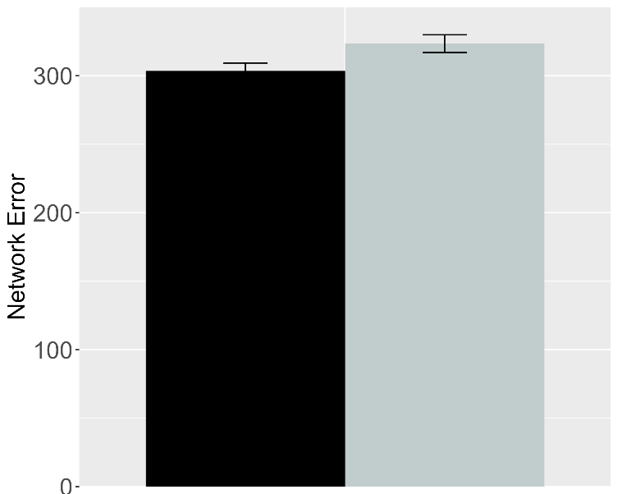 | 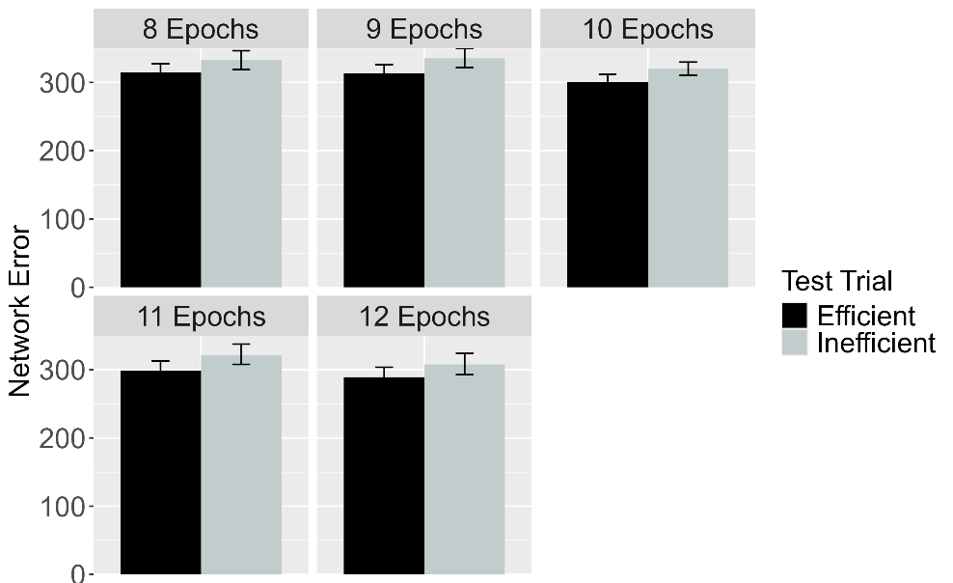
Figure 22. Performance of ALIAS in the Effective Action condition. Plotted is networks’ mean error to the Efficient and Inefficient test events in the Experimental (top row) and Control conditions (bottom row), both overall (left column) and across different habituation epochs (right column). The Experimental and Control conditions correspond to Experiments 1, 4, and 5 in Skerry et al. (2013).

Figure 22 shows the test performance of ALIAS in the Effective Action condition. Results show that networks in the Experimental condition produced more error to the Inefficient than to the Efficient event. The effect was much attenuated for networks in the Control condition.

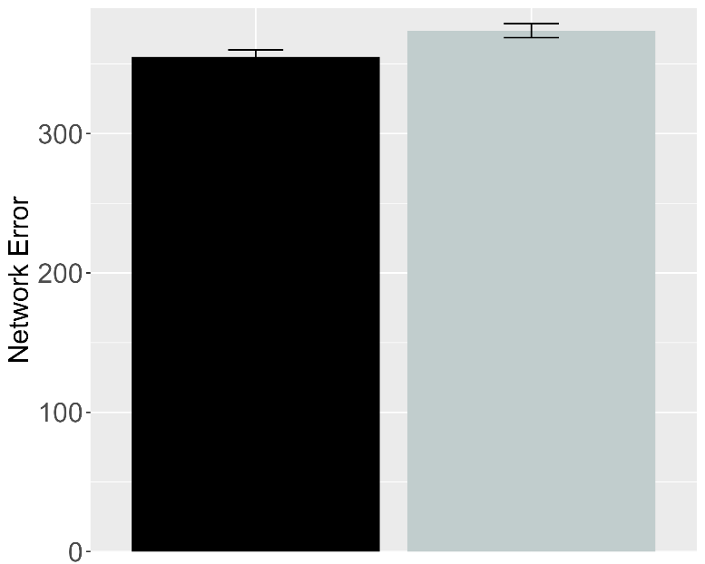 | 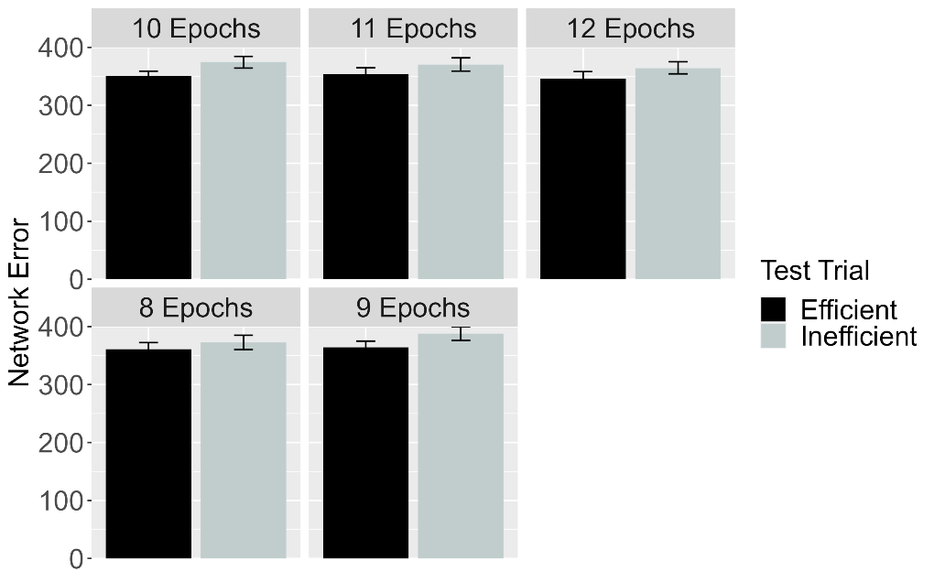
Figure 23. Performance of ALIAS in the No Training condition. The overall error produced to the Efficient and Inefficient test events is shown on the left, and the error produced across different habituation epochs is shown on the right. This condition corresponds to Experiment 3 in Skerry et al. (2013).

Figure 23 shows the performance of networks in the No Training condition. Networks produced comparable error to both test events. If prior experience with constrained arced motion was sufficient for networks to associate arced motion with barriers and then to detect when such associations are violated, then networks in Effective Action and No Training conditions should have treated the test events similarly.

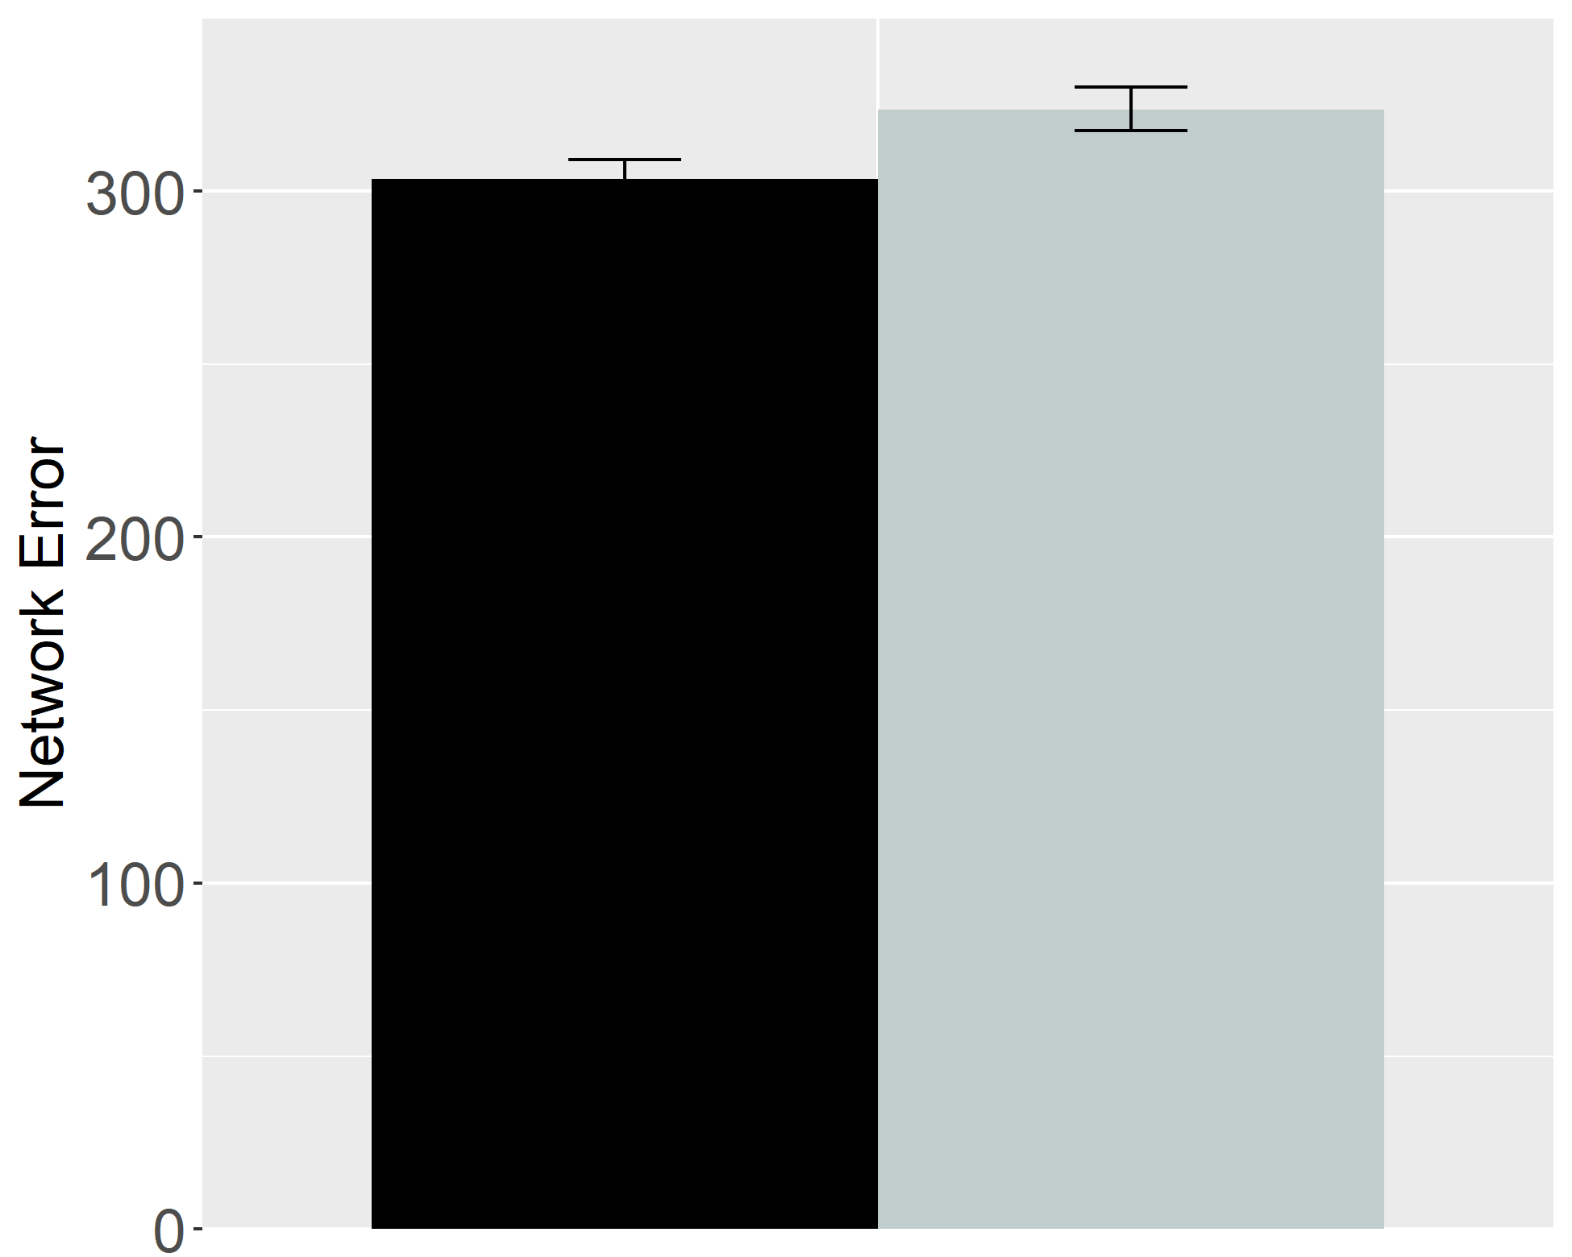 | 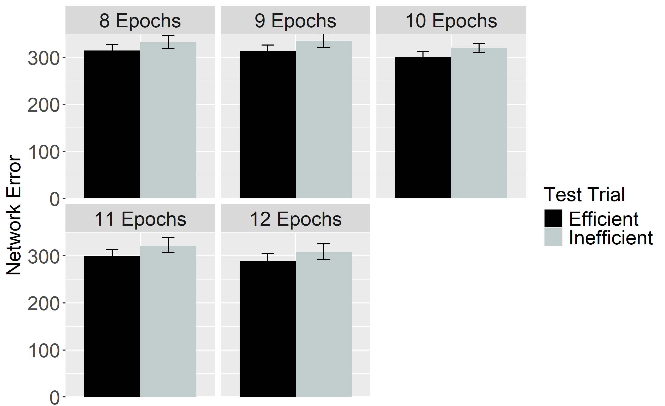
Figure 24. Performance of ALIAS in the Ineffective Action condition. The overall error produced to the Efficient and Inefficient test events is shown on the left, and the error produced across different habituation epochs is shown on the right. This condition corresponds to Experiment 2 in Skerry et al. (2013).

Figure 24 shows the performance of networks in the Ineffective Action condition. As with networks in the No Training condition, these networks also produced comparable error to both test events. These results indicate that enhanced encoding of straight reach trajectories is sufficient to reproduce the fifth target finding.

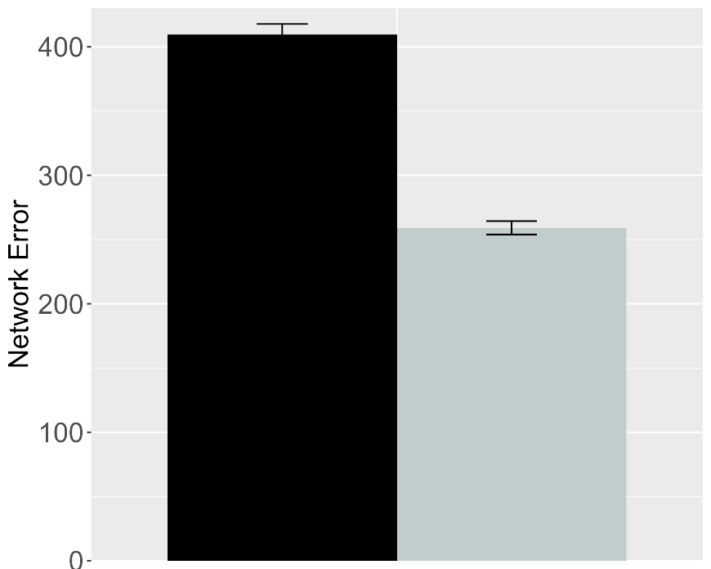 | 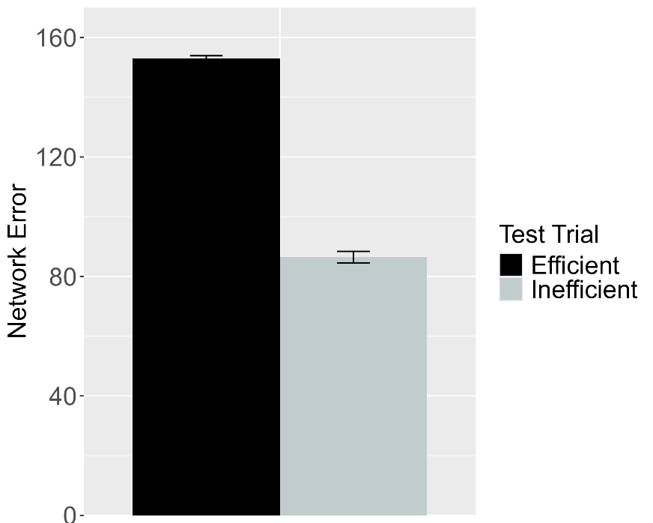
Figure 25. Performance of ALIAS in the Experimental (left) and Control (right) conditions of the Effective Action condition. These data correspond to a version of ALIAS in which the attentional boost extends into the habituation phase.

To determine whether attentional boosts must be transient, this boost was allowed to extend into habituation for a different set of networks. Figure 25 shows that networks produced greater error to the Efficient than to the Inefficient test event, thereby suggesting that the attentional boost must be transient.
The basis for these findings is straightforward: Although networks’ heightened attention during the action phase enabled them robustly to encode their own straight reach trajectories, the fact that this attentional boost persisted into the habituation phase meant that networks’ representations of these trajectories were overridden by robust representations of the arced motion trajectories and the surface features associated with those trajectories (e.g., the height of the apex of a reach’s trajectory) during the habituation phase. Consequently, the Inefficient test event—which, apart from the barrier, preserved most of the features of the habituation event—was partially consistent with the habituation representation; the Efficient test event was not because it depicted a straight reach trajectory. The extremely brief nature of the pretraining phase, combined with networks’ impoverished processing abilities in this simulation, precluded them from forming robust representations of straight motion during this phase.

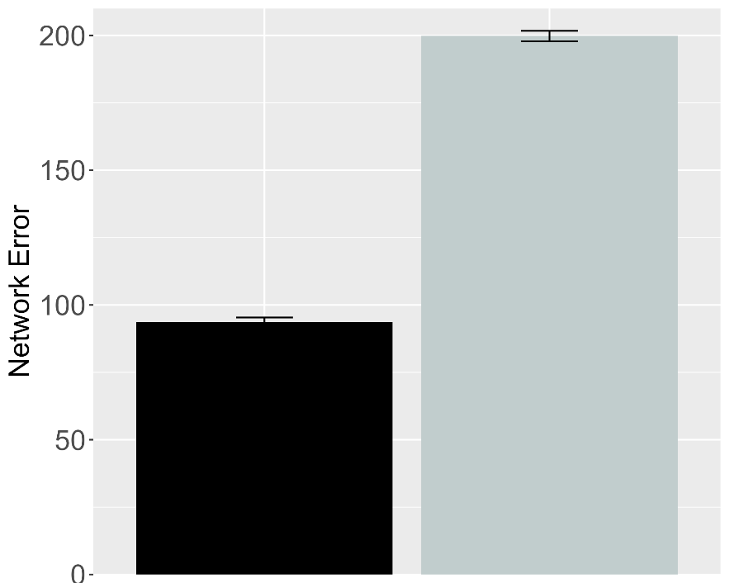 | 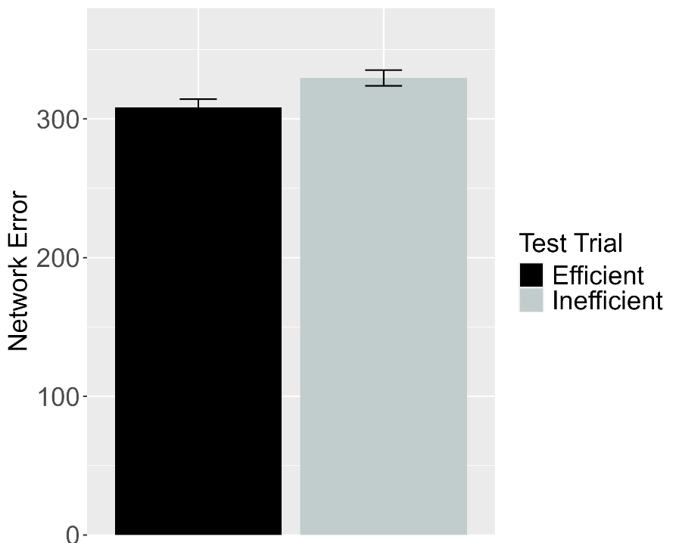
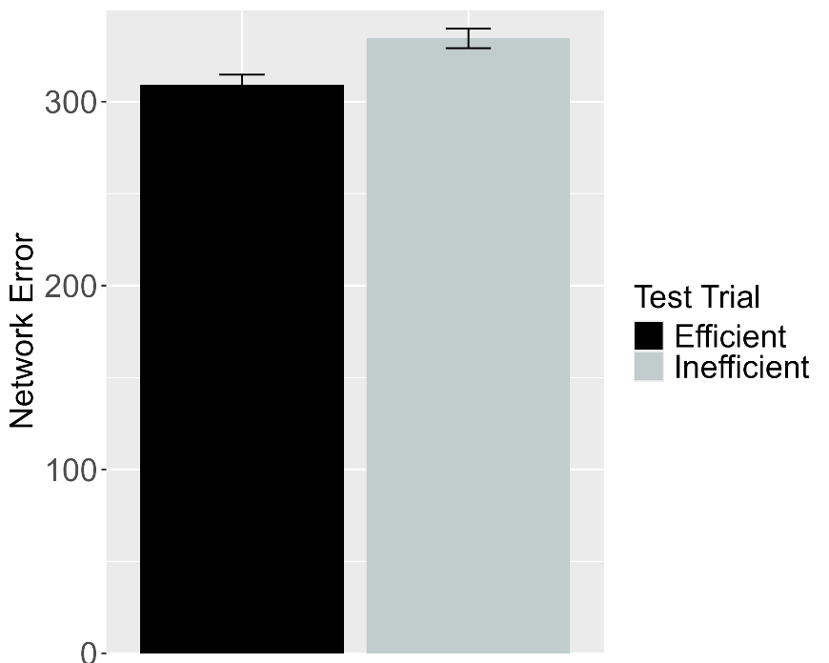
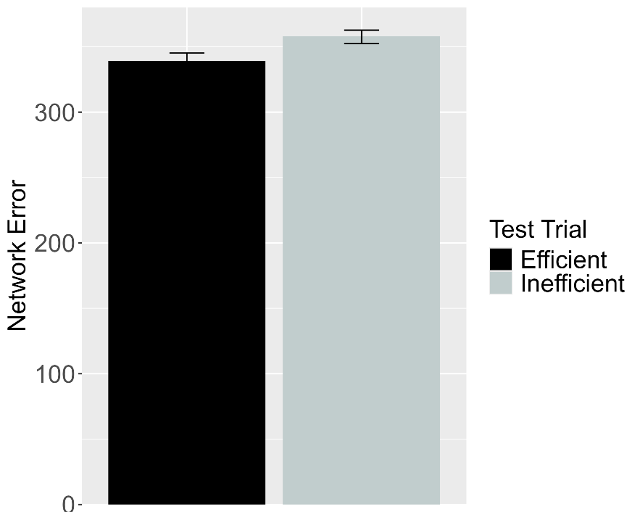
Figure 26. Performance of ALIAS-2. Plotted in the top row is the overall mean error to the Efficient and Inefficient test events for networks assigned either to the Experimental (top left) or to the Control condition (top right) in the Effective Action condition. Plotted in the middle row is the overall mean error to the two test events for networks assigned to the Ineffective Action condition. Plotted in the bottom row is the overall mean error to the two test events for networks assigned to the No Training condition. The No Training condition corresponds to Experiment 2 in Skerry et al. (2013).

The next analysis examined whether associative learning alone was sufficient for ALIAS-2 to reproduce the fifth target finding. Note that the attentional boost remained short-lived in this simulation. As Figure 26 depicts, ALIAS-2 was able successfully to reproduce the fifth target finding: In the Effective Action condition, networks habituated to constrained action produced greater error to the Inefficient than to the Efficient test event. In contrast, networks habituated to unconstrained action in the Ineffective and No Training conditions produced comparable amounts of error to both test events. The results of this simulation indicate that associative learning alone is sufficient to account for Skerry et al.’s (2013) findings.
The five simulations reported here demonstrate that infants' looking behaviors in studies assessing their action efficiency understanding can be explained by associative learning. Specifically, ALIAS reproduced the finding that infants look selectively at inefficient actions, that this effect is independent of whether the entities involved possess animacy cues, that infants make bidirectional inferences among actions, goals, and constraints, that ostensibly they possess graded representations of efficiency, and that action efficiency understanding is present in pre-reaching infants. ALIAS's ability to capture such a diverse set of findings undermines the claim that such looking behaviors derive from specialized mechanisms and abstract, conceptually rich representations of goals, constraints, efficiency, and utility. Instead, the present simulations suggest that these phenomena can be readily explained in terms of a domain-general associative learning mechanism operating over the semantically neutral visible surface features of action events and the entities and objects involved in them. At the same time, a complete account of infants’ looking performance in these studies should do more than reproduce existing findings. The account must also be generative: it should produce testable predictions for future research. The final section does exactly this by placing ALIAS in a series of novel situations and examining its resulting behavior. These behaviors constitute a set of predictions that can be used to decide between the present account and the domain-specific alternatives.

Model predictions
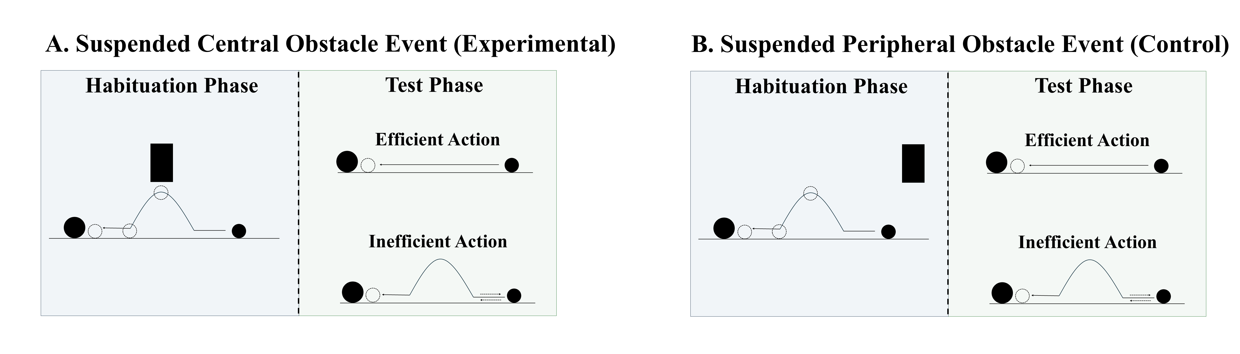
Figure 27. Schematic depiction of the behavioral task associated with the first prediction. In the suspended central obstacle event (A), the first object jumps under a suspended, centrally located barrier before it comes to rest next to the second object; in the suspended peripheral obstacle event (B), the first object jumps beside the suspended barrier before coming to rest next to the second one. The barrier is removed at test for both events, and infants observe either an efficient straight-path action or an inefficient arced-path action.

A potentially interesting question that the current simulations raise concerns how ALIAS would respond if it were habituated to an event in which a barrier was located directly above rather beneath the apex of an arced motion trajectory. Figure 27 depicts what such an event would look like. If the current account is correct that spatial proximity to the motion trajectory is the critical factor, then networks (and by hypothesis, infants) should respond similarly when the obstacle is positioned above rather than below the trajectory.
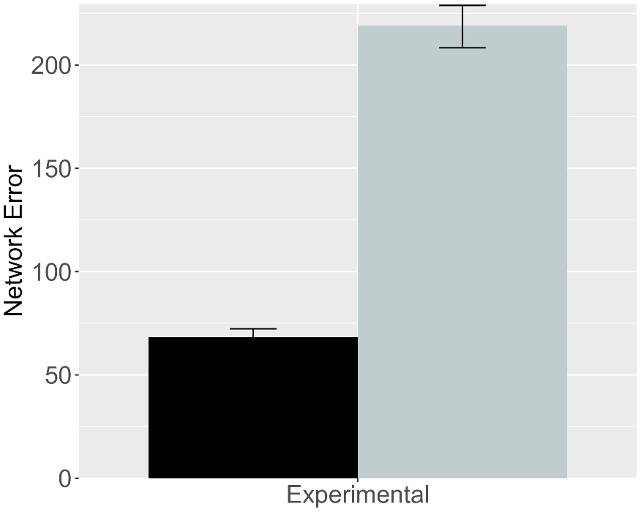 | 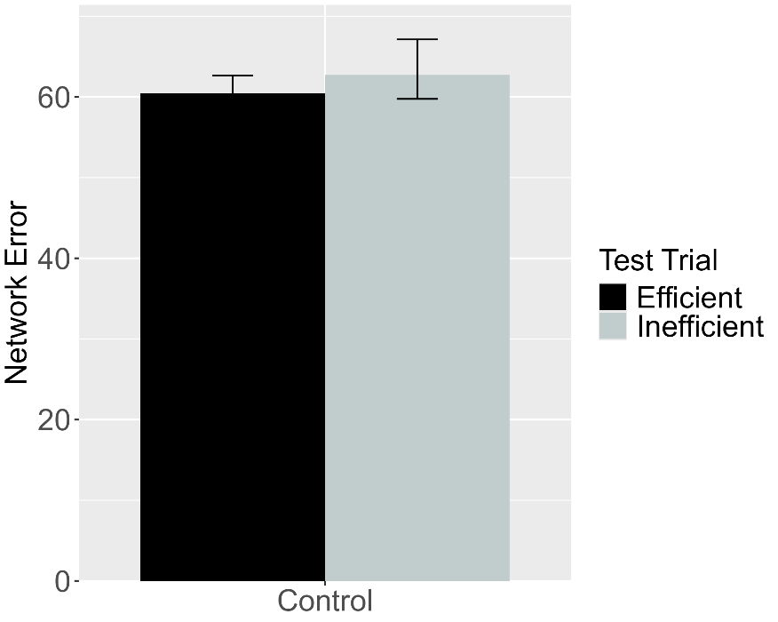
Figure 28. Performance of ALIAS. (Left) Overall error produced to the Efficient and Inefficient test events for networks in the Experimental condition. (Right) Overall error produced to the Efficient and Inefficient test events for networks in the Control condition. The barrier shown during habituation for this simulation appeared directly above rather than beneath arced motion.

This simulation was identical to Simulation 1a with two critical exceptions. First, a fourth unit was added to the Obstacle Horizontal Position input and output groups. This unit corresponded to the location directly above arced motion. Second, because the previous results were robust to the number of habituation epochs, the length of the habituation phase was reduced to eight epochs; this was the smallest number used in the prior simulations. Obstacles were only in the above-the-curved-motion spatial configuration during the habituation phase. As Figure 29 shows, when networks were subsequently tested on barrierless Inefficient and Efficient test events, only those in the Experimental condition looked longer at the Inefficient than at the Efficient test event. These results mirror those in Simulation 1a.

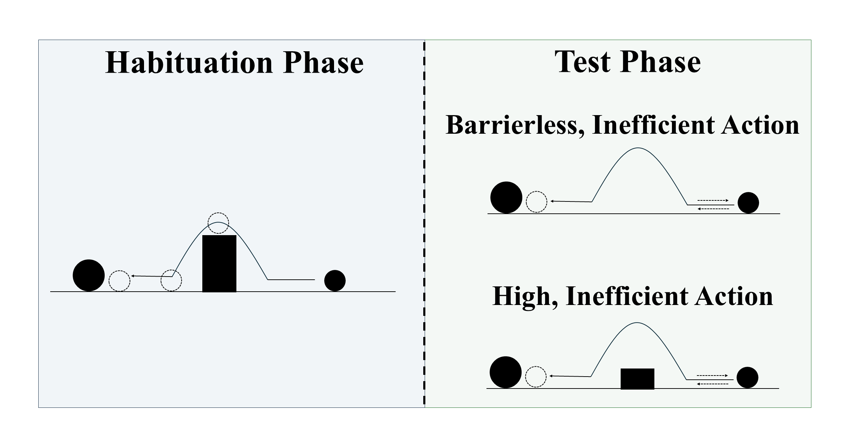
Figure 29. Schematic depiction of the behavioral task associated with the second prediction. During habituation, the first object jumps over centrally located barrier before it comes to rest next to the second object. Barrierless, inefficient and High, inefficient test events are then shown.

Given that action efficiency understanding studies employ different kinds of inefficient events, it might be asked how ALIAS would treat two different inefficient test events. For example, how might ALIAS respond if it were tested on Liu and Spelke’s (2017) High, inefficient test event and Gergely et al.’s (1995) Barrierless, inefficient test event? To address this question, networks were habituated to a constrained action event and tested on the High, inefficient test event from Simulation 4 and the inefficient one from Simulation 1a (Figure 29). Networks were again 6 months old.
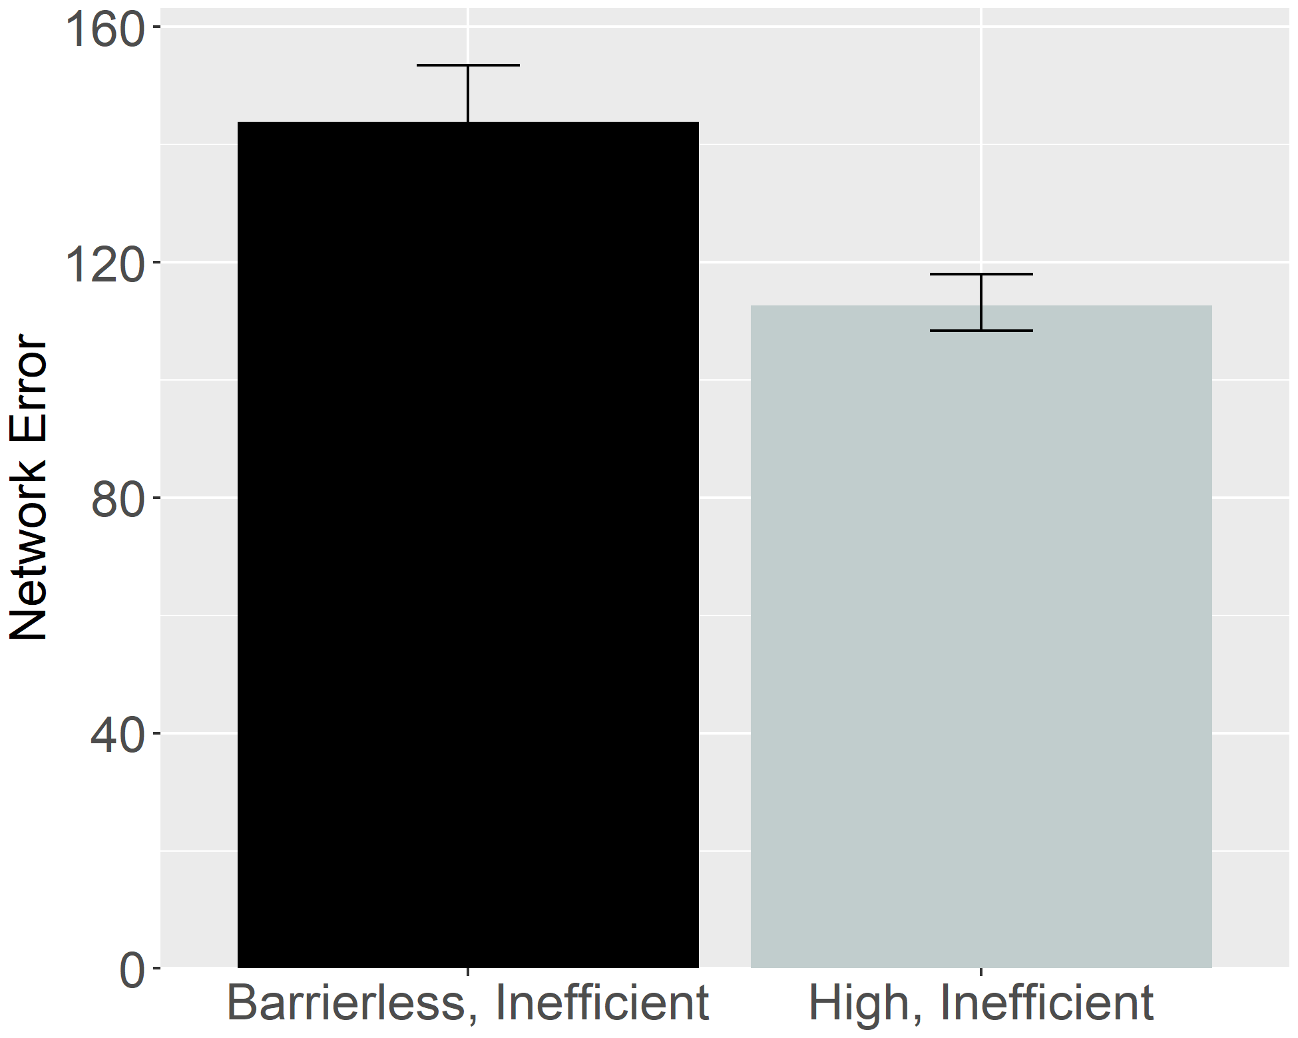
Figure 30. Performance of ALIAS. Overall error produced to the High, inefficient and Inefficient test events.

Figure 30 shows that networks produced more error to the Barrierless, inefficient test event than to the High, inefficient one. The former test event produced more error than the latter one because many of its input features strongly activated the associated straight-motion representation, a representation that ultimately conflicted with the observed arced motion. By contrast, the High, inefficient test event produced less error because the associations among its input features were largely consistent with those formed during pretraining.
The results presented in this section are theoretically significant because arguably they are at odds with what any of the domain-specific proposals discussed here would predict. If these accounts are correct that action processing depends on the efficiency, cost, and subjective utility of those actions, among other things, then infants should show equivalent dishabituation to both inconsistent events because both events are non-rational and costly. This contention falls directly out of the math of the naïve utility calculus, the full details of which are beyond the scope of this paper (see Jara-Ettinger et al., 2016; Jara-Ettinger et al., 2020). In this model, cost is defined in terms of an agent’s actions (or more formally, its policy)—this policy is equivalent in both inefficient test events. These accounts also predict equivalent performance between the Suspended Central Obstacle Event and Suspended Peripheral Obstacle Event conditions. In both conditions, the agent’s actions are not rational given the environmental constraints.

General Discussion
Developmental scientists have long wrestled with how infants discover that some actions are more efficient than others. Rich proposals maintain that infants possess early-emerging and conceptually rich domain-specific systems that support processing actions in terms of their efficiency, cost, rationality, and subjective utility, among other things (Csibra & Gergely, 1998; Gergely & Csibra, 2003; Jara-Ettinger et al., 2016; Jara-Ettinger et al., 2020; Liu et al., 2026). Lean proposals argue instead that infants’ behaviors in violation-of-expectation investigations broadly—of which studies assessing infants’ action efficiency understanding are specific instances reflect the operation of more domain-general processes.
This paper extends this second perspective in a model called ALIAS. Across five simulations, this model reproduced key findings in this literature that have been interpreted as evidence for domain-specific mechanisms. These include infants’ sensitivity to efficient and inefficient actions for animate and non-animate objects alike, bidirectional inferences about actions, goals, and constraints, graded representations of efficiency, and the effects of early action experience. Together, the simulations show that these phenomena can emerge from associative learning operating over perceptually grounded event representations.
The present results also showed that ALIAS provided a better account of these target findings than ALIAS-2 and VOM10-2. Table 3 makes this point especially clear. The table shows that ALIAS successfully captured all five target findings as well as the more specific findings associated with each target finding. In contrast, the remaining models either failed to capture several of the target findings, could only partially capture them, or could not be used to simulate them because of theoretical limitations.

Table 3. Qualitative fits of the different models to the five target findings examined in the current paper.
 |  |  |  | Model
Target finding | Illustrative paradigm | Articles | ALIAS | ALIAS-2 | VOM10 | VOM10-2
- Selective longer looking to inefficient than efficient actions following constrained habituation. | Animate agent constrained action | Csibra et al. (1999); Gergely et al. (1995) |  |  |  | 
 | Animate agent unconstrained action |  |  |  |  | 
- Independence from animacy. | Inanimate-agent constrained action | Csibra et al. (1999) Sodian et al. (2004) |  |  |  | 
 | Inanimate agent unconstrained action |  |  |  |  | 
- Bidirectional inferences about actions, goals, and constraints. | Goal inference | Csibra et al. (2003); Wagner & Carey (2005) |  |  |  | 
 | Constraint inference |  |  |  |  | 
- Graded representations of efficiency. | More costly vs. less costly constrained action | Liu & Spelke (2017) |  |  | — | 
 | More costly vs. less costly unconstrained action |  |  |  | — | 
 | More costly vs. less costly constrained action with a previously inefficient agent |  |  |  | — | 
- Action efficiency understanding in pre-reaching infants. | Sticky mittens training constrained action | Skerry et al. (2013) |  |  | — | —
 | Non-sticky mittens training constrained action |  |  |  | — | —
 | Sticky mittens training unconstrained action |  |  |  | — | —
Note. Check marks indicate that a given model captured the qualitative pattern associated with a target finding and its corresponding illustrative paradigm; Xs indicate that the model failed to capture the finding; and dashes indicate that the model could not meaningfully be applied to the corresponding target and illustrative paradigm. Illustrative paradigms are nested within the broader target finding to which they correspond. Because several of the current target findings were derived from multiple experiments and published studies, the associated citations are also provided.

As it relates to VOM10—the main competitor model—this model was unable to reproduce the third and fifth target findings. VOM10’s failure to capture the third and fifth target findings can be attributed to a common source: the absence of prior action processing experience. Yet just such experience is required for the model to represent aspects of the visual scene that otherwise were absent or to model the role of experience on action processing. Although VOM10 captured the first target finding, even here caution is warranted. This is because a revised version of this model—which more faithfully simulated the experimental task from which the first target finding derived—failed to reproduce this finding. This suggests that VOM10’s original success stemmed from quirks relating to how this model can be used to simulate action efficiency understanding studies rather than from its ability to capture the processes underlying action efficiency processing in infants. Interestingly, Simulation 4 demonstrated that retaining such quirks prevented VOM10 from capturing infants’ graded sensitivity to efficiency. This failure should not be interpreted as failures of connectionist systems more broadly. ALIAS could not have reproduced the target findings if this were true.
In terms of the novel contributions that the current simulations make, two are particularly noteworthy. First, they provided insight into the mechanistic basis of infants’ looking responses in action efficiency understanding studies. As one example, Simulation 4 demonstrated that prior experience with curved trajectories and obstacles can explain why infants look longer at events depicting barrierless arced motion than those depicting constrained arced motion or why infants look longer when agents stop short of their goals than when they stop next to them: Both error patterns were the emergent consequence of prior experience observing arced motion in the presence of barriers and actions that terminate in the agent being spatially contiguous with its goal. As another example, Simulation 5 showed that increased error to the Inefficient than to the Efficient test events can be expected in an otherwise developmentally inexperienced system that develops a representation of its own straight reaches while in a heightened attentional state. Action events whose kinematics subsequently deviate from this learned representation (e.g., the Inefficient test event) should elicit more error than events whose kinematics overlap with this representation (e.g., the Efficient test event). In general, ALIAS’s behavior here was based not on e specialized processes or explicit notions of goals, action, efficiency, cost, or rationality but rather on associations—formed during pretraining and reinforced (or weakened) during habituation—among differentially salient, conceptually neutral visible surface features.
Second, the current simulations generate a number of testable predictions. One is that infants who are habituated to a constrained action event and then tested on a High, inefficient test event like that in Liu and Spelke (2017) and a Barrierless, inefficient test event like that in Gergely et al. (1995) should look longer at latter than the former event. Another prediction is that infants should look longer at an Inefficient test event than at an Efficient one following habituation to an event in which arced motion unfolds beneath rather than over an obstacle. Although not explicitly tested here, another prediction the model makes is that increasing the salience of peripherally located obstacles should enable infants to form robust associations between them and arced motion. Conversely, decreasing the salience of centrally located obstacles should prevent robust associations from forming between them and arced motion. Still another prediction—again not explicitly tested here—the model makes is that infants should look longer at Barrierless, inefficient test event than an Efficient test event, even in the absence of habituation. Behavioral findings that corroborate any of these predictions—but ideally all of them—would be difficult to reconcile under any of the current domain-specific proposals.
The present account may also help to explain an apparent discontinuity between action efficiency processing in infancy and later development. On the one hand, studies with infants suggest that sensitivity to action efficiency emerges sometime between 6 and 12 months of age (e.g., Csibra et al., 2003; Csibra et al., 1999; Gergely et al., 1995; Liu & Spelke, 2017; Liu et al., 2017), if not earlier (e.g., Liu et al., 2019; Skerry et al., 2013). On the other hand, evidence from toddlers and young children is more equivocal. Some findings are consistent with the view that action efficiency understanding is continuous throughout development. For example, 14-month-olds imitate inefficient actions only when more efficient alternatives are unavailable (Gergely et al., 2002), 2-year-olds use cost information when evaluating others' behavior (Jara-Ettinger et al., 2015), and 5-year-olds reason productively about others' actions in terms of the costs and rewards (Jara-Ettinger et al., 2015). In contrast, other studies show that preschool-aged children neither distinguish efficient from inefficient actions (e.g., Ossmy et al., 2021) nor do they expect agents to follow more efficient and less costly paths when pursuing goals (e.g., Gönül & Paulus, 2021). These diverging findings are difficult to reconcile under the present domain-specific theories because each implicitly assumes continuity in the mechanisms supporting action efficiency understanding. Yet, if sophisticated notions like goals, efficiency, cost, and utility really do guide infants’ action processing, then it is unclear why evidence for such representations are present in early infancy but not in early childhood.
This discrepancy evaporates if the current account is correct that looking behavior in studies on this topic reflects low-level associative processes operating over visible surface features. If so, such behavior does not reflect veridical efficiency-based action processing. One outstanding question concerns how genuine efficiency-based action processing develops. Although ALIAS is not a theory of how this capacity emerges, there is no reason to think that its development is not ultimately rooted in the same general associative processes. Indeed, a similar proposal has been advanced in another domain. The proposal in question is Associative Sequence Learning (ASL; e.g., Heyes & Ray, 2000; Heyes, 2001) and the phenomenon it seeks to explain is imitation. ASL is relevant because it demonstrates how a capacity like imitation can emerge via more general associative-based processes. According to ASL, repeated pairings between observed and executed actions establish associations linking perception and action. Over time, these associations become sufficiently strong that observing another person's action elicits the corresponding motor response. Importantly, ASL does not deny that imitation is a sophisticated cognitive ability; rather, it maintains that such sophistication is the emergent consequence of learning rather than specialized mechanisms. The present account adopts a similar perspective. Although ALIAS is concerned with infants' early looking behavior rather than the development of efficiency-based action processing, the notion that the latter develops via the very same associative processes that underpin the former is entirely consistent with it. At the same time, observation alone might be insufficient to support a complete understanding of action efficiency. Physically experiencing the efficiency of one's own actions may be additionally important (e.g., Ossmy et al., 2021). Mature efficiency-based action processing may thus arise from a combination of observation and action, thereby allowing perceptually grounded associative representations to become integrated with action production over development.
Before concluding, two potential criticisms of ALIAS are worth noting. The first concerns the fact that the present simulations focused primarily on studies employing some version of the Gergely paradigm. Potential downsides of this are that the conclusions that can be drawn from it are necessarily limited in scope and that it is unclear to what extent the current model can capture findings on infant action understanding broadly (e.g., Gergely et al., 2002; Woodward, 1998). Future work will therefore need to determine whether extended versions of ALIAS can capture findings beyond those related to infants’ action efficiency understanding.
The second concerns the model’s simplicity. Although movement was represented dynamically, all other aspects of the model were represented statically. Additionally, a localist rather than a distributed encoding scheme was used to represent objects, their features, and any external constraints or barriers in the environment. Based on these simplifications, the model may poorly approximate infants’ real-world action experience. Although I do not dispute this critique, this simplification was deliberate: Because simple models afford tracing precisely how simple model’s process information, it is possible to elucidate the mechanisms driving the model’s performance and thus to advance theories of infant cognitive development. Although it is true that complex models better capture the richness of infants’ action perception, a major disadvantage of such models is that their complexity hinders their interpretability. This complexity also makes it difficult to separate the meaningful consequences of different theoretical assumptions from extraneous model details.
In sum, ALIAS reproduced benchmark findings that previously were interpreted as evidence for specialized mechanisms and abstract efficiency-based notions of action. The model achieved this via an associative-learning mechanism operating over perceptual features and action kinematics. The success of this model does not mean that infants do not possess an efficiency-based understanding of action. They show instead that existing looking-time evidence does not uniquely require that interpretation. Thus, before concluding that infants’ performance reflects domain-specific and early-emerging concepts, future studies must first rule out the possibility that such performance reflects associative processes and visible surface features.
References
Baillargeon, R. (1986). Representing the existence and the location of hidden objects: Object permanence in 6-and 8-month-old infants. Cognition, 23(1), 21–41. https://doi.org/10.1016/0010-0277(86)90052-1
Baillargeon, R. (1987). Object permanence in 3½- and 4½-month-old infants. Developmental Psychology, 23(5), 655–664. https://doi.org/10.1037/0012-1649.23.5.655
Baillargeon, R., & DeVos, J. (1991). Object permanence in young infants: Further evidence. Child Development, 62(6), 1227–1246. https://doi.org/10.1111/j.1467-8624.1991.tb01602.x
Baillargeon, R., Spelke, E. S., & Wasserman, S. (1985). Object permanence in five-month-old infants. Cognition, 20(3), 191–208. https://doi.org/10.1016/0010-0277(85)90008-3
Benton, D. T. (2022). The elusive “Developmental Mechanism”: What they are and how to study and test them. Developmental Review, 65, 101034. https://doi.org/10.1016/j.dr.2022.101034
Benton, D. T. (2023). But what is the mechanism?’: Demystifying the ever elusive ‘developmental mechanism. Infant and Child Development, 32(6), e2355. https://doi.org/10.1002/icd.2355
Benton, D. T. (2025). An associative-learning account of how infants learn about causal action in animates and inanimates: A critical reexamination of four classic studies. Journal of Experimental Psychology: General, 154(2), 497–521. https://doi.org/10.1037/xge0001656
Benton, D.T., & Hoch, J.E. (2026). An associative learning account of how saliva becomes a cue for comfort. Child Development. 10.1093/chidev/aacag119
Benton, D. T., & Lapan, C. (2021). Moral masters or moral apprentices? A connectionist account of sociomoral evaluation in preverbal infants. Cognitive Development, 62, 101164. https://doi.org/10.1016/j.cogdev.2022.101164
Benton, D. T., Kamper, D., Beaton, R. M., & Sobel, D. M. (2024). Don't throw the associative baby out with the Bayesian bathwater: Children are more associative when reasoning retrospectively under information processing demands. Developmental Science, 27(3), e13464. https://doi.org/10.1111/desc.13464
Berthiaume, V. G., Shultz, T. R., & Onishi, K. H. (2013). A constructivist connectionist model of transitions on false-belief tasks. Cognition, 126(3), 441–458. https://doi.org/10.1016/j.cognition.2012.11.007
Blumberg, M. S., & Adolph, K. E. (2023). Protracted development of motor cortex constrains rich interpretations of infant cognition. Trends in cognitive sciences, 27(3), 233-245. https://doi.org/10.1016/j.tics.2022.12.014
Bogartz, R. S., Shinskey, J. L., & Schilling, T. H. (2000). Object permanence in five‐and‐a‐half‐month‐old infants?. Infancy, 1(4), 403–428. https://doi.org/10.1207/S15327078IN0104_3
Bomba, P. C., & Siqueland, E. R. (1983). The nature and structure of infant form categories. Journal of Experimental Child Psychology, 35(3), 294–328. https://doi.org/10.1016/0022-0965(83)90085-3
Carey, S. (2009). The origin of concepts. Oxford University Press.
Christiansen, M. H., & Curtin, S. (1999). Transfer of learning: Rule acquisition or statistical learning? Trends in Cognitive Sciences, 3(8), 289–290. https://doi.org/10.1016/S1364-6613(99)01356-X
Clearfield, M. W., & Mix, K. S. (1999). Number versus contour length in infants' discrimination of small visual sets. Psychological science, 10(5), 408-411. https://doi.org/10.1111/1467-9280.00177
Cohen, L. B. (1973). A two-process model of infant visual attention. Merrill-Palmer Quarterly, 19(3), 157–180.
Cohen, L. B., Chaput, H. H., & Cashon, C. H. (2002). A constructivist model of infant cognition. Cognitive Development, 17(3–4), 1323–1343. https://doi.org/10.1016/S0885-2014(02)00124-7
Cohen, L. B., & Marks, K. S. (2002). How infants process addition and subtraction events. Developmental Science, 5(2), 186–201. https://doi.org/10.1111/1467-7687.00220
Cohen, L. B., & Oakes, L. M. (1993). How infants perceive a simple causal event. Developmental Psychology, 29(3), 421–433. https://doi.org/10.1037/0012-1649.29.3.421
Colunga, E., & Smith, L. B. (2005). From the lexicon to expectations about kinds: A role for associative learning. Psychological Review, 112(2), 347–382. https://doi.org/10.1037/0033-295X.112.2.347
Csibra, G., & Gergely, G. (1998). The teleological origins of mentalistic action explanations: A developmental hypothesis. Developmental Science, 1(2), 255–259. https://doi.org/10.1111/1467-7687.00039
Csibra, G., Bíró, S., Koós, O., & Gergely, G. (2003). One‐year‐old infants use teleological representations of actions productively. Cognitive Science, 27(1), 111–133. https://doi.org/10.1207/s15516709cog2701_4
Csibra, G., Gergely, G., Bíró, S., Koos, O., & Brockbank, M. (1999). Goal attribution without agency cues: The perception of 'pure reason' in infancy. Cognition, 72(3), 237–267. https://doi.org/10.1016/S0010-0277(99)00039-6
Elman, J. L. (1990). Finding structure in time. Cognitive Science, 14(2), 179–211. https://doi.org/10.1207/s15516709cog1402_1
Gelman, R. (1990). First principles organize attention to and learning about relevant data: Number and the animate‐inanimate distinction as examples. Cognitive Science, 14(1), 79–106. https://doi.org/10.1207/s15516709cog1401_5
Geraci, A., & Surian, L. (2011). The developmental roots of fairness: Infants' reactions to equal and unequal distributions of resources. Developmental Science, 14(5), 1012–1020. https://doi.org/10.1111/j.1467-7687.2011.01048.x
Geraci, A., Surian, L., Tina, L. G., et al. (2025). Human newborns spontaneously attend to prosocial interactions. Nature Communications, 16, 6304. https://doi.org/10.1038/s41467-025-61517-3
Gergely, G., Bekkering, H., & Király, I. (2002). Rational imitation in preverbal infants. Nature, 415(6873), 755. https://doi.org/10.1038/415755a
Gergely, G., & Csibra, G. (2003). Teleological reasoning in infancy: The naïve theory of rational action. Trends in Cognitive Sciences, 7(7), 287–292. https://doi.org/10.1016/S1364-6613(03)00128-1
Gergely, G., Nádasdy, Z., Csibra, G., & Bíró, S. (1995). Taking the intentional stance at 12 months of age. Cognition, 56(2), 165–193. https://doi.org/10.1016/0010-0277(95)00661-H
Gönül, G., & Paulus, M. (2021). Children’s reasoning about the efficiency of others’ actions: The development of rational action prediction. Journal of Experimental Child Psychology, 204, 105035. https://doi.org/10.1016/j.jecp.2020.105035
Haith, M. M. (1998). Who put the cog in infant cognition? Is rich interpretation too costly? Infant Behavior and Development, 21(2), 167–179. https://doi.org/10.1016/S0163-6383(98)90001-7
Hamlin, J. K. (2013). Moral judgment and action in preverbal infants and toddlers: Evidence for an innate moral core. Current Directions in Psychological Science, 22(3), 186–193. https://doi.org/10.1177/0963721412470687
Hamlin, J. K., & Wynn, K. (2011). Young infants prefer prosocial to antisocial others. Cognitive Development, 26(1), 30–39. https://doi.org/10.1016/j.cogdev.2010.09.001
Hamlin, J. K., Wynn, K., & Bloom, P. (2007). Social evaluation by preverbal infants. Nature, 450(7169), 557–559. https://doi.org/10.1038/nature06288
Heyes, C. (2018). Cognitive gadgets: The cultural evolution of thinking. Harvard University Press.
Heyes, C. (2001). Causes and consequences of imitation. Trends in cognitive sciences, 5(6), 253-261. https://doi.org/10.1016/S1364-6613(00)01661-2
Heyes, C. (2024). Rethinking norm psychology. Perspectives on Psychological Science, 19(1), 12-38. https://doi.org/10.1177/17456916221112075
Heyes, C. M., & Ray, E. D. (2000). What is the significance of imitation in animals?. In Advances in the Study of Behavior (Vol. 29, pp. 215-245). Academic Press. https://doi.org/10.1016/S0065-3454(08)60106-0
Hinton, G. E. (1984). Distributed representations (Technical Report CMU-CS-84-157). Carnegie-Mellon University, Department of Computer Science.
Hinton, G. E. (1989). Deterministic Boltzmann learning performs steepest descent in weight-space. Neural Computation, 1(1), 143–150. https://doi.org/10.1162/neco.1989.1.1.143
Hunter, M. A., & Ames, E. W. (1988). A multifactor model of infant preferences for novel and familiar stimuli. Advances in Infancy Research, 5, 69–95.
Hunter, M. A., Ames, E. W., & Koopman, R. (1983). Effects of stimulus complexity and familiarization time on infant preferences for novel and familiar stimuli. Developmental Psychology, 19(3), 338–352. https://doi.org/10.1037/0012-1649.19.3.338
Jara-Ettinger, J., Gweon, H., Schulz, L. E., & Tenenbaum, J. B. (2016). The naïve utility calculus: Computational principles underlying commonsense psychology. Trends in Cognitive Sciences, 20(8), 589–604. https://doi.org/10.1016/j.tics.2016.05.011
Jara-Ettinger, J., Gweon, H., Tenenbaum, J. B., & Schulz, L. E. (2015). Children’s understanding of the costs and rewards underlying rational action. Cognition, 140, 14-23. https://doi.org/10.1016/j.cognition.2015.03.006
Jara-Ettinger, J., Schulz, L. E., & Tenenbaum, J. B. (2020). The naive utility calculus as a unified, quantitative framework for action understanding. Cognitive Psychology, 123, 101334. https://doi.org/10.1016/j.cogpsych.2020.101334
Jara-Ettinger, J., Tenenbaum, J. B., & Schulz, L. E. (2015). Not so innocent: Toddlers’ inferences about costs and culpability. Psychological science, 26(5), 633-640. https://doi.org/10.1177/0956797615572806
Jones, S. S., & Smith, L. B. (1993). The place of perception in children's concepts. Cognitive Development, 8(2), 113–139. https://doi.org/10.1016/0885-2014(93)90008-S
Kamewari, K., Kato, M., Kanda, T., Ishiguro, H., & Hiraki, K. (2005). Six-and-a-half-month-old children positively attribute goals to human action and to humanoid-robot motion. Cognitive Development, 20(2), 303–320. https://doi.org/10.1016/j.cogdev.2005.04.004
Kellman, P. J., & Spelke, E. S. (1983). Perception of partly occluded objects in infancy. Cognitive Psychology, 15(4), 483–524. https://doi.org/10.1016/0010-0285(83)90017-8
Kim, I. K., & Spelke, E. S. (1992). Infants' sensitivity to effects of gravity on visible object motion. Journal of Experimental Psychology: Human Perception and Performance, 18(2), 385–393. https://doi.org/10.1037/0096-1523.18.2.385
Kotovsky, L., & Baillargeon, R. (1998). The development of calibration-based reasoning about collision events in young infants. Cognition, 67(3), 311–351. https://doi.org/10.1016/S0010-0277(98)00036-5
Leslie, A. M. (1995). A theory of agency. In D. Sperber, D. Premack, & A. J. Premack (Eds.), Causal cognition: A multidisciplinary debate (pp. 121–141). Clarendon Press.
Leslie, A. M., & Keeble, S. (1987). Do six-month-old infants perceive causality?. Cognition, 25(3), 265–288. https://doi.org/10.1016/S0010-0277(87)80006-9
Liu, S., Brooks, N. B., & Spelke, E. S. (2019). Origins of the concepts cause, cost, and goal in prereaching infants. Proceedings of the National Academy of Sciences, 116(36), 17747–17752. https://doi.org/10.1073/pnas.1904786116
Liu, S., & Spelke, E. S. (2017). Six-month-old infants expect agents to minimize the cost of their actions. Cognition, 160, 35–42. https://doi.org/10.1016/j.cognition.2016.12.007
Lucca, K., Yuen, F., Wang, Y., Alessandroni, N., Allison, O., Alvarez, M., ... & Hamlin, J. K. (2025). Infants' social evaluation of helpers and hinderers: A large‐scale, multi‐lab, coordinated replication study. Developmental Science, 28(1), e13581. https://doi.org/10.1111/desc.13581
Marr, D. (1982). Vision: A computational investigation into the human representation and processing of visual information. W. H. Freeman.
Mareschal, D., French, R. M., & Quinn, P. C. (2000). A connectionist account of asymmetric category learning in early infancy. Developmental Psychology, 36(5), 635–645. https://doi.org/10.1037/0012-1649.36.5.635
Mareschal, D., & Shultz, T. R. (1999). Development of children's seriation: A connectionist approach. Connection Science, 11(2), 149–186. https://doi.org/10.1080/095400999116322
McClelland, J. L., & Thompson, R. M. (2007). Using domain-general principles to explain children's causal reasoning abilities. Developmental Science, 10(3), 333–356. https://doi.org/10.1111/j.1467-7687.2007.00586.x
McCrink, K., & Wynn, K. (2004). Large-number addition and subtraction by 9-month-old infants. Psychological Science, 15(11), 776–781. https://doi.org/10.1111/j.0956-7976.2004.00755.x
McMahon, E., & Isik, L. (2023). Seeing social interactions. Trends in cognitive sciences, 27(12), 1165-1179. https://doi.org/10.1016/j.tics.2023.09.001
Meltzoff, A. N., & Moore, M. K. (1997). Explaining facial imitation: A theoretical model. Infant and child development, 6(3‐4), 179-192. https://doi.org/10.1002/(SICI)1099-0917(199709/12)6:3/4%3C179::AID-EDP157%3E3.0.CO;2-R
Muentener, P., & Carey, S. (2010). Infants' causal representations of state change events. Cognitive Psychology, 61(2), 63–86. https://doi.org/10.1016/j.cogpsych.2010.02.001
Munakata, Y. (1998). Infant perseveration and implications for object permanence theories: A PDP model of the AB task. Developmental Science, 1(2), 161–184. https://doi.org/10.1111/1467-7687.00021
Munakata, Y., McClelland, J. L., Johnson, M. H., & Siegler, R. S. (1997). Rethinking infant knowledge: Toward an adaptive process account of successes and failures in object permanence tasks. Psychological Review, 104(4), 686–713. https://doi.org/10.1037/0033-295X.104.4.686
Nair, V., & Hinton, G. E. (2010). Rectified linear units improve restricted boltzmann machines. In Proceedings of the 27th international conference on machine learning (ICML-10) (pp. 807-814).
Needham, A., & Baillargeon, R. (1997). Object segregation in 8-month-old infants. Cognition, 62(2), 121–149. https://doi.org/10.1016/S0010-0277(96)00727-5
Needham, A., Barrett, T., & Peterman, K. (2002). A pick-me-up for infants' exploratory skills: Early simulated experiences reaching for objects using 'sticky mittens' enhances young infants' object exploration skills. Infant Behavior and Development, 25(3), 279–295. https://doi.org/10.1016/S0163-6383(02)00097-8
Onishi, K. H., & Baillargeon, R. (2005). Do 15-month-old infants understand false beliefs?. Science, 308(5719), 255–258. https://doi.org/10.1126/science.1107621
Ossmy, O., Han, D., Kaplan, B. E., Xu, M., Bianco, C., Mukamel, R., & Adolph, K. E. (2021). Children do not distinguish efficient from inefficient actions during observation. Scientific Reports, 11(1), 18106. https://doi.org/10.1038/s41598-021-97354-9
Perner, J., & Ruffman, T. (2005). Infants' insight into the mind: How deep?. Science, 308(5719), 214–216. https://doi.org/10.1126/science.1111656
Phillips, A. T., & Wellman, H. M. (2005). Infants' understanding of object-directed action. Cognition, 98(2), 137–155. https://doi.org/10.1016/j.cognition.2004.11.005
Plaut, D. C., & Vande Velde, A. K. (2017). Statistical learning of parts and wholes: A neural network approach. Journal of Experimental Psychology: General, 146(3), 318–336. https://doi.org/10.1037/xge0000260
Powell, L. J., & Spelke, E. S. (2018). Human infants' understanding of social imitation: Inferences of affiliation from third party observations. Cognition, 170, 31–48. https://doi.org/10.1016/j.cognition.2017.09.007
Quinn, P. C., & Eimas, P. D. (1997). A reexamination of the perceptual-to-conceptual shift in mental representations. Review of General Psychology, 1(3), 271–287. https://doi.org/10.1037/1089-2680.1.3.271
Quinn, P. C., & Johnson, M. H. (2000). Global-before-basic object categorization in connectionist networks and 2-month-old infants. Infancy, 1(1), 31–46. https://doi.org/10.1207/S15327078IN0101_04
Rakison, D. H., & Lupyan, G. (2008). Developing object concepts in infancy: An associative learning perspective. Monographs of the Society for Research in Child Development, 73(1), 1–110. https://doi.org/10.1111/j.1540-5834.2008.00469.x
Rohde, D. L. T. (1999). LENS: The light, efficient network simulator (Technical Report CMU-CS-99-164). Carnegie Mellon University.
Rumelhart, D. E., Hinton, G. E., & Williams, R. J. (1986). Learning representations by back-propagating errors. Nature, 323(6088), 533–536. https://doi.org/10.1038/323533a0
Scarf, D., Imuta, K., Colombo, M., & Hayne, H. (2012a). Golden Rule or valence matching? Methodological problems in Hamlin et al. Proceedings of the National Academy of Sciences, 109(22), E1426-E1426. https://doi.org/10.1073/pnas.1204123109
Scarf, D., Imuta, K., Colombo, M., & Hayne, H. (2012b). Social evaluation or simple association? Simple associations may explain moral reasoning in infants. PLOS ONE, 7(8), e42698. https://doi.org/10.1371/journal.pone.0042698
Schlesinger, M., & Casey, P. (2003). Where infants look when impossible things happen: Simulating and testing a gaze-direction model. Connection Science, 15(4), 271–280. https://doi.org/10.1080/09540090310001655093
Schlingloff, L., Csibra, G., & Tatone, D. (2020). Do 15-month-old infants prefer helpers? A replication of Hamlin et al. (2007). Royal Society Open Science, 7(4), 191795. https://doi.org/10.1098/rsos.191795
Schmidt, M. F., & Sommerville, J. A. (2011). Fairness expectations and altruistic sharing in 15-month-old human infants. PLoS ONE, 6(10), e23223. https://doi.org/10.1371/journal.pone.0023223
Schwier, C., Van Maanen, C., Carpenter, M., & Tomasello, M. (2006). Rational imitation in 12-month-old infants. Infancy, 10(3), 303–311. https://doi.org/10.1207/s15327078in1003_6
Scott, L. S., & Arcaro, M. J. (2023). A domain-relevant framework for the development of face processing. Nature Reviews Psychology, 2(3), 183–195. https://doi.org/10.1038/s44159-023-00152-5
Simon, T. J. (1997). Reconceptualizing the origins of number knowledge: A “non-numerical” account. Cognitive development, 12(3), 349-372. https://doi.org/10.1016/S0885-2014(97)90008-3
Singh, S. E., Benton, D. T., & Lei, R. F. (2025). Using artificial neural networks to simulate social category learning: A tutorial. Social Cognition, 43(3), 152–166. https://doi.org/10.1521/soco.2025.43.3.152
Sirois, S., & Mareschal, D. (2002). Models of habituation in infancy. Trends in Cognitive Sciences, 6(7), 293–298. https://doi.org/10.1016/S1364-6613(02)01926-5
Skerry, A. E., Carey, S. E., & Spelke, E. S. (2013). First-person action experience reveals sensitivity to action efficiency in prereaching infants. Proceedings of the National Academy of Sciences, 110(46), 18728–18733. https://doi.org/10.1073/pnas.1318053110
Slater, A. (1989). Visual memory and perception in early infancy. In A. Slater & G. Bremner (Eds.), Infant development (pp. 43–71). Erlbaum.
Sloutsky, V. M. (2010). From perceptual categories to concepts: What develops?. Cognitive Science, 34(7), 1244–1286. https://doi.org/10.1111/j.1551-6709.2010.01129.x
Sodian, B., Schoeppner, B., & Metz, U. (2004). Do infants apply the principle of rational action to human agents? Infant Behavior and Development, 27(1), 31–41. https://doi.org/10.1016/j.infbeh.2003.05.006
Sokolov, E. N. (1963). Higher nervous functions: The orienting reflex. Annual Review of Physiology, 25(1), 545–580. https://doi.org/10.1146/annurev.ph.25.030163.002553
Sommerville, J. A., Woodward, A. L., & Needham, A. (2005). Action experience alters 3-month-old infants' perception of others' actions. Cognition, 96(1), B1–B11. https://doi.org/10.1016/j.cognition.2004.07.004
Spelke, E. S. (2022). What babies know: Core knowledge and composition (Vol. 1). Oxford University Press.
Spelke, E. S., Breinlinger, K., Macomber, J., & Jacobson, K. (1992). Origins of knowledge. Psychological Review, 99(4), 605–632. https://doi.org/10.1037/0033-295X.99.4.605
Stahl, A. E., & Kibbe, M. M. (2022). Great expectations: The construct validity of the violation‐of‐expectation method for studying infant cognition. Infant and Child Development, 31(6), e2359. https://doi.org/10.1002/icd.2359
Vallortigara, G., Regolin, L., & Marconato, F. (2005). Visually inexperienced chicks exhibit spontaneous preference for biological motion patterns. PLoS Biology, 3(7), e208. https://doi.org/10.1371/journal.pbio.0030208
Van Overwalle, F. (2010). Infants' teleological and belief inference: A recurrent connectionist approach to their minimal representational and computational requirements. NeuroImage, 52(3), 1095–1108. https://doi.org/10.1016/j.neuroimage.2010.05.028
Wagner, L., & Carey, S. (2005). 12-month-old infants represent probable endings of motion events. Infancy, 7(1), 73–83. https://doi.org/10.1207/s15327078in0701_6
Westermann, G., & Mareschal, D. (2012). Mechanisms of developmental change in infant categorization. Cognitive Development, 27(4), 367–382. https://doi.org/10.1016/j.cogdev.2012.08.004
Williams, R. J., & Zipser, D. (1995). Gradient-based learning algorithms for recurrent networks and their computational complexity. In Y. Chauvin & D. E. Rumelhart (Eds.), Back-propagation: Theory, architectures and applications (pp. 433–486). Erlbaum.
Woo, B. M., Steckler, C. M., Le, D. T., & Hamlin, J. K. (2017). Social evaluation of intentional, truly accidental, and negligently accidental helpers and harmers by 10-month-old infants. Cognition, 168, 154–163. https://doi.org/10.1016/j.cognition.2017.06.029
Woodward, A. L. (1998). Infants selectively encode the goal object of an actor's reach. Cognition, 69(1), 1–34. https://doi.org/10.1016/S0010-0277(98)00058-4
Woodward, A. L., & Sommerville, J. A. (2000). Twelve-month-old infants interpret action in context. Psychological Science, 11(1), 73–77. https://doi.org/10.1111/1467-9280.00218
Wynn, K. (1992). Addition and subtraction by human infants. Nature, 358(6389), 749–750. https://doi.org/10.1038/358749a0
Wynn, K. (1995). Infants possess a system of numerical knowledge. Current Directions in Psychological Science, 4(6), 172–177. https://doi.org/10.1111/1467-8721.ep10772615
Younger, B. A. (1985). The segregation of items into categories by ten-month-old infants. Child Development, 56(6), 1574–1583. https://doi.org/10.2307/1130473

