“Associative learning—combined with differential barrier salience and heightened attention—is sufficient to explain infants’ action understanding”
Abstract
One of the many challenges that young learners face is learning how to navigate the world. A key prerequisite for such navigation is distinguishing between efficient and inefficient actions. Several domain-specific proposals have been offered to explain how infants achieve this. The current paper departs from these proposals by arguing that infants' behaviors in studies that evaluate their action understanding can be explained by a combination of real-world experience with different kinds of actions and real-time, online domain-general associative learning. I demonstrate that when this proposal is implemented in a connectionist artificial neural network model, the model (and by extension, the proposal that it implements) can account for a range of findings from studies that use some version of the original Gergely et al. (1995) paradigm. The results of four simulation studies indicate that associative learning alone can explain several aspects of infants’ looking behavior in these experiments. Specifically, the model successfully captures the findings that infants look longer at inefficient actions than efficient ones, respond similarly to animate and inanimate agents, infer goals from observed constraints, and represent efficiency continuously. These results challenge the necessity of domain-specific accounts for action understanding. Instead, they suggest associative learning and real-world, third-person action experience provides a more parsimonious explanation of infants’ action understanding.
“Associative learning is sufficient to explain infants’ action understanding”
A key task for young learners is discovering how to navigate the world. One prerequisite for successful navigation is distinguishing between efficient and inefficient actions. For instance, a child may learn that it is safer and more efficient to use stairs to reach the top of a slide upon observing another child tumble down the slide after attempting clumsily to climb the slide from the bottom. Likewise, if a younger sibling observes their older sibling hurt themselves by falling off the gate of an enclosed play area that they attempted to clamber over, the younger sibling may learn that it is safer and more efficient to enter the same play area by entering through rather than over the gate. An open question in the developmental cognitive sciences, then, concerns when and how action understanding—that is, the capacity to detect and distinguish between efficient and inefficient actions—develops.
A considerable body of evidence now attests that the capacity to process actions in terms of their efficiency may be in place in infancy (Csibra et al., 1999; Gergely et al., 1995). Evidence for this comes from studies that have used the violation-of-expectation (VoE) paradigm (e.g., Baillargeon et al., 1995). In this method, infants are habituated or familiarized either to an event or set of events designed to establish an expectation of some kind or to acquaint them with the set-up of the experiment. In a subsequent test phase, infants are shown events that either conform to or violate the expectations that an adult observer might have formed during the initial phase (e.g., Stahl & Kibbe, 2022). A number of key insights about infants’ early number concepts (e.g. McCrink & Wynn, 2004; Wynn, 1992), physical concepts (e.g., Kim & Spelke, 1992; Spelke et al., 1992), moral concepts (e.g., Geraci & Surian, 2011; Hamlin et al., 2007; Schmidt & Sommerville, 2011; Woo et al., 2017), object concepts (e.g., Baillargeon, 1987; Baillargeon et al., 1985; Kellman & Spelke, 1983; Needham & Baillargeon, 1997), and causal concepts (e.g., Kotovsky & Baillargeon, 1998; Leslie & Keeble, 1987; Muentener & Carey, 2010) have emerged from research using this method. This research suggests that infants possess sophisticated capacities that support learning in each of these domains from early in development.
Two of the first studies to use the VoE method to assess infant action understanding in particular were that by Gergely et al. (1995) and Csibra et al. (1999). These authors habituated infants between 6 and 12 months of age to an event in which an animated ball jumped over a barrier to reach another animated ball. Infants were then shown two barrierless test events. In the old action test event, the small circle followed the familiar curved motion path to reach the large circle. In contrast, in the new action test event, the small circle moved along a straight path to reach the large circle. The results of these studies revealed that infants 9 months of age and older looked longer at the old action event than at the new action event. A control condition testing whether infants looked longer at the old action than to the new action event because of an a priori preference for curved trajectories found that infants looked equally long at both events when the small circle jumped beside rather than over the barrier.
This finding has since been extended in important ways. For example, it is now known that infants’ expectation for efficient actions applies not only to people (e.g., Phillips & Wellman, 2005; Sodian et al., 2004; Woodward & Sommerville, 2000) and animals (e.g., Schwier et al., 2006) but also to geometric shapes (Csibra et al., 2003; Gergely et al., 1995) and inanimate objects such as robots (Kamewari et al., 2005). Additionally, although infants fail to distinguish inefficient and efficient actions if the target or goal object is absent (e.g., Phillips & Wellman, 2005), they recognize that two actions can be inefficient (or efficient) even if one is more of one kind than the other (Liu & Spelke, 2017). Still other research has shown that action understanding can be elicited in infants as young as 3 months of age if they are given direct action experience (e.g., Skerry et al., 2013) or the action events themselves depict a causal interaction (e.g., Liu et al., 2019). Beyond infants’ processing of others’ actions, research shows that how infants imitate another person’s actions depends on the constraints imposed on those actions. For example, 14-month-olds use their foreheads to activate a light if they observe a hands-free agent do the same thing but use their hands to activate the same light if the agent’s hands are bound (e.g., Gergely et al., 2002). Taken together, this research suggests that action understanding may be in place sometime in the second half of the first year of life.

Rich proposals for the origins of infant action understanding
Several proposals have been put forward to explain the mechanistic basis of such understanding. These proposals fall roughly into two classes. The first is “rich” proposals for the origins of infant action understanding. According to these accounts, infants possess from birth or shortly thereafter domain-specific mechanisms—that is, specialized processes that are triggered by a single input type and operate in a single domain—that support abstract and conceptually rich knowledge about how the various objects and entities in the world behave and act. For example, some argue that infants’ knowledge about how animate entities act is subserved by a core knowledge system for agents, whereas their knowledge about inanimate objects is supported by a core system for objects (e.g., Carey, 2009; Spelke, 2022). The core system for agents enables infants to know that agents are goal-directed, self-propelled, can move on irregular trajectories, and can cause other agents to act at a distance. In contrast, the core system for objects allows infants to know that objects do not move in the absence of physical contact from other objects or agents, are bound and cohesive, and tend to move on linear trajectories.
In addition to this broad account of how agents and objects move and behave, specific proposals have been developed to explain infants’ looking behaviors in studies like that by Gergely et al. (1995). An extremely prominent one is the teleological stance (Csibra & Gergely, 1998; Gergely & Csibra, 2003). Proponents of this account maintain that if an agent’s or object’s behavior satisfies the "rationality principle" such that it is seen as the most efficient and rational way to bring about an end state given the physical context, then the end states will be seen as the "goal", the agent's behaviors as a "means" to the goal, and the physical context as a set of "constraints”. In other words, an agent’s actions are seen as goal-directed only if they are the most efficient actions given the environmental constraints. Thus, the reason infants in the Experimental conditions of the studies mentioned above looked longer during a test phase when a first agent followed a curved path to reach a second object than when it follows a straight path to reach the same object is because this action is no longer justified when the barrier that was present during habituation is absent. In contrast, the reason infants in the Control condition looked equally long at the curved and straight paths is that they had not formed an efficiency-based expectation during habituation, given that the agent’s actions during habituation were not rational given the environmental constraints. Crucially, this account is “non-mentalistic” in that infants can recognize an action as goal-directed without considering or inferring an agent's mental states, such as its desires, beliefs, or intentions; instead, infants apply a “reality-based” interpretation of an action in terms of the alignment between that action, an end state, and external environmental constraints.
A conceptually related account is the naïve utility calculus (e.g., Jara-Ettinger et al., 2016; Jara-Ettinger et al., 2020). This proposal concerns how agents choose actions and how observers process those actions. On the agent side, actors evaluate possible plans—that is, sequences of actions that lead to a goal—and select the plan that maximizes expected subjective utilities. A subjective utility is the difference between the rewards that result from an outcome and the cost of executing the plan. Because making this difference as large as possible depends on minimizing unnecessary costs, agents are expected to carry out plans that are as efficient as possible, given the constraints of the environment. These utilities are considered “subjective” because the perceived rewards of an outcome and the perceived costs of a plan may differ across agents. On the observer side, observers must infer the rewards and costs that drove an agent’s behavior from the behavior itself. The way observers solve this computational problem is via Bayesian inference. In other words, learners can estimate the probability of the reward of an outcome and the cost of executing a plan to achieve that outcome given different actions—that is, p(C, R|A)—by computing the product of two terms. One is the likelihood of an action given a reward and associated cost—that is, p(A|C, R). The other is the likelihood of the reward and cost by itself—that is, p(C, R).
This account can also explain infants’ looking behavior in studies like Gergely et al. (1995). Consider the Experimental condition, for example. In that condition, the agent engages in a costly action to reach a goal (i.e., jumping over a barrier). Because observers assume that agents are strictly utility maximizers, the observer (in this case, the infant) reasons that this action only makes sense if the reward for reaching the goal is large enough to outweigh the cost of jumping over the barrier. However, this same action no longer makes sense once the barrier is removed: The agent could have taken a path that was shorter, more efficient, and less effortful. The fact that both paths lead to the same size reward despite one being more costly (the jumping path) than the other (the straight path) implies that the straight path has greater utility; that is, the difference between the reward and the cost is larger for the straight path than the curved path. As such, the agent should choose to execute this plan. A corollary of this is that infants will look longer at the jumping path test event than at the straight path test event because their expectation for efficient, utility-maximizing behavior is violated in the former but not in the latter. In contrast, in the control condition, infants never formed a clear expectation about which path is more efficient and thus looked equally at the events. This is because the barrier was not included in the habituation event. In this way, NUC explains both patterns of looking by assuming that infants prefer actions that make sense in terms of getting the most reward for the least cost.
A final account maintains that infant action understanding specifically and their reasoning about objects and entities generally can be explained by two distinct domain-specific systems that interact directly with one another (e.g., Liu et al., 2025). The naïve psychology system causes infants to represent agents as self-propelled, as possessing beliefs, desires, and goals, and as behaving in ways that maximize rewards and minimize costs. In contrast, the naïve physics system enables infants to represent objects as being solid, bounded, coherent, and permanent. Although this perspective has much in common with the core knowledge account, there are important differences. One is that Liu et al. (2015) argue that infants reason about objects and agents by running mental simulations akin to the physics engines that power modern video games (e.g., Ullman et al., 2017); such simulations do not play a role in core knowledge accounts (though see Spelke, 2022). Another is that the naïve psychology is thought to depend on the naïve physics systems. As Liu et al. (2022) state, “computations about the mind require input from naïve physics to return an answer”. There is no necessary dependence between these two systems for proponents of the core knowledge perspective. A third difference is that infants’ representation of agents not only includes the fact that they are intentional and self-propelled entities but that fundamentally agents are physical objects that move through physical space—the notion that infants represent agents in two ways is absent in the core knowledge perspective. Yet, as with the core knowledge perspective, positing that infants possess a system for representing objects and one for representing agents presupposes that infants possess abstract and conceptually rich concepts of agents and objects that are present from birth or shortly thereafter. Crucially, this account, much like the previous ones, can explain infants’ behavior in studies that assess their action understanding. For example, infants may mentally simulate different trajectories in the physical scene along with their associated costs. If the barrier is removed and infants subsequently see an actor choose a now more costly curved path over a less-costly straight one, they should look longer at the old than at the new action. This pattern of looking should be especially likely if, as Liu et al. (2022) and Jara-Ettinger et al. (2020) propose, infants expect agents to choose actions that are subjectively maximally rewarding and minimally costly.
Although these perspectives differ from one another in their specifics, they share the notion that infants process others' actions both in terms of the identities of the objects engaged in them (i.e., agents or objects) and in terms of their efficiency, rationality, and cost, among other things. This has intuitive appeal, not least because adults probably do use such principles to process and interpret others' actions. Other attractive aspects of these accounts are that they address foundational questions at the heart of the developmental cognitive sciences, have generated a substantial body of research, and enjoy some degree of empirical support. Yet important questions remain about key aspects of each proposal. For example, although proponents of the teleological stance maintain that infants interpret actions in terms of goals, constraints, efficiency, and rationality, the theory is notably silent about the origins of these notions. This is a notable shortcoming given that possessing some idea of what makes an action rational or efficient is a prerequisite for judging whether an action is or is not efficient or rational. Another critique of this proposal is that it remains to be seen how, in precise mechanistic terms, an observed action consisting of an end state, a physical context, and observed behavior is transformed into an interpreted action representation consisting of goals, behaviors, and constraints (Csibra et al., 2003; Gergely & Csibra, 1997); merely stipulating that such a transformation takes place once it is determined that some behavior is rational and goal-directed if it is the most efficient way to achieve some end state given the physical context is insufficient.
Similar concerns apply to the naive utility calculus account. Two concerns are particularly worth noting. The first is that this theory leaves unspecified the developmental origins of notions such as reward, cost, and subjective utility; learners are simply assumed to use these concepts when evaluating the basis of an agent’s actions. The second is that because this perspective is cast at Marr’s (1982) computational level, it has yet to be determined how the computations specified by the theory are physically realized in the human brain and mind at the implementational level or what psychologically plausible and biologically tractable operations give rise to these computations at the algorithmic and representational level. In terms of Liu et al.’s (2025) proposal, the primary concern is that it assumes that infants possess innate concepts for agents and objects. As has been discussed extensively elsewhere, the difficulty with this position is that the evidence on which these claims are based comes largely from infants who have had months of experience interacting with and learning about agents and objects in the world (e.g., Benton, 2025; Haith, 1998; Rakison & Lupyan, 2008; Scott & Arcaro, 2023).
In light of these criticisms, there are at least two ways forward. One is simply to address these criticisms by elaborating and refining the theories themselves. Another is to develop a fundamentally different account. This is the approach I take here. I will argue that infants’ looking behavior in action understanding studies can be explained without recourse to domain-specific mechanisms that support conceptually rich notions of agents, objects, goals, cost, subjective utility, efficiency or rationality that are early emerging or even innate. Instead, I will argue that such behavior emerges from much leaner domain-general learning mechanisms that operate over the statistics of infants’ everyday visual experience and that process the conceptually neutral, perceptual regularities that define others’ actions. It is nevertheless worth being clear from the outset that demonstrating that an alternative account can capture the very same data as domain-specific proposals does not disprove them any more than it proves that the alternative proposal is the one that underpins infants’ behavior. Such a demonstration does, however, do two things. First, it provides a proof of concept that infants’ behavior in studies purported to assess their action understanding can emerge from simpler and more general processes. Second, it calls into question whether the findings from these studies uniquely support richer, domain-specific interpretations.”
In what follows, I describe this alternative account. However, because it builds on and extends existing lean explanations of infants’ performance in studies using methodologies similar to those employed in action understanding research, I first discuss these earlier proposals and the explanations they offer for infants’ looking behavior.

Lean explanations for infants’ looking behavior in studies that employ the VoE paradigm
In contrast to the rich proposals described above, a second class of “lean” proposals adopts a radically different viewpoint. The crux of these proposals is that infants’ behavior in VoE studies—of which the study by Gergely et al. (1995), and others, is a special case—do not reflect specialized processes for reasoning about agents, objects, number, physics, morality, or causality, among many other domains of knowledge. Instead, it is argued that infants’ behavior in these studies can be explained by the operation of simple, albeit extremely powerful, domain-general learning mechanisms (e.g., associative learning, habituation, conditioning, pattern learning, statistical learning, prototype formation, etc.) that operate over low-level, surface-based perceptual features and information and that extract statistical regularities in visual scenes (e.g., Cohen et al., 2002; Colunga & Smith, 2005; Cohen & Oakes, 2003; Jones & Smith, 1993; Quinn & Eimas, 1997; Rakison & Lupyan, 2008; Sloutsky, 2010). Domain-general mechanisms are sometimes considered “all purpose” because they operate on many kinds of input and support learning across a wide range of domains. Although the specific details of the theories that constitute this class of perspectives differ widely, each places considerable importance on the visible, surface properties of objects and each emphasizes the notion that infants’ concepts for animates and inanimates are formed much more slowly than the available data may suggest. These perspectives are also united in the idea that the input that is available to infants is much more richly structured than had been previously thought. An implication of this account is that infants’ behaviors in VoE studies do not reflect sophisticated adult-like abilities, conceptually rich knowledge, or abstract, theory-like inferences; rather, such abilities and knowledge may emerge gradually through a slow, effortful, and piecemeal process that begins in early infancy and continues through childhood into adulthood.
To see how lean accounts explain infants’ looking behaviors in VoE studies, it can help to consider how they explain specific findings in the developmental cognitive science literature. To that end, consider the finding that infants ostensibly possess a theory of mind and understand that people can have and act on beliefs that are incongruous with reality (i.e., false beliefs). In one of the first studies on this topic, Onishi and Baillargeon (2005) showed 15-month-old infants a stage that contained a toy watermelon slice positioned between a yellow box and a green box. A previously unseen actor then emerged from behind a wall, picked up the watermelon slice, and placed it into one of the boxes (e.g., the green box). The actor’s visual access to the contents on the stage was then removed for several seconds, after which the actor returned and reached into the green box (as if to retrieve the toy). These trials established ostensibly that the actor desired the toy. The experimenter then manipulated whether the actor held a true or false belief. In the true-belief condition, the actor watched as the toy was moved from the green box to the yellow box. In the false-belief condition, the actor again watched the toy move from the green box to the yellow box. The actor then moved from view behind the back wall, at which point the toy was moved back to the green box. Thus, the actor held a false belief that the toy was in the yellow box. The authors found that infants looked longer when the actor reached in the green box than when it reached in the yellow box if it held a true belief about the toy’s location. Infants showed this same pattern of looking when the actor held a false belief. Onishi and Baillargeon (2005) interpreted these results to mean that infants understand that people act in accordance with their beliefs and that they may possess beliefs that are inconsistent with reality.
Perner and Ruffman (2005) challenged this interpretation by arguing that infants’ responses to the test events may be based on learned associations among the different visible, low-level aspects of the events rather than on an understanding of others’ mental states. These authors specifically argued that infants’ looking behaviors during the test events reflected tripartite associations that were formed during the familiarization and belief-induction phases. For instance, seeing the toy move from the green box to the yellow box in the presence of the actor in both belief conditions could have led infants to form a simple actor-toy-yellow-box association. A consequence of such an association is that events that are consistent with it—such as the test event in which the actor retrieves the toy from the yellow box—should lead to little (or no) increase in looking, whereas events that are inconsistent with the established association—such as the test events in which the actor retrieves the toy from the green box—should lead to an increase in looking. As this alternative lean explanation makes clear, infants’ looking behaviors in Onishi and Baillargeon’s (2005) study can be explained by simple associative learning; it is not necessary to posit the existence of an early emerging understanding of others’ mental states to explain infants’ looking behaviors in this study.
Similar lean proposals have been used to explain infants’ looking behaviors in other VoE studies. For example, it has been suggested that infants possess innately a domain-specific “accumulator” mechanism that enables them precisely to add and subtract small and large numbers (McCrink & Wynn, 2004; Wynn, 1992, 1995). One challenge to this view is that infants’ looking patterns in these studies reflect imprecise quantity or amount estimation rather than exact numerical reasoning (e.g., Cohen & Marks, 2002). In other words, infants may simply expect addition to result in more of something and subtraction to result in less of something, even if the precise quantities that are shown are inconsistent with the correct outcome. Similarly, some argue that infants possess an “innate moral core” that, among other things, enables them to distinguish between prosocial and antisocial agents (e.g., Geraci et al., 2025; Hamlin, 2013a; Hamlin & Wynn, 2011; cf., Lucca et al., 2025; Schlingloff et al., 2020). For instance, in a classic study, Hamlin et al. (2007) showed that 6- and 10-month-old infants preferred a Helping character that helped a protagonist reach the top of a hill over a Hindering character that prevented the protagonist for reaching the top of the hill. As with arguments against an inborn number ability, it has been argued that these data may instead reflect the operation of simple associative processes (e.g., Scarf et al., 2012), a preference for imitative agents (e.g., Powell & Spelke, 2018), or some combination of both (e.g., Benton & Lapan, 2022). Finally, it has been claimed that infants as young as 5 months of age, if not earlier, understand that objects continue to exist when hidden based in part on the finding that they show increased looking when a screen ostensibly rotates through a box (impossible event) than when it stops rotating once it has reached the box (possible event; e.g., Baillargeon et al., 1985; Baillargeon, 1987; for conceptually similar findings, see Baillargeon, 1986; Baillargeon & DeVos, 1991). Others, however, have argued and showed through rigorous experimentation that infants’ responses to the two test events can be explained by well-documented familiarity and novelty preferences (e.g., Bogartz et al., 2000; Hunter & Ames, 1988; Hunter et al., 1983). For example, infants who were not given enough time to process a familiarization event in which the screen rotates 180° in the absence of a box looked longer at the perceptually more familiar but physically impossible test event than at the perceptually more novel but physically possible event. In contrast, infants who were given sufficient time to process the familiarization sequence showed increased looking to the perceptually novel test event.
As mentioned at the outset of this section, lean accounts differ in their specifics but share one core commitment: conceptually rich knowledge and theory-like inferences that are subserved by domain-specific mechanisms are not necessary to explain infants’ looking behaviors in VoE studies. Instead, these accounts maintain that such behaviors may reflect factors such as how strongly a stimulus was encoded, whether that stimulus is familiar or novel after being encoded, and the operation of domain-general learning mechanisms that process and operate over the low-level, perceptually grounded, and conceptually neutral features of visual scenes.

A new lean account that can explain infants’ looking in action understanding studies
As the discussion so far has shown, there have been many attempts to explain infants’ looking behaviors in VoE studies from a lean perspective. However, efforts to explain infants’ looking behavior in studies that tap their so-called action understanding—that is, the ability to discriminate efficient and inefficient actions—from the same perspective remain relatively scarce. A notable exception to this is a proposal put forward by Overwalle (2010). In contrast to the teleological stance—which presupposes that infants possess a priori notions of efficiency—Overwalle’s (2010) position is that infants learn through experience that agents follow some but not other trajectories to reach a goal. An action is thus seen as efficient if aligns with the typical trajectory that an agent takes to obtain a goal; an action that deviates from this trajectory is seen as inefficient. Overwalle (2010) argued that such learning is achieved mechanistically via a forward model. The idea is that as infants watch agents follow particular paths to obtain a goal, corresponding internal representations are established that will come to mirror in some meaningful way the visible state of the world at each point along each agent’s action trajectories. On this view, then, infants are not actually predicting the agent’s position on the trajectory at the next point in time given its current position in time; instead, infants are learning internal representations that faithfully capture the visible state of the world as an action unfolds. A potentially helpful way to capture Overwalle’s perspective is to draw an analogy between it and a flipbook. In the same way that each page of a flipbook represents an instantaneous snapshot of an unfolding scene, infants’ representations of action trajectories can be thought of as a sequence of internal snapshots that, together, encode how an action unfolds.
Overwalle (2010) showed that a computational instantiation of this account could explain infants’ looking behaviors in Gergely et al. (2010). The model itself—which was an auto-associative connectionist network (McClelland & Rumelhart, 1988)—consisted of 27 units, 25 of which were arranged in a 5 × 5 grid to implement the spatial layout of a scene and the remaining two of which corresponded to a moving agent and goal. To model the study by Gergely et al. (1995), networks were “habituated” to an event in which an agent moved horizontally along an arced path to reach a goal. This event was implemented by turning on the agent unit (i.e., setting its activation to 1) and sequentially activating neighboring cells at each step along the arced trajectory. As stipulated by Overwalle’s (2010) account, the network’s task was faithfully to encode and represent the state of the world at each of these steps. Crucially, arced movement occurred over an obstacle for networks in the Experimental condition; this obstacle was absent in the Control condition. Networks were then shown two barrierless test events. In one test event, the agent moved horizontally along a straight path to reach the goal object. In the second test event, the agent moved horizontally along an arced path to reach the same goal. Network’s looking performance was measured by activating the agent and goal units and measuring the activation of a subset of units at critical places along the arced and straight paths. The critical units for the arced path were those comprising the apex of that path. In contrast, the critical units for the straight path were those comprising the midpoint of the straight path. Greater activation of these units was interpreted as lower looking times. Overwalle (2010) found that networks in the Experimental condition produced less activation (i.e., greater looking) to the curved test event than to the straight one. These results mirror infants’ looking performance in Gergely et al. (1995). The fact that the model’s performance mirrored infants’ suggests that Overwalle’s account is sufficient to explain how infants process efficient and inefficient actions.
Although these results suggest that Overwalle’s (2010) account is sufficient to explain how infants process efficient and inefficient actions in a study that assesses their action understanding, caution should be exercised before accepting his proposal. One reason is that Overwalle’s model neither possessed any hidden layers nor had any action experience prior to its participation in a simulation analogue of Gergely et al. (1995; see below). These represent limitations because they meant that the model could not bring to bear in its processing of the habituation and test events its prior action observation experience. Despite demonstrating that a model lacking a hidden layer or prior action experience can reproduce infants’ looking behaviors in Gergely et al. (1995), one or both factors may be necessary for a model like that by Overwalle (2010) to capture other key findings in this literature. For example, Overwalle’s (2010) model may struggle to capture infants’ looking responses in a now classic study by Csibra et al. (2003). In one of their experiments, 12-month-olds were habituated to an event like that shown in the Experimental condition in Gergely et al. (1995) except that the barrier was hidden behind an opaque screen. However, infants could still see the second object and the apex of the arced motion path from behind the occluder as it moved to reach the second object. Infants were then shown two test events without the occluder. The first object jumped over a now visible barrier to reach the second object in the Obstacle test event. The No-Obstacle test event was identical except that the barrier was missing. Csibra et al. (2003) found that infants looked longer at the No-Obstacle test event than at the Obstacle test event. There reason it would be predicted that Overwalle’s (2010) model would struggle to reproduce infants’ responses in this study is that at test the network must somehow spontaneously infer aspects of the visual array that were notably absent during the habituation phase; it is unclear where such an expectation would come from in a model that is not given prior action experience.
The second concern relates to the role that agents and goals play in Overwalle’s (2010) account. Although the crux of his position is that infants learn through experience that some actions are more efficient ways to achieve goals than others, Overwalle’s (2010) perspective nonetheless presupposes a preexisting notion of agent and goal. Evidence for this is garnered by the use of agent and goal units in the model. The problem here is that Overwalle (2010) does not provide a corresponding mechanistic account of how these concepts develop or from where they originate. Yet just such a description would be needed to provide a complete description of infant action understanding. However, such an account would not be needed if it can be shown that infants’ behaviors in studies like that by Gergely et al. (1995) can be explained on other grounds.
A third limitation is that Overwalle’s (2010) model did not faithfully represent key aspects of Gergely et al.’s (1995) experimental set-up. Two specific issues are worth highlighting here. First, the Control conditions differed between the behavioral and computational studies. In the behavioral study, infants in the Control condition were habituated to an event in which an obstacle was located off to one side of the stage while an agent jumped over empty space in the center of the stage. In contrast, networks in the same condition were habituated to arced motion alone; no obstacle information was provided. Because the Experimental and Control conditions differed in multiple ways in Overwalle’s (2010) simulation of Gergely et al. (1995), it is difficult to determine whether the distinct patterns of looking between conditions were due to these differences or to an acquired notion of efficiency. These discrepancies also make it difficult to know what can be concluded from Overwalle’s (2010) simulation about the mechanisms underlying infants’ performance in the original behavioral study.
Second, the physical configuration of the obstacle and arced motion differed between the two investigations. For example, in the behavioral study, the agent jumped just high enough to clear the obstacle. In the computational study, however, the agent jumped higher than necessary to clear the barrier. Specifically, in the simulation the barrier was one cell wide by one cell tall, whereas the apex of the arced motion reached three cells in height. This spatial arrangement meant that the agent effectively “jumped” two cells higher than required to clear the obstacle. In Overwalle’s (2010) simulation, the barrier was one cell wide by one cell tall. Given that the apex of the arced motion was three cells high, the agent “jumped” two cells higher than it needed to clear the barrier; a 2-cell-high jump would have been sufficient. Taken together, these four issues—namely, the absence of a hidden layer, the absence of prior action experience, the use of a different Control condition, and the altered barrier configuration—limit what can be concluded about the sufficiency of Overwalle’s proposal for explaining how action understanding develops in infants. Rather than demonstrating that the proposed mechanism is sufficient, the model’s success may instead reflect the fact that the simulation set-up did not faithfully capture key aspects of the original behavioral experiment.
Taken together, these four issues—namely, the absence of a hidden layer, the absence of prior action experience, the use of a different Control condition, and the altered barrier configuration—limit what can be concluded about the sufficiency of Overwalle’s proposal for explaining how action understanding develops in infants. These criticisms suggest that the success of the model may instead reflect the fact that the simulation set-up did not faithfully capture key aspects of the original behavioral experiment. Based on these limitations, the goals of the present paper were twofold. The first goal was to develop an alternative lean account that not only can explain infants’ looking behaviors in Gergely et al. (1995) but can capture a range of key findings in the literature on infant action understanding. I make this case by demonstrating that a connectionist instantiation of the current theory in a new model called ALIAS (for Associative Learning for Infant Action Sequences) can readily reproduce such key findings. The second goal was to demonstrate that not only does ALIAS provide a more complete account of infants’ looking behavior than the model proposed by Overwalle (2010) but it avoids the limitations that characterize that earlier simulation.
I propose that infants’ looking behaviors in action understanding (VoE) studies can be explained by two factors. The first factor relates to infants’ experience observing different kinds of motion in the real world. Specifically, infants’ performance during the test phase of a typical action understanding study presumably not only reflects what is learned during habituation, but it reflects their extensive, real-world, third-person experience observing individuals interact with one another via straight and curved motion paths. For example, infants may learn that people mostly, but not always, move along straight motion paths in the absence of physical barriers. In contrast, because solid objects cannot simultaneously occupy the same position in space, these same entities will move around or over barriers along curved or arced trajectories when such barriers are present. Additionally, when entities move over barriers such as when the babysitter steps or jumps over a tricycle that was left out, the vertical distance between the apex of the trajectory and the top of the obstacle is often minimal. In terms of how infants represent and process these different motion paths, it is assumed here that infants process such actions—along with the actors involved in them—not in terms of their efficiency, utility, or deeper, conceptual meaning but rather in terms of their semantically neutral kinematics (i.e., spatiotemporal properties) and visible, low-level surface features. My contention is that this kind of perceptually grounded experience can explain infants’ looking responses during the test phase of the experiment described above by Csibra et al. (2003). If infants learned in the real world that individuals tend only to follow curved motion paths to reach other individuals or other things when a physical barrier is present, they may have shown heightened looking to the barrierless test event in which the first character followed along a curved path to reach the second one not because they expect actors to maximize subjective utilities but simply because curved motion is associated with barriers (and their attention was captured by the absence of an expected barrier).
The second and related factor concerns the relation between what infants learn during the habituation phase in action understanding studies and their subsequent looking behaviors during the test phase. To illustrate the importance of this factor, consider Gergely et al.’s (1995) classic study. In that study, infants may have formed an association between the kinematics of the arced motion path and the perceptual features of a barrier based on repeated pairings of the two over the course of the habituation phase. If this association is sufficiently strong, then presence of one component of the association (e.g., the kinematics of curved motion) should lead to an expectation of the other component (namely, a barrier). A test event that subsequently meets this expectation or aligns with prior real-world experience (e.g., the new action event in Gergely et al. [1995]) should evoke much less looking than one that violates this expectation (e.g., the old action event in Gergely et al. [1995]). Given that infants in the Control condition were also being habituated to an event that included curved motion and a barrier, one might expect infants in this condition also to look longer at the old action test event than at the new one. However, such a prediction would conflict with the observed data. It will be recalled that infants in the Control condition looked equally long at both test events.
Although it is true that infants in both conditions saw curved motion and a barrier during habituation, a key difference between the habituation experiences of infants in both conditions is that the curved motion occurred over a barrier in the Experimental condition; this motion occurred some distance to the side of the barrier in the Control condition. A corollary of this is that the strength of the link (i.e., association) between curved motion and the barrier may be stronger when the curved motion repeatedly occurs over rather than beside the barrier. The reason for this is that when the jumping action occurs over the barrier, the curved motion and the barrier occupy the same region of the screen. The fact that both features are located at the same place in space is important because it means that both can be simultaneously fixated. The fact that both aspects of the scene are spatially continuous with one another is important because it may mean that infants find that it is easier to associate one with the other. In contrast, when the curved motion occurs beside the barrier, it is not guaranteed that infants will notice the barrier given its reduced visual salience in this configuration. The association that is established between the barrier and arced motion for infants who do notice the barrier may be weaker simply because of its reduced salience and the fact that more effort would necessarily be required to form the link between it and curved motion. The reason that more effort is necessary is simply that it is not possible for infants to fixate the curved motion and the barrier simultaneously. In other words, establishing an association between the curved motion and a peripherally located barrier would require infants repeatedly to shift their attention from the curved motion at the center of the screen to the barrier positioned off to the side. An additional complication that peripherally located barriers present is that infants would need to notice them in the first place—this is not a foregone conclusion. A ramification of these facts is that within the relatively short time span of a typical habituation study, there simply may not be sufficient time for infants in the Control condition to form a robust association between the barrier and curved motion.
These two factors—that is, online associative learning and prior third-person, observational action experience—can explain why infants in the Experimental condition displayed a different pattern of looking than those in the Control condition, even though both groups saw a barrier and curved motion during habituation. For example, infants in a standard Experimental condition may be able to form a robust association between the curved motion and barrier during habituation because the barrier and arced motion were located in the same region of the visual field. The ramification of this for infants’ looking behaviors during test is that when infants were shown the old action event in the absence of the barrier, the presence of curved motion without the expected accompanying obstacle may have conflicted both with this recently formed association as well as with infants’ broader real-world experience. This fact may explain why, in a study like that by Gergely et al. (1995), infants in the Experimental condition looked longer at the old action than at the new action test event. In contrast, because the arced motion and barrier occupied different regions of the screen during habituation for infants in the Control condition, the association formed between the barrier and curved motion may have been weaker. A consequence of this is that infants may have looked equally long at both test events because neither robustly violated the expectations that infants formed in the real-world or in the lab during habituation. I contend that this simple idea—that infants’ looking behaviors in action understanding studies reflect sensitivity to the same real-world and in-lab correlations between action kinematics and the surface features of elements within a visual scene—can account for key results in this literature without invoking domain-specific mechanisms or rich notions of agents, objects, action efficiency, or subjective utility. To make this case, I will show that ALIAS—a connectionist model that implements this account—can reproduce several key findings in this literature.
Given that the current account stipulates that experience is an important factor that governs infants’ performance in action understanding studies, a question that one may be led to ask is how such an account explains the fact that pre-reaching 3-month-olds who are given direct, first-person action experience (Skerry et al., 2013) or who are shown actions that are causally efficacious (e.g., Liu & Spelke, 2019) show similar looking patterns to that of older infants. In the study by Skerry et al. (2013), for example, 3-month-olds were fitted either with mittens that contained Velcro on the palm-sides or with mittens not lined with Velcro. Infants in both groups were then allowed to retrieve a Velcro-covered ball. It should be clear from this description that successful retrievals—in which the ball became attached to the mittens—were only possible in the Sticky mittens condition. All infants were then habituated to a Gergely et al.-like event in which an actor reached over (Experimental condition) or besides (Control condition) a barrier to retrieve the same ball and then tested on barrierless events in which the actress either followed a straight path (efficient action event) or the same curved path (inefficient action) to reach the ball. The results indicated that only the infants fitted with sticky mittens in the Experimental condition looked longer at the inefficient test event than at the efficient one. Skerry et al. (2012) suggested that this finding demonstrates that extensive, direct, first-person action experience is not necessary for infants to identify goals or detect when an action is inefficient. Instead, these authors contend that both of these feats can be achieved by a relatively brief period of direct action experience. A built-in assumption of this perspective is that it presupposes the prior existence of these abilities; their potential innateness is a separate question.
Now consider the study by Liu et al. (2019). In this study, 3-month-olds were habituated to an event in which an actor reached either over a barrier to grab and lift a ball or over (or beside) the barrier to touch the ball. In the latter case, the ball could light up and play a soft sound when the hand contacted it (causal state change) or after a delay and when the hand was not physically in contact with it (non-causal state change). Infants were then shown barrierless efficient (straight path) and inefficient (curved path) events at test. Liu et al. (2019) found that infants looked proportionally longer at the inefficient test event than at the efficient one following habituation to an event in which the hand, upon reaching over the barrier, caused the ball to change state by touching it; infants look for a proportionally equivalent amount of time at both events when the object either never changed states when picked up, did so after a delay in the absence of a touch by the hand, or the hand reached besides the barrier to cause the object to change state. Interestingly, although infants did look proportionally longer at the inefficient test event than at the efficient event when the object changed states and the hand was physically constrained by the barrier, inspection of the raw looking-time data in the Supplementary Materials tells a different story: The same infants, at least numerically, looked longer at the efficient test event than at the inefficient one. These conflicting results suggest that the findings reported in the main paper may be more a reflection of how looking time was operationally defined than of infants’ sensitivity to action efficiency. Given these interpretational issues, this study will not be discussed further. It should be noted that although Skerry et al. (2013) also reported proportional looking in their paper, inspection of the raw looking times in their Supplementary Materials showed that they aligned with the reported proportional looks.
The challenge that the findings by Skerry et al. (2013) raise is how to reconcile them with the present notion that infants’ looking behaviors in action understanding studies derive from third-person, real-world action experience. One way to reconcile the two is to consider the potential effect that infants’ own direct action experience has on their subsequent processing of actions. The basic idea is that action experience that is effective—such as when a Velcro-covered ball adheres to Velcro-covered mittens—might temporarily heighten infants’ attention to, and encoding of, key surface features of the task that bear directly on their subsequent looking behavior. This attentional boost may itself stem from a discrepancy between infants’ prior real-world action experience—in which their attempts to contact and retrieve objects have largely been unsuccessful—and the immediate success that infants experience when infants attempt the very same actions during a sticky-mittens manipulation. As it relates to Skerry et al. (2013), if the 3-month-olds tested in that study learned that their attempts to contact and retrieve objects in the real world have typically been ineffective, then the unanticipated success of their reaches—as well as the contingent feedback that accompanies them—during a sticky-mittens experience may be inherently attention-grabbing and attention-heightening. In terms of support for the claim that sticky-mittens experience may heighten infants’ attention to, encoding of, and learning about the surface features of a task, Needham et al. (2002) demonstrated that providing young infants with object-directed action experience via sticky mittens can enhance their attention to, encoding of, and learning about an object’s visible features. The contention that sticky-mittens experience induces a short-lived attentional boost also has empirical support. For example, research by Sommerville et al. (2005) showed that infants in the sticky mittens condition looked longer during the first trial of the habituation phase than infants in the non-sticky mittens condition.
In addition to attending to the properties of the objects during a sticky-mittens experience, successful reaches may enable infants incidentally to encode regularities in the those reaches. A critical regularity may be the geometry (i.e., configuration) of their arms and trajectory (i.e., the directness) of their reaches during these episodes. Infants may notice that each time they contact and attempt to retrieve an object, their arms are extended forward from the body in a relatively straight configuration and follow a mostly direct path. An illustrative example of this is an infant excitedly slapping a highchair in anticipation of a snack. In such moments, the arms are relatively straight, extend forward to form a near right angle with the torso, and move in a rhythmic, up-and-down pattern along a largely linear path. Crucially, even if the geometry of the arms does not perfectly reflect a 180-degree angle or the trajectory of a reach is not perfectly linear, these movements may nonetheless approximate (and be perceived as) linear trajectories. Coupled with the fact that it is unlikely that infants spontaneously produce arced reaches (as one might when reaching over obstacles), such action experience may lead to more robust encoding of direct, nearly linear paths than of more circuitous, arced ones. A corollary of this is that, over repeated experience, such regularities could render straight (or nearly straight) paths more familiar than curved ones.
This view has important implications for infants’ looking behaviors in studies like that by Skerry et al. (2013). If sticky-mittens experience cause infants—who are known to look longer at novel than at familiar stimuli following habituation (e.g., Cohen, 1973; Sokolov, 1963)—to represent straight motions as more familiar than curved ones, then they should look longer at novel, inefficient test events depicting arced motion than at familiar, efficient events depicting linear motion. Such a pattern of looking is that it would suggest that infants’ responses in Skerry et al. (2013) may have had little to do with a priori notions of efficiency or goals. Instead, these responses may reflect the consequences of sticky-mittens experience, one of which is to heighten infants’ attention to and enhance their encoding of the geometry of their own successful reaches, perhaps as well as the surface features of the contacted object.
This account—at least as it has been presented thus far—raises an important question: How do pre-reaching infants detect a correspondence between their own reaches and that of another individual during the efficient test event in the first place? It is one thing to encode one’s own actions; it is another to map those actions to the external actions of others such that one set is treated as familiar and another as novel. Yet, such a mapping seems necessary for pre-reaching infants to perceive the efficient test event as familiar. One potential solution to this apparent conundrum begins with the observation that self-recognition—or the ability to recognize one’s image as their own—is not in place until well after the second year of life (e.g., Amsterdam, 1972). This is relevant here because 3-month-olds—the population tested in studies like that by Skerry et al. (2013)—are far below this age. It may be the case that at this age infants may not yet represent themselves as the agents of their own actions. Nevertheless, because their reaches occur largely in their field of view, infants can see their own actions and form representations that capture their surface geometry and trajectory. This account does present one complication. This is that the precise geometry and trajectory of an infant’s reach likely vary across retrieval attempts. Such variability need not undermine the present account, however. The reason is that, even if the trajectory of any one reach attempt deviates from a canonical straight reach trajectory, the statistical average of these reaches—that is, their prototype—may well approximate a linear trajectory. Of course, this account is only viable if infants can form prototypical representations. Fortunately, it is now known that prototype formation comes online sometime between 3 and 4 months of age (e.g., Bomba & Siqueland, 1983; Sucevic et al., 2020; Younger, 1985).
More generally, once a prototypical representation is established—perhaps via a very similar Hebbian-learning-like, associative-learning process of the kind described here (e.g., Benton & Hoch, in press)—it may capture the perceptual appearance or “look” of these reaches. A consequence of this for infants’ looking behaviors during the test phase in studies such as Skerry et al. (2013) is that observing similar external actions—as pre-reaching infants do when viewing the efficient test event—may activate many of the same representational units that were recruited to encode their own nearly linear and mostly direct reaches. If it is assumed that there is a negative relation between how long infants look at a stimulus and their internal representation of it (e.g., Benton, 2025, 2026; Cohen, 1973; Hunter & Ames, 1988; Sokolov, 1963)—such that weaker representations are associated with longer looking—then the match between the actor’s linear reach in the efficient event and infants’ existing prototypical representation of such reaches should render the efficient event relatively familiar and, therefore, less interesting. The downstream effect of this is that infants should spend minimal time looking at the efficient test event. In contrast, because presumably no comparable representation exists for the arced trajectory depicted in the inefficient test event, this event should elicit longer looking precisely because a representation of it would need to be established before it too becomes familiar. In sum, pre-reaching infants’ looking behaviors in studies like Skerry et al. (2013) can be explained in terms of prototypical representations of straight reaches that arise when sticky-mittens experience heightens infants’ attention to, and enhance their encoding of, such actions; abstract notions of efficiency or domain-specific mechanisms that subserve them need not be assumed.
In the remainder of the paper, I present a series of simulations that demonstrate that the present mechanistic proposal—when instantiated in a connectionist computational model—can account for several major findings in the literature on infant action understanding. Before turning to these simulations, however, two points merit clarification. First, the present account is neither a theory of action understanding nor is it a theory of how such a capacity emerges. These issues, although important, are well beyond the scope of the present paper. Instead, the current perspective is an attempt to explain infants' behaviors in studies on this topic in terms of domain-general associative learning—a process grounded in everyday experience and that operates over, and forms connections between and among, the visible and conceptually neutral surface features of visual scenes and the perceptible kinematics of different actions. Second, although the primary goal of this paper is to test whether a computational instantiation of the present account is sufficient to capture infants’ looking behavior in action-understanding studies without recourse to rich notions of actions, efficiency, or cost, the implications of the current work are far reaching. Specifically, the proposed account and accompanying simulations support the contention that infants’ looking behavior in these studies can be explained by the very same general processes that proponents of lean accounts have argued underlie infants’ looking responses in violation-of-expectation paradigms more broadly (e.g., Altmann & Dienes, 1999; Benton, 2024, 2026; Benton & Hoch, in press; Benton et al., 2024; Benton & Lapan, 2021; Endress & Johnson, 2021; McClelland & Thompson, 2007; Munakata, 1998; Munakata et al., 1997; Orhan & Lake, 2024; Overwalle, 2010; Rakison & Lupyan, 2008; Rumelhart & McClelland, 1985; Vong et al., 2004; for excellent reviews see Elman et al., 1996 and Yermolayeva & Rakison, 2014). In this way, the current theory and model build on, rather than departs from, this extensive literature.

The present simulation studies
The simulations that follow were developed with two goals in mind. The first was to assess the sufficiency of the current account. To that end, the current account was implemented in a connectionist computational model called ALIAS to assess the model’s ability to reproduce infants’ looking responses across a range of action-understanding studies. Critically, because ALIAS was developed to capture a broad set of target findings in this literature rather than to account for one or two specific findings, the simulations reported below did not attempt to instantiate the full details of any one study or every experiment within it. Instead, each study—from which the key findings that were targeted here were derived—was modeled in enough detail that the critical elements of the task are preserved (e.g., the relation between the agent’s motion, the presence or absence of obstacles, and the resulting action trajectory). Additionally, by simulating a broad set of findings rather than a small number of specific findings, the explanatory breadth of the current account could be determined. The five findings that were the targets of the present series of simulations were:
- Selective longer looking to inefficient than actions following constrained. In the absence of a physical barrier, infants look longer when a first character follows a curved path to reach a second character than when the first character follows a straight path to reach the second one. Crucially, this pattern only holds when the curved action occurs over a barrier during an initial habituation phase; infants look equally long at both actions when the action and barrier are spatially separated (e.g., Gergely et al., 1995; Csibra et al., 1999).
- Independence from animacy. Infants’ looking behaviors adhere to the pattern described in (1) even when the characters engaged in those actions do not possess animate features (i.e., they are inanimate; Csibra et al., 1999; Sodian et al., 2004).
- Bidirectional inferences for actions, goals, and constraints. Infants can infer external constraints from an agent’s actions and goals and goals from its actions and external constraints (e.g., Csibra et al., 2003; Wagner & Carey, 2005).
- Graded representations of efficiency. Infants represent action efficiency continuously rather than dichotomously (e.g., Liu & Spelke, 2017).
- Action understanding in pre-reaching infants. Infants as young as 3 months of age show the pattern observed in (1) and (2) but only when they are given direct motor experience during an action phase (e.g., Skerry et al., 2013).
One thing that should be clear from the list above is that all the findings derive from studies that used some version of the task used in the original Gergely et al. (1995) study (hereafter the Gergely paradigm). The rationale for focusing on studies that adopt this paradigm is that few paradigms have been used more extensively to study infant action understanding than this one. Another reason is that it was possible to test the explanatory scope of the current account with minimal changes to the underlying model architecture. Although the current model could, in principle, be extended to simulate an even broader range of infant action-understanding studies, doing so would entail modifying its architecture in ways that would complicate determining whether any success reflects the explanatory power of the present account or simply the model’s increased flexibility.
The second goal of the current simulations was to demonstrate that ALIAS provides a better account of the five target findings than Overwalle’s (2010), hereafter OM10, model. Specifically, the goal of the current simulations was to show that ALIAS—which incorporates prior experience, richer internal structure, and a more faithful representation of key task features in action-understanding studies—does a better job at capturing infants’ looking data across a broader range of studies than OM10, a model that lacks these features. By demonstrating that OM10 accounts for less of the data than ALIAS, the present simulations not only show that the limitations identified in OM10 are genuine but also demonstrate that removing them increases explains the enhanced explanatory scope of ALIAS.
In the next section, I describe ALIAS’s architecture and the pretraining experience—this experience was crucially identical across all reported simulations. I also provide an overview of OM10, although the description of this model will be kept brief given that a fuller description can be found in Overwalle (2010). I then present [insert the number here] simulations, each corresponding to one of the aforementioned key findings or to a model prediction that should be tested in future behavioral research. In each simulation, I compare the performance of ALIAS to three separate models to determine which one best captures the target finding of that simulation. One is OM10. Another is an extension of OM10, OM10-2, that more faithfully represents the task structure of the studies from which the present target behaviors were derived. A final model is an extension of ALIAS-2.The sole difference between this model and ALIAS is that salience information is removed from it. By removing such information, it is possible to evaluate the theoretical claim of the present account that the strength of the association between a barrier and arced motion depends on their relative configuration. Given the overarching aim of the present simulations to demonstrate that ALIAS can capture the five target findings, A final point that is worth noting is that—given that the overarching aim of the present simulations was to demonstrate the sufficiency of ALIAS in capturing the five target findings—each of the studies from which a given target finding or behavior was derived was modeled at only the most general level. This means that experimental or methodological details deemed nonessential for assessing the implications and consequences of the present account were omitted (e.g., the perceptual overlap between objects, the full range of actions that infants might plausibly encounter in everyday life, among others). In cases where the original reports did not provide sufficient detail to model aspects of a study that a veritable model of it must implement (e.g., the length of the action phase in studies that evaluate action understanding in pre-reaching infants; e.g., Skerry et al., 2013), reasonable assumptions were made to implement those elements.
To foreshadow the results of the simulation, and in particular of the model comparisons, ALIAS and ALIAS-2 were the only models to succeed in capturing all five target findings. This model also generated several predictions that can, and should, be tested in future behavioral experiments. The remaining models varied in the number of target findings for which they were able to account. For example, OM10 fully captured the first two findings but failed to capture the remaining two findings. Similarly, …. . In contrast, …. The performance of each model is shown in Table 1. ALIAS’ss uccess in accounting for all five fidnings suggests that theoretical proposal that it implements is sufficient to explain infants’ looking behaviors in action undersatdning studies. Specifically, the success of this model suggests that associative learning, combined with is sufficient to explain a range of key findings that, before now, have been interpreted to mean that infants ….

General Method
Network Architecture
OM10. This was a one-layer recurrent connectionist model that consisted of 27 units. Twenty-five of these units implemented a navigable spatial grid, whereas the 26th and 27th units represented, respectively, an agent and a goal. Each unit was bidirectionally connected to every other unit except for itself. As described in Overwalle (2010), OM10 was trained either on an event in which arced motion occurred over a barrier (Experimental condition) or on an event in which arced motion occurred alone (Control condition). Due to the necessarily dynamic nature of actions, each arced motion event unfolded across a series of 9 steps. Crucially, each step was processed in three phases. During the initial, activation phase, the network is provided with information corresponding to a single time slice of one of the training events. This information was instantiated by activating units representing the agent’s current location, the goal (if the action was at the final step; see T₉ below in Figure 1), and the surrounding spatial context. In particular, the activity of the agent unit and its current position was set to 1. The activity of the units that were immediately adjacent to the agent’s current location was set to 0.5 unless the agent was located to the immediate left or right side of the barrier (see T₂ and T₈ in Figure 1). In the latter case, the unit corresponding to the barrier’s location was set to -1; this unit was set to 0 when the agent was two or more units to the right or left of the barrier. Once the network was provided with information that captured the visible state of the world at a particular time step, activation was allowed to propagate through the network over four internal activation cycles (see Overwalle, 2010 for information about how such information was propagated).

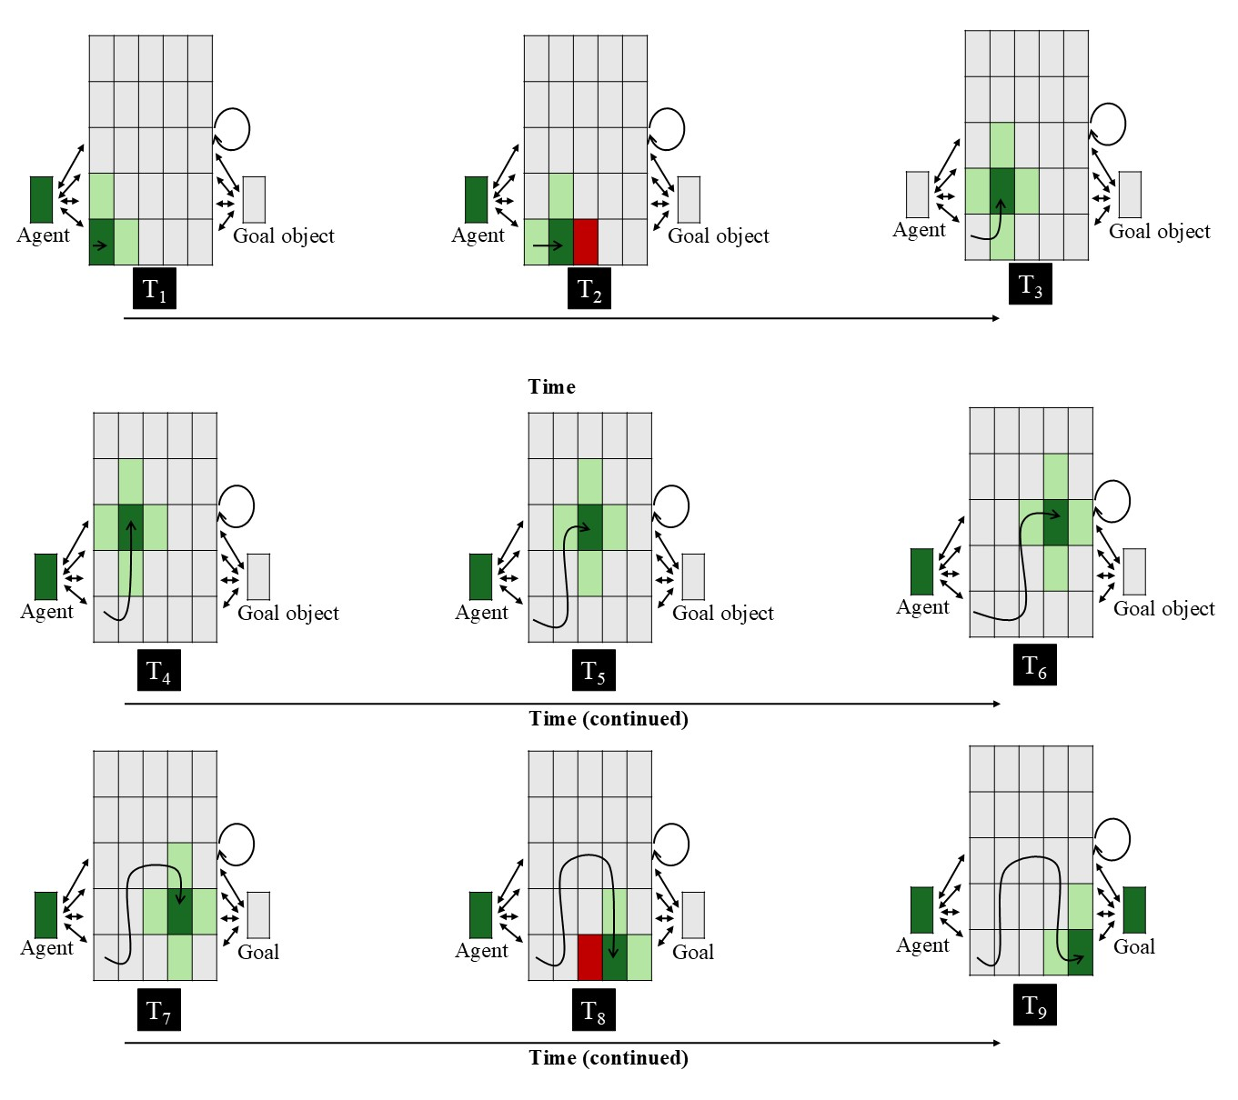
Figure 1. Input patterns shown to OM10 networks in the Experimental condition across nine steps. Each panel represents the input to the network at a given time step. The central 5 × 5 array corresponds to the spatial grid; the two units flanking the spatial grid to the right and left of it correspond, respectively, to the agent and goal objects. Dark green indicates the agent’s current position (+1), light green indicates adjacent cells (+0.5), red indicates the presence of the barrier (-1), and gray indicates no activation (0). The goal unit is activated only at the final step. The barrier is present only when the agent occupies a position immediately adjacent to it (i.e., to its left or right; see Overwalle, 2010). The overlaid curved path in each panel depicts the amount of arc motion the agent has completed through that time step. Two-headed arrows and the circular arrow denote bidirectional connectivity.

To make concrete what the network “saw” during the activation phase, Figure 1 above depicts the full, nine-step arced-motion trajectory that was shown to networks in the Experimental condition; that is, the figure shows the state of the network at each of the nine steps comprising the training event. Three features of this input are particularly noteworthy given their divergence from the nature of the events that infants are shown in action understanding studies. First, the obstacle was only present when the agent was located in a cell that was directly adjacent to it. This contrasts with how obstacles are treated in most, if not all, action understanding studies. In such studies, obstacles, when present, remain fully visible throughout an entire action event. Second, the agent “overshoots” the barrier by one cell. This can be seen by tracing the agent’s arced trajectory. This also departs in important ways from what infants typically see in action events that involve obstacles (though see the simulation corresponding to the target finding associated with Liu & Spelke, 2017): The vertical distance between the apex of the arced motion and the top of the barrier tends to be sufficient for the agent to clear the barrier. Third, the goal object became “visible” to the network only when the agent reached the terminal position of its trajectory. This, too, deviates from the approach taken in most studies on this topic, in which the goal object remains fully visible throughout the duration of an action event. These issues raise critical questions about the basis of the success of Overwalle’s (2010) model in capturing infants’ looking behaviors in Gergely et al. (1995); that is, it is possible that the success of this model stemmed from properties of the input that failed faithfully to implement the events presented to infants rather than from capturing the processes that underlie infants’ action understanding. To assess the importance of and impact on OM10’s overall performance, in all simulations the behavior of OM10 was compared to that of a modified version of the model called OM10-2 as well as to ALIAS. In OM10-2, the agent does not overshoot the barrier and both the barrier and goal object remain present across all time steps. Finally, because there is greater overall network activity in OM10-2 compared to OM10—given that the barrier and goal objects remain visible across all time steps in which they are present—a sigmoid activation was applied to the internal activation. In the absence of this activity function, the stronger recurrent activity in OM10-2 could lead to a situation in which the activity of the network cannot be computed due to unstable network dynamics.
At the conclusion of the first phase, the model entered a second, learning phase. During this phase, the Delta rule (e.g., McClelland & Rumelhart, 1988; Widrow & Hoff, 1960) was used to update the network weights. It is worth noting that the specific form of this rule that Overwalle (2010) employed encouraged the network to reduce the discrepancy between the externally provided state of the environment and the internally generated pattern of activation that emerged over the course of the network’s settling dynamic; more common usages of the Delta rule involve reducing the discrepancy between a target output and the network’s predicted output (e.g., Rumelhart & McCllelland, 1986). As was the case in Overwalle (2010), learning rate was set to 0.10 and the weights were randomly initialized within the range ±0.2.
The final phase that the model entered into was the prediction phase. This phase is the model analogue of the test phase in infant studies on action understanding. As such, the network was shown barrierless straight and arced motion events; as was the case in Overwalle (2010), the straight event lasted 5 steps. Crucially, the internal activation of “critical units” was recorded following network settling. These units corresponded to locations along the two trajectories. The critical cells for the straight trajectory were columns 2-4 in the bottom row of the spatial grid; the cells corresponding to column 2-4 in the third row of the grid comprised the critical cells for the arced motion trajectory. Overwalle (2010) interpreted the magnitude of the combined activation of these units as a measure of the network’s expectation for a given event—greater activation denoted a stronger expectation. However, because the primary dependent measure in infant action understanding studies tends to be looking time rather than expectation, Overwalle (2010) linearly rescaled these activation values such that lower activation (weaker expectation) corresponded to longer looking times and higher activation (stronger expectation) corresponded to shorter looking times (Overwalle, 2010). Because the exact nature of this rescaling was not specified, in the present implementation, this relationship was made explicit by transforming activation values using a simple inverse mapping in which the combined activation of the critical units was subtracted from one. Although the mathematical transformation used here differed from that in Overwalle (2010), the interpretation of the mapping between activation and looking time was preserved: higher activation values on this transformed measure reflect longer looking.
ALIAS. The was a connectionist model that combined an autoencoder (e.g., Mareschal et al., 2000) with a simple recurrent network (i.e., an SRN; e.g., Elman, 1990). Autoencoders are artificial neural networks that learn a compact internal representation at the hidden layer that is sufficient to reproduce input presented to the model at the output layer. This kind of model was chosen because the form of learning that it employs—namely, self-supervised learning that is input-driven rather than driven by an explicit teaching signal—aligns with prominent theories of how infants learn (e.g., Jeffrey & Cohen, 1971; Sokolov, 1963). In contrast, the task of the SRN was to predict an object’s position at the next time point given its current position. However, like an autoencoder, SRNs rely on self-supervised learning. Specifically, in an SRN, the error signal used to update the weights in the network comes from the input itself. An SRN was also used because encoding actions necessarily involves predicting how the kinematics comprising them unfold over time. Networks were trained with backpropagation in cross-entropy error (e.g., Rumelhart et al., 1986).
The network itself consisted of three layers (Figure 2). The input and output layers of the model consisted of the same 11 clusters or groups of units, and both layers used a localist or “one-hot” coding scheme. The main difference between the input and output layers was that the activity of the units in the input layer was “hard-clamped” (i.e., their activity was set externally by the environment), whereas the activity of the output units was determined by a sigmoid activation function. A localist encoding scheme—in which a single unit is used to represent a given concept or feature—was adopted in both layers to ensure that the model’s performance reflected learned relations between surface and kinematic features rather than arbitrary similarity relations among the objects. In contrast, the hidden layer was a single group of 50 units; the activity of the units in this layer was determined by a RELU activation function to prevent error derivatives from vanishing as they were propagated backwards through time. Crucially, the representations that developed over these units were largely distributed. A distributed representation is one in which multiple units code for a given concept, and the same unit could participate in coding different concepts (Hinton, 1984). The fact that the hidden layer learned distributed representations was important here because it meant that the network’s output responses were based on a more diffuse representation rather than a one-hot encoding of the input. In contrast, the output layer used a sigmoid activation function.
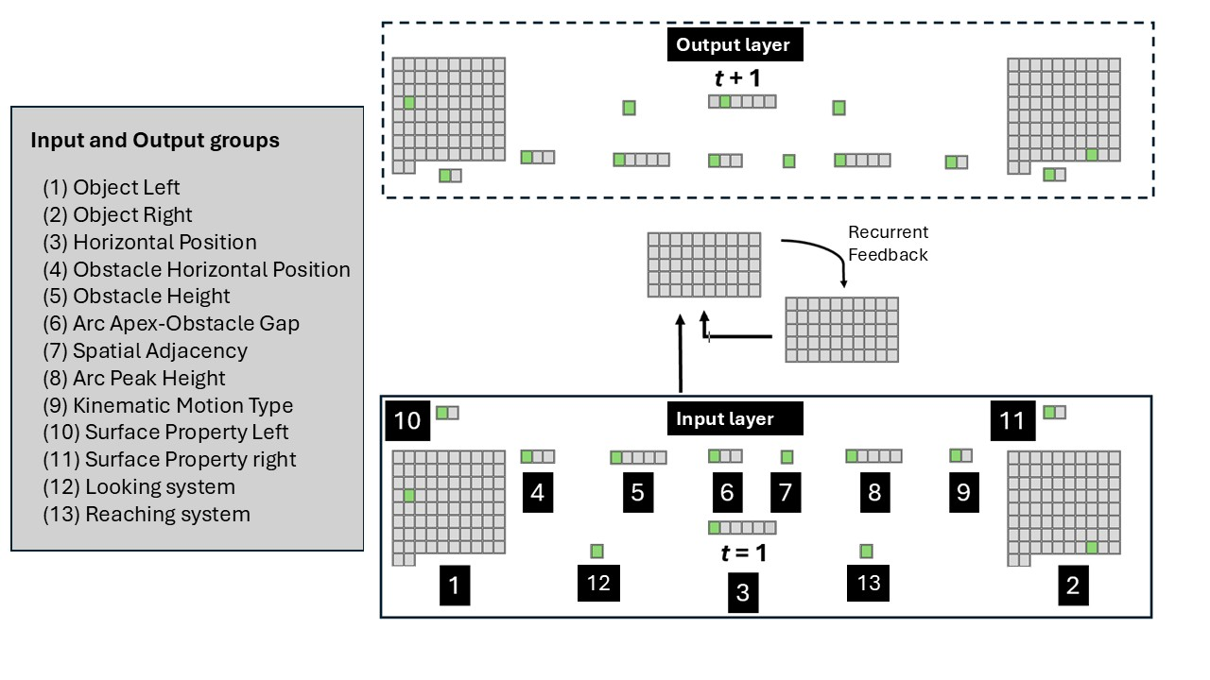
Figure 2. Schematic of an untrained ALIAS. A linear path event is being depicted here, in which one object beginning to move horizontally along a linear path to reach the other object. Looking and reaching by the network is also taking place. The legend on the left provides the names of the input groups and corresponding output groups.

The first two groups in the input layer were Object Left and Object Right. Copies of each input group also appeared on the output side of the model. Two different object groups were used because studies that used the Gergely paradigm tended to use two objects or entities. Crucially, each group consisted of 82 units. One of these groups was located on the network’s “left side” (hence, Object Left); the other group was located on the network’s “right side” (hence, Object Right). A single unit was used to represent a given object. Networks experienced 80 objects during the pretraining phase in the all reported simulations; this phase approximated infants’ real-world experience. Although it was possible to present networks with many more objects during this phase, this number was chosen to simplify the current model and interpretation of its dynamics as well as to keep the training time within reasonable limits. There is no reason to believe that the results reported below would change drastically if more or fewer objects were used. In contrast, the remaining two objects were shown to networks during the habituation and test phases of their corresponding simulation.
Surface Property Left and Surface Property Right were the next input and output groups; both groups consisted of two units. As before, the left-right designation denoted on which side of the network the group appeared. The first unit in either group represented one class of visible, perceptually grounded features (e.g., elongated appendage-like extensions [e.g., legs], high-contrast, ovular elements [e.g., eyes], etc.). This unit corresponds to Surface Feature A. In contrast, the second unit in either group represented a different class of visible, surface features (e.g., rigid and compact [e.g., solid geometric shapes], uniform contour structure [e.g., the smooth, rectilinear edges of a block]). This unit corresponds to Surface Feature B. This way of coding features meant that the object on the left or right possessed Surface Feature A if the first unit of the corresponding right or left Surface Property group had a value of 1. In contrast, the object possessed Surface Property B if the second unit in either of these groups had a value of 1.
A point that is worth noting is that because the current simulations were designed to demonstrate that associations formed among one or more visible features and the kinematics of different actions can explain infants’ looking patterns in studies assessing their putative action understanding, no attempt was made here to model specific surface features. Instead, the first and second units in the Surface Property Left and Surface Property Right groups served, respectively, as placeholders for the surface features possessed by animate entities (e.g., elongated appendage-like extensions) and inanimate objects (e.g., rigidity and compactness); these units did not serve as placeholders for the categories themselves. A chief advantage of not modeling specific surface features is that it eschewed the need to commit to any specific feature. Such a commitment would also be premature given that it would first need to be determined which surface features infants attend to in action understanding studies. The reason such evidence is lacking is that existing accounts have interpreted infants’ looking behaviors in studies on this topic as arising from abstract, conceptually rich notions of action rather than from associations formed over semantically neutral, visible, surface features.
Horizontal Position was the next group of input and output units. This group consisted of six units. Although the network could “see” at any point in time two objects, a single group that captured the horizontal position of either object at any given moment in time was used (for a similar approach, see Benton, 2024 and Rakison & Lupyan, 2008). It should be noted that this group captured the precise horizontal position of the left object at a particular moment in time and relative to the horizontal position of the right object rather than that motion’s type or kinematics; that is, this group represented simply that an object can either move towards or away from another object. On each timestep, a single bit in this layer was active according to the first object’s current horizontal position. In particular, at time t = 1, the activation value of the 1st (or leftmost) unit in this group was set to 1 (the activation values of the remaining units were set to 0), and the network’s task was to activate the second unit (from the left) in the corresponding output group. At time t = 2, the activation value of the second input unit in this group was set to 1 (all other values were set to 0), and the network’s task was to turn on the 3rd output unit (from the left) in the corresponding output group. Horizontal movement continued in this manner until the 5th input unit was activated in the input layer. The network’s job at this point was to activate the 6th unit in the output layer. The type or nature of movement was instead captured by a separate group of input and output units called the Kinematic Motion Type. The first unit in this group was the Linear Path unit; the second unit was the Arced Path unit. Separating these two aspects of motion—that is, horizontal translation from curvature—in this way enabled the model to represent heading direction independently from its geometry and simplified later analyses of the model’s internal dynamics. Nonetheless, it is unlikely that these two aspects of motion are perceived independently in the real world, and a more realistic model would need to simulate linear and arced paths as integrated, dynamic activity patterns. Simulating movement dynamically aligned with how movement unfolds in the real world.
The remaining five input and output groups were a five-unit Obstacle Height group, a five-unit Arc Peak Height group, a three-unit Obstacle Horizontal Spatial Position group, a third-unit Arc Apex-Obstacle Gap group, and a one-unit Final Adjacency group. The five units in the Obstacle Height group represented progressively larger obstacles (i.e., Obstacle Height 0 through Obstacle Height 4). Similarly, the five units in the Arc Peak Height group represented curved motions or arcs that became increasingly higher (i.e., Arc Peak Height 0 through Arc Height 4). Note that Obstacle Height 0 corresponds to the absence of an obstacle. The same is true for Arc Peak 0, which represented the absence of curved or arced movement. In the simulations reported below, Arced Peak and Obstacle Heights mostly aligned with one another (though see Simulations X). The first unit in the Obstacle Horizontal Spatial Position group corresponded to the Obstacle Missing unit, whereas the remaining two units corresponded, respectively, to Obstacle Middle (i.e., the obstacle was positioned in the middle of the screen) and Obstacle Side (i.e., the obstacle was positioned to one of the two sides of the screen) units. In terms of the three-unit Arc Apex-Obstacle Gap group, the first unit was No Vertical Separation (which occurred when an object did not engage in arced motion), the second to Small Vertical Separation (which occurred when the vertical distance between the apex of the arced motion and the top of the obstacle was small), and the third to Large Vertical Separation (which occurred when the vertical distance between the apex of the arced motion and the top of the obstacle was large). The single unit in the Final Adjacency group encoded whether the first and second object were spatially abutted at the end of a motion sequence. This unit was turned on only if this was true. The rationale for this naming scheme was to emphasize each group’s surface-level, perceptually grounded, and conceptually neutral nature.

Pretraining
A key assumption of the current theoretical proposal is that infants’ looking behaviors in studies that putatively measure their action understanding are based on real-world experience processing and encoding the kinematics of different movements, the perceptual or surface-based appearance of the different objects and entities that engage in those movements, as well as the associative relations among these perceptually-grounded elements. To implement this aspect of the proposal in the model, networks experienced two different kinds of events during a model analogue of the real-world experience—this experience is what infants are assumed to bring with them into action understanding studies. Here, I refer to this aspect of a network’s experience as the pretraining phase—all networks, regardless of simulation, received identical pretraining experience. In Linear Path pretraining events, one of the objects translates or moves linearly along a horizontal motion path towards the other object. This event was instantiated by activating one of the 82 units in each of the Object Left and Right input groups; the Linear Path unit in the Kinematic Motion Type input group; the Obstacle Height 0 unit in the Obstacle Height input group; the Arc Peak Height 0 unit in the Arc Peak Height input group; the Obstacle Missing unit in the Obstacle Horizontal Spatial Position group; the No Vertical Separation unit in the Arc Apex-Obstacle Gap input group; and the single unit in the Final Adjacency input group. In the Arced Path pretraining events, one of the objects moved horizontally along an arced path towards and over an obstacle until it came to rest next to a second object. This event was instantiated by turning on one of the 82 units in each of the Object Left and Right input groups; the Arced Path unit in the Kinematic Motion Type input group; the Obstacle Height 1 unit in the Obstacle Height input group; the Arc Peak Height 1 unit in the Arc Peak Height input group; the Obstacle Middle unit in the Obstacle Horizontal Spatial Position group; the Small Vertical Separation unit in the Arc Apex-Obstacle Gap input group; and the single unit in the Final Adjacency input group. Recall that the network’s task for both types of events was twofold. First, the network needed to reconstruct the full pattern of input activation at the output layer by activating the corresponding units in each output group. Second, the network simultaneously needed to predict the horizontal position of the objects at time t + 1 given their position at time t.
To instantiate the assumption that things with different surface features can move along arced (e.g., an object with elongated appendage-like extensions [e.g., a sibling] jumping over a toy left on the floor or a plastic cup being tossed into a bin) or linear (e.g., an object with elongated appendage-like extensions moving swiftly along a horizontal path towards another similarly-feature object [e.g., mom] or a rigid, small object [e.g., toy car] with paired circular elements [e.g., wheels] moving horizontally along a linear path across the floor) motion paths, within each type of Linear or Arced Path event, half of the objects possessed one set of surface features (i.e., Feature A in the Surface Property groups) and half possessed the other set (i.e., Feature B in the Surface Property groups).
Other key assumptions of the present theoretical account are that obstacles visually are more salient when they are spatially contiguous with arced motion than when they are located in the periphery and the vertical distance between the apex of arced motion that occurs over obstacles and the top of obstacles themselves is small (i.e., objects do not overshoot barriers when passing over them). The first of these remaining assumptions was implemented by lower the learning rate and increasing the weight decay on the incoming and outgoing links to the Obstacle Height and Obstacle Position groups. The specific value used for the learning rate was 1×10⁻⁴; the value used for the weight decay was 0.1. These values were kept constant across all simulations. The theoretical relevance of learning rate is that it is a parameter that controls the speed at which the weights in the network adapt; larger learning rates lead to more rapid weight changes and hence faster learning. In contrast, weight decay controls how “big” the weights are allowed to grow; lower values for this parameter correspond to larger weights. Typically, learning rate and weight decay are values less than 1. The decision to implement salience via these parameters aligns with past connectionist modeling work (e.g., Benton, 2024; Singh et al., 2025). The last assumption was instantiated by turning on the Small Vertical Separation unit in the Arc Apex-Obstacle Gap group whenever arced motion occurred over barriers.
Given that the studies associated with each of the five target findings tested infants at different ages, across the simulations presented here, the length of the pretraining phase was varied in such a way that simulations corresponding to studies that tested older ages received proportionally more pretraining than simulations of studies that tested younger infants. In particular, the length of the pretraining phase was set to 900 for simulations of target findings typically associated with studies that tested 12-month-olds (e.g., Gergely et al., 1995; Csibra et al., 2003), to 675 for simulations of studies that tested 9-month-olds (e.g.., Csibra et al., 1999), to 450 for simulations of studies that tested 6-month-olds (e.g., Liu & Spelke, 2017), and to 225 for simulations of studies that tested 3-month-olds (e.g., Skerry et al., 2013). As with pretraining duration, the learning rate for connections that did not instantiate a particular theoretical assumption varied systematically across simulations in accordance with the “age” of the model. Specifically, a higher value for this parameter was used for older models than younger models; this value was ranged from 0.1 for the oldest models to 0.05 for the youngest models. This implemented the assumption that processing speed improves with age. The habituation phase always followed the pretraining phase and lasted between 8 and 12 epochs in step sizes of 1 (see below for details about the nature of the habituation experience for a given simulation). Different numbers of habituation epochs were used to ensure that the results reported below were robust to particular values of this parameter.
The dependent measure used in these simulations was network (cross-entropy) error (Hinton, 1989). This is consistent with existing developmental models. As is typical in simulation studies that use autoencoder models like the current one (e.g., Benton, 2024, 2026; Benton & Lapan, 2021; Benton & Rakison, 2019; Mareschal et al., 2000; Quinn & Johnson, 2000; Rakison & Lupyan, 2008; Twomey & Westermann, 2016), it is common to treat error as a proxy for looking such that greater network error corresponds to longer looking. To understand why such an interpretation is merited, it is instructive briefly to consider the relation between existing proposals of what looking behavior means in habituation studies and the nature of learning in autoencoder models. According to one high-profile model that continues to influence how developmental cognitive scientists construe infant looking (Sokolov, 1963), habituation is a process in which a learner’s internal representation of an external stimulus is gradually adjusted until there is a meaningful match between it and the external stimulus. Given that time is needed for an internal representation to be constructed, during the first few trials of the habituation phase there will be a discrepancy between this representation and the external stimulus. A consequence of this is that infants will continue attending to—and thus refining their internal representation of—the external stimulus. It is only when the discrepancy between infants’ internal representations of an external stimulus and the external stimulus itself is resolved that infants are thought to disengage from the external stimulus and turn their attention elsewhere.
An analogous process occurs in autoencoder models. Recall that these models are tasked with reproducing at the output layer the input that is presented to the model. This input is akin to an external stimulus. To achieve this objective, these networks must gradually adjust their “hidden” representations until they are sufficient to reproduce that input at the output. These hidden representations are akin to the model’s internal representation of the input. Given that learning continues until the network is able reliably to reproduce the input at the output layer, network error will remain high (much like infant looking to an external stimulus will remain high) until the discrepancy between the input and the model’s representation of it is resolved.
The aims of the following simulations were threefold. The first—and most important—aim was to determine whether ALIAS—a connectionist computational instantiation of the current proposal—is sufficient to account for a range of key findings in studies that putatively assess infants’ action understanding. The second aim was to assess whether, and in what contexts, ALIAS provides a better account of these findings than the only other connectionist model on this topic, OM10, and an extension of this model that more faithfully encodes experimental set-up of action understanding studies, OM10-2. Given that the current account assumes that the spatial arrangement of barriers and arced motion has important implications on how infants process action events, the final aim was to determine whether it was necessary to assume that peripherally located obstacles espouse reduced salience. To this end, the performance of ALIAS was compared to a version of this model that did not implement such differential salience, ALIAS-2. If ALIAS provides a better account for the five findings that are the targets of the current series of simulations than ALIAS-2, then this would suggest that salience is a key player in networks’ performance than it is a modeling convenience.
All simulations were run using the Lens neural network simulator (Rohde, 1999). The full set of training and testing files, including data from the simulations reported here, are available for download at https://osf.io/9eqpf/?view_only=62f752417a9141c7b0509a998039ad13.

Simulation 1a: Selective longer looking to inefficient than actions following constrained.
Early studies on infant action understanding showed that, following habituation to an event in which an object with visible surface features typical of animate entities pass over a barrier along an arced path, infants looked longer at a test event in which that same object continues to move along the arced path in the absence of the barrier than when it moves along a straight path. Subsequent control experiments revealed that infants looked equally long at both test events for a peripherally located obstacle. Simulation 1 tested whether ALIAS could capture this finding. To assess how much better ALIAS accounts for this finding compared to existing connectionist models of action understanding, ALIAS’s performance was compared to OM10, OM10-2, and ALIAS-2.
Networks were assigned either to the Experimental condition (N = 20) or to the Control condition (N = 20). Twenty networks were assigned to each condition for both versions of OM10 (N = 40). Given that the “looking” performance in the main model was assessed at each of five different “habituation” epochs and across two conditions, a total of 400 networks were tested in ALIAS (N = 200) and ALIAS-2 (N = 200). The habituation event shown to networks in the Experimental condition mirrored the Arced Path pretraining events with two exceptions. First, novel objects were used. Because the finding that was the target of the current simulation was generated by experiments that used animate stimuli and given that it is assumed here that animate entities and inanimate objects possess largely surface features (e.g., elongated appendage-like extensions for animate entities and smooth, rectilinear edges for objects), the objects used in this simulation possessed Feature A. To ensure that networks’ looking behaviors in the current simulations were not due to prior experience with a particular arc or obstacle height, the fourth unit rather than the second unit was turned on in the Obstacle Height and Arc Peak Height groups. Networks were then shown straight and arced path test events involving the habituation objects. The former event corresponded to the Efficient test event; the latter event corresponded to the Inefficient test event. Both events were shown without the obstacle and used the same objects from habituation.

Results and Discussion
Figure 3 shows the looking time data—operationalized as network error—for ALIAS overall (i.e., averaged over different lengths of habituation; left) and for different amounts of habituation (right). This table reveals two notable takeaways. First, ALIAS successfully reproduced the first of the five target findings. Specifically, networks assigned to the Experimental condition produced greater error to (i.e., looked longer at) the Inefficient test event than at the Efficient one. In contrast, networks in the Control condition looked about equally long at both test events. Second, this looking pattern held for different amounts of habituation. This suggests that ALIAS’s success was robust to habituation length, at least within the range of lengths used here.

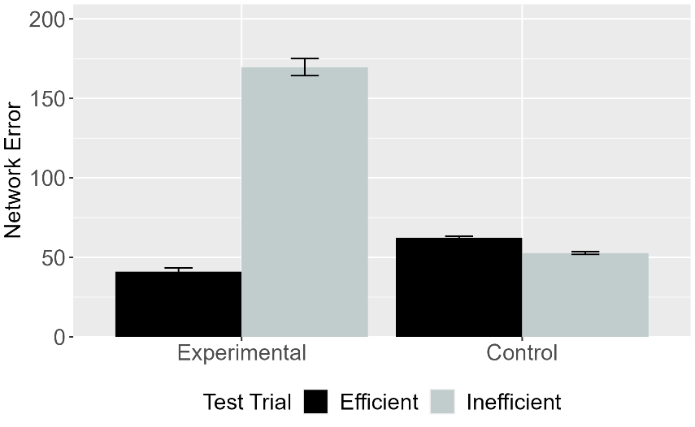 | 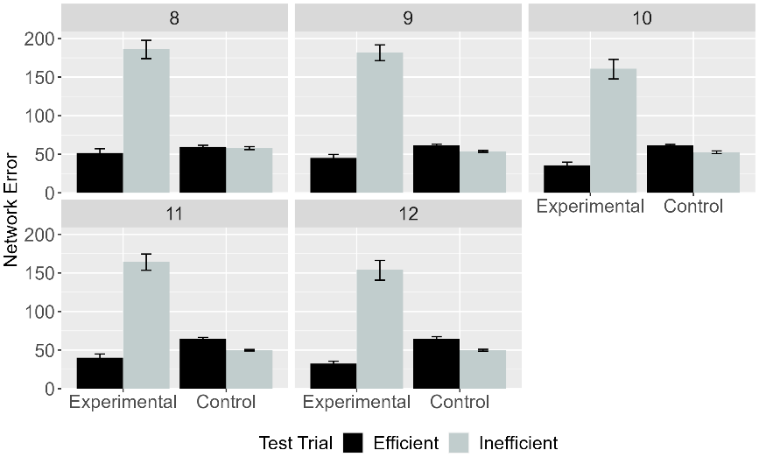
Figure 3. Mean network error produced to the Efficient and Inefficient test events in the Experimental and Control conditions collapsed across habituation epochs (left panel) and for different lengths of habituation (right panel) or collapses over these different lengths (right panel). Data shown here were generated by ALIAS.

Figure 4 shows the same overall looking time data for ALIAS as that shown in Figure 3 as well as the looking responses of OM10. As shown in the figure, both networks reproduced the first target finding, although it is clear from the figure that the difference in error between the Inefficient and Efficient test events was larger for ALIAS than for OM10. A different pattern emerged for networks in the Control condition in both models. Specifically, in both models, networks assigned to this condition overall looked equally long at both conditions. The fact that ALIAS succeeded in qualitatively reproducing the first target finding suggests that the theoretical account that it implements is sufficient to capture such looking behavior. OM10’s ability qualitatively to reproduce infants’ looking times in both conditions as well is perhaps not surprising given that it was built specifically and independently shown to capture the first major finding. Yet, as noted in the Introduction, it is possible that OM10’s success reflects a failure to model key features of the design of some of the early studies on infant action understanding rather than to its ability to capture the processes supporting action understanding.

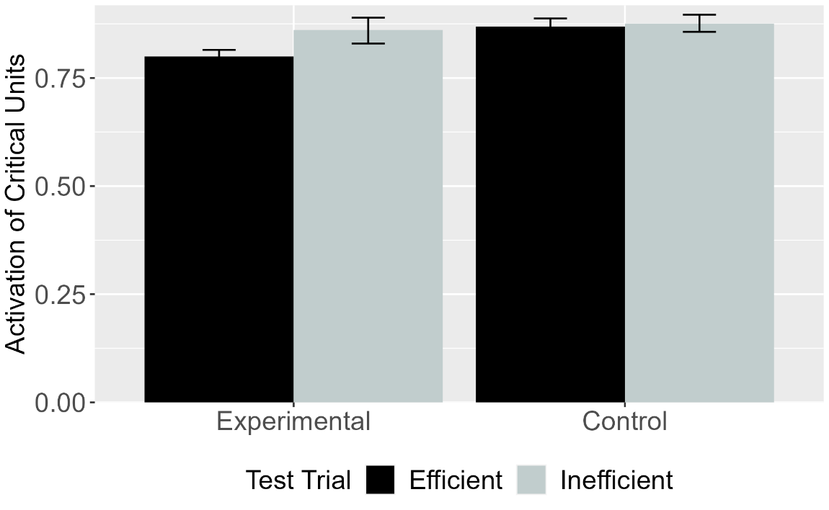
Figure 4. Mean activation of the critical units produced to Efficient and Inefficient test events in the Experimental and Control conditions for OM10. Error bars represent standard errors.

To assess whether OM10’s performance is an artifact of these design choices, OM10’s performance was compared to that of a modified version of this model, OM10-2. It will be recalled that in this version of the model, the agent no longer overshoots the barrier and both the barrier and goal remain fully visible across all time steps. Figure 5 shows the looking time data of OM10 (replotted) and OM10-2. There are two important takeaways from this figure. First, OM10-2 model—which more faithfully captures the experimental details of studies associated with the first target finding) than OM10—fails qualitatively to capture the first target finding. Second, OM10-2’s pattern of looking is the mirror reversal of that of OM10; that is, networks in the Control condition, but not those in the Experimental condition, looked longer at the Inefficient test event than at the Efficient test event.

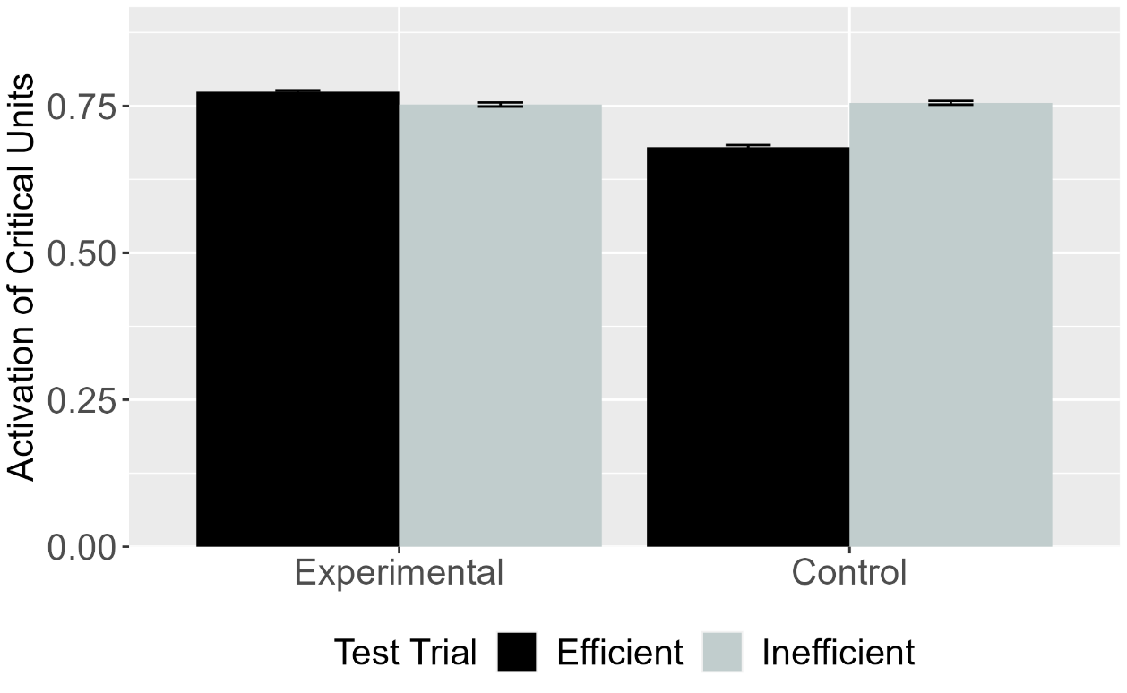
Figure 5. Mean activation of the critical units produced to the Efficient and Inefficient test events in the Experimental and Control conditions for OM10-2.

Given that a key assumption of ALIAS is that barriers that are located in the periphery of a visual scene are less salient than those located beneath arced motion trajectories—which has consequences for the strength or the magnitude of the association that is formed between them—the final analysis compared the performance of ALIAS to a version of this model that did not implement differential salience. Data for this analysis is shown in Figure 6. Although both models showed similar patterns of looking in the Experimental condition, their patterns of looking diverged in the Control condition. Specifically, although the difference in time spent looking at the two test events was smaller in this condition than in the Experimental condition in both models, only networks in ALIAS-2 looked longer at the Inefficient test event than at the Efficient one. Such reduced but still longer looking to the Inefficient to the Efficient test event can be traced to how salience was implemented in the current simulations and its absence in ALIAS-2. Recall that salience was implemented by reducing the learning rate of and applying weight decay to the weights linking the model’s internal representation to the barrier input and output information.

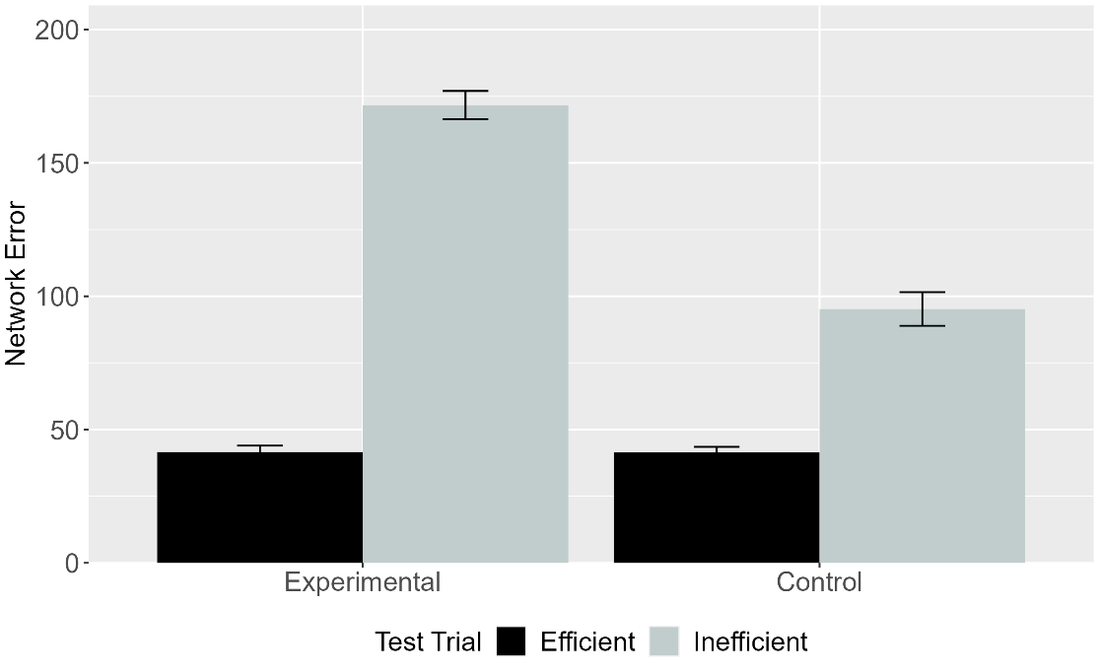
Figure 6. Mean network error produced to the Efficient and Inefficient test events in the Experimental and Control conditions for ALIAS-2.

This way of implementing salience meant that any association that is established between arced motion and obstacles should not only be weaker for models that implemented differential salience than those that did not but that the models should differ in the “pattern” of looking following exposure to events that are inconsistent with prior experience. One example of such an event is that shown to networks in the Control condition, in which objects move horizontally along an arced path and over a barrier. This barrier-motion information event contrasts with that encountered during pretraining; networks learned that arced motion occurs over rather than besides obstacles during that phase. Because there is nothing that prevents networks that lack differential salience from forming robust associations between arced motion and peripherally located barriers, these networks will readily associate them irrespective of their relative spatial positions. Yet, because such learning involves modifying the very same set of connections that embody knowledge that arced motion occurs over obstacles, the new information presented to the model during habituation will be learned at the expense of the barrier-motion information encountered—and learned—during pretraining; that is, some amount of the barrier-motion information that was acquired during the pretraining phase will be unlearned during habituation.
Crucially, because the length of the habituation phase is necessarily shorter than the pretraining phase and the barrier-motion information presented during habituation conflicts with that encountered during pretraining, the association that is established between obstacles and arced motion will be weaker than what it would be if the habituation and pretraining phases were comparable lengths and the information presented to networks in both phases was compatible. What this means for the looking behavior of networks in the Control condition during the test phase is that the presence of one component of the relation (i.e., arced motion) will not activate as strongly the representation—at the hidden layer—of the other component (i.e., obstacles). The fact that the hidden representation is reactivated means that networks in ALIAS-2 will look longer at the Inefficient test event than at the Efficient one. Yet, because such activation is dampened means that the difference in looking to the Inefficient and Efficient test events will be smaller for networks in the Control condition than that for networks in the Experimental condition. The fact that ALIAS outperformed ALIAS-2 suggests that differential salience is necessary for ALIAS to reproduce the full pattern of data.
Simulation 1a was designed with three goals in mind. First, it tested whether infants’ performance in action-understanding studies that use animate-like entities can be explained by an associative learning mechanism that operates over the low-level, perceptually grounded kinematics of motion and the surface features of the objects involved. Second, it compared the performance of a computational instantiation of this proposal in a model called ALIAS to that of OM10 and an extended version of this model that more faithfully captures the experimental set-up that infants experience in action understanding studies called OM-10. Third, it tested the internal coherence of a key assumption of the present account: Infants’ looking behaviors in action understanding studies is based, at least in part, on how obstacles and arced motions are positioned relative to and thus associated with one another. The critical idea here is that obstacles located peripherally to a salient motion trajectory should be less visually salient than those located directly beneath arced motion trajectories. Such reduced salience of peripherally located obstacles should not only lead to much weaker learned associations between them and arced trajectories but to a more diminished expectation for one of the components of this association (e.g., obstacles) given the other component (e.g., arced motion) compared to when obstacles are positioned beneath the trajectories. This leads to the prediction that infants habituated to a constrained jumping event should show a greater increase in looking to a barrierless arced motion test event than infants habituated to an unconstrained jumping event.
The main result of this simulation was that ALIAS succeeded in explaining infants’ looking in Gergely et al. (1995). This model, like infants, looked longer at (i.e., produced greater error to) the Inefficient test event than at the Efficient one following habituation to an event in which arced motion occurred over an obstacle; networks looked equally long at both test events if the arced motion occurred beside the barrier during habituation. The fact that ALIAS-2—which, unlike ALIAS, omitted differential obstacle salience—produced responses that differed from those of ALIAS suggests that associative learning alone is not, by itself, sufficient to account for the looking behavior of infants in Gergely et al. (1995); information pertaining to the salience of barriers in different spatial positions needed also to be included to explain the full pattern of data. explain infants’ performance across the conditions in Gergely et al. (1995). to reproduce infants’ responses in studies like that by Gergely et al. (1995). Although it was the case that OM10—like ALIAS—captures infants’ looking responses in Gergely et al. (1995), it is notable that an extended version of this model that better aligned with Gergely et al’s (1995) task structure in its design could not capture infants’ looking responses. This suggests that OM10’s original success may have had less to do with it capturing the processes underlying infant action understanding and more to do with the fact that it did not faithfully model the experimental set up in Gergely et al. (1995). This suggests that it is prudent to interpret any success that OM10 has in reproducing infants’ looking behaviors in the subsequent simulations with caution.
Although ALIAS’s success suggests that the present account is at least sufficient to capture infants’ looking behaviors in Gergely et al. (1995)—it has yet to be shown that ALIAS can capture data in other Gergely-style action-understanding studies—it was nevertheless important independently to confirm that the actual mechanism through which the model reproduced these looking behaviors aligned with the proposal that it implemented. Clarifying the manner in which the model reproduced infants’ looking responses across the Experimental and Control conditions in Gergely et al. (1995) is also important because it can provide insight into how associative learning might have operated in infants’ minds to drive their looking responses in this study. In the model, event processing began during the pretraining phase. It will be recalled that during this phase networks were repeatedly exposed to events in which agents move along either straight or curved trajectories to reach other objects or agents. In the model, environmental events were implemented in the model as a pattern of activation that were distributed across the model’s various input groups (e.g., Barrier Position, Motion Type, Jump Height, Clearance). Because, at the outset of the pretraining phase, it is necessarily the case that the model’s weights have not been tuned through learning, the pattern of activation that these input events elicit at the hidden layer will be largely random and unable to reproduce this input at the output layer as well as predict the future location of an agent. However, as the network accrues more experience with these different actions and the input and output patterns of activity begin to align, its hidden-layer representation of straight and curved motion events will become increasingly more distinct.
A critical feature of these hidden representations is that not only do they encode different kinds of motion in an action event, but they also come to capture the various surface features that reliably co-occur in those events. Because Curved Motion, Jump Height, and Barrier Height are examples of features that appear frequently together, they will become indirectly associated via the shared hidden-layer representation. The fact that these associations have hundreds of epochs to develop means that, at some point when the strength of these associations is sufficiently robust, presentation of one feature at test (e.g., Curved Motion) can reactivate other features with which it was previously associated (e.g., Barrier Height) either during pretraining or habituation. It will turn out that this reactivation process is vital to understand the network’s test behavior.
To illustrate, consider the Experimental condition in the first simulation. As was true for infants in this condition, networks were habituated to an event in which an animate-like object jumped over a centrally located obstacle along an arced trajectory. Although some features of this event were novel relative to that experienced during the pretraining phase—for example, the height of the jump as well as the barrier over which it occurred differed from that encountered during pretraining—many of these features were familiar. Curved motion itself along with an obstacle located beneath it are two such features that were experienced during the pretraining phase. Given that the obstacle was again located beneath an agent’s curved motion trajectory during pretraining, the model’s experience during habituation served to reinforce the learned association between obstacles and the arced motion occurs over it. This means that the only truly new information that needed to be incorporated into the model’s hidden representation during the habituation phase was the novel jump and barrier heights. A consequence of this is that when networks are later shown a high, curved jump during the Inefficient test event, the representation of the barrier that became associated with it during the habituation phase is reactivated. However, because no actual barrier appeared during this event—despite its representation being active during it—the network produced a huge spike in error. By contrast, because the Efficient test event depicted a straight motion trajectory that networks had repeatedly experienced during pretraining, the spike in error was much less substantial.
These same associative ideas can also explain how, mechanistically, networks in the Control condition came to look about equally long at both test events. In this case, because the barrier was located beside rather than beneath the curved jump during habituation—and given that the present account assumes that peripherally located barriers possess reduced salience—the model formed only a weak association between arced motion and the peripheral barrier during the relatively brief habituation phase. Ultimately, this association was insufficient to compete with or replace the stronger association between arced motion and centrally located barriers that had been established during pretraining. A corollary of this is that the model showed comparable error to both test events given that neither one strongly violated its learned representation.
In sum, the reason networks looked longer at the Inefficient test event than at the Efficient test event in the Experimental condition is because the association that was formed between curved motion and obstacle-related information during pretraining—and that was subsequently reinforced during the habituation phase—was violated when curved motion occurred in the absence of the expected barrier. By contrast, the reason networks in the Control condition looked about equally long at both test events is because the reduced salience of the peripheral obstacle prevented robust associations from forming between the obstacle and the arced trajectory during habituation. Taken together, these findings suggest that infants’ looking behavior in Gergely-style studies may be explained in terms of learned associations among perceptual features combined with assumptions about the visual salience of those features. A more extended discussion of the mechanism underlying the model’s behavior was provided here because many of the same associative principles described in the current simulation will also explain how ALIAS reproduces the target behaviors in the remaining simulations. As such, establishing how these principles operate here makes it possible for subsequent discussions of the model’s behavior to be more abbreviated.
Although the current results challenge the claim that infants possess a domain-specific system that enables them to reason about actions in terms of their efficiency and rationality, they nevertheless raise one potential concern: This is that the network’s “real-world” experience may have been much purer than that of infants. The specific concern here is that, in the current model, arced motion never occurred in the absence of obstacles during pretraining. By contrast, it seems likely that infants observe instances of arced motion in the absence of physical obstacles (e.g., when an older sibling joyfully skips around the yard or a cousin plays the “Floor is Lava”). Thus, before it can be concluded that ALIAS provides a plausible explanation of infants’ looking performance in action understanding studies broadly rather than being limited to capturing the first target finding, it is important to demonstrate the robustness of ALIAS’s performance in a simulation that varies the ratio of constrained (i.e., with a barrier) to unconstrained (i.e., without a barrier) arced motion during pretraining. Simulation 1b addressed this issue. Subsequent simulations will address several remaining issues.

Simulation 1b
The main difference between this simulation and Simulation 1a was that here the ratio of constrained arced motion to unconstrained arced motion varied across networks. Six different ratios were used, and each corresponded to a different condition: 100% constrained vs. 0% unconstrained; 90% constrained vs. 10% unconstrained; 80% constrained vs. 20% unconstrained; 70% constrained vs. 30% unconstrained; 60% constrained vs. 40% unconstrained; and 50% constrained vs. 50% unconstrained. Here, a given ratio reflects the proportion of time during pretraining that networks experienced the corresponding motion. To illustrate, consider the “60% constrained vs. 40% unconstrained” condition. In this condition, arced motion occurred with obstacles 60% of the time; the remaining 40% of the time, arced motion occurred alone. Parametric variation of the ratio of constrained to unconstrained arced motion was used here because there is no clear way empirically to derive the true proportion of each kind of event in the real world; however, because the true estimates likely fall within the range of proportions tested here, the results reported below should provide a reasonable approximation of infants’ expected responses across this parameter range.
Two final notes are worth making before proceeding. First, the “100% arced motion with obstacles vs. 0% arced motion without obstacles” condition served as a direct replication of Simulation 1a. As with networks in that simulation, networks in this condition never experienced arced motion without obstacles. All other aspects of this simulation were identical to Simulation 1a. Second, because this simulation was designed to assess the robustness of ALIAS’s responses and given that OM10 (and its extension, OM10-2) does not model infants’ real-world action-processing experience—this is a model of a typical action understanding study itself—ALIAS’s performance was not compared to that of OM10. Although such experience was integral component of ALIAS-2, the performance of this model was not compared to that of ALIAS. The principal reason is that this model failed to capture infants’ looking behaviors across conditions, despite the fact that the relation between arced motion and obstacles was fully deterministic during pretraining.

Results
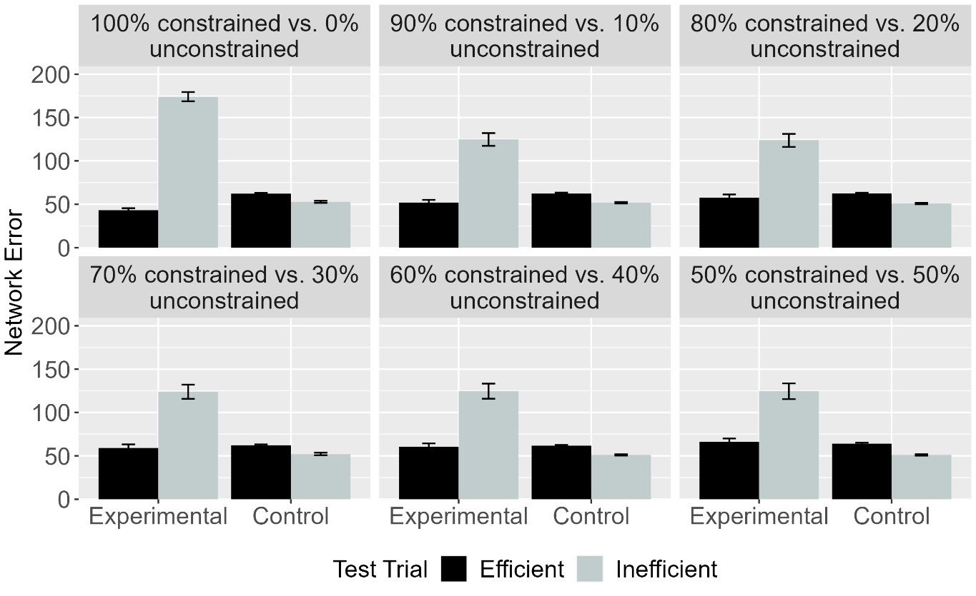Figure 7. Mean network error produced to the Efficient and Inefficient test events in the Experimental and Control conditions across different ratios and averaged over habituation epochs.

Figure 7 depicts the looking time data (i.e., error) for networks in ALIAS across different ratio conditions and averaged over different lengths of habituation. As shown in the figure, networks in the Experimental condition looked longer at the Inefficient test event than at the Efficient event irrespective of the ratio condition to which they were assigned. In contrast, networks in the Control condition looked about equally at these two test events; this result also did not depend on the ratio condition to which networks were assigned. These results suggest that ALIAS test performance is robust to the amount of constrained and unconstrained arced motion experienced during pretraining, at least for the ratios tested here.

Discussion
One concern that Simulation 1a raised was that ALIAS may have succeeded in capturing infants’ looking behaviors in Gergely et al. (1995) simply because this model never encountered unconstrained arced motion during pretraining. The problem here is that infants’ own real-world, action-processing experience likely involves some amount of unconstrained arced motion. This means that any model claiming to provide a veridical account of infants’ looking-time behavior in action understanding studies must also be able to reproduce such behavior even when its prior experience includes both constrained and unconstrained arced motion. This would demonstrate that ALIAS’s performance in Simulation 1a did not depend on a fully deterministic mapping between curved trajectories and the presence of obstacles.
Simulation 1b addressed this concern by systematically varying the amount of constrained and unconstrained arced motion that networks experienced during pretraining and assessing whether ALIAS would continue to capture infants’ looking responses to inefficient and efficient test events across these ratios. The results showed that, irrespective of how much prior experience networks had with constrained and unconstrained arced motion, those in the Experimental condition looked longer at the Inefficient test event than at the Efficient test event, whereas those in the Control condition looked about equally long at both events. These results indicate that the performance of ALIAS in Simulation 1a was robust to the precise amount of constrained and unconstrained arced motion with which it was presented during pretraining and does not depend on a deterministic mapping between curved trajectories and obstacles. One notable feature of these results—which can be seen clearly in Figure 7—is that the magnitude of the difference in the amount of time that networks in the Experimental condition looked at the two test events was largely unaffected by the ratio of constrained to unconstrained arced motion. This facet of the data is notable because it might be expected that this difference should decrease as the proportion of unconstrained arced motion increases. The reason the difference in looking to the Inefficient and Efficient test events remained relatively stable across ratios was simply because the network was habituated to a constrained arced motion event. A consequence of this was that, even when networks experienced equivalent amounts of constrained and unconstrained arced motion during pretraining, the arced motion-obstacle association was strengthened.
Although this simulation demonstrated that ALIAS’s performance in Simulation 1a did not hinge on a deterministic mapping between arced motion and obstacles, it remains to be seen whether ALIAS provides a veridical account of infant action understanding. One way to address this issue is to show that ALIAS can capture each of the four remaining findings. Simulation 2 took a first step in this direction by assessing whether ALIAS could capture the second target finding. This is the finding that infants’ looking responses in action understanding studies do not depend on whether the entities involved are animate. The objects used in this simulation—unlike those used in Simulation 1a—did not possess surface features typical of animate entities; instead, the objects possessed features typical of inanimate objects. A second difference between this simulation and the earlier ones is that because the performance of OM10 (and OM10-2) in Simulation 2 would be identical to that in Simulation 1a—given that neither model has a means for representing whether an object possesses animate- or object-typical surface features—Simulation 2 only focused on the behavior of ALIAS and ALIAS-2. OM10 and OM10-2’s inability to represent the surface features of different kinds of entities should be considered yet another weakness of this model.

Simulation 2
Simulation 2 was identical to Simulation 1a with two key exceptions. First, the objects used during habituation and test did not possess surface features associated with animate entities. To that end, the second rather than the first unit was activated in the Surface Property Left and Right groups during habituation and test. As was also true in Simulation 1a, ALIAS’s performance was compared to OM10, OM10-2, and ALIAS-2. By habituating networks to objects that possessed features typical on inanimate objects, it was possible to determine whether ALIAS’s behavior in Simulations 1a and 1b depended on objects possessing features typical of inanimate objects during habituation and test. Second, the length of the habituation phase was shortened from 900 epochs to 675 epochs. This decision was justified by the fact that the finding that animate cues are not necessary for infants to process actions in terms of their efficiency comes from research with younger infants, namely, with 9-month-olds (e.g., Csibra et al., 1999).

Results
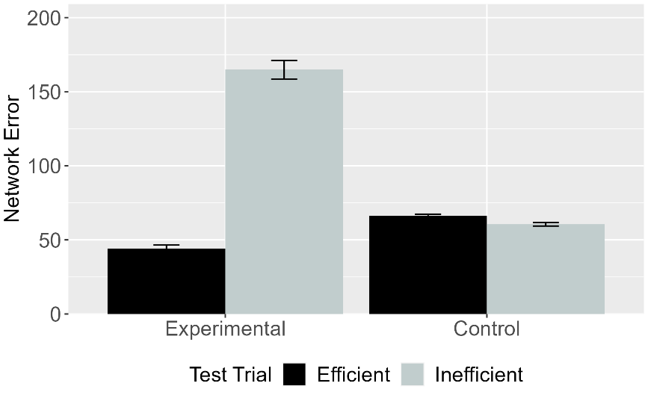 | 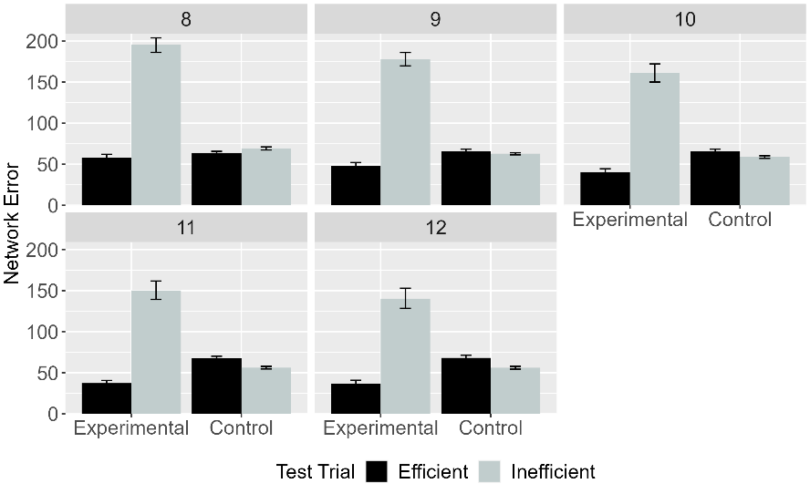
Figure 8. Mean network error produced to the Efficient and Inefficient test events in Simulation 2 across conditions overall (left panel) and across different habituation epochs (right panel).

Figure 8 depicts the mean network error produced to the Efficient and Inefficient test events for the Experimental and Control conditions overall and across the training epochs. As can be seen, networks assigned to the Experimental condition looked longer at the Inefficient test event than at the Efficient test event. This was true both overall and across training epochs. In contrast, and as was true for Simulations 1a and 1b, networks in Control condition looked about equally long at both test events both overall and for different habituation lengths.

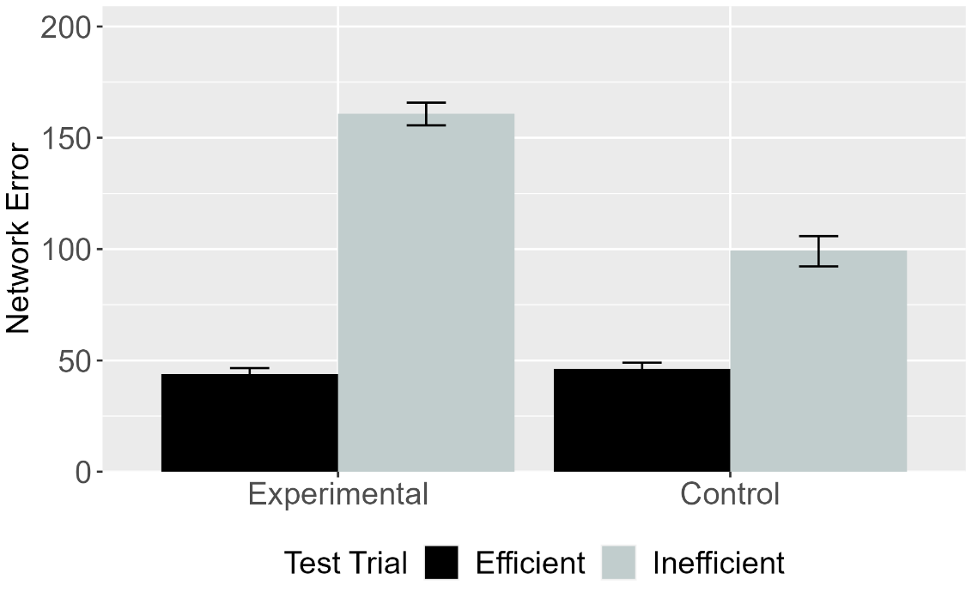
Figure 9. Mean network error produced to Efficient and Inefficient test events in the Experimental and Control conditions for ALIAS (left panel) and ALIAS-2 (right panel).

Figure 9 contrasts ALIAS’s overall performance with that of ALIAS-2. As was true in Simulation 1a, ALIAS-2 failed to capture infants’ looking behaviors across conditions. This finding reinforces the contention that associative learning alone is insufficient to reproduce infants’ looking behaviors in actions-understanding studies; instead, it is necessary that peripherally located obstacles have lower salience than obstacles located beneath arced motion trajectories for ALIAS to capture the complete pattern of looking responses. The explanation that was provided earlier for why the difference in looking to the Inefficient and Efficient test events is lower in the Control condition than in the Experimental condition for ALIAS-2 also applies here. The idea is that because the association between barriers and arced trajectories will be weaker when those barriers are peripherally located than when they occupy the same region of space, it will be the case that networks will show less heightened looking to test events that violate those associations.

Discussion
Simulation 2 tested whether ALIAS could capture a second target finding in the literature on infant action understanding. This is that infants’ putative processing of action events based on their efficiency is unaffected by whether the entities or objects that are involved in those actions possess animate features (e.g., Csibra et al., 1999). The results of Simulation 2 showed that it was not necessary that the objects involved in the action sequences possess animate features. As was true for infants in Gergely et al. (1995) and Csibra et al. (1999), ALIAS showed heightened looking at (i.e., increased cross-entropy error in response to) the Inefficient test event relative to the Efficient test event if earlier the agent jumped over a barrier than if the agent jumped beside it. However, and as was true in Simulation 1a, ALIAS failed to reproduce infants’ looking behaviors across conditions if the salience of obstacles located beneath arced trajectories was equivalent to that of peripherally located obstacles. This suggest that an associative learning mechanism combined with differential salience is necessary for ALIAS to capture the full qualitative pattern of looking-time data. More broadly, the results from this simulation lend additional support to the notion that infants’ looking responses in Gergely-style studies can be explained by the operation of an associative learning mechanism that operates over prior experience with curved and straight motions as well as over differentially salient obstacles.
Although these simulations demonstrate that ALIAS can reproduce qualitatively infants’ looking responses in action understanding studies that use objects that possess animate and inanimate features, it might be argued that this is only a weak demonstration of the explanatory breadth of the model. This is because the two simulations differed only in terms of whether the objects involved possessed animate features. Yet, a true test of ALIAS’s explanatory breadth would entail demonstrating that this model can capture infants’ responses in studies that require them to go beyond discriminating between inefficient and efficient actions produced by animate entities and inanimate objects to making inferences about the relations among actions, goals, and environmental constraints.
Simulation 3 was the first step in this direction. The target behavior addressed in Simulation 3 were the findings that infants can ostensibly infer external constraints from an agent’s actions and goals and can infer goals from its actions and external constraints (e.g., Csibra et al., 2003; Wagner & Carey, 2005). Consider the study by Csibra et al. (2003), for example. In one of their experiments, 12-month-olds were habituated to an event in which a small circle entered the screen from the bottom left and a larger circle entered the screen from the bottom left; the larger circle entered the screen shortly after the small circle emerged and appeared to be chasing the smaller circle. The small circle then disappeared from the screen after moving through a small gap between two bars. The larger circle followed a short distance behind the smaller circle. However, because the opening between the two bars was too narrow for the larger circle to fit through, it moved around one of the bars before continuing in the small circle’s last seen direction. Crucially, because the larger circle never reached the smaller one, its goal—namely, to catch the small circle—had to be inferred. In the simulation reported below, networks that are habituated to a model analogue of this event are said to be in the Inferring Goals condition. this condition is referred to as the Inferring Goals condition. Infants were then shown two test events. In both test events, the gap between the two barriers was now wide enough for both circles to pass through. In the Incongruent event, the larger circle again moved around the right barrier; it passed through the gap in the Congruent event. Csibra et al. (2003) found that infants looked longer at the former event than at the latter. This was interpreted to mean that infants understood that the larger circle’s goal was to catch the smaller circle. In another experiment—which was briefly discussed in the Introduction—infants were habituated to Gergely paradigm event in which one object moved horizontally along a visible arced path ostensibly to reach as second object except that the barrier over which the first object passed was hidden from view by an opaque screen. Csibra et al. (2003) found that infants looked longer at a barrierless event in which the first object followed the same arced path to reach a second object barrierless arced test event (No-Obstacle test event) than at a test event than at an event in which the first object jumped over a now visible barrier to reach the second object (Obstacle test event). The second event was identical to the first except that the obstacle was missing (No-Obstacle test event). This finding was interpreted to mean that infants can infer invisible constraints from actions and goals. These two findings together were taken to mean that infants possess a teleological stance.
A point worth noting before continuing is that although the experiment testing whether infants could infer goals from actions and constraints did not employ a Gergely et al.-style paradigm, it is straightforward to recast it within this paradigm. For example, the habituation event could be stopped after the first object clears the barrier but before the first object reaches the second. Because observers never see the first object reach the second in this configuration, observers must infer that the second object is the first object’s goal. Simulation 3 adopted this approach. A complication that recasting this experiment within the context the Gergely et al. paradigm avoids is that it ensures that any failure by ALIAS to reproduce infants’ responses cannot be attributed to changes in the model architecture relative to previous simulations but instead to limitations of the theoretical proposal that the model instantiates.

Simulation 3
Simulation 3 tested whether ALIAS could explain the finding that 12-month-old infants can ostensibly infer goals from constraints and behavior as well as constraints from goals and behaviors. Networks were assigned either to the Inferring Goals condition (N = 20) or to the Inferring Constraints condition (N = 20). The model used to simulate the Inferring Goals condition was identical to that used in Simulation 1 except that the Contiguous group was absent during habituation. Thus, the network could not know whether the first object came to rest next to the second object (the Inferring Goals scenario). Non-contiguity was implemented in a similar model for networks assigned to this condition in OM10 and OM10-2. The habituation event in the Inferring Constraints condition was identical to that used Simulation 1a except that barrier information was missing; that is, the Barrier Height and Barrier Position groups were removed; barrier information was also removed for networks assigned to this condition in OM10 and OM10-2. Given that the studies associated with the behaviors that were the targets of this simulation were qualitatively different than those associated with the behavioral targets of Simulation 1, ALIAS’s performance was once again compared to that of ALIAS-2, OM10, and OM10-2. Note that non-contiguity was implemented in a similar manner for OM10 (and OM10-2) networks assigned to the Inferring Goals condition to that for ALIAS networks assigned to this condition. This was achieved by stopping the agent one cell earlier than needed to reach the goal. Likewise, barrier information was removed for OM10 networks in the Inferring Constraints condition by making such information invisible during habituation; that is, the barrier could neither contribute to other units’ net inputs nor to updates to the network weights during habituation. ALIAS-2 was also identical to ALIAS except that peripherally and centrally located barriers were equivalently salient.

Results and Discussion
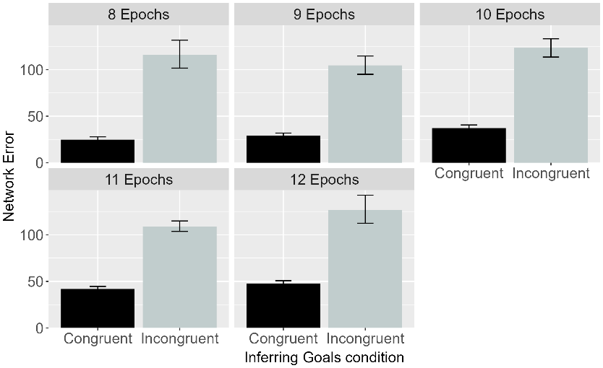 | 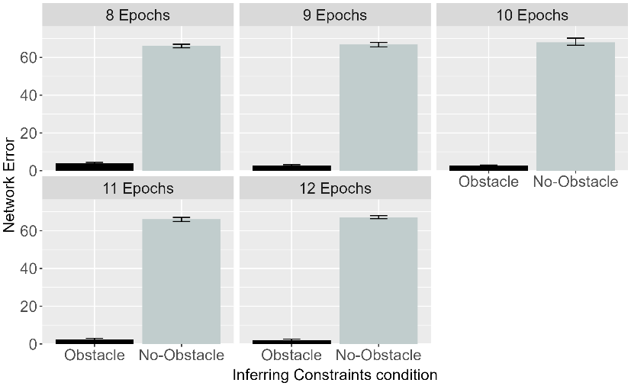
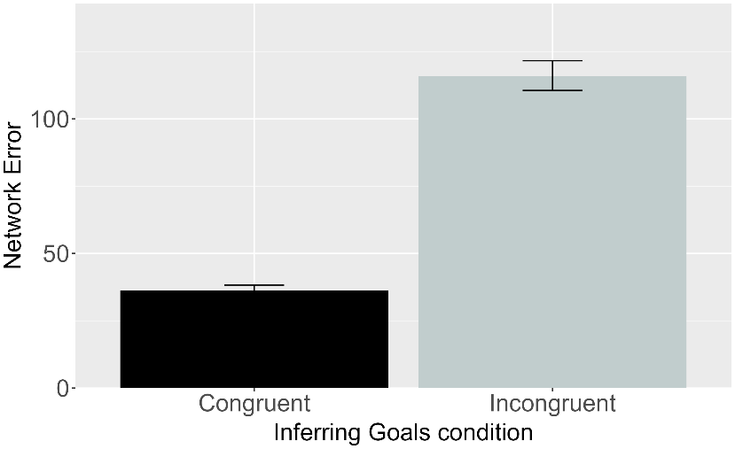 | 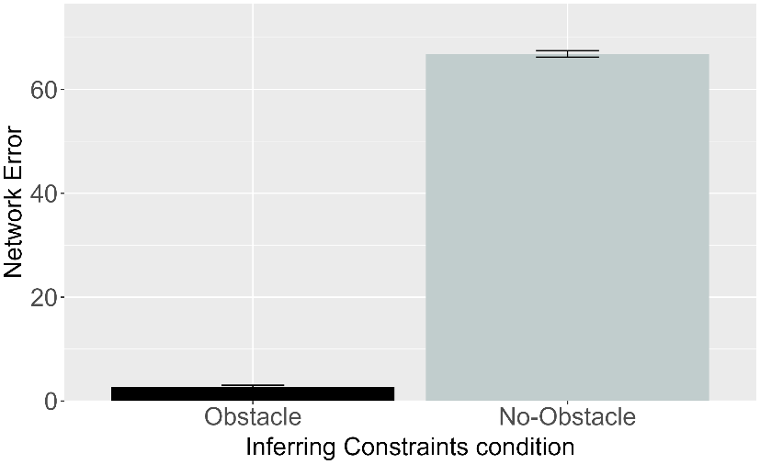

Figure 10. Performance of ALIAS. Plotted is the mean network error produced to the Congruent and Incongruent test events for networks in the Inferring Goals condition (left column) and to the Obstacle and No-Obstacle test events for networks in the Inferring Constraints condition across habituation epochs (top row) and overall (bottom row).
Figure 10 shows the performance of ALIAS networks in the Inferring Goals and Inferring Constraints conditions across habituation epochs and overall. As shown in the figure, networks assigned to the Inferring Goals condition produced greater error to (i.e., looked longer at) the Incongruent test event—in which the first object failed to stop next to the first one—than to the Congruent test event—in which the first object came to rest next to the first one. Networks assigned to the Inferring Constraints condition also responded differently to the two test events with which they were presented. Specifically, these networks produced greater error to the No-Obstacle test event than to the Obstacle test event. These patterns were true both across different habituation lengths as well as overall. Crucially, such looking patterns were not based on information acquired during habituation. This is because the aspects of the task relevant to networks’ treatment of the test events—that is, information about obstacles and goals—were absent during habituation. Instead, networks’ differential treatment of the test events stemmed from the fact that, during pretraining, arced motion tended to occur over barriers and agents behaved in a goal-directed manner rather than haphazardly. The fact that a system that lacks a teleological stance, rich notions of goals and action efficiency, or sensitivity to subjective utilities could capture these target findings suggests that these conceptually rich principles and domain-specific mechanisms may not be necessary. This simulation suggests, instead, that associative learning combined with assumptions about differentially salient obstacles and real-world experience with different action trajectories is sufficient to explain infants’ looking behaviors.

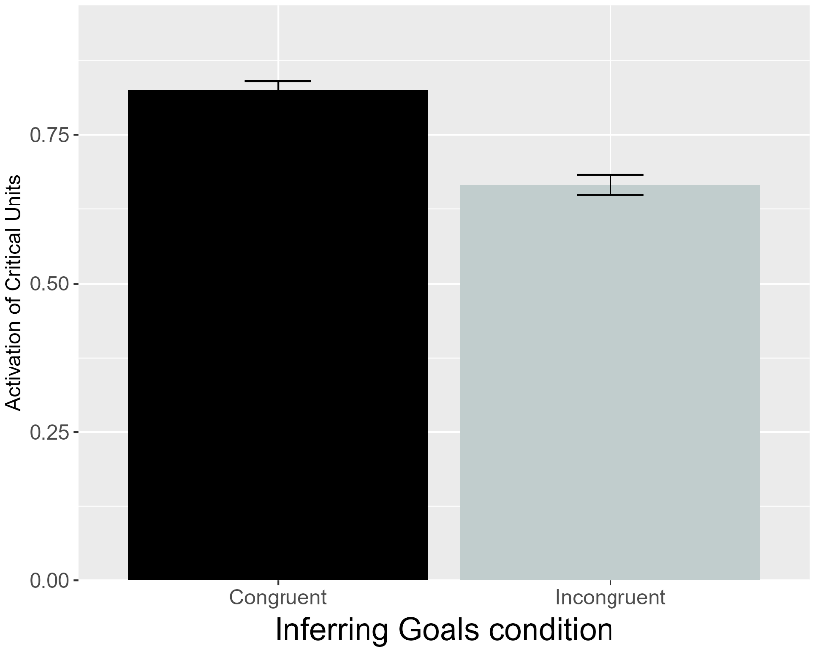 | 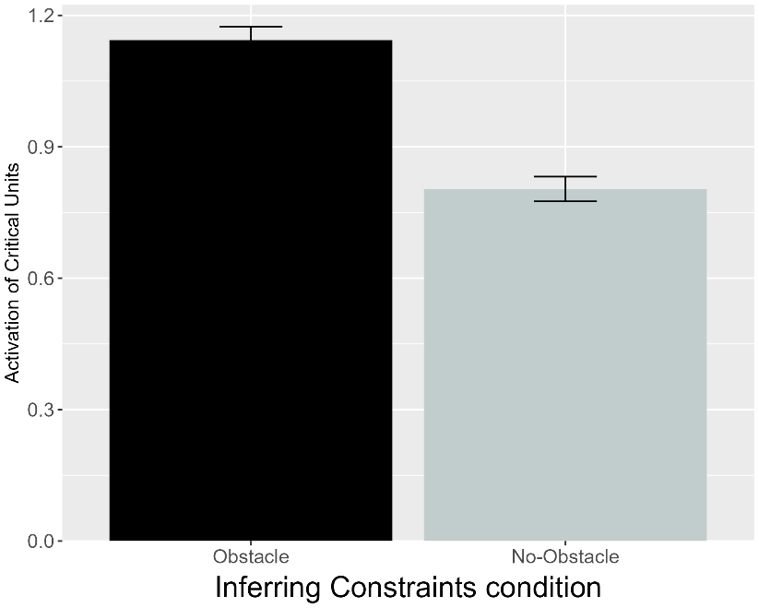
Figure 11. Performance of OM10. Plotted is the mean activation of the critical units produced to the Congruent and Incongruent test events for networks in the Inferring Goals condition and to the Obstacle and No-Obstacle test events for networks assigned to the Inferring Constraints condition (right).

A different pattern emerged for OM10. Figure 11 shows that the behavior of these networks was exactly opposite to that of ALIAS. Specifically, networks assigned to the Inferring Goals condition produced greater critical-unit activation in response to the Congruent test event than to the Incongruent test event. Likewise, the critical units were activated to a greater extent for the Obstacle test event than for the No-Obstacle event for networks in the Inferring Goals condition. Crucially, both patterns of responses depart from those of a model capable of reproducing infants’ looking behaviors in the same conditions and suggests that OM10 cannot account for infants’ putative ability to reason productively about goals, actions, and constraints.

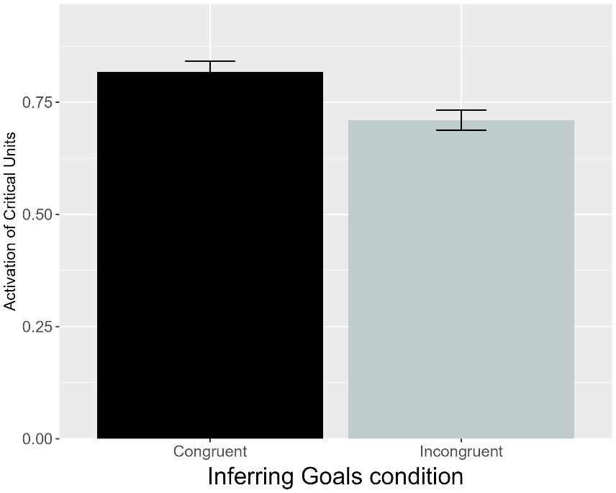 | 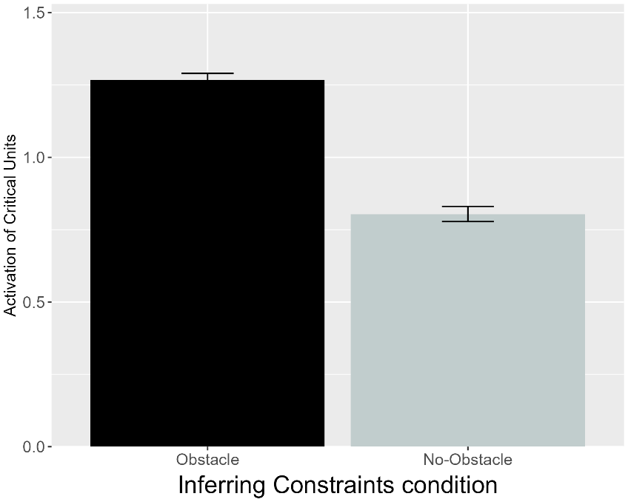
Figure 12. Performance of OM10-2. Plotted is the mean activation of the critical units produced to the Congruent and Incongruent test events for networks in the Inferring Goals condition and to the Obstacle and No-Obstacle test events for networks assigned to the Inferring Constraints condition (right).

It is possible that OM10’s failure to capture the behavioral targets of this simulation is that the model failed sufficiently to instantiate the task structure of the studies from which the target findings were derived. One notable difference between the task the model faced and that infants faced is that in the Obstacle test event that was shown to networks in the Inferring Constraints condition, the agent overshot the obstacle; this did not happen in the corresponding event shown to infants. However, OM10-2—a model that better reflects the structure of the tasks in which the present behavioral targets were observed—also failed to replicate these behaviors. As was true for OM10 and can be seen in Figure 12, networks’ responses in both conditions were at variance with those of a model capable of capturing infants’ responses in the corresponding behavioral conditions. The performance of this model suggests that OM10’s difficulties cannot be attributed to its failure properly to implement the structure of the tasks that produced the target behaviors of this simulation. Instead, OM10’s performance may point to a more fundamental failure to capture the processes subserving infants’ looking behaviors in studies requiring them to reason productively about goals, constraints, and actions.

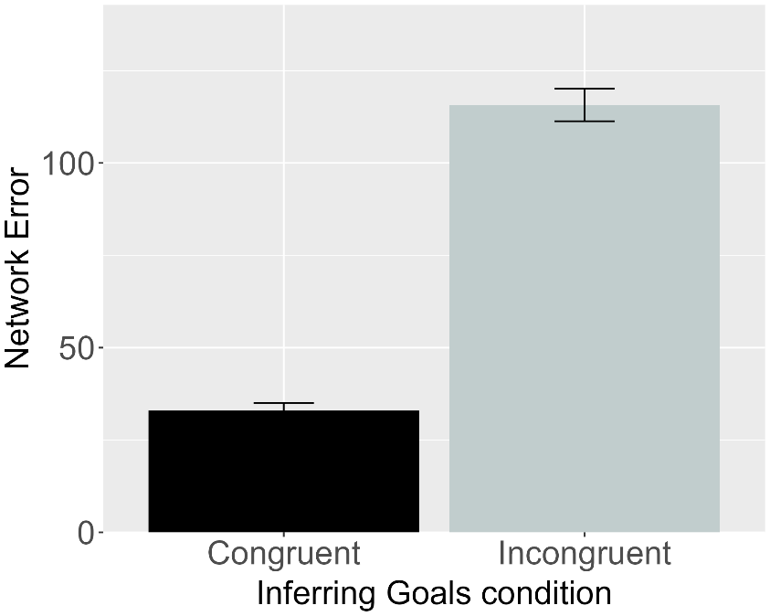 | 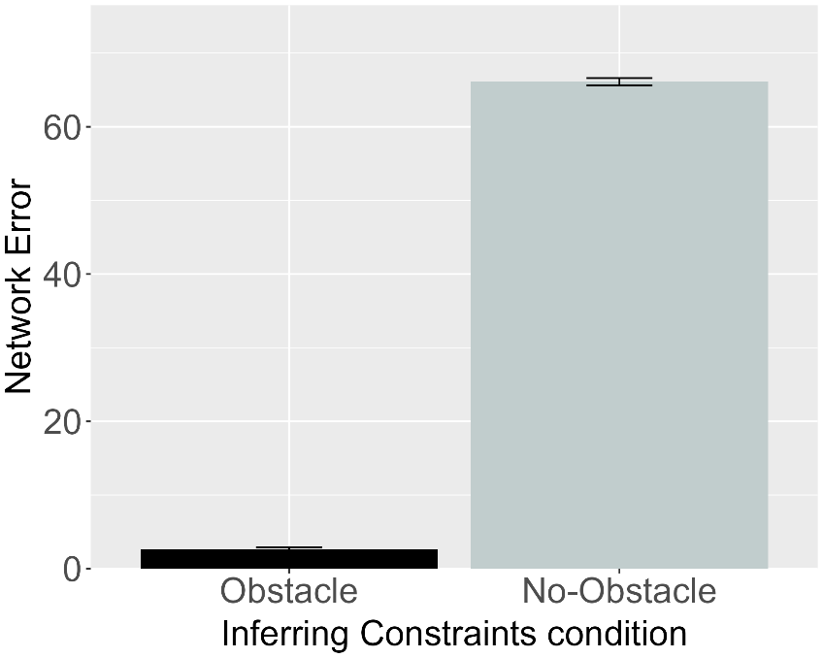
Figure 13. Performance of ALIAS-2. Plotted is the mean network error produced to the Congruent and Incongruent test events for networks assigned to the Inferring Goals condition (left) and to the Obstacle and No-Obstacle test events for networks in the Inferring Constraints condition (right).

Although ALIAS-2 failed to reproduce the first two target behaviors, it remains possible that this model would succeed in accounting for the present target findings. Figure 13 shows that this was indeed the case. As with ALIAS, networks in both conditions produced greater error to that condition’s inconsistent test event than to the consistent one. Thus, networks in the Inferring Goals condition produced greater error to the Incongruent test event than at the Congruent one, and networks in the Inferring Constraints condition produced greater error to the No-Obstacle test event than tot the Obstacle test event. Given that the only difference between ALIAS and ALIAS-2 is that the former implements differential barrier salience whereas the latter does not. ALIAS-2’s success suggests that associative learning alone is sufficient to explain a pattern of looking that heretofore has been taken to indicate that infants possess a teleological stance and can make inferences about how goals, actions, and constraints all relate to one another. At the same time, ALIAS-2 cannot be considered a veridical model of infants’ looking behaviors in action understanding studies. This is because, unlike ALIAS, it failed to capture the first two target findings. Any worthy model simulating the processing underpinning infants’ looking behaviors in action understanding studies must capture the complete range of target findings.
Overall, Simulation 3 showed that both versions of ALIAS can account for patterns of looking that have been construed as stemming from an ability to make bidirectional inferences about the relations among actions, goals, and environmental constraints based on rational inferences and domain-specific mechanisms. Specifically, the performance of these models across the Inferring Goals and Inferring Constraints conditions matched that of infants in the corresponding conditions. The same was not true for both variants of OM10; the behavior of these models was exactly opposite to that of ALIAS or infants. The fact that here both ALIAS and ALIAS-2 replicated the looking responses of infants is noteworthy, not least because it suggests that behavior previously interpreted as evidence for abstract, theory-like reasoning about goals, actions, and constraints can instead be explained by a domain-general associative learning mechanism that, in the real world and in the lab, operates over the kinematics of various actions and the surface features of the individuals and entities that comprise them.
Although Simulation 3 demonstrated that ALIAS can account for infants’ apparent ability productively to infer goals and constraints, an important question that remains is whether ALIAS can capture additional findings that might, at first blush, seem to challenge associative-learning proposals. One such finding is that showing that, in addition to representing the efficiency of an action in an all-or-none fashion, 6-month-old infants can ostensibly represent action efficiency continuously (e.g., Liu & Spelke, 2017). In the first experiment of this study infants were habituated to an event in which a cartoon-like character jumped over a barrier to reach another cartoon-like character on the other side. These infants were then tested on two events—the barrier shown in both test events was now much shorter than that shown during habituation. In the low, efficient jump test event, the height of the agent’s jump was sufficient to clear the barrier. In the high, inefficient jump event, however, the agent jumped as high as it did during habituation but now much higher than needed to clear the barrier. Another set of infants—tested in Experiment 2—were habituated to and tested on the same events except that the barrier was located peripherally. Liu and Spelke (2017) found that only when the barrier was located beneath the curved motion did infants look longer at the high, inefficient test event than at the low, inefficient one; infants in Experiment 2 looked about equally long at both test events. If anything, there was a numerical, but still non-significant, tendency for infants in Experiment 2 to look longer at the low, efficient event than at the high one.
One question that these studies raised was whether infants expect agents that engaged in inefficient and costly actions in the past to continue to do so in a new situation with a different set of constraints. To address this question, Liu and Spelke (2017) habituated a third set of infants to the habituation event used in Experiment 2. Instead of testing infants on efficient and inefficient actions that occur besides a barrier, however, these infants were tested on the test events used in Experiment 1, which the barrier was located beneath the arced motion. As was the case for infants in Experiment 1, infants looked longer at the high, inefficient test event than at the low, efficient one. Together, these results were interpreted to mean two things. First, infants can represent the efficiency of actions in a continuous manner, Second, if the environmental context does not change, infants no longer expect agents to behave efficiently. However, if the infants do not expect agents that behaved inefficiently in the past to continue to do so in a new situation that differs from the old one.
On the basis of these findings, one might conclude that they challenge a simple associative learning account of these data. This is because it might be thought that the predictions that such an account makes are fundamentally at odds with how infants actually performed in this study. For example, if infants’ performance in this task were governed by an associative learning mechanism and a link was established between an obstacle of a certain height and an arced motion trajectory during habituation, then it might be expected that infants should show an equivalent increase in looking at both test events. The reason is that the obstacle information changed in both events—different sized obstacles were shown across the phases. This means that any association that would have been established between a barrier and arced motion would be violated in both test events. If the assumption is made that infants also encode the height of the arced motion is also made, then infants might even be expected to look longer at the low, efficient jump event than at the high, inefficient one; the low, efficient event involves two changes relative to that seen during habituation (i.e., a change to barrier and arced motion heights), whereas the high, inefficient event involves only a single change (i.e., a change to barrier height alone). Although these predictions might explain the behavior of a simple associative model, it is possible that a refined model that implements additional features of the task—and infants real-world experience with different kinds of constrained and unconstrained motions—could capture their looking behaviors in this study. One potentially relevant feature is the vertical distance between the top of an obstacle and the apex of arced motion that occurs over it. The idea here is that if infants learn in the real world that the vertical distance between the apex of a trajectory and the top of an obstacle is minimal—in addition to learning that arced motion trajectories tend to be associated with obstacles—then they should look longer at test events in which this relation is violated—such as the high, inefficient test event in Liu and Spelke (2017) in which an agent follows an unnecessarily high, inefficient arced trajectory over a low barrier—than at events that preserve this relation. Crucially, such heightened looking to the high, inefficient event need not reflect that infants see it as unnecessarily costly, perhaps as an adult might. Instead, it might reflect infants’ sensitivity to an association—formed in the real world—that has been violated. Simulation 4 tests whether ALIAS—an associative learning model sensitive to the relation between obstacle and arced trajectory heights—can capture infants’ looking behaviors in Liu and Spelke (2017). If so, this model would undermine the claim sensitivity to the costliness of actions is necessary to explain infants’ looking behaviors in studies like that by Liu and Spelke (2017).

Simulation 4
This simulation tested whether ALIAS, like infants, could distinguish between two events that differed in their relative costliness. Networks were habituated to an event in which one object with animate features jumped over a large barrier to reach another object with animate features. The large barrier was instantiated by turning on the Barrier Height 5 unit in the Barrier Height group and the Jump Height 5 unit in the Jump Height group. Networks were then tested with a High Jump test event and a Low Jump test event. The High Jump test event was identical to the habituation event (e.g., the jump height remained the same) except that it used a low barrier. This barrier was implemented by turning on the Barrier Height 2 unit in the Barrier Height group. Thus, the first object jumped higher than needed to clear the now much shorter barrier. The Low Jump test event was identical to the High Jump test event except that the height of the first object’s jump corresponded to the height of the now much shorter barrier (i.e., the Jump Height 2 unit was turned on). These events were implemented in an identical manner in ALIAS-2 except that, as before, differential barrier salience was not incorporated into this model.
Given that the study associated with the present target behavior tested 6-month-olds, for ALIAS and ALIAS-2 the pretraining phase was 450 epochs long. The learning rate and number of hidden units were also reduced—the learning rate was set to 0.0875, and the number of hidden units that were used was 30. The models used in this simulation were thus functionally “younger” than those used in the previous simulation. No such modifications were made to OM10 (or its extension, OM10-2). This is because this model does not simulate age or real-world experience. By not manipulating this information in OM10, then, it was possible to evaluate the importance of these factors by comparing the performance of OM10 as stipulated in Overwalle (2010) to ALIAS.
One issue that immediately arises as it relates to OM10 concerns how to treat the configural relation between arced motion and the obstacle. The specific issue here is that because the agent overshoots the barrier by two cells during habituation in the original model, it was neither clear what constituted true overshooting in this model nor was it obvious how to adapt this model to simulate the current target finding. Although there are presumably many solutions to this problem, at least for the present purposes, the approach that was adopted here was to operationalize non-overshooting as a two-cell vertical height difference between the top of an obstacle and the apex of an arced motion—this was the height difference, in cells, used in Overwalle (2010). Overshooting is thus any vertical distance that is greater than two cells. This was the approach taken here. An alternative strategy that could have—but ultimately was not—taken here would be to decrease the vertical distance between the arced motion and obstacle. The problem here is that OM10-2, by design, more faithfully implements the experimental context of action-understanding studies by removing any overshooting. This means that reducing the vertical distance between the arced motion and obstacle in OM10 would render OM10-2 redundant and remove one of the major limitations of the original Overwalle (2010) model. By instead defining non-overshooting as a two-cell vertical height difference, the configural relation between the arced trajectory and obstacle in the original model is preserved.
As with ALIAS (and its extension, ALIAS-2), OM10 and OM10-2 networks were either assigned to the Experimental condition or to the Control condition. A three-cell high obstacle was included in the environment specification for the networks in the Experimental conditionwas shown during the habituation phase for OM10 and OM10-2 networks in the Experimental condition. This barrier remained fully visible throughout the duration of the habituation event for OM10-2 networks. For OM10 networks, in contrast, the obstacle was only visible when the agent was adjacent to it. Recall that this was the approach taken in the first three simulations as well as in Overwalle (2010). No such barrier existed during habituation for OM10 networks assigned to the Control condition; a peripherally located barrier—that remained fully visibly throughout the habituation phase—was shown to OM10-2 networks assigned to the Control condition. In terms of the arced motion that occurred either over or besides the obstacle, the apex of this motion was five cells high for OM10 networks and four cells high for OM10-2 networks. The zenith of this trajectory was lower for OM10-2 networks than for OM10 to ensure that the agent did not overshoot the three-cell high obstacle. The barrier used in both test events was one cell high; this was true irrespective of the condition to which networks were assigned. The apex of the arced motion in the high, inefficient test event was identical to that during habituation. This meant that the agent overshot the barrier by four cells for OM10-2 and by three cells for OM10. The results reported below remain unchanged if the extent of overshooting is controlled. In contrast, the apex of the arced motion in the low, efficient event was three cells high for OM10 networks and two cells high for OM10-2 networks (to prevent overshooting).

Results
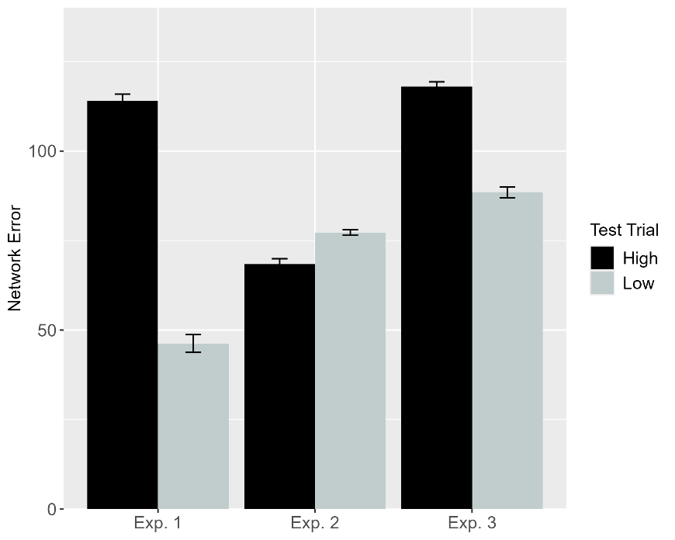 | 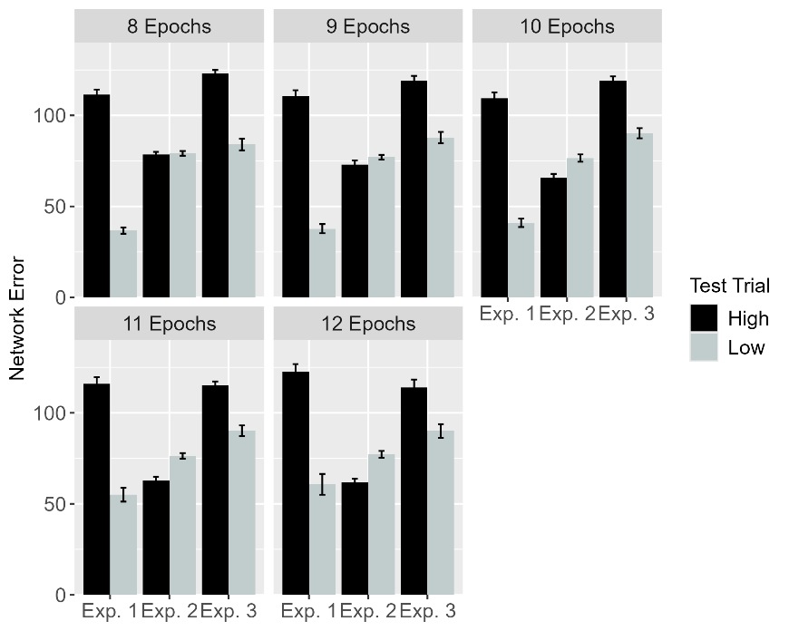
Figure 14. Performance of ALIAS. Plotted is networks’ mean error to the High (i.e., high, inefficient) and Low (i.e., low, efficient) test events across experiments both overall (left) and across different habituation epochs (right). These experiments correspond to those in Liu and Spelke (2017).

Figure 14 shows the looking (i.e., error) behavior of networks to the High (i.e., high, inefficient) test event than to the Low (i.e., low, efficient) test event in each of three experiments. These experiments correspond to those in Liu and Spelke (2017). As was true for infants in Experiments 1 and 3 of that study, networks in the simulation analogue of these experiments looked longer at—that is, produced greater error to—the high, inefficient test event than to the low, efficient event. This was true both overall and across different amounts of habituation. In contrast, networks in Experiment 2—like infants in the corresponding behavioral experiment—looked about equally long at both test events. As was also true for infants in Experiment 2, networks in the simulation analogue of it showed a slight numerical tendency to look longer at the low, efficient test event than at the high, inefficient one. It is nonetheless worth interpreting this particular result with a bit of caution given that the difference in looking to these test events failed to reach statistical significance in Liu and Spelke (2017), whereas here this numerical difference would likely be reliable. This caveat notwithstanding, the fact that a model lacking continuous notions of efficiency, cost, or utility can nonetheless qualitatively reproduce infants’ looking behaviors lends additional support to the contention that these concepts are not necessary to explain such patterns of looking; associative learning might be sufficient.

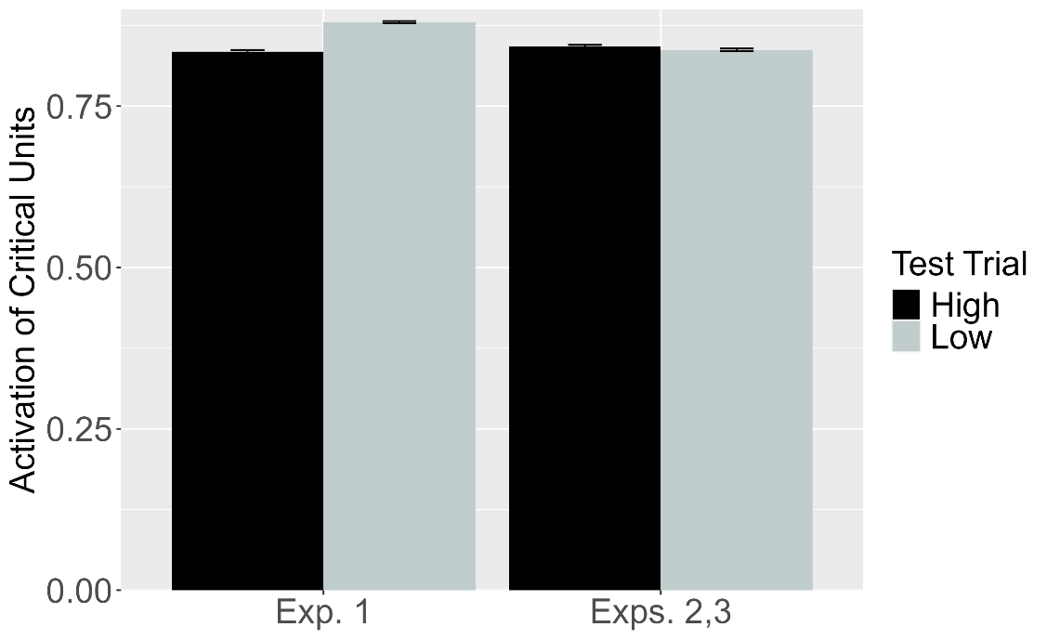
Figure 15. Performance of OM10. Plotted is the mean activation of the critical units produced to the High (i.e., high, inefficient) and Low (i.e., low, efficient) test events for networks in Experiment 1 and those in Experiments 2 and 3. These experiments correspond to those in Liu and Spelke (2017).

As with the previous simulations, a different pattern of performance emerged for OM10. This pattern is shown in Figure 15. The figure shows that for networks in Experiment 1, the critical units were activated to a greater extent during the Low test event than during the High one. In contrast, these units were activated to the same degree during both test events for networks in Experiments 2 and 3. The rationale for not plotting OM10’s performance separately for Experiments 2 and 3 was that simulating control conditions with this model—which the corresponding behavioral experiments served as in Liu and Spelke (2017)—entails removing obstacles. Including obstacles in the simulation of Experiments 1 and 2 would thus constitute a significant departure from how Overwalle (2010) used this model to simulate the control condition in Gergely et al. (1995) and how these conditions were implemented in the previous simulations. In those simulations, barrier-less control conditions were treated as a theoretical commitment—and limitation—about which task-relevant features are relevant when modeling these conditions in action-understanding studies; relaxing this constraint here would effectively transform OM10 into a fundamentally different model.

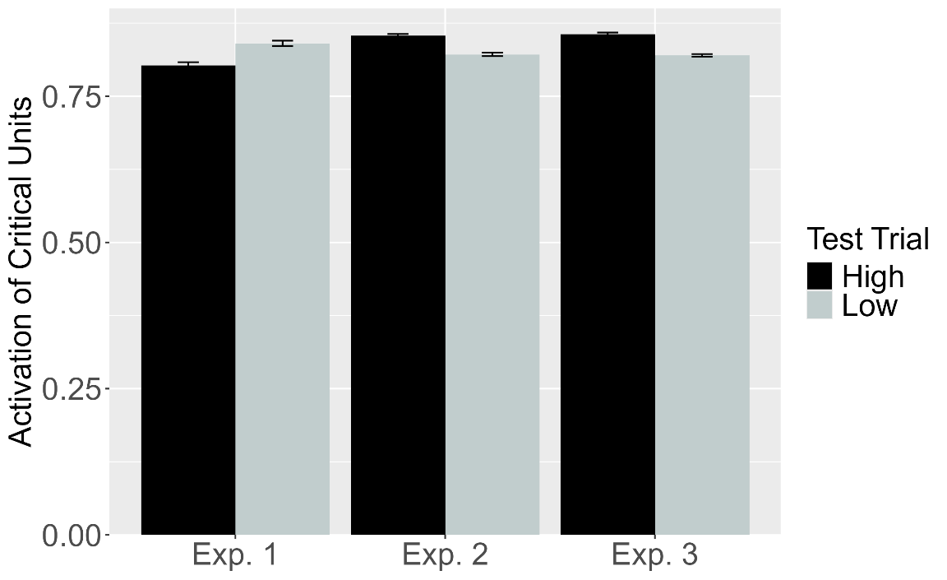
Figure 16. Performance of OM10-2. Plotted is the mean activation of the critical units produced to the High (i.e., high, inefficient) and Low (i.e., low, efficient) test events for networks in Experiment 1-3. These experiments correspond to those in Liu and Spelke (2017).

It is possible that OM10 would succeed at capturing infants’ looking responses in Liu and Spelke (2017) if it simulated the three experiments in this study more veridically. One way to achieve this is by including an obstacle during the test phase the simulation of Experiments 2 and 3. Another way that this can be achieved is ensuring that obstacles remains fully visible throughout the duration of the habituation and test phases across all three experiments. The revised version of OM10, OM10-2, incorporated both of these changes. Although these modifications resulted in a slight improvement in this model’s ability to capture infants’ looked responses—networks in Experiment 3, like infants in the corresponding behavioral experiment showed more activity in the critical units for the High test event than for the Low one—OM10-2’s responses during Experiments 1 and 2 diverged from those of ALIAS and infants. In Experiment 1, for example, the critical units were activated to a greater extent during the Low test event than during the High test event. The reverse pattern was observed in Experiment 2; that is, the critical units were activated to a greater extent during the High test event than the Low test event. These findings suggest that simply improving OM10’s fidelity to the task structure of Experiments 1-3 in Liu and Spelke (2017) is insufficient to reproduce infants’ looking responses. Instead, they point to a more fundamental limitation in the model’s ability to account for infants’ behavior in this study and in action-understanding studies more generally.
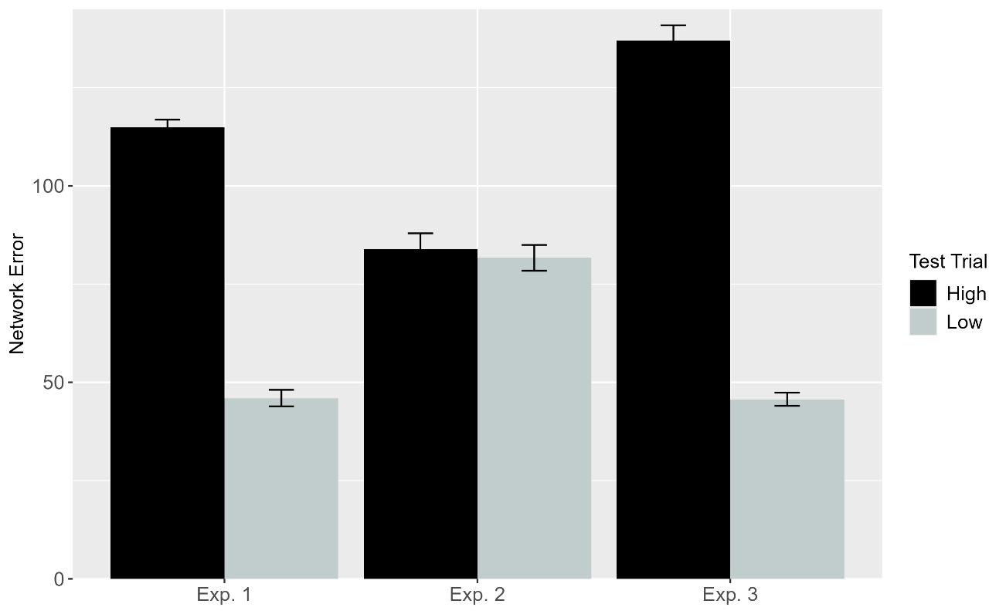
Figure 17. Performance of ALIAS-2. Plotted is networks’ mean error to the High (i.e., high, inefficient) and Low (i.e., low, efficient) test events across experiments both overall. These experiments correspond to those in Liu and Spelke (2017).

The fact that ALIAS succeeded in reproducing infants’ looking responses across the three experiments in Liu and Spelke (2017) suggests that associative learning may be sufficient to account for these responses. However, because this model also incorporated differential barrier salience, it is possible that its success depended on associative learning and this additional assumption. The performance of ALIAS-2—which omits differential barrier salience—was examined to shed light on this question. Figure 17 depicts the performance of this model. The pattern of performance—which is shown in Figure 17—is clear: Networks in Experiments 1 and 3 produced greater error to the High test event than the Low test event, whereas networks in Experiment 2 produced roughly equivalent error to both test events. These responses are notable not only because they qualitatively match those of ALIAS and infants, but it suggests that associative learning alone is sufficient to account for infants’ looking responses across in Liu and Spelke (2017); it is not necessary to include addition assumptions about the salience of barriers in different positions.
The goal of this simulation was to examine whether ALIAS could be extended to explain a set of results that, before now, were interpreted to mean that infants represent action efficiency in a graded or continuous manner. The results revealed that ALIAS succeeded in qualitatively reproducing infants’ looking responses across the three experiments reported in Liu and Spelke (2017). To clarify whether the success of this model was due to associative learning alone, the performance of a version of this model that omitted differential barrier salience—called ALIAS-2—was evaluated. Here too it was the case that ALIAS-2’s performance qualitatively matched that of infants in Liu and Spelke (2017). This suggests that associative learning alone is sufficient to capture the findings in this study. At the same time, the fact that ALIAS-2 was unable to replicate the first two target findings indicates that additional assumptions—in addition to associative learning—are required to capture the full range of findings in the infant literature on action understanding. One assumption relates to the differential salience of barriers: In events that include arced motion, barriers located peripherally to this motion are less visually salient than those located directly beneath it. The other assumption is that infants’ patterns of looking in a typical action-understanding study are shaped by the amount of real-world experience they have processing different kinds of actions.
In contrast to the success of ALIAS and ALIAS-2, OM10 was unable to reproduce infants’ looking responses in Liu and Spelke (2017). Although OM10-2 performed slightly better than OM10, it too was unable to account for all of the data in this study. That even OM10-2—a model that more closely mirrors the surface features of the tasks it simulates—failed to account for infants’ looking responses in this study is notable because it suggests that simply improving a connectionist model’s fidelity to the task structure is insufficient. A successful model must additionally capture the underlying processes and incorporate key assumptions that are presumed to give rise to infants’ behavior in studies that assess their action understanding.
The implementations of ALIAS evaluated thus far were designed to account for the looking behavior of infants who, because of their age, enter action-understanding studies with considerable experience processing actions in the real world. Yet, before ALIAS can be considered a truly general account of infants’ looking behavior in studies on this topic, it must also be able to explain findings from prior work demonstrating that much younger infants exhibited patterns of looking similar to those of older infants. For example, Skerry et al. (2013) found that prior direct “sticky mittens” experience was sufficient to elicit this pattern of looking in pre-reaching 3-month-olds. Given that 3-month-olds necessarily have had less experience processing other’s actions than older infants, it is unlikely that these looking patterns arise solely from extensive, real-world action processing experience.
As outlined in the Introduction, it may not be necessary to posit extensive, real-world action-processing experience to explain infants’ performance in Skerry et al. (2013). This is because features of the sticky-mittens task itself could clarify how the looking behavior of pre-reaching 3-month-olds can mirror that of older infants. The crux of the idea is that action experience that is effective—such as when a Velcro-covered ball adheres to Velcro-covered mittens—might temporarily heighten infants’ attention to, and encoding of, the surface features of the ball as well as the geometry and trajectory of their own mostly direct and nearly linear reaches. A prototypical representation of these reaches could emerge if, as is the case in these studies, infants are allowed to engage in multiple reaching attempts. If infants subsequently observe an action whose geometry and trajectory overlap with this representation, it may be perceived as familiar because, due to this overlap, the observed action reactivates the same representational units that encoded the infant’s own reaches during the action phase. Actions that deviate from this representation—such as arced reaches—may fail to reactivate these units to the same extent and, as such, elicit longer looks because they require additional encoding before they are perceived as familiar. Simulation 5 was carried out to test whether this account is sufficient to explain the performance of pre-reaching infants in these studies. It is worth noting that because there is no way to model developmental age with OM10, the performance of ALIAS and ALIAS-2 was not compared to that of OM10 or OM10-2. In general, OM10’s inability to simulate age represents a significant limitation because it means that this model cannot be used to evaluate how differences in experience across development shape infants’ looking behavior.

Simulation 5
The primary goal of this simulation was to assess whether, when ALIAS is given limited pretraining experience, it can reproduce the looking behavior of pre-reaching infants when its attention is heightened during a phase analogous to the action phase in Skerry et al. (2013). To simulate the performance of the 3-month-olds in this study, X changes were made to the model. The first involved reducing the length of the pretraining phase. This phase lasted between 450 and 900 epochs in Simulations 1-4. Here, the pretraining phase lasted 225 epochs. This implemented the assumption that 3-month-olds have less action processing experience than 6- to 12-month-olds (the typical age of infants tested in action-understanding studies). The second change involved reducing the number of hidden units to 10; Simulations 1-4 used between 30 and 50 hidden units. As discussed earlier, this is a hyperparameter that corresponds to a network’s storage capacity; more hidden units translates to greater storage. The final change related to the task structure. In the first four simulations, the habituation and test phases followed the pretraining phase. In the current simulation, an action phase immediately followed the pretraining phase; the habituation and test phases immediately followed this phase. The motion that networks in both conditions were shown during this phase was a straight trajectory. This decision reflects the assumption that infants’ reaches are largely linear in trajectory and their arms nearly straight in configuration during a typical action phase.
In terms of the length of this phase, it—like the habituation phase—ranged from 8 to 12 epochs, in step sizes of 1. A range of values were used rather than one specific value because the original report did not specify the duration of the action phase. Although this meant that some liberties had to be taken to implement this aspect of the task, this range reflected the brief nature of a typical action phase. Importantly, for a given run of the model, the lengths of the action and habituation phases were identical. Thus, if the habituation phase was 9 epochs in length during a given run of the model, the action phase was also 9 epochs in length.
As was true for infants in Skerry et al. (2013), networks were assigned to one of three conditions: Effective Action, Ineffective Action, or No Training. Networks in the Effective Action condition—like infants in the same condition—were further divided into either the Experimental condition or the Control condition. The assumption that effective rather than ineffective sticky-mittens experience heightens infants’ attention was implemented by increasing the learning rate from its pretraining value of .01 to .175 during the action phase for networks in the Effective Action condition. A lower learning rate was used during the pretraining phase than that used during the same phase in previous simulations because younger infants’ processing speed—which is captured by a network’s learning rate—is assumed to be lower than that of older infants. The assumption that this attentional boost is short-lived was implemented by resetting the learning rate to its pretraining value at the start of the subsequent habituation phase. The learning rate maintained its pretraining value across the pretraining, action, and habituation phases for networks in the Ineffective Action condition. In all other respects, these two conditions were identical to one another. Specifically, within the Effective Action condition, networks were assigned either to the Experimental sub-condition or to the Control sub-condition. The Experimental condition corresponded to Skerry et al.’s (2013) Experiments 1 and 4 in Skerry et al. (2013), whereas the Control condition corresponded to their Experiment 5. Given that the Ineffective Action condition did not include a Control sub-condition in Skerry et al. (2012), networks in this condition only participated in the Experimental sub-condition; that is, networks in this condition were habituated to an event in which arced motion occurred over rather than besides the obstacle. The performance of these networks corresponded to that of the infants in Skerry et al.’s (2013) Experiment 2.

Results
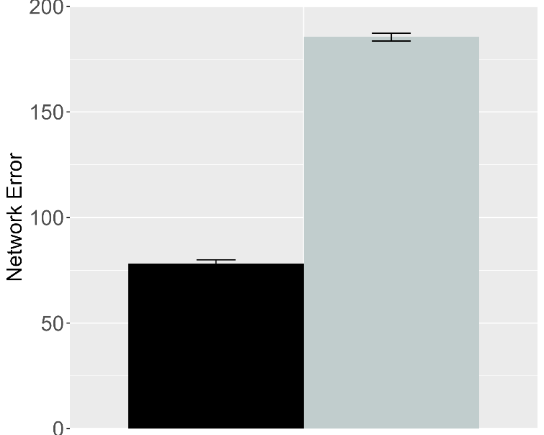 | 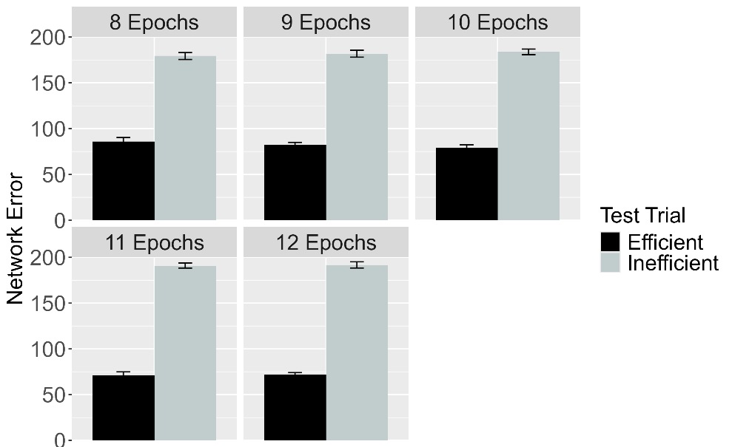
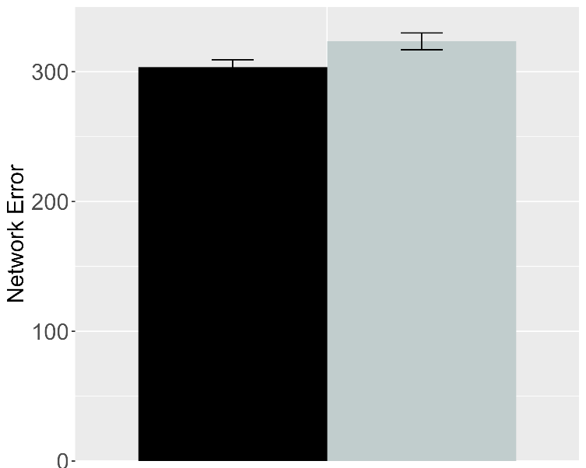 | 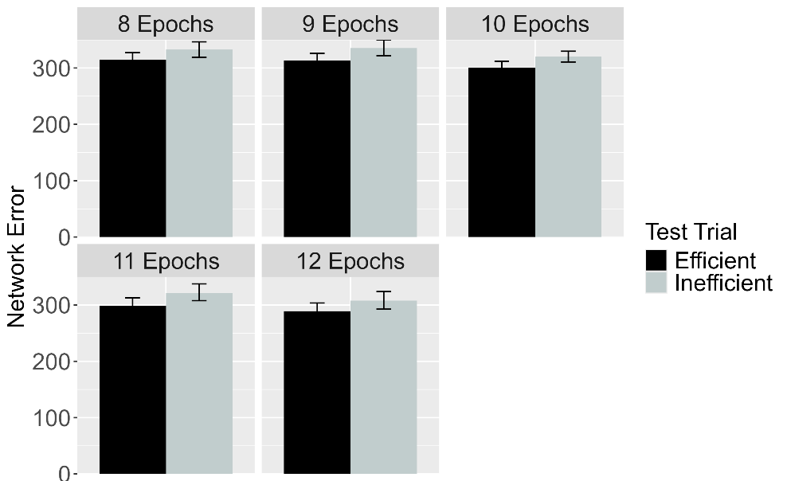
Figure 18. Performance of ALIAS. Plotted is networks’ mean error to the Efficient and Inefficient test events in the Experimental (top row) and Control conditions, both overall (left column) and across different habituation epochs (right column). The Experimental and Controls correspond to Experiments 1, 4, and 5 in Skerry et al. (2013).

Figure 18 shows the performance of ALIAS, both across habituation epochs and overall. The performance of the networks in the Effective Action condition is shown in the top row of the figure; the performance of the networks in the Ineffective Action condition is shown in the bottom row. The figure shows that, in the Effective Action condition, networks assigned to the Experimental condition produced greater error to (or look longer at) the Inefficient test event than at the Efficient test event. This was true overall and for different amounts of habituation. In contrast, networks in the Control condition produced roughly equivalent error to both test events, both overall and for different habituation amounts. Both findings qualitatively matched infants’ looking behaviors in Skerry et al. (2013). In particular, networks’ performance in the Experimental condition matched that of infants in Experiments 1 and 4, and networks’ performance in the Control condition matched that of infants in Experiment 5.

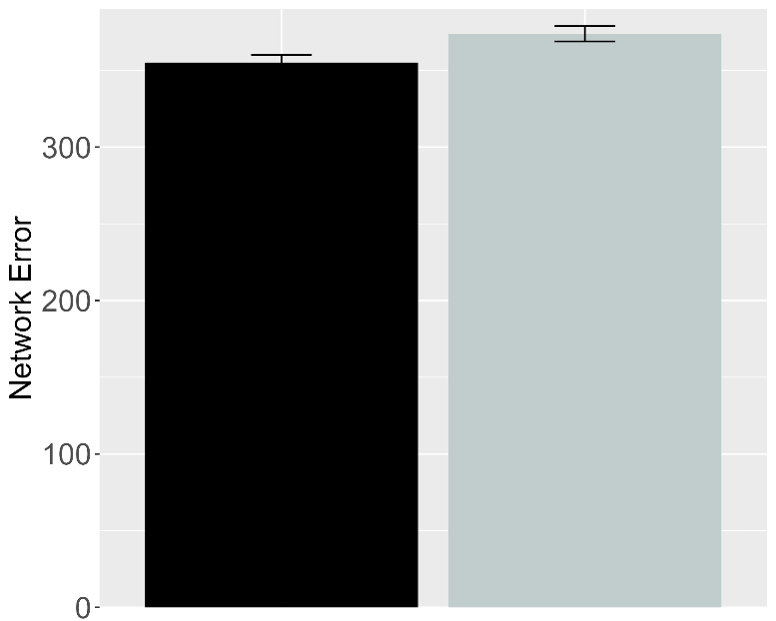 | 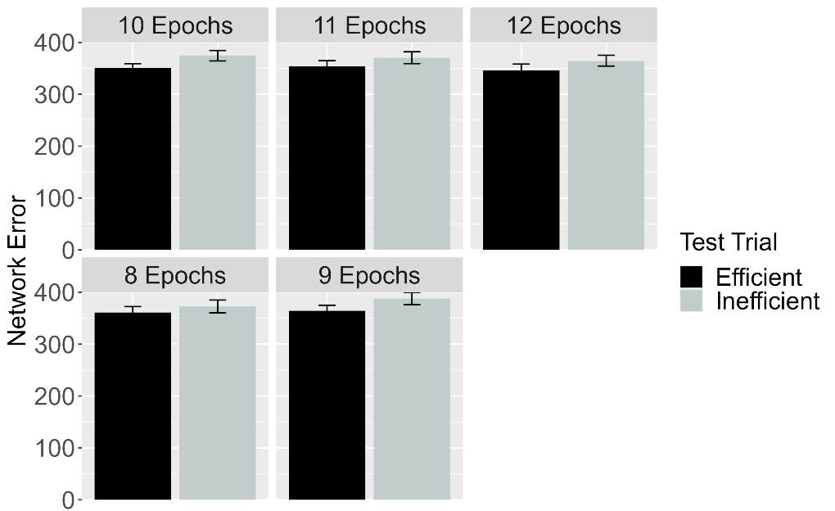
Figure 19. Performance of ALIAS in the No Training condition. The overall error produced to the Efficient and Inefficient test events is shown on the left, and the error produced across different habituation epochs is shown on the right. This condition corresponds to Experiment 3 in Skerry et al. (2013).

Given that a different set of infants were tested in a No Training condition, it is important that ALIAS also be able to account for infants’ behavior in the No Training and Ineffective Action conditions. Figure 19 shows the performance of networks assigned to the No Training condition. As was true for infants in this condition, networks looked about equally long at both test events.
Importantly, if networks’ prior experience with constrained arced motion (i.e., arced motion that occurs over obstacles) enabled them to associate arced motion with barriers and detect when such associations are violated, then those in the No Training condition—like networks in the Effective Action Experimental condition—should have produced more error to the Inefficient test event than the Efficient one. This was clearly not the case. This suggests that attentional boost that networks experienced during the action phase was both sufficient and causally necessary for them not only to encode their own straight reach trajectory but to perceive that trajectory as more familiar than an arced one.

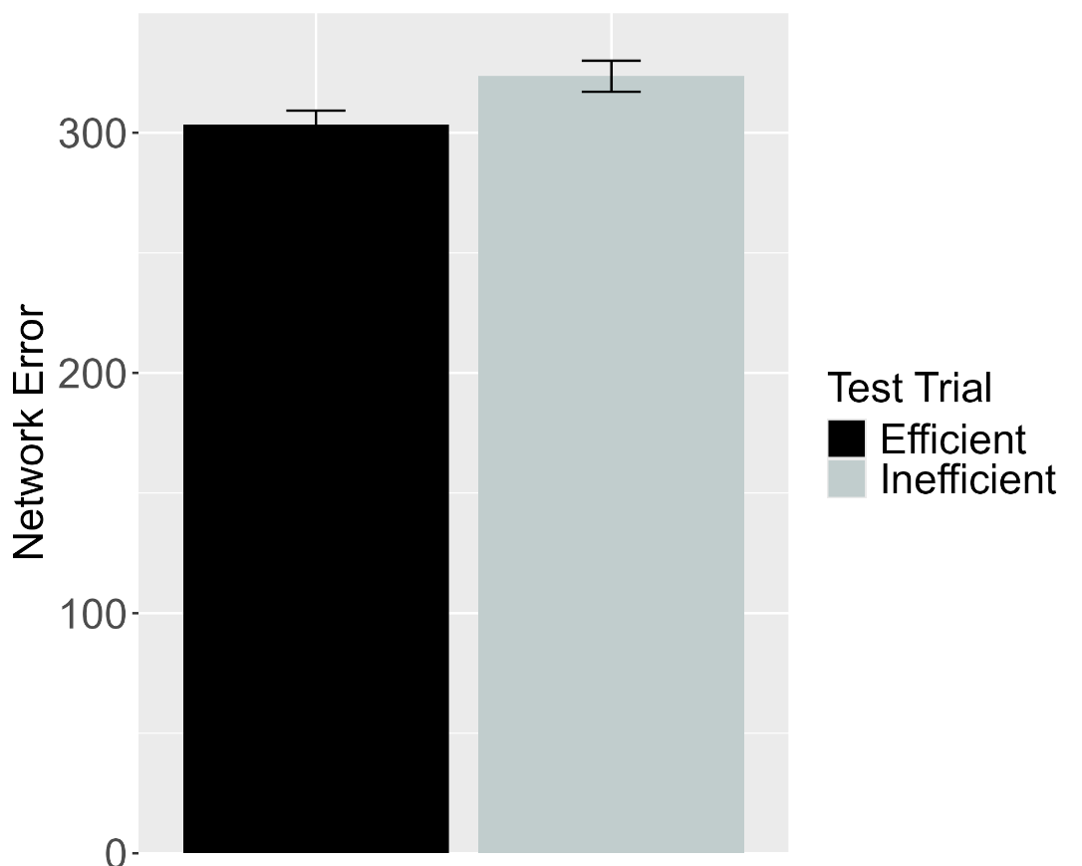
Figure 20. Performance of ALIAS in the Ineffective Condition. Plotted is networks’ overall mean error to the Efficient and Inefficient test events. This condition corresponds to Experiment 2 in Skerry et al. (2013).

Figure 20 shows the performance of networks assigned to the Ineffective Action condition. In contrast to networks in the Effective Action Experimental Condition, networks in this condition produced roughly equivalent error to the Efficient and Inefficient test events. This result qualitatively matched that of infants in Skerry et al.’s (2013) Experiment 2. The fact that ALIAS was able qualitatively to reproduce infants’ looking patterns across experiments suggests that Skerry et al.’ (2013) conclusion that first-person action experience enables pre-reaching infants to detect an agent’s goal and to reason about whether the actions it takes to achieve that goal is rational and efficient may be premature. Instead, these results raise the intriguing possibility that effective action experience may heighten infants’ attention of their own reaches and enhance their encoding of their geometry and trajectory.

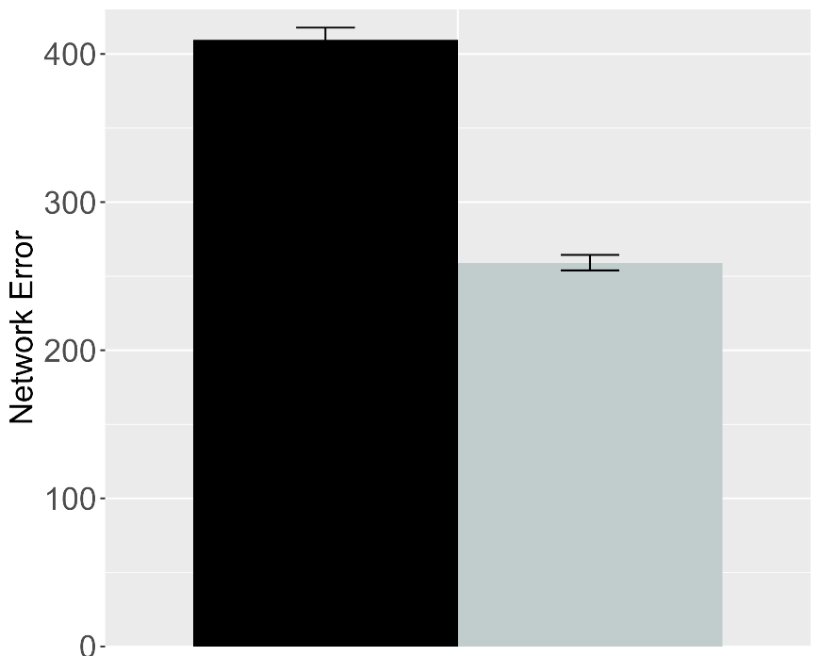 | 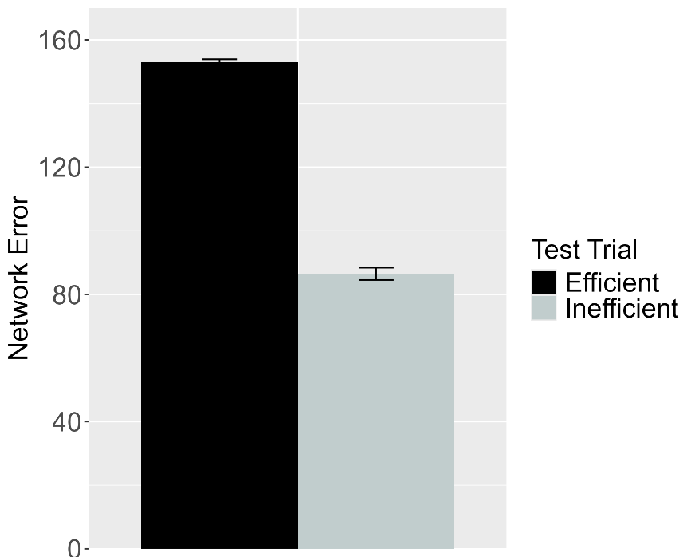
Figure 21. Performance of ALIAS in the Effective Action condition. (Left) Overall error produced to the Efficient and Inefficient test events for networks in the Experimental condition. (Right) Overall error produced to the Efficient and Inefficient test events for networks in the Control condition. These data correspond to a version of ALIAS in which the attentional boost extends into the habituation phase.

One assumption that the present account makes—that is worth testing—concerns whether ALIAS’s performance, particularly its success in capturing qualitatively infants’ looking behavior in the Effective Action condition, hinges on a fleeting attentional boost; for example, would ALIAS continue to capture infants’ behavior in this condition if the attentional boost that networks experience carries over to the habituation phase from the action phase? If ALIAS is less successful in this situation, then this would indicate that its earlier success did depend on a short-lived attentional boost. To evaluate this question, a new set of networks were assigned either to the Experimental condition (N = 20 for each of five habituation epochs) or to the Control condition (N = 30 for each of five habituation epochs). Twenty networks were tested in each condition for each of five habituation epochs (N_{experimental} = 100; N_{control} = 100). Additionally, both groups of networks were assigned to the Effective Action condition. This simulation was identical to that for ALIAS above except that the attentional boost extended to the habituation phase; that is, networks’ attention was heighted during the action and habituation phases and only returned to their pretraining levels at the start of the test phase. The rationale for focusing on this condition was simply that the present account assumes that to the extent that infants experienced an attentional boost in Skerry et al. (2013), such a boost occurred in the Effective Action condition. Figure 21 shows the performance of these networks. These data indicate that networks in both conditions produced greater error to the Efficient test event than to the Inefficient event. This pattern of responses is inconsistent with that produced by ALIAS above and, critically, with infants’ looking behaviors in the Effective Action condition in Skerry et al. (2013). These results also suggest that ALIAS’s earlier success did depend on an evanescent attentional boost.
The basis for these findings is straightforward: Although networks’ heightened attention during the action phase enabled them robustly to encode their own straight reach trajectories, the fact that this attentional boost persisted into the habituation phase meant that networks’ representations of these trajectories were overridden by robust representations of the arced motion trajectories and the surface features associated with those trajectories (e.g., the height of the apex of a reach’s trajectory) shown to them during the habituation phase. A consequence of this is that the Inefficient test event—which preserved many of the features of this event, despite violating the learned association between arced motion and the barrier—was partially consistent with the representation of an arced motion event that was established during habituation. In contrast, networks treated the Efficient test event as more dissimilar to this learned representation because this event depicted a straight reach trajectory. These factors explain why networks in both conditions produced greater error to the Efficient than the Inefficient test event. Importantly, this pattern of results would not have emerged if networks possessed greater information-processing abilities that enabled them to form robust representations of both straight and curved trajectories during the pretraining phase. This is because the learned representation of an arced trajectory during the relatively brief habituation phase would have been insufficient to override the representation of a straight motion trajectory formed during the pretraining and action phases. However, because networks’ information-processing abilities were intentionally limited here to approximate those of pre-reaching infants, networks learned relatively little about either straight or curved motion during pretraining. As a result, the representations formed during the action and habituation phases exerted a greater influence on networks’ subsequent looking behavior.

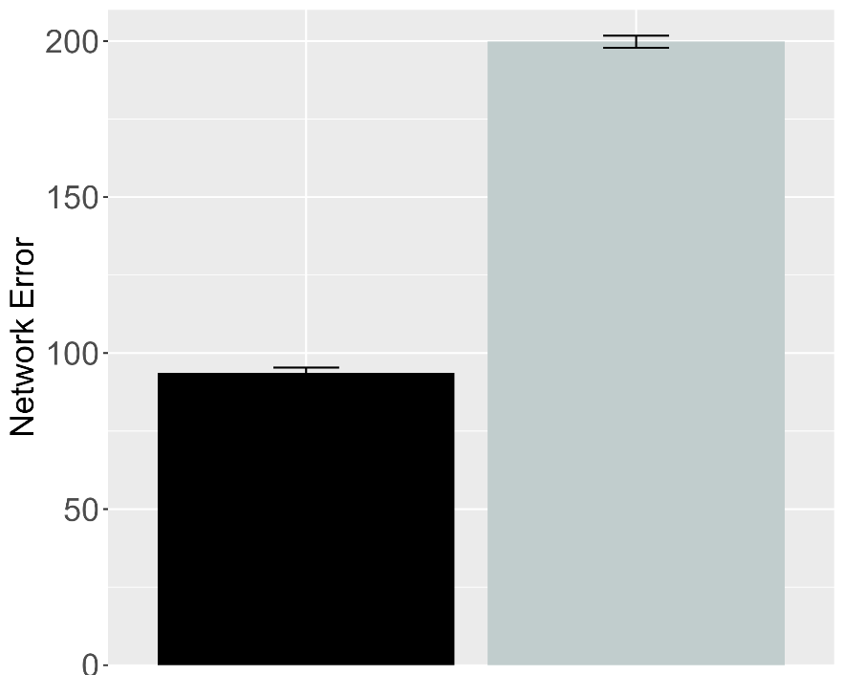 | 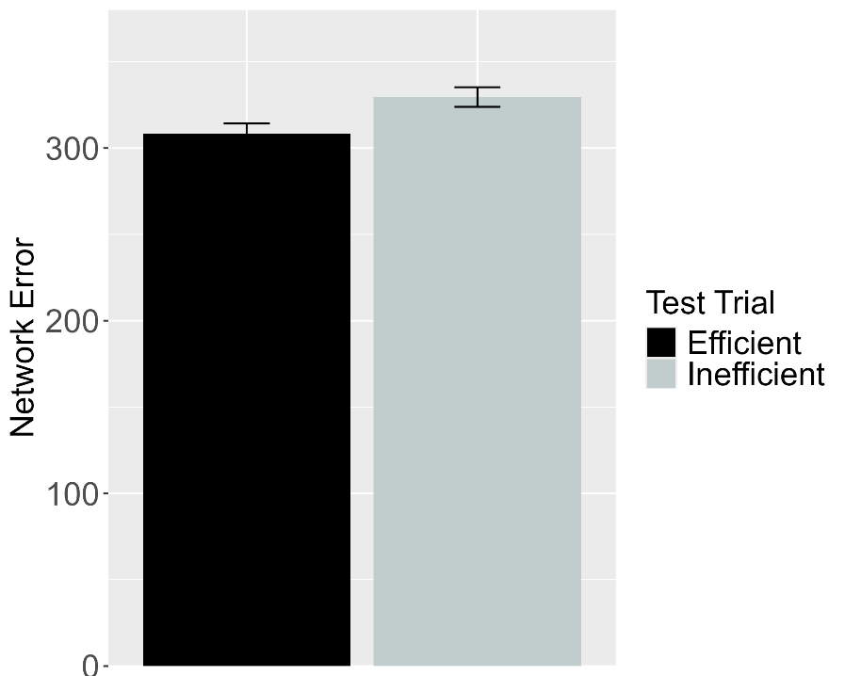
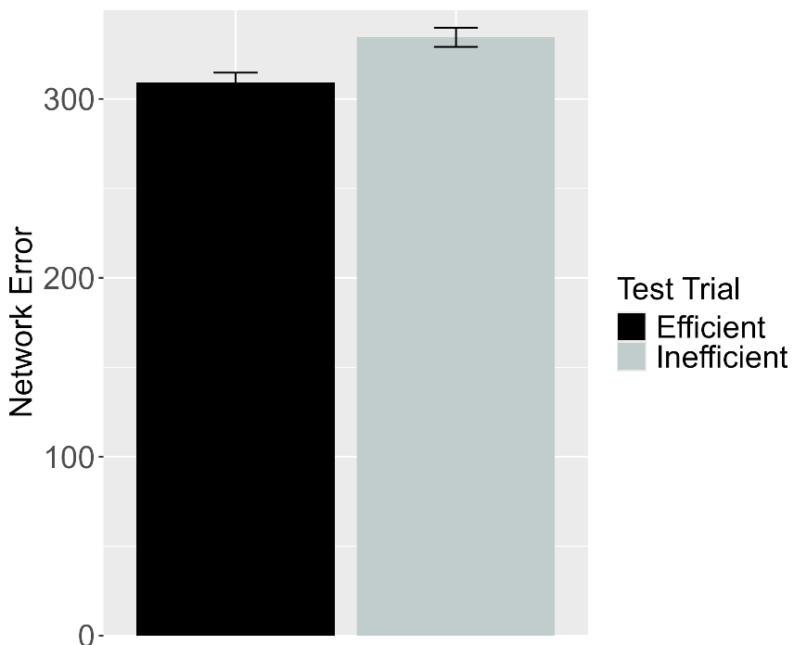
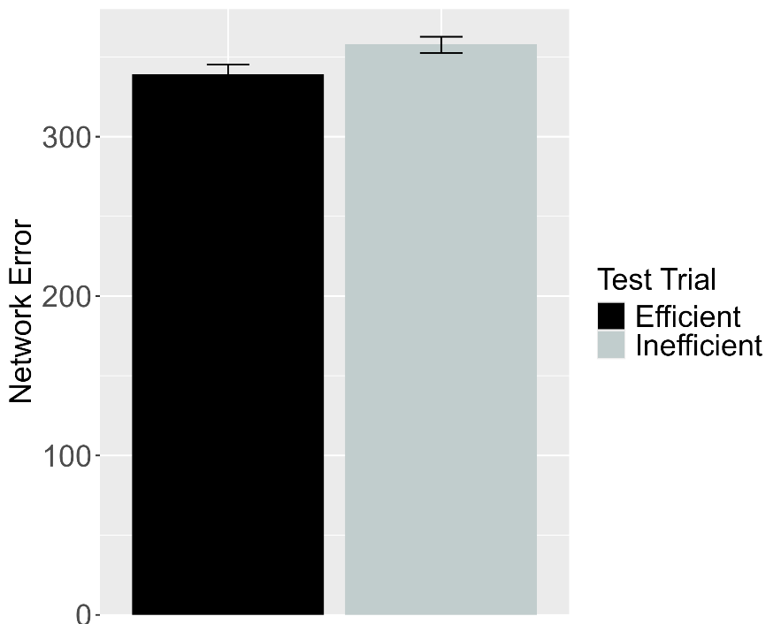
Figure 22. Performance of ALIAS-2. Plotted in the top row is the overall mean error to the Efficient and Inefficient test events for networks assigned either to Experimental (top left) or to the Control condition (top right) in the Efficient Action condition. Plotted in the middle row is the overall mean error to the two test events for networks assigned to the Ineffective Action condition. Plotted in the bottom row is the overall mean error to the two test events for networks assigned to the No Training Condition. This condition corresponds to Experiment 2 in Skerry et al. (2013).

The results above indicate that the attentional boost that networks experience during the action phase must be short-lived for ALIAS qualitatively to replicate infants’ looking behaviors in the Effective Action condition in Skerry et al. (2013); ALIAS was unable to capture infants’ looking patterns in this condition when networks experienced a more extended attentional boost. Yet, another question that these results raise concerns to what extent ALIAS’s success in capturing infants’ overall looking behavior in Skerry et al. (2013) was due to associative learning alone or to this mechanism combined with the built-in assumption that an obstacle’s salience depends on its relative spatial position. As in the previous simulations, one way to answer this question is to assess whether ALIAS-2 is also able to reproduce infants’ looking behaviors across the various experiments and conditions in Skerry et al. (2013); this version of ALIAS omits differential obstacle salience. If this model also succeeds in accounting for infants’ overall pattern of looking, then this would suggest that associative learning alone is sufficient to explain Skerry et al.’s (2013) findings. Figure 22 shows the performance of this model. As was true for ALIAS, networks in the Experimental condition of the Effective Action condition produced greater error to the Inefficient test event than to the Efficient one, whereas networks in this condition’s Control condition as well as those in either the Ineffective condition or No Training condition produced about equivalent error to both test events. Together, these results suggest that associative learning alone is sufficient to account for all of the data in Skerry et al. (2013); assumptions about differential obstacle salience, at least here, are not additionally needed.
Taken together, the results from this simulation indicate that ALIAS can be extended to explain the looking behavior of pre-reaching infants in Skerry et al. (2013). There are three findings from this simulation that are particularly noteworthy. The first is that these results indicate that ALIAS can overcome its limited pretraining experience with actions to respond like older infants in a Gergely-style experiment if, during an action phase, its attention is heightened sufficiently to enable it robustly to encode the geometry and trajectory of its straight reaches. The second is that, in contrast to Simulations 1 and 2 but like Simulation 4, associative learning alone was sufficient qualitatively to reproduce the full pattern of looking responses in Skerry et al. (2013); it was not necessary to implement the notion that peripherally located barriers are less salient than centrally located ones. The third is that ALIAS was only able qualitatively to reproduce infants’ looking behavior in the Effective Action condition when the attentional boost that networks experienced during the action phase was restricted to that phase; when this boost extended into the habituation phase, the model failed to account for infants’ responses. The reason for this failure was that networks formed robust representations of the arced motion shown during habituation that overrode their earlier representations of straight reach trajectories.
A longstanding assumption in the developmental cognitive sciences is that infants possess domain-specific mechanisms that enable them to reason about actions in terms of their efficiency, cost, and subjective utility. The teleological stance, naïve utility calculus, and a proposal by Liu et al. (2026) are three examples. Although each of these perspectives has empirical support and intuitive appeal, I argued here that infants’ behaviors in action understanding studies can be explained without appealing to them. I showed that a model that learns via associative learning and that implements the assumption that peripherally located obstacles have reduced salience succeeded in capturing a range of findings in this literature. This model also accounted for a broader range of data than a version of it that omitted differential obstacle salience and even outperformed alternative models based on similar constructivist ideas such as that by Overwalle (2010). This suggests that ALIAS may be a viable contender to existing domain-specific accounts of infants’ action understanding.
At the same time, a complete account of the mechanistic basis of infants’ looking behaviors in action understanding studies would do more than show that a model that instantiates it can capture existing data. Ideally, a comprehensive account would additionally generate predictions that can be tested in future behavioral experiments. The goal of the final section is to do exactly this. Specifically, ALIAS will be placed in a series of novel situations and its resulting behaviors will be assessed. These behaviors will serve both as predictions for future research on infant action understanding and as a basis for teasing apart the current perspective from domain-specific ones.

Model predictions
Computational modeling offers many benefits. One is that they force researchers to be explicit about key terms and concepts in their verbal theories. For example, to build a working model of some developmental phenomenon, theorists must be explicit about how external events are represented, what information the model receives, the learning rule that operates over that information, how much exposure the model has to that information before the relevant test events, and how the model’s internal states and outputs map onto observable behavior (e.g., Benton, 2022, 2023; Mareschal & Thomas, 2007; Munakata et al., 2003; Singh et al., 2025; Yermolayeva & Rakison, 2014).

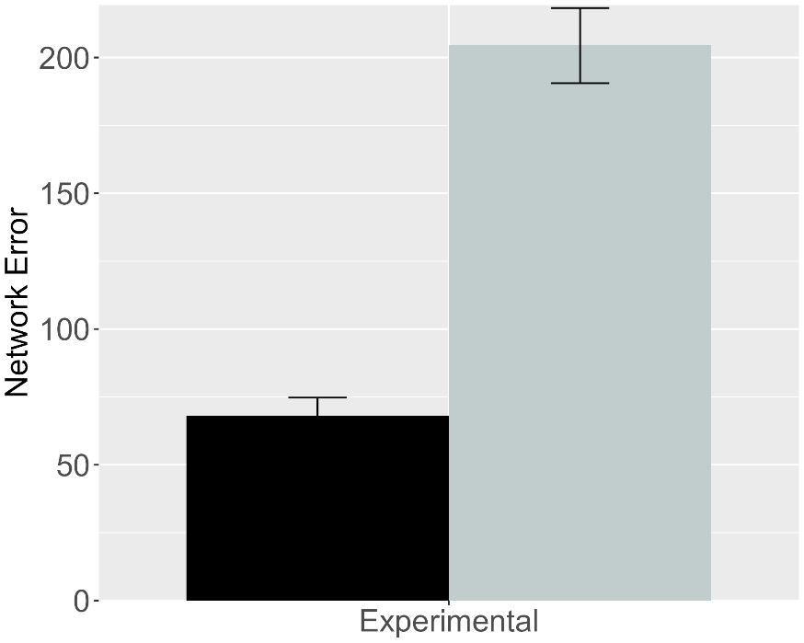 | 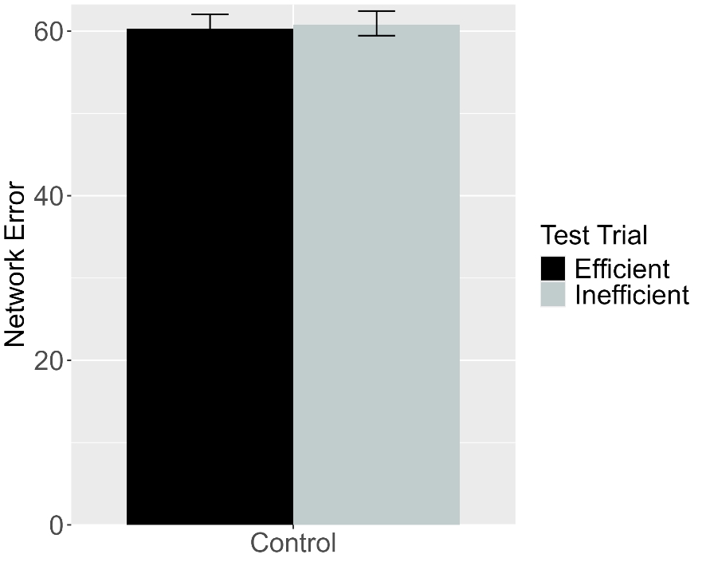
Figure 23. Performance of ALIAS. (Left) Overall error produced to the Efficient and Inefficient test events for networks in the Experimental condition. (Right) Overall error produced to the Efficient and Inefficient test events for networks in the Control condition. The barrier shown during habituation for this simulation appeared directly above rather than beneath arced motion.

Another benefit of developing computational models is that their behavior in novel situations can serve as testable predictions for future research. In the current context, for example, a potentially interesting question concerns how ALIAS would respond if, instead of being habituated to an event in which an agent jumps over a barrier that is tethered to the ground as is typical in these studies, networks were habituated to an event in which the barrier was positioned just above the apex of the agent’s jump trajectory. If the current account is correct that infants’ looking behavior in action understanding studies in part reflects associative learning, then networks should form as robust an association between the curved motion and the obstacle in this anomalous configuration as when the obstacle is located directly beneath the motion. This is because, on the current account, the critical factor determining whether a strong association is formed between an obstacle and arced motion is whether the obstacle is visually salient; positioning the obstacle in the immediate vicinity of the motion trajectory ensures that it is. If, instead, infants’ process others’ actions in terms of a teleological stance, a naïve utility calculus, a naïve psychology system that receives input from a naïve physics system, or some combination of all three, then infants in both conditions should equally long at both test events. This is because neither the habituation event in the Experimental condition nor that in the Control condition depicts behavior that could reasonably be construed as rational or efficient given the physical constraints of the scene. As a result, infants might be expected to suspend any expectation for rational or efficient action in the future.
The first simulation reported in this section was identical to Simulation 1A with two exceptions. First, a fourth unit was added to the Obstacle Horizontal Position input and output groups. This unit corresponded to a location that appeared directly above arced motion when paired with it. Second, because the results reported in the previous simulations were robust across the different numbers of habituation epochs that were used, here the habituation phase lasted for just eight epochs; this was the smallest number used in the prior simulations. This was also the value used in all of the prediction simulations reported here for consistency.
As was the case in Simulation 1A, networks were assigned either to the Experimental condition (N = 20) or to the Control condition (N = 20). Importantly, networks encountered barriers in this novel spatial configuration only during the habituation phase; barriers that were present during pretraining were always tethered to the ground. The relative horizontal position of this barrier was identical to that in Simulation 1a. The results from this simulation—depicted in Figure 23—indicate that networks in the Experimental condition produced greater error (i.e., look longer) to the Inefficient test event than to the Efficient one. In contrast, networks in the Control condition looked for an equivalent amount of time at both test events. Both sets of results mirror those in Simulation 1a. The mechanistic basis of these results is identical to that described in Simulation 1a.
The fact that these predictions are presumably at odds with those derived from the current domain-specific proposals suggests that a behavioral experiment based on this simulation could provide one way to decide between these competing accounts; the present account would be supported if, following habituation to an event depicting a barrier above an agent’s curved trajectory, infants in the Experimental condition looked longer at the Inefficient than the Efficient test event. In contrast, the domain-specific proposals would be supported if infants look equally long at the two test events in both conditions. Such a result would indicate that infants did not an agent’s actions during habituation as being rational or efficient.

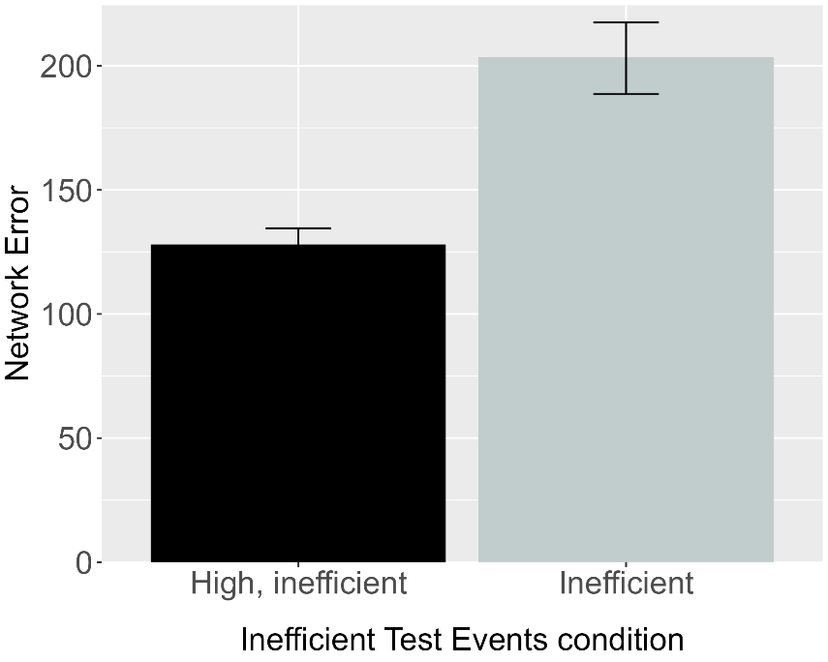 | 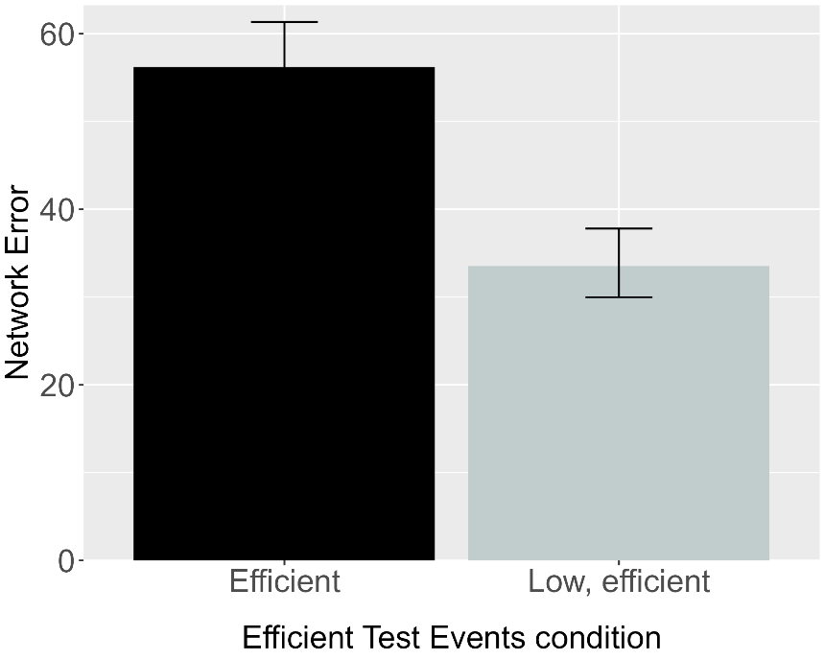
Figure 24. Performance of ALIAS. (Left) Overall error produced to the High, inefficient and Inefficient test events for networks in the Inefficient Test Events condition. (Right) Overall error produced to the Efficient and Low, efficient test events for networks in the Efficient Test Events condition.

Given that action understanding studies have employed different types of inconsistent events, another interesting question that might be asked concerns ALIAS’s performance when tested on two different inefficient test events or two different efficient events. This contrasts with the standard approach of testing infants on inefficient and efficient test events. For example, how might ALIAS respond if it were tested on Liu and Spelke’s (2017) Low, efficient test event and Gergely et al.’s (1995) barrierless efficient test event? To address this question, here networks were randomly assigned to the Inefficient Test Events condition (N = 20) or to the Efficient Test Events condition (N = 20). The length of the pretraining phase here was identical to that in Simulation 4a. Networks in the Inefficient Test Events condition were shown the High, inefficient test event from Simulation 4a and the inefficient test events from Simulation 1a. In contrast, networks in the Efficient Test Events condition were shown the Low, efficient test event from Simulation 4a and the efficient test event from Simulation 1a. The results—shown in Figure 24—revealed that networks in the Inefficient Test Events condition produced greater error to the Inefficient than to the High, inefficient test event. In contrast, greater error was produced to the Efficient than to the Low, efficient event for networks in the Efficient Test Events condition.
In terms of the mechanistic basis of networks’ responses in both of these conditions, networks in the Inefficient Test Events condition looked longer at the Inefficient test event than at the High, inefficient one. This is because some of the input information presented in the Inefficient test event—specifically that pertaining to a now absent obstacle—strongly activated an internal representation corresponding to straight motion. The reason for this is that the motion that corresponded to, and was associated with, such missing information during pretraining was a straight trajectory. Ultimately, however, this learned association was at odds with the information presented in the Inconsistent test event—this event presented networks with barrierless curved motion. This discrepancy between what networks were shown and what they they expected produced multiple sources of error. One source of error derived from the fact that networks erroneously predicted straight rather than observed curved motion. Another source of error resulted from networks’ erroneous prediction of straight motion when in fact a curved motion was observed. A final source of error pertained to networks’ failed prediction of no vertical clearance—due to an expectation of straight motion—rather than of the large vertical clearance that networks actually observed.
The reason the High, inefficient test event produced comparatively less error was because the input information associated with this event was much more consistent with that encountered during pretraining. It will be recalled that whenever barriers were present during the pretraining phase, not only were they small—like that presented in the High, inefficient test event—but they were associated with curved motion. As such, the presence of both a barrier and curved motion during this event closely matched networks’ prior experience. This means that the primary source of error for this event came from the height of the jump itself. Here, networks expected a lower jump with minimal vertical clearance given that both feature covaried with a small barrier during pretraining. However, this expectation conflicted with the observed higher jump with substantial vertical clearance. This combined with the fact that the habitation phase was much shorter in length than the pretraining phase precluded networks from acquiring a representation of high jumps. As a consequence, this event produced error, although it was much less than that produced by the Inefficient test event.
Unsurprisingly, these same principles can explain how networks in the Efficient test event came to look longer at the Efficient test event than at the Low, efficient one. Although the habituation phase was not longe enough for networks in this condition to develop a representation of curved motion, it was long enough for them to
Crucially, both sets of results presumably run counter to the predictions of the current domain-specific proposals. Such accounts might predict that infants should look equally long at both test events in the Inefficient Test Events. This is because the height that the first agent jumps in this event—and therefore the cost that it incurs—is equivalent in both events. In contrast, infants might be expected to look longer at the Low, efficient test event than at the Efficient test event in the Efficient Test Events condition. This is because the agent incurs less of a cost in the Efficient test event than in the Low, efficient test event. is the identical in both test events, the cost that both agents incur is equivalent between the two test events. This is because if infants process others’ actions in terms of their efficiency and cost, then infants might be expected to look equally long at both test events in both conditions. In the Inefficient Test Events condition, for example, Similarly, because
Importantly, the other accounts are at odds with those derived from the domain-specific proposals. For xample, infants in the Efficient Test Events condition might be
All networks experienced the same habituation phase; this phase was identical to that experienced by networks in the Experimental condition in Simulation 4a.

Discussion
The main aim of Simulation 4 was to capture the finding that infants look longer when agents engage in superfluously costly action than when those same agents engage in minimally costly action (e.g., Liu & Spelke, 2017). The results of this simulation showed that networks also looked longer at a more costly event than they did at a less costly one. This finding is significant because neither the current associative learning account nor the model that instantiated it implements a notion of cost, utility, efficiency, or action or domain-specific mechanisms such as a NUC or a teleological stance. This suggests that such principles and domain-specific mechanisms are not necessary to account for infants’ looking behaviors. Instead, these results demonstrate that prior experience with different kinds of actions and an associative learning mechanism that is sensitive to and detects the relation between and among the low-level, surface features in action events may be sufficient to explain infants’ looking behaviors in studies like that by Liu and Spelke (2017), among the others discussed in this paper.
Although the current series of simulations make a strong case that an associative learning mechanism is sufficient to account for infants’ looking behaviors in studies that assess their action understanding, they do not—and indeed cannot—demonstrate that infants lack specialized mechanisms for processing actions. Similarly, the present simulations cannot speak to whether associative learning underpins infants’ processing of action sequences in the real world. Instead, the present simulations serve as a proof of concept that associative learning alone is sufficient to explain infants’ looking behaviors in VoE studies that assess their action understanding.
The simulations to this point show that associative learning can explain a number of findings in the literature on infant action understanding. But that associative learning, combined with real-world experience with curved and linear actions, reproduces infants’ looking behaviors says little about the precise nature of that learning. Put plainly, it is unresolved how associative learning operated in the model to enable it to capture infants’ looking behaviors in some Gergely-style studies.

Unpacking the mechanism by which the model produced a match to the behavioral data
The simulations thus far suggest that real-world experience with straight and curved motion, combined with online associative learning, can explain infants’ looking behavior in VoE studies that use the Gergely paradigm. However, the fact that associative learning mechanism captured the current set of findings is silent about how this process enabled the model to do so. Yet, elucidating how the model captured infants’ looking behaviors is important because it can provide meaningful insight into how associative learning might operate in infants’ minds to support action processing. One way to get insight into how the current model was able to reproduce infants’ looking responses through associative learning is to consider how it processed and linked the various surface features across the different phases of the simulation. Given that the study by Gergely et al. (1995) laid the foundation for this line of research, I provide a detailed account of how the model reproduced infants’ looking behavior in that study. I conclude this section by briefly discussing how those principles extend to capture the remaining findings.
Processing in the model begins during the pretraining phase. At the beginning of this phase, the network is presented with an action event. This event is encoded as a pattern of activation across different input groups (e.g., Object Left and Right, Barrier Location, Barrier Position, etc.). These events correspond to situations in which one object or animate entity moves along either a straight or curved path to reach a second object or animate entity. This pattern of activation is then propagated to the hidden layer via the weights that connect each of the input groups to the hidden layer. At the beginning of training, this pattern of activity does not capture or reflect anything meaningful about the input to the model. This is because the weights themselves are small, random values. Despite the fact that this hidden activity has not encoded anything meaningful in the input, it is then propagated to, and elicits a pattern of activity over, the output groups in the output layer. This observed pattern of activation is then compared to the desired or target pattern of activation. Any discrepancy between the two patterns is treated as error, and the network uses this error to adjust the weights throughout the network.
Crucially, the pattern of error that the linear motion events produce over the output groups is different than that produced by the curved motion events. One consequence of this is that the weight changes will be different for the two action events; that is, the distinct error signals will cause the network weights to move in different directions for both events. Over time, these distinct weight changes lead to distinct and now meaningful hidden representations for both types of motion. Specifically, the network will develop a representation at the hidden layer that not only encodes information about motion but that reflects learned indirect associations between and among specific surface features. These associations are indirect because they are “routed” through the hidden layer. As such, features in the input (e.g., Curved Motion) will indirectly activate at the output layer the features with which they were associated during training (e.g., Jump Height 1). The fact that these associations had 800 epochs to develop during pretraining—combined with the fact that many of the same features reappear during the experimental phase—plays an important role in explaining how the network responds to the test events in these simulations.
For example, consider the habituation and test events shown to networks in the Experimental condition of Simulation 1. Recall that during this phase, networks are shown an event in which a novel object with animate features jumps over a barrier to reach another object on the other side. Importantly, two of these features are novel; the remaining two are familiar. The novel features relate to the height of the barrier (Barrier Height 4) and the height of the jump (Jump Height 4). The familiar features relate to the position of the barrier (Barrier Middle), the nature of the jumping action (Curved Motion), the size of the gap between the jumping agent and the barrier (Clearance Small), and the fact that the agent stops next to its goal (Contiguous). At the beginning of the habituation phase, the familiar features activate indirectly the features that they occurred with during the pretraining phase. By contrast, because the novel features were not experienced during the pretraining phase, new associations must be formed during habituation. Here, the network must learn that the new jumping action and the taller barrier are connected. Although the habituation phase is shorter than the pretraining phase, the network has little difficulty learning these associations while simultaneously preserving old ones. Consequently, if one (or more) of these features is presented to the model as input in either of the test events, it will activate—again via the hidden layer—features that it was associated with during the pretraining and habituation phases. The reason the network can learn these new associations and incorporate them into the old ones within the short timeframe of the habituation phase is because the salience of the Barrier Height 4 and Jump Height 4 units were heighted relative to that during the pretraining phrase. This reflected the assumption that barriers are visually more salient when they occur beneath jumps, as well as the assumption that jumps are intrinsically salient or attention grabbing. It will be recalled that this assumption was implemented by increasing the learning rate on the weights to and from these units. Thus, salient features can be learned quickly in a short period of time.
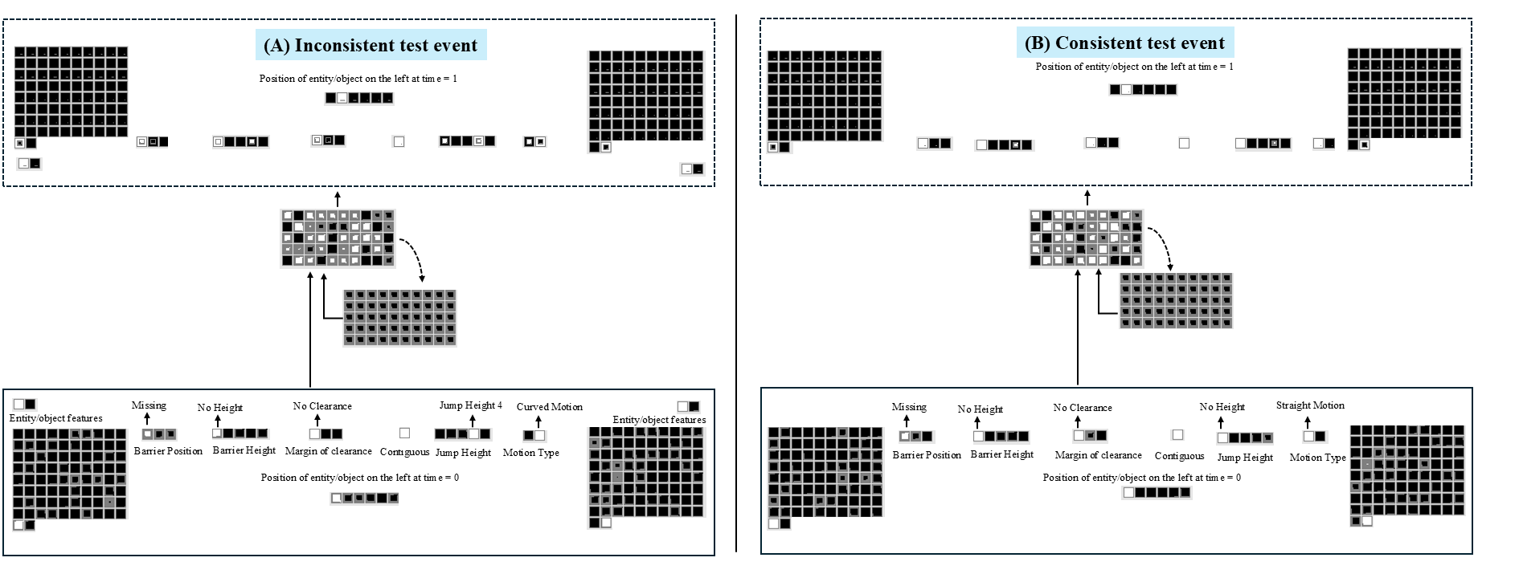
Figure 25. Depiction of the test performance of networks in the Experimental condition. (A) Network’s test performance on the Inconsistent test event. (B) Network’s test performance on the Consistent test events. The size of the colored region within each output unit corresponds to the activation of that output unit. Larger colored region corresponds to greater activation of that unit. Darker colored inner regions for output units correspond to activation values ≤0.5; lighter color inner regions correspond to activation values >0.4. The colored border that encircles each output unit corresponds to it “target” values. Dark borders correspond to target values of “0”; light colored borders correspond to target values of “1”.

This fact helps to explain the network’s responses to the barrierless test events. In the Inefficient test event, the first object again follows an arced path to reach the second object. This event was instantiated by turning on the Barrier Height 0 unit, the Curved Motion unit, the Barrier Missing unit, the single unit in the Contiguous group, the No Clearance unit, and the Jump Height 4 unit. Because five of these features appeared during the habituation phase—namely, Contiguous unit, both Animate Feature units, the Curved Motion Unit, and the Jump Height 4 unit—they will activate features they became associated with during that phase (i.e., Barrier Height 4, Jump Height 4), among others. For instance, presentation of the Jump Height 4 and Curved Motion input units leads to activation of the Barrier Height 4 unit. This can be seen in Figure 7. In particular, Figure 7 shows that in the Inconsistent test event, the network correctly activates the Barrier Missing, the Barrier Height 0, Contiguous, and Jump Height 4 output units. The first three are activated due to associations formed during pretraining; the last is activated due to associations formed with itself during habituation. At the same time, the network incorrectly activates the Barrier 4, Jump Height 0, and Straight Motion output units. This response is also expected: The Jump Height 0 and Straight Motion units were associated with their input counterparts during pretraining, and the Barrier Height 4 unit came to be associated with Jump Height 4, its input counterpart, Contiguous, and Animate Feature input units during habituation. Thus, three output units (i.e., Barrier 4, Jump Height 0, and Straight Motion) contribute to the error in the Inconsistent test event. This pattern of activation is precisely what the present theory predicts. Specifically, if infants, like the network, learn that a particular barrier height is associated with a specific type of motion (e.g., Curved Motion), then presenting one of these features at test (e.g., Jump Height 4) should reactivate the other (e.g., Barrier Height 4). If that associated feature is absent, as in the Inconsistent test event, then the network (and by extension, the infant) should detect an error and show heightened attention.
Now consider the Consistent test event. This event was implemented in the same manner except that the Straight Motion and Jump Height 0 input units were turned on. As can be seen in Figure 7, the network activates the same units as those in the Inconsistent test event. However, because the network correctly activates four of these units and incorrectly activates the remaining two units via the same associative processes described above, two rather than three output units contribute to this event’s error. The fact that one fewer unit contributes to error in the Consistent than in the Inconsistent event means the network looks less long at the Consistent test event than at the Inconsistent one. This provides a mechanistic explanation for infants’ looking behaviors in the Experimental condition, but it does not explain infants’ looking in the Control condition.
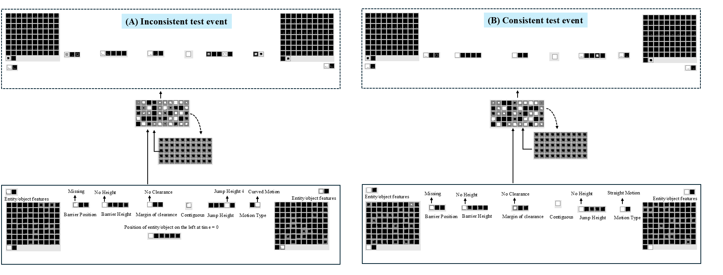
Figure 26. Depiction of the test performance of networks in the Control condition.

As it turns out, the same associative principles also explain why the network responds more similarly to the two test events in the Control condition. Figure 8 shows the test performance of one of the 20 networks in this condition. The habituation event in this condition was identical to that in the Experimental condition with one key exception: the barrier was now positioned to the side rather than in the middle. To reflect the assumption that barriers positioned to the side are less salient than centrally located ones, the learning rate for connections to and from the Barrier Height 4 units was lowered; weight decay was introduced further to decrease their salience. Consequently, the network failed sufficiently to adjust the weights connecting this unit with those features with which it was associated during habitation. A corollary of this is that during the Inconsistent test event, the network does not activate the Barrier Height 4 or Barrier Side output units in response to input from the Curved Motion, Jump Height 4, Contiguous, and Animate Feature units, even though these features co-occurred with the Barrier Side unit during habituation. This outcome too is consistent with the present theoretical account. Because the barrier was less salient in the side position, the resulting associations with curved motion were weaker and insufficient to support reliable reactivation of the Barrier Height 4 or Barrier Side output units at test.
It might seem surprising that the network fails to activate the Barrier Side unit at all. This is because, unlike the Barrier Height 4 unit, this unit was not subject to the same salience manipulation. This failure can nevertheless be understood by considering the network’s prior learning. During pretraining, the network learned that curved motion occurs over centrally located barriers. However, this regularity is violated in the habituation event for networks in the Control condition: curved motion now occurs beside the barrier. For the network to learn this new association, it would have to unlearn an established association between curved motion and central barriers. Ultimately, the network is unable to do this within the short time frame of the pretraining phase; that is, the short duration of the habituation phase precludes the network from overriding prior learned associations. This also explains why the network correctly activates the Barrier Missing output unit in both test events. In the Inconsistent test event, the Barrier Missing and Barrier Height 0 input units—which became associated during the pretraining phase—are presented to the model as input. Given that this activation reflects the correct response in both test events, it does not contribute to the network’s error (i.e., looking at this event).
In contrast to the lowered salience of the Barrier Height 4 unit, the Jump Height 4 unit remains visually salient to reflect the assumption that infants are drawn to dynamic motion events. As a result, the network can adjust its weights sufficiently during the habituation phase to activate the Jump Height 4 output unit in response to any of the input features it was associated with during pretraining, including itself—namely, the Curved Motion input unit, and the No Clearance input unit. If any of these units subsequently appear in a test event, the Jump Height 4 output unit will be activated. Because at least one of these input units is turned on in both test events, this output unit is active in both. This is the correct response in the Inconsistent test event but the incorrect response in the Consistent test event. Thus, the largest contributor to error in the Consistent test event is the Jump Height 4 output unit; the network correctly activates the remaining output units.
By comparison, the Inconsistent event includes two smaller contributors to error: the Straight Motion and Jump Height 0 units. These units are activated because they were previously associated with at least some of the features that appear as input to the model—namely, the Barrier Missing, Barrier Height 0, Jump Height 0, and Straight Motion input units. Importantly, the combined contribution of these two units to the network’s total error in the Inconsistent event matches the contribution of the Jump Height 4 unit in the Consistent test event. As a result, the network, like infants, looks about equally at both test events. This provides a mechanistic explanation for infants’ looking behaviors in the Control condition.
In sum, the reason networks in the Experimental condition looked longer at the Inconsistent test event than at the Consistent test event is that the learned association between barrier-related information (e.g., barrier height and position) and motion-related information (e.g., curved motion and high jumping) was violated in the former but not in the latter. This robust association emerged because these features were made more salient through an increased learning rate and reduced weight decay. The decision to increase the salience of these features was itself driven by the assumption that barriers are more visually prominent when jumping actions—which are inherently attention-grabbing for infants (e.g., Slater, 1989; Vallortigara et al., 2005)—occur above them rather than beside them. By contrast, networks in the Control condition looked equally at both test events because the reduced salience of the barrier—implemented via a lower learning rate and higher weight decay—prevented the model from forming an association between the barrier and the jumping action during habituation. Taken together, these results suggest that infants’ behavior in VoE Gergely-style studies may be explained by real-world experience observing curved and linear motion, combined with a domain-general associative mechanisms that operates over and forms associations among perceptual features.
Before closing, it is worth noting that the principles outlined above also account for the remaining simulations. For instance, the reason networks in the Inferring Constraints condition in Simulation 3 looked longer at the No-Obstacle test event than at the Obstacle test event was because the former violated an association that was established during the pretraining phase between jumping actions and barriers; that is, networks found anomalous test events in which jumping actions occurred in the absence of barriers because their pretraining experience was such that barriers and jumping actions went together. Similarly, the basis for networks’ longer looking at the high, inefficient test event than at the low, efficient test event in Simulation 4 was that it violated a learned expectation that agents jump just high enough to clear barriers. Considered together, these findings reinforce the notion that infants' looking behaviors in VoE studies based on the Gergely paradigm may be explained by domain-general associative processes operating over perceptual regularities.

General Discussion
A question that developmental scientists have wrestled with for the last 30 years concerns how infants learn about and process others’ actions. One perspective—which here I referred to as the rich perspective—maintains that infants’ knowledge about agents’ and objects’ actions is conceptually rich and abstract and underpinned by specialized learning processes that are present from birth or shortly thereafter (Carey, 2009; Csibra & Gergely, 1998; Gergely & Csibra, 2003; Jara-Ettinger et al., 2020; Leslie, 1995; Spelke, 2022). Another perspective—referred to here as the lean perspective—argues that infants’ behaviors in VoE studies, of which Gergely-style studies are an example, can be explained by domain-general learning mechanisms (e.g., associative learning, habituation, conditioning, imitation, among others) that operate over low-level perceptual features, features that are devoid of any conceptual meaning or semantic content (e.g., Benton, 2024; Benton & Lapan, 2022; Bogartz et al., 2000; Cohen et al., 2002; Cohen & Marks, 2002; Colunga & Smith, 2005; Jones & Smith, 1993; Oakes & Cohen, 2003; Perner & Ruffman, 2005; Quinn & Eimas, 1997; Rakison & Lupyan, 2008; Sloutsky, 2010).
This paper builds on this second view. The crux of my argument was that infants’ performance in VoE studies that used the Gergely paradigm reflect a combination of prior experience with linear and curved motion events and online associative learning in which barriers are linked with curved action based on their salience. I argued further that the strength of these associations depends on the physical proximity of the barrier to the curved motion: Stronger associations are established when the barrier appears beneath rather than beside curved action. I then showed that when this proposal was implemented in a simple connectionist model, it was able to account for a range of important findings. Simulation 1 accounted for the finding that infants show elevated looking when animated objects behave inefficiently. Simulation 2 reproduced the finding that infants show this pattern irrespective of whether objects possess animate features. Simulation 3 captured the finding that infants can infer external constraints from an agent’s actions as well as goals from its actions and external constraints. Finally, Simulation 4 replicated the finding that infants recognize that action events can differ in their relative efficiency and cost. Taken together, these simulations suggest that infants’ behaviors in these studies reflect learned associations among perceptual features rather than domain-specific mechanisms that permit abstract, inferential reasoning or conceptually rich knowledge about agents, goals, efficiency, utility, or cost.
The findings presented here also contribute to a broader tradition in the developmental cognitive sciences that uses connectionist models to simulate infants’ responses in VoE studies and other cognitive tasks (e.g., Benton, 2024; Benton & Lapan, 2021; Christiansen & Curtin, 1999; Cohen et al., 2002; Elman et al., 1996; Mareschal et al., 2000; Sirois & Mareschal, 2002; Schlesinger & Casey, 2003; Westermann & Mareschal, 2012; Yermolayeva & Rakison, 2014). The primary contribution of this earlier work has been to show that infants' responses in tasks ranging from object permanence to causal reasoning can be explained by associative principles. The present study extends this line of research by demonstrating that the same connectionist systems and associative learning principles can also account for infant action understanding.
Although the present model is not the first to simulate infants’ behavior in Gergely-style studies, it makes several novel contributions. First, it demonstrates that a single connectionist architecture accounts for multiple findings across studies. This contrasts with the only other connectionist model in this space by Overwalle (2010); this model only simulated the Gergely et al. (1995) study. Second, by unpacking the internal dynamics of the model—specifically, how and why it generated greater error (i.e., longer looking) in response to certain events in different conditions—it was possible to move beyond a typical demonstration that a model can reproduce behavioral data to providing a mechanistic explanation for how those data arose in the first place. A chief advantage of such an analysis is that it can provide insight into how the mind might implement associative learning. Finally, unlike earlier models that implement explicit notions of efficiency, cost, and utility, the current simulations suggest that infants' looking behaviors in action understanding studies can emerge from purely bottom-up processes. The current simulations demonstrate that these behaviors may emerge from associative learning mechanisms.
Despite the success of the current model, at least two potential criticisms are worth considering. One concerns the model’s simplicity. Although it was the case that movement was represented dynamically, all other aspects of the model were represented statically and locally rather than in a distributed fashion. For example, a localist or “one-hot” encoding scheme was used to represent objects, their features, and any external constraints or barriers in the environment. These simplifications might suggest that the model is a poor approximation of infants’ real-world action experience. However, a major advantage of simpler models is that it is possible to trace precisely how they process information. This was seen clearly in the section that traced how mechanistically the model reproduced infants’ looking behaviors across several Gergely-style studies. That simple models can be taken apart and scrutinized in this way makes them especially well-suited for advancing theories of infant action understanding. Although it is true that complex models could better capture the richness of infants’ action perception, a major disadvantage of such models is that their complexity hinders their interpretability. This complexity also makes it difficult to separate the meaningful consequences of different theoretical assumptions from extraneous model details. Simple models mostly eschew this conflict altogether by eliminating such details. Thus, although complex models may be ideal for simulating infants’ real-world action experiences, simpler models are invaluable for identifying underlying processes and advancing cognitive theory.
Another reason a simple model was chosen over a more complex one was that the larger goal of the present simulations was to shed light on how an associative learning mechanism might account for infants’ looking behaviors in action understanding studies that use the Gergely paradigm. To achieve this aim, it was necessary to develop a model that could address this specific theoretical question without attempting to simulate every detail of an action event. Although a comprehensive lean account ultimately will need to explain how features such as richly structured agent representations or dynamically encoded spatial relations beyond that implemented here influence infants’ performance in these studies, such features were not essential for evaluating whether sensitivity to low-level surface features and their associative relations are sufficient to explain infants’ responses in these tasks. By incorporating only the most theoretically relevant features (e.g., straight and curved motion, animate and inanimate features, external constraints, etc.), the model offers a more focused test of the core claim that associative learning, combined with experience with different kinds of actions, can produce the looking patterns observed in these studies. Nonetheless, fully evaluating and extending the current theoretical account will require the development of more sophisticated models that capture the full richness and complexity of infants’ real-world experiences. Additionally, although the present model is not developmental in nature, future modeling work could explore how changes in the strength of learned associations over time might account for any developmental trends observed in infants action understanding.
A second potential criticism is that because the current simulations focused on Gergely-style studies, it remains to be seen whether they can explain findings from other studies on infant action understanding. The specific concern is that by focusing exclusively on studies based on the Gergely paradigm, the current results cannot speak to the broader literature on infant action understanding. However, this limitation may be more apparent than real. This is because if those studies can be recast within the Gergely paradigm, it is possible that the same model could account for infants’ behavior in those studies as well. This would suggest that the explanatory breadth of the current extends beyond the specific paradigm for which it was originally developed. Simulation 3 took a step in this direction by reframing the Inferring Goals condition in Csibra et al. (2003)—which did not use the Gergely paradigm—within the context of the Gergely paradigm and showing that the model could nonetheless capture infants’ looking behaviors in this condition. Future modeling work that builds on the current set of simulations could similarly recast other studies on infant action understanding in terms of the Gergely paradigm to determine whether the current model can explain an even wider range of findings.
More generally, the current simulations should be understood as speaking to a much broader theoretical point that is related to how infants’ looking behaviors in action understanding tasks should be interpreted. The central claim is that such behaviors reflect learned associations among semantically neutral perceptual features rather than abstract inferences about agent action, goal, utility, cost, and efficiency, inferences that may be governed by innately endowed specialized processes. One implication of this view is that the current theoretical account should be implementable in any generic connectionist system, and thereby able to test whether a wider range of action understanding studies can be captured. Such a model could offer a perceptually grounded, theoretically coherent alternative to accounts that rely on domain-specific knowledge to explain infants’ responses across paradigms.
In sum, the current studies were carried out to test a novel theoretical account of infants’ action understanding that is grounded in domain-general associative learning and real-world experience with different types of actions and that builds on and extends existing lean accounts in the literature. By successfully modeling infants’ responses in studies using the Gergely paradigm, this work challenges the notion that infants rely on conceptually rich knowledge and specialized systems for processing action. Instead, the findings suggest that associative learning is sufficient to explain infants’ responses in these studies. It may also offer a more parsimonious explanation of infants’ behavior in these studies than accounts that invoke abstract notions of cost, efficiency, and agent action. More broadly, this work speaks to ongoing debates about how best to interpret infants’ looking behaviors in VoE tasks, perhaps as well as in other cognitive tasks. If such behaviors can be captured by simple associative processes that operate over perceptual input, this casts doubts on claims that infants’ looking in these tasks necessarily reflect conceptually rich inferences. But the debate continues.

although OM10-2 failed to capture the target findings the results from all models will continue to be reported for each subsequent simulation so that a "score card" can be generated at the end KEEP
References
Baillargeon, R. (1986). Representing the existence and the location of hidden objects: Object permanence in 6-and 8-month-old infants. Cognition, 23(1), 21-41. https://doi.org/10.1016/0010-0277(86)90052-1
Baillargeon, R. (1987). Object permanence in 3½- and 4½-month-old infants. Developmental Psychology, 23(5), 655–664. https://doi.org/10.1037/0012-1649.23.5.655
Baillargeon, R., & DeVos, J. (1991). Object permanence in young infants: Further evidence. Child development, 62(6), 1227-1246. https://doi.org/10.1111/j.1467-8624.1991.tb01602.x
Baillargeon, R., Spelke, E. S., & Wasserman, S. (1985). Object permanence in five-month-old infants. Cognition, 20(3), 191-208. https://doi.org/10.1016/0010-0277(85)90008-3
Benton, D. T. (2025). An associative-learning account of how infants learn about causal action in animates and inanimates: A critical reexamination of four classic studies. Journal of Experimental Psychology: General, 154(2), 497–521. https://doi.org/10.1037/xge0001656
Benton, D. T., & Lapan, C. (2022). Moral masters or moral apprentices? A connectionist account of sociomoral evaluation in preverbal infants. Cognitive Development, 62, 101164. https://doi.org/10.1016/j.cogdev.2022.101164
Bogartz, R. S., Shinskey, J. L., & Schilling, T. H. (2000). Object permanence in five‐and‐a‐half‐month‐old infants?. Infancy, 1(4), 403-428. https://doi.org/10.1207/S15327078IN0104_3
Carey, S. (2009). The origin of concepts. Oxford University Press.
Christiansen, M. H., & Curtin, S. (1999). Transfer of learning: Rule acquisition or statistical learning? Trends in Cognitive Sciences, 3(8), 289–290. https://doi.org/10.1016/S1364-6613(99)01356-X
Cohen, L. B., Chaput, H. H., & Cashon, C. H. (2002). A constructivist model of infant cognition. Cognitive Development, 17(3-4), 1323-1343. https://doi.org/10.1016/S0885-2014(02)00124-7
Cohen, L. B., & Marks, K. S. (2002). How infants process addition and subtraction events. Developmental science, 5(2), 186-201. https://doi.org/10.1111/1467-7687.00220
Cohen, L. B., & Oakes, L. M. (1993). How infants perceive a simple causal event. Developmental psychology, 29(3), 421-433.
Colunga, E., & Smith, L. B. (2005). From the Lexicon to Expectations About Kinds: A Role for Associative Learning. Psychological Review, 112(2), 347–382. https://doi.org/10.1037/0033-295X.112.2.347
Csibra, G., & Gergely, G. (1998). The teleological origins of mentalistic action explanations: A developmental hypothesis. Developmental science, 1(2), 255-259. https://doi.org/10.1111/1467-7687.00039
Csibra, G., Gergely, G., Bı́ró, S., Koos, O., & Brockbank, M. (1999). Goal attribution without agency cues: the perception of ‘pure reason’in infancy. Cognition, 72(3), 237-267. https://doi.org/10.1016/S0010-0277(99)00039-6
Csibra, G., Bíró, S., Koós, O., & Gergely, G. (2003). One‐year‐old infants use teleological representations of actions productively. Cognitive science, 27(1), 111-133. https://doi.org/10.1207/s15516709cog2701_4
Elman, J. L., Bates, E. A., Johnson, M. H., Karmiloff‑Smith, A., Parisi, D., & Plunkett, K. (1996). Rethinking innateness: A connectionist perspective on development. MIT Press.
Gelman, R. (1990). First principles organize attention to and learning about relevant data: Number and the animate‐inanimate distinction as examples. Cognitive science, 14(1), 79-106. https://doi.org/10.1207/s15516709cog1401_5
Geraci, A., & Surian, L. (2011). The developmental roots of fairness: Infants’ reactions to equal and unequal distributions of resources. Developmental science, 14(5), 1012-1020. https://doi.org/10.1111/j.1467-7687.2011.01048.x
Geraci, A., Surian, L., Tina, L.G. et al. Human newborns spontaneously attend to prosocial interactions. Nat Commun 16, 6304 (2025). https://doi.org/10.1038/s41467-025-61517-3
Gergely, G., & Csibra, G. (2003). Teleological reasoning in infancy: The naıve theory of rational action. Trends in cognitive sciences, 7(7), 287-292. https://doi.org/10.1016/S1364-6613(03)00128-1
Gergely, G., Nádasdy, Z., Csibra, G., & Bíró, S. (1995). Taking the intentional stance at 12 months of age. Cognition, 56(2), 165-193. https://doi.org/10.1016/0010-0277(95)00661-H
Hamlin, J. K. (2013a). Moral judgment and action in preverbal infants and toddlers: Evidence for an innate moral core. Current Directions in Psychological Science, 22(3), 186-193. https://doi.org/10.1177/0963721412470687
Hamlin, J. K., & Wynn, K. (2011). Young infants prefer prosocial to antisocial others. Cognitive development, 26(1), 30-39. https://doi.org/10.1016/j.cogdev.2010.09.001
Hamlin, J. K., Wynn, K., & Bloom, P. (2007). Social evaluation by preverbal infants. Nature, 450(7169), 557-559. https://doi.org/10.1038/nature06288
Hinton, G. E. (1989). Deterministic Boltzmann learning performs steepest descent in weight-space. Neural computation, 1(1), 143-150. https://doi.org/10.1162/neco.1989.1.1.143
Hunter, M. A., & Ames, E. W. (1988). A multifactor model of infant preferences for novel and familiar stimuli. Advances in Infancy Research, 5, 69–95.
Hunter, M. A., Ames, E. W., & Koopman, R. (1983). Effects of stimulus complexity and familiarization time on infant preferences for novel and familiar stimuli. Developmental Psychology, 19(3), 338–352. https://doi.org/10.1037/0012-1649.19.3.338
Jones, S. S., & Smith, L. B. (1993). The place of perception in children's concepts. Cognitive Development, 8(2), 113-139. https://doi.org/10.1016/0885-2014(93)90008-S
Kamewari, K., Kato, M., Kanda, T., Ishiguro, H., & Hiraki, K. (2005). Six-and-a-half-month-old children positively attribute goals to human action and to humanoid-robot motion. Cognitive Development, 20(2), 303-320. https://doi.org/10.1016/j.cogdev.2005.04.004
Kellman, P. J., & Spelke, E. S. (1983). Perception of partly occluded objects in infancy. Cognitive psychology, 15(4), 483-524. https://doi.org/10.1016/0010-0285(83)90017-8
Kim, I. K., & Spelke, E. S. (1992). Infants' sensitivity to effects of gravity on visible object motion. Journal of Experimental Psychology: Human Perception and Performance, 18(2), 385-393.
Kotovsky, L., & Baillargeon, R. (1998). The development of calibration-based reasoning about collision events in young infants. Cognition, 67(3), 311-351. https://doi.org/10.1016/S0010-0277(98)00036-5
Leslie, A. M. (1995). A theory of agency. In D. Sperber, D. Premack, & A. J. Premack (Eds.), Causal cognition: A multidisciplinary debate (pp. 121-141). Clarendon Press.
Leslie, A. M., & Keeble, S. (1987). Do six-month-old infants perceive causality?. Cognition, 25(3), 265-288. https://doi.org/10.1016/S0010-0277(87)80006-9
Lucca, K., Yuen, F., Wang, Y., Alessandroni, N., Allison, O., Alvarez, M., ... & Hamlin, J. K. (2025). Infants’ Social Evaluation of Helpers and Hinderers: A Large‐Scale, Multi‐Lab, Coordinated Replication Study. Developmental Science, 28(1), e13581. https://doi.org/10.1111/desc.13581
Liu, S., & Spelke, E. S. (2017). Six-month-old infants expect agents to minimize the cost of their actions. Cognition, 160, 35-42. https://doi.org/10.1016/j.cognition.2016.12.007
Mareschal, D., French, R. M., & Quinn, P. C. (2000). A connectionist account of asymmetric category learning in early infancy. Developmental Psychology, 36(5), 635–645. https://doi.org/10.1037/0012-1649.36.5.635
Mareschal, D., & Shultz, T. R. (1999). Development of children's seriation: A connectionist approach. Connection Science, 11(2), 149-186. https://doi.org/10.1080/095400999116322
McCrink, K., & Wynn, K. (2004). Large-number addition and subtraction by 9-month-old infants. Psychological Science, 15(11), 776-781. https://doi.org/10.1111/j.0956-7976.2004.00755.x
Muentener, P., & Carey, S. (2010). Infants’ causal representations of state change events. Cognitive psychology, 61(2), 63-86. https://doi.org/10.1016/j.cogpsych.2010.02.001
Needham, A., & Baillargeon, R. (1997). Object segregation in 8-month-old infants. Cognition, 62(2), 121-149. https://doi.org/10.1016/S0010-0277(96)00727-5
Onishi, K. H., & Baillargeon, R. (2005). Do 15-month-old infants understand false beliefs?. science, 308(5719), 255-258. https://doi.org/10.1126/science.1107621
Perner, J., & Ruffman, T. (2005). Infants' insight into the mind: How deep?. Science, 308(5719), 214-216. https://doi.org/10.1126/science.1111656
Phillips, A. T., & Wellman, H. M. (2005). Infants' understanding of object-directed action. Cognition, 98(2), 137-155. https://doi.org/10.1016/j.cognition.2004.11.005
Powell, L. J., & Spelke, E. S. (2018). Human infants’ understanding of social imitation: Inferences of affiliation from third party observations. Cognition, 170, 31-48. https://doi.org/10.1016/j.cognition.2017.09.007
Quinn, P. C., & Eimas, P. D. (1997). A reexamination of the perceptual-to-conceptual shift in mental representations. Review of General Psychology, 1(3), 271-287. https://doi.org/10.1037/1089-2680.1.3.271
Rakison, D. H., & Lupyan, G. (2008). Developing object concepts in infancy: An associative learning perspective. Monographs of the Society for Research in Child Development, 73(1), 1-110. http://www.jstor.org/stable/30162860
Rumelhart, D. E., Hinton, G. E., & Williams, R. J. (1986). Learning representations by back-propagating errors. Nature, 323(6088), 533-536. https://doi.org/10.1038/323533a0
Scarf, D., Imuta, K., Colombo, M., & Hayne, H. (2012). Social evaluation or simple association? Simple associations may explain moral reasoning in infants. https://doi.org/10.1371/journal.pone.0042698
Schlesinger, M., & Casey, P. (2003). Where infants look when impossible things happen: Simulating and testing a gaze-direction model. Connection Science, 15(4), 271-280. https://doi.org/10.1080/09540090310001655093
Schlingloff, L., Csibra, G., & Tatone, D. (2020). Do 15-month-old infants prefer helpers? A replication of Hamlin et al.(2007). Royal Society open science, 7(4), 191795. https://doi.org/10.1098/rsos.191795
Schmidt, M. F., & Sommerville, J. A. (2011). Fairness expectations and altruistic sharing in 15-month-old human infants. PloS one, 6(10), e23223. https://doi.org/10.1371/journal.pone.0023223
Schwier, C., Van Maanen, C., Carpenter, M., & Tomasello, M. (2006). Rational imitation in 12-month-old infants. Infancy, 10(3), 303-311. https://doi.org/10.1207/s15327078in1003_6
Singh, S. E., Benton, D. T., & Lei, R. F. (2025). Using artificial neural networks to simulate social category learning: A tutorial. Social Cognition, 43(3), 152-166. https://doi.org/10.1521/soco.2025.43.3.152
Sirois, S., & Mareschal, D. (2002). Models of habituation in infancy. Trends in Cognitive Sciences, 6(7), 293-298. https://doi.org/10.1016/S1364-6613(02)01926-5
Slater, A. (1989). Visual memory and perception in early infancy. Infant development, 43-71.
Sloutsky, V. M. (2010). From perceptual categories to concepts: What develops?. Cognitive science, 34(7), 1244-1286. https://doi.org/10.1111/j.1551-6709.2010.01129.x
Sodian, B., Schoeppner, B., & Metz, U. (2004). Do infants apply the principle of rational action to human agents? Infant Behavior and Development, 27(1), 31-41. https://doi.org/10.1016/j.infbeh.2003.05.006
Sokolov, E. N. (1963). Higher nervous functions: The orienting reflex. Annual review of physiology, 25(1), 545-580. https://doi.org/10.1146/annurev.ph.25.030163.002553
Spelke, E. S. (2022). What babies know: Core knowledge and composition (Vol. 1). Oxford University Press.
Spelke, E. S., Breinlinger, K., Macomber, J., & Jacobson, K. (1992). Origins of knowledge. Psychological Review, 99(4), 605–632. https://doi.org/10.1037/0033-295X.99.4.605
Stahl, A. E., & Kibbe, M. M. (2022). Great expectations: The construct validity of the violation‐of‐expectation method for studying infant cognition. Infant and Child Development, 31(6), e2359. https://doi.org/10.1002/icd.2359
Vallortigara, G., Regolin, L., & Marconato, F. (2005). Visually inexperienced chicks exhibit spontaneous preference for biological motion patterns. PLoS biology, 3(7), e208. https://doi.org/10.1371/journal.pbio.0030208
Van Overwalle, F. (2010). Infants' teleological and belief inference: A recurrent connectionist approach to their minimal representational and computational requirements. NeuroImage, 52(3), 1095-1108. https://doi.org/10.1016/j.neuroimage.2010.05.028
Westermann, G., & Mareschal, D. (2012). Mechanisms of developmental change in infant categorization. Cognitive Development, 27(4), 367-382. https://doi.org/10.1016/j.cogdev.2012.08.004
Woo, B. M., Steckler, C. M., Le, D. T., & Hamlin, J. K. (2017). Social evaluation of intentional, truly accidental, and negligently accidental helpers and harmers by 10-month-old infants. Cognition, 168, 154-163. https://doi.org/10.1016/j.cognition.2017.06.029
Woodward, A. L., & Sommerville, J. A. (2000). Twelve-month-old infants interpret action in context. Psychological Science, 11(1), 73-77. https://doi.org/10.1111/1467-9280.00218
Wynn, K. (1992). Addition and subtraction by human infants. Nature, 358(6389), 749-750. https://doi.org/10.1038/358749a0
Wynn, K. (1995). Infants possess a system of numerical knowledge. Current directions in psychological science, 4(6), 172-177. https://doi.org/10.1111/1467-8721.ep10772615
Yermolayeva, Y., & Rakison, D. H. (2014). Connectionist modeling of developmental changes in infancy: Approaches, challenges, and contributions. Psychological Bulletin, 140(1), 224–255. https://doi.org/10.1037/a0032150

Inferential statistics were not used in any of the simulations for two reasons. First, because infant looking times and model error are measured on fundamentally different scales and exhibit different distributions, direct statistical comparisons between them were not appropriate. Second, the goal of the current simulations was not to show that the magnitude of the model’s effects matched those observed in empirical studies. Instead, the aim was to demonstrate that the qualitative pattern of results—such as greater error to unexpected or inefficient events in some conditions but not others—aligned with the patterns observed in infant behavior. This emphasis on qualitative pattern matching over statistical inference is consistent with prior modeling work in the developmental cognitive sciences (e.g., Benton, 2024; Mareschal et al., 2000; Mareschal & Schultz, 1999; McClelland & Thompson, 2007; Plaut & Vande Velde, 2017).

