Associative learning over distinct surface features can explain infants’ action efficiency understanding
Deon T. Benton
Vanderbilt University

Address correspondence to Deon T. Benton, Department of Psychology and Human Development, Vanderbilt University, Peabody College, 230 Appleton Place #552, Nashville, TN 37235

Data availability statement: The simulation data for these simulations can be found here https://osf.io/9eqpf/?view_only=62f752417a9141c7b0509a998039ad13.
Conflicts of interests: none

“Associative learning over distinct surface features can explain infants’ action efficiency”

Abstract
Developmental scientists have long debated how infants come to understand the efficiency of others’ actions. The nativist position maintains that infants possess conceptually rich, domain-specific systems that enable them to represent actions in terms of goals, constraints, efficiency, and rationality. The empiricist position argues that the looking behavior of preverbal infants in most looking-time studies reflects domain-general processes that operate over the conceptually neutral surface features of the events and entities and objects that comprise them. Here, I instantiate a version of this latter proposal in a new connectionist model called Associative Learning in Action Sequences (ALIAS) and show that the model reproduced findings previously taken as evidence for different domain-specific systems that support processing actions in terms of their efficiency, cost and utility. An analysis of the internal dynamics of the model indicated that its behaviors arose mechanistically through learned associations among perceptual features, the reactivation of associated representations during test events, differential obstacle salience, and transient attentional modulation. Additionally, ALIAS generated novel predictions concerning how changes in salience, experience, and attentional persistence should shape infants’ looking behavior in future experiments. Prominent theoretical accounts of infant cognitive posit specialized processes in domains such as causal learning, moral cognition, physical reasoning, among others. Yet, the present findings show that even in a domain as complex as action efficiency understanding, simple, albeit extremely powerful, domain-general learning processes operating over perceptually grounded event representations can account for infants' looking behaviors. As such, this study raises crucial questions about the necessity of specialized learning mechanisms to explain infants’ looking behaviors.
“Associative learning over differentially salient surface features is sufficient to explain infants’ action efficiency understanding”
A key challenge for young learners is distinguishing between efficient and inefficient actions. For instance, by observing a child tumble down a slide after attempting clumsily to climb it from the bottom, a child may learn that stairs are a more efficient—and indeed safer—way to use to slides. Similarly, by observing a person walk around a fence rather than repeatedly, and unsuccessfully, pushing against it, that same child will learn that moving around obstacles is a more efficient way to reach a destination. In general, recognizing when an action is or is not efficient—a capacity I refer to as action efficiency understanding—is crucial for navigating the world effectively. An open question in the developmental cognitive sciences concerns when and how preverbal infants, despite their limited mobility and first-hand experience interacting in the world, come to interpret actions in terms of their efficiency.
One method that developmental scientists have used to assess the developmental origins of action efficiency understanding is the violation-of-expectation paradigm. In this method, infants are tested on events either conforming to or violating expectations established during habituation (e.g., Baillargeon et al., 1995; Stahl & Kibbe, 2022). In action efficiency understanding studies that use this method, infants are habituated to an event in which an object jumps over a barrier to reach another one and then tested on events that differ in their efficiency (see Figure 1). In the so-called efficient event, the first object moves along a straight path to reach the second object. In the so-called inefficient event, the first object continues to move along the familiar, but now inefficient, curved or arced motion path to reach the second object. Figure 1 depicts this general approach for studying action efficiency in infants.

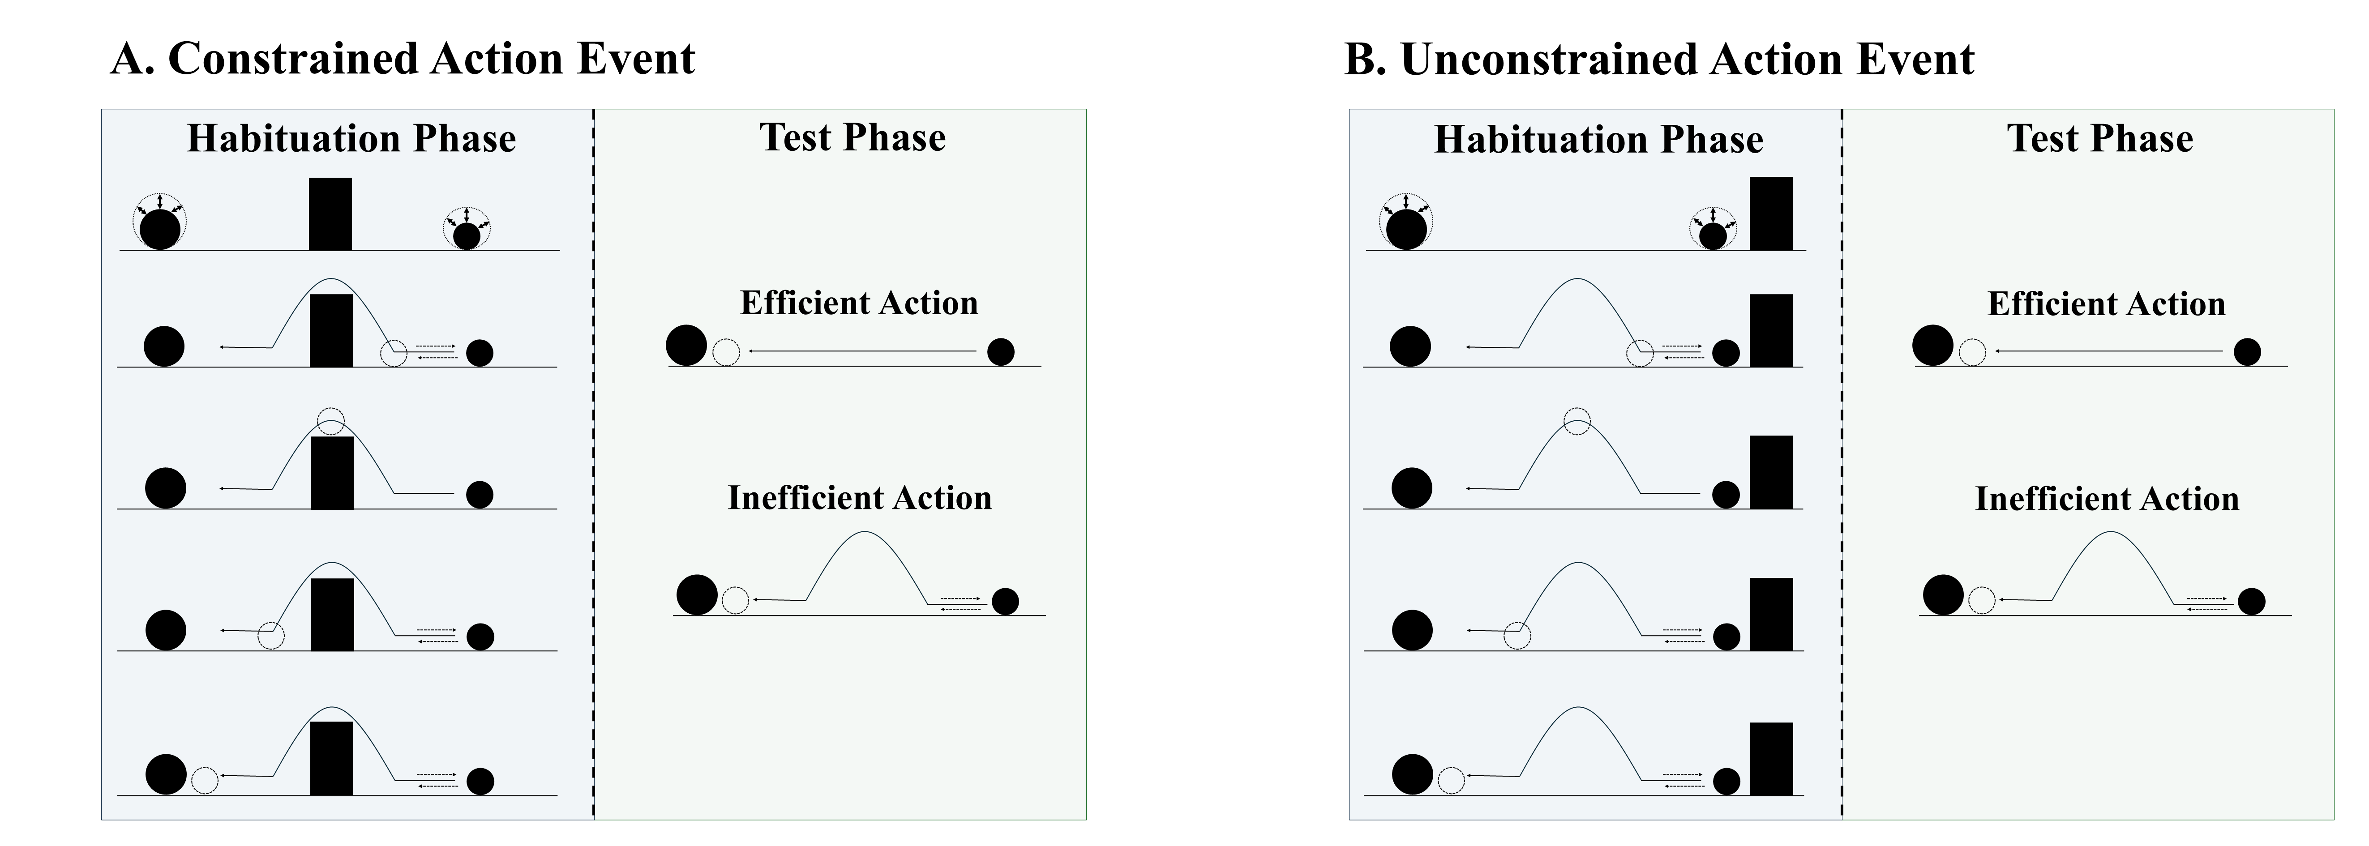
Figure 1. Schematic depiction of a typical constrained and unconstrained action event used in studies assessing action efficiency understanding in infants. In the constrained action event (A), the first object jumps over the barrier before it comes to rest next to the second object; in the unconstrained action event (B), the first object jumps beside the barrier before coming to rest next to the second one. The barrier is removed at test for both events, and infants observe either an efficient straight-path action or an inefficient arced-path action. Data for the first target finding discussed in the text derived from this paradigm.

A number of important findings—which serve as targets for the present series of simulations—have emerged from the use of this method. Figure 2 provides a visualization of the paradigms from which the findings reviewed in this section derive. One of the earliest and most influential findings is that 9- to 12-month-olds look longer at the inefficient test event than at the efficient one but only if the first object’s movement during habituation was constrained (i.e., it occurred over a barrier); infants look equally long at both events if its movement was unconstrained (Figure 1; i.e., it occurred beside a barrier; Gergely et al., 1995; Phillips & Wellman, 2005; Schwier et al., 2006; Sodian et al., 2004; Woodward & Sommerville, 2000). Another is that infants show the same pattern whether the moving entity is animate or inert (Figure 2A; e.g., Csibra et al., 1999; Kamewari et al., 2005).

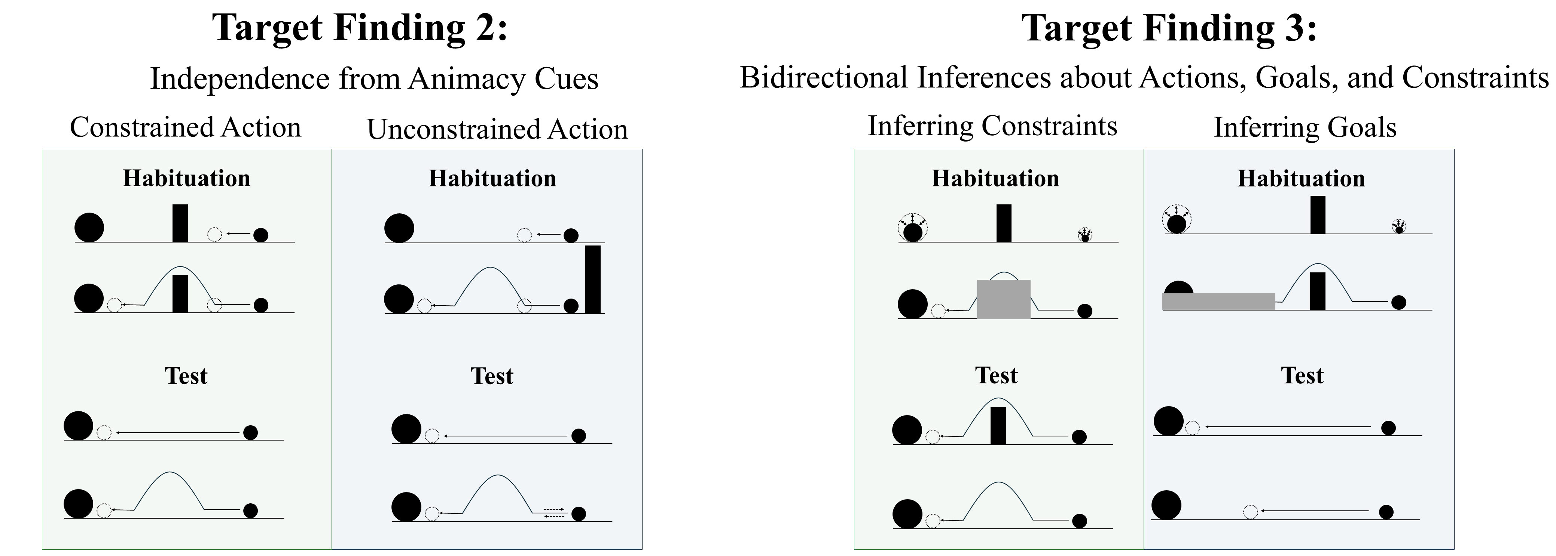
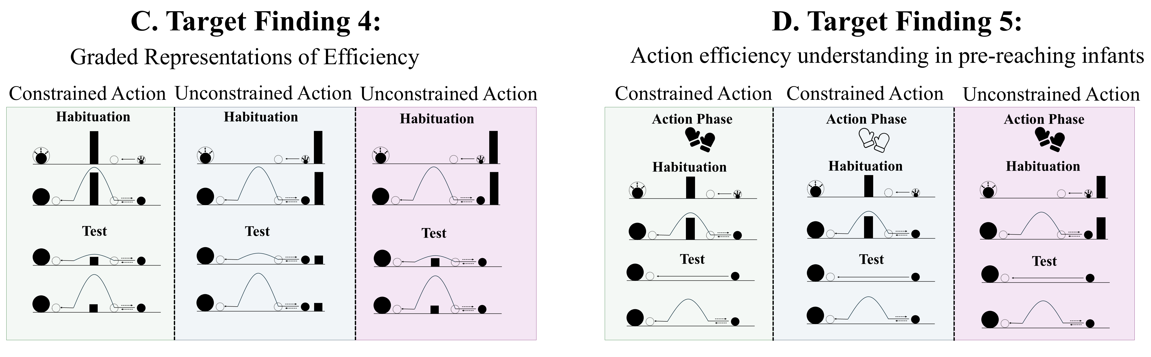
Figure 2. Schematic overview of the paradigms from which Target Findings 2–5 derive. Panels A–D depict, respectively, the experimental paradigms showing (A) the independence of action efficiency understanding from animacy cues, (B) bidirectional inferences about actions, goals, and constraints, (C) graded representations of efficiency, and (D) action efficiency understanding in pre-reaching infants. Note that closed gloves correspond to the sticky-mittens condition, whereas open gloves correspond to the non-sticky-mittens condition. The paradigm underlying Target Finding 1 is shown in Figure 1.

Beyond identifying inefficient actions across different types of entities, previous research suggests that infants can also reason about the relations among actions, goals, and environmental constraints (Figure 2B). For example, Csibra et al. (2003; see also Wagner & Carey, 2005) showed that 12-month-olds can make bidirectional inferences among these factors: they can use information about an agent’s actions and the constraints under which those actions are performed to infer the agent's goal, and they can use information about an agent’s goal and actions to infer the presence of environmental constraints. Infants looked longer at the test events that violated these inferred relations. Finally, infants appear sensitive to graded differences in action efficiency. Liu and Spelke (2017) found that infants showed heightened looking to test events that were substantially inefficient compared to events that were only mildly inefficient, and they generalized these expectations across changes in environmental constraints (Figure 2C).
A final notable finding is that pre-reaching infants—that is, infants with little firsthand object-manipulation experience and little opportunity to observe others' actions—nevertheless behave as though they are sensitive to action efficiency when they are given direct action experience (e.g., Skerry et al., 2013; see also Liu et al., 2019). In Skerry et al.’s (2013) study, for example, 3-month-olds were fitted either with sticky mittens that enabled them successfully to hold a Velcro-covered ball or with non-sticky mittens that did not (Figure 2D). Skerry et al. (2013) found that only infants habituated to a constrained action event—in which an actor reached over or beside a barrier to retrieve the same ball—looked longer when the actor followed the familiar arced path than a novel straight one when the obstacle was removed. Although this research suggests that action efficiency understanding is in place sometime in the second half of the first year of life, an open question that it raises concerns its mechanistic basis.

Rich proposals for the origins of infant action efficiency understanding
Accounts of the mechanistic basis of infants’ looking into two classes: rich and lean. Rich proposals maintain that infants possess early emerging, domain-specific mechanisms that support abstract and conceptually rich knowledge about how the various objects and entities in the world behave and act. For example, the teleological stance (Csibra & Gergely, 1998; Gergely & Csibra, 2003) holds that if an agent pursues some end state efficiently given the physical context—and thus satisfies the “rationality principle”—then the end state will be treated as the agent’s goal, the agent's behavior as a goal-directed “means” to it, and the physical context as a set of “constraints”. The naïve utility calculus casts this in Bayesian terms (Jara-Ettinger et al., 2016, 2020): agents choose actions that minimize costs. More recently, Liu et al. (2026) argued that action efficiency understanding emerges from a naïve psychology system (in which agents are represented as goal-directed reward-maximizers) that receives input from a naïve physics system (in which objects are represented as bounded and solid).
These perspectives have real strengths: they address foundational questions at the heart of the developmental cognitive sciences, have generated a substantial body of research, and enjoy some degree of empirical support. Yet, each share a common limitation: None specify the origins of relevant primitives. The teleological stance does not explain from where notions such as goals, constraints, efficiency, or rationality originate. The naïve utility calculus is silent about the origins of reward, cost, and subjective utility and does not address how the proposed computations are implemented mechanistically. And Liu et al.’s (2026) proposal presupposes the very agent and object concept it is meant to explain (e.g., Benton, 2025).

Lean proposals for the origins of infant action efficiency understanding
Lean proposals take a different tack: They explain infants’ looking behaviors in violation-of-expectation studies as emerging from simple, albeit extremely powerful, domain-general learning mechanisms (e.g., associative learning, habituation, conditioning, etc.). These “all purpose” processes operate over low-level, surface-based perceptual features and that extract statistical regularities in visual scenes (e.g., Blumberg & Adolph, 2023; Cohen et al., 2002; Cohen & Oakes, 1993; Colunga & Smith, 2005; Heyes, 2018, 2024; Jones & Smith, 1993; Quinn & Eimas, 1997; Rakison & Lupyan, 2008; Sloutsky, 2010). Although lean proposals abound for a range of cognitive capacities (Benton, 2025; Benton & Hoch, 2026; Benton & Lapan, 2021; Berthiaume et al., 2013; Bogartz et al., 2000; Clearfield & Mix, 1999; Cohen et al., 2002; Cohen & Marks, 2002; McClelland & Thompson, 2007; McMahon & Isik, 2023; Munakata, 1998; Munakata et al., 1997; Perner & Ruffman, 2005; Scarf et al., 2012a, 2012b; Simon, 1997; Rakison & Lupyan, 2008), efforts to explain infants’ looking behavior in action efficiency understanding studies remain scarce.
Van Overwalle (2010; hereafter, OM10) is an exception to this. He argued that infants rely on a “forward model” to learn what makes actions efficient: as agents are observed moving toward goals, internal representations are established that capture the visible state at points along the trajectory. Van Overwalle (2010) showed that a connectionist implementation of this proposal could reproduce Gergely et al.’s (1995) findings: Habituation to constrained but not to unconstrained action produced longer looking to the inefficient than to the efficient test event.
VOM10 is nonetheless limited in a couple critical respects that bear directly on the present account. The model received no action observation experience prior to the simulated habituation phase and thus could not draw on prior exposure the way Csibra et al.’s (2003) inference findings requires. The model built in the very concepts that lean accounts should explain by stipulating units for agents and objects. Finally, VOM10 departed from Gergely et al.’s (1995) study in two crucial ways: It omitted the obstacle from the Control habituation event and the agent’s simulated curved trajectory overshot the barrier. These issues severely limit what can be concluded from the model’s apparent success.
The present paper develops an alternative lean account—instantiated as a connectionist computational model—that captures Gergely et al.'s (1995) findings and the above four target findings reviewed. It is then compared to VOM10 and modified versions of both models.

An experienced-based associative learning account of infants’ looking behavior in action efficiency understanding studies

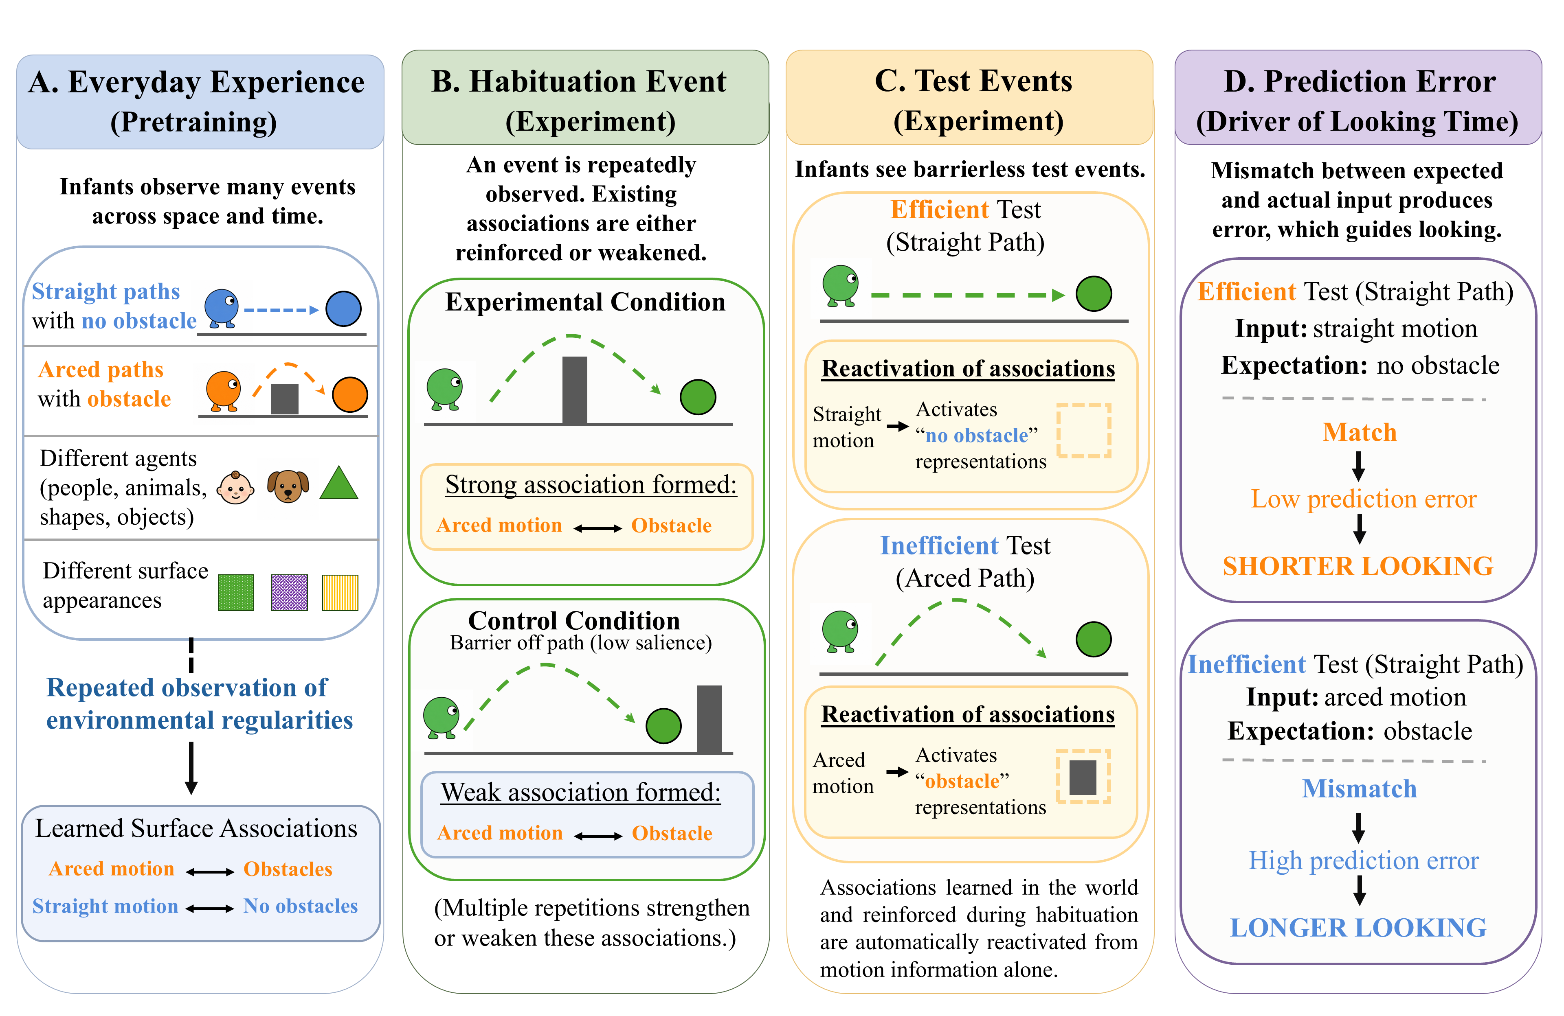
Figure 3. An associative learning account of infants’ looking in action efficiency understanding studies. (A) In the real world, infants form associations among the kinematics of different actions and the surface features of the entities and objects involved in them (e.g., arced motion is associated with obstacles and straight motion with absent obstacles). (B) During habituation, these associations are reinforced when arced motion occurs over an obstacle (Experimental condition) but are weakened when curved motion occurs beside it (Control condition). (C) At test, seeing a particular motion trajectory automatically activates the associated feature (e.g., an arced path activates a representation of an obstacle). If the expected features are not present, this produces prediction error which manifests as longer looking times; expectations that are met produce minimal to no error, and this manifests as shorter looking times.

The present account’s central proposal—illustrated in Figure 3—is that infants' looking behavior in action efficiency studies reflects repeated experience observing agents move along straight trajectories when obstacles are absent and along arced trajectories when obstacles are present. This experience causes associations to form between arced motion and obstacles and between straight motion and the absence of obstacles (Figure 3A). With repeated experience, these learned associations become strong enough that presenting one component of a relation activates a representation of the other (for similar proposals in other domains see Rakison & Poulin-Dubois, 2001 and Heyes, 2019). Crucially, the representations that emerge from this associative-learning process embody only the semantically neutral kinematics of the observed actions and the conceptually neutral visible surface features of the objects and entities involved.
Two consequences follow from this account. First, habituation events that align with prior experience reinforce these associations; misaligned habituation events weaken them. Second, test events presenting only one component of a learned relation will evince longer looking that those presenting both components (Figures 3C and 3D). Together, these principles explain why infants habituated to constrained action look longer at inefficient than at efficient test events: The inefficient test event violates the learned arced-motion-obstacle association—reinforced during habituation—by only presenting the first component of this relation; the efficient test event preserves the learned straight motion–no-obstacle association and thus evokes minimal looking.
Yet, if associative learning is the basis of infants’ looking behaviors in these studies, why then does habituation to unconstrained action eliminate the effect? The key is that arced motion occurs over a barrier during constrained motion but beside it during unconstrained motion. Given that peripherally located obstacles are plausibly less salient than centrally located ones, infants may simply be less likely to notice obstacles in the latter configuration. This distinction, combined with a preexisting bias for motion (Figure 3B; e.g., Slater, 1989; Vallortigara, Regolin, & Marconato, 2005), could elicit more looking at the moving object and its arced trajectory and comparatively less at the stationary obstacle. If infants nevertheless notice the obstacle, then the association formed between it and arced motion will compete with—and thereby weaken—the stronger association formed previously between this motion and centrally located obstacles. At the same time, because the habituation phase is much shorter than infants' real-world experience, any association that is established between arced motion and a peripherally located obstacle will be relatively weak. Subsequent testing on the inefficient test event should therefore produce equivalent looking to the inefficient and efficient test events.
The present account can also explain Skerry et al.’s (2013; see also Liu et al., 2019) finding that pre-reaching 3-month-olds show the effect only after direct action experience. Such experience may temporarily boost infants’ encoding of the geometry (i.e., arm configuration) and movement trajectory (i.e., straightness of arm movement) of their own successful reaches. Consistent with this proposal, Needham et al. (2002) showed that sticky-mittens experience does enhance infants’ learning about objects, and research by Sommerville et al. (2005) showed that sticky mittens experience induces longer looks at initial action events than non-sticky mittens experience. If successful reaches approximate a straight path on average and produce amodal representations—that is, abstract and identity-independent—capturing the geometry and trajectory of those reaches, then straight trajectories and the corresponding efficient test events should be rendered more familiar than curved ones and the corresponding inefficient test events.
In the remainder of the paper, I instantiate this proposal in a connectionist computational model called ALIAS (for Association Learning in Action Studies) and test its ability to reproduce the present target findings. Note, however, that the present account is neither a theory of action efficiency understanding nor is it a theory of how such a capacity emerges—it is an account of infants’ looking behavior in these studies and is grounded entirely in associative learning over conceptually neutral surface features and kinematics.

The present simulation studies
The five simulations that follow were developed with two goals in mind. The first was to assess the sufficiency of the current account to reproduce the following five target findings:
- Selective longer looking to inefficient actions. Twelve-month-old infants look longer at barrierless curved than straight trajectories following habituation to a constrained event. This pattern disappears following habituation to an unconstrained event (e.g., Csibra et al., 1999; Gergely et al., 1995).
- Independence from animacy. Nine-month-old infants show the pattern described in (1) even when the agents lack animate features (e.g., Csibra et al., 1999; Sodian et al., 2004).
- Bidirectional inferences about actions, goals, and constraints. Twelve-month-old Infants can infer goals from actions and constraints, and constraints from actions and goals (e.g., Csibra et al., 2003; Wagner & Carey, 2005).
- Graded representations of efficiency. Six-month-old infants represent action efficiency continuously rather than dichotomously (e.g., Liu & Spelke, 2017).
- Action efficiency understanding in pre-reaching infants. Three-month-olds show the pattern described in (1) following direct action experience (e.g., Skerry et al., 2013).
The second goal of the current simulations was to compare ALIAS to VOM10 and extensions of both models. VOM10-2 was designed to more faithfully represent the tasks underlying the present target findings. In this model, obstacles and goal objects remain continuously visible and the agent no longer overshoots the barrier. ALIAS-2 eliminated the assumption that peripherally located obstacles are less salient than central ones. Both extensions are described more fully below. By comparing ALIAS to these alternative models, it is possible to determine whether VOM10’s limitations are genuine and whether differential obstacle salience is necessary to reproduce the current findings. Given these goals, the studies underlying these findings were modeled only in enough detail to preserve the critical structure of the task. In cases where the original reports did not provide sufficient detail to model their critical aspects (e.g., the action phase length in Skerry et al., 2013), reasonable assumptions were made.
As the primary comparison model throughout the present simulations, the next section begins with a discussion of VOM10. This discussion will be kept brief because a fuller one can be found in Van Overwalle (2010). Following this is a description of ALIAS’s architecture. Five simulations will then be reported, each corresponding to one of the target findings. Each simulation is then followed by a discussion of how ALIAS reproduced the corresponding target finding. The paper concludes with two final simulations. Each one involves placing and then assessing ALIAS’s behavior in a novel situation. It will be suggested that this behavior constitutes testable predictions for future research.
The current simulations were run using the Lens neural network simulator (Rohde, 1999). The full set of training and testing files, including data from the simulations reported here, are available for download at https://osf.io/9eqpf/?view_only=62f752417a9141c7b0509a998039ad13.

General Method
Models
VOM10
This model was a one-layer recurrent connectionist model consisting of 27 fully interconnected units—25 of these units implemented a 5 × 5 spatial grid and the remaining two represented an agent and goal object. Training involved networks observing action trajectories that unfolded across a series of discrete time step and corresponded to habituation. Networks in the Experimental condition (N = 20) observed an agent follow an arced path over a barrier to reach a goal object; networks in the Control condition (N = 20), in contrast, saw the same event except that the barrier was missing. In all simulations and regardless of model type, “participants” corresponded to separate model runs with different initial random weights. Following habituation, networks were shown barrierless straight and arced trajectories, and activation over a set of “critical units” served as the dependent measure. As in Overwalle (2010), lower activation corresponded to longer looking. Figure 4 illustrates a nine-step habituation sequence for networks assigned to the Experimental condition.
VOM10-2 was identical to this model except that the agent no longer overshot the barrier by one cell (seen in middle cell of the middle row in Figure 4). Additionally, the barrier and goal remained continuously visible throughout the agent’s arced trajectory.

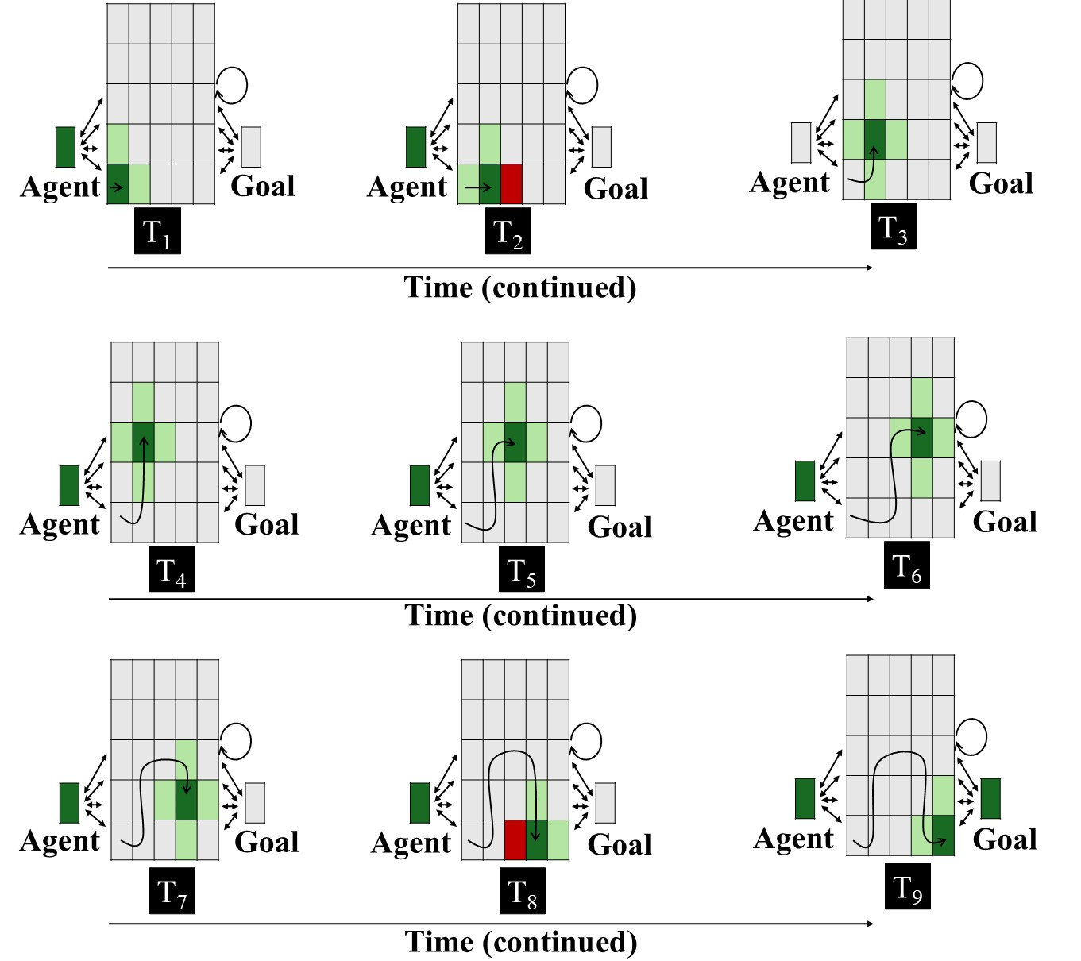
Figure 4. Input patterns shown to VOM10 networks in the Experimental condition across nine steps. Each panel represents the input to the network at a given time step. The central 5 × 5 array corresponds to the spatial grid; the two units flanking the spatial grid to the right and left of it correspond, respectively, to the agent and goal objects. Dark green indicates the agent’s current position (+1), light green indicates adjacent cells (+0.5), red indicates the presence of the barrier (-1), and gray indicates no activation (0). The goal unit is activated only at the final step. The barrier is present only when the agent occupies a position immediately adjacent to it (see Van Overwalle, 2010). The overlaid curved path in each panel depicts the amount of arc motion the agent has completed through that time step. Two-headed arrows and the circular arrow denote bidirectional connectivity. As in Overwalle (2010), the critical units for arced arced were the three units comprising its apex; the bottommost middle cell was the critical unit for the straight path. See the online article for a color version of this figure.

ALIAS
Method
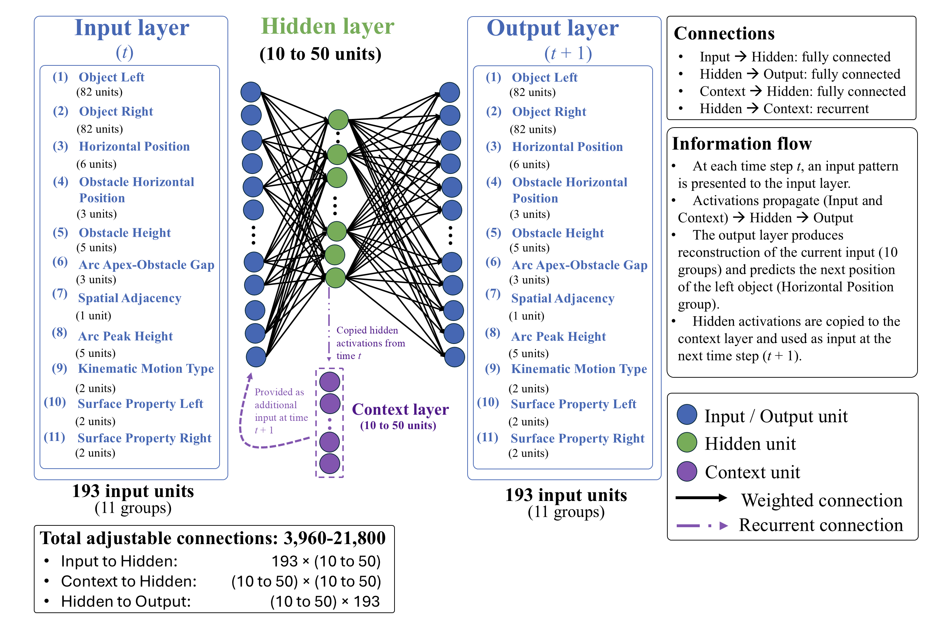
Figure 5. Architecture of the ALIAS model. The model consisted of input, hidden, context, and output layers. Input and output layers consisted of 193 units spread across 11 groups. The number of hidden units ranged from 10-50 across simulations. The model combined an autoencoder (Groups 1-2 and 4-11) and a simple recurrent network (Group 3). The autoencoder copied the input activity to the output layer; the SRN predicted left object’s next position given its current one.

Network Architecture. Figure 5 shows the model architecture. The model consisted of three layers of units. The input and output layers contained 193 input and output units. These units were divided into 11 groups corresponding to different visible surface features. Between the input and output layers were 10 to 50 hidden and context units depending on the simulation. The input and context units were fully connected to the hidden units. These units, in turn, were fully connected to the output units. Weights were initialized to small random values and were sampled uniformly between ±0.1. Bias connections were not included in any of the reported simulations. In total, the network contained 21,800 adjustable connections.
Activation values of input units were externally set to reflect the input appropriate to the current time step. Activation values for units elsewhere in the model depended on their net input from other units. Net input to hidden units was calculated as follows:

${net}_{j}=\sum_{i}{a_{i}w_{ij}}$, | (1)

where $a_{i}$ is the activation of unit i and $w_{ij}$is the weight on the connection from input unit i to hidden unit j. To prevent vanishing error derivatives during training, hidden unit activations were based on the rectified linear unit activation function (Nair & Hinton, 2010) and were calculated as follows:

$a_{j}=max⁡(0, {net}_{j})$, | (2)

where $a_{j}$ is the activation of hidden unit j, ${net}_{j}$ is its net input, and $max$ denotes the maximum of its two arguments. Net input to output units was calculated as follows:

${net}_{k}=\sum_{j}{a_{j}w_{jk}}$, | (3)

where $a_{j}$ is the activation of hidden unit j and $w_{jk}$is the weight on the connection from hidden unit j to output unit k. Output unit activations were then a smooth, logistic function of this net input, calculated as follows:

$a_{k}=\frac{1}{1+exp⁡(-{net}_{k})}$, | (4)

where $a_{k}$ is activation of output unit k, ${net}_{k}$ is its net input, $w_{jk}$ is the weight on the connection from hidden unit j to output unit k, and $exp⁡(∙)$ is the exponential function. Finally, as is true in simple recurrent networks (SRNs; Elman, 1990), the activation of the hidden units at time $t$ was copied to the context units and made available as input at time$t+1$. This provided the model with a rudimentary form of memory such that information from earlier time steps influences processing at later ones.
Representations and Task. At each time step, a linear or arced motion event was presented to the network as a pattern of activation distributed across the 11 input and output groups (Figure 5). Each group corresponded to a different visible surface feature, and the units within each group, to different manifestations of that feature. A localist encoding scheme was used for two reasons. First, it ensured that the model’s responses reflected learned regularities among actions and the visible surface features of the objects and entities involved. Second, it facilitated interpretation of the mechanism producing those responses. Table 1 lists each group and the features represented by each unit within it. The naming convention used for each group was intended to emphasize their semantically neutral, surface-based nature and to reflect the present account’s assumption that infants represent action events in terms of their low-level perceptual features rather than concepts such as goals, constraints, efficiency, or rationality.

Table 1
ALIAS’s input and output groups
Group | Num | Represents | Unit Meaning
Object Left | 82 | Identity of left object | Each unit corresponds to a unique object identity
Object Right | 82 | Identity of right object | Each unit corresponds to a unique object identity
Horizontal Position | 6 | Left object’s position relative to the right one | Position 1–6 in network space
Obstacle Horizontal Position | 3 | Horizontal location of obstacle | Missing, Middle, Periphery
Obstacle Height | 5 | Height of obstacle | No Obstacle, Heights 1–4
Arc Apex–Obstacle Gap | 3 | Vertical distance between an obstacle and the apex of the arced motion trajectory | No Separation, Small Vertical Separation, Large Vertical Separation
Spatial Adjacency | 1 | Whether the two objects are adjacent | Spatially Continguous, Spatially Separated
Arc Peak Height | 5 | Maximum height of arced trajectory | No arc, Heights 1–4
Kinematic Motion Type | 2 | Type of motion | Linear, Arced
Surface Property Left | 2 | Surface features of left object | Animate-like, Inanimate-like
Surface Property Right | 2 | Surface features of right object | Animate-like, Inanimate-like
Note. Group names correspond to those shown in Figure 5. Each group represented a different visible surface feature; units within a group represented different manifestations of that feature. A localist encoding scheme was adopted for each group.

Input units corresponding to the features present during a given time step of an action event had their activation set to 1.0; all other input units had their activation set to 0.0. A small amount of Gaussian noise (M = 0, SD = 0.3) was then applied to these activations to instantiate the notion that infants’ learning and processing are noisy functions of experience. The network’s task at each time step was twofold. First, it was required to reproduce at the output layer the activation pattern presented across 10 of the 11 groups. Second, it was required to predict the subsequent position of the left object via the Horizontal Position group. The reason Horizontal Position was the only group whose future state the network was required to predict is that movement itself is dynamic and necessarily unfolds over time. Thus, if the first unit in the Horizontal Position group was active (i.e., had an activation value of 1.0) at time $t$, the network’s task was to activate the second unit in the corresponding output group at time $t+1$. This captured the idea that the left object moved from one location in network space to the next. Movement trajectory (e.g., linear or arced) was represented separately. The first task was accomplished via an autoencoder (e.g., Mareschal et al., 2000); the second, via an SRN. Autoencoders learn compact internal representations that are sufficient to reproduce the current input pattern at the output layer. In contrast, SRNs learn to predict upcoming states from prior states by extracting sequential regularities in the input. More generally, both model types were used because they employ self-supervised learning, which aligns with prominent theories of how infants learn and do not require an explicit teaching signal (e.g., Cohen, 1973; Sokolov, 1963).
Training procedure. Learning in the model unfolded across two phases: Pretraining and Habituation. The duration of the pretraining phase and the specific nature of the habituation experience are described in the relevant simulation sections. During pretraining, networks experienced two broad classes of events: Linear Path Events and Arced Path Events. These events—whose encodings are illustrated in Table 2—implemented the assumption that infants’ looking behaviors in action efficiency studies are shaped by prior experience processing these actions. In Linear Path Events, one object moved unobstructed along a straight, horizontal trajectory toward another object. In Arced Path Events, one object moved along an arced trajectory toward the other object. Half of the objects in both event types possessed surface features commonly associated with animate entities; the remaining half possessed surface features commonly associated with inanimate objects. This implemented the assumption that entities possessing either class of surface features can engage in both actions.

Table 2
Example encodings of linear and arced motion events
Group | Linear Path Event | Arced Path Event
Object Left | Unit 1 | Unit 1
Object Right | Unit 2 | Unit 2
Horizontal Position | Position 1 | Position 1
Obstacle Horizontal Position | Missing | Middle
Obstacle Height | No Obstacle | Height 2
Arc Apex–Obstacle Gap | No Separation | Small Vertical Separation
Spatial Adjacency | Spatially Contiguous | Spatially Contiguous
Arc Peak Height | No Arc | Height 2
Kinematic Motion Type | Linear | Arced
Surface Property Left | Animate-like | Animate-like
Surface Property Right | Animate-like | Animate-like
Note. Values are illustrative of each event type at a single time step. Cell entries identify the units whose states were clamped during that time step. Bolded text reflects features on which the two event types differed.
At each time step, an action event was presented to the network by clamping the states of the units corresponding to that event’s surface features. Activity then propagated from the input layer to the hidden layer and then from the hidden layer to the output layer. The resulting pattern of activity over the output units represented the network’s attempt at reproducing the input activity and predicting the subsequent position of the left object. A version of recurrent backpropagation through time, adapted to the simple recurrent network architecture (Williams & Zipser, 1995), was used to modify the connection weights. These adjustments were designed to reduce the discrepancy between the network's target and output patterns after each full pass through the training patterns. The error measure was cross-entropy error:

$$C=-\sum_{p}{\sum_{t}{\sum_{k}{t_{k,t}^{p}}\log_{2}(a_{k,t}^{p}})+(1-t_{k,t}^{p})\log_{2}(1-a_{k,t}^{p})}$$ | (5)

where $t_{k,t}^{p}$ is the target activation of output unit k in training pattern p at time t, $a_{k,t}^{p}$ is the observed activation of that unit, and the summation is computed across all output units, time steps, and training patterns. Weight changes were then calculated as follows:

$∆w_{ij}=-$η$(\frac{∂C}{∂w_{ij}})$ | (6)

where η is the learning rate and $\frac{∂C}{∂w_{ij}}$ is the function’s derivative with respect to weight $w_{ij}$.
Testing procedure. No further learning occurred at test and network weights were frozen. The specific testing procedure depended on the simulation but generally involved presenting two action events: one consistent with prior experience and one inconsistent with that experience. Test events were presented to the network in the same manner as training events.
The dependent measure in all simulations was network cross-entropy error. As in prior developmental connectionist models (e.g., Benton, 2025; Mareschal et al., 2000; Quinn & Johnson, 2000; Rakison & Lupyan, 2008), error served as a proxy for looking time such that greater error corresponded to heightened looking. Test events that elicited more error than others were therefore considered analogous to events that produced longer looking in infants.
Developmental age. Networks corresponding to “older” infants received proportionally more pretraining than those corresponding to “younger” infants. Thus, the pretraining phase was 900 epochs for simulations whose target findings derived from studies testing 12-month-olds; for simulations whose findings derived from studies testing 9-, 6-, and 3-month-olds, respectively, it was 675, 450, and 225. Additionally, older networks possessed larger learning rates than younger ones. The learning rate was 0.1 for the 12-month-old networks, 0.0875 for the 9- and 6-month-old networks, and 0.01 for the 3-month-old networks.
Salience manipulation. To implement the assumption that peripherally located obstacles have reduced salience, the learning rate was reduced and weight decay was increased on the incoming and outgoing weights associated with the Obstacle Height and Obstacle Position groups. The specific value used for the learning rate—which, importantly, was distinct from that used to simulate developmental age (see below)—was 1×10⁻⁴; the value used for the weight decay was 0.1. As mentioned above, this manipulation did not apply to ALIAS-2. These values were kept constant across all simulations. This way of implementing salience aligns with past connectionist modeling work (e.g., Benton, 2025). Additional simulations—reported in the Supplementary Materials—indicated that the present results were robust to specific values of the age- and salience-based learning rates as well as the salience-based weight decay.
A second instantiated assumption was that arced trajectories clear obstacles by relatively small margins. This assumption was implemented by clamping the state of the Small Vertical Separation unit for constrained action events during pretraining.

Simulation 1a: Selective longer looking to inefficient actions.
Simulation 1a modeled the first target finding: Infants look longer at a barrierless curved test event than at a barrierless straight-path event following habituation to a constrained event. ALIAS performance was compared to that of VOM10, VOM10-2, and ALIAS-2. All networks were assigned either to the Experimental (N = 20) or Control (N = 20) condition. For ALIAS and ALIAS-2 and across simulations, the habituation phase lasted between 8 and 12 epochs in increments of 1. Different numbers were used to ensure that the present results were robust to variation in this parameter. In each condition, 20 networks were tested at each of the five epochs, yielding a total of 200 networks per model variant. Networks were 12-month-olds (900 pretraining epochs, learning rate of 0.1, and 50 hidden units).
The habituation event used in the Experimental condition closely resembled the Arced Path pretraining event with two modifications. First, novel objects with animate-typical features were used. Second, a higher obstacle and curved trajectory were used than during pretraining. Networks were tested on barrierless straight and curved events; the former corresponded to the Efficient test event; the latter, to the Inefficient test event.

Results and Discussion
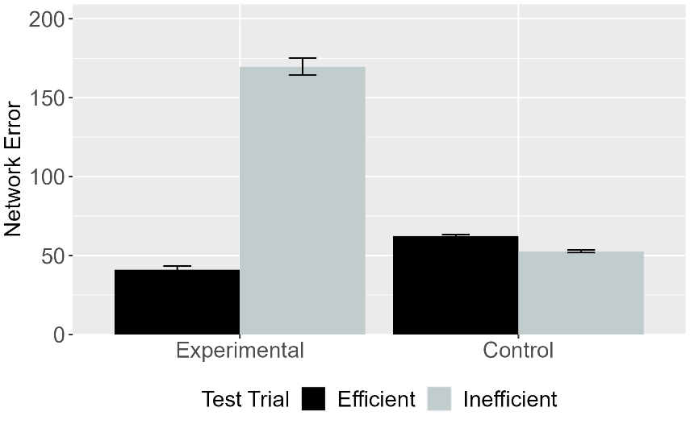 | 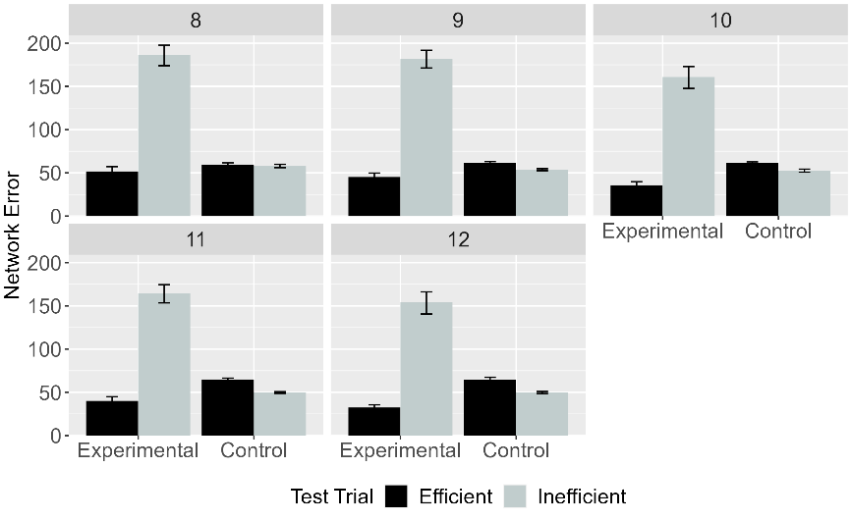
Figure 6. Mean network error produced to the Efficient and Inefficient test events in the Experimental and Control conditions. (Left) Network error collapsed across habituation lengths. (Right) Error as a function of habituation length. Data shown were generated by ALIAS.

Figure 6 shows error data for ALIAS overall (left) and for different amounts of habituation (right). As can be seen, ALIAS successfully reproduced the first target finding, both overall and across different amounts of habituation: Networks in the Experimental condition produced greater error to (i.e., looked longer at) the Inefficient test event than at the Efficient one. Networks in the Control condition looked equally long at both test events.

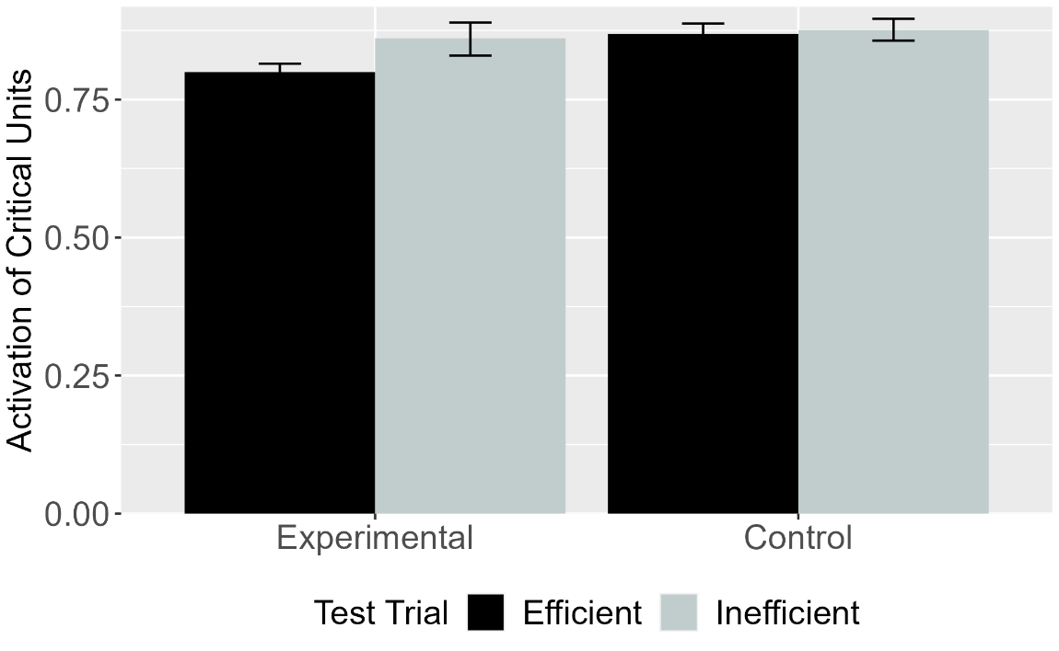
Figure 7. Mean activation of the critical units for Efficient and Inefficient test events in the Experimental and Control conditions for VOM10. Error bars represent standard errors.

Figure 7 shows that VOM10 also qualitatively reproduced the first target finding. At the same time, comparing these responses to ALIAS’s reveals that the error difference in the Experimental condition was substantially attenuated for VOM10 compared to ALIAS.

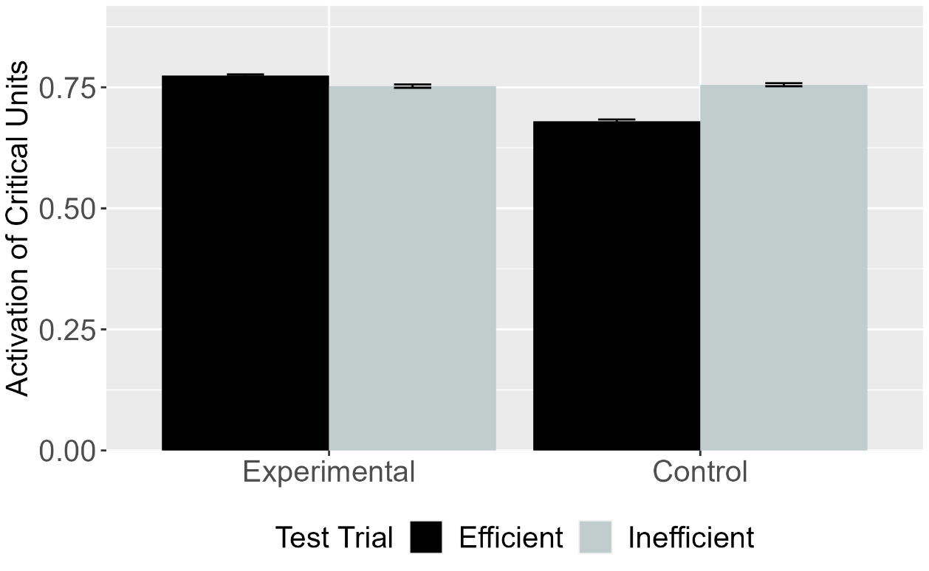
Figure 8. Mean activation of the critical units for Efficient and Inefficient test events in the Experimental and Control conditions for VOM10-2. Error bars represent standard errors.

To determine whether VOM10’s success depended on specific implementational details, its performance was compared to VOM10-2. These results—shown in Figure 8—reveal that VOM10-2 failed qualitatively to capture the first target finding: VOM10-2’s pattern of looking is the exact opposite of VOM10’s pattern.

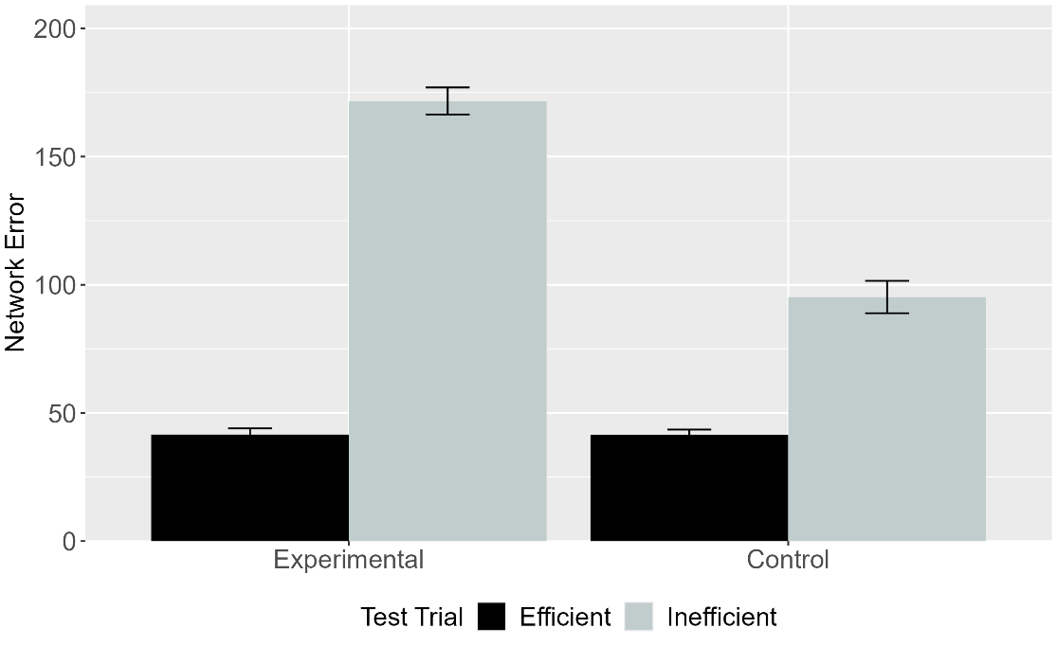
Figure 9. Mean network error produced to the Efficient and Inefficient test events in the Experimental and Control conditions. Data shown were generated by ALIAS-2. Error bars represent standard errors.

The final analysis focused on ALIAS-2’s responses. These are shown in Figure 9. This version of ALIAS omits differential obstacle salience. Although both models showed similar patterns of looking in the Experimental condition, only ALIAS-2 looked longer at the Inefficient test event than at the Efficient one.
The results presented thus far suggest that associative learning, at least in part, underpinned ALIAS’s success in reproducing the first target finding. To confirm that this was in fact that case, it was necessary to explicate the precise mechanism through which it successfully reproduced the first target finding by tracing the model’s internal dynamics at various points during processing. Such processing began during the pretraining phase. Note that the following discussion, although based on a single model run, is illustrative of the mechanism that emerged across model runs more generally and it not idiosyncratic to this particular network.
The pattern of activation produced by the straight and arced events across the input groups propagated to the hidden layer via the weights that connect each of the input groups to the hidden layer. At the beginning of training, this pattern of activity does not capture or reflect anything meaningful about the input to the model because the model’s weights themselves are small, meaningless, random values. This activity nonetheless then propagates to and elicits a pattern of activity across the groups comprising the output layer. Any discrepancy between the observed and target patterns is treated as error that model seeks to reduce.
The key insight is that, from the outset of training, the pattern of error that both motion types produce distinct patterns of error across the output groups A corollary of this is that the network weights move in different directions for both events such that, over time, meaningfully distinct hidden representations for each action emerge. These representations will also come to capture learned associations among specific surface features.
To illustrate how these learned features impact networks’ behavior at test, consider the habituation events networks in the Experimental condition. Two of the presented features were novel (i.e., Obstacle Height 4 and Arc Peak Height 4); the remaining four were familiar (i.e., Horizontal Spatial Position Middle, Arc Apex-Obstacle Gap minimal separation, Spatially Contiguous, and Arc Path). At the beginning of the habituation phase, the familiar features activate—via the hidden layer—the features with which they co-occurred during pretraining. By contrast, new associations must be formed among the novel features. Thus, networks must associate a higher jump with a taller barrier. Although the habituation phase is shorter in length than the pretraining phase, the network had little difficulty learning these associations due to its enhanced processing capacity.

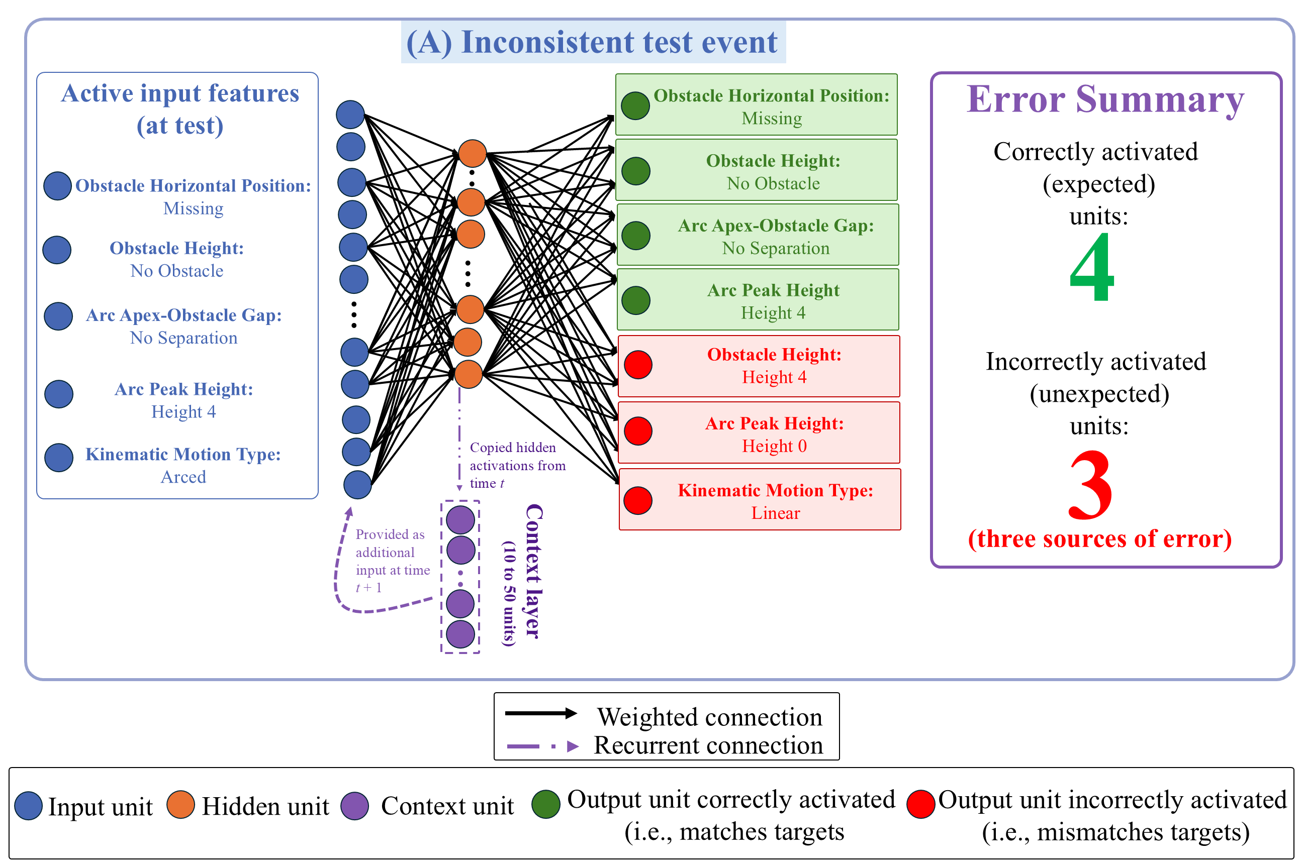
Figure 10. Mechanism underpinning ALIAS’s responses during the Inconsistent test event in the Experimental condition. Active input features presented at test reactivated learned associations acquired during pretraining and habituation. Although the network correctly activated four of those features, it also incorrectly activated the Obstacle Height 4, Arc Peak Height 0, and Linear Motion units. These three erroneously activated units constituted the primary sources of error and looking during this event. Shown here: Units necessary to explain the basis of ALIAS’s responses during the Inconsistent test event.

These facts help to explain the network’s responses to the barrierless test events. As shown in Figure 10, during the Inconsistent test event ALIAS correctly activated the Missing unit in the Obstacle Horizontal Position output group, the No Obstacle unit in the Obstacle Height output group, the No Separation Unit in the Arc Apex-Obstacle Gap group, and the Arc Peak Height 4 unit in the Arc Peak Height output group. The first three were activated due to associations formed during pretraining; the last was activated due to associations formed with itself during habituation. At the same time, the network incorrectly activated the Obstacle Height 4, Arc Height 0, and Linear Path output units. This response is also expected: The Arc Peak Height 0 and Linear Path units were associated with each unit’s input counterpart during pretraining, and the Obstacle Height 4 unit was associated with Arc Peak Height 4 and Obstacle Height 4 input units, among others, during habituation. Thus, three output units (i.e., Obstacle Height 4, Arc Peak Height 0, and Linear Path) contributed to the network’s looking time (or error) during the Inconsistent test event. This pattern of activation is precisely what the present theory predicts. Specifically, if infants, like the network, learn that a particular obstacle height is associated with a specific type of motion, then presenting one of these features at test (e.g., Arc Path and Arc Peak Height 4) should reactivate the other (e.g., Obstacle Height 4). If that associated feature is absent, as is the case with the Obstacle Height 4 unit in the Inconsistent test event, then the network should detect an error and show heightened looking.

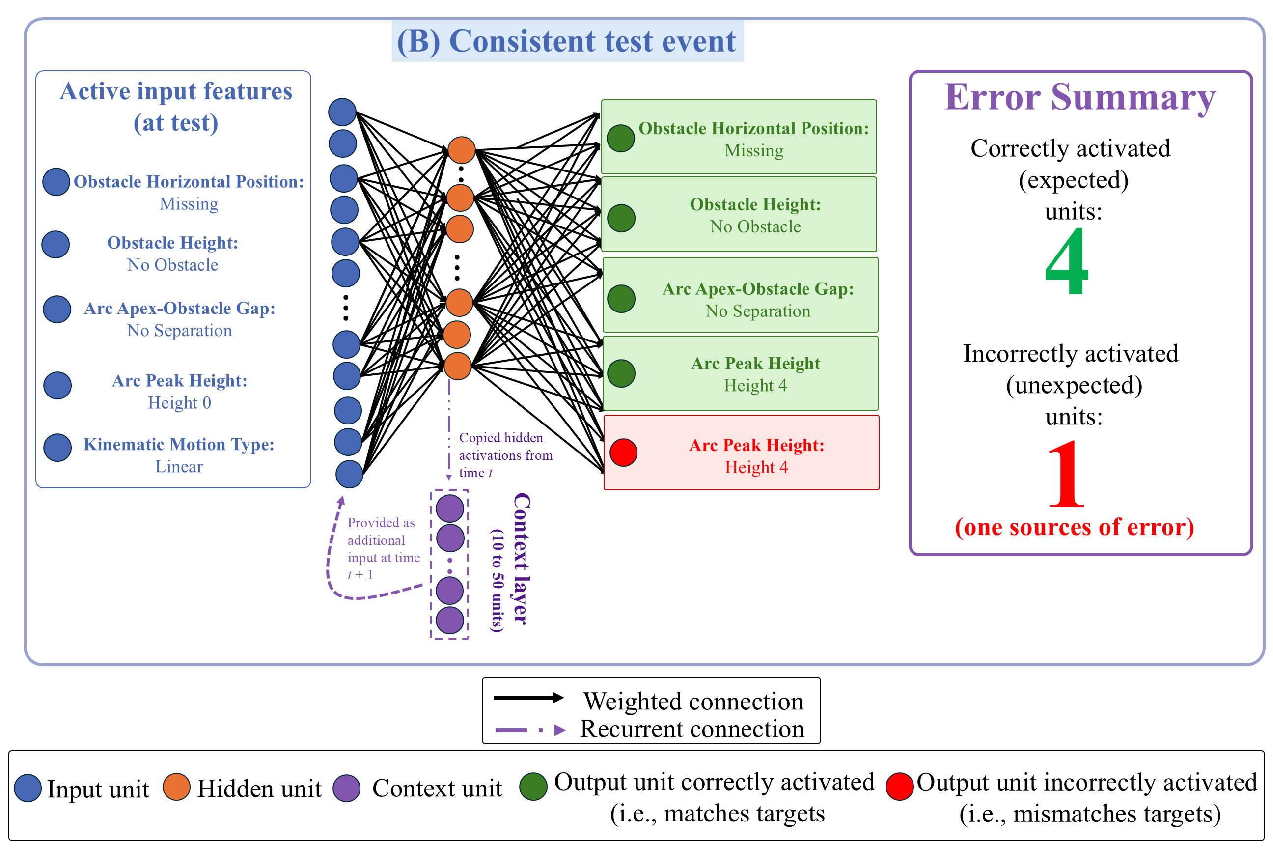
Figure 11. Mechanism underpinning ALIAS’s responses during the Consistent test event in the Experimental condition. Active input features reactivated many of the same learned associations observed in the Inconsistent event. However, here only the Arc Peak Height 4 output unit was incorrectly activated. This one erroneously activated unit constituted the primary source of error and looking during this event. Shown here: Units necessary to explain the basis of ALIAS’s responses during the Inconsistent test event.
Now consider the Consistent test event. This event was implemented in the same manner except that the Linear Path and Arc Peak Height 0 input units were turned on. As shown in Figure 11, the network activated the same units as those in the Inconsistent test event. However, because it correctly activated four of these units and incorrectly activated the remaining unit via the same associative processes described above, one rather than four output units contributed to this event’s error. The fact that one fewer unit contributed to error in the Consistent test event means the network looked for less time at this event than at the Inconsistent one.
The same associative principles also explain how ALIAS came to respond more similarly to the two test events in the Control condition. Because peripherally located barriers were less salient than central ones as stipulated by the current theory, the network largely failed to associate the Obstacle Height 4 and Periphery units with the three other critical input features (Arced Path, Arc Peak Height 4, and Small Separation) that these units were associated with—via adjustments to the weights connecting these units—during habituation. Thus, the network did not activate both obstacle units when presented with two of the three associated features (Arced Path and Arc Peak Height 4) during the Inconsistent test event. This is the correct response.
In contrast, because the Arc Peak Height group was not subjected to the same visual salience manipulation as the obstacle groups, the network developed a sufficiently strong association to activate correctly the Arc Peak Height 4 output unit in response to some of the input features it was associated with during habituation (i.e., itself and Arced Path). This again was the correct response. Combined with the fact that all five features were activated correctly during the Consistent test event meant that both events produced equivalent “looking” or error. In sum, the associative theory that the model implements is the one governing its performance.
It might nonetheless be argued that these results and this analysis are undermined by the fact that the model’s pretraining experience poorly approximated infants’ real-world experience. The basis for this potential objection is that whereas infants see at some instances of unconstrained arced motion, such motion never occurred during pretraining for networks. Simulation 1b addressed this issue head-on by testing ALIAS’s ability to reproduce the first target finding when the pretraining ratio of constrained to unconstrained arced motion varied..

Simulation 1b
To test whether ALIAS’s performance in Simulation 1a depended on not seeing unconstrained arced motion during pretraining, the ratio of this motion to arced motion was varied during pretraining. The ratios used were: 90% constrained vs. 10% unconstrained to 50% constrained vs. 50% unconstrained, in step sizes of 10%. A sixth ratio—100% constrained vs. 0% unconstrained—was also used to test the robustness of Simulation 1a. In each ratio, the first and second numbers corresponded to the proportion of time that constrained motion occurred during pretraining; the second number corresponded to the proportion of time that unconstrained motion occurred during this phase. Parametric variation was used here because the true proportion of constrained-to-unconstrained arced motion in the real world is unknown. Given the goal of this simulation, ALIAS was not compared to the competitor models.

Results
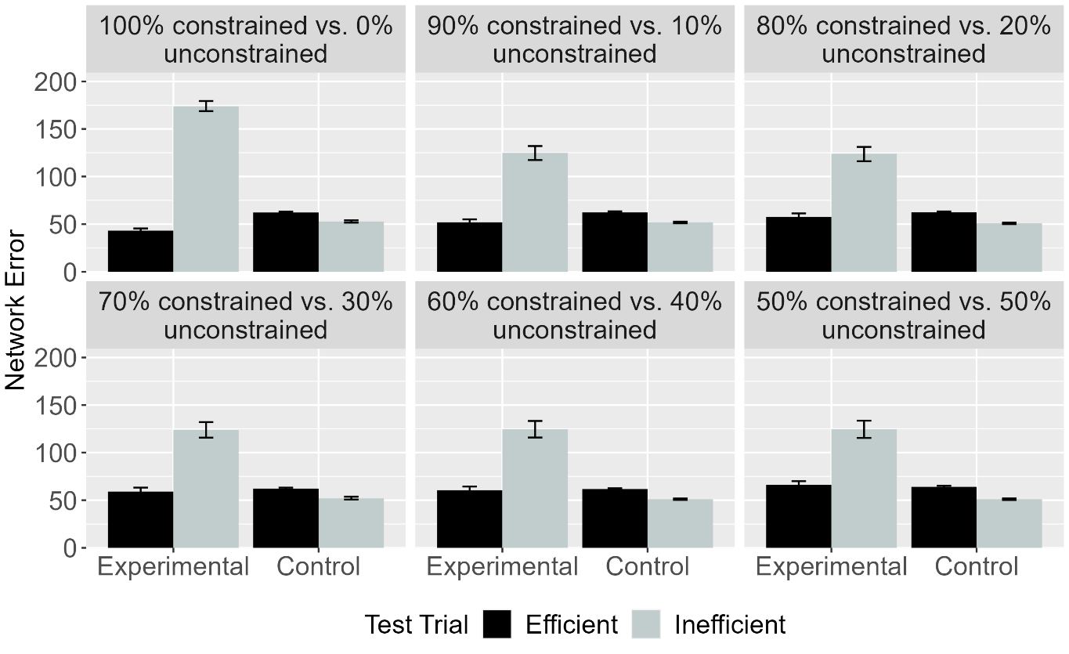Figure 12. Mean network error produced to the Efficient and Inefficient test events in the Experimental and Control conditions across different ratios. Error bars represent standard errors.

As shown in Figure 12, ALIAS reproduced the first target finding irrespective of the ratio of each kind of motion.

Discussion
This simulation showed that ALIAS’s success in reproducing the first target finding was robust to variation in the amount of constrained and unconstrained motion experienced during pretraining. One notable feature of these results is that the magnitude of the difference in the amount of time that networks in the Experimental condition looked at the two test events was largely unaffected by the ratio of constrained to unconstrained arced motion. The reason for this was simply that ALIAS was habituated to constrained action.
Simulation 2 took a first step toward assessing the explanatory breadth of ALIAS by examining whether it can capture the second target finding: Infants’ looking responses in action efficiency understanding studies do not depend on the entities involved possessing animate features. Simulation 2 was identical Simulation 1a except that the objects possessed features typical of inanimate objects. Simulation 2 only focused on the behavior of ALIAS and ALIAS-2 because neither VOM10 nor VOM10-2 had a means for representing whether an object possessed animate- or object-typical surface features.

Simulation 2: Independence from animacy.
Simulation 2 tested whether ALIAS’s performance in Simulations 1a and 1b hinged in the objects possessing animate-typical features. To that end, the objects used here possessed inanimate-typical features. The networks tested here were “9-month-olds” (675 pretraining epochs, learning rate of 0.0875, and 40 hidden units) because the study from which this target finding derived tested this age.

Results
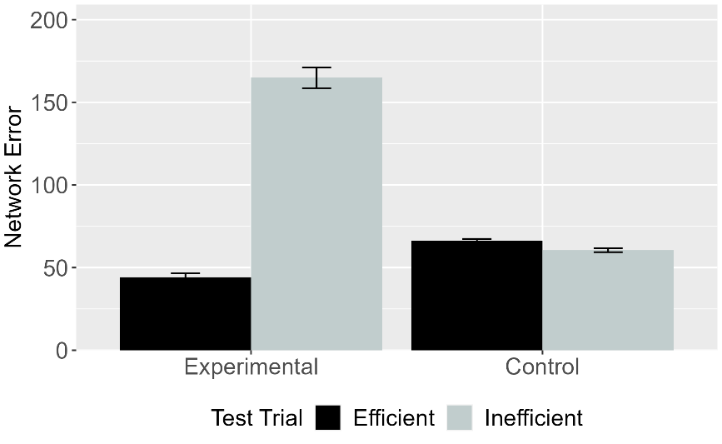 | 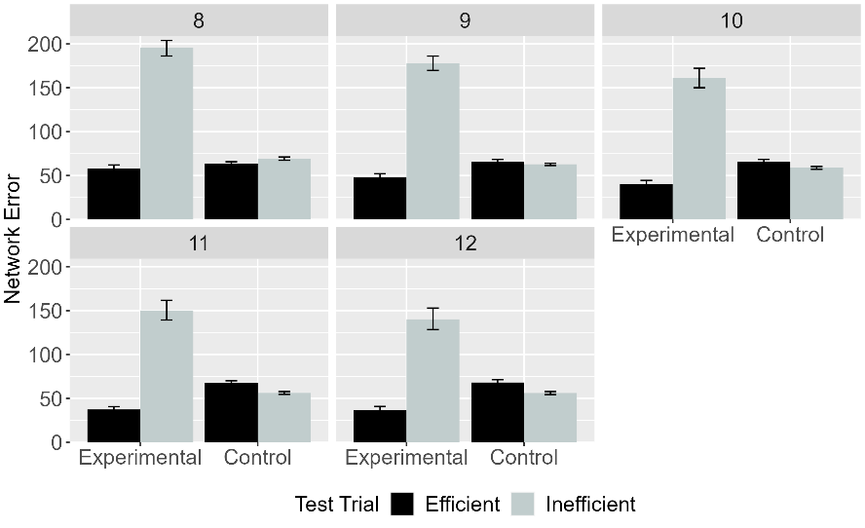
Figure 13. Mean network error produced to the Efficient and Inefficient test events in Simulation 2 across conditions overall (left panel) and different habituation epochs (right panel). Error bars represent standard errors.

Figure 13 shows clearly that, both overall and for different habituation lengths, ALIAS’s responses did not hinge on the objects possessing animate-typical features.

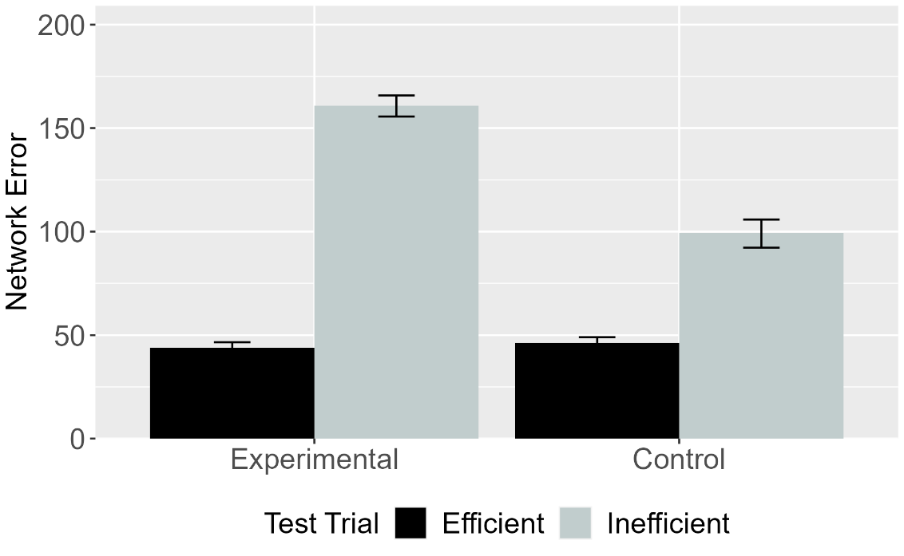
Figure 14. Mean network error produced to Efficient and Inefficient test events in the Experimental and Control conditions for ALIAS-2. Error bars represent standard errors.

Figure 14 shows that as was the case in Simulation 1a, ALIAS-2 failed to capture infants’ looking behavior across conditions. These findings suggest that associative learning alone is insufficient to reproduce the first two target findings; differential barrier salience must additionally be included.

Discussion
Simulation 2 showed that ALIAS could capture the second target finding and that associative learning alone was insufficient to capture it. Nonetheless, a potential objection to the simulations presented thus far is that demonstrating that ALIAS’s performance is robust to whether objects possess animate-typical features only weakly demonstrate its explanatory breadth. Simulation 3 took this criticism seriously by testing whether ALIAS could capture a more substantively different target finding. This simulation examined whether ALIAS could capture Csibra et al.’s (2003) finding that 12-month-olds can make bidirectional inferences among goals, actions, and constraints. In their first experiment, infants were habituated to an event in which a large circle appeared to be chasing a small circle. However, before the large circle reached the small one, the small circle moved through a narrow gap between two bars and disappeared from the screen; the width of the gap forced the larger circle to move around one of the bars. The fact that the large circle never reached the small one before it disappeared from the screen meant that the large circle’s goal of reaching the small one had to be inferred. The authors found that when the gap was widened such that the large circle could fit through, infants looked longer when it continued moving around one of the barriers than when it passed through it. Note that although this experiment did not employ a standard Gergely paradigm, it can readily be recast within it by, for instance, terminating the habituation event after the first object clears the barrier but before it reaches the second object. This leaves the first object’s goal unclear. This was the approach taken in Simulation 3 to model this experiment.
In a second experiment, infants were habituated to a constrained action event except that the barrier was hidden behind an opaque screen. Infants could nonetheless see the second object and parts of the first object’s arced motion path. Csibra et al. (2003) found that infants looked longer when the first object followed the same curved path in the absence of an obstacle than when it did so in the presence of one. These findings were argued to support the teleological stance. Simulation 3 tested whether ALIAS could capture these findings and thereby challenge the necessity of this assumption. Its performance was also compared to the competitor models.

Simulation 3: Bidirectional inferences about actions, goals, and constraints.
Simulation 3 tested whether ALIAS could explain the finding that 12-month-old infants putatively can infer goals from constraints and behavior as well as constraints from goals and behaviors. Networks of all model types were assigned either to the Inferring Goals condition (N = 20) or to the Inferring Constraints condition (N = 20). The events shown to networks in this condition were identical to those shown to networks in the Experimental condition in Simulation 1a except that they could not know whether the first object stopped next to the second one (its goal). The Inferring Constraints condition was implemented by removing all barrier information during habituation. All other aspects of this simulation were identical to Simulation 1a.

Results and Discussion
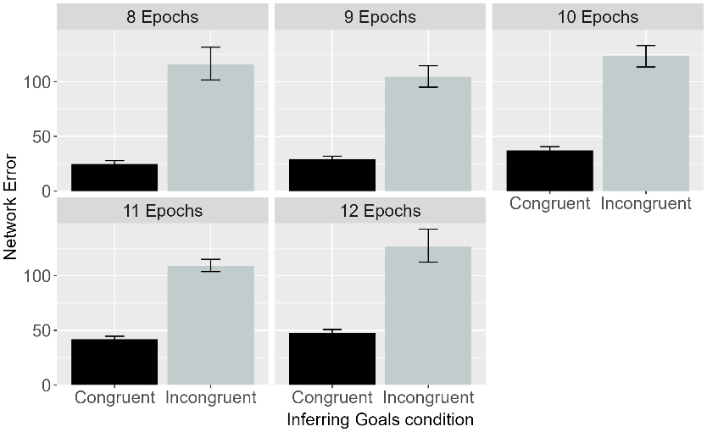 | 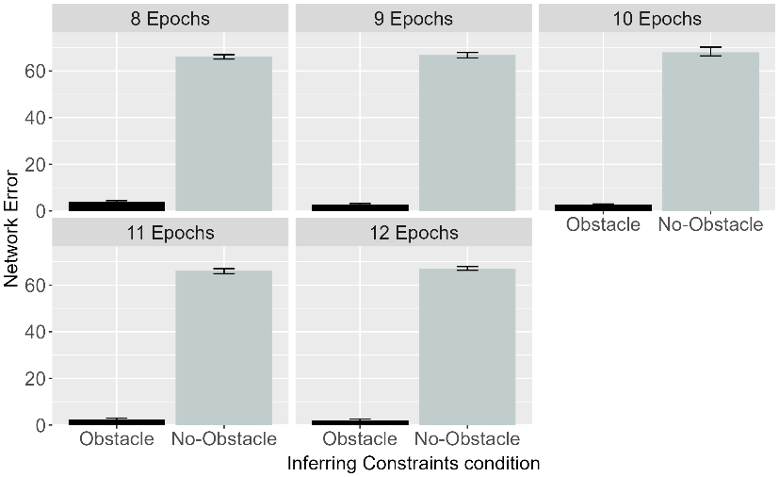
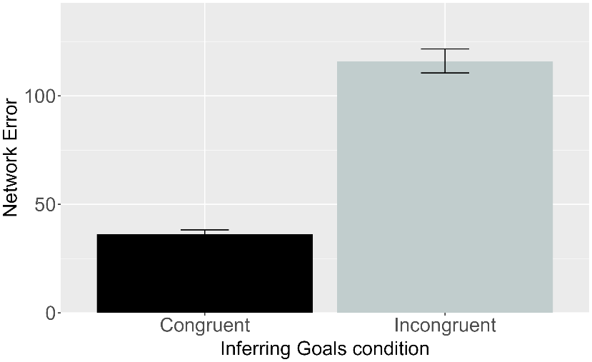 | 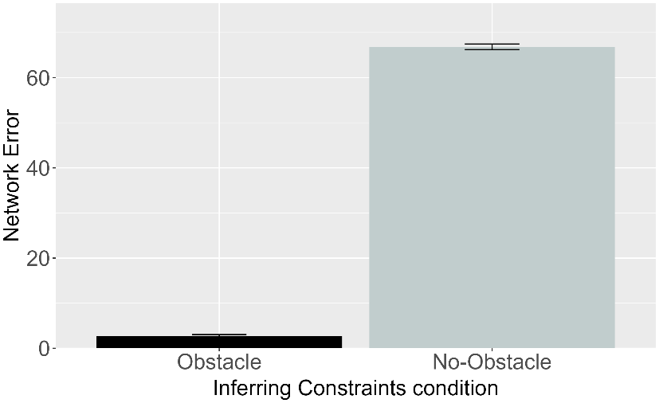

Figure 15. Performance of ALIAS. Plotted is the mean network error produced to the Congruent and Incongruent test events for networks in the Inferring Goals condition (left column) and to the Obstacle and No-Obstacle test events for networks in the Inferring Constraints condition across habituation epochs (top row) and overall (bottom row).

Figure 12 shows the performance of ALIAS in the Inferring Goals and Inferring Constraints conditions overall and across habituation epochs. Networks in both conditions looked longer at their respective inconsistent events. Specifically, networks in the Inferring Goals condition looked longer at the Incongruent test event—in which the first object failed to stop next to the second one—than at the Congruent test event—in which the first object came to rest next to the second one. Similarly, networks in the Inferring Constraints condition looked longer at the No-Obstacle than at the Obstacle test event. These patterns were true both across different habituation lengths as well as overall. The mechanistic basis for these looking patterns is straightforward. Longer looking was observed to the Incongruent than to the Congruent test event In the Inferring Goals condition because it violated an association—formed during the pretraining phase—between arced motion, a small barrier, and a low jump, on the one hand, and spatial contiguity between an agent and its goal, on the other. No such violation occurred for the Congruent test event because the visual information accorded with that during pretraining. Similarly, networks in the Inferring Constraints condition looked longer at the No-Obstacle test event than at the Obstacle one because the presence of arced motion in the absence of an obstacle in the No-Obstacle event violated an association that was established during the pretraining phase between arced motion and obstacles; no such violation occurred in the Obstacle test event. These results indicate that ALIAS can also capture the third target finding.

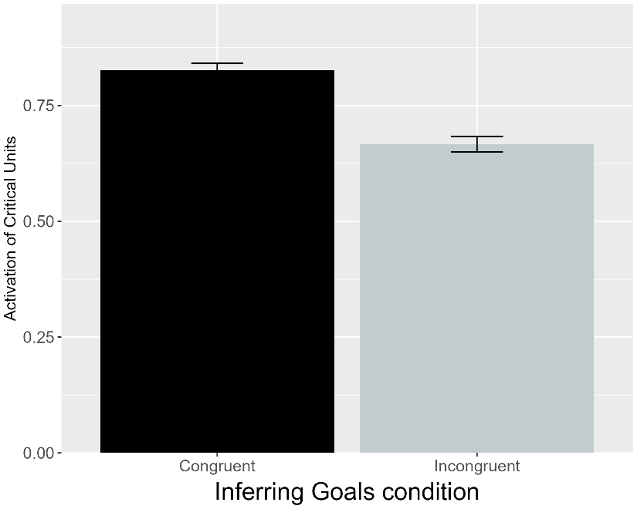 | 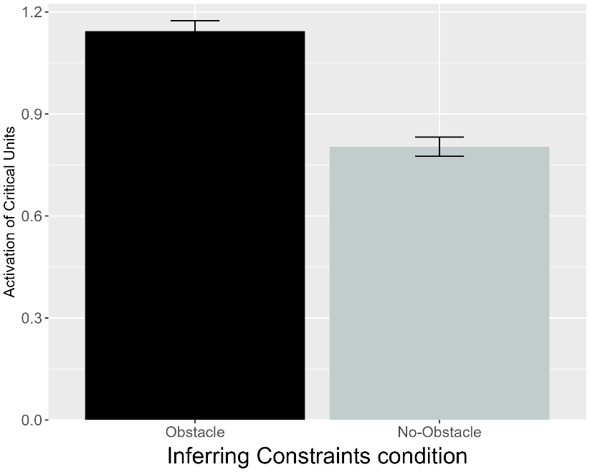
Figure 16. Performance of VOM10. Plotted is the mean activation of the critical units produced to the Congruent and Incongruent test events for networks in the Inferring Goals condition (left) and to the Obstacle and No-Obstacle test events for networks assigned to the Inferring Constraints condition (right).

As shown in Figure 16, VOM10’s responses were exactly opposite those of ALIAS. These results indicate that VOM10 as originally conceived by Overwalle (2010) was unable to reproduce the third target finding.

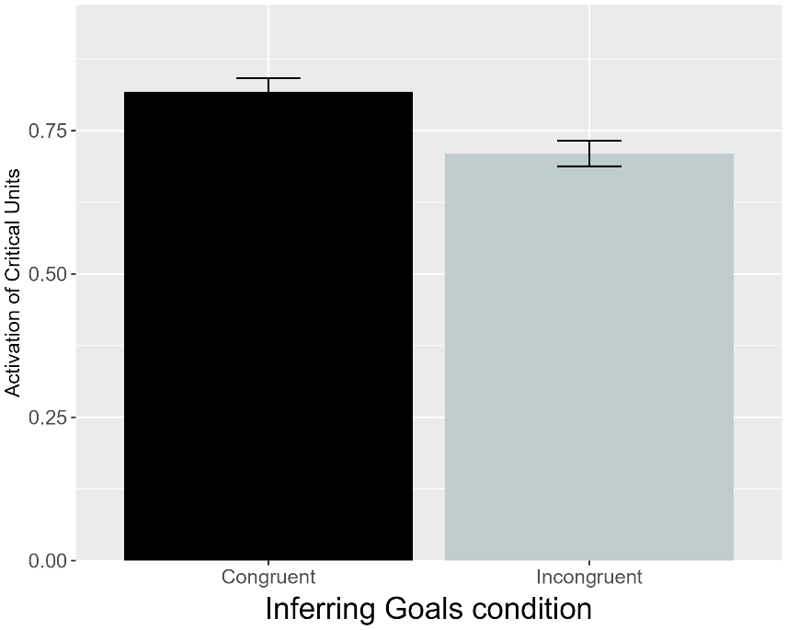 | 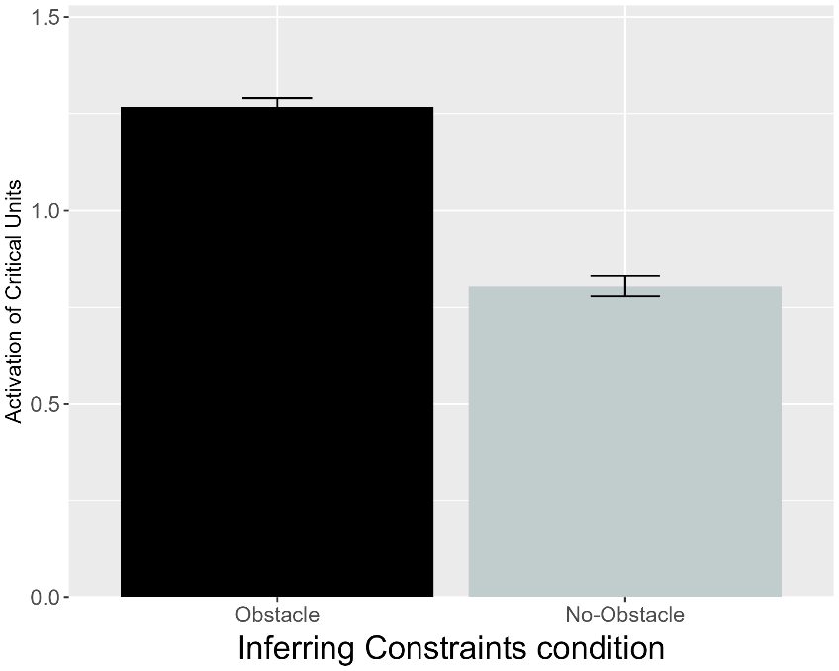
Figure 17. Performance of VOM10-2. Plotted is the mean activation of the critical units produced to the Congruent and Incongruent test events for networks in the Inferring Goals condition and to the Obstacle and No-Obstacle test events for networks assigned to the Inferring Constraints condition (right).

Figure 17 shows that VOM10-2 also failed to replicate the third target finding. This suggests that VOM10's failure reflects a more fundamental inability to simulate the processes underpinning infant action efficiency understanding outside of the study by Gergely et al. (1995).

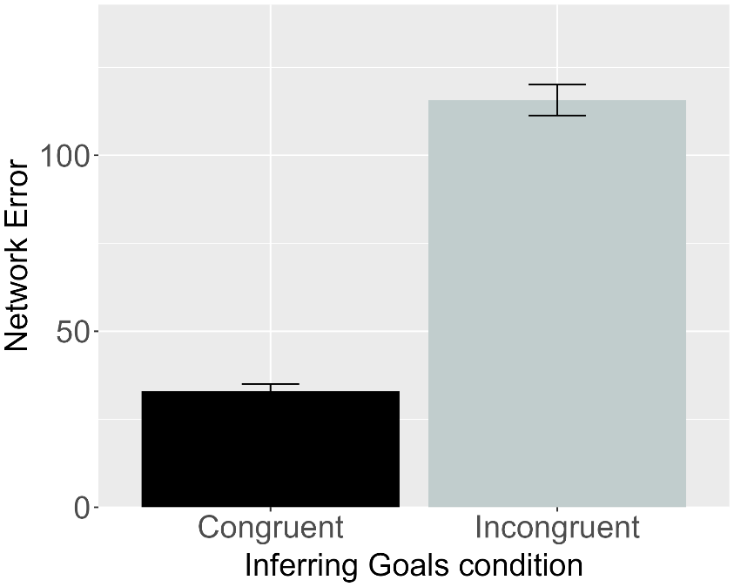 | 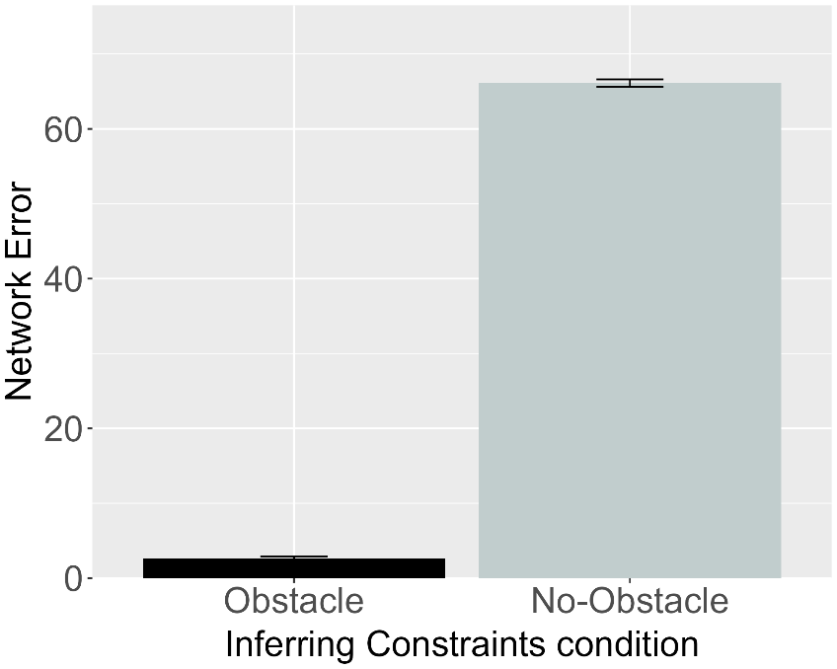
Figure 18. Performance of ALIAS-2. Plotted is the mean network error produced to the Congruent and Incongruent test events for networks assigned to the Inferring Goals condition (left) and to the Obstacle and No-Obstacle test events for networks in the Inferring Constraints condition (right).

Figure 15 shows that, like ALIAS, ALIAS-2 captured the third target finding. This suggests that, at least here, associative learning alone is sufficient to reproduce this finding. ALIAS’s and ALIAS-2’s success in reproducing the third target finding undermines the claim that infants use a teleological stance to reason productively about goals, actions, and constraints. Instead, these results indicate that an associative learning mechanism operating over the low-level kinematics of action and the surface features of the entities involved is clearly sufficient.
It might nonetheless be argued that the third target finding does not pose a sufficiently strong enough challenge to ALIAS and that a more compelling test of its explanatory scope is to demonstrate that it can capture Liu and Spelke’s (2017) finding that infants apparently represent efficiency continuously rather than in an all-or-none fashion. Six-month-olds were habituated either to a constrained action event (Experiment 1) or to an unconstrained one (Experiment 2). Infants were then tested either on constrained Low, efficient and constrained High, inefficient test events (Experiment 1) or on unconstrained versions of these events (Experiment 2). The constrained High, inefficient test event was so called because the agent jumped much higher than needed to clear the barrier. Liu and Spelke (2017) found that infants in Experiment 1 looked longer at the High, inefficient test event than at the Low, efficient one; infants in Experiment 2 looked numerically, but not significantly, longer at the Low, efficient test event.
In a final experiment, Liu and Spelke (2017) tested whether infants expect agents whose actions were inefficient in the past to continue behaving inefficiently in a new situation with a different set of constraints. Infants were habituated to the event used in Experiment 2 and then tested on the constrained events used in Experiment 1. Here, infants looked longer at the High, inefficient test event than at the Low, efficient one. These findings have since been interpreted as support for naïve psychology and naïve physics systems (Liu et al., 2026). Simulation 4 tested whether such systems are necessary to capture these findings or whether associative learning, either alone or in combination with differential obstacle salience, is sufficient to explain them.

Simulation 4: Graded representations of efficiency.
This simulation tested whether ALIAS could capture the fourth target finding. The networks tested here were “6-month-olds” (450 pretraining epochs, a learning rate of 0.0875, and 30 hidden units) because Liu et al. (2017) tested this age. Networks were habituated to and tested on events analogous to those in Experiments 1-3 in Liu and Spelke (2017); twenty networks were assigned to each experiment. Unlike the previous simulations, however, VOM10 was not tested here. The reason is that the original formulation of this model omitted barrier information from its prediction (or test) phase. This meant that at test this model could not be presented with a barrier that differed in size from the one shown during habituation. Presenting such information to the model here would therefore radically depart from how it was implemented in the previous simulations and, more importantly, from Van Overwalle’s (2010) original conception of it. ALIAS’s performance was thus only compared to that of VOM10-2 and ALIAS-2.

Results
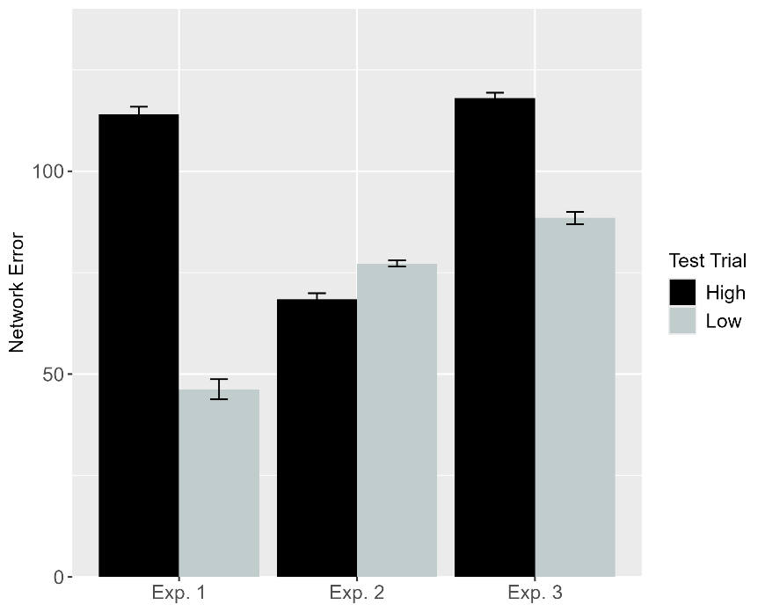 | 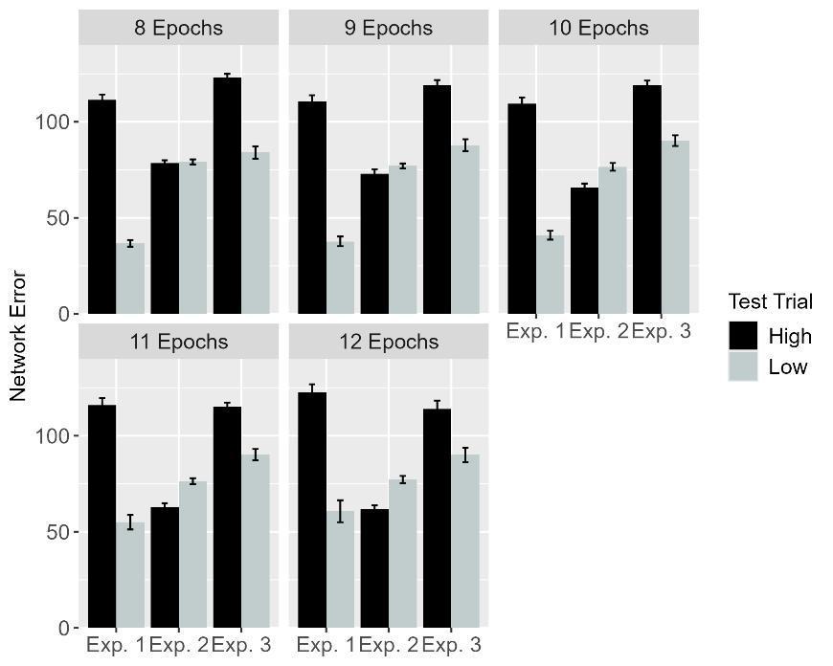
Figure 19. Performance of ALIAS. Plotted is networks’ mean error to the High, inefficient and Low, efficient test events across experiments overall (left) and across different habituation epochs (right). These experiments correspond to those in Liu and Spelke (2017).

Figure 19 shows that ALIAS reproduced the fourth target finding both overall and across habituation epochs. ALIAS’s treatment of the High, inefficient and Low, efficient test events across the three experiments. Networks in Experiments 1 and 3—like infants in these same experiments—produced more error to (i.e., look longer at) the High, inefficient than to the Low, efficient one. Networks in Experiment 2—like infants in the same experiment—looked slightly numerically longer at the Low, efficient than at the High, inefficient test event.

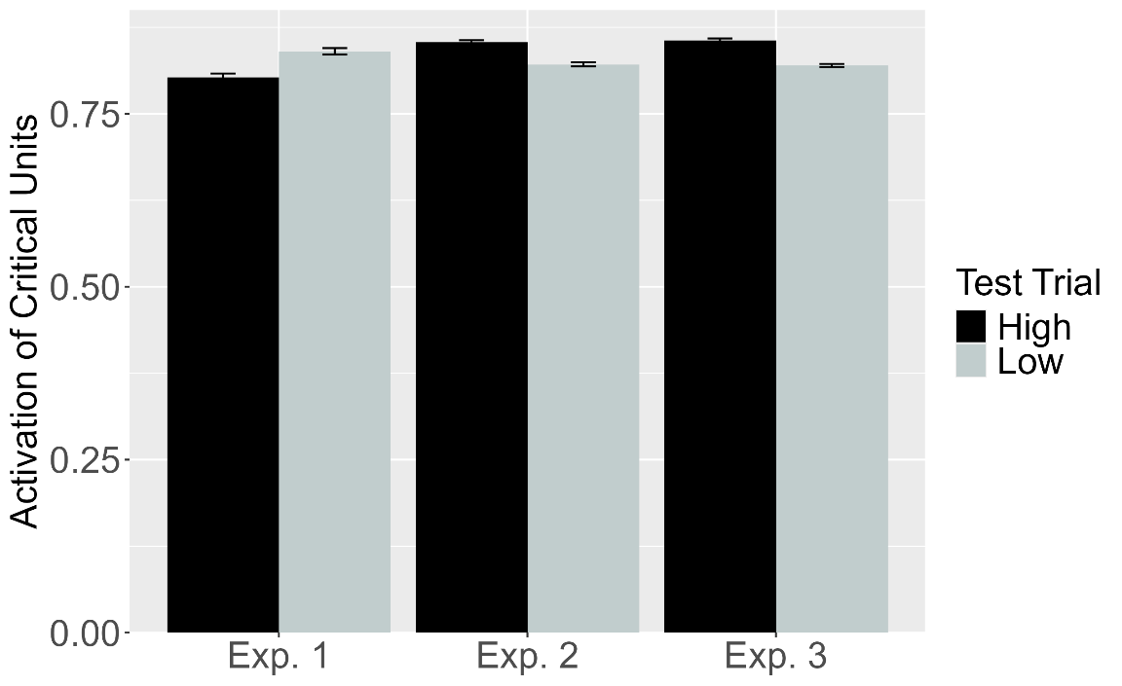
Figure 20. Performance of VOM10-2. Plotted is the mean activation of the critical units produced to the High, inefficient and Low, efficient test events for networks in Experiment 1-3.

As shown in Figure 20, although VOM10-2 captured infants’ looking responses in Experiment 3—showing slightly more critical unit activation following the High, inefficient test event than the Low, efficient test event—its responses in Experiments 1 and 2 did not match those of infants in the corresponding behavioral experiments.

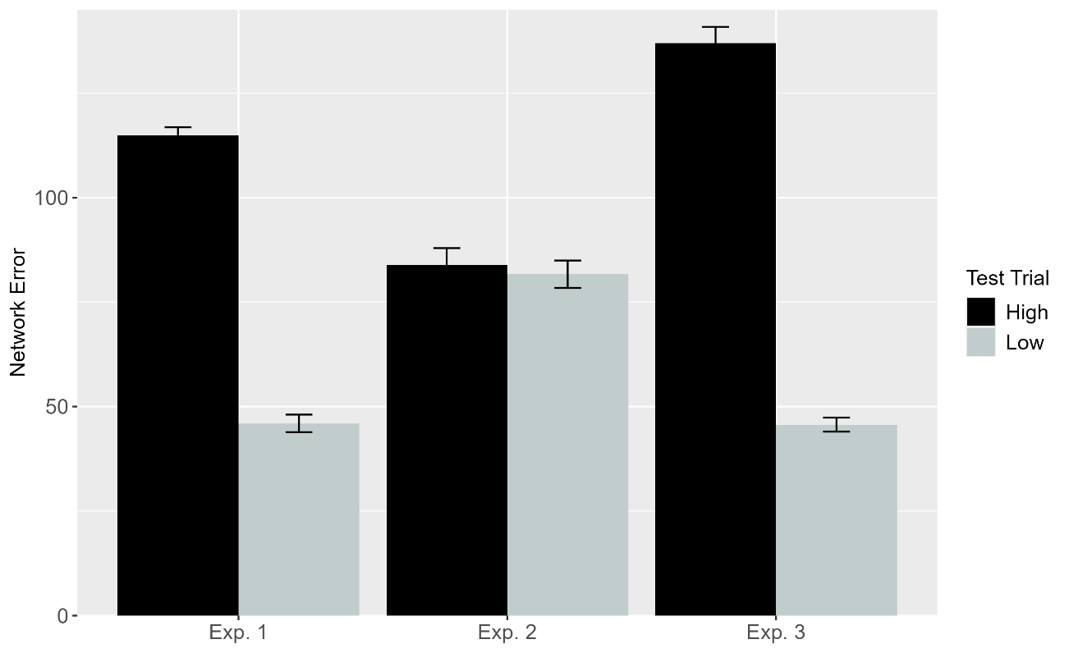
Figure 21. Performance of ALIAS-2. Plotted is networks’ overall mean error to the High, inefficient and Low, efficient test events across experiments.

Figure 21 demonstrates that ALIAS-2 largely reproduced the fourth target finding. It captured infants’ responses in Experiments 1 and 3 but deviated from their responses in Experiment 2. This latter finding conflicts with ALIAS’s and infants’ tendency to look (numerically) longer at the Low, efficient than at the High, inefficient test event.
In terms of the mechanistic basis of ALIAS’s behavior, it looked longer at the High, inefficient than at the Low, efficient test event during Experiments 1 and 3 because the presentation of a small obstacle, a high jump, and substantial vertical clearance associated with this event violated the association that networks formed among a small obstacle, a low jump, and small vertical clearance during the pretraining phase. Attenuated looking was observed to the Low, efficient test event because its visual information (e.g., a small obstacle, low jump, and low vertical clearance) overlapped with that experienced during pretraining.
The finding that ALIAS provided a slightly better qualitative fit to the data than ALIAS-2 suggests that associative learning needs to be combined with the assumption that peripherally located obstacles have reduced salience to capture the fourth target finding. More broadly, ALIAS’s success in capturing the first four target findings suggest that it possesses substantial explanatory scope. At the same time, the current simulations all correspond to behavioral studies that tested infants with considerable real-world action observation experience. For ALIAS to constitute a viable alternative to domain-specific proposals of infant action processing, it must also reproduce findings suggesting that much younger infants are sensitive to action efficiency.
Of particular note here is Skerry et al.’s (2013) discovery that a small amount of sticky-mitten reaching experience was sufficient for pre-reaching 3-month-olds to show looking patterns that resembled those of older infants. Simulation 5 tested whether ALIAS could nevertheless capture the fifth target finding if, despite limited pretraining action observation experience, effective action experience temporarily heightens its attention to and encoding of its own straight reaching trajectories. If so, a subsequent straight trajectory event should be rendered relatively more familiar than a curved trajectory event. This simulation only focused on ALIAS and ALIAS-2 because these were the only two models capable of simulating development.

Simulation 5: Action efficiency understanding in pre-reaching infants.
The primary goal of this simulation was to assess whether ALIAS can reproduce the looking behavior of pre-reaching infants when its attention is heightened during a phase analogous to the action phase in Skerry et al. (2013). Networks were “3-month-olds” (225 pretraining epochs, a learning rate of 0.01, and 10 hidden units). This simulation also differed from the previous ones by including an “action phase” that immediately followed the pretraining phase (Figure 2D). Because Skerry et al. (2013) did not indicate the length of this phase, their lengths phases were equated here. Finally, the assumption that infants’ reaches approximate a linear path during the action was implemented by showing networks straight motion during it.
Networks were assigned to one of three conditions: Effective Action (N = 20), Ineffective Action (N = 20), or No Training (N = 20). The first condition was further divided into either the Experimental condition or the Control condition. The assumption that effective sticky mittens experience heightens infants’ attention was implemented by increasing the learning rate on all connections to 0.175 during the action phase for networks in the Effective Action condition only. The assumption that this attentional boost is short-lived was implemented by returning the learning rate to its pretraining value at the start of the subsequent habituation phase. The learning rate maintained its pretraining value across the three phases for networks in the Ineffective Action condition and across the pretraining and habituation phases for networks in the No Training condition. In all other respects, these two conditions were identical.

Results
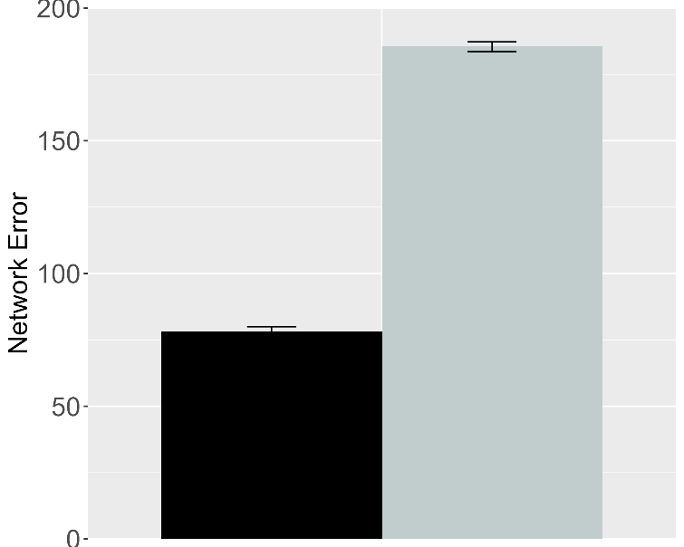 | 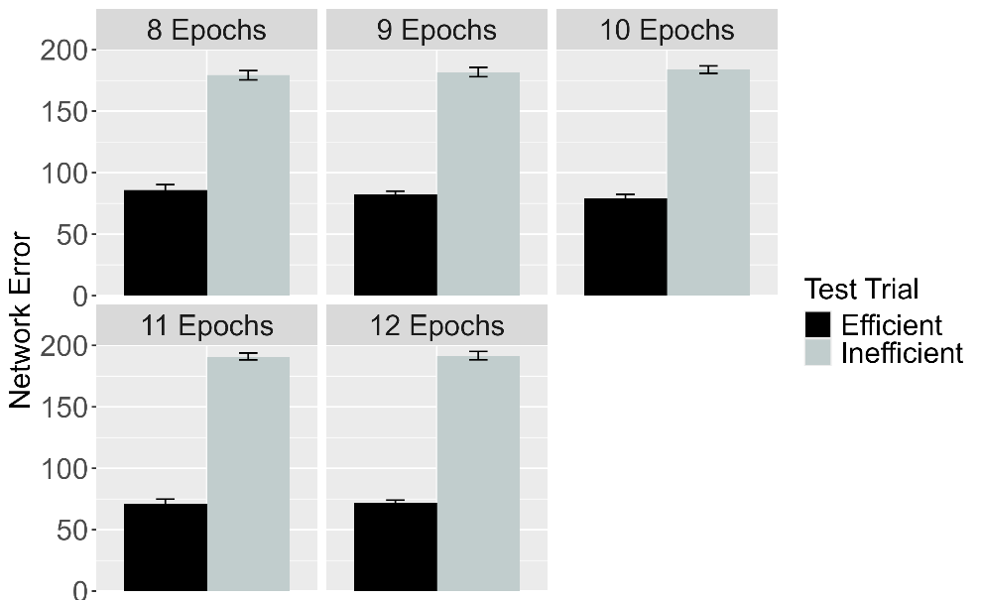
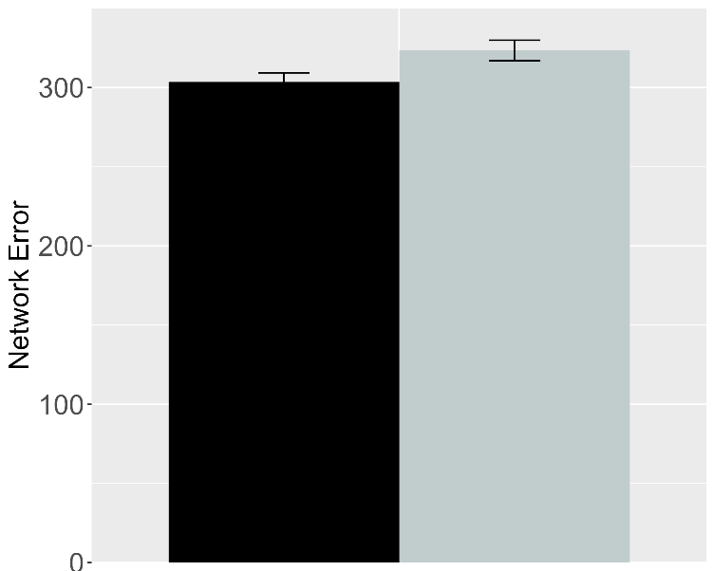 | 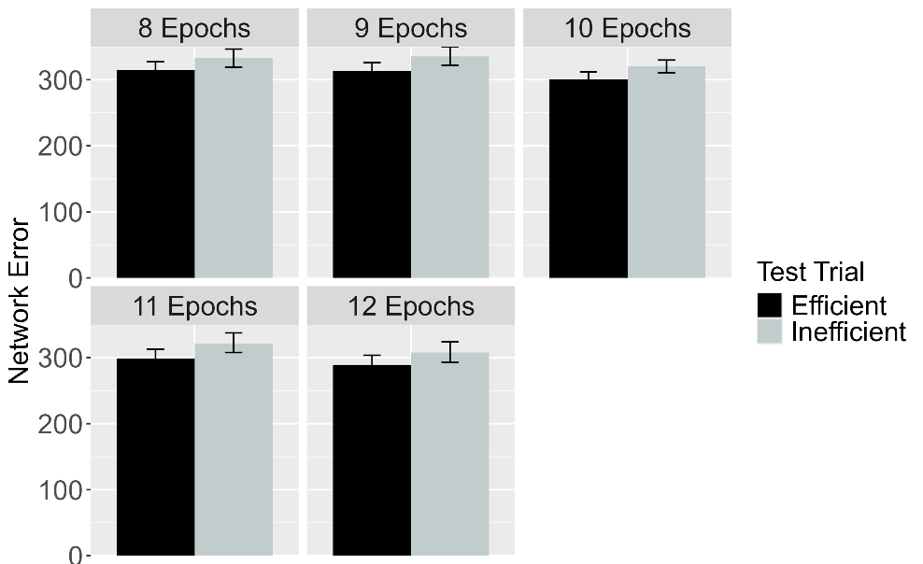
Figure 22. Performance of ALIAS in the Effective Action condition. Plotted is networks’ mean error to the Efficient and Inefficient test events in the Experimental (top row) and Control conditions (bottom row), both overall (left column) and across different habituation epochs (right column). The Experimental and Control conditions correspond to Experiments 1, 4, and 5 in Skerry et al. (2013).

Figure 22 shows the performance of ALIAS in the Effective Action condition. The results revealed that, both overall and for different habituation lengths, networks in the Experimental condition looked longer at the Inefficient test event than at the Efficient one. This effect was considerably attenuated for networks in the Control condition. Both findings qualitatively matched those of infants in the Effective Action condition in Skerry et al. (2013).

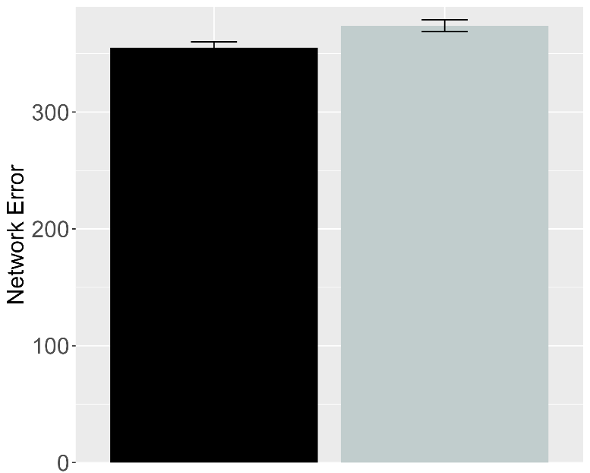 | 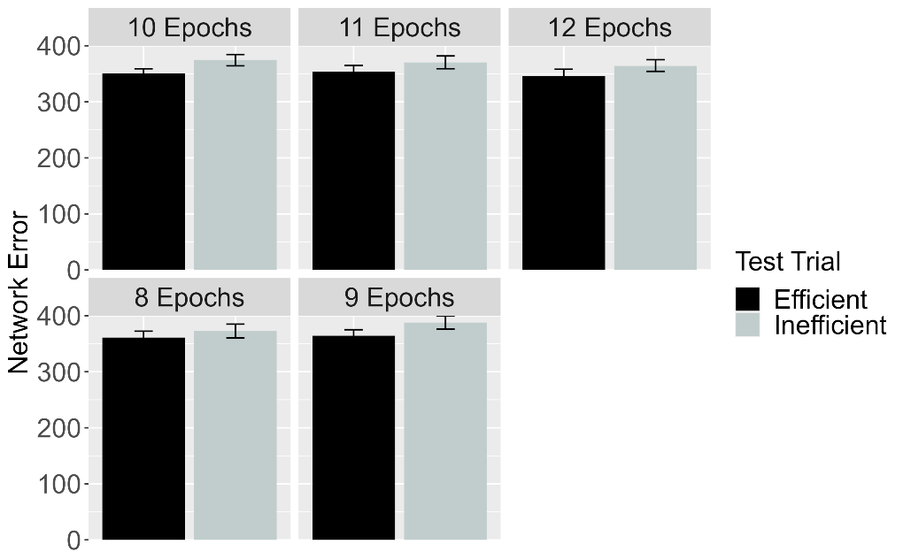
Figure 23. Performance of ALIAS in the No Training condition. The overall error produced to the Efficient and Inefficient test events is shown on the left, and the error produced across different habituation epochs is shown on the right. This condition corresponds to Experiment 3 in Skerry et al. (2013).

Figure 23 shows the performance of networks in the No Training condition. Networks—like infants in the corresponding behavioral condition—looked about equally long at both test events. Note that if prior (i.e., pretraining) experience with constrained arced motion was sufficient for networks to associate arced motion with barriers and then to detect when such associations are violated, then networks in Effective Action and No Training conditions should have treated the test events similarly.

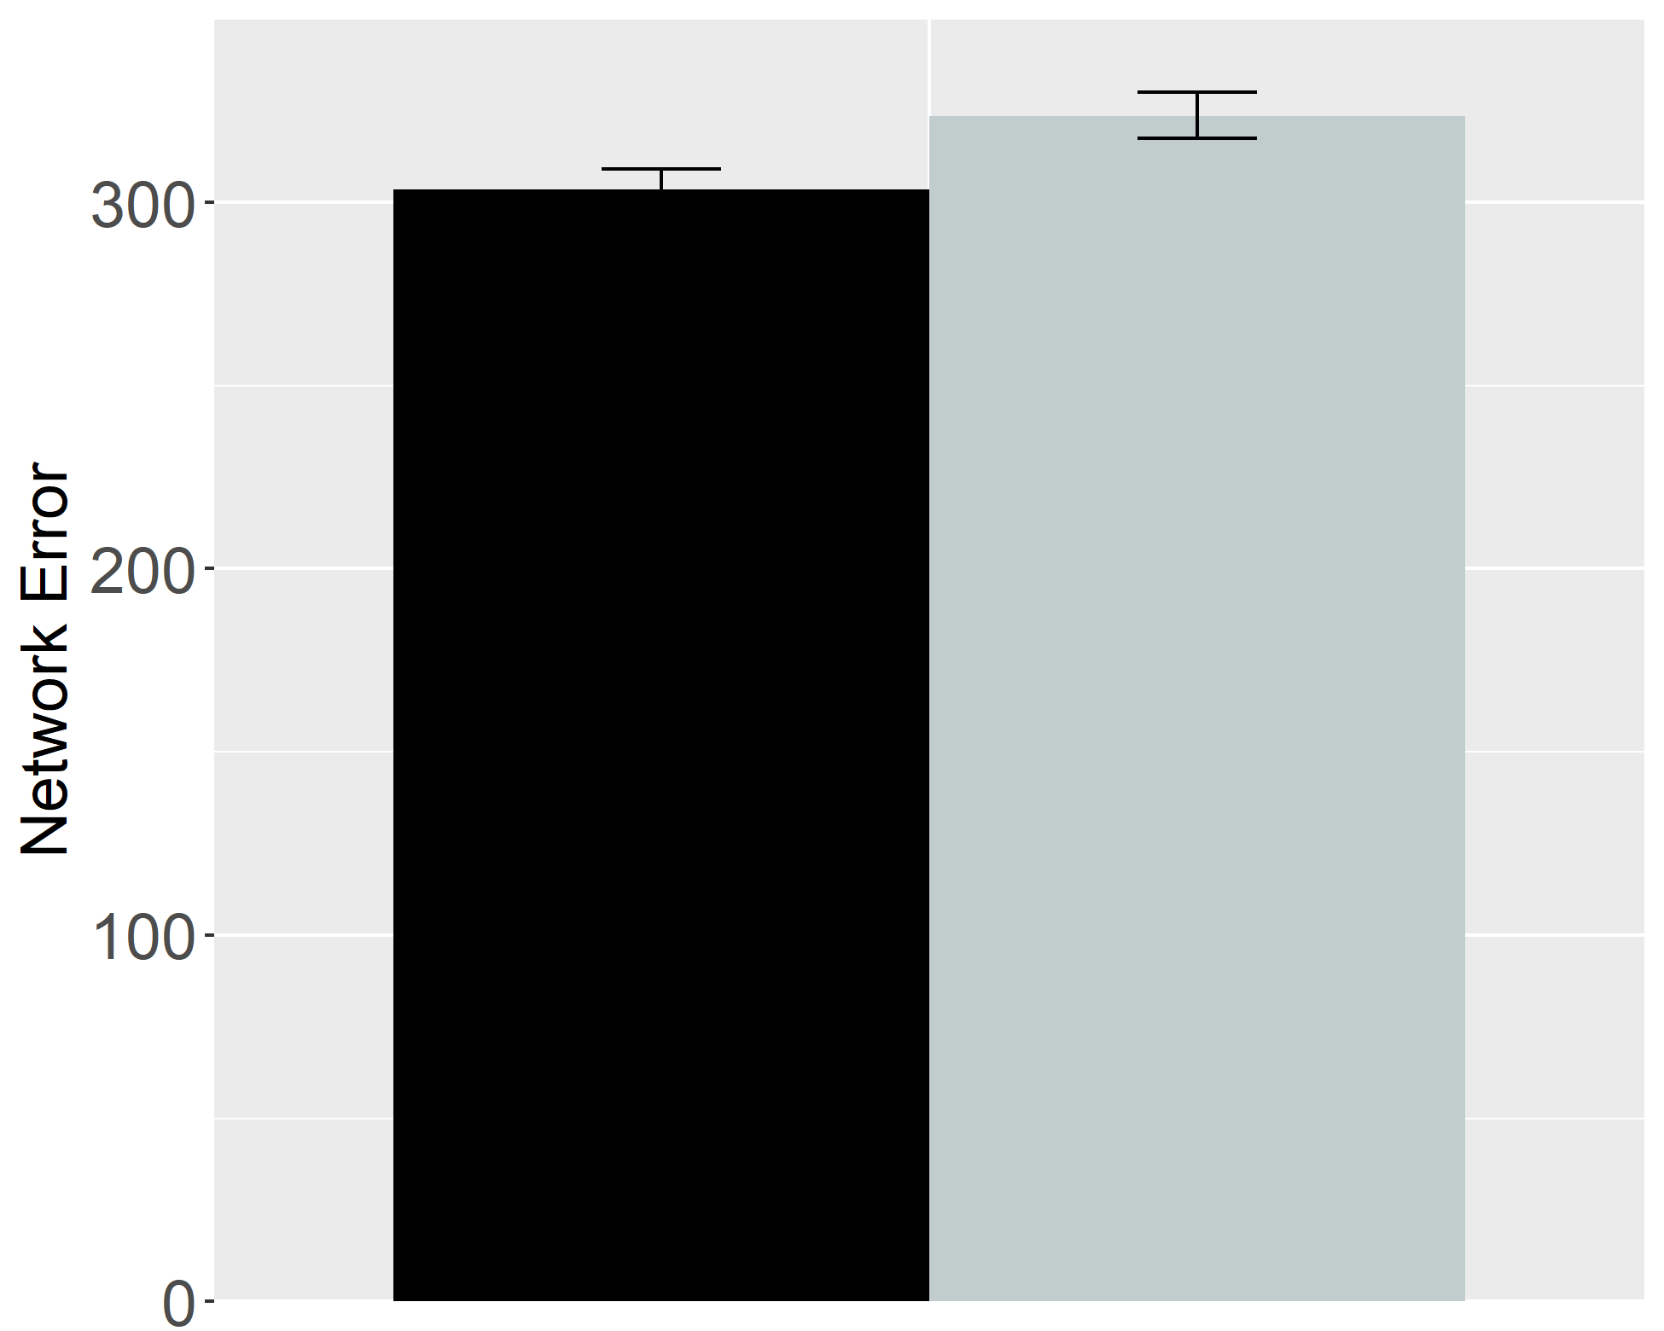 | 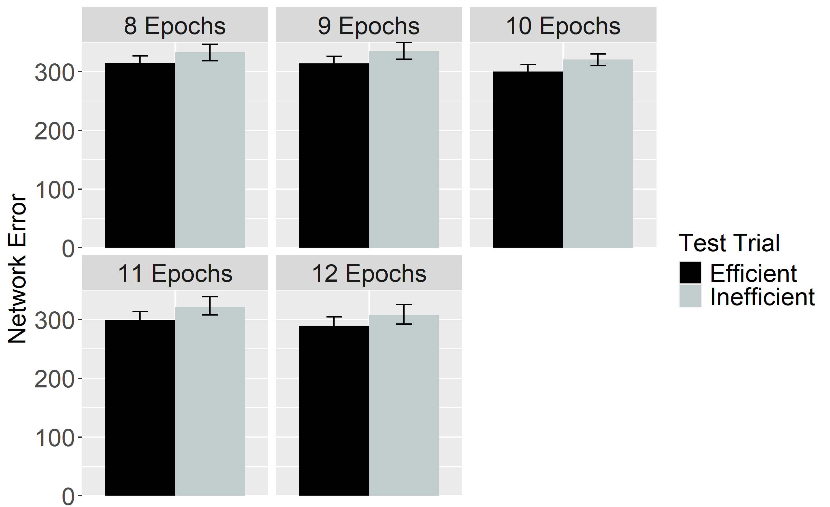
Figure 24. Performance of ALIAS in the Ineffective Action condition. The overall error produced to the Efficient and Inefficient test events is shown on the left, and the error produced across different habituation epochs is shown on the right. This condition corresponds to Experiment 2 in Skerry et al. (2013).

Figure 24 shows the performance of networks in the Ineffective Action condition. As with networks in the No Training condition, these networks also looked about equally long at both test events. Together, these results support the contention that, by enhancing infants’ encoding of their own reach trajectories, effective action experience enabled ALIAS to reproduce the fifth target finding.

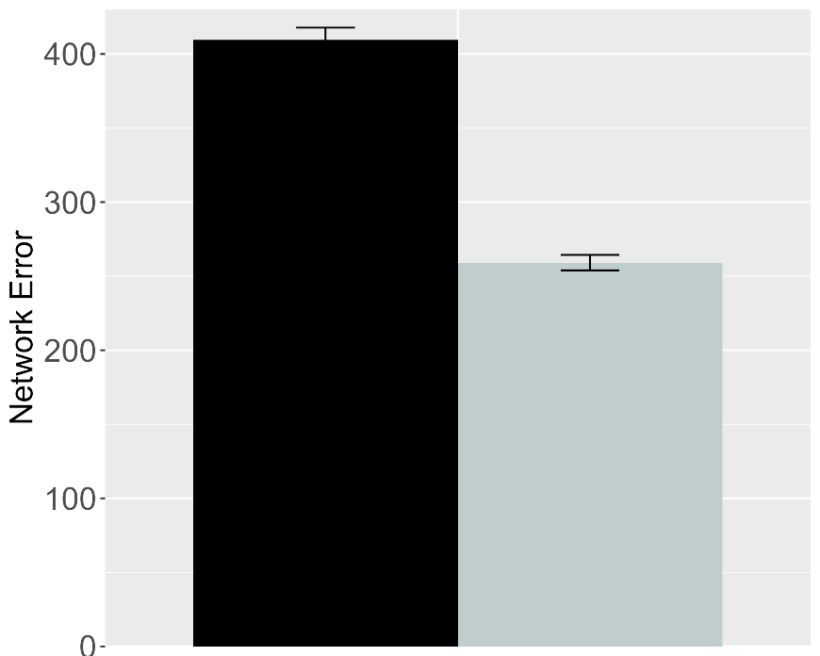 | 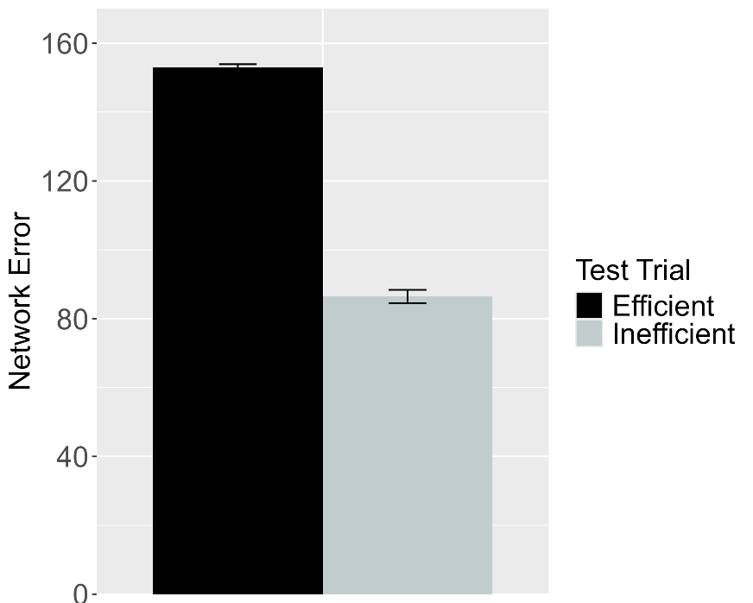
Figure 25. Performance of ALIAS in the Experimental (left) and Control (right) conditions of the Effective Action condition. These data correspond to a version of ALIAS in which the attentional boost extends into the habituation phase.

To determine whether the attentional boost that infants experience in the Effective Action condition must be ephemeral for ALIAS to capture the fifth target finding, the attentional boost experienced by networks in the Experimental and Control conditions of the broader Effective Action condition extended into habituation. As Figure 25 depicts, networks in both conditions produced greater error to the Efficient than to the Inefficient test event. These results indicate that a transient attention boost is necessary for ALIAS to capture the final target finding.
The basis for these findings is straightforward: Although networks’ heightened attention during the action phase enabled them robustly to encode their own straight reach trajectories, the fact that this attentional boost persisted into the habituation phase meant that networks’ representations of these trajectories were overridden by robust representations of the arced motion trajectories and the surface features associated with those trajectories (e.g., the height of the apex of a reach’s trajectory) during the habituation phase. Consequently, the Inefficient test event—which, apart from the barrier, preserved most of the features of the habituation event—was partially consistent with the habituation representation; the Efficient test event was not because it depicted a straight reach trajectory. Note that the extremely brief nature of the pretraining phase, combined with networks’ impoverished processing abilities in this simulation, precluded them from forming robust representations of straight motion during this phase.

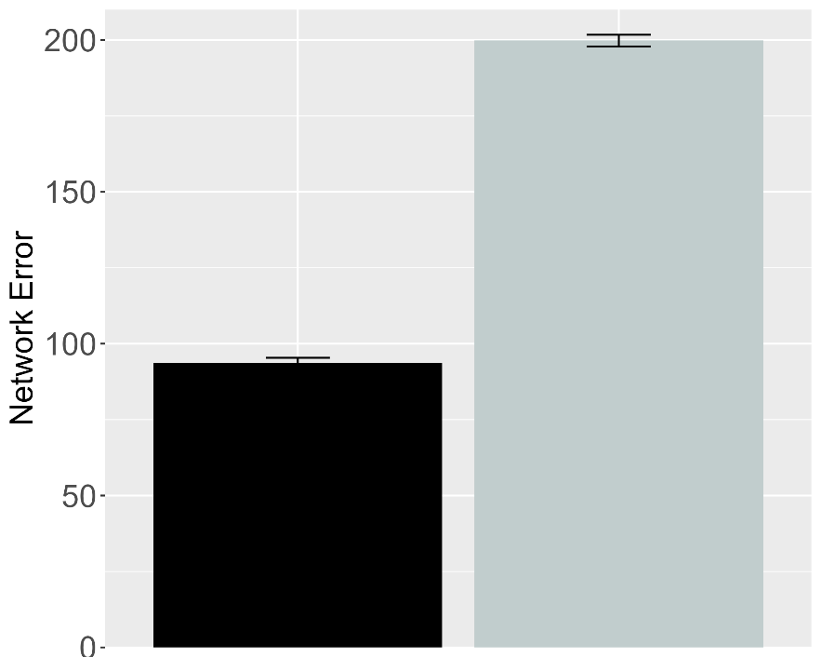 | 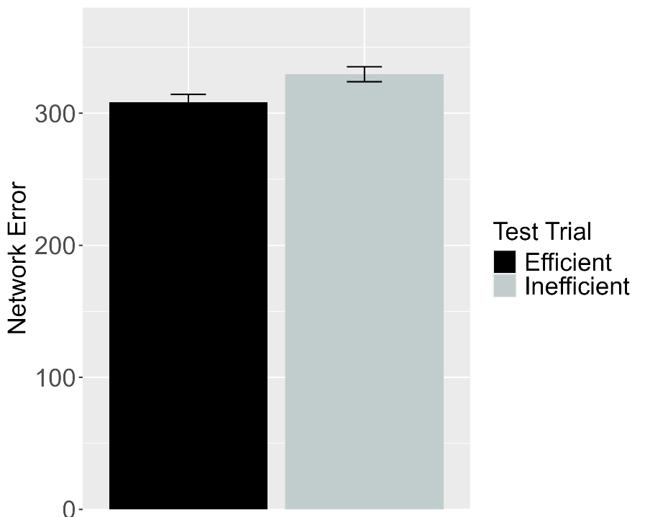
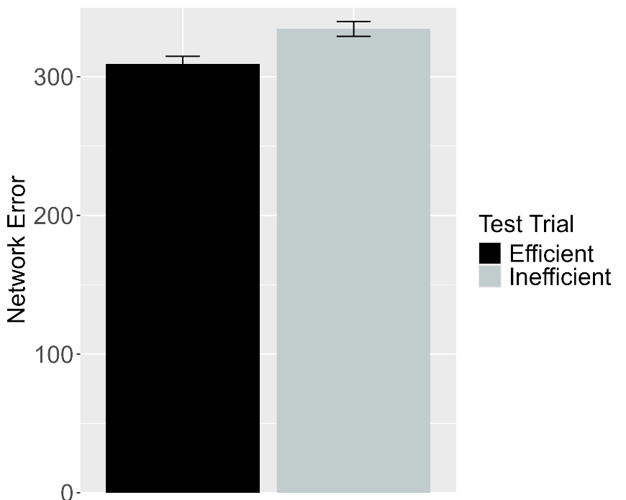
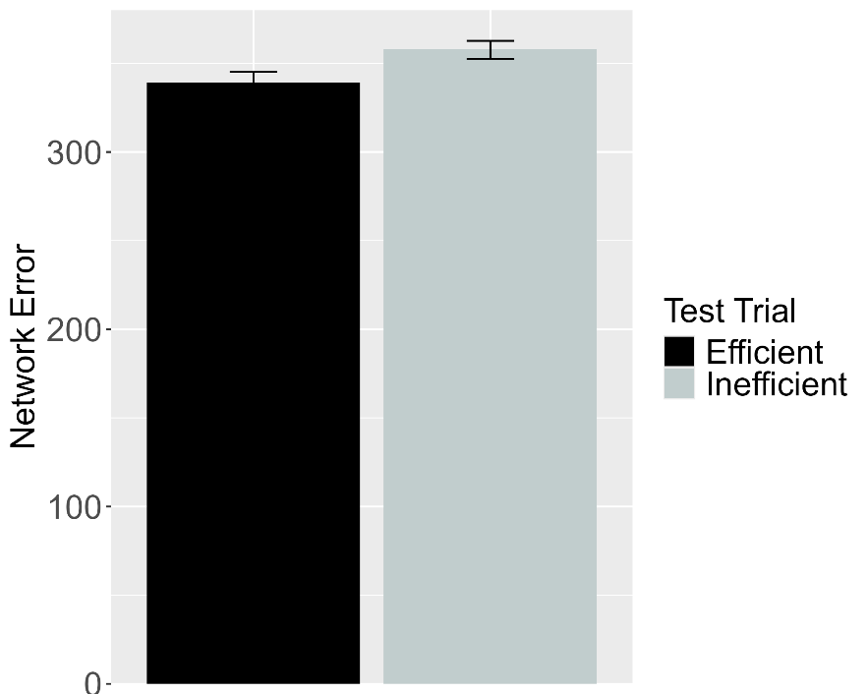
Figure 26. Performance of ALIAS-2. Plotted in the top row is the overall mean error to the Efficient and Inefficient test events for networks assigned either to the Experimental (top left) or to the Control condition (top right) in the Effective Action condition. Plotted in the middle row is the overall mean error to the two test events for networks assigned to the Ineffective Action condition. Plotted in the bottom row is the overall mean error to the two test events for networks assigned to the No Training condition. The No Training condition corresponds to Experiment 2 in Skerry et al. (2013).

The next analysis examined whether associative learning alone was sufficient for ALIAS-2 to reproduce the fifth target finding. Note that the attentional boost remained short-lived in this simulation. As Figure 26 depicts, ALIAS-2 was able successfully to reproduce the fifth target finding: In the Effective Action condition, networks habituated to constrained action produced greater error to the Inefficient than to the Efficient test event. In contrast, networks habituated to unconstrained action in the Ineffective and No Training conditions produced comparable amounts of error to both test events. The results of this simulation indicate that associative learning alone is sufficient to account for Skerry et al.’s (2013) findings.
The principal argument advanced in this paper is that infants' looking behaviors in studies assessing their action efficiency understanding reflect associative learning. The five simulations reported here support this contention. Specifically, ALIAS reproduced the finding that infants look selectively at inefficient actions, that this effect is independent of whether the entities involved possess animacy cues, that infants make bidirectional inferences among actions, goals, and constraints, that ostensibly they possess graded representations of efficiency, and that action efficiency understanding is present in pre-reaching infants. ALIAS's ability to capture such a diverse set of findings undermines the claim that such looking behaviors derive from specialized mechanisms and abstract, conceptually rich representations of goals, constraints, efficiency, and utility. Instead, the present simulations suggest that these phenomena can be readily explained in terms of a domain-general associative learning mechanism operating over the semantically neutral visible surface features of action events and the entities and objects involved in them.
At the same time, a complete account of infants’ looking performance in these studies should do more than reproduce existing findings. The account must also be generative: it should produce testable predictions for future research. The final section does exactly this by placing ALIAS in a series of novel situations and examining its resulting behavior. These behaviors constitute a set of predictions that can be used to decide between the present account and the domain-specific alternatives.

Model predictions
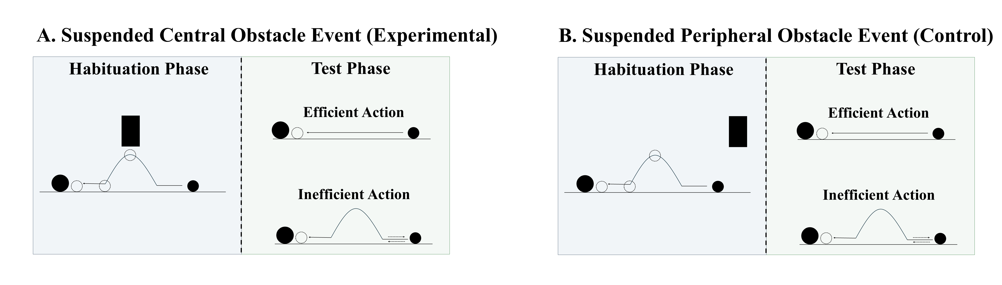
Figure 27. Schematic depiction of the behavioral task associated with the first prediction. In the suspended central obstacle event (A), the first object jumps under a suspended, centrally located barrier before it comes to rest next to the second object; in the suspended peripheral obstacle event (B), the first object jumps beside the suspended barrier before coming to rest next to the second one. The barrier is removed at test for both events, and infants observe either an efficient straight-path action or an inefficient arced-path action.

A potentially interesting question that the current simulations raise concerns how ALIAS would respond if it were habituated to an event in which a barrier was located directly above rather beneath the apex of an arced motion trajectory. Figure 27 depicts what such an event would look like. If the current account is correct that spatial proximity to the motion trajectory is the critical factor, then networks (and by hypothesis, infants) should respond similarly when the obstacle is positioned above rather than below the trajectory.
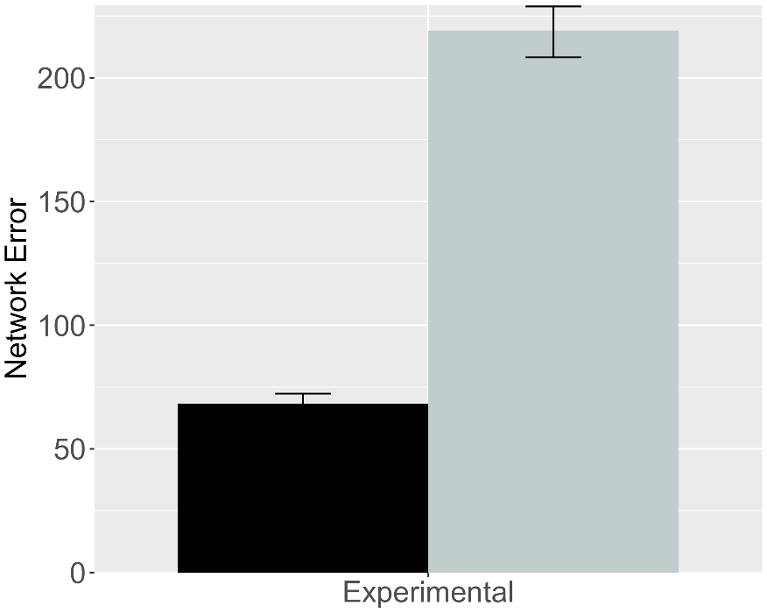 | 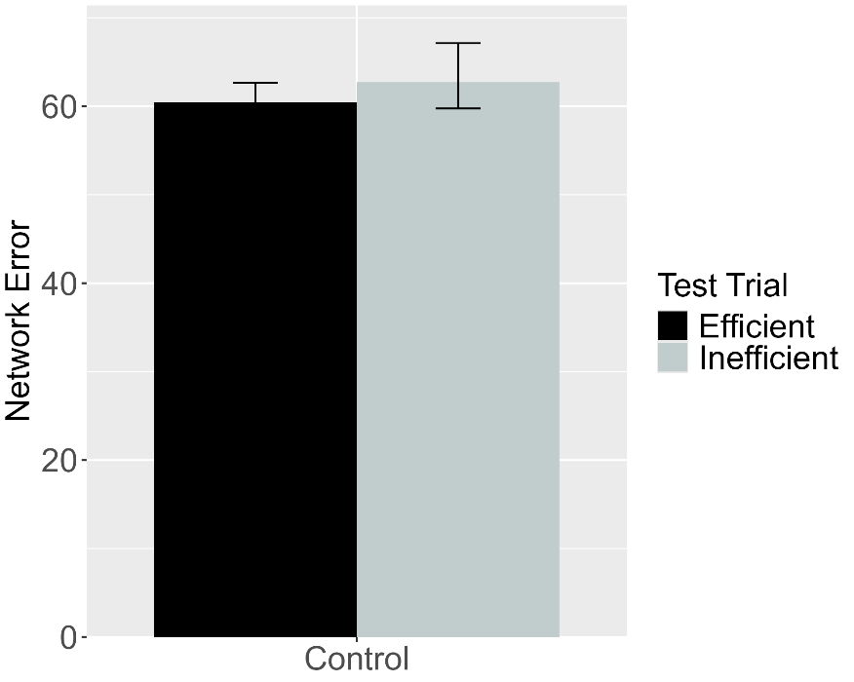
Figure 28. Performance of ALIAS. (Left) Overall error produced to the Efficient and Inefficient test events for networks in the Experimental condition. (Right) Overall error produced to the Efficient and Inefficient test events for networks in the Control condition. The barrier shown during habituation for this simulation appeared directly above rather than beneath arced motion.

This simulation was identical to Simulation 1a with two critical exceptions. First, a fourth unit was added to the Obstacle Horizontal Position input and output groups. This unit corresponded to the location directly above arced motion. Second, because the previous results were robust to the number of habituation epochs, the length of the habituation phase was reduced to eight epochs; this was the smallest number used in the prior simulations. Crucially, as in Simulation 1a, networks were assigned either to the Experimental condition (N = 20) or to the Control condition (N = 20). Obstacles were only in the above-the-curved-motion spatial configuration during the habituation phase. As Figure 29 shows, when networks were subsequently tested on barrierless inefficient and efficient test events, only those in the Experimental condition looked longer at the Inefficient than at the Efficient test event. These results mirror those in Simulation 1a.

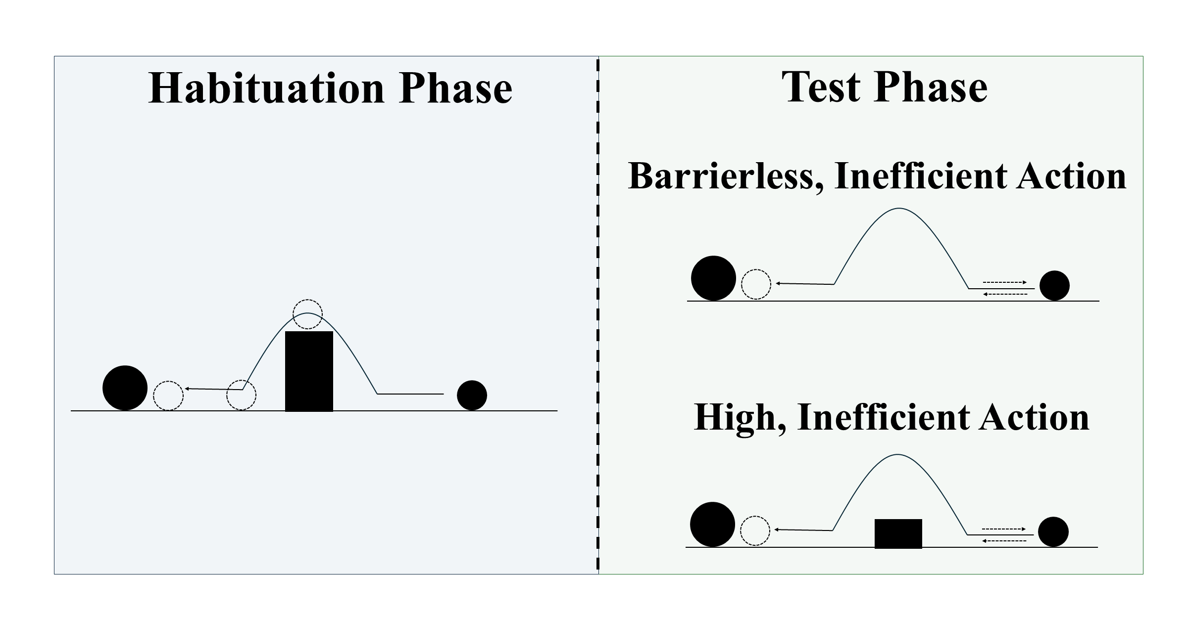
Figure 29. Schematic depiction of the behavioral task associated with the second prediction. During habituation, the first object jumps over centrally located barrier before it comes to rest next to the second object. Barrierless, inefficient and high, inefficient test events are then shown.

Given that action efficiency understanding studies employ different kinds of inefficient events, another interesting question raised by the current simulations concerns ALIAS’s performance when tested on two different inefficient test events; the typical approach is to test infants on inefficient and efficient test events. For example, how might ALIAS respond if it were tested on Liu and Spelke’s (2017) High, inefficient test event and Gergely et al.’s (1995) barrierless inefficient test event? To address this question, networks (N = 20) were habituated to a constrained action event and tested on the High, inefficient test event from Simulation 4 and the inefficient one from Simulation 1a (Figure 29). Networks were the same “age” as those in Simulation 4.
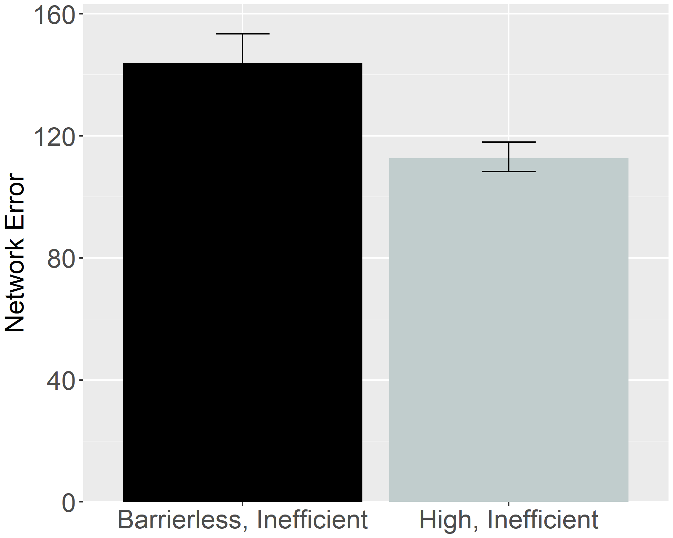
Figure 30. Performance of ALIAS. Overall error produced to the High, inefficient and Inefficient test events.

As is evident in Figure 30, networks looked longer at the barrierless, inefficient test event than at the high, inefficient one. Heightened looking (or error) was observed to the barrierless, inefficient test event than to the high, inefficient one because, as was discussed more extensively in Simulation 1a, many of the input features shown in this event strongly activated an internal representation corresponding to straight motion. This information ultimately conflicted with the fact that the barrierless, inefficient event presented arced motion. By contrast, the high, inefficient test event produced comparatively less error because the input information associated it was largely consistent with that encountered during pretraining.
The results presented in this section are theoretically significant because, arguably, they are at odds with what any of the current domain-specific proposals would predict for the same events. If these accounts are correct that action processing depends on the efficiency, cost, and subjective utility of those actions, among other things, then they would predict that infants should show equivalent dishabituation to both inconsistent events because both events are non-rational and costly. This contention falls directly out of the math of the naïve utility calculus, the full details of which are beyond the scope of this paper (see Jara-Ettinger et al., 2016; Jara-Ettinger et al., 2020). In this model, cost is defined in terms of an agent’s actions (or more formally, its policy)—this policy is equivalent in both inefficient test events. Future research would do well to test these predictions. These same accounts might also predict equivalent performance between the Suspended Central Obstacle Event and Suspended Peripheral Obstacle Event conditions. This is because the agent’s actions during the habituation phase in both conditions were not rational given the environmental constraints. As such, these accounts predict that infants should fail to form efficiency-based expectations during this phase.

General Discussion
A question that developmental scientists have wrestled with for the last 30 years concerns how infants discover that some actions are more efficient than others. Rich proposals maintain that infants possess early-emerging and conceptually rich domain-specific systems that support processing actions in terms of their efficiency, cost, rationality, and subjective utility, among other things(Csibra & Gergely, 1998; Gergely & Csibra, 2003; Jara-Ettinger et al., 2016; Jara-Ettinger et al., 2020; Liu et al., 2026). Lean proposals argue instead that infants’ behaviors in violation-of-expectation investigations broadly—of which studies assessing infants’ action efficiency understanding are specific instances reflect the operation of more domain-general processes.
This paper extends this second perspective by maintaining that the looking behavior of infants in studies assessing their putative action efficiency understanding stems from an associative learning mechanism that operates over the low-level kinematics of actions as well as over the differentially salient and conceptually neutral surface features that comprise the entities and objects that engage in those actions. It was demonstrated that when this account was implemented in a connectionist computational model called ALIAS, the model readily captured several key findings in this literature. In particular, the model captured the finding that infants look longer at inefficient than efficient actions following habituation to animate-like constrained events (Simulations 1a and 1b); the finding that infants’ sensitivity to an action’s efficiency extends to inanimate-like constrained events (Simulation 2); the finding that infants can infer missing constraints from an agent’s behavior and its goal as well as its goal from its behavior and environmental constraints (Simulation 3); the finding that infants putatively possess a graded notion of efficiency (Simulation 4); and the finding that pre-reaching 3-month-olds can process action efficiency like older infants if they are given action experience (Simulation 5).
The present results also showed that ALIAS provided a better account of these target findings than ALIAS-2 and VOM10-2. Table 3—which shows the qualitative fits of each of these models to the five target findings—makes this point especially clear. The table shows that ALIAS successfully captured all five target findings as well as the more specific findings associated with each target finding. In contrast, the remaining models either failed to capture several of the target findings, could only partially capture them, or could not be used to simulate them because of theoretical limitations.

Table 3. Qualitative fits of the different models to the five target findings examined in the current paper.
 |  |  |  | Model
Target finding | Illustrative paradigm | Articles | ALIAS | ALIAS-2 | VOM10 | VOM10-2
- Selective longer looking to inefficient than efficient actions following constrained habituation. | Animate agent constrained action | Csibra et al. (1999); Gergely et al. (1995) |  |  |  | 
 | Animate agent unconstrained action |  |  |  |  | 
- Independence from animacy. | Inanimate-agent constrained action | Csibra et al. (1999) Sodian et al. (2004) |  |  |  | 
 | Inanimate agent unconstrained action |  |  |  |  | 
- Bidirectional inferences about actions, goals, and constraints. | Goal inference | Csibra et al. (2003); Wagner & Carey (2005) |  |  |  | 
 | Constraint inference |  |  |  |  | 
- Graded representations of efficiency. | More costly vs. less costly constrained action | Liu & Spelke (2017) |  |  | — | 
 | More costly vs. less costly unconstrained action |  |  |  | — | 
 | More costly vs. less costly constrained action with a previously inefficient agent |  |  |  | — | 
- Action efficiency understanding in pre-reaching infants. | Sticky mittens training constrained action | Skerry et al. (2013) |  |  | — | —
 | Non-sticky mittens training constrained action |  |  |  | — | —
 | Sticky mittens training unconstrained action |  |  |  | — | —
Note. Check marks indicate that a given model captured the qualitative pattern associated with a target finding and its corresponding illustrative paradigm; Xs indicate that the model failed to capture the finding; and dashes indicate that the model could not meaningfully be applied to the corresponding target and illustrative paradigm. Illustrative paradigms are nested within the broader target finding to which they correspond. Because several of the current target findings were derived from multiple experiments and published studies, the associated citations are also provided.

As it relates to VOM10—the main competitor model—this model was unable to reproduce the third and fifth target findings. VOM10’s failure to capture the third and fifth target findings can be attributed to a common source: the absence of prior action processing experience. Yet just such experience is required for the model to represent aspects of the visual scene that otherwise were absent or to model the role of experience on action processing. Although VOM10 captured the first target finding, even here caution is warranted. This is because a revised version of this model—which more faithfully simulated the experimental task from which the first target finding derived—failed to reproduce this finding. This suggests that VOM10’s original success stemmed from quirks relating to how this model can be used to simulate action efficiency understanding studies rather than from its ability to capture the processes underlying action efficiency processing in infants. Interestingly, Simulation 4 demonstrated that retaining such quirks prevented VOM10 from capturing the finding that infants possess a graded notion of efficiency. understanding or instead arose from atheoretical quirks in how the original simulations were implemented. VOM10’s inability to capture four of the five target findings, however, should not be interpreted to reflect a broader failure of connectionist systems to simulate the processes governing infants’ looking behaviors in studies assessing their putative action efficiency understanding. If this were true, then ALIAS—a connectionist system itself—should have failed to explain infants’ looking behaviors in these studies.
In terms of the novel contributions that the current simulations make, two are particularly noteworthy. First, they provided insight into the possible mechanistic basis of infants’ looking responses in action efficiency understanding studies. As one example, Simulation 4 demonstrated that prior experience with curved trajectories and obstacles can explain why infants look longer at events depicting barrierless arced motion than those depicting constrained arced motion or why infants look longer when agents stop short of their goals than when they stop next to them: Both patterns of looking were the emergent consequence of prior experience observing arced motion in the presence of barriers and actions that terminate in the agent being spatially contiguous with its goal. As another example, Simulation 5showed that longer looking at inefficient than efficient test events can be expected in an otherwise developmentally inexperienced system that develops a representation of its own straight reaches while in a heightened attentional state. Action events whose kinematics subsequently deviate from this learned representation (e.g., the inefficient test event) should elicit more error (and thereby, more looking) than events whose kinematics overlap with this representation (e.g., the efficient test event). In general, ALIAS’s behavior here was based not on e specialized processes or explicit notions of goals, action, efficiency, cost, or rationality but rather on associations—formed during pretraining and reinforced (or weakened) during habituation—among differentially salient, conceptually neutral visible surface features.
Second, the current simulations generate a number of testable predictions. One is that infants who are habituated to a constrained action event and then tested on a high, inefficient test event like that in Liu and Spelke (2017) and a barrierless, inefficient test event like that in Gergely et al. (1995) should look longer at latter than the former event. Another prediction is that infants should look longer at an inefficient test event than at an efficient one following habituation to an event in which arced motion unfolds beneath rather than over an obstacle. Although not explicitly tested here, another prediction the model makes is that increasing the salience of peripherally located obstacles should enable infants to form robust associations between then and arced motion. Conversely, decreasing the salience of centrally located obstacles should prevent robust associations from forming between them and arced motion. Still another prediction—again not explicitly tested here—the model makes is that infants should look longer at barrierless, inefficient test event than an efficient test event, even in the absence of habituation. Behavioral findings that corroborate any of these predictions—but ideally all of them—would be difficult to reconcile under any of the current domain-specific proposals.
The present account may also help explain an apparent discontinuity between action efficiency processing in infancy and later development. On the one hand, studies with infants suggest that sensitivity to action efficiency emerges sometime between 6 and 12 months of age (e.g., Csibra et al., 1999, 2003; Gergely et al., 1995; Liu & Spelke, 2017; Liu et al., 2017), if not even earlier (e.g., Liu et al., 2019; Skerry et al., 2013). On the other hand, evidence from toddlers and young children is more equivocal. Some findings are consistent with the view that action efficiency understanding is continuous throughout development. For example, 14-month-olds imitate inefficient actions only when more efficient alternatives are unavailable (Gergely et al., 2002), 2-year-olds use action costs when evaluating others' behavior (Jara-Ettinger et al., 2015), and 5-year-olds reason productively about others' actions in terms of their associated costs and rewards (Jara-Ettinger et al., 2015). In contrast, other studies show that preschool-aged children neither distinguish efficient from inefficient uses of familiar tools (e.g., Ossmy et al., 2021) nor expect an agent to follow the shorter—and therefore more efficient and less costly—of two available paths to a goal (e.g., Gönül & Paulus, 2021). These diverging findings are difficult to reconcile under the domain-specific theories considered here because each implicitly assumes continuity in the mechanisms supporting action efficiency understanding. Yet, if infants truly represent actions in terms of sophisticated notions such as goals, efficiency, and utility, then it is not immediately obvious why evidence for such representations should become less consistent during the preschool years. The present account offers a different interpretation. If infants' looking behavior in studies on this topic reflects low-level associative processes operating over visible surface features, then their apparent sensitivity to action efficiency may be more apparent than real because their looking behavior does not reflect a genuine capacity for efficiency-based action processing.
Although ALIAS is not a model of how action efficiency understanding itself emerges, I contend that the very same processes argued to govern infants’ looking behaviors in studies on this topic also support the development of an authentic understanding of what makes an action efficient. At the same time, however, the current simulations cannot disprove domain-specific mechanisms for representing goals, efficiency, cost, or rationality any more than they can prove that ALIAS is the right description of the processes underpinning infants’ action efficiency understanding. Instead, they demonstrate that an associative learning mechanism operating over differentially salient surface features is sufficient to explain a broad range of findings in this literature. Behavioral experiments are ultimately needed to decide among the current competing proposals.
Before concluding, two potential criticisms of ALIAS are worth noting. The first concerns the fact that the present simulations focused primarily on studies employing some version of the Gergely paradigm. Potential downsides of this are that the conclusions that can be drawn from it are necessarily limited in scope and that it is unclear to what extent the current model can capture findings on infant action understanding broadly (e.g., Gergely et al., 2002; Woodward, 1998). Future work will therefore need to determine whether extended versions of ALIAS can capture findings beyond those related to infants’ action efficiency understanding.
The second concerns the model’s simplicity. Although movement was represented dynamically, all other aspects of the model were represented statically. Additionally, a localist rather than a distributed encoding scheme was used to represent objects, their features, and any external constraints or barriers in the environment. Based on these simplifications, the model may poorly approximate infants’ real-world action experience. Although I do not dispute this critique, this simplification was deliberate: Because simple models afford tracing precisely how they process information, they provide meaningful insight into the possible mechanistic basis of some phenomenon in the human mind specifically and advance theories of infant cognitive development broadly. Although it is true that complex models better capture the richness of infants’ action perception, a major disadvantage of such models is that their complexity hinders their interpretability. This complexity also makes it difficult to separate the meaningful consequences of different theoretical assumptions from extraneous model details.
In sum, the current simulations demonstrate that a domain-general associative learning mechanism operating over the low-level kinematics of actions and the differentially salient surface features of environments is sufficient to explain a broad range of findings in the action efficiency understanding literature. This proposal—when instantiated in a new connectionist model called ALIAS—not only successfully captured five major findings in this literature but also generated several predictions that should be tested in future research. Additionally, the current simulations provided insight into the possible mechanistic basis of infants’ action efficiency understanding through detailed analyses of ALIAS’s behavior in each simulation. Considered together, the current simulations suggest that before concluding that infants possess conceptually rich knowledge that is underpinned by domain-specific mechanisms based on their performance in a behavioral task, it is important to determine first whether more general processes are sufficient to explain the same performance. The current simulations indicate that they are, at least in the domain of infant action efficiency understanding.
References
Baillargeon, R. (1986). Representing the existence and the location of hidden objects: Object permanence in 6-and 8-month-old infants. Cognition, 23(1), 21–41. https://doi.org/10.1016/0010-0277(86)90052-1
Baillargeon, R. (1987). Object permanence in 3½- and 4½-month-old infants. Developmental Psychology, 23(5), 655–664. https://doi.org/10.1037/0012-1649.23.5.655
Baillargeon, R., & DeVos, J. (1991). Object permanence in young infants: Further evidence. Child Development, 62(6), 1227–1246. https://doi.org/10.1111/j.1467-8624.1991.tb01602.x
Baillargeon, R., Spelke, E. S., & Wasserman, S. (1985). Object permanence in five-month-old infants. Cognition, 20(3), 191–208. https://doi.org/10.1016/0010-0277(85)90008-3
Benton, D. T. (2022). The elusive “Developmental Mechanism”: What they are and how to study and test them. Developmental Review, 65, 101034. https://doi.org/10.1016/j.dr.2022.101034
Benton, D. T. (2023). But what is the mechanism?’: Demystifying the ever elusive ‘developmental mechanism. Infant and Child Development, 32(6), e2355. https://doi.org/10.1002/icd.2355
Benton, D. T. (2025). An associative-learning account of how infants learn about causal action in animates and inanimates: A critical reexamination of four classic studies. Journal of Experimental Psychology: General, 154(2), 497–521. https://doi.org/10.1037/xge0001656
Benton, D.T., & Hoch, J.E. (in press). An associative learning account of how saliva becomes a cue for comfort. Child Development. 10.1093/chidev/aacag119
Benton, D. T., & Lapan, C. (2021). Moral masters or moral apprentices? A connectionist account of sociomoral evaluation in preverbal infants. Cognitive Development, 62, 101164. https://doi.org/10.1016/j.cogdev.2022.101164
Benton, D. T., Kamper, D., Beaton, R. M., & Sobel, D. M. (2024). Don't throw the associative baby out with the Bayesian bathwater: Children are more associative when reasoning retrospectively under information processing demands. Developmental Science, 27(3), e13464. https://doi.org/10.1111/desc.13464
Berthiaume, V. G., Shultz, T. R., & Onishi, K. H. (2013). A constructivist connectionist model of transitions on false-belief tasks. Cognition, 126(3), 441–458. https://doi.org/10.1016/j.cognition.2012.11.007
Blumberg, M. S., & Adolph, K. E. (2023). Protracted development of motor cortex constrains rich interpretations of infant cognition. Trends in cognitive sciences, 27(3), 233-245. https://doi.org/10.1016/j.tics.2022.12.014
Bogartz, R. S., Shinskey, J. L., & Schilling, T. H. (2000). Object permanence in five‐and‐a‐half‐month‐old infants?. Infancy, 1(4), 403–428. https://doi.org/10.1207/S15327078IN0104_3
Bomba, P. C., & Siqueland, E. R. (1983). The nature and structure of infant form categories. Journal of Experimental Child Psychology, 35(3), 294–328. https://doi.org/10.1016/0022-0965(83)90085-3
Carey, S. (2009). The origin of concepts. Oxford University Press.
Christiansen, M. H., & Curtin, S. (1999). Transfer of learning: Rule acquisition or statistical learning? Trends in Cognitive Sciences, 3(8), 289–290. https://doi.org/10.1016/S1364-6613(99)01356-X
Clearfield, M. W., & Mix, K. S. (1999). Number versus contour length in infants' discrimination of small visual sets. Psychological science, 10(5), 408-411. https://doi.org/10.1111/1467-9280.00177
Cohen, L. B. (1973). A two-process model of infant visual attention. Merrill-Palmer Quarterly, 19(3), 157–180.
Cohen, L. B., Chaput, H. H., & Cashon, C. H. (2002). A constructivist model of infant cognition. Cognitive Development, 17(3–4), 1323–1343. https://doi.org/10.1016/S0885-2014(02)00124-7
Cohen, L. B., & Marks, K. S. (2002). How infants process addition and subtraction events. Developmental Science, 5(2), 186–201. https://doi.org/10.1111/1467-7687.00220
Cohen, L. B., & Oakes, L. M. (1993). How infants perceive a simple causal event. Developmental Psychology, 29(3), 421–433. https://doi.org/10.1037/0012-1649.29.3.421
Colunga, E., & Smith, L. B. (2005). From the lexicon to expectations about kinds: A role for associative learning. Psychological Review, 112(2), 347–382. https://doi.org/10.1037/0033-295X.112.2.347
Csibra, G., & Gergely, G. (1998). The teleological origins of mentalistic action explanations: A developmental hypothesis. Developmental Science, 1(2), 255–259. https://doi.org/10.1111/1467-7687.00039
Csibra, G., Bíró, S., Koós, O., & Gergely, G. (2003). One‐year‐old infants use teleological representations of actions productively. Cognitive Science, 27(1), 111–133. https://doi.org/10.1207/s15516709cog2701_4
Csibra, G., Gergely, G., Bíró, S., Koos, O., & Brockbank, M. (1999). Goal attribution without agency cues: The perception of 'pure reason' in infancy. Cognition, 72(3), 237–267. https://doi.org/10.1016/S0010-0277(99)00039-6
Elman, J. L. (1990). Finding structure in time. Cognitive Science, 14(2), 179–211. https://doi.org/10.1207/s15516709cog1402_1
Gelman, R. (1990). First principles organize attention to and learning about relevant data: Number and the animate‐inanimate distinction as examples. Cognitive Science, 14(1), 79–106. https://doi.org/10.1207/s15516709cog1401_5
Geraci, A., & Surian, L. (2011). The developmental roots of fairness: Infants' reactions to equal and unequal distributions of resources. Developmental Science, 14(5), 1012–1020. https://doi.org/10.1111/j.1467-7687.2011.01048.x
Geraci, A., Surian, L., Tina, L. G., et al. (2025). Human newborns spontaneously attend to prosocial interactions. Nature Communications, 16, 6304. https://doi.org/10.1038/s41467-025-61517-3
Gergely, G., & Csibra, G. (2003). Teleological reasoning in infancy: The naïve theory of rational action. Trends in Cognitive Sciences, 7(7), 287–292. https://doi.org/10.1016/S1364-6613(03)00128-1
Gergely, G., Bekkering, H., & Király, I. (2002). Rational imitation in preverbal infants. Nature, 415(6873), 755. https://doi.org/10.1038/415755a
Gergely, G., Nádasdy, Z., Csibra, G., & Bíró, S. (1995). Taking the intentional stance at 12 months of age. Cognition, 56(2), 165–193. https://doi.org/10.1016/0010-0277(95)00661-H
Haith, M. M. (1998). Who put the cog in infant cognition? Is rich interpretation too costly? Infant Behavior and Development, 21(2), 167–179. https://doi.org/10.1016/S0163-6383(98)90001-7
Hamlin, J. K. (2013). Moral judgment and action in preverbal infants and toddlers: Evidence for an innate moral core. Current Directions in Psychological Science, 22(3), 186–193. https://doi.org/10.1177/0963721412470687
Hamlin, J. K., & Wynn, K. (2011). Young infants prefer prosocial to antisocial others. Cognitive Development, 26(1), 30–39. https://doi.org/10.1016/j.cogdev.2010.09.001
Hamlin, J. K., Wynn, K., & Bloom, P. (2007). Social evaluation by preverbal infants. Nature, 450(7169), 557–559. https://doi.org/10.1038/nature06288
Heyes, C. (2018). Cognitive gadgets: The cultural evolution of thinking. Harvard University Press.
Heyes, C. (2024). Rethinking norm psychology. Perspectives on Psychological Science, 19(1), 12-38. https://doi.org/10.1177/17456916221112075
Hinton, G. E. (1984). Distributed representations (Technical Report CMU-CS-84-157). Carnegie-Mellon University, Department of Computer Science.
Hinton, G. E. (1989). Deterministic Boltzmann learning performs steepest descent in weight-space. Neural Computation, 1(1), 143–150. https://doi.org/10.1162/neco.1989.1.1.143
Hunter, M. A., & Ames, E. W. (1988). A multifactor model of infant preferences for novel and familiar stimuli. Advances in Infancy Research, 5, 69–95.
Hunter, M. A., Ames, E. W., & Koopman, R. (1983). Effects of stimulus complexity and familiarization time on infant preferences for novel and familiar stimuli. Developmental Psychology, 19(3), 338–352. https://doi.org/10.1037/0012-1649.19.3.338
Jara-Ettinger, J., Gweon, H., Schulz, L. E., & Tenenbaum, J. B. (2016). The naïve utility calculus: Computational principles underlying commonsense psychology. Trends in Cognitive Sciences, 20(8), 589–604. https://doi.org/10.1016/j.tics.2016.05.011
Jara-Ettinger, J., Schulz, L. E., & Tenenbaum, J. B. (2020). The naive utility calculus as a unified, quantitative framework for action understanding. Cognitive Psychology, 123, 101334. https://doi.org/10.1016/j.cogpsych.2020.101334
Jones, S. S., & Smith, L. B. (1993). The place of perception in children's concepts. Cognitive Development, 8(2), 113–139. https://doi.org/10.1016/0885-2014(93)90008-S
Kamewari, K., Kato, M., Kanda, T., Ishiguro, H., & Hiraki, K. (2005). Six-and-a-half-month-old children positively attribute goals to human action and to humanoid-robot motion. Cognitive Development, 20(2), 303–320. https://doi.org/10.1016/j.cogdev.2005.04.004
Kellman, P. J., & Spelke, E. S. (1983). Perception of partly occluded objects in infancy. Cognitive Psychology, 15(4), 483–524. https://doi.org/10.1016/0010-0285(83)90017-8
Kim, I. K., & Spelke, E. S. (1992). Infants' sensitivity to effects of gravity on visible object motion. Journal of Experimental Psychology: Human Perception and Performance, 18(2), 385–393. https://doi.org/10.1037/0096-1523.18.2.385
Kotovsky, L., & Baillargeon, R. (1998). The development of calibration-based reasoning about collision events in young infants. Cognition, 67(3), 311–351. https://doi.org/10.1016/S0010-0277(98)00036-5
Leslie, A. M. (1995). A theory of agency. In D. Sperber, D. Premack, & A. J. Premack (Eds.), Causal cognition: A multidisciplinary debate (pp. 121–141). Clarendon Press.
Leslie, A. M., & Keeble, S. (1987). Do six-month-old infants perceive causality?. Cognition, 25(3), 265–288. https://doi.org/10.1016/S0010-0277(87)80006-9
Liu, S., Brooks, N. B., & Spelke, E. S. (2019). Origins of the concepts cause, cost, and goal in prereaching infants. Proceedings of the National Academy of Sciences, 116(36), 17747–17752. https://doi.org/10.1073/pnas.1904786116
Liu, S., & Spelke, E. S. (2017). Six-month-old infants expect agents to minimize the cost of their actions. Cognition, 160, 35–42. https://doi.org/10.1016/j.cognition.2016.12.007
Lucca, K., Yuen, F., Wang, Y., Alessandroni, N., Allison, O., Alvarez, M., ... & Hamlin, J. K. (2025). Infants' social evaluation of helpers and hinderers: A large‐scale, multi‐lab, coordinated replication study. Developmental Science, 28(1), e13581. https://doi.org/10.1111/desc.13581
Marr, D. (1982). Vision: A computational investigation into the human representation and processing of visual information. W. H. Freeman.
Mareschal, D., French, R. M., & Quinn, P. C. (2000). A connectionist account of asymmetric category learning in early infancy. Developmental Psychology, 36(5), 635–645. https://doi.org/10.1037/0012-1649.36.5.635
Mareschal, D., & Shultz, T. R. (1999). Development of children's seriation: A connectionist approach. Connection Science, 11(2), 149–186. https://doi.org/10.1080/095400999116322
McClelland, J. L., & Thompson, R. M. (2007). Using domain-general principles to explain children's causal reasoning abilities. Developmental Science, 10(3), 333–356. https://doi.org/10.1111/j.1467-7687.2007.00586.x
McCrink, K., & Wynn, K. (2004). Large-number addition and subtraction by 9-month-old infants. Psychological Science, 15(11), 776–781. https://doi.org/10.1111/j.0956-7976.2004.00755.x
McMahon, E., & Isik, L. (2023). Seeing social interactions. Trends in cognitive sciences, 27(12), 1165-1179. https://doi.org/10.1016/j.tics.2023.09.001
Muentener, P., & Carey, S. (2010). Infants' causal representations of state change events. Cognitive Psychology, 61(2), 63–86. https://doi.org/10.1016/j.cogpsych.2010.02.001
Munakata, Y. (1998). Infant perseveration and implications for object permanence theories: A PDP model of the AB task. Developmental Science, 1(2), 161–184. https://doi.org/10.1111/1467-7687.00021
Munakata, Y., McClelland, J. L., Johnson, M. H., & Siegler, R. S. (1997). Rethinking infant knowledge: Toward an adaptive process account of successes and failures in object permanence tasks. Psychological Review, 104(4), 686–713. https://doi.org/10.1037/0033-295X.104.4.686
Nair, V., & Hinton, G. E. (2010). Rectified linear units improve restricted boltzmann machines. In Proceedings of the 27th international conference on machine learning (ICML-10) (pp. 807-814).
Needham, A., & Baillargeon, R. (1997). Object segregation in 8-month-old infants. Cognition, 62(2), 121–149. https://doi.org/10.1016/S0010-0277(96)00727-5
Needham, A., Barrett, T., & Peterman, K. (2002). A pick-me-up for infants' exploratory skills: Early simulated experiences reaching for objects using 'sticky mittens' enhances young infants' object exploration skills. Infant Behavior and Development, 25(3), 279–295. https://doi.org/10.1016/S0163-6383(02)00097-8
Onishi, K. H., & Baillargeon, R. (2005). Do 15-month-old infants understand false beliefs?. Science, 308(5719), 255–258. https://doi.org/10.1126/science.1107621
Perner, J., & Ruffman, T. (2005). Infants' insight into the mind: How deep?. Science, 308(5719), 214–216. https://doi.org/10.1126/science.1111656
Phillips, A. T., & Wellman, H. M. (2005). Infants' understanding of object-directed action. Cognition, 98(2), 137–155. https://doi.org/10.1016/j.cognition.2004.11.005
Plaut, D. C., & Vande Velde, A. K. (2017). Statistical learning of parts and wholes: A neural network approach. Journal of Experimental Psychology: General, 146(3), 318–336. https://doi.org/10.1037/xge0000260
Powell, L. J., & Spelke, E. S. (2018). Human infants' understanding of social imitation: Inferences of affiliation from third party observations. Cognition, 170, 31–48. https://doi.org/10.1016/j.cognition.2017.09.007
Quinn, P. C., & Eimas, P. D. (1997). A reexamination of the perceptual-to-conceptual shift in mental representations. Review of General Psychology, 1(3), 271–287. https://doi.org/10.1037/1089-2680.1.3.271
Quinn, P. C., & Johnson, M. H. (2000). Global-before-basic object categorization in connectionist networks and 2-month-old infants. Infancy, 1(1), 31–46. https://doi.org/10.1207/S15327078IN0101_04
Rakison, D. H., & Lupyan, G. (2008). Developing object concepts in infancy: An associative learning perspective. Monographs of the Society for Research in Child Development, 73(1), 1–110. https://doi.org/10.1111/j.1540-5834.2008.00469.x
Rohde, D. L. T. (1999). LENS: The light, efficient network simulator (Technical Report CMU-CS-99-164). Carnegie Mellon University.
Rumelhart, D. E., Hinton, G. E., & Williams, R. J. (1986). Learning representations by back-propagating errors. Nature, 323(6088), 533–536. https://doi.org/10.1038/323533a0
Scarf, D., Imuta, K., Colombo, M., & Hayne, H. (2012a). Golden Rule or valence matching? Methodological problems in Hamlin et al. Proceedings of the National Academy of Sciences, 109(22), E1426-E1426. https://doi.org/10.1073/pnas.1204123109
Scarf, D., Imuta, K., Colombo, M., & Hayne, H. (2012b). Social evaluation or simple association? Simple associations may explain moral reasoning in infants. PLOS ONE, 7(8), e42698. https://doi.org/10.1371/journal.pone.0042698
Schlesinger, M., & Casey, P. (2003). Where infants look when impossible things happen: Simulating and testing a gaze-direction model. Connection Science, 15(4), 271–280. https://doi.org/10.1080/09540090310001655093
Schlingloff, L., Csibra, G., & Tatone, D. (2020). Do 15-month-old infants prefer helpers? A replication of Hamlin et al. (2007). Royal Society Open Science, 7(4), 191795. https://doi.org/10.1098/rsos.191795
Schmidt, M. F., & Sommerville, J. A. (2011). Fairness expectations and altruistic sharing in 15-month-old human infants. PLoS ONE, 6(10), e23223. https://doi.org/10.1371/journal.pone.0023223
Schwier, C., Van Maanen, C., Carpenter, M., & Tomasello, M. (2006). Rational imitation in 12-month-old infants. Infancy, 10(3), 303–311. https://doi.org/10.1207/s15327078in1003_6
Scott, L. S., & Arcaro, M. J. (2023). A domain-relevant framework for the development of face processing. Nature Reviews Psychology, 2(3), 183–195. https://doi.org/10.1038/s44159-023-00152-5
Simon, T. J. (1997). Reconceptualizing the origins of number knowledge: A “non-numerical” account. Cognitive development, 12(3), 349-372. https://doi.org/10.1016/S0885-2014(97)90008-3
Singh, S. E., Benton, D. T., & Lei, R. F. (2025). Using artificial neural networks to simulate social category learning: A tutorial. Social Cognition, 43(3), 152–166. https://doi.org/10.1521/soco.2025.43.3.152
Sirois, S., & Mareschal, D. (2002). Models of habituation in infancy. Trends in Cognitive Sciences, 6(7), 293–298. https://doi.org/10.1016/S1364-6613(02)01926-5
Skerry, A. E., Carey, S. E., & Spelke, E. S. (2013). First-person action experience reveals sensitivity to action efficiency in prereaching infants. Proceedings of the National Academy of Sciences, 110(46), 18728–18733. https://doi.org/10.1073/pnas.1318053110
Slater, A. (1989). Visual memory and perception in early infancy. In A. Slater & G. Bremner (Eds.), Infant development (pp. 43–71). Erlbaum.
Sloutsky, V. M. (2010). From perceptual categories to concepts: What develops?. Cognitive Science, 34(7), 1244–1286. https://doi.org/10.1111/j.1551-6709.2010.01129.x
Sodian, B., Schoeppner, B., & Metz, U. (2004). Do infants apply the principle of rational action to human agents? Infant Behavior and Development, 27(1), 31–41. https://doi.org/10.1016/j.infbeh.2003.05.006
Sokolov, E. N. (1963). Higher nervous functions: The orienting reflex. Annual Review of Physiology, 25(1), 545–580. https://doi.org/10.1146/annurev.ph.25.030163.002553
Sommerville, J. A., Woodward, A. L., & Needham, A. (2005). Action experience alters 3-month-old infants' perception of others' actions. Cognition, 96(1), B1–B11. https://doi.org/10.1016/j.cognition.2004.07.004
Spelke, E. S. (2022). What babies know: Core knowledge and composition (Vol. 1). Oxford University Press.
Spelke, E. S., Breinlinger, K., Macomber, J., & Jacobson, K. (1992). Origins of knowledge. Psychological Review, 99(4), 605–632. https://doi.org/10.1037/0033-295X.99.4.605
Stahl, A. E., & Kibbe, M. M. (2022). Great expectations: The construct validity of the violation‐of‐expectation method for studying infant cognition. Infant and Child Development, 31(6), e2359. https://doi.org/10.1002/icd.2359
Vallortigara, G., Regolin, L., & Marconato, F. (2005). Visually inexperienced chicks exhibit spontaneous preference for biological motion patterns. PLoS Biology, 3(7), e208. https://doi.org/10.1371/journal.pbio.0030208
Van Overwalle, F. (2010). Infants' teleological and belief inference: A recurrent connectionist approach to their minimal representational and computational requirements. NeuroImage, 52(3), 1095–1108. https://doi.org/10.1016/j.neuroimage.2010.05.028
Wagner, L., & Carey, S. (2005). 12-month-old infants represent probable endings of motion events. Infancy, 7(1), 73–83. https://doi.org/10.1207/s15327078in0701_6
Westermann, G., & Mareschal, D. (2012). Mechanisms of developmental change in infant categorization. Cognitive Development, 27(4), 367–382. https://doi.org/10.1016/j.cogdev.2012.08.004
Williams, R. J., & Zipser, D. (1995). Gradient-based learning algorithms for recurrent networks and their computational complexity. In Y. Chauvin & D. E. Rumelhart (Eds.), Back-propagation: Theory, architectures and applications (pp. 433–486). Erlbaum.
Woo, B. M., Steckler, C. M., Le, D. T., & Hamlin, J. K. (2017). Social evaluation of intentional, truly accidental, and negligently accidental helpers and harmers by 10-month-old infants. Cognition, 168, 154–163. https://doi.org/10.1016/j.cognition.2017.06.029
Woodward, A. L. (1998). Infants selectively encode the goal object of an actor's reach. Cognition, 69(1), 1–34. https://doi.org/10.1016/S0010-0277(98)00058-4
Woodward, A. L., & Sommerville, J. A. (2000). Twelve-month-old infants interpret action in context. Psychological Science, 11(1), 73–77. https://doi.org/10.1111/1467-9280.00218
Wynn, K. (1992). Addition and subtraction by human infants. Nature, 358(6389), 749–750. https://doi.org/10.1038/358749a0
Wynn, K. (1995). Infants possess a system of numerical knowledge. Current Directions in Psychological Science, 4(6), 172–177. https://doi.org/10.1111/1467-8721.ep10772615
Younger, B. A. (1985). The segregation of items into categories by ten-month-old infants. Child Development, 56(6), 1574–1583. https://doi.org/10.2307/1130473

Inferential statistics were not used in the present simulations because the goal of the modeling effort was not quantitatively to fit infant looking responses or reproduce the precise magnitude of empirical effects. The goal was instead to determine whether the qualitative pattern of model responses—such as greater error to unexpected or inefficient events in some conditions but not in others—aligned with the patterns observed in infants. This emphasis on assessing whether the model’s behavior qualitatively matches that of infants is consistent with prior connectionist modeling work in the cognitive sciences (e.g., Benton, 2024; Mareschal et al., 2000; Mareschal & Schultz, 1999; McClelland & Thompson, 2007; Plaut & Vande Velde, 2017).

