Associative learning is sufficient to explain infants’ putative action efficiency understanding
Deon T. Benton
Vanderbilt University

Address correspondence to Deon T. Benton, Department of Psychology and Human Development, Vanderbilt University, Peabody College, 230 Appleton Place #552, Nashville, TN 37235

Data availability statement: The simulation data for these simulations can be found here https://osf.io/9eqpf/?view_only=62f752417a9141c7b0509a998039ad13.
Conflicts of interests: none

“Associative learning is sufficient to explain infants’ putative efficiency understanding”

Abstract
Developmental scientists have long debated how infants determine whether an action is efficient. Nativists argue that infants possess conceptually rich, domain-specific systems for representing actions in terms of goals, costs, efficiency, and rationality. Empiricists instead maintain that preverbal infants’ looking behaviors reflect domain-general learning mechanisms operating over perceptually grounded event representations. The present paper instantiates this latter proposal in a new connectionist model called ALIAS (for Associative Learning in Action Studies) and shows that it reproduces key findings in this literature previously taken as evidence for the nativist position. Analyses of ALIAS’s internal dynamics indicate that its responses emerge from learned associations between action kinematics and their associated visible surface features. The model also generates novel predictions for future experiments. Together, these findings suggest that a domain-general associative learning mechanism operating over perceptually grounded event representations is sufficient to account for the principal findings in the infant action-efficiency literature without recourse to specialized, early-emerging, and action-centered representations.
“Associative learning over differentially salient surface features is sufficient to explain infants’ action efficiency understanding”
A daunting challenge faced by young learners is distinguishing efficient from inefficient actions. For instance, a child may learn that stairs provide a safer and more efficient route to the top after observing another child tumble down one. In general, determining an action’s efficiency—a capacity referred to here as action efficiency understanding—is crucial for navigating the world competently. An open question then concerns when, and importantly how, this capacity develops in preverbal infants with limited mobility and first-hand action experience.
Developmental cognitive scientists have typically studied the origins of this capacity via the violation-of-expectation paradigm, in which infants are habituated to an event in which an object jumps over a barrier to reach another one and then tested on events that differ in their efficiency (see Figure 1). In the Efficient event, the first object moves along a straight path to reach the second object. In the Inefficient event, the first object continues to move along the familiar, but now inefficient, curved or arced motion path to reach the second object.

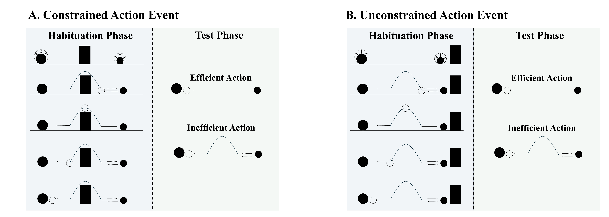
Figure 1. Schematic depiction of a typical constrained and unconstrained action event used in studies assessing action efficiency understanding in infants. In the constrained action event (A), the first object jumps over the barrier before it comes to rest next to the second object; in the unconstrained action event (B), the first object jumps beside the barrier before coming to rest next to the second one. The barrier is removed at test for both events, and infants observe either an efficient straight-path action or an inefficient arced-path action. Data for the first target finding discussed in the text derived from this paradigm.

Several important findings have emerged from the use of this method. Figure 2 provides a visualization of their corresponding paradigms. One is that 9- to 12-month-olds looked longer at inefficient than efficient actions if the first object’s habituation movement was constrained (Figure 1A) but not unconstrained (Figure 1B; Gergely et al., 1995; see also Phillips & Wellman, 2005; Schwier et al., 2006; Sodian et al., 2004; Woodward & Sommerville, 2000). Importantly, the agent did not need to be self-propelled for infants to show this pattern (Figure 2A; e.g., Csibra et al., 1999; Kamewari et al., 2005).

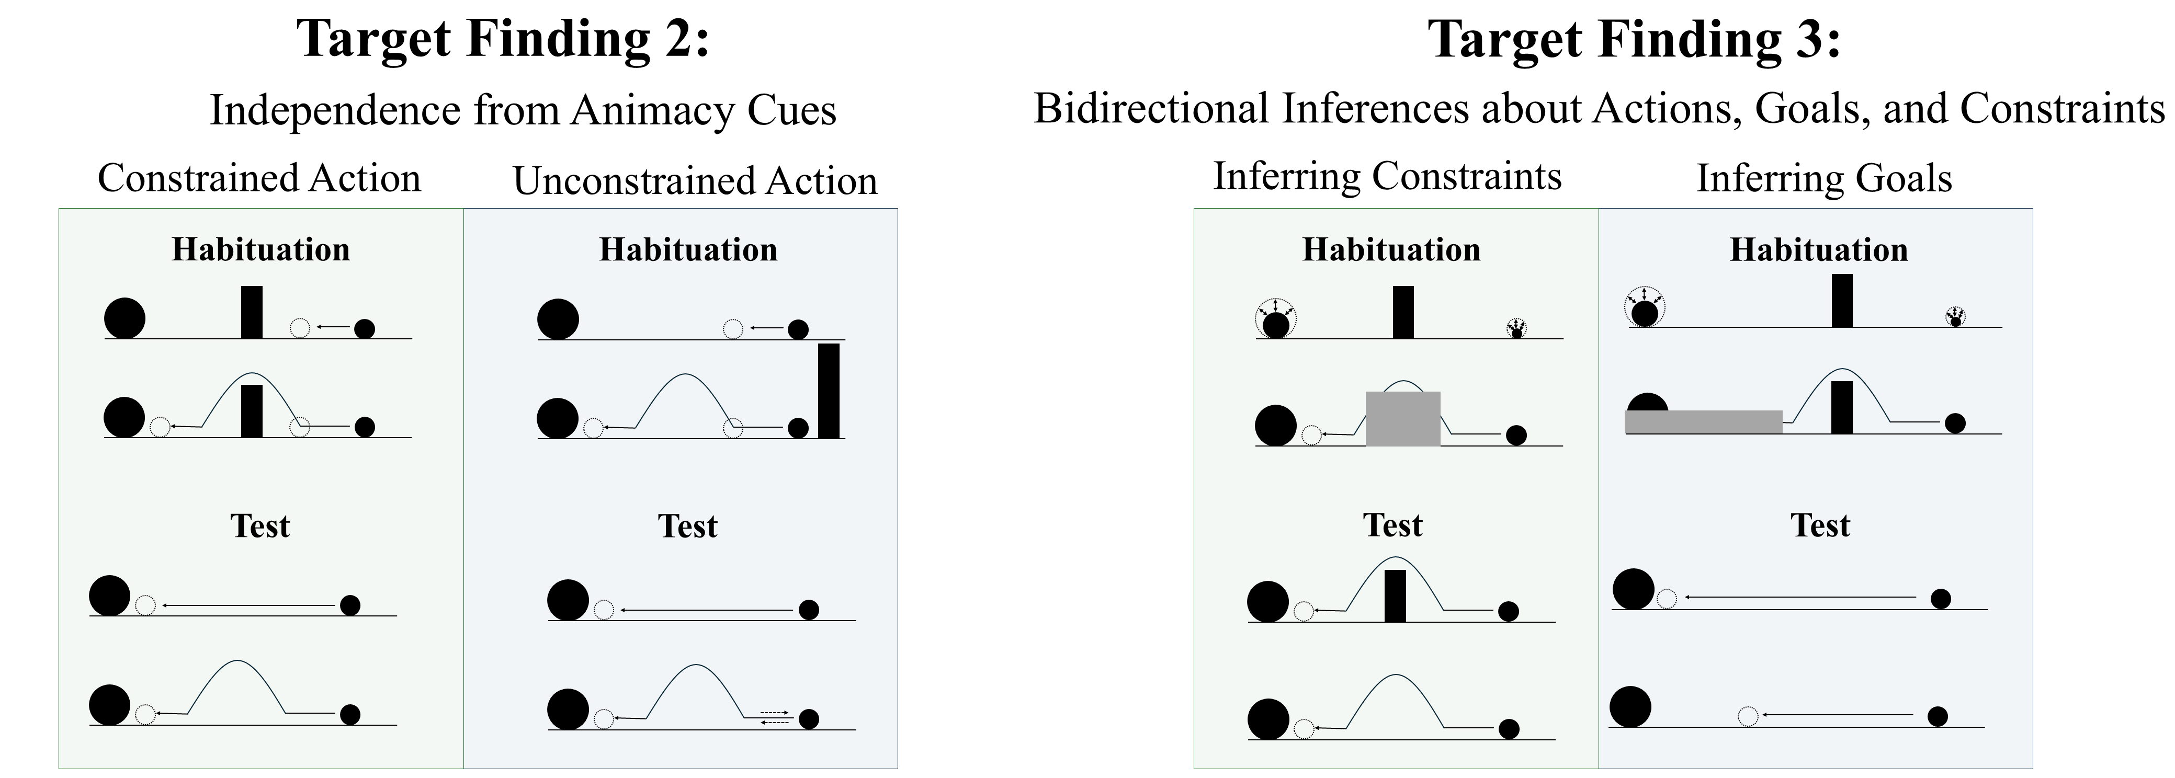
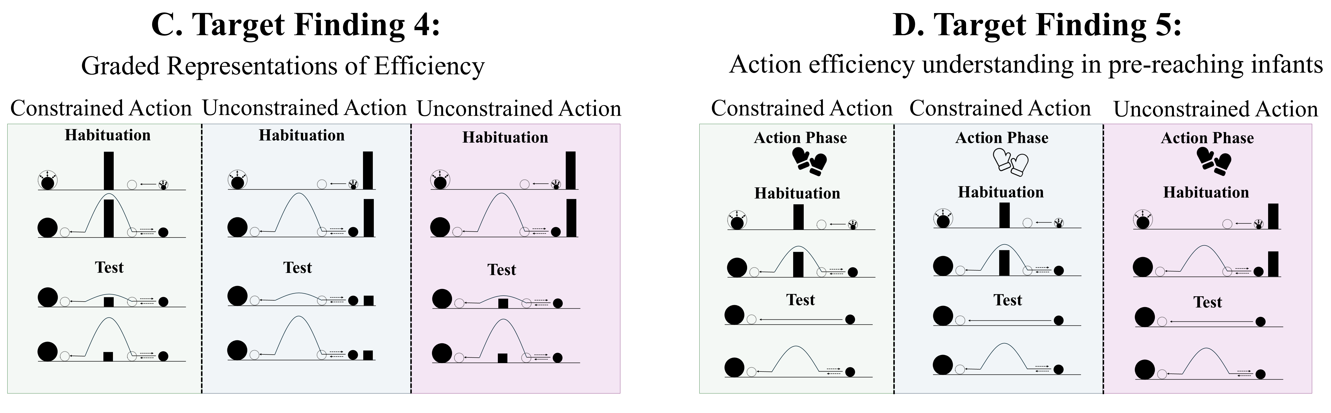
Figure 2. Schematic overview of the paradigms from which Target Findings 2–5 derive. Panels A–D depict, respectively, the experimental paradigms showing (A) the independence of action efficiency understanding from animacy cues, (B) bidirectional inferences about actions, goals, and constraints, (C) graded representations of efficiency, and (D) action efficiency understanding in pre-reaching infants. Note that closed gloves correspond to the sticky-mittens condition, whereas open gloves correspond to the non-sticky-mittens condition. The paradigm underlying Target Finding 1 is shown in Figure 1.

Beyond identifying inefficient actions across different types of entities, previous research suggests that infants can also reason about the relations among actions, goals, and environmental constraints (Figure 2B). For example, Csibra et al. (2003; see also Wagner & Carey, 2005) showed that 12-month-olds can make bidirectional inferences among these factors: they can use information about an agent’s actions and the constraints under which those actions are performed to infer the agent's goal, and they can use information about an agent’s goal and actions to infer the presence of environmental constraints. Infants looked longer at the test events that violated these inferred relations. Finally, infants appear sensitive to graded differences in action efficiency. Liu and Spelke (2017) found that infants looked longer at substantially inefficient than mildly inefficient events, and they generalized these expectations across changes in environmental constraints (Figure 2C).
A final notable finding is that infants with minimal object-manipulation experience show sensitivity to action efficiency when they are given direct action experience (e.g., Skerry et al., 2013; see also Liu et al., 2019). Skerry et al. (2013) showed that providing pre-reaching 3-month-olds with direct-action experience via “sticky mittens” enabled them to distinguish efficient from inefficient actions (Figure 2D); this pattern was absent in infants fitted with non-sticky mittens or given no mittens training whatsoever. Although this research suggests that action efficiency understanding is in place sometime in the second half of the first year of life, an open question that it raises concerns its mechanistic basis.

Rich proposals for the origins of infant action efficiency understanding
Two kinds of proposals have been offered to explain the origins of infant action efficiency understanding. Rich proposals maintain that infants possess early emerging, domain-specific mechanisms that support abstract and conceptually rich knowledge about how the various objects and entities in the world behave and act. For example, the teleological stance (Csibra & Gergely, 1998; Gergely & Csibra, 2003) holds that if an agent pursues some end state efficiently given the physical context—and thus satisfies the “rationality principle”—then the end state will be treated as the agent’s goal, the agent's behavior as a goal-directed “means” to it, and the physical context as a set of “constraints”. The naïve utility calculus casts this in Bayesian terms (Jara-Ettinger et al., 2016, 2020): agents choose minimally costly actions. More recently, Liu et al. (2026) argued that action efficiency understanding emerges from a naïve psychology system (in which agents are represented as goal-directed reward-maximizers) that receives input from a naïve physics system (in which objects are represented as bounded and solid).
These perspectives have real strengths: they address foundational questions at the heart of the developmental cognitive sciences, have generated a substantial body of research, and enjoy some degree of empirical support. Yet, each shares a common limitation: None specify the origins of the relevant primitives. The teleological stance does not explain from where goal, constraint, efficiency, or rationality notions originate. The naïve utility calculus is similarly silent about the basis of such notions as reward, cost, and subjective utility and does not address how the proposed computations are implemented mechanistically. And Liu et al.’s proposal presupposes the very agent and object concept explains (e.g., Benton, 2025).

Lean proposals for the origins of infant action efficiency understanding
Lean proposals instead explain infants’ looking behaviors as the product of domain-general learning over perceptual regularities (e.g., Blumberg & Adolph, 2023; Cohen et al., 2002; Cohen & Oakes, 1993; Colunga & Smith, 2005; Heyes, 2018, 2024; Jones & Smith, 1993; Quinn & Eimas, 1997; Rakison & Lupyan, 2008; Sloutsky, 2010). Although lean proposals abound for a range of cognitive capacities (Benton, 2025; Benton & Hoch, 2026; Benton & Lapan, 2021; Berthiaume et al., 2013; Bogartz et al., 2000; Clearfield & Mix, 1999; Cohen et al., 2002; Cohen & Marks, 2002; McClelland & Thompson, 2007; McMahon & Isik, 2023; Munakata, 1998; Munakata et al., 1997; Perner & Ruffman, 2005; Scarf et al., 2012a, 2012b; Simon, 1997; Rakison & Lupyan, 2008), efforts to explain action efficiency remain scarce.
Van Overwalle (2010; hereafter, VOM10) is an exception to this. He argued that as infants observe agents moving toward their goals, internal representations develop capturing the visible state of the world at points along the trajectory. He showed that a connectionist model implementing this “forward model” reproduced the finding that infants looked longer at inefficient than efficient actions following habituation to constrained motion only.
VOM10 is nevertheless limited in key respects. First, it received no action observation experience prior to the simulated habituation phase and thus could not draw on prior exposure the way findings like that by Csibra et al. (2003) requires. Second, implementing agent and object units meant that the model built in the very concepts lean accounts should explain. Finally, it departed from Gergely et al.’s (1995) study by omitting barrier information from its simulation of the Control condition (Figure 1B) and allowing the curved trajectory to overshoot the barrier.
Given these limitations, I develop and computationally instantiate an alternative lean account that captures the five target findings discussed in the opening. Importantly, this theory, dubbed ALIAS, is not an account of how action efficiency understanding per se develops. It is an account of the mechanistic basis of infants’ looking behaviors in studies on this topic. How genuine action efficiency may develop is described in the General Discussion.

An experienced-based associative learning account of infants’ looking behavior in action efficiency understanding studies

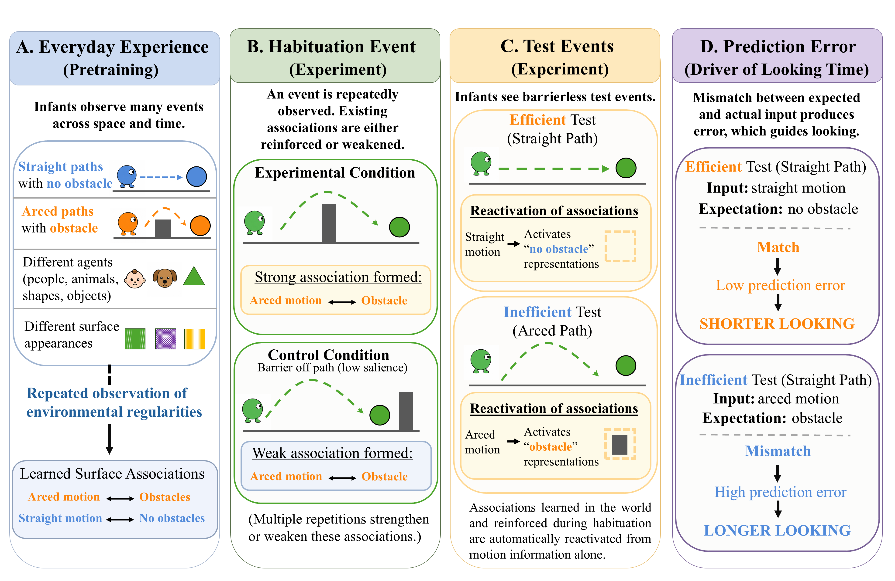
Figure 3. Overview of the account instantiated by ALIAS. (A) In the real world, infants learn associations among action kinematics and visible event features. (B) Habituation either reinforces or weakens these associations, and (C) test events that omit expected features (D) elicit prediction error.

As Figure 3 illustrates, ALIAS’s central thesis is that infants’ looking patterns are governed by learned associations among the kinematics of different actions and the visible surface features of the objects involved and the physical environments in which those actions occur. The critical associations for the present phenomena link obstacles with arced trajectories and absent obstacles with straight motion. Crucially, the resulting representations are entirely perceptually grounded. Nothing in them reflects goals, constraints, efficiency, cost, or rationality.
Habituation events that align with these associations reinforce them; those that do not weaken them. A corollary of this learning process is that test events that present one component of a learned relation should produce greater prediction error than those presenting both components. Greater looking to inefficient actions relative to efficient ones thus arises because inefficient actions violate a learned association between arced trajectories and obstacles.
The effect disappears following unconstrained habituation because the barrier is peripheral to the arced trajectory, making it less salient and less likely to be encoded. If infants nevertheless manage to notice it in this configuration, any new association formed between it and arced motion will tend to weaken the stronger one between arced trajectories and obstacles. In either case, inefficient and efficient actions should be treated equivalently.
This account can also explain why pre-reaching infants show the effect only after direct action experience. Sticky-mittens experience may temporarily heighten infants’ attention to the geometry and trajectory of successful reaches (for evidence consistent with this, see Needham et al., 2002 and Sommerville et al., 2005). Because successful reaches approximate a straight path, sticky-mittens experience should selectively strengthen the association between no obstacles and straight trajectories. The consequence is that efficient actions should produce less prediction error—and thus less looking—than inefficient ones.
The next section opens with a brief discussion of VOM10 and its modified variant, VOM10-2, followed by a discussion of ALIAS and its modified variant, ALIAS-2. To determine whether ALIAS could reproduce the five target findings as well as whether it provided a better account of these findings than any of the competitor models, five simulations are then reported. Two additional simulations are then reported demonstrating that ALIAS does more than capture existing data: It can generate predictions that meaningfully diverge from those of domain-specific accounts and that serve as predictions for how infants would perform in analogous experiments. In all simulations, only the most critical aspects of the corresponding experiments were preserved. Reasonable assumptions were made when methodological details were unavailable. Simulations were run using the Lens neural network simulator (Rohde, 1999). All training, testing, and data files are available for download at https://osf.io/9eqpf/?view_only=62f752417a9141c7b0509a998039ad13.

General Method
Models
VOM10
This model was a one-layer recurrent connectionist model consisting of 27 fully interconnected units—25 of these units implemented a 5 × 5 spatial grid and the remaining two represented an agent and goal object. Training involved presenting action trajectories that unfolded across a series of discrete time step. Figure 4 illustrates such an action sequence. VOM10-2 was identical except that the agent no longer overshot the barrier by one cell (seen in middle cell of the middle row in Figure 4). Additionally, the barrier and goal remained continuously visible throughout the agent’s arced trajectory.

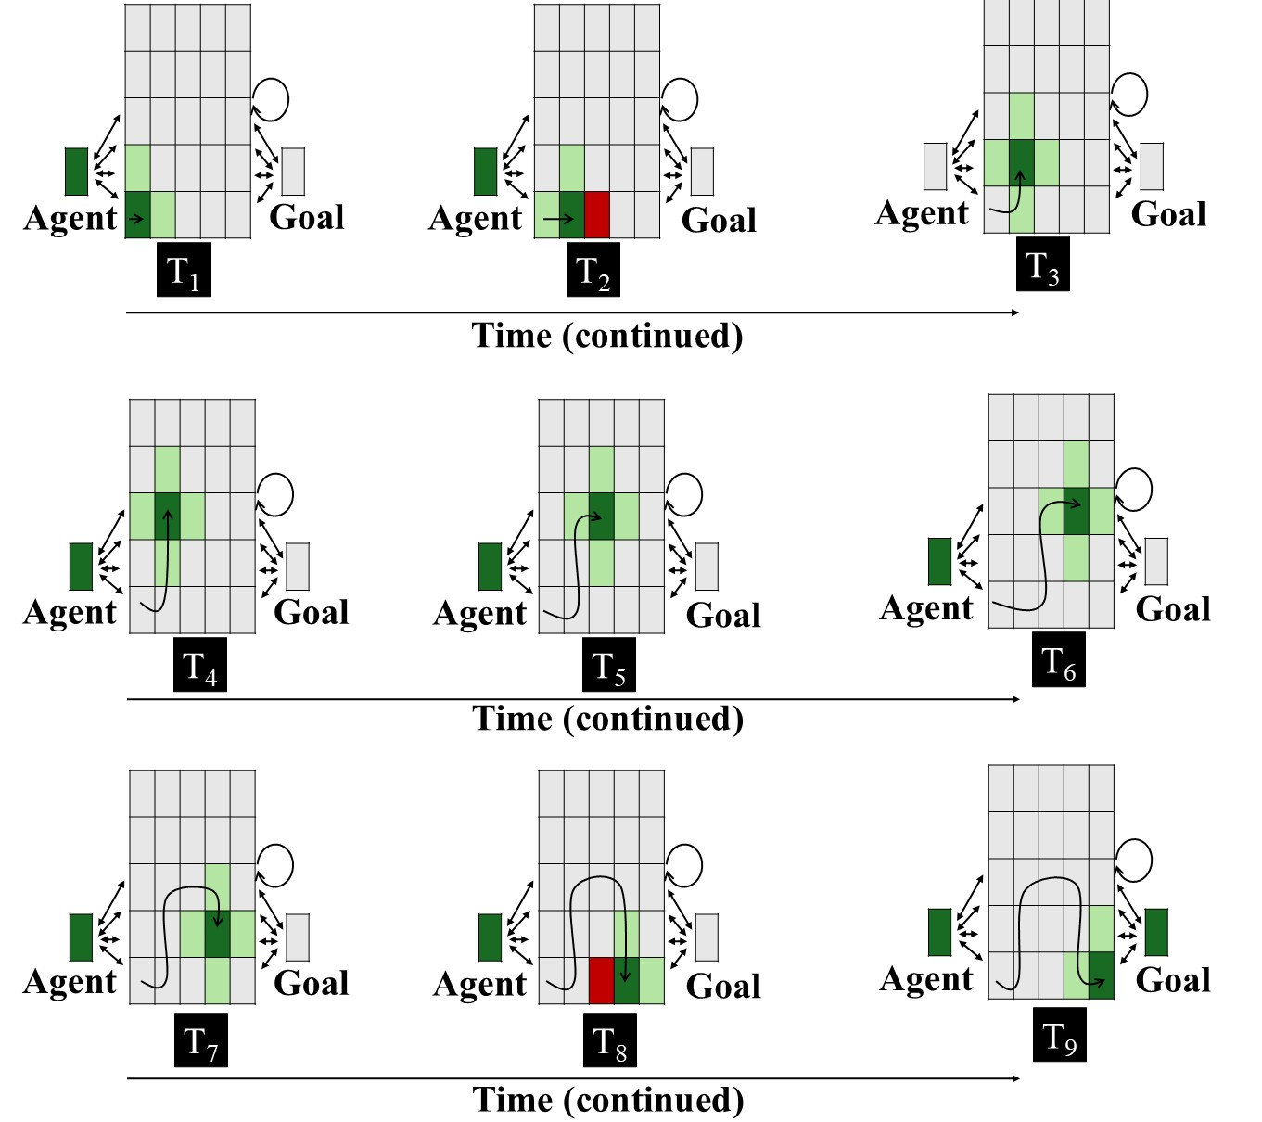
Figure 4. Input patterns shown to VOM10 networks in the Experimental condition across nine steps. Each panel represents the input to the network at a given time step. The central 5 × 5 array corresponds to the spatial grid; the two units flanking the spatial grid to the right and left of it correspond, respectively, to the agent and goal objects. Dark green indicates the agent’s current position (+1), light green indicates adjacent cells (+0.5), red indicates the presence of the barrier (-1), and gray indicates no activation (0). The goal unit is activated only at the final step. The barrier is present only when the agent occupies a position immediately adjacent to it (see Van Overwalle, 2010). The overlaid curved path in each panel depicts the amount of arc motion the agent has completed through that time step. Two-headed arrows and the circular arrow denote bidirectional connectivity. As in Overwalle (2010), the critical units for arced arced were the three units comprising its apex; the bottommost middle cell was the critical unit for the straight path. See the online article for a color version of this figure.

ALIAS
Method
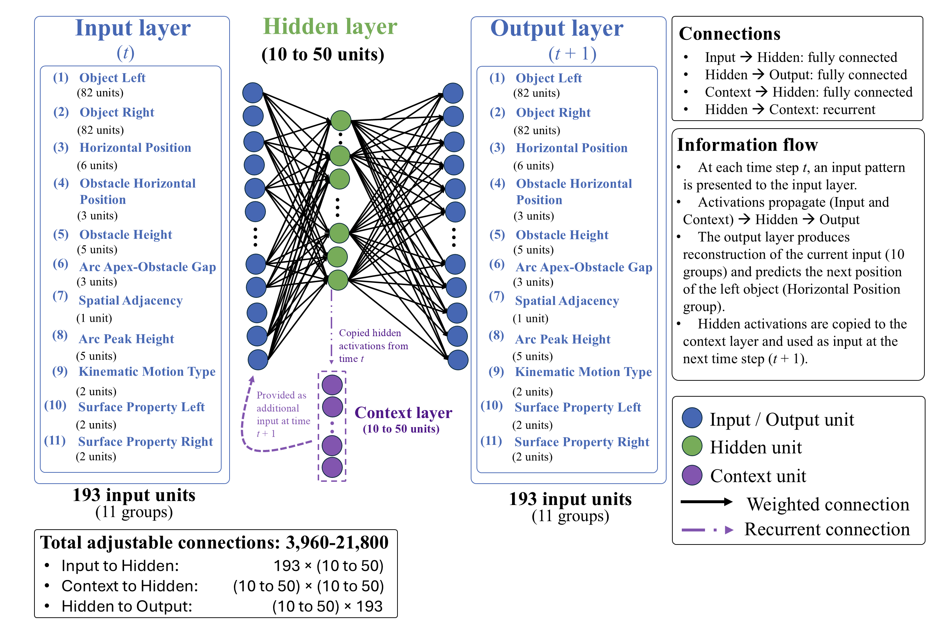
Figure 5. Architecture of the ALIAS model. The model consisted of input, hidden, context, and output layers. Input and output layers consisted of 193 units. The model combined an autoencoder (Groups 1-2 and 4-11) with an SRN (Group 3). The autoencoder copied the input activity to the output layer; the SRN predicted the left object’s next position given its current one.

Network Architecture. Figure 5 shows the model architecture. ALIAS combined an autoencoder with a simple recurrent network (SRN). Autoencoders learn compact internal representations sufficient to reproduce the current input pattern at the output layer. SRNs learn to predict upcoming states from prior states by extracting sequential regularities in the input. The fact that both model types employed self-supervised learning and thus did not require an explicit teaching signal made them appropriate choices for the present simulations.
The model consisted of input and output layers, each consisting of 11 groups. The groups corresponded to different visible surface features (described more below). Between the input and output layers were 10 to 50 hidden and context units; the precise number depended on the simulation. The input and context layers were fully connected to the hidden layer, which in turn was fully connected to the output layer. Weights were initialized to small random values sampled uniformly between ±0.1. Bias connections were not included in any of the simulations.
The activation values of input units were set externally to reflect the input appropriate to the current time step. The activation values for “upstream” units were based on their net input from other units. For example, the net input into a hidden unit was calculated as follows:

${net}_{j}=\sum_{i}{a_{i}w_{ij}}$, | (1)

where $a_{i}$ is the activation of unit i and $w_{ij}$is the weight on the connection from input unit i to hidden unit j. Hidden unit activations were based on the rectified linear unit activation function (Nair & Hinton, 2010) and were calculated as follows:

$a_{j}=max⁡(0, {net}_{j})$, | (2)

where $a_{j}$ is the activation of hidden unit j, ${net}_{j}$ is its net input, and $max$ denotes the maximum of its two arguments. Output unit activations were a smooth, logistic function of this net input and was calculated as follows:

$a_{k}=\frac{1}{1+exp⁡(-{net}_{k})}$, | (4)

where $a_{k}$ is activation of output unit k, ${net}_{k}$ is its net input, $w_{jk}$ is the weight on the connection from hidden unit j to output unit k, and $exp⁡(∙)$ is the exponential function. Finally, as is true in simple recurrent networks (SRNs; Elman, 1990), the activation of the hidden units at time $t$ was copied to the context units and made available as input at time$t+1$. This provided the model with a rudimentary form of memory such that information from earlier time steps could influence processing at later ones.
Representations and Task. At each time step, a linear or arced motion event was presented to the network as a pattern of activation distributed across the 11 input and output groups (Figure 5). The units within each group corresponded to different manifestations of a surface feature. Localist coding was used because it ensured that the model’s responses reflected learned regularities among actions and the visible surface features of the objects and entities involved and facilitated interpretation of the mechanism producing those responses. Table 1 lists each group and the features represented by each unit within it. The naming convention used for each group was intended to emphasize their semantically neutral, surface-based nature.

Table 1
ALIAS’s input and output groups
Group | Num | Represents | Unit Meaning
Object Left | 82 | Identity of left object | Each unit corresponds to a unique object identity
Object Right | 82 | Identity of right object | Each unit corresponds to a unique object identity
Horizontal Position | 6 | Left object’s position relative to the right one | Position 1–6 in network space
Obstacle Horizontal Position | 3 | Horizontal location of obstacle | Missing, Middle, Periphery
Obstacle Height | 5 | Height of obstacle | No Obstacle, Heights 1–4
Arc Apex–Obstacle Gap | 3 | Vertical distance between an obstacle and the apex of the arced motion trajectory | No Separation, Small Vertical Separation, Large Vertical Separation
Spatial Adjacency | 1 | Whether the two objects are adjacent | Spatially Contiguous, Spatially Separated
Arc Peak Height | 5 | Maximum height of arced trajectory | No arc, Heights 1–4
Kinematic Motion Type | 2 | Type of motion | Linear, Arced
Surface Property Left | 2 | Surface features of left object | Animate-like, Inanimate-like
Surface Property Right | 2 | Surface features of right object | Animate-like, Inanimate-like
Note. Group names correspond to those shown in Figure 5. Each group represented a different visible surface feature; units within a group represented different manifestations of that feature. A localist encoding scheme was adopted for each group.

Input units corresponding to active (i.e., present) features during a given time step of an action event had activations of 1.0; all other input units had activations of 0.0. A small amount of Gaussian noise (M = 0, SD = 0.3) was then applied to these activations to instantiate the notion that learning and processing in infants is noisy. The network’s task at each time step was twofold. First, it was required to reproduce at the output layer the activation pattern presented across 10 of the 11 input groups. Second, it was required to predict that the position to the immediate right of the current position in the Horizontal Position input group would be active in the corresponding output group at the immediate next step. Thus, if the first unit in the Horizontal Position group was active at time $t$, the network’s task was to predict that the second unit in the corresponding output group would be active at time $t+1$. This captured the fact that motion is dynamic and necessarily unfolds over time. Movement trajectory (e.g., linear or arced) itself was captured by the Kinematic Motion Type group. The copying task was carried out by the autoencoder (e.g., Mareschal et al., 2000); the prediction task, by the SRN.
Training procedure. Learning unfolded across two phases. During pretraining, networks experienced two broad classes of events: Linear Path Events and Arced Path Events. These events—illustrated in Table 2—implemented the assumption that looking in action efficiency understanding studies is shaped by prior experience with these actions. In Linear Path Events, one object moved unobstructed along a straight, horizontal trajectory toward another object. In Arced Path Events, one object moved over a short barrier along an arced trajectory toward the other object. Half of the objects in both event types possessed surface features typical of animate entities; the remaining half possessed surface features typical of inanimate objects. Although the exact nature of habituation depended on the simulation, networks were generally experienced an Arced Path event. Novel objects and differently sized barriers were used to assess generalization beyond the pretraining stimuli.

Table 2
Example encodings of linear and arced motion events
Group | Linear Path Event | Arced Path Event
Object Left | Unit 1 | Unit 1
Object Right | Unit 2 | Unit 2
Horizontal Position | Position 1 | Position 1
Obstacle Horizontal Position | Missing | Middle
Obstacle Height | No Obstacle | Height 2
Arc Apex–Obstacle Gap | No Separation | Small Vertical Separation
Spatial Adjacency | Spatially Contiguous | Spatially Contiguous
Arc Peak Height | No Arc | Height 2
Kinematic Motion Type | Linear | Arced
Surface Property Left | Animate-like | Animate-like
Surface Property Right | Animate-like | Animate-like
Note. Values are illustrative of each event type at a single time step. Cell entries identify the units whose states were clamped during that time step. Bolded text reflects features on which the two event types differed.
During each time step of both phases, an action event was presented by clamping the states of the units corresponding to that event’s surface features. Activity then propagated from the input layer to the hidden layer and then from the hidden layer to the output layer. The resulting pattern of activity over the output units represented the network’s attempt at reproducing the input activity and predicting an object’s next position. To minimize the target and output patterns after a full pass through the training patterns, connection weights were modified via a version of recurrent backpropagation through time adapted to the simple recurrent network architecture (Williams & Zipser, 1995). Cross-entropy was the error measure:

$$C=-\sum_{p}{\sum_{t}{\sum_{k}{t_{k,t}^{p}}\log_{2}(a_{k,t}^{p}})+(1-t_{k,t}^{p})\log_{2}(1-a_{k,t}^{p})}$$ | (5)

where $t_{k,t}^{p}$ is the target activation of output unit k in training pattern p at time t, $a_{k,t}^{p}$ is the observed activation of that unit, and the summation is computed across all output units, time steps, and training patterns. Weight changes were then calculated as follows:

$∆w_{ij}=-$η$(\frac{∂C}{∂w_{ij}})$ | (6)

where η is the learning rate and $\frac{∂C}{∂w_{ij}}$ is the function’s derivative with respect to weight $w_{ij}$.
Testing procedure. At test, network weights were frozen to simulate no further learning. The specific testing procedure depended on the simulation but generally involved presenting two action events: one consistent with prior experience and one inconsistent with that experience.
Salience manipulation. The assumption that peripherally located obstacles have lower salience relative to centrally located ones was implemented by decreasing the learning rate and increasing the weight decay on the incoming and outgoing weights associated with the Obstacle Height and Obstacle Position groups. The learning rate value—which importantly was distinct from that used to simulate developmental age (see below)—was 1×10⁻⁴; the weight decay value was 0.1. As mentioned above, this manipulation did not apply to ALIAS-2. These values were kept constant across all simulations. This way of implementing salience aligns with past connectionist modeling work (e.g., Benton, 2025). Additional simulations—reported in the Supplementary Materials—showed that the current findings were robust across a range of values for these different parameters. The assumption that arced trajectories clear obstacles by small margins was implemented by clamping the state of the Small Vertical Separation unit for constrained action events during pretraining.

Common Simulation Procedures
Participants. In all simulations, “participants” corresponded to independent model runs, each with different initial random weights. Each condition consisted of 20 participants.
Developmental age. Networks corresponding to “older” infants received proportionally more pretraining than those corresponding to “younger” infants. Thus, the pretraining phase was 900 epochs for simulations whose target findings derived from studies testing 12-month-olds; for simulations testing 9-, 6-, and 3-month-olds, respectively, it was 675, 450, and 225. Additionally, older networks possessed larger learning rates and more hidden units than younger ones. These were 0.1 and 50, respectively, for the 12-month-old networks, 0.0875 and 40 for the 9-month-olds, 0.0875 and 30 for the 6-month-olds, and 0.01 and 10 for the 3-month-olds. Larger learning rates reflect more rapid learning; more hidden units support enhanced information storage.
Simulation structure. All simulations followed the same general structure: (1) pretraining, (2) habituation, and (3) test. Unless otherwise noted, test trials contrasted barrierless straight- and curved- path events. Throughout the simulations, the former were referred to as Efficient test events; the latter, as Inefficient events.
Dependent measures. For ALIAS and ALIAS-2, the dependent measure was network cross-entropy error. Here greater error was treated as longer looking. This interpretation is consistent with that made in prior developmental models (e.g., Benton, 2025; Mareschal et al., 2000; Quinn & Johnson, 2000; Rakison & Lupyan, 2008).
For VOM10 and VOM10-2, the dependent measure was activation of the critical units; lower activation corresponded to longer looking, as in Overwalle (2010).
Habituation length and stimuli. For ALIAS and ALIAS-2, habituation lasted between 8 and 12 epochs, in increments of one. Different numbers were used to ensure that results were robust to variation in this parameter. Results are shown both collapsed across habituation length and separately for each habituation duration.
Evaluation of Model Performance. Inferential statistics were not used because the goal of the present simulations was not quantitatively to fit infant looking responses or reproduce the precise magnitude of empirical effects. Instead, the goal was to determine whether the qualitative pattern of model responses aligned with those observed in infants. This approach has precedence in prior connectionist modeling work (e.g., Benton, 2024; Mareschal et al., 2000; Mareschal & Schultz, 1999; McClelland & Thompson, 2007; Plaut & Vande Velde, 2017).

Simulation 1a: Selective longer looking to inefficient actions.
Simulation 1a modeled the first target finding: Infants look longer at a barrierless curved test event than at a barrierless straight-path event following habituation to a constrained event. Networks were 12 months old and were assigned either to the Experimental or Control condition. The objects used during habituation possessed animate-typical features.

Results and Discussion
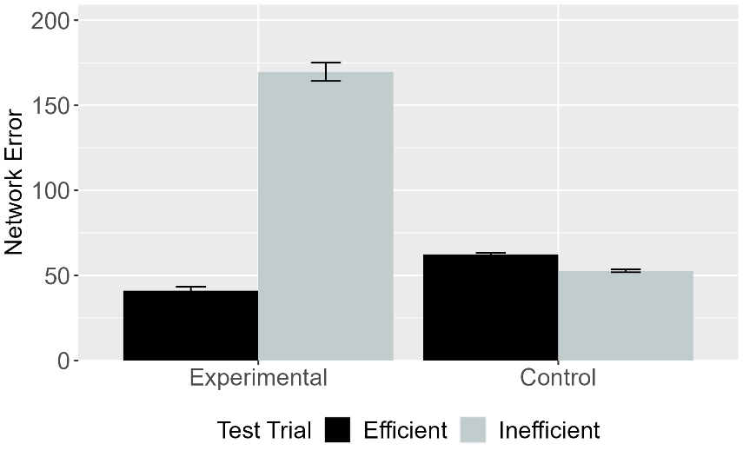 | 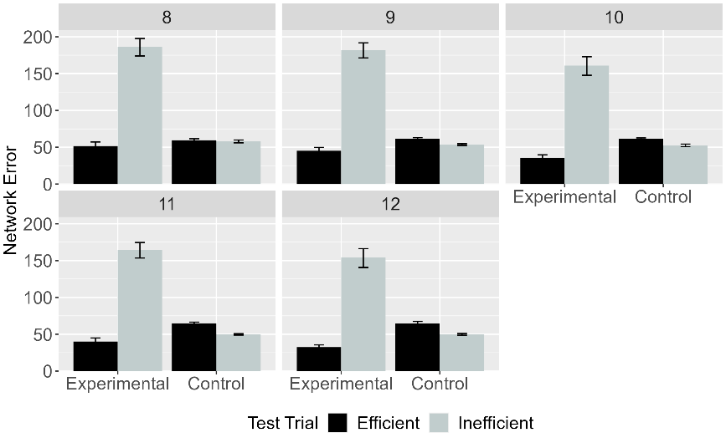
Figure 6. Mean network error produced to the Efficient and Inefficient test events in the Experimental and Control conditions. (Left) Network error collapsed across habituation lengths. (Right) Error as a function of habituation length. Data shown were generated by ALIAS.

Figure 6 shows ALIAS’s responses across the conditions. Networks in the Experimental condition produced greater error to the Inefficient test event than to the Efficient one in the Experimental condition. In contrast, networks in the Control condition produced equivalent error to both test events. ALIAS thus reproduced the first target finding.

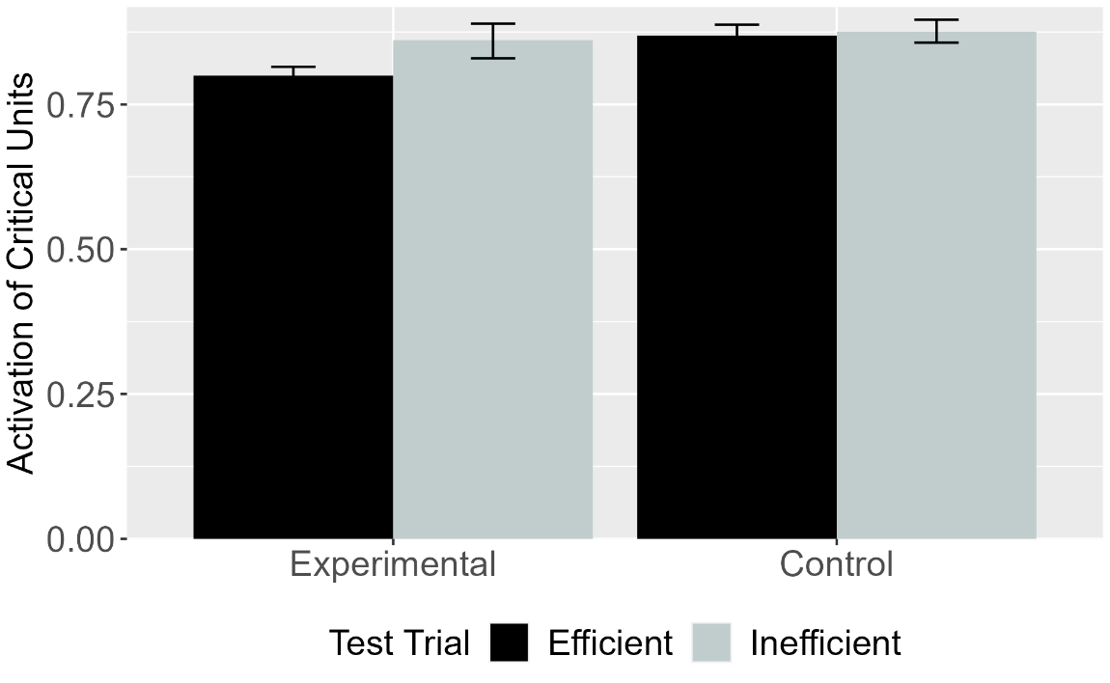
Figure 7. Mean activation of the critical units for Efficient and Inefficient test events in the Experimental and Control conditions for VOM10. Error bars represent standard errors.

Figure 7 shows that—like ALIAS—VOM10’s critical units were more active during the Inefficient than the Efficient test event in the Experimental condition; these units were equivalently active in the Control condition. Although VOM10 also reproduced the first target finding, comparing its responses to those of ALIAS reveals that the effect was smaller for VOM10 than for ALIAS.

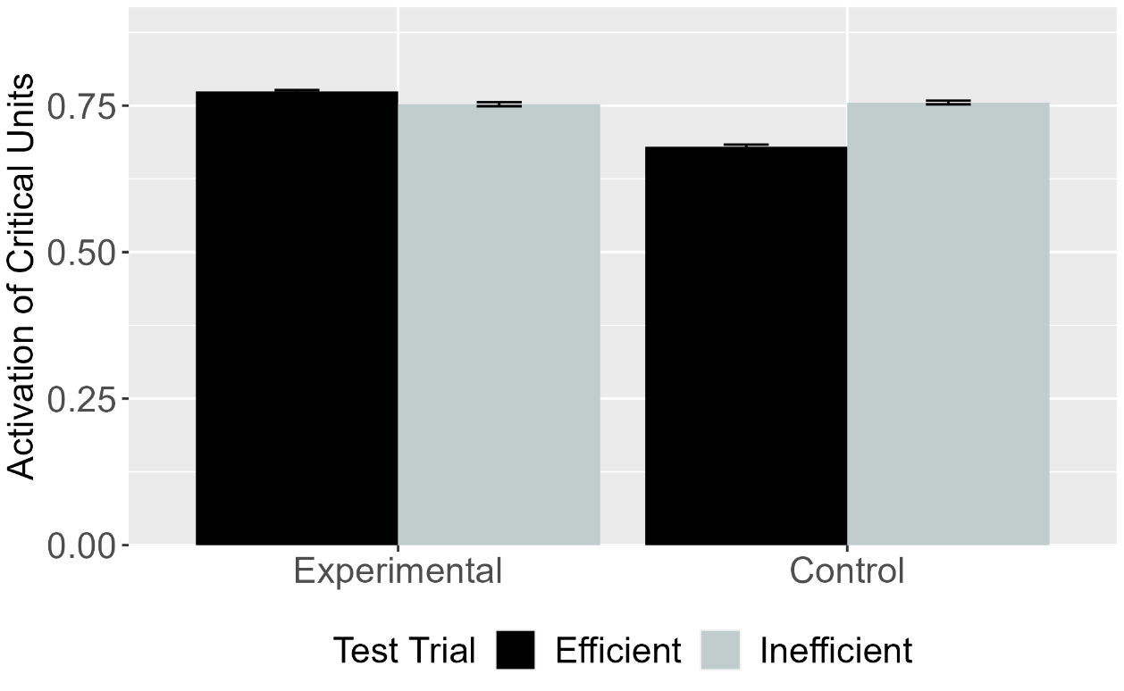
Figure 8. Mean activation of the critical units for Efficient and Inefficient test events in the Experimental and Control conditions for VOM10-2. Error bars represent standard errors.

To determine whether VOM10’s success depended on specific implementational details, its performance was compared to VOM10-2. Figure 8 shows that, in contrast to VOM10, VOM10-2’s critical units were more active during the Efficient than the Inefficient test event in the Control condition. These units showed equivalent activation in the Experimental condition. Thus, VOM10-2 failed to capture the first finding.

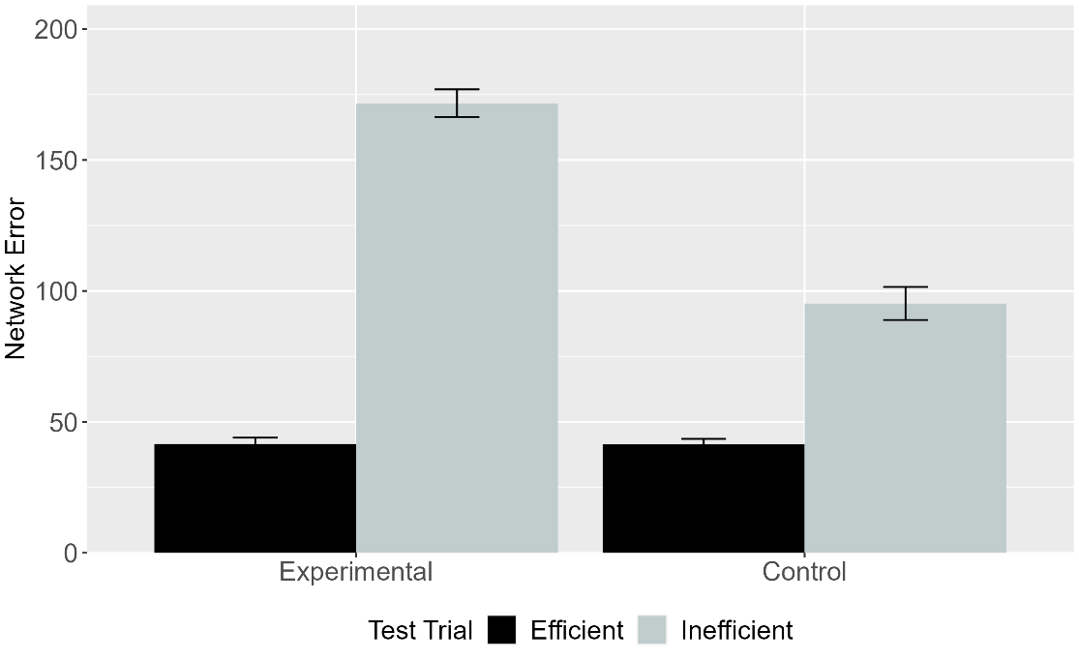
Figure 9. Mean network error produced to the Efficient and Inefficient test events in the Experimental and Control conditions. Data shown were generated by ALIAS-2. Error bars represent standard errors.

The final analysis focused on ALIAS-2’s responses. Figure 9 shows that networks in both conditions produced greater error to the Inefficient than to the Efficient event, although the effect was weaker in the Control than in the Experimental condition. Thus, ALIAS-2 partially replicates the first finding.
ALIAS’s—and to a lesser extent, ALIAS-2’s—ability to capture the first target finding suggests that it is premature to use this finding to conclude that infants’ sensitivity to action efficiency stems from specialized mechanisms supporting rich notions of agents, goals, constraints, cost, and efficiency. Instead, these findings demonstrate that an associative learning mechanism is sufficient to reproduce this pattern of behavior. Nevertheless, it was important to provide independent evidence that associative learning was responsible for ALIAS’s success. This can be achieved by tracing the model’s internal dynamics at various points throughout processing. Note that the mechanism described below is typical of most model runs, although the discussion focuses on just one run.
As described above, such processing began during the pretraining phase, in which networks were exposed repeatedly to events in which agents move along either straight or curved trajectories to reach other objects or agents. This pattern of activation is then propagated to the hidden layer via the weights between them. Because the network weights are small, random values at the beginning of training, this pattern of activity does not reflect anything meaningful about the input to the model. This hidden activity nevertheless propagates to, and elicits a corresponding pattern of activity over, the output groups in the output layer via the weights connecting them. This pattern of activation is then compared to the target pattern of activation, and any discrepancy between the two is treated as error. The network then uses this error to adjust the weights throughout the network.
Crucially, from the outset of the pretraining phase, linear and arced motion events produce distinct error patterns over the output groups because they activate different perceptual features. A corollary of these disparate error signals is that both action events cause the weights throughout the network to move in different directions. The accumulated weight changes create distinct hidden representations for linear and arced motion. As these weight changes accumulate, meaningfully distinct hidden representations begin to emerge for both types of motion and their corresponding statistical regularities. As is described more below, test responses then arise, at least in part, because presenting part of a feature bundle reactivates the remaining features.
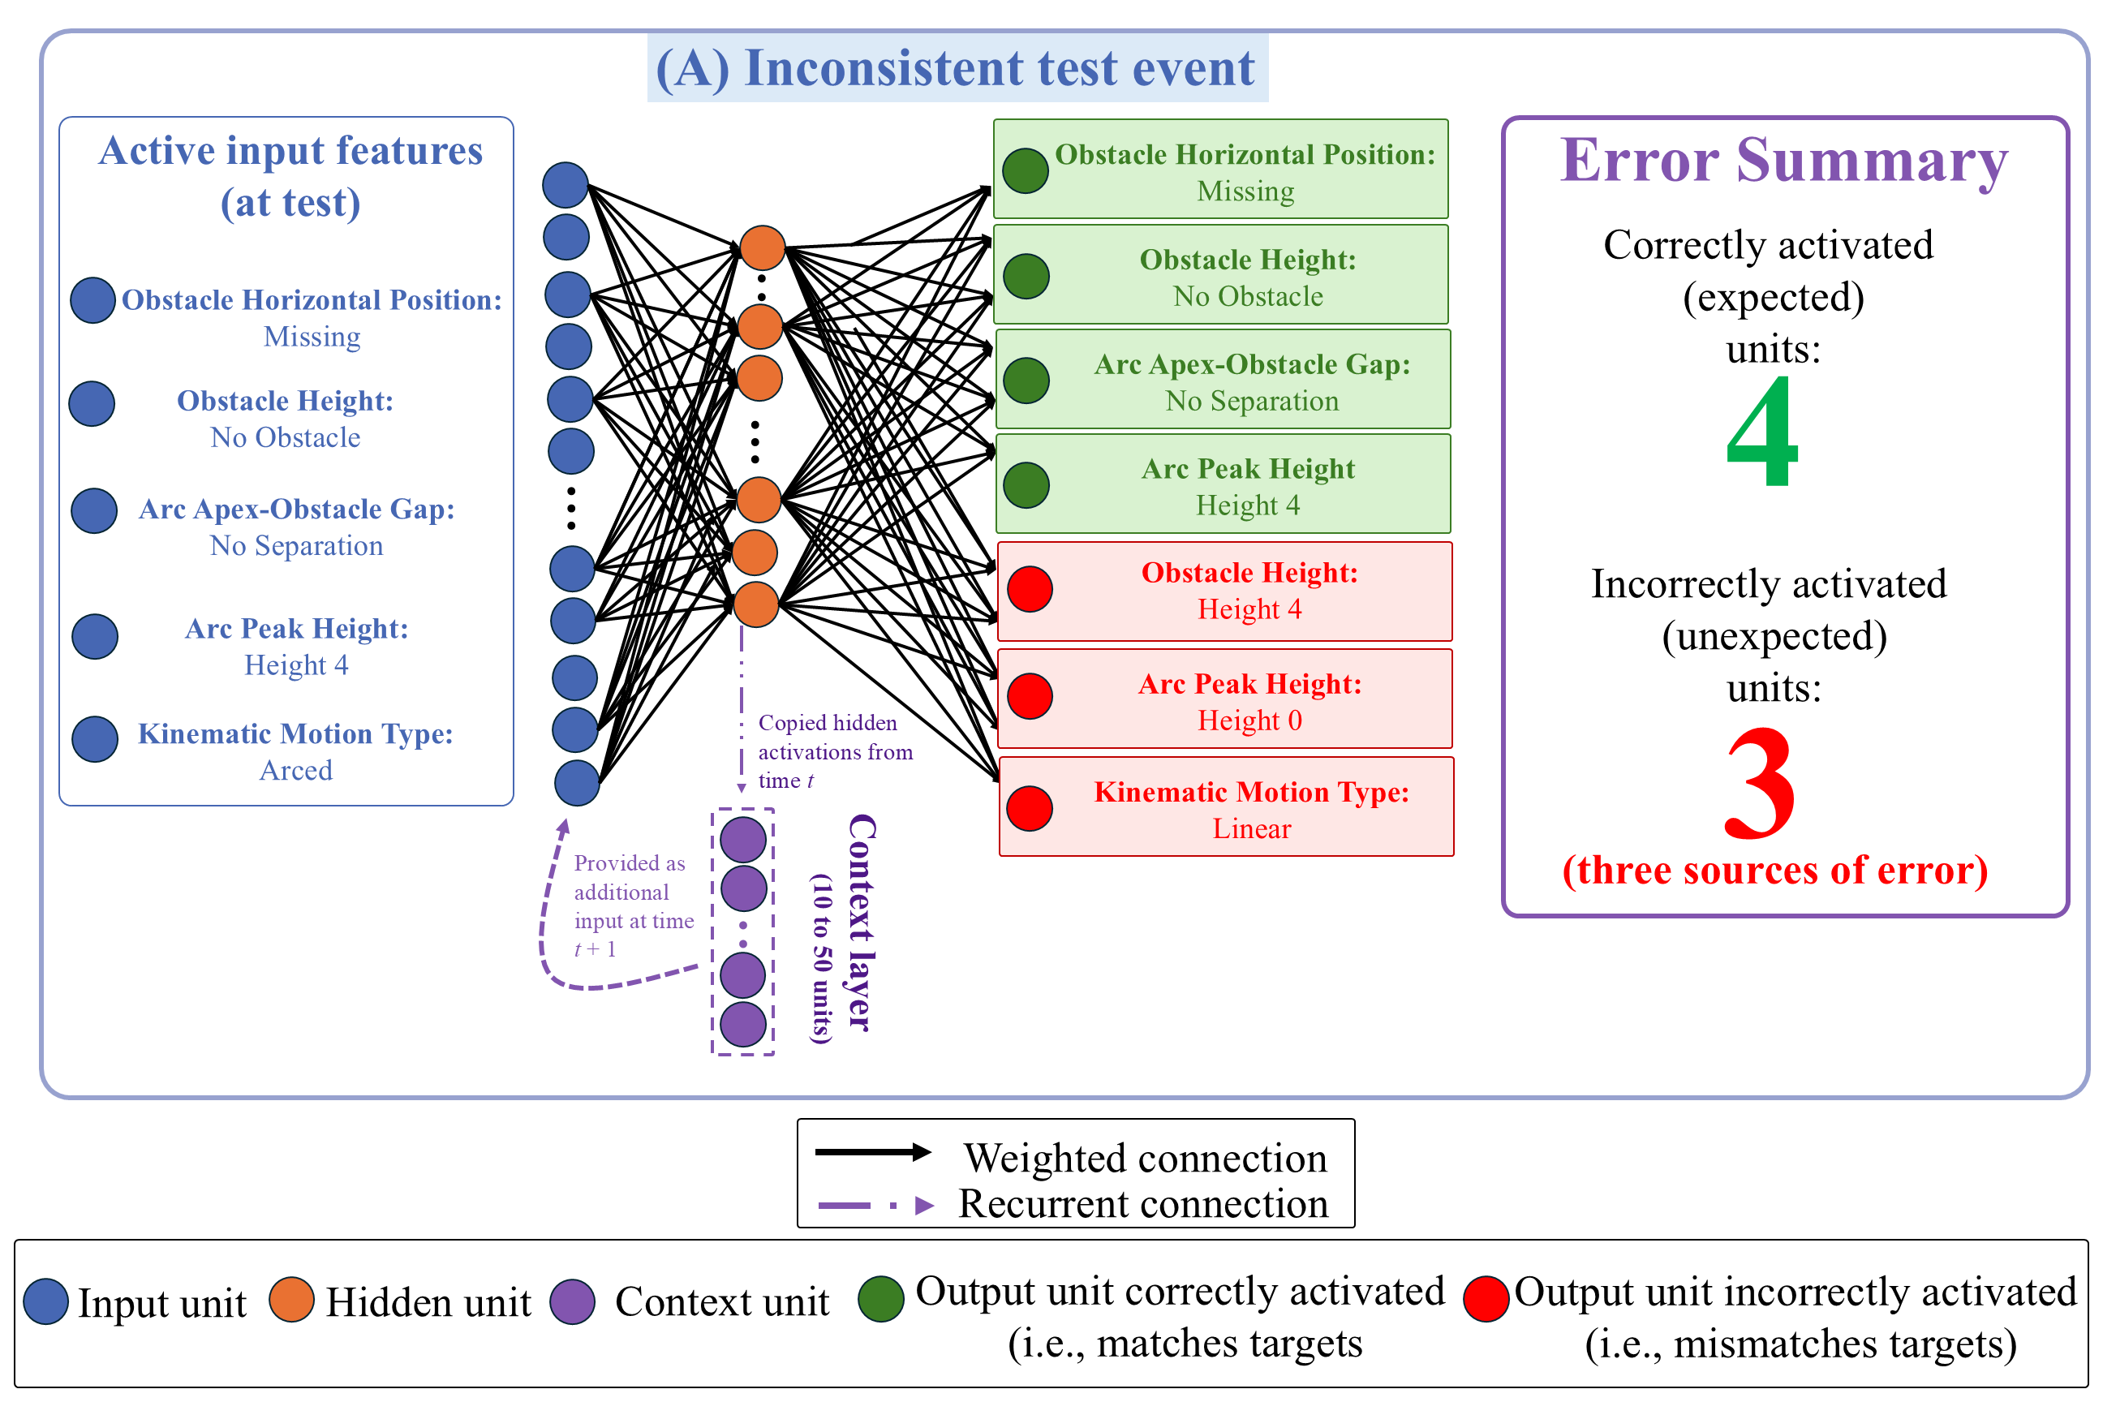
Figure 10. Mechanism underpinning ALIAS’s responses during the Inconsistent test event in the Experimental condition. Active input features presented at test reactivated learned associations acquired during pretraining and habituation. Although the network correctly activated four of those features, it also incorrectly activated the Obstacle Height 4, Arc Peak Height 0, and Linear Motion units. These three erroneously activated units constituted the primary sources of error and looking during this event. Shown here: Units necessary to explain the basis of ALIAS’s responses during the Inconsistent test event. This results pattern was typical of most model runs.

At the conclusion of the pretraining phase, networks entered the habituation phase. For those in the Experimental condition, four of the input features were familiar (i.e., Obstacle Horizontal Position Middle, Arc Apex-Obstacle Gap minimal separation, Spatially Contiguous, and Arc Path). These features activated at the output layer—via the hidden layer—the features they co-occurred with during the pretraining phase. By contrast, because the remaining two features were novel (i.e., Obstacle Height 4 and Arc Peak Height 4), new associations had to be formed between them. Although habituation was much shorter than the pretraining phase, networks’ enhanced processing as “12-month-olds” enabled them to form these associations and preserve old ones.

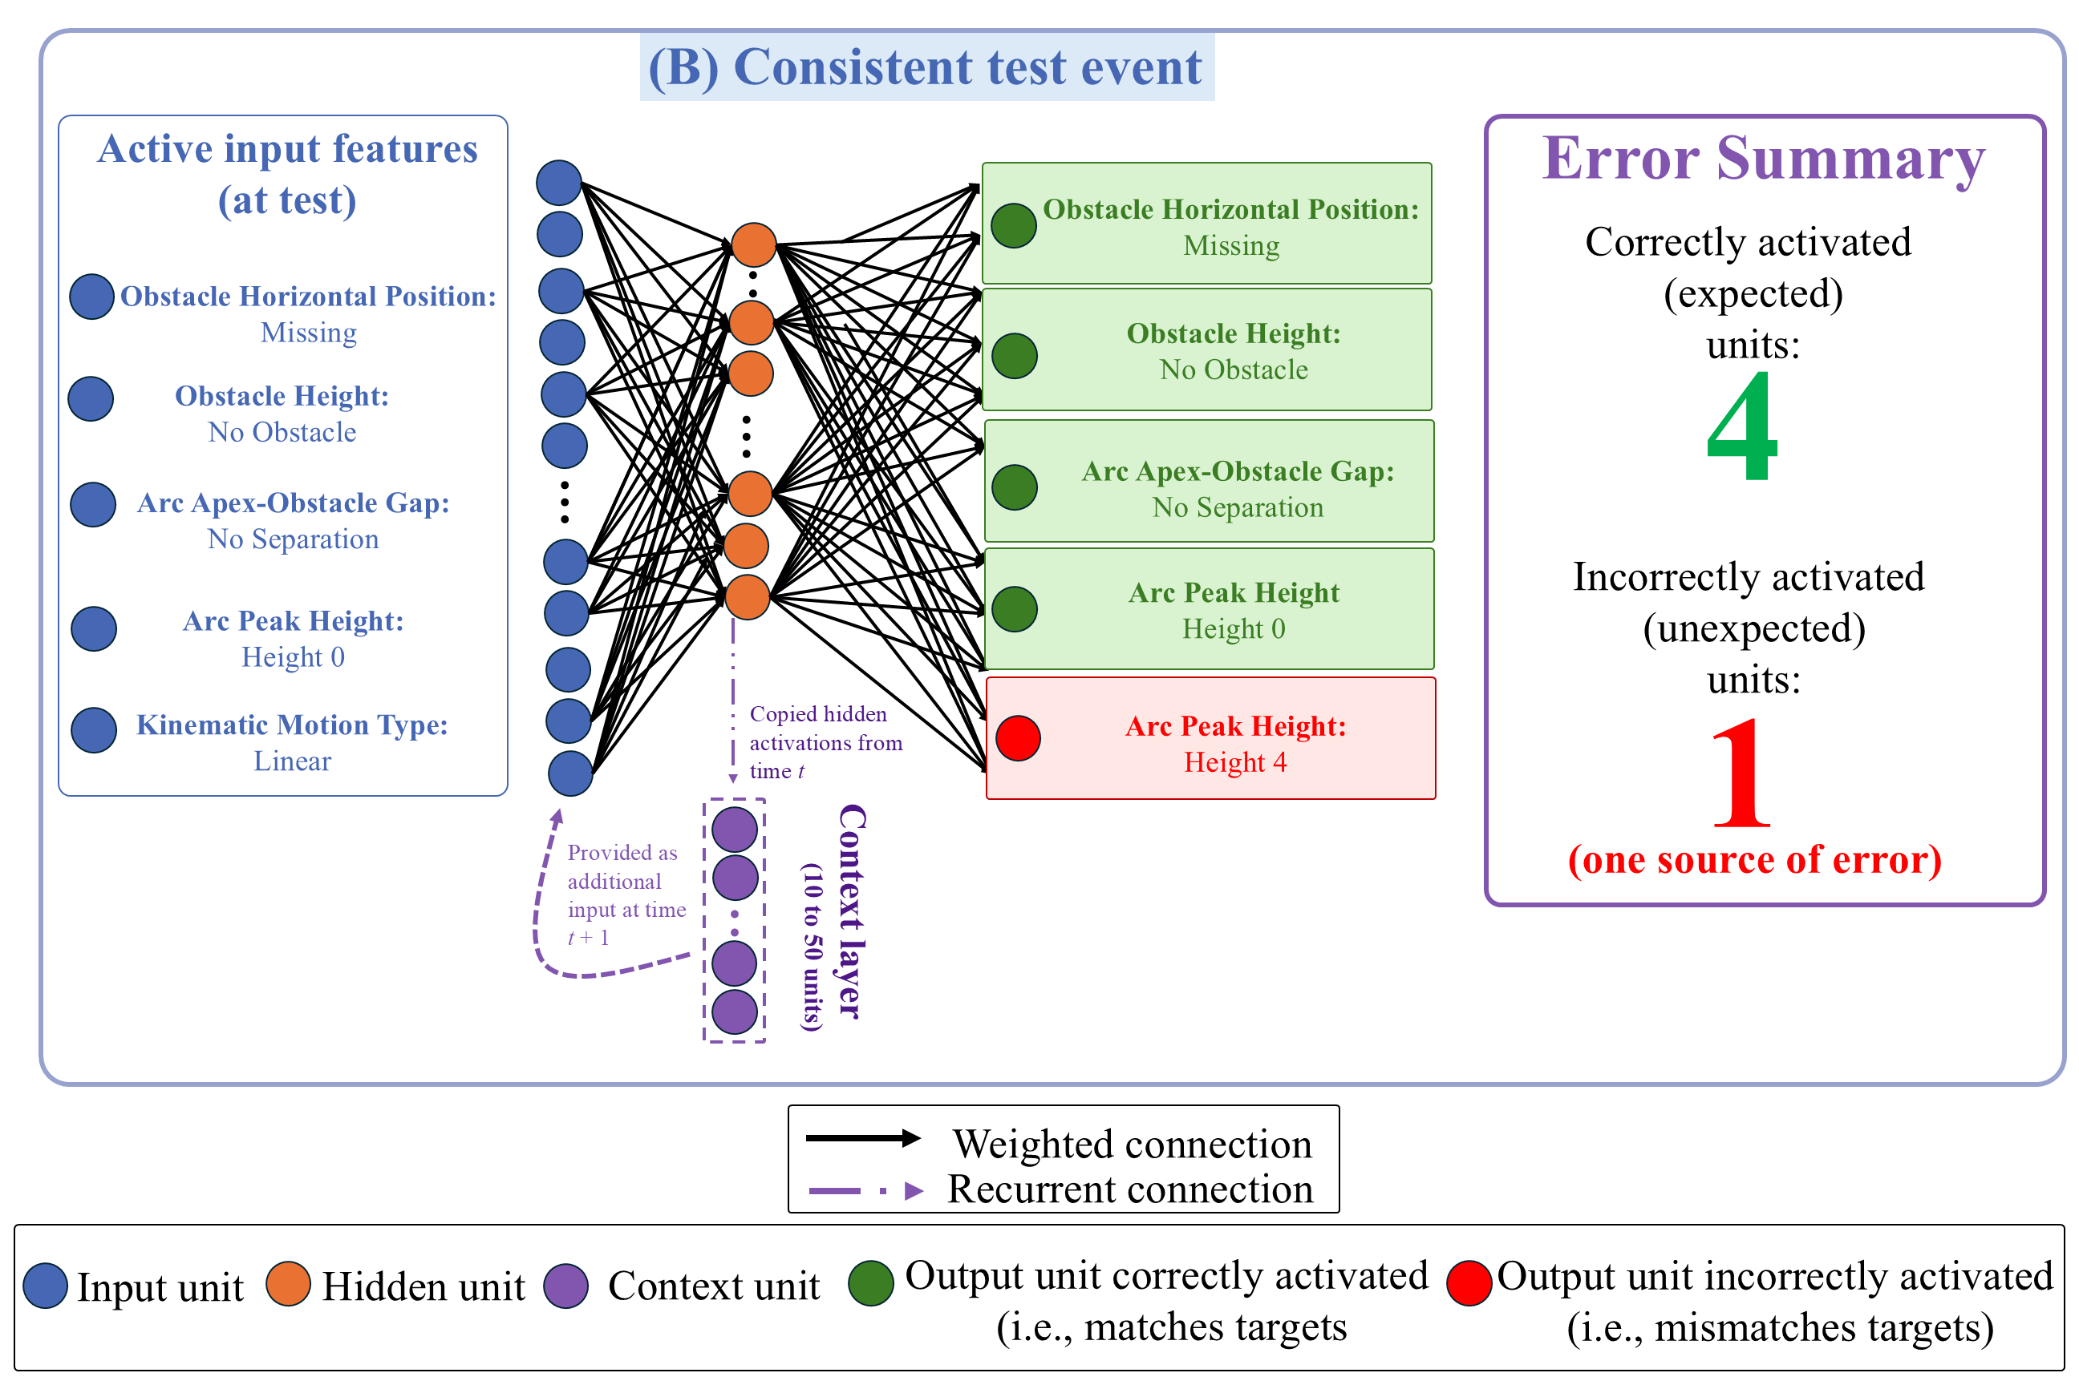
Figure 11. Mechanism underpinning ALIAS’s responses during the Consistent test event in the Experimental condition. Active input features reactivated many of the same learned associations observed in the Inconsistent event. However, here only the Arc Peak Height 4 output unit was incorrectly activated. This one erroneously activated unit constituted the primary source of error and looking during this event. Shown here: Units necessary to explain the basis of ALIAS’s responses during the Inconsistent test event.

Networks' test responses can be understood as a consequence of learning and processing during these two phases. As shown in Figure 10, presentation of the input features associated with the Inefficient test event caused four features to be correctly activated and three to be incorrectly activated at the output layer. The first three features were correctly activated due to associations formed among them during pretraining; the last (i.e., Arc Peak Height 4) was activated due to associations formed with itself during habituation. Two of the incorrect features (i.e., Arc Peak Height 0 and Kinematic Motion Type Linear) were activated because of their association during pretraining. The last was activated because Obstacle Height 4 was associated with Arc Peak Height 4 and itself during habituation.
For the Consistent test event, presentation of its input features caused four features to be correctly activated and one feature to be incorrectly activated. The four features were activated due to their association during pretraining. The last feature was activated because it was associated with some of this event’s input features (not pictured in Figure 11) during habituation. The fact that two fewer units contributed to prediction error in the Consistent test event meant that networks spent less time looking at it than at the Inconsistent one.
The same associative principles extend to the Control condition. The reduced salience of peripherally located obstacles in this condition meant that the weights connecting the Obstacle Height 4 and Periphery units to the other co-occurring features during habituation could not be adjusted sufficiently during this brief phase. In contrast, because features such as Arc Peak Height 4 were not subjected to the same salience manipulation, robust associations were able to be formed among these features. Thus, presentation of the features associated with Arc Peak Height 4 during habituation caused this unit to activate at the output layer. This was the correct response in the Inconsistent test event but the incorrect response in the Consistent test event. Thus, there was one large contributor to error in the Consistent test event. By comparison, the Inconsistent event tended to have two smaller contributors to error: the Linear Path and Arc Peak Height 0 units. These units were activated because they were linked to some of this event’s input features (e.g., Obstacle Height 0, Obstacle Horizontal Position Missing, etc.) during pretraining. Importantly, the combined contribution of these two units to the network’s total error in the Inconsistent event matched the sole contributor to error in the Consistent test event. As a result, the network, like infants, looked about equally long at both test events.
Although ALIAS replicated the first target finding, it could nevertheless be argued that its success is undermined by the fact that the network never experienced unconstrained motion during pretraining. By comparison, it seems likely that infants experience some amount of unconstrained motion in the real world, even if in absolute terms this amount is less than that of constrained motion. To address this potential limitation, Simulation 1b was carried out to evaluate the extent to which ALIAS’s initial success depended on no prior experience with unconstrained motion.

Simulation 1b
This simulation was identical to Simulation 1a with one major exception: the ratio of this motion to arced motion was varied during pretraining. The ratios were ranged from 100% vs. 0% to 50% constrained vs. 50% unconstrained, in 10% increments. For each ratio, the first number represented proportion of constrained motion; the second number represented the proportion of unconstrained motion. ALIAS’s performance was not compared to the competitor models in this simulation.

Results and Discussion
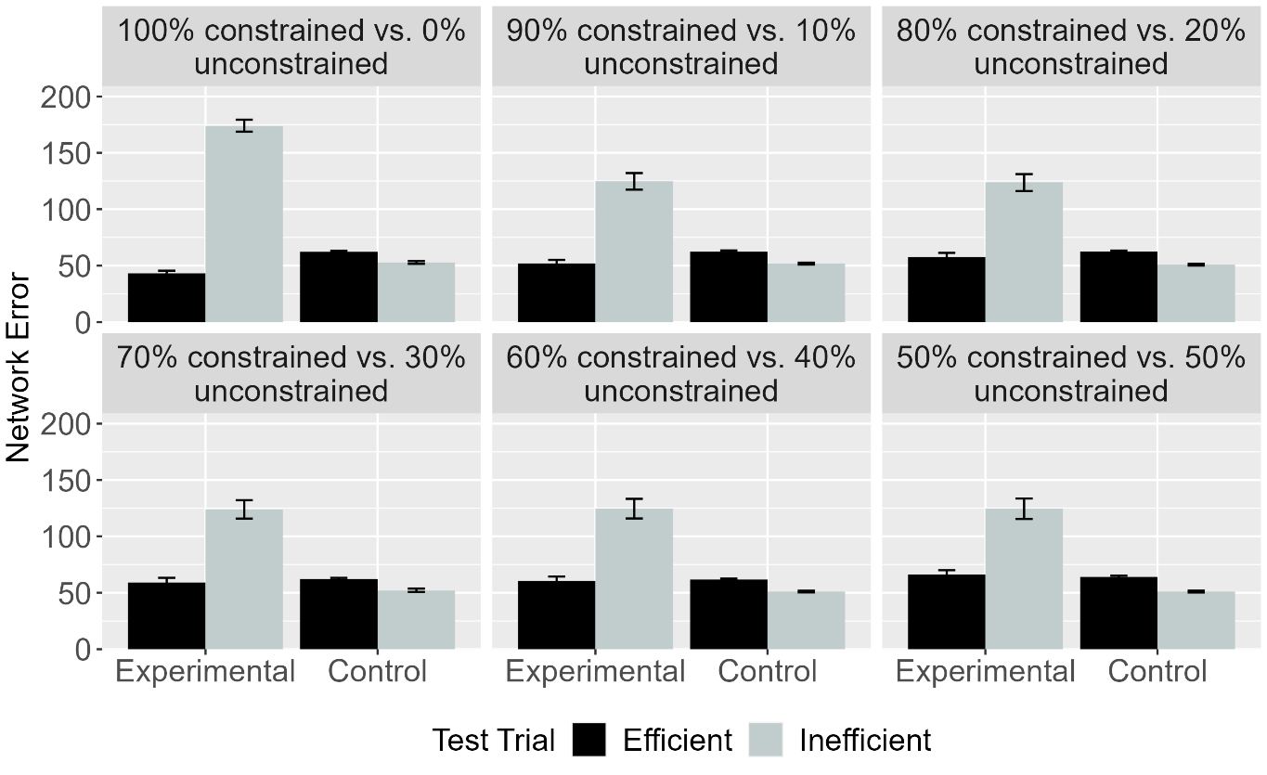Figure 12. Mean network error produced to the Efficient and Inefficient test events in the Experimental and Control conditions across different ratios. Error bars represent standard errors.

The results for this simulation—shown in Figure 12—demonstrate that regardless of how much constrained and unconstrained motion networks experienced during pretraining, those in the Experimental condition produced more error to the Inconsistent test event than to the Consistent one; those in the Control condition produced comparable error to both test events.. These results indicate that ALIAS’s success in Simulation 1a did not hinge on it having never experienced unconstrained motion during pretraining.
It might be surprising that—at least in the 50% constrained versus 50% unconstrained condition, in which networks experienced equal numbers of arced- and linear-path events during pretraining—networks did not produce equivalent error to both test events across conditions. This prediction did not bear out because all networks experienced an additional arced-path event during habituation. These additional weight changes meant that the associations among the features comprising the arced-path event were further strengthened, thereby increasing the likelihood that presenting some of its features at test would incorrectly activate others, produce greater prediction error, and lead ultimately to differential treatment of the test events.
Having established that ALIAS could capture the first target finding and that its performance did not depend on absent prior experience with unconstrained motion, Simulation 2 examined whether the same associative mechanism could reproduce the second target finding.

Simulation 2: Independence from animacy.
This simulation examined whether the same associative learning mechanism that captured the first target finding could reproduce the second: that infants’ looking responses do not depend on the objects involved possessing animate features. As such, the objects used here possessed inanimate-typical features. Networks were 9 months old. Only ALIAS and ALIAS-2 were examined because neither VOM10 nor VOM10-2 could represent whether an object possessed animate- or object-typical surface features.

Results and Discussion
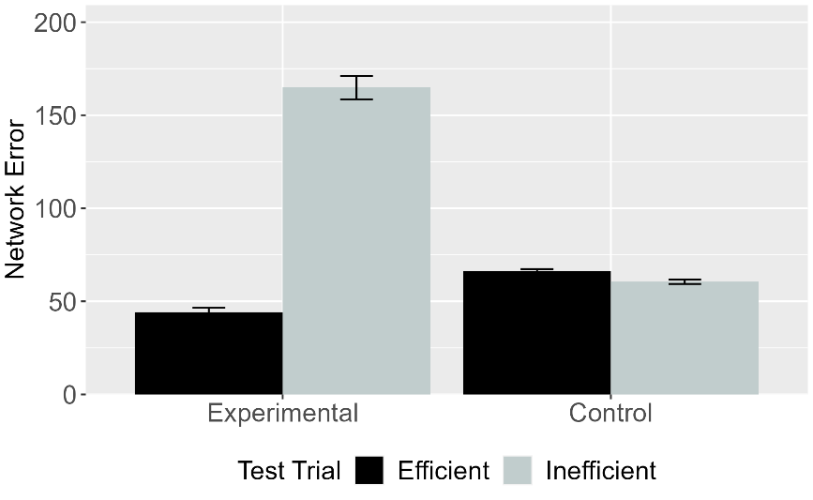 | 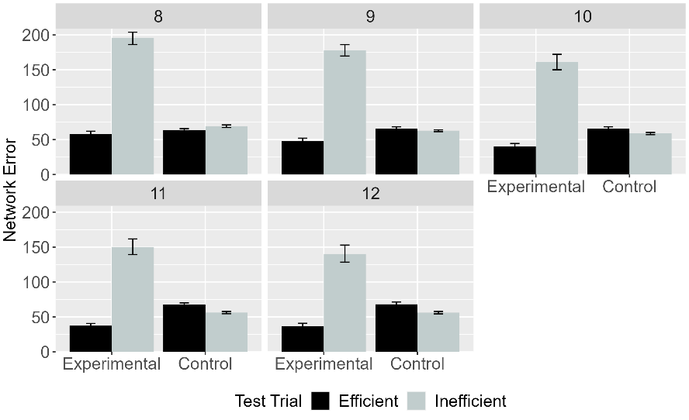
Figure 13. Mean network error produced to the Efficient and Inefficient test events in Simulation 2 across conditions overall (left panel) and different habituation epochs (right panel). Error bars represent standard errors.

Figure 13 shows that networks in the Experimental condition produced more error to the Inefficient than to the Efficient test event, whereas those in the Control condition produced equivalent error to both events. These results indicate that ALIAS’s responses—like infants’—did not hinge on objects espousing animate-typical features.

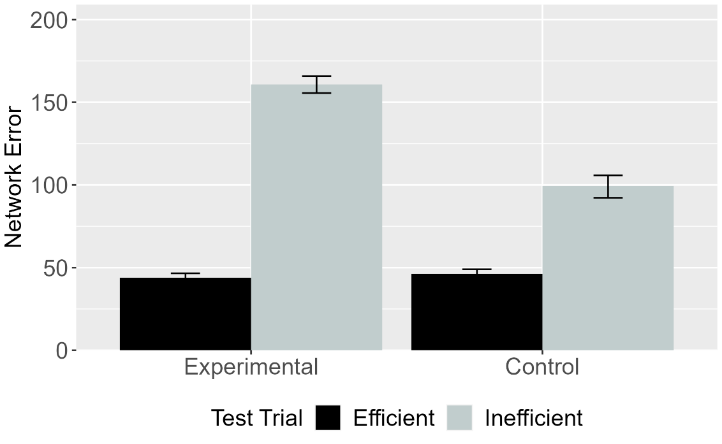
Figure 14. Mean network error produced to Efficient and Inefficient test events in the Experimental and Control conditions for ALIAS-2. Error bars represent standard errors.

Figure 14 shows ALIAS-2’s performance. Networks in conditions produced greater error to the Inefficient than to the Efficient event. However, as was true in Simulation 1a, this effect was weaker in the Control than in the Experimental condition. The fact that ALIAS-2 only partially replicated the second target finding indicates that associative learning over differentially salient surface features is necessary to capture it.
Together, Simulations 1 and 2 demonstrate that the same associative learning mechanism can account for infants’ looking behavior regardless of prior experience with unconstrained motion or whether the objects possessed animate- or inanimate-typical surface features. Nevertheless, one potential criticism of the simulations presented thus far is that they provide only limited evidence for ALIAS's explanatory breadth because both target findings were derived from closely related paradigms. Simulation 3 addressed this criticism by assessing whether ALIAS could capture a more substantively different target finding.

Simulation 3: Bidirectional inferences about actions, goals, and constraints.
Simulation 3 examined whether ALIAS could account for findings that have been taken to show that 12-month-olds make bidirectional inferences among goals, actions, and constraints. Crucially, this simulation represents a substantially more demanding test of ALIAS because the target findings have been argued to require richer inferential abilities than mere sensitivity to the low-level features of action events. The target findings come from a classic study by Csibra et al. (2003). In the first experiment, infants were habituated to an event in which a large circle appeared to be chasing a small circle. However, before the large circle reached the small one, the small circle moved through a narrow gap between two bars before disappearing from the screen; the width of the gap forced the larger circle to move around one of the bars. The fact that the large circle never reached the small one before it disappeared from the screen meant that the large circle’s goal of reaching the small one had to be inferred. The authors found that when the gap was widened, infants looked longer when the large circle continued moving around one of the barriers than when it moved through it. Although this experiment differed from the “over-the-barrier” paradigm, it is possible to instantiate it within that framework. The approach taken here involved terminating the habituation event after the first object cleared the barrier but before it reached the second object. This ensured that the first object’s goal remained ambiguous, thereby preserving the critical inferential demands of the original experiment.
In a second experiment, infants were habituated to a constrained action event except that the barrier was hidden behind an opaque screen. Infants could nonetheless see the second object and parts of the first object’s arced motion path. Csibra et al. (2003) found that infants looked longer when the first object followed the same curved path in the absence of an obstacle than in its presence. These findings were taken to support the teleological stance. This simulation tested whether instead they could be captured by an associative learning mechanism. To model these experiments, networks were assigned either to the Inferring Goals or to the Inferring Constraints condition. The habituation event in the Inferring Goals condition was identical to that in Simulation 1a except that networks could not know whether the first object’s goal was met (i.e., whether it stopped next to the second one). TheInferring Constraints condition was implemented by removing all barrier information during habituation. This simulation was identical to Simulation 1a in all other respects. As in Simulation 1a, ALIAS’s performance was compared to that of the competitor models.

Results and Discussion
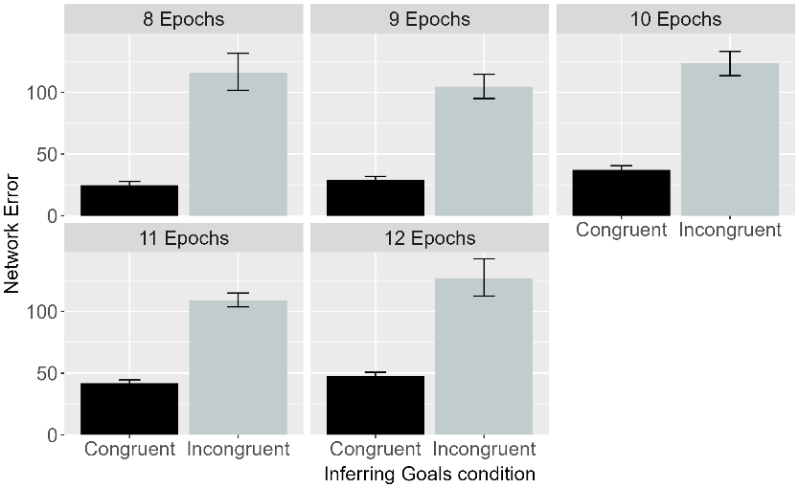 | 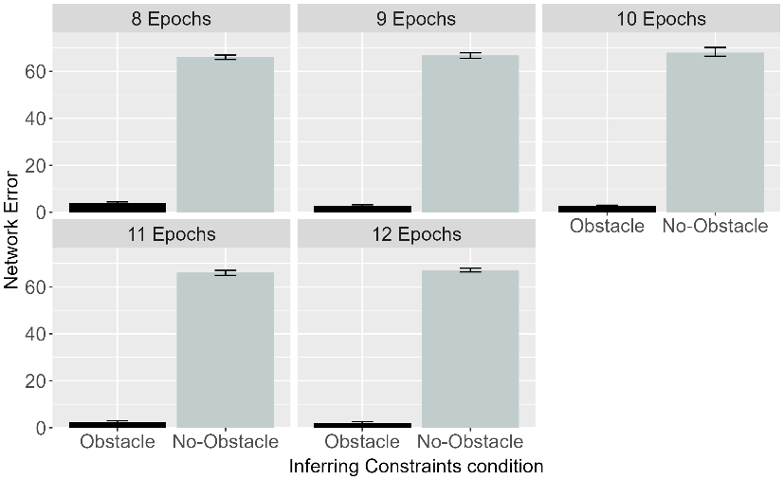
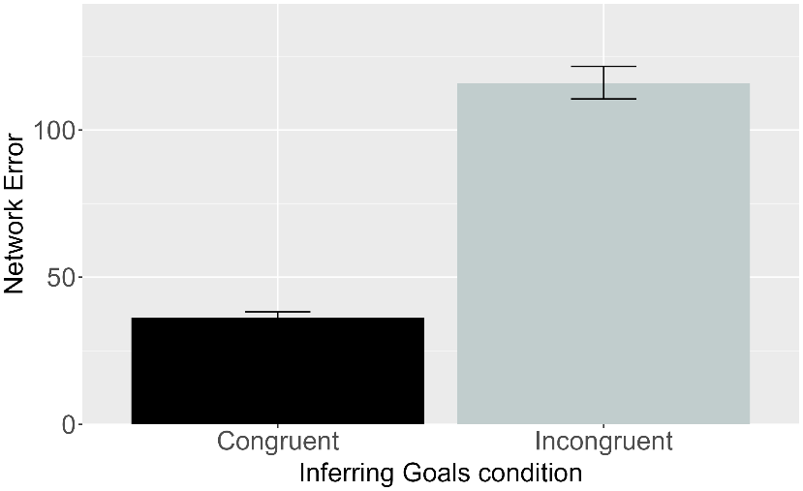 | 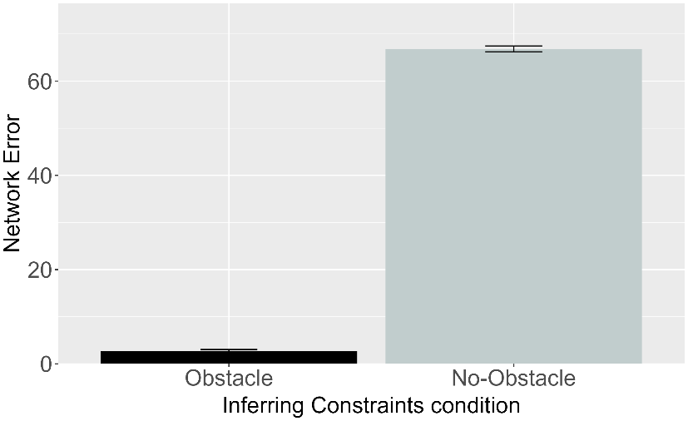

Figure 15. Performance of ALIAS. Plotted is the mean network error produced to the Congruent and Incongruent test events for networks in the Inferring Goals condition (left column) and to the Obstacle and No-Obstacle test events for networks in the Inferring Constraints condition across habituation epochs (top row) and overall (bottom row).

Figure 15 shows ALIAS’s performance across the conditions. Networks in the Inferring Goals condition produced greater error to the Incongruent than to the Congruent test event. This pattern arose because the former test event violated a learned association between arced motion over a small barrier and spatial contiguity between the two objects. Networks in the Inferring Constraints condition produced more error to the No-Obstacle than to the Obstacle test event. This pattern arose because the former test event violated a learned association between arced motion and obstacles.

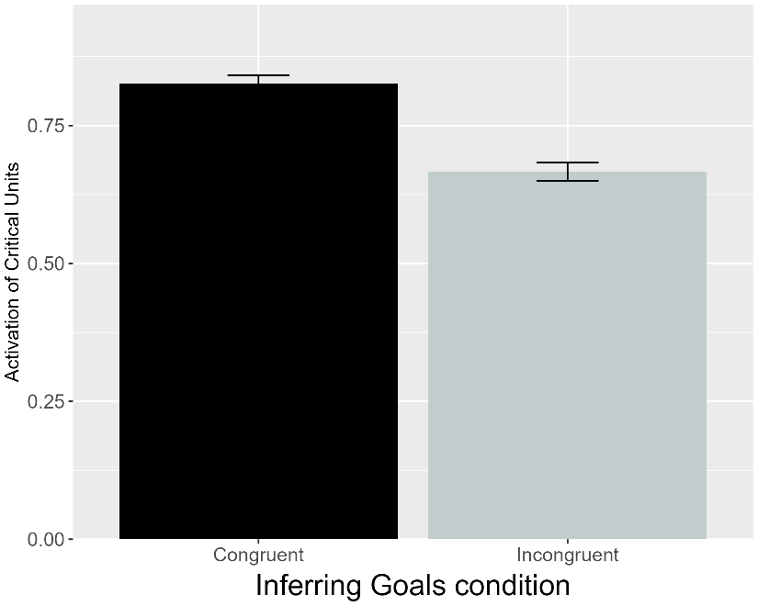 | 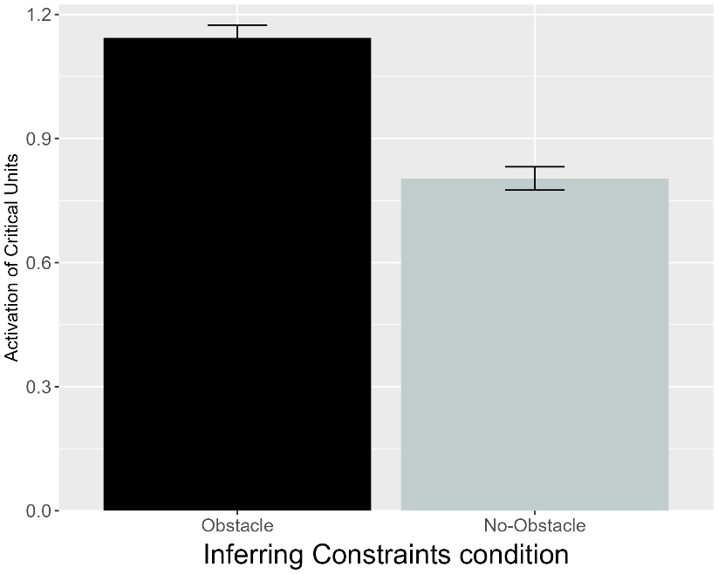
Figure 16. Performance of VOM10. Plotted is the mean activation of the critical units produced to the Congruent and Incongruent test events for networks in the Inferring Goals condition (left) and to the Obstacle and No-Obstacle test events for networks assigned to the Inferring Constraints condition (right).

Figure 16 shows that VOM10 failed to reproduce the target findings. Networks in the Inferring Goals condition produced more activation to the Congruent than to the Incongruent test event. Likewise, networks in the Inferring Constraints condition produced more activation to the Obstacle than to the No Obstacle test events.

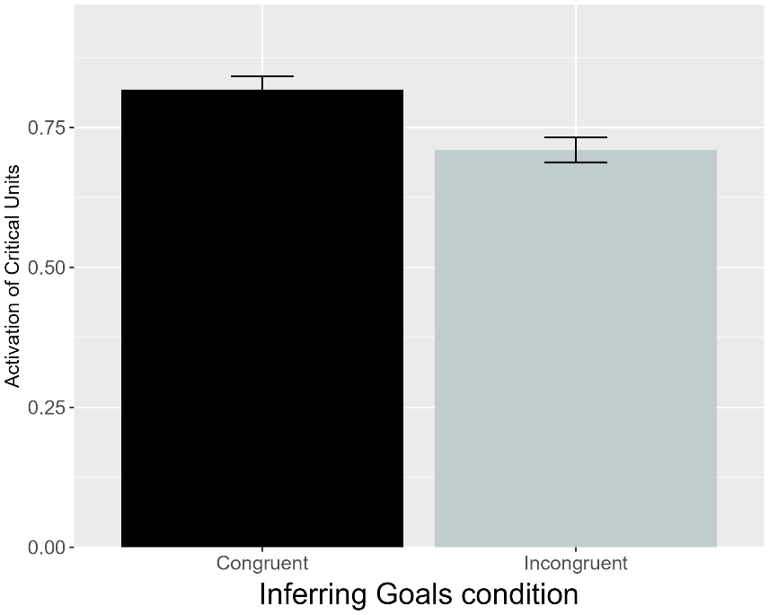 | 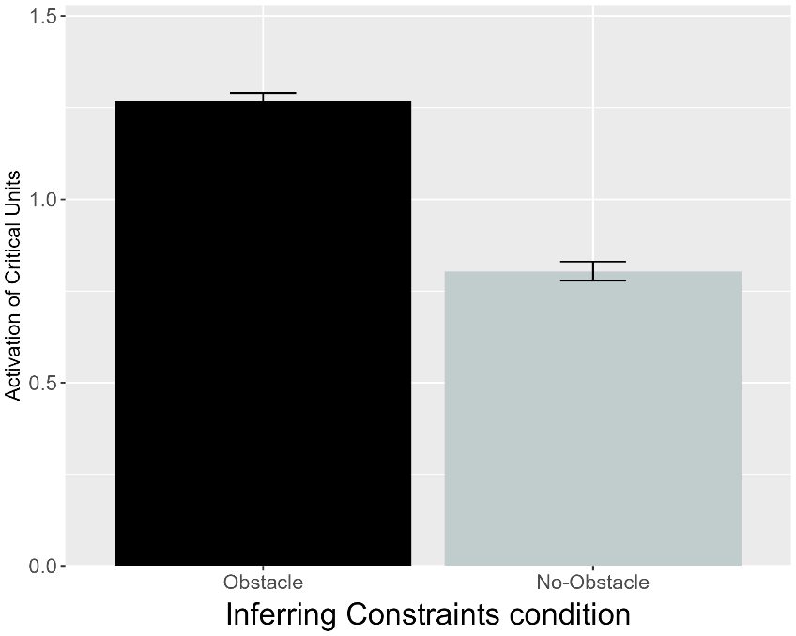
Figure 17. Performance of VOM10-2. Plotted is the mean activation of the critical units produced to the Congruent and Incongruent test events for networks in the Inferring Goals condition and to the Obstacle and No-Obstacle test events for networks assigned to the Inferring Constraints condition (right).

Figure 17 shows that VOM10-2 responses mirrored those of VOM10. The fact that both versions failed to reproduce the third target finding suggests that this limitation reflects a more fundamental property of VOM10 than a consequence of a lack of fidelity in its implementation.

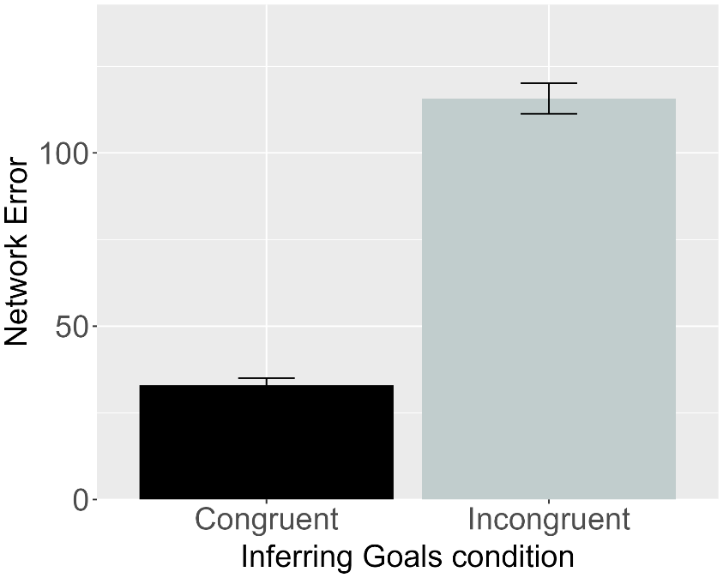 | 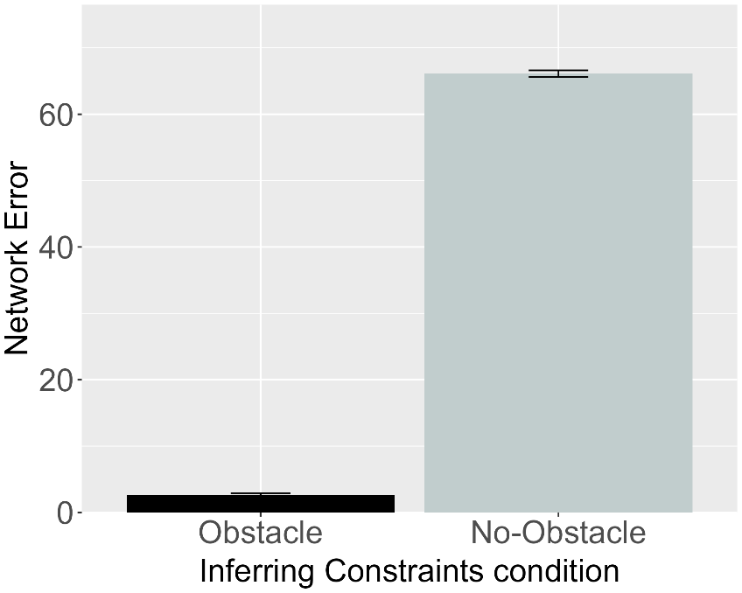
Figure 18. Performance of ALIAS-2. Plotted is the mean network error produced to the Congruent and Incongruent test events for networks assigned to the Inferring Goals condition (left) and to the Obstacle and No-Obstacle test events for networks in the Inferring Constraints condition (right).

Figure 18 shows that, like ALIAS, ALIAS-2 networks looked longer at their condition’s corresponding inconsistent test event. The fact that both versions of ALIAS were successful in capturing the third target finding suggests that associative learning alone is sufficient to capture this pattern of behavior. A clear pattern that is emerging across the simulations is that it is not necessary to posit specialized mechanisms or a rich understanding of goals, action, efficiency, or cost to explain infants’ looking behaviors in action efficiency understanding studies. Such behavior can instead be readily captured by domain-general associative learning.
Nevertheless, one might argue that even this simulation does not pose a sufficiently strong challenge to ALIAS and that a more compelling test of its explanatory scope would be to show that it can capture data from Liu and Spelke’s (2017). Six-month-olds were habituated either to a constrained action event (Experiment 1) or to an unconstrained one (Experiment 2). Infants were then tested either on constrained Low, efficient and constrained High, inefficient test events (Experiment 1) or on unconstrained versions of these events (Experiment 2). Liu and Spelke (2017) found that infants in Experiment 1 looked longer at the High, inefficient test event when the agent jumped higher than needed to clear the barrier than at the Low, efficient one; infants in Experiment 2 looked numerically, but not significantly, longer at the Low, efficient test event. These findings were interpreted to mean that infants can represent efficiency continuously.
A final experiment habituated infants to the event used in Experiment 2 and then tested on the constrained events used in Experiment 1. Infants looked longer at the High, inefficient test event than at the Low, efficient one. These findings suggest that infants responded as if they expected previously inefficient agents to behave efficiently in a new situation. More broadly, these findings were subsequently argued to support naïve psychology and naïve physics systems (Liu et al., 2026). Simulation 4 tested whether such conclusions were warranted or whether the same findings can be captured by associative learning.

Simulation 4: Graded representations of efficiency.
This simulation tested whether ALIAS could capture the finding that infants ostensibly represent efficiency continuously and expect agents to behave efficiently in future situations even if, in the past, they behaved inefficiently. Six-month-old networks were habituated to and tested on events analogous to those in Experiments 1-3 in Liu and Spelke (2017). ALIAS’s performance was compared only to VOM10-2 and ALIAS-2. VOM10 was not included because its original implementation omitted barrier information during the prediction (i.e., test) phase. Modifying VOM10 to include such information during test would have represented a substantial departure from its implementation in the previous simulations and from Van Overwalle’s (2010).

Results
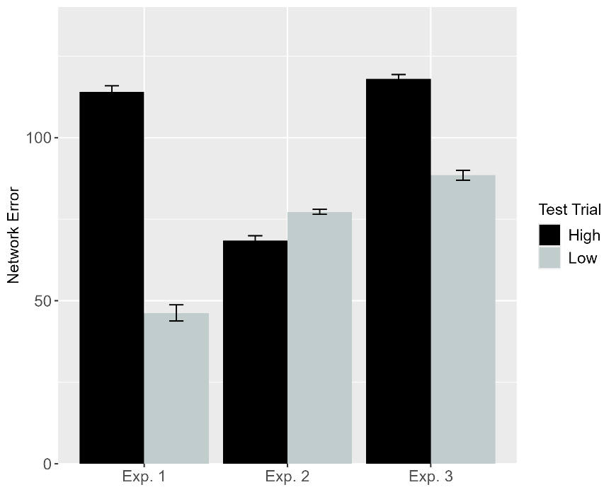 | 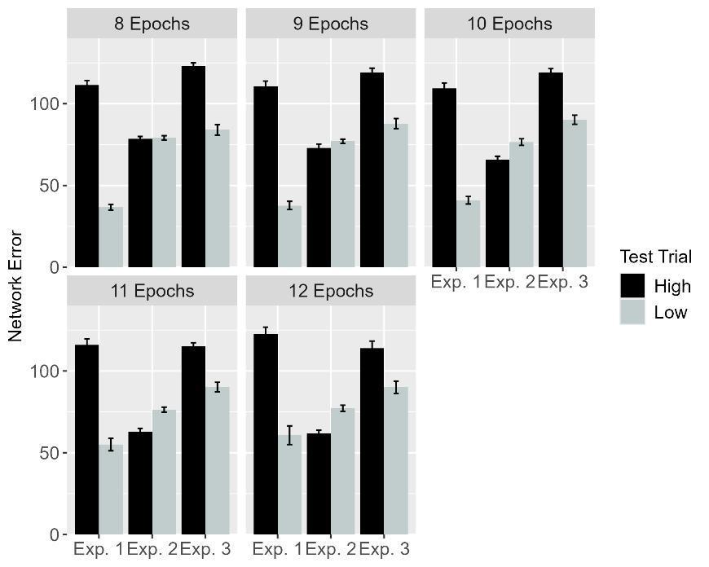
Figure 19. Performance of ALIAS. Plotted is networks’ mean error to the High, inefficient and Low, efficient test events across experiments overall (left) and across different habituation epochs (right). These experiments correspond to those in Liu and Spelke (2017).

Figure 19 shows that ALIAS’s responses. Networks in Experiments 1 and 3 produced more error to the High, inefficient than to the Low, efficient one. Networks in Experiment 2 produced numerically more error to the Low, efficient than to the High, inefficient test event. This pattern of error stemmed from the fact that the High, inefficient test event violated learned associations among a small obstacle, a low jump, and minimal vertical clearance. Such associations were largely preserved in the Low, efficient test event.

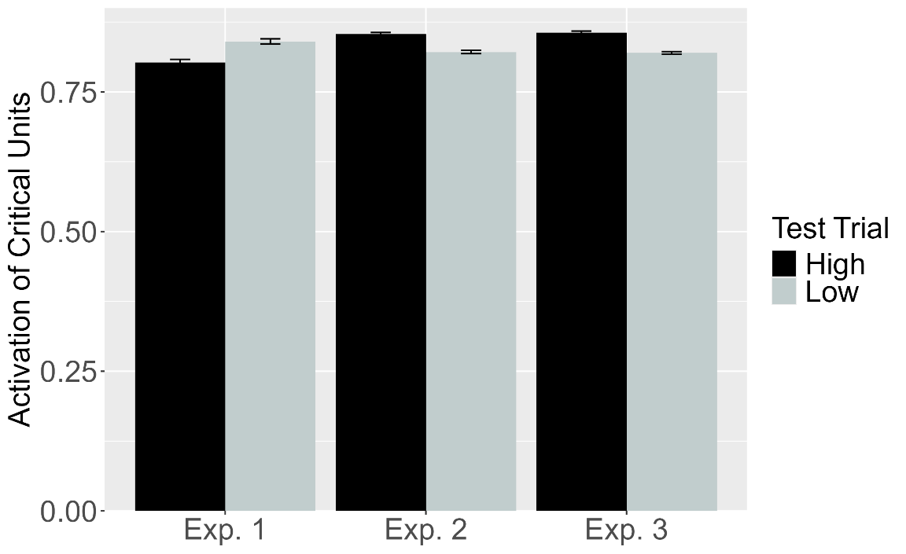
Figure 20. Performance of VOM10-2. Plotted is the mean activation of the critical units produced to the High, inefficient and Low, efficient test events for networks in Experiment 1-3.

As shown in Figure 20, although VOM10-2 captured infants’ looking responses in Experiment 3—showing slightly more critical unit activation following the High, inefficient test event than the Low, efficient test event—its responses in Experiments 1 and 2 did not match those of infants in the corresponding behavioral experiments. In Experiment 1, networks produced more activation to the Low, efficient than to the High, inefficient test event. This pattern was reversed in Experiment 2. These results indicate once more that VOM10 is unable to capture multiple target findings in the literature on infant action efficiency understanding.

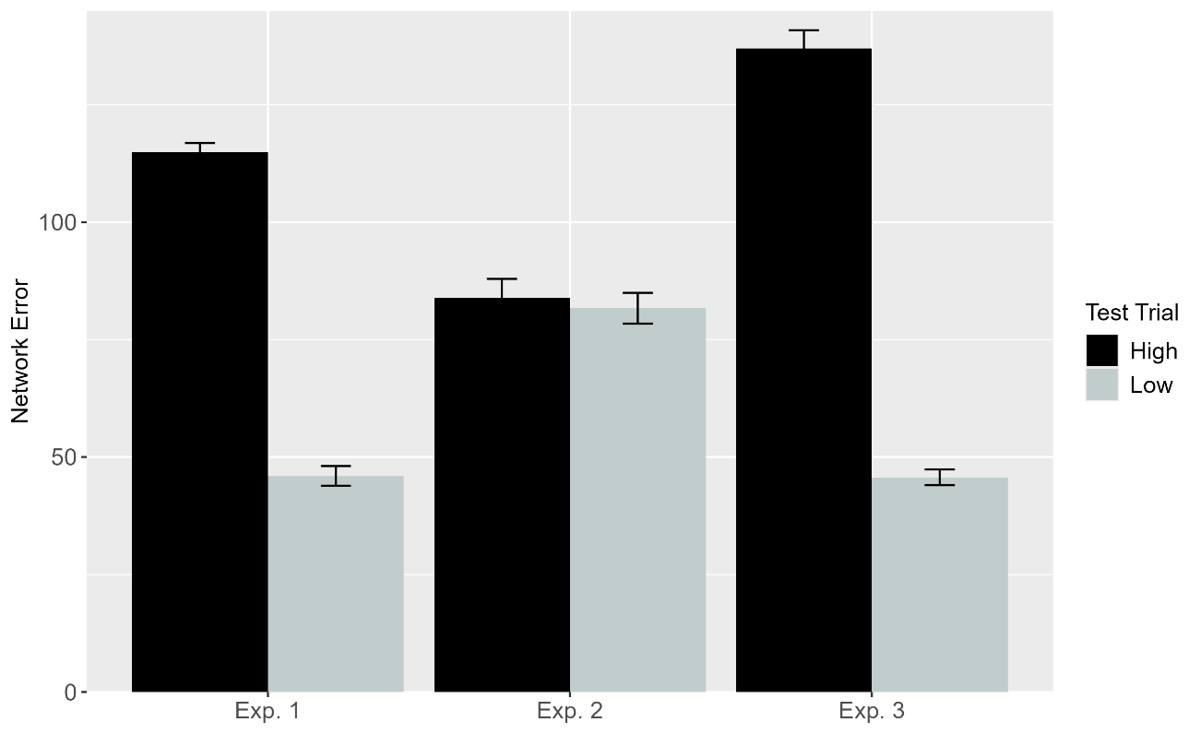
Figure 21. Performance of ALIAS-2. Plotted is networks’ overall mean error to the High, inefficient and Low, efficient test events across experiments.

Figure 21 shows ALIAS-2’s responses. Networks in Experiments 1 and 3 produced more error to the High, inefficient test event than to the Low, efficient one. Networks in Experiment 2 produced equivalent error to both test events. This result contrasts with ALIAS’s behavior and infants’ tendency numerically to look longer, albeit not significantly so, at the Low, efficient than the High, inefficient test event. These findings suggest that associative learning must be coupled with differential obstacle salience to capture the full pattern of data. More broadly, ALIAS's success in capturing the first four target findings suggests that it possesses substantial explanatory scope. At the same time, all four findings involve infants with months of real-world action experience. Thus, for ALIAS to constitute a truly viable account of infants’ looking behavior in action efficiency studies, it must also explain why much younger infants exhibit similar looking patterns to older infants despite minimal direct-action experience.
Of note is Skerry et al.’s (2013) finding that a small amount of direct action experience—via sticky mittens—was sufficient for pre-reaching 3-month-olds to distinguish efficient from inefficient actions much like older infants. Simulation 5 tested whether temporarily increasing ALIAS's attention to, and encoding of, its own straight reaching trajectories could reproduce this finding despite limited prior action experience. This simulation focused on the ALIAS models because they were the only ones capable of simulating development.

Simulation 5: Action efficiency understanding in pre-reaching infants.
Simulation 5 examined whether ALIAS could reproduce the looking behavior of pre-reaching infants in Skerry et al. (2013) when its attention was temporarily heightened during a phase analogous to the action phase in Skerry et al. (2013). Because Skerry et al. (2013) did not report the length of action phase, their lengths phases were equated here. The assumption that infants’ reaches approximate straight trajectories during the action phase was implemented by exposing networks only to straight-motion events during this phase.
Networks were assigned to one of three conditions: Effective Action, Ineffective Action, or No Training. Those in the Effective Action condition were either assigned either to the Experimental condition or to the Control condition. The hypothesis that sticky-mitten experience temporarily heightens attention was implemented by increasing the learning rate on all connections to 0.175 during the action phase for networks in the Effective Action condition only. The learning rate returned to its age-appropriate developmental value at the start of the habituation phase. Networks in the Ineffective Action and No Training conditions retained their developmental learning rate throughout training. All other aspects of the simulation were identical across conditions.

Results
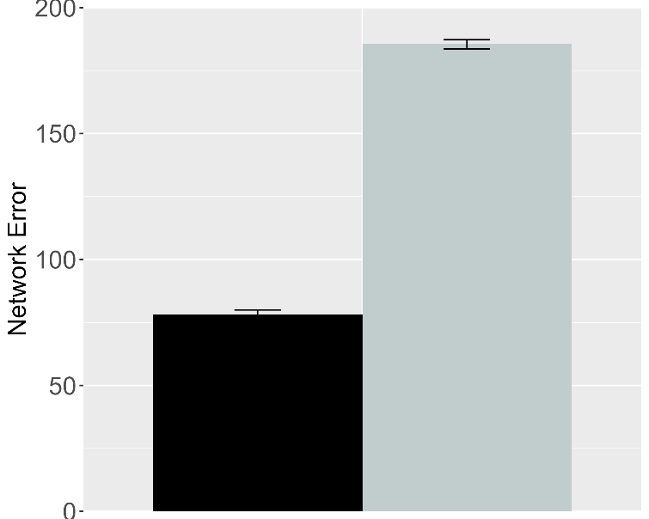 | 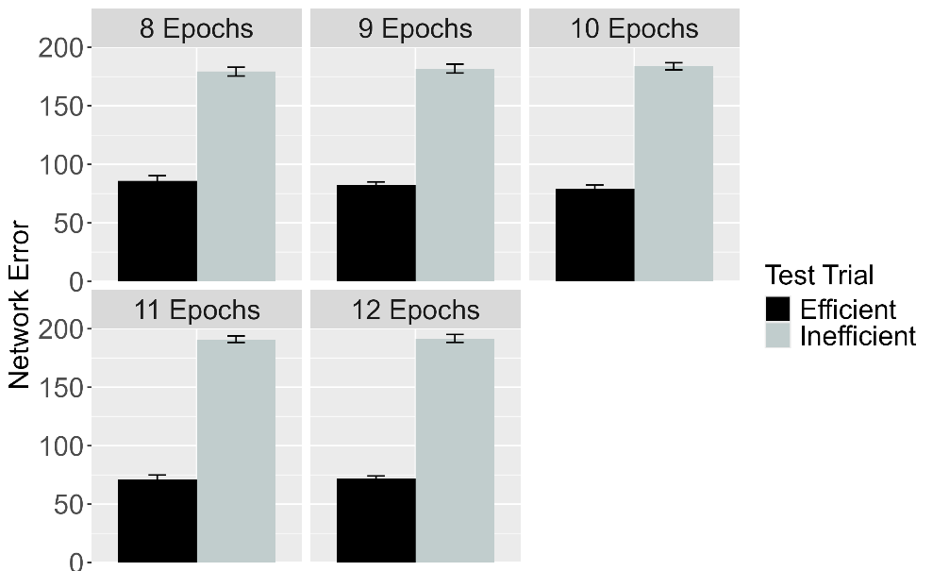
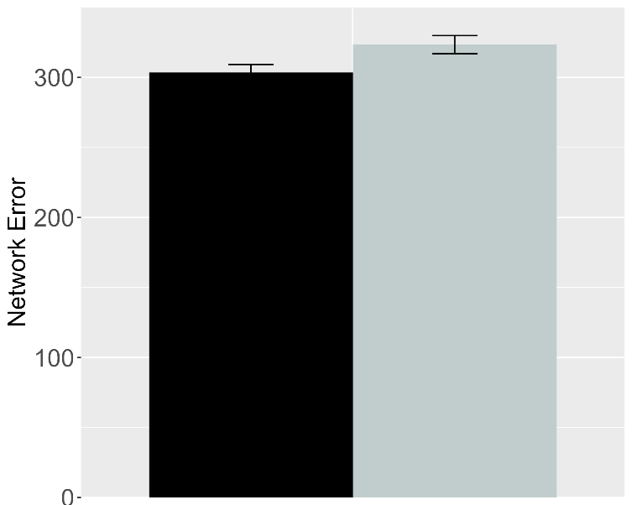 | 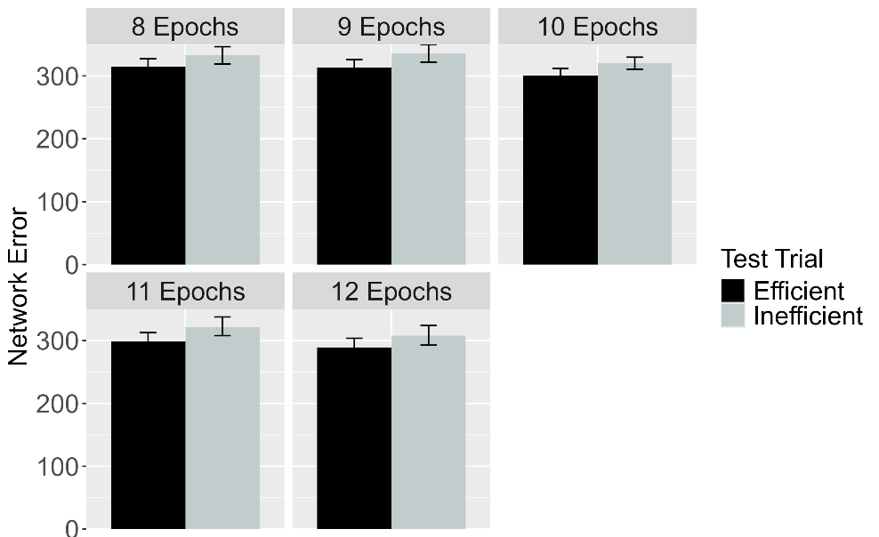
Figure 22. Performance of ALIAS in the Effective Action condition. Plotted is networks’ mean error to the Efficient and Inefficient test events in the Experimental (top row) and Control conditions (bottom row), both overall (left column) and across different habituation epochs (right column). The Experimental and Control conditions correspond to Experiments 1, 4, and 5 in Skerry et al. (2013).

Figure 22 shows the test performance of ALIAS in the Effective Action condition. Results show that networks in the Experimental condition produced more error to the Inefficient than to the Efficient event. The effect was much attenuated for networks in the Control condition.

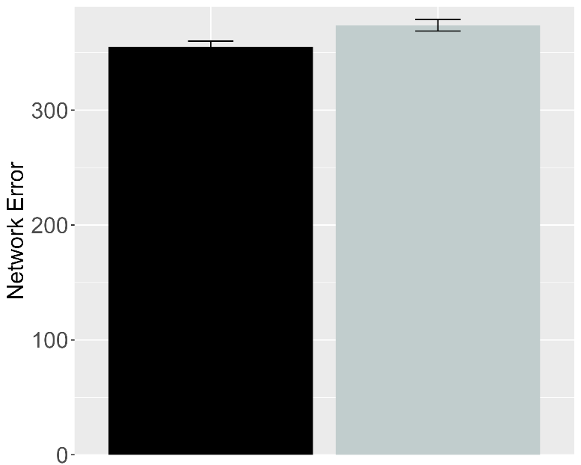 | 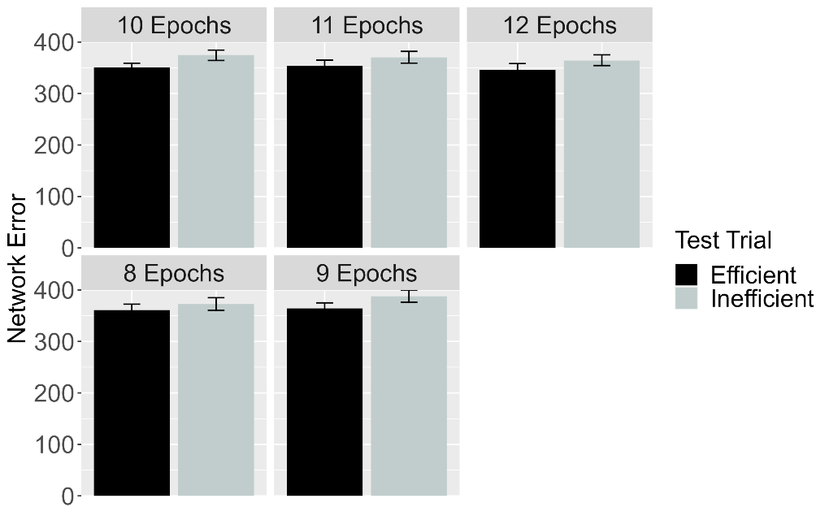
Figure 23. Performance of ALIAS in the No Training condition. The overall error produced to the Efficient and Inefficient test events is shown on the left, and the error produced across different habituation epochs is shown on the right. This condition corresponds to Experiment 3 in Skerry et al. (2013).

Figure 23 shows the performance of networks in the No Training condition. Networks produced comparable error to both test events. If prior experience with constrained arced motion was sufficient for networks to associate arced motion with barriers and then to detect when such associations are violated, then networks in Effective Action and No Training conditions should have treated the test events similarly.

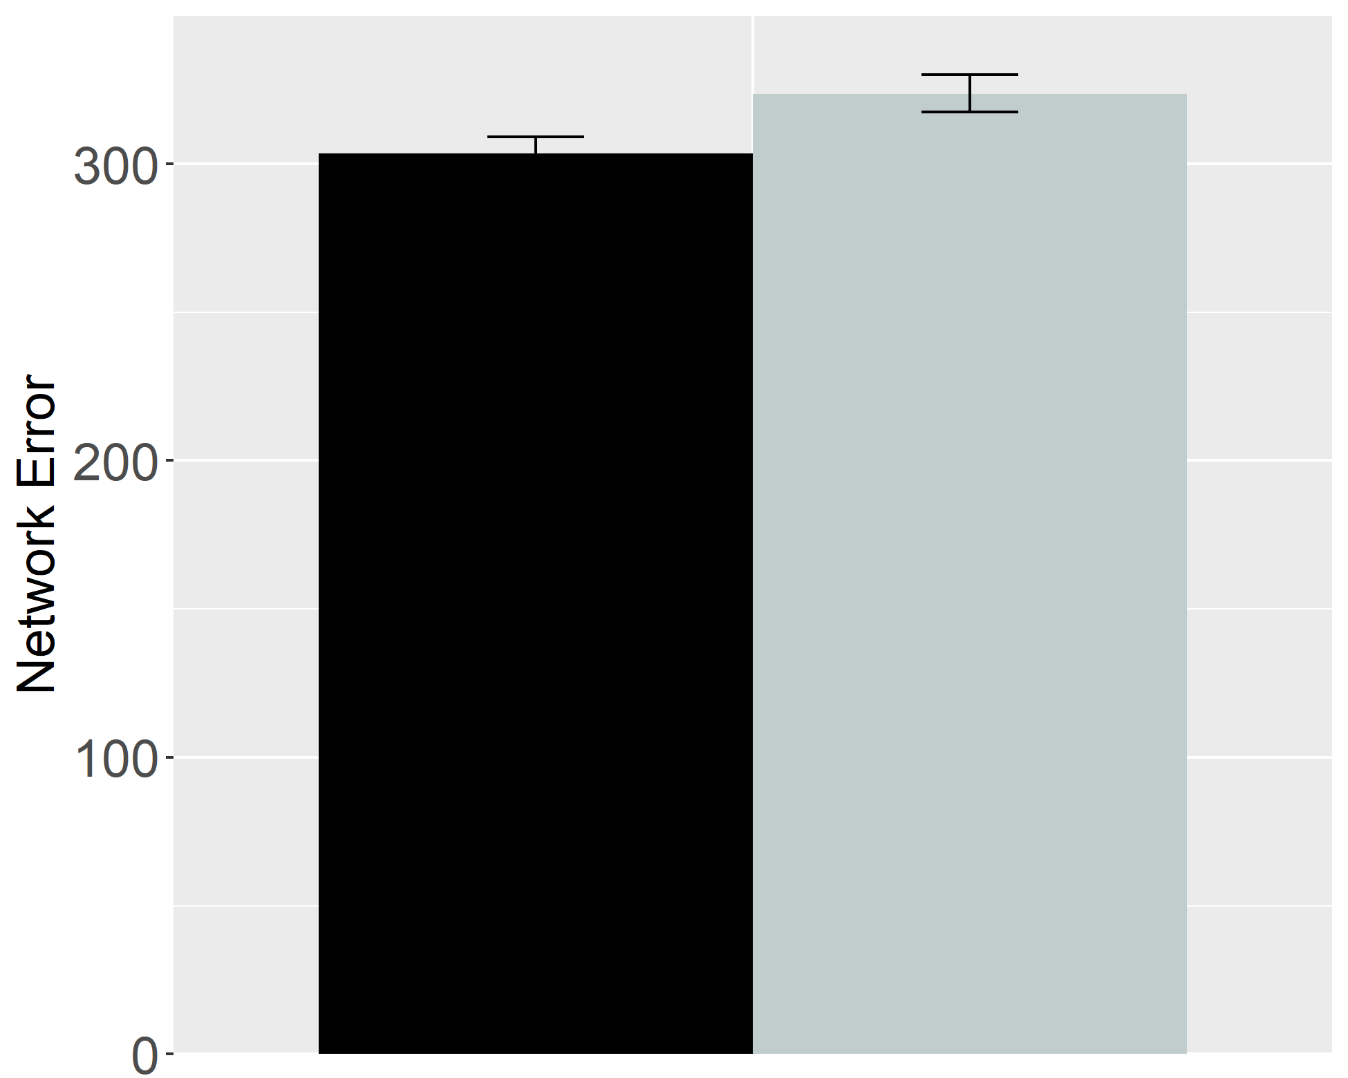 | 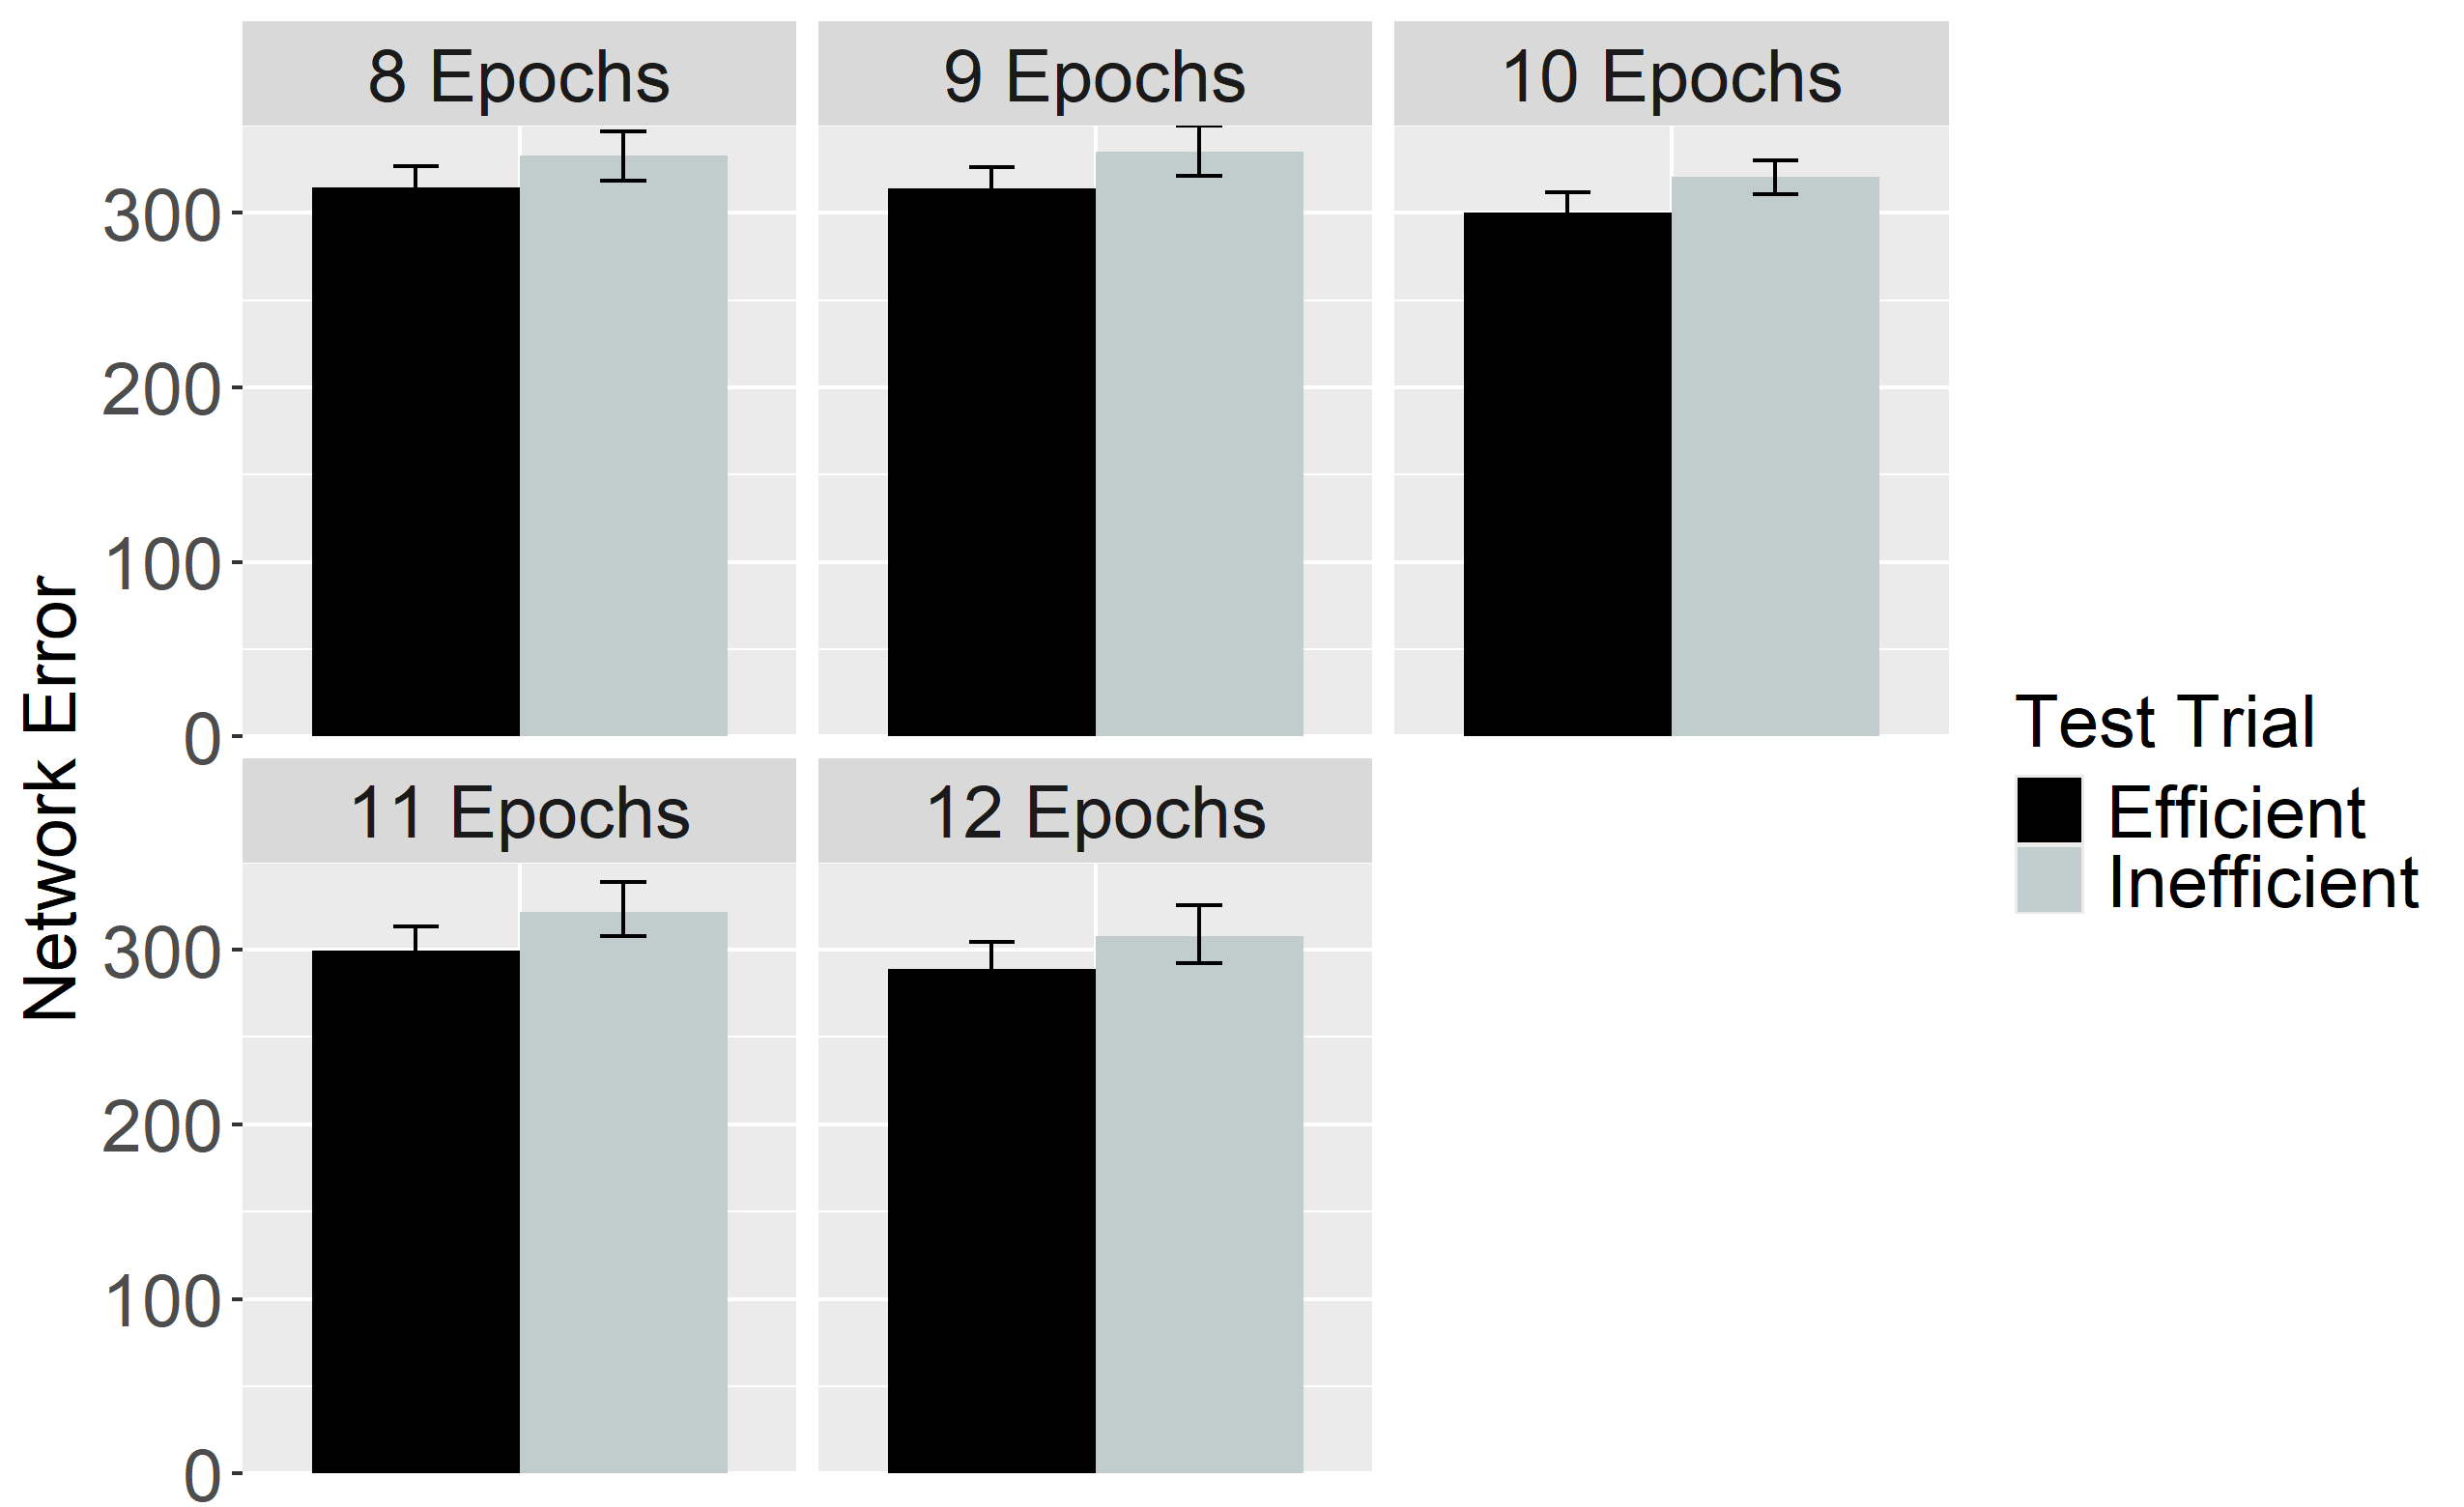
Figure 24. Performance of ALIAS in the Ineffective Action condition. The overall error produced to the Efficient and Inefficient test events is shown on the left, and the error produced across different habituation epochs is shown on the right. This condition corresponds to Experiment 2 in Skerry et al. (2013).

Figure 24 shows the performance of networks in the Ineffective Action condition. As with networks in the No Training condition, these networks also produced comparable error to both test events. These results indicate that enhanced encoding of straight reach trajectories is sufficient to reproduce the fifth target finding.

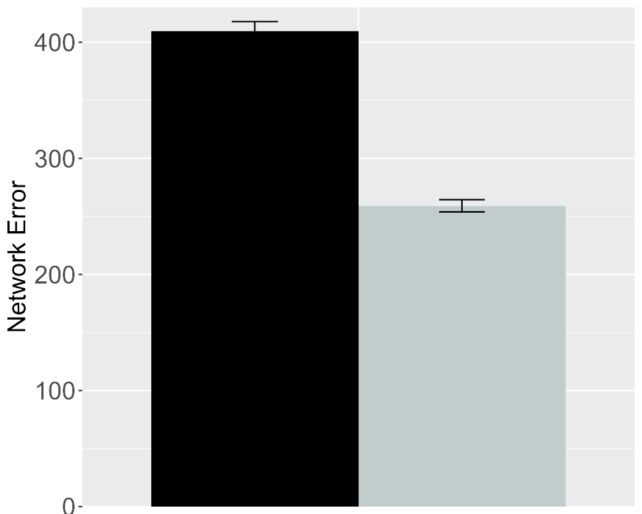 | 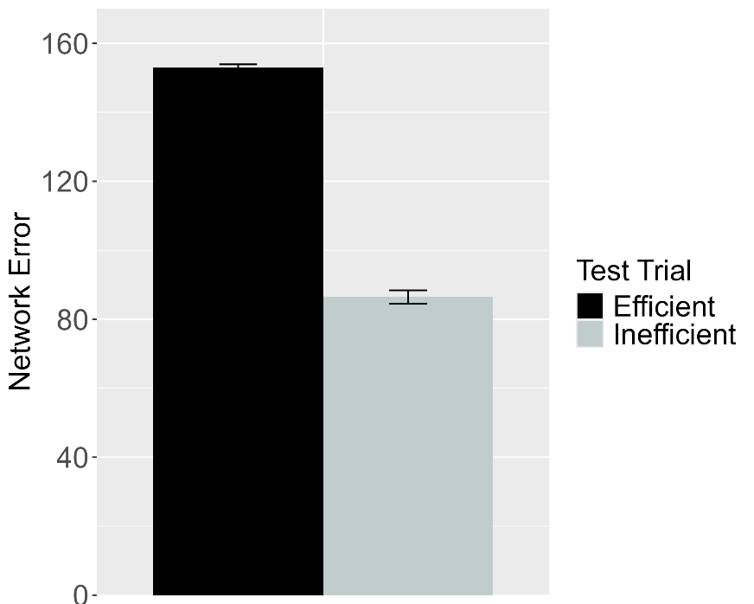
Figure 25. Performance of ALIAS in the Experimental (left) and Control (right) conditions of the Effective Action condition. These data correspond to a version of ALIAS in which the attentional boost extends into the habituation phase.

To determine whether attentional boosts must be transient, this boost was allowed to extend into habituation for a different set of networks. Figure 25 shows that networks produced greater error to the Efficient than to the Inefficient test event, thereby suggesting that the attentional boost must be transient.
The basis for these findings is straightforward: Although networks’ heightened attention during the action phase enabled them robustly to encode their own straight reach trajectories, the fact that this attentional boost persisted into the habituation phase meant that networks’ representations of these trajectories were overridden by robust representations of the arced motion trajectories and the surface features associated with those trajectories (e.g., the height of the apex of a reach’s trajectory) during the habituation phase. Consequently, the Inefficient test event—which, apart from the barrier, preserved most of the features of the habituation event—was partially consistent with the habituation representation; the Efficient test event was not because it depicted a straight reach trajectory. The extremely brief nature of the pretraining phase, combined with networks’ impoverished processing abilities in this simulation, precluded them from forming robust representations of straight motion during this phase.

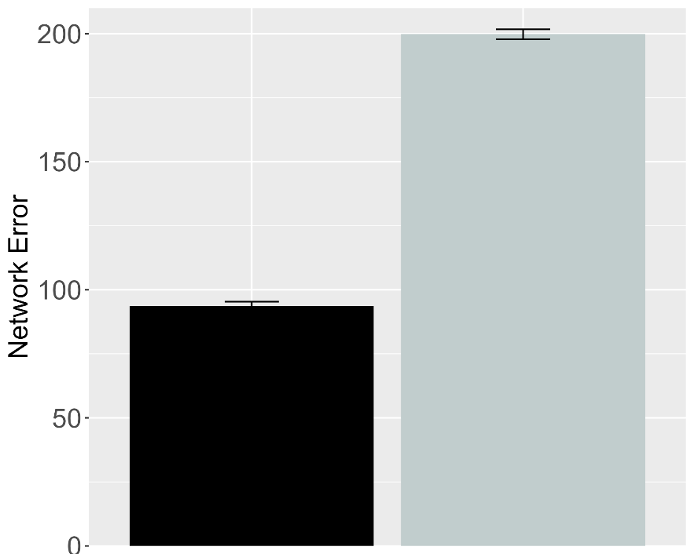 | 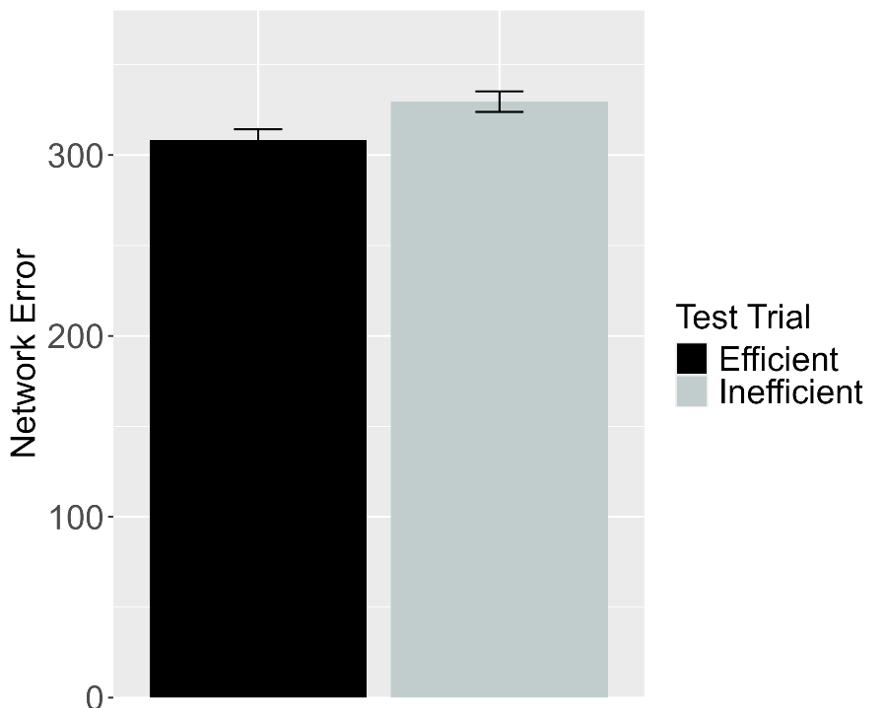
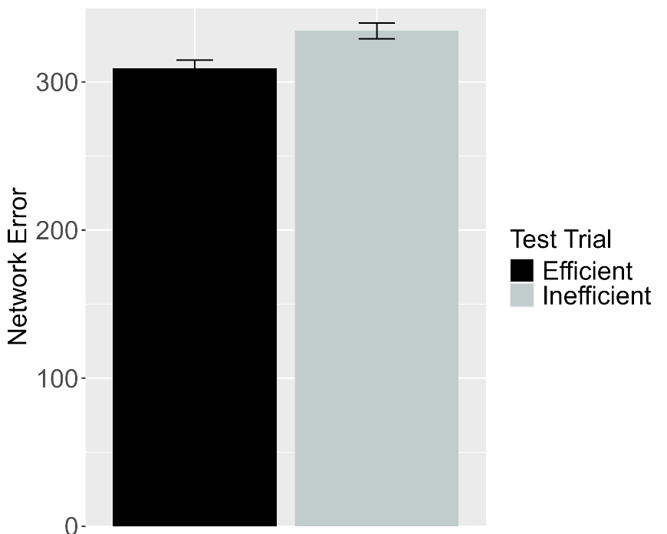
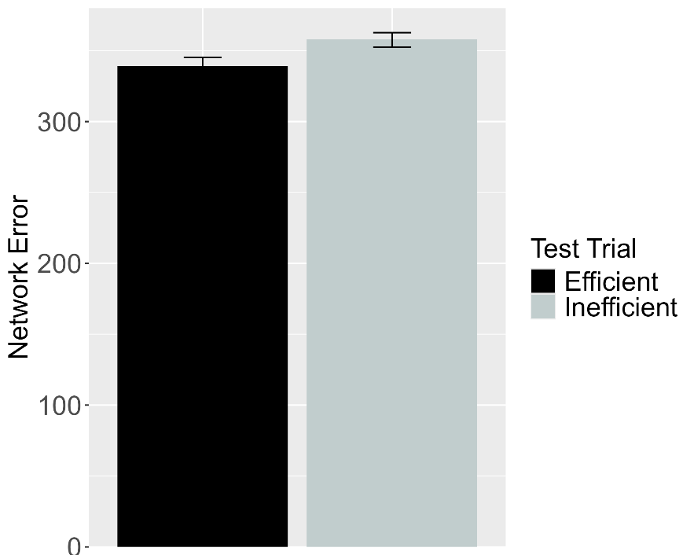
Figure 26. Performance of ALIAS-2. Plotted in the top row is the overall mean error to the Efficient and Inefficient test events for networks assigned either to the Experimental (top left) or to the Control condition (top right) in the Effective Action condition. Plotted in the middle row is the overall mean error to the two test events for networks assigned to the Ineffective Action condition. Plotted in the bottom row is the overall mean error to the two test events for networks assigned to the No Training condition. The No Training condition corresponds to Experiment 2 in Skerry et al. (2013).

The next analysis examined whether associative learning alone was sufficient for ALIAS-2 to reproduce the fifth target finding. Note that the attentional boost remained short-lived in this simulation. As Figure 26 depicts, ALIAS-2 was able successfully to reproduce the fifth target finding: In the Effective Action condition, networks habituated to constrained action produced greater error to the Inefficient than to the Efficient test event. In contrast, networks habituated to unconstrained action in the Ineffective and No Training conditions produced comparable amounts of error to both test events. The results of this simulation indicate that associative learning alone is sufficient to account for Skerry et al.’s (2013) findings.
The five simulations reported here demonstrate that infants' looking behaviors in studies assessing their action efficiency understanding can be explained by associative learning. Specifically, ALIAS reproduced the finding that infants look selectively at inefficient actions, that this effect is independent of whether the entities involved possess animacy cues, that infants make bidirectional inferences among actions, goals, and constraints, that ostensibly they possess graded representations of efficiency, and that action efficiency understanding is present in pre-reaching infants. ALIAS's ability to capture such a diverse set of findings undermines the claim that such looking behaviors derive from specialized mechanisms and abstract, conceptually rich representations of goals, constraints, efficiency, and utility. Instead, the present simulations suggest that these phenomena can be readily explained in terms of a domain-general associative learning mechanism operating over the semantically neutral visible surface features of action events and the entities and objects involved in them. At the same time, a complete account of infants’ looking performance in these studies should do more than reproduce existing findings. The account must also be generative: it should produce testable predictions for future research. The final section does exactly this by placing ALIAS in a series of novel situations and examining its resulting behavior. These behaviors constitute a set of predictions that can be used to decide between the present account and the domain-specific alternatives.

Model predictions
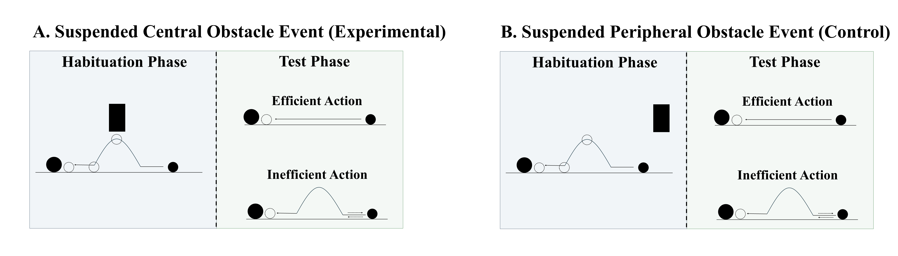
Figure 27. Schematic depiction of the behavioral task associated with the first prediction. In the suspended central obstacle event (A), the first object jumps under a suspended, centrally located barrier before it comes to rest next to the second object; in the suspended peripheral obstacle event (B), the first object jumps beside the suspended barrier before coming to rest next to the second one. The barrier is removed at test for both events, and infants observe either an efficient straight-path action or an inefficient arced-path action.

A potentially interesting question that the current simulations raise concerns how ALIAS would respond if it were habituated to an event in which a barrier was located directly above rather beneath the apex of an arced motion trajectory. Figure 27 depicts what such an event would look like. If the current account is correct that spatial proximity to the motion trajectory is the critical factor, then networks (and by hypothesis, infants) should respond similarly when the obstacle is positioned above rather than below the trajectory.
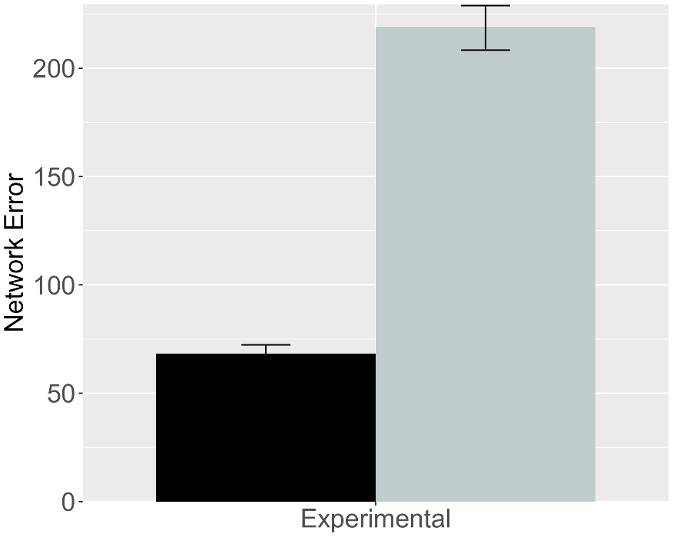 | 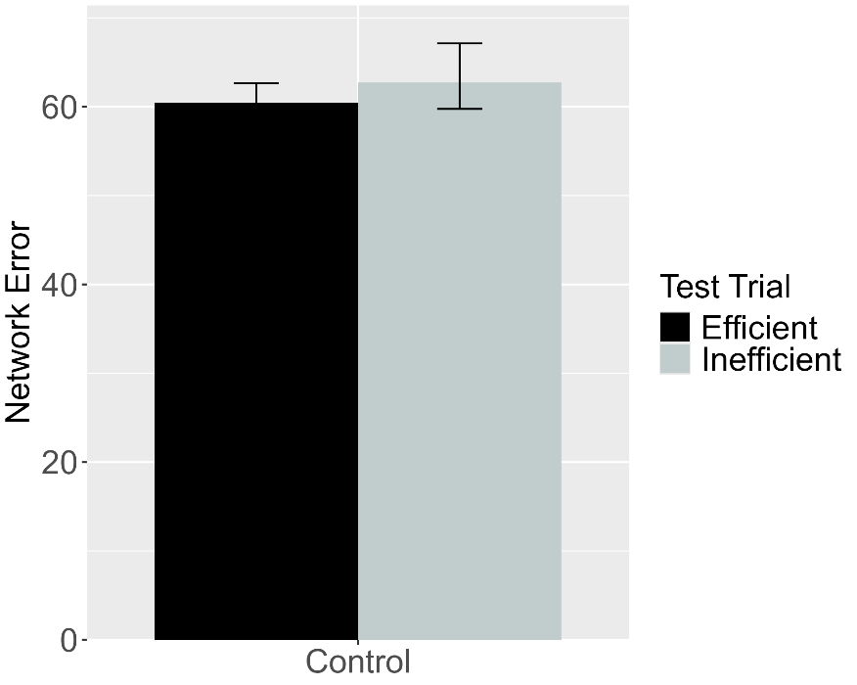
Figure 28. Performance of ALIAS. (Left) Overall error produced to the Efficient and Inefficient test events for networks in the Experimental condition. (Right) Overall error produced to the Efficient and Inefficient test events for networks in the Control condition. The barrier shown during habituation for this simulation appeared directly above rather than beneath arced motion.

This simulation was identical to Simulation 1a with two critical exceptions. First, a fourth unit was added to the Obstacle Horizontal Position input and output groups. This unit corresponded to the location directly above arced motion. Second, because the previous results were robust to the number of habituation epochs, the length of the habituation phase was reduced to eight epochs; this was the smallest number used in the prior simulations. Obstacles were only in the above-the-curved-motion spatial configuration during the habituation phase. As Figure 29 shows, when networks were subsequently tested on barrierless Inefficient and Efficient test events, only those in the Experimental condition looked longer at the Inefficient than at the Efficient test event. These results mirror those in Simulation 1a.

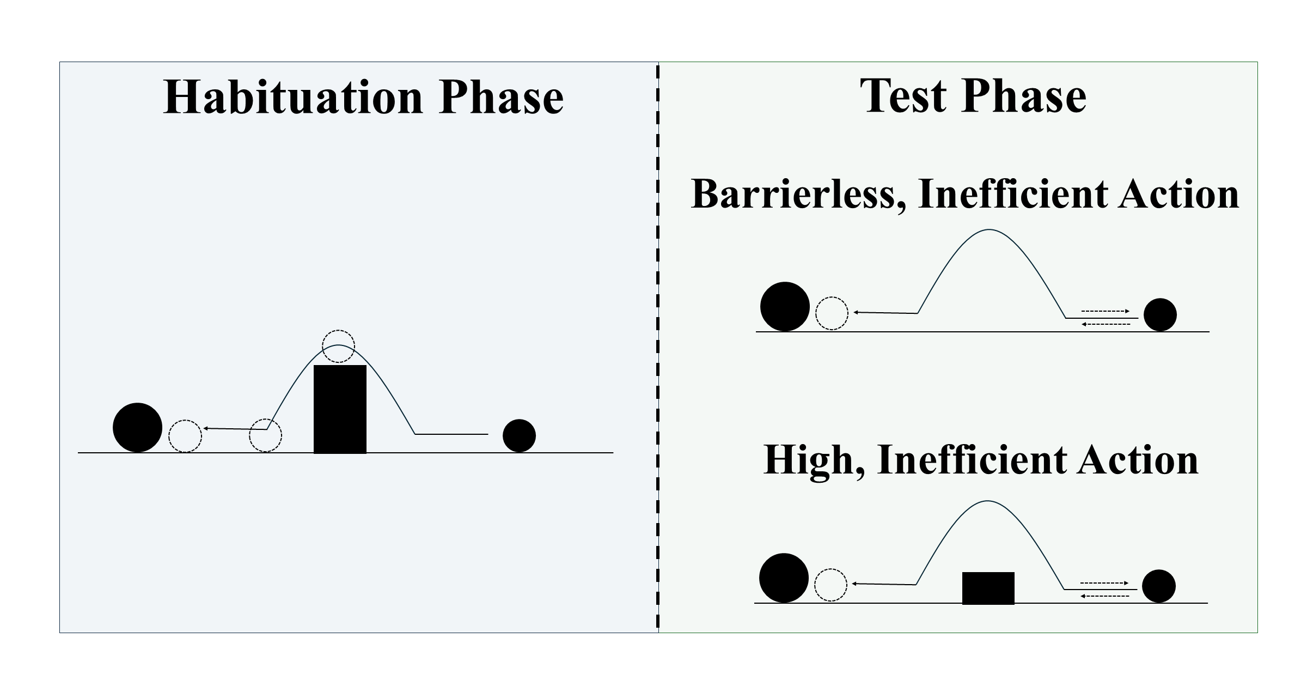
Figure 29. Schematic depiction of the behavioral task associated with the second prediction. During habituation, the first object jumps over centrally located barrier before it comes to rest next to the second object. Barrierless, inefficient and High, inefficient test events are then shown.

Given that action efficiency understanding studies employ different kinds of inefficient events, it might be asked how ALIAS would treat two different inefficient test events. For example, how might ALIAS respond if it were tested on Liu and Spelke’s (2017) High, inefficient test event and Gergely et al.’s (1995) Barrierless, inefficient test event? To address this question, networks were habituated to a constrained action event and tested on the High, inefficient test event from Simulation 4 and the inefficient one from Simulation 1a (Figure 29). Networks were again 6 months old.
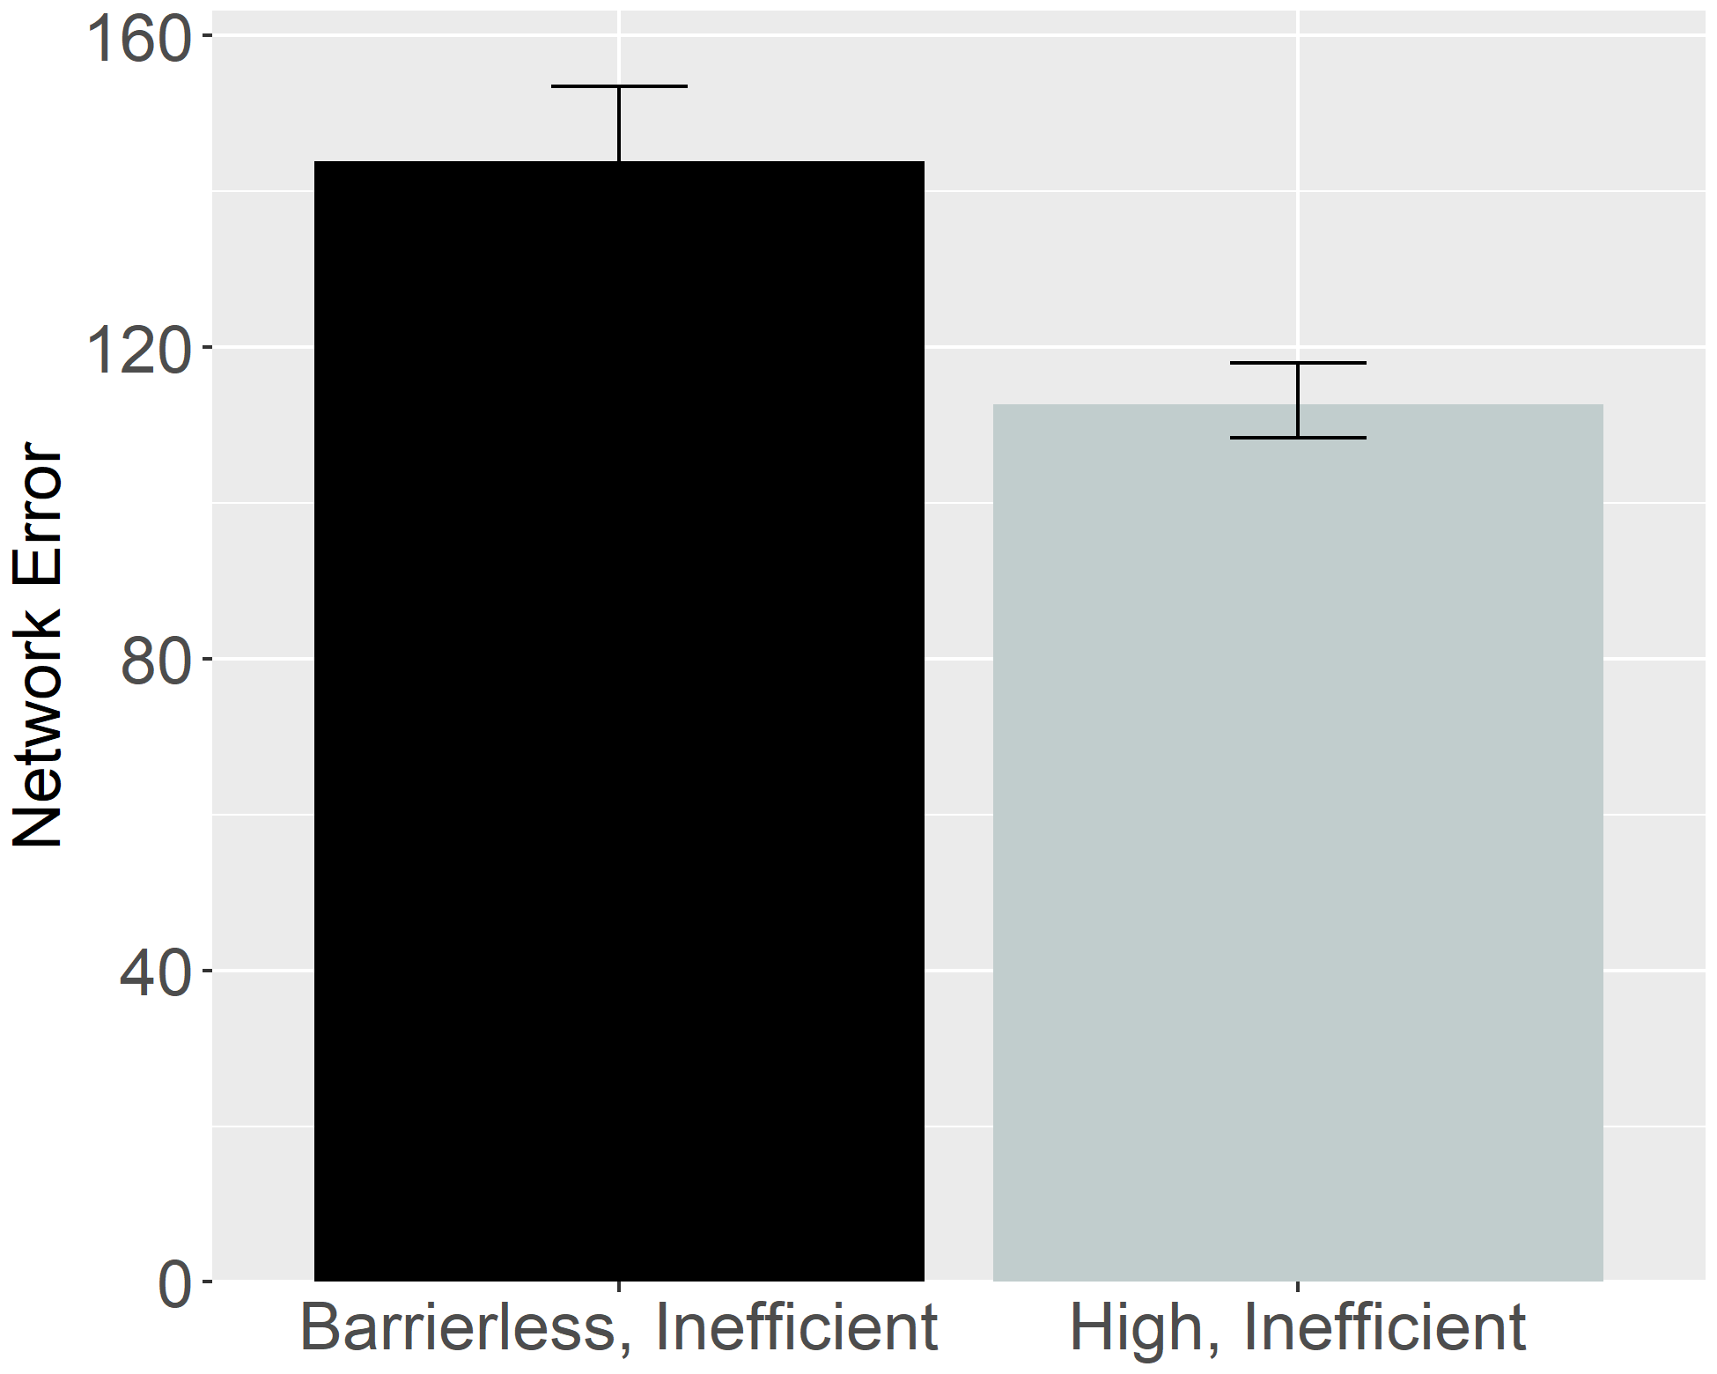
Figure 30. Performance of ALIAS. Overall error produced to the High, inefficient and Inefficient test events.

Figure 30 shows that networks produced more error to the Barrierless, inefficient test event than to the High, inefficient one. The former test event produced more error than the latter one because many of its input features strongly activated the associated straight-motion representation, a representation that ultimately conflicted with the observed arced motion. By contrast, the High, inefficient test event produced less error because the associations among its input features were largely consistent with those formed during pretraining.
The results presented in this section are theoretically significant because arguably they are at odds with what any of the domain-specific proposals discussed here would predict. If these accounts are correct that action processing depends on the efficiency, cost, and subjective utility of those actions, among other things, then infants should show equivalent dishabituation to both inconsistent events because both events are non-rational and costly. This contention falls directly out of the math of the naïve utility calculus, the full details of which are beyond the scope of this paper (see Jara-Ettinger et al., 2016; Jara-Ettinger et al., 2020). In this model, cost is defined in terms of an agent’s actions (or more formally, its policy)—this policy is equivalent in both inefficient test events. These accounts also predict equivalent performance between the Suspended Central Obstacle Event and Suspended Peripheral Obstacle Event conditions. In both conditions, the agent’s actions are not rational given the environmental constraints.

General Discussion
Developmental scientists have long wrestled with how infants discover that some actions are more efficient than others. Rich proposals maintain that infants possess early-emerging and conceptually rich domain-specific systems that support processing actions in terms of their efficiency, cost, rationality, and subjective utility, among other things (Csibra & Gergely, 1998; Gergely & Csibra, 2003; Jara-Ettinger et al., 2016; Jara-Ettinger et al., 2020; Liu et al., 2026). Lean proposals argue instead that infants’ behaviors in violation-of-expectation investigations broadly—of which studies assessing infants’ action efficiency understanding are specific instances reflect the operation of more domain-general processes.
This paper extends this second perspective in a model called ALIAS. Across five simulations, this model reproduced key findings in this literature that have been interpreted as evidence for domain-specific mechanisms. These include infants’ sensitivity to efficient and inefficient actions for animate and non-animate objects alike, bidirectional inferences about actions, goals, and constraints, graded representations of efficiency, and the effects of early action experience. Together, the simulations show that these phenomena can emerge from associative learning operating over perceptually grounded event representations.
The present results also showed that ALIAS provided a better account of these target findings than ALIAS-2 and VOM10-2. Table 3 makes this point especially clear. The table shows that ALIAS successfully captured all five target findings as well as the more specific findings associated with each target finding. In contrast, the remaining models either failed to capture several of the target findings, could only partially capture them, or could not be used to simulate them because of theoretical limitations.

Table 3. Qualitative fits of the different models to the five target findings examined in the current paper.
 |  |  |  | Model
Target finding | Illustrative paradigm | Articles | ALIAS | ALIAS-2 | VOM10 | VOM10-2
- Selective longer looking to inefficient than efficient actions following constrained habituation. | Animate agent constrained action | Csibra et al. (1999); Gergely et al. (1995) |  |  |  | 
 | Animate agent unconstrained action |  |  |  |  | 
- Independence from animacy. | Inanimate-agent constrained action | Csibra et al. (1999) Sodian et al. (2004) |  |  |  | 
 | Inanimate agent unconstrained action |  |  |  |  | 
- Bidirectional inferences about actions, goals, and constraints. | Goal inference | Csibra et al. (2003); Wagner & Carey (2005) |  |  |  | 
 | Constraint inference |  |  |  |  | 
- Graded representations of efficiency. | More costly vs. less costly constrained action | Liu & Spelke (2017) |  |  | — | 
 | More costly vs. less costly unconstrained action |  |  |  | — | 
 | More costly vs. less costly constrained action with a previously inefficient agent |  |  |  | — | 
- Action efficiency understanding in pre-reaching infants. | Sticky mittens training constrained action | Skerry et al. (2013) |  |  | — | —
 | Non-sticky mittens training constrained action |  |  |  | — | —
 | Sticky mittens training unconstrained action |  |  |  | — | —
Note. Check marks indicate that a given model captured the qualitative pattern associated with a target finding and its corresponding illustrative paradigm; Xs indicate that the model failed to capture the finding; and dashes indicate that the model could not meaningfully be applied to the corresponding target and illustrative paradigm. Illustrative paradigms are nested within the broader target finding to which they correspond. Because several of the current target findings were derived from multiple experiments and published studies, the associated citations are also provided.

As it relates to VOM10—the main competitor model—this model was unable to reproduce the third and fifth target findings. VOM10’s failure to capture the third and fifth target findings can be attributed to a common source: the absence of prior action processing experience. Yet just such experience is required for the model to represent aspects of the visual scene that otherwise were absent or to model the role of experience on action processing. Although VOM10 captured the first target finding, even here caution is warranted. This is because a revised version of this model—which more faithfully simulated the experimental task from which the first target finding derived—failed to reproduce this finding. This suggests that VOM10’s original success stemmed from quirks relating to how this model can be used to simulate action efficiency understanding studies rather than from its ability to capture the processes underlying action efficiency processing in infants. Interestingly, Simulation 4 demonstrated that retaining such quirks prevented VOM10 from capturing infants’ graded sensitivity to efficiency. This failure should not be interpreted as failures of connectionist systems more broadly. ALIAS could not have reproduced the target findings if this were true.
In terms of the novel contributions that the current simulations make, two are particularly noteworthy. First, they provided insight into the mechanistic basis of infants’ looking responses in action efficiency understanding studies. As one example, Simulation 4 demonstrated that prior experience with curved trajectories and obstacles can explain why infants look longer at events depicting barrierless arced motion than those depicting constrained arced motion or why infants look longer when agents stop short of their goals than when they stop next to them: Both error patterns were the emergent consequence of prior experience observing arced motion in the presence of barriers and actions that terminate in the agent being spatially contiguous with its goal. As another example, Simulation 5 showed that increased error to the Inefficient than to the Efficient test events can be expected in an otherwise developmentally inexperienced system that develops a representation of its own straight reaches while in a heightened attentional state. Action events whose kinematics subsequently deviate from this learned representation (e.g., the Inefficient test event) should elicit more error than events whose kinematics overlap with this representation (e.g., the Efficient test event). In general, ALIAS’s behavior here was based not on e specialized processes or explicit notions of goals, action, efficiency, cost, or rationality but rather on associations—formed during pretraining and reinforced (or weakened) during habituation—among differentially salient, conceptually neutral visible surface features.
Second, the current simulations generate a number of testable predictions. One is that infants who are habituated to a constrained action event and then tested on a High, inefficient test event like that in Liu and Spelke (2017) and a Barrierless, inefficient test event like that in Gergely et al. (1995) should look longer at latter than the former event. Another prediction is that infants should look longer at an Inefficient test event than at an Efficient one following habituation to an event in which arced motion unfolds beneath rather than over an obstacle. Although not explicitly tested here, another prediction the model makes is that increasing the salience of peripherally located obstacles should enable infants to form robust associations between them and arced motion. Conversely, decreasing the salience of centrally located obstacles should prevent robust associations from forming between them and arced motion. Still another prediction—again not explicitly tested here—the model makes is that infants should look longer at Barrierless, inefficient test event than an Efficient test event, even in the absence of habituation. Behavioral findings that corroborate any of these predictions—but ideally all of them—would be difficult to reconcile under any of the current domain-specific proposals.
The present account may also help to explain an apparent discontinuity between action efficiency processing in infancy and later development. On the one hand, studies with infants suggest that sensitivity to action efficiency emerges sometime between 6 and 12 months of age (e.g., Csibra et al., 2003; Csibra et al., 1999; Gergely et al., 1995; Liu & Spelke, 2017; Liu et al., 2017), if not earlier (e.g., Liu et al., 2019; Skerry et al., 2013). On the other hand, evidence from toddlers and young children is more equivocal. Some findings are consistent with the view that action efficiency understanding is continuous throughout development. For example, 14-month-olds imitate inefficient actions only when more efficient alternatives are unavailable (Gergely et al., 2002), 2-year-olds use cost information when evaluating others' behavior (Jara-Ettinger et al., 2015), and 5-year-olds reason productively about others' actions in terms of the costs and rewards (Jara-Ettinger et al., 2015). In contrast, other studies show that preschool-aged children neither distinguish efficient from inefficient actions (e.g., Ossmy et al., 2021) nor do they expect agents to follow more efficient and less costly paths when pursuing goals (e.g., Gönül & Paulus, 2021). These diverging findings are difficult to reconcile under the present domain-specific theories because each implicitly assumes continuity in the mechanisms supporting action efficiency understanding. Yet, if sophisticated notions like goals, efficiency, cost, and utility really do guide infants’ action processing, then it is unclear why evidence for such representations are present in early infancy but not in early childhood.
This discrepancy evaporates if the current account is correct that looking behavior in studies on this topic reflects low-level associative processes operating over visible surface features. If so, such behavior does not reflect veridical efficiency-based action processing. One outstanding question concerns how genuine efficiency-based action processing develops. Although ALIAS is not a theory of how this capacity emerges, there is no reason to think that its development is not ultimately rooted in the same general associative processes. Indeed, a similar proposal has been advanced in another domain. The proposal in question is Associative Sequence Learning (ASL; e.g., Heyes & Ray, 2000; Heyes, 2001) and the phenomenon it seeks to explain is imitation. ASL is relevant because it demonstrates how a capacity like imitation can emerge via more general associative-based processes. According to ASL, repeated pairings between observed and executed actions establish associations linking perception and action. Over time, these associations become sufficiently strong that observing another person's action elicits the corresponding motor response. Importantly, ASL does not deny that imitation is a sophisticated cognitive ability; rather, it maintains that such sophistication is the emergent consequence of learning rather than specialized mechanisms. The present account adopts a similar perspective. Although ALIAS is concerned with infants' early looking behavior rather than the development of efficiency-based action processing, the notion that the latter develops via the very same associative processes that underpin the former is entirely consistent with it. At the same time, observation alone might be insufficient to support a complete understanding of action efficiency. Physically experiencing the efficiency of one's own actions may be additionally important (e.g., Ossmy et al., 2021). Mature efficiency-based action processing may thus arise from a combination of observation and action, thereby allowing perceptually grounded associative representations to become integrated with action production over development.
Before concluding, two potential criticisms of ALIAS are worth noting. The first concerns the fact that the present simulations focused primarily on studies employing some version of the Gergely paradigm. Potential downsides of this are that the conclusions that can be drawn from it are necessarily limited in scope and that it is unclear to what extent the current model can capture findings on infant action understanding broadly (e.g., Gergely et al., 2002; Woodward, 1998). Future work will therefore need to determine whether extended versions of ALIAS can capture findings beyond those related to infants’ action efficiency understanding.
The second concerns the model’s simplicity. Although movement was represented dynamically, all other aspects of the model were represented statically. Additionally, a localist rather than a distributed encoding scheme was used to represent objects, their features, and any external constraints or barriers in the environment. Based on these simplifications, the model may poorly approximate infants’ real-world action experience. Although I do not dispute this critique, this simplification was deliberate: Because simple models afford tracing precisely how simple model’s process information, it is possible to elucidate the mechanisms driving the model’s performance and thus to advance theories of infant cognitive development. Although it is true that complex models better capture the richness of infants’ action perception, a major disadvantage of such models is that their complexity hinders their interpretability. This complexity also makes it difficult to separate the meaningful consequences of different theoretical assumptions from extraneous model details.
In sum, ALIAS reproduced benchmark findings that previously were interpreted as evidence for specialized mechanisms and abstract efficiency-based notions of action. The model achieved this via an associative-learning mechanism operating over perceptual features and action kinematics. The success of this model does not mean that infants do not possess an efficiency-based understanding of action. They show instead that existing looking-time evidence does not uniquely require that interpretation. Thus, before concluding that infants’ performance reflects domain-specific and early-emerging concepts, future studies must first rule out the possibility that such performance reflects associative processes and visible surface features.
References
Baillargeon, R. (1986). Representing the existence and the location of hidden objects: Object permanence in 6-and 8-month-old infants. Cognition, 23(1), 21–41. https://doi.org/10.1016/0010-0277(86)90052-1
Baillargeon, R. (1987). Object permanence in 3½- and 4½-month-old infants. Developmental Psychology, 23(5), 655–664. https://doi.org/10.1037/0012-1649.23.5.655
Baillargeon, R., & DeVos, J. (1991). Object permanence in young infants: Further evidence. Child Development, 62(6), 1227–1246. https://doi.org/10.1111/j.1467-8624.1991.tb01602.x
Baillargeon, R., Spelke, E. S., & Wasserman, S. (1985). Object permanence in five-month-old infants. Cognition, 20(3), 191–208. https://doi.org/10.1016/0010-0277(85)90008-3
Benton, D. T. (2022). The elusive “Developmental Mechanism”: What they are and how to study and test them. Developmental Review, 65, 101034. https://doi.org/10.1016/j.dr.2022.101034
Benton, D. T. (2023). But what is the mechanism?’: Demystifying the ever elusive ‘developmental mechanism. Infant and Child Development, 32(6), e2355. https://doi.org/10.1002/icd.2355
Benton, D. T. (2025). An associative-learning account of how infants learn about causal action in animates and inanimates: A critical reexamination of four classic studies. Journal of Experimental Psychology: General, 154(2), 497–521. https://doi.org/10.1037/xge0001656
Benton, D.T., & Hoch, J.E. (2026). An associative learning account of how saliva becomes a cue for comfort. Child Development. 10.1093/chidev/aacag119
Benton, D. T., & Lapan, C. (2021). Moral masters or moral apprentices? A connectionist account of sociomoral evaluation in preverbal infants. Cognitive Development, 62, 101164. https://doi.org/10.1016/j.cogdev.2022.101164
Benton, D. T., Kamper, D., Beaton, R. M., & Sobel, D. M. (2024). Don't throw the associative baby out with the Bayesian bathwater: Children are more associative when reasoning retrospectively under information processing demands. Developmental Science, 27(3), e13464. https://doi.org/10.1111/desc.13464
Berthiaume, V. G., Shultz, T. R., & Onishi, K. H. (2013). A constructivist connectionist model of transitions on false-belief tasks. Cognition, 126(3), 441–458. https://doi.org/10.1016/j.cognition.2012.11.007
Blumberg, M. S., & Adolph, K. E. (2023). Protracted development of motor cortex constrains rich interpretations of infant cognition. Trends in cognitive sciences, 27(3), 233-245. https://doi.org/10.1016/j.tics.2022.12.014
Bogartz, R. S., Shinskey, J. L., & Schilling, T. H. (2000). Object permanence in five‐and‐a‐half‐month‐old infants?. Infancy, 1(4), 403–428. https://doi.org/10.1207/S15327078IN0104_3
Bomba, P. C., & Siqueland, E. R. (1983). The nature and structure of infant form categories. Journal of Experimental Child Psychology, 35(3), 294–328. https://doi.org/10.1016/0022-0965(83)90085-3
Carey, S. (2009). The origin of concepts. Oxford University Press.
Christiansen, M. H., & Curtin, S. (1999). Transfer of learning: Rule acquisition or statistical learning? Trends in Cognitive Sciences, 3(8), 289–290. https://doi.org/10.1016/S1364-6613(99)01356-X
Clearfield, M. W., & Mix, K. S. (1999). Number versus contour length in infants' discrimination of small visual sets. Psychological science, 10(5), 408-411. https://doi.org/10.1111/1467-9280.00177
Cohen, L. B. (1973). A two-process model of infant visual attention. Merrill-Palmer Quarterly, 19(3), 157–180.
Cohen, L. B., Chaput, H. H., & Cashon, C. H. (2002). A constructivist model of infant cognition. Cognitive Development, 17(3–4), 1323–1343. https://doi.org/10.1016/S0885-2014(02)00124-7
Cohen, L. B., & Marks, K. S. (2002). How infants process addition and subtraction events. Developmental Science, 5(2), 186–201. https://doi.org/10.1111/1467-7687.00220
Cohen, L. B., & Oakes, L. M. (1993). How infants perceive a simple causal event. Developmental Psychology, 29(3), 421–433. https://doi.org/10.1037/0012-1649.29.3.421
Colunga, E., & Smith, L. B. (2005). From the lexicon to expectations about kinds: A role for associative learning. Psychological Review, 112(2), 347–382. https://doi.org/10.1037/0033-295X.112.2.347
Csibra, G., & Gergely, G. (1998). The teleological origins of mentalistic action explanations: A developmental hypothesis. Developmental Science, 1(2), 255–259. https://doi.org/10.1111/1467-7687.00039
Csibra, G., Bíró, S., Koós, O., & Gergely, G. (2003). One‐year‐old infants use teleological representations of actions productively. Cognitive Science, 27(1), 111–133. https://doi.org/10.1207/s15516709cog2701_4
Csibra, G., Gergely, G., Bíró, S., Koos, O., & Brockbank, M. (1999). Goal attribution without agency cues: The perception of 'pure reason' in infancy. Cognition, 72(3), 237–267. https://doi.org/10.1016/S0010-0277(99)00039-6
Elman, J. L. (1990). Finding structure in time. Cognitive Science, 14(2), 179–211. https://doi.org/10.1207/s15516709cog1402_1
Gelman, R. (1990). First principles organize attention to and learning about relevant data: Number and the animate‐inanimate distinction as examples. Cognitive Science, 14(1), 79–106. https://doi.org/10.1207/s15516709cog1401_5
Geraci, A., & Surian, L. (2011). The developmental roots of fairness: Infants' reactions to equal and unequal distributions of resources. Developmental Science, 14(5), 1012–1020. https://doi.org/10.1111/j.1467-7687.2011.01048.x
Geraci, A., Surian, L., Tina, L. G., et al. (2025). Human newborns spontaneously attend to prosocial interactions. Nature Communications, 16, 6304. https://doi.org/10.1038/s41467-025-61517-3
Gergely, G., Bekkering, H., & Király, I. (2002). Rational imitation in preverbal infants. Nature, 415(6873), 755. https://doi.org/10.1038/415755a
Gergely, G., & Csibra, G. (2003). Teleological reasoning in infancy: The naïve theory of rational action. Trends in Cognitive Sciences, 7(7), 287–292. https://doi.org/10.1016/S1364-6613(03)00128-1
Gergely, G., Nádasdy, Z., Csibra, G., & Bíró, S. (1995). Taking the intentional stance at 12 months of age. Cognition, 56(2), 165–193. https://doi.org/10.1016/0010-0277(95)00661-H
Gönül, G., & Paulus, M. (2021). Children’s reasoning about the efficiency of others’ actions: The development of rational action prediction. Journal of Experimental Child Psychology, 204, 105035. https://doi.org/10.1016/j.jecp.2020.105035
Haith, M. M. (1998). Who put the cog in infant cognition? Is rich interpretation too costly? Infant Behavior and Development, 21(2), 167–179. https://doi.org/10.1016/S0163-6383(98)90001-7
Hamlin, J. K. (2013). Moral judgment and action in preverbal infants and toddlers: Evidence for an innate moral core. Current Directions in Psychological Science, 22(3), 186–193. https://doi.org/10.1177/0963721412470687
Hamlin, J. K., & Wynn, K. (2011). Young infants prefer prosocial to antisocial others. Cognitive Development, 26(1), 30–39. https://doi.org/10.1016/j.cogdev.2010.09.001
Hamlin, J. K., Wynn, K., & Bloom, P. (2007). Social evaluation by preverbal infants. Nature, 450(7169), 557–559. https://doi.org/10.1038/nature06288
Heyes, C. (2018). Cognitive gadgets: The cultural evolution of thinking. Harvard University Press.
Heyes, C. (2001). Causes and consequences of imitation. Trends in cognitive sciences, 5(6), 253-261. https://doi.org/10.1016/S1364-6613(00)01661-2
Heyes, C. (2024). Rethinking norm psychology. Perspectives on Psychological Science, 19(1), 12-38. https://doi.org/10.1177/17456916221112075
Heyes, C. M., & Ray, E. D. (2000). What is the significance of imitation in animals?. In Advances in the Study of Behavior (Vol. 29, pp. 215-245). Academic Press. https://doi.org/10.1016/S0065-3454(08)60106-0
Hinton, G. E. (1984). Distributed representations (Technical Report CMU-CS-84-157). Carnegie-Mellon University, Department of Computer Science.
Hinton, G. E. (1989). Deterministic Boltzmann learning performs steepest descent in weight-space. Neural Computation, 1(1), 143–150. https://doi.org/10.1162/neco.1989.1.1.143
Hunter, M. A., & Ames, E. W. (1988). A multifactor model of infant preferences for novel and familiar stimuli. Advances in Infancy Research, 5, 69–95.
Hunter, M. A., Ames, E. W., & Koopman, R. (1983). Effects of stimulus complexity and familiarization time on infant preferences for novel and familiar stimuli. Developmental Psychology, 19(3), 338–352. https://doi.org/10.1037/0012-1649.19.3.338
Jara-Ettinger, J., Gweon, H., Schulz, L. E., & Tenenbaum, J. B. (2016). The naïve utility calculus: Computational principles underlying commonsense psychology. Trends in Cognitive Sciences, 20(8), 589–604. https://doi.org/10.1016/j.tics.2016.05.011
Jara-Ettinger, J., Gweon, H., Tenenbaum, J. B., & Schulz, L. E. (2015). Children’s understanding of the costs and rewards underlying rational action. Cognition, 140, 14-23. https://doi.org/10.1016/j.cognition.2015.03.006
Jara-Ettinger, J., Schulz, L. E., & Tenenbaum, J. B. (2020). The naive utility calculus as a unified, quantitative framework for action understanding. Cognitive Psychology, 123, 101334. https://doi.org/10.1016/j.cogpsych.2020.101334
Jara-Ettinger, J., Tenenbaum, J. B., & Schulz, L. E. (2015). Not so innocent: Toddlers’ inferences about costs and culpability. Psychological science, 26(5), 633-640. https://doi.org/10.1177/0956797615572806
Jones, S. S., & Smith, L. B. (1993). The place of perception in children's concepts. Cognitive Development, 8(2), 113–139. https://doi.org/10.1016/0885-2014(93)90008-S
Kamewari, K., Kato, M., Kanda, T., Ishiguro, H., & Hiraki, K. (2005). Six-and-a-half-month-old children positively attribute goals to human action and to humanoid-robot motion. Cognitive Development, 20(2), 303–320. https://doi.org/10.1016/j.cogdev.2005.04.004
Kellman, P. J., & Spelke, E. S. (1983). Perception of partly occluded objects in infancy. Cognitive Psychology, 15(4), 483–524. https://doi.org/10.1016/0010-0285(83)90017-8
Kim, I. K., & Spelke, E. S. (1992). Infants' sensitivity to effects of gravity on visible object motion. Journal of Experimental Psychology: Human Perception and Performance, 18(2), 385–393. https://doi.org/10.1037/0096-1523.18.2.385
Kotovsky, L., & Baillargeon, R. (1998). The development of calibration-based reasoning about collision events in young infants. Cognition, 67(3), 311–351. https://doi.org/10.1016/S0010-0277(98)00036-5
Leslie, A. M. (1995). A theory of agency. In D. Sperber, D. Premack, & A. J. Premack (Eds.), Causal cognition: A multidisciplinary debate (pp. 121–141). Clarendon Press.
Leslie, A. M., & Keeble, S. (1987). Do six-month-old infants perceive causality?. Cognition, 25(3), 265–288. https://doi.org/10.1016/S0010-0277(87)80006-9
Liu, S., Brooks, N. B., & Spelke, E. S. (2019). Origins of the concepts cause, cost, and goal in prereaching infants. Proceedings of the National Academy of Sciences, 116(36), 17747–17752. https://doi.org/10.1073/pnas.1904786116
Liu, S., & Spelke, E. S. (2017). Six-month-old infants expect agents to minimize the cost of their actions. Cognition, 160, 35–42. https://doi.org/10.1016/j.cognition.2016.12.007
Lucca, K., Yuen, F., Wang, Y., Alessandroni, N., Allison, O., Alvarez, M., ... & Hamlin, J. K. (2025). Infants' social evaluation of helpers and hinderers: A large‐scale, multi‐lab, coordinated replication study. Developmental Science, 28(1), e13581. https://doi.org/10.1111/desc.13581
Marr, D. (1982). Vision: A computational investigation into the human representation and processing of visual information. W. H. Freeman.
Mareschal, D., French, R. M., & Quinn, P. C. (2000). A connectionist account of asymmetric category learning in early infancy. Developmental Psychology, 36(5), 635–645. https://doi.org/10.1037/0012-1649.36.5.635
Mareschal, D., & Shultz, T. R. (1999). Development of children's seriation: A connectionist approach. Connection Science, 11(2), 149–186. https://doi.org/10.1080/095400999116322
McClelland, J. L., & Thompson, R. M. (2007). Using domain-general principles to explain children's causal reasoning abilities. Developmental Science, 10(3), 333–356. https://doi.org/10.1111/j.1467-7687.2007.00586.x
McCrink, K., & Wynn, K. (2004). Large-number addition and subtraction by 9-month-old infants. Psychological Science, 15(11), 776–781. https://doi.org/10.1111/j.0956-7976.2004.00755.x
McMahon, E., & Isik, L. (2023). Seeing social interactions. Trends in cognitive sciences, 27(12), 1165-1179. https://doi.org/10.1016/j.tics.2023.09.001
Meltzoff, A. N., & Moore, M. K. (1997). Explaining facial imitation: A theoretical model. Infant and child development, 6(3‐4), 179-192. https://doi.org/10.1002/(SICI)1099-0917(199709/12)6:3/4%3C179::AID-EDP157%3E3.0.CO;2-R
Muentener, P., & Carey, S. (2010). Infants' causal representations of state change events. Cognitive Psychology, 61(2), 63–86. https://doi.org/10.1016/j.cogpsych.2010.02.001
Munakata, Y. (1998). Infant perseveration and implications for object permanence theories: A PDP model of the AB task. Developmental Science, 1(2), 161–184. https://doi.org/10.1111/1467-7687.00021
Munakata, Y., McClelland, J. L., Johnson, M. H., & Siegler, R. S. (1997). Rethinking infant knowledge: Toward an adaptive process account of successes and failures in object permanence tasks. Psychological Review, 104(4), 686–713. https://doi.org/10.1037/0033-295X.104.4.686
Nair, V., & Hinton, G. E. (2010). Rectified linear units improve restricted boltzmann machines. In Proceedings of the 27th international conference on machine learning (ICML-10) (pp. 807-814).
Needham, A., & Baillargeon, R. (1997). Object segregation in 8-month-old infants. Cognition, 62(2), 121–149. https://doi.org/10.1016/S0010-0277(96)00727-5
Needham, A., Barrett, T., & Peterman, K. (2002). A pick-me-up for infants' exploratory skills: Early simulated experiences reaching for objects using 'sticky mittens' enhances young infants' object exploration skills. Infant Behavior and Development, 25(3), 279–295. https://doi.org/10.1016/S0163-6383(02)00097-8
Onishi, K. H., & Baillargeon, R. (2005). Do 15-month-old infants understand false beliefs?. Science, 308(5719), 255–258. https://doi.org/10.1126/science.1107621
Ossmy, O., Han, D., Kaplan, B. E., Xu, M., Bianco, C., Mukamel, R., & Adolph, K. E. (2021). Children do not distinguish efficient from inefficient actions during observation. Scientific Reports, 11(1), 18106. https://doi.org/10.1038/s41598-021-97354-9
Perner, J., & Ruffman, T. (2005). Infants' insight into the mind: How deep?. Science, 308(5719), 214–216. https://doi.org/10.1126/science.1111656
Phillips, A. T., & Wellman, H. M. (2005). Infants' understanding of object-directed action. Cognition, 98(2), 137–155. https://doi.org/10.1016/j.cognition.2004.11.005
Plaut, D. C., & Vande Velde, A. K. (2017). Statistical learning of parts and wholes: A neural network approach. Journal of Experimental Psychology: General, 146(3), 318–336. https://doi.org/10.1037/xge0000260
Powell, L. J., & Spelke, E. S. (2018). Human infants' understanding of social imitation: Inferences of affiliation from third party observations. Cognition, 170, 31–48. https://doi.org/10.1016/j.cognition.2017.09.007
Quinn, P. C., & Eimas, P. D. (1997). A reexamination of the perceptual-to-conceptual shift in mental representations. Review of General Psychology, 1(3), 271–287. https://doi.org/10.1037/1089-2680.1.3.271
Quinn, P. C., & Johnson, M. H. (2000). Global-before-basic object categorization in connectionist networks and 2-month-old infants. Infancy, 1(1), 31–46. https://doi.org/10.1207/S15327078IN0101_04
Rakison, D. H., & Lupyan, G. (2008). Developing object concepts in infancy: An associative learning perspective. Monographs of the Society for Research in Child Development, 73(1), 1–110. https://doi.org/10.1111/j.1540-5834.2008.00469.x
Rohde, D. L. T. (1999). LENS: The light, efficient network simulator (Technical Report CMU-CS-99-164). Carnegie Mellon University.
Rumelhart, D. E., Hinton, G. E., & Williams, R. J. (1986). Learning representations by back-propagating errors. Nature, 323(6088), 533–536. https://doi.org/10.1038/323533a0
Scarf, D., Imuta, K., Colombo, M., & Hayne, H. (2012a). Golden Rule or valence matching? Methodological problems in Hamlin et al. Proceedings of the National Academy of Sciences, 109(22), E1426-E1426. https://doi.org/10.1073/pnas.1204123109
Scarf, D., Imuta, K., Colombo, M., & Hayne, H. (2012b). Social evaluation or simple association? Simple associations may explain moral reasoning in infants. PLOS ONE, 7(8), e42698. https://doi.org/10.1371/journal.pone.0042698
Schlesinger, M., & Casey, P. (2003). Where infants look when impossible things happen: Simulating and testing a gaze-direction model. Connection Science, 15(4), 271–280. https://doi.org/10.1080/09540090310001655093
Schlingloff, L., Csibra, G., & Tatone, D. (2020). Do 15-month-old infants prefer helpers? A replication of Hamlin et al. (2007). Royal Society Open Science, 7(4), 191795. https://doi.org/10.1098/rsos.191795
Schmidt, M. F., & Sommerville, J. A. (2011). Fairness expectations and altruistic sharing in 15-month-old human infants. PLoS ONE, 6(10), e23223. https://doi.org/10.1371/journal.pone.0023223
Schwier, C., Van Maanen, C., Carpenter, M., & Tomasello, M. (2006). Rational imitation in 12-month-old infants. Infancy, 10(3), 303–311. https://doi.org/10.1207/s15327078in1003_6
Scott, L. S., & Arcaro, M. J. (2023). A domain-relevant framework for the development of face processing. Nature Reviews Psychology, 2(3), 183–195. https://doi.org/10.1038/s44159-023-00152-5
Simon, T. J. (1997). Reconceptualizing the origins of number knowledge: A “non-numerical” account. Cognitive development, 12(3), 349-372. https://doi.org/10.1016/S0885-2014(97)90008-3
Singh, S. E., Benton, D. T., & Lei, R. F. (2025). Using artificial neural networks to simulate social category learning: A tutorial. Social Cognition, 43(3), 152–166. https://doi.org/10.1521/soco.2025.43.3.152
Sirois, S., & Mareschal, D. (2002). Models of habituation in infancy. Trends in Cognitive Sciences, 6(7), 293–298. https://doi.org/10.1016/S1364-6613(02)01926-5
Skerry, A. E., Carey, S. E., & Spelke, E. S. (2013). First-person action experience reveals sensitivity to action efficiency in prereaching infants. Proceedings of the National Academy of Sciences, 110(46), 18728–18733. https://doi.org/10.1073/pnas.1318053110
Slater, A. (1989). Visual memory and perception in early infancy. In A. Slater & G. Bremner (Eds.), Infant development (pp. 43–71). Erlbaum.
Sloutsky, V. M. (2010). From perceptual categories to concepts: What develops?. Cognitive Science, 34(7), 1244–1286. https://doi.org/10.1111/j.1551-6709.2010.01129.x
Sodian, B., Schoeppner, B., & Metz, U. (2004). Do infants apply the principle of rational action to human agents? Infant Behavior and Development, 27(1), 31–41. https://doi.org/10.1016/j.infbeh.2003.05.006
Sokolov, E. N. (1963). Higher nervous functions: The orienting reflex. Annual Review of Physiology, 25(1), 545–580. https://doi.org/10.1146/annurev.ph.25.030163.002553
Sommerville, J. A., Woodward, A. L., & Needham, A. (2005). Action experience alters 3-month-old infants' perception of others' actions. Cognition, 96(1), B1–B11. https://doi.org/10.1016/j.cognition.2004.07.004
Spelke, E. S. (2022). What babies know: Core knowledge and composition (Vol. 1). Oxford University Press.
Spelke, E. S., Breinlinger, K., Macomber, J., & Jacobson, K. (1992). Origins of knowledge. Psychological Review, 99(4), 605–632. https://doi.org/10.1037/0033-295X.99.4.605
Stahl, A. E., & Kibbe, M. M. (2022). Great expectations: The construct validity of the violation‐of‐expectation method for studying infant cognition. Infant and Child Development, 31(6), e2359. https://doi.org/10.1002/icd.2359
Vallortigara, G., Regolin, L., & Marconato, F. (2005). Visually inexperienced chicks exhibit spontaneous preference for biological motion patterns. PLoS Biology, 3(7), e208. https://doi.org/10.1371/journal.pbio.0030208
Van Overwalle, F. (2010). Infants' teleological and belief inference: A recurrent connectionist approach to their minimal representational and computational requirements. NeuroImage, 52(3), 1095–1108. https://doi.org/10.1016/j.neuroimage.2010.05.028
Wagner, L., & Carey, S. (2005). 12-month-old infants represent probable endings of motion events. Infancy, 7(1), 73–83. https://doi.org/10.1207/s15327078in0701_6
Westermann, G., & Mareschal, D. (2012). Mechanisms of developmental change in infant categorization. Cognitive Development, 27(4), 367–382. https://doi.org/10.1016/j.cogdev.2012.08.004
Williams, R. J., & Zipser, D. (1995). Gradient-based learning algorithms for recurrent networks and their computational complexity. In Y. Chauvin & D. E. Rumelhart (Eds.), Back-propagation: Theory, architectures and applications (pp. 433–486). Erlbaum.
Woo, B. M., Steckler, C. M., Le, D. T., & Hamlin, J. K. (2017). Social evaluation of intentional, truly accidental, and negligently accidental helpers and harmers by 10-month-old infants. Cognition, 168, 154–163. https://doi.org/10.1016/j.cognition.2017.06.029
Woodward, A. L. (1998). Infants selectively encode the goal object of an actor's reach. Cognition, 69(1), 1–34. https://doi.org/10.1016/S0010-0277(98)00058-4
Woodward, A. L., & Sommerville, J. A. (2000). Twelve-month-old infants interpret action in context. Psychological Science, 11(1), 73–77. https://doi.org/10.1111/1467-9280.00218
Wynn, K. (1992). Addition and subtraction by human infants. Nature, 358(6389), 749–750. https://doi.org/10.1038/358749a0
Wynn, K. (1995). Infants possess a system of numerical knowledge. Current Directions in Psychological Science, 4(6), 172–177. https://doi.org/10.1111/1467-8721.ep10772615
Younger, B. A. (1985). The segregation of items into categories by ten-month-old infants. Child Development, 56(6), 1574–1583. https://doi.org/10.2307/1130473

