“Associative learning over differentially salient surface features is sufficient to explain infants’ action efficiency understanding”
Abstract
One of the many challenges that young learners face is learning how to navigate the world. A key prerequisite for such navigation is distinguishing between efficient and inefficient actions. Several domain-specific proposals have been offered to explain how infants achieve this. The current paper departs from these proposals by arguing that infants' behaviors in studies that evaluate their action efficiency understanding can be explained by a combination of real-world experience with different kinds of actions and real-time, online domain-general associative learning. I demonstrate that when this proposal is implemented in a connectionist artificial neural network model, the model (and by extension, the proposal that it implements) can account for a range of findings from studies that use some version of the original Gergely et al. (1995) paradigm. The results of four simulation studies indicate that associative learning alone can explain several aspects of infants’ looking behavior in these experiments. Specifically, the model successfully captures the findings that infants look longer at inefficient actions than efficient ones, respond similarly to animate and inanimate agents, infer goals from observed constraints, and represent efficiency continuously. These results challenge the necessity of domain-specific accounts for action efficiency understanding. Instead, they suggest associative learning and real-world, third-person action experience provides a more parsimonious explanation of infants’ action efficiency understanding.
“Associative learning is sufficient to explain infants’ action efficiency understanding”
A key challenge for young learners is distinguishing between efficient and inefficient actions. For instance, a child may learn that it is safer and more efficient to use stairs to reach the top of a slide upon observing another child tumble down the slide after attempting clumsily to climb the slide from the bottom. An open question in the developmental cognitive sciences concerns when and how action efficiency understanding—that is, the capacity to detect and distinguish between efficient and inefficient actions—develops.
A considerable body of evidence now attests that the capacity to process actions in terms of their efficiency may be in place in infancy (Csibra et al., 1999; Gergely et al., 1995). Evidence for this comes from studies that have used the violation-of-expectation paradigm (e.g., Baillargeon et al., 1995). In this method, infants are habituated or familiarized either to events designed to establish an expectation of some kind or to acquaint them with the set-up of the experiment. In a subsequent test phase, infants are shown events that either conform to or violate the expectations that an adult observer might have formed during the initial phase (e.g., Stahl & Kibbe, 2022). One of the first studies to use this method to assess infant action efficiency understanding was that by Gergely et al. (1995). Twelve-month-old infants were habituated to an event in which an animated ball jumped over a barrier to reach another animated ball. Infants were then shown an old action test event—in which the first circle followed the familiar curved motion path to reach the large circle—and a new action test event—in which the small circle moved along a straight path to reach the large circle. The results revealed that infants looked longer at the old action event than at the new event. Data from infants in a control condition showed that they looked equally long at both events when the circle jumped beside the barrier.
This finding has since been extended in important ways. For example, efficiency-based expectations have been shown to apply not only to people (e.g., Phillips & Wellman, 2005; Sodian et al., 2004; Woodward & Sommerville, 2000; cf., Phillips & Wellman, 2005) and animals (e.g., Schwier et al., 2006) but also to geometric shapes (Csibra et al., 2003; Gergely et al., 1995) and inanimate or inert objects (Csibra et al., 1999; Kamewari et al., 2005). Additionally, recent evidence suggests that infants represent action efficiency in a more graded, continuous fashion rather than in an all-or-none manner (Liu & Spelke, 2017). Still other research has shown that action efficiency understanding can be elicited in infants as young as 3 months of age if they are given direct action experience (e.g., Skerry et al., 2013) or the action events are causally efficacious (e.g., Liu et al., 2019). Together, this research suggests that action efficiency understanding may be in place sometime in the second half of the first year of life.

Rich proposals for the origins of infant action efficiency understanding
Several proposals have been put forward to explain the mechanistic basis of such understanding. These proposals fall roughly into two classes. The first is “rich” proposals for the origins of infant action efficiency understanding. According to these accounts, infants possess from birth or shortly thereafter domain-specific mechanisms—that is, specialized processes that are triggered by a single input type and operate in a single domain—that support abstract and conceptually rich knowledge about how the various objects and entities in the world behave and act. An extremely prominent example of this kind of account is the teleological stance (Csibra & Gergely, 1998; Gergely & Csibra, 2003). Proponents of this account maintain that if an agent pursues some end state efficiently given the physical context—and thereby satisfies the “rationality principle”—then that end state will come to be seen as the agent’s goal, the agent's behavior as a goal-directed "means" to it, and the physical context as a set of "constraints”. In other words, an action is goal-directed to the extent that it is rational and efficient. Crucially, this account is “non-mentalistic” in that infants can recognize an action as goal-directed without considering or inferring an agent's mental states.
A conceptually related account is the naïve utility calculus (e.g., Jara-Ettinger et al., 2016; Jara-Ettinger et al., 2020). This proposal concerns how agents choose actions and how observers process those actions. On the agent side, actors evaluate possible plans—that is, sequences of actions that lead to a goal—and select the plan that maximizes expected subjective utilities. A subjective utility is the difference between the rewards that result from an outcome and the cost of executing the plan. Because making this difference as large as possible depends on minimizing unnecessary costs, agents are expected to carry out plans that are as efficient as possible, given the constraints of the environment. These utilities are considered “subjective” because the perceived rewards of an outcome and the perceived costs of a plan may differ across agents. On the observer side, observers must infer the rewards and costs that drove an agent’s behavior from the behavior itself. Bayesian inference has been used to describe how, at a computational level, learners solve this problem. The way observers solve this computational problem is via Bayesian inference.
A final account maintains that infant action efficiency understanding on the one hand and their reasoning about objects and entities on the other can be explained by two distinct yet interactive domain-specific systems (e.g., Liu et al., 2025). The naïve psychology system causes infants to represent agents as self-propelled, as possessing beliefs, desires, and goals, and as behaving in ways that maximize rewards and minimize costs. In contrast, the naïve physics system enables infants to represent objects as being solid, bounded, coherent, and permanent. A key assumption of this account is that the naïve psychology system depends on input from the naïve physics system. As Liu et al. (2026) state, “computations about the mind require input from naïve physics to return an answer”. Crucially, each of these accounts explain infants’ looking behaviors in action efficiency understanding studies in a similar way: Infants may mentally simulate different trajectories in the physical scene via Liu et al.’s (2026) naïve physics system along with computing their associated costs perhaps via the naïve utility calculus. If the barrier is removed and infants subsequently see an actor choose a now more costly curved path over a less-costly straight one, they should look longer at the old than at the new action. This pattern of looking should be especially likely if, as is stipulated by the teleological stance, infants expect agents to choose rational and efficient actions
Although each of these theories differ somewhat in their specifics, they share the notion that infants process others' actions terms of their efficiency, rationality, cost, and rewards, among other things. The notion that infants possess these concepts has some intuitive appeal, particularly adults likely use similar principles to process and interpret others' actions. Other attractive aspects of these accounts are that they address foundational questions at the heart of the developmental cognitive sciences, have generated a substantial body of research, and enjoy some degree of empirical support. Yet, important questions remain about key aspects of each proposal. For example, although proponents of the teleological stance maintain that infants interpret actions in terms of goals, constraints, efficiency, and rationality, the theory is notably silent about the origins of these notions. This is an important shortcoming given that possessing some idea of what makes an action rational or efficient is a prerequisite for judging whether an action is or is not efficient or rational. Another critique of this proposal is that it remains to be seen how, in precise mechanistic terms, an observed action consisting of an end state, a physical context, and observed behavior is transformed into an interpreted action representation consisting of goals, behaviors, and constraints (Csibra et al., 2003; Gergely & Csibra, 1997).
Similar concerns apply to the naive utility calculus account. Two concerns are particularly worth noting. The first is that this theory leaves unspecified the developmental origins of notions such as reward, cost, and subjective utility. The second is that because this perspective is cast at Marr’s (1982) computational level, it has yet to be determined how the computations specified by the theory are physically realized in the mind or what operations give rise to these computations. In terms of Liu et al.’s (2025) proposal, the primary concern is that the naïve psychology system presupposes concepts for agents and objects. However, as has been discussed extensively elsewhere, the difficulty with this position is that the evidence on which it is based comes largely from infants who have had months of potentially pertinent real-world experience (e.g., Benton, 2025; Haith, 1998; Rakison & Lupyan, 2008; Scott & Arcaro, 2023).
Given these criticisms, there are at least two viable paths forward. One is simply to address these criticisms through elaborations and refinements of the theories themselves. Another is to develop a fundamentally different account. This is the approach adopted here. I will argue that infants’ looking behavior in action efficiency understanding studies can be explained without recourse to domain-specific mechanisms or conceptually rich notions of agents, objects, goals, cost, subjective utility, efficiency or rationality. Instead, I will argue that such behavior emerges from domain-general learning mechanisms that operate over the perceptual regularities present in infants’ everyday experience. However, it is worth being clear from the outset that demonstrating that an alternative account can capture the very same data as domain-specific proposals does not disprove them any more than it proves that the alternative proposal is the one that underpins infants’ behavior. Nevertheless, such a demonstration does accomplish two things. First, it serves as proof of concept that infants’ behavior in studies purported to assess their action efficiency understanding can emerge from simpler and more general processes. Second, it calls into question whether the findings from these studies uniquely support richer, domain-specific interpretations. In what follows, I describe this alternative account. However, because it builds on existing lean explanations of infants’ performance in violation-of-expectation studies, I first briefly describe the core tenet of lean proposals. .

A lean account that can explain infants’ behavior in action efficiency understanding studies
In contrast to the rich proposals described above, a second class of “lean” proposals adopts a radically different viewpoint. The crux of these proposals is that infants’ behavior in violation-of-expectation studies—of which the study by Gergely et al. (1995) and others are special cases—do not reflect specialized processes for reasoning about agents, objects, number, physics, morality, or causality, among many other domains of knowledge. Instead, these proposals maintain that infants’ behavior in these studies can be explained by the operation of simple, albeit extremely powerful, domain-general learning mechanisms (e.g., associative learning, habituation, conditioning, pattern learning, statistical learning, prototype formation, etc.) that operate over low-level, surface-based perceptual features and information and that extract statistical regularities in visual scenes (e.g., Cohen et al., 2002; Colunga & Smith, 2005; Cohen & Oakes, 2003; Jones & Smith, 1993; Quinn & Eimas, 1997; Rakison & Lupyan, 2008; Sloutsky, 2010). Domain-general mechanisms are sometimes considered “all purpose” because they operate on many kinds of input and support learning across a wide range of domains. Although the specific details of the theories that constitute this class of perspectives differ widely, each places considerable importance on the visible, surface properties of objects and each emphasizes the notion that infants’ concepts for animates and inanimates are formed much more slowly than the available data may suggest. These perspectives are also united in the idea that the input that is available to infants is much more richly structured than had been previously thought. On this account, infants’ behaviors in violation-of-expectation studies do not reflect sophisticated adult-like abilities, conceptually rich knowledge, or abstract, theory-like inferences; rather, such abilities and knowledge may emerge gradually through a slow, effortful, and piecemeal process that begins in early infancy and continues into adulthood.
Although learn proposals abound for capacities such as theory of mind (e.g., Berthiaume et al., 2013; Perner & Ruffman, 2005), causal perception and reasoning (e.g., Cohen et al., 2002; McClelland & Thompson, 2007), sociomoral reasoning (e.g., Benton & Lapan, 2021), object permanence (e.g., Bogartz et al., 2000; Munakata et al., 1997), numerical cognition (e.g., Cohen & Marks, 2002), among others (e.g., Benton, 2025; Rakison & Lupyan, 2008), efforts to explain infants’ looking behavior in studies that assess their putative action efficiency understanding from the same perspective remain relatively scarce. A notable exception to this is a proposal by Overwalle (2010). In contrast to the teleological stance—which presupposes that infants possess a priori notions of efficiency—Overwalle’s (2010) position is that infants learn through experience that agents follow some but not other trajectories to reach a goal. An action is thus seen as efficient if aligns with the typical trajectory that an agent takes to obtain a goal; an action that deviates from this trajectory is seen as inefficient. Overwalle (2010) argued that such learning is achieved mechanistically via a forward model. The idea is that as infants watch agents follow particular paths to obtain a goal, corresponding internal representations are established that, with time, resemble the visible state of the world at each point along an agent’s action trajectory. On this view, then, infants are not actually predicting the agent’s position on the trajectory at the next point in time given its current position in time; instead, infants are learning internal representations that faithfully capture the visible state of the world as an action unfolds.
Overwalle (2010) showed that a connectionist implementation of this proposal could reproduce infants’ looking behavior in Gergely et al. (1995). Networks were “habituated” to an event in which an agent followed an arced trajectory to reach a goal; this was done either in the presence or absence of a barrier. Networks—like infants—were then shown barrierless straight and curved test events. The model reproduced infants’ tendency to show greater looking to the inefficient test event following habituation to the constrained (i.e., with a barrier) action event.
Although these results suggest that Overwalle’s (2010) account is sufficient to explain infants’ looking responses in Gergely et al. (1995), there are several reasons to exercise caution before accepting his proposal. The first concern is that the model lacked any action experience prior to participation in a simulation analogue of Gergely et al. (1995). A consequence of this is that the model could not draw on prior action observation experience when processing habituation and test events. Yet such experience may be precisely what is needed to account for findings like that by Csibra et al. (2003). In one of their experiments, 12-month-olds were habituated to an event like that shown in the Experimental condition in Gergely et al. (1995) except that the barrier was hidden behind an opaque screen. Infants could nonetheless still see the second object and the apex of the arced motion path as it moved to reach the second object. Infants were found to look longer when the first object followed the same path in the absence of an obstacle than when it did so in the presence of one. Overwalle’s (2010) model might be expected to struggle to account for this finding because doing so would entail spontaneously inferring aspects of the visual array that were notably absent during the habituation phase.
The second concern relates to the role that agents and goals play in Overwalle’s (2010) account. Although this account maintains that infants learn through experience that some actions are more efficient ways of achieving goals than others, the model itself presupposes a preexisting notion of agent and goal by stipulating units for each of these concepts. As such, this model leaves unresolved how such concepts develop in the first place.
A third limitation is that the model did not faithfully capture several key aspects of Gergely et al.’s (1995) study. Most notably, the Control condition differed between the behavioral and computational investigations. In Gergely et al.’s (1995) study, an obstacle appeared off to one side of the stage during habituation for infants in this condition. However, in Overwalle’s (2010) simulation, no such obstacle appeared during habituation. In Overwalle’s (2010) model, in contrast, no such obstacle was present during habituation. In addition to this discrepancy, the agent’s simulated curved trajectory overshot the barrier; no such overshooting occurs in typical infant action-efficiency studies (though see Liu & Spelke, 2017 and Simulation 4, which models it). Considered together, these issues limit what can be concluded about the sufficiency of Overwalle’s (2010) proposal for explaining infant action efficiency understanding.
Due in part to these limitations and given that Overwalle’s (2010) model is the only lean account of infant action efficiency understanding, the goals of the present paper were twofold. The first was to develop an alternative lean account that can both explain infants’ looking behaviors in Gergely et al. (1995) and can but capture a range of other key findings in this literature. I will demonstrate that when this alternative account is implemented in a new connectionist model called ALIAS (for Associative Learning for Infant Action Sequences), the model can readily reproduce such key findings. The second was to demonstrate that ALIAS provides a more complete account of infants’ looking behavior than Overwalle’s (2010) original model and an extension of it.
The crux of my proposal is that infants’ looking behaviors in action efficiency understanding studies reflects their extensive real-world experience observing agents move along straight and curved trajectories in the presence or absence of physical barriers. Over time, infants may learn that curved motion tends to co-occur with obstacles, whereas straight motion tends to occur in unobstructed contexts. A critical assumption of the current proposal is that infants process and represent actions in terms of their semantically neutral kinematics and represent obstacles and the agents that avoid them in terms of similarly neutral surface features. Importantly, associations formed by infants between curved trajectories and barriers in the real world may be reinforced during the habituation phase of studies such as Gergely et al. (1995). A corollary of such associations is that, if it is sufficiently strong, the presence of one component of the relation will trigger expectations about the other. Test events that then violate these expectations should therefore evoke longer looking than those that confirm them.
Given that infants in the Control condition were also habituated to an event that included curved motion and a barrier, one may wonder why infants in this condition do not show the same pattern of looking. However, such a prediction would conflict with the observed data. It will be recalled that infants in the Control condition looked equally long at both test events. Although it is true that the habituation event in both conditions depict curved motion and a barrier, a key difference between the habituation experiences of infants in both conditions is that the curved motion occurred over a barrier in the Experimental condition but beside it in the Control condition. A corollary of this is that the strength of the link (i.e., association) between curved motion and the barrier may be stronger when the curved motion repeatedly occurs over rather than beside it. This may have to do with the fact that when the jumping action occurs over the barrier, the curved motion and the barrier occupy the same region of the screen. The fact that both features are located next to one another in space is important because it means that it should be easier to associate one with the other given that both can be attended to simultaneously. In contrast, when the curved motion occurs beside the barrier, the reduced visual salience of the barrier in this configuration means that it is not a guarantee that infants will even notice it. If infants do manage to notice the barrier in this arrangement, the association that is established between the barrier and arced motion may be weaker simply because more effort would necessarily be required to form this link. The reason for this is straightforward: Associating curved motion with a peripherally located barrier requires that infants make repeated saccades between the curved motion located at the center of the screen and the barrier located in the periphery. Thus, even if infants in the Control condition do notice the barrier, because the habituation phase is brief, any learned association between the barrier and curved motion may be much weaker than in the Experimental condition.
The present learning account may appear difficult to reconcile with findings showing that infants with minimal experience processing others’ actions nonetheless behave as though they are sensitive to action efficiency when they are given direct action experience (e.g., Skerry et al.; see also Liu et al., 2019). In Skerry et al.’s (2013) study, for example, 3-month-olds were fitted either with sticky mittens that enabled them successfully to retrieve a Velcro-covered ball or with non-sticky mittens that did not. Infants were then habituated to a Gergely-style event in which an actor reached over or beside a barrier to retrieve the same ball. Infants then viewed barrierless test events in which the actress either followed a straight or curved path to reach the ball. Only infants in the sticky-mittens condition looked longer at the curved action following habituation to the arm-constrained habituation event. These results were interpreted to mean that minimal direct-action experience is sufficient for infants to represent goals and action efficiency.
One way to reconcile this finding with the current account is to consider the possibility that effective direct-action experience temporarily heightens infants’ attention to and encoding of an object’s visible surface features and kinematics of actions. Consistent with this proposal, Needham et al. (2002) showed that sticky-mittens experience does enhance infants’ attention to and learning about objects, and research by Sommerville et al. (2005) showed that sticky mittens experience induces longer looks at initial action events than non-sticky mittens experience.
Such experience is particularly important here because it may strengthen infants’ encoding of the geometry (i.e., arm configuration) and trajectory (i.e., straightness of arm movement) of their own successful reaches. Specifically, infants in a sticky-mittens condition may notice that each time they attempt to retrieve an object, their arms are extended forward from the body in a relatively straight configuration and move along a largely direct path. To envision what this might look like, imagine an infant excitedly slapping their highchair in anticipation of a snack. Crucially, because the statistical average (i.e., prototype) of infants’ successful reaches may approximate a relatively direct path, this experience may render straight trajectories more familiar than curved ones. This could result in longer looking to the inefficient test events than efficient ones without requiring a priori notions of goals, efficiency, or cost.
One important question that this account raises concerns how pre-reaching infants detect a correspondence between their own reaches and those performed by others? One possibility is that because infants can see their own arm movements, they may form amodal representations—that is, representations that do not distinguish infants’ own arm movements from those performed by others—of the geometry and trajectory of those reaches. On this view, infants may perceive efficient reaches performed by another individual as more familiar because those reaches overlap with representations established during their own successful action experience.
In the remainder of the paper, I present a series of computer simulations demonstrating that the present mechanistic proposal—when instantiated in a connectionist computational model called ALIAS—can account for several major findings in the literature on infant action efficiency understanding. Before turning to these simulations, however, two points merit clarification. First, the present account is neither a theory of action efficiency understanding nor is it a theory of how such a capacity emerges. These issues, although important, are well beyond the scope of the present paper. Instead, the current perspective is an attempt to explain infants' behaviors in studies on this topic in terms of an associative learning mechanism that operates over, and forms connections between and among, the visible and conceptually neutral surface features of visual scenes and the perceptible kinematics of observed actions. Second, although the primary goal of this paper is to test whether a computational instantiation of the present account is sufficient to capture infants’ looking behavior in studies in this literature without recourse to rich notions of actions, efficiency, or cost, the implications of the current work extend well beyond it. Specifically, the present simulations support the broader contention that infants’ looking behavior in violation-of-expectation studies can emerge from “all-purpose” learning mechanisms that operate over perceptual input (e.g., Altmann & Dienes, 1999; Benton, 2023, 2024, 2026; Benton & Hoch, in press; Benton et al., 2024; Benton & Lapan, 2021; Endress & Johnson, 2021; McClelland & Thompson, 2007; Munakata, 1998; Munakata et al., 1997; Orhan & Lake, 2024; Overwalle, 2010; Rakison & Lupyan, 2008; Rumelhart & McClelland, 1985; Vong et al., 2004; for excellent reviews see Elman et al., 1996 and Yermolayeva & Rakison, 2014). In this way, the current theory and model build on, rather than depart from, this extensive literature.

The present simulation studies
The simulations that follow were developed with two goals in mind. The first was to assess the sufficiency of the current account. To that end, the current account was implemented in a connectionist computational model called ALIAS to assess the model’s ability to reproduce a range of key findings in the literature on infant action efficiency understanding. A benefit of simulating a broad set of findings rather than a small number of specific ones is that the explanatory breadth of the current account could be determined. Because the overarching aim of the present simulations was to demonstrate the sufficiency of ALIAS in capturing a range of key findings in this literature rather than to model every experiment from which these findings were derived with high fidelity, each study was modeled only at the most general level necessary to preserve the critical structure of the task. In cases where the original reports did not provide sufficient detail to model its critical aspects (e.g., the action phase length in Skerry et al., 2013), reasonable assumptions were made. The target findings that were the focus of the present series of simulations were the following five:
- Selective longer looking to inefficient actions. Infants look longer at barrierless curved than straight trajectories following habituation to a constrained event. This pattern disappears following habituation to an unconstrained (i.e., without a barrier) event (e.g., Csibra et al., 1999; Gergely et al., 1995).
- Independence from animacy. Infants show the pattern described in (1) even when the agents lack animate features (e.g., Csibra et al., 1999; Sodian et al., 2004).
- Bidirectional inferences about actions, goals, and constraints. Infants can infer goals from actions and constraints, and constraints from actions and goals (e.g., Csibra et al., 2003; Wagner & Carey, 2005).
- Graded representations of efficiency. Infants represent action efficiency continuously rather than dichotomously (e.g., Liu & Spelke, 2017).
- Action efficiency understanding in pre-reaching infants. 3-month-olds show the pattern described in (1) following direct action experience (e.g., Skerry et al., 2013).
One thing that should be clear from the list above is that all of the findings derive from studies that used some variant of Gergely et al.’s (1995) study. The rationale for this was twofold. First, few paradigms have been used more extensively to study infant action efficiency understanding than this one. Second, it was possible to test the explanatory scope of the current account with minimal changes to the underlying model architecture. Nonetheless, I revisit this issue and consider its potential limitations in the General Discussion.
The second goal of the current simulations was to demonstrate that ALIAS better captures the five target findings than Overwalle’s (2010) model (hereafter, OM10). By demonstrating that OM10 does a poorer job at capturing these target findings than ALIAS, the present simulations show that the limitations that earlier were ascribed to OM10 are genuine and that removing them produces a model with enhanced explanatory scope.
In the next section, I begin by briefly describing OM10 because this model serves as the primary comparison model throughout the present simulations. That said, because a detailed description of this model can be found in Overwalle (2010), the discussion here is necessarily kept brief. I next describe ALIAS’s architecture followed by a discussion of its pretraining experience; this experience remained identical across all simulations. I then present five simulations, each corresponding to one of the target findings. In each one, I compare ALIAS’s performance to that of OM10 as well as to modified versions of both models, OM10-2 and ALIAS-2. OM10-2 differs from OM10 in that it more faithfully represents the experimental set-up of the behavioral studies from which the target findings were derived. This is achieved by ensuring that obstacles and goal objects remain continuously visible and that the agent no longer overshoots the barrier when passing over it. These modifications make it possible to determine whether OM10’s original success reflected its ability to capture the processes underlying infant action efficiency understanding or instead arose from atheoretical quirks in how the original simulations were implemented. In contrast, ALIAS-2 differs from ALIAS in that it omits differential obstacle salience; that is, peripherally located obstacles are no less salient than obstacles located directly beneath curved motion trajectories. This modification makes it possible to assess whether the assumption that barriers located peripheral to curved motion trajectories are less salient than barriers located directly beneath them is sufficient to reproduce the differential patterns of looking shown by infants in the Experimental and Control conditions. This manipulation also makes it possible to determine whether associative learning alone is sufficient to capture the target findings.
In addition to evaluating whether a given model qualitatively captures a target finding and comparing ALIAS’s performance to each one, I also discuss the mechanistic basis of ALIAS’s responses in each simulation. Finally, I present two additional simulations that involve placing and then evaluating place ALIAS’s behavior in novel situations. I will suggest that because there exist no analogous behavioral experiments for these situations, the model’s responses in these novel contexts constitute testable predictions for future research.

General Method
Models
OM10
As briefly described in the Introduction, OM10 was a one-layer recurrent connectionist model consisting of 27 fully interconnected units—25 of these units implemented a 5 × 5 spatial grid and the remaining two represented an agent and goal object. Training involved networks observing action trajectories that unfolded across a series of discrete time steps. In this model, training was akin to habituation. For networks assigned to the Experimental condition (N = 20), the agent followed an arced path over a barrier to reach a goal object. For networks in the Control condition, in contrast, the same arced motion occurred but in the absence of a barrier. A key feature of this model is that, at each time step, activation propagated throughout the network recurrently before the Delta rule was used to update the weights. Following habituation, networks—like infants—were shown barrierless straight and arced trajectories. Activation over a set of “critical units” served as the dependent measure. This activation was treated as being inversely related to looking time (see Overwalle, 2010). Figure 1 illustrates a nine-step habituation sequence for networks assigned to the Experimental condition.

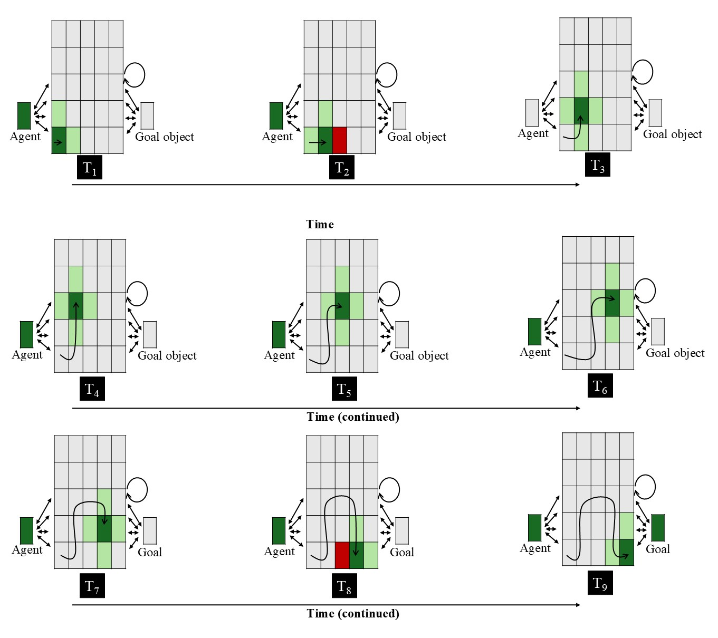
Figure 1. Input patterns shown to OM10 networks in the Experimental condition across nine steps. Each panel represents the input to the network at a given time step. The central 5 × 5 array corresponds to the spatial grid; the two units flanking the spatial grid to the right and left of it correspond, respectively, to the agent and goal objects. Dark green indicates the agent’s current position (+1), light green indicates adjacent cells (+0.5), red indicates the presence of the barrier (-1), and gray indicates no activation (0). The goal unit is activated only at the final step. The barrier is present only when the agent occupies a position immediately adjacent to it (see Overwalle, 2010). The overlaid curved path in each panel depicts the amount of arc motion the agent has completed through that time step. Two-headed arrows and the circular arrow denote bidirectional connectivity. See the online article for a color version of this figure.

Three aspects of OM10 are worth highlighting. The first is that the barrier was visible only when the agent was either to its immediate left or right. The second is that the agent overshot the barrier by one cell. The third is that the goal object was not continuously present but only became visible at the final time step. Note that OM10-2 was identical to this model in every way except that, as was mentioned earlier, the agent no longer overshot the barrier and the barrier and goal remained continuously visible throughout the agent’s curved motion path. Because there was greater overall network activity in OM10-2 compared to OM10—given that the barrier and goal objects remained continuously—a sigmoid activation was applied to the internal activation. This functioned to stabilize the recurrent dynamics in the network.

ALIAS
This model combined an autoencoder (e.g., Mareschal et al., 2000) with a simple recurrent network (i.e., an SRN; e.g., Elman, 1990). Autoencoders learn a compact internal representation at the hidden layer that is sufficient for the model to “copy” the input to the model at the output layer. In contrast, SRNS learn sequential regularities by predicting upcoming states from prior states. These architectures were chosen because the forms of learning they employ—namely, self-supervised, input-driven learning—align with prominent theories of how infants learn and do not require an explicit teaching signal (e.g., Jeffrey & Cohen, 1971; Sokolov, 1963). The SRN was an especially important component of ALIAS because representing actions necessarily involves encoding how movement unfolds over time. All networks were trained using recurrent backpropagation through time with cross-entropy error (e.g., Rumelhart et al., 1986; Williams & Zipser, 1995).
The model itself consisted of three layers (Figure 2). The input and output layers contained the same 11 clusters or groups of units and employed localist (“one-hot”) encodings. The activity of units in the input layer was “hard-clamped” (i.e., their activity was set externally), whereas the activity of the output units was a smooth, nonlinear (logistic) function of the input they received from units in the hidden layer. A localist encoding scheme was adopted in both layers to ensure that the model’s performance reflected learned relations between surface and kinematic features rather than similarity structure imposed by the encoding scheme itself and to facilitate interpretation of the mechanism underlying the model’s responses. In contrast, the hidden layer was a single group of 50 RELU units, and over training these units developed distributed representations. This enabled the model to encode learned relations among the surface features of objects and the surface kinematics of different actions (Hinton, 1984).
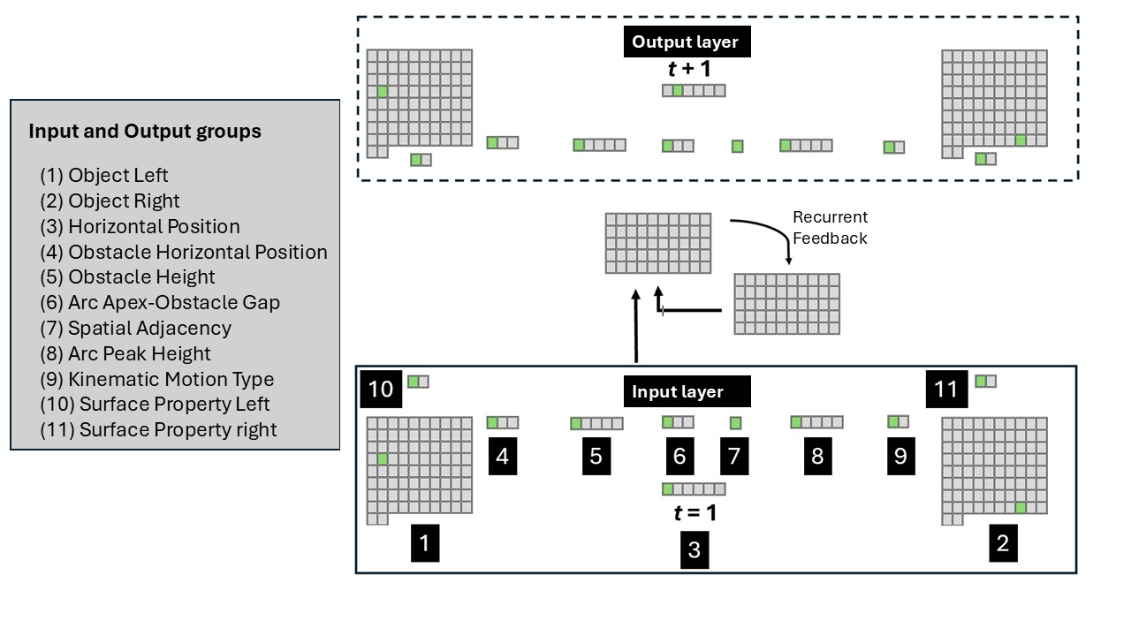
Figure 2. Schematic of an untrained ALIAS. A linear path event is being depicted here, in which one object beginning to move horizontally along a linear path to reach the other object. The legend on the left provides the names of the input groups and corresponding output groups.

The first two input and output groups were Object Left and Object Right. Each group consisted of 82 units, and each unit within a given group corresponded to a single object. The left-right naming designation captures the relative spatial position of a given group. Eighty different objects were used during pretraining phase in all reported simulations. This number ensured that networks had sufficient exposure to different objects while simultaneously allowing training time to be kept reasonable limits. There is no reason to believe that the results reported below would change drastically if more or fewer objects were used. The remaining two objects were used during the habituation and test phases.
Surface Property Left and Surface Property Right were the next input and output groups; both groups consisted of two units. The first unit in either group represented one class of visible, perceptually grounded surface features (e.g., elongated appendage-like extensions [e.g., legs], high-contrast, ovular elements [e.g., eyes], etc.); the second unit represented a different class of visible, surface features (e.g., rigid and compact [e.g., solid geometric shapes], uniform contour structure [e.g., the smooth, rectilinear edges of a block]). If a feature was being presented as input to the model, the activation of its corresponding unit was set to 1.0; the other unit was set to 0.0. Note that because the current simulations were designed to demonstrate that associations formed among one or more visible features and the kinematics of different actions can explain infants’ looking patterns in studies assessing their putative action efficiency understanding, no attempt was made here to model specific surface features with high fidelity. Instead, the first and second units in the Surface Property Left and Surface Property Right groups served, respectively, as placeholders for the semantically neutral surface features possessed by animate entities (e.g., elongated appendage-like extensions) and inanimate objects (e.g., rigidity and compactness); these units did not serve as placeholders for the semantically rich categories themselves.
Horizontal Position was the next group of input and output units. This group consisted of six units. Although the network could “see” two objects at any point in time, a single group capturing the precise horizontal position of the left object relative to the right one at any given moment in time was used (for a similar approach, see Benton, 2024 and Rakison & Lupyan, 2008); this group did not capture the kinematics of an action. On each timestep, a single bit in this layer was active according to the first object’s current horizontal position. In particular, at time t = 1, the activation value of the 1st (or leftmost) unit in this group was set to 1 (the activation values of the remaining units were set to 0), and the network’s task was to activate the second unit (from the left) in the corresponding output group. Horizontal movement continued in this manner until the 5th input unit was activated in the input layer, at which point the network’s job at this point was to activate the 6th unit in the output layer. The type of movement itself was captured separately by a Kinematic Motion Type group consisting of Linear Path and Arced Path units. Separating horizontal translation from trajectory geometry in this way enabled the model to represent heading direction independently from movement curvature and simplified later analyses of the model’s internal dynamics. Nonetheless, these aspects of motion are unlikely to be perceived independently in the real world, and a more realistic model would represent them as integrated, dynamic activity patterns unfolding over time.
The remaining five input and output groups were a five-unit Obstacle Height group, a five-unit Arc Peak Height group, a three-unit Obstacle Horizontal Spatial Position group, a third-unit Arc Apex-Obstacle Gap group, and a one-unit Final Adjacency group. The five units in the Obstacle Height and Arc Peak Height groups represented, respectively, progressively larger obstacles (i.e., Obstacle Height 0 through Obstacle Height 4) higher arcs (i.e., Arc Peak Height 0 through Arc Height 4). The Obstacle Height 0 and Arc Peak 0 units corresponded, respectively, to the absence of an obstacle and no curved motion. Arced Peak and Obstacle Heights tended to align with one another (though see Simulations 4). The three units in the Obstacle Horizontal Spatial Position group corresponded to spatial position of the obstacle (i.e., missing, middle, periphery), and the three units in the Arc Apex-Obstacle Gap group corresponded to the vertical distance between the top of an obstacle and the apex of the arced motion trajectory (i.e., no separation [used for linear movements], minimal separation, large separation). The single unit in the Final Adjacency group encoded whether the first and second object were spatially abutted at the end of a motion sequence. This unit was turned on only if this was true. All eleven groups were named this way intentionally to emphasize their semantically neutral, surface natures.

Pretraining
The present account assumes that infants’ looking behaviors in studies assessing their action efficiency understanding reflect extensive real-world experience in which they process the kinematics of actions, the visible surface features of objects and agents, and the associative relations among these perceptually grounded features. This proposal was implemented via a pretraining phase; this phase was identical for all networks and approximated infants’ real-world action experience. During this phase, networks experienced two broad classes of events: Linear Path Events and Arced Path Events. In the former event, one object moved unobstructed towards another along a horizontal trajectory. In the latter event, one object moved along a curved trajectory over an obstacle before coming to rest next to the other object. Half of the objects in both events possessed one of the two classes of visible surface features represented by the Surface Property groups, whereas the remaining half possessed the other class. This implemented the assumption that entities with different appearances can engage in both kinds of movement.
Additional assumptions that were implemented during pretraining were that obstacles have reduced salience when they are located peripheral to curved motion than when they are spatially contiguous and that curved trajectories clear obstacles by relatively small margins. The first of these assumptions was implemented by lowering the learning rate and increasing the weight decay on the incoming and outgoing weights to the Obstacle Height and Obstacle Position groups. The specific value used for the learning rate was 1×10⁻⁴; the value used for the weight decay was 0.1. These values were kept constant across all simulations. Learning rate is a parameter that controls how quickly a network’s weights adapt; larger learning rates correspond to more rapid weight changes and faster learning. In contrast, weight decay controls how “big” the weights are allowed to grow; lower values for this parameter correspond to larger weights. This way of implementing salience aligns with past connectionist modeling work (e.g., Benton, 2024; Singh et al., 2025). The second assumption was implemented by activating the Small Vertical Separation unit whenever curved motion occurred over an obstacle.
In terms of the duration of the pretraining phase, its length varied systematically across simulations such that networks corresponding to older infants received proportionally more pretraining experience than those corresponding to younger infants. In particular, simulations that modeled 12-month-olds received 900 epochs of pretraining, whereas simulations that modeled 9-, 6-, and 3-month-olds received 675, 450, and 225 epochs, respectively. Developmental “age” was also modeled via the learning rate parameters; a higher learning rate was used for older models than younger ones. This value ranged from 0.1 for the oldest models to 0.05 for the youngest models. Assigning larger learning rates to older models implemented the assumption that processing efficiency improves developmentally. The habituation phase always followed the pretraining phase and lasted between 8 and 12 epochs in step sizes of 1 (see below for details about the nature of the habituation experience for a given simulation). Different numbers of habituation epochs were used to ensure that the results reported below were robust to particular values of this parameter.
The dependent measure used in these simulations was network (cross-entropy) error (Hinton, 1989). As in prior developmental connectionist models (e.g., Mareschal et al., 2000; Quinn & Johnson, 2000; Rakison & Lupyan, 2008), network error was treated as a proxy for looking time such that greater error corresponded to longer looking. This interpretation of error also aligns with theories of habituation proposing that infants’ looking declines as their internal representations increasingly match external events (e.g., Cohen, 1973; Sokolov, 1963), as well as with how autoencoders—which ALIAS partly is—learn.
All simulations were run using the Lens neural network simulator (Rohde, 1999). The full set of training and testing files, including data from the simulations reported here, are available for download at https://osf.io/9eqpf/?view_only=62f752417a9141c7b0509a998039ad13.

Simulation 1a: Selective longer looking to inefficient actions.
Simulation 1a modeled the first target finding: Infants look longer at a barrierless curved test event than at a barrierless straight-path event following habituation to a constrained event. ALIAS performance was compared to that of OM10, OM10-2, and ALIAS-2. For ALIAS and ALIAS-2, networks were assigned either to the Experimental condition or to the Control condition. Twenty networks were tested at each of five different “habituation” epochs across both conditions. This yielded a total of 200 networks per model variant.
The habituation event used in the Experimental condition closely resembled the Arced Path pretraining event with two modifications. First, novel objects possessing surface features typical of animate entities were used; these objects approximated the animate stimuli employed in the original behavioral studies. Second, a higher obstacle and curved trajectory were used than those encountered during pretraining. This ensured that networks’ responses were not driven by prior experience with a particular obstacle or arc height. Networks were then tested on barrierless straight and curved events involving the habituation objects. The straight trajectory corresponded to the Efficient test event; the curved trajectory, to the Inefficient test event.

Results and Discussion
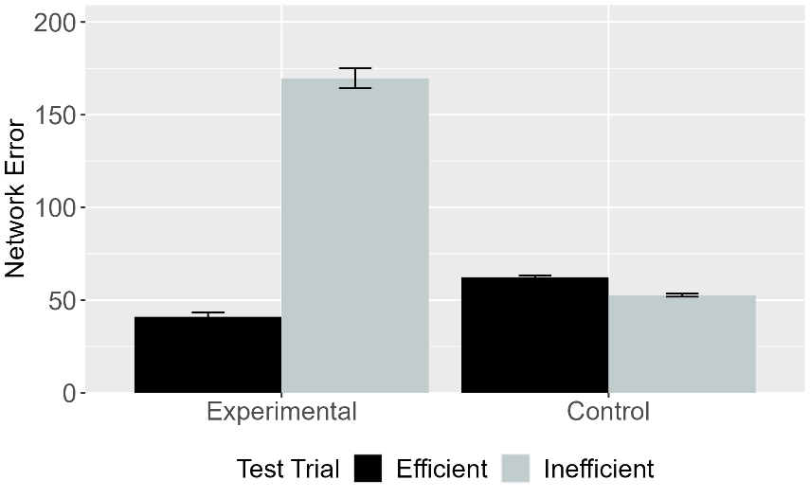 | 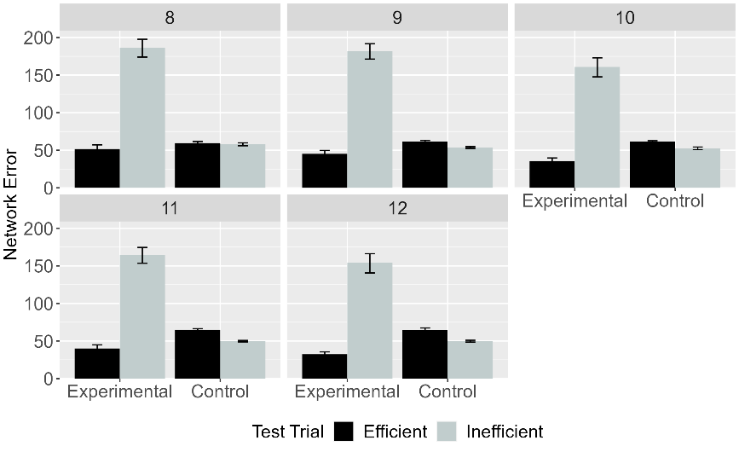
Figure 3. Mean network error produced to the Efficient and Inefficient test events in the Experimental and Control conditions. (Left) Network error collapsed across habituation lengths. (Right) Error as a function of habituation length. Data shown were generated by ALIAS.

Figure 3 shows the looking time data—operationalized as network error—for ALIAS overall (i.e., averaged over different lengths of habituation; left) and for different amounts of habituation (right). This table reveals two notable takeaways. First, ALIAS successfully reproduced the first target finding: Networks in the Experimental condition produced greater error to (i.e., looked longer at) the Inefficient test event than at the Efficient one. In contrast, networks in the Control condition produced comparable error across the two test events. Second, this looking pattern held across different amounts of habituation. This suggests that ALIAS’s success was robust to habituation length, at least within the range of lengths used here. The fact that ALIAS successfully reproduced the first target finding suggests that the theoretical account it implements is sufficient to capture this pattern of looking behavior

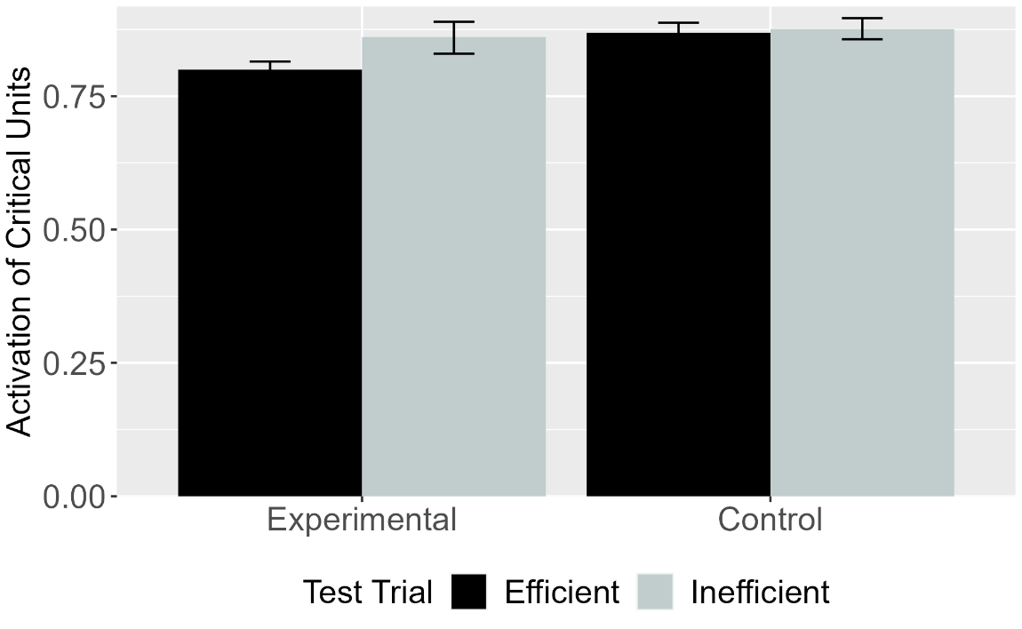
Figure 4. Mean activation of the critical units for Efficient and Inefficient test events in the Experimental and Control conditions for OM10. Error bars represent standard errors.

Figure 4 shows OM10’s responses to the same test events. The results revealed that networks in the Experimental condition produced greater error to the Inefficient test event than to the Efficient one. In contrast, networks in the Control condition produced comparable error across the two test events. OM10 thus qualitatively reproduced the first target finding. At the same time, comparing these responses to ALIAS’s responses in Figure 3 reveals that the difference in error between the Efficient and Inefficient test events in the Experimental condition was substantially attenuated for OM10 than for ALIAS.

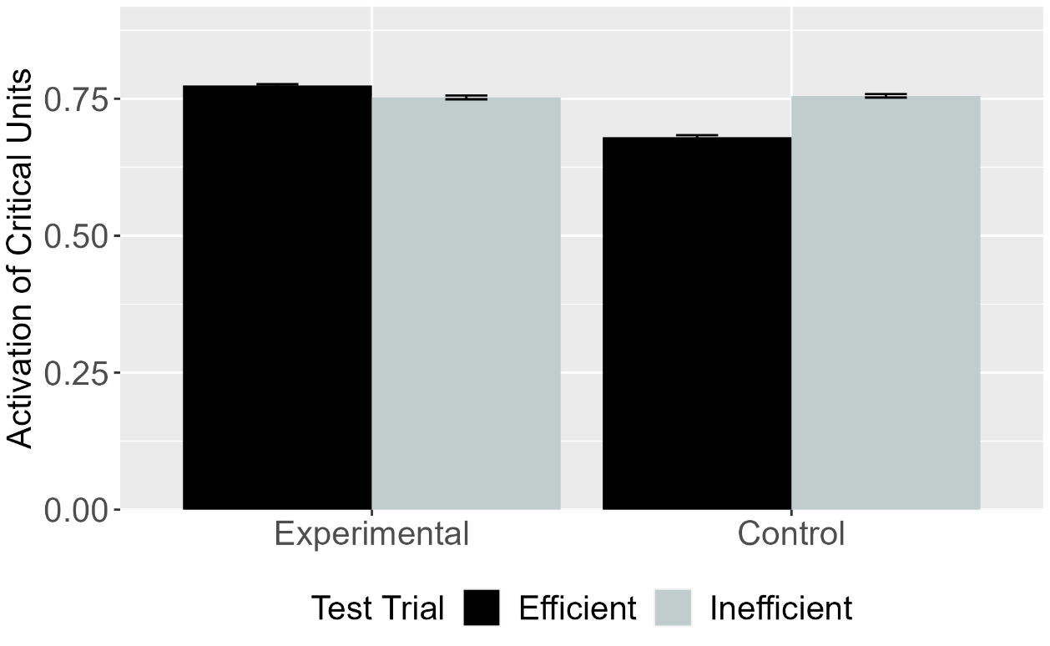
Figure 5. Mean activation of the critical units for Efficient and Inefficient test events in the Experimental and Control conditions for OM10. Error bars represent standard errors.

To determine whether OM10’s success depended on specific implementational details, its performance was compared to OM10-2. There are two important takeaways from this figure. First, OM10-2 model—which more faithfully captures the experimental details of studies associated with the first target finding than OM10—fails qualitatively to capture the first target finding. Second, OM10-2’s pattern of looking is the exact opposite of OM10’s pattern; that is, networks in the Control condition, but not those in the Experimental condition, looked longer at the Inefficient test event than at the Efficient test event. These findings suggest that OM10’s earlier success resulted from its failure faithfully to model key aspects of the corresponding behavioral experiment.

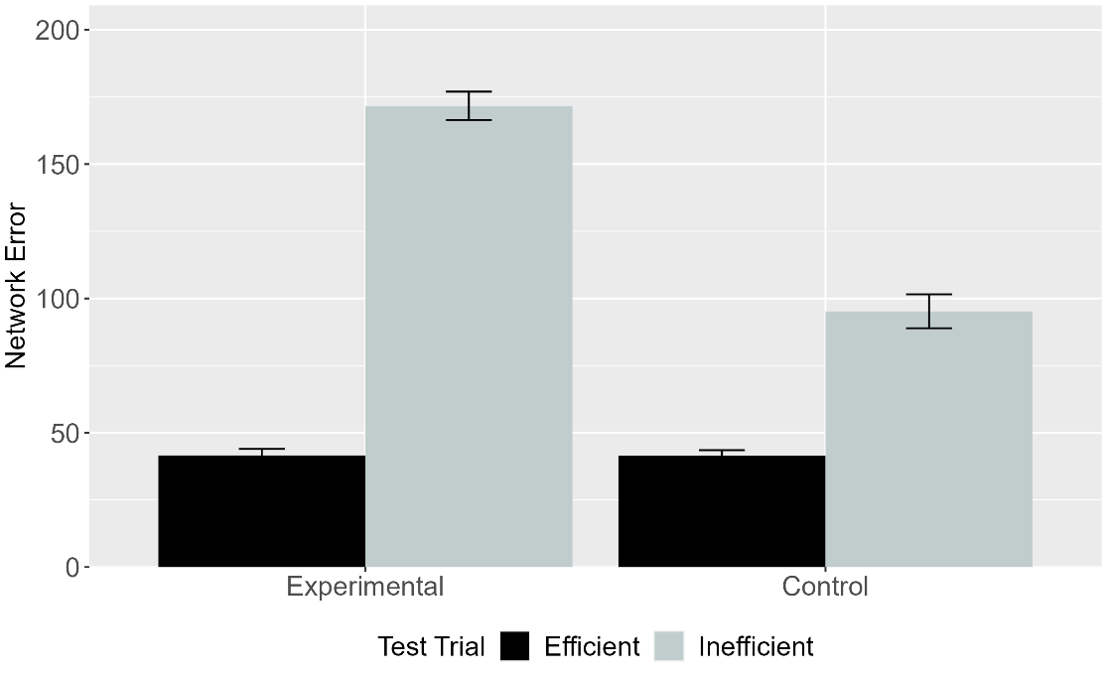
Figure 6. Mean network error produced to the Efficient and Inefficient test events in the Experimental and Control conditions. Data shown were generated by ALIAS-2. Error bars represent standard errors.

The final analysis focused on the responses of ALIAS-2. These are shown in Figure 6. This version of ALIAS omits differential obstacle salience. Although both models showed similar patterns of looking in the Experimental condition, their patterns of looking diverged in the Control condition. Specifically, only ALIAS-2 looked longer at the Inefficient test event than at the Efficient one. This difference reflects how salience was implemented in ALIAS. In this model, reduced salience of peripherally located was implemented by lowering the learning rate of and applying weight decay to the barrier-relevant weights; barriers retained their salience irrespective of their position relative to curved motion in ALIAS-2. What this means for ALIAS-2 is that because there is nothing preventing it from forming robust associations between arced motion and peripherally located barriers during habituation, it will readily associate the two irrespective of their relative spatial positions. The problem here is that, because such learning modifies the same connections that encode the relation between arced motion and obstacles, presenting curved motion beside rather than over a barrier during habituation partially overwrites the barrier-under-curved-motion association acquired during pretraining. The reason this association is partially rather than fully overwritten is simply that the habituation phase is much shorter than the pretraining phase. A corollary of this competition is that, when arced motion is shown during the Inefficient test event for networks in the Control condition, the associated obstacle representation is reactivated less strongly than it is for networks in the Experimental condition. Given that looking time for ALIAS is operationalized as the discrepancy between its expectations and the observed event, this weaker reactivation resulted in an attenuated difference in looking between the two test events in the Control than in the Experimental condition. In sum, the fact that ALIAS better captured the first target finding than ALIAS-2 suggests that differential obstacle salience is key to reproducing this finding.
Simulation 1a tested whether ALIAS could reproduce the first target finding: In action efficiency understanding studies that use animate- entities, infants look longer at barrierless curved test events than at barrierless straight ones following habituation to a constrained but not an unconstrained jumping event. To evaluate whether ALIAS provided a better qualitative fit to the target finding than competitor models, ALIAS's performance was additionally compared to that of OM10, OM10-2, and ALIAS-2. It was found that ALIAS not only reproduced the first target finding but provided a superior qualitative fit to it relative to the other models.
Although the present results suggest that associative learning—combined with the assumption that obstacles located to the side of curved motion are less salient than those located directly beneath it—underpinned ALIAS’s success, it was nonetheless important to confirm that associative learning was the actual mechanism through which the model reproduced these looking behaviors. aligned with the proposal that it implemented. This mechanism began during the pretraining phase. It was during this phase that networks were exposed repeatedly to events in which agents move along either straight or curved trajectories to reach other objects or agents. These events were implemented as distributed across the model’s various input groups. Because it is necessarily the case that the model’s weights have not been tuned through learning at the outset of the pretraining phase, the pattern of activation that these input events elicit at the hidden layer will be largely unable to reproduce this input at the output layer as well as predict the future location of an agent. As training progresses and the network accrues more experience with different actions the network will develop increasingly differentiated interna representations of straight and curved motions.
In addition to encoding different kinds of motion in an action event, these representations will also come to capture those input features that reliably co-occur across events; the more these features co-occur the stronger their associations. Examples of such features include Curved Motion, Jump Height, and Barrier Height. The implications of this experience can be understood by considering its impact on the networks’ performance in the Experimental and Control conditions. In the Experimental condition, for example, networks were habituated to an event in which an animate-like object jumped over a centrally located obstacle along an arced trajectory. Although some features of this event were novel relative to that experienced during the pretraining phase—for example, the jump and barrier heights—many of these features were familiar. Curved motion itself along with an obstacle located beneath it are two such features that were experienced during the pretraining phase. Given that this configuration was preserved during habituation, the model’s experience during this phase reinforced the barrier-under-arced-motion association. Consequently, when networks are later shown a high, curved jump during the Inefficient test event, the representation of the associated barrier is reactivated. However, because no actual barrier appeared during this event, the network produced a huge spike in error. Correspondingly less error is produced to the Efficient test event because the networks experienced straight motion during the pretraining phase.
Now consider the network’s looking behavior in the Control condition. In this condition, networks showed comparable looking to the two test events. This pattern of looking resulted from the weak association formed between arced motion and the peripheral barrier during habituation. The reason a weaker association was formed here than in the Experimental condition was because barriers located beside rather than beneath curved motion trajectories possessed reduced salience. The relative weakness of this association meant that it was insufficient to compete with or replace that formed between arced motion and centrally located during pretraining. The fact that neither test event strongly violated the model’s learned representation resulted in both test events producing similar error (or looking time).
In sum, the reason networks looked longer at the Inefficient test event than at the Efficient test event in the Experimental condition is because the association that was formed between curved motion and obstacle-related information during pretraining—and subsequently reinforced during the habituation phase—was violated when curved motion occurred in the absence of the expected barrier. By contrast, the reason networks in the Control condition looked about equally long at both test events is because the reduced salience of the peripheral obstacle prevented robust associations from forming between the obstacle and the arced trajectory during habituation. Together, these findings suggest that infants’ looking behavior in Gergely-style studies can be explained by learned associations among differentially salient surface features.
One potential criticism of this simulation concerns the nature of the network’s pretraining experience. Specifically, arced motion never occurred in the absence of obstacles during pretraining. Yet, it seems likely that infants sometimes observe arced motion in the absence of obstacles. Simulation 1b thus assessed whether ALIAS could reproduce the first target finding when the ratio of constrained to unconstrained arced motion was varied during pretraining.

Simulation 1b
This simulation assessed ALIAS’s performance across different ratios of constrained to unconstrained arced motion experienced. Six ratios ranging from 100% constrained vs. 0% unconstrained to 50% constrained vs. 50% unconstrained, in step sizes of 10%, were tested during habituation. For example, in the 60% constrained vs. 40% unconstrained condition, arced motion occurred over obstacles 60% of the time; 40% of the time it occurred without them. Parametric variation was used here because the true proportion of constrained-to-unconstrained arced motion in the real world is unknown. At the same time, because the true estimates presumably fall somewhere in the range tested here, the results likely provide a reasonable approximation of infants’ expected responses across that range. Finally, because this simulation was designed to assess whether ALIAS’s responses were robust across different constrained-to-unconstrained ratios, its performance was not compared to that of the competitor models.

Results
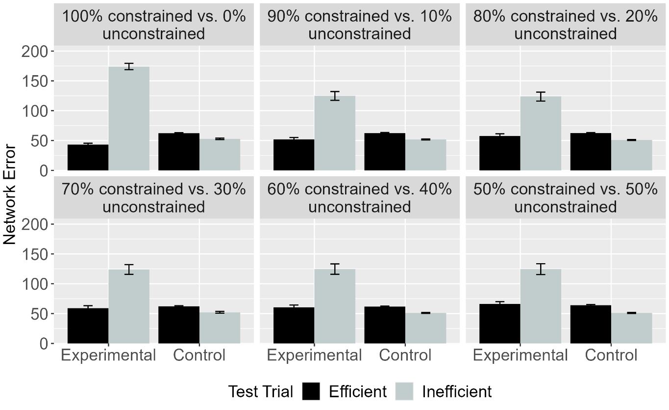Figure 7. Mean network error produced to the Efficient and Inefficient test events in the Experimental and Control conditions across different ratios. Error bars represent standard errors.

Figure 7 depicts networks’ looking time to the two test events across conditions and ratios. The key takeaway is that networks in the Experimental condition looked longer at the Inefficient than at the Efficient test event irrespective of the ratio of constrained-to-unconstrained motion experienced during pretraining. In contrast, networks in the Control condition looked about equally at these two test events across different ratios. These results suggest that ALIAS’s performance in Simulation 1a is robust to variation in the amount of constrained motion.

Discussion
Simulation 1a assessed whether ALIAS’s ability to reproduce the first target finding was robust to variation in the amount of constrained and unconstrained motion experienced during pretraining. The results of this simulation provided a positive answer to this question. Specifically, networks in the Experimental condition looked longer at the Inefficient than at the Efficient test event; networks in the Control condition showed comparable looking to both events. One notable feature of these results—which can be seen clearly in Figure 7—is that the magnitude of the difference in the amount of time that networks in the Experimental condition looked at the two test events was largely unaffected by the ratio of constrained to unconstrained arced motion. This facet of the data is notable because it might be expected that this difference should decrease as the proportion of unconstrained arced motion increases. The reason the difference remained relatively stable across ratios was simply because the network was habituated to constrained action.
Simulation 2 took a first step toward assessing the explanatory breadth of ALIAS by examining whether it can capture the second target finding: Infants’ looking responses in action efficiency understanding studies do not depend on the entities involved possessing animate features. Simulation 2 was thus similar to Simulation 1a except that the objects lacked surface features typical of animate entities. Note that because neither OM10 nor OM10-2 has a means for representing whether an object possesses animate- or object-typical surface features, Simulation 2 only focused on the behavior of ALIAS and ALIAS-2.

Simulation 2: Independence from animacy.
Simulation 2 tested whether ALIAS could capture the second target finding. This is the finding that infants’ performance in action efficiency understanding studies is unaffected by whether the objects involved possess animate features. To that end, the objects used here did not possess surface features associated with animate entities. Additionally, because the second target finding derives from research that tested 9-month-olds rather than 12-month-olds (Csibra et al., 1999), the habituation phase was shortened to 675 epochs.

Results
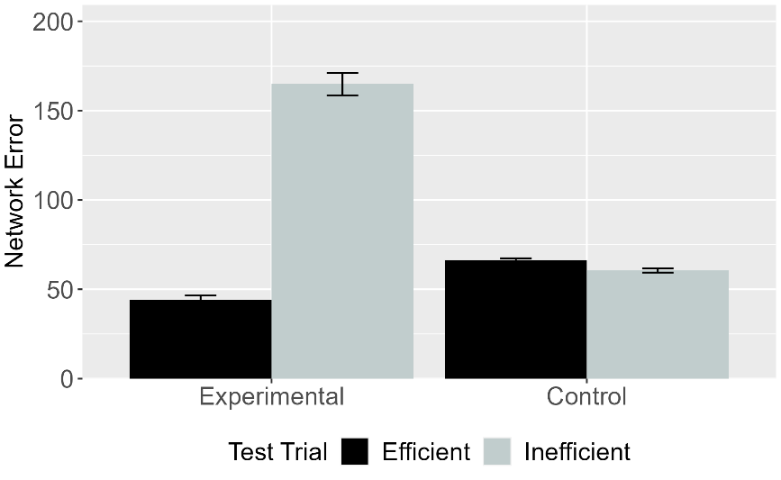 | 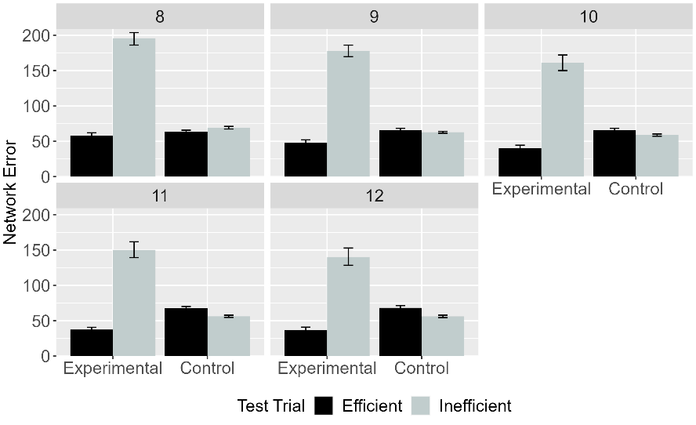
Figure 8. Mean network error produced to the Efficient and Inefficient test events in Simulation 2 across conditions overall (left panel) and across different habituation epochs (right panel). Error bars represent standard errors.

Figure 8 depicts ALIAS’s responses to the Efficient and Inefficient test events, both across conditions and training epochs. The results indicated that networks in the Experimental condition looked longer at the Inefficient than at the Efficient test event. In contrast, networks in the Control condition looked about equally long at both test events both overall and for different habituation lengths. Both results were true irrespective of the length of habituation.

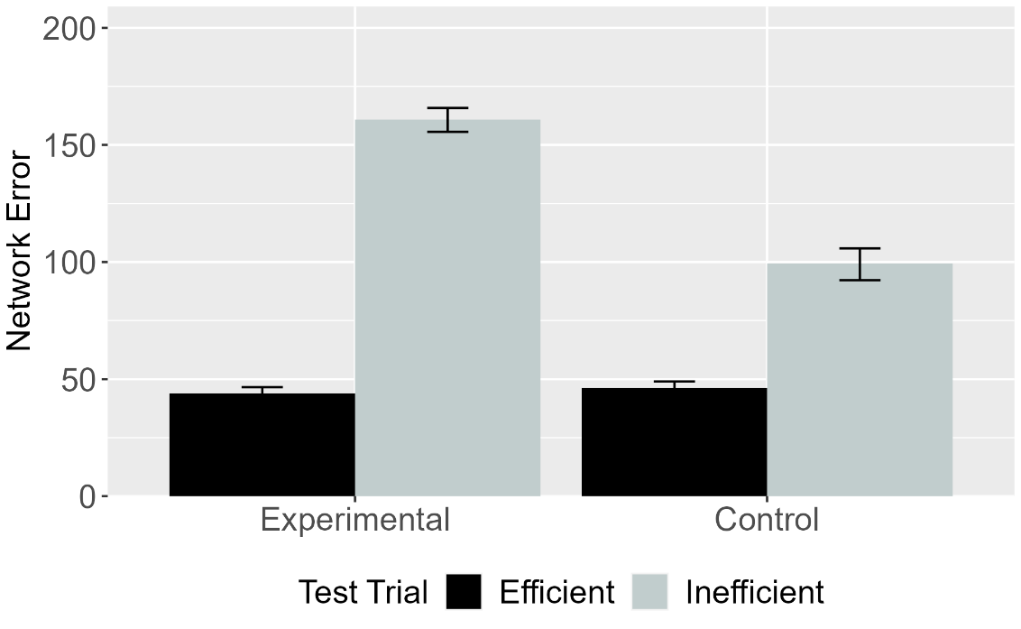
Figure 9. Mean network error produced to Efficient and Inefficient test events in the Experimental and Control conditions for ALIAS (left panel) and ALIAS-2 (right panel). Error bars represent standard errors.

Figure 9 shows the performance of ALIAS-2 across conditions. As in Simulation 1a, ALIAS-2 failed to capture infants’ looking behavior across conditions. These findings suggest that associative learning alone is insufficient to reproduce the first two target findings; associative learning must additionally be combined with the assumption that peripherally located obstacles possess reduced salience appears to account for these findings.

Discussion
Simulation 2 examined whether ALIAS could capture the second target finding that infants’ putative action efficiency understanding is not impacted by whether the objects involved possess animate features. The simulation revealed that it could. Additionally, ALIAS-2’s failure to account for this finding indicates that associative learning alone is insufficient to capture it; it is necessary that barriers located peripheral to curved motion also possess reduced salience.
A potential objection to the simulation presented thus far is that they only weakly demonstrate ALIAS’s explanatory breadth. This is because the two simulations differed only in terms of whether the objects involved possessed animate features. Yet, a true test of ALIAS’s explanatory breadth would entail demonstrating that this model can capture other target findings. Simulation 3 took a first step in this direction. Simulation 3 was specifically examined whether ALIAS could capture Csibra et al.’s (2003) finding that 12-month-olds can infer goals from actions and constraints and infer constraints from actions and goals. In their first experiment, infants were habituated to an event in which a large circle appeared to be chasing a small circle. However, before large circle could reach the small circle, the small circle moved through a small gap between two bars and then disappeared from the screen. The fact that the opening between the two bars was too narrow for the larger circle to fit through, it was forced moved around one of the bars before continuing to move in the small circle’s last seen direction. Crucially, because the large circle never reached the small one, its goal of reaching it had to be inferred. Together Csibra et al.’s Experiment 2 finding that infants looked longer at an unconstrained than at a constrained arced event, these findings were taken to support the teleological stance.
Note that although Csibra et al.’s (2003) first experiment did not employ the Gergely-style paradigm, it can readily be recast within it. This can be done by terminating the habituation event after the first object clears the barrier but before it reaches the second object. Here, the first object’s goal must be inferred because of the first object never reaches the first one.

Simulation 3: Bidirectional inferences about actions, goals, and constraints.
Simulation 3 tested whether ALIAS could explain the finding that 12-month-old infants putatively can infer goals from constraints and behavior as well as constraints from goals and behaviors. Networks were assigned either to the Inferring Goals condition (N = 20) or to the Inferring Constraints condition (N = 20); the same number of networks were assigned to ALIAS-2, OM10, and OM10-2. The simulation of this condition was identical to the Experimental condition in Simulation 1a except that networks could not know whether the first object came to rest next to the second one (i.e., its goal). The Inferring Constraints condition was implemented by removing all barrier information during habituation. All other aspects of this simulation were identical to Simulation 1a.

Results and Discussion
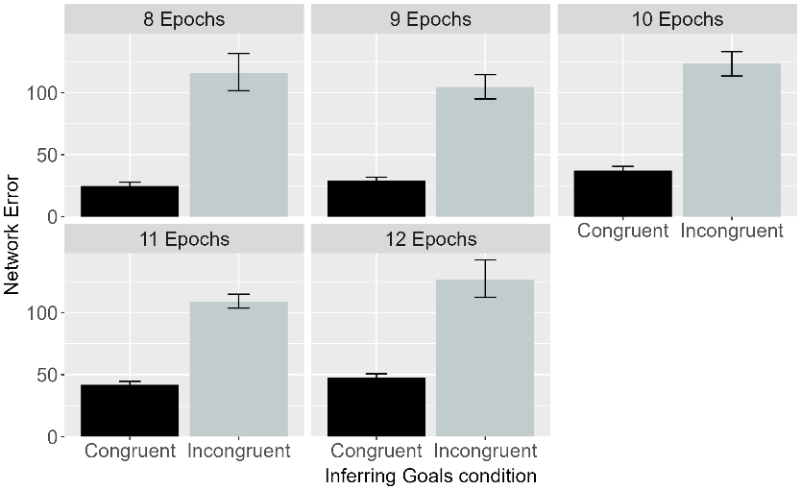 | 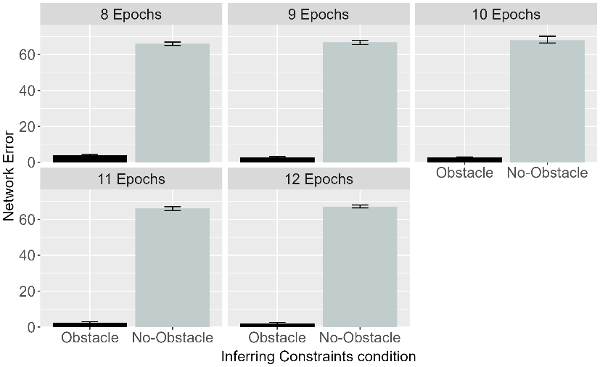
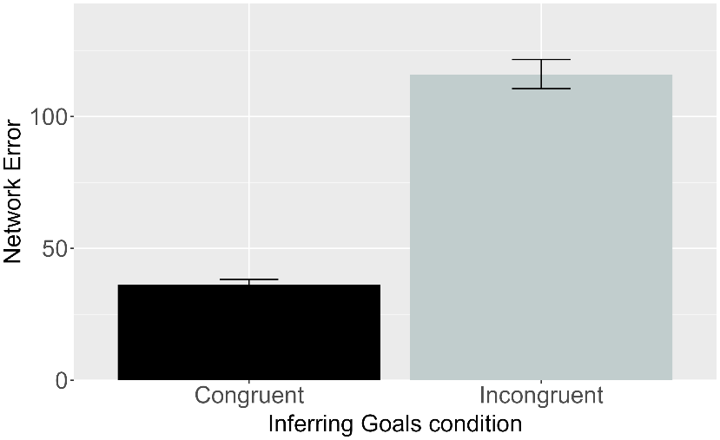 | 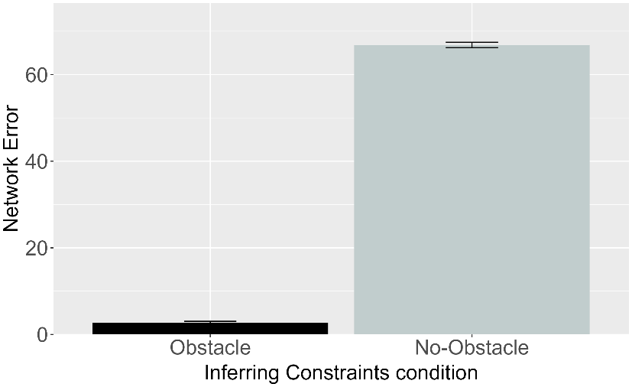

Figure 10. Performance of ALIAS. Plotted is the mean network error produced to the Congruent and Incongruent test events for networks in the Inferring Goals condition (left column) and to the Obstacle and No-Obstacle test events for networks in the Inferring Constraints condition across habituation epochs (top row) and overall (bottom row).

Figure 10 shows the performance of ALIAS in the Inferring Goals and Inferring Constraints conditions overall and across habituation epochs. Networks in both conditions looked longer at their respective inconsistent events. Specifically, networks in the Inferring Goals condition look longer at the Incongruent test event—in which the first object failed to stop next to the first one—than the Congruent test one—in which the first object came to rest next to the first one. Similarly, networks in the Inferring Constraints condition looked longer at the No-Obstacle than at the Obstacle test event. These patterns were true both across different habituation lengths as well as overall. The mechanistic basis for these looking patterns is straightforward. In the Inferring Goals condition, for example, networks showed heightened looking to the Incongruent test event because it violated a learned association between curved motion, a small barrier, and a low jump, on the one hand, and spatial contiguity between an agent and its goal, on the other. No such violation occurred for the Congruent test event because the visual information accorded with that during pretraining. Similarly, networks in the Inferring Constriants condition looked longer at the No-Obstacle test event than at the Obstacle one because the presence of curved motion in the absence of an obstacle in the No-Obstacle event violated an association that was established during the pretraining phase between curved motion and obstacles; no such violation occurred in the Obstacle test event. These results indicate that ALIAS can capture the third target finding.

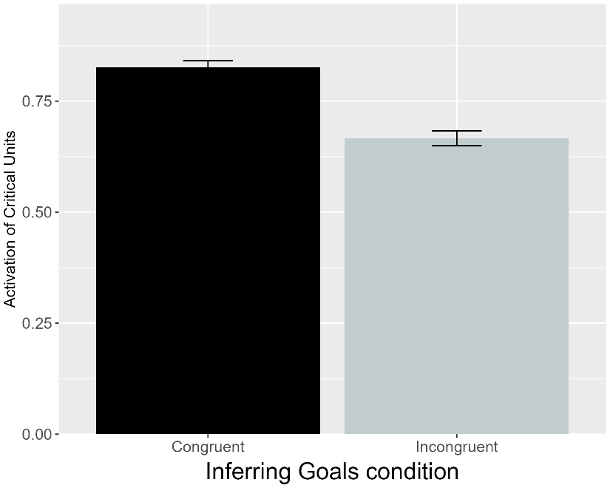 | 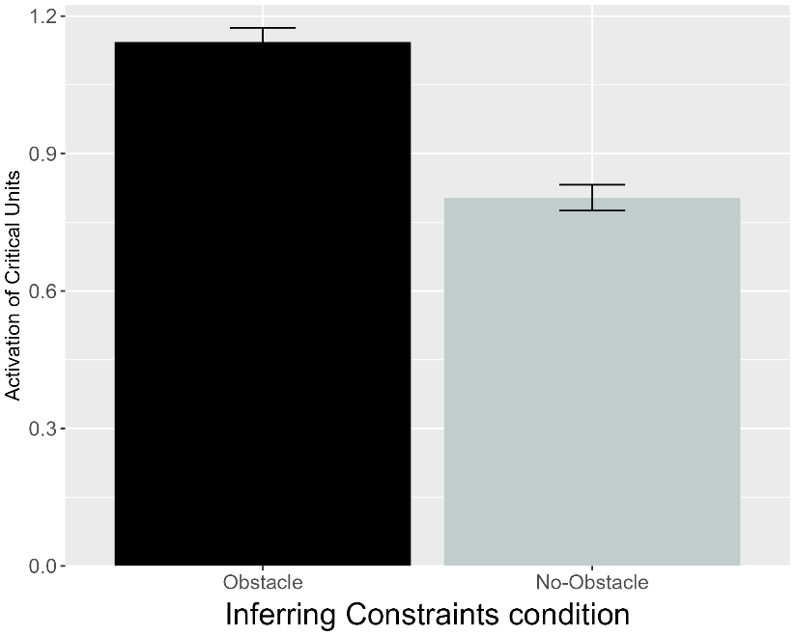
Figure 11. Performance of OM10. Plotted is the mean activation of the critical units produced to the Congruent and Incongruent test events for networks in the Inferring Goals condition and to the Obstacle and No-Obstacle test events for networks assigned to the Inferring Constraints condition (right).

Figure 11 shows that OM10’s responses were exactly opposite that of ALIAS: These networks looked longer at their condition’s efficient test event. These results indicate that OM10 was unable to account for the finding that infant can putatively reason productively about goals, actions, and constraints.

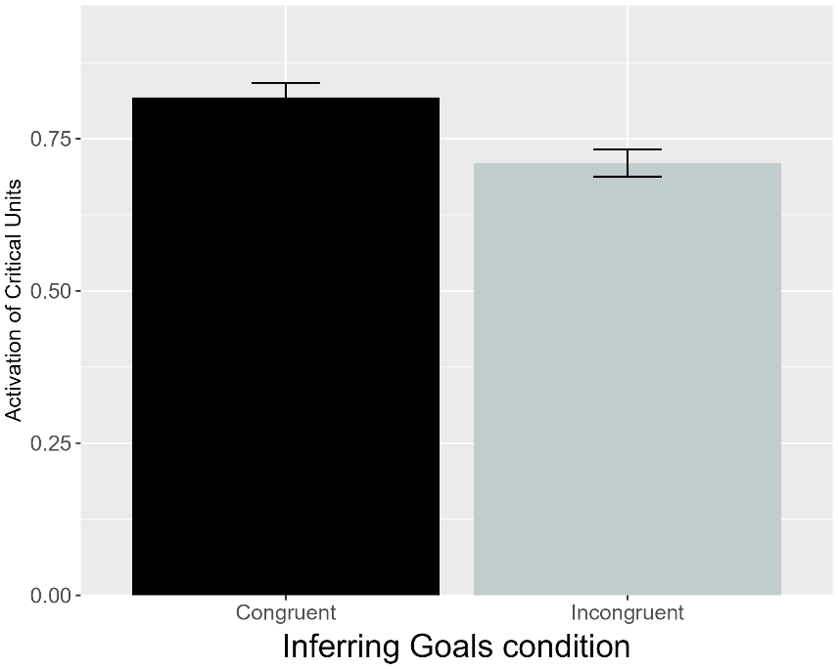 | 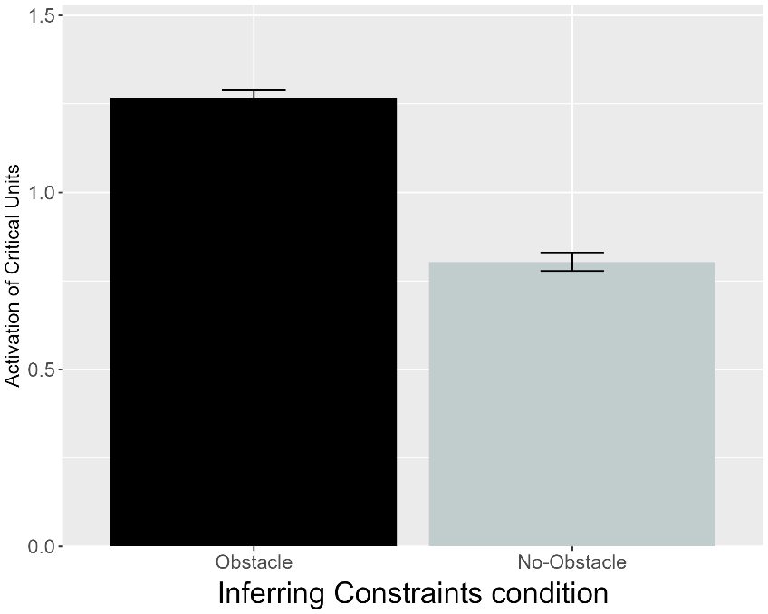
Figure 12. Performance of OM10-2. Plotted is the mean activation of the critical units produced to the Congruent and Incongruent test events for networks in the Inferring Goals condition and to the Obstacle and No-Obstacle test events for networks assigned to the Inferring Constraints condition (right).

As shown in Figure 12, OM10-2 also failed to replicate the third target finding. This suggests that OM10’s failure could not be attributed to limitations in how the Csibra et al. (2003) task was implemented. was not due to its failure faithfully to represent Csibra et al.’s (2003) task. Instead, such failure may point to a fundamental inability of the model to simulate the processes underpinning infant action efficiency understanding.

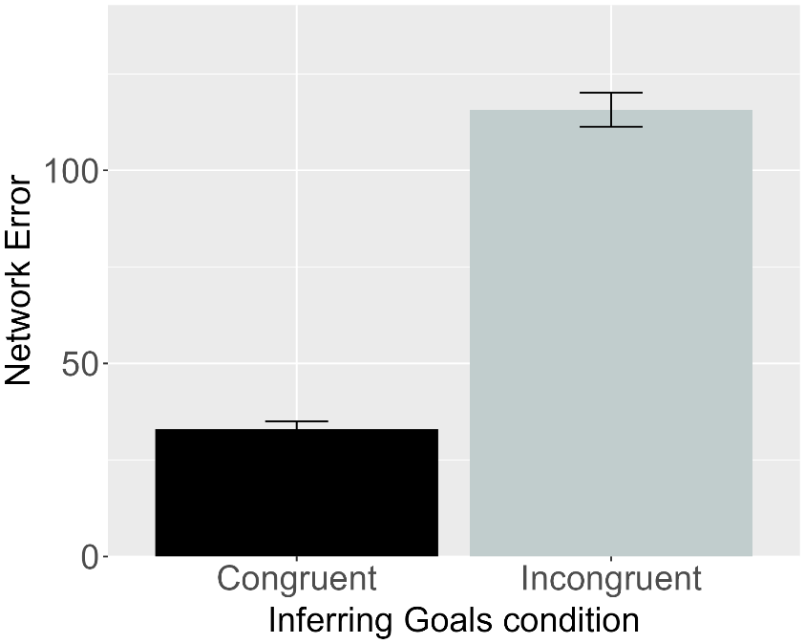 | 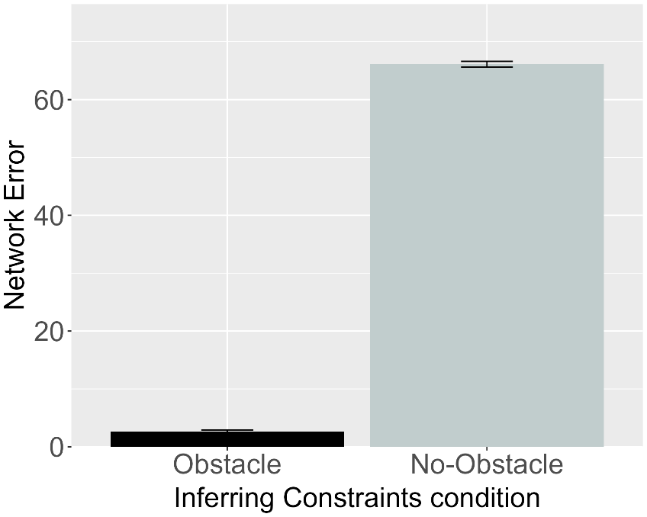
Figure 13. Performance of ALIAS-2. Plotted is the mean network error produced to the Congruent and Incongruent test events for networks assigned to the Inferring Goals condition (left) and to the Obstacle and No-Obstacle test events for networks in the Inferring Constraints condition (right).

Although ALIAS-2 failed to reproduce the first two target behaviors, it remains possible that this model would succeed in accounting for the present target findings. Figure 13 shows that this was indeed the case. As with ALIAS, networks in both conditions looked longer at their condition’s inconsistent test event. ALIAS-2’s success suggests that, at least here, associative learning alone is sufficient to reproduce the third target finding. The fact that both models replicated infants’ looking responses in Csibra et al. (2003) suggests that behavior previously interpreted as evidence for abstract, theory-like reasoning about goals, actions, and constraints can instead be explained by an associative learning mechanism that operates over differentially salient surface features. At the same time, however, the fact thatALIAS-2 failed to reproduce the first two target findings indicates that it is a less veritable model of infant action efficiency understanding than ALIAS.
One finding with which ALIAS might nonetheless be predicted to struggle is that by Liu and Spelke (2017) showing that infants apparently represent efficiency continuously rather than in an all-or-none fashion. Six-month-olds were habituated either to a constrained action event (Experiment 1) or to an unconstrained one (Experiment 2). Infants were then tested either on constrained Low, efficient and High, inefficient test events (Experiment 1) or to unconstrained versions of these events (Experiment 1). Note that in the constrained High, inefficient test event, the agent jumped much higher than needed to clear the barrier. Liu and Spelke (2017) found that infants in Experiment 1 looked longer at the High, inefficient test event than at the Low, efficient one. In contrast, infants in Experiment 2 looked numerically, but not significantly, longer at the Low, efficient event than at the High, inefficient one.
In a final experiment, Liu and Spelke (2017) tested whether infants expect agents whose actions were costly and inefficient in the past to continue behaving inefficiently in a new situation with a different set of constraints. Infants were habituated to the event used in Experiment 2 and then tested on the constrained events used in Experiment 1. Here, infants looked longer at the High, inefficient test event than at the Low, efficient one. Considered together, these results were interpreted to mean that infants represent action efficiency continuously and that they expect previously inefficient agents to behave efficiently in the future. These findings were taken as support Liu et al.’s (2026) naïve psychology and physics systems.
Simulation 4 tested whether associative learning alone or combined with differential obstacle salience is sufficient to explain Liu and Spelke’s (2017) findings. A positive finding would undermine the claim that the aforementioned domain-specific systems underpinned infants’ behavior in Liu and Spelke (2017).

Simulation 4: Graded representations of efficiency.
This simulation tested whether ALIAS could capture the fourth target finding. The pretraining phase was shortened to 450 epochs because Liu and Spelke (2017) tested 6-month-olds. Following pretraining, networks were habituated to and tested on events analogous to those in Experiments 1-3 in Liu et al. (2017); twenty networks were assigned to each experiment. Unlike the previous simulations, however, OM10 was not applied to Simulation 4. This is because OM10 could not meaningfully simulate Liu and Spelke’s (2017) use of differently sized barriers across the habituation and test phases in each experiment. This is because OM10 omits barrier information during its prediction (or test) phase. As such, OM10 could not be used to simulate Liu and Spelke (2017). Note that this is not an in-principle limitation of this model. Although it would be straightforward to present obstacle information during OM10’s test phase, doing so would radically depart from how it was implemented in the previous simulations and, more importantly, from Overwalle’s (2010) original conception of it. ALIAS’s performance was thus only compared to that of OM10-2 and ALIAS-2 in Simulation 4. Note that because OM10-2 did not implement a pretraining phase, it could not simulate developmental age like ALIAS or ALIAS-2. As was true for ALIAS, 20 networks were assigned to each experiment foach model.

Results
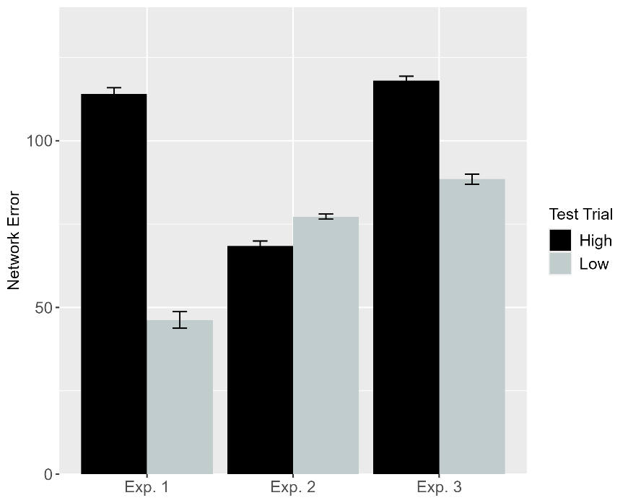 | 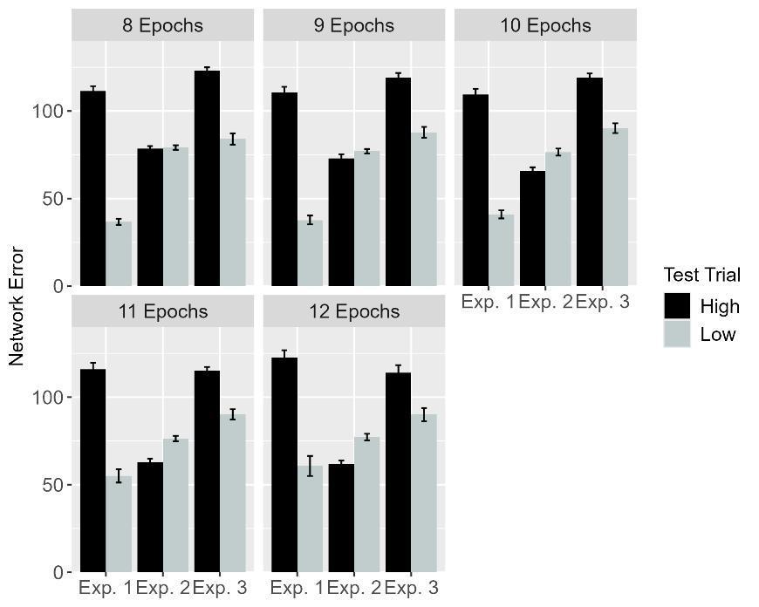
Figure 14. Performance of ALIAS. Plotted is networks’ mean error to the High, inefficient and Low, efficient test events across experiments both overall (left) and across different habituation epochs (right).

Figure 14 shows ALIAS’s treatment of the High, inefficient and Low, efficient test events across the three experiments. Networks—like infants in Experiments 1 and 3 in Liu and Spelke (2017)—looked longer at the High, inefficient than at the Low, efficient one. This was true overall and across different habituation epochs. In contrast, networks in Experiment 2—like infants in the corresponding behavioral experiment—looked slightly numerically longer at the Low, efficient than at the High, inefficient test event. The fact that a model lacking explicit notions of efficiency, cost, or utility could nonetheless reproduce the fourth target finding lends additional support to the contention that such concepts may not be necessary to account for so-called action efficiency understanding in infants.

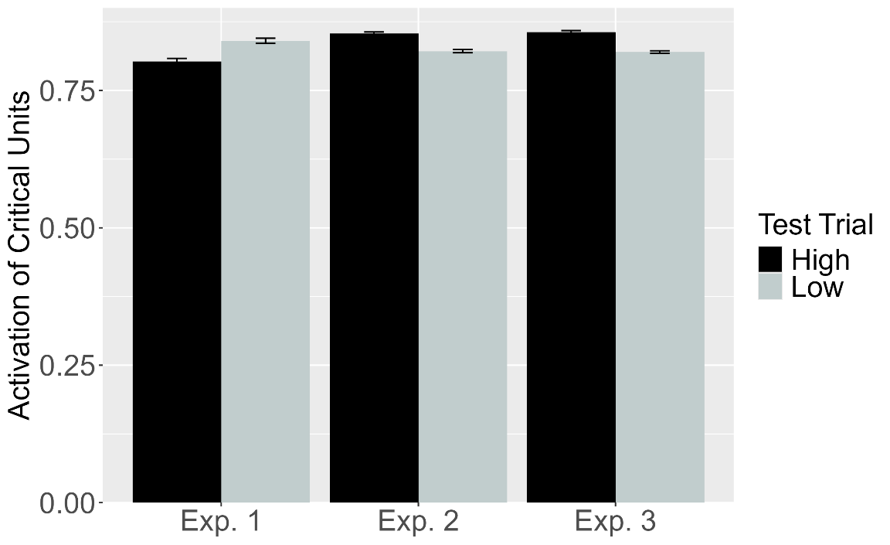
Figure 15. Performance of OM10-2. Plotted is the mean activation of the critical units produced to the High, inefficient and Low, efficient test events for networks in Experiment 1-3. These experiments correspond to those in Liu and Spelke (2017).

Although OM10-2 captured infants’ looking responses in Experiment 3—showing slightly more critical unit activation following the High, inefficient test event than the Low, efficient test event—it failed to capture infants’ responses in Experiments 1 and 2. In Experiment 1, for example, the Low, efficient test event caused slightly more activation of the critical units than the High, inefficient test event. The reverse pattern was observed in Experiment 2. These results are shown in Figure 15. These findings suggest that simply improving OM10’s fidelity to Liu and Spelke’s (2017) task structure does not enable it to reproduce infants’ looking responses.

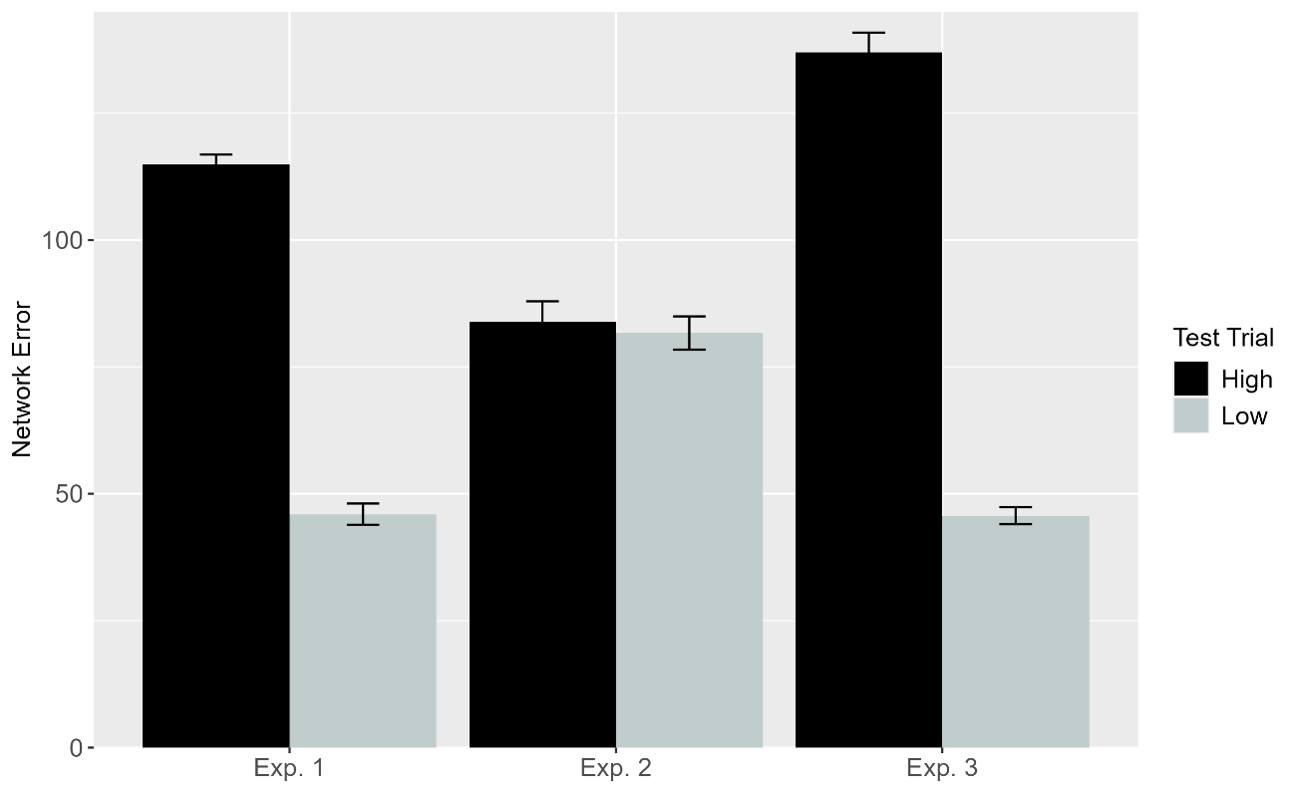
Figure 16. Performance of ALIAS-2. Plotted is networks’ mean error to the High, inefficient and Low, efficient test events across experiments both overall. These experiments correspond to those in Liu and Spelke (2017).

ALIAS-2’s performance was examined next to determine whether associative learning alone is sufficient to capture the fourth target finding. The results—which are shown above in Figure 16—showed that it mostly could. Specifically, networks in Experiments 1 and 3 looked longer at the High, inefficient test event than at the Low, efficient one. However, in the Control condition, networks looked about equally long at both test events. This latter finding conflicts with ALIAS’s and infants’ tendency to look numerically longer at the Low, efficient than at the High, inefficient test event. ALIAS-2’s performance suggest that associative learning is mostly sufficient to account for infants’ looking responses across in Liu and Spelke (2017); additional assumptions about differential barrier salience may nonetheless be necessary to capture the full range of results related to the fourth target finding.
In terms of the mechanistic basis of ALIAS’s behavior, the reason networks showed heightened looking to the High, inefficient test event during Experiments 1 and 3 is that the presentation of a small obstacle, high jump, and substantial vertical clearance during the High, inefficient test event violated the association that networks formed among a small obstacle, low jump, small vertical clearance during the pretraining phase. In contrast, the reason networks showed attenuated looking to the Low, efficient test event during the same experiments is that the visual information associated with this event (e.g., a small obstacle, low jump, and low vertical clearance) overlapped with that experienced during pretraining (e.g., a small obstacle, low jump, and low vertical clearance).
The goal of this simulation was to determine whether ALIAS could reproduce the find that infants can apparently represent action efficiency in a graded or continuous manner. The results revealed that not only could ALIAS capture the fourth target finding, but it provided a better qualitative fit to the data than ALIAS-2. This suggest that associative learning—combined with the assumption that obstacles that are peripheral to curved motion—have reduced salience is necessary to reproduce infants’ looking responses across the experiments in Liu and Spelke (2013). By contrast, OM10-2 was unable to account for these findings, which suggests that simply improving a connectionist model’s fidelity to the structure of a task is insufficient.
Despite ALIAS’s success in reproducing the first four target findings, it remained important to demonstrate that this model could also capture the finding that much younger infants appear to be sensitive to an action’s efficiency. Of particular note here is Skerry et al.’s (2013) finding that a small amount of sticky-mitten reaching experience was sufficient for pre-reaching 3-month-olds to show looking patterns that resembled those of older infants. Simulation 5 tested whether, in the absence of extensive action-observation experience during pretraining, the notion that effective action experience temporarily heightens infants’ attention to their own straight reaching trajectories—such that a subsequent straight trajectory event is rendered relatively more familiar than curved trajectory event—would enable ALIAS to capture the fourth target finding. This simulation only focused on ALIAS and ALIAS-2 because these were the only two models capable of simulating development.

Simulation 5: Action efficiency understanding in pre-reaching infants.
The primary goal of this simulation was to assess whether, when ALIAS is given limited pretraining experience, it can reproduce the looking behavior of pre-reaching infants when its attention is heightened during a phase analogous to the action phase in Skerry et al. (2013). To simulate the performance of the 3-month-olds in this study, two changes were made to the model. The first involved reducing the length of the pretraining phase to 225 epochs, the number of hidden units to 10, and the learning rate to 0.1. These modifications implemented the assumption that 3-month-olds have less action-observation experience, reduced information storage capacity, and slower processing speed than the typical 6- to 12-month-old infant in action efficiency understanding studies. The second and more substantial change related to the addition of an “action phase” that immediately followed pretraining; the habituation and test phases immediately followed this phase. To instantiate the assumption that infants’ reaches during this phase are largely linear, networks were shown straight motion during this phase.
As was true for infants in Skerry et al. (2013), networks were assigned to one of three conditions: Effective Action (N = 20), Ineffective Action (N = 20), or No Training (N = 20). Those in the first condition were further divided into either the Experimental condition or the Control condition. The assumption that effective sticky mittens experience heightens infants’ attention was implemented by increasing the learning rate to .175 during the action phase for networks in the Effective Action condition only. The assumption that this attentional boost is short-lived was implemented by resetting the learning rate to its pretraining value at the start of the subsequent habituation phase. The learning rate maintained its pretraining value across the pretraining, action, and habituation phases for networks in the Ineffective Action condition. In all other respects, these two conditions were identical to one another.

Results
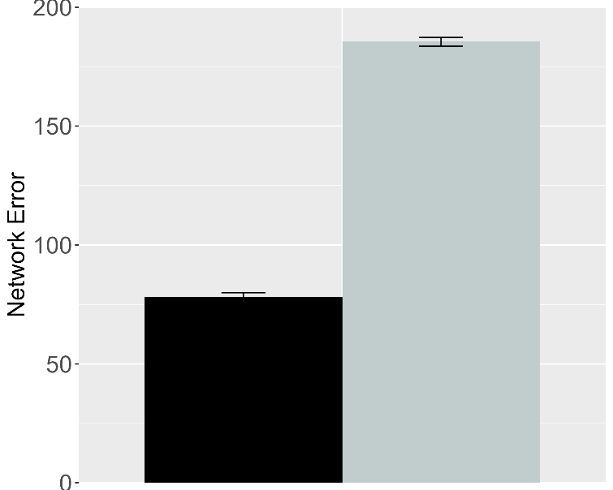 | 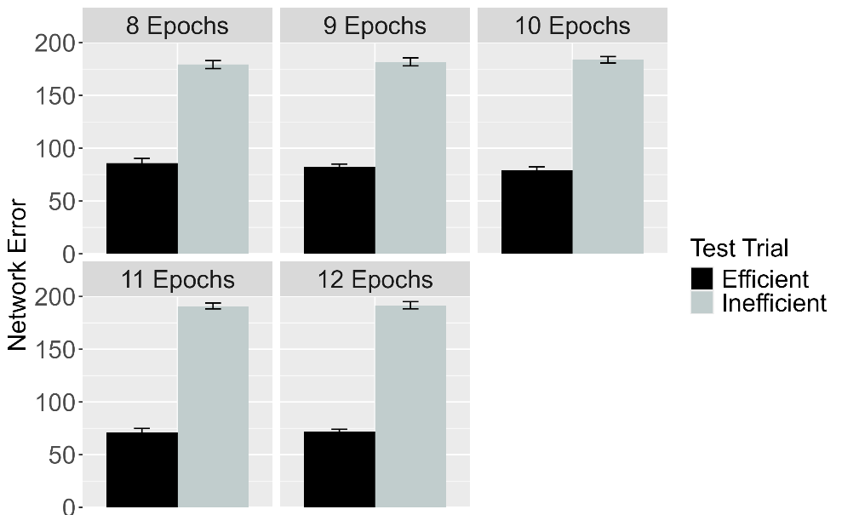
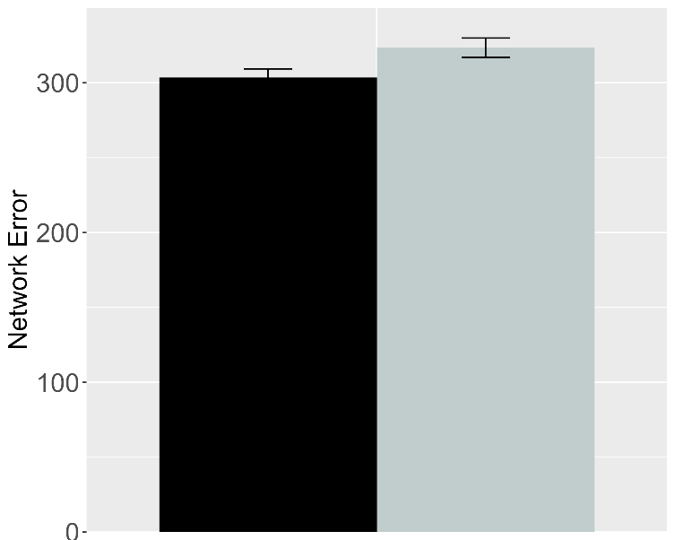 | 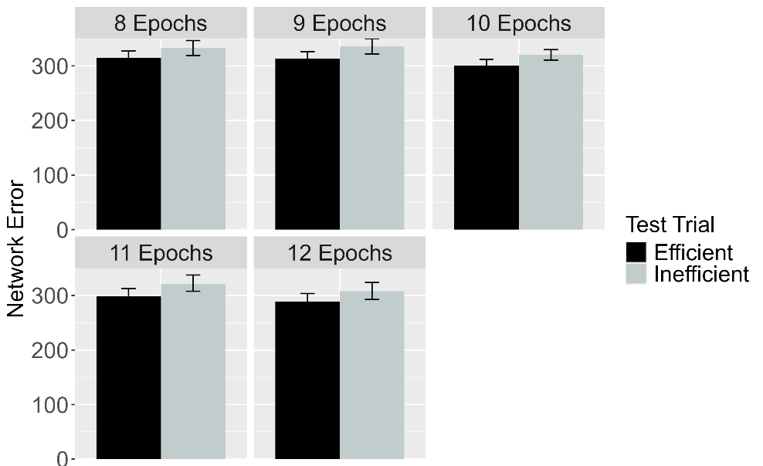
Figure 17. Performance of ALIAS. Plotted is networks’ mean error to the Efficient and Inefficient test events in the Experimental (top row) and Control conditions, both overall (left column) and across different habituation epochs (right column). The Experimental and Controls correspond to Experiments 1, 4, and 5 in Skerry et al. (2013).

Figure 17 shows the performance of ALIAS, both across habituation epochs and overall. The results—which are shown in Figure 17, showed that networks in the Experimental condition looked longer at the Inefficient test event than at the Efficient one. This was true overall and for different amounts of habituation. In contrast, networks in the Control condition looked equally long at both test events. Both findings qualitatively matched those of Skerry et al. (2013).

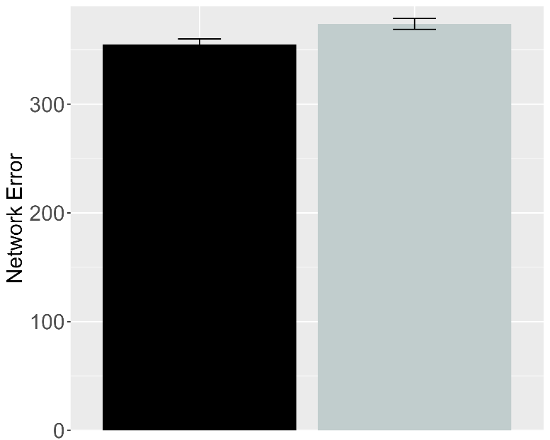 | 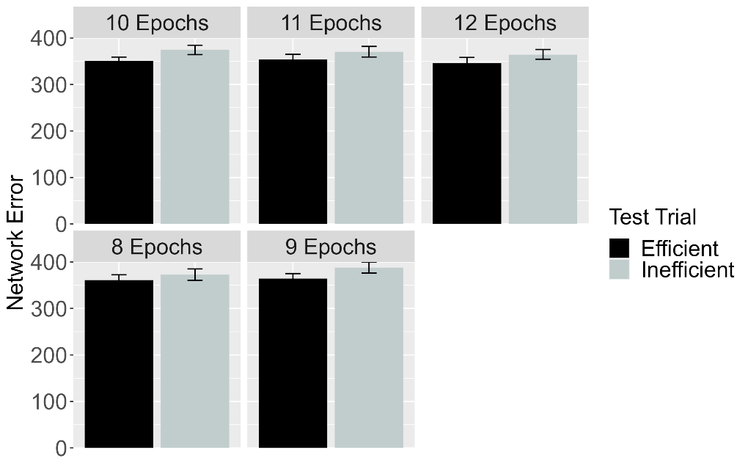
Figure 18. Performance of ALIAS in the No Training condition. The overall error produced to the Efficient and Inefficient test events is shown on the left, and the error produced across different habituation epochs is shown on the right. This condition corresponds to Experiment 3 in Skerry et al. (2013).

Figure 18 shows the performance of networks in the No Training condition. Networks—like infants in the corresponding behavioral condition—looked about equally long at both test events.
Importantly, if networks’ prior experience with constrained arced motion enabled them to associate arced motion with barriers and then to detect when such associations are violated, then those in the No Training condition—like networks in the Effective Action condition—should have looked longer at the Inefficient than at the Efficient test event. This suggests that attentional boost that networks experienced during the action phase was necessary for the model to treat the two test events differently like older infants.

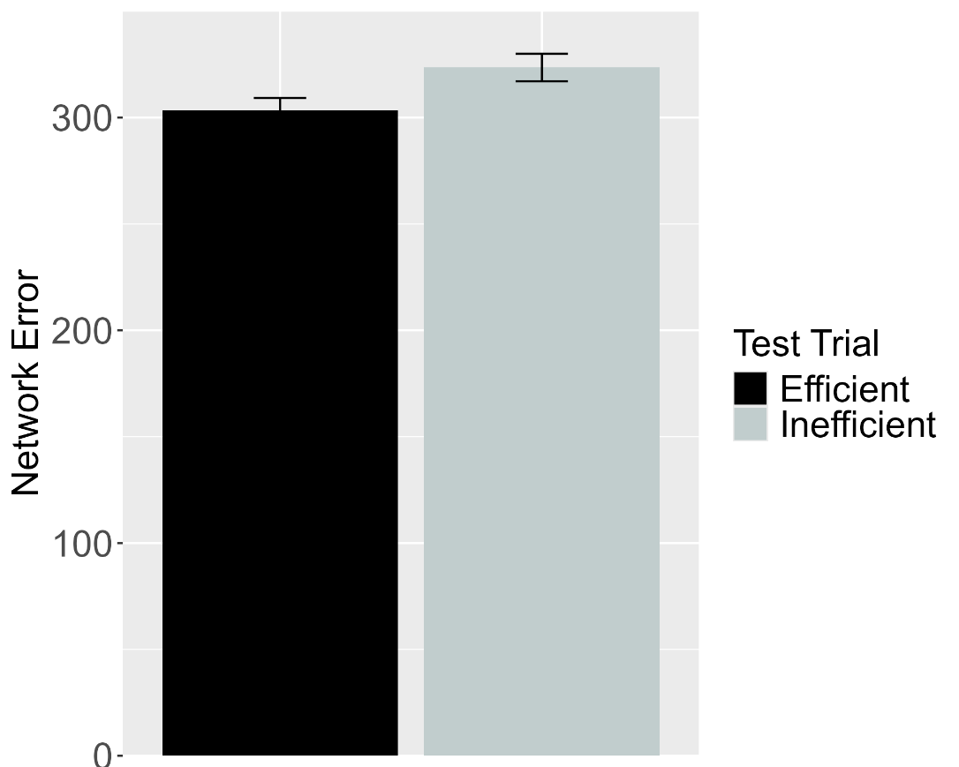
Figure 19. Performance of ALIAS in the Ineffective Action condition. Plotted is networks’ overall mean error to the Efficient and Inefficient test events. This condition corresponds to Experiment 2 in Skerry et al. (2013).

In contrast to networks in the Effective Action, networks in the Ineffective Action condition—like infants in the corresponding behavioral condition—looked about equally at both test events. The present results challenge The present results raise the intriguing possibility that effective action experience, through enhancing infants’ attention to and encoding of a reach’s straight and curved trajectory, is sufficient to reproduce infants’ looking behavior in Skerry et al.’s (2013) Effective Action condition; it is not necessary to assume that such experience enables infants to detect an agent’s goal and the rationality of its action to account for this finding.

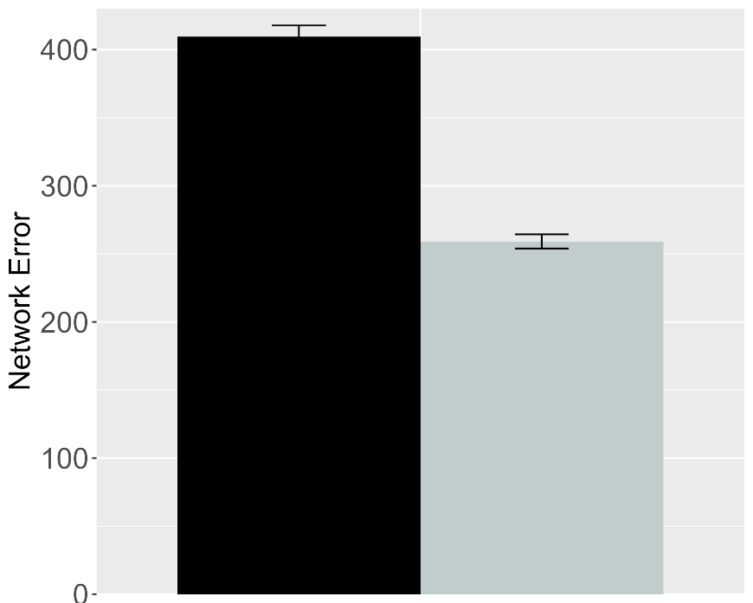 | 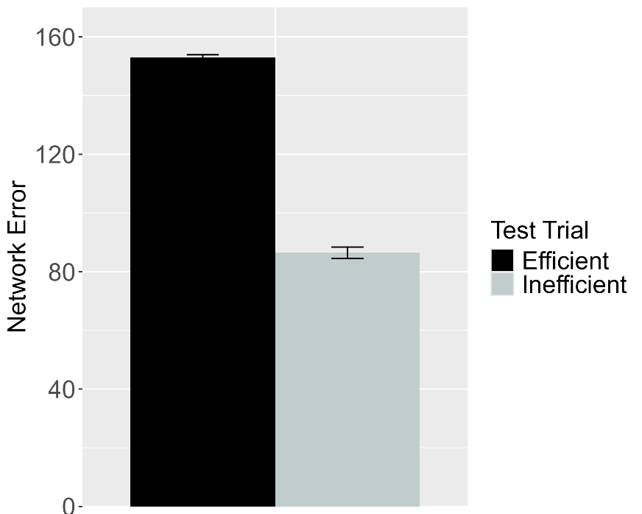
Figure 20. Performance of ALIAS in the Effective Action condition. (Left) Overall error produced to the Efficient and Inefficient test events for networks in the Experimental condition. (Right) Overall error produced to the Efficient and Inefficient test events for networks in the Control condition. These data correspond to a version of ALIAS in which the attentional boost extends into the habituation phase.

A key assumption that present account makes is that the attentional boost that infants experience in the Effective Action condition is fleeting. Yet, it remains to be seen whether such a boost must be transient to capture infants’ behavior in this condition. For example, would ALIAS still capture infants’ looking behaviors if the attentional boost extended into and through the habituation phase? This simulation examined this issue. The simulation itself was identical to the Effective Action condition described above except that the attentional boost experienced by networks in the Experimental and Control conditions persisted throughout habituation. The results for this simulation indicated that networks in both conditions produced greater error to the Efficient test event than to the Inefficient event. These data are shown in Figure 21. These results suggest that it is necessary that the action-phase attentional boost be transient for ALIAS to reproduce infants’ looking responses in the Effective Action condition.
The basis for these findings is straightforward: Although networks’ heightened attention during the action phase enabled them robustly to encode their own straight reach trajectories, the fact that this attentional boost persisted into the habituation phase meant that networks’ representations of these trajectories were overridden by robust representations of the arced motion trajectories and the surface features associated with those trajectories (e.g., the height of the apex of a reach’s trajectory) shown to them during the habituation phase. Consequently, the Inefficient test event—which, with the expection of the barrier, preserved most of the features of this event—was partially consistent with the habituation representation; the Efficient test event was not because it depicted a straight reach trajectory. As such, the Efficient test event produced more error (or longer looking) than the Inefficent test event.

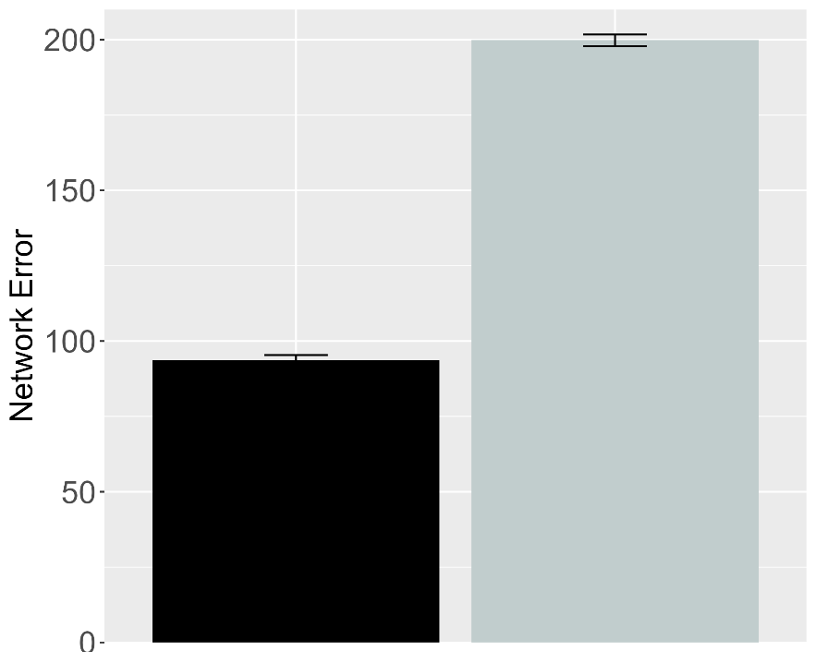 | 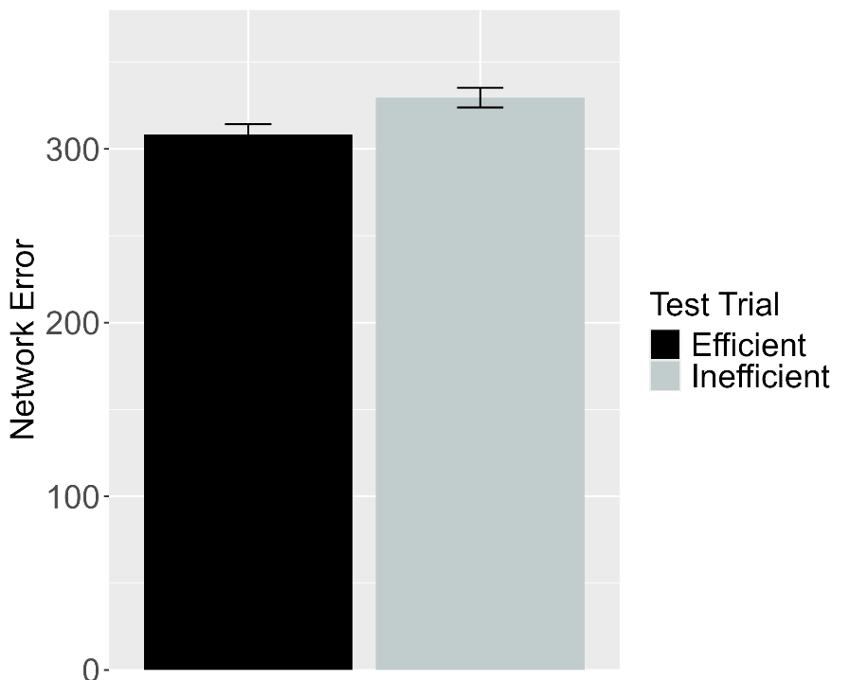
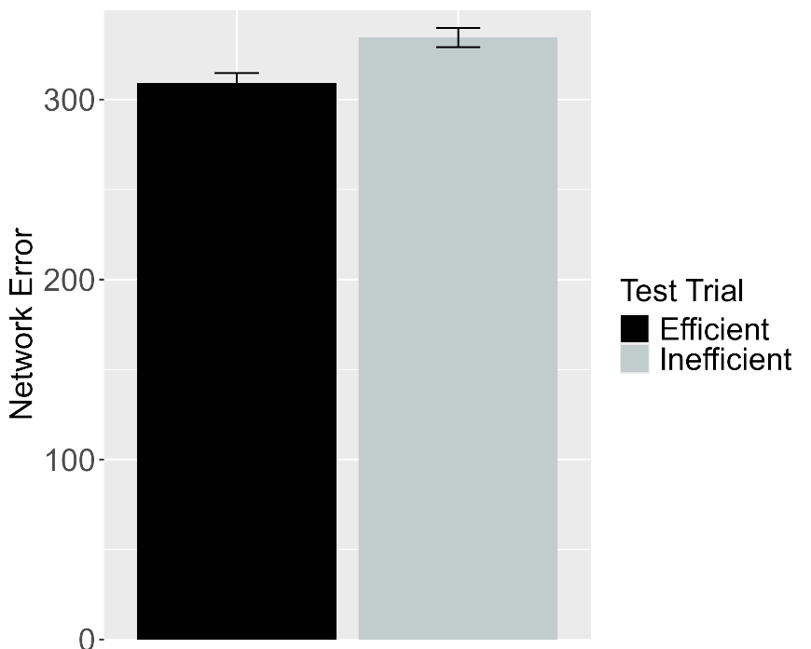
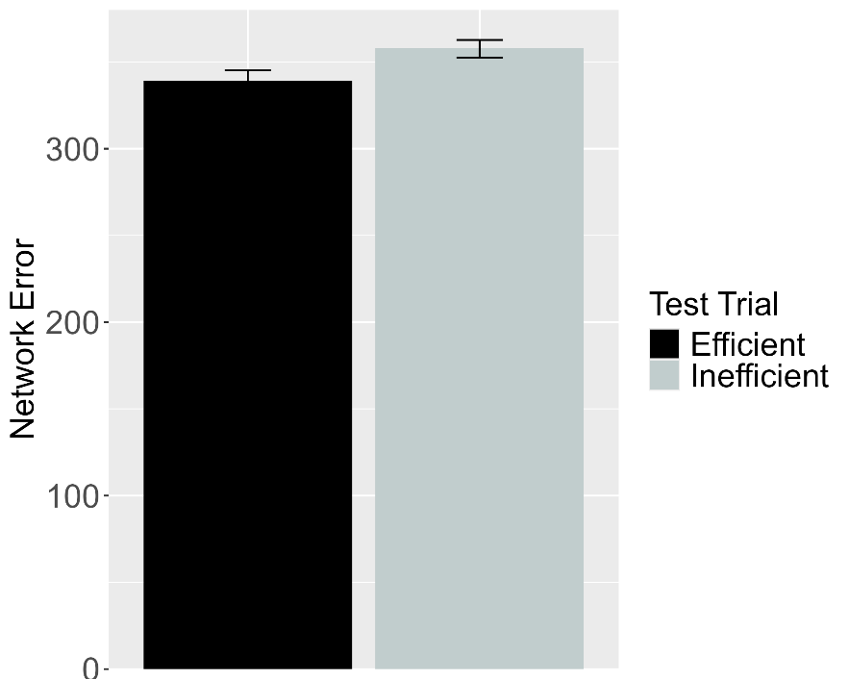
Figure 21. Performance of ALIAS-2. Plotted in the top row is the overall mean error to the Efficient and Inefficient test events for networks assigned either to Experimental (top left) or to the Control condition (top right) in the Efficient Action condition. Plotted in the middle row is the overall mean error to the two test events for networks assigned to the Ineffective Action condition. Plotted in the bottom row is the overall mean error to the two test events for networks assigned to the No Training Condition. This condition corresponds to Experiment 2 in Skerry et al. (2013).

The next analysis examined whether associative learning alone was sufficient for ALIAS to reproduce Skerry et al.’s (2013) findings; the attentional boost remained short-lived in this simulation. In the Effective Action condition, networks in the Experimental condition produced greater error to the Inefficient test event than to the Efficient one. In contrast, networks in the Control condition as well as those in the Ineffective and No Training conditions produced about equivalent error to both test events. Together, these results—shown in Figure 21—suggest that associative learning alone is sufficient to account for Skerry et al.’s (2013) finding; including assumptions about differential obstacle salience, at least here, are not additionally needed.
A longstanding assumption in the developmental cognitive sciences is that infants possess domain-specific mechanisms that enable them to reason about actions in terms of their efficiency, cost, and subjective utility. The teleological stance, naïve utility calculus, and a proposal by Liu et al. (2026) are three examples. Although each of these perspectives has empirical support and intuitive appeal, I argued here that infants’ behaviors in action efficiency understanding studies can be explained without appealing to them. I showed that a model that learns via associative learning and that implements the assumption that peripherally located obstacles have reduced salience succeeded in capturing a range of key findings in this literature. This model also accounted for a broader range of data than a version of it that omitted differential obstacle salience and even outperformed alternative models based on similar constructivist ideas such as that by Overwalle (2010). This suggests that ALIAS may be a viable contender to existing domain-specific accounts of infants’ action efficiency understanding.
At the same time, a complete account of infants’ looking behaviors in action efficiency understanding studies should do more than reproduce existing data; it should also generate predictions that can be tested in future behavioral experiments. The final section does exactly this by placing ALIAS in a series of novel situations and assessing its resulting behaviors.These behaviors will serve both as predictions for future research on infant action efficiency understanding and as a basis for teasing apart the current perspective from domain-specific ones.

Model predictions
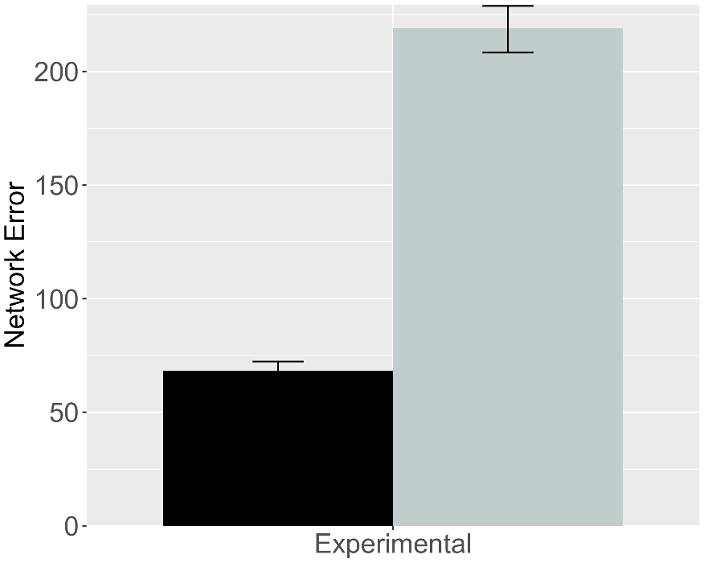 | 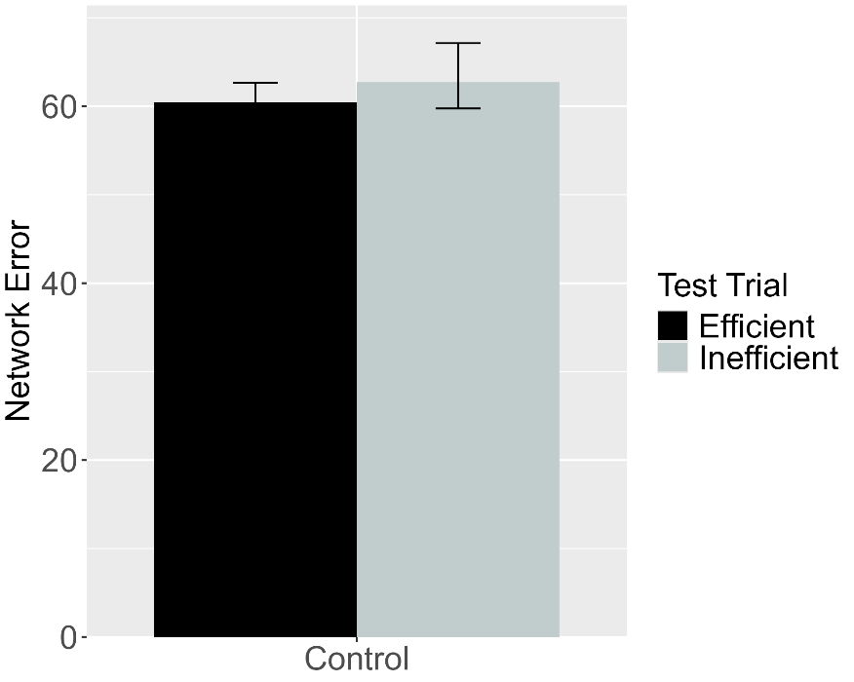
Figure 22. Performance of ALIAS. (Left) Overall error produced to the Efficient and Inefficient test events for networks in the Experimental condition. (Right) Overall error produced to the Efficient and Inefficient test events for networks in the Control condition. The barrier shown during habituation for this simulation appeared directly above rather than beneath arced motion.

A key benefit of developing computational models is that their behavior in novel situations can be treated as testable predictions for future research. In the current context, for example, a potentially interesting question concerns how ALIAS would respond if, instead of being habituated to a canonical constrained event, it were habituated to an event in which the barrier was positioned just above the apex of the agent’s jump trajectory. If the current account is correct that positioning the obstacle in the immediate vicinity of the motion trajectory is the critical factor enabling the formation of a robust association between the two, then networks should form as robust an association between the curved motion and the obstacle in this anomalous configuration as when the barrier is located beneath that motion.
The first simulation reported in this section addressed this first issue. The simulation itself was identical to Simulation 1A with two exceptions. First, a fourth unit was added to the Obstacle Horizontal Position input and output groups. This unit corresponded to a location that appeared directly above arced motion when paired with it. Second, to simplify the simulations reported in this section, the length of the habituation phase was reduced to eight epochs; this was the smallest number used in the prior simulations. This was also the value used in all of the prediction simulations reported here for consistency. This decision was justified because the results reported in the previous simulations were robust to different habituation epochs.
As in Simulation 1A, networks were assigned either to the Experimental condition (N = 20) or to the Control condition (N = 20). Importantly, networks encountered barriers in the above-the-curved-motion spatial configuration only during the habituation phase; pretraining barriers were always tethered to the ground. The relative horizontal position of this barrier was identical to that in Simulation 1a. The results from this simulation—depicted in Figure 23—indicate that networks in the Experimental condition produced greater error to the Inefficient than to the Efficient test event. In contrast, networks in the Control condition produced equivalent error to both test events. These results mirror those in Simulation 1a.
The fact that these predictions are presumably at odds with those derived from the current domain-specific proposals suggests that a behavioral experiment based on this simulation could be one way to decide between these competing accounts; the present account would be supported if infants in the Experimental condition looked longer at the Inefficient than at the Efficient test event. In contrast, the domain-specific proposals would be supported if infants looked equally long at the two test events in both conditions. Such result would suggest that infants did not see the habituation event as rational or efficient.

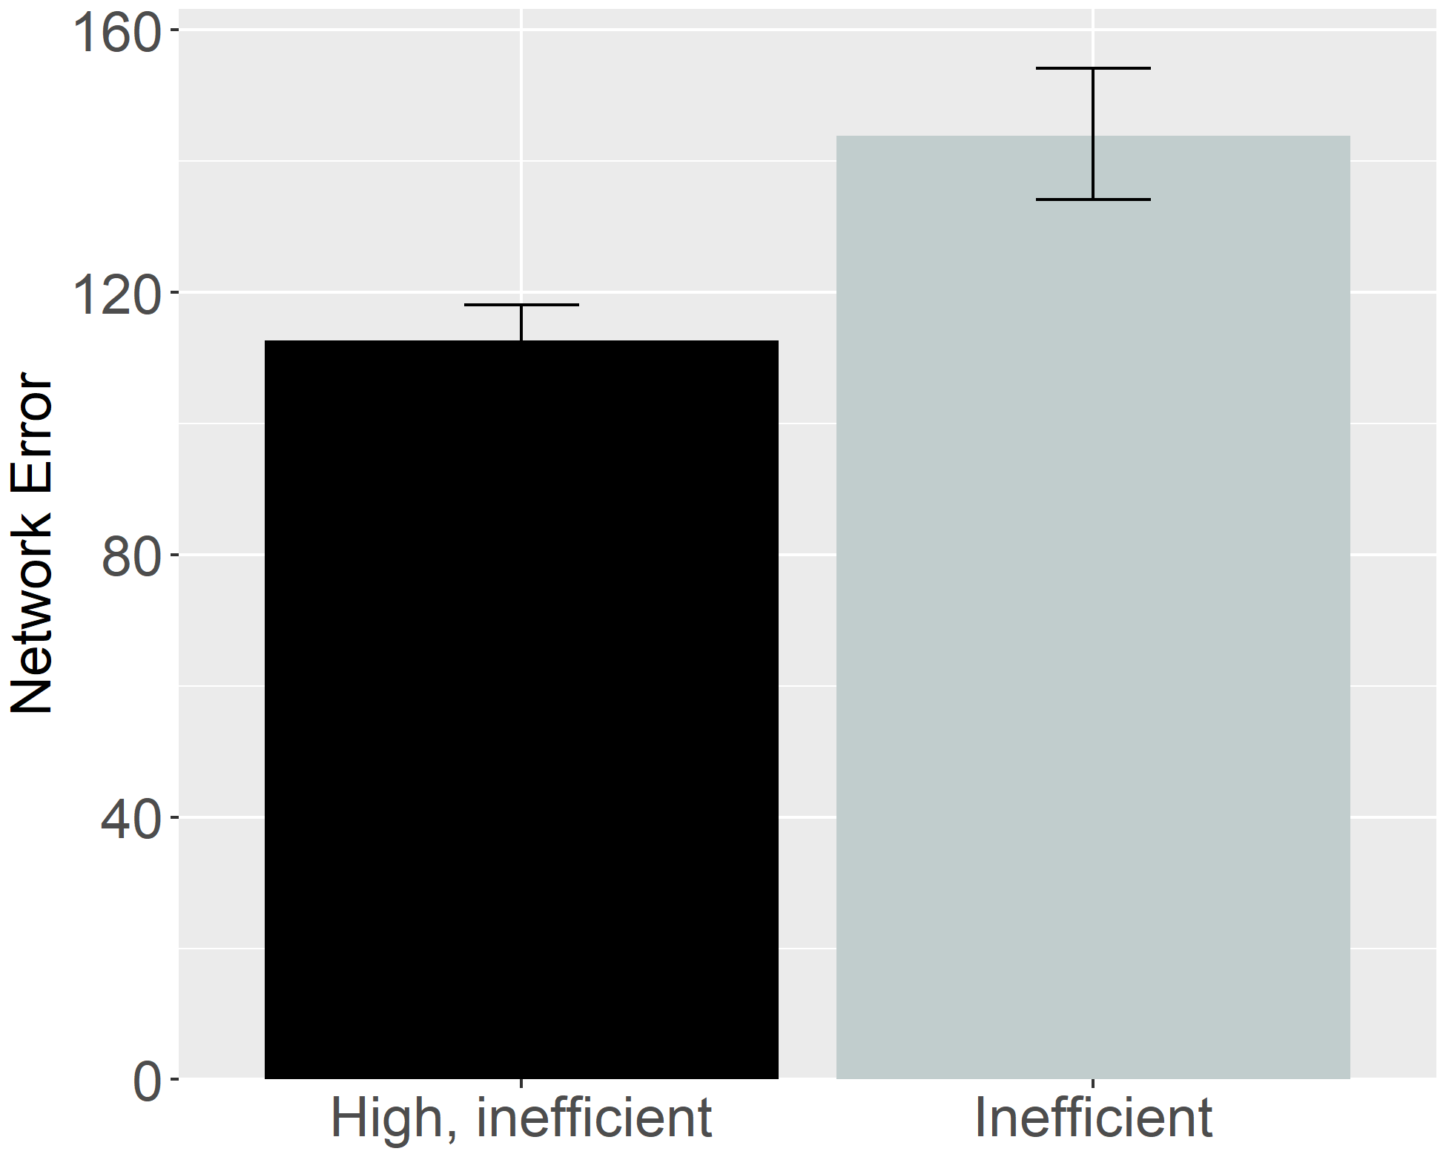
Figure 23. Performance of ALIAS. Overall error produced to the High, inefficient and Inefficient test events.

Given that action efficiency studies have used many different kinds of inefficient events, another interesting question concerns ALIAS’s performance when tested on two different inefficient test events rather than on the standard inefficient and efficient test events. For example, how might ALIAS respond if it were tested on Liu and Spelke’s (2017) High, inefficient test event and Gergely et al.’s (1995) barrierless inefficient test event? To address this question, networks (N = 20) were habituated to the same event used in Simulation 4a following a pretraining phase that was also identical in length to that in Simulation 4a; the networks tested here were thus the same “age” as those tested in Simulation 4a. Networks were then tested on the High, inefficient test event from Simulation 4a and the inefficient one from Simulation 1a. The results for this simulation—which are shown in Figure 24—revealed that networks produced greater error to the Inefficient than to the High, inefficient test event.
In terms of the mechanistic basis of networks’ responses here, networks looked longer at the Inefficient test event than at the High, inefficient one because some of the input information presented in this event—specifically that pertaining to an absent obstacle—strongly activated an internal representation corresponding to straight motion. The reason for this is that networks learned to associate the absence of obstacles with straight motion during the pretraining phases. Ultimately, however, this learned association was at odds with the visual information presented in the Inconsistent test event—this event presented networks with barrierless curved motion. This discrepancy between what networks were shown and what they expected, in turn, resulted in multiple sources of error. One source of error was networks’ erroneous prediction of the unobserved straight rather than the curved motion. Another was networks’ mistaken prediction of the unobserved no vertical clearance rather than the observed large vertical clearance. By contrast, the High, inefficient test event produced comparatively less error because the input information associated with this event was much more consistent with that encountered during pretraining. As such, there were fewer contributors to error for this event than the inefficient one. The contributors for this event were discussed in Simulation 4.
Beyond these mechanistic details, the current results are theoretically significant because presumably they are at odds with those predicted by any of the present domain-specific proposals for the same events. If these accounts are correct that infants process others’ actions in terms of their efficiency, cost, and subjective utility, then infants should look equally long at both inconsistent events. This is because not only is it the case that the actions themselves are non-rational, but it is also the case that they are equally costly. The latter contention falls directly out of the math of the naïve utility calculus. Although the full mathematical details of this model are beyond the scope of this paper (see Jara-Ettinger et al., 2016; Jara-Etttinger et al., 2020), an aspect of this model that is worth highlighting here is that in the model cost is defined in terms of an agent’s actions (or more formally, its policy)—this policy is equivalent in both inefficient test events. Thus, because the agent jumps to the same height in both test events, it also incurs the same cost in each event. A promising goal for future research will be to test these predictions.

General Discussion
A question that developmental scientists have wrestled with for the last 30 years concerns how infants discover that some actions are more efficient than others. One perspective—here referred to as the rich perspective—maintains that infants possess early-emerging and conceptually rich domain-specific systems that enable them to process actions in terms of their efficiency, cost, rationality, and subjectivity as well as in terms of the agents involved in them (Csibra & Gergely, 1998; Gergely & Csibra, 2003; Jara-Ettinger et al., 2016; Jara-Ettinger et al., 2020; Liu et al., 2026). Another perspective is that infants’ behaviors in violation-of expectation investigations—of which studies assessing infants’ action efficiency understanding are specific instances—can instead be explained by domain-general learning mechanisms (e.g., associative learning, habituation, conditioning, imitation, among others).
This paper builds on and extends this second perspective. The crux of the present argument was that infants’ looking behavior in studies assessing their putative sensitivity to action efficiency results from an associative learning mechanism that operates over the differentially salient, and conceptually neutral surface features of actions events. The current paper showed that a model called ALIAS that instantiated this proposal captured the finding that infants look longer at inefficient than efficient actions following habituation to animate-like constrained events (Simulation 1); the finding that infants’ sensitivity to an action’s efficiency extends to inanimate-like constrained events (Simulation 2); the finding that infants can infer missing constraints from an agent’s behavior and its goal as well as its goal from its behavior and environmental constraints (Simulation 3); the finding that infants’ putatively possess a graded notion of efficiency (Simulation 4); and the finding that pre-reaching 3-month-olds can process action efficiency if they are given action experience (Simulation 5).
The present results also showed that ALIAS provided a better account of these target findings than any of the current competitor models: ALIAS-2, OM10, and OM10-2. Table 1—which shows the qualitative fits of each of these models to the five target findings—makes this point especially clear. The table shows that ALIAS successfully captured all five target findings as well as the more specific findings associated with illustrative paradigms from which the target findings were derived. In contrast, the remaining models either failed to capture several of the target findings, could only partially account for them, or could not be used to simulate them because of theoretical or architectural limitations. ALIAS’s superior performance challenges the idea that infants’ looking behavior in action efficiency studies is underpinned by domain-specific mechanisms that provide infants with rich notions of efficiency and cost.

Table 1. Qualitative fits of the different models to the five target findings examined in the current paper.
 |  |  |  | Model
Target finding | Illustrative paradigm | Articles | ALIAS | ALIAS-2 | OM10 | OM10-2
- Selective longer looking to inefficient than actions following constrained. | Animate agent constrained action | Csibra et al. (1999); Gergely et al. (1995) |  |  |  | 
 | Animate agent unconstrained action |  |  |  |  | 
- Independence from animacy. | Inanimate-agent constrained action | Csibra et al. (1999) Sodian et al. (2004) |  |  |  | 
 | Inanimate agent unconstrained action |  |  |  |  | 
- Bidirectional inferences for actions, goals, and constraints. | Goal inference | Csibra et al. (2003); Wagner & Carey (2005) |  |  |  | 
 | Constraint inference |  |  |  |  | 
- Graded representations of efficiency. | More costly vs. less costly constrained action | Liu & Spelke (2017) |  |  | — | 
 | More costly vs. less costly unconstrained action |  |  |  | — | 
 | More costly vs. less costly constrained action with a previously inefficient agent |  |  |  | — | 
- Action efficiency understanding in pre-reaching infants. | Sticky mittens training constrained action | Skerry et al. (2013) |  |  | — | —
 | Non-sticky mittens training constrained action |  |  |  | — | —
 | Sticky mittens training unconstrained action |  |  |  | — | —
Note. Check marks indicate that a given model captured the qualitative pattern associated with a target finding and its corresponding illustrative paradigm; Xs indicate that the model failed to capture the finding; and dashes indicate that the model could not meaningfully be applied to the corresponding target and illustrative paradigm. Illustrative paradigms are nested within the broader target finding to which they correspond. Because several of the current target findings were derived from multiple experiments and published studies, the associated citations are also provided.
The current simulations also make several contributions to the literature on infants’ action efficiency understanding. Two are particularly notable. First, they provided insight into the possible mechanistic basis of infants’ looking responses in the corresponding behavioral experiments. This was accomplished by unpacking the model’s internal representations, the associations it learned, and the activation dynamics that gave rise to its behavior. Several important insights resulted from this process. For example, analyses of the model’s innerworkings revealed that ALIAS’s responses to inefficient and efficient actions emerged not from explicit representations of goals, efficiency, cost or rationality. Instead, they emerged from associations between curved trajectories and obstacles that were first formed during pretraining and later reinforced during habituation. Additionally, the sticky-mittens simulation (i.e., Simulation 5) showed that longer looking to inefficient test events than efficient ones is the natural consequence of an otherwise inexperienced model encoding and becoming familiar with its own straight reaches due to its heightened attentional state. Still other simulations (e.g., Simulation 4) showed that prior experience with curved trajectories and obstacles can explain why it is the case that infants look longer at events in which curved motion occurs in the absence of an obstacle than when it occurs with an obstacle or why infants look longer when agents stop short of their goals than when they stop next to them; it is not necessary to assume that infants are making sophisticated inferences about missing barriers and goals to explain these patterns.
Second, the current simulations generate a number of testable predictions. One is that infants who are habituated to a constrained action event and then tested on a High, inefficient test event like that in Liu and Spelke (2017) and an inefficient test event like that in Gergely et al. (1995) should look longer at the inefficient than at the High, inefficient one. Another prediction is that infants should look longer at an inefficient test event than at an efficient one following habituation to an event in which curved motion unfolds beneath rather than over an obstacle. Still another prediction of the current model is that increasing peripherally located obstacles’ salience in unconstrained control events should strengthen the association formed between them and curved motion. Along similar lines, decreasing barriers’ salience in constrained experimental events should weaken the association formed between them and curved trajectories. Such findings would be difficult to reconcile with any of the domain-specific proposals, not least because infants are thought to possess abstract notions of efficiency, rationality, and cost.
It is nonetheless important to restate what ALIAS is and is not as well as what the current simulations do and do not accomplish. In terms of the first point, ALIAS is not a model of how action efficiency understanding itself emerges. ALIAS is instead a model of the mechanistic basis of infants’ looking responses in studies on this topic. This does not mean that the processes that ALIAS implements are unrelated to the development of genuine action efficiency understanding, however. Indeed, it is my contention that the very same processes argued here to underlie infants’ looking behaviors in studies on this topic may also support the development of an authentic understanding of what makes an action efficient. In terms of the second point, the current simulations cannot disprove a domain-specific mechanisms for representing goals, efficiency, cost, or rationality any more than it can prove that ALIAS is the right description of the processes underpinning infants’ action efficiency understanding. Instead, they demonstrate that a domain-general associative learning mechanism operating over differentially salient surface features is sufficient to explain a broad range of findings in this literature. Behavioral experiments are ultimately needed to decide among the current competing proposals.
Before concluding, two potential criticisms of ALIAS are worth noting. The first concerns the fact that the present simulations focused primarily on studies employing some version of the Gergely paradigm. Potential downsides of this are that the conclusions that can be drawn from it are necessarily limited in scope and that it is unclear to what extent that current model can capture findings on infant action understanding broadly (e.g., Gergely et al., 2002; Woodward, 1998). Future work will therefore need to determine whether extended versions of ALIAS can capture findings beyond those related to infants’ action efficiency understanding.
The second concerns the model’s simplicity. Although movement was represented dynamically, all other aspects of the model were represented statically. Additionally, a localist rather than a distributed encoding scheme was used to represent objects, their features, and any external constraints or barriers in the environment. Based on these simplifications, it could be argued that the model poorly approximates infants’ real-world action experience. However, a major advantage of simpler models is that by tracing precisely how they process information, they can provide meaningful insight into the possible mechanistic basis of some phenomenon in the human mind. That simple models can be taken apart and scrutinized in this way makes them especially well-suited for advancing theories of infant cognitive development. Although it is true that complex models could better capture the richness of infants’ action perception, a major disadvantage of such models is that their complexity hinders their interpretability. This complexity also makes it difficult to separate the meaningful consequences of different theoretical assumptions from extraneous model details. This makes simple models invaluable tools for instantiating and evaluating the consequences of proposed mechanisms.
In sum, the current simulations demonstrate that a domain-general associative learning mechanism operating over the low-level kinematics of actions and the differentially salient surface features of environments is sufficient to explain a broad range of findings in the action efficiency understanding literature. This proposal—when instantiated in a new connectionist model called ALIAS—not only successfully captured five major findings in this literature but also generated several predictions that should be tested in future research. Additionally, the current simulations provided insight into the possible mechanistic basis of infants’ action efficiency understanding through detailed analyses of ALIAS’s behavior in each simulation. Considered together, the current simulations suggest that before concluding that infants possess conceptually rich knowledge that is underpinned by domain-specific mechanisms based on their performance in a behavioral task, it is important to determine first whether more general processes are sufficient to explain the same performance. The current simulations suggest that they may well be, at least in the domain of infant action efficiency understanding.
References
Baillargeon, R. (1986). Representing the existence and the location of hidden objects: Object permanence in 6-and 8-month-old infants. Cognition, 23(1), 21-41. https://doi.org/10.1016/0010-0277(86)90052-1
Baillargeon, R. (1987). Object permanence in 3½- and 4½-month-old infants. Developmental Psychology, 23(5), 655–664. https://doi.org/10.1037/0012-1649.23.5.655
Baillargeon, R., & DeVos, J. (1991). Object permanence in young infants: Further evidence. Child development, 62(6), 1227-1246. https://doi.org/10.1111/j.1467-8624.1991.tb01602.x
Baillargeon, R., Spelke, E. S., & Wasserman, S. (1985). Object permanence in five-month-old infants. Cognition, 20(3), 191-208. https://doi.org/10.1016/0010-0277(85)90008-3
Benton, D. T. (2025). An associative-learning account of how infants learn about causal action in animates and inanimates: A critical reexamination of four classic studies. Journal of Experimental Psychology: General, 154(2), 497–521. https://doi.org/10.1037/xge0001656
Benton, D. T., & Lapan, C. (2022). Moral masters or moral apprentices? A connectionist account of sociomoral evaluation in preverbal infants. Cognitive Development, 62, 101164. https://doi.org/10.1016/j.cogdev.2022.101164
Bogartz, R. S., Shinskey, J. L., & Schilling, T. H. (2000). Object permanence in five‐and‐a‐half‐month‐old infants?. Infancy, 1(4), 403-428. https://doi.org/10.1207/S15327078IN0104_3
Carey, S. (2009). The origin of concepts. Oxford University Press.
Christiansen, M. H., & Curtin, S. (1999). Transfer of learning: Rule acquisition or statistical learning? Trends in Cognitive Sciences, 3(8), 289–290. https://doi.org/10.1016/S1364-6613(99)01356-X
Cohen, L. B., Chaput, H. H., & Cashon, C. H. (2002). A constructivist model of infant cognition. Cognitive Development, 17(3-4), 1323-1343. https://doi.org/10.1016/S0885-2014(02)00124-7
Cohen, L. B., & Marks, K. S. (2002). How infants process addition and subtraction events. Developmental science, 5(2), 186-201. https://doi.org/10.1111/1467-7687.00220
Cohen, L. B., & Oakes, L. M. (1993). How infants perceive a simple causal event. Developmental psychology, 29(3), 421-433.
Colunga, E., & Smith, L. B. (2005). From the Lexicon to Expectations About Kinds: A Role for Associative Learning. Psychological Review, 112(2), 347–382. https://doi.org/10.1037/0033-295X.112.2.347
Csibra, G., & Gergely, G. (1998). The teleological origins of mentalistic action explanations: A developmental hypothesis. Developmental science, 1(2), 255-259. https://doi.org/10.1111/1467-7687.00039
Csibra, G., Gergely, G., Bı́ró, S., Koos, O., & Brockbank, M. (1999). Goal attribution without agency cues: the perception of ‘pure reason’in infancy. Cognition, 72(3), 237-267. https://doi.org/10.1016/S0010-0277(99)00039-6
Csibra, G., Bíró, S., Koós, O., & Gergely, G. (2003). One‐year‐old infants use teleological representations of actions productively. Cognitive science, 27(1), 111-133. https://doi.org/10.1207/s15516709cog2701_4
Elman, J. L., Bates, E. A., Johnson, M. H., Karmiloff‑Smith, A., Parisi, D., & Plunkett, K. (1996). Rethinking innateness: A connectionist perspective on development. MIT Press.
Gelman, R. (1990). First principles organize attention to and learning about relevant data: Number and the animate‐inanimate distinction as examples. Cognitive science, 14(1), 79-106. https://doi.org/10.1207/s15516709cog1401_5
Geraci, A., & Surian, L. (2011). The developmental roots of fairness: Infants’ reactions to equal and unequal distributions of resources. Developmental science, 14(5), 1012-1020. https://doi.org/10.1111/j.1467-7687.2011.01048.x
Geraci, A., Surian, L., Tina, L.G. et al. Human newborns spontaneously attend to prosocial interactions. Nat Commun 16, 6304 (2025). https://doi.org/10.1038/s41467-025-61517-3
Gergely, G., & Csibra, G. (2003). Teleological reasoning in infancy: The naıve theory of rational action. Trends in cognitive sciences, 7(7), 287-292. https://doi.org/10.1016/S1364-6613(03)00128-1
Gergely, G., Nádasdy, Z., Csibra, G., & Bíró, S. (1995). Taking the intentional stance at 12 months of age. Cognition, 56(2), 165-193. https://doi.org/10.1016/0010-0277(95)00661-H
Hamlin, J. K. (2013a). Moral judgment and action in preverbal infants and toddlers: Evidence for an innate moral core. Current Directions in Psychological Science, 22(3), 186-193. https://doi.org/10.1177/0963721412470687
Hamlin, J. K., & Wynn, K. (2011). Young infants prefer prosocial to antisocial others. Cognitive development, 26(1), 30-39. https://doi.org/10.1016/j.cogdev.2010.09.001
Hamlin, J. K., Wynn, K., & Bloom, P. (2007). Social evaluation by preverbal infants. Nature, 450(7169), 557-559. https://doi.org/10.1038/nature06288
Hinton, G. E. (1989). Deterministic Boltzmann learning performs steepest descent in weight-space. Neural computation, 1(1), 143-150. https://doi.org/10.1162/neco.1989.1.1.143
Hunter, M. A., & Ames, E. W. (1988). A multifactor model of infant preferences for novel and familiar stimuli. Advances in Infancy Research, 5, 69–95.
Hunter, M. A., Ames, E. W., & Koopman, R. (1983). Effects of stimulus complexity and familiarization time on infant preferences for novel and familiar stimuli. Developmental Psychology, 19(3), 338–352. https://doi.org/10.1037/0012-1649.19.3.338
Jones, S. S., & Smith, L. B. (1993). The place of perception in children's concepts. Cognitive Development, 8(2), 113-139. https://doi.org/10.1016/0885-2014(93)90008-S
Kamewari, K., Kato, M., Kanda, T., Ishiguro, H., & Hiraki, K. (2005). Six-and-a-half-month-old children positively attribute goals to human action and to humanoid-robot motion. Cognitive Development, 20(2), 303-320. https://doi.org/10.1016/j.cogdev.2005.04.004
Kellman, P. J., & Spelke, E. S. (1983). Perception of partly occluded objects in infancy. Cognitive psychology, 15(4), 483-524. https://doi.org/10.1016/0010-0285(83)90017-8
Kim, I. K., & Spelke, E. S. (1992). Infants' sensitivity to effects of gravity on visible object motion. Journal of Experimental Psychology: Human Perception and Performance, 18(2), 385-393.
Kotovsky, L., & Baillargeon, R. (1998). The development of calibration-based reasoning about collision events in young infants. Cognition, 67(3), 311-351. https://doi.org/10.1016/S0010-0277(98)00036-5
Leslie, A. M. (1995). A theory of agency. In D. Sperber, D. Premack, & A. J. Premack (Eds.), Causal cognition: A multidisciplinary debate (pp. 121-141). Clarendon Press.
Leslie, A. M., & Keeble, S. (1987). Do six-month-old infants perceive causality?. Cognition, 25(3), 265-288. https://doi.org/10.1016/S0010-0277(87)80006-9
Lucca, K., Yuen, F., Wang, Y., Alessandroni, N., Allison, O., Alvarez, M., ... & Hamlin, J. K. (2025). Infants’ Social Evaluation of Helpers and Hinderers: A Large‐Scale, Multi‐Lab, Coordinated Replication Study. Developmental Science, 28(1), e13581. https://doi.org/10.1111/desc.13581
Liu, S., & Spelke, E. S. (2017). Six-month-old infants expect agents to minimize the cost of their actions. Cognition, 160, 35-42. https://doi.org/10.1016/j.cognition.2016.12.007
Mareschal, D., French, R. M., & Quinn, P. C. (2000). A connectionist account of asymmetric category learning in early infancy. Developmental Psychology, 36(5), 635–645. https://doi.org/10.1037/0012-1649.36.5.635
Mareschal, D., & Shultz, T. R. (1999). Development of children's seriation: A connectionist approach. Connection Science, 11(2), 149-186. https://doi.org/10.1080/095400999116322
McCrink, K., & Wynn, K. (2004). Large-number addition and subtraction by 9-month-old infants. Psychological Science, 15(11), 776-781. https://doi.org/10.1111/j.0956-7976.2004.00755.x
Muentener, P., & Carey, S. (2010). Infants’ causal representations of state change events. Cognitive psychology, 61(2), 63-86. https://doi.org/10.1016/j.cogpsych.2010.02.001
Needham, A., & Baillargeon, R. (1997). Object segregation in 8-month-old infants. Cognition, 62(2), 121-149. https://doi.org/10.1016/S0010-0277(96)00727-5
Onishi, K. H., & Baillargeon, R. (2005). Do 15-month-old infants understand false beliefs?. science, 308(5719), 255-258. https://doi.org/10.1126/science.1107621
Perner, J., & Ruffman, T. (2005). Infants' insight into the mind: How deep?. Science, 308(5719), 214-216. https://doi.org/10.1126/science.1111656
Phillips, A. T., & Wellman, H. M. (2005). Infants' understanding of object-directed action. Cognition, 98(2), 137-155. https://doi.org/10.1016/j.cognition.2004.11.005
Powell, L. J., & Spelke, E. S. (2018). Human infants’ understanding of social imitation: Inferences of affiliation from third party observations. Cognition, 170, 31-48. https://doi.org/10.1016/j.cognition.2017.09.007
Quinn, P. C., & Eimas, P. D. (1997). A reexamination of the perceptual-to-conceptual shift in mental representations. Review of General Psychology, 1(3), 271-287. https://doi.org/10.1037/1089-2680.1.3.271
Rakison, D. H., & Lupyan, G. (2008). Developing object concepts in infancy: An associative learning perspective. Monographs of the Society for Research in Child Development, 73(1), 1-110. http://www.jstor.org/stable/30162860
Rumelhart, D. E., Hinton, G. E., & Williams, R. J. (1986). Learning representations by back-propagating errors. Nature, 323(6088), 533-536. https://doi.org/10.1038/323533a0
Scarf, D., Imuta, K., Colombo, M., & Hayne, H. (2012). Social evaluation or simple association? Simple associations may explain moral reasoning in infants. https://doi.org/10.1371/journal.pone.0042698
Schlesinger, M., & Casey, P. (2003). Where infants look when impossible things happen: Simulating and testing a gaze-direction model. Connection Science, 15(4), 271-280. https://doi.org/10.1080/09540090310001655093
Schlingloff, L., Csibra, G., & Tatone, D. (2020). Do 15-month-old infants prefer helpers? A replication of Hamlin et al.(2007). Royal Society open science, 7(4), 191795. https://doi.org/10.1098/rsos.191795
Schmidt, M. F., & Sommerville, J. A. (2011). Fairness expectations and altruistic sharing in 15-month-old human infants. PloS one, 6(10), e23223. https://doi.org/10.1371/journal.pone.0023223
Schwier, C., Van Maanen, C., Carpenter, M., & Tomasello, M. (2006). Rational imitation in 12-month-old infants. Infancy, 10(3), 303-311. https://doi.org/10.1207/s15327078in1003_6
Singh, S. E., Benton, D. T., & Lei, R. F. (2025). Using artificial neural networks to simulate social category learning: A tutorial. Social Cognition, 43(3), 152-166. https://doi.org/10.1521/soco.2025.43.3.152
Sirois, S., & Mareschal, D. (2002). Models of habituation in infancy. Trends in Cognitive Sciences, 6(7), 293-298. https://doi.org/10.1016/S1364-6613(02)01926-5
Slater, A. (1989). Visual memory and perception in early infancy. Infant development, 43-71.
Sloutsky, V. M. (2010). From perceptual categories to concepts: What develops?. Cognitive science, 34(7), 1244-1286. https://doi.org/10.1111/j.1551-6709.2010.01129.x
Sodian, B., Schoeppner, B., & Metz, U. (2004). Do infants apply the principle of rational action to human agents? Infant Behavior and Development, 27(1), 31-41. https://doi.org/10.1016/j.infbeh.2003.05.006
Sokolov, E. N. (1963). Higher nervous functions: The orienting reflex. Annual review of physiology, 25(1), 545-580. https://doi.org/10.1146/annurev.ph.25.030163.002553
Spelke, E. S. (2022). What babies know: Core knowledge and composition (Vol. 1). Oxford University Press.
Spelke, E. S., Breinlinger, K., Macomber, J., & Jacobson, K. (1992). Origins of knowledge. Psychological Review, 99(4), 605–632. https://doi.org/10.1037/0033-295X.99.4.605
Stahl, A. E., & Kibbe, M. M. (2022). Great expectations: The construct validity of the violation‐of‐expectation method for studying infant cognition. Infant and Child Development, 31(6), e2359. https://doi.org/10.1002/icd.2359
Vallortigara, G., Regolin, L., & Marconato, F. (2005). Visually inexperienced chicks exhibit spontaneous preference for biological motion patterns. PLoS biology, 3(7), e208. https://doi.org/10.1371/journal.pbio.0030208
Van Overwalle, F. (2010). Infants' teleological and belief inference: A recurrent connectionist approach to their minimal representational and computational requirements. NeuroImage, 52(3), 1095-1108. https://doi.org/10.1016/j.neuroimage.2010.05.028
Westermann, G., & Mareschal, D. (2012). Mechanisms of developmental change in infant categorization. Cognitive Development, 27(4), 367-382. https://doi.org/10.1016/j.cogdev.2012.08.004
Woo, B. M., Steckler, C. M., Le, D. T., & Hamlin, J. K. (2017). Social evaluation of intentional, truly accidental, and negligently accidental helpers and harmers by 10-month-old infants. Cognition, 168, 154-163. https://doi.org/10.1016/j.cognition.2017.06.029
Woodward, A. L., & Sommerville, J. A. (2000). Twelve-month-old infants interpret action in context. Psychological Science, 11(1), 73-77. https://doi.org/10.1111/1467-9280.00218
Wynn, K. (1992). Addition and subtraction by human infants. Nature, 358(6389), 749-750. https://doi.org/10.1038/358749a0
Wynn, K. (1995). Infants possess a system of numerical knowledge. Current directions in psychological science, 4(6), 172-177. https://doi.org/10.1111/1467-8721.ep10772615
Yermolayeva, Y., & Rakison, D. H. (2014). Connectionist modeling of developmental changes in infancy: Approaches, challenges, and contributions. Psychological Bulletin, 140(1), 224–255. https://doi.org/10.1037/a0032150

Note that the ability to form prototypes develops between 3 and 4 months of age (e.g., Bomba & Siqueland, 1983; Younger, 1985).
Inferential statistics were not used in the present simulations because the goal of the modeling effort was not quantitatively to fit infant looking responses or reproduce the precise magnitude of empirical effects. The goal was instead to determine whether the qualitative pattern of model responses—such as greater error to unexpected or inefficient events in some conditions but not in others—aligned with the patterns observed in infants. This emphasis on assessing whether the model’s behavior qualitatively matches that of infants is consistent with prior connectionist modeling work in the cognitive sciences (e.g., Benton, 2024; Mareschal et al., 2000; Mareschal & Schultz, 1999; McClelland & Thompson, 2007; Plaut & Vande Velde, 2017).

