“Associative learning is sufficient to explain infants’ action understanding”
Abstract
[Abstract here]

“Associative learning is sufficient to explain infants’ action understanding”

A formidable task that young learners face is discovering how to navigate the world effectively. One of the prerequisites for such successful navigation is identifying and distinguishing between efficient and inefficient actions. For example, a child will learn that it is easier, much less dangerous, and more efficient to consume smaller bites of food than to attempt to fit at once entire handfuls of food into their mouth. Likewise, a child will learn that using stairs to reach the top of a slide is safer and more efficient than attempting clumsily to climb it from the bottom. Finally, a child will discover that opening the gate to their play area by grabbing and pulling its handle is physically less taxing, safer, and more efficient than attempting to clamber over the gate. Although it may be relatively straightforward for a young learner to discover what makes some actions more efficient than others in each of these isolated situations, the vast number of different settings a child may find themselves in the real world poses significant challenges on how infants acquire this knowledge broadly. Further complicating issues is the fact that young learners are not directly taught in a supervised manner what distinguishes efficient actions from inefficient ones. Instead, children must discover this fact on their own, in an unsupervised way.
Yet, despite the apparent difficulty of this task, the capacity to interpret others’ actions in terms of their efficiency seems to be in place in infancy (Csibra et al., 1999; Gergely et al., 1995). In these studies infants 6, 9, and 12 months of age are habituated to an event in which an ostensibly animated and self-propelled small ball jumped over a barrier to reach a large ball. Infants were then shown two barrierless test events. In the old action test event, the small circle followed the familiar curved motion path to reach the large circle. In contrast, in the new action test event, the small circle moved along a straight path to reach the large circle. It was reasoned that if infants viewed the small circle's jumping action during habituation as justified—that is, it was the most efficient way to reach the larger circle given the barrier—then once the barrier is removed, infants should look longer when the small circle repeats this now unnecessary action compared to when it follows a more sensible straight path. The results supported this contention: 9- and 12-month-olds, but not 6-month-olds, looked longer at the old action test event than at the new action event. A control condition testing whether infants attended longer to the old action than to the new action event due to a preference for curved trajectories found that infants looked equally long at both test events.
This finding has since been extended in important ways. One such extension concerns the finding that infants’ expectation for efficient actions applies not only to people (e.g., Phillips & Wellman, 2005; Sodian et al., 2004; Woodward & Sommerville, 2000) and animals (e.g., Schwier et al., 2006) but also to geometric shapes (Csibra et al., 2003; Gergely et al., 1995) and inanimate objects such as robots (Kamewari et al., 2005). Another extension is that infants’ ability to process actions as efficient or not depends on the nature of those actions. For instance, 14-month-olds will distinguish between efficient and inefficient actions if an action is directed towards an object and therefore goal-directed but not if it occurs without an object (Phillips & Wellman, 2005). A final extension is that infants ostensibly understand that actions can differ in their relative efficiency such that one inefficient action can still be more inefficient than another (Liu & Spelke, 2017). Beyond infants’ action processing, research shows that how infants imitate another person’s actions depends on the constraints imposed on those actions. For example, 14-month-olds will use their foreheads to activate a light if they observe an agent, whose hands are free, do the same thing. Infants will active the light with their hands, however, if the agent’s hands are occupied (e.g., Gergely et al., 2002).

Mechanistic proposals of action understanding
Several proposals have been put forward to explain the mechanistic basis of infant action understanding (e.g., Carey, 2009; Heyes & Ray, 2000; Hunnius & Bekkering, 2014; Leslie, 1995; Meltzoff & Moore, 1997; Rakison & Lupyan, 2008; Spelke, 2022). Here, I consider just two. One is the teleological stance (Csibra & Gergely, 1998; Gergely & Csibra, 2003). Proponents of this account maintain that if a behavior satisfies the "rationality principle" such that it is seen as the most effective and rational way to bring about an end state given the physical context, then the end states will be seen as the "goal", the agent's behaviors as a "means" to the goal, and the physical context as a set of "constraints”. In other words, an agent’s actions or behaviors are seen as goal-directed only if they are the most efficient and rational actions given the environmental constraints. Thus, the reason infants in the studies mentioned above looked longer when a first agent followed a curved path to reach a second object than when it follows a straight path to reach the same object is because this action is no longer justified when the barrier is absent. Crucially, this account is “non-mentalistic”. This means that infants can recognize an action as goal-directed without recourse to the agent's hidden mental states (e.g., desires, beliefs, or intentions). Instead, infants need only apply a “reality-based” interpretation of actions based on whether an action is justified based on external constraints.
Another account is the naïve utility calculus (NUC; Jara-Ettinger et al., 2016; Jara-Ettinger et al., 2020). This is a theoretical proposal about how agents choose actions and how observers process those actions. On the agent side, actors are said to choose actions with the largest “utility functions”; that is, agents undertake actions that maximize rewards and minimize costs. On the observer side, because the rewards and costs that drive an agent’s actions are unobservable, observers must infer costs and rewards based on observed actions. NUC proposes that learners use Bayesian inference to solve this problem. In other words, observes combine information about the likelihood of an action under a given utility function—p(A|C, R)—with the overall likelihood of that utility function—p(C, R)—to estimate the likelihood of different utility functions for a given action p(C, R|A).
Although both perspectives can account for various aspects of infant understanding and have intuitive appeal, each has its own weakness. For example, a limitation of the teleological stance is that it does not specify a mechanism through which behavior, a physical context, and an end state are transformed, respectively, into a means, a constraint, and a goal. Another weakness is that it assumes a preexisting notion of efficiency; no mechanism is offered for how such a concept might emerge in the first place. This limitation is also shared by NUC. Specifically, because NUC assumes a priori notions of cost and rewards, it remains unresolved what the developmental origins are of these concepts. NUC is limited in at least one additional way. This has to do with the fact that it is a computational level account of action understanding (Marr, 1982). This means that NUC’s primary focus is on specifying the problem that infants are solving when processing actions—namely, inferring utility functions for actions—and proposing a high-level solution to that problem—namely, Bayesian inference. This focus means that NUC does not address perhaps a more fundamental, algorithmic level question: Through what cognitive mechanism does the mind accomplish Bayesian inference? Along similar lines, NUC leaves unresolved the implemental level question: How might such an algorithm be physically realized in the brain?

An alternative mechanistic account of action understanding
Based on these limitations, the goals of this paper were twofold. The first was to present an alternative account of infant action understanding. In particular, it is argued that infants’ looking behaviors in studies that assess their action understanding can be explained by associative learning alone. The basic idea is that infants’ online behavior during the test portion of action understanding experiments reflects learned associations established before and during an experiment. In the classic study by Gergely et al. (1995), for instance, infants may have formed an association between the arced motion path and the barrier based on the repeated pairings of the two over the course of the habituation phase. Crucially, such an associative link may come to be particularly strong when the trajectory occurs over rather than beside the barrier. This may be because when the jumping action occurs over the barrier, the apex of the curved motion and the barrier occupy the same region of the screen. This may have two consequences. First, it makes the barrier visually more salient. Second, this increased salience may enhance the likelihood that an associative link is established. In contrast, when the curved motion occurs beside the barrier, as is the case in the control condition of action understanding studies, more effort is required to form this link. This may be because infants must first fixate on the jumping action in the middle of the screen before shifting their gaze to the barrier off to the side. A consequence of this is that the barrier becomes less salient in this arrangement, thereby leading to a weaker association between the curved motion and barrier. This could potentially explain why in action understanding studies infants in the experimental conditions, but not those in the control conditions, look longer at inefficient than efficient actions. In particular, when infants are shown barrierless curved motion (the so-called "inefficient" action) and straight motion (the so-called "efficient" action), only infants in the experimental conditions should look longer at the curved than straight motion: the former triggers an expectation for a barrier, based on an established link between them, that goes unmet.
Associations learned in the real world may also be able to explain why infants’ treatment of efficient and inefficient actions depends on the presence of target objects. One study that bears directly on this issue is that by Phillips and Wellman (2005). They habituated 12-month-olds to an event in which a person reached over a barrier along an arced path to pick up an object on the other side. Infants were then tested on two barrierless test events. In the Direct reach event, the actor reached directly for the ball along a straight-line path. In the Indirect reach event, the actor reached for the ball along the familiar arched path. Infants in a second condition were habituated to and tested on the same events except that the target object was missing. Phillips and Wellman (2005) found that only the infants in the first condition looked longer at the Indirect reach test event than at the Direct reach event. If infants learned that objects’ actions tend to be directed towards other objects, then infants should look equally long at inefficient and efficient actions that contain a single object. This is because associations established among external features in the world, actions, and goal objects would be violated to equal extents in both test events.
Given the admittedly speculative nature of this proposal, it was important to show that it could in fact capture existing data on infant action understanding, both in the studies above used to illustrate how associative learning might work to explain the data but in other studies as well. To achieve this, the proposal was instantiated in an artificial neural network (connectionist) model (see Singh et al., 2025 for a gentle introduction). However, the goal of the simulations presented below was not to simulate any one action understanding study. Instead, the aim was to show the explanatory breadth of the current proposal by demonstrating that it could capture a range of empirical findings on this topic. I focused specifically on the following key findings:
- Infants look longer at inefficient test events than at the efficient ones if the jumping action occurs over rather than besides a barrier (e.g., Gergely et al., 1995).
- Infants’ looking behaviors towards inefficient and efficient actions does not depend on whether the characters possess animate features (Csibra et al., 1999).
- Infants represent efficiency continuously (e.g., Liu & Spelke, 2017).
- Infants can infer external constraints from an agent’s actions and goals as well as an agent’s goal from its actions and external constraints (e.g., Csibra et al., 2003).
- Infants look longer at inefficient actions relative to efficient ones if an action is directed towards an object (e.g., Phillips & Wellman, 2005).

It should be clear from the list above that all the findings derive from studies that used some version of the Gergely et al. (1995) method (henceforth, the Gergely paradigm). The rationale for focusing on some of the studies that have used this paradigm is that few paradigms have been used more extensively to study infant action understanding than this one. Another reason is that it was possible to test the explanatory scope of the current account with the same basic architecture. A point worth noting is that although this list does not cover the full range of findings from studies that used the Gergely paradigm, demonstrating that the current account—implemented as an artificial neural network (connectionist) model—can capture these findings should be sufficient to illustrate its explanatory scope. Space constraints also make it infeasible to simulate the full breadth of relevant work.
In the remainder of the paper, I introduce the model architecture used in each simulation, along with details about the training experience that all models received prior to being run in a specific simulation. Details that are specific to a simulation will be discussed in the relevant simulation. I then present five simulations, each corresponding to one of the key empirical findings outlined earlier. Following the presentation of each simulation, I will discuss in some detail how the model produced a match to the behavioral data. I will limit this discussion to one of the simulations but will note that the same basic principles apply to the remaining simulations. Given that the focus here was to show that a model that implements the current theory can capture data from studies that use the Gergely paradigm, each of the studies that illustrate one of the previous findings will be modeled only at the most general level. This means that study specific details that were not deemed to be causally meaningful were not simulated.

General Method
Network Architecture
The network architecture used in the current series of simulations was a three-layer, feedforward, autoencoder network (e.g., Mareschal et al., 2000). Networks were trained with backpropagation in cross-entropy error (e.g., Rumelhart et al., 1986). The hidden units used a RELU activation function; the output units used a sigmoid activation function. A key feature of autoencoders is that the number of units in the input and output layers outnumber that in the hidden layer. This aspect of these models introduces a bottleneck in the flow of information through the network that forces it to develop a compact representation of the input sufficient to reproduce it as output. That these networks learn to reproduce the input to the model as output means that they are self-supervised (e.g., Mareschal & Johnson, 2002); that is, the signal used to train the model comes from the input itself rather than from an external agent or teacher. An autoencoder was chosen because it is assumed, and has been argued convincingly elsewhere (e.g., Orhan et al., 2020; Vong et al., 2024), that the processes outlined in the previous section are also self-supervised. In other words, the associative learning processes thought to underpin how infants process actions are also thought to be self-supervised.
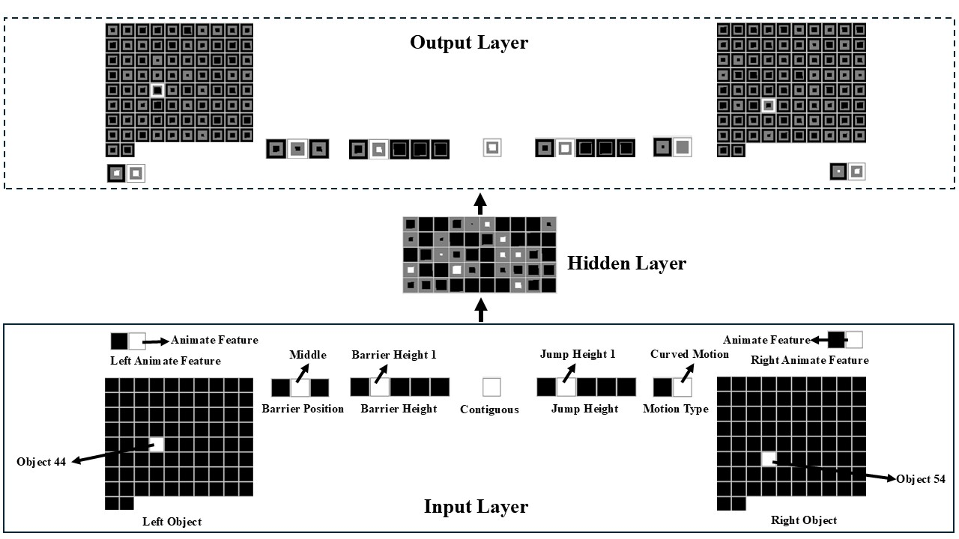
Figure 1. Schematic of the untrained model architecture used in the current simulations. Of note is that the input and output groups are identical.

The model consisted of three layers (Figure 1). The input and output layers consisted of 8 groups of units. The groups in the input and output layers were identical, and all groups used a localist coding scheme (i.e., a single unit was used to represent a given concept or feature). Localist representations were adopted to ensure that the network’s performance was not unduly influenced by preexisting similarities between any of the features or concepts. Note that values of unspecified units are assumed to be 0 (corresponding to the unit being “off”). In contrast, the hidden layer consisted of a single group of units and the representations developed over these units were largely distributed (i.e. multiple units coded for a given concept or feature, and the same unit could participate in coding different concepts of features) (Hinton, 1984). Fifty hidden units were used in Simulations 1 through 4 and 6, whereas 30 units were used in Simulation 5. Fewer hidden units were used in Simulation 5 than in the other simulations for two reasons. First, the experiments on which this simulation was based tested 3-month-olds. Second, it was assumed that the representational capacity of 3-month-olds was less than infants 6 months of age and older. Hidden units, which themselves represent the representational capacity of a neural network, made it possible to implement this assumption.
The first two input groups were Object Left and Object Right groups. These groups also appeared on the output side of the model. Two different object groups were used to ensure that the network could be shown two objects at a time. This was necessary because two objects were also presented at a time in action understanding studies that employed the Gergely paradigm. Crucially, each group consisted of 82 units. One of these groups was located on the network’s left side (hence, Object Left); the other group was located on the network’s right side (hence, Object Right). A single unit was used to represent a given object. Eighty objects were used for training; the remaining two were used for testing. Input units that coded for objects present in a scene were turned “on”; that is, their values were set to 1.
The next two input groups (with corresponding groups on the model’s output side) were two-unit Animate Feature Left and Animate Feature Right groups. The Left-Right designation, as before, denoted on which side of the network the group appeared. These groups represented the type of feature possessed by the object on the same side of the network. Specifically, the first unit in either group was the Animate Feature unit; the second unit in either group was the Inanimate Feature unit. This meant that the object on the left or object on the right possessed an animate feature if the first unit in either of Animate Feature groups had a value of 1. In contrast, the object possessed an inanimate feature if the second unit in either of these groups had a value of 0. The next group of units was a two-unit Motion Type group. One of these groups appeared on the input side of the model; the other group appeared on the output side. The first unit in this group was the Straight Motion unit, whereas the second unit was the Curved Motion unit. Motion was represented statically rather than dynamically (i.e., as it unfolds over time) to simplify the interpretation of the model’s behavior. Although representing motion dynamically would better align with infants’ real-world experience with motion, a downside with incorporating such motion in a model is that is necessarily makes the model more complicated and in turn more difficult to interpret. In contrast, it easier to explore the implications of a set of theoretical assumptions and elucidate mechanisms of change—the primary objectives of this paper—when motion is represented statically. Nonetheless, future work should consider whether the current results hold when motion is represented dynamically.
The remaining four input and output groups were a five-unit Barrier Height group, a five-unit Jump Height group, a three-unit Barrier Location group, and a one-unit Contiguous group. The first unit in the Barrier Height group was the No Barrier unit. The remaining four units represented progressively larger barriers (i.e., Barrier Height 1 unit through Barrier Height 4 unit). Similarly, the first unit in the Jump Height group was the No Jump unit. The remaining four units represented increasingly higher jumps (i.e., Jump 1 unit through Jump 4 unit). In the simulations reported below, jump heights mostly aligned with barrier heights (though see Simulation 3). In terms of the Barrier Location group, the first unit corresponded to the No Barrier unit, whereas the remaining two units corresponded, respectively, to Barrier Middle and Barrier Side units. Finally, the single unit in the Contiguous group coded whether two objects came to rest next to one another following a reaching or jumping event.

Pretraining
Given that the current theoretical proposal assumes that infants’ real-world experiences with action influences their looking behavior in action understanding studies, it was important to approximate this experience in the model. As stipulated by the theory, networks experienced two different kinds of events during habituation. In Straight Path pretraining events, the object on the right “followed” a linear path to reach the object on the right; that is, one of the 82 units in the object group on the left and one of the 82 units in the object group on the right were turned on along with the straight motion unit in the motion group. It is worth noting that because motion was not actually simulated in these simulations, it would be just as accurate to say that the object on the left followed one of two paths to reach the object on the right. Units that were turned on for all straight motion events were the No Barrier unit in the Jump Height Group, the No Jump unit in the Jump Height group, and the Barrier Missing unit in the Barrier Location group. In the Curved Path pretraining events, the object on the right jumped over a short barrier to reach the object on the left. This event involved turning on the Barrier Height 1 unit in the Barrier Height group, the Jump Height 1 unit in the Jump Height Group, the Barrier Middle unit in the Barrier Location group, and the Curved Motion unit in the Motion Type group.
To instantiate the assumption that animate entities and inanimate objects can follow either curved or linear motion paths, half of the objects within each type of event possessed animate features (i.e., the Animate Feature unit in the Animate Feature groups was activated) and half possessed inanimate features (i.e., the Inanimate Feature unit in the Animate Feature groups was activated). In addition, to instantiate the assumption that infants experience more linear than curved motion, 75% of the network’s pretraining experience involved straight motion and the remaining 25%, linear motion. Although this difference in the amount of exposure to curved and linear motion may overestimate that in the real world, these values were intentionally chosen to amplify the effect of differential exposure to different types of motion. In the analyses reported below, I test the necessity of such differential experience.
All networks received 250 epochs (i.e., weight updates) of pretraining experience. The learning rate in these simulations was 0.1. Crucially, the nature of this pretraining experience was identical for all networks, regardless of simulation. In addition, across all simulations, the habituation phase lasted 10 epochs. The dependent measure used in the simulations reported below was cross-entropy error (Hinton, 1989). Greater error corresponds to longer looking. Using error as a proxy for infant looking is typical in simulation studies (e.g., Benton, 2024; Mareschal et al., 2000; Rakison & Lupyan, 2008).

Simulation 1
Previous research showed that infants looked longer at an inefficient event than at an efficient event following habituation to an event in which a first animate-like object jumps over a barrier to reach a second animate-like object (e.g., Gergely et al., 1995). However, infants attended equally to both events if, during habituation, the barrier was positioned alongside rather than beneath the jump. Simulation 1 tested whether the current model (and thereby, the current proposal) could account for this finding.
Networks were assigned either to the Experimental condition (N = 20) or to the Control condition (N = 20). The habituation event in the Experimental Condition mirrored the Straight Path pretraining events with two key exceptions. First, novel objects were used. Second, the third unit rather than the first unit from habituation was turned on in the Barrier Height and Jump Height groups. Networks were then shown a straight path event (Efficient test event) and curved path event (Inefficient test event). Both events were shown without the barrier and used the same objects from habituation.
Mean “looking time” (i.e., reconstruction error) to the two test trials for networks assigned to the two conditions is shown below in Figure 2. Data were entered into a linear mixed-effects model with Trial Type (Inefficient vs. Efficient) as the within-subjects fixed effect and Condition (Experimental vs. Control) as the between-subjects fixed effect. Networks were treated as the random effect. This analysis revealed a significant main effect of Trial Type, which was qualified by a significant interaction between Condition and Trial Type, F(1, 385) = 765.18, p < .0001. A follow-up paired t-tests indicated that networks in the Experimental condition looked longer at the Inefficient test event (M = 13.69, SD = 0.86) than at the Efficient test event (M = 10.77, SD = 1.14), t(99) = 33.50, p < .0001. Although networks in the Control condition also looked at the Inefficient test event (M = 12.60, SD = 0.90) than at the Efficient test event (M = 12.29, SD = 1.28), t(99) = 3.35, p < .01, the difference in looking to these two test events was greater for networks in the Experimental condition (M = 2.92 SD = 0.87) than networks in the Control condition (M = 0.31, SD = 0.92), t(197.37) = 20.57, p < .0001.

Discussion
Simulation 1 showed that networks, like infants, looked longer at the Inefficient test event than at the Efficient test event if a first object jumped over a barrier to reach a second object on the other side than if the barrier and the path of the first object’s motion was spatially contiguous with the barrier. Crucially, networks showed this pattern of “looking” irrespective of whether they the objects possessed animate features. This result supports the contention that associative learning is sufficient to explain infants’ looking behaviors in some of the studies that employed the Gergely paradigm. However, this results, by itself, is insufficient to show the explanatory breadth of the current account. Simulation 2 was the first step in this direction. In particular, Simulation 2 tested whether the current results depended on the presence of animacy features. To the extent that the current model is an account of how infants process action events in the Gergely paradigm, it is important to show that networks treatment of inefficient and efficient action events similarly does not depend on the presence or absence of animacy cues.

Simulation 2
Simulation 2 was loosely based on that by Csibra et al. (1999) and tested whether networks continued to distinguish inefficient and efficient test events when the objects involved in them were inanimate. This simulation was identical to Simulation 1 in all respects except for the fact that the objects did not possess animate features; that is, the Inanimate Feature unit was turned on in both Animate Feature groups.
Figure 4 depicts networks’ mean looking times to the Low and High Jump test events. Data were entered into a linear mixed-effects model with Trial Type (Inefficient vs. Efficient) as the within-subjects fixed effect and Condition (Experimental vs. Control) as the between-subjects fixed effect, with network treated as a random effect. This analysis revealed a significant main effect of Trial Type, which was qualified by a significant interaction between both variables, F(1, 358) = 225.46, p < .0001. A follow-up analysis indicated that networks in the Experimental condition looked longer at the Inefficient test event (M = 13.53, SD = 0.90) than at the Efficient test event (M = 11.31, SD = 1.69), t(99) = 13.81, p < .0001. In contrast, networks in the Control condition looked equally long at both test events, t(99) = -0.55, p = .58.

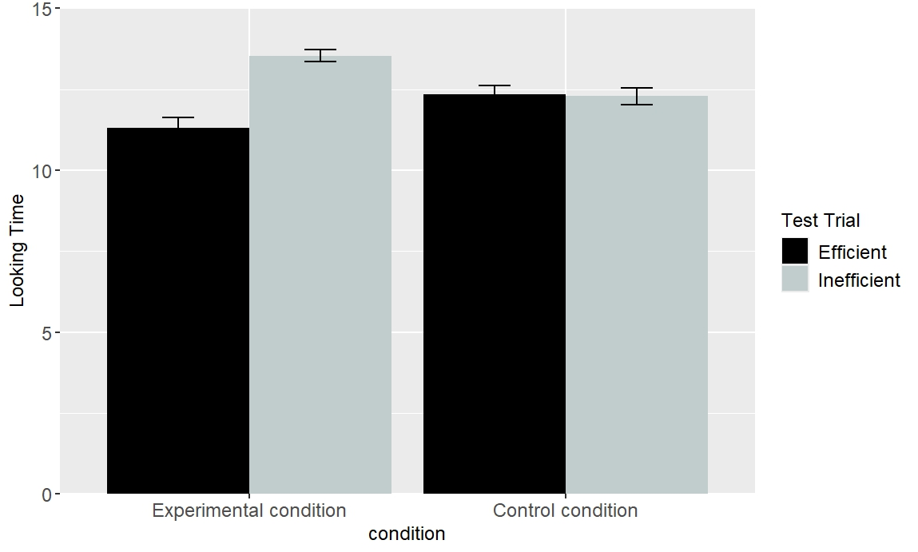
Figure 3. Networks’ mean “looking time” (i.e., cross-entropy error) to the Low and High Jump test events.

Discussion
This simulation examined whether the animate features that the objects possessed in Simulation 1 affected how networks processed the test events across conditions. The results of Simulation 2 provided a negative answer to this question: Networks showed heightened looking at the Inefficient test event relative to the Efficient test event in the Experimental condition but not in the Control condition. This result provides additional support for the notion that infants’ looking responses in studies that employ the Gergely paradigm can be explained by an associative learning mechanism.
The next simulation was designed to address a key claim of the teleological stance: Infants can make inferences about one the components of the model given information about the other components. For example, infants can infer that an external constraint exists based on an agent’s actions and its goals. Similarly, infants can infer an agent’s goals from its actions and external constraints. Data that bear directly on this question comes from a study by Csibra et al. (2003). In one of the experiments, 12-month-olds were habituated to an event in which small circle entered from the bottom left, moved straight through a gap between two bars, and then disappeared from the screen. A larger circle, which entered the screen from the bottom right shortly after the small circle emerged, moved in the direction of the small circle as if to be chasing it. Because the gap between the two barriers was too narrow for the larger circle to fit through, it moved around the right bar before continuing in the direction that the small circle was last seen. Crucially, because the larger circle never actually caught up to the small circle, its goal—namely, to catch the small circle—needed to be inferred. Infants were then shown two test events—the gap between the two barriers was now wide enough for both circles to pass through in both events. In the Incongruent event, the larger circle again moved around the right barrier; it passed through the gap in the Congruent event. Csibra et al. (2003) found that infants looked longer at the former event than the latter one. This was interpreted to mean that infants understood that the larger circle’s goal was to catch the smaller circle.
In another experiment, infants were habituated to an event like that shown in the Experimental condition in Gergely et al. (1995) except that the barrier was hidden behind an occluder. However, infants could see the second object as well as parts of the parabolic motion path behind the occluder that first object followed to reach the second object. Infants were then shown two test events without the occluder. The first event depicted the first object jumping over a now visible barrier to reach the second object (Obstacle test event). The second event was identical to the first except that the obstacle was missing (No-Obstacle test evenet). The results indicated that infants looked longer at the No-Obstacle test event than at the Obstacle test event. The authors interpreted this as evidence that infants can infer invisible constraints from actions and goals. Simulation 3 assessed the need for a teleological account by assessing whether these findings could also be explained by the current associative learning proposal.
It is worth noting that although the experiment that tested whether infants could infer goals from actions and constraints did not use the Gergely paradigm, it is straightforward to recast it within that paradigm. For example, the habituation event—which would mirror that shown in the Experimental condition of Gergely et al. (1995)—could be stopped right before the first object reaches the second object but after the first object clears the barrier. Because observers never see the first object reach the second object in this configuration, observers must infer that the second object is the first object’s goal. This was the approach taken in Simulation 3.

Simulation 3
Simulation 3 tested whether the current model could explain the finding that infants appear able to infer goals from constraints and behavior and constraints from goals and behaviors. Networks were assigned either to the Inferring Goals condition (N = 20) or to the Inferring Constraints condition (N = 20). The model used to simulate the Inferring Goals condition was identical to that used in Simulation 1 except that the Contiguous group was absent during habituation. Thus, the network could not know whether the first object came to rest next to the second object (the Inferring Goals scenario). In contrast, the model used to simulate the Inferring Constraints condition was also identical to that used in Simulation 1 except that barrier information was missing; that is, the Barrier Height and Barrier Position groups were absent.
Figure 4 shows the looking behavior of networks used in the Inferring Goals scenario and the Inferring Constraints scenario. Data for networks in the Inferring Goals scenario were entered into a linear mixed-effects model with Trial Type (Obstacle vs. No-Obstacle) as the within-subjects fixed effect and network treated as a random effect. This analysis revealed a significant main effect of Trial Type, F(1, 179) = 10958.36, p < .0001. This analysis indicated that networks looked longer at the No-Obstacle test event (M = 9.24, SD = 0.61) than at the Obstacle test event (M = 3.67, SD = 0.22). Data for networks in the Inferring Constraints scenario also showed a significant main effect of Trial Type (Congruent vs. Incongruent): Networks looked longer at the No-Obstacle test event (M = 21, SD = 0.89) than at the Obstacle test event (M = 9.56, SD = 1.05).
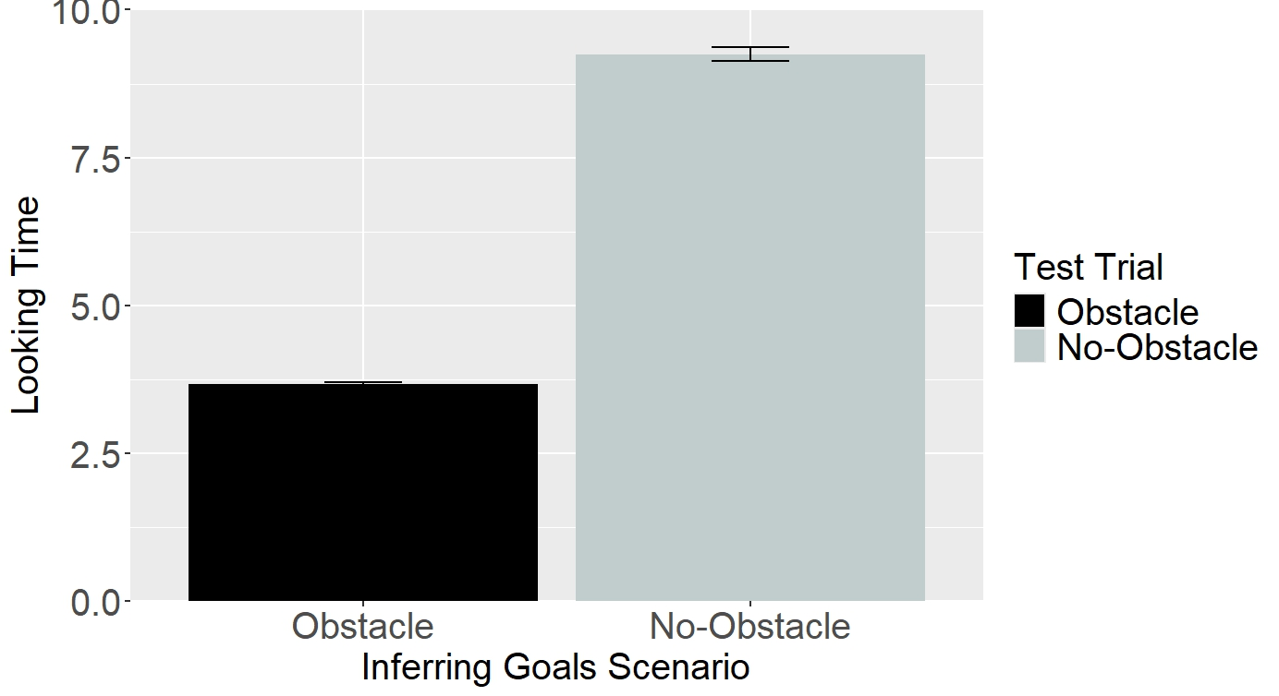 | 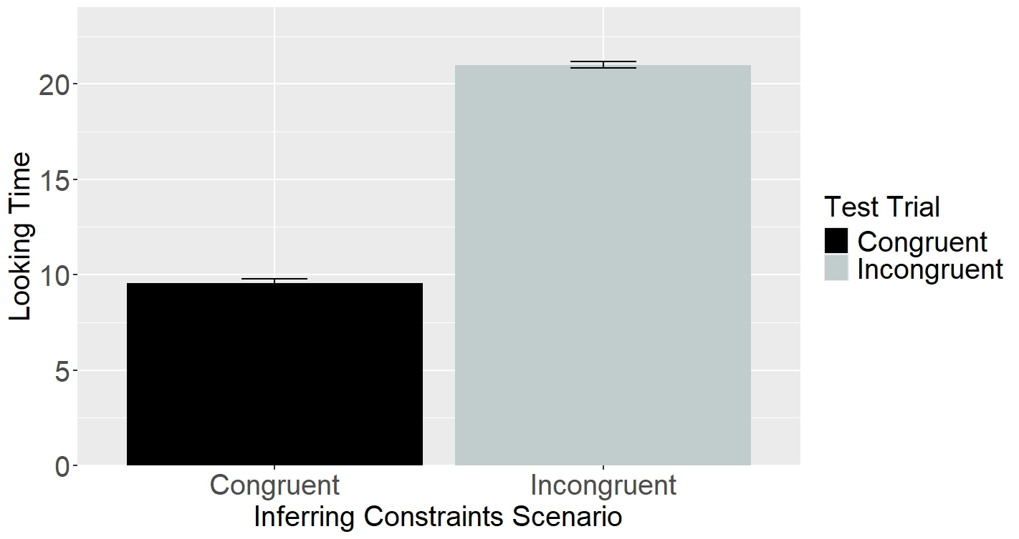
Figure 4. Left: Networks’ mean looking times to the two test events in the Inferring Goals Scenario. Right: Networks’ mean looking times to the two test events in the Inferring Constraints Scenario.

Discussion
Perhaps one of the strongest pieces of evidence for the existence of a teleological stance is the finding that infants can infer different components of this model given others. Although it is tempting to conclude that infants possess such a stance based on the apparent flexibility of their inferences, the current simulation demonstrated that such an account is not necessary to explain this aspect of infants’ action understanding. Simulation 4 showed that associative learning alone is sufficient to account for this facet of infants’ action understanding. Together, these simulations demonstrate that neither a teleological stance nor a NUC is not necessary to explain infants’ looking behaviors in some of the studies that use the Gergely paradigm; domain-general associative learning appears to be sufficient.
The final simulation focused on the finding that infants only distinguish efficient and inefficient actions when they are directed towards target objects. As was suggested in the Introduction, perhaps the only study to examine this issue directly was that by Phillips and Wellman (2005). They found that 12-month-olds who habituated to an actor reaching over a barrier along an arching path to grab an object looked longer when the actor used the same motion without a barrier than when they reached directly. Simulation 4 tested whether an associative learning mechanism could capture this finding.

Simulation 4
The final simulation tested whether the model could account for the finding that 12-month-olds look longer at indirect reaches than directed reaches if there is a goal object but when the goal object is missing. This simulation was loosely based on Phillips and Wellman (2005).
Networks were assigned either to the Experimental condition or to the Control condition. The Experimental condition was identical to that in Simulation 1. The Control condition was also identical to the Experimental condition in Simulation 1 except that the second object was missing from the input and output layers during the habituation and test phases.
Figure 5 shows the looking time data to the Indirect and Direct Reach test events for networks assigned either to the Target Present condition or to the Target Absent condition. Data for this experiment were entered into linear mixed-effects model with Trial Type (Indirect Reach vs. Direct Reach) as the within-subjects fixed effect, Condition (Target Present vs. Target Absent) as the between-subjects condition, and network treated as a random effect. This analysis revealed main effects of Trial Type and Condition, which were qualified by an interaction between the two, F(1, 358) = 925.08, p < .0001. A follow-up analysis indicated that networks in the Target Present condition looked longer at the Indirect Reach test event (M = 13.86, SD = 0.45) than at the Direct Reach test event (M = 11.66, SD = 0.74), t(99) = 34.92, p < .0001. In contrast, networks in the Target Absent condition looked equally long at the both test events, t(99) = -0.45, p = .65. As can be seen in the figure below, networks looked longer overall in the Target Absent condition (M = 17.75, SD = 0.66) than in the Target Present condition (M = 12.76, SD = 1.26), a pattern that is inconsistent with that observed in infants. This difference stems from the fact that networks never encountered action events with a single object during the pretraining phase. In contrast, infants likely do experience action events with single objects, even if infrequently. A corollary of this is that the overall looking times in these two conditions may be more comparable in infants than in networks like that used here.

Discussion
Simulation 4 tested whether an associative learning mechanism was sufficient to explain why infants look longer at indirect reaches than direct reaches in events that involve target objects but not in events lacking such objects. The results demonstrated that such a mechanism could account for this finding. Taken together, Simulations 1-4 suggests that infants’ looking behaviors in studies that use the Gergely paradigm can be explained by associative learning. Although a NUC or a teleological stance can also provide, the current series of simulations indicate that they are not necessary. This conclusion is also consistent with the only other published connectionist modeling study on this topic (Van Overwalle, 2010). However, one major difference between that model and the current one is that it only simulated Gergely et al. (1995). This means that it is unknown whether that model could account for other findings on this topic. The current model, in contrast, accounted for a range of findings, thereby demonstrating its explanatory scope. Before turning to the discussion, one outstanding issue remains: How exactly did associative learning unfold in the model to enable it to produce a match to the behavioral data that were the focus of the current simulations? I provide an answer to this question in the next section.

Unpacking the mechanism by which the model produced a match to the behavioral data
The simulations suggest that associative learning can explain infants’ looking behavior in studies using the Gergely paradigm. However, they leave unresolved the precise nature of this learning process. Fortunately, it is possible to answer this question by considering how the model processed the information presented to it during the pretraining phase as well as during the habituation and test phases in the different simulations. In the model, this process begins when the network is shown a particular action event as a pattern of activation across different input groups (e.g., Object Left and Right, Barrier Location, Barrier Position, etc.). These events correspond to situations in which one object (i.e., an object with an inanimate feature) or animate entity (i.e., object with an animate feature) moves along either a straight or curved path to reach a second object or animate entity. This pattern of activation is then propagated to the hidden layer via the weights that connect each of the input groups to the hidden layer. At the beginning of training, this pattern of activity is undifferentiated and meaningless. This is because the weights themselves are small, random values. This hidden pattern of activity is then propagated to, and elicits a pattern of activity over, the output groups in the output layer. This observed pattern of activation is then compared to the desired or target pattern of activation. Any discrepancy between the two patterns is treated as error, and the network uses this error to adjust the weights throughout the network. Crucially, the pattern of error that the linear events produce over the output groups is different than that produced by the curved motion events. This not only means that the weight changes will be different for the two action events but that the evoked patterns of hidden activation will differ for the events.
A consequence of this training process is that the network will develop a representation at the hidden layer that reflects learned associations between specific features of the input and different hidden units. Specifically, features in the input (e.g., the feature or unit that represent curved motion) will activate different hidden units via the associations between them. These units, in turn, will activate the reconstruction of those same features at the output layer via a different set of associations that connect them. The fact that these associations had 250 epochs to develop during the pretraining phase along with the fact that many of the features experienced during pretraining are also encountered during the experiment portion of the various simulations factors importantly in explaining how the network comes to respond the way it does to the test events in these simulations. For example, consider the habituation and test events used in Simulation 1. In this event, networks are shown an event in which a novel object with animate features jumps over a barrier to reach another object on the other side. Crucially, two of these features, namely, the height of the jump and the height of the barrier, are novel in relation to jump and barrier heights experienced during pretraining. This has two consequences. First, the familiar features (e.g., curved motion) and the units in the hidden layer with which they are associated will strongly activate one another. Second, because the habituation phase is necessarily shorter than the pretraining phase, any new associations that are established between these new features and units in the hidden layer will be insufficiently strong to override any learned associations between those same units and the more familiar features in the input. This means that although nascent links are established between these new input and output features and units in the hidden layer during the habituation phase, because some of these hidden units have preexisting robust connections with the more familiar features in the input, activation of these units will activate those features to a greater extent than the new features.
These two facts help to explain the network’s responses to the barrierless test events in the Experimental condition. It will be recalled that in the Inefficient test event, the first object once again follows an arced path to reach the second object. This event was instantiated by turning on the No Barrier unit in the Barrier Height group, the Curved Motion unit in the Motion Type group, the Missing unit in the Barrier Location group, the single unit in the Contiguous group, and the Four Jump unit in the Jump Height group. The Efficient test event was implemented in the same manner except that the Straight Motion unit was turned on in the Motion Type group. The network’s objective for both events is to turn on the corresponding units in the corresponding output groups. Because robust associations exist between the No Barrier and Missing input units and units in the hidden layer—which were established during the pretraining phase—activation of these hidden units will activate the corresponding units in the output layer. The issue here is that this is the right response for the Efficient test event but the incorrect response for the Inefficient test event. This accounts for how the network comes to produce greater error to (i.e., looks longer at) the Inefficient test event than the Efficient test event. These facts also explain networks’ responses to the test events in the Control condition.
This same basic account also explains why the network responds the way it does in the other simulations. Consider the “Inferring Constraints” condition in Simulation 4 as an example. During the habituation phase, the network sees an event in which one object follows a curved trajectory to reach a second object. Crucially, information about the height and location of the barrier that ostensibly separates both objects is missing from both the input and output. This has two consequences for the nature of the associations that the network forms. The first is that during the habituation phase, the network will only learn associations between the visible aspects of the event—such as the height of the jump, whether the objects possess animate features, and the type of movement that one of the objects engages in to reach the other—and the units in the hidden layer. The second is that because all barrier information is missing from the input and output, whatever preexisting associations from the pretraining phase exist between this information and units in the hidden layer will be retained. These preexisting associations mean that the network activates the Barrier Middle unit in the Barrier Position group and the Barrier Height 1 unit in the Barrier Height group. Because this is the wrong response for the Incongruent test event (the Barrier Missing and No Barrier units should be activated instead) but the right response for the Congruent test event, the former event elicits more error than the latter event.

General Discussion
Before closing, it can be instructive to consider how—or through what mechanism—the network comes to attend longer to the inefficient test events relative to the efficient ones. To the extent that similar processes unfold in infants’ minds, this could shed light on the nature of those processes.

