Author & Affiliations
- Deon T. Benton, Ph.D., Vanderbilt University
Dear Drs. Ori Ossmy & Daniel Messinger,
This letter is in response to your recent call for computational investigations of developmental phenomena. The overall goal of the proposed paper is to present an associative learning account (see below) of infant action understanding and to demonstrate that when this perspective is instantiated in artificial neural networks that rely on unsupervised learning, the mechanistic account is sufficient to account for looking-time data in studies on infant action understanding.
Proposed title: Associative learning is sufficient to explain infants’ action understanding
Abstract
A formidable task facing young learners is knowing how to navigate the world effectively. One of the prerequisites for successful navigation is identifying and distinguishing between efficient and inefficient actions. The ability to make this distinction is important because infants can use this knowledge to design their own efficient actions. Yet, one of the things that makes this task particularly daunting for the young learner is that is not “supervised”; that is, learners are not directly taught what distinguishes efficient from inefficient actions. Instead, the task is “unsupervised”; that is, learners must discover on their own what distinguishes these different actions. Despite the apparent difficulty of this task, a considerable body of evidence suggests that preverbal infants can distinguish between efficient and inefficient actions and expect agents to act efficiently.
In one of the first studies on this topic, Gergely et al. (1995) habituated 12-month-old infants to an event in which a small ball jumped over a barrier to reach a large ball. Infants were then shown two test events without the barrier. In the inefficient action event, the small circle engaged in the same, albeit now inefficient, jumping action as during habituation. In contrast, in the efficient action event, the small circle followed a now more sensible straight path to reach the large circle. Gergely et al. (1999) reasoned that if infants viewed the small circle's jumping action during habituation as justified—that is, it is the most efficient way to reach the larger circle given the absence of a physical constraint—then once the barrier is removed, infants should look longer when the small circle repeats the inefficient jumping action compared to the more efficient straight-line trajectory. This is what they found. A control condition designed to assess whether infants attended longer to the inefficient action than the efficient action simply because they preferred curved trajectories found that infants looked equally long at both test events.
Several important findings have emerged in this literature since this groundbreaking research. For example, infants’ expectation that actions be efficient or rational applies equally to geometric shapes (Csibra et al., 2003; Gergely et al., 1995), people (e.g., Sodian et al., 2004), hands (e.g., Woodward & Sommerville, 2000), and robots (Kamewari et al., 2005). Moreover, application of this “rationality principle” does not seem to depend on whether the objects or entities used in these studies are animate (Csibra et al., 1999).
Although these studies have extended what is known about infant action understanding, they are limited in at least two ways. One is that they assume that infants represent actions in an all-or-none fashion: an action is either efficient or it is not. This means that it remains unresolved whether infants understand that efficiency exists on a continuum. For example, do infants recognize that some actions are more efficient or inefficient than others, beyond the simple recognition that an action may be efficient or inefficient? One study that addressed this question directly was that by Liu and Spelke (2017). Six-month-old infants were habituated to events in which a circle character jumped over barriers of varying heights—short, medium, or tall—to reach a triangle character on the other side. Infants were then shown two test events. In both, the barrier was shorter than the shortest barrier that was shown during habituation. In the low, efficient jump test event, the agent jumped just high enough to clear this barrier. In the high, inefficient jump event, the agent jumped as high as it did to clear the tall barrier during habituation, despite the barrier now being much shorter than what it was during habituation. The authors reasoned that if infants represent efficiency (or cost) continuously and expect agents to engage in the least inefficient and costly action when pursuing goals, then they should look longer at the second test event than at the first one. This is because the agent incurred more of a cost in the second test event than it did in the first test event. The results of this experiment supported this contention. A first control condition ruled out the possibility that infants simply preferred higher over lower jumps, and a second control condition indicated that this pattern of looking at test was not learned during the experiment.
Another limitation is that they leave undetermined at what age infants begin to represent actions as efficient or inefficient. This question was taken up only in a study by Liu et al. (2019). These authors found that infants' expectation of rational action by agents is present by 3 months of age but only if the action is causal (i.e., it produces a change in a target object immediately and through direct contact). Infants were assigned to one of two conditions. In the causal condition, a gloved hand reached over a barrier and caused a ball to light up and emit a sound immediately when it touched the ball. In the noncausal condition, the ball again lit up and played music but this time after a brief delay and in the absence of direct contact and after a brief (0.5 s) delay. Following habituation, infants were shown two test events: efficient and inefficient. In the efficient test event, the hand caused the ball to activate through a direct, efficient reach. In contrast, in the inefficient condition, the hand caused the ball to activate through the same curved and now inefficient reach as that used to reach the ball during habituation. Liu et al. (2019) found that only infants in the causal condition looked longer at the inefficient test event than at the efficient test event.
One proposal for the cognitive mechanism that supports infants’ action understanding is the teleological stance. On this account, an action is goal-directed and rational if it is the most sensible action given situational constraints (Gergely & Csibra, 2003). Thus, the small circle’s decision to jump over the barrier to reach the large circle is justified because both circles were separated by a physical barrier. However, this same action is no longer justified when the barrier is removed—a straight line path is now the more rational action. Crucially, this account suggests that infants can recognize an action as goal-directed without considering an agent's hidden mental states, such as desires, beliefs, or intentions; they only need to assess how well the action aligns with environmental constraints. If there is alignment, then infants expect the future actions of the agent to be rational. In contrast, if alignment is missing, infants suspend their expectation for rational action. A closely related proposal to this one maintains that infants understand abstractly—and possibly innately—that actions are shaped both by situational constraints and by the agent's mental states, perhaps as well as by the costs and rewards of those actions (Liu, 2022).
In this paper, I will argue that neither of these accounts is necessary to explain infants’ behavior in action reasoning studies. I will make this argument in the context of Gergely et al. (1995), Liu and Spelke (2017), and Liu et al. (2019). The rationale for focusing on these three studies is twofold. First, it is possible to demonstrate the explanatory breadth of the current perspective by focusing on different studies. Second, it is important to show that studies that focus on meaningfully different question—for Gergely et al. (1995) the question was whether infants can distinguish efficient and inefficient actions; for Liu and colleagues the question was whether infants can represent the cost of actions—can be explained by the same underlying mechanism. The crux of my argument will be that infants' performance in these studies (and perhaps in action understanding literature broadly) is better explained by two interrelated factors. First, infants likely enter these experiments with greater experience of straight motion trajectories than curved ones. A corollary of this is that straight paths in an experimental setting should evoke less looking time than less familiar curved paths.
However, this alone cannot explain why infants’ responses to efficient versus inefficient actions seem to depend on the nature of their habituation experience. Specifically, infants respond differently when jumping or reaching actions occur over a barrier versus when the barrier is absent or off to the side. Thus, I suggest a second factor: infants’ online behavior during action-understanding experiments reflects the operation of an associative learning mechanism, whereby motion trajectories become “linked” with barriers through repeated pairings. This linking may be particularly strong when the trajectory occurs over rather than beside the barrier. I will argue that when the jumping action occurs over the barrier, the apex of the curved motion and the barrier occupy the same region of the screen. This may have two consequences. First, it makes the barrier visually more salient. Second, this increased salience may enhance the likelihood that infants establish an associative link between the curved motion trajectory and the barrier. In contrast, when the jumping action occurs beside the barrier, more effort is required to form this link. This is because infants must first fixate on the region depicting the jumping action and then physically shift their gaze to the barrier, which lies to the side rather than directly beneath the action. As a result, the barrier becomes less salient in this arrangement, which may decrease the likelihood that infants link the barrier with the curved trajectory.
A consequence of such a learning process is that, at test, infants in the experimental condition—who presumably formed a robust association between the curved motion and the barrier due to its heightened salience—respond differently to the test events than infants in a control condition (in which the barrier is beside rather than under the curved motion). When shown the barrier-less curved motion path (the so-called "inefficient" action) and the straight motion path (the so-called "efficient" action), only the infants in the experimental condition should look longer at the curved motion path. This occurs because the curved motion triggers an expectation for a barrier that never appears in either test event, thereby violating an infant’s learned association and eliciting their prolonged attention.
I will further argue that this same “heighted salience” account can explain why 3-month-old infants in Liu et al. (2019) only differentiated between efficient and inefficient actions when those actions were causal. Specifically, the repeated state change of the ball by the hand may have highlighted or made salient the link between the curvilinear motion trajectory of the reach and the barrier. This increase in salience, in turn, may have increased the likelihood that infants formed an association between the curved trajectory and the barrier in the causal condition than in the noncausal condition. I will suggest that Liu et al.’s findings had little to do with something inherently special about causality.

Preliminary Simulations

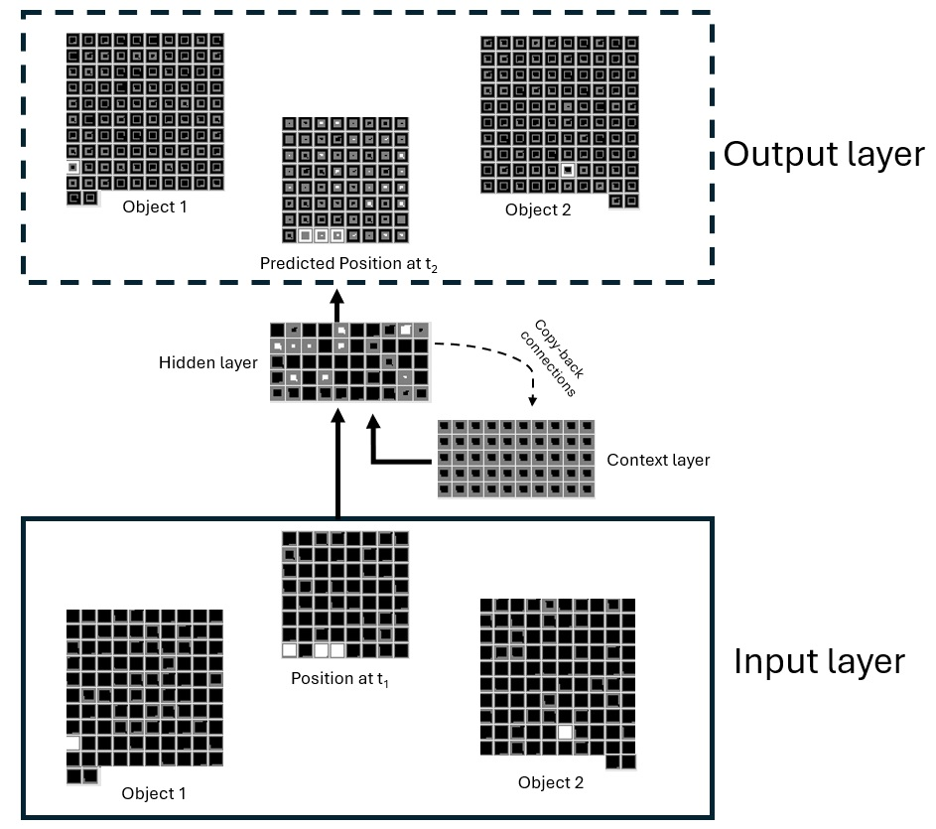
Figure 1. Schematic of an untrained model used. The model architecture for the model used in the simulations of Liu et al. (1995) was identical except that fewer hidden units were used.

To demonstrate the viability of this alternative mechanistic account, preliminary simulations of Gergely et al. (1995), Liu and Spelke (2017), and Liu et al. (2019) were carried out via artificial neural networks (ANNs). Figure 1 above shows the model architecture. The model was a three-layer simple-recurrent network (SRN; Elman, 1990). The model was trained using backpropagation in cross-entropy error. A sigmoid activation function was used for the output units; a RELU activation function was used for the hidden units to prevent vanishing gradients as error was backpropagated across time. The models used for the simulations of Gergely et al. (1995) and Liu and Spelke (2017) used a learning rate of 0.05, a momentum of 0.9, and 50 hidden units. In contrast, the models used in the simulation of Liu et al. (2019) used a learning rate of X, momentum of 0.9, and 15 hidden units. A smaller learning rate and fewer hidden units were used in this simulation to simulate the fact that the infants tested in Liu et al. (2019) were younger than the infants tested in Gergely et al. (1995) and Liu and Spelke (2017).
As can be seen in the figure above, the network consisted of three layers. The input and output layers consisted of 3 “groups” of units and the hidden layer consisted of a single group of “hidden” units. Two of the input and output banks of units were used to represent objects. Each input and output bank consisted of 102 units. One hundred objects were reserved for pretraining; two were reserved for habituation and test (see below). The first group of object units corresponded to objects located to the left of the network’s visual field; the second group of object units corresponded to objects located to the right of the network’s visual field. To simplify the simulations, each object was represented by a single unit. The final group of input and output units represented the path that an object on the left of the network’s visual space took to reach its goal (i.e., the object on the right). The input and output motion groups were implemented as an 8 × 8 grid.
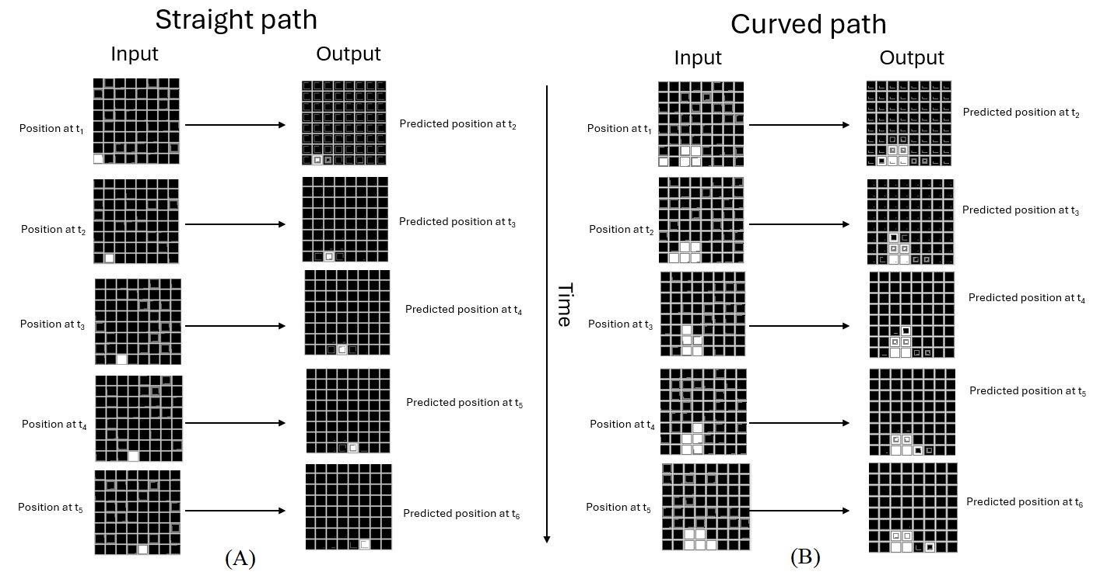
Figure 2. Examples of a straight motion path (A) and a curved motion path (B) used during pretraining.

Two different motion paths were simulated: straight motion and curved motion. Example straight and curved trajectories are shown above in Figure 2. The network’s task for each motion type was to predict the position of the left object at the next time step based on its current position. As can be seen in the figure, curved motion (Fig. 2, right side) was implemented with two straight paths with a “discontinuity” in the middle, in which the path appeared to “jump up” (e.g., predicted position at t₃). This curved motion occurred over a 2 × 2 barrier that was in columns 3 and 4 of the grid. Although no such discontinuity existed for curved motion in the real world—instead, real-world curved motion is arced and continuous—a discontinuity was introduced here to equate the time it took networks to complete straight- and curved-motion paths. Note that because the last two columns of the path or motion grid were reserved for the barriers used in the control conditions of the three studies (see below), curved and straight motions occurred over the first six columns of the motion grid.
Crucially, to instantiate the assumption that infants’ have more real-world experience with straight paths than with curved paths, networks experienced 40 straight paths and 5 curved paths during pretraining phase. This phase served as a proxy for “real-world” experience. In addition to less experience with curved paths relative to straight paths, networks experienced straight paths 90% of the time and curved paths 10% of the time. These frequencies were normalized over examples. Although these differences in experience with straight and curved paths likely exaggerate that encountered in the real world, such differences would make visible any effect of differential experience. A full version of this paper would systematically assess the effect of different amounts of experience with straight and curved paths.
The networks used to simulate Gergely et al. (1995) and Liu and Spelke (2017) received 1000 epochs of pretraining experience. In contrast, the networks used to simulate Liu et al. (2019) received 300 epochs of pretraining. Given that infants in Liu et al. (2019) were younger than those in Gergely et al. (1995) and Liu and Spelke (2017), it was important that the networks used in the fomer study received less pretraining than the networks used in the latter two studies. Below I briefly discuss the training procedure for each study as well as the preliminary results.
Gergely et al. (1995) simulation
Following pretraining, 50 networks were assigned to the experimental condition, and 50 networks were assigned to the control condition. As was the case in Gergely et al. (1995), networks in the experimental condition were “habituated” to an event in which a new object jumped over a barrier to reach another new object. The height of this barrier differed from that experienced during the pretraining phase. In particular, the habituation event used a 4 × 2 barrier that was in columns 3 and 4of the grid. The habituation event for networks in the control condition was identical except that the barrier was in column 7 and 8 of the grid. For all three simulations, the habituation phase lasted 15 epochs. Both groups then received two test events; the barrier was absent in both test events. In the inefficient action event, the object on the left followed a now inefficient curved path to reach the object on the right. In the efficient action event, in contrast, the object on the left followed an efficient straight path to reach the circle. Network error was recorded for each event. This served as a proxy for infant looking time; greater error corresponds to longer looking (Mareschal et al., 2000).
Preliminary simulation results indicate that this account is sufficient to explain the data across these studies.

References
Csibra, G., Gergely, G., Bı́ró, S., Koos, O., & Brockbank, M. (1999). Goal attribution without agency cues: the perception of ‘pure reason’in infancy. Cognition, 72(3), 237-267.
Csibra, G., Bíró, S., Koós, O., & Gergely, G. (2003). One‐year‐old infants use teleological representations of actions productively. Cognitive science, 27(1), 111-133.
Gergely, G., & Csibra, G. (2003). Teleological reasoning in infancy: The naıve theory of rational action. Trends in cognitive sciences, 7(7), 287-292.
Gergely, G., Nádasdy, Z., Csibra, G., & Bíró, S. (1995). Taking the intentional stance at 12 months of age. Cognition, 56(2), 165-193.
Kamewari, K., Kato, M., Kanda, T., Ishiguro, H., & Hiraki, K. (2005). Six-and-a-half-month-old children positively attribute goals to human action and to humanoid-robot motion. Cognitive Development, 20(2), 303-320.
Liu, S. (2022, December 8). From infancy, we model people as minds, acting in a physical world. https://doi.org/10.31234/osf.io/sg4bz
Liu, S., Brooks, N. B., & Spelke, E. S. (2019). Origins of the concepts cause, cost, and goal in prereaching infants. Proceedings of the National Academy of Sciences, 116(36), 17747-17752.
Liu, S., & Spelke, E. S. (2017). Six-month-old infants expect agents to minimize the cost of their actions. Cognition, 160, 35-42.
Sodian, B., Schoeppner, B., & Metz, U. (2004). Do infants apply the principle of rational action to human agents?. Infant Behavior and Development, 27(1), 31-41.
Woodward, A. L., & Sommerville, J. A. (2000). Twelve-month-old infants interpret action in context. Psychological Science, 11(1), 73-77.

