Associative learning is sufficient to explain infants’ action understanding
Deon T. Benton
Vanderbilt University

Address correspondence to Deon T. Benton, Department of Psychology and Human Development, Vanderbilt University, Peabody College, 230 Appleton Place #552, Nashville, TN 37235

Data availability statement: The code and network-modeling scripts are available upon reasonable request.
Conflicts of interests: none
“Associative learning is sufficient to explain infants’ action understanding”
Abstract
One of the many challenges that young learners face is learning how to navigate the world. A key prerequisite for such navigation is distinguishing between efficient and inefficient actions. Several domain-specific proposals have been offered to explain how infants achieve this. The current paper departs from these proposals by arguing that infants' behaviors in studies that evaluate their action understanding can be explained by a combination of real-world experience with different kinds of actions and real-time, online domain-general associative learning. I demonstrate that when this proposal is implemented in a connectionist artificial neural network model, the model (and by extension, the proposal that it implements) can account for a range of findings from studies that use some version of the original Gergely et al. (1995) paradigm. The results of four simulation studies indicate that associative learning alone can explain several aspects of infants’ looking behavior in these experiments. Specifically, the model successfully captures the findings that infants look longer at inefficient actions than efficient ones, respond similarly to animate and inanimate agents, infer goals from observed constraints, and represent efficiency continuously. These results challenge the necessity of domain-specific accounts such as the teleological stance or naïve utility calculus. Instead, they suggest associative learning alone can provide a more parsimonious explanation of infants’ action understanding.
“Associative learning is sufficient to explain infants’ action understanding”
A key task for young learners is discovering how to navigate the world. One prerequisite for successful navigation is distinguishing between efficient and inefficient actions. For instance, a child will learn that it is easier and more efficient to consume smaller bites of food than to attempt to fit entire handfuls of food into their mouth. Likewise, a child will learn that using stairs to reach the top of a slide is safer and more efficient than attempting clumsily to climb it from the bottom. Finally, a child will discover that opening the gate to their play area by grabbing and pulling its handle is physically less taxing, safer, and more efficient than attempting to clamber over the gate. Although it may be relatively straightforward for a young learner to discover what makes some actions more efficient than others, the vast number of different settings a child may find themselves in poses significant challenges in how infants acquire this knowledge broadly.
Yet, despite its apparent difficulty, recognizing that some actions are more efficient than others is ostensibly in place in infancy (Csibra et al., 1999; Gergely et al., 1995). Evidence that the ability to interpret the efficiency of actions is present from early in development comes from studies that have used the violation-of-expectation (VoE) paradigm (e.g., Baillargeon et al., 1995). In studies that use this method, infants are habituated or familiarized to an event or set of events designed to establish an expectation about how objects or agents behave. In a subsequent test phase, infants are shown events that either conform to or violate the expectations that an adult observer might have formed during the initial phase (e.g., Stahl & Kibbe, 2022). A number of important insights about infants’ early number concepts (e.g. McCrink & Wynn, 2004; Wynn, 1992), physical concepts (e.g., Baillargeon et al., 1992; Kim & Spelke, 1992; Spelke et al., 1992), moral concepts (e.g., Geraci & Surian, 2011; Hamlin et al., 2007; Schmidt & Sommerville, 2011; Woo et al., 2017), object concepts (e.g., Baillargeon, 1987; Baillargeon et al., 1985; Kellman & Spelke, 1983; Needham & Baillargeon, 1997), and causal concepts (e.g., Kotovsky & Baillargeon, 1998; Leslie & Keeble, 1987; Muentener & Carey, 2010). The general takeaway from this research is that infants possess sophisticated capacities that enable them to learning in each of these domains from early in development.
Two of the first studies to use the VoE method to assess infant action understanding in particular was that by Gergely et al. (1995) and Csibra et al. (1999). These authors habituated infants between 6 and 12 months of age to an event in which an animated ball jumped over a barrier to reach another ball. Infants were then shown two test events without barriers. In the old action test event, the small circle followed the familiar curved motion path to reach the large circle. In contrast, in the new action test event, the small circle moved along a straight path to reach the large circle. The results of these studies revealed that infants 9 months of age and older looked longer at the old action event than at the new action event. A control condition testing whether infants attended longer to the old action than to the new action event due to a preference for curved trajectories found that infants looked equally long at both events.
This finding has since been extended in important ways. For example, it is now known that infants’ expectation for efficient actions applies not only to people (e.g., Phillips & Wellman, 2005; Sodian et al., 2004; Woodward & Sommerville, 2000) and animals (e.g., Schwier et al., 2006) but also to geometric shapes (Csibra et al., 2003; Gergely et al., 1995) and inanimate objects such as robots (Kamewari et al., 2005). Additionally, although infants fail to distinguish inefficient and efficient actions if the target or goal object is absent (e.g., Phillips & Wellman, 2005), they recognize that two actions can be inefficient (or efficient) even if one is more of one kind than the other (Liu & Spelke, 2017). Beyond infants’ processing of others’ actions, research shows that how infants imitate another person’s actions depends on the constraints imposed on those actions. For example, 14-month-olds use their foreheads to activate a light if they observe a hands-free agent do the same thing but use their hands to activate the same light if the agent’s hands are bound (e.g., Gergely et al., 2002).

Rich proposals for the origins of infant action understanding
Several proposals have been put forward to explain the mechanistic basis of infant action understanding. These proposals roughly fall into two classes. The first is “rich” proposals for the origins of infant action understanding. According to these accounts, infants possess from birth or shortly domain-specific mechanisms, or mechanisms that are triggered by a single input type and operate in a single domain, that support abstract and conceptually rich knowledge about how the various objects and entities in the world behave and act. For example, some argue that infants’ knowledge about how animate entities act is subserved by a core knowledge system for agents, whereas their knowledge about inanimate objects act is supported by a core system for objects (e.g., Carey, 2009; Spelke, 2022). The core system for agents enables infants to know that agents are goal-directed, self-propelled, can move on irregular trajectories, and can cause other agents to act at a distance. In contrast, the core system for objects allows infants to know that objects do not move in the absence of physical contact from other objects or agents, are bounded and cohesive, and tend to move on linear trajectories.
Conceptually similar proposals have been put forward by other theorists. For example, Leslie (1995) argued infants’ knowledge about agents and objects is supported by a theory of body and a theory of mind module. These modules enable infants to know that animate entities, but not inanimate objects, act in accordance with their beliefs, desires and goals and can move in the absence of external contact from other agents or objects because they possess an internal, renewable source of energy. Similarly, Gelman (1990) argued that infants’ knowledge about objects and agents is subserved by innate skeletal causal principles. The function of these principles is to direct infants' and young children's attention toward perceptual cues that distinguish agents from objects. For example, in the presence of an agent, children may focus on its legs, eyes, or skin because these cues may indicate that the agent is capable of self-generated motion. In contrast, in the presence of an inanimate object, children may attend to its external parts (e.g., wheels), its rigid structure, or its mechanical components because these features may indicate that an external force is needed to allow the object to move.
In addition to these broad accounts of how agents and objects move and behave, specific proposals have been developed to explain infants’ looking behaviors in studies like that by Gergely et al. (1995). One is the teleological stance (Csibra & Gergely, 1998; Gergely & Csibra, 2003). Proponents of this account maintain that if an agent’s or object’s behavior satisfies the "rationality principle" such that it is seen as the most effective and rational way to bring about an end state given the physical context, then the end states will be seen as the "goal", the agent's behaviors as a "means" to the goal, and the physical context as a set of "constraints”. In other words, an agent’s actions are seen as goal-directed only if they are the most efficient actions given the environmental constraints. Thus, the reason infants in the Experimental conditions of the studies mentioned above looked longer when a first agent followed a curved path to reach a second object than when it follows a straight path to reach the same action is because this action is no longer justified when the barrier that was present during habituation is absent. In contrast, the reason infants looked equally long at the curved and straight paths is that they had not formed an efficiency-based expectation during habituation, given that the agent’s actions during habituation were not rational given the environmental constraints Crucially, this account is “non-mentalistic” in that infants can recognize an action as goal-directed without considering or inferring an agent's mental states, such as its desires, beliefs, or intentions; instead, infants apply a “reality-based” interpretation of an action in terms of the alignment between that action and external, environmental constraints.
An account that is related to the teleological stance in its focus on efficient action is the naïve utility calculus (e.g., Jara-Ettinger et al., 2016; Jara-Ettinger et al., 2020). This proposal concerns how agents choose actions and how observers process those actions. On the agent side, actors evaluate possible plans—that is, sequences of actions that lead to a goal—and select the plan that maximizes expected subjective utilities. A subjective utility is the difference between the rewards that result from an outcome and the cost of executing the plan. Crucially, because making this difference as large as possible depends on minimizing unnecessary costs, agents are expected to carry out plans that are as efficient as possible, given the constraints of the environment. These utilities are considered “subjective” because the perceived rewards of an outcome and the perceived costs of a plan may differ across agents. On the observer side, observers must infer rewards and costs that drove an agent’s behavior from the from the behavior itself. The way observers solve this computational problem is via Bayesian inference. In other words, learners can estimate the probability of the reward of an outcome and the cost of executing a plan to achieve that outcome given different actions—that is, p(C, R|A)—by computing the product of two terms. One is the likelihood of an action given a reward and associated cost—that is, p(A|C, R). The other is the likelihood of the reward and cost by itself—that is, p(C, R).
This account can also explain infants’ looking behavior in studies like Gergely et al. (1995). Consider the Experimental condition, for example. In that condition, the agent engages in a costly action to reach a goal (i.e., jumping over a barrier). Because observers assume that agents are strictly utility maximizers, the observer (in this case, the infant) reasons that this action only makes sense if the reward for reaching the goal is large enough to outweigh the cost of jumping over the barrier. However, this same action no longer makes sense once the barrier is removed: The agent could have taken a path that was shorter, more efficient, and less effortful. The fact that both paths lead to the same size rewards despite one being more costly (the jumping path) than the other (the straight path) implies that the straight path has greater utility; that is, the difference between the reward and the cost is larger for the straight path than the curved path and thus should be the plan that is chosen. A corollary of this is that infants will look longer at the jumping path test event than at the straight path test event because their expectation for efficient, utility-maximizing behavior is violated in the former but not in the latter. In contrast, in the control condition, infants never formed a clear expectation about which path is more efficient. This is because the barrier was not included in the habituation event. As a result, they look equally at the test events. In this way, NUC explains both patterns of looking by assuming that infants prefer actions that make sense in terms of getting the most reward for the least cost.
Although each of the perspectives presented in this section differ in their specifics, what is common among them is the notion that infants possess abstract, conceptually rich knowledge about how agents and objects act and behave in the world, and that this knowledge is supported by domain-specific, specialized processes that are operational and present from birth or shortly after.

Lean proposals for the origins of infant action understanding
The second class is “lean” proposals (e.g., Cohen et al., 2002; Colunga & Smith, 2005; Oakes & Cohen, 2003; Jones & Smith, 1993; Quinn & Eimas, 1997; Rakison & Lupyan, 2008; Sloutsky, 2010). The crux of these proposals is that infants’ behavior in VoE studies—of which the study by Gergely et al. (1995) is a special case—do not reflect specialized processes for reasoning about agent and object action. Instead, infants’ behavior in these studies can be explained by the operation of domain-general learning mechanisms (e.g., associative learning, habituation, conditioning, pattern learning, statistical learning, etc.) that operate over low-level, surface-based perceptual features and information. Domain-general mechanisms are sometimes considered “all purpose” because they operate on many kinds of input and support learning across a wide range of domains. Crucially, although the theories that constitute this class of perspectives differ in their specifics, each places considerable importance on the surface properties of objects and each emphasizes the notion that infants’ concepts for animates and inanimates are formed much more slowly than the available data may suggest. An implication of this account is that infants’ behaviors in VoE studies do not reflect, sophisticated adult-like abilities or conceptually rich knowledge; instead, such abilities and knowledge emerge gradually over time through a slow, effortful, and piecemeal process that begins in early infancy and continues through childhood.
To see how lean accounts explain infants’ looking behaviors in VoE studies, it can help to consider how lean accounts have been used to explain specific finds. To that end, consider the finding that infants ostensibly possess a theory of mind and understand that people can have beliefs that are inconsistent with reality (i.e., false beliefs). In one of the first studies on this topic in infants, Onishi and Baillargeon (2005) showed infants a stage that showed a toy watermelon slice that was positioned between a yellow box and a green box. A previously unseen actor then emerged from behind a wall, picked up the watermelon slice, and placed it into one of the boxes (e.g., the green box). The actor’s visual access to the contents on the stage was then removed for several seconds, after which the actor returned and reached into the green box (as if to retrieve the toy). These trials established that the actor desired the toy. The experimenter then manipulated whether the actor held a true or false belief. In the true-belief condition, the actor watched as the toy was moved from the green box to the yellow box. In the false-belief condition, the actor again watched the toy move from the green box to the yellow box. The actor then moved from view behind the back wall, at which point the toy was moved back to the green box. Thus, the actor held a false belief that the toy was in the yellow box. The authors found that infants looked longer when the actor reached in the green box than when it reached in the yellow box if it held a true belief about the toy’s location. Infants showed this same pattern of looking when the actor held a false belief. Onishi and Baillargeon (2005) interpreted these results to mean that infants understand that people act in accordance with their beliefs and that they may possess beliefs that are inconsistent with reality.
Perner and Ruffman (2005) challenged this interpretation by arguing that infants’ responses to the test events may be based on learned associations rather than an understanding of others’ mental states. These authors specifically argued that infants’ looking behaviors during the test events in Onishi and Baillargeon (2005) reflected tripartite associations that were formed during the familiarization and belief-induction phases. For instance, seeing the toy move from the green box to the yellow box in the presence of the actor in both belief conditions could have led infants to form a simple actor-toy-yellow-box association. A consequence of such an association is that events that are consistent with it—such as the test event in which the actor retrieves the toy from the yellow box—should lead to little (or no) increase in looking, whereas events that are inconsistent with the established association—such as the test events in which the actor retrieves the toy from the green box—should lead to an increase in looking. Critically, infants’ looking behaviors in Onishi and Baillargeon’s study can be explained by simple associative learning without recourse to an early emerging understanding of others’ mental states.
Similar lean proposals have been applied to explain infants’ looking behaviors in VoE studies that test for tother early emerging, cognitively sophisticated capacities. For example, it has been suggested that infants possess innately a domain-specific “accumulator” mechanism that enables them precisely to add small and large numbers (McCrink & Wynn, 2004; Wynn, 1992, 1995). However, this conclusion has been contested; some argue that infants’ looking patterns in these studies reflect imprecise quantity or amount estimation rather than exact numerical reasoning (e.g., Cohen & Marks, 2002). In other words, infants may simply expect addition to result in more stuff and subtraction to result in less stuff, even if the precise quantities that are shown are incongruous with the correct outcome. Similarly, some argue that infants possess an “innate moral core” that, among other things, enables them to distinguish between prosocial and antisocial agents (e.g., Hamlin, 2013a; Hamlin & Wynn, 2011; cf., Lucca et al., 2025, Schlingloff et al., 2020). For instance, in a classic study, Hamlin et al. (2007) showed that 6- and 10-month-old infants preferred a Helping character that helped a protagonist reach the top of a hill over a Hindering character that prevented the protagonist for reaching the top of the hill. As with arguments against an inborn number ability, it has been argued that these data may instead reflect the operation of simple associative processes (e.g., Scarf et al., 2012), a preference for imitative agents (e.g., Powell & Spelke, 2018), or some combination of both (e.g., Benton & Lapan, 2022). Scarf et al. Finally, it has been claimed that infants as young as 5 months of age, if not earlier, understand that objects continue to exist when hidden based in part on the finding that they show increased looking when a screen ostensibly rotates through a box (impossible event) than when it stops rotating once its reached the box (possible event; e.g., Baillargeon et al., 1985; Baillargeon, 1987; for conceptually similar findings, see Baillargeon, 1986; Baillargeon & DeVos, 1991). This conclusion has not been universally accepted. For example, Bogartz et al. (2000) argued and showed through rigorous experimentation that infants’ responses to the two test events can be explained by well-documented familiarity and novelty preferences (e.g., Hunter & Ames, 1988; Hunter et al., 1982). For example, infants who were not given enough time to process a familiarization event in which the screen rotates 180° in the absence of a box looked longer at the perceptually more familiar but physically impossible test event than at the perceptually more novel but physically possible event. In contrast, infants who were given sufficient time to process the familiarization sequence showed increased looking to the perceptually novel test event only.
Although it is also true that lean accounts differ in their particulars, they share a commitment to the idea that infants’ looking behaviors in VoE studies can be explained without recourse to conceptually rich, innate knowledge that is supported by domain-specific mechanisms. Instead, these accounts maintain that domain-general learning mechanisms—such as habituation, statistical learning, associative learning, and conditioning, among others—that operate on low-level, surface-based features can capture infants’ responses in VoE studies. In other words, infants’ looking responses may reflect factors such as the strength of stimulus encoding, perceptual novelty or familiarity, and simple preferences rather than inferences about numerical computations, sociomoral evaluation, or object permanence. This more sophisticated knowledge is thought to emerge gradually via the same learning mechanisms believed to subserve infants’ responses in VoE studies.

A lean proposal for the origins of infant action understanding
As the discussion to this point has shown, there have been many attempts to explain infants’ looking behaviors in VoE studies from a lean perspective. However, efforts to explain infants’ action understanding and processing in particular from the same perspective remain relatively scarce. A notable exception to this is a computational investigation by Overwalle (2010). One of the goals of this study was to explain infants’ looking behaviors in Gergely et al. (1995). Overwalle (2010) argued that infants learn about what makes an action efficient (or inefficient) based on prior experience either observing or engaging in those actions; a priori notions of efficiency based on a teleological stance are not necessary. Thus, infants might learn to see jumping as the most efficient action to perform in the presence of a wall if, each time an agent jumps, a wall is present. In contrast, they might learn to see straight motion paths as most efficient if agents engage in this action whenever an obstacle is absent. Overwalle (2010) implemented this idea in a recurrent connectionist model and showed that it could explain infants’ looking responses across the Experimental and Control conditions in Gergely et al. (1995). Overwalle (2010) interpreted this finding to mean that knowledge about what makes an action efficient can be learned from experience observing objects move in relation to external constraints and obstacles; a priori notions of efficiency based on a teleological stance are not necessary to account for infants’ responses in Gergely et al. (1995).
Although Overwalle’s (2010) model results suggest putatively that action efficiency can be learned, caution should be exercised before accepting this conclusion for at least three reasons. The first is that because the model did not possess one (or more) hidden layers, it could not develop internal representations. This inability to develop internal representations is problematic because it meant that the model could not make use of any prior, “real-world” experience. Yet, infants probably do enter studies like that by Gergely et al. (1995) with substantial experience processing others’ actions, and this experience may bear directly on how infants process the habituation and test events. Thus, to the extent Overwalle (2010) is correct that infants learn about efficiency by processing the movement trajectories of different objects in the real world, then it is imperative to show that such experience is sufficient to capture infants’ looking behaviors in Gergely et al. (1995).
A second limitation concerns how Overwalle (2010) simulated the Experimental and Control conditions in Gergely et al. (1995). It will be recalled that the habituation events shown to infants in the Experimental and Control conditions included a small wall; the difference between the habituation events shown to infants in these two conditions was whether the first circle jumped over the wall (Experimental condition) or beside it (Control condition). In contrast, such a wall was not included in Overwalle simulation of the habituation event in the Control condition; it only appeared in the Experimental condition. Thus, the model’s success may simply reflect a failure accurately to simulate the Control condition rather than evidence it learned what makes actions efficient.
A final limitation relates to the fact that Overwalle (2010) only modeled the original Gergely et al.’s (2010) study. This means that it remains unknown whether the same model can account for findings from several follow-up studies—based on the original designed used in Gergely et al. (1995)—that were designed to assess the scope (and thereby, the limits) of infants’ action understanding. In the absence of such a demonstration, it is difficult to know whether the lean mechanisms instantiated in Overwalle’s (2010) model were sufficient to explain how infants learn about the efficiency of others’ actions.
These limitations make it difficult to assess whether the results reported by Gergely et al. (1995) and in several follow-up studies can be explained from a lean perspective. Based on these limitations, the goals of this paper were twofold. The first was to present an alternative lean account of infant action understanding that can explain several of the key findings in the literature based on the original Gergely et al. (1995) paradigm. It should be noted that although the focus here is on infant action understanding, the account offered here and the findings from the simulations reported below may reflect the ability of domain-general learning mechanisms to account for infants’ behavior in VoE studies. My central argument is that infants’ performance in action understanding studies that employ the VoE design can be explained by real-world, third person experience processing others’ action as well as by associative learning In particular, my argument is that infants’ online behavior in studies reflects sensitivity to the low-level kinematic properties of motion—such as whether an action follows a linear or curved motion path—and to online associative learning. In my view, infants’ behavior neither reflects an innate notion or efficiency nor does it reflect a learned notion of efficiency. Instead, infants’ responses are shaped by extensive experience observing movement in the real world together with an associative learning mechanism that operates over low-level, surface-based kinematic features. In the classic study by Gergely et al. (1995), for instance, infants may have formed an association between the arced motion path and the barrier based on the repeated pairings of the two over the course of the habituation phase. Crucially, such an associative link may come to be particularly strong when the trajectory occurs over rather than beside the barrier. This may be because when the jumping action occurs over the barrier, the apex of the curved motion and the barrier occupy the same region of the screen. This may have two consequences. First, it makes the barrier visually more salient. Second, this increased salience may enhance the likelihood that an associative link is established. In contrast, when the curved motion occurs beside the barrier, as is the case in the control condition of action understanding studies, more effort is required to form this link. This may be because infants must first attend to the jumping action in the middle of the screen before making a saccade to the barrier located to the side. A consequence of this is that the barrier becomes less salient in this arrangement, and this may lead to a weaker association between the curved motion and barrier. This could potentially explain why in action understanding VoE studies like that by Gergely et al. (1995), infants in the experimental conditions, but not those in the control conditions, look longer at inefficient than efficient actions: When shown barrierless curved motion and straight motion, only infants in the experimental conditions should look longer at the curved than straight motion; the former triggers an expectation for a barrier, based on an established link between them, that goes unmet.

The present simulation studies
Given the admittedly speculative nature of this proposal, it was important to show that it could in fact capture existing data on infant action understanding. To achieve this, the proposal was instantiated in a connectionist artificial neural network model (see Singh et al., 2025 for a gentle introduction). Crucially, the model was not developed to simulate any one VoE study on infants’ action understanding. Instead, the goal was to capture a broad set of findings that, to this point, have been taken as evidence of conceptually rich knowledge and specialized processes. By simulating a broad set of findings rather than one or two specific findings, as was the case in Overwalle (2010), it was possible to demonstrate the explanatory breadth of the current account in particular and the sufficiency of lean accounts in general:
- Infants look longer at inefficient test events than at efficient ones if the jumping action occurs over rather than besides a barrier (e.g., Gergely et al., 1995).
- Infants’ looking behaviors towards inefficient and efficient actions does not depend on whether the characters possess animate features (Csibra et al., 1999; Sodian et al., 2004).
- Infants can infer external constraints from an agent’s actions and goals as well as an agent’s goal from its actions and external constraints (e.g., Csibra et al., 2003).
- Infants represent efficiency continuously (e.g., Liu & Spelke, 2017).
It should be clear from the list above that all the findings derive from studies that used some version of the Gergely et al. (1995) VoE method (henceforth, the Gergely paradigm). The rationale for focusing on findings from these studies is that few paradigms have been used more extensively to study infant action understanding than this one. Another reason is that it was possible to test the explanatory scope of the current account with the same basic architecture. A point worth noting is that although this list does not cover the full range of findings from studies that used the Gergely paradigm, demonstrating that the current account—implemented as a connectionist model—can capture these findings should be sufficient to illustrate its explanatory scope. Space constraints also make it infeasible to simulate the full breadth of relevant work.
In the remainder of the paper, I introduce the model architecture used in each simulation, along with details about the pretraining experience that all models received prior to their participation in a specific simulation. I then present four simulations, each corresponding to a key empirical finding. Given that the focus here was to show that a model that implements the current perspective can capture data from studies that use the Gergely paradigm, each of the studies that illustrate one of the previous findings will be modeled only at the most general level. This means that study specific details deemed nonessential were omitted. It is worth reiterating that although I have chosen to focus on key findings from VoE studies on infant action understanding, I see these simulations—and the theoretical argument they implement—contribute to a much broader literature that demonstrates that domain-general mechanisms may suffice to explain infants’ seemingly sophisticated behaviors in VoE tasks; rich knowledge or specialized processes may neither be necessary nor sufficient to account for these behaviors.

General Method
Network Architecture
The current series of simulations used a three-layer, feedforward, autoencoder network (e.g., Mareschal et al., 2000). Networks were trained with backpropagation in cross-entropy error (e.g., Rumelhart et al., 1986). The hidden units used a RELU activation function; the output units used a sigmoid activation function. The network’s task was to compress the input via the hidden units and then reconstruct it at the output layer.
The model consisted of three layers (Figure 1). The input and output layers each contained 9 groups of units. The groups in the input and output layers were identical, and all groups used a localist coding scheme (i.e., a single unit was used to represent a given concept or feature). Localist representations were adopted to ensure that no two objects were more similar to each other than any other object. Note that values of units that are unspecified in the text are assumed to be 0 (corresponding to the unit being “off”). In contrast, the hidden layer consisted of a single group of units and the representations developed over these units were largely distributed (i.e., multiple units coded for a given concept or feature, and the same unit could participate in coding different concepts or features; Hinton, 1984). The hidden layer consisted of 50 units.

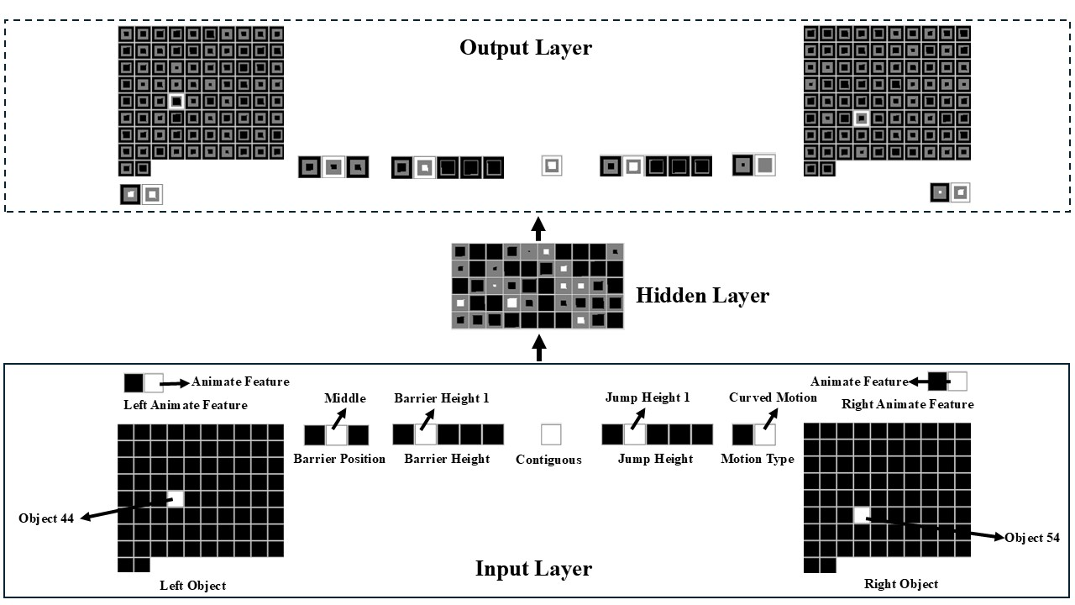
Figure 1. Schematic of the untrained model architecture used in the current simulations. Of note is that the input and output groups are identical.

The first two input groups were Object Left and Object Right groups. Copies of each input group also appeared on the output side of the model. Two different object groups were used because studies that used the Gergely paradigm tended to use two objects or entities. Crucially, each group consisted of 82 units. One of these groups was located on the network’s left side (hence, Object Left); the other group was located on the network’s right side (hence, Object Right). A single unit was used to represent a given object. Eighty objects were used for training; the remaining two were used for testing. Units that coded for objects present in a scene were turned “on”; that is, their values were set to 1.
The next two input and output groups were two-unit Animate Feature Left and Animate Feature Right groups. The Left-Right designation, as before, denoted on which side of the network the group appeared. Specifically, the first unit in either group was the Animate Feature unit; the second unit in either group was the Inanimate Feature unit. This meant that the object on the left or object on the right possessed an animate feature if the first unit of the corresponding right or left Animate Feature group had a value of 1. In contrast, the object possessed an inanimate feature if the second unit in either of these groups had a value of 0. The next group of input and output units was a two-unit Motion Type group. The first unit in this group was the Straight Motion unit, whereas the second unit was the Curved Motion unit. Motion was represented statically rather than dynamically (i.e., as it unfolds over time) to simplify the interpretation of the model’s behavior (I return to this issue in the General Discussion).
The remaining four input and output groups were a five-unit Barrier Height group, a five-unit Jump Height group, a three-unit Barrier Location group, and a one-unit Contiguous group. The five units in the Barrier Height group represented progressively larger barriers (i.e., Barrier Height 0 through Barrier Height 4). Similarly, the five units in the Jump Height group represented increasingly higher jumps (i.e., Jump Height 0 through Jump Height 4). Note that Barrier Height 0 corresponds to a barrier with no height. The same is true for Jump Height 0. In the simulations reported below, jump heights mostly aligned with barrier heights (though see Simulation 3). In terms of the Barrier Location group, the first unit corresponded to the Barrier Missing unit, whereas the remaining two units corresponded, respectively, to Barrier Middle and Barrier Side units. Finally, the single unit in the Contiguous group coded whether two objects came to rest next to one another following a reaching or jumping event.
Although I use semantically rich terms to describe the features in the model, this is not meant to suggest that infants represent these features in a conceptually or semantically meaningful way. These terms are used solely to help readers understand the model’s structure. As I assume is true for infants, the present models process these features as low-level perceptual properties without recourse to their conceptual meaning. Nonetheless, a potential objection is that because the features that the model processes are stipulated in the input, the learning task differs in important ways from the one that infants face in the real world. Specifically, by deciding which features to implement, the aspects of the input that the model attends to have been prespecified. There are two responses to this potential criticism. First, it has been shown that when some features are made more salient than others—as is the case here—models like that used here can discover autonomously which features to focus on, and this is true even if the features are perfectly correlated (e.g., Benton, 2024; Rakison & Lupyan, 2008; Singh et al., 2025). Second, the features chosen for the model to process are exactly those that infants attend to in the real world. For instance, research shows that from birth or shortly thereafter that infants preferentially attend to movement over nonmovement (e.g., Slater, 1989). Thus, including features like motion may better reflect infants’ perceptual biases than including features like color or texture.

Pretraining
Given that the current theoretical proposal assumes that infants’ real-world experiences with action influences their looking behavior in action understanding studies, it was important to approximate this experience in the model. As stipulated by the account, networks experienced two different kinds of events during habituation. In Straight Path pretraining events, one of the objects “followed” a linear path to reach the other one; that is, one of the 82 units in the object group on the left and one of the 82 units in the object group on the right were turned on, along with the Straight Motion unit in the Motion Type group. Other units that were turned on for all straight motion events were the Barrier Height 0 unit in the Barrier Height Group, the Jump Height 0 unit in the Jump Height group, the Barrier Missing unit in the Barrier Location group, and the Contiguous unit in the Contiguous group. In the Curved Path pretraining events, one of the objects “jumped over” a short barrier to reach the other object. Units that were turned on for this event were the Barrier Height 1 unit in the Barrier Height group, the Jump Height 1 unit in the Jump Height Group, the Barrier Middle unit in the Barrier Location group, the Contiguous unit in the Contiguous group, and the Curved Motion unit in the Motion Type group.
To instantiate the assumption that things with or without animate features can follow either curved or linear motion paths, half of the objects within each type of event possessed animate features (i.e., the Animate Feature unit in the Animate Feature groups was activated) and half possessed inanimate features (i.e., the Inanimate Feature unit in the Animate Feature groups was activated). In addition, the pretraining events instantiated the assumptions that curved motion is more salient than straight motion and that barriers become more salient when curved motion occurs over them than when it occurs besides them. The first assumption was implemented by assigning a higher learning rate to the incoming and outgoing weights of the Jump Height units during curved motion events compared to linear motion events. Specifically, for curved motion pretraining events, the learning rate was set to 0.375. The learning rate for curved motion was set even higher to 0.475 during habituation based on the assumption that, unlike in the real world with its many distractions, infants in this phase are likely focused exclusively on the presented motion events. To instantiate the second assumption, the learning rate on the incoming and outgoing links to the Barrier Height group was set to 0.375 during the pretraining phase, to 0.475 whenever curved motion occurred above it during habituation, and to 0.0001 whenever curved motion occurred besides it. To further decrease the salience of the barrier when it occurred beside the motion, weight decay was added to the incoming and outgoing weights to the Barrier Height group. The value for this parameter was 0.01. The decision to implement salience through the learning rate and weight decay aligns with past connectionist modeling work (e.g., Benton, 2024; Singh et al., 2025).
Across all four simulations, the pretraining phase lasted 250 epochs. The learning rate for the non-Jump Height and non-Barrier Height connections was 0.1. Crucially, the nature of this pretraining experience was identical for all networks, regardless of simulation. Additionally, with the exception of Simulation 3, the habituation phase lasted 10 epochs in all other simulations. The dependent measure used in the simulations reported below was cross-entropy error (Hinton, 1989). Greater error corresponds to longer looking. Using error as a proxy for infant looking is typical in simulation studies (e.g., Rakison & Lupyan, 2008). To understand why this is the case—that is, why it is appropriate to conceptualize error as being positively related to infant looking time—it is important to consider the relation between infant habituation and learning in standard autoencoder neural networks. briefly to consider how autoencoders work (e.g., Mareschal et al., 2000). According to one influential model (Sokolov, 1963), habituation is a process in which learners gradually adjust their internal representation of an external stimulus until it matches the external stimulus in some way. Crucially, while there is a discrepancy between the internal representation and the external stimulus, learners will continue visually to fixate the external stimulus. At the point that the discrepancy is resolved, however, learners will disengage from the external stimulus and turn their attention elsewhere. In a similar vein, autoencoder neural networks learn to reproduce at the output layer input to the model. These networks do this by gradually adjusting their internal (hidden) representations until those representations are sufficient to reproduce that input at the output. As was true for infant habituation, network error (akin to infant looking times) will remain high until the discrepancy between the model’s representation of the external stimulus at the hidden layer matches the external stimulus in some way. All simulations were run using the Lens neural network simulator (Rohde, 1999). All training and testing files are available for download at https://osf.io/9eqpf/?view_only=62f752417a9141c7b0509a998039ad13.

Simulation 1
Previous research found that infants looked longer at an inefficient event than an efficient one after habituating to an event where an animate-like object either jumped or reached over a barrier to approach another animate-like object (e.g., Gergely et al., 1995; see also Sodian et al., 2004). However, infants attended equally to both events if, during habituation, the barrier was located alongside rather than beneath the jump or reach. Simulation 1 tested whether the current model (and thereby, the current proposal) could account for this finding.
Networks were assigned either to the Experimental condition (N = 20) or to the Control condition (N = 20). The habituation event in the Experimental condition mirrored the Curved Path pretraining events with two key exceptions. First, novel objects with animate features were used. Second, the third unit rather than the first unit from habituation was turned on in the Barrier Height and Jump Height groups. This ensured that network’s processing during habituation was not influenced by prior experience with the pretraining barrier height. Networks were then shown a straight path event (Efficient test event) and curved path event (Inefficient test event). Both events were shown without the barrier and used the same objects from habituation.
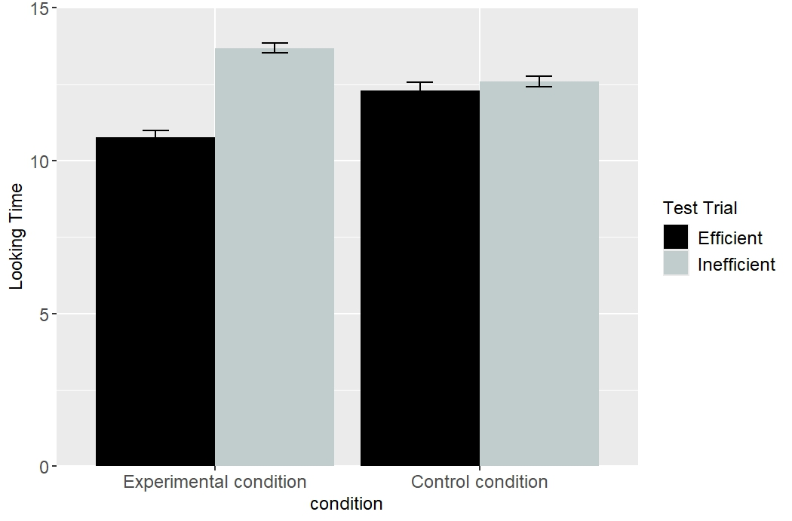
Figure 2. Networks’ mean “looking time” (i.e., cross-entropy error) to the Efficient and Inefficient test events.

Mean “looking time” (i.e., cross-entropy error) to the two test trials for networks assigned to the two conditions is shown above in Figure 2. Data were entered into a linear mixed-effects model with Trial Type (Inefficient vs. Efficient) as the within-subjects fixed effect and Condition (Experimental vs. Control) as the between-subjects fixed effect. Networks were treated as the random effect. This analysis revealed a significant main effect of Trial Type, which was qualified by a significant interaction between Condition and Trial Type, F(1, 385) = 765.18, p < .0001. Follow-up paired t-tests indicated that networks in the Experimental condition looked longer at the Inefficient test event (M = 13.69, SD = 0.86) than at the Efficient test event (M = 10.77, SD = 1.14), t(99) = 33.50, p < .0001. Although networks in the Control condition also looked longer at the Inefficient test event (M = 12.60, SD = 0.90) than at the Efficient test event (M = 12.29, SD = 1.28), t(99) = 3.35, p < .01, the difference in looking to these two test events was greater for networks in the Experimental condition (M = 2.92 SD = 0.87) than networks in the Control condition (M = 0.31, SD = 0.92), t(197.37) = 20.57, p < .0001.

Discussion
Simulation 1 showed that networks, like infants, only looked longer at the Inefficient test event than at the Efficient test event if the barrier was beneath rather than beside the curved motion during habituation. This result supports the contention that associative learning is sufficient to explain infants’ looking behaviors in some of the studies that employed the Gergely paradigm. However, this result alone is insufficient to show the explanatory breadth of the current account. Simulation 2 was the first step in this direction. This simulation tested whether the current results depended on the presence of animacy features.

Simulation 2
Simulation 2 was loosely based on that by Csibra et al. (1999) and tested how much of the network’s behavior in Simulation 1 depended on whether the object’s possessed animate features. This simulation was identical to Simulation 1 in all respects except for the fact that the objects did not possess animate features; that is, the Inanimate Feature unit was turned on in both Animate Feature groups. Figure 3 depicts networks’ mean looking times to the Efficient and Inefficient test events for the Experimental and Control conditions. Data were entered into a linear mixed-effects model with Trial Type (Inefficient vs. Efficient) as the within-subjects fixed effect and Condition (Experimental vs. Control) as the between-subjects fixed effect, with network treated as a random effect. This analysis revealed a significant main effect of Trial Type, which was qualified by a significant interaction between both variables, F(1, 358) = 225.46, p < .0001. A follow-up analysis indicated that networks in the Experimental condition looked longer at the Inefficient test event (M = 13.53, SD = 0.90) than at the Efficient test event (M = 11.31, SD = 1.69), t(99) = 13.81, p < .0001. In contrast, networks in the Control condition looked equally long at both test events, t(99) = -0.55, p = .58.
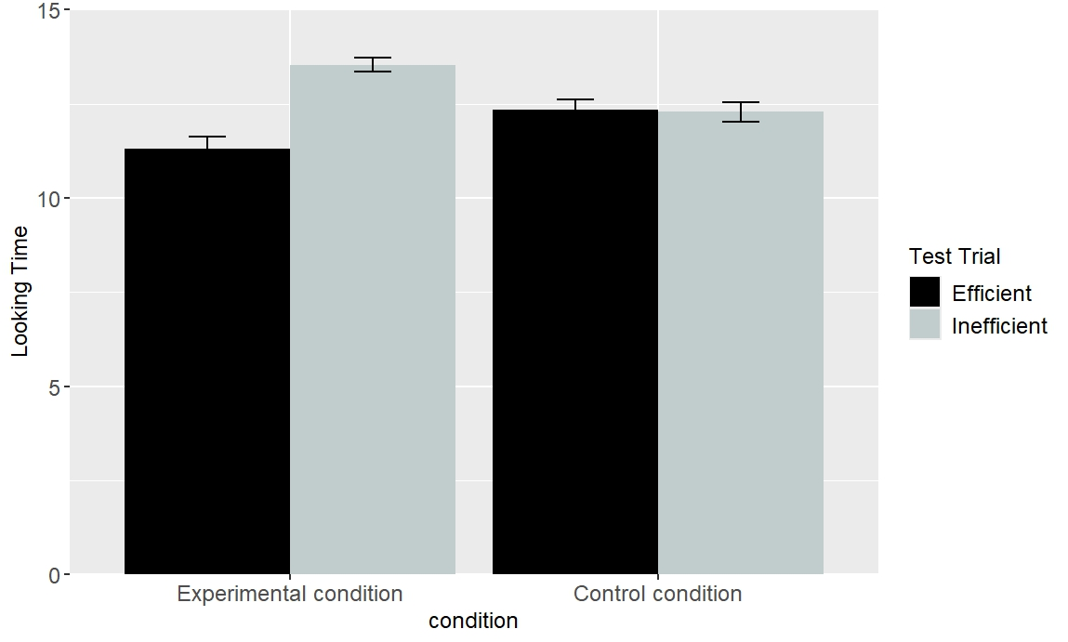
Figure 3. Networks’ mean “looking time” to the Low and High Jump test events in Simulation 2.

Discussion
This simulation examined whether the animate features that the objects possessed in Simulation 1 affected how networks processed the test events across conditions. The results of Simulation 2 provided a negative answer to this question: Networks showed heightened looking at the Inefficient test event relative to the Efficient test event in the Experimental condition but not in the Control condition. This result provides additional support for the notion that infants’ looking responses in studies that employ the Gergely paradigm can be explained by an associative learning mechanism.
The next simulation was designed to address a key finding that has been interpreted as support for the teleological stance: Infants can make inferences about one of the components of the model given information about the other components. For example, infants can infer that an external constraint exists based on an agent’s actions and its goals. Similarly, infants can infer an agent’s goals from its actions and external constraints. Data that bear directly on this question come from a study by Csibra et al. (2003). In one of the experiments, 12-month-olds were habituated to an event in which a small circle entered the screen from the bottom left, moved straight through a gap between two bars, and then disappeared from the screen. A larger circle, which entered the screen from the bottom right shortly after the small circle emerged, moved in the direction of the small circle as if chasing it. Because the gap between the two barriers was too narrow for the larger circle to fit through, it moved around the right bar before continuing in the direction in which the small circle was last seen. Crucially, because the larger circle never reached the small circle, its goal—namely, to catch the small circle—had to be inferred. Infants were then shown two test events—the gap between the two barriers was now wide enough for both circles to pass through. In the Incongruent event, the larger circle again moved around the right barrier; it passed through the gap in the Congruent event. Csibra et al. (2003) found that infants looked longer at the former event than at the latter. This was interpreted to mean that infants understood that the larger circle’s goal was to catch the smaller circle.
In another experiment, infants were habituated to an event like that shown in the Experimental condition in Gergely et al. (1995) except that the barrier was hidden behind an occluder. However, infants could still see the second object and portions of the first object’s parabolic motion path behind the occluder as it moved to reach the second object. Infants were then shown two test events without the occluder. The first event depicted the first object jumping over a now visible barrier to reach the second object (Obstacle test event). The second event was identical to the first except that the obstacle was missing (No-Obstacle test event). The results indicated that infants looked longer at the No-Obstacle test event than at the Obstacle test event. The authors interpreted this as evidence that infants can infer invisible constraints from actions and goals. Simulation 3 assessed the need for a teleological account by assessing whether these findings could also be explained by the current associative learning proposal.
It is worth noting that although the experiment that tested whether infants could infer goals from actions and constraints did not use the Gergely paradigm, it is straightforward to recast it within that paradigm. For example, the habituation event—which would mirror that shown in the Experimental condition of Gergely et al. (1995)—could be stopped right before the first object reaches the second object but after the first object clears the barrier. Because observers never see the first object reach the second object in this configuration, observers must infer that the second object is the first object’s goal. This was the approach taken in Simulation 3.

Simulation 3
Simulation 3 tested whether the model used in Simulations 1 and 2 could also explain the finding that infants appear able to infer goals from constraints and behavior and constraints from goals and behaviors. Networks were assigned either to the Inferring Goals condition (N = 20) or to the Inferring Constraints condition (N = 20). The model used to simulate the Inferring Goals condition was identical to that used in Simulation 1 except that the Contiguous group was absent during habituation. Thus, the network could not know whether the first object came to rest next to the second object (the Inferring Goals scenario). In contrast, the model used to simulate the Inferring Constraints condition was also identical to that used in Simulation 1 except that barrier information was missing; that is, the Barrier Height and Barrier Position groups were absent.
Figure 4 shows the looking behavior of networks used in the Inferring Goals scenario and the Inferring Constraints scenario. Data for networks in the Inferring Goals scenario were entered into a linear mixed-effects model with Trial Type (Obstacle vs. No-Obstacle) as the within-subjects fixed effect and network treated as a random effect. This analysis revealed a significant main effect of Trial Type, F(1, 179) = 10958.36, p < .0001. This analysis indicated that networks looked longer at the No-Obstacle test event (M = 9.24, SD = 0.61) than at the Obstacle test event (M = 3.67, SD = 0.22). Data for networks in the Inferring Constraints scenario also showed a main effect of Trial Type (Congruent vs. Incongruent): Networks looked longer at the No-Obstacle test event (M = 21, SD = 0.89) than at the Obstacle test event (M = 9.56, SD = 1.05).
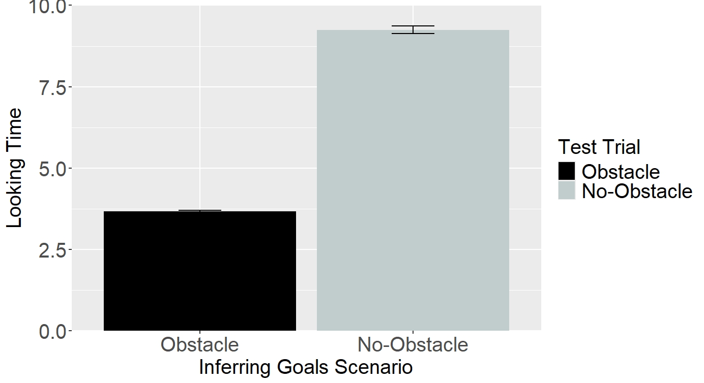 | 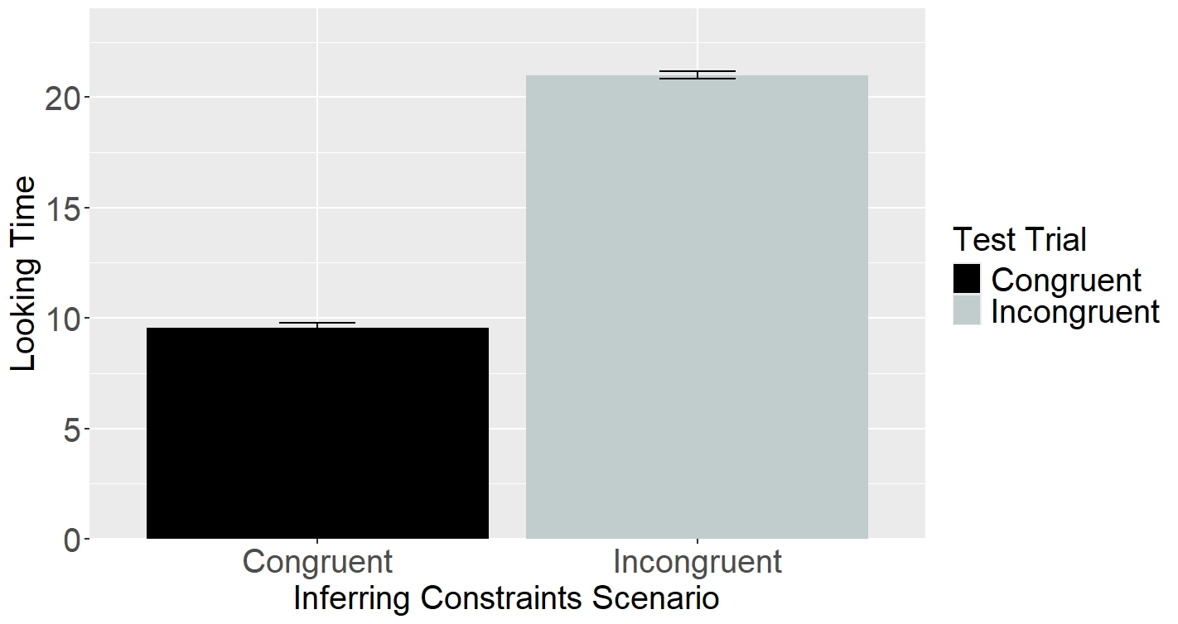
Figure 4. Left: Networks’ mean looking times to the two test events in the Inferring Goals Scenario. Right: Networks’ mean looking times to the two test events in the Inferring Constraints Scenario.

Discussion
One of the strongest pieces of evidence for the teleological stance is the finding that infants can infer different components of this model given others. Although it is tempting to conclude that infants possess such a stance based on the apparent flexibility of their inferences, the current simulation demonstrated that such an account is not necessary to explain this aspect of infants’ action understanding. Simulation 3 showed that associative learning alone is sufficient to account for this facet of infants’ action understanding. To further show the explanatory scope of the current account, the final simulation tested whether the current model could explain yet another aspect of infant action understanding: By 6 months of age, infants understand that actions can differ in their efficiency such that one event is more efficient (or inefficient) than the other. Simulation 4 tested whether the current model could capture this finding.

Simulation 4
This simulation was inspired by Liu and Spelke (2017) and tested whether networks could distinguish between two events that differed in their relative costliness. In this study, 6-month-olds were habituated to an event in which a circle character jumped over a barrier to reach a triangle character on the other side. Infants were then shown two test events. Crucially, unlike the test events used in other studies that employed the Gergely paradigm, which did not include a barrier, this study did include one. However, the barrier was much shorter than that was shown during habituation. In the low, efficient jump test event, the agent jumped just high enough to clear this barrier. In the high, inefficient jump event, the agent jumped as high as it did to clear the taller barrier during habituation. Liu and Spelke (2017) argued that if infants represent efficiency (or cost) continuously and expect agents to engage in the least inefficient and costly action when pursuing goals, then they should look longer at the second test event than at the first one. The results of this experiment supported this prediction
In this simulation, networks were habituated for two epochs to an event in which one object with animate features jumped over a large barrier to reach another object with animate features. The large barrier was instantiated by turning on the Barrier Height 4 unit in the Barrier Height group. Networks were then tested with a High Jump test event and a Low Jump test event. The High Jump test event was identical to the habituation event (e.g., the jump height remained the same) except that it used a low barrier. This barrier was implemented by turning on the Barrier Height 2 unit in the Barrier Height group. Thus, the first object jumped much higher than needed to clear the now much shorter barrier. The low jump test event was identical to the High Jump test event except that the height of the first object’s jump corresponded to the height of the now much shorter barrier (i.e., the Jump Height 2 unit was turned on).
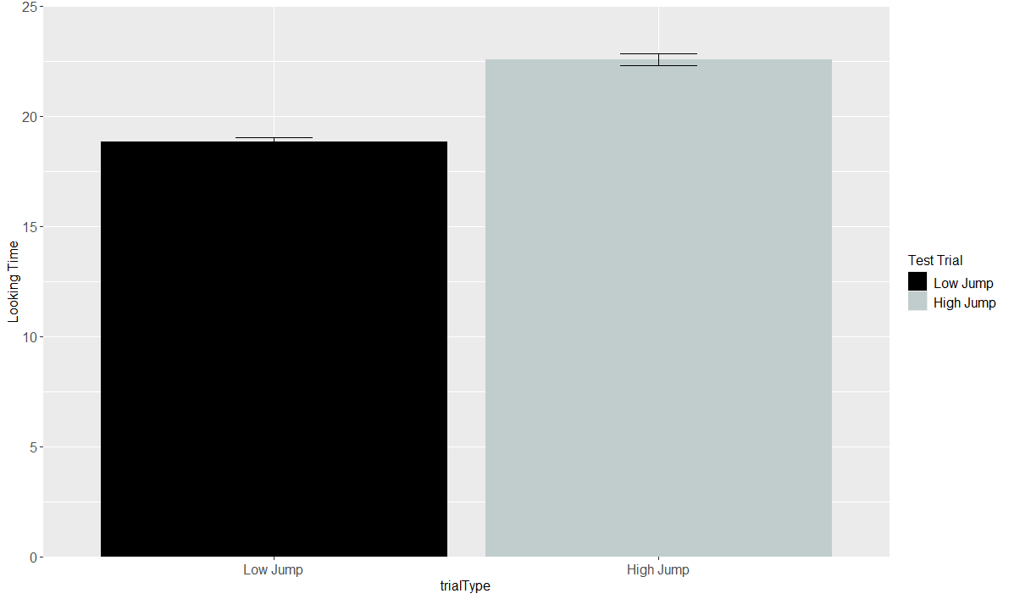
Figure 5. Networks’ mean “looking time” (i.e., cross-entropy error) to the Low and High Jump test events.

Figure 5 depicts networks’ mean looking times to the Low and High Jump test events. Data for this simulation were entered into a linear mixed-effects model with Trial Type (High Jump vs. Low Jump) as the within-subjects fixed effect and network treated as a random effect. This analysis revealed a significant main effect of Trial Type, F(1, 179) = 3181.82, p < .0001. This result reflected the fact that networks looked longer at the High Jump test event (M = 22.58, SD = 1. 29) than at the Low Jump test event (M = 18.85, SD = 0.99).

Discussion
Simulation 4 showed that a network, like infants, looked longer at a more costly event than it does at a less costly event. This finding is significant because neither the current associative learning account nor the model that instantiated it implements a notion of cost, a NUC, or a teleological stance. This suggests that such principles and domain-specific mechanisms are not necessary to account for infants’ looking behaviors. These results demonstrate, instead, that domain-general associative learning may be sufficient to explain infants’ looking behaviors in studies that use the Gergely paradigm. This conclusion is also consistent with the only other published connectionist modeling study on this topic (Van Overwalle, 2010). However, a key difference between the model in that paper and the current one is that Van Overwalle (2010) only simulated Gergely et al. (1995). In contrast, the current model accounted for a range of findings from several studies that employed the Gergely paradigm. This demonstrates the explanatory breadth of the current model (and by extension, the proposal it implements). A second major difference is that Van Overwalle’s model could not develop internal representations. This means that his model could not make use of any prior, “real-world” experience with action events. Although the current simulations demonstrate the sufficiency of associative learning, the present simulations do not show that infants do not possess a NUC or a teleological stance. This issue can only be resolved empirically.

Unpacking the mechanism by which the model produced a match to the behavioral data
The simulations suggest that associative learning can explain infants’ looking behavior in studies using the Gergely paradigm. However, they leave unresolved the precise nature of this learning process. One way to answer this question is to consider how the model processed the information during various phases in the different simulations. Given space constraints, I will use Simulation 1 as a case study. However, the principles used to explain the network’s behavior in Simulation 1 also apply to the remaining simulations.
Processing in the model begins during the pretraining phase. Here, the network is presented with an action event, encoded as a pattern of activation across different input groups (e.g., Object Left and Right, Barrier Location, Barrier Position, etc.). These events correspond to situations in which one object or animate entity moves along either a straight or curved path to reach a second object or animate entity. This pattern of activation is then propagated to the hidden layer via the weights that connect each of the input groups to the hidden layer. At the beginning of training, this pattern of activity is arbitrary. This is because the weights themselves are small, random values. This hidden pattern of activity is then propagated to, and elicits a pattern of activity over, the output groups in the output layer. This observed pattern of activation is then compared to the desired or target pattern of activation. Any discrepancy between the two patterns is treated as error, and the network uses this error to adjust the weights throughout the network. Crucially, the pattern of error that the linear motion events produce over the output groups is different than that produced by the curved motion events. This has two effects. First, the weight changes will be different for the two action events. Second, the patterns of hidden activation that each event evokes after training will be different.
A consequence of this training process is that the network will develop a representation at the hidden layer that reflects learned associations between specific surface features of the input and different hidden units. Specifically, features in the input (e.g., the feature or unit that represent curved motion) will activate different hidden units via the weights or associations between them. These units, in turn, will activate the reconstruction of those same features at the output layer via a different set of associations that connect them. The fact that these associations had 250 epochs to develop during the pretraining phase combined with the fact that many of the features experienced during pretraining are also encountered during the experiment portion of the various simulations factors importantly in explaining how the network comes to respond the way it does to the test events in these simulations. For example, consider the habituation and test events shown to networks in the Experimental condition of Simulation 1. Here, networks are shown an event in which a novel object with animate features jumps over a barrier to reach another object on the other side. Crucially, two of these features, namely, the height of the jump and the height of the barrier, are novel in relation to the jump and barrier heights experienced during pretraining. This means that the familiar features (e.g., the Curved Motion unit) and the units in the hidden layer with which they are associated will strongly activate one another. Although the habituation phase is shorter than the pretraining phase, the network still learns associations between specific input and output units. In particular, it forms links between the Barrier Height 0, Barrier Missing, Curved Motion, Contiguous, Animate Features, and Jump Height 4 input units and their corresponding output units through the hidden layer. This means that if one or more of these input features are presented in either of the test events, not only will “old” features be activated based on preexisting indirect associations, but new features will be activated based on associations established during habituation.
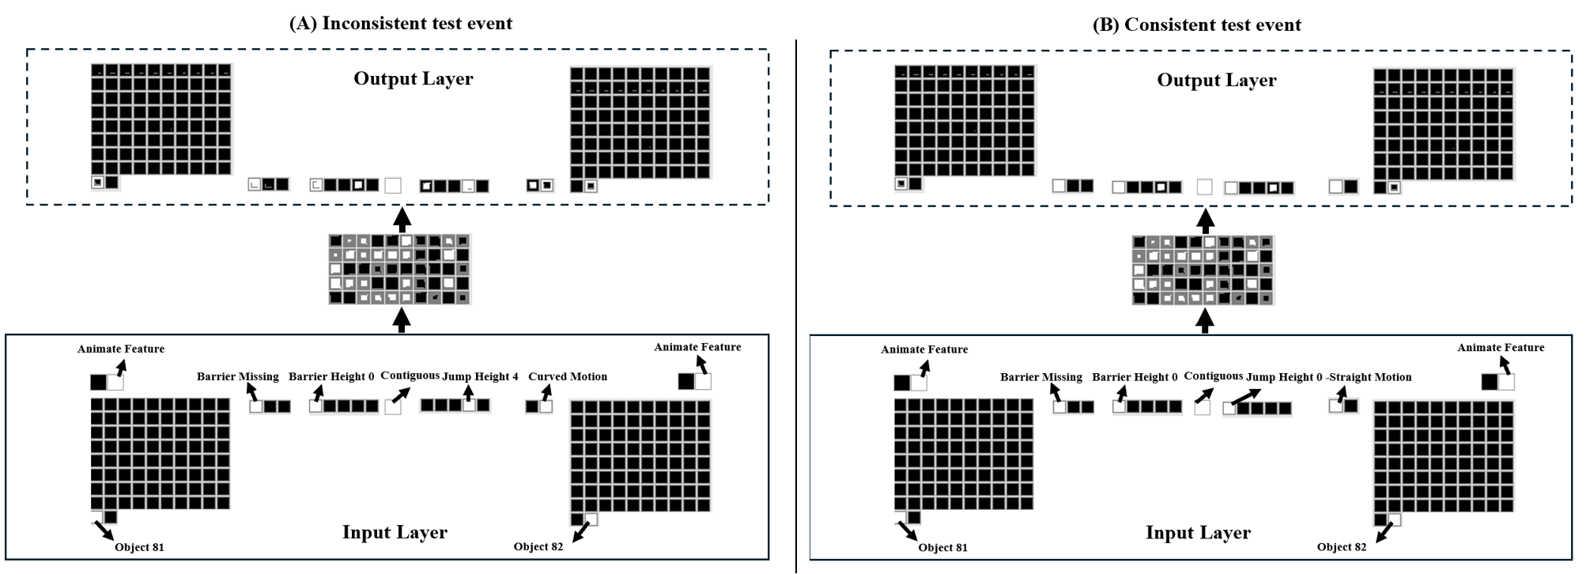
Figure 6. Depiction of the test performance of networks in the Experimental condition. (A) Network’s test performance on the Inconsistent test event. (B) Network’s test performance on the Consistent test events. The size of the colored region within each output unit corresponds to the activation of that output unit. Larger colored region corresponds to greater activation of that unit. Darker colored inner regions for output units correspond to activation values ≤0.5; lighter color inner regions correspond to activation values >0.4. The colored border that encircles each output unit corresponds to it “target” values. Dark borders correspond to target values of “0”; light colored borders correspond to target values of “1”.

This fact helps to explain the network’s responses to the barrierless test events. It will be recalled that in the Inefficient test event, the first object again follows an arced path to reach the second object. This event was instantiated by turning on the Barrier Height 0 unit in the Barrier Height group, the Curved Motion unit in the Motion Type group, the Barrier Missing unit in the Barrier Location group, the single unit in the Contiguous group, and the Jump Height 4 unit in the Jump Height group. Because five of these features appeared during the habituation phase (i.e., Contiguous unit, both Animate Feature units, the Curved Motion Unit, and the Jump Height 4 unit), they will activate features they were associated with during that phase (i.e., Barrier Height 4, Jump Height 4). Additionally, they may activate older features from the pretraining phase (i.e., the Straight and Jump Height 0 output units) through previously established associations. In practice, however, the pattern of output unit activation that results from the presentation of these input features is more complex. The critical factor is whether the hidden units provide support for one output unit over another. This can be seen most clearly above in Figure 6. This figure shows the test performance of one of the 20 networks in the Experimental condition on the Inconsistent and Consistent test event. As can be in the Inconsistent test event, the network correctly activates the Barrier Missing, the Barrier Height 0, Contiguous, and Jump Height 4 output units. The first three of these units are activated because they were associated with the corresponding input units via the hidden units during the pretraining phase; in contrast, the last of these units is activated because it was associated with the Jump Height 4, Contiguous, and Animate Feature units during the habituation phase. However, it can also be seen that the network incorrectly activates the Barrier 4, Jump Height 0, and Straight Motion output units. This response also makes sense: The Jump Height 0 and Straight Motion output units were associated indirectly with their corresponding input units during the pretraining phase, whereas the Barrier 4 output unit was indirectly associated with the Jump Height 4, Barrier Height 4, Contiguous, and Animate Feature input units during the habituation phase. This means that three output units (i.e., Barrier 4, Jump Height 0, and Straight Motion) contribute to the error in the Inconsistent test event.
Now consider the Consistent test event. This event was implemented in the same manner except that the Straight Motion and Jump Height 0 input units were turned on. As shown in Figure 6, the network activates the same units as those in the Inconsistent test event. However, because the network correctly activates four of these units and incorrectly activates the remaining two units via the same processes described above, two rather than three output units contribute to this event’s error. That one fewer unit contributes to error in the Consistent than in the Inconsistent event means the network “looks longer” at the latter than the former event.
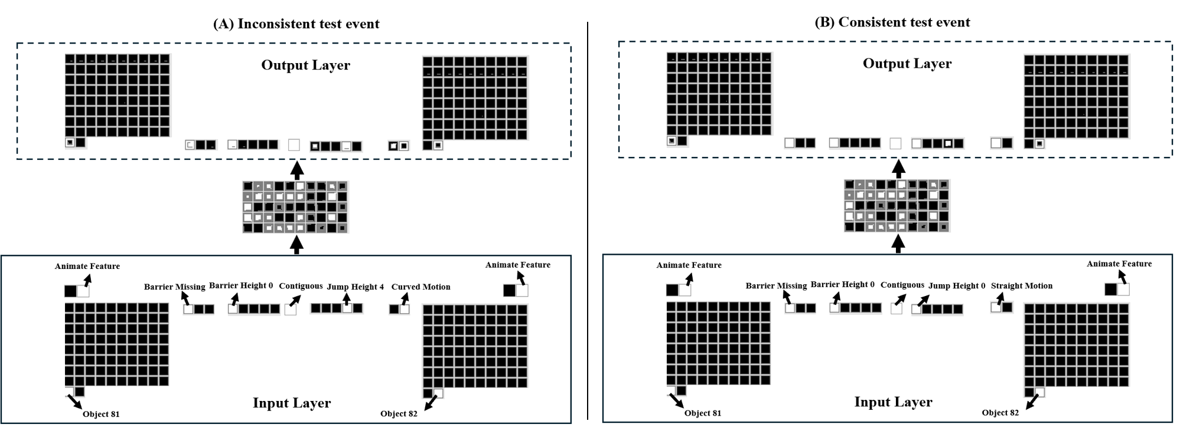
Figure 7. Depiction of the test performance of networks in the Control condition.

The same principles can be used to explain how the network comes to respond more comparably to these test events in the Control condition. Figure 7 above shows the test performance of one of the 20 networks in the Control condition to the two test events. Before examining the network’s test performance, it's useful first to consider how it processed the habituation event. This event was identical to that in the Experimental condition except that the barrier was located to the side rather than in the middle. Because the learning rate for the Barrier Side units is kept at the pretraining value, the network fails sufficiently to adjust its weights during habituation. Consequently, any associations that involve this unit from the pretraining phase remain largely unchanged. This means that when the network is tested on the Inconsistent test event, it will not activate the Barrier Side output units in response to activity in the Curved Motion, Jump Height 4, Contiguous, and Animate Feature input units. This can be seen in Figure 7. Instead, it will activate the Barrier Missing output unit given that the Barrier Missing and Barrier Height 0 input units—which were indirectly associated with it via the associated hidden units—are presented as input in the Inconsistent test event. Given that this is the correct response in both test events, activation of this unit does not contribute to each test event’s error.
Similarly, following habituation, the network fails to activate the Barrier Height 4 output unit in response to activity in the Barrier Height 4, Jump Height 4, Curved Motion, Barrier Missing, Animate Features, and Contiguous input units. This stems from the fact that its weights have weight decay and an even lower learning rate than that for the Barrier Side units. This means that if any one of the five input units is turned on in either of the test events, the network will not activate the Barrier Height 4 unit. Instead, the network will activate whichever output unit was indirectly associated via the hidden units with any one of these five input units during the pretraining phase. In this case, this means that the network will turn on the Barrier Missing output unit because this unit formed an indirect association with the Barrier Missing, Barrier Height 0, and Contiguous input units during the pretraining phase. Because this too is the correct response for the Inconsistent and Consistent test events, activation of this unit also does not contribute to either test event’s error.
In contrast, because the learning rate on the incoming and outgoing connections to the Jump Height 4 unit is large to reflect its heightened salience, the network can adjust its weight sufficiently within the timeframe of the habituation phase to activate the Jump Height 4 output unit in response to activity in the same five input units. This means that if any of these input units is turned on in either of the test events, the Jump Height 4 output unit will also be turned on. Given that at least one of these units is turned on in both test events, this output unit is active in both test events. This is the right response in the Inconsistent test event, but the wrong response in the Consistent test event. Thus, the largest contributor to error in the Consistent test event is the Jump Height 4 test event; the network activates the correct units in the other output groups. In contrast, the largest contributor to error in the Inconsistent test event is activation of the Straight Motion output unit instead of the desired Curved Motion output unit. The explanation for this is the same as that above. Notably, and as can be seen in Figure 7, there is also some activation of the Jump Height 0 output unit. The reason for this is that some of the input units with which it was indirectly associated during the pretraining phase are present (i.e., the Barrier Missing and Barrier Height 0 units). However, this activation is largely dampened in relation to the Jump Height 4 output unit (the size of the square for this unit overestimates its true activation). This is because when the Jump Height 4 input unit is activated, it triggers hidden units that both excite the correct Jump Height 4 output unit and suppress the Jump Height 0 unit through differential positive and negative weights. Crucially, because there is only a single large contributor to error in both test events, both events produce equivalent error. The network, thus, looks equally long at both test events.
This analysis suggests that infants’ behavior in Gergely-style studies can be explained by learned associations between different kinds of actions and low-level perceptual features rather than by abstract reasoning about goals, cost, or efficiency.

General Discussion
The current paper presented an alternative perspective to account for infants’ looking behaviors in studies that test their action understanding. The crux of my argument was that infants’ performance in these studies reflects a combination of prior experience with linear and curved motion events and online associative learning in which barriers are linked with curved action. I argued further that the strength of these associations depends on the physical proximity of the barrier to the curved motion: Stronger associations are established when the barrier appears beneath rather than beside curved action. I then showed that when this proposal was implemented in a connectionist artificial neural network model, it was able to account for a range of key findings from studies that employed the Gergely paradigm. Specifically, Simulation 1 accounted for the finding that infants show elevated looking when animated objects behave inefficiently. Simulation 2 accounted for the finding that infants show this pattern irrespective of whether objects possess animate features. Simulation 3 accounted for the finding that infants can infer external constraints from an agent’s actions and goals from its actions and external constraints. Finally, Simulation 4 accounted for the finding that infants recognize that event can differ in their relative efficiency. Taken together, these simulations suggest that domain-general associative learning is sufficient to account for infants’ performance in studies that test their action understanding with the Gergely paradigm; a NUC or teleological stance is not necessary.
Despite the success of the current model, at least three potential criticisms are worth considering. One concerns the model’s simplicity. The model was simple in two key respects. First, movement and action were represented statically rather than dynamically. Second, objects, their features, and action events were represented locally rather than in a distributed fashion. These simplifications might suggest that the model is a poor approximation of infants’ real-world action experience. However, a major advantage of simpler models is that it is possible to trace precisely how they process information. This feature of simple models makes them particularly useful for advancing theories of infant action understanding. Although it is true that complex models could better capture the richness of infants’ action perception, a major disadvantage of such models is that their complexity hinders their interpretability. Thus, although complex models may be ideal for simulating infants’ real-world action experiences, simpler models remain valuable for identifying underlying processes and advancing cognitive theory.
A second potential criticism concerns the limited scope of the findings and studies modeled in the present simulations. The criteria for choosing the studies that were included were the following. First, at least some studies needed to be foundational—that is, they needed to be among the first to investigate this topic. Second, the remaining studies had to employ the same paradigm while addressing a qualitatively distinct question. The studies that were simulated here met these criteria. A more practical reason for limiting the scope of modeled studies was the space constraints of the paper, which made it impossible to simulate every study that has used the Gergely paradigm. Nonetheless, an important direction for future simulation studies will be to explore whether the present model, or an extension of it, can account for additional findings in the literature on infant action understanding.
A third and related limitation is that because the current simulations focused on studies that employed the Gergely paradigm, it remains to be seen whether the current model (and the theory it implements) can explain findings from other studies on infant action understanding. Although it is true that the current simulations may have little to say about these other studies because they were designed to capture a broad set of findings from studies that used the Gergely paradigm, this limitation may be more apparent than real. This is because if those studies can be recast within the Gergely paradigm, it is possible that the same model could account for infants’ behavior in those studies as well. This would suggest that the explanatory breadth of the current extends beyond the specific paradigm for which it was originally developed. Simulation 3 took a step in this direction by reframing the Inferring Goals condition in Csibra et al. (2003)—which did not use the Gergely paradigm—in terms of that framework and showing that the model could capture infants' responses in this condition. Future modeling work that builds on the current set of simulations could similarly recast other studies on infant action understanding in terms of the Gergely paradigm to determine whether the current model can explain an even wider range of findings.
The current studies were undertaken to test a new proposal based on domain-general associative learning for how infants process action events in studies that employed the Gergely paradigm. By successfully modeling infants’ responses in studies using this paradigm, this work challenges the view that infants’ action understanding is governed by a teleological stance or a naïve utility calculus. Instead, these findings suggest that associative learning is sufficient and may offer a more parsimonious explanation.
References
Benton, D. T. (2025). An associative-learning account of how infants learn about causal action in animates and inanimates: A critical reexamination of four classic studies. Journal of Experimental Psychology: General, 154(2), 497–521. https://doi.org/10.1037/xge0001656
Carey, S. (2009). The origin of concepts. Oxford University Press.
Csibra, G., & Gergely, G. (1998). The teleological origins of mentalistic action explanations: A developmental hypothesis. Developmental Science, 1(2), 255-259. https://doi.org/10.1111/1467-7687.00039
Csibra, G., Biro, S., Koos, O., & Gergely, G. (2003). One-year-old infants use teleological representations of actions productively. Cognitive Science, 27(1), 111-133. https://doi.org/10.1207/s15516709cog2701_4
Csibra, G., Gergely, G., Biro, S., Koos, O., & Brockbank, M. (1999). Goal attribution without agency cues: The perception of ‘pure reason’ in infancy. Cognition, 72(3), 237-267. https://doi.org/10.1016/S0010-0277(99)00039-6
Gergely, G., Bekkering, H., & Király, I. (2002). Rational imitation in preverbal infants. Nature, 415(6873), 755-756. https://doi.org/10.1038/415755a
Gergely, G., & Csibra, G. (2003). Teleological reasoning in infancy: The naive theory of rational action. Trends in Cognitive Sciences, 7(7), 287-292. https://doi.org/10.1016/S1364-6613(03)00128-1
Gergely, G., Nádasdy, Z., Csibra, G., & Bíró, S. (1995). Taking the intentional stance at 12 months of age. Cognition, 56(2), 165-193. https://doi.org/10.1016/0010-0277(95)00661-H
Heyes, C., & Ray, E. D. (2000). What is the significance of imitation in animals? Advances in the Study of Behavior, 29, 215-245. https://doi.org/10.1016/S0065-3454(08)60106-0
Hinton, G. E. (1984). Distributed representations. Carnegie-Mellon University Technical Report, 43, 1-12.
Hinton, G. E. (1989). Connectionist learning procedures. Artificial Intelligence, 40(1-3), 185-234. https://doi.org/10.1016/B978-0-08-051055-2.50029-8
Hunnius, S., & Bekkering, H. (2014). What are you doing? How active and observational experience shape infants’ action understanding. Philosophical Transactions of the Royal Society B: Biological Sciences, 369(1644), 20130490. https://doi.org/10.1098/rstb.2013.0490
Jara-Ettinger, J., Gweon, H., Schulz, L. E., & Tenenbaum, J. B. (2016). The naïve utility calculus: Computational principles underlying commonsense psychology. Trends in cognitive sciences, 20(8), 589-604. https://doi.org/10.1016/j.tics.2016.05.011
Jara-Ettinger, J., Schulz, L. E., & Tenenbaum, J. B. (2020). The naive utility calculus as a unified, quantitative framework for action understanding. Cognitive Psychology, 123, 101333. https://doi.org/10.1016/j.cogpsych.2020.101334
Kamewari, K., Kato, M., Kanda, T., Ishiguro, H., & Hiraki, K. (2005). Six-and-a-half-month-old children positively attribute goals to human action and to humanoid-robot motion. Cognition, 95(1), 67-75. https://doi.org/10.1016/j.cogdev.2005.04.004
Leslie, A. M. (1995). A theory of agency. In D. Sperber, D. Premack, & A. J. Premack (Eds.), Causal cognition: A multidisciplinary debate (pp. 121-141). Clarendon Press.
Liu, S., & Spelke, E. S. (2017). Six-month-old infants expect agents to minimize the cost of their actions. Cognition, 160, 35-42. https://doi.org/10.1016/j.cognition.2016.12.007
Mareschal, D., French, R. M., & Quinn, P. C. (2000). A connectionist account of asymmetric category learning in early infancy. Developmental Psychology, 36(5), 635–645. https://doi.org/10.1037/0012-1649.36.5.635
Meltzoff, A. N., & Moore, M. K. (1997). Explaining facial imitation: A theoretical model. Early Development and Parenting, 6(3-4), 179-192. https://doi.org/10.1002/(SICI)1099-0917(199709/12)6:3/4%3C179::AID-EDP157%3E3.0.CO;2-R
Phillips, A. T., & Wellman, H. M. (2005). Infants’ understanding of object-directed action. Cognition, 98(2), 137-155. https://doi.org/10.1016/j.cognition.2004.11.005
Rakison, D. H., & Lupyan, G. (2008). Developing object concepts in infancy: An associative learning perspective. Monographs of the Society for Research in Child Development, 73(1), 1-110. http://www.jstor.org/stable/30162860
Rohde, D. L. (1999). LENS: The light, efficient network simulator. School of Computer Science, Carnegie Mellon University.
Rumelhart, D. E., Hinton, G. E., & Williams, R. J. (1986). Learning representations by back-propagating errors. Nature, 323(6088), 533-536. https://doi.org/10.1038/323533a0
Schwier, C., van Maanen, C., Carpenter, M., & Tomasello, M. (2006). Rational imitation in 12-month-old infants. Infant Behavior and Development, 29(2), 186-193. https://doi.org/10.1207/s15327078in1003_6
Singh, S., Benton, D., & Rogers, T. (in press). Using artificial neural networks to simulate social category learning: A tutorial. Social Cognition
Sodian, B., Schoeppner, B., & Metz, U. (2004). Do infants apply the principle of rational action to human agents? Infant Behavior and Development, 27(1), 31-41. https://doi.org/10.1016/j.infbeh.2003.05.006
Spelke, E. S. (2022). What babies know: Core knowledge and composition (Vol. 1). Oxford University Press.
Van Overwalle, F. (2010). Infants' teleological and belief inference: A recurrent connectionist approach to their minimal representational and computational requirements. NeuroImage, 52(3), 1095-1108. https://doi.org/10.1016/j.neuroimage.2010.05.028
Woodward, A. L., & Sommerville, J. A. (2000). Twelve-month-old infants interpret action in context. Psychological Science, 11(1), 73-77. https://doi.org/10.1111/1467-9280.00218

Fewer habituation epochs were used here than that used in previous simulations because preliminary simulations indicated that networks required many fewer epochs to produce the target result. Critically, the architecture along with the parameter values were identical to that used in previous simulations.

