Associative learning over distinct surface features can explain infants’ action efficiency understanding
Deon T. Benton
Vanderbilt University

Address correspondence to Deon T. Benton, Department of Psychology and Human Development, Vanderbilt University, Peabody College, 230 Appleton Place #552, Nashville, TN 37235

Data availability statement: The simulation data for these simulations can be found here https://osf.io/9eqpf/?view_only=62f752417a9141c7b0509a998039ad13.
Conflicts of interests: none

“Associative learning over distinct surface features can explain infants’ action efficiency”

Abstract
Developmental scientists have long debated how infants come to understand the efficiency of others’ actions. The nativist position maintains that infants possess conceptually rich, domain-specific systems that enable them to represent actions in terms of goals, constraints, efficiency, and rationality. The empiricist position argues that the looking behavior of preverbal infants in most looking-time studies reflects domain-general processes that operate over the conceptually neutral surface features of the events and entities and objects that comprise them. Here, I instantiate a version of this latter proposal in a new connectionist model called Associative Learning in Action Sequences (ALIAS) and show that the model reproduced findings previously taken as evidence for different domain-specific systems that support processing actions in terms of their efficiency, cost and utility. An analysis of the internal dynamics of the model indicated that its behaviors arose mechanistically through learned associations among perceptual features, the reactivation of associated representations during test events, differential obstacle salience, and transient attentional modulation. Additionally, ALIAS generated novel predictions concerning how changes in salience, experience, and attentional persistence should shape infants’ looking behavior in future experiments. Prominent theoretical accounts of infant cognitive posit specialized processes in domains such as causal learning, moral cognition, physical reasoning, among others. Yet, the present findings show that even in a domain as complex as action efficiency understanding, simple, albeit extremely powerful, domain-general learning processes operating over perceptually grounded event representations can account for infants' looking behaviors. As such, this study raises crucial questions about the necessity of specialized learning mechanisms to explain infants’ looking behaviors.
“Associative learning over differentially salient surface features is sufficient to explain infants’ action efficiency understanding”
A key challenge for young learners is distinguishing between efficient and inefficient actions. For instance, by observing a child tumble down a slide after attempting clumsily to climb it from the bottom, a child may learn that stairs are a more efficient—and indeed safer—way to use to slides. Similarly, by observing a person walk around a fence rather than repeatedly, and unsuccessfully, pushing against it, that same child will learn that moving around obstacles is a more efficient way to reach a destination. In general, recognizing when an action is or is not efficient—a capacity I refer to as action efficiency understanding—is crucial for navigating the world effectively. An open question in the developmental cognitive sciences concerns when and how preverbal infants, despite their limited mobility and first-hand experience interacting in the world, come to interpret actions in terms of their efficiency.
One method that developmental scientists have used to assess the developmental origins of action efficiency understanding is the violation-of-expectation paradigm. In this method, infants are either habituated or familiarized to events designed to establish an expectation of some kind or to acquaint them with the set-up of the experiment. In a subsequent test phase, infants are shown events that either conform to or violate the expectations that an adult observer might have formed during the initial phase (e.g., Baillargeon et al., 1995; Stahl & Kibbe, 2022). The way this method has typically been used to study action efficiency understanding in infants has been first to habituate preverbal infants to an event in which a self-propelled, animated object jumps over a barrier to reach another animated ball and then to test them on events that differ in their efficiency. Figure 1 In the so-called efficient event, first object moves along a straight path to reach the second object. In the so-called inefficient event, the first object continues to move along the familiar, but now inefficient, curved or arced motion path to reach the second object. Figure 1 depicts this general approach for studying action efficiency in infants.

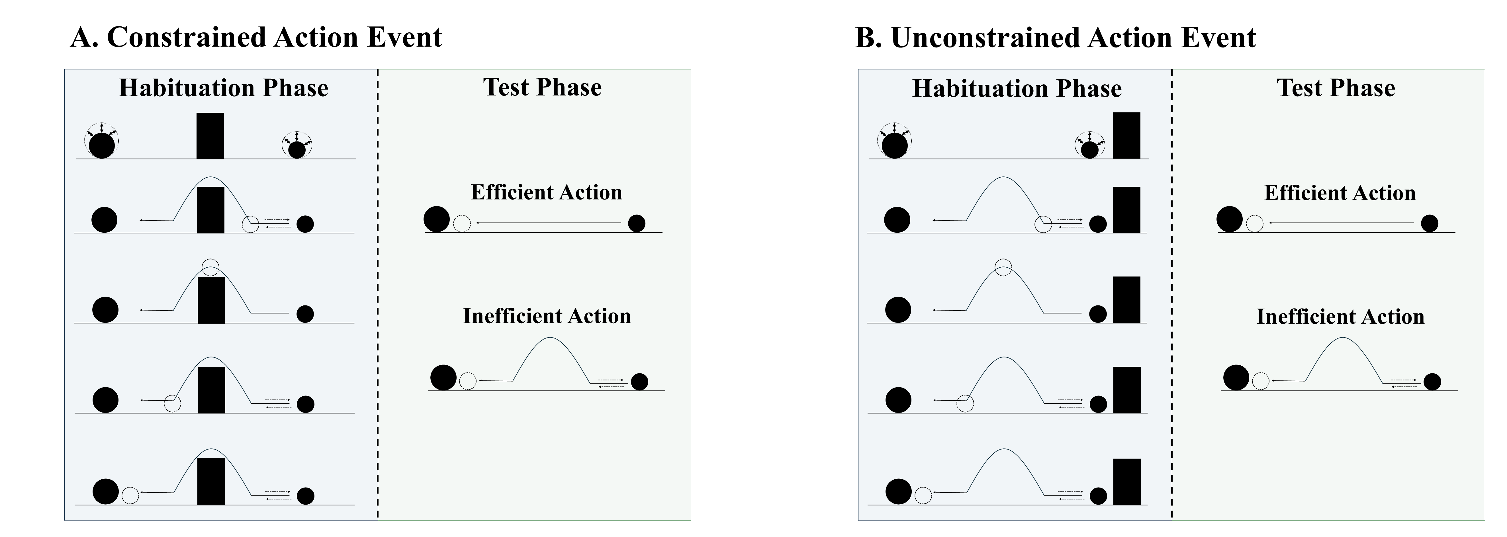
Figure 1. Schematic depiction of a typical constrained and unconstrained action event used in studies assessing action efficiency understanding in infants. In the constrained action event (A), the first object jumps over the barrier before it comes to rest next to the second object; in the unconstrained action event (B), the first object jumps beside the barrier before coming to rest next to the second one. The barrier is removed at test for both events, and infants observe either an efficient straight-path action or an inefficient arced-path action. Data for the first target finding discussed in the text derived from this paradigm.

A number of important findings—which serve as targets for the present series of simulations—have emerged from the use of this method. Figure 2 provides a visualization of the paradigms from which the findings reviewed in this section derive. One of the earliest and most influential findings is that 9- to 12-month-olds look longer at the inefficient test event than at the efficient one but only if the first object’s movement during habituation was constrained (i.e., it occurred over a barrier); infants look equally long at both events if its movement was unconstrained (Figure 1; i.e., it occurred beside a barrier; Gergely et al., 1995; Phillips & Wellman, 2005; Schwier et al., 2006; Sodian et al., 2004; Woodward & Sommerville, 2000). Another is that infants’ looking behaviors extend to action events depicting inert or non-self-propelled objects (Figure 2A; e.g., Csibra et al., 1999; Kamewari et al., 2005). In other words, infants continue to look longer at the inefficient test event than at the efficient one following habituation to constrained, but not to unconstrained, actions, irrespective of whether the entities involved are animated.

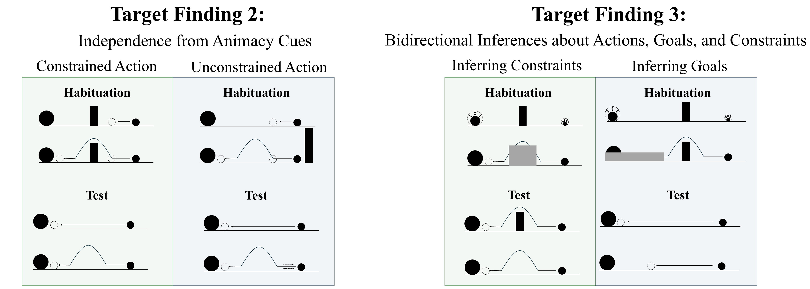
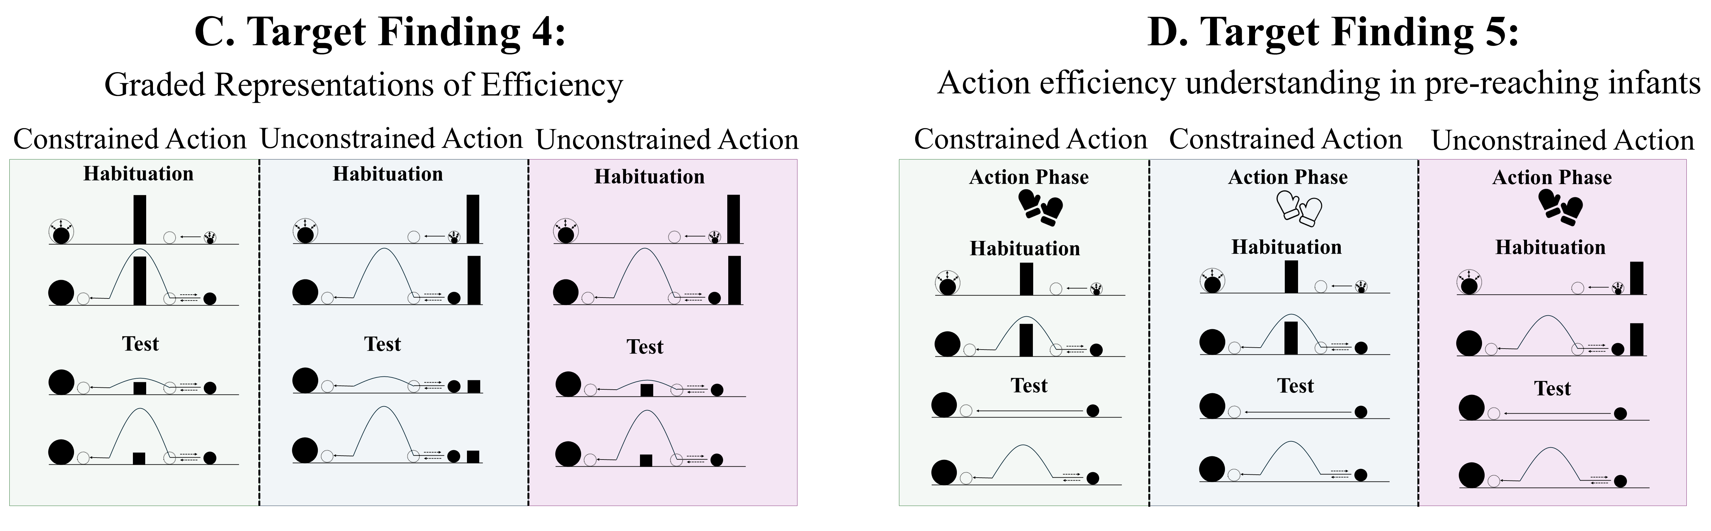
Figure 2. Schematic overview of the paradigms from which Target Findings 2–5 derive. Panels A–D depict, respectively, the experimental paradigms showing (A) the independence of action efficiency understanding from animacy cues, (B) bidirectional inferences about actions, goals, and constraints, (C) graded representations of efficiency, and (D) action efficiency understanding in pre-reaching infants. Note that closed gloves correspond to the sticky-mittens condition, whereas open gloves correspond to the non-sticky-mittens condition. The paradigm underlying Target Finding 1 is shown in Figure 1.

Beyond identifying inefficient actions across different types of entities, previous research suggests that infants can also reason about the relations among actions, goals, and environmental constraints (Figure 2B). For example, Csibra et al. (2003; see also Wagner & Carey, 2005) showed that 12-month-olds can make bidirectional inferences among these factors: they can use information about an agent’s actions and the constraints under which those actions are performed to infer the agent's goal, and they can use information about an agent’s goal and actions to infer the presence of environmental constraints. In their first experiment, infants were habituated to an event in which a large circle appeared to be chasing a small circle. However, before the large circle reached the small one, the small circle moved through a narrow gap between two bars and disappeared from the screen; the width of the gap forced the larger circle to move around one of the bars. The fact that the large circle never reached the small one before it disappeared from the screen meant that the large circle’s goal of reaching the small one had to be inferred. The authors found that when the gap was widened such that the large circle could fit through, infants looked longer when it continued moving around one of the barriers than when it passed through it. In a second experiment, infants were habituated to a constrained action event except that the barrier was hidden behind an opaque screen. Infants could nonetheless see the second object and parts of the first object’s arced motion path. Csibra et al. (2003) found that infants looked longer when the first object followed the same curved path in the absence of an obstacle than when it did so in the presence of one.
One aspect of action processing that the research discussed above cannot speak to is whether infants can represent the efficiency of an action continuously rather than in a binary, all-or-none fashion. To address this question, 6-month-olds were habituated either to a constrained action event or to an unconstrained one (Figure 2C). Infants were then tested either on constrained Low, efficient and constrained High, inefficient test events (Experiment 1) or on unconstrained versions of these events (Experiment 2); the barrier used in both test events was now much lower than that shown during habituation (see Figure 2C). In the constrained High, inefficient test event, the agent jumped much higher than needed to clear the barrier; the first agent jumped as high as necessary to clear the barrier. Liu and Spelke (2017) found that infants only looked longer at the High, inefficient test event than at the Low, efficient one following habituation to the constrained event. To test whether infants expect agents whose actions were inefficient in the past to continue behaving inefficiently in a new situation with a different set of constraints, a different set of infants were habituated to an unconstrained action event and then tested on the constrained events. Liu and Spelke (2017) found that infants looked longer at the High, inefficient test event than at the Low, efficient one.
A final notable finding is that pre-reaching infants—that is, infants with little firsthand object-manipulation experience and little opportunity to observe others' actions—nevertheless behave as though they are sensitive to action efficiency when they are given direct action experience (e.g., Skerry et al., 2013; see also Liu et al., 2019). In Skerry et al.’s (2013) study, for example, 3-month-olds were fitted either with sticky mittens that enabled them successfully to hold onto a Velcro-covered ball or with non-sticky mittens that did not (Figure 2D). Infants were then habituated to a constrained action event in which an actor reached over or beside a barrier to retrieve the same ball. Skerry et al. (2013) found that when the obstacle was removed and the actor followed the familiar arced path on some test trials and the novel straight path on others, only infants who had been habituated to a constrained action event looked longer at the former than at the latter. Although this research suggests that action efficiency understanding is in place sometime in the second half of the first year of life, an open question that it raises concerns its mechanistic basis.

Rich proposals for the origins of infant action efficiency understanding
Several accounts have been proposed to explain the mechanistic basis of infants’ behaviors in these studies. These theories fall roughly into two classes: rich and lean proposals. According to rich accounts, infants possess early emerging domain-specific mechanisms that support abstract and conceptually rich knowledge about how the various objects and entities in the world behave and act. These mechanisms are called domain-specific because they are triggered by a single input type and operate in a single domain. An example of such an account is the teleological stance (Csibra & Gergely, 1998; Gergely & Csibra, 2003). On this perspective, if an agent pursues some end state efficiently given the physical context—and thus satisfies the “rationality principle”—then an observed action is transformed into an interpreted action representation; that is, the end state will be treated as the agent’s goal, the agent's behavior as a goal-directed “means” to it, and the physical context as a set of “constraints”. On this account, then, an action is goal-directed if it is deemed rational and efficient. Crucially, the teleological stance is “non-mentalistic”: infants can recognize an action as goal-directed without considering or inferring an agent's mental states (i.e., beliefs, desires, and intentions).
A conceptually related account is the naïve utility calculus (e.g., Jara-Ettinger et al., 2016; Jara-Ettinger et al., 2020). This proposal concerns how agents choose actions and how observers process those actions. On the agent side, actors evaluate possible plans—sequences of goal-directed actions—in accordance with their expected subjective utilities. A subjective utility is the difference between the rewards that result from an outcome and the cost of executing the plan. Agents are expected to choose those plans that, by minimizing unnecessary costs, make this difference as large as possible. On the observer side, observers must infer—via Bayesian inference—the rewards and costs that drove the agent to choose a plan from its behavior.
A final account maintains that infant action efficiency understanding on the one hand and their reasoning about objects and entities on the other can be explained by two domain-specific systems that, despite being independent, interact (e.g., Liu et al., 2026). The naïve psychology system causes infants to represent agents as self-propelled, as possessing beliefs, desires, and goals, and as behaving in ways that maximize rewards and minimize costs. In contrast, the naïve physics system enables infants to represent objects as being solid, bounded, coherent, and permanent. A key assumption of this account is that the naïve psychology system depends on, and receives input from, the naïve physics system. As Liu et al. (2026, p. 66) state, “computations about the mind require input from naïve physics to return an answer”.
Despite differing somewhat in their specifics, each of these accounts share the notion that infants process others’ actions in terms of their efficiency, rationality, cost, and rewards, among other things. The notion that infants possess these concepts has some intuitive appeal, not least because adults likely use similar principles to interpret others’ actions. Other attractive aspects of these accounts are that they address foundational questions at the heart of the developmental cognitive sciences, have generated a substantial body of research, and enjoy some degree of empirical support. Yet, key questions remain. For example, the teleological stance is silent about the origins of such notions as goals, constraints, efficiency, or rationality. This is an important shortcoming given that knowing what makes an action rational or efficient is a prerequisite for judging whether an action is or is not efficient or rational. For example, before the child mentioned at the outset understands that walking around a fence is more efficient than pushing against it or even clumsily clambering over it, they must first possess some notion of what makes actions efficient. The teleological stance is also limited because it leaves unspecified how mechanistically an observed action maps onto an interpreted action representation.
Similar concerns apply to the naive utility calculus account. Two concerns are particularly notable. The first is that this theory leaves unspecified the developmental origins of notions such as reward, cost, and subjective utility. The second is that because this perspective is cast at Marr’s (1982) computational level, it has yet to be determined how the computations specified by the theory are physically realized in the mind at the implementational level or what operations give rise to these computations at the algorithmic level. In terms of Liu et al.’s (2026) proposal, the primary concern is that the naïve psychology system presupposes concepts for agents and objects. However, the difficulty with this position is that the evidence on which it is based comes largely from infants who have had months of potentially pertinent real-world experience (e.g., Benton, 2025; Haith, 1998; Scott & Arcaro, 2023).
Given these criticisms, I will develop here a fundamentally different account of infants’ looking behaviors in studies that assess their putative knowledge of action efficiency based on the idea that such behaviors are the product of a domain-general associative learning mechanism that operates over action-based semantically neutral perceptual regularities present in infants’ everyday experience. However, because this account is both inspired by and extends similarly perceptually grounded explanations of infants’ looking behaviors in violation-of-expectation studies, I first briefly describe the core tenet of lean proposals.

Lean proposals for the origins of infant action efficiency understanding
In contrast to the rich accounts described above, lean proposals maintain that infants’ behavior in violation-of-expectation studies can be explained by the operation of simple, albeit extremely powerful, domain-general learning mechanisms (e.g., associative learning, habituation, conditioning, pattern learning, statistical learning, etc.) that operate over low-level, surface-based perceptual features and that extract statistical regularities in visual scenes (e.g., Blumberg & Adolph, 2023; Cohen et al., 2002; Cohen & Oakes, 1993; Colunga & Smith, 2005; Heyes, 2018, 2024; Jones & Smith, 1993; Quinn & Eimas, 1997; Rakison & Lupyan, 2008; Sloutsky, 2010). Domain-general mechanisms are sometimes considered “all purpose” because they operate on many kinds of input and support learning across a wide range of domains. Beyond violation-of-expectation studies, a theme that is common to all lean proposals is the notion that that infants’ concepts emerge more slowly than the available data suggests, that these concepts are grounded in the visible surface features of the objects and entities they represent, and that the input available to infants is far more richly structured than has often been assumed.
Although lean proposals abound for capacities such as theory of mind (e.g., Berthiaume et al., 2013; Perner & Ruffman, 2005), causal perception and reasoning (e.g., Cohen et al., 2002; McClelland & Thompson, 2007), sociomoral reasoning (e.g., Benton & Lapan, 2021; McMahon & Isik, 2023; Scarf et al., 2012a, 2012b), object permanence (e.g., Bogartz et al., 2000; Munakata, 1998; Munakata et al., 1997), numerical cognition (e.g., Clearfield & Mix, 1999; Cohen & Marks, 2002; Simon, 1997), among others (e.g., Benton, 2025; Benton & Hoch, 2026; Rakison & Lupyan, 2008), efforts to explain infants’ looking behavior in studies that assess their putative action efficiency understanding from the same perspective remain relatively scarce.
A notable exception to this is a proposal by Van Overwalle (2010). The crux of Van Overwalle’s (2010) position is that infants learn which actions are efficient and which are inefficient via a “forward model”; that is, as infants watch agents follow particular trajectories to reach a goal, corresponding internal representations are established that come to resemble the visible state of the world at each point along those trajectories. Van Overwalle (2010), hereafter VVOM10, showed that a connectionist implementation of this proposal could reproduce Gergely et al.’s (1995) findings: Networks “habituated” to a constrained action event but not to an unconstrained action event looked longer at the inefficient test event than at the efficient one.
Despite reproducing Gergely et al.’s (1995) findings, caution should be exercised before concluding that these results challenge domain-specific proposals. One reason is that the model lacked any action observation experience prior to participation in a simulation analogue of Gergely et al. (1995). Thus, the model could not draw on such experience when processing habituation and test events. Yet, such experience may be necessary to account for findings like that described above by Csibra et al. (2003). VOM10 should struggle to account for this finding because doing so entails spontaneously inferring aspects of the visual array that were notably absent during the habituation phase. Another reason this conclusion should be adopted cautiously is that, by stipulating units for agents and goals, the model presupposes preexisting notions of these things. In this way, VOM10—like the teleological stance—leaves unresolved the developmental origins of these concepts. A final reason to exercise caution concerns the lack of fidelity between VOM10’s simulation of Gergely et al. (1995) and the study itself. Recall that in Gergely et al.’s (1995) study, an obstacle appeared off to one side of the stage during habituation for infants in the Control condition. No such obstacle appeared in Van Overwalle’s (2010) simulation of this condition. An additional point of departure between VOM10 and Gergely et al. (1995) is that the agent’s simulated curved trajectory overshot the barrier in the model but not in the behavioral study. Considered together, these issues limit what can be concluded about the sufficiency of Van Overwalle’s (2010) proposal for explaining infant action efficiency understanding.
Due in part to these limitations and given that Van Overwalle’s (2010) model is, to my knowledge, the only lean account of infant action efficiency understanding, the goals of the present paper were twofold. The first was to develop an alternative lean account that can explain infants’ looking behaviors in Gergely et al. (1995) as well as capture a range of other key findings in this literature. I will demonstrate that when this alternative account is implemented in a new connectionist model called ALIAS (for Associative Learning in Action Sequences), the model can readily reproduce these key findings. The second was to compare ALIAS to VOM10 and modified versions of both models.

An experienced-based associative learning account of infants’ looking behavior in action efficiency understanding studies

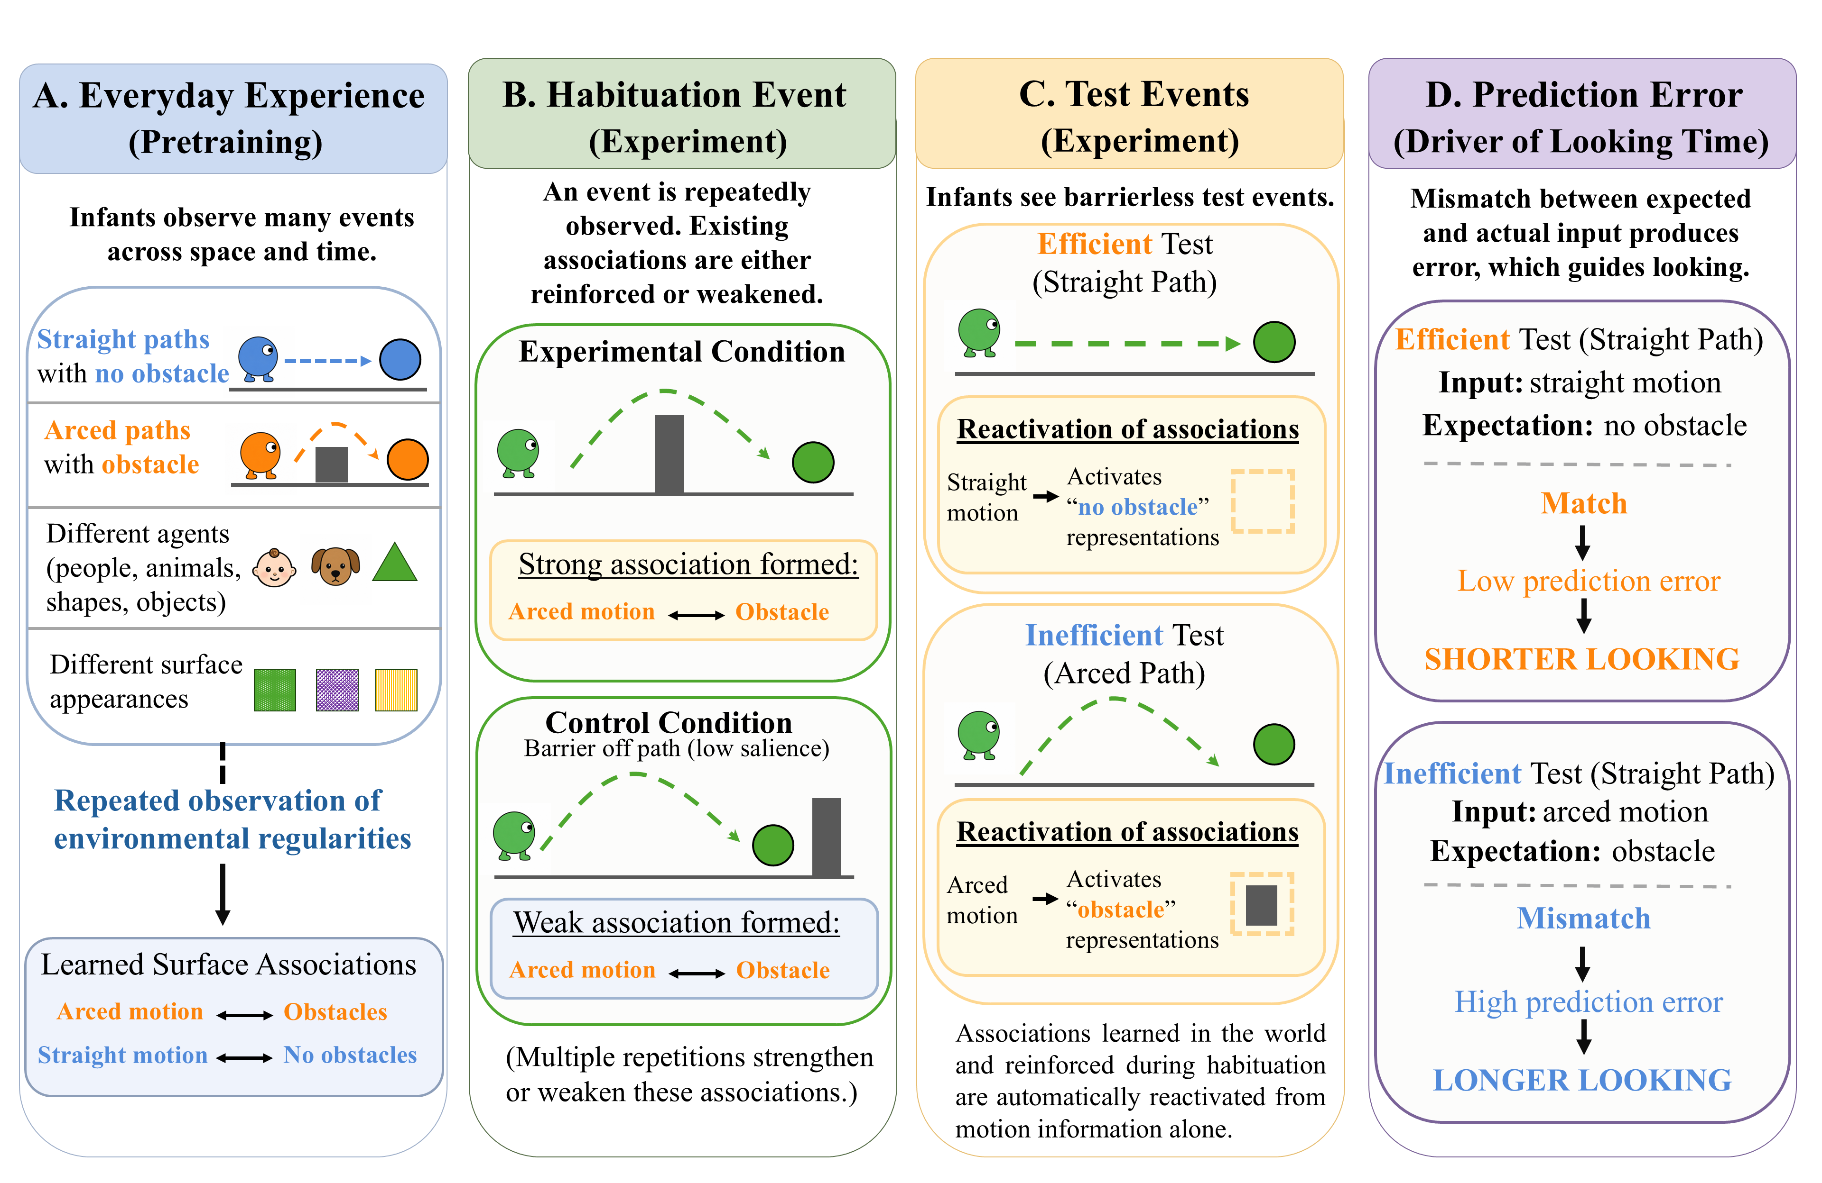
Figure 3. An associative learning account of infants’ looking in action efficiency understanding studies. (A) In the real world, infants form associations among the kinematics of different actions and the surface features of the entities and objects involved in them (e.g., arced motion is associated with obstacles and straight motion with absent obstacles). (B) During habituation, these associations are reinforced when arced motion occurs over an obstacle (Experimental condition) but are weakened when curved motion occurs beside it (Control condition). (C) At test, seeing a particular motion trajectory automatically activates the associated feature (e.g., an arced path activates a representation of an obstacle). If the expected features are not present, this produces prediction error which manifests as longer looking times; expectations that are met produce minimal to no error, and this manifests as shorter looking times.

A central thesis of the current alternative account—illustrated in Figure 3—is that infants' looking behavior in action efficiency studies reflects repeated experience observing agents move along straight trajectories when obstacles are absent and along arced trajectories when obstacles are present. A consequence of such repeated exposure to these environmental regularities is that associations will be formed between arced motion and obstacles and between straight motion and the absence of obstacles (Figure 3A). During the early stages of this learning process, both components of the newly established relation would need to be present for an association to be detected. However, if the components continue to be experienced together, not only will their association be strengthened, but the presence of one of the components will be sufficient to activate a representation of the other (for similar proposals in other domains see Rakison & Poulin-Dubois, 2001 and Heyes, 2019). Crucially, the representations that emerge from this associative-learning process embody only the semantically neutral kinematics of the observed actions and the conceptually neutral visible surface features of the objects and entities involved.
This account has two implications for infants' looking behavior in action efficiency studies. First, associations may either be strengthened or weakened depending on the degree of overlap between infants' prior experience and the events they observe during habituation (Figure 3B). Second, test events in which one component of a relation is missing will evoke longer looking than test events that present both components (Figures 3C and 3D). Together, these principles explain why infants who are habituated to a constrained action event look longer at inefficient action events than at efficient ones. Because habituation to a constrained motion event reinforces the learned arced motion-obstacle association due to its overlap with prior experience, infants look longer at the inefficient than at the efficient test event. The former event presents only one component of the arced motion–obstacle association; the latter presents both components of the previously formed straight motion–absence-of-obstacle association.
Yet, if associative learning is the basis of infants’ looking behaviors in action efficiency studies, one question that the current account raises is why infants habituated to an unconstrained event do not show a similar pattern of looking. Although it is true that infants habituated to both kinds of events see arced motion and an obstacle, a key difference between them is that arced motion occurs over a barrier during constrained motion but beside it during unconstrained motion. Infants may simply be less likely to notice obstacles in the latter configuration than in the former one. This may be a consequence of the reduced salience of peripherally located obstacles and a preexisting bias to attend to motion (Figure 3B; e.g., Slater, 1989; Vallortigara, Regolin, & Marconato, 2005). Together, these factors should lead infants to devote most of their attention to the moving object and its arced trajectory and comparatively little attention to the stationary obstacle. If infants nevertheless do notice the obstacle in this configuration, then the association formed between it and arced motion will compete with—and thereby weaken—the stronger association formed previously between this motion and centrally located obstacles. At the same time, because the habituation phase is much shorter than infants' real-world experience, any association that is established between arced motion and a peripherally located obstacle will be relatively weak. This means that when infants are subsequently tested on the inefficient test event following habituation to unconstrained motion, the arced motion that is presented in this event will only weakly activate a representation of the obstacle. As a consequence, the inefficient and efficient test events should evoke comparable amount of looking time in infants.
An additional finding that the present account must explain is why infants with minimal action processing experience behave as though they are sensitive to action efficiency when they are given direct action experience (e.g., Skerry et al., 2013; see also Liu et al., 2019). One way to reconcile this finding—discussed above—with the current account is to consider the possibility that direct-action experience that is effective may temporarily heighten infants’ attention to and encoding of an object’s surface features and an action’s kinematics; that is, effective action may
strengthen infants’ encoding of the geometry (i.e., arm configuration) and movement trajectory (i.e., straightness of arm movement) of their own successful reaches. Consistent with this proposal, Needham et al. (2002) showed that sticky-mittens experience does enhance infants’ learning about objects, and research by Sommerville et al. (2005) showed that sticky mittens experience induces longer looks at initial action events than non-sticky mittens experience. In the context of a sticky-mittens experience, infants may notice that their arms are extended forward from the body in a relatively straight configuration and move along a largely direct path during each reach attempt. Crucially, because the statistical average (i.e., prototype) of infants’ successful reaches will approximate a relatively direct path, this experience will render straight trajectories more familiar than curved ones. This could eventuate in longer looking at the inefficient than the efficient test event without recourse to a priori notions of goals or efficiency.
In terms of how pre-reaching infants detect a correspondence between their own reaches and those performed by others in the first place, one possibility is that because infants can see their own arm movements, they will form amodal representations—that is, representations that do not distinguish infants’ own arm movements from those performed by others—of the geometry and trajectory of those reaches. A corollary of this is that efficient reaches performed by another individual will be perceived as familiar to the extent that they overlap with representations established during infants’ own successful action experience.
In the remainder of the paper, I present a series of computer simulations demonstrating that this proposal—when instantiated in a connectionist computational model called ALIAS—can account for several major findings in the literature on action efficiency understanding in infants. Before turning to these simulations, however, it is worth noting that the present account is neither a theory of action efficiency understanding nor is it a theory of how such a capacity emerges. These issues, though important, are well beyond the scope of the present paper. Instead, the current perspective is an attempt to explain infants’ behaviors in studies on this topic in terms of an associative learning mechanism that operates over the visible and conceptually neutral surface features of visual scenes and the perceptible kinematics of observed actions.

The present simulation studies
The five simulations that follow were developed with two goals in mind. The first was to assess the sufficiency of the current account. To that end, the current account was implemented in a connectionist computational model called ALIAS to assess its ability to reproduce a range of key findings in the literature on infants’ understanding of what makes an action efficient and thus its explanatory breadth. The target findings that were the focus of the present series of simulations—which we discussed above—were the following:
- Selective longer looking to inefficient actions. Twelve-month-old infants look longer at barrierless curved than straight trajectories following habituation to a constrained event. This pattern disappears following habituation to an unconstrained event (e.g., Csibra et al., 1999; Gergely et al., 1995).
- Independence from animacy. Nine-month-old infants show the pattern described in (1) even when the agents lack animate features (e.g., Csibra et al., 1999; Sodian et al., 2004).
- Bidirectional inferences about actions, goals, and constraints. Twelve-month-old Infants can infer goals from actions and constraints, and constraints from actions and goals (e.g., Csibra et al., 2003; Wagner & Carey, 2005).
- Graded representations of efficiency. Six-month-old infants represent action efficiency continuously rather than dichotomously (e.g., Liu & Spelke, 2017).
- Action efficiency understanding in pre-reaching infants. Three-month-olds show the pattern described in (1) following direct action experience (e.g., Skerry et al., 2013).
The second goal of the current simulations was to assess whether ALIAS better captures the five target findings than either VOM10 or extensions of both models. A modified version of VOM10, called VOM10-2, was designed to more faithfully represent the experimental paradigms that produced the present target findings. This is achieved by ensuring that obstacles and goal objects remain continuously visible and that the agent no longer overshoots the barrier when passing over it. A modified version of ALIAS, called ALIAS-2, eliminated the assumption that obstacles located peripheral to arced motion are less salient than obstacles located directly beneath it. Both extensions are described more fully below. By comparing ALIAS to these alternative models, the present simulations make it possible to determine whether the limitations previously ascribed to VOM10 are genuine and whether the assumptions unique to ALIAS are necessary for reproducing the current target findings. Given the goals of the present simulations, the studies from which the current target findings were derived were modeled only in enough detail to preserve the critical structure of the task. In cases where the original reports did not provide sufficient detail to model their critical aspects (e.g., the action phase length in Skerry et al., 2013), reasonable assumptions were made.
In the next section, I begin by briefly describing VOM10. I start with VOM10 because this model serves as the primary comparison model throughout the present simulations. That said, because a detailed description of this model can be found in Van Overwalle (2010), the discussion here is necessarily kept brief. Next I describe ALIAS’s architecture followed by a discussion of its pretraining experience; this experience remained identical across all simulations. I then present five simulations, each corresponding to one of the target findings. In each one, I compare ALIAS’s performance to that of VOM10, VOM10-2, and ALIAS-2. In addition to evaluating whether a given model qualitatively captures a target finding and comparing ALIAS’s performance to each one, I also discuss the mechanistic basis of ALIAS’s responses in each simulation. Finally, I present two additional simulations. In each one, ALIAS will be placed in a novel situation. I will suggest that ALIAS’s responses in these novel contexts constitute testable predictions for future research.

General Method
Models
VOM10
VOM10 was a one-layer recurrent connectionist model consisting of 27 fully interconnected units—25 of these units implemented a 5 × 5 spatial grid and the remaining two represented an agent and goal object. Training involved networks observing action trajectories that unfolded across a series of discrete time steps. In this model, training was akin to habituation. For networks assigned to the Experimental condition (N = 20), the agent followed an arced path over a barrier to reach a goal object. For networks in the Control condition (N = 20), in contrast, the same arced motion occurred but in the absence of a barrier. A key feature of this model is that, at each time step, activation propagated throughout the network recurrently before the Delta rule was used to update the weights. Following habituation, networks—like infants—were shown barrierless straight and arced trajectories. Activation over a set of “critical units” served as the dependent measure. This activation was treated as being inversely related to looking time (see Van Overwalle, 2010). Figure 1 illustrates a nine-step habituation sequence for networks assigned to the Experimental condition.
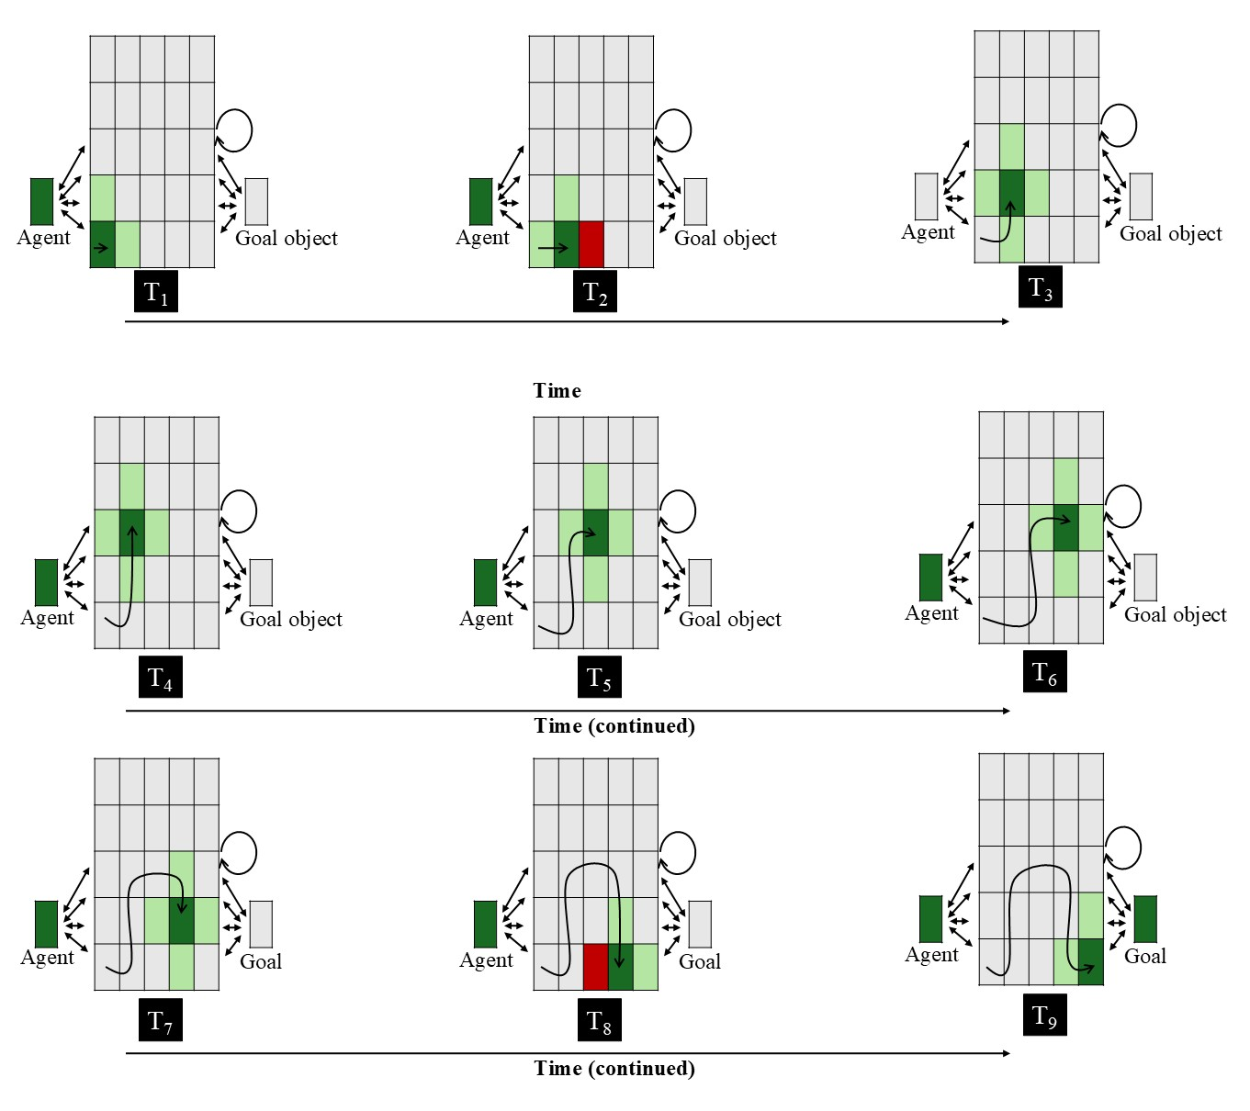
Figure 4. Input patterns shown to VOM10 networks in the Experimental condition across nine steps. Each panel represents the input to the network at a given time step. The central 5 × 5 array corresponds to the spatial grid; the two units flanking the spatial grid to the right and left of it correspond, respectively, to the agent and goal objects. Dark green indicates the agent’s current position (+1), light green indicates adjacent cells (+0.5), red indicates the presence of the barrier (-1), and gray indicates no activation (0). The goal unit is activated only at the final step. The barrier is present only when the agent occupies a position immediately adjacent to it (see Van Overwalle, 2010). The overlaid curved path in each panel depicts the amount of arc motion the agent has completed through that time step. Two-headed arrows and the circular arrow denote bidirectional connectivity. See the online article for a color version of this figure.

Note that VOM10-2 was identical to this model in every way except that, as was mentioned earlier, the agent no longer overshot the barrier by one cell. Additionally, the barrier and goal remained continuously visible throughout the agent’s arced motion path. Because these changes resulted in greater overall network activity in VOM10-2 compared to VOM10, the actual activation of the network was a sigmoid function of its internal activation. This functioned to stabilize the recurrent dynamics in the network.

ALIAS
Network Architecture (follow Memory for Serial Order Botvinick & Plaut closely)
This model combined an autoencoder (e.g., Mareschal et al., 2000) with a simple recurrent network (i.e., an SRN; e.g., Elman, 1990). Autoencoders learn a compact internal representation at the hidden layer that is sufficient for the model to “copy” the input to the model at the output layer. In contrast, SRNs learn sequential regularities by predicting upcoming states from prior states. These architectures were chosen because the forms of learning they employ—namely, self-supervised, input-driven learning—align with prominent theories of how infants learn and do not require an explicit teaching signal (e.g., Cohen, 1973; Sokolov, 1963).
The architecture itself consisted of three layers of units (Figure 5). The network consisted of 193 input and output units—which were divided into 11 identical groups—and between 10 and 50 hidden and context units depending on the simulation. Input units corresponding to features present at a given time step were assigned an activation value of 1.0; all other input units were assigned an activation value of 0.0. The activity level of the context units was 0.5 during the first step of an event but was equal to the activation of the hidden units during the immediately preceding time step thereafter. In contrast to the input units, the activation levels of the hidden and output units were not externally specified but instead were determined by their net input. This input was calculated as follows.

The input and context units were fully connected to the hidden units, which, in turn, were fully connected to the output units. The activation value for input units representing the input appropriate to the current time step was set to 1.0; all other input units had an activation value of 0.0. During the initial time step, the activation value for the context units was 0.5. However, This is standard for SRNs

Input units that were present during the current time step had activation values that were externally set; activation of its corresponding unit was set to 1.0; the other unit was set to 0.0. for the input units were set externally to represent the input appropriate to a given time step, and activation values for the hidden units w

Action events were presented to the network by clamping the states of the input units corresponding to that event’s perceptual features. Features that were present during a given time step to the network by setting the activation of the input unit

Need to mention context group
Task and Representations
Each input and output group corresponded to the different surface features comprising an action event, and the units contained within each group represented a different manifestation of that feature. Table 1 lists each group and the features represented by each unit within it.Each group corresponded to a different visible surface feature and the units comprising each group to a different manifestation of that feature. An additional group of units captured an agent’s horizontal position across time.
In addition to developing a compact representation at the hidden layer sufficient to “copy” the pattern of activation along the input groups to the corresponding output groups, the model’s task was to activate the output unit that corresponded

This model combined an autoencoder (e.g., Mareschal et al., 2000) with a simple recurrent network (i.e., an SRN; e.g., Elman, 1990). Autoencoders learn a compact internal representation at the hidden layer that is sufficient for the model to “copy” the input to the model at the output layer. In contrast, SRNs learn sequential regularities by predicting upcoming states from prior states. These architectures were chosen because the forms of learning they employ—namely, self-supervised, input-driven learning—align with prominent theories of how infants learn and do not require an explicit teaching signal (e.g., Cohen, 1973; Sokolov, 1963). The SRN was an especially important component of ALIAS given that representing actions necessarily involves encoding how movement unfolds over time. All networks were trained using recurrent backpropagation through time in cross-entropy error (e.g., Williams & Zipser, 1995).
The model itself consisted of three layers (Figure 2). The input and output layers contained the same 11 clusters or groups of units and employed localist (“one-hot”) encodings. The activity of units in the input layer was “hard-clamped” (i.e., their activity was set externally), whereas the activity of the output units was a smooth, nonlinear (logistic) function of its input. A localist encoding scheme was adopted in both layers to ensure that the model’s performance reflected learned relations between surface and kinematic features rather than similarity structure imposed by the encoding scheme itself and to facilitate interpretation of the mechanism underlying the model’s responses. In contrast, the hidden layer was a single group of 50 RELU units. Over training, these units developed distributed representations. This enabled the model to encode learned relations among the surface features of objects and the surface kinematics of different actions (e.g., Hinton, 1984).
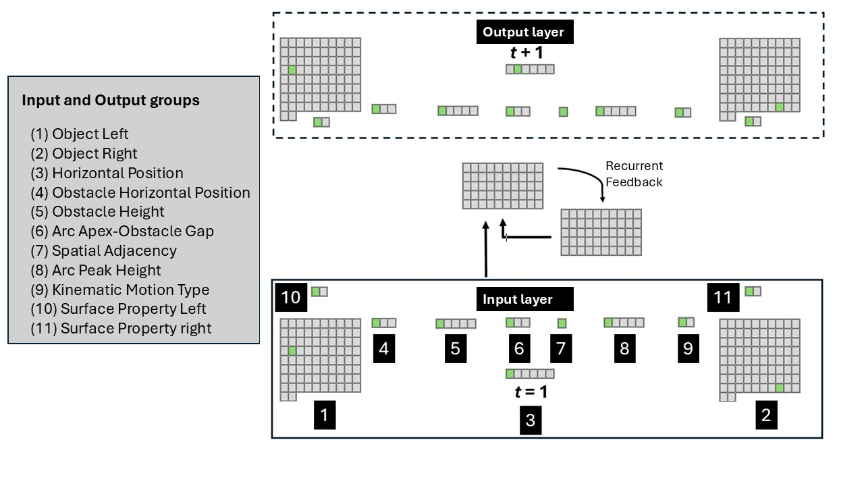
Figure 5. Schematic of an untrained ALIAS. A linear path event is being depicted here, in which one object begins to move horizontally along a linear path to reach the other object. The legend on the left provides the names of the input groups and corresponding output groups.

The first two input and output groups were Object Left and Object Right. Each group consisted of 82 units, and each unit within a given group corresponded to a single object. The left-right naming designation captures the relative spatial position of a given group. Eighty different objects were used during the pretraining phase in all reported simulations. This number ensured that networks had sufficient exposure to different objects while simultaneously allowing training time to be kept within reasonable limits. There is no reason to believe that the results reported below would change drastically if more or fewer objects were used. The remaining two objects were used during the habituation and test phases.
Surface Property Left and Surface Property Right were the next input and output groups; both groups consisted of two units. The first unit in either group represented one class of visible, perceptually grounded surface features (e.g., elongated appendage-like extensions [e.g., legs], high-contrast, ovular elements [e.g., eyes], etc.); the second unit represented a different class of visible surface features (e.g., rigid and compact [e.g., solid geometric shapes], uniform contour structure [e.g., the smooth, rectilinear edges of a block]). If a feature was being presented as input to the model, the activation of its corresponding unit was set to 1.0; the other unit was set to 0.0. Note that because the current simulations were designed to demonstrate that associations formed among one or more visible features and the kinematics of different actions can explain infants’ looking patterns in studies assessing their putative action efficiency understanding, no attempt was made here to model specific surface features with high fidelity. Instead, the first and second units in the Surface Property Left and Surface Property Right groups served, respectively, as placeholders for the semantically neutral surface features possessed by animate entities (e.g., elongated appendage-like extensions) and inanimate objects (e.g., rigidity and compactness); these units did not serve as placeholders for the semantically rich categories themselves.
Horizontal Position was the next group of input and output units. This group consisted of six units. Although the network could “see” two objects at any point in time, a single group capturing the precise horizontal position of the left object relative to the right one at any given moment in time was used (for a similar approach, see Benton, 2024 and Rakison & Lupyan, 2008); this group did not capture the kinematics of an action. On each timestep, a single bit in this layer was active according to the first object’s current horizontal position. In particular, at time t = 1, the activation value of the 1st (or leftmost) unit in this group was set to 1.0 (the activation values of the remaining units were set to 0.0), and the network’s task was to activate the second unit (from the left) in the corresponding output group. Horizontal movement continued in this manner until the 5th input unit was activated in the input layer, at which point the network’s job was to activate the 6th unit in the output layer. The type of movement itself was captured separately by a Kinematic Motion Type group. This group consisted of Linear Path and Arced Path units. Separating horizontal translation from trajectory geometry in this way enabled the model to represent heading direction independently from movement curvature and simplified later analyses of the model’s internal dynamics. In the real world, these aspects of motion are perceived as integrated; a more biologically realistic model would encode them as such. The present simplification is adopted to facilitate interpretation of the model's internal dynamics.
The remaining five input and output groups were a five-unit Obstacle Height group, a five-unit Arc Peak Height group, a three-unit Obstacle Horizontal Spatial Position group, a three-unit Arc Apex-Obstacle Gap group, and a one-unit Final Adjacency group. The five units in the Obstacle Height and Arc Peak Height groups represented, respectively, progressively larger obstacles (i.e., Obstacle Height 1 through Obstacle Height 4) and higher arcs (i.e., Arc Peak Height 1 through Arc Peak Height 4). The Obstacle Height 0 and Arc Peak 0 units corresponded, respectively, to the absence of an obstacle and no arced motion. The three units in the Obstacle Horizontal Spatial Position group corresponded to the spatial position of the obstacle (i.e., missing, middle, periphery), and the three units in the Arc Apex-Obstacle Gap group corresponded to the vertical distance between the top of an obstacle and the apex of the arced motion trajectory (i.e., no separation [used for linear movements], minimal separation, large separation). The single unit in the Final Adjacency group encoded whether the first and second objects were spatially abutted at the end of a motion sequence. This unit was turned on only if this was true. All eleven groups were named this way intentionally to emphasize their semantically neutral, surface natures.

Pretraining
The present account assumes that infants’ looking behaviors in studies assessing their action efficiency understanding reflect extensive real-world experience in which they process the kinematics of actions, the visible surface features of objects and agents, and the associative relations among these perceptually grounded features. This proposal was implemented via a pretraining phase. During this phase, networks experienced two broad classes of events: Linear Path Events and Arced Path Events. In the former event, one object moved unobstructed towards another along a horizontal trajectory. In the latter event, one object moved along a curved trajectory over an obstacle before coming to rest next to the other object. Half of the objects in both events possessed one of the two classes of visible surface features represented by the Surface Property groups, whereas the remaining half possessed the other class. This implemented the assumption that entities with different appearances can engage in both kinds of movement.
Additional assumptions that were implemented in the model were that obstacles have reduced salience when they are located peripheral to arced motion than when they are spatially contiguous and that curved trajectories clear obstacles by relatively small margins. The first of these assumptions was implemented by lowering the learning rate and increasing the weight decay on the incoming and outgoing weights to the Obstacle Height and Obstacle Position groups. The specific value used for the learning rate—which, importantly, were distinct from the learning rate values used to simulate development age (see below)—was 1×10⁻⁴; the value used for the weight decay was 0.1. These values were kept constant across all simulations. Additional simulations reported in the Supplementary Materials indicated that the results reported below were robust to the specific values used for the learning rate and weight decay. Learning rate is a parameter that controls how quickly a network’s weights adapt; larger learning rates correspond to more rapid weight changes and faster learning. In contrast, weight decay controls how “big” the weights are allowed to grow; lower values for this parameter correspond to larger weights. This way of implementing salience aligns with past connectionist modeling work (e.g., Benton, 2024; Singh et al., 2025). The second assumption was implemented by activating the Small Vertical Separation unit whenever arced motion occurred over an obstacle.
In terms of the duration of the pretraining phase, its length varied systematically across simulations such that networks corresponding to older infants received proportionally more pretraining experience than those corresponding to younger infants. Specifically, simulations that modeled 12-month-olds received 900 epochs of pretraining, whereas simulations that modeled 9-, 6-, and 3-month-olds received 675, 450, and 225 epochs, respectively. Developmental “age” was also modeled via the learning rate parameter; a higher learning rate was used for older models than younger ones. This value ranged from 0.1 for the oldest models to 0.05 for the youngest models. Note that these learning rates applied to the non-obstacle weights. Assigning larger learning rates to older models implemented the assumption that processing efficiency improves developmentally. Apart from Simulation 5, the habituation phase always followed the pretraining phase and lasted between 8 and 12 epochs in step sizes of 1 (see below for details about the nature of the habituation experience for a given simulation). Different numbers of habituation epochs were used to ensure that the results reported below were robust to particular values of this parameter.
The dependent measure used in these simulations was network (cross-entropy) error (Hinton, 1989). As in prior developmental connectionist models (e.g., Mareschal et al., 2000; Quinn & Johnson, 2000; Rakison & Lupyan, 2008), network error was treated as a proxy for looking time such that greater error corresponded to longer looking. This interpretation of error also aligns with theories of habituation proposing that infants’ looking declines as their internal representations increasingly match external events (e.g., Cohen, 1973; Sokolov, 1963), as well as with how autoencoders—which, in part, ALIAS is—learn.
All simulations were run using the Lens neural network simulator (Rohde, 1999). The full set of training and testing files, including data from the simulations reported here, are available for download at https://osf.io/9eqpf/?view_only=62f752417a9141c7b0509a998039ad13.

Simulation 1a: Selective longer looking to inefficient actions.
Simulation 1a modeled the first target finding: Infants look longer at a barrierless curved test event than at a barrierless straight-path event following habituation to a constrained event. ALIAS performance was compared to that of VOM10, VOM10-2, and ALIAS-2. All networks were assigned either to the Experimental (N = 20) or Control (N = 20) condition. For ALIAS and ALIAS-2, in particular, 20 networks were tested at each of five different “habituation” epochs across both conditions. This yielded a total of 200 networks per model variant.
The habituation event used in the Experimental condition closely resembled the Arced Path pretraining event with two modifications. First, novel objects possessing surface features typical of animate entities were used; these objects approximated the animate stimuli employed in the original behavioral studies. Second, a higher obstacle and curved trajectory were used than those encountered during pretraining. Networks were then tested on barrierless straight and curved events involving the habituation objects. The straight trajectory corresponded to the Efficient test event; the curved trajectory, to the Inefficient test event.

Results and Discussion
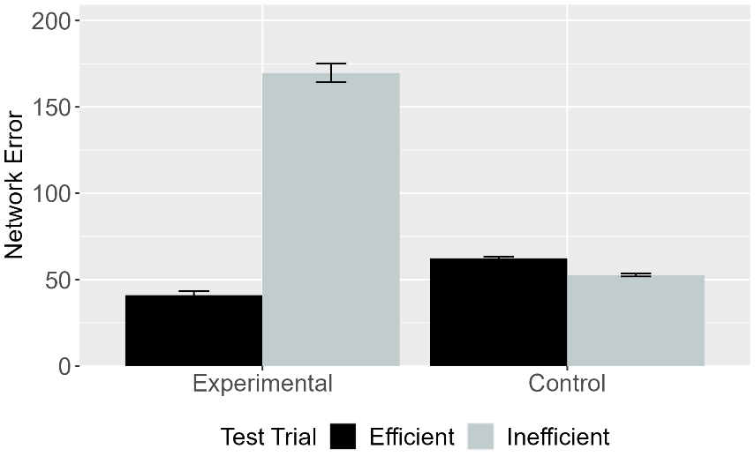 | 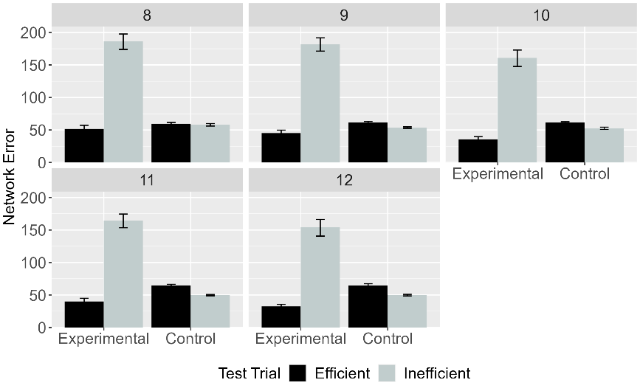
Figure 6. Mean network error produced to the Efficient and Inefficient test events in the Experimental and Control conditions. (Left) Network error collapsed across habituation lengths. (Right) Error as a function of habituation length. Data shown were generated by ALIAS.

Figure 3 shows the looking time data—operationalized as network error—for ALIAS overall (i.e., averaged over different lengths of habituation) and for different amounts of habituation. As can be seen, ALIAS successfully reproduced the first target finding, both overall and across different amounts of habituation: Networks in the Experimental condition produced greater error to (i.e., looked longer at) the Inefficient test event than at the Efficient one. In contrast, networks in the Control condition produced comparable error across the two test events.

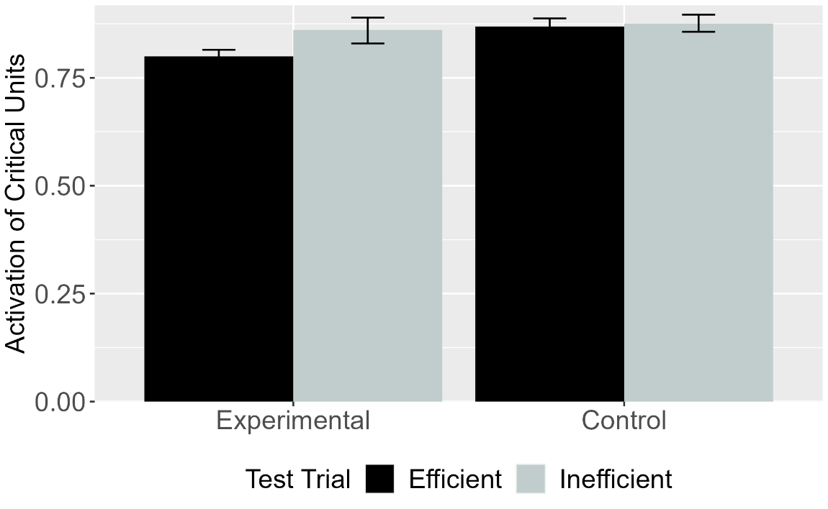
Figure 7. Mean activation of the critical units for Efficient and Inefficient test events in the Experimental and Control conditions for VOM10. Error bars represent standard errors.

Figure 4 shows VOM10’s responses to the same test events. The results revealed that networks in the Experimental condition produced greater error to the Inefficient test event than to the Efficient one. In contrast, networks in the Control condition produced comparable error across the two test events. VOM10 thus qualitatively reproduced the first target finding. At the same time, comparing these responses to ALIAS’s responses in Figure 3 reveals that the difference in error between the Efficient and Inefficient test events in the Experimental condition was substantially attenuated for VOM10 compared to ALIAS.

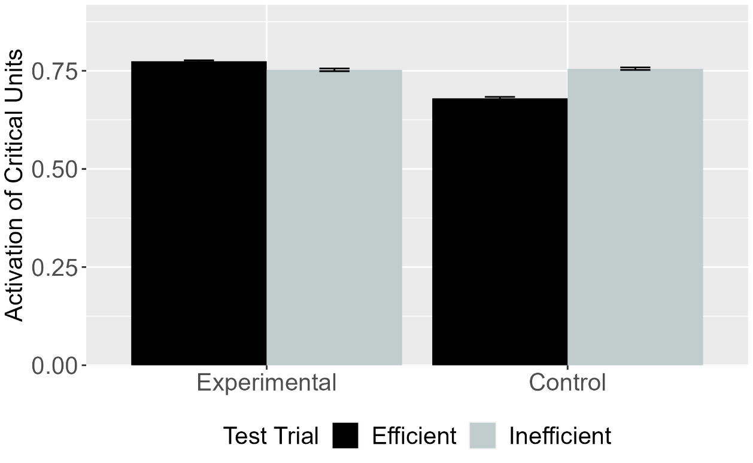
Figure 8. Mean activation of the critical units for Efficient and Inefficient test events in the Experimental and Control conditions for VOM10-2. Error bars represent standard errors.

To determine whether VOM10’s success depended on specific implementational details, its performance was compared to VOM10-2. These results—shown in Figure 5—reveal that VOM10-2 failed qualitatively to capture the first target finding: VOM10-2’s pattern of looking is the exact opposite of VOM10’s pattern.

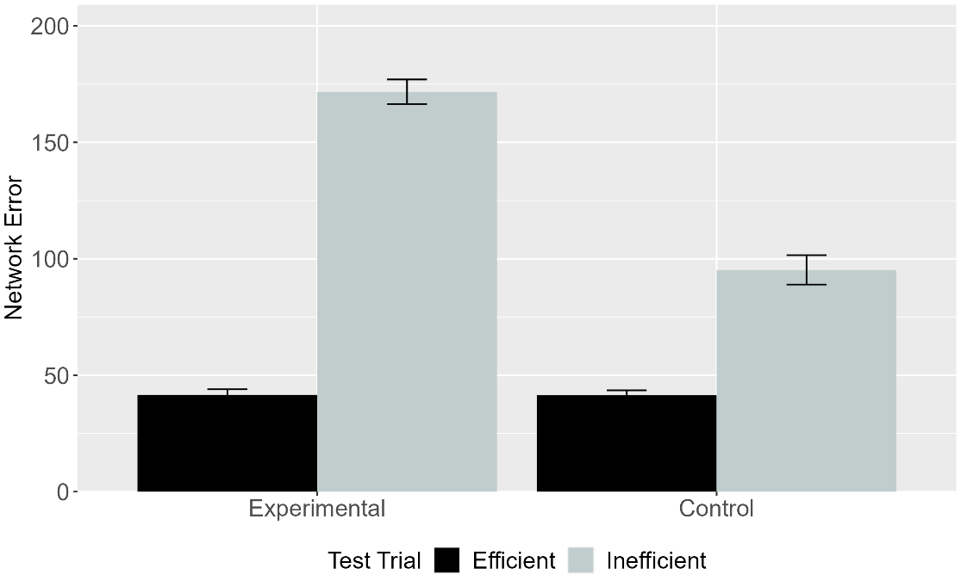
Figure 9. Mean network error produced to the Efficient and Inefficient test events in the Experimental and Control conditions. Data shown were generated by ALIAS-2. Error bars represent standard errors.

The final analysis focused on ALIAS-2’s responses. These are shown in Figure 6. This version of ALIAS omits differential obstacle salience. Although both models showed similar patterns of looking in the Experimental condition, their patterns of looking diverged in the Control condition. Specifically, only ALIAS-2 looked longer at the Inefficient test event than at the Efficient one.
To evaluate whether, in fact, associative learning underpinned ALIAS’s current performance, it is worth explicating the mechanism through which it successfully reproduced the first target finding. Processing began during the pretraining phase, in which networks were exposed repeatedly to events in which agents move along either straight or curved trajectories to reach other objects or agents.
These events were implemented as distributed patterns of activity across the model’s various input groups (e.g., Object Left and Right, Horizontal Position, Obstacle Height, etc.). This pattern of activation is then propagated to the hidden layer via the weights that connect each of the input groups to the hidden layer. At the beginning of training, this pattern of activity does not capture or reflect anything meaningful about the input to the model. This is because the weights themselves are small, random values. This hidden activity, then, propagates to, and elicits a corresponding pattern of activity over, the output groups in the output layer. This observed pattern of activation is then compared to the target pattern of activation. Any discrepancy between the two patterns is treated as error, and the network uses this error to adjust the weights throughout the network.
Crucially, from the outset, the pattern of error that the linear motion events produce over the output groups is different than that produced by the arced motion events. As a result, each motion type’s distinct error signal will cause the network weights to move in different directions for both events. Over time, these distinct weight changes led to meaningfully distinct hidden representations for both types of motion. At the same time, the network will develop a representation at the hidden layer that reflects learned associations between and among specific surface features. That these associations had 900 epochs to develop—combined with the fact that many of the same features reappear during the experimental phase—plays an important role in explaining how the network responds to the test events in these simulations.
To illustrate, consider the habituation and test events for networks in the Experimental condition. Two of the features presented to the model during this phase were novel (i.e., Obstacle Height 4 and Arc Peak Height 4); the remaining four were familiar (i.e., Horizontal Spatial Position Middle, Arc Apex-Obstacle Gap minimal separation, Spatially Contiguous, and Arc Path). At the beginning of the habituation phase, the familiar features activated—via the hidden layer—the features that they occurred with during the pretraining phase. By contrast, because the novel features were not experienced during the pretraining phase, new associations must be formed during habituation. Thus, the network must learn that a higher jump and taller barrier are associated. Although the habituation phase is shorter than the pretraining phase, the network had little difficulty learning these associations while simultaneously preserving old ones due to its enhanced processing capacity.

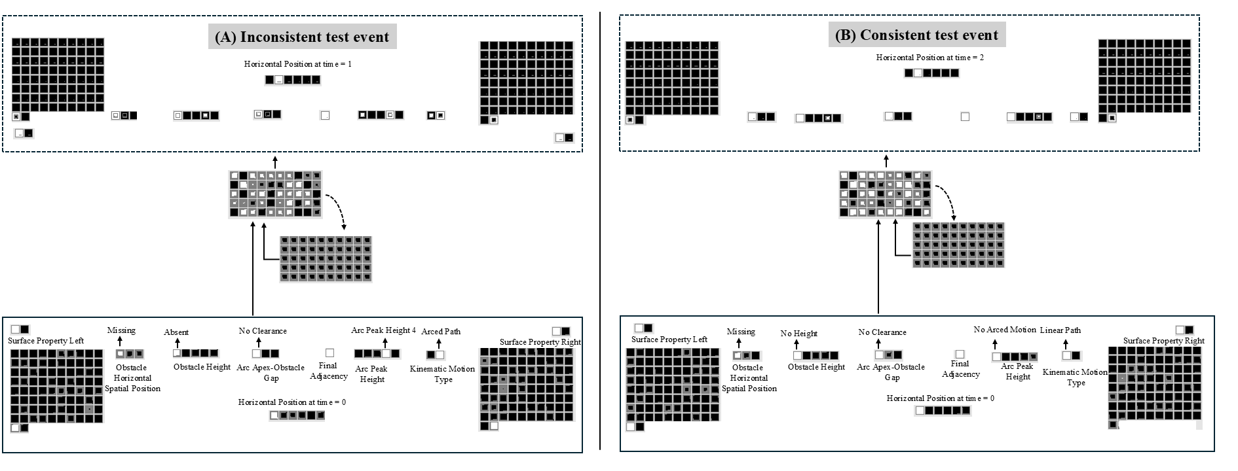
Figure 10. Depiction of the test performance of networks in the Experimental condition. (A) Network’s test performance on the Inconsistent test event. (B) Network’s test performance on the Consistent test events. The size of the colored region within each output unit corresponds to the activation of that output unit. Larger colored region corresponds to greater activation of that unit. Darker colored inner regions for output units correspond to activation values ≤0.5; lighter color inner regions correspond to activation values >0.4. The colored border that encircles each output unit corresponds to it “target” values. Dark borders correspond to target values of “0” (i.e., the unit should be “off”); light colored borders correspond to target values of “1” (i.e., the unit should be “on”). Correct unit activation = color of inner and outer regions of an output unit is identical. Incorrect unit activation = color of inner and outer regions of an output unit is different.

These facts help to explain the network’s responses to the barrierless test events. In the Inefficient test event, the first object again followed an arced path to reach the second object. This event was instantiated by turning on the Obstacle Height 0, Curved Motion, Horizontal Spatial Position Missing, Spatially Contiguous, No Clearance, and Arc Peak Height 4 input units. Because four of these features appeared during the habituation phase—namely, the Spatially Contiguous, Animate Feature, Curved Motion, and Arc Peak Height 4 input units—they activated the features with which they were associated during that phase (i.e., Obstacle Height 4, Arc Peak Height 4), among others. For instance, presentation of the Arc Peak Height 4 and Curved Motion input units led to activation of the Obstacle Height 4 unit. This can be seen in Figure 7. During the Inconsistent test event, ALIAS correctly activated the Missing unit in the Obstacle Horizontal Position output group, the Obstacle Height 0 unit in the Obstacle Height output group, the Spatially Contiguous unit in the Final Adjacency output group, and the Arc Peak Height 4 unit in the Arc Peak Height output group. The first three were activated due to associations formed during pretraining; the last was activated due to associations formed with itself during habituation. At the same time, the network incorrectly activated the Obstacle Height 4, Arc Height 0, and Linear Path output units. This response is also expected: The Arc Peak Height 0 and Linear Path units were associated with each unit’s input counterpart during pretraining, and the Obstacle Height 4 unit was associated with Arc Peak Height 4 and Obstacle Height 4 input units, among others, during habituation. Thus, three output units (i.e., Obstacle Height 4, Arc Peak Height 0, and Linear Path) contributed to the network’s looking time (or error) during the Inconsistent test event. This pattern of activation is precisely what the present theory predicts. Specifically, if infants, like the network, learn that a particular obstacle height is associated with a specific type of motion, then presenting one of these features at test (e.g., Arc Path and Arc Peak Height 4) should reactivate the other (e.g., Obstacle Height 4). If that associated feature is absent, as is the case with the Obstacle Height 4 unit in the Inconsistent test event, then the network should detect an error and show heightened looking.
Now consider the Consistent test event. This event was implemented in the same manner except that the Linear Path and Arc Peak Height 0 input units were turned on. As shown in Figure 7, the network activated the same units as those in the Inconsistent test event. However, because the network correctly activated four of these units and incorrectly activated the remaining two units via the same associative processes described above, two rather than three output units contributed to this event’s error. The fact that one fewer unit contributed to error in the Consistent test event means the network looked for less time at this event than at the Inconsistent one.

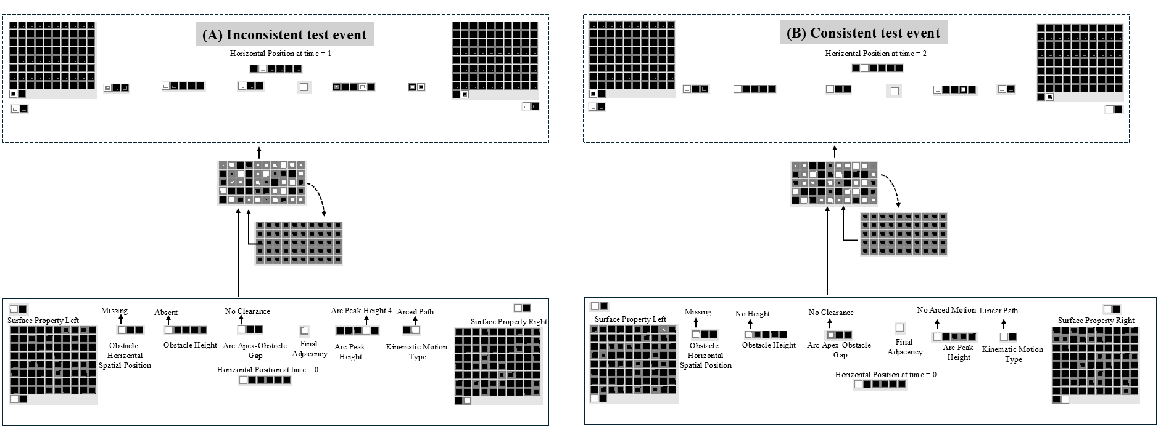
Figure 11. Depiction of the test performance of networks in the Control condition.

The same associative principles also explain how ALIAS came to respond more similarly to the two test events in the Control condition. Figure 8 shows ALIAS’s performance in the Control condition. Because peripherally located barriers were less salient than central ones as stipulated by the current theory, the network failed sufficiently to adjust the weights connecting the Obstacle Height 4 and Periphery units with those features with which it was associated during habituation. A corollary of this is that during the Inconsistent test event, the network did not activate the Obstacle Height 4 or Periphery output units in response to input from the Arced Path, Arc Peak Height 4, Contiguous, and Animate Feature input units, even though these features co-occurred with the Obstacle Height 4 and Periphery input units during habituation.
In contrast, because the Arc Peak Height group remained visually salient during habituation, the network was able to adjust its weights sufficiently during this phase to activate the Arc Peak Height 4 output unit in response to the input features it was associated with during habituation, including itself—namely, the Arc Peak Height 4, Arc Path and the No Clearance input units. This was the correct response in the Inconsistent test event but the incorrect response in the Consistent test event. Thus, the Arc Peak Height 4 output unit was the largest contributor to error in the Consistent test event. By comparison, the Inconsistent event included two smaller contributors to error: the Linear Path and Arc Peak Height 0 units. These units were activated because they were associated with some of the input features (e.g., Obstacle Height 0, Linear Path, Missing, etc.) during pretraining. Importantly, the combined contribution of these two units to the network’s total error in the Inconsistent event matched that of the Arc Peak Height 4 unit in the Consistent test event. As a result, the network, like infants, looked about equally long at both test events. Together, this discussion elucidates the mechanism through which the model’s behavior emerged across the two conditions in Simulation 1a and, critically, demonstrates that the mechanism implemented by the model is the one governing its performance.
Nevertheless, one potential criticism of this simulation concerns the nature of pretraining. Specifically, arced motion never occurred in the absence of obstacles during pretraining. Yet, infants do observe arced motion in the absence of obstacles in the real world. Simulation 1b thus assessed whether ALIAS could reproduce the first target finding when the ratio of constrained to unconstrained arced motion was varied during pretraining.

Simulation 1b
This simulation assessed ALIAS’s test performance across different ratios of constrained to unconstrained arced motion experienced during pretraining. Six ratios, ranging from 100% constrained vs. 0% unconstrained (a replication of Simulation 1a) to 50% constrained vs. 50% unconstrained, in step sizes of 10%, were tested during habituation. For example, in the 60% constrained vs. 40% unconstrained condition, arced motion occurred over obstacles 60% of the time; 40% of the time it occurred without them. Parametric variation was used here because the true proportion of constrained-to-unconstrained arced motion in the real world is unknown. At the same time, because the true estimates likely fall somewhere in the range tested here, the results reported below provide a reasonable approximation of infants’ expected responses across that range. Finally, because this simulation was designed to assess whether ALIAS’s responses were robust across different constrained-to-unconstrained ratios, its performance was not compared to that of the competitor models.

Results
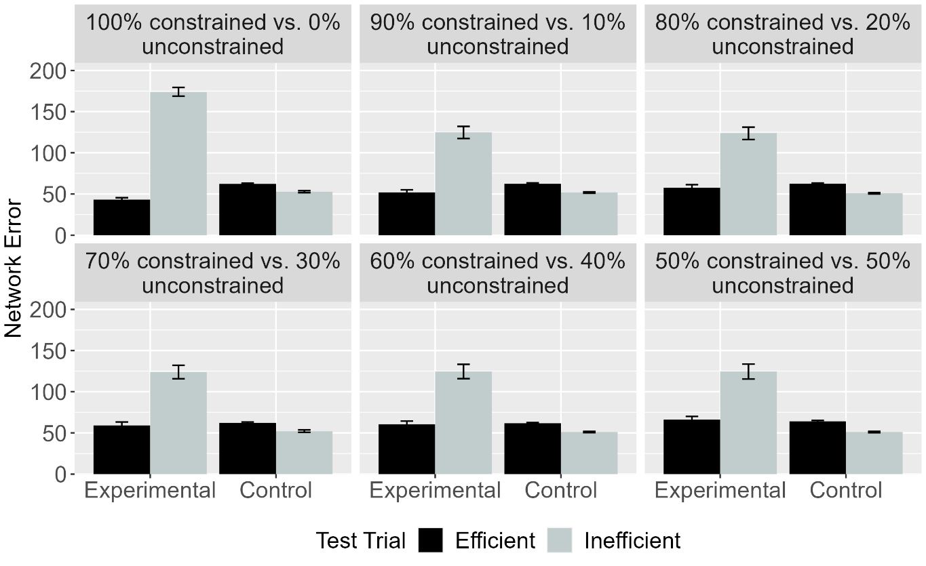Figure 12. Mean network error produced to the Efficient and Inefficient test events in the Experimental and Control conditions across different ratios. Error bars represent standard errors.

Figure 9 depicts networks’ looking time to the two test events across conditions and ratios. The key takeaway is that networks in the Experimental condition looked longer at the Inefficient than at the Efficient test event irrespective of the ratio of constrained-to-unconstrained motion experienced during pretraining. In contrast, networks in the Control condition looked about equally long at these two test events across different ratios. These results confirm that ALIAS’s performance in Simulation 1a was robust to experience with constrained motion.

Discussion
Simulation 1b assessed whether ALIAS’s ability to reproduce the first target finding was robust to variation in the amount of constrained and unconstrained motion experienced during pretraining. The results of this simulation provided a positive answer to this question. Specifically, networks in the Experimental condition looked longer at the Inefficient than at the Efficient test event; networks in the Control condition showed comparable looking to both events. One notable feature of these results—which can be seen clearly in Figure 7—is that the magnitude of the difference in the amount of time that networks in the Experimental condition looked at the two test events was largely unaffected by the ratio of constrained to unconstrained arced motion. The reason for this was simply that ALIAS was habituated to constrained action.
Simulation 2 took a first step toward assessing the explanatory breadth of ALIAS by examining whether it can capture the second target finding: Infants’ looking responses in action efficiency understanding studies do not depend on the entities involved possessing animate features. Simulation 2 was thus similar to Simulation 1a except that the objects lacked surface features typical of animate entities. Simulation 2 only focused on the behavior of ALIAS and ALIAS-2 because neither VOM10 nor VOM10-2 had a means for representing whether an object possessed animate- or object-typical surface features.

Simulation 2: Independence from animacy.
Simulation 2 tested whether ALIAS could capture the (second target) finding that 9-month-old infants’ performance in action efficiency understanding studies is unaffected by whether the objects involved possess animate features. To that end, the objects used here possessed surface features associated with inanimate objects and the pretraining phase and learning rate were shortened, respectively, to 675 epochs and 0.0875 because Csibra et al. (1999) tested 9-month-olds.

Results
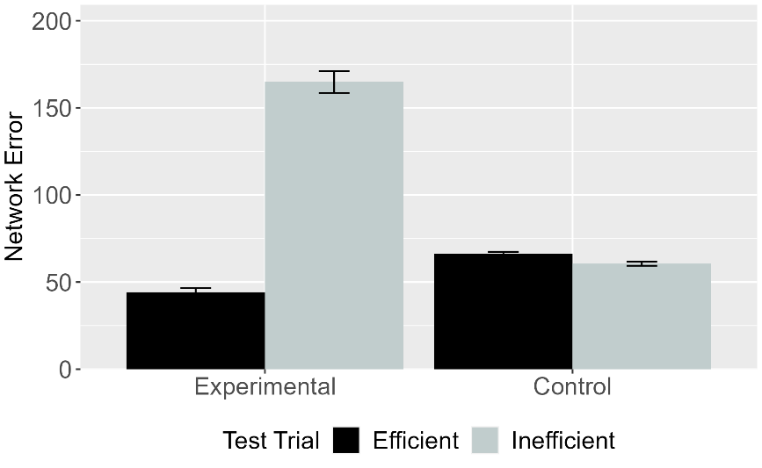 | 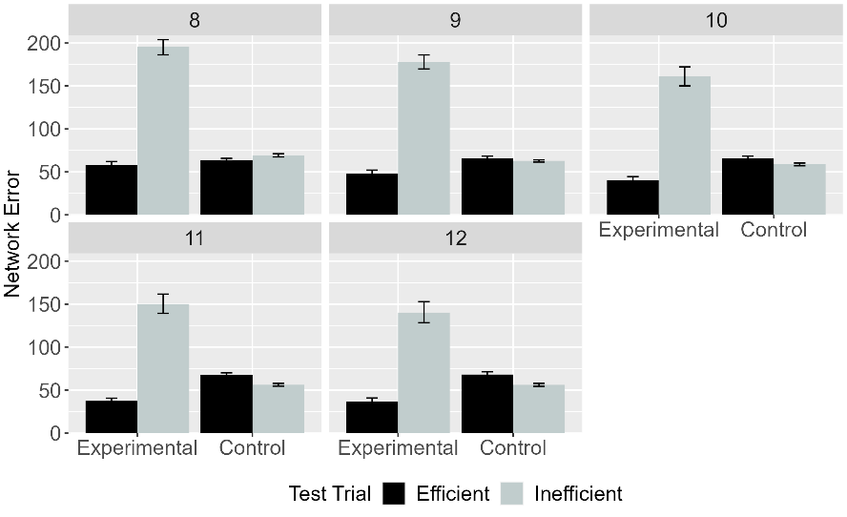
Figure 13. Mean network error produced to the Efficient and Inefficient test events in Simulation 2 across conditions overall (left panel) and different habituation epochs (right panel). Error bars represent standard errors.

Figure 10 depicts ALIAS’s responses to the Efficient and Inefficient test events. The results indicated that networks in the Experimental condition looked longer at the Inefficient than at the Efficient test event. In contrast, networks in the Control condition looked about equally long at both test events. Both results were true irrespective of the length of habituation.

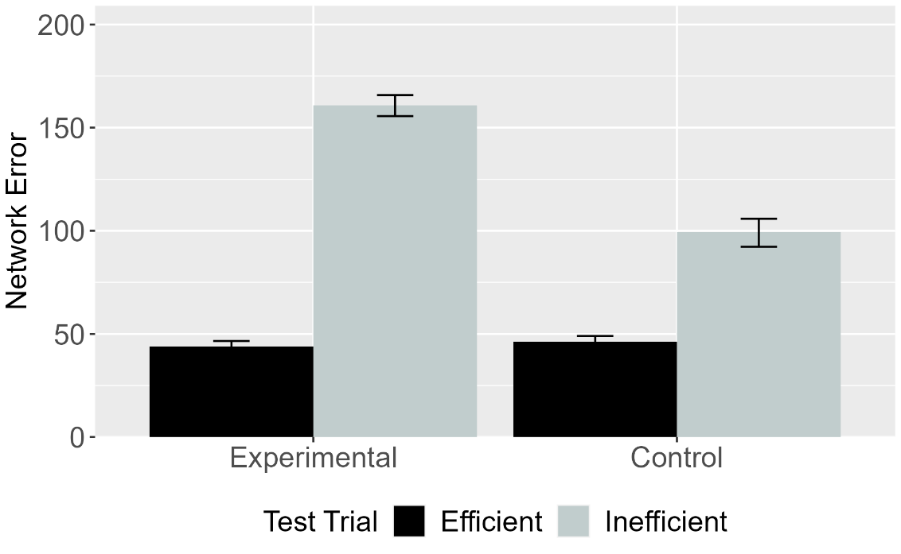
Figure 14. Mean network error produced to Efficient and Inefficient test events in the Experimental and Control conditions for ALIAS-2 (left panel) and ALIAS-2 (right panel). Error bars represent standard errors.

Figure 11 shows the performance of ALIAS-2 across conditions. As in Simulation 1a, ALIAS-2 failed to capture infants’ looking behavior across conditions. These findings suggest that associative learning alone is insufficient to reproduce the first two target findings.

Discussion
Simulation 2 showed that ALIAS could capture the second target finding and that associative learning alone was insufficient to capture it. Nonetheless, a potential objection to the simulations presented thus far is that they only weakly demonstrate ALIAS’s explanatory breadth. This is because the two simulations differed only in terms of whether the objects involved possessed animate features. Simulation 3 took this criticism seriously by testing whether ALIAS could capture a more substantively different target finding. This simulation examined whether ALIAS could capture Csibra et al.’s (2003) finding that 12-month-olds can make bidirectional inferences among goals, actions, and constraints. In their first experiment, infants were habituated to an event in which a large circle appeared to be chasing a small circle. However, before the large circle could reach the small circle, the small circle moved through a small gap between two bars before disappearing from the screen. Because the opening between the two bars was too narrow for the larger circle to fit through, it was forced to move around one of the bars before continuing to move in the small circle’s last-seen direction. Crucially, because the large circle never reached the small one, its goal of reaching it had to be inferred. Together with Csibra et al.’s Experiment 2 finding that infants looked longer at an unconstrained than at a constrained arced event, these findings were taken to support the teleological stance. Note that although Csibra et al.’s (2003) first experiment did not employ the Gergely-style paradigm, it can readily be recast within it. This can be done by terminating the habituation event after the first object clears the barrier but before it reaches the second object. This was the approach adopted here.

Simulation 3: Bidirectional inferences about actions, goals, and constraints.
Simulation 3 tested whether ALIAS could explain the finding that 12-month-old infants putatively can infer goals from constraints and behavior as well as constraints from goals and behaviors. Networks were assigned either to the Inferring Goals condition (N = 20) or to the Inferring Constraints condition (N = 20); the same number of networks were assigned to ALIAS-2, VOM10, and VOM10-2. The simulation of this condition was identical to the Experimental condition in Simulation 1a except that networks could not know whether the first object came to rest next to the second one (i.e., its goal). The Inferring Constraints condition was implemented by removing all barrier information during habituation. All other aspects of this simulation were identical to Simulation 1a.

Results and Discussion
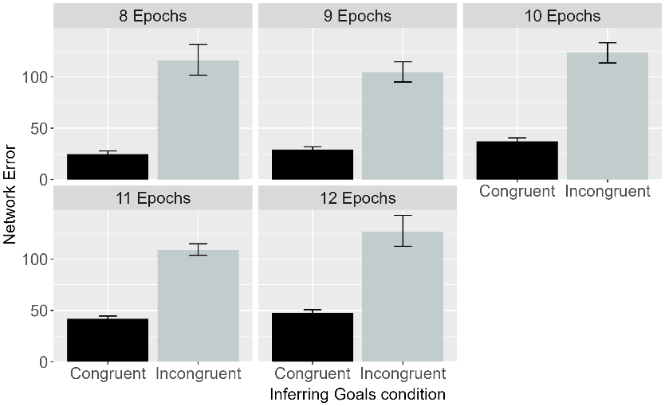 | 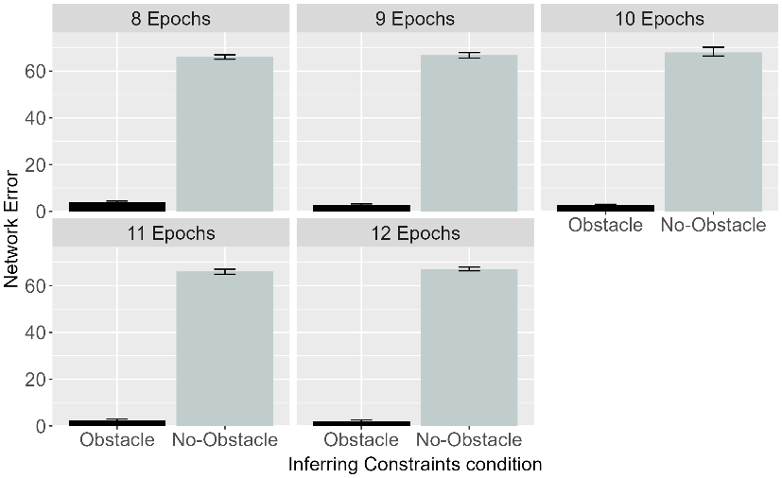
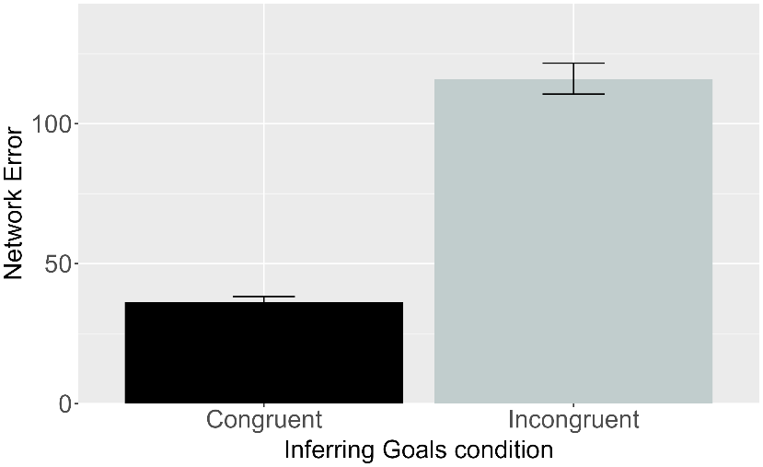 | 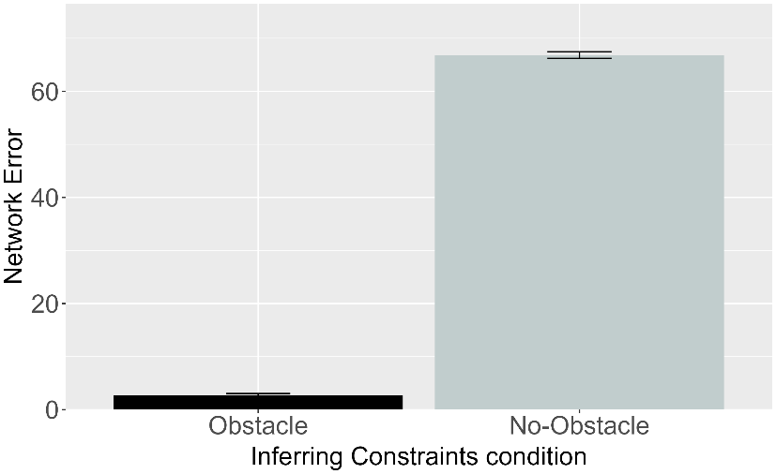

Figure 15. Performance of ALIAS. Plotted is the mean network error produced to the Congruent and Incongruent test events for networks in the Inferring Goals condition (left column) and to the Obstacle and No-Obstacle test events for networks in the Inferring Constraints condition across habituation epochs (top row) and overall (bottom row).

Figure 12 shows the performance of ALIAS in the Inferring Goals and Inferring Constraints conditions overall and across habituation epochs. Networks in both conditions looked longer at their respective inconsistent events. Specifically, networks in the Inferring Goals condition looked longer at the Incongruent test event—in which the first object failed to stop next to the second one—than at the Congruent test event—in which the first object came to rest next to the second one. Similarly, networks in the Inferring Constraints condition looked longer at the No-Obstacle than at the Obstacle test event. These patterns were true both across different habituation lengths as well as overall. The mechanistic basis for these looking patterns is straightforward. In the Inferring Goals condition, for example, networks showed heightened looking to the Incongruent test event because it violated an association—formed during the pretraining phase—between arced motion, a small barrier, and a low jump, on the one hand, and spatial contiguity between an agent and its goal, on the other. No such violation occurred for the Congruent test event because the visual information accorded with that during pretraining. Similarly, networks in the Inferring Constraints condition looked longer at the No-Obstacle test event than at the Obstacle one because the presence of arced motion in the absence of an obstacle in the No-Obstacle event violated an association that was established during the pretraining phase between arced motion and obstacles; no such violation occurred in the Obstacle test event. These results indicate that ALIAS can also capture the third target finding.

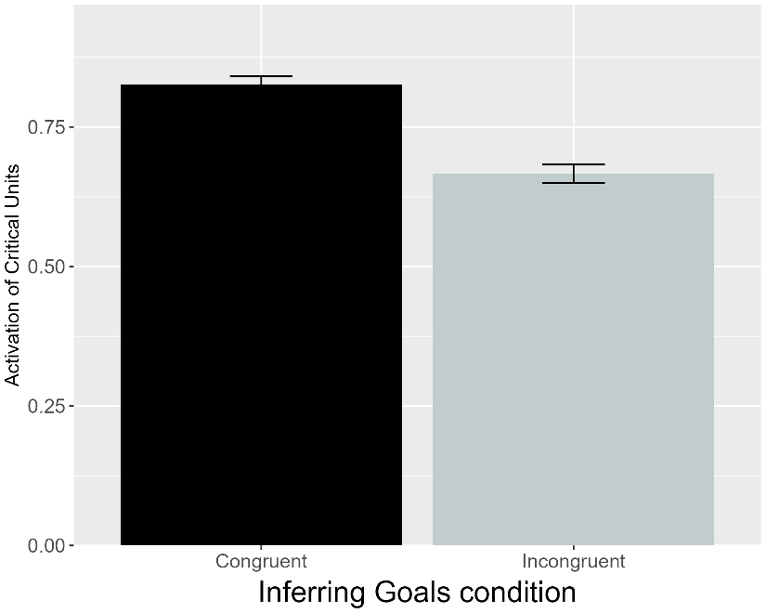 | 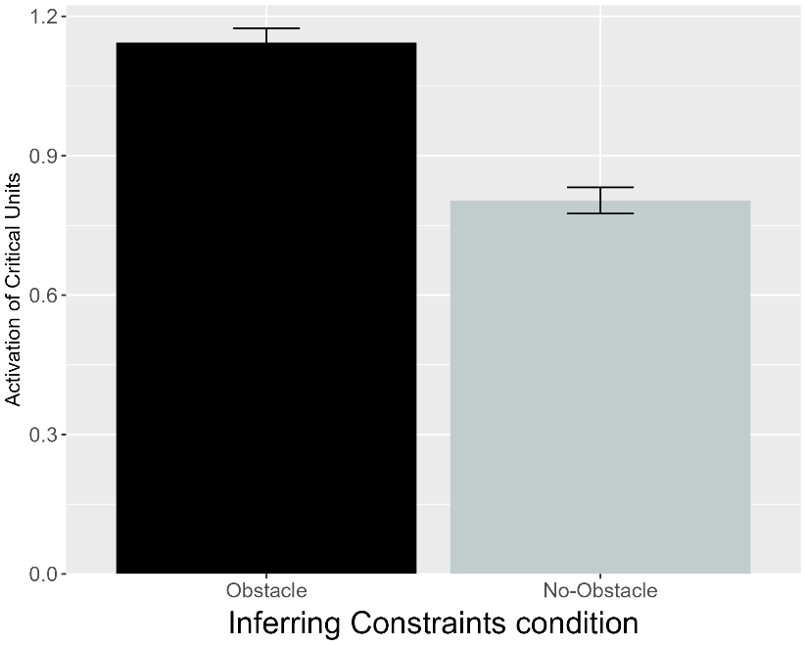
Figure 16. Performance of VOM10. Plotted is the mean activation of the critical units produced to the Congruent and Incongruent test events for networks in the Inferring Goals condition and to the Obstacle and No-Obstacle test events for networks assigned to the Inferring Constraints condition (right).

Figure 13 shows that VOM10’s responses were exactly opposite those of ALIAS and that networks looked longer at their condition’s efficient test event. These results indicate that VOM10 was unable to reproduce the third target finding.

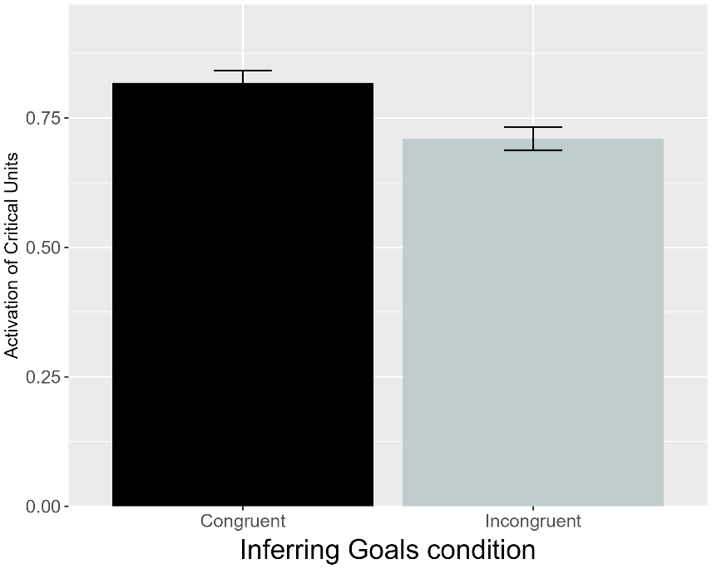 | 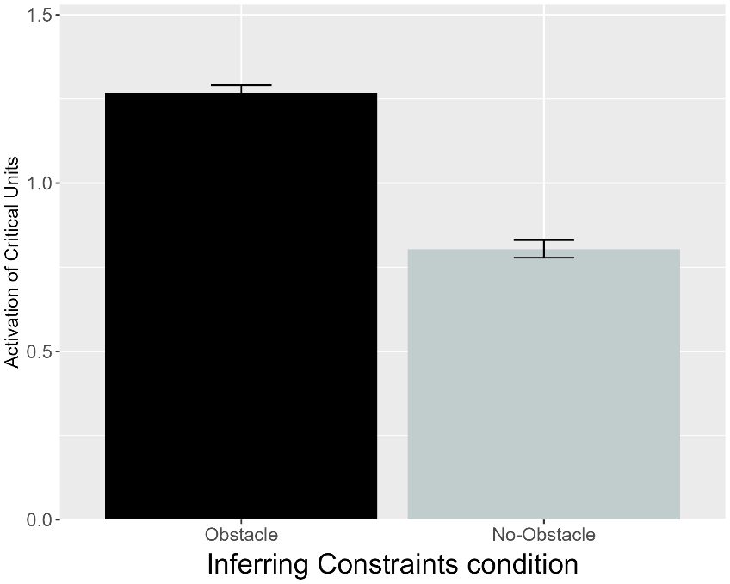
Figure 17. Performance of VOM10-2. Plotted is the mean activation of the critical units produced to the Congruent and Incongruent test events for networks in the Inferring Goals condition and to the Obstacle and No-Obstacle test events for networks assigned to the Inferring Constraints condition (right).

As shown in Figure 14, VOM10-2 also failed to replicate the third target finding. This suggests that VOM10's failure could not be attributed to limitations in how the Csibra et al. (2003) task was implemented. Instead, such failure may point to a fundamental inability of the model to simulate the processes underpinning infant action efficiency understanding.

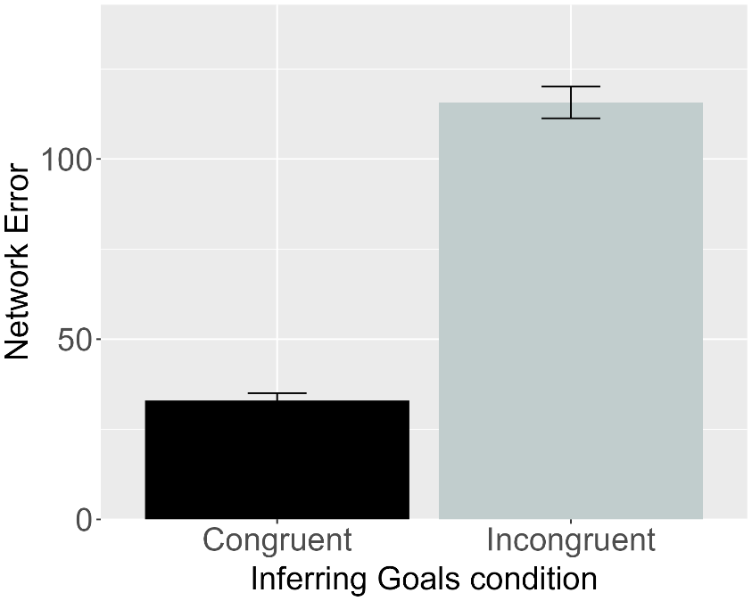 | 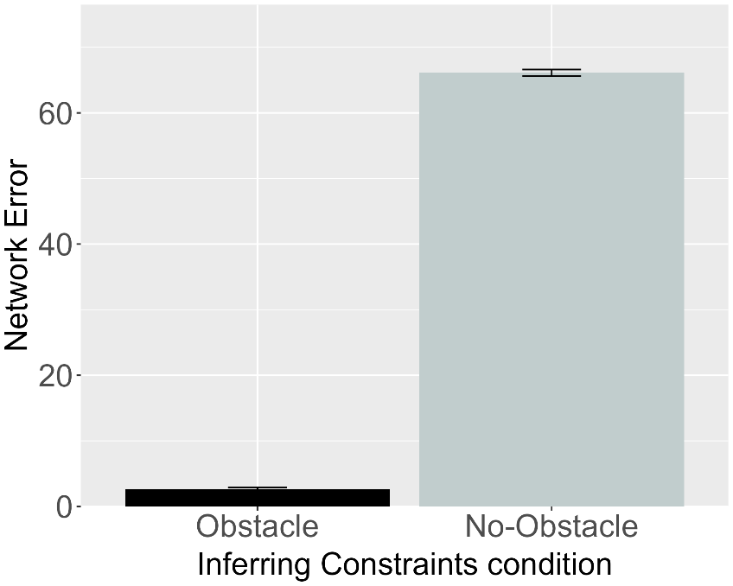
Figure 18. Performance of ALIAS-2. Plotted is the mean network error produced to the Congruent and Incongruent test events for networks assigned to the Inferring Goals condition (left) and to the Obstacle and No-Obstacle test events for networks in the Inferring Constraints condition (right).

Figure 15 shows that, for the first time, ALIAS-2 captured a target finding—in this case, it was the third one. ALIAS-2’s success suggests that, at least here, associative learning alone is sufficient to reproduce this finding. One finding with which both models might nonetheless be predicted to struggle is that by Liu and Spelke (2017) showing that infants apparently represent efficiency continuously rather than in an all-or-none fashion. Six-month-olds were habituated either to a constrained action event (Experiment 1) or to an unconstrained one (Experiment 2). Infants were then tested either on constrained Low, efficient and constrained High, inefficient test events (Experiment 1) or on unconstrained versions of these events (Experiment 2). Note that in the constrained High, inefficient test event, the agent jumped much higher than needed to clear the barrier. Liu and Spelke (2017) found that infants in Experiment 1 looked longer at the High, inefficient test event than at the Low, efficient one. In contrast, infants in Experiment 2 looked numerically, but not significantly, longer at the Low, efficient test event than at the High, inefficient one.
In a final third experiment, Liu and Spelke (2017) tested whether infants expect agents whose actions were inefficient in the past to continue behaving inefficiently in a new situation with a different set of constraints. Infants were habituated to the event used in Experiment 2 and then tested on the constrained events used in Experiment 1. Here, infants looked longer at the High, inefficient test event than at the Low, efficient one. Considered together, these results were interpreted to mean that infants represent action efficiency continuously and that they expect previously inefficient agents to behave efficiently in the future. Liu et al. (2026) interpreted these findings as support for their naïve psychology and naïve physics systems.
Simulation 4 tested whether ALIAS could capture these findings.

Simulation 4: Graded representations of efficiency.
This simulation tested whether ALIAS could capture the fourth target finding. The pretraining phase was shortened to 450 epochs because Liu and Spelke (2017) tested 6-month-olds. Following pretraining, networks were habituated to and tested on events analogous to those in Experiments 1-3 in Liu and Spelke (2017); twenty networks were assigned to each experiment. Unlike the previous simulations, however, VOM10 could not be used to simulate the current target finding. This is because, by omitting barrier information during its prediction or test phase, VOM10 could not meaningfully simulate Liu and Spelke’s (2017) use of differently sized barriers across the habituation and test phases in each experiment. Note that this is not an in-principle limitation of this model. Although it would be straightforward to present obstacle information during VOM10’s test phase, doing so would radically depart from how it was implemented in the previous simulations and, more importantly, from Van Overwalle’s (2010) original conception of it. ALIAS’s performance was thus only compared to that of VOM10-2 and ALIAS-2 in Simulation 4. Note that because VOM10-2 did not implement a pretraining phase, it could not simulate developmental age like ALIAS or ALIAS-2.

Results
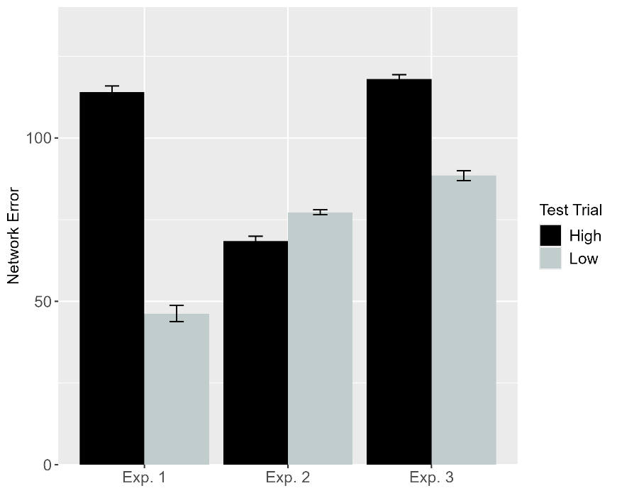 | 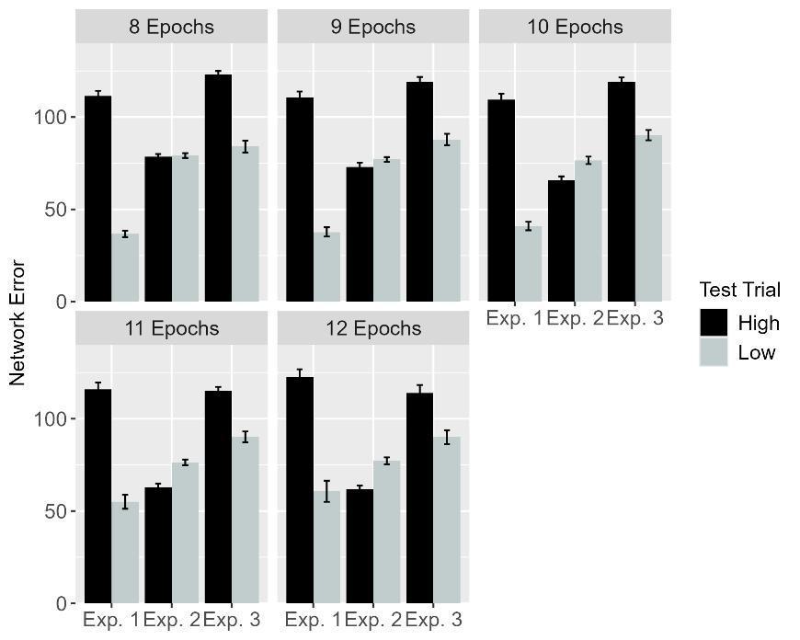
Figure 19. Performance of ALIAS. Plotted is networks’ mean error to the High, inefficient and Low, efficient test events across experiments overall (left) and different habituation epochs (right). These experiments correspond to those in Liu and Spelke (2017).

Figure 16 shows ALIAS’s treatment of the High, inefficient and Low, efficient test events across the three experiments. Networks—like infants in Experiments 1 and 3 in Liu and Spelke (2017)—looked longer at the High, inefficient than at the Low, efficient one. This was true overall and across different habituation epochs. In contrast, networks in Experiment 2—like infants in the corresponding behavioral experiment—looked slightly numerically longer at the Low, efficient than at the High, inefficient test event.

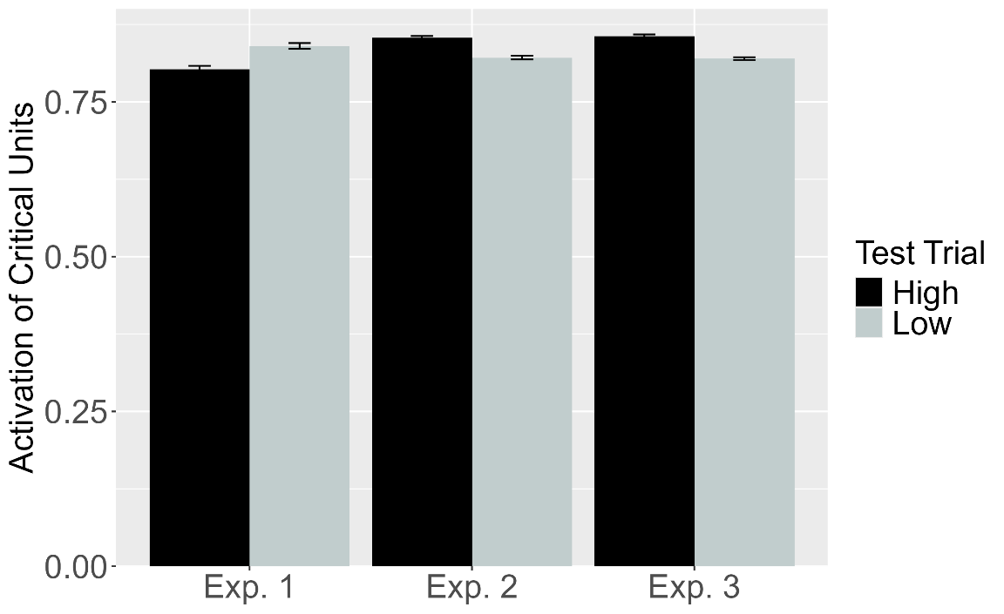
Figure 20. Performance of VOM10-2. Plotted is the mean activation of the critical units produced to the High, inefficient and Low, efficient test events for networks in Experiment 1-3.

Although VOM10-2 captured infants’ looking responses in Experiment 3—showing slightly more critical unit activation following the High, inefficient test event than the Low, efficient test event—it failed to capture infants’ responses in Experiments 1 and 2. These results are shown in Figure 17. In Experiment 1, for example, the Low, efficient test event caused slightly more activation of the critical units than the High, inefficient test event. The reverse pattern was observed in Experiment 2.

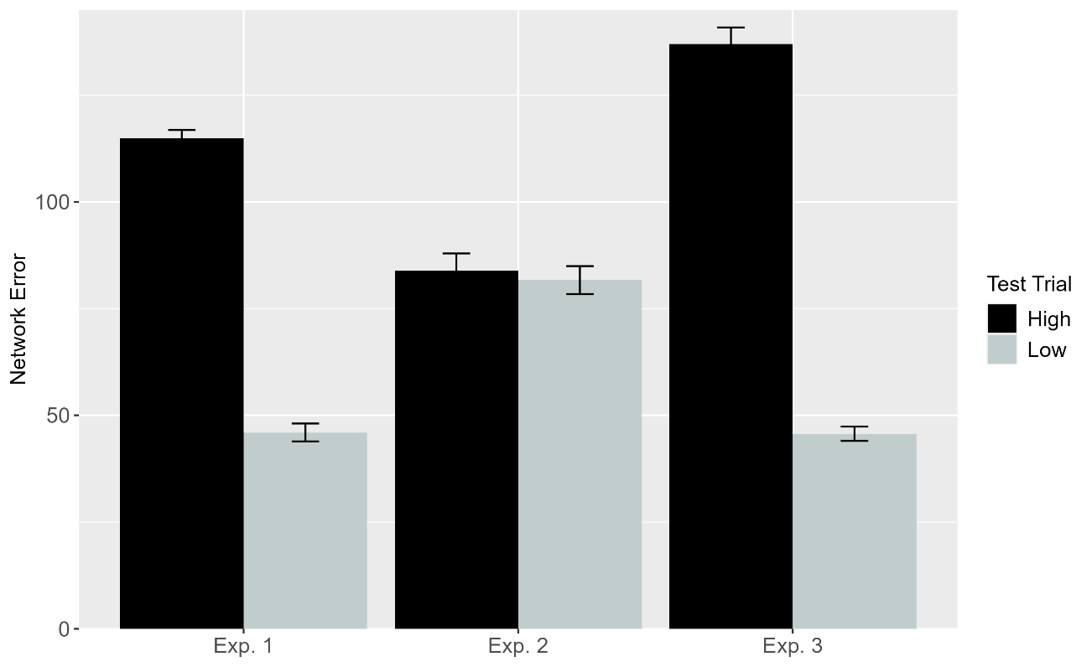
Figure 21. Performance of ALIAS-2. Plotted is networks’ overall mean error to the High, inefficient and Low, efficient test events across experiments.

ALIAS-2’s performance was examined next to determine whether associative learning alone is sufficient to capture the fourth target finding. The results—which are shown above in Figure 18—showed that it mostly could. Specifically, networks in Experiments 1 and 3 looked longer at the High, inefficient test event than at the Low, efficient one. However, in the Control condition, networks looked about equally long at both test events. This latter finding conflicts with ALIAS’s and infants’ tendency to look numerically longer at the Low, efficient than at the High, inefficient test event.
In terms of the mechanistic basis of ALIAS’s behavior, this model showed heightened looking to the High, inefficient test event during Experiments 1 and 3 because the presentation of a small obstacle, a high jump, and substantial vertical clearance associated with this event violated the association that networks formed among a small obstacle, a low jump, and small vertical clearance during the pretraining phase. In contrast, the reason ALIAS showed attenuated looking to the Low, efficient test event during the same experiments is that the visual information associated with this event (e.g., a small obstacle, low jump, and low vertical clearance) largely overlapped with that experienced during pretraining (e.g., a small obstacle, low jump, and low vertical clearance).
The goal of this simulation was to determine whether ALIAS could reproduce the finding that infants apparently represent action efficiency in a graded or continuous manner. ALIAS captured the fourth target finding and provided a better qualitative fit to the data than ALIAS-2This suggests that associative learning combined with the assumption of reduced salience for peripherally located obstacles is necessary to reproduce infants’ looking responses across the experiments in Liu and Spelke (2017). By contrast, VOM10-2 was unable to account for these findings, which suggests that simply improving VOM10’s fidelity to the structure of Liu and Spelke’s (2017) task is insufficient.
Despite ALIAS’s success in reproducing the first four target findings, it remained important to demonstrate that this model could also capture perhaps the more challenging finding that much younger infants appear to be sensitive to an action’s efficiency. Of particular note here is Skerry et al.’s (2013) discovery that a small amount of sticky-mitten reaching experience was sufficient for pre-reaching 3-month-olds to show looking patterns that resembled those of older infants. Simulation 5 tested whether ALIAS could nevertheless capture the fifth target finding if, despite limited pretraining action observation experience, effective action experience temporarily heightens its attention to and encoding of its own straight reaching trajectories. If so, a subsequent straight trajectory event should be rendered relatively more familiar than a curved trajectory event. This simulation only focused on ALIAS and ALIAS-2 because these were the only two models capable of simulating development.

Simulation 5: Action efficiency understanding in pre-reaching infants.
The primary goal of this simulation was to assess whether, despite limited pretraining action observation experience, ALIAS can reproduce the looking behavior of pre-reaching infants when its attention is heightened during a phase analogous to the action phase in Skerry et al. (2013). To simulate the performance of the 3-month-olds with ALIAS, two changes were made to the model. The first set of changes involved reducing the length of the pretraining phase to 225 epochs, the number of hidden units to 10, and the learning rate to 0.1. These modifications implemented the assumption that 3-month-olds have less action-observation experience, reduced information storage capacity, and slower processing speed than the typical 6- to 12-month-old infant in action efficiency understanding studies. The second and more substantial change related to the addition of an “action phase” that immediately followed pretraining. Because Skerry et al. (2013) do not provide information about the length of this phase, here both were equated in length. Thus, the action phase, like the habituation phase, could last anywhere from 8 to 12 epochs. To instantiate the assumption that infants’ reaches during this phase are largely linear, networks were shown straight motion during this phase.
As was true for infants in Skerry et al. (2013), networks were assigned to one of three conditions: Effective Action (N = 20), Ineffective Action (N = 20), or No Training (N = 20). Those in the first condition were further divided into either the Experimental condition or the Control condition. The assumption that effective sticky mittens experience heightens infants’ attention was implemented by increasing the learning rate on all connections to .175 during the action phase for networks in the Effective Action condition only. The assumption that this attentional boost is short-lived was implemented by returning the learning rate to its pretraining value at the start of the subsequent habituation phase. The learning rate maintained its pretraining value across the pretraining, action, and habituation phases for networks in the Ineffective Action condition and across the pretraining and habituation phases for networks in the No Training condition. In all other respects, these two conditions were identical to one another.

Results
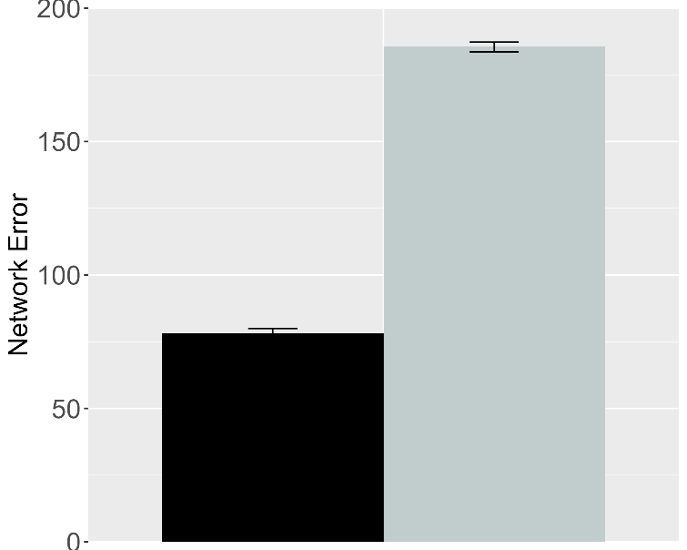 | 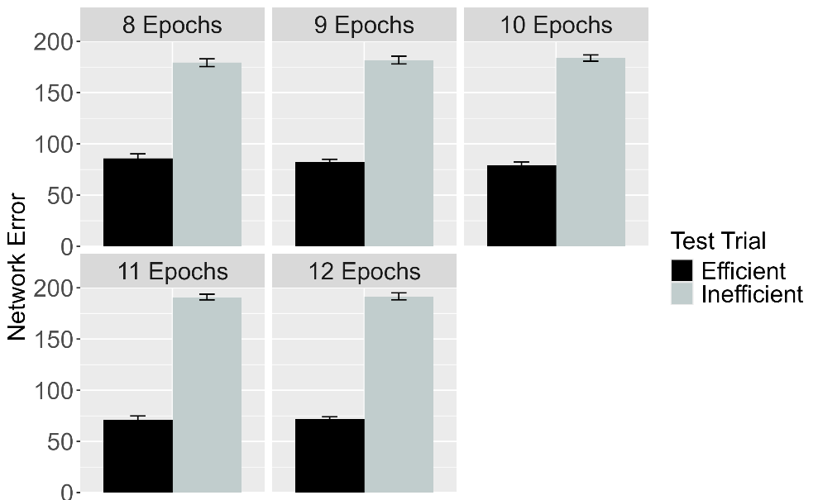
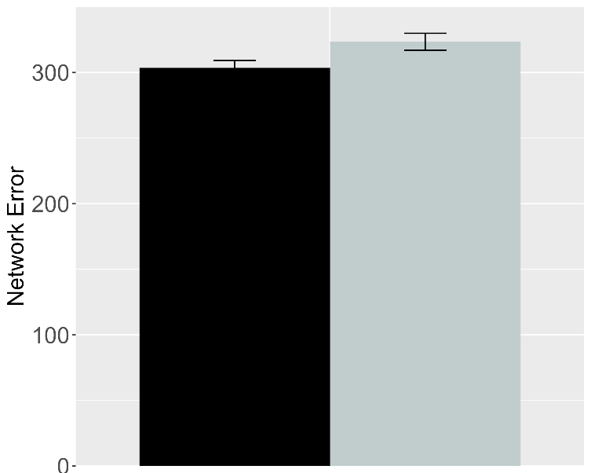 | 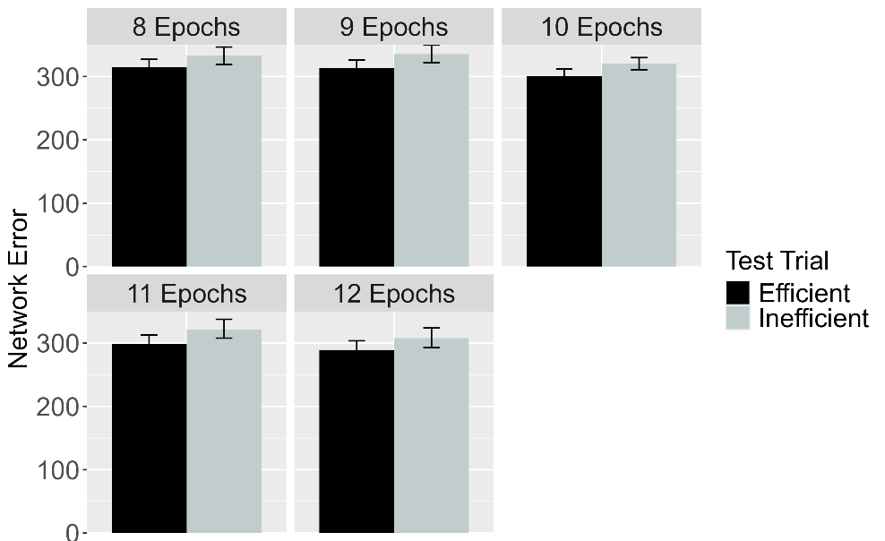
Figure 22. Performance of ALIAS in the Effective Action condition. Plotted is networks’ mean error to the Efficient and Inefficient test events in the Experimental (top row) and Control conditions (bottom row), both overall (left column) and across different habituation epochs (right column). The Experimental and Control conditions correspond to Experiments 1, 4, and 5 in Skerry et al. (2013).

Figure 19 shows the performance of ALIAS in the Effective Action condition. The results revealed that networks in the Experimental condition looked longer at the Inefficient test event than at the Efficient one. This was true overall and for different amounts of habituation. In contrast, networks in the Control condition looked equally long at both test events. Both findings qualitatively matched those of infants in the Effective Action condition in Skerry et al. (2013).

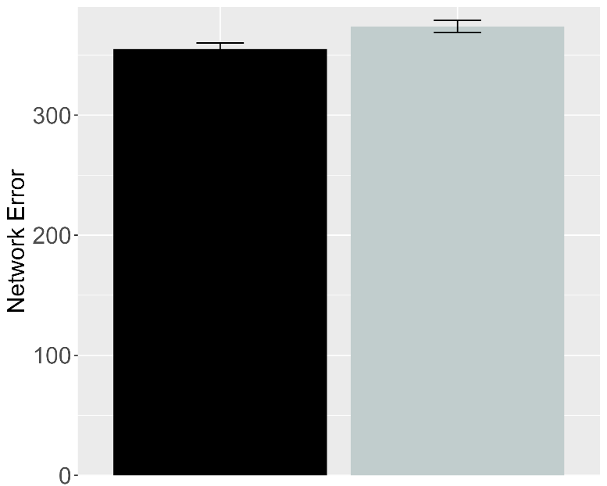 | 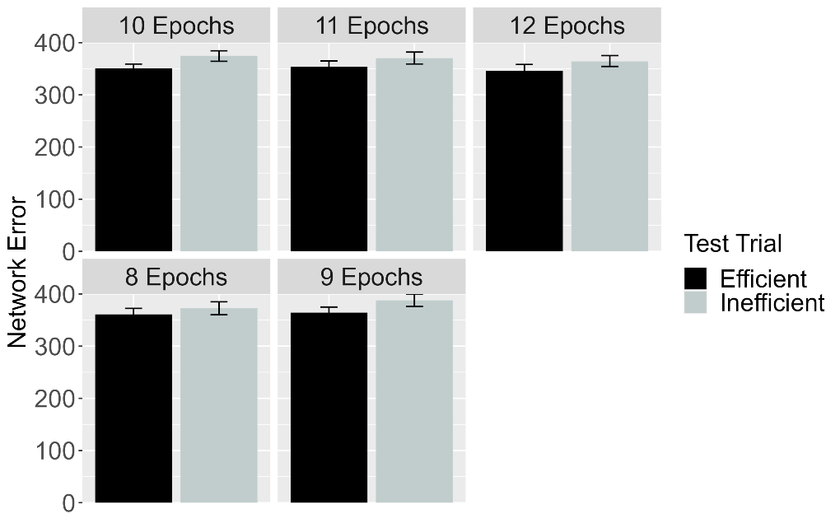
Figure 23. Performance of ALIAS in the No Training condition. The overall error produced to the Efficient and Inefficient test events is shown on the left, and the error produced across different habituation epochs is shown on the right. This condition corresponds to Experiment 3 in Skerry et al. (2013).

Figure 20 shows the performance of networks in the No Training condition. Networks—like infants in the corresponding behavioral condition—looked about equally long at both test events.
Importantly, if networks’ prior experience with constrained arced motion enabled them to associate arced motion with barriers and then to detect when such associations are violated, then those in the No Training condition—like networks in the Effective Action condition—should have looked longer at the Inefficient than at the Efficient test event.

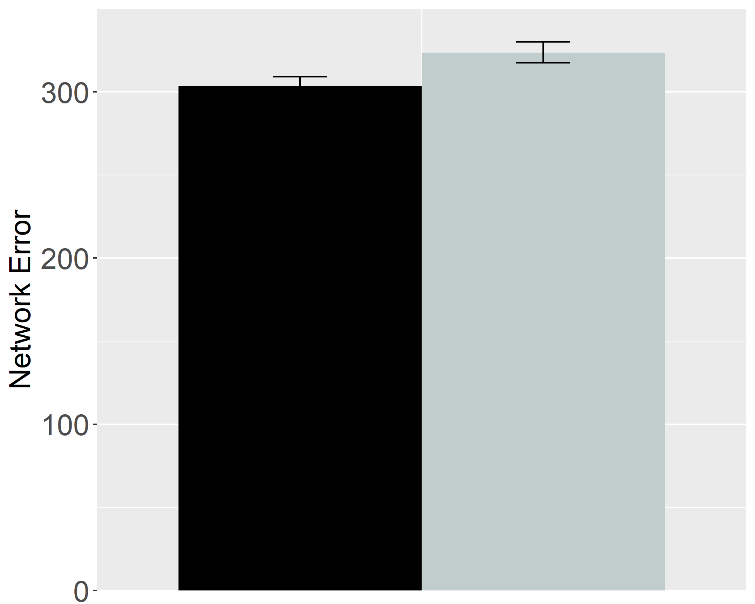 | 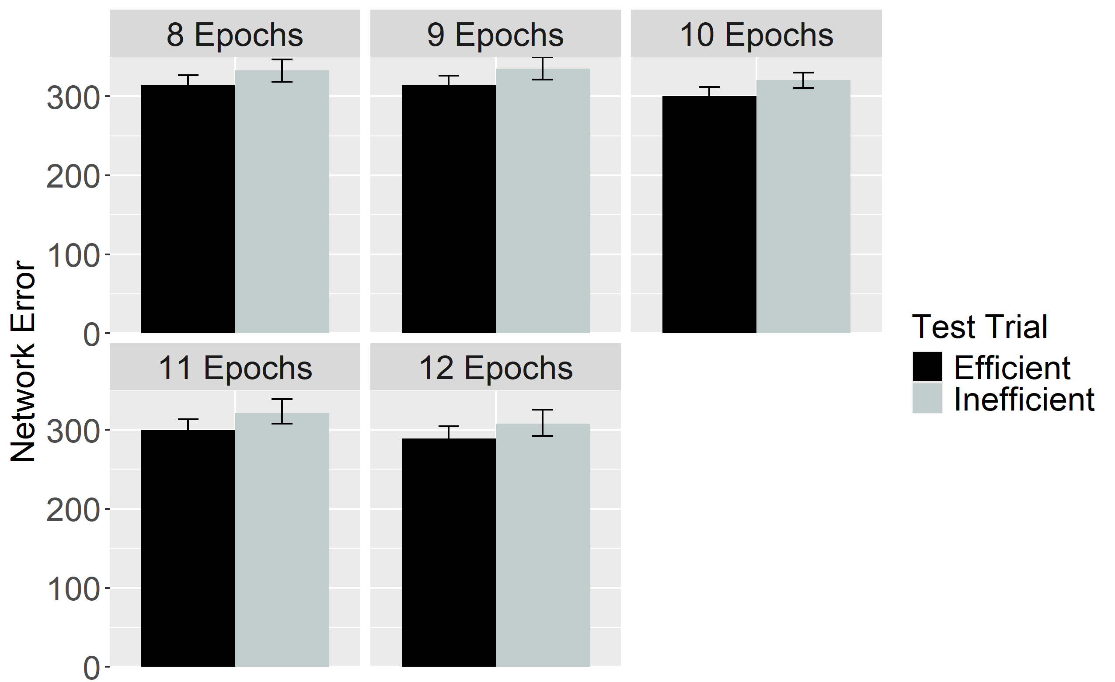
Figure 24. Performance of ALIAS in the Ineffective Action condition. The overall error produced to the Efficient and Inefficient test events is shown on the left, and the error produced across different habituation epochs is shown on the right. This condition corresponds to Experiment 2 in Skerry et al. (2013).

In contrast, networks in the Ineffective Action condition—like infants in the corresponding behavioral condition—looked about equally long at both test events (Figure 21). These results raise the intriguing possibility that effective action experience, through enhancing infants’ attention to and encoding of a reach’s straight and curved trajectory, is sufficient to reproduce infants’ looking behavior in Skerry et al.’s (2013) study.

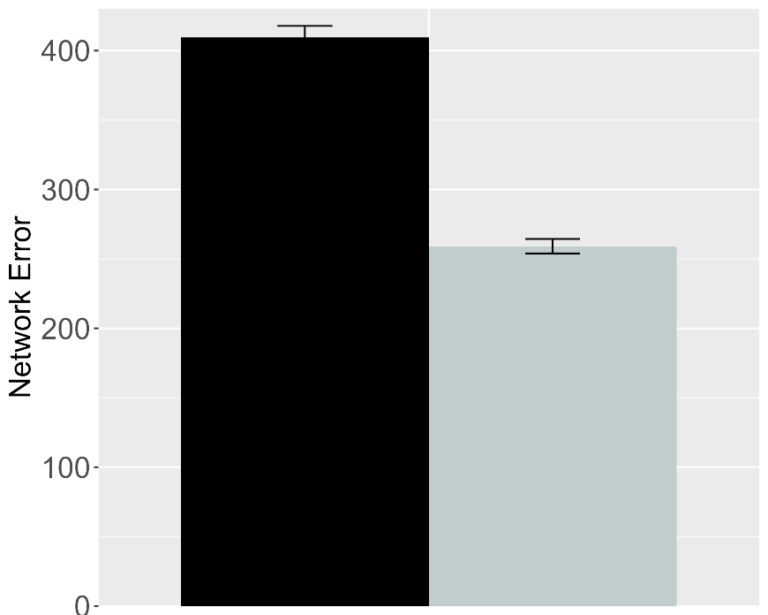 | 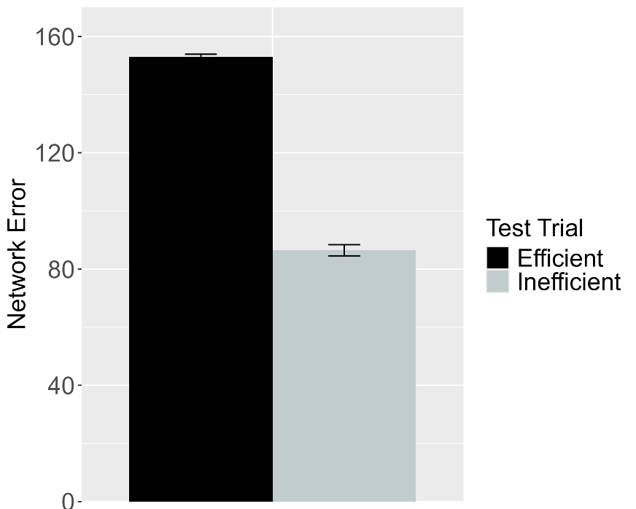
Figure 25. Performance of ALIAS in the Experimental (left) and Control (right) conditions of the Effective Action condition. These data correspond to a version of ALIAS in which the attentional boost extends into the habituation phase.

A key assumption that the present account makes is that the attentional boost that infants experience in the Effective Action condition is fleeting. Yet, it remains to be seen whether such a boost must be transient to capture infants’ behavior in this condition. For example, would ALIAS still capture infants’ looking behaviors if the attentional boost extended into and through the habituation phase? The current simulation examined this issue. The simulation itself was identical to the Effective Action condition described above except that the attentional boost experienced by networks in the Experimental and Control conditions persisted throughout habituation. The results for this simulation indicated that networks in both conditions produced greater error to the Efficient test event than to the Inefficient event. These data are shown in Figure 22. These results suggest that it is necessary that the action-phase attentional boost be transient for ALIAS to reproduce infants’ looking responses in the Effective Action condition.
The basis for these findings is straightforward: Although networks’ heightened attention during the action phase enabled them robustly to encode their own straight reach trajectories, the fact that this attentional boost persisted into the habituation phase meant that networks’ representations of these trajectories were overridden by robust representations of the arced motion trajectories and the surface features associated with those trajectories (e.g., the height of the apex of a reach’s trajectory) during the habituation phase. Consequently, the Inefficient test event—which, apart from the barrier, preserved most of the features of the habituation event—was partially consistent with the habituation representation; the Efficient test event was not because it depicted a straight reach trajectory. Note that such straight motion would have been treated as familiar if networks had formed a robust representation of it (as well as of over-an-obstacle arced motion) during pretraining; the extremely brief nature of this phase precluded that. The Efficient test event thus produced longer looking than the Inefficient test event.

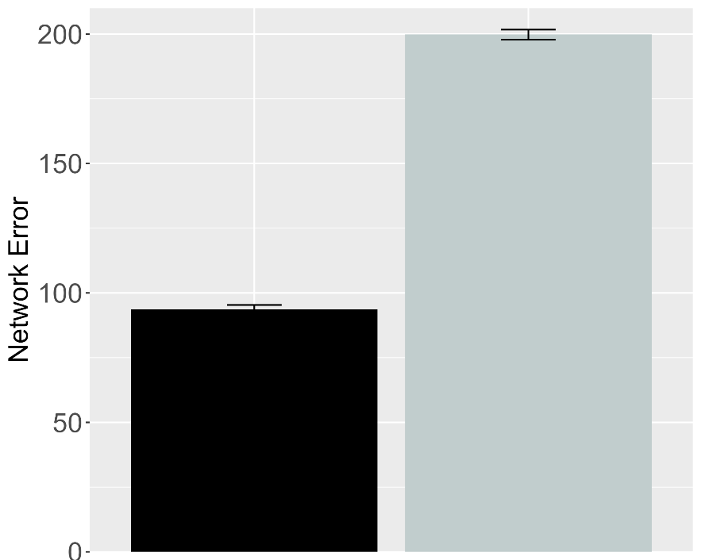 | 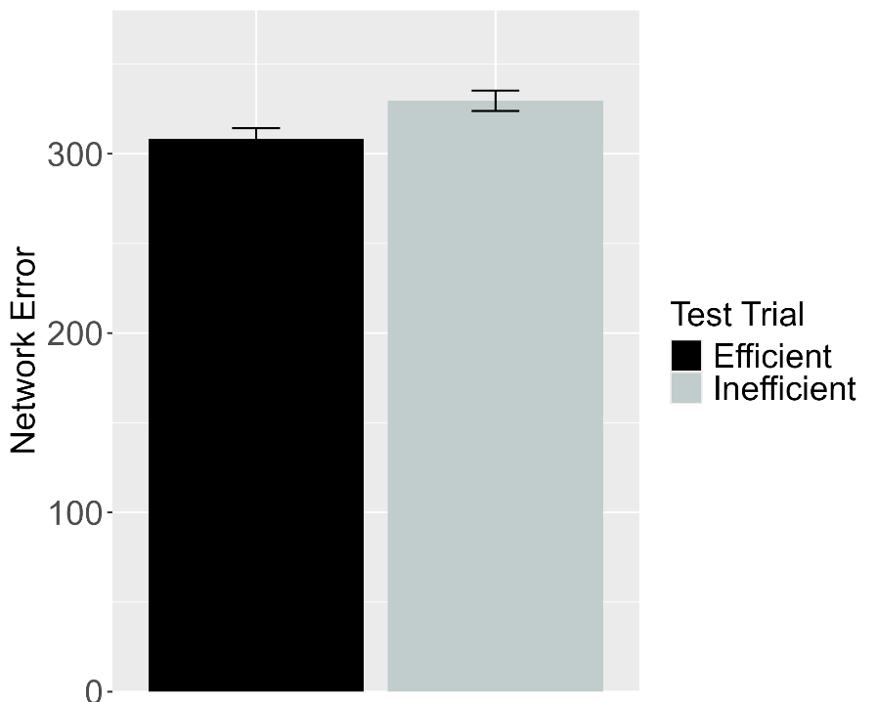
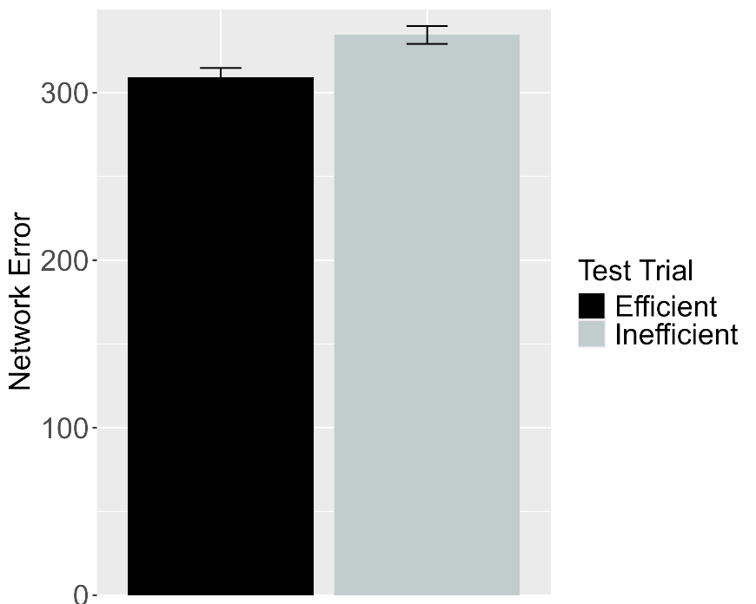
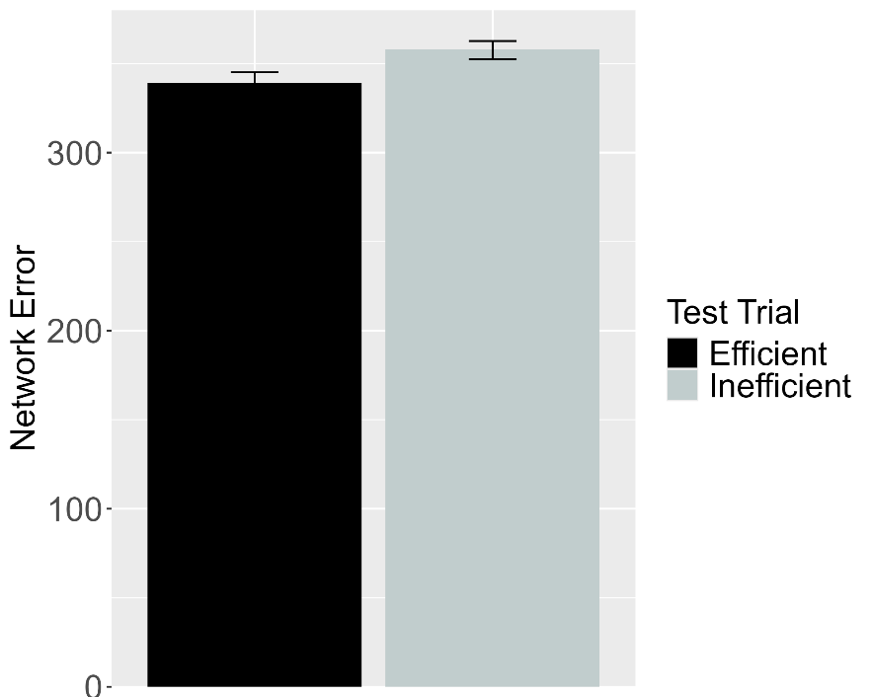
Figure 26. Performance of ALIAS-2. Plotted in the top row is the overall mean error to the Efficient and Inefficient test events for networks assigned either to the Experimental (top left) or to the Control condition (top right) in the Effective Action condition. Plotted in the middle row is the overall mean error to the two test events for networks assigned to the Ineffective Action condition. Plotted in the bottom row is the overall mean error to the two test events for networks assigned to the No Training condition. The No Training condition corresponds to Experiment 2 in Skerry et al. (2013).

The next analysis examined whether associative learning alone was sufficient for ALIAS-2 to reproduce the fifth target finding; the attentional boost remained short-lived in this simulation. In the Effective Action condition, networks in the Experimental condition produced greater error to the Inefficient test event than to the Efficient one. In contrast, networks in the Control condition as well as those in the Ineffective and No Training conditions produced about equivalent error to both test events. Together, these results—shown in Figure 23—suggest that associative learning alone is sufficient to account for Skerry et al.’s (2013) finding.
Although the current simulations indicate that ALIAS is sufficient to capture a number of key findings in the literature on infant action efficiency understanding, a complete account of should do more than reproduce existing data; it should also generate predictions that can be tested in future behavioral experiments. The final section does exactly this by placing ALIAS in a series of novel situations and assessing its resulting behaviors. These behaviors should be viewed as predictions to be tested in future research and as a basis for deciding between the current perspective and the domain-specific ones.

Model predictions
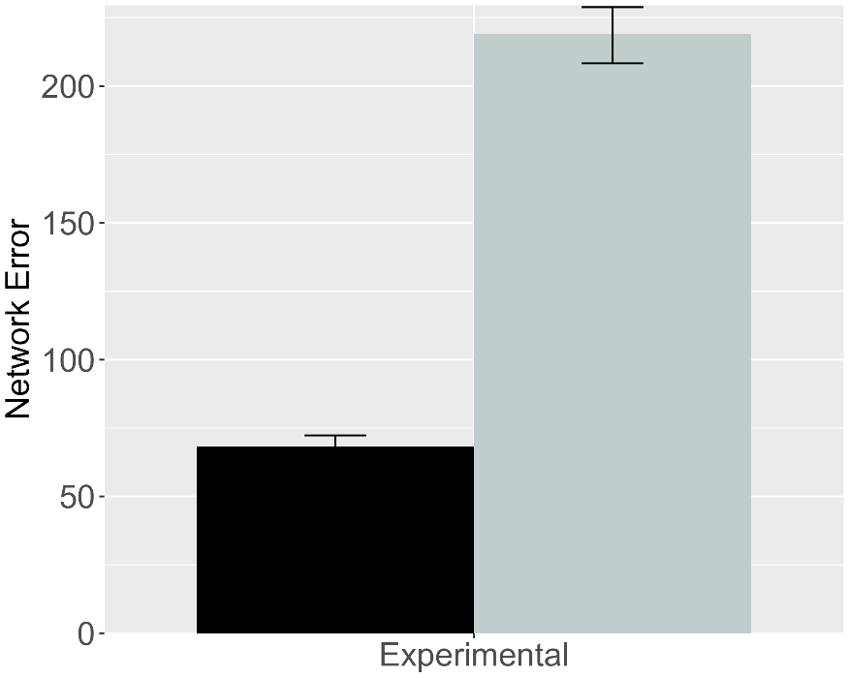 | 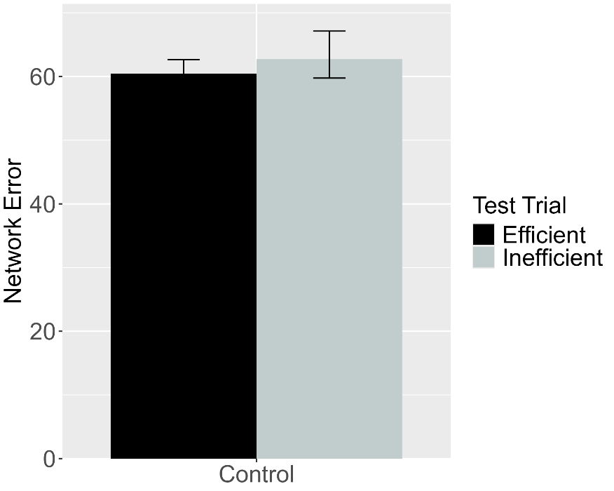
Figure 27. Performance of ALIAS. (Left) Overall error produced to the Efficient and Inefficient test events for networks in the Experimental condition. (Right) Overall error produced to the Efficient and Inefficient test events for networks in the Control condition. The barrier shown during habituation for this simulation appeared directly above rather than beneath arced motion.

A key benefit of developing computational models is that their behavior in novel situations can be treated as testable predictions for future research. In the current context, for example, a potentially interesting question concerns how ALIAS would respond if, instead of being habituated to a canonical constrained action event, it were habituated to an event in which the barrier was positioned just above the apex of the agent’s jump trajectory. If the current account is correct that positioning the obstacle in the immediate vicinity of the motion trajectory is the critical factor enabling the formation of a robust association between the two, then networks should form as robust an association between the arced motion and the obstacle in this anomalous configuration as when the barrier is located beneath that motion.
The first simulation reported in this section addressed this first issue. The simulation itself was identical to Simulation 1a with two exceptions. First, a fourth unit was added to the Obstacle Horizontal Position input and output groups. This unit corresponded to a location that appeared directly above arced motion when paired with it. Second, to simplify the simulations reported in this section, the length of the habituation phase was reduced to eight epochs; this was the smallest number used in the prior simulations. This decision was justified because the results reported in the previous simulations were robust to different habituation epochs.
As in Simulation 1a, networks were assigned either to the Experimental condition (N = 20) or to the Control condition (N = 20). Importantly, networks encountered barriers in the above-the-curved-motion spatial configuration only during the habituation phase; pretraining barriers were always tethered to the ground. The relative horizontal position of this barrier was identical to that in Simulation 1a. The results from this simulation—depicted in Figure 24—indicate that networks in the Experimental condition produced greater error to the Inefficient than to the Efficient test event. In contrast, networks in the Control condition produced equivalent error to both test events. These results mirror those in Simulation 1a.

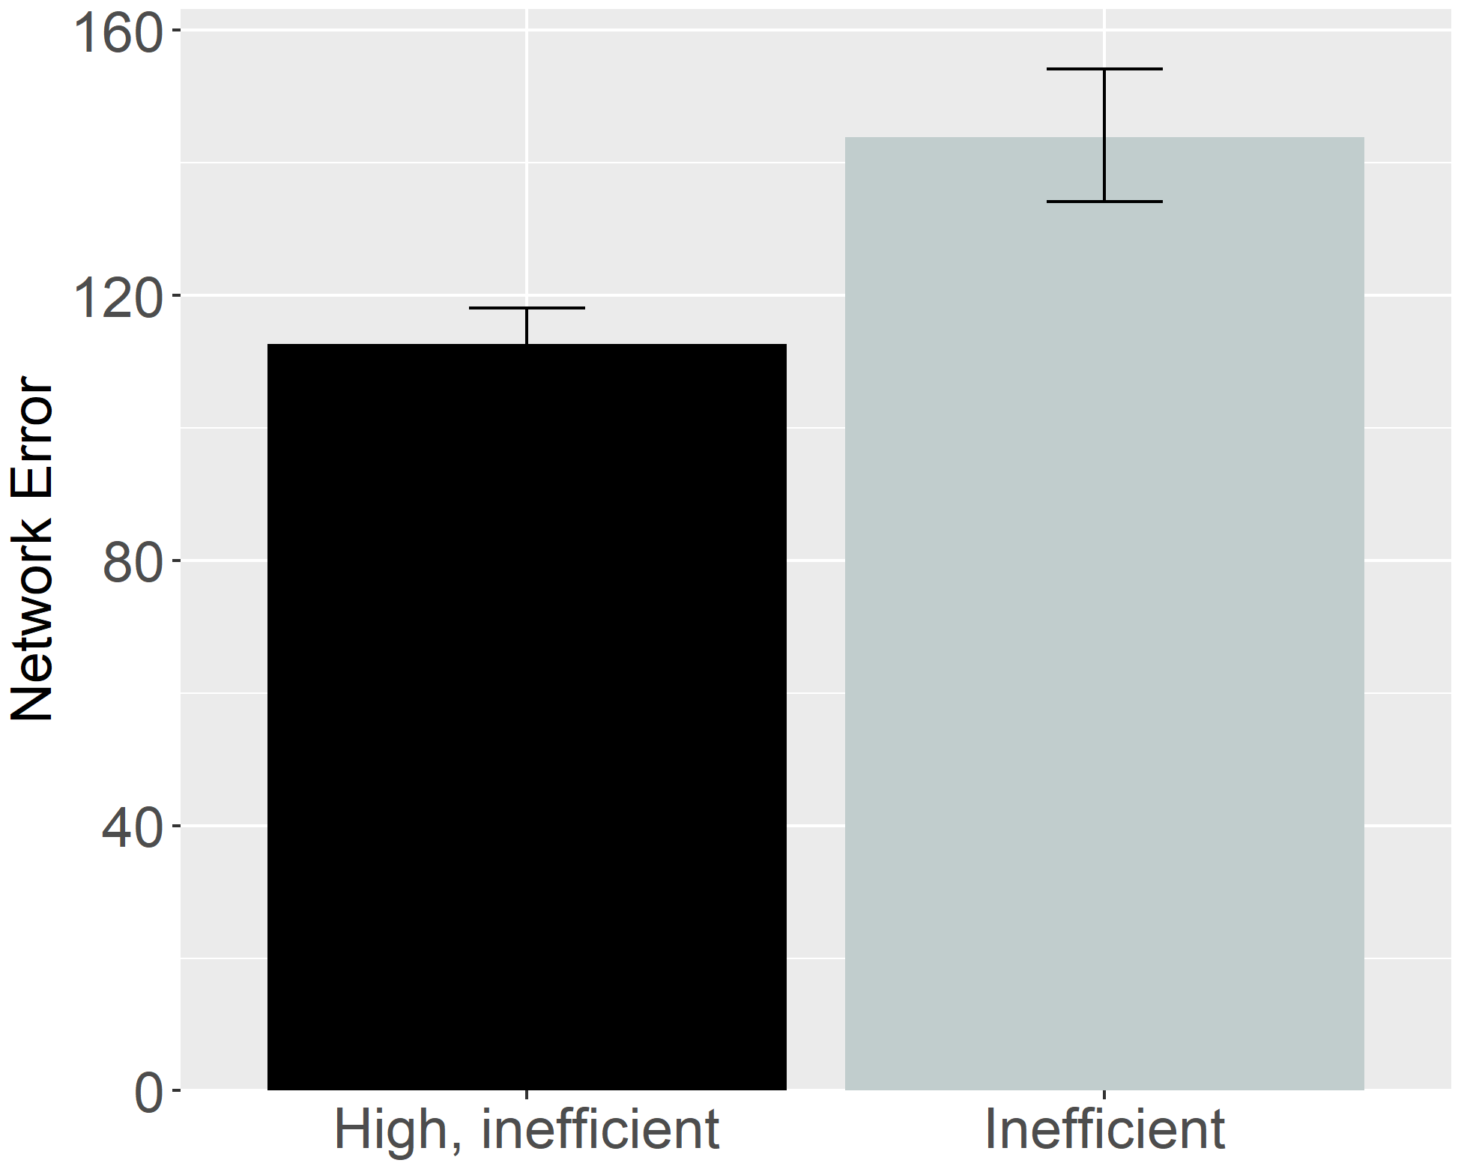
Figure 28. Performance of ALIAS. Overall error produced to the High, inefficient and Inefficient test events.

Given that action efficiency studies have used many different kinds of inefficient events, another interesting question concerns ALIAS’s performance when tested on two different inefficient test events rather than on the standard inefficient and efficient test events. For example, how might ALIAS respond if it were tested on Liu and Spelke’s (2017) High, inefficient test event and Gergely et al.’s (1995) barrierless inefficient test event? To address this question, networks (N = 20) were habituated to the same event used in Simulation 4a following a pretraining phase that was also identical in length to that in Simulation 4; the networks tested here were thus the same “age” as those tested in Simulation 4. Networks were then tested on the High, inefficient test event from Simulation 4 and the inefficient one from Simulation 1a. The results for this simulation—which are shown in Figure 25—revealed that networks produced greater error to the Inefficient than to the High, inefficient test event.
In terms of the mechanistic basis of networks’ responses here, networks looked longer at the Inefficient test event than at the High, inefficient one because some of the input information presented in the latter event—specifically that pertaining to an absent obstacle—strongly activated an internal representation corresponding to straight motion. The reason for this is that networks learned to associate the absence of obstacles with straight motion during the pretraining phase. Ultimately, however, this learned association was at odds with the visual information presented in the Inconsistent test event—this event presented networks with barrierless arced motion. This discrepancy between what networks were shown and what they expected, in turn, resulted in multiple sources of error. One source of error was networks’ erroneous prediction of the unobserved straight rather than the arced motion. Another was networks’ mistaken prediction of the unobserved absence of vertical clearance rather than the observed large vertical clearance. By contrast, the High, inefficient test event produced comparatively less error because the input information associated with this event was much more consistent with that encountered during pretraining. As such, there were fewer contributors to error for this event than the inefficient one. The contributors to error for this event were discussed in Simulation 4.
Beyond these mechanistic details, the current results are theoretically significant because presumably they are at odds with those predicted by any of the present domain-specific proposals for the same events. If these accounts are correct that infants process others’ actions in terms of their efficiency, cost, and subjective utility, then infants should look equally long at both inconsistent events. This is because not only is it the case that the actions themselves are non-rational, but it is also the case that they are equally costly. The latter contention falls directly out of the math of the naïve utility calculus. Although the full mathematical details of this model are beyond the scope of this paper (see Jara-Ettinger et al., 2016; Jara-Ettinger et al., 2020), an aspect of this model that is worth highlighting here is that in the model, cost is defined in terms of an agent’s actions (or more formally, its policy)—this policy is equivalent in both inefficient test events. Thus, because the agent jumps to the same height in both test events, it also incurs the same cost in each event. A promising goal for future research will be to test these predictions.

General Discussion
A question that developmental scientists have wrestled with for the last 30 years concerns how infants discover that some actions are more efficient than others. One perspective—referred to here as the rich perspective—maintains that infants possess early-emerging and conceptually rich domain-specific systems that enable them to process actions in terms of their efficiency, cost, rationality, and subjectivity as well as in terms of the agents involved in them (Csibra & Gergely, 1998; Gergely & Csibra, 2003; Jara-Ettinger et al., 2016; Jara-Ettinger et al., 2020; Liu et al., 2026). Another perspective is that infants’ behaviors in violation-of-expectation investigations—of which studies assessing infants’ action efficiency understanding are specific instances—can instead be explained by domain-general learning mechanisms (e.g., associative learning, habituation, conditioning, imitation, among others).
This paper extends this second perspective. The crux of the present argument was that infants’ looking behavior in studies assessing their putative sensitivity to action efficiency results from an associative learning mechanism that operates over the differentially salient and conceptually neutral surface features of action events. The current paper showed that a model called ALIAS that instantiated this proposal captured the finding that infants look longer at inefficient than efficient actions following habituation to animate-like constrained events (Simulations 1a and 1b); the finding that infants’ sensitivity to an action’s efficiency extends to inanimate-like constrained events (Simulation 2); the finding that infants can infer missing constraints from an agent’s behavior and its goal as well as its goal from its behavior and environmental constraints (Simulation 3); the finding that infants putatively possess a graded notion of efficiency (Simulation 4); and the finding that pre-reaching 3-month-olds can process action efficiency like older infants if they are given action experience (Simulation 5).
The present results also showed that ALIAS provided a better account of these target findings than any of the current competitor models: ALIAS-2, VOM10, and VOM10-2. Table 1—which shows the qualitative fits of each of these models to the five target findings—makes this point especially clear. The table shows that ALIAS successfully captured all five target findings as well as the more specific findings associated with each target finding. In contrast, the remaining models either failed to capture several of the target findings, could only partially capture them, or could not be used to simulate them because of theoretical limitations.

Table 1. Qualitative fits of the different models to the five target findings examined in the current paper.
 |  |  |  | Model
Target finding | Illustrative paradigm | Articles | ALIAS | ALIAS-2 | VOM10 | VOM10-2
- Selective longer looking to inefficient than efficient actions following constrained habituation. | Animate agent constrained action | Csibra et al. (1999); Gergely et al. (1995) |  |  |  | 
 | Animate agent unconstrained action |  |  |  |  | 
- Independence from animacy. | Inanimate-agent constrained action | Csibra et al. (1999) Sodian et al. (2004) |  |  |  | 
 | Inanimate agent unconstrained action |  |  |  |  | 
- Bidirectional inferences about actions, goals, and constraints. | Goal inference | Csibra et al. (2003); Wagner & Carey (2005) |  |  |  | 
 | Constraint inference |  |  |  |  | 
- Graded representations of efficiency. | More costly vs. less costly constrained action | Liu & Spelke (2017) |  |  | — | 
 | More costly vs. less costly unconstrained action |  |  |  | — | 
 | More costly vs. less costly constrained action with a previously inefficient agent |  |  |  | — | 
- Action efficiency understanding in pre-reaching infants. | Sticky mittens training constrained action | Skerry et al. (2013) |  |  | — | —
 | Non-sticky mittens training constrained action |  |  |  | — | —
 | Sticky mittens training unconstrained action |  |  |  | — | —
Note. Check marks indicate that a given model captured the qualitative pattern associated with a target finding and its corresponding illustrative paradigm; Xs indicate that the model failed to capture the finding; and dashes indicate that the model could not meaningfully be applied to the corresponding target and illustrative paradigm. Illustrative paradigms are nested within the broader target finding to which they correspond. Because several of the current target findings were derived from multiple experiments and published studies, the associated citations are also provided.

The current simulations also make several contributions to the literature on infants’ action efficiency understanding. Two are particularly notable. First, they provided insight into the possible mechanistic basis of infants’ looking responses in the corresponding behavioral experiments. This was accomplished by unpacking the model’s internal representations, the associations it learned, and the activation dynamics that gave rise to its behavior. Several important insights resulted from this process. For example, analyses of the model’s innerworkings revealed that ALIAS’s responses to inefficient and efficient actions emerged not from explicit representations of goals, efficiency, cost, or rationality. Instead, they emerged from associations between curved trajectories and obstacles that were first formed during pretraining and later reinforced during habituation. Additionally, the sticky-mittens simulation (i.e., Simulation 5) showed that longer looking to inefficient test events than to efficient ones is the natural consequence of an otherwise inexperienced model encoding and becoming familiar with its own straight reaches due to its heightened attentional state. Still other simulations (e.g., Simulation 4) showed that prior experience with curved trajectories and obstacles can explain why it is the case that infants look longer at events in which arced motion occurs in the absence of an obstacle than when it occurs with an obstacle or why infants look longer when agents stop short of their goals than when they stop next to them.
Second, the current simulations generate a number of testable predictions. One is that infants who are habituated to a constrained action event and then tested on a High, inefficient test event like that in Liu and Spelke (2017) and an inefficient test event like that in Gergely et al. (1995) should look longer at the inefficient than at the High, inefficient one. Another prediction is that infants should look longer at an inefficient test event than at an efficient one following habituation to an event in which arced motion unfolds beneath rather than over an obstacle. Still another prediction of the current model is that increasing peripherally located obstacles’ salience in unconstrained control events should strengthen the association formed between them and arced motion. Along similar lines, decreasing barriers’ salience in constrained experimental events should weaken the association formed between them and curved trajectories. Such findings would be difficult to reconcile with any of the domain-specific proposals.
Although ALIAS is not a model of how action efficiency understanding itself emerges, I contend that the same processes argued here to underlie infants’ looking behaviors in studies on this topic also support the development of an authentic understanding of what makes an action efficient. At the same time, however, the current simulations cannot disprove domain-specific mechanisms for representing goals, efficiency, cost, or rationality any more than they can prove that ALIAS is the right description of the processes underpinning infants’ action efficiency understanding. Instead, they demonstrate that an associative learning mechanism operating over differentially salient surface features is sufficient to explain a broad range of findings in this literature. Behavioral experiments are ultimately needed to decide among the current competing proposals.
Before concluding, two potential criticisms of ALIAS are worth noting. The first concerns the fact that the present simulations focused primarily on studies employing some version of the Gergely paradigm. Potential downsides of this are that the conclusions that can be drawn from it are necessarily limited in scope and that it is unclear to what extent the current model can capture findings on infant action understanding broadly (e.g., Gergely et al., 2002; Woodward, 1998). Future work will therefore need to determine whether extended versions of ALIAS can capture findings beyond those related to infants’ action efficiency understanding.
The second concerns the model’s simplicity. Although movement was represented dynamically, all other aspects of the model were represented statically. Additionally, a localist rather than a distributed encoding scheme was used to represent objects, their features, and any external constraints or barriers in the environment. Based on these simplifications, the model may poorly approximate infants’ real-world action experience. Although I do not dispute this critique, this simplification was deliberate: Because simple models afford tracing precisely how they process information, they provide meaningful insight into the possible mechanistic basis of some phenomenon in the human mind specifically and advance theories of infant cognitive development broadly. Although it is true that complex models better capture the richness of infants’ action perception, a major disadvantage of such models is that their complexity hinders their interpretability. This complexity also makes it difficult to separate the meaningful consequences of different theoretical assumptions from extraneous model details.
In sum, the current simulations demonstrate that a domain-general associative learning mechanism operating over the low-level kinematics of actions and the differentially salient surface features of environments is sufficient to explain a broad range of findings in the action efficiency understanding literature. This proposal—when instantiated in a new connectionist model called ALIAS—not only successfully captured five major findings in this literature but also generated several predictions that should be tested in future research. Additionally, the current simulations provided insight into the possible mechanistic basis of infants’ action efficiency understanding through detailed analyses of ALIAS’s behavior in each simulation. Considered together, the current simulations suggest that before concluding that infants possess conceptually rich knowledge that is underpinned by domain-specific mechanisms based on their performance in a behavioral task, it is important to determine first whether more general processes are sufficient to explain the same performance. The current simulations indicate that they are, at least in the domain of infant action efficiency understanding.
References
Baillargeon, R. (1986). Representing the existence and the location of hidden objects: Object permanence in 6-and 8-month-old infants. Cognition, 23(1), 21–41. https://doi.org/10.1016/0010-0277(86)90052-1
Baillargeon, R. (1987). Object permanence in 3½- and 4½-month-old infants. Developmental Psychology, 23(5), 655–664. https://doi.org/10.1037/0012-1649.23.5.655
Baillargeon, R., & DeVos, J. (1991). Object permanence in young infants: Further evidence. Child Development, 62(6), 1227–1246. https://doi.org/10.1111/j.1467-8624.1991.tb01602.x
Baillargeon, R., Spelke, E. S., & Wasserman, S. (1985). Object permanence in five-month-old infants. Cognition, 20(3), 191–208. https://doi.org/10.1016/0010-0277(85)90008-3
Benton, D. T. (2022). The elusive “Developmental Mechanism”: What they are and how to study and test them. Developmental Review, 65, 101034. https://doi.org/10.1016/j.dr.2022.101034
Benton, D. T. (2023). But what is the mechanism?’: Demystifying the ever elusive ‘developmental mechanism. Infant and Child Development, 32(6), e2355. https://doi.org/10.1002/icd.2355
Benton, D. T. (2025). An associative-learning account of how infants learn about causal action in animates and inanimates: A critical reexamination of four classic studies. Journal of Experimental Psychology: General, 154(2), 497–521. https://doi.org/10.1037/xge0001656
Benton, D.T., & Hoch, J.E. (in press). An associative learning account of how saliva becomes a cue for comfort. Child Development. 10.1093/chidev/aacag119
Benton, D. T., & Lapan, C. (2021). Moral masters or moral apprentices? A connectionist account of sociomoral evaluation in preverbal infants. Cognitive Development, 62, 101164. https://doi.org/10.1016/j.cogdev.2022.101164
Benton, D. T., Kamper, D., Beaton, R. M., & Sobel, D. M. (2024). Don't throw the associative baby out with the Bayesian bathwater: Children are more associative when reasoning retrospectively under information processing demands. Developmental Science, 27(3), e13464. https://doi.org/10.1111/desc.13464
Berthiaume, V. G., Shultz, T. R., & Onishi, K. H. (2013). A constructivist connectionist model of transitions on false-belief tasks. Cognition, 126(3), 441–458. https://doi.org/10.1016/j.cognition.2012.11.007
Blumberg, M. S., & Adolph, K. E. (2023). Protracted development of motor cortex constrains rich interpretations of infant cognition. Trends in cognitive sciences, 27(3), 233-245. https://doi.org/10.1016/j.tics.2022.12.014
Bogartz, R. S., Shinskey, J. L., & Schilling, T. H. (2000). Object permanence in five‐and‐a‐half‐month‐old infants?. Infancy, 1(4), 403–428. https://doi.org/10.1207/S15327078IN0104_3
Bomba, P. C., & Siqueland, E. R. (1983). The nature and structure of infant form categories. Journal of Experimental Child Psychology, 35(3), 294–328. https://doi.org/10.1016/0022-0965(83)90085-3
Carey, S. (2009). The origin of concepts. Oxford University Press.
Christiansen, M. H., & Curtin, S. (1999). Transfer of learning: Rule acquisition or statistical learning? Trends in Cognitive Sciences, 3(8), 289–290. https://doi.org/10.1016/S1364-6613(99)01356-X
Clearfield, M. W., & Mix, K. S. (1999). Number versus contour length in infants' discrimination of small visual sets. Psychological science, 10(5), 408-411. https://doi.org/10.1111/1467-9280.00177
Cohen, L. B. (1973). A two-process model of infant visual attention. Merrill-Palmer Quarterly, 19(3), 157–180.
Cohen, L. B., Chaput, H. H., & Cashon, C. H. (2002). A constructivist model of infant cognition. Cognitive Development, 17(3–4), 1323–1343. https://doi.org/10.1016/S0885-2014(02)00124-7
Cohen, L. B., & Marks, K. S. (2002). How infants process addition and subtraction events. Developmental Science, 5(2), 186–201. https://doi.org/10.1111/1467-7687.00220
Cohen, L. B., & Oakes, L. M. (1993). How infants perceive a simple causal event. Developmental Psychology, 29(3), 421–433. https://doi.org/10.1037/0012-1649.29.3.421
Colunga, E., & Smith, L. B. (2005). From the lexicon to expectations about kinds: A role for associative learning. Psychological Review, 112(2), 347–382. https://doi.org/10.1037/0033-295X.112.2.347
Csibra, G., & Gergely, G. (1998). The teleological origins of mentalistic action explanations: A developmental hypothesis. Developmental Science, 1(2), 255–259. https://doi.org/10.1111/1467-7687.00039
Csibra, G., Bíró, S., Koós, O., & Gergely, G. (2003). One‐year‐old infants use teleological representations of actions productively. Cognitive Science, 27(1), 111–133. https://doi.org/10.1207/s15516709cog2701_4
Csibra, G., Gergely, G., Bíró, S., Koos, O., & Brockbank, M. (1999). Goal attribution without agency cues: The perception of 'pure reason' in infancy. Cognition, 72(3), 237–267. https://doi.org/10.1016/S0010-0277(99)00039-6
Elman, J. L. (1990). Finding structure in time. Cognitive Science, 14(2), 179–211. https://doi.org/10.1207/s15516709cog1402_1
Gelman, R. (1990). First principles organize attention to and learning about relevant data: Number and the animate‐inanimate distinction as examples. Cognitive Science, 14(1), 79–106. https://doi.org/10.1207/s15516709cog1401_5
Geraci, A., & Surian, L. (2011). The developmental roots of fairness: Infants' reactions to equal and unequal distributions of resources. Developmental Science, 14(5), 1012–1020. https://doi.org/10.1111/j.1467-7687.2011.01048.x
Geraci, A., Surian, L., Tina, L. G., et al. (2025). Human newborns spontaneously attend to prosocial interactions. Nature Communications, 16, 6304. https://doi.org/10.1038/s41467-025-61517-3
Gergely, G., & Csibra, G. (2003). Teleological reasoning in infancy: The naïve theory of rational action. Trends in Cognitive Sciences, 7(7), 287–292. https://doi.org/10.1016/S1364-6613(03)00128-1
Gergely, G., Bekkering, H., & Király, I. (2002). Rational imitation in preverbal infants. Nature, 415(6873), 755. https://doi.org/10.1038/415755a
Gergely, G., Nádasdy, Z., Csibra, G., & Bíró, S. (1995). Taking the intentional stance at 12 months of age. Cognition, 56(2), 165–193. https://doi.org/10.1016/0010-0277(95)00661-H
Haith, M. M. (1998). Who put the cog in infant cognition? Is rich interpretation too costly? Infant Behavior and Development, 21(2), 167–179. https://doi.org/10.1016/S0163-6383(98)90001-7
Hamlin, J. K. (2013). Moral judgment and action in preverbal infants and toddlers: Evidence for an innate moral core. Current Directions in Psychological Science, 22(3), 186–193. https://doi.org/10.1177/0963721412470687
Hamlin, J. K., & Wynn, K. (2011). Young infants prefer prosocial to antisocial others. Cognitive Development, 26(1), 30–39. https://doi.org/10.1016/j.cogdev.2010.09.001
Hamlin, J. K., Wynn, K., & Bloom, P. (2007). Social evaluation by preverbal infants. Nature, 450(7169), 557–559. https://doi.org/10.1038/nature06288
Heyes, C. (2018). Cognitive gadgets: The cultural evolution of thinking. Harvard University Press.
Heyes, C. (2024). Rethinking norm psychology. Perspectives on Psychological Science, 19(1), 12-38. https://doi.org/10.1177/17456916221112075
Hinton, G. E. (1984). Distributed representations (Technical Report CMU-CS-84-157). Carnegie-Mellon University, Department of Computer Science.
Hinton, G. E. (1989). Deterministic Boltzmann learning performs steepest descent in weight-space. Neural Computation, 1(1), 143–150. https://doi.org/10.1162/neco.1989.1.1.143
Hunter, M. A., & Ames, E. W. (1988). A multifactor model of infant preferences for novel and familiar stimuli. Advances in Infancy Research, 5, 69–95.
Hunter, M. A., Ames, E. W., & Koopman, R. (1983). Effects of stimulus complexity and familiarization time on infant preferences for novel and familiar stimuli. Developmental Psychology, 19(3), 338–352. https://doi.org/10.1037/0012-1649.19.3.338
Jara-Ettinger, J., Gweon, H., Schulz, L. E., & Tenenbaum, J. B. (2016). The naïve utility calculus: Computational principles underlying commonsense psychology. Trends in Cognitive Sciences, 20(8), 589–604. https://doi.org/10.1016/j.tics.2016.05.011
Jara-Ettinger, J., Schulz, L. E., & Tenenbaum, J. B. (2020). The naive utility calculus as a unified, quantitative framework for action understanding. Cognitive Psychology, 123, 101334. https://doi.org/10.1016/j.cogpsych.2020.101334
Jones, S. S., & Smith, L. B. (1993). The place of perception in children's concepts. Cognitive Development, 8(2), 113–139. https://doi.org/10.1016/0885-2014(93)90008-S
Kamewari, K., Kato, M., Kanda, T., Ishiguro, H., & Hiraki, K. (2005). Six-and-a-half-month-old children positively attribute goals to human action and to humanoid-robot motion. Cognitive Development, 20(2), 303–320. https://doi.org/10.1016/j.cogdev.2005.04.004
Kellman, P. J., & Spelke, E. S. (1983). Perception of partly occluded objects in infancy. Cognitive Psychology, 15(4), 483–524. https://doi.org/10.1016/0010-0285(83)90017-8
Kim, I. K., & Spelke, E. S. (1992). Infants' sensitivity to effects of gravity on visible object motion. Journal of Experimental Psychology: Human Perception and Performance, 18(2), 385–393. https://doi.org/10.1037/0096-1523.18.2.385
Kotovsky, L., & Baillargeon, R. (1998). The development of calibration-based reasoning about collision events in young infants. Cognition, 67(3), 311–351. https://doi.org/10.1016/S0010-0277(98)00036-5
Leslie, A. M. (1995). A theory of agency. In D. Sperber, D. Premack, & A. J. Premack (Eds.), Causal cognition: A multidisciplinary debate (pp. 121–141). Clarendon Press.
Leslie, A. M., & Keeble, S. (1987). Do six-month-old infants perceive causality?. Cognition, 25(3), 265–288. https://doi.org/10.1016/S0010-0277(87)80006-9
Liu, S., Brooks, N. B., & Spelke, E. S. (2019). Origins of the concepts cause, cost, and goal in prereaching infants. Proceedings of the National Academy of Sciences, 116(36), 17747–17752. https://doi.org/10.1073/pnas.1904786116
Liu, S., & Spelke, E. S. (2017). Six-month-old infants expect agents to minimize the cost of their actions. Cognition, 160, 35–42. https://doi.org/10.1016/j.cognition.2016.12.007
Lucca, K., Yuen, F., Wang, Y., Alessandroni, N., Allison, O., Alvarez, M., ... & Hamlin, J. K. (2025). Infants' social evaluation of helpers and hinderers: A large‐scale, multi‐lab, coordinated replication study. Developmental Science, 28(1), e13581. https://doi.org/10.1111/desc.13581
Marr, D. (1982). Vision: A computational investigation into the human representation and processing of visual information. W. H. Freeman.
Mareschal, D., French, R. M., & Quinn, P. C. (2000). A connectionist account of asymmetric category learning in early infancy. Developmental Psychology, 36(5), 635–645. https://doi.org/10.1037/0012-1649.36.5.635
Mareschal, D., & Shultz, T. R. (1999). Development of children's seriation: A connectionist approach. Connection Science, 11(2), 149–186. https://doi.org/10.1080/095400999116322
McClelland, J. L., & Thompson, R. M. (2007). Using domain-general principles to explain children's causal reasoning abilities. Developmental Science, 10(3), 333–356. https://doi.org/10.1111/j.1467-7687.2007.00586.x
McCrink, K., & Wynn, K. (2004). Large-number addition and subtraction by 9-month-old infants. Psychological Science, 15(11), 776–781. https://doi.org/10.1111/j.0956-7976.2004.00755.x
McMahon, E., & Isik, L. (2023). Seeing social interactions. Trends in cognitive sciences, 27(12), 1165-1179. https://doi.org/10.1016/j.tics.2023.09.001
Muentener, P., & Carey, S. (2010). Infants' causal representations of state change events. Cognitive Psychology, 61(2), 63–86. https://doi.org/10.1016/j.cogpsych.2010.02.001
Munakata, Y. (1998). Infant perseveration and implications for object permanence theories: A PDP model of the AB task. Developmental Science, 1(2), 161–184. https://doi.org/10.1111/1467-7687.00021
Munakata, Y., McClelland, J. L., Johnson, M. H., & Siegler, R. S. (1997). Rethinking infant knowledge: Toward an adaptive process account of successes and failures in object permanence tasks. Psychological Review, 104(4), 686–713. https://doi.org/10.1037/0033-295X.104.4.686
Needham, A., & Baillargeon, R. (1997). Object segregation in 8-month-old infants. Cognition, 62(2), 121–149. https://doi.org/10.1016/S0010-0277(96)00727-5
Needham, A., Barrett, T., & Peterman, K. (2002). A pick-me-up for infants' exploratory skills: Early simulated experiences reaching for objects using 'sticky mittens' enhances young infants' object exploration skills. Infant Behavior and Development, 25(3), 279–295. https://doi.org/10.1016/S0163-6383(02)00097-8
Onishi, K. H., & Baillargeon, R. (2005). Do 15-month-old infants understand false beliefs?. Science, 308(5719), 255–258. https://doi.org/10.1126/science.1107621
Perner, J., & Ruffman, T. (2005). Infants' insight into the mind: How deep?. Science, 308(5719), 214–216. https://doi.org/10.1126/science.1111656
Phillips, A. T., & Wellman, H. M. (2005). Infants' understanding of object-directed action. Cognition, 98(2), 137–155. https://doi.org/10.1016/j.cognition.2004.11.005
Plaut, D. C., & Vande Velde, A. K. (2017). Statistical learning of parts and wholes: A neural network approach. Journal of Experimental Psychology: General, 146(3), 318–336. https://doi.org/10.1037/xge0000260
Powell, L. J., & Spelke, E. S. (2018). Human infants' understanding of social imitation: Inferences of affiliation from third party observations. Cognition, 170, 31–48. https://doi.org/10.1016/j.cognition.2017.09.007
Quinn, P. C., & Eimas, P. D. (1997). A reexamination of the perceptual-to-conceptual shift in mental representations. Review of General Psychology, 1(3), 271–287. https://doi.org/10.1037/1089-2680.1.3.271
Quinn, P. C., & Johnson, M. H. (2000). Global-before-basic object categorization in connectionist networks and 2-month-old infants. Infancy, 1(1), 31–46. https://doi.org/10.1207/S15327078IN0101_04
Rakison, D. H., & Lupyan, G. (2008). Developing object concepts in infancy: An associative learning perspective. Monographs of the Society for Research in Child Development, 73(1), 1–110. https://doi.org/10.1111/j.1540-5834.2008.00469.x
Rohde, D. L. T. (1999). LENS: The light, efficient network simulator (Technical Report CMU-CS-99-164). Carnegie Mellon University.
Rumelhart, D. E., Hinton, G. E., & Williams, R. J. (1986). Learning representations by back-propagating errors. Nature, 323(6088), 533–536. https://doi.org/10.1038/323533a0
Scarf, D., Imuta, K., Colombo, M., & Hayne, H. (2012a). Golden Rule or valence matching? Methodological problems in Hamlin et al. Proceedings of the National Academy of Sciences, 109(22), E1426-E1426. https://doi.org/10.1073/pnas.1204123109
Scarf, D., Imuta, K., Colombo, M., & Hayne, H. (2012b). Social evaluation or simple association? Simple associations may explain moral reasoning in infants. PLOS ONE, 7(8), e42698. https://doi.org/10.1371/journal.pone.0042698
Schlesinger, M., & Casey, P. (2003). Where infants look when impossible things happen: Simulating and testing a gaze-direction model. Connection Science, 15(4), 271–280. https://doi.org/10.1080/09540090310001655093
Schlingloff, L., Csibra, G., & Tatone, D. (2020). Do 15-month-old infants prefer helpers? A replication of Hamlin et al. (2007). Royal Society Open Science, 7(4), 191795. https://doi.org/10.1098/rsos.191795
Schmidt, M. F., & Sommerville, J. A. (2011). Fairness expectations and altruistic sharing in 15-month-old human infants. PLoS ONE, 6(10), e23223. https://doi.org/10.1371/journal.pone.0023223
Schwier, C., Van Maanen, C., Carpenter, M., & Tomasello, M. (2006). Rational imitation in 12-month-old infants. Infancy, 10(3), 303–311. https://doi.org/10.1207/s15327078in1003_6
Scott, L. S., & Arcaro, M. J. (2023). A domain-relevant framework for the development of face processing. Nature Reviews Psychology, 2(3), 183–195. https://doi.org/10.1038/s44159-023-00152-5
Simon, T. J. (1997). Reconceptualizing the origins of number knowledge: A “non-numerical” account. Cognitive development, 12(3), 349-372. https://doi.org/10.1016/S0885-2014(97)90008-3
Singh, S. E., Benton, D. T., & Lei, R. F. (2025). Using artificial neural networks to simulate social category learning: A tutorial. Social Cognition, 43(3), 152–166. https://doi.org/10.1521/soco.2025.43.3.152
Sirois, S., & Mareschal, D. (2002). Models of habituation in infancy. Trends in Cognitive Sciences, 6(7), 293–298. https://doi.org/10.1016/S1364-6613(02)01926-5
Skerry, A. E., Carey, S. E., & Spelke, E. S. (2013). First-person action experience reveals sensitivity to action efficiency in prereaching infants. Proceedings of the National Academy of Sciences, 110(46), 18728–18733. https://doi.org/10.1073/pnas.1318053110
Slater, A. (1989). Visual memory and perception in early infancy. In A. Slater & G. Bremner (Eds.), Infant development (pp. 43–71). Erlbaum.
Sloutsky, V. M. (2010). From perceptual categories to concepts: What develops?. Cognitive Science, 34(7), 1244–1286. https://doi.org/10.1111/j.1551-6709.2010.01129.x
Sodian, B., Schoeppner, B., & Metz, U. (2004). Do infants apply the principle of rational action to human agents? Infant Behavior and Development, 27(1), 31–41. https://doi.org/10.1016/j.infbeh.2003.05.006
Sokolov, E. N. (1963). Higher nervous functions: The orienting reflex. Annual Review of Physiology, 25(1), 545–580. https://doi.org/10.1146/annurev.ph.25.030163.002553
Sommerville, J. A., Woodward, A. L., & Needham, A. (2005). Action experience alters 3-month-old infants' perception of others' actions. Cognition, 96(1), B1–B11. https://doi.org/10.1016/j.cognition.2004.07.004
Spelke, E. S. (2022). What babies know: Core knowledge and composition (Vol. 1). Oxford University Press.
Spelke, E. S., Breinlinger, K., Macomber, J., & Jacobson, K. (1992). Origins of knowledge. Psychological Review, 99(4), 605–632. https://doi.org/10.1037/0033-295X.99.4.605
Stahl, A. E., & Kibbe, M. M. (2022). Great expectations: The construct validity of the violation‐of‐expectation method for studying infant cognition. Infant and Child Development, 31(6), e2359. https://doi.org/10.1002/icd.2359
Vallortigara, G., Regolin, L., & Marconato, F. (2005). Visually inexperienced chicks exhibit spontaneous preference for biological motion patterns. PLoS Biology, 3(7), e208. https://doi.org/10.1371/journal.pbio.0030208
Van Overwalle, F. (2010). Infants' teleological and belief inference: A recurrent connectionist approach to their minimal representational and computational requirements. NeuroImage, 52(3), 1095–1108. https://doi.org/10.1016/j.neuroimage.2010.05.028
Wagner, L., & Carey, S. (2005). 12-month-old infants represent probable endings of motion events. Infancy, 7(1), 73–83. https://doi.org/10.1207/s15327078in0701_6
Westermann, G., & Mareschal, D. (2012). Mechanisms of developmental change in infant categorization. Cognitive Development, 27(4), 367–382. https://doi.org/10.1016/j.cogdev.2012.08.004
Williams, R. J., & Zipser, D. (1995). Gradient-based learning algorithms for recurrent networks and their computational complexity. In Y. Chauvin & D. E. Rumelhart (Eds.), Back-propagation: Theory, architectures and applications (pp. 433–486). Erlbaum.
Woo, B. M., Steckler, C. M., Le, D. T., & Hamlin, J. K. (2017). Social evaluation of intentional, truly accidental, and negligently accidental helpers and harmers by 10-month-old infants. Cognition, 168, 154–163. https://doi.org/10.1016/j.cognition.2017.06.029
Woodward, A. L. (1998). Infants selectively encode the goal object of an actor's reach. Cognition, 69(1), 1–34. https://doi.org/10.1016/S0010-0277(98)00058-4
Woodward, A. L., & Sommerville, J. A. (2000). Twelve-month-old infants interpret action in context. Psychological Science, 11(1), 73–77. https://doi.org/10.1111/1467-9280.00218
Wynn, K. (1992). Addition and subtraction by human infants. Nature, 358(6389), 749–750. https://doi.org/10.1038/358749a0
Wynn, K. (1995). Infants possess a system of numerical knowledge. Current Directions in Psychological Science, 4(6), 172–177. https://doi.org/10.1111/1467-8721.ep10772615
Younger, B. A. (1985). The segregation of items into categories by ten-month-old infants. Child Development, 56(6), 1574–1583. https://doi.org/10.2307/1130473

Note that the ability to form prototypes develops between 3 and 4 months of age (e.g., Bomba & Siqueland, 1983; Younger, 1985); this is precisely the age of the infants in Skerry et al. (2013).
Inferential statistics were not used in the present simulations because the goal of the modeling effort was not quantitatively to fit infant looking responses or reproduce the precise magnitude of empirical effects. The goal was instead to determine whether the qualitative pattern of model responses—such as greater error to unexpected or inefficient events in some conditions but not in others—aligned with the patterns observed in infants. This emphasis on assessing whether the model’s behavior qualitatively matches that of infants is consistent with prior connectionist modeling work in the cognitive sciences (e.g., Benton, 2024; Mareschal et al., 2000; Mareschal & Schultz, 1999; McClelland & Thompson, 2007; Plaut & Vande Velde, 2017).

