“An associative-learning account of infants’ looking in action-efficiency paradigms understanding”

Abstract
Developmental scientists have long debated how infants determine whether an action is efficient. Nativists argue that infants possess conceptually rich, domain-specific systems for representing actions in terms of goals, costs, efficiency, and rationality. Empiricists instead maintain that preverbal infants’ looking behaviors reflect domain-general learning mechanisms operating over perceptually grounded event representations. The present paper instantiates a version of this latter proposal in a connectionist model called ALIAS (for Associative Learning in Action Studies) and shows that it reproduces key findings in this literature, findings previously taken as evidence for the nativist position. Analyses of ALIAS’s internal dynamics indicated that its responses emerged from learned associations between action kinematics and their associated visible surface features. The success of this model in accounting for these findings indicates that specialized, early-emerging, and action-centered representations are not necessary to account for them and that associative learning is sufficient.
A challenge faced by young learners is distinguishing between efficient and inefficient actions. For instance, a child may learn that stairs provide a safer and more efficient route to the top of a slide after observing another child tumble down one after failing to climb it from the bottom. In general, determining an action’s efficiency—a capacity referred to here as action efficiency understanding—is crucial for navigating the world competently. An open question then concerns when, and importantly how, this capacity develops in preverbal infants with limited mobility or first-hand action experience.
Developmental cognitive scientists have typically studied the origins of this capacity via the violation-of-expectation paradigm, whereby infants are habituated to an event in which an object jumps over a barrier to reach another one and then tested on events that differ in their efficiency (see Figure 1). In the Efficient event, the first object moves along a straight path to reach the second object. In the Inefficient event, the first object continues to move along the familiar, but now inefficient, curved or arced motion path.

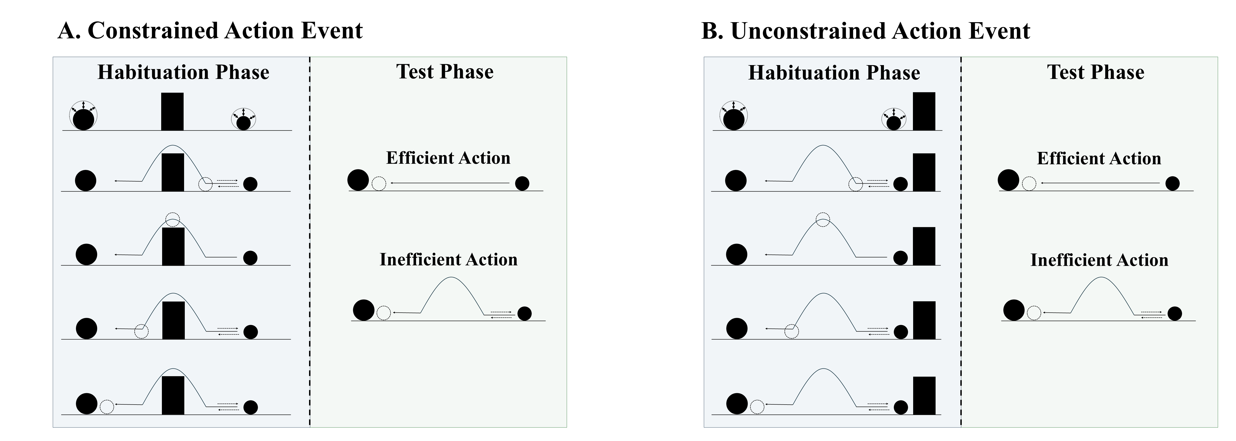
Figure 1. Schematic depiction of a typical constrained and unconstrained action event used in studies assessing action efficiency understanding in infants. In the constrained action event (A), the first object jumps over the barrier before it comes to rest next to the second object; in the unconstrained action event (B), the first object jumps beside the barrier before coming to rest next to the second one. The barrier is removed at test for both events, and infants observe either an efficient straight-path action or an inefficient arced-path action. Data for the first target finding discussed in the text derived from this paradigm.
Several important findings have emerged from the use of this method (see Figure 2 for a visualization of the corresponding paradigms). One is that 9- to 12-month-olds looked longer at inefficient than efficient actions if the first object’s habituation movement was constrained (Figure 1A) but not if it was unconstrained (Figure 1B; Gergely et al., 1995; see also Phillips & Wellman, 2005; Schwier et al., 2006; Sodian et al., 2004; Woodward & Sommerville, 2000). Importantly, the agent did not need to be self-propelled for infants to show this looking pattern (Figure 2A; e.g., Csibra et al., 1999; Kamewari et al., 2005).

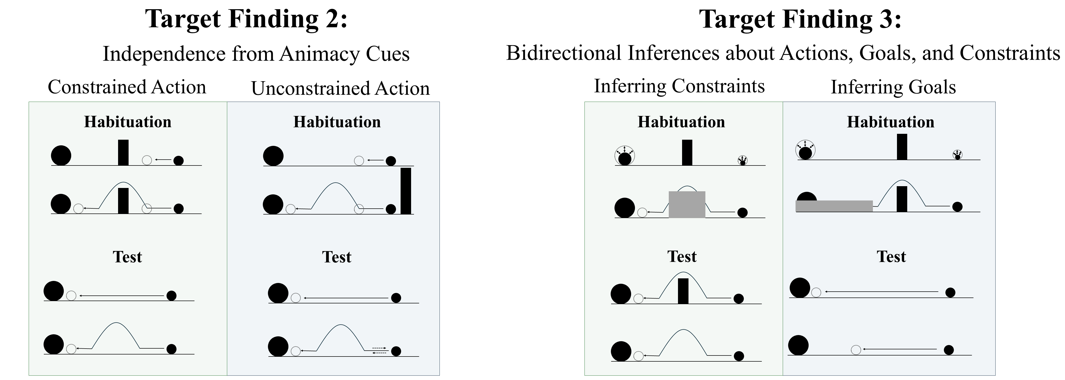
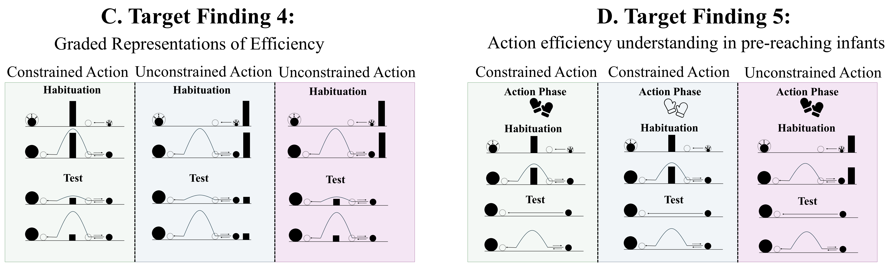
Figure 2. Schematic overview of the paradigms from which Target Findings 2–5 derive. Panels A–D depict, respectively, the experimental paradigms showing (A) the independence of action efficiency understanding from animacy cues, (B) bidirectional inferences about actions, goals, and constraints, (C) graded representations of efficiency, and (D) action efficiency understanding in pre-reaching infants. Note that closed gloves correspond to the sticky-mittens condition, whereas open gloves correspond to the non-sticky-mittens condition. The paradigm underlying Target Finding 1 is shown in Figure 1.

Beyond identifying inefficient actions across different types of entities, research suggests that infants can also reason about the relations among actions, goals, and environmental constraints (Figure 2B). For example, Csibra et al. (2003; see also Wagner & Carey, 2005) showed that 12-month-olds can make bidirectional inferences among these factors: they can use information about an agent’s actions and the constraints under which those actions are performed to infer its goal, and they can use information about its goal and actions to infer the presence of environmental constraints. Evidence also suggests that infants interpret action efficiency in a graded rather than a categorical manner. Support for this comes from a study by Liu and Spelke (2017) who found that infants looked longer at substantially than at mildly inefficient events, and they generalized these expectations across changes in environmental constraints (Figure 2C).
Finally, previous research suggests that providing pre-reaching infants with direct object-manipulation experience enables them to interpret actions in terms of their efficiency. For example, Skerry et al. (2013; see also Liu et al., 2019) showed that fitting 3-month-olds with Velcro-covered “sticky mittens” and giving them Velcro-covered objects to retrieve facilitated efficiency-based action processing (Figure 2D); this pattern was absent in infants fitted with non-sticky mittens or given no mittens training whatsoever. One question that these findings nevertheless raise concerns the origins of such action efficiency understanding.

Rich proposals for the origins of infant action efficiency understanding
Two kinds of proposals have been offered to explain its origins. Rich proposals maintain that infants possess early emerging, domain-specific mechanisms that support abstract and conceptually rich knowledge about how the various objects and entities in the world behave and act. For example, the teleological stance (Csibra & Gergely, 1998; Gergely & Csibra, 2003) holds that if an agent pursues some end state efficiently given the physical context—and thus satisfies the “rationality principle”—then the end state will be treated as the agent’s goal, its behavior as a goal-directed “means” to it, and the physical context as a set of “constraints”. The naïve utility calculus casts this in Bayesian terms (Jara-Ettinger et al., 2016, 2020): agents choose minimally costly actions based on their subjective utilities. More recently, Liu et al. (2026) argued that action efficiency understanding emerges from a naïve psychology system (in which agents are represented as goal-directed reward-maximizers) that interfaces with a naïve physics system (in which objects are represented as bounded and solid).
These perspectives have real strengths: they address foundational questions at the heart of the developmental cognitive sciences, have generated a substantial body of research, and enjoy some degree of empirical support. Yet, each shares a common limitation: none specifies the origins of the relevant primitives. The teleological stance does not explain the basis for goal, constraint, efficiency, or rationality notions. The naïve utility calculus is similarly silent about the origins of notions like reward, cost, and subjective utility. And Liu et al.’s proposal presupposes the very agent and object concept it explains.

Lean proposals for the origins of infant action efficiency understanding
Lean proposals explain infants’ looking behaviors as the product of domain-general learning over perceptual regularities (e.g., Blumberg & Adolph, 2023; Cohen et al., 2002; Cohen & Oakes, 1993; Colunga & Smith, 2005; Heyes, 2018, 2024; Jones & Smith, 1993; Quinn & Eimas, 1997; Rakison & Lupyan, 2008; Sloutsky, 2010). Although such proposals abound for a range of cognitive capacities (Benton, 202, 2026; Benton & Hoch, 2026; Benton & Lapan, 2021; Benton et al., 2024; Berthiaume et al., 2013; Bogartz et al., 2000; Clearfield & Mix, 1999; Cohen et al., 2002; Cohen & Marks, 2002; McClelland & Thompson, 2007; McMahon & Isik, 2023; Munakata, 1998; Munakata et al., 1997; Perner & Ruffman, 2005; Scarf et al., 2012a, 2012b; Schlesinger et al., 2012; Schlesinger & Casey, 2013; Simon, 1997; Rakison & Lupyan, 2008), efforts to explain action efficiency remain scarce.
Van Overwalle (2010; hereafter, VOM10) is an exception to this. He argued that as infants observe agents moving toward their goals, internal representations develop capturing the visible state of the world at points along the trajectory. He showed that a connectionist model implementing this “forward model” reproduced the finding that infants looked longer at inefficient than efficient actions following habituation to constrained motion only.
VOM10 is nevertheless limited in key respects. First, it received no action observation experience prior to the simulated habituation phase and thus could not draw on prior exposure the way findings like those by Csibra et al. (2003) require. Second, implementing agent and object units meant that the model built in the very concepts lean accounts should explain. Finally, it departed from Gergely et al.’s (1995) study by omitting barrier information from the Control condition (Figure 1B) and allowing the curved trajectory to overshoot the barrier.
Given these shortcomings, an alternative lean account is developed here and shown to reproduce the five key findings in the literature on this topic. Importantly, this theory, instantiated in a connectionist model called ALIAS, is not an account of how action efficiency understanding per se develops. Instead, it is an account of the mechanistic basis of infants’ looking behaviors in studies on this topic. How genuine action efficiency may develop is described in the General Discussion.

An experience-based associative learning account of infants’ looking behavior in action efficiency understanding studies

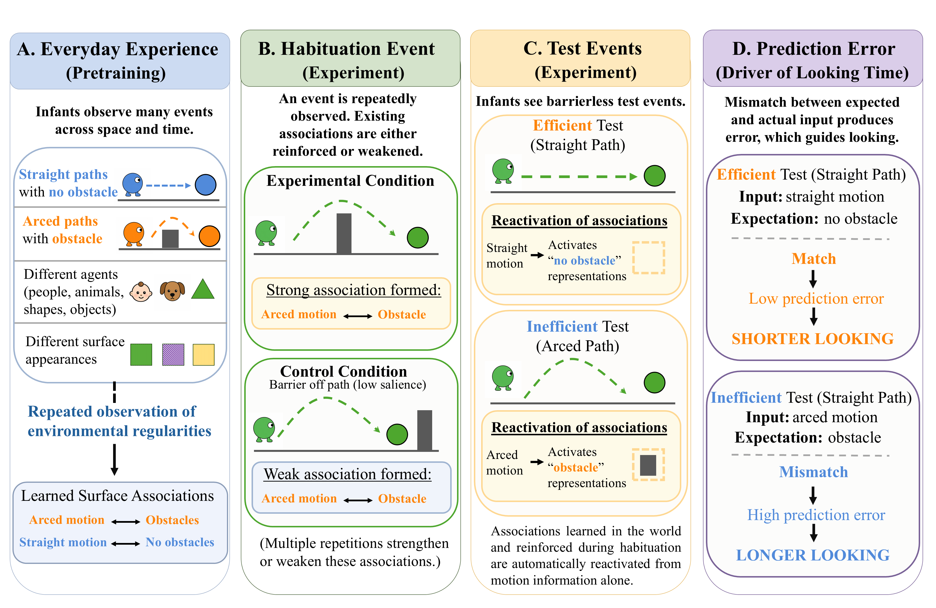
Figure 3. Overview of the account instantiated by ALIAS. (A) In the real world, infants learn associations among sensorimotor features and representations. (B) Habituation either reinforces or weakens these associations, and (C) test events that omit expected features (D) elicit prediction error.

As Figure 3 illustrates, ALIAS’s central thesis is that infants’ looking patterns in studies assessing their action efficiency understanding are governed by learned associations among the kinematics of different actions and the visible surface features of the objects involved and the physical environments in which those actions occur. Specifically, infants learn from their action observation experience that obstacles are associated with arced trajectories and absent obstacles with straight motion. Crucially, these associative-based representations are entirely non-conceptual and wholly perceptually grounded—nothing in them reflects goals, constraints, efficiency, cost, or rationality.
Habituation events that align with these associations reinforce them; those that do not weaken them. A corollary of this learning process is that test events that present one component of a learned association should produce greater prediction error than those presenting both components. Greater looking to inefficient relative to efficient actions thus arises because inefficient actions violate learned associations between arced trajectories and obstacles.
The effect disappears following unconstrained habituation simply because the learned association between arced motion and central obstacles is overridden by a new one between that motion and a peripherally located, and crucially now less visually salient, obstacle.
This account can also explain why pre-reaching infants show the effect only after direct-action experience. Sticky-mittens experience may temporarily heighten infants’ attention to the geometry and trajectory of their own successful reaches (for evidence consistent with this, see Needham et al., 2002 and Sommerville et al., 2005). Because such reaches likely approximate a straight path, sticky-mittens experience should selectively strengthen the association between no obstacles and straight trajectories. Consequently, efficient actions should produce less prediction error—and thus less looking—than inefficient ones.
An important question raised by this account concerns how pre-reaching infants detect a correspondence between their own and others’ reaches in the first place. One possibility is that observing their own arm movements causes infants to form amodal representations of the geometry and trajectory of those reaches. This means that others’ efficient reaches should be perceived as familiar because they overlap with these abstract representations.
To assess whether this theory is sufficient to capture the target findings discussed at the outset, the next section presents five simulations. ALIAS’s performance is compared to that of the competitor models (i.e., VOM10, VOM10-2, and ALIAS-2) in a number of these simulations. VOM10-2 differed from VOM10 in that it more faithfully instantiated the experimental set-up of the original behavioral studies. Thus, obstacles and goal objects remained continuously visible, and agents no longer overshot barriers when passing over them. ALIAS-2 differed from ALIAS in that peripherally located obstacles were no less salient than obstacles located directly beneath such motion. Two additional simulations are then presented demonstrating that ALIAS does more than capture existing data: It can generate genuinely novel predictions capable of teasing apart the current account from the domain-specific ones. In all simulations, only the most critical aspects of the corresponding experiments were preserved. Reasonable assumptions were made when methodological details were unavailable. Simulations were run using the Lens neural network simulator (Rohde, 1999). All training, testing, and data files are available for download at https://osf.io/vkdn9/overview?view_only=b8e21677414f4b18b83dccc0bbcb4d09.

General Method
Models
VOM10
This model was a one-layer recurrent connectionist model consisting of 27 fully interconnected units—25 of these units implemented a 5 × 5 spatial grid and the remaining two represented an agent and goal object. Training involved presenting action trajectories that unfolded across a series of discrete time steps. Figure 4 illustrates such an action sequence. As noted above, VOM10-2 was identical except that the agent no longer overshot the barrier by one cell (seen in the middle cell of the middle row in Figure 4). Additionally, in VOM10-2 the barrier and goal remained continuously visible throughout the agent’s arced trajectory.

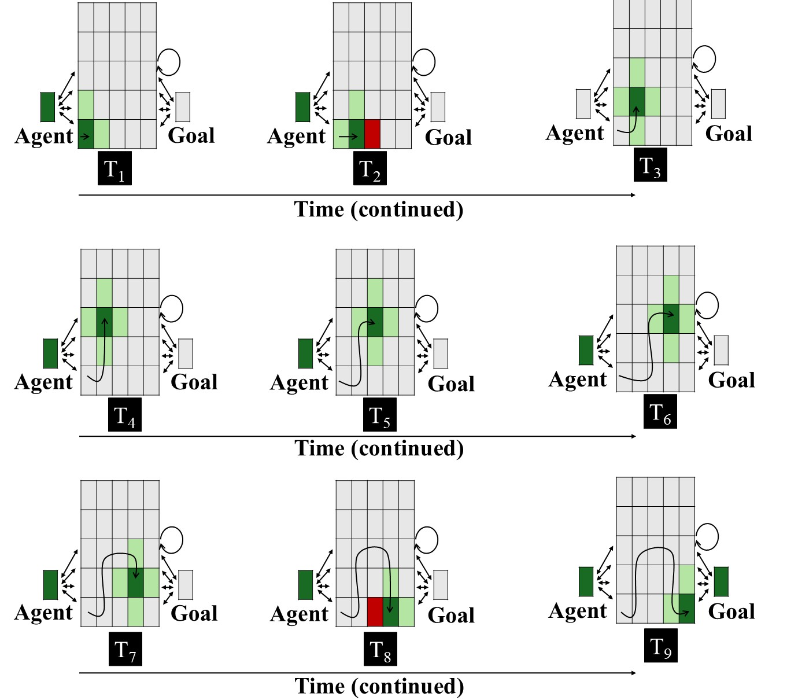
Figure 4. Input patterns shown to VOM10 networks in the Experimental condition across nine steps. Each panel represents the input to the network at that time step. The central 5 × 5 array corresponds to the spatial grid; the two units flanking the spatial grid correspond to the agent and goal objects. Dark green indicates the agent’s current position (+1), light green indicates adjacent cells (+0.5), red indicates the presence of the barrier (-1), and gray indicates no activation (0). The goal unit is activated only at the final step. The barrier is present only when the agent occupies a position immediately adjacent to it. The overlaid curved path in each panel depicts the amount of arc motion the agent has completed through that time step. Two-headed arrows and the circular arrow denote bidirectional connectivity. As in Overwalle (2010), the critical units for arced motion were the three units comprising its apex; the bottommost middle cell was the critical unit for the straight path. See the online article for a color version of this figure.

ALIAS
Method
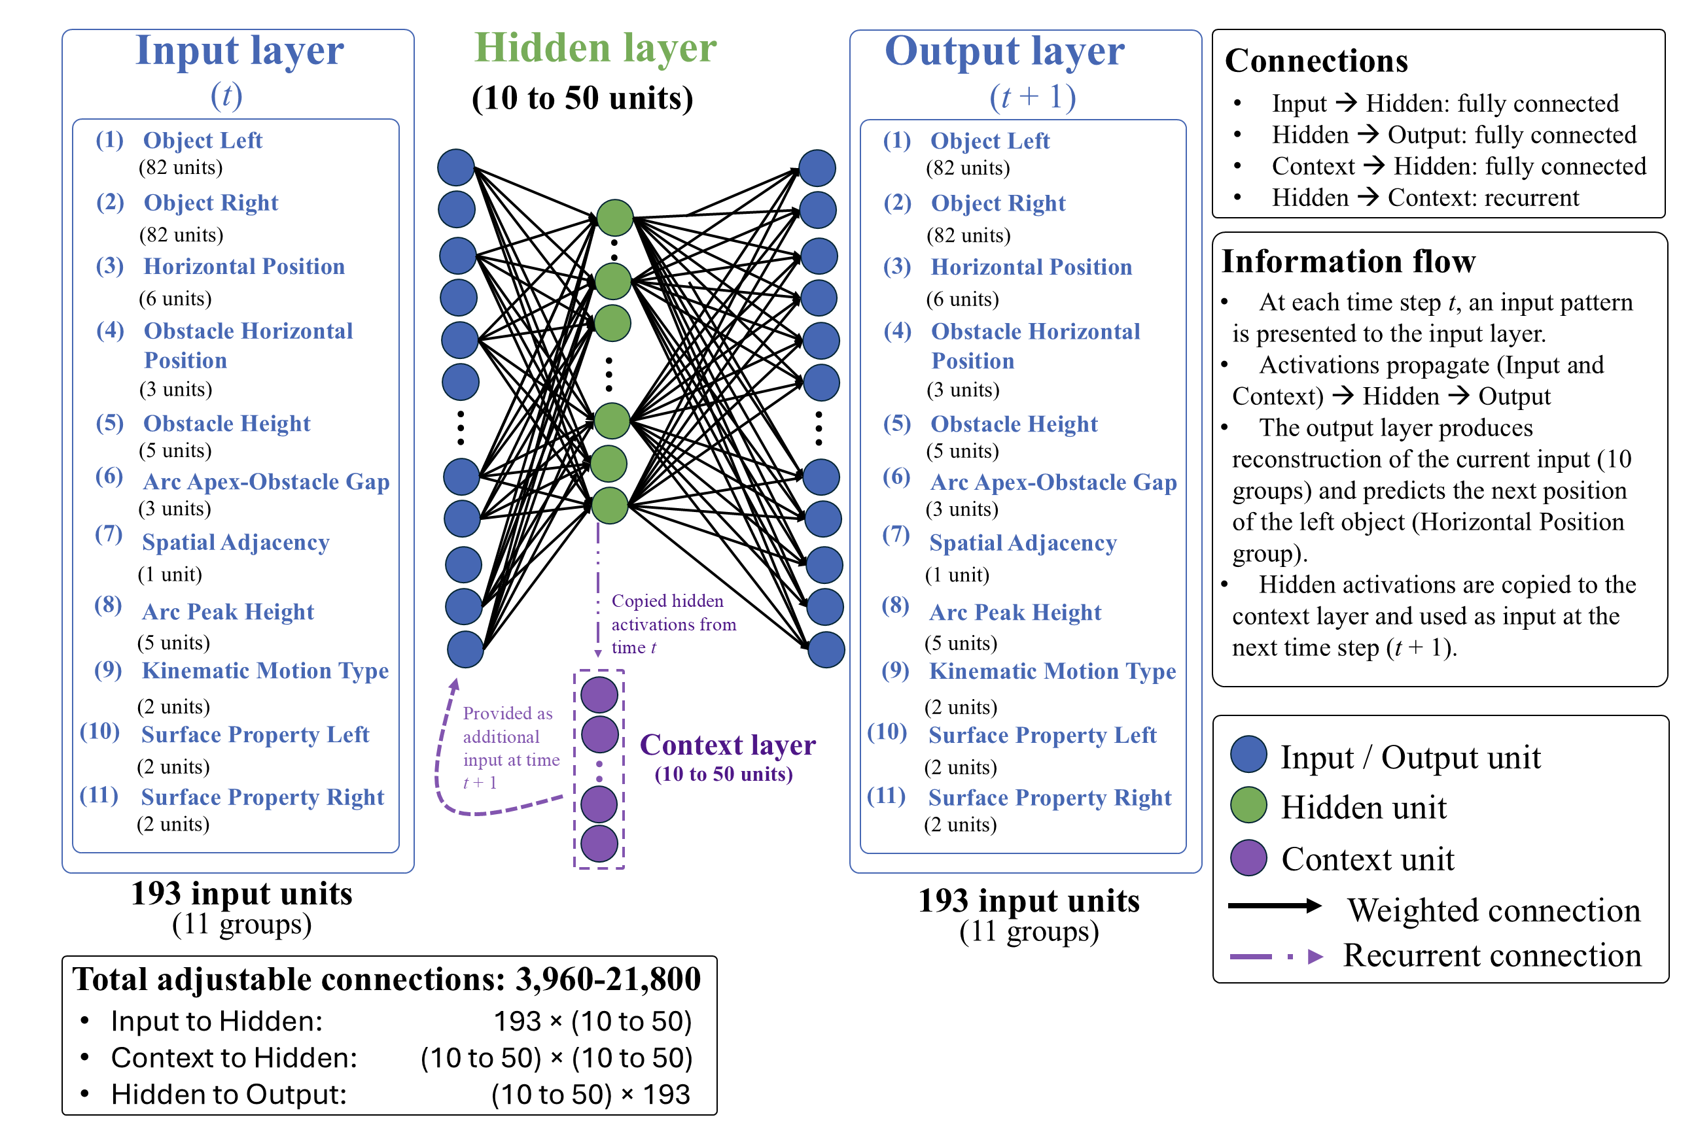
Figure 5. Architecture of the ALIAS model. The model consisted of input, hidden, context, and output layers. Input and output layers consisted of 193 units. The model combined an autoencoder (Groups 1-2 and 4-11) with an SRN (Group 3). The autoencoder copied the input activity to the output layer; the SRN predicted subsequent spatial positions from earlier ones. See the online article for a color version of this figure.

Network Architecture. Figure 5 shows the model architecture. ALIAS combined an autoencoder with a simple recurrent network (SRN; Elman, 1990). Autoencoders learn compact internal representations sufficient to reproduce the current input pattern at the output layer. SRNs learn to predict upcoming states from prior states by extracting sequential regularities in the input. That both model types employed a form of learning called self-supervised learning that did not require an explicit teaching signal and that accorded with prominent theories of infant learning (e.g., Cohen, 1973; Sokolov, 1963) made them appropriate choices for these simulations.
The model consisted of input and output layers, each consisting of 11 groups. The groups corresponded to different visible surface features (described below). Between the input and output layers were 10 to 50 hidden and context units; the precise number depended on the simulation. The input and context layers were fully connected to the hidden layer, which in turn was fully connected to the output layer. Weights were initialized to small random values sampled uniformly between ±0.1. Bias connections were not included in any of the simulations.
The activation values of input units were set externally to reflect the input appropriate to the current time step. The activation values for “upstream” units were based on their net input from other units. The net input into a hidden unit was calculated as follows:

$${net}_{j}=\sum_{i}{a_{i}w_{ij}}$$ | (1)

where $a_{i}$ is the activation of input unit i and $w_{ij}$is the weight on the connection from that unit to hidden unit j. Hidden unit activations were based on the rectified linear unit activation function (Nair & Hinton, 2010) and were calculated as follows:

$a_{j}=max⁡(0, {net}_{j})$, | (2)

where $a_{j}$ is the activation of hidden unit j, ${net}_{j}$ is its net input, and $max$ denotes the maximum of its two arguments. Output unit activations were a smooth, logistic function of a given output unit’s net input and were calculated as follows:

$a_{k}=\frac{1}{1+exp⁡(-{net}_{k})}$, | (4)

where $a_{k}$ is activation of output unit k, ${net}_{k}$ is its net input, and $exp⁡(∙)$ is the exponential function. Finally, as is true of SRNs, hidden unit activations at time $t$ were copied to the context units and made available as input at time$t+1$. This provided the model with a rudimentary form of memory in which information from earlier steps could influence later processing.
Representations and Task. At each time step, a linear or arced motion event was presented to the network as a pattern of activation distributed across the 11 input and output groups (Figure 5). The units within each group corresponded to distinct manifestations of a surface feature. Localist coding was used because it ensured that the model’s responses reflected learned regularities among actions and the visible surface features of the objects and entities involved. Such representations also facilitated interpretation of the mechanism producing those responses. Table 1 lists each group and the features represented by each unit within it. Each group’s name was intended to emphasize their semantically neutral, surface-based nature.

Table 1
ALIAS’s input and output groups
Group | Num | Represents | Unit Meaning
Object Left | 82 | Identity of left object | Each unit corresponds to a unique object identity
Object Right | 82 | Identity of right object | Each unit corresponds to a unique object identity
Horizontal Position | 6 | Sequential spatial positions | Position 1–6 in network space
Obstacle Horizontal Position | 3 | Horizontal location of obstacle | Missing, Middle, Periphery
Obstacle Height | 5 | Height of obstacle | No Obstacle, Heights 1–4
Arc Apex–Obstacle Gap | 3 | Vertical distance between an obstacle and the apex of the arced motion trajectory | No Separation, Small Vertical Separation, Large Vertical Separation
Spatial Adjacency | 1 | Whether the two objects are adjacent | Spatially Contiguous, Spatially Separated
Arc Peak Height | 5 | Maximum height of arced trajectory | No arc, Heights 1–4
Kinematic Motion Type | 2 | Type of motion | Linear, Arced
Surface Property Left | 2 | Surface features of left object | Animate-like, Inanimate-like
Surface Property Right | 2 | Surface features of right object | Animate-like, Inanimate-like
Note. Group names correspond to those shown in Figure 5. Each group represented a different visible surface feature; units within a group represented different manifestations of that feature. A localist encoding scheme was adopted for each group. A large number of object identities was used to ensure that the network learned regularities among action kinematics and visible event features rather than memorizing particular associations involving specific objects.

Input units corresponding to active (i.e., present) features during a given time step of an action event had activations of 1.0; all other input units had activations of 0.0. A small amount of Gaussian noise (M = 0, SD = 0.3) was then applied to these activations to instantiate the notion that learning and processing in infants is noisy. The network’s task at each time step was twofold. First, it was required to reproduce at the output layer the activation pattern presented across 10 of the 11 input groups. Second, it was required to predict at the output layer the position to the immediate right of the current position in the 11th (Horizontal Position) input group. Thus, if the first input unit in this group was active at time $t$, the network’s task was to predict that the second output unit would be active at time $t+1$. This represented the fact that motion is dynamic and unfolds over time and captured, in abstract form, the horizontal, rightward movement of objects in efficiency-based action studies. Movement trajectory (e.g., linear or arced) itself was captured by the Kinematic Motion Type group.
Training procedure. Learning unfolded across two phases. During pretraining, networks experienced two broad classes of events illustrated in Table 2. In Linear Path Events, one object moved unobstructed along a straight, horizontal trajectory toward another object. In Arced Path Events, one object moved over a short barrier along an arced trajectory toward the other object. Half of the objects in both event types possessed surface features typical of animate entities; the remaining half possessed surface features typical of inanimate objects. Although the exact nature of habituation depended on the simulation, networks generally experienced an Arced Path event. Novel objects and differently sized barriers were used during this phase to assess generalization beyond the pretraining stimuli.

Table 2
Example encodings of linear and arced motion events
Group | Linear Path Event |  | Arced Path Event
 | Input | Target | Input | Target
Object Left | Unit 1 | Unit 1 | Unit 1 | Unit 1
Object Right | Unit 2 | Unit 2 | Unit 2 | Unit 2
Horizontal Position | Position 1 | Position 2 | Position 1 | Position 2
Obstacle Horizontal Position | Missing | Missing | Middle | Middle
Obstacle Height | No Obstacle | No Obstacle | Height 2 | Height 2
Arc Apex–Obstacle Gap | No Separation | No Separation | Small Vertical Separation | Small Vertical Separation
Spatial Adjacency | Spatially Contiguous | Spatially Contiguous | Spatially Contiguous | Spatially Contiguous
Arc Peak Height | No Arc | No Arc | Height 2 | Height 2
Kinematic Motion Type | Linear | Linear | Arced | Arced
Surface Property Left | Animate-like | Animate-like | Animate-like | Animate-like
Surface Property Right | Animate-like | Animate-like | Animate-like | Animate-like
Note. Values are illustrative of each event type at a single time step. Input cell entries identify the units whose states were clamped during that time step. Target cell entries identify the units who state the network was trained to activate. Highlighted rows reflect features on which the two event types differed.
During each time step of both phases, an action event was presented by clamping the states of the units corresponding its surface features. Activity then propagated from the input layer to the hidden layer and then from the hidden layer to the output layer. The resulting pattern of activity over the output units represented the network’s attempt at reproducing the input activity and predicting an object’s next position. To minimize the discrepancy between the target and output patterns after a full pass through the training patterns, connection weights were modified via a version of recurrent backpropagation through time adapted to the simple recurrent network architecture (Williams & Zipser, 1995). Cross-entropy was the error measure:

$$C=-\sum_{p}{}\sum_{t}{}\sum_{k}{}t_{k,t}^{p}\log_{2}(a_{k,t}^{p})+(1-t_{k,t}^{p})\log_{2}(1-a_{k,t}^{p})$$ | (5)

where $t_{k,t}^{p}$ is the target activation of output unit k in training pattern p at time t, $a_{k,t}^{p}$ is the observed activation of that unit, and the summation is computed across all output units, time steps, and training patterns. Weight changes were then calculated as follows:

$∆w_{ij}=-$η$(\frac{∂C}{∂w_{ij}})$ | (6)

where η is the learning rate and $\frac{∂C}{∂w_{ij}}$ is the partial derivative of C with respect to weight $w_{ij}$.
Testing procedure. Network weights were frozen at test to simulate no further learning. The specific testing procedure depended on the simulation but generally involved presenting two action events: one consistent with prior experience and one inconsistent with that experience.
Salience manipulation. The assumption that peripherally located obstacles have lower salience than centrally located ones was implemented by decreasing the learning rate and increasing the weight decay on the incoming and outgoing weights associated with the Obstacle Height and Obstacle Position groups. The learning rate value—which was distinct from that used to simulate developmental age (see below)—was 1×10⁻⁴; the weight decay value was 0.1. This manipulation did not apply to ALIAS-2 because this model tested whether it is necessary to assume that peripherally located obstacles have reduced salience to capture key findings in the infant action efficiency understanding literature. This model was identical to ALIAS in all other respects. Learning rate and weight decay were kept constant across all simulations. This way of implementing salience aligns with past connectionist models (e.g., Benton, 2025). Additional simulations reported in the Supplementary Materials showed that the present findings were robust across a range of salience learning rate and weight decay values. The assumption that arced trajectories clear obstacles by small margins was implemented by clamping the Small Vertical Separation unit to on for constrained action events during pretraining.

Common Simulation Procedures
Participants. In all simulations, “participants” corresponded to independent model runs, each with different initial random weights. Each condition consisted of 20 participants.
Developmental age. Networks corresponding to “older” infants received proportionally more pretraining than those corresponding to “younger” infants. This phase was 900 epochs for simulations whose target findings derived from studies testing 12-month-olds and 675, 450, and 225 for simulations testing 9-, 6-, and 3-month-olds, respectively. Additionally, older networks possessed larger developmental learning rates and more hidden units than younger ones. These were 0.1 and 50, respectively, for the 12-month-old networks, 0.0875 and 40 for the 9-month-olds, 0.0875 and 30 for the 6-month-olds, and 0.01 and 10 for the 3-month-olds. Larger learning rates reflect more rapid learning; more hidden units support enhanced information storage. These values were held constant across simulations. Nonetheless, because it could be argued that the results reported below were idiosyncratic to these parameter values, the Supplementary Materials includes additional simulations indicating that the current results were robust across a range of parameter values.
Simulation structure. Unless otherwise noted, all simulations followed the same general structure—that is, pretraining, habituation, and test—and all test trials contrasted barrierless straight- and curved-path events. Throughout the simulations, the former were referred to as Efficient test events; the latter, as Inefficient events.
Dependent measures. For ALIAS and ALIAS-2, the dependent measure was network cross-entropy error; greater error corresponded to longer looking. This interpretation is consistent with that made in prior developmental models (e.g., Benton, 2025; Benton & Lapan, 2021; Mareschal et al., 2000; Quinn & Johnson, 2000; Rakison & Lupyan, 2008).
For VOM10 and VOM10-2, the dependent measure was activation of the critical units; lower activation corresponded to longer looking, as in Overwalle (2010).
Habituation length and stimuli. For ALIAS and ALIAS-2, habituation lasted between 8 and 12 epochs, in increments of one. Different numbers were used to ensure that results were robust to variation in this parameter. Results are shown both collapsed across habituation length and separately for each habituation duration. Error bars in all figures represented standard errors.
Evaluation of Model Performance. Inferential statistics were not used because the goal of the present simulations was not quantitatively to fit infant looking responses or reproduce the precise magnitude of effects reported in prior studies. Instead, the goal was to determine whether the qualitative pattern of model responses aligned with those observed in infants.

Simulation 1a: Selective longer looking to inefficient actions.
Simulation 1a modeled the first target finding: Infants look longer at a barrierless curved test event than at a barrierless straight-path event following habituation to a constrained event. Networks were 12 months old and were assigned either to the Experimental condition or to the Control condition. The objects used during habituation possessed animate-typical features.

Results and Discussion
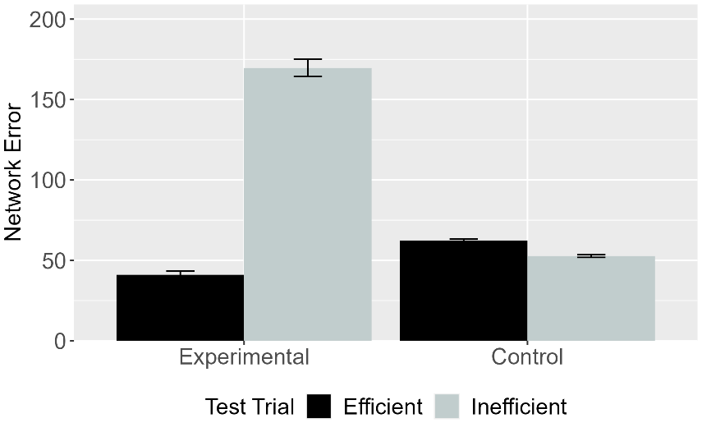 | 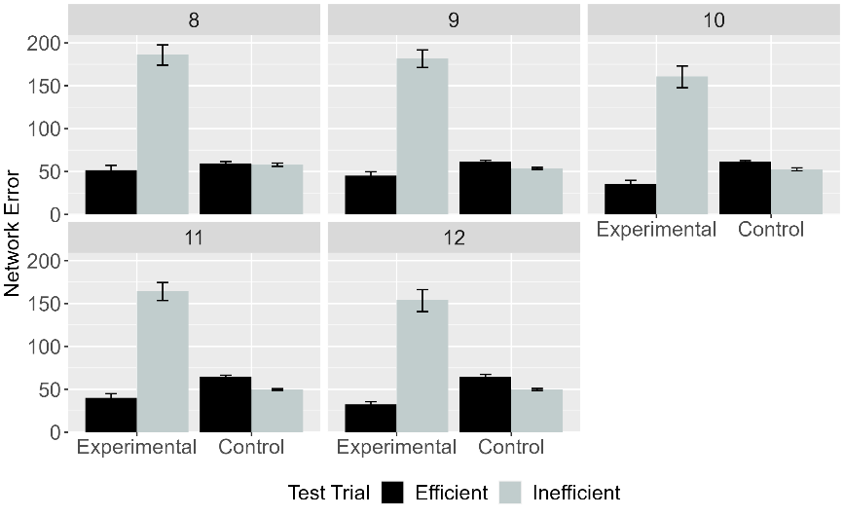
Figure 6. Performance of ALIAS. Mean network error produced to the Efficient and Inefficient test events in the Experimental and Control conditions (left) collapsed across habituation lengths and (right) as a function of habituation length.

Figure 6 shows ALIAS’s responses across the conditions. Networks in the Experimental condition produced greater error to the Inefficient than to the Efficient test event in the Experimental condition. In contrast, networks in the Control condition produced equivalent error to both test events.

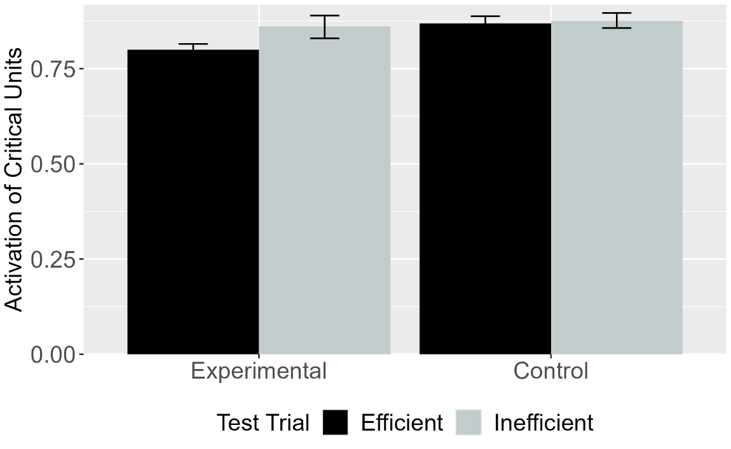
Figure 7. Performance of VOM10. Mean activation of the critical units for Efficient and Inefficient test events in the Experimental and Control conditions for VOM10.

Figure 7 shows that—like ALIAS—VOM10’s critical units were more active during the Inefficient than during the Efficient test event in the Experimental condition; these units were equivalently active in the Control condition. Although VOM10 also reproduced the first target finding, comparing its responses to those of ALIAS reveals that the effect was considerably smaller for VOM10 than for ALIAS.

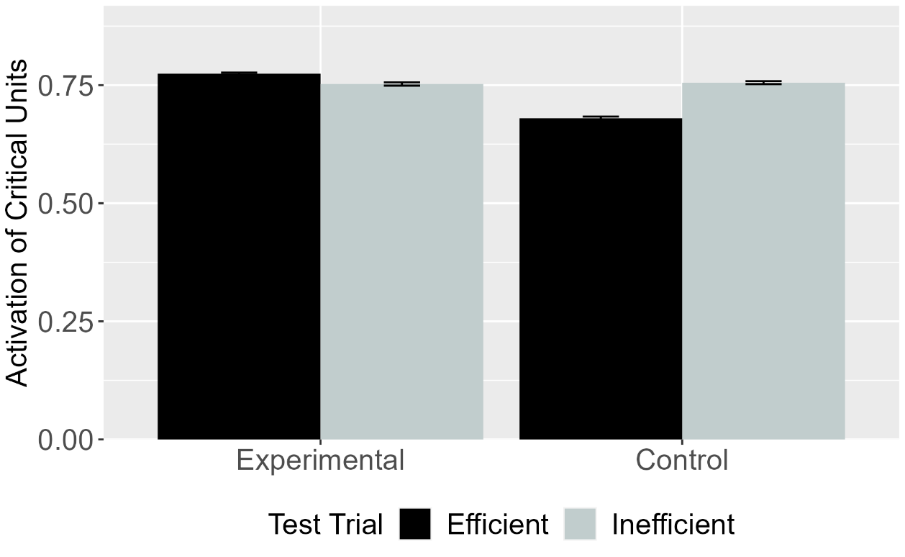
Figure 8. Performance of VOM10-2. Mean activation of the critical units for Efficient and Inefficient test events in the Experimental and Control conditions for VOM10-2.

To determine whether VOM10’s success depended on its implementation, its performance was compared to VOM10-2. Figure 8 shows that, in contrast to VOM10, VOM10-2’s critical units were more active during the Efficient than the Inefficient test event in the Control condition. These units showed equivalent activation in the Experimental condition.

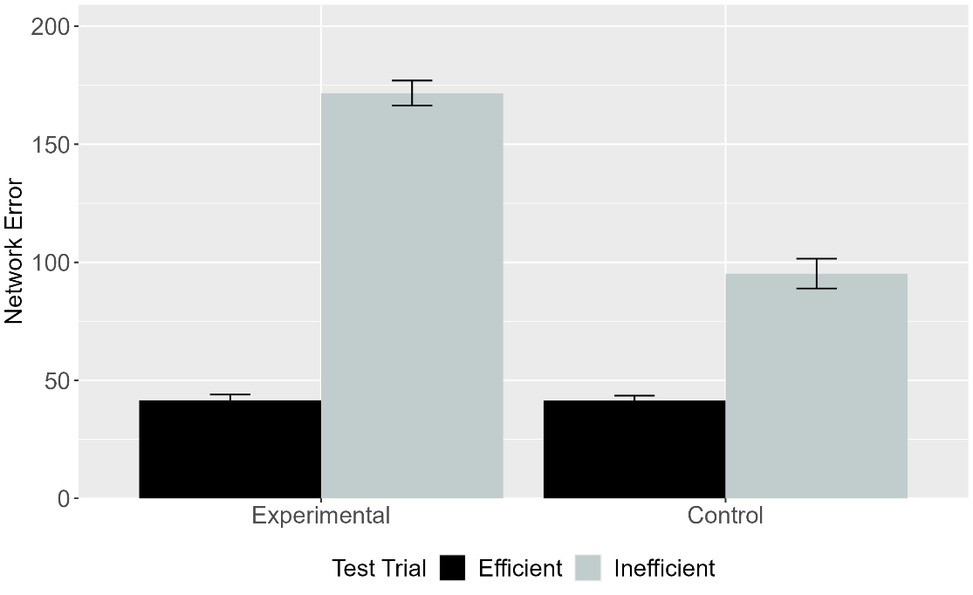
Figure 9. Performance of ALIAS-2. Mean network error produced to the Efficient and Inefficient test events in the Experimental and Control conditions.
The final analysis focused on ALIAS-2’s responses. Figure 9 shows that networks in both conditions produced greater error to the Inefficient than to the Efficient event, although the effect was clearly weaker in the Control than in the Experimental condition.
ALIAS’s—and to a lesser extent, ALIAS-2’s—ability to capture the first target finding suggests that it is premature to use this finding to conclude that infants’ sensitivity to action efficiency stems from specialized mechanisms supporting rich notions of agents, goals, constraints, cost, and efficiency. Instead, these findings demonstrate that an associative learning mechanism is sufficient to reproduce this pattern of behavior. Nevertheless, it was important to provide independent evidence that associative learning was responsible, at least in part, for ALIAS’s success. This can be achieved by tracing the model’s internal dynamics at various points throughout processing. Although the discussion below pertains to a single run (or subject), the mechanism that is described was typical of most model runs.
As described above, such processing began during the pretraining phase, in which networks were exposed repeatedly to events in which agents move along either straight or curved trajectories to reach other objects or agents. This pattern of activation is then propagated to the hidden layer via the weights between them. Because the network weights are small, random values at the beginning of training, this pattern of activity does not yet encode meaningful information about the input to the model. This hidden activity nevertheless propagates to, and elicits a corresponding pattern of activity over, the output groups via the weights connecting them. This pattern of activation is then compared to the target pattern of activation, and any discrepancy between them is treated as error. The network then uses this error to adjust the weights throughout the network.
Crucially, from the outset of the pretraining phase, linear and arced motion events produce distinct error patterns over the output groups, not least because they activate different perceptual features. A corollary of these disparate error signals is that both action events cause the weights throughout the network to move in different directions (e.g., Rogers & McClelland, 2004). These weight changes—particularly those connecting the input and hidden layers—culminate in meaningfully distinct representations emerging at the hidden layer capturing both types of motion and their corresponding visible surface features.
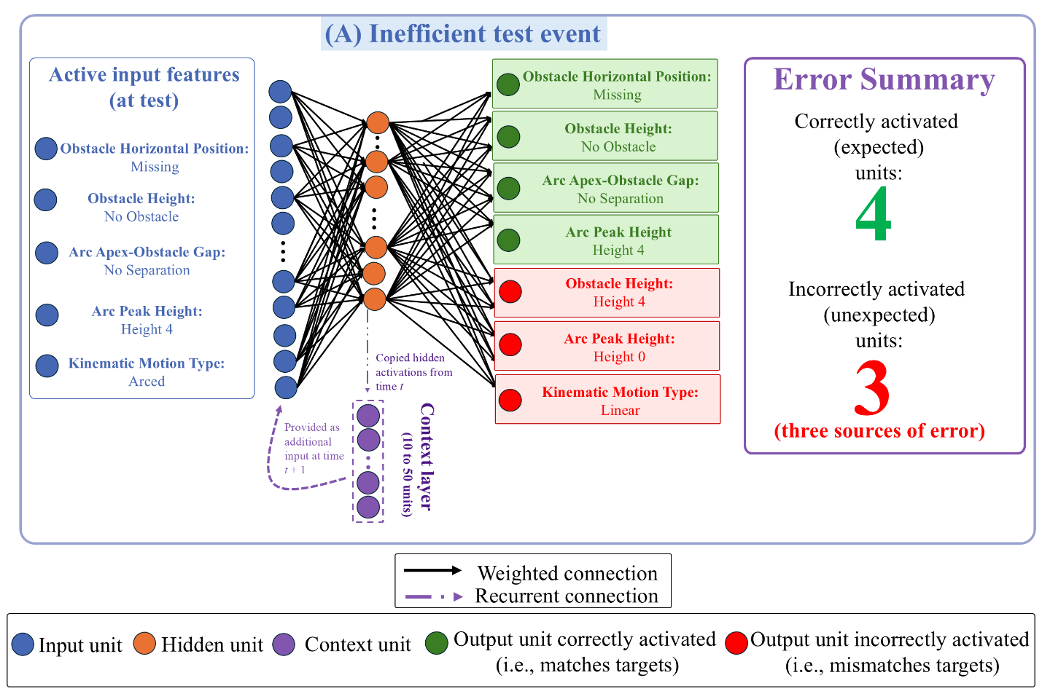
Figure 10. Mechanism underpinning ALIAS’s responses during the Inefficient test event in the Experimental condition. Active input features presented at test reactivated learned associations acquired during pretraining and habituation. Although the network correctly activated four of those features, it also incorrectly activated the Obstacle Height 4, Arc Peak Height 0, and Linear Motion units. These three erroneously activated units constituted the primary sources of error (and thus looking) during this event. Shown here: Units necessary to explain the basis of ALIAS’s responses during the Inefficient test event.

At the conclusion of the pretraining phase, networks entered the habituation phase. For those in the Experimental condition, four of the input features were familiar (i.e., Obstacle Horizontal Position Middle, Arc Apex-Obstacle Gap minimal separation, Spatially Contiguous, and Arc Path). These features activated at the output layer—via the hidden layer—the features they co-occurred with during pretraining. By contrast, because the remaining two features were novel (i.e., Obstacle Height 4 and Arc Peak Height 4), new associations had to be formed between them. Although habituation was much shorter than the pretraining phase, networks’ enhanced processing as “12-month-olds” enabled them to form these associations while preserving old ones.

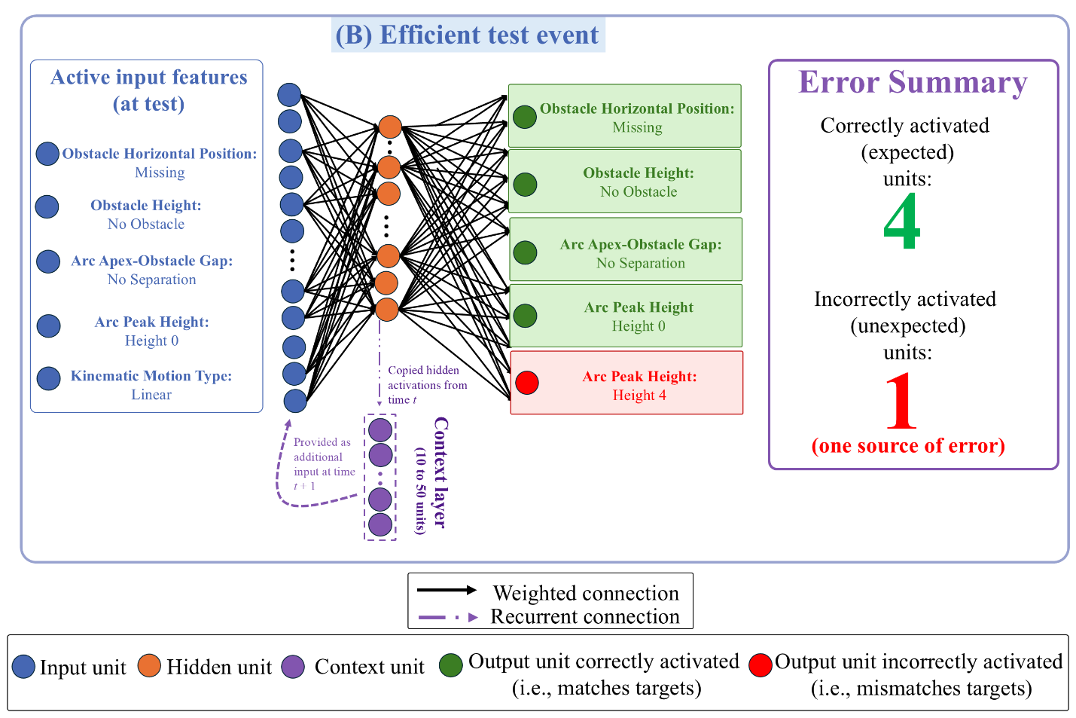
Figure 11. Mechanism underpinning ALIAS’s responses during the Efficient test event in the Experimental condition. Active input features reactivated many of the same learned associations observed in the Inefficient event. However, here only the Arc Peak Height 4 output unit was incorrectly activated. This one erroneously activated unit constituted the primary source of error (and thus looking) during this event.

Networks’ test responses can be understood as the consequence of learning and processing during these two phases. As shown in Figure 10, presentation of the input features associated with the Inefficient test event caused four output features to be correctly activated and three to be incorrectly activated. The first three were correctly activated due to associations formed among them during pretraining; the last (i.e., Arc Peak Height 4) was activated due to associations formed with itself during habituation. Two of the incorrect features (i.e., Arc Peak Height 0 and Kinematic Motion Type Linear) were activated because they co-occurred during pretraining. The last was activated because Obstacle Height 4 and Arc Peak Height 4 co-occurred during habituation.
For the Efficient test event, presentation of its input features caused four output features to be correctly activated and one feature to be incorrectly activated. The four features were activated due to their association during pretraining. The last feature was activated because it was associated with some of this event’s input features (not pictured in Figure 11) during habituation. The fact that two fewer units contributed to prediction error in the Efficient test event meant that networks spent less time looking at it than at the Inefficient one.
The same associative principles extend to the Control condition. The reduced salience of peripherally located obstacles in this condition meant that the weights connecting the Obstacle Height 4 and Periphery units to the other co-occurring features during habituation could not be adjusted sufficiently during this brief phase. In contrast, because features such as Arc Peak Height 4 were not subjected to the same salience manipulation, robust associations could form among these features. Thus, presentation of any of these features at test caused the Arc Peak Height 4 output unit to activate. This was the correct response in the Inefficientt test event but the incorrect response in the Efficient test event. Thus, there was one large contributor to error in the Efficient test event. By comparison, across model runs the Inefficient event tended to have two smaller contributors to error: the Linear Path and Arc Peak Height 0 units. These units were activated because they were linked to some of this event’s input features (e.g., Obstacle Height 0, Obstacle Horizontal Position Missing, etc.) during pretraining. Importantly, the combined contribution of these two units to the network’s total error in the Inefficient event matched the sole contributor to error in the Efficient test event. As a result, the network, like infants, produced comparable error to both test events.
Although ALIAS replicated the first target finding, one may urge that this result be interpreted cautiously because the network never experienced unconstrained motion during pretraining. By comparison, it seems likely that infants experience at least some amount of unconstrained motion in the real world, even if in absolute terms this amount is less than that of constrained motion. To address this potential limitation, Simulation 1b was carried out to evaluate the extent to which ALIAS’s initial success depended on no prior experience with unconstrained motion.

Simulation 1b: How prior experience with unconstrained action impacts processing
This simulation was identical to Simulation 1a with one major exception: the ratio of constrained-to-unconstrained motion was varied during pretraining. The ratios ranged from 100% vs. 0% to 50% constrained vs. 50% unconstrained, in 10% increments. A 90% constrained vs. 10% unconstrained corresponded to observing constrained motion 90% of the time and unconstrained motion just 10% of the time during pretraining. ALIAS’s performance was not compared to that of the competitor models.

Results and Discussion
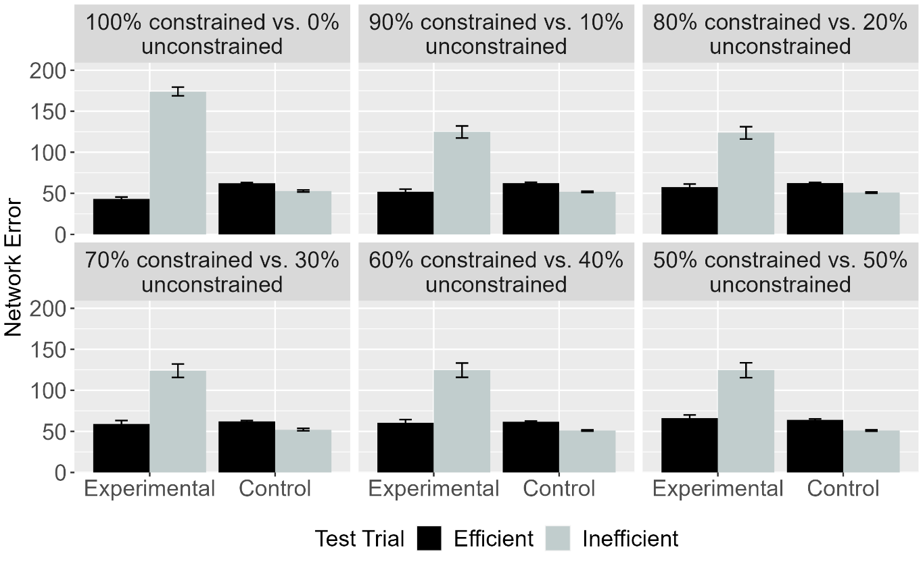Figure 12. Performance of ALIAS. Mean network error produced to the Efficient and Inefficient test events in the Experimental and Control conditions across different ratios.

The results for this simulation—shown in Figure 12—demonstrate that regardless of the ratio of constrained to unconstrained motion experienced during pretraining, those in the Experimental condition produced more error to the Inefficient test event than to the Efficient one; those in the Control condition produced comparable error to both test events. These results indicate that ALIAS’s success in Simulation 1a did not hinge on it having never experienced unconstrained motion during pretraining.
It might be surprising that—at least in the 50% constrained versus 50% unconstrained condition, in which networks experienced an equal proportion of arced- and linear-path events during pretraining—networks did not produce equivalent error to both test events across conditions. This prediction did not bear out because all networks experienced an additional arced-path event during habituation. These additional weight changes meant that associations among the features comprising the arced-path event were further strengthened, thereby increasing the likelihood that presenting some of its features at test would incorrectly activate others, produce greater error, and ultimately lead to differential treatment of the test events.
Having established that ALIAS could capture the first target finding and that its performance did not depend on absent prior experience with unconstrained motion, Simulation 2 examined whether the same associative mechanism could reproduce the second target finding.

Simulation 2: Independence from animacy.
This simulation examined whether ALIAS could reproduce the finding that infants’ looking responses do not depend on the objects involved possessing animate-typical features. As such, the objects used here possessed inanimate-typical features. Networks were 9 months old. Only ALIAS and ALIAS-2 were examined because neither VOM10 nor VOM10-2 could represent whether an object possessed animate- or object-typical surface features.

Results and Discussion
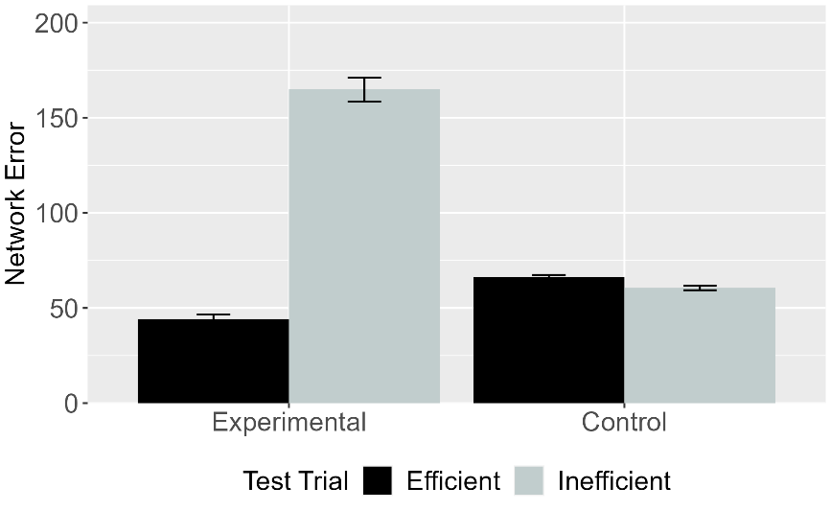 | 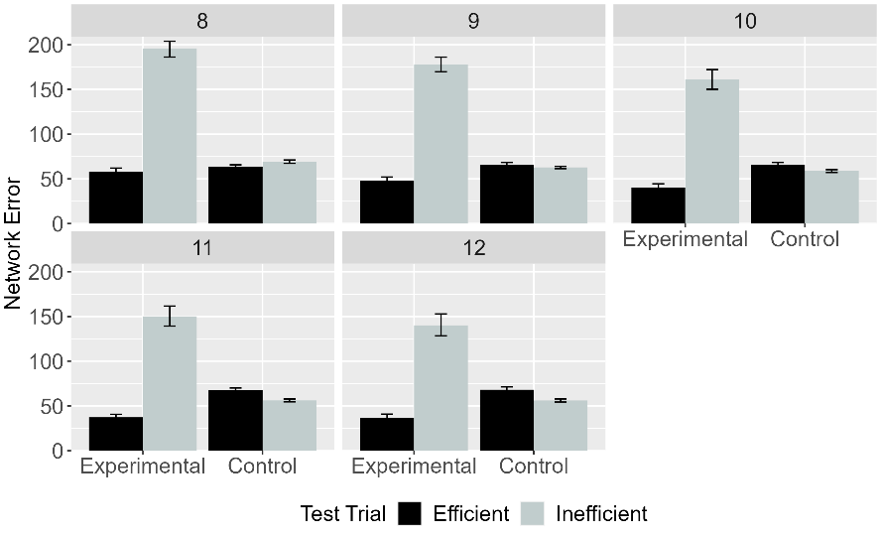
Figure 13. Performance of ALIAS. Mean network error produced to the Efficient and Inefficient test events in Simulation 2 across conditions overall (left) and different habituation epochs (right).

Figure 13 shows that networks in the Experimental condition produced more error to the Inefficient than to the Efficient test event, whereas those in the Control condition produced equivalent error to both events. These results indicate that ALIAS’s responses—like infants’—did not hinge on objects possessing animate-typical features.

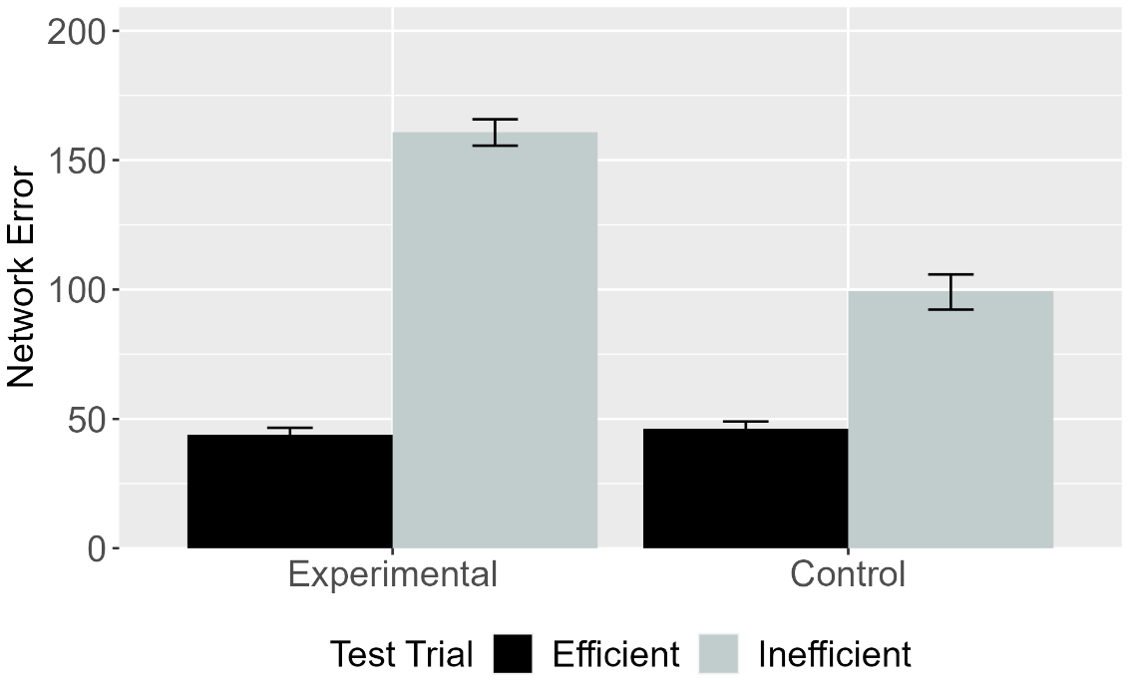
Figure 14. Performance of ALIAS-2. Mean network error produced to Efficient and Inefficient test events in the Experimental and Control conditions.

Figure 14 shows ALIAS-2’s performance. Networks in both conditions produced greater error to the Inefficient than to the Efficient event. However, as was true in Simulation 1a, this effect was weaker in the Control than in the Experimental condition. The fact that ALIAS-2 only partially replicated the second target finding indicates that associative learning over differentially salient surface features is necessary to capture it.
Together, Simulations 1 and 2 demonstrate that the same associative learning mechanism can account for infants’ looking behavior regardless of prior experience with unconstrained motion or whether the objects possessed animate- or inanimate-typical surface features. Nevertheless, one potential criticism of the simulations presented thus far is that they provide only weak evidence for ALIAS’s explanatory breadth, given that both target findings were derived from closely related paradigms. Simulation 3 addressed this criticism by assessing whether ALIAS could capture a more substantively different target finding.

Simulation 3: Bidirectional inferences about actions, goals, and constraints.
This simulation examined whether ALIAS could account for findings that have been taken to show that 12-month-olds make bidirectional inferences among goals, actions, and constraints. Crucially, this simulation represents a substantially more demanding test of ALIAS’s theoretical scope because the target findings have been argued to require richer inferential abilities than mere sensitivity to the statistical regularities among low-level action features. The target findings come from a classic study by Csibra et al. (2003). In the first experiment, infants were habituated to an event in which a large circle appeared to be chasing a small circle. However, before the large circle reached the small one, the small circle moved through a narrow gap between two bars before disappearing from the screen; the width of the gap forced the large circle to move around one of the bars. The fact that the large circle never reached the small one before it disappeared from the screen meant that the large circle’s goal of reaching the small one had to be inferred. The authors found that when the gap was widened, infants looked longer when the large circle continued moving around one of the bars than when it moved through it. Although this experiment differed from the more standard “over-the-barrier” paradigm, it is possible to instantiate it within that framework by terminating the habituation event after the first object cleared the barrier but before it reached the second object. This ensured that the first object’s goal remained ambiguous, thereby preserving the critical inferential demands of the original experiment. This was the approach taken in the next simulation.
In a second experiment, infants were habituated to a constrained action event except that the barrier was hidden behind an opaque screen. Infants could nonetheless see the second object and parts of the first object’s arced motion path. Csibra et al. (2003) found that infants looked longer when the first object followed the same curved path in the absence of an obstacle than in its presence. These findings were taken to support the teleological stance. This simulation tested whether instead they could be captured by an associative learning mechanism. To model these experiments, networks were assigned either to the Inferring Goals or to the Inferring Constraints condition. The habituation event in the Inferring Goals condition was identical to that in Simulation 1a except that networks could not know whether the first object’s goal was met (i.e., whether it stopped next to the second one). The Inferring Constraints condition was implemented by removing all barrier information during habituation. This simulation was identical to Simulation 1a in all other respects. As in Simulation 1a, ALIAS’s performance was compared to that of the competitor models.

Results and Discussion
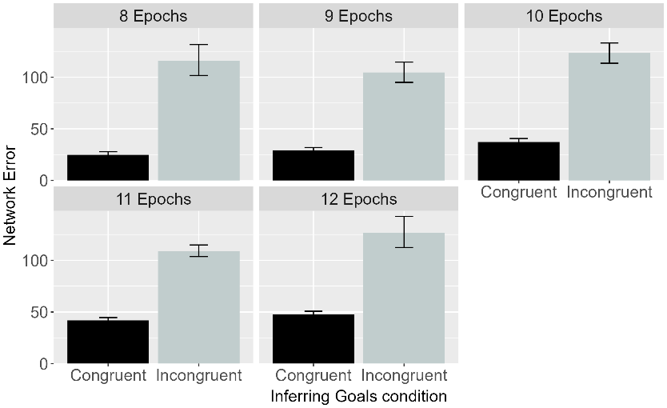 | 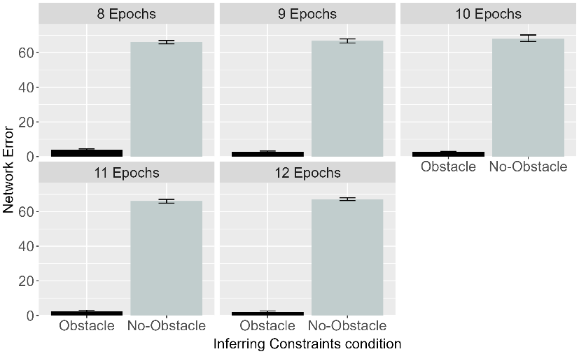
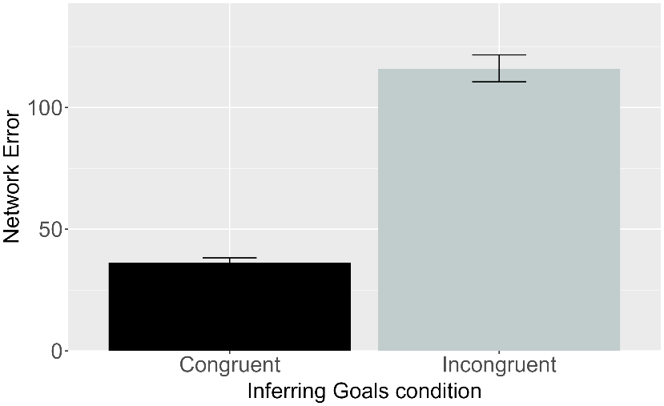 | 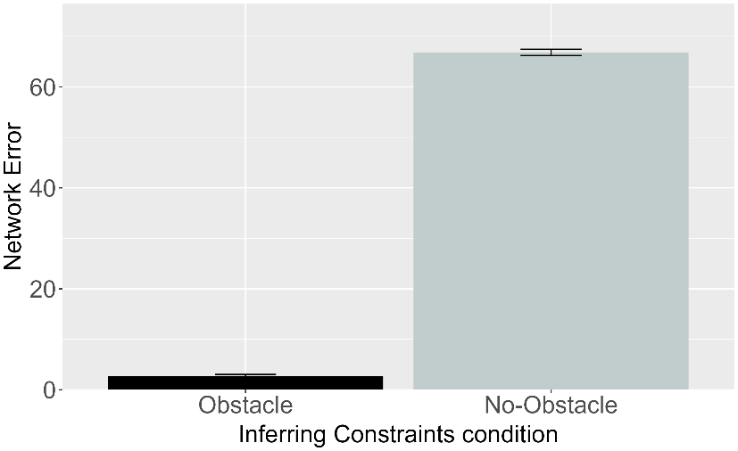

Figure 15. Performance of ALIAS. Plotted is the mean network error produced to the Congruent and Incongruent test events for networks in the Inferring Goals condition (left column) and to the Obstacle and No-Obstacle test events for networks in the Inferring Constraints condition across habituation epochs (top row) and overall (bottom row).

Figure 15 shows ALIAS’s performance across the conditions. Networks in the Inferring Goals condition produced greater error to the Incongruent than to the Congruent test event. This pattern arose because the former test event violated a learned association between arced motion over a small barrier and spatial contiguity between the two objects. Networks in the Inferring Constraints condition produced more error to the No-Obstacle than to the Obstacle test event. This pattern arose because the former test event violated a learned association between arced motion and obstacles.

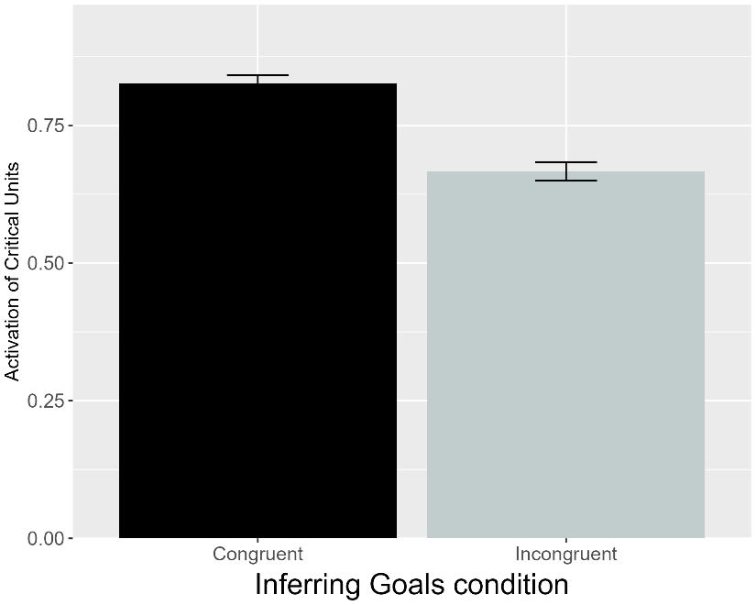 | 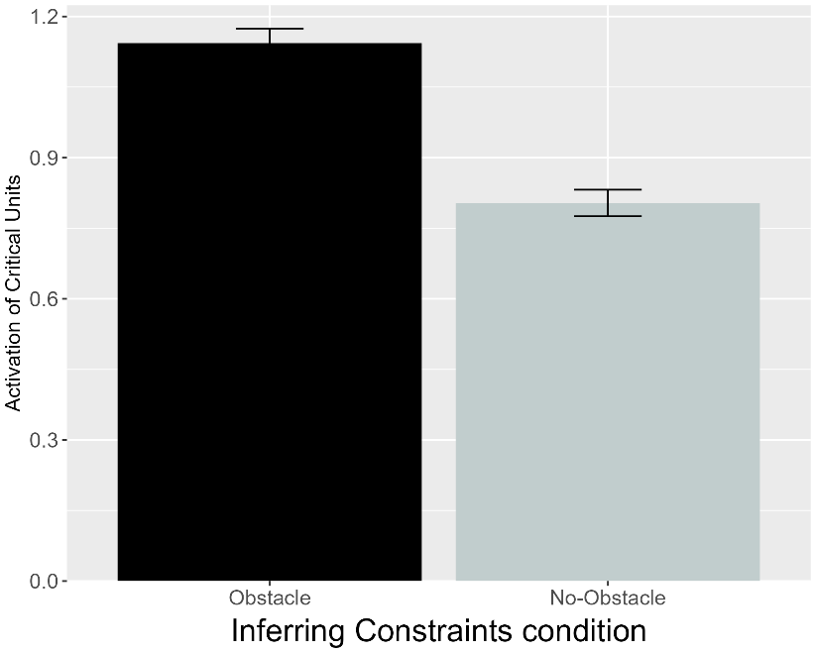
Figure 16. Performance of VOM10. Plotted is the mean activation of the critical units produced to the Congruent and Incongruent test events for networks in the Inferring Goals condition (left) and to the Obstacle and No-Obstacle test events for networks assigned to the Inferring Constraints condition (right).

Figure 16 shows that VOM10 failed to reproduce the target findings. Networks in the Inferring Goals condition produced more activation to the Congruent than to the Incongruent test event. Likewise, networks in the Inferring Constraints condition produced more activation to the Obstacle than to the No Obstacle test events.

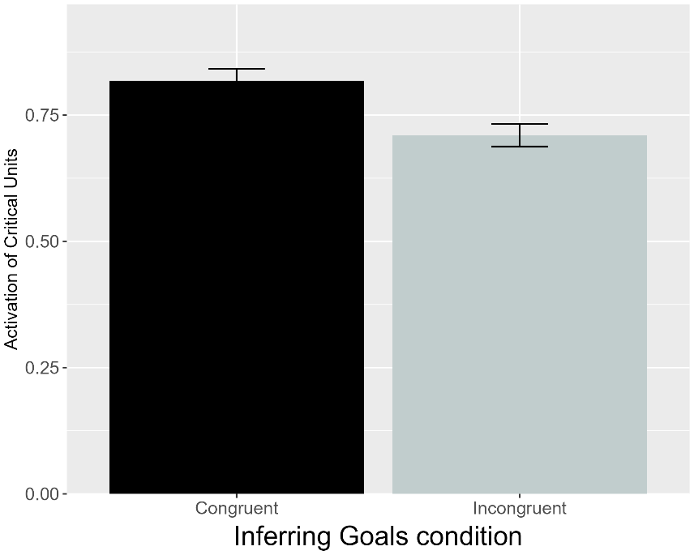 | 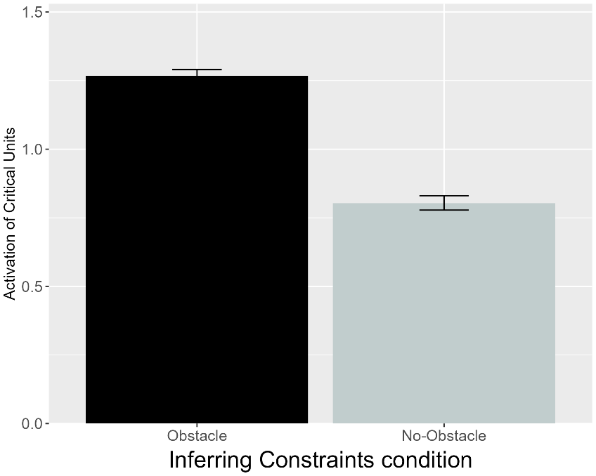
Figure 17. Performance of VOM10-2. Plotted is the mean activation of the critical units produced to the Congruent and Incongruent test events for networks in the Inferring Goals condition (left) and to the Obstacle and No-Obstacle test events for networks assigned to the Inferring Constraints condition (right).

Figure 17 shows that VOM10-2 responses mirrored those of VOM10. The fact that both versions failed to reproduce the third target finding suggests that this limitation reflects a more fundamental inability of VOM10 than compromised implementational fidelity.

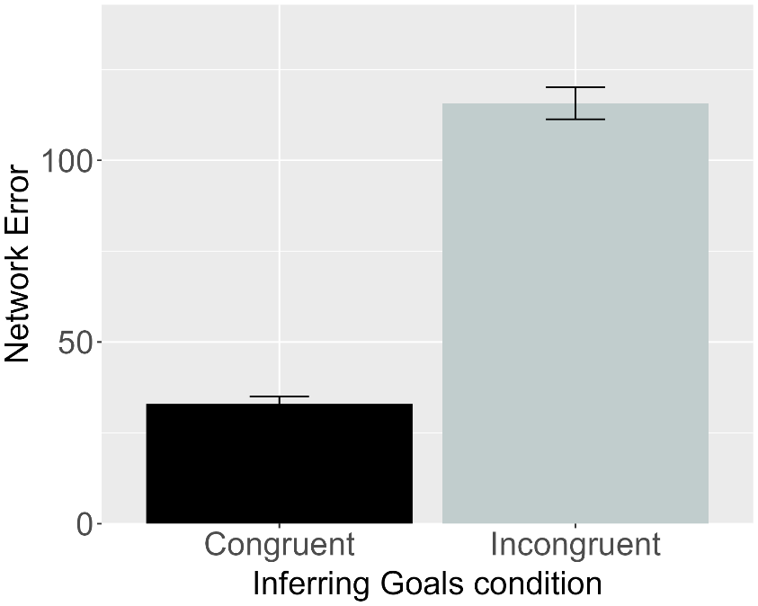 | 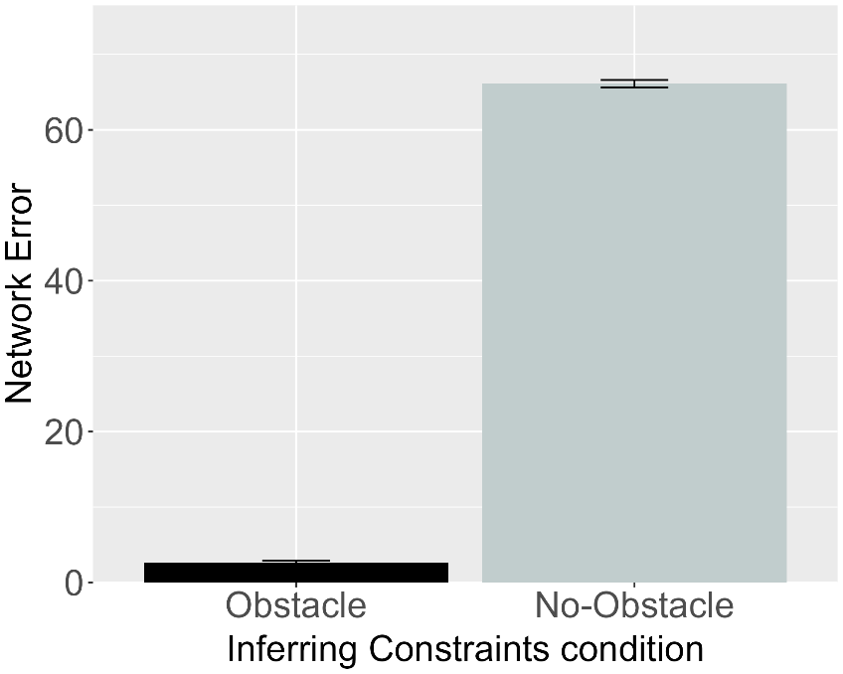
Figure 18. Performance of ALIAS-2. Plotted is the mean network error produced to the Congruent and Incongruent test events for networks assigned to the Inferring Goals condition (left) and to the Obstacle and No-Obstacle test events for networks in the Inferring Constraints condition (right).

Figure 18 shows that, like ALIAS, ALIAS-2 networks looked longer at their condition’s respective inconsistent test event. The fact that both versions of ALIAS were successful in capturing the third target finding suggests that associative learning alone is sufficient to capture this pattern of behavior. A clear pattern that is emerging across the simulations is that it is not necessary to posit specialized mechanisms or a rich understanding of goals, action, efficiency, or cost to explain infants’ looking behaviors in action efficiency understanding studies. Such behavior can instead be readily captured by and emerge from associative learning.
Nevertheless, one might continue to argue that even this simulation does not pose a sufficiently strong challenge to ALIAS and that a more compelling test of its explanatory scope would be to show that it can capture data from Liu and Spelke’s (2017) study. They habituated 6-month-olds either to a constrained action event (Experiment 1) or to an unconstrained one (Experiment 2). Infants were then tested either on constrained Low, efficient and constrained High, inefficient test events (Experiment 1) or on unconstrained versions of these events (Experiment 2). Liu and Spelke (2017) found that infants in Experiment 1 looked longer at the High, inefficient test event when the agent jumped higher than needed to clear the barrier than at the Low, efficient one; infants in Experiment 2 looked numerically, but not significantly, longer at the Low, efficient test event. These findings were interpreted to mean that infants can represent efficiency continuously.
A final experiment habituated infants to the event used in Experiment 2 and then tested on the constrained events used in Experiment 1. Now infants looked longer at the High, inefficient test event than at the Low, efficient one. These findings suggest that infants responded as if they expected previously inefficient agents to behave efficiently in a new situation and were argued to support naïve psychology and naïve physics systems (Liu et al., 2026). Simulation 4 tested whether such conclusions were warranted.

Simulation 4: Graded representations of efficiency.
This simulation tested whether ALIAS could capture the finding that infants ostensibly represent efficiency continuously and expect agents to behave efficiently in future situations despite their past actions. Six-month-old networks were habituated to and tested on events analogous to those in Experiments 1-3 in Liu and Spelke (2017). ALIAS’s performance was compared only to VOM10-2 and ALIAS-2. VOM10 was not included because its original implementation omitted barrier information during the prediction (i.e., test) phase. Modifying this model to include such information during test would have represented a substantial departure from its implementation in the previous simulations and in Van Overwalle (2010).

Results and Discussion
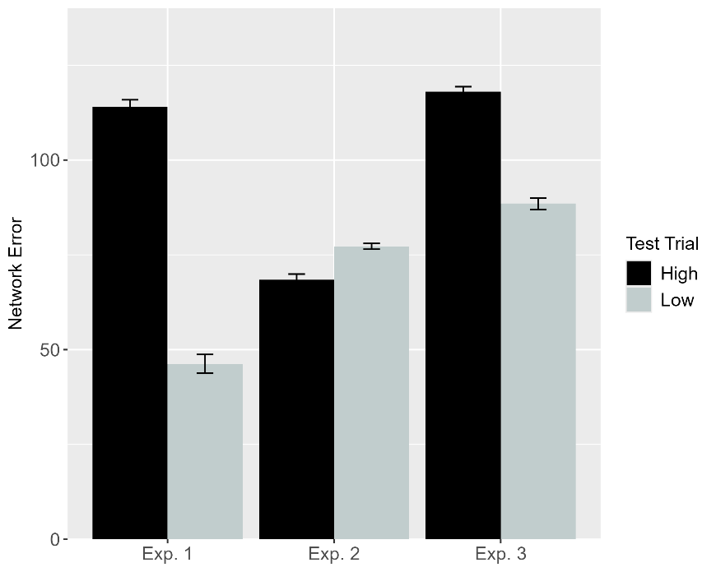 | 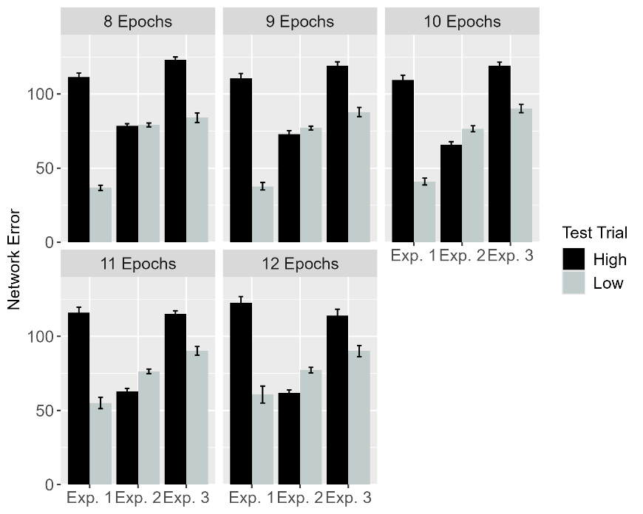
Figure 19. Performance of ALIAS. Plotted is networks’ mean error to the High, inefficient and Low, efficient test events across experiments overall (left) and across different habituation epochs (right). These experiments correspond to those in Liu and Spelke (2017).

Figure 19 shows ALIAS’s responses. Networks in Experiments 1 and 3 produced more error to the High, inefficient than to the Low, efficient one. This pattern of error stemmed from the fact that the High, inefficient test event violated learned associations among a small obstacle, a low jump, and minimal vertical clearance. Such associations were largely preserved in the Low, efficient test event. Networks in Experiment 2 produced numerically more error to the Low, efficient than to the High, inefficient test event.

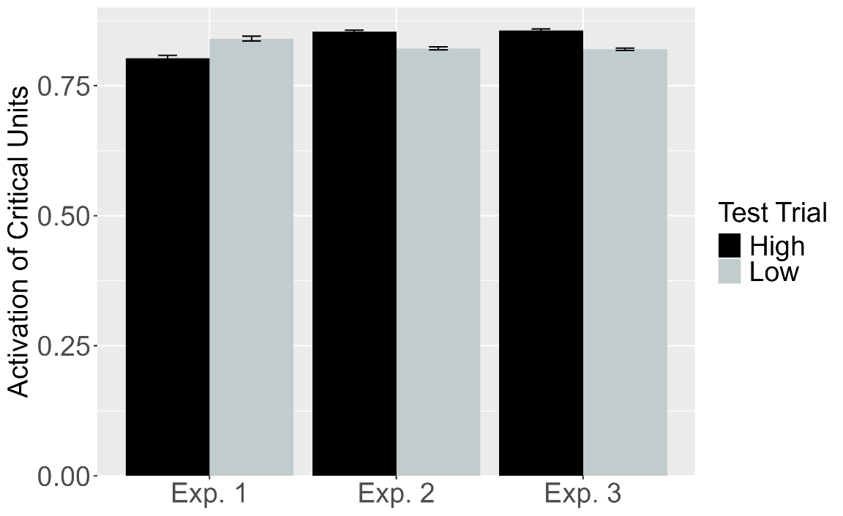
Figure 20. Performance of VOM10-2. Plotted is the mean activation of the critical units produced to the High, inefficient and Low, efficient test events for networks in Experiment 1-3.

As shown in Figure 20, although VOM10-2 captured infants’ looking responses in Experiment 3—showing slightly more critical unit activation following the High, inefficient test event than the Low, efficient test event—its responses in Experiments 1 and 2 did not match those of infants. In Experiment 1, networks produced more activation to the Low, efficient than to the High, inefficient test event. This pattern was reversed in Experiment 2.

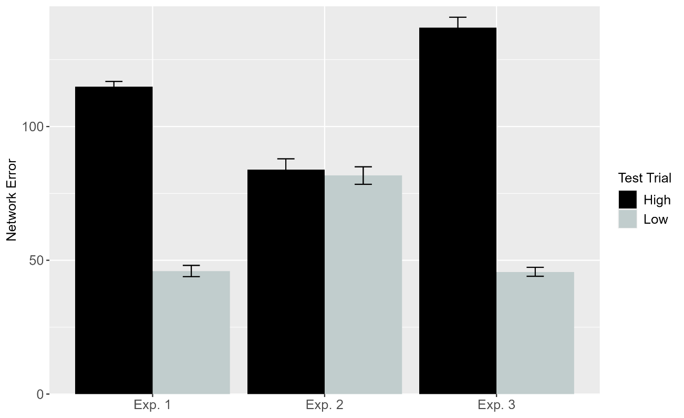
Figure 21. Performance of ALIAS-2. Plotted is networks’ overall mean error to the High, inefficient and Low, efficient test events across experiments.

Figure 21 shows ALIAS-2’s responses. Networks in Experiments 1 and 3 produced more error to the High, inefficient test event than to the Low, efficient one. Networks in Experiment 2 produced equivalent error to both test events. This latter result contrasts with ALIAS’s behavior and infants’ tendency numerically to look longer, albeit not reliably so, at the Low, efficient than the High, inefficient test event. These findings suggest that associative learning must be coupled with differential obstacle salience to capture the complete data associated with the current target finding. More broadly, ALIAS’s success in capturing the first four target findings suggests that it possesses substantial explanatory scope. At the same time, all four findings involve infants with months of real-world action experience. Thus, for ALIAS to constitute a truly viable account of infants’ looking behavior, it must also explain why much younger infants exhibit similar looking patterns to older infants when given direct-action experience (e.g., Skerry et al., 2013).
Simulation 5 tested whether temporarily increasing ALIAS’s attention to, and encoding of, its own straight reach trajectories during a simulated action phase could reproduce this finding despite its limited prior action experience. This simulation focused on the ALIAS models because they were the only ones capable of simulating development.

Simulation 5: Action efficiency understanding in pre-reaching infants.
This simulation examined whether ALIAS could reproduce the looking behavior of pre-reaching infants in Skerry et al. (2013) when its attention was temporarily heightened during a simulated action phase. Because Skerry et al. (2013) did not report the length of the action phase, their lengths were equated here. The assumption that infants’ reaches approximate straight trajectories during the action phase was implemented by exposing networks only to straight motion during this phase.
Networks were assigned to one of three conditions: Effective Action, Ineffective Action, or No Training. Those in the Effective Action condition were assigned either to the Experimental or to the Control condition. The hypothesis that sticky-mitten experience temporarily heightens attention was implemented by increasing the learning rate on all connections to 0.175 during the action phase for networks in the Effective Action condition only. The learning rate returned to its developmental value at the start of habituation. Networks in the Ineffective Action and No Training conditions retained their developmental learning rate throughout training. All other aspects of the simulation were identical across conditions.

Results and Discussion
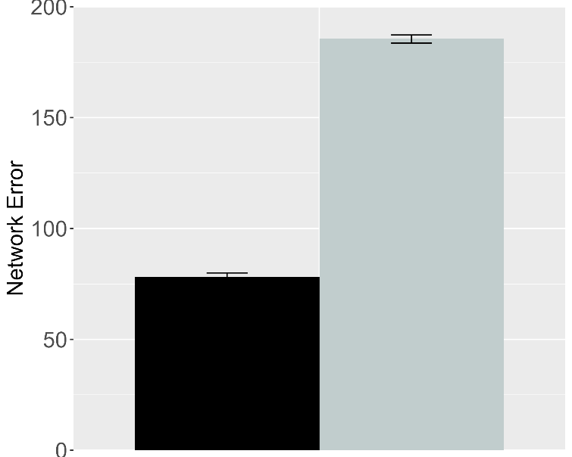 | 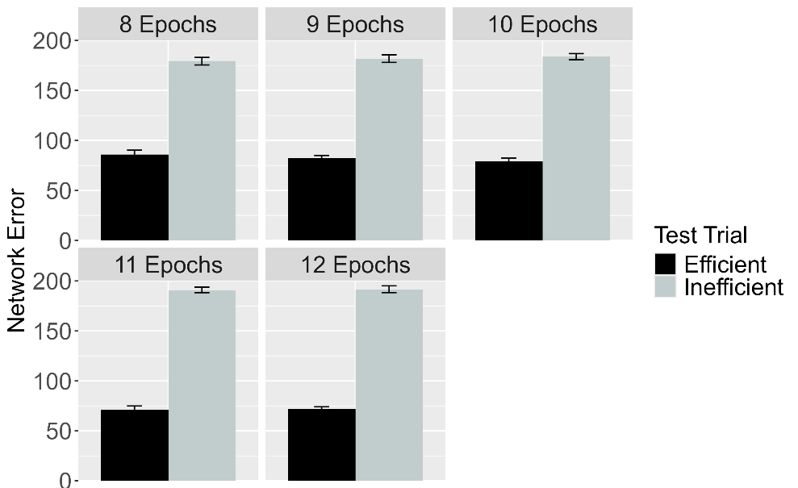
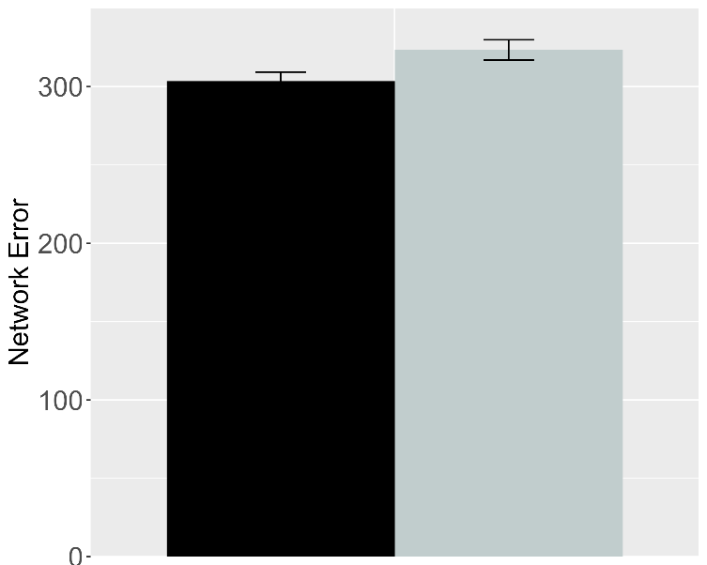 | 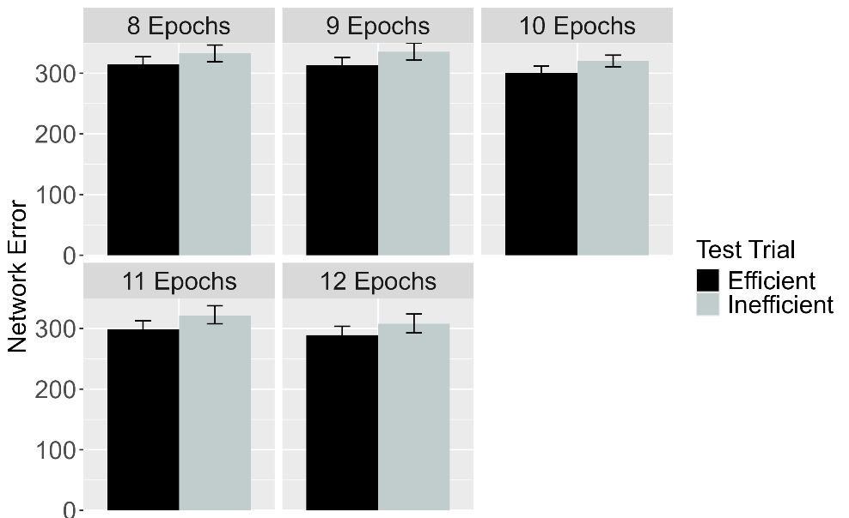
Figure 22. Performance of ALIAS in the Effective Action condition. Plotted is networks’ mean error to the Efficient and Inefficient test events in the Experimental (top row) and Control conditions (bottom row), both overall (left column) across different habituation epochs (right column). The Experimental and Control conditions correspond to Experiments 1, 4, and 5 in Skerry et al. (2013).

Figure 22 shows the test performance of ALIAS in the Effective Action condition. Results show that networks in the Experimental condition—like the 3-month-olds in the corresponding condition in Skerry et al. (2013)—produced more error to the Inefficient than to the Efficient event. Although networks in the Control condition showed a slight tendency to produce more error to the Inefficient test event than to the Efficient one—a result stemming from the fact that networks’ behavior is less variable than that of infants’—it is clear from the figure that the effect was substantially attenuated in this condition.

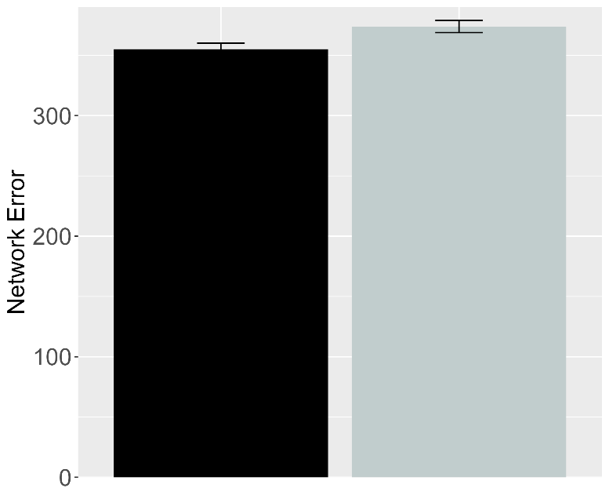 | 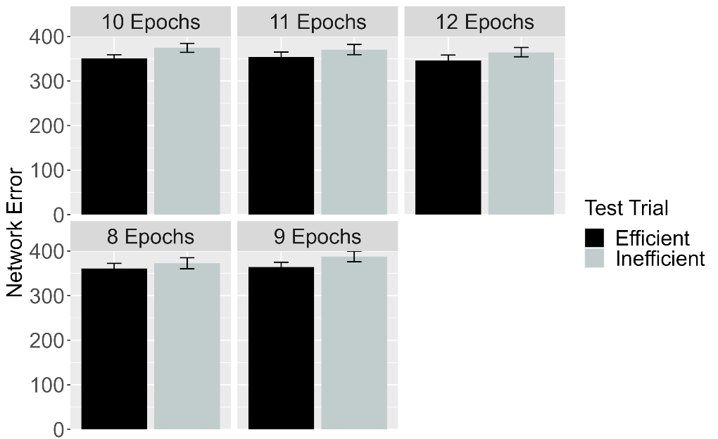
Figure 23. Performance of ALIAS in the No Training condition. The overall error produced to the Efficient and Inefficient test events is shown on the left, and the error produced across different habituation epochs is shown on the right. This condition corresponds to Experiment 3 in Skerry et al. (2013).

Figure 23 shows the performance of networks in the No Training condition. As in the Control condition above, networks produced slightly more error to the Inefficient than to the Efficient test event, but again there was considerable attenuation of this effect relative to that seen in the Experimental condition. If prior or pretraining experience with constrained motion was sufficient for networks to associate arced motion with barriers and then to detect violations of such associations at test, the performance profiles of networks in the Effective Experimental and No Training conditions should have overlapped to a greater degree across conditions.

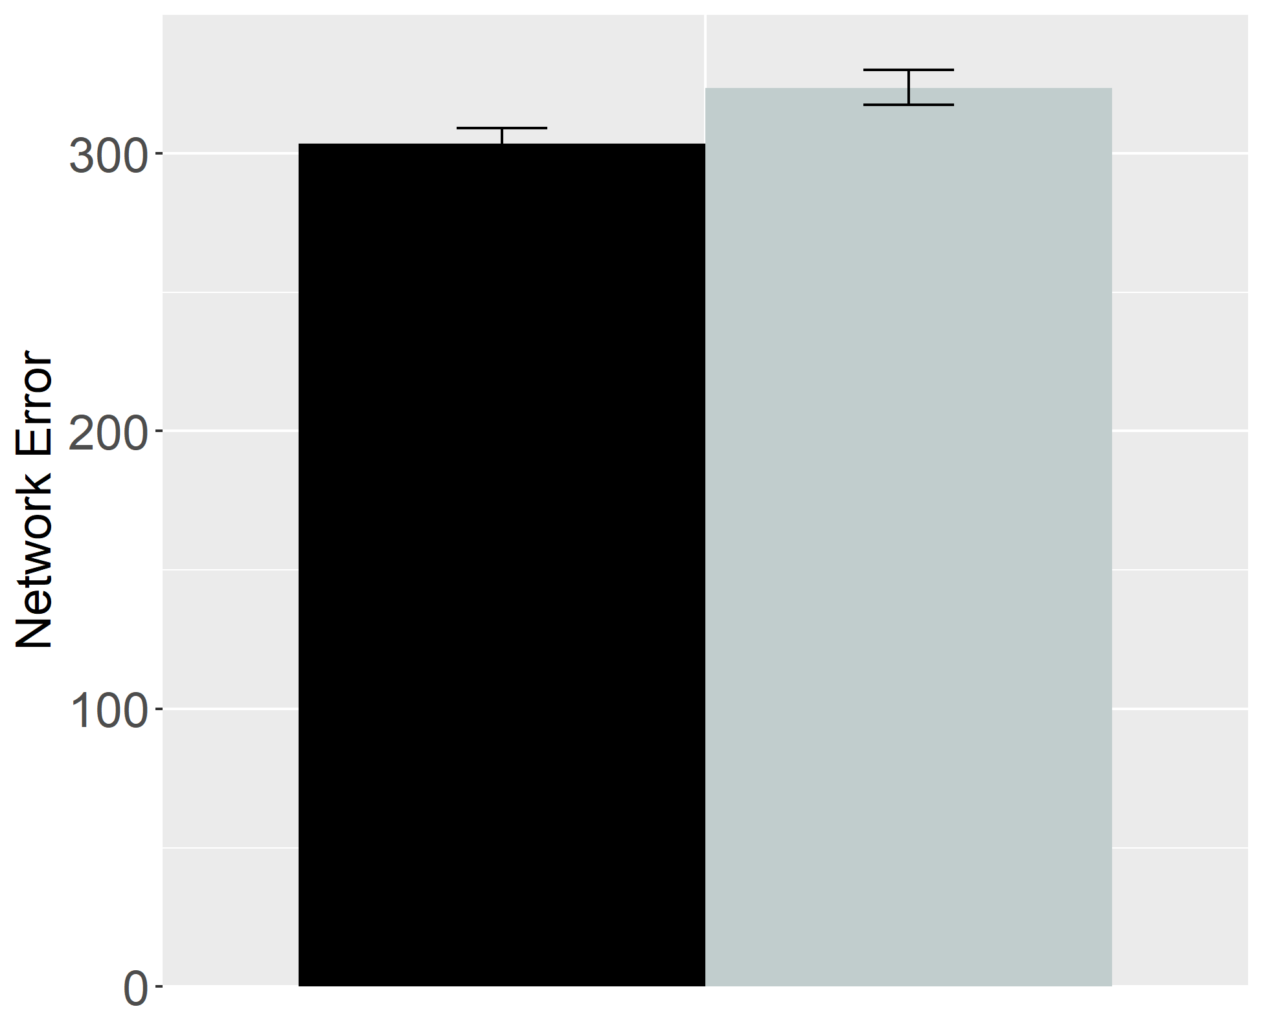 | 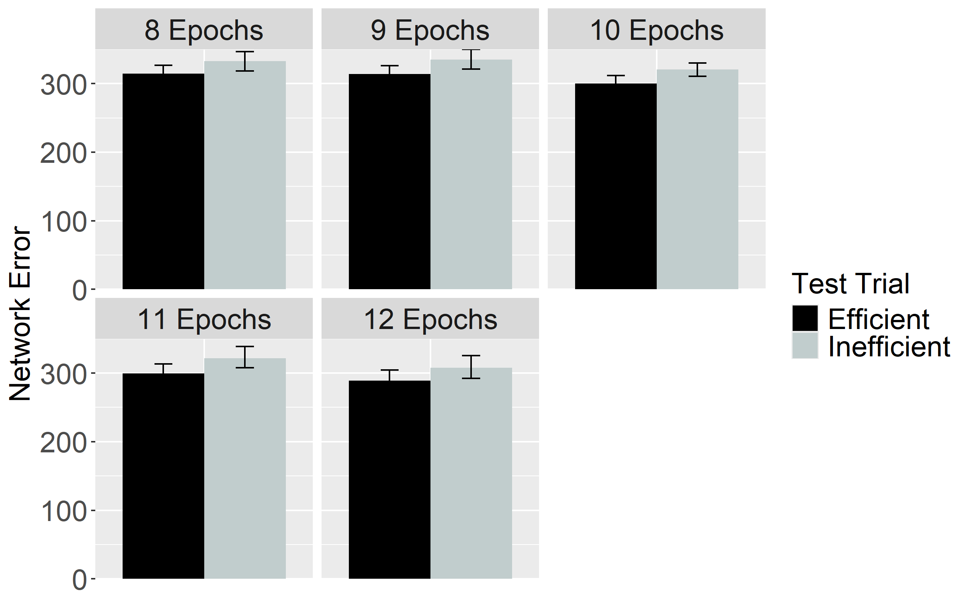
Figure 24. Performance of ALIAS in the Ineffective Action condition. The overall error produced to the Efficient and Inefficient test events is shown on the left, and the error produced across different habituation epochs is shown on the right. This condition corresponds to Experiment 2 in Skerry et al. (2013).

Figure 24 shows the performance of networks in the Ineffective Action condition. As with networks in the Effective Control and No Training conditions above, there was a slight, but again substantially attenuated, tendency to produce more error to the Inefficient than to the Efficient test event. These results indicate that enhanced encoding of straight reach trajectories is necessary to demonstrate a pattern of performance that mirrors that of older networks (and by analogy, that of older infants); participation in an action phase is clearly insufficient.

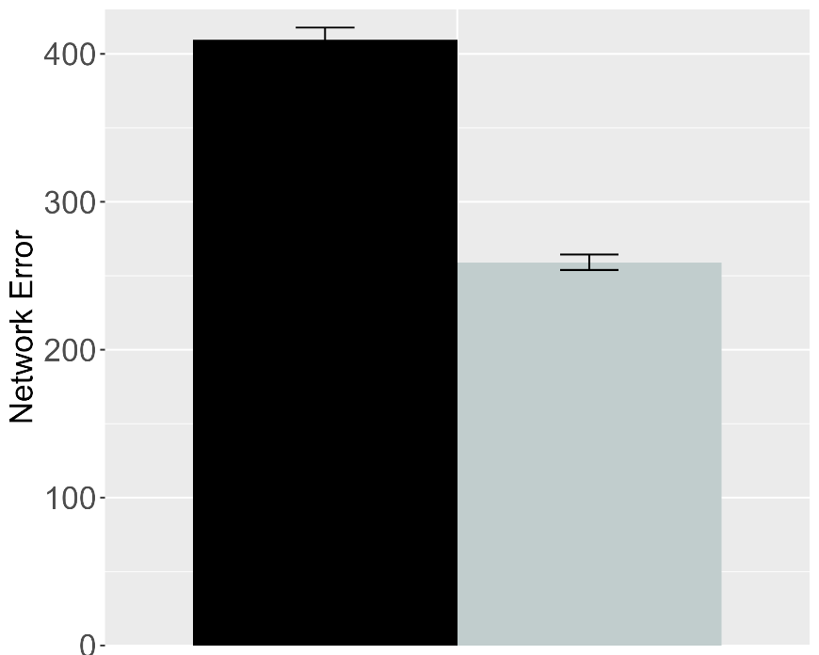 | 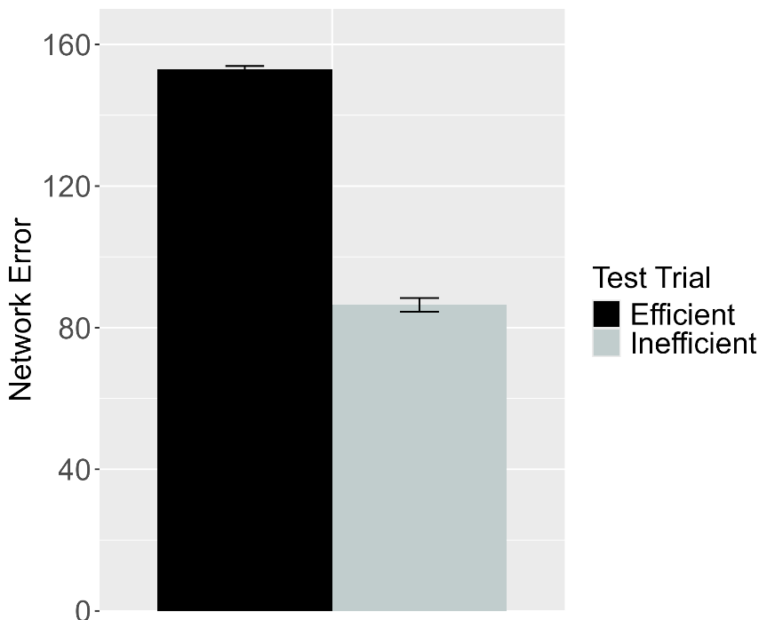
Figure 25. Performance of ALIAS in the Experimental (left) and Control (right) conditions of the Effective Action condition. These data correspond to a version of ALIAS in which the attentional boost extends into the habituation phase.

One of the critical assumptions of ALIAS is that the attentional boost afforded by sticky mittens experience must be short-lived for networks to produce a mature error pattern. To evaluate the necessity of this assumption, the attentional boost extended into habituation for a different set of networks. Figure 25 shows that now networks produced more error to the Efficient than to the Inefficient test event. Although networks formed a robust representation of straight motion during the action phase, the fact that their attention remained heightened during habituation meant that this representation was overridden by a robust arced motion-obstacle association. Consequently, the Inefficient test event was more consistent with this representation than the Efficient test event. Production of error patterns like those of older networks thus depends on an ephemeral attentional boost.
This finding makes an interesting and perhaps counterintuitive prediction: Infants should look longer at the Efficient than at the Inefficient test event following experimental manipulations that induce a prolonged attentional boost. Additionally, the model predicts that if the action phase follows rather than precedes habituation, infants should show the canonical pattern of longer looking to the Inefficient than to the Efficient test event. In both cases, longer looking to one event or the other would be due to competing low-level motion representations rather than consideration of each event’s relative efficiency.

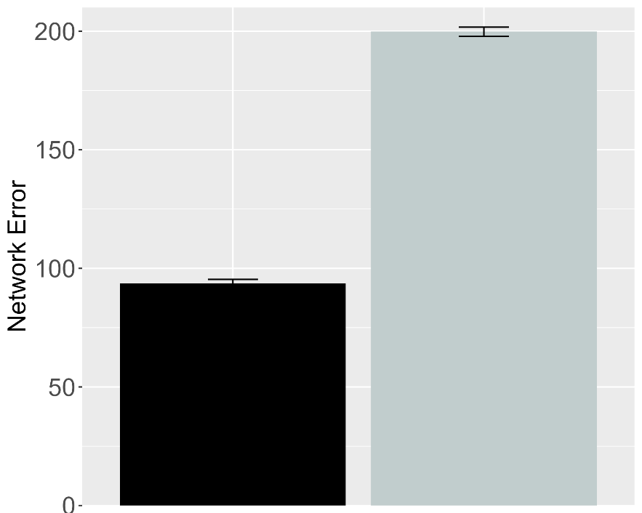 | 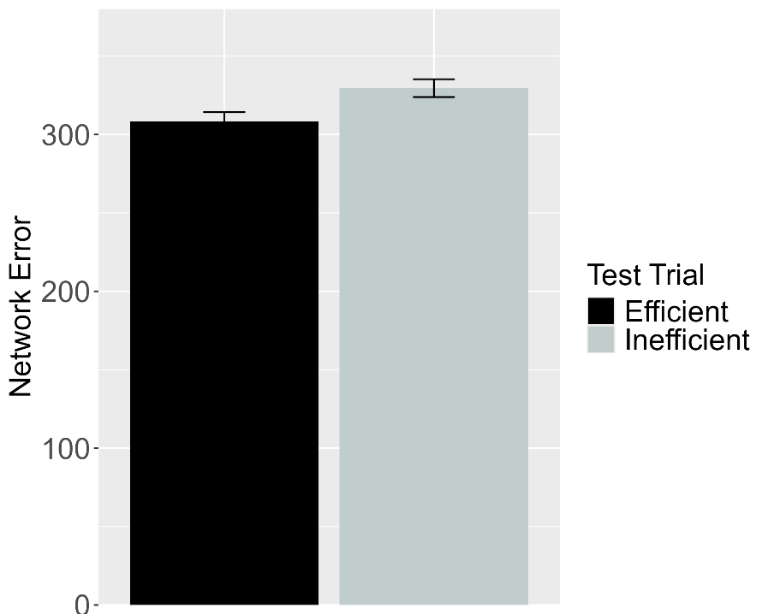
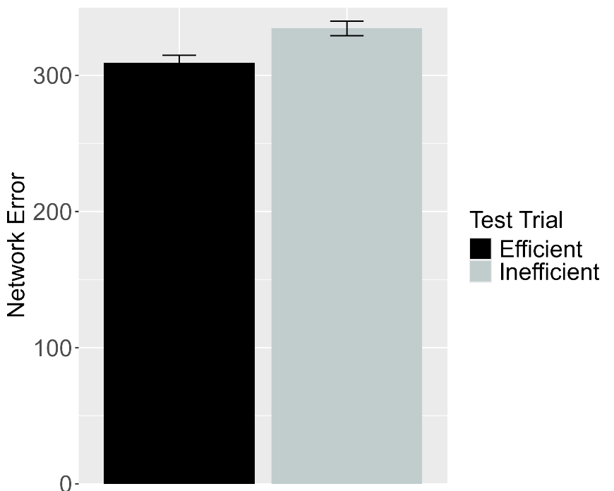
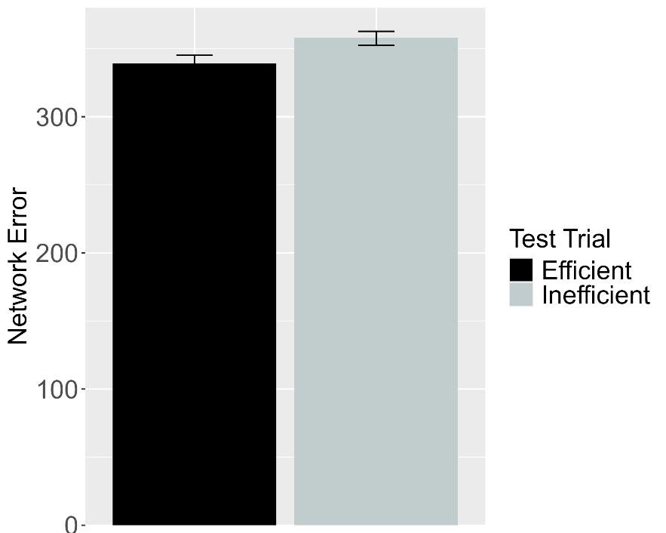
Figure 26. Performance of ALIAS-2. Plotted in the top row is the overall mean error to the Efficient and Inefficient test events for networks assigned either to the Experimental (top left) or to the Control condition (top right) in the Effective Action condition. Plotted in the middle row is the overall mean error to the two test events for networks assigned to the Ineffective Action condition. Plotted in the bottom row is the overall mean error to the two test events for networks assigned to the No Training condition. The No Training condition corresponds to Experiment 2 in Skerry et al. (2013).

The final analysis focused on ALIAS-2 to assess to what extent ALIAS’s ability to reproduce the fifth target finding was due to associative learning alone. The attentional boost remained short-lived for this simulation. Figure 26 shows that networks in the Effective Action Experimental condition showed greater error to the Inefficient than to the Efficient test event. As with ALIAS above, this effect was substantially attenuated in the Ineffective and No Training conditions. Thus, associative learning alone is sufficient to replicate the full pattern of behavior associated with the fifth target finding.
Taken together, the present simulations demonstrate that a domain-general associative learning mechanism operating over differentially salient surface features is sufficient to capture key findings in the literature on infant action efficiency understanding. ALIAS’s—and to a lesser extent, ALIAS-2’s—ability to capture such a diverse set of findings also undermines the claim that infants interpret actions in terms of special-purpose mechanisms and abstract, conceptually rich representations of goals, constraints, efficiency, cost, and subjective utility.
At the same time, a complete account of infants’ looking behavior should do more than capture existing data. It should also be generative. Although two predictions have already been discussed, the final section reports two additional simulations in which ALIAS’s behavior is evaluated following its placement in novel situations. The model’s behavior in these situations serves as predictions for how infants should perform in behavioral analogues of these situations.

Model predictions
Simulation 6: Networks’ behavior following experience with suspended obstacles

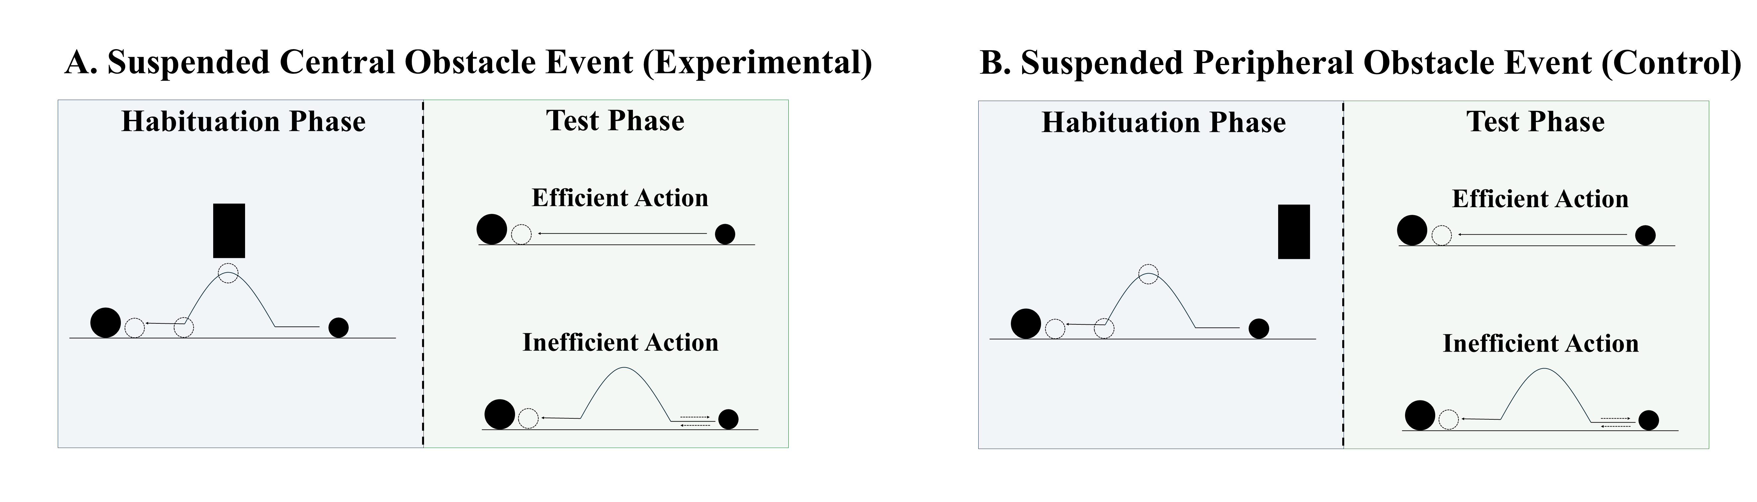
Figure 27. Schematic depiction of the behavioral task associated with the first prediction. (A) In the suspended central obstacle event, the first object jumps under a suspended, centrally located barrier before it comes to rest next to the second object; (B) in the suspended peripheral obstacle event, the first object jumps beside the suspended barrier before coming to rest next to the second one. The barrier is removed at test for both events, and infants observe either an efficient straight-path action or an inefficient arced-path action.

A potentially interesting question that the current simulations raise concerns how ALIAS would respond if it were habituated to an event in which a barrier was located directly above rather than beneath an arced motion trajectory. Figure 27 depicts what this would look like. If the current account is correct that an obstacle’s spatial proximity to arced motion is key to explaining infants’ looking behaviors, then networks (and by hypothesis, infants) should respond identically to networks habituated to canonical constrained action. This simulation was identical to Simulation 1a with two exceptions. First, a fourth unit—that represented a position directly above arced motion—was added to the Obstacle Horizontal Position input and output groups. Second, because the previous results were robust to the number of habituation epochs, the length of the habituation phase was reduced to eight epochs. Obstacles were only in the above-the-curved-motion spatial configuration during the habituation phase. Twelve-month-old networks were assigned either to the Suspended Central Obstacle Event (Experimental) condition or to the Suspended Peripheral Obstacle Event (Control) condition.

Results
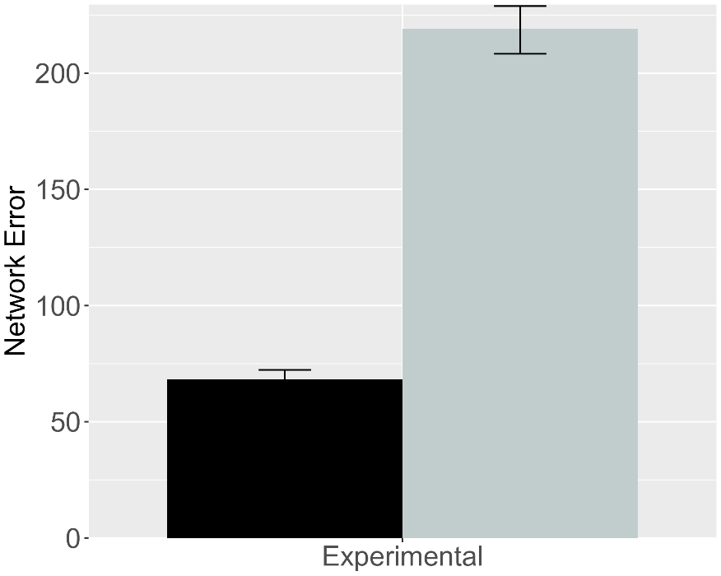 | 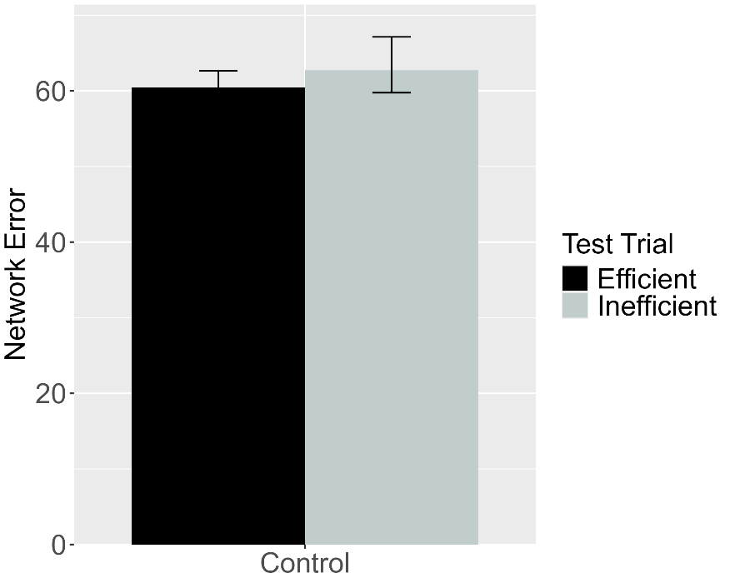
Figure 28. Performance of ALIAS. (Left) Overall error produced to the Efficient and Inefficient test events for networks in the Experimental condition. (Right) Overall error produced to the Efficient and Inefficient test events for networks in the Control condition.

Figure 28 shows that networks in the Experimental condition produced more error to the Inefficient than to the Efficient test event. In contrast, networks in the Control condition produce comparable errors to both test events. Thus, the network predicts longer looking to an inefficient than to an efficient action even if the centrally located obstacle is suspended.

Simulation 7: Networks’ treatment of two inefficient test events

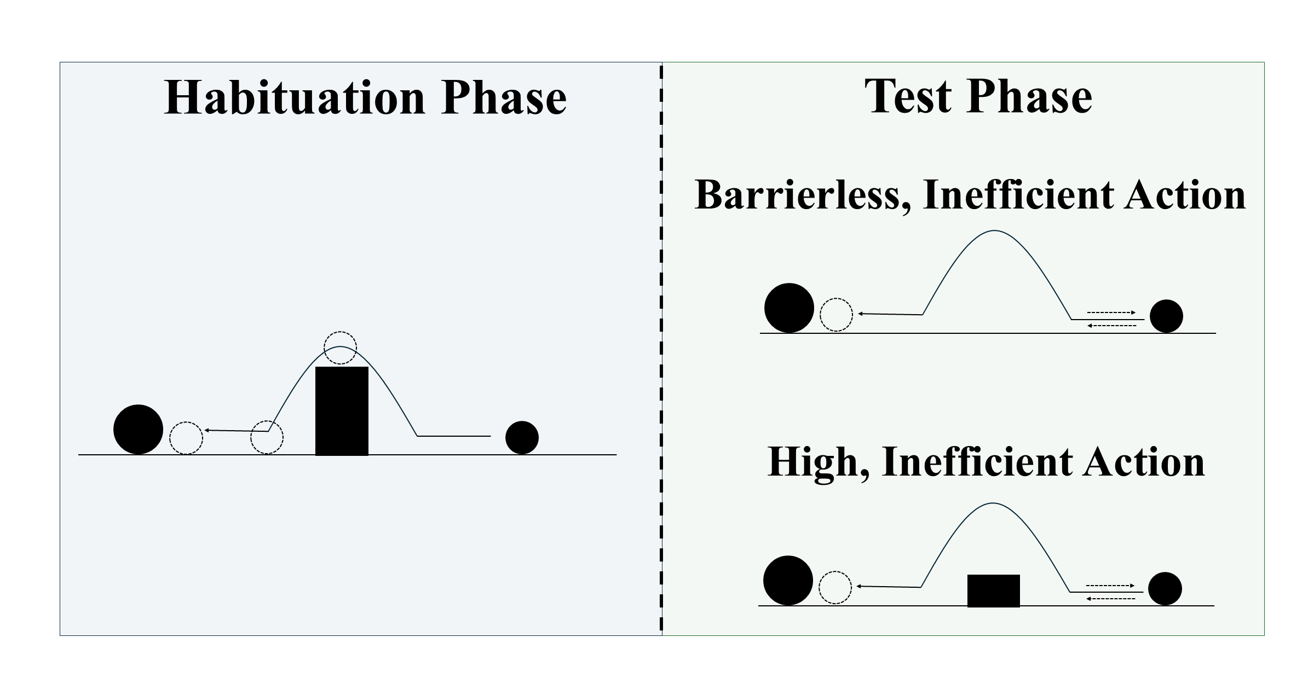
Figure 29. Schematic depiction of the behavioral task associated with the second prediction. During habituation, the first object jumps over a centrally located barrier before it comes to rest next to the second object. Barrierless, inefficient and High, inefficient test events are then shown.

Because different inefficient action events have been used in previous action efficiency studies, it is natural to ask how ALIAS would treat them when pit together. To answer this question, 6-month-old networks were habituated to constrained action and tested on Simulation 4’s High, inefficient and Simulation 1a’s Barrierless, inefficient test event (Figure 29).

Results and Discussion
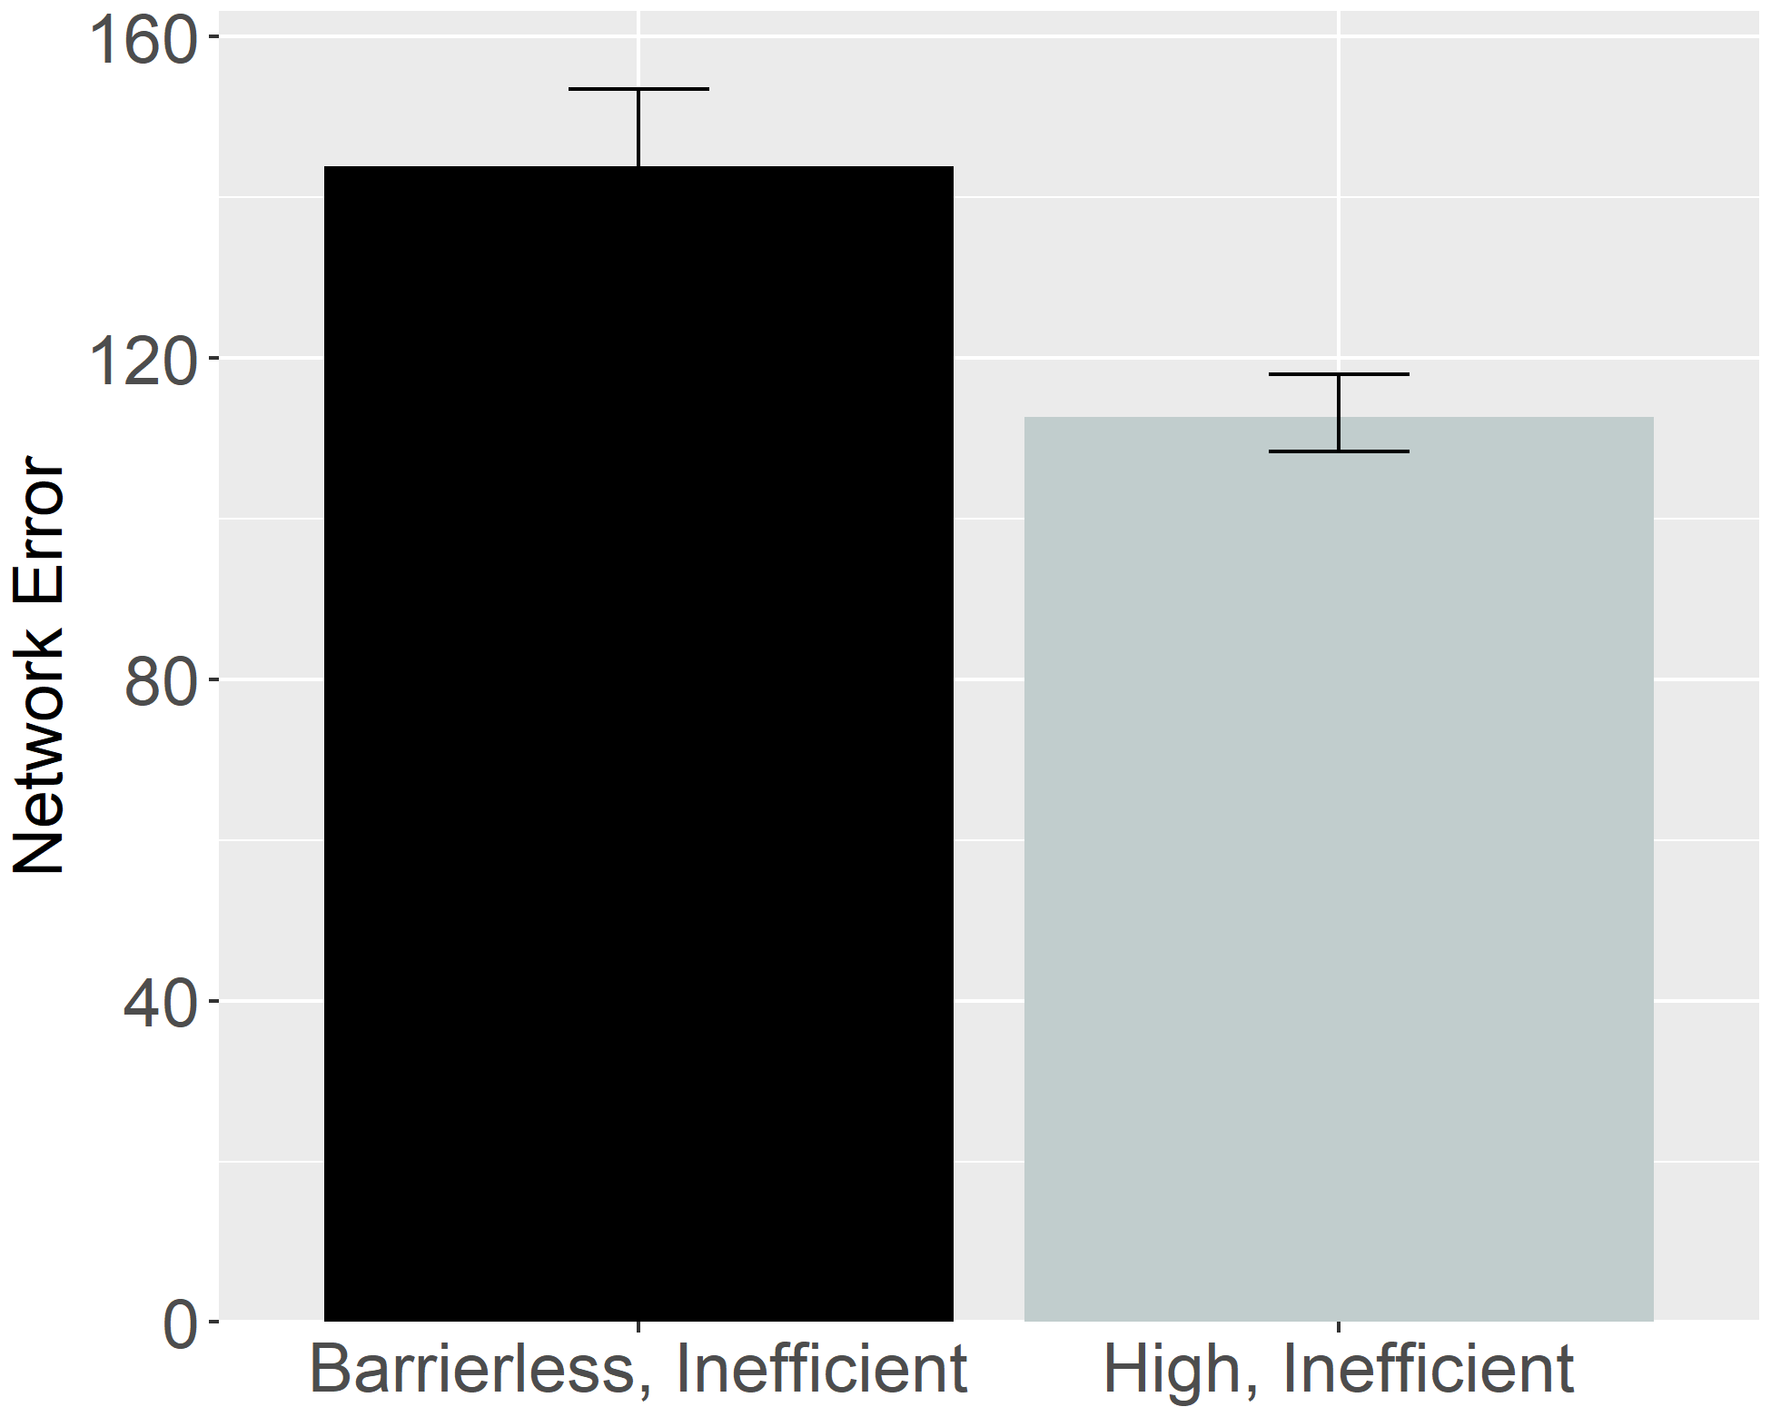
Figure 30. Performance of ALIAS. Overall error produced to the Barrierless, inefficient and High, inefficient test events.

Figure 30 shows that networks produced more error to the Barrierless, inefficient test event than to the High, inefficient one. Thus, ALIAS predicts that infants habituated to and tested on similar events should look longer at a Barrierless, inefficient test event than at a High, inefficient one. Networks produced more error to the former test event because many of its input features co-occurred with straight motion during pretraining. As such, these features activated a representation of straight motion that conflicted with the observed arced motion.
These predictions arguably are at odds with what any of the domain-specific proposals discussed here would predict. If these accounts are correct that infant action processing is governed by notions of efficiency, cost, constraints, and subjective utility, among other things, then infants should look for the same amount of time at High, inefficient and Barrierless, inefficient test events because both events are costly and inefficient. This contention falls directly out of the math of the naïve utility calculus. Although the full mathematical details of this theory are beyond the scope of this paper (see Jara-Ettinger, Gweon, et al., 2016; Jara-Ettinger, Schulz, et al., 2020), an aspect of this model that is worth highlighting is that in it, cost is defined in terms of an agent’s actions (or more formally, its policy)—this policy is equivalent in both inefficient test events. Thus, this perspective predicts that infants should look equally long at both test events. Notably, this account also predicts equivalent performance between the Suspended Central Obstacle Event and Suspended Peripheral Obstacle Event conditions. In both conditions, the agent’s actions are not rational given the environmental constraints.

General Discussion
An open question in the developmental cognitive sciences concerns when and how action efficiency understanding develops. One widely accepted answer is that infants interpret actions in terms of specialized mechanisms and abstract efficiency-based notions of action (e.g., Csibra & Gergely, 1998; Gergely & Csibra, 2003; Jara-Ettinger et al., 2016; Liu et al., 2026). The current paper argues that it is not necessary to invoke such mechanisms and notions to explain infants’ looking patterns in action-efficiency paradigms. The present findings suggest instead that behavior that looks like it stems from rich efficiency-based action representations can emerge from an associative learning mechanism operating over perceptually grounded representations.
This conclusion was supported by five simulations. ALIAS not only captured infants’ sensitivity to action efficiency for both animate and inanimate entities, but also their bidirectional inferences about actions, goals, and constraints, their graded sensitivity to efficiency, and the effects of direct-action experience in pre-reaching infants.
Beyond demonstrating that ALIAS can capture benchmark findings in this literature, the current results showed that its theoretical assumptions were the sine qua non of its success. As the simulations have shown, removing any of those assumptions produced a model—ALIAS-2—that explained fewer findings. Comparisons with VOM10 further showed the importance of these assumptions. Although VOM10 reproduced the first target finding, a revised version of this model that more faithfully implemented the original experimental paradigms—VOM10-2—failed to replicate any of the target findings. This indicates that VOM10’s original success depended more on its architecture than on its ability to capture the processes underlying infants’ action efficiency understanding. These comparisons suggest that ALIAS’s assumptions—not merely its implementation—are critical to its success.
In addition to capturing the target findings, the simulations provide insight into the mechanisms subserving infants’ looking behaviors. As one example, Simulation 4 showed that prior experience with curved trajectories and obstacles and with seeing agents stop next to their goals can explain why infants look longer at barrierless than constrained actions and why they look longer when agents stop short of their goals than when they stop next to them. As another example, Simulation 5 showed that increased error to the Inefficient than to the Efficient test events can be expected in an otherwise inexperienced system when it is allowed to develop a representation of its own straight reaches while in a heightened attentional state. Actions whose kinematics subsequently deviate from this learned representation should generate greater prediction error than actions whose kinematics match it. Taken together, the simulations do more than reproduce existing data—they elucidate the computational processes through which those findings arise in the model and could arise in infants.
Second, the current simulations generated several testable predictions. One is that infants habituated to constrained action and tested on High, inefficient and Barrierless, inefficient test events should look longer at the latter than at the former event. A second prediction is that infants should look longer at an inefficient than at an efficient action following habituation to arced motion that unfolds beneath an obstacle. Because ALIAS attributes’ looking to learned associations among perceptually grounded features, the model also predicts that increasing the salience of peripherally located obstacles should promote the formation of associations between them and arced motion; decreasing the salience of centrally located obstacles should weaken or prevent the formation of those same associations. Additionally, extending the sticky-mittens-induced attentional boost beyond the action phase should reverse the canonical pattern of longer looking to inefficient than to efficient actions, and placing the action phase after rather than before habituation should restore it. Behavioral findings corroborating any of these predictions would provide strong support for the current account while posing a challenge for existing domain-specific proposals.
More generally, the present account may help to explain an apparent discontinuity between infant action efficiency understanding and later development. On the one hand, studies with infants suggest that sensitivity to action efficiency emerges sometime between 6 and 12 months of age (e.g., Csibra et al., 2003; Csibra et al., 1999; Gergely et al., 1995; Liu & Spelke, 2017; Liu et al., 2017), if not earlier (e.g., Liu et al., 2019; Skerry et al., 2013). On the other hand, evidence from toddlers and young children is more equivocal. Some findings are consistent with the view that action efficiency understanding is continuous throughout development. For example, 14-month-olds imitate inefficient actions only when more efficient alternatives are unavailable (Gergely et al., 2002), 2-year-olds use cost information when evaluating others’ behavior (Jara-Ettinger et al., 2015), and 5-year-olds reason productively about actions in terms of costs and rewards (Jara-Ettinger et al., 2015). In contrast, other studies show that preschoolers neither distinguish efficient from inefficient actions (e.g., Ossmy et al., 2021) nor do they expect agents to follow more efficient and less costly paths when pursuing goals (e.g., Gönül & Paulus, 2021). These diverging findings are difficult to reconcile under the domain-specific proposals described here because each implicitly assumes continuity in the mechanisms supporting action-efficiency-based inferences.
This discrepancy evaporates under the current account. As should now be clear, on this account, infants’ looking behaviors do not reflect veridical efficiency-based action processing. To the extent that this is true, it does raise one outstanding question: How, then, does genuine efficiency-based action processing develop? There is no reason to think that its development is not ultimately rooted in the very same general associative processes that underpin the looking behavior of preverbal infants. Insight into what such a process might look like can be gleaned from the Associative Sequence Learning theory (ASL; e.g., Heyes & Ray, 2000; Heyes, 2001). The phenomenon this account explains is the development of imitation. According to ASL, perception and action are linked via repeated pairings between observed and executed actions. Over time, these associations become sufficiently strong that, upon observing another person engage in a familiar action, this action elicits the corresponding motor response. Importantly, ASL does not deny that imitation is a sophisticated cognitive ability; rather, it maintains that such sophistication emerges from learning rather than specialized mechanisms. In a similar vein, ALIAS neither denies that action efficiency understanding is a sophisticated capacity nor would it deny that individuals use it as some point during ontogeny to interpret others’ actions. Although ALIAS is an account of infants’ early looking behavior rather than a proposal for how efficiency-based action processing develops, the notion that the latter develops via the very same associative processes that underpin the former is entirely consistent with it. At the same time, observation alone is likely insufficient to support full action efficiency understanding. Physically experiencing the efficiency of one’s own actions may also be key (e.g., Ossmy et al., 2021).
Before concluding, two potential criticisms are worth noting. The first concerns the fact that the present simulations focused primarily on studies employing some version of Gergely et al.’s (1995) original paradigm. Potential downsides are that the conclusions that can thus be drawn from them are necessarily limited in scope and that it is unclear to what extent the current model can capture findings on infant action understanding broadly (e.g., Gergely et al., 2002; Woodward, 1998).
The second concerns the model’s simplicity. Although movement was represented dynamically, all other aspects of the model were represented statically and locally. It could thus be argued that these simplifications resulted in a model that poorly approximated infants’ real-world action-observation experience. Without denying this criticism, it is worth bearing in mind that such simplifications were deliberate. By developing a simple model, it is possible precisely to elucidate the mechanisms by which it operates and, based on such an analysis, to advance theories of infant cognitive development. Although more sophisticated “deep learning” models may ultimately better capture the richness of infants’ real-world action-observation experience (e.g., Wai Keen Vong et al., 2024), a major disadvantage of such models is that their complexity can preclude their interpretability. A promising way forward that addresses both critiques is to implement ALIAS’s assumptions in a more ecologically valid model to assess whether it would continue to capture infants’ looking behaviors in efficiency-based action studies.
The takeaway message from these simulations is this: Caution should be exercised before concluding that infants’ looking behaviors in studies assessing their cognitive competencies necessarily stem from conceptually rich knowledge and equally sophisticated specialized processes. The present simulations provide a compelling case in point by demonstrating that, in studies evaluating infants’ understanding of action efficiency, such looking behaviors may instead emerge from domain-general associative learning operating over perceptual primitives.

References
Benton, D. T. (2022). The elusive “Developmental Mechanism”: What they are and how to study and test them. Developmental Review, 65, 101034. https://doi.org/10.1016/j.dr.2022.101034
Benton, D. T. (2023). But what is the mechanism?’: Demystifying the ever elusive ‘developmental mechanism. Infant and Child Development, 32(6), e2355. https://doi.org/10.1002/icd.2355
Benton, D. T. (2025). An associative-learning account of how infants learn about causal action in animates and inanimates: A critical reexamination of four classic studies. Journal of Experimental Psychology: General, 154(2), 497–521. https://doi.org/10.1037/xge0001656
Benton, D. T. (2026). Second-order correlation learning in 2-to 4-year-old children, and its underlying mechanism. Journal of Experimental Child Psychology, 267, 106494. https://doi.org/10.1016/j.jecp.2026.106494
Benton, D.T., & Hoch, J.E. (2026). An associative learning account of how saliva becomes a cue for comfort. Child Development. 10.1093/chidev/aacag119. https://doi.org/10.1093/chidev/aacag119
Benton, D. T., & Lapan, C. (2021). Moral masters or moral apprentices? A connectionist account of sociomoral evaluation in preverbal infants. Cognitive Development, 62, 101164. https://doi.org/10.1016/j.cogdev.2022.101164
Benton, D. T., Kamper, D., Beaton, R. M., & Sobel, D. M. (2024). Don't throw the associative baby out with the Bayesian bathwater: Children are more associative when reasoning retrospectively under information processing demands. Developmental Science, 27(3), e13464. https://doi.org/10.1111/desc.13464
Berthiaume, V. G., Shultz, T. R., & Onishi, K. H. (2013). A constructivist connectionist model of transitions on false-belief tasks. Cognition, 126(3), 441–458. https://doi.org/10.1016/j.cognition.2012.11.007
Blumberg, M. S., & Adolph, K. E. (2023). Protracted development of motor cortex constrains rich interpretations of infant cognition. Trends in cognitive sciences, 27(3), 233-245. https://doi.org/10.1016/j.tics.2022.12.014
Bogartz, R. S., Shinskey, J. L., & Schilling, T. H. (2000). Object permanence in five‐and‐a‐half‐month‐old infants?. Infancy, 1(4), 403–428. https://doi.org/10.1207/S15327078IN0104_3
Braitenberg, V. (1986). Vehicles: Experiments in synthetic psychology. MIT press.
Clearfield, M. W., & Mix, K. S. (1999). Number versus contour length in infants' discrimination of small visual sets. Psychological science, 10(5), 408-411. https://doi.org/10.1111/1467-9280.00177
Cohen, L. B. (1973). A two-process model of infant visual attention. Merrill-Palmer Quarterly, 19(3), 157–180.
Cohen, L. B., Chaput, H. H., & Cashon, C. H. (2002). A constructivist model of infant cognition. Cognitive Development, 17(3–4), 1323–1343. https://doi.org/10.1016/S0885-2014(02)00124-7
Cohen, L. B., & Marks, K. S. (2002). How infants process addition and subtraction events. Developmental Science, 5(2), 186–201. https://doi.org/10.1111/1467-7687.00220
Cohen, L. B., & Oakes, L. M. (1993). How infants perceive a simple causal event. Developmental Psychology, 29(3), 421–433. https://doi.org/10.1037/0012-1649.29.3.421
Colunga, E., & Smith, L. B. (2005). From the lexicon to expectations about kinds: A role for associative learning. Psychological Review, 112(2), 347–382. https://doi.org/10.1037/0033-295X.112.2.347
Csibra, G., & Gergely, G. (1998). The teleological origins of mentalistic action explanations: A developmental hypothesis. Developmental Science, 1(2), 255–259. https://doi.org/10.1111/1467-7687.00039
Csibra, G., Bíró, S., Koós, O., & Gergely, G. (2003). One‐year‐old infants use teleological representations of actions productively. Cognitive Science, 27(1), 111–133. https://doi.org/10.1207/s15516709cog2701_4
Csibra, G., Gergely, G., Bíró, S., Koos, O., & Brockbank, M. (1999). Goal attribution without agency cues: The perception of 'pure reason' in infancy. Cognition, 72(3), 237–267. https://doi.org/10.1016/S0010-0277(99)00039-6
Elman, J. L. (1990). Finding structure in time. Cognitive Science, 14(2), 179–211. https://doi.org/10.1207/s15516709cog1402_1
Gergely, G., Bekkering, H., & Király, I. (2002). Rational imitation in preverbal infants. Nature, 415(6873), 755. https://doi.org/10.1038/415755a
Gergely, G., & Csibra, G. (2003). Teleological reasoning in infancy: The naïve theory of rational action. Trends in Cognitive Sciences, 7(7), 287–292. https://doi.org/10.1016/S1364-6613(03)00128-1
Gergely, G., Nádasdy, Z., Csibra, G., & Bíró, S. (1995). Taking the intentional stance at 12 months of age. Cognition, 56(2), 165–193. https://doi.org/10.1016/0010-0277(95)00661-H
Gönül, G., & Paulus, M. (2021). Children’s reasoning about the efficiency of others’ actions: The development of rational action prediction. Journal of Experimental Child Psychology, 204, 105035. https://doi.org/10.1016/j.jecp.2020.105035
Haith, M. M. (1998). Who put the cog in infant cognition? Is rich interpretation too costly? Infant Behavior and Development, 21(2), 167–179. https://doi.org/10.1016/S0163-6383(98)90001-7
Heyes, C. (2018). Cognitive gadgets: The cultural evolution of thinking. Harvard University Press.
Heyes, C. (2001). Causes and consequences of imitation. Trends in cognitive sciences, 5(6), 253-261. https://doi.org/10.1016/S1364-6613(00)01661-2
Heyes, C. (2024). Rethinking norm psychology. Perspectives on Psychological Science, 19(1), 12-38. https://doi.org/10.1177/17456916221112075
Heyes, C. M., & Ray, E. D. (2000). What is the significance of imitation in animals?. In Advances in the Study of Behavior (Vol. 29, pp. 215-245). Academic Press. https://doi.org/10.1016/S0065-3454(08)60106-0
Jara-Ettinger, J., Gweon, H., Schulz, L. E., & Tenenbaum, J. B. (2016). The naïve utility calculus: Computational principles underlying commonsense psychology. Trends in Cognitive Sciences, 20(8), 589–604. https://doi.org/10.1016/j.tics.2016.05.011
Jara-Ettinger, J., Gweon, H., Tenenbaum, J. B., & Schulz, L. E. (2015). Children’s understanding of the costs and rewards underlying rational action. Cognition, 140, 14-23. https://doi.org/10.1016/j.cognition.2015.03.006
Jara-Ettinger, J., Schulz, L. E., & Tenenbaum, J. B. (2020). The naive utility calculus as a unified, quantitative framework for action understanding. Cognitive Psychology, 123, 101334. https://doi.org/10.1016/j.cogpsych.2020.101334
Jara-Ettinger, J., Tenenbaum, J. B., & Schulz, L. E. (2015). Not so innocent: Toddlers’ inferences about costs and culpability. Psychological science, 26(5), 633-640. https://doi.org/10.1177/0956797615572806
Jones, S. S., & Smith, L. B. (1993). The place of perception in children's concepts. Cognitive Development, 8(2), 113–139. https://doi.org/10.1016/0885-2014(93)90008-S
Liu, S., Brooks, N. B., & Spelke, E. S. (2019). Origins of the concepts cause, cost, and goal in prereaching infants. Proceedings of the National Academy of Sciences, 116(36), 17747–17752. https://doi.org/10.1073/pnas.1904786116
Liu, S., Karakose-Akbiyik, S., Outa, J., & Kim, M. J. (2026). How physical information is used to make sense of the psychological world. Nature Reviews Psychology, 5(1), 59-73. https://doi.org/10.1038/s44159-025-00514-1
Liu, S., & Spelke, E. S. (2017). Six-month-old infants expect agents to minimize the cost of their actions. Cognition, 160, 35–42. https://doi.org/10.1016/j.cognition.2016.12.007
Mareschal, D., French, R. M., & Quinn, P. C. (2000). A connectionist account of asymmetric category learning in early infancy. Developmental Psychology, 36(5), 635–645. https://doi.org/10.1037/0012-1649.36.5.635
McClelland, J. L., & Thompson, R. M. (2007). Using domain-general principles to explain children's causal reasoning abilities. Developmental Science, 10(3), 333–356. https://doi.org/10.1111/j.1467-7687.2007.00586.x
McMahon, E., & Isik, L. (2023). Seeing social interactions. Trends in cognitive sciences, 27(12), 1165-1179. https://doi.org/10.1016/j.tics.2023.09.001
Munakata, Y. (1998). Infant perseveration and implications for object permanence theories: A PDP model of the AB task. Developmental Science, 1(2), 161–184. https://doi.org/10.1111/1467-7687.00021
Munakata, Y., McClelland, J. L., Johnson, M. H., & Siegler, R. S. (1997). Rethinking infant knowledge: Toward an adaptive process account of successes and failures in object permanence tasks. Psychological Review, 104(4), 686–713. https://doi.org/10.1037/0033-295X.104.4.686
Nair, V., & Hinton, G. E. (2010). Rectified linear units improve restricted boltzmann machines. In Proceedings of the 27th international conference on machine learning (ICML-10) (pp. 807-814).
Needham, A., Barrett, T., & Peterman, K. (2002). A pick-me-up for infants' exploratory skills: Early simulated experiences reaching for objects using 'sticky mittens' enhances young infants' object exploration skills. Infant Behavior and Development, 25(3), 279–295. https://doi.org/10.1016/S0163-6383(02)00097-8
Ossmy, O., Han, D., Kaplan, B. E., Xu, M., Bianco, C., Mukamel, R., & Adolph, K. E. (2021). Children do not distinguish efficient from inefficient actions during observation. Scientific Reports, 11(1), 18106. https://doi.org/10.1038/s41598-021-97354-9
Perner, J., & Ruffman, T. (2005). Infants' insight into the mind: How deep?. Science, 308(5719), 214–216. https://doi.org/10.1126/science.1111656
Phillips, A. T., & Wellman, H. M. (2005). Infants' understanding of object-directed action. Cognition, 98(2), 137–155. https://doi.org/10.1016/j.cognition.2004.11.005
Quinn, P. C., & Johnson, M. H. (2000). Global-before-basic object categorization in connectionist networks and 2-month-old infants. Infancy, 1(1), 31–46. https://doi.org/10.1207/S15327078IN0101_04
Rakison, D. H., & Lupyan, G. (2008). Developing object concepts in infancy: An associative learning perspective. Monographs of the Society for Research in Child Development, 73(1), 1–110. https://doi.org/10.1111/j.1540-5834.2008.00469.x
Rohde, D. L. T. (1999). LENS: The light, efficient network simulator (Technical Report CMU-CS-99-164). Carnegie Mellon University.
Rogers, T. T., & McClelland, J. L. (2004). Semantic cognition: A parallel distributed processing approach. MIT press.
Rumelhart, D. E., Hinton, G. E., & Williams, R. J. (1986). Learning representations by back-propagating errors. Nature, 323(6088), 533–536. https://doi.org/10.1038/323533a0
Scarf, D., Imuta, K., Colombo, M., & Hayne, H. (2012a). Golden Rule or valence matching? Methodological problems in Hamlin et al. Proceedings of the National Academy of Sciences, 109(22), E1426-E1426. https://doi.org/10.1073/pnas.1204123109
Scarf, D., Imuta, K., Colombo, M., & Hayne, H. (2012b). Social evaluation or simple association? Simple associations may explain moral reasoning in infants. PLOS ONE, 7(8), e42698. https://doi.org/10.1371/journal.pone.0042698
Schlesinger, M., Amso, D., & Johnson, S. P. (2012). Simulating the role of visual selective attention during the development of perceptual completion. Developmental science, 15(6), 739-752. https://doi.org/10.1111/j.1467-7687.2012.01177.x
Schlesinger, M., & Casey, P. (2003). Where infants look when impossible things happen: Simulating and testing a gaze-direction model. Connection Science, 15(4), 271–280. https://doi.org/10.1080/09540090310001655093
Schlingloff, L., Csibra, G., & Tatone, D. (2020). Do 15-month-old infants prefer helpers? A replication of Hamlin et al. (2007). Royal Society Open Science, 7(4), 191795. https://doi.org/10.1098/rsos.191795
Schwier, C., Van Maanen, C., Carpenter, M., & Tomasello, M. (2006). Rational imitation in 12-month-old infants. Infancy, 10(3), 303–311. https://doi.org/10.1207/s15327078in1003_6
Simon, T. J. (1997). Reconceptualizing the origins of number knowledge: A “non-numerical” account. Cognitive development, 12(3), 349-372. https://doi.org/10.1016/S0885-2014(97)90008-3
Skerry, A. E., Carey, S. E., & Spelke, E. S. (2013). First-person action experience reveals sensitivity to action efficiency in prereaching infants. Proceedings of the National Academy of Sciences, 110(46), 18728–18733. https://doi.org/10.1073/pnas.1318053110
Sloutsky, V. M. (2010). From perceptual categories to concepts: What develops?. Cognitive Science, 34(7), 1244–1286. https://doi.org/10.1111/j.1551-6709.2010.01129.x
Sodian, B., Schoeppner, B., & Metz, U. (2004). Do infants apply the principle of rational action to human agents? Infant Behavior and Development, 27(1), 31–41. https://doi.org/10.1016/j.infbeh.2003.05.006
Sokolov, E. N. (1963). Higher nervous functions: The orienting reflex. Annual Review of Physiology, 25(1), 545–580. https://doi.org/10.1146/annurev.ph.25.030163.002553
Sommerville, J. A., Woodward, A. L., & Needham, A. (2005). Action experience alters 3-month-old infants' perception of others' actions. Cognition, 96(1), B1–B11. https://doi.org/10.1016/j.cognition.2004.07.004
Van Overwalle, F. (2010). Infants' teleological and belief inference: A recurrent connectionist approach to their minimal representational and computational requirements. NeuroImage, 52(3), 1095–1108. https://doi.org/10.1016/j.neuroimage.2010.05.028
Wagner, L., & Carey, S. (2005). 12-month-old infants represent probable endings of motion events. Infancy, 7(1), 73–83. https://doi.org/10.1207/s15327078in0701_6
Westermann, G., & Mareschal, D. (2012). Mechanisms of developmental change in infant categorization. Cognitive Development, 27(4), 367–382. https://doi.org/10.1016/j.cogdev.2012.08.004
Williams, R. J., & Zipser, D. (1995). Gradient-based learning algorithms for recurrent networks and their computational complexity. In Y. Chauvin & D. E. Rumelhart (Eds.), Back-propagation: Theory, architectures and applications (pp. 433–486). Erlbaum.
Woodward, A. L. (1998). Infants selectively encode the goal object of an actor's reach. Cognition, 69(1), 1–34. https://doi.org/10.1016/S0010-0277(98)00058-4
Woodward, A. L., & Sommerville, J. A. (2000). Twelve-month-old infants interpret action in context. Psychological Science, 11(1), 73–77. https://doi.org/10.1111/1467-9280.00218

