An associative learning account of how saliva becomes a cue to comfort
Deon T. Benton^{ǂ} and Justine E. Hoch^{ǂ}
^{ǂ}Share first-authorship
Vanderbilt University

Address correspondence either to Deon T. Benton or Justine E. Hoch, Department of Psychology and Human Development, Vanderbilt University, Peabody College, 230 Appleton Place #552, Nashville, TN 37235

Data availability statement: The code and network-modeling scripts are available upon reasonable request.
Conflicts of interests: none
“How saliva becomes a cue to comfort”
Abstract

“How saliva becomes a cue to comfort”
Preverbal infants face many challenges. One of the more formidable of these challenges is learning to distinguish between animate entities and inanimate objects. For example, infants must learn that not only are animates are agents or a class of objects that can cause state changes in other entities or objects both directly and at a distance, but that they can grow and reproduce, cause action at a distance in other entities, are self-propelled, respond contingently to other animates, and act based on their beliefs, desires, and goals. Inanimate objects, in contrast, possess none of these characteristics; that is, inanimates are caused to move, cannot grow and reproduce, are generally not contingent, and do not possess mental states that govern their action (e.g., Gelman & Spelke, 1981; Rakison & Poulin-Dubois, 2001). This knowledge about what distinguishes animates and inanimates is important because it enables individuals to navigate the world effectively and informs how those individuals interact with such entities and objects. For example, an individual who possesses such knowledge would be expected to be more likely to greet another person than a stop sign.
If inanimates and, to a greater degree, animates operated independently of one another in the real world, infants’ task would be straightforward: Their sole job would be to figure out which things among them were animates and which things were inanimates. However, animates, and most especially people, do not operate as isolated, independent beings in the world. Instead, people form relationships with others, and their behavior and actions are in part governed by those relationships. This means that infants face at least two additional obstacles. The first is to discover who is related to whom. The second is to uncover the nature of those relations; that is, infants must learn and come to appreciate that not all relationships are the same and may differ in their closeness or “thickness”. Perhaps the best example of a thick relationship is that among immediate family members such as the relationship between a father and their child. An important property of such relations is that members of these relationships often feel a sense of oneness and strong levels of attachment, commitment, allegiance, loyalty, obligation, and mutual responsiveness (Thomas, 2024; Thomas et al., 2022). These properties have consequences for how ingroup and outgroup members should behave towards one another. For example, it is typical for a father to provide comfort to his distressed child, even if doing so may temporarily disrupts his own comfort. By understanding who is in a thick relationship and who is not, infants can begin to make predictions about how in- and outgroup members of those relationships will behave in the future. For example, a father might be expected to pick up his child if they are crying, but it would be incongruous for him to do the same with another child. Similarly, it would be unsurprising for a mother to hug their child at preschool drop-off, but it would be unusual for that same mother to hug another person’s child.
Given that evaluating and predicting how someone will behave towards another person in the future partially depends on knowing the kind of relationship that they are in and its thickness, an open question concerns how infants solve these interrelated obstacles. One proposal for how infants might overcome these obstacles is to use external cues to infer not only the existence of a relationship but its strength. A promising candidate for such a cue is saliva. Paradigmatic examples of real-world saliva sharing include sharing food, beverages, and utensils as well as exchanging saliva. There are at least two reasons why saliva sharing may be a promising cue. The first is that the act of sharing saliva with another person may have predictive validity for other actions. For example, individuals who share saliva (henceforth, “saliva-sharers”) should be more likely than non-saliva-sharers to invest in one another, be emotionally responsive, provide comfort and care during illness or distress, engage in physical affection (e.g., hugging, cuddling), and cooperate in everyday tasks. The second reason is that, compared to many culturally specific practices that can signal relationship closeness (e.g., bowing, handshakes, cheek-kissing, etc.), saliva sharing is not tied to a specific culture. Instead, saliva sharing occurs across all of the world’s cultures, which may mean that it functions as a universal indicator that two individuals share a thick relation. Such universality may also mean that the tendency to treat saliva sharing as a cue to relationship strength has an evolutionary basis. If saliva sharing is indeed a universal marker of a thick relationship and has a basis in evolution, then this would suggest that people may possess psychological adaptations that predispose them to infer a thick relationship between individuals that share saliva.
One of the only studies to assess whether infants treat saliva sharing as a cue to relationship thickness—and whether such sharing makes actions like comforting when distressed more likely—was conducted by Thomas et al. (2022). Although Thomas et al. (2022) tested children, here we focus on the infant experiments. The rationale for this is that unlike children who can be explicitly told who is in a relationship and how close that relationship is, infants must rely on observable cues to make inferences about relationship closeness. Thus, infants’ behavior in this study can provide insight into the developmental origins of the ability to identify close relationships and make predictions about how members of such relationships should behave towards one another in the future. In one experiment (i.e., Exp. 2B), 8½-month-old to 10-month-old infants were shown an event in which a puppet, which was positioned between two actresses, either ate from the same orange slice as one of the actresses (the “orange actress”) or shared a ball (the “ball actress”) with the other actress. The former event was used to denote saliva-sharing. Infants then saw the same puppet express distress; that is, the puppet appeared as though it was crying. As the puppet cried, both actresses turned towards the puppet. Thomas et al. (2012) reasoned that if infants expected saliva-sharers to comfort one another when distressed, then infants should look longest and first at the actress that ate from the same orange slice as the puppet. This is what Thomas et al. (2022) found; that is, they found that Infants looked first and longest at the actress that shared the orange slice with the puppet than at the actress that shared a ball with it as if to expect the first but not the second actress to comfort the puppet.
One complication with this experiment is that infants might show the same pattern of looking—that is, looking first and longest towards the orange actress—even if the original puppet was replaced with a new puppet. This would suggest that infants expect food sharers to comfort anyone in distress. Thomas et al. (2022) addressed this concern in Experiment 2D by replacing the original puppet with a new puppet in the distress event, following the food- and ball-sharing events; this new puppet also expressed distress. They found that infants looked equally long at both actresses when the new puppet was in distress. This suggests that infants expect saliva-sharers to comfort their saliva-sharing partners when those partners are distressed rather than to comfort distressed individuals generally.
In their final study, or Experiment 3B, Thomas et al. (2022) tested whether infants’ behavior in the previous experiments were due to saliva sharing specifically rather than food sharing generally. Thomas et al. (2022) tested this idea by showing infants a video in which a central actress—who was flanked by two puppets—placed her finger into her mouth, rotated it, and then placed it into one of the puppet’s mouths. The actress then placed her finger on her forehead, rotated it, and placed it on the other puppet’s forehead. Thomas et al. (2022) then measured which puppet infants looked first and longest at when the actress subsequently expressed distress. Although infants’ first looks were split evenly between both puppets, infants did look longer at the puppet with whom the actress shared saliva. Thomas et al. (2022) interpreted these findings—which were recently replicated to mean that preverbal infants use saliva sharing specifically as a cue for identifying thick relationships and predicting that members of such relationships will comfort one another during moments of distress. It is worth noting that these findings were largely replicated in a recent study by Ciftci et al. (2025). These authors replicated Thomas et al.’s (2022) finding that infants looked longest at former saliva sharers; they did not replicate Thomas et al.’s (2022) finding that infants tended to look first at former saliva sharers.
Although Thomas et al. (2022) suggested that there may be an evolutionary basis for the expectation that saliva sharers comfort each other, they remained largely agnostic about its developmental origins and even acknowledged that such an expectation may be learned. However, because they do not provide a mechanism for this expectation one way or the other, it remains to be seen what the cognitive mechanism could explain it or how such a expectation might arise. Yet, understanding how this expectation arises is important because it can clarify under what conditions such an expectation emerges and can contribute to existing theories about the mechanisms through which infants’ social reasoning develop. Given this limitation, the primary goal of the current paper is to provide an account of the mechanism of change that underpinned infants’ expectation that comfort occurs among saliva sharers. Our central argument will be that infants’ looking behaviors in Thomas et al. (2022) can be explained by a domain-general associative process that links saliva sharing and comforting into a common mental representation when the same individuals are involved in both actions. We then will show that when this proposal is implemented into a connectionist computational model, it is sufficient to explain infants’ looking behaviors in Thomas et al. (2022). Although we will show that associative learning can explain infants’ performance in Thomas et al. (2022), we note at the outset that our account is merely a sufficiency account; that is, it shows that associative learning alone can explain how infants behaved in Thomas et al. (2022). However, the fact that associative learning can explain infants’ responses does not mean that their expectation that saliva sharing and comfort go together derives from such a process. Similarly, the finding that associative learning can explain infants’ behavior in Thomas et al. (2022) neither rules out the possibility that this expectation might emerge from some other mechanisms nor does it discount the possibility that this expectation has an evolutionary basis.

An associative learning account for how saliva sharing comes to be used to indicate comfort
Our main claim is that infants’ expectation that comforting happens among saliva sharers but not among non-saliva sharers is the product of specific visual experiences and a domain-general associative learning mechanism that operates over those experiences. Specifically, the reason infants looked longest at the actress with whom the now distressed puppet shared saliva may have been because they have learned in the real world that individuals who share saliva also comfort each other during moments of distress. At the same time, infants may have looked equally long at both actresses when the distressed puppet was not a part of the original saliva-sharing event because infants have also learned that individuals who do not share saliva typically do not comfort one another during distress. Critically, both representations—that is, a representation of saliva sharing and a representation of comforting—are unlikely to be directly linked. This is because saliva sharing and comforting often occur as separate events. Instead, both representations may become linked via a common mental representation. The idea is that whenever this common representation is activated by one of the features associated with it (e.g., saliva sharing), it also activates the other feature (e.g., comforting). Such a common representation is likely established through two kinds of extensive experience. First, as infants repeatedly witness others sharing saliva in the real world, they gradually build a mental representation of those events. This representation will come to include information about who shared saliva with whom. Second, as infants accrue experience of individuals comforting one another during moments of distress, they establish and build a parallel representation of those events. A point that is worth noting is that this process is likely bidirectional; that is, in the same way that the representation of saliva sharing can later be enriched by comforting, the representation of comforting can later be enriched by saliva sharing.
Crucially, these parallel representations are able to be integrated because the same individuals who engage in saliva sharing are also the ones who provide comfort. Thus, when infants see those individuals again, their identity as saliva sharers activates the common representation and any subsequent features that distinguish the comforting event from the saliva event are incorporated into it. Importantly, infants would be unable to incorporate aspects of the comforting event into the representations they have built for the saliva event if they could not track which individuals shared saliva in the first place. Thus, our account assumes that infants can track the identity of individuals across space and time. Our contention that infants can track the identity of individuals is supported by research showing that this capacity emerges between 6 and 12 months of age (Káldy & Leslie, 2003, 2005; Kibbe & Leslie, 2011, 2013, 2016). Given that the infants tested in Thomas et al. (2022) were 8½- to 10-month-olds—an age that falls squarely within this range—it is reasonable to conclude that they could track individual identities across space and time.
In sum, our view is that infants’ behavior in Thomas et al. (2022) can be explained by the operation of a domain-general associative learning mechanism whereby separate experiences of saliva sharing and comforting are integrated into a common representation when the same individuals appear across both events. Given the speculative nature of this account, in the next section we present a connectionist computational model that instantiates it to determine whether such a mechanistic proposal can capture infants’ looking behavior in Thomas et al. (2022). Across three simulations, we not only show that our proposal—when implemented in a computational model—is sufficient to explain infants’ looking responses in Thomas et al. (2022) but also provides a mechanism through which infants come to use saliva as a cue to relationship closeness.

General Method
Network Architecture
The current simulations used a three-layer, feedforward autoassociative neural network model (e.g., Mareschal et al., 2000) trained with backpropagation in cross-entropy error (e.g., Rumelhart et al., 1986). The hidden and output units used a sigmoid activation function. Gaussian noise was added to input activations to reflect infants’ noisy sensory processing (M = 0, SD = 0.175).
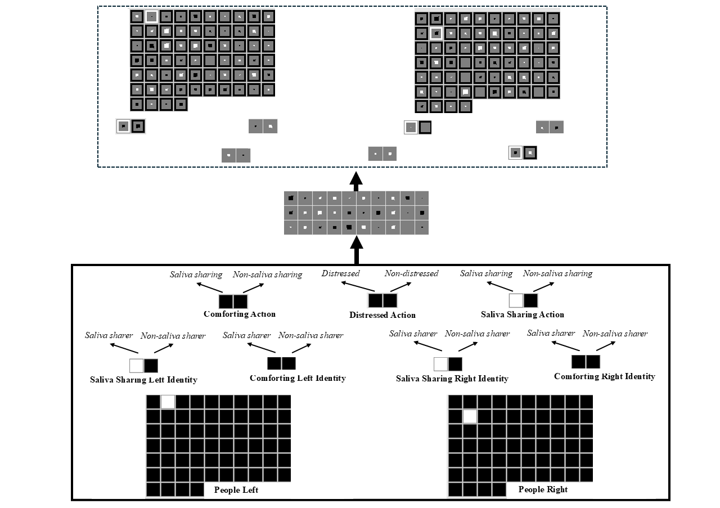Figure 1. Schematic of the untrained model architecture used in the current simulations. The input and output groups are identical. The input groups are written in bold. The model consisted of nine structurally identical input and output groups: People Left/Right, Saliva Sharing Left/Right Identity, Comforting Left/Right Identity, Comforting Action, Distressed Action, and Saliva Sharing Action. These groups are written in bold. The specific feature that a given unit coded for is shown in italics within each group. The differently colored borders that surround each output unit correspond to the target value for that unit. Black borders correspond to target values of “0” (i.e., corresponding to a unit being “off”). White borders correspond to target values of “1” (i.e., corresponding to a unit being “on”). The size of the colored region within the borders correspond to the actual activation value of that unit. The size of the inner region corresponds to the magnitude of the activation of a unit. For the hidden and output units, inner regions that are darker in color correspond to activation values ≤ 0.5, whereas inner regions lighter in color correspond to activation values > 0.5.

The model consisted of three layers (Figure 1). There were 142 input units, 30 hidden units, and 142 output units. The 142 input and output units were divided into 9 groups of units—the output groups were identical to the input groups. These groups—along with the number of units that comprised them—are listed and shown in Figure 1. A few things are worth noting about the model architecture. The first is that the Saliva Sharing Identity and Comforting Identity groups captured the property of being a saliva sharer or comforter; the Saliva Sharing Action and Comforting Action groups captured the action of engaging in saliva sharing or comforting. By separating an individual’s property for its action, it was possible for the model to represent situations in which a former comforter engages in saliva sharing or a former saliva sharer engages in comforting. The second is that for each input group, the model’s task was to activate in the output layer exactly those units that were active in the input layer. The third is that localist representations—in which a single unit represented a single concept—were adopted for each group to simplify the interpretation and analysis of the model. We have no reason to believe that the model’s performance would differ if richer representations were used. The fourth is that although the names of the groups and features were conceptually laden (e.g., Distressed Action), we do not intend to suggest that infants see these features in a semantically meaningful or rich way. We use these terms simply to make it easier to understand the structure of the model. The final comment is that because saliva/non-saliva sharing and comforting/non-comforting necessarily occur between two people, it was always the case in the current simulation that the model always saw two people (i.e., at all points a single unit was turned on in the People Left and Right groups).

Pretraining
Table 1. Eights pretraining events used to approximate infants’ everyday experience with saliva sharing, comforting, and distress, including events that link these actions. The purpose of each event is also included. The numbers in parentheses next to each event type indicate how many times the event was shown during the pretraining phase.
Event Type | Key Action(s) | Purpose of Pretraining
Saliva Sharing Only | Two individuals sharing saliva | Encode representation of saliva sharing
Saliva Sharing + Comfort + Distress | One individual comforts their saliva-sharing partner when distressed | Establish a common representation linking saliva sharing and comfort via shared individual
Non-Saliva Sharing Only | Two individuals share something other than saliva | Encode representation of non-saliva sharing
Non-Saliva Sharing + Non-Comfort + Distress | One individual does not comfort their non-saliva-sharing partner when distressed | Establish a common representation linking non-saliva sharing and non-comfort via shared individual
Comfort + Distress | One individual comforts their distressed partner | Encode representation of comforting
Comfort + Saliva Sharing | A former comforter shares saliva with their previously distressed partner | Establish common representation linking comforting and saliva sharing via a shared individual
Non-Comfort + Distress | One individual fails to comfort a distressed partner | Encode representation of non-comforting
Non-Comfort + Non-Saliva Sharing | One individual does not share saliva with a non-distressed partner | Establish common representation linking non-comforting and non-saliva sharing via a shared individual

The pretraining phase—which approximated infants’ real-world experience—lasted from anywhere between 600 and 800 epochs, in increments of 100. Different numbers of epochs were used to ensure that the network’s performance was not idiosyncratic to the length of the pretraining phase. Networks experienced eight kinds of events during training (Table 1). Each event was shown 10 different times. A unique combination of people was shown in each instance. These events instantiated our assumptions about the kinds of real-world, saliva sharing and comforting experience that influenced infants’ looking behaviors in Thomas et al. (2022). Each event was implemented by activating the relevant units in the Person, Saliva Sharing/Comforting Identity groups, Distressed Action, Saliva Sharing/Comforting Action groups (see the Appendix for details about which features were turned on for each event type).

Familiarization
Following the pretraining phase, networks were randomly assigned to 1 of 5 conditions. The first three conditions corresponded, respectively, to Experiments 2B, 2D, and 3B in Thomas et al. (2022). It is worth noting that because we did not simulate food items, Condition 3 was a replication of Condition 1. We focused on these experiments because they tested infants and, in doing so, enabled us to assess whether our mechanistic account could capture infants’ behavior in Thomas et al. (2022). The fourth and fifth conditions was included because enabled us to test the claim that the associative relation between saliva sharing and comfort via a common representation is bidirectional such that infants can predict comfort from saliva sharing and saliva sharing from comfort. The familiarization phase for networks in Conditions 1-3 involved showing them an event in which a central character engage in saliva sharing with one person and non-saliva sharing with another person. In contrast, the familiarization phase for networks in Conditions 4 and 5 involved showing them an event in which one of these individuals comforted the distressed central character. All events used novel people and were implemented in a similar manner to the pretraining events (see the Appendix). Finally, the length of the familiarization phase was 5 or 10 epochs. As with the length of the pretraining phase, different values were used to ensure that the model’s performance was robust to the length of familiarization phase.
Test
Following the familiarization phase, networks participated in a test phase. The nature of this test phase depended on the condition to which networks were assigned. Networks in Conditions 1 and 3 were shown an event in which the same central character expressed distress. Networks in Condition 2 were shown the same event except that the character that was in distress was different from that shown during the familiarization phase. Networks in Condition 4 were shown an event in which the central character from the familiarization phase engaged in saliva sharing with one individual and non-saliva sharing with the other individual. Finally, networks in Condition 4 were tested on the same events as those in Condition 4 except that the central character was replaced with a new individual. This condition served as a control for Condition 4.
Across all four conditions, we used cross-entropy error as a measure of network performance. Typically, greater error corresponds to longer looking. However, because the looking times in Thomas et al. (2022) were reported in terms of expectations rather than surprise, we applied a simple numerical transformation to make the present error values more comparable to those data. Specifically, we subtracted a given network’s error score produced by a test event from the maximum error for that test event. A corollary of this is that lower network error corresponded to longer looking or greater expectation. We used these transformed values in all subsequent analyses.

Results
Given that Conditions 4-5 were not tested in Thomas et al. (2022) and the nature of the test trials differed between these conditions and Conditions 4-5, we conducted separate analyses for networks in Conditions 1-3 and Conditions 4-5.

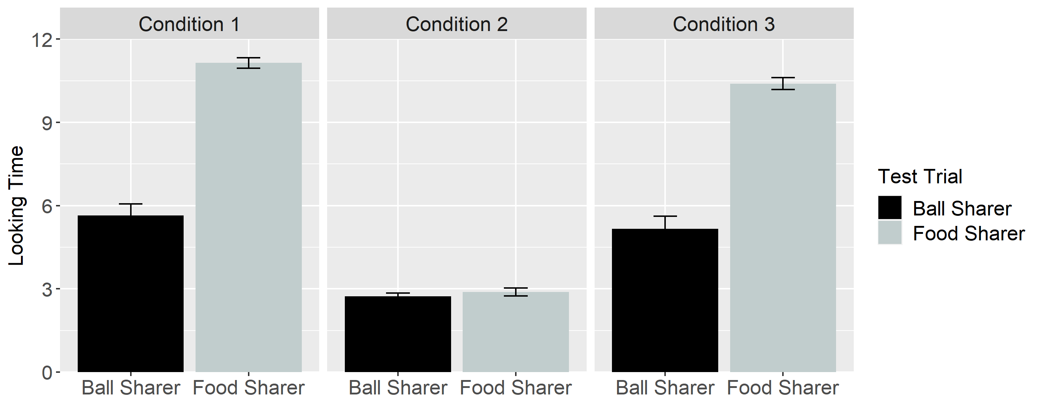
Figure 2. Networks’ mean expectation or looking time to the Ball Sharer and Food Sharer test events.

Figure 2 shows networks’ looking times to and expectations for the Food and Ball Sharers across Conditions 1-3. Data were entered into a linear mixed-effects model with Test Trial as the within-subjects fixed effect (Ball Sharer vs. Food Sharer), Condition as the between-subjects fixed effect (Condition 1 vs. Condition 2 vs. Condition 3), and participants as the random effect. The results revealed a main effects of Test Trial and Condition, which were qualified by an interaction between the two, F(2, 357) = 325.35, p = 0.

Across all four conditions, we used cross-entropy error as a measure of network performance. Typically, greater error corresponds to longer looking. However, because the looking times in Thomas et al. (2022) were reported in terms of expectations rather than surprise, we applied a simple numerical transformation to make the present error values more comparable to those data. Specifically, we subtracted a given network’s error score produced by a test event from the maximum error for that test event. A corollary of this is that lower network error corresponded to longer looking or greater expectation. We used these transformed values in all subsequent analyses.

