An associative learning account of how saliva becomes a cue to comfort
Deon T. Benton^{ǂ} and Justine E. Hoch^{ǂ}
^{ǂ}Share first-authorship
Vanderbilt University

Address correspondence either to Deon T. Benton or Justine E. Hoch, Department of Psychology and Human Development, Vanderbilt University, Peabody College, 230 Appleton Place #552, Nashville, TN 37235

Data availability statement: The code and network-modeling scripts are available upon reasonable request.
Conflicts of interests: none
“How saliva becomes a cue to comfort”
Abstract
One of the challenges infants face is learning who is related to whom. A recent study in Science by Thomas et al. (2022) showed that 8- to 10-month-olds use saliva sharing as a cue of relationship closeness: infants expected individuals who shared saliva to comfort one another during distress. The current paper offers a mechanistic explanation for this finding. We propose that infants form separate representations of saliva sharing and comforting through everyday experience and that, when the same individuals participate in both actions, these representations become integrated into a common representation that supports bidirectional expectations. In a first simulation, we show that when this proposal is implemented in a connectionist computational model, the model accounts for infants’ looking responses in Thomas et al. (2022). In a second simulation, we show that the model also uses prior comforting as a predictor of saliva sharing. We argue that this latter result serves a behavioral prediction that can be tested in future infant studies. Overall, these results demonstrate that domain-general associative learning is sufficient to explain how infants’ knowledge about the social meaning of saliva sharing might develop.

“How saliva becomes a cue to comfort”
Preverbal infants face many challenges. One of the more formidable of these challenges is discovering how individuals are related. A related but equally daunting challenge is recognizing that not all relationships are the same and may differ in “thickness” or closeness. Perhaps the best example of a thick relationship is that among immediate family members such as the relationship between a father and their child. An important property of such relations is that members often feel a sense of oneness and strong levels of attachment, commitment, allegiance, loyalty, obligation, and mutual responsiveness (Thomas, 2024; Thomas et al., 2022). By understanding who is in a thick relationship and who is not, infants can begin to make predictions about how in- and outgroup members of those relationships will behave in the future. For example, a father might be expected to pick up his child if they are crying, but it would be incongruous for him to do the same with another child.
Given that evaluating and predicting how someone will behave towards another person in the future partially depends on knowing the kind of relationship that they are in and its thickness, an open question concerns how infants solve these interrelated obstacles. One proposal for how infants might overcome them is to use external cues to infer not only the existence of a relationship but its strength. A promising candidate for such a cue is saliva. Paradigmatic examples of real-world saliva sharing include sharing food, beverages, and utensils as well as exchanging saliva. There are at least two reasons why saliva sharing represents promising cue. The first is that the act of sharing saliva with another person may have predictive validity for other actions. For example, individuals who share saliva should be more likely than non-saliva-sharers to invest in one another, be emotionally responsive, provide comfort and care during illness or distress, engage in physical affection (e.g., hugging, cuddling), and cooperate in everyday tasks. The second reason is that, compared to many culturally specific practices that can signal relationship closeness (e.g., bowing, handshakes, cheek-kissing, etc.), saliva sharing is not tied to a specific culture. Instead, saliva sharing occurs across all of the world’s cultures, which may mean that it functions as a universal indicator that two individuals share a thick relation.
A recent study published in Science by Thomas et al. (2022) tested whether infants treat saliva sharing as a cue to relationship thickness and whether such sharing makes actions like comforting when distressed more likely. Although Thomas et al. (2022) tested infants and children, here we focus on the infant experiments. The rationale for this is that unlike children who can be explicitly told who is in a relationship and what its strength is, infants must rely on observable cues to make inferences about relationship closeness. Thus, infants’ behavior in this study can provide insight into the developmental origins of the ability to identify close relationships and make predictions about how members of such relationships should behave towards one another in the future. In one experiment (i.e., Exp. 2B), 8½- to 10-month-old infants were shown an event in which a puppet, which was positioned between two actresses, either ate from the same orange slice as one of the actresses or shared a ball with the other actress. The former event was used to denote saliva-sharing. Infants then saw the same puppet express distress; that is, the puppet appeared as though it was crying. As the puppet cried, both actresses turned towards the puppet. Thomas et al. (2022) reasoned that if infants expected saliva-sharers to comfort one another when distressed, then they should look longest and first at the actress that ate from the same orange slice as the puppet. This is what Thomas et al. (2022) found.
One complication with this experiment is that infants might show the same pattern of looking—that is, looking first and longest towards the orange actress—even if the original puppet was replaced with a new puppet. This would suggest that infants expect food sharers to comfort anyone in distress. Thomas et al. (2022) addressed this concern in Experiment 2D by replacing the original puppet with a new puppet at the beginning of the distress event, following the food- and ball-sharing events. They found that infants looked equally long at both actresses when the new puppet was in distress. This suggests that infants expected saliva-sharers to comfort their saliva-sharing partners when those partners are distressed rather than to comfort distressed individuals generally.
In the final infant study (Experiment 3B), Thomas et al. (2022) tested whether infants’ behavior in the previous experiments were due to saliva sharing specifically rather than food sharing generally. Thomas et al. (2022) tested this idea by showing infants a video in which a central actress—who was flanked by two puppets—placed her finger into her mouth, rotated it, and then placed it into one of the puppet’s mouths. The actress then placed her finger on her forehead, rotated it, and placed it on the other puppet’s forehead. The actress then expressed distress and Thomas et al. (2022) measured which puppet infants looked at longest and first. Although infants’ first looks were split evenly between both puppets, they did look longer at the puppet with whom the actress shared saliva. Thomas et al. (2022) interpreted these findings—which were recently partially replicated in a recent study by Ciftci et al. (2025)—to mean that preverbal infants use saliva sharing specifically as a cue for identifying thick relationships and predicting that members of such relationships will comfort one another during moments of distress.
Although Thomas et al. (2022) suggested that there may be an evolutionary basis for the expectation that saliva sharers comfort each other, they remained largely agnostic about its developmental origins. However, because they do not provide a mechanism for this expectation one way or the other, it remains to be seen what the cognitive mechanism could explain it or how such a expectation might arise. Given this unanswered question, the primary goal of the current paper is to provide an account of the mechanism of change that underpinned infants’ expectation that comfort occurs among saliva sharers. Our central argument will be that infants’ looking behaviors in Thomas et al. (2022) can be explained by a domain-general associative process that links saliva sharing and comforting to a common mental representation that supports bidirectional expectations. We then will show that when this proposal is implemented into a connectionist computational model, it is sufficient to explain infants’ looking behaviors in Thomas et al. (2022).

An associative learning account for how saliva sharing comes to be used to indicate comfort
Our central claim is that infants’ expectation that comforting happens among saliva sharers but not among non-saliva sharers is the product of specific visual experiences and a domain-general associative learning mechanism that operates over those experiences. Specifically, the reason infants looked longest at the actress with whom the now distressed puppet shared saliva may have been because they have learned in the real world that individuals who share saliva also comfort each other during moments of distress. At the same time, infants may have looked equally long at both actresses when the distressed puppet was not a part of the original saliva-sharing event because infants have also learned that individuals who do not share saliva typically do not comfort one another during distress. Critically, both representations—that is, a representation of saliva sharing and a representation of comforting—are established through two kinds of extensive experience. First, as infants repeatedly witness others sharing saliva in the real world, they gradually build a mental representation of those events. This representation will come to include information about who shared saliva with whom. Importantly, because the specific food items may vary from one saliva-sharing instance to the next, the association between saliva sharing and the internal representation will be stronger than that between any one food item and this representation. Second, as infants accrue experience of individuals comforting one another during moments of distress, they establish and build a parallel representation of those events.
Crucially, what enables these separate representations to merge into a common one is that the same individuals who engage in saliva sharing also engage in comfort giving. Thus, when infants see a former saliva sharer during a comforting event, the presence of the saliva sharer activates the representation of saliva sharing. While this representation is active, any subsequent features that distinguish the comforting event from the saliva sharing event are incorporated into it. As a result, a common mental representation emerges that contains information about saliva sharing and comforting. A corollary of such a common representation that is linked to saliva sharing and comforting is that infants’ expectations about both actions should be bidirectional: just as saliva sharing predicts comforting via this common representation, comforting should predict saliva sharing via the same representation.
Importantly, infants would be unable to incorporate aspects of the comforting event into the representations they have built for saliva sharing if they could not track which individuals shared saliva in the first place. Thus, our account assumes that infants can track the identity of individuals across space and time. Our contention that infants can track the identity of individuals is supported by research showing that this capacity emerges between 6 and 12 months of age (Káldy & Leslie, 2003, 2005; Kibbe & Leslie, 2011, 2013, 2016). Given that the infants tested in Thomas et al. (2022) were 8½- to 10-month-olds—an age that falls squarely within this range—it is reasonable to conclude that they could track individual identities across space and time.
Given the speculative nature of this account, in the next section we present a connectionist computational model that instantiates it to determine whether such a mechanistic proposal can capture infants’ looking behavior in Thomas et al. (2022). Across two simulations, we not only show that a computational instantiation of our proposal is sufficient to explain infants’ looking responses in Thomas et al. (2022) (Simulation 1) but we also show that these expectations might be bidirectional in nature (Simulation 2).

General Method
Network Architecture
The simulations reported here used a three-layer, feedforward, autoassociative neural network model (e.g., Mareschal et al., 2000) trained with backpropagation in cross-entropy error (e.g., Rumelhart et al., 1986). The hidden and output units used a sigmoid activation function. Gaussian noise was added to input activations to reflect infants’ noisy sensory processing (M = 0, SD = 0.2).
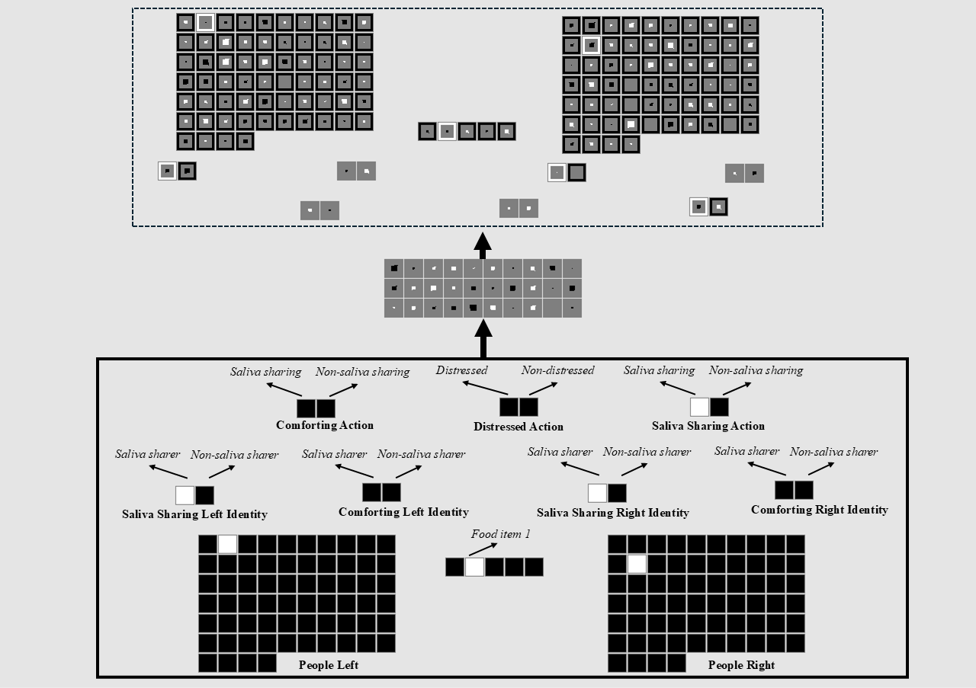Figure 1. Schematic of an untrained model architecture used in the current simulations. The input and output groups are identical. The input groups are written in bold. The model consisted of nine structurally identical input and output groups: People Left/Right, Saliva Sharing Left/Right Identity, Comforting Left/Right Identity, Comforting Action, Distressed Action, Food Item, and Saliva Sharing Action. The specific feature that a given unit coded for is shown in italics within each group.

The model consisted of three layers (Figure 1). There were 147 input units, 30 hidden units, and 147 output units. The 147 input and output units were divided into 10 groups of units—the output groups were identical to the input groups. These groups—along with the number of units that comprised them—are listed and shown in Figure 1. A few things are worth noting about the model architecture. The first is that the Saliva Sharing Identity and Comforting Identity groups captured the property of being a saliva sharer or comforter; the Saliva Sharing Action and Comforting Action groups captured the action of engaging in saliva sharing or comforting. By separating an individual’s property from its action, it was possible for the model to represent situations in which a former comforter engages in saliva sharing or a former saliva sharer engages in comforting. The second is that for each input group, the model’s task was to activate in the output layer exactly those units that were active in the input layer. The third is that localist representations—in which a single unit represented a single concept—were adopted for each group to simplify the interpretation and analysis of the model. We have no reason to believe that the model’s performance would differ if richer representations were used. The fourth is that although the names of the groups and features were conceptually laden (e.g., Distressed Action), we do not intend to suggest that infants see these features in a semantically meaningful or rich way. We use these terms simply to make it easier to understand the structure of the model. The final comment is that because saliva/non-saliva sharing and comforting/non-comforting necessarily occur between two people, it was always the case in the current simulation that the model always saw two people (i.e., at all points a single unit was turned on in the People Left and Right groups).

Pretraining
Table 1. Eights pretraining events used to approximate infants’ everyday experience with saliva sharing, comforting, and distress, including events that link these actions. The purpose of each event is also included. The numbers in parentheses next to each event type indicate how many times the event was shown during the pretraining phase.
Event Type | Key Action(s) | Purpose of Pretraining
Saliva Sharing Only | Two individuals sharing saliva via different foods | Encode representation of saliva sharing
Saliva Sharing + Comfort + Distress | One individual comforts their saliva-sharing partner when distressed | Establish a common representation linking saliva sharing and comfort via shared individual
Non-Saliva Sharing Only | Two individuals share something other than saliva | Encode representation of non-saliva sharing
Non-Saliva Sharing + Non-Comfort + Distress | One individual does not comfort their non-saliva-sharing partner when distressed | Establish a common representation linking non-saliva sharing and non-comfort via shared individual
Comfort + Distress | One individual comforts their distressed partner | Encode representation of comforting
Comfort + Saliva Sharing | A former comforter shares saliva with their previously distressed partner via different foods | Establish common representation linking comforting and saliva sharing via a shared individual
Non-Comfort + Distress | One individual fails to comfort a distressed partner | Encode representation of non-comforting
Non-Comfort + Non-Saliva Sharing | One individual does not share saliva with a non-distressed partner | Establish common representation linking non-comforting and non-saliva sharing via a shared individual

The pretraining phase—which approximated infants’ real-world experience—lasted from anywhere between 600 and 800 epochs, in increments of 100. Different numbers of epochs were used to ensure that the network’s performance was not idiosyncratic to the length of the pretraining phase, and different food items were used in each saliva sharing event to instantiate the idea that the crucial link is between saliva sharing and comforting rather than between food sharing and comforting. Networks experienced eight kinds of events during training (Table 1). Each event was shown 10 different times. A unique combination of people was shown in each instance. These events instantiated our assumptions about the kinds of real-world, saliva sharing and comforting experience that influenced infants’ looking behaviors in Thomas et al. (2022). Each event was implemented by activating the relevant units in the Person, Saliva Sharing/Comforting Identity groups, Distressed Action, Saliva Sharing/Comforting Action groups (see the Appendix for details about which features were turned on for each event type).

Familiarization
Following the pretraining phase, networks were randomly assigned to 1 of 3 conditions (20 networks per condition). The first three conditions corresponded, respectively, to Experiments 2B, 2D, and 3B in Thomas et al. (2022). A “participant” corresponded to an untrained model who weights were initialized to small random values (sampled uniformly between ±0.1). It is worth noting that because we did not simulate food items, Condition 3 was identical to Condition 1 except that food information was missing (as was the case in Thomas et al., 2022). The familiarization phase for networks in all three conditions involved them an event in which a central character engaged in saliva sharing with one person and non-saliva sharing with another person. All events used novel people and were implemented in a similar manner to the pretraining events (see the Appendix). Finally, the familiarization phase could last for either 5 or 10 epochs. As with the length of the pretraining phase, different values were used to ensure that the model’s performance was robust to the length of the familiarization phase.
Test
Following the familiarization phase, networks participated in a test phase. The nature of this test phase depended on the condition to which networks were assigned. Networks in Conditions 1 and 3 were shown an event in which the same central character expressed distress. In contrast, networks in Condition 2 were shown the same event except that the character that was in distress was different from that shown during the familiarization phase.
The dependent measure used in this and the subsequent simulation was cross-entropy error. Typically, greater error corresponds to longer looking. However, because the looking times in Thomas et al. (2022) were reported in terms of expectations rather than surprise, we applied a simple numerical transformation to make the present error values more comparable to those data. Specifically, we subtracted a given network’s error score produced by a test event from the maximum error for that test event. This transformation means that lower network error corresponded to longer looking or greater expectation.

Results
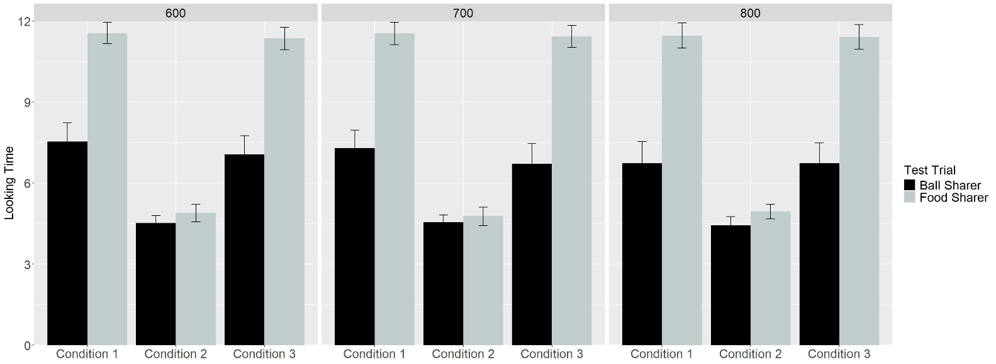
Figure 2. Networks’ mean expectation or looking time to the Ball Sharer and Food Sharer test events across Conditions and Pretraining Epochs.

Figure 2 shows networks’ looking times to and expectations for the Food and Ball Sharers across Conditions 1-3 and Pretraining Epochs. Data were entered into a linear mixed-effects model with Test Trial as the within-subjects fixed effect (Ball Sharer vs. Food Sharer), Condition as the between-subjects fixed effect (Condition 1 vs. Condition 2 vs. Condition 3), Pretraining Epochs (600 vs. 700 vs. 800), and participants as the random effect. The number of familiarization epochs was not included as an additional fixed effect because it was colinear with Pretraining Epochs and created singularity issues for the model. The results revealed a main effect of Test Trial and Condition, which were qualified by an interaction between the two, F(2, 351) = 222.49, p = 0. Follow-up analyses were conducted for each Condition to assess the nature of this interaction. A paired t-test for Conditions 1 and 3 showed that networks looked longer at the Food Sharer (Condition 1: M = 11.53, SD = 1.40; Condition 3: M = 11.41, SD = 1.40) than at the Ball Sharer (Condition 1: M = 7.20, SD = 2.42; Condition 3: M = 6.84, SD =2.44), both ts > 24.22, both p’s = 0. Although networks in Condition 2 also looked longer at the Food Sharer (M = 4.88, SD = 1.05) than at the Ball Sharer (M = 4.51, SD = 0.97), t(119) = 3.45, p < .001, the difference in looking time was greater for networks in the Conditions 1 and 2 (M = 4.45, SD = 1.94) than networks in Condition 2 (M = 0.38, SD = 1.19), t(342.04) = 24.49, p = 0.

Discussion
The simulation was carried out to test whether infants’ looking behaviors in Thomas et al. (2022) could be captured by the operation of a domain-general learning mechanism that links instances of saliva sharing and comforting to a shared representation, particularly when those experiences involve the same individuals. The results indicated that infants’ responses, at least qualitatively in terms of the overall pattern of looking, could be explained by such a mechanism. Yet, one feature of our account that Simulation 1 does not address is the notion that the common representation that derives from domain-general associative learning should support bidirectional expectations; that is, because saliva sharing and comforting are linked to the same representation via a recurring individual, the model (and by extension infants) should expect saliva sharing given information about comforting. Simulation 2 was undertaken to determine whether in fact the current model expects saliva sharing following comforting, as predicted by our account.

Simulation 2
Network Architecture and Familiarization
The architecture used in Simulation 2 was identical to that in Simulation 1. The pretraining phase was also identical.

Familiarization and Test
Following pretraining, networks (N = 20) were familiarized to an event in which one of two individuals comforted a distressed central character; the other person did not provide comfort to the central character. Networks were then tested on an event in which the central character from the familiarization phase engaged in saliva sharing with the individual that comforted it and non-saliva sharing with the other individual. A separate group of networks (N = 20) in a Control condition were familiarized to the same event as the first group but tested on a different event. The test event for these networks was identical to networks in the Experimental condition except that the central character was replaced with a new character. The dependent measure was identical to Simulation 1.

Results
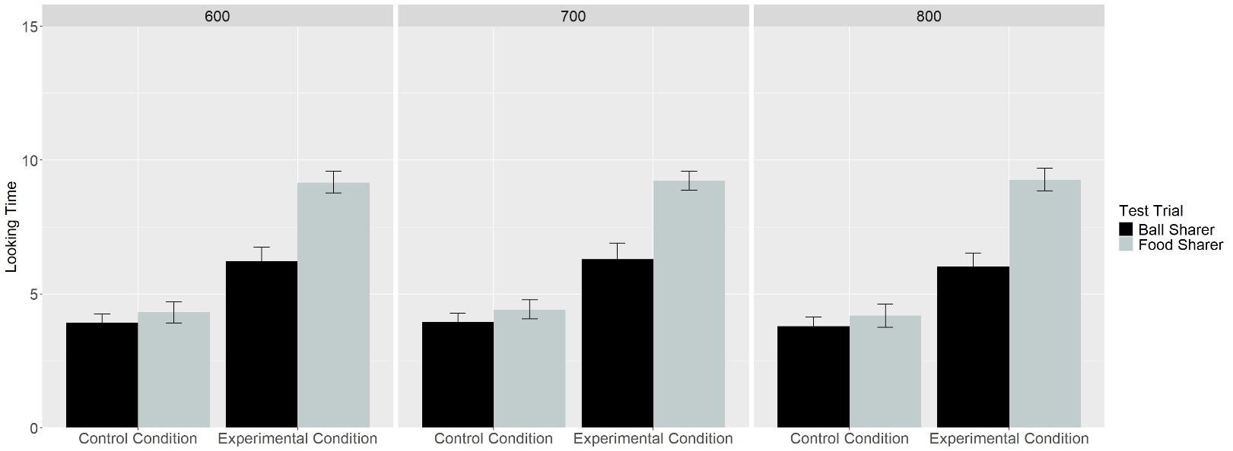
Figure 3. Networks’ mean expectation or looking time to the Ball Sharer and Food Sharer test events across Conditions and Pretraining Epochs.

Figure 3 shows networks’ looking times to and expectations for the Food and Ball Sharers across the Experimental and Control Conditions and Pretraining Epochs. Data for networks in these conditions were entered into a linear mixed-effects model with Test Trial as the within-subjects fixed effect (Ball Sharer vs. Food Sharer), Condition as the between-subjects fixed effect (Experimental vs. Control), Pretraining Epochs (600 vs. 700 vs. 800), and participants as the random effect. The results revealed main effects for Condition and Test trial, both of which were qualified by two interactions. The first interaction was between Trial Type and Pretraining Epoch, F(2, 234) = 5.59, p = .004. This interaction reflected the fact that, although networks looked longer at the Food Sharer than the Ball Sharer across Pretraining Epochs, the size of this difference varied across epochs. More importantly, there was an interaction between Condition and Test Trial, F(1, 234) = 755.87, p = 0. Follow-up analyses were conducted for each Condition to assess the nature of this interaction. A paired t-test for the Experimental Condition showed that networks looked longer at the Food Sharer (M = 12.17, SD = 1.09) than the Ball Sharer (M = 6.67, SD = 2.32), both t(119) = 29.37, p = 0. Although networks in the Control Condition also looked longer at the Food Sharer (M = 2.59, SD = 1.11) than at the Ball Sharer (M = 2.44, SD = 0.97), t(119) = 2.24, p = 0.03, the difference in looking time was greater for networks in the Experimental Condition (M = 5.50, SD = 2.05) than networks in the Control Condition (M = 0.15, SD = 0.75), t(150.12) = 26.82, p = 0.

Discussion
Simulation 2 was conducted to determine whether a common representation that derives from domain-general associative learning and forms when the same person engages in saliva sharing and comfort supports bidirectional expectations about one action given the other. The results demonstrated that a common representation does support such expectations.

General Discussion
A recent study by Thomas et al. (2022) showed that 8- to 10-month-old infants expect saliva-sharers to comfort each other during moments of distress. Crucially, Thomas et al. (2022) showed that this expectation is specific to saliva sharing and only holds when the individual in distress is the same one that appeared during the saliva-sharing event. The goal of the current paper was to offer a mechanistic explanation for these findings and then to test whether this account—when instantiated in a connectionist computational model—could explain them. The crux of our proposal is that infants build separate representations of saliva sharing and comforting based on repeated, real-world experience seeing these events. Crucially, if the same individual participates in both events, those representations become integrated into a common mental representation. Two consequences follow from this process. First, activating one feature (e.g., saliva sharing) will trigger the other (e.g., comforting). Second, this common representation may support bidirectional expectations: Infants may expect comforting following saliva sharing and but also expect saliva sharing following comforting.
Simulation 1 demonstrated that this account was sufficient to explain infants’ looking behavior in Thomas et al. (2022). However, because this simulation did not test the notion that infants’ expectations of saliva sharing and comforting is bidirectional, a second simulation was carried out to determine whether a model that implemented our mechanistic account would also expect saliva sharing following prior instances of comforting. The results supported this prediction: Networks familiarized to an event in which one person comforted a central character showed a greater expectation for saliva sharing between those two individuals than between the other individual and the central character. Taken together, these results provide a mechanistic explanation of how preverbal infants learn to use saliva as a cue for relationship closeness and predictor of comfort.
The current findings add to a broader tradition in the developmental cognitive sciences that use connectionist models to demonstrate the sufficiency of domain-general processes for capturing infants’ behavior in tasks that rely on looking time. (e.g., Benton, 2024, Benton & Lapan, 2021; Christiansen & Curtin, 1999; Cohen et al., 2002; Munakata et al., 1997; Schlesinger & Casey, 2003; Vong et al., 2024). At the same time, the current simulations extend this extensive body of evidence by demonstrating that the basis of infants’ expectation of comfort following saliva sharing may be associative learning.
Although our model demonstrates that associative learning is sufficient to explain how infants come to see saliva sharing as having social significance, it does not rule out the possibility—as suggested by Thomas et al. (2022)—that this expectation has an evolutionary basis. Additionally, the current simulations do not show that infants’ knowledge about the social meaning of saliva sharing derives from associative processes. Addressing both questions will require behavioral experiments. For example, if infants, like the networks in Simulation 2, use saliva sharing as a predictor of comforting, this would suggest that they relied on associative learning. A promising avenue for future research will be to test this prediction directly and to pit the current proposal against alternatives. Beyond these issues, our model could be critiqued by its use of localist, semantically neutral input representations. Such representations—which are neither rich nor multimodal—likely poorly approximate infants’ real-world experience with saliva sharing and comfort. Future modeling work should instantiate the current proposal into neural networks with richer representations that better capture infants’ natural experiences.
In sum, by demonstrating that a shared mental representation that arises from a domain-general associative learning is sufficient to explain infants’ responses in Thomas et al. (2022), we show mechanistically how ostensibly abstract social expectations can emerge from simple learning mechanisms and experience. More broadly, these findings underscore the value of computational modeling for elucidating potential mechanisms of early social reasoning.
References
Benton, D. T. (2024). An associative-learning account of how infants learn about causal action in animates and inanimates: A critical reexamination of four classic studies. Journal of Experimental Psychology: General, 154(2), 497–521. https://doi.org/10.1037/xge0001656
Benton, D. T., & Lapan, C. (2022). Moral masters or moral apprentices? A connectionist account of sociomoral evaluation in preverbal infants. Cognitive Development, 62, 101164. https://doi.org/10.1016/j.cogdev.2022.101164
Christiansen, M. H., & Curtin, S. (1999). Transfer of learning: rule acquisition or statistical learning?. Trends in Cognitive Sciences, 3(8), 289-290. https://doi.org/10.1016/S1364-6613(99)01356-X
Ciftci, B. G., Kominsky, J. F., & Csibra, G. (2025). Do infants use cues of saliva-sharing to infer close relationships? A replication of Thomas et al.(2022). Royal Society Open Science, 12(4), 240229. https://doi.org/10.1098/rsos.240229
Cohen, L. B., Chaput, H. H., & Cashon, C. H. (2002). A constructivist model of infant cognition. Cognitive Development, 17(3-4), 1323-1343. https://doi.org/10.1016/S0885-2014(02)00124-7
Káldy, Z., & Leslie, A. M. (2003). Identification of objects in 9‐month‐old infants: integrating ‘what’and ‘where’information. Developmental Science, 6(3), 360-373. https://doi.org/10.1111/1467-7687.00290
Káldy, Z., & Leslie, A. M. (2005). A memory span of one? Object identification in 6.5-month-old infants. Cognition, 97(2), 153-177. https://doi.org/10.1016/j.cognition.2004.09.009
Kibbe, M. M., & Leslie, A. M. (2011). What do infants remember when they forget? Location and identity in 6-month-olds’ memory for objects. Psychological science, 22(12), 1500-1505. https://doi.org/10.1177/0956797611420165
Kibbe, M. M., & Leslie, A. M. (2013). What’s the object of object working memory in infancy? Unraveling ‘what’and ‘how many’. Cognitive Psychology, 66(4), 380-404. https://doi.org/10.1016/j.cogpsych.2013.05.001
Kibbe, M. M., & Leslie, A. M. (2016). The ring that does not bind: Topological class in infants’ working memory for objects. Cognitive Development, 38, 1-9. https://doi.org/10.1016/j.cogdev.2015.12.001
Mareschal, D., French, R. M., & Quinn, P. C. (2000). A connectionist account of asymmetric category learning in early infancy. Developmental Psychology, 36(5), 635–645. https://doi.org/10.1037/0012-1649.36.5.635
Munakata, Y., McClelland, J. L., Johnson, M. H., & Siegler, R. S. (1997). Rethinking infant knowledge: Toward an adaptive process account of successes and failures in object permanence tasks. Psychological Review, 104(4), 686–713. https://doi.org/10.1037/0033-295X.104.4.686
Rumelhart, D. E., Hinton, G. E., & Williams, R. J. (1986). Learning representations by back-propagating errors. nature, 323(6088), 533-536. https://doi.org/10.1038/323533a0
Schlesinger, M., & Casey, P. (2003). Where infants look when impossible things happen: Simulating and testing a gaze-direction model. Connection Science, 15(4), 271-280. https://doi.org/10.1080/09540090310001655093
Thomas, A. J. (2024). Cognitive representations of social relationships and their developmental origins. Behavioral and Brain Sciences, 1-53. https://doi.org/10.1017/S0140525X24001328
Thomas, A. J., Woo, B., Nettle, D., Spelke, E., & Saxe, R. (2022). Early concepts of intimacy: Young humans use saliva sharing to infer close relationships. Science, 375(6578), 311-315. https://doi.org/10.1126/science.abh1054
Vong, W. K., Wang, W., Orhan, A. E., & Lake, B. M. (2024). Grounded language acquisition through the eyes and ears of a single child. Science, 383(6682), 504-511. https://doi.org/10.1126/science.adi1374

