An associative learning account of how saliva becomes a cue for comfort
Deon T. Benton^{ǂ} and Justine E. Hoch^{ǂ}
^{ǂ}Share first-authorship
Vanderbilt University

Address correspondence either to Deon T. Benton or Justine E. Hoch, Department of Psychology and Human Development, Vanderbilt University, Peabody College, 230 Appleton Place #552, Nashville, TN 37235

Data availability statement: The code and network-modeling scripts are available upon reasonable request.
Conflicts of interests: none
“How saliva becomes a cue for comfort”
Abstract
One of the challenges infants face is learning who is related to whom. A recent study in Science by Thomas et al. (2022) showed that 8- to 10-month-olds use saliva sharing as an indicator of relationship closeness: infants expect individuals who previously shared saliva to comfort one another when distressed. The current paper offers a mechanistic explanation for this finding. We propose that infants form separate representations of saliva sharing and comforting through everyday experience and that, when the same individuals participate in both actions, these representations become integrated into a common representation that supports bidirectional expectations in which one action predicts the other (and vice versa). In a first simulation, we show that when this proposal is implemented in a connectionist computational model, the model uses prior saliva sharing as a predictor of comfort and accounts for infants’ looking responses in Thomas et al. (2022). In a second simulation, we show that the model also uses prior comforting as a predictor of saliva sharing. The results of the second simulation generate a behavioral prediction that can be tested in future infant studies. Taken together, our findings suggest that domain-general associative learning can explain how infants come to understand the social meaning of saliva sharing.

“How saliva becomes a cue for comfort”
To make sense of the social world, preverbal infants must learn to detect social relationships and evaluate their strength, or “thickness.” Thick relationships—such as those among immediate family members—are marked by strong levels of attachment, loyalty, obligation, and mutual responsiveness (Thomas, 2024; Thomas et al., 2022). Distinguishing thick relationships from thinner ones enables infants to predict how people are likely to behave. For example, a father might be expected to comfort his own child, but not another child. However, despite the clear social utility of detecting thick relationships, the developmental origins of this ability are poorly understood.
One account suggests that infants infer the strength of social relationships by observing external cues. A promising candidate for such a cue is saliva sharing. People in thick relationships frequently share saliva via shared food, beverages, and utensils, whereas those in thinner relationships typically do not. There are at least two reasons why saliva sharing represents a promising cue. First, saliva sharing may predict other actions. For example, individuals who share saliva should be more likely than non-saliva-sharers to invest in one another, be emotionally responsive, provide comfort and care during illness or distress, engage in physical affection, and cooperate in everyday tasks. Second, unlike other culturally specific practices that can signal relationship closeness (e.g., bowing, cheek-kissing, etc.), saliva sharing occurs across all of the world’s cultures (e.g., Thomas et al., 2022). Thus, saliva sharing may be a universal indicator of thick relationships.
A recent study published in Science by Thomas et al. (2022) tested whether infants treat saliva sharing as a cue for relationship thickness by testing whether infants expect individuals who previously shared saliva to comfort one another when distressed. Although Thomas et al. (2022) also tested older children, we focus on infants who cannot rely on explicit instruction. In Thomas et al.’s primary experiment (i.e., Exp. 2B), 8.5- to 10-month-old infants saw a puppet interact with two actresses. The puppet shared saliva with the first actress by eating from the same orange slice. The puppet shared a ball with the second actress but did not share saliva. Then, infants saw the same puppet positioned between the two actresses on the screen. The puppet then exhibited distress by crying. As the puppet cried, both actresses turned towards the puppet. Thomas et al. (2022) reasoned that if infants expected saliva-sharers to comfort one another when distressed, infants should look first and longest at the actress who ate from the same orange slice as the puppet—and this is exactly what they found.
To test whether infants’ expectations were specific to previous saliva-sharing partners, rather than a general expectation that saliva-sharers comfort anyone in distress, Thomas et al. (2022) repeated the initial study but replaced the original puppet with a new puppet at the beginning of the distress event (Experiment 2D). When the new puppet was in distress, infants looked equally long at both actresses. The findings from these two studies suggest that infants expect saliva-sharers to comfort their saliva-sharing partners, but not distressed individuals generally.
In a third experiment (Experiment 3B), Thomas et al. (2022) tested whether infants’ behavior in the previous experiments was specifically due to saliva sharing (rather than food sharing). They showed infants a video of a central actress flanked by two puppets. First, the actress placed her finger into her mouth, rotated it, and then placed it into one of the puppet’s mouths. Next, the actress placed her finger on her forehead, rotated it, and placed it on the other puppet’s forehead. The actress then expressed distress, and Thomas et al. (2022) measured which puppet infants looked at first and longest. Although infants’ first looks were split evenly between both puppets, infants looked longer at the puppet with whom the actress shared saliva. Thomas et al. (2022) interpreted these findings—which were partially replicated by Ciftci et al. (2025)—to mean that preverbal infants specifically use saliva sharing to predict who should provide comfort to whom.
Although Thomas et al. (2022) suggest that there may be an evolutionary basis for the expectation that saliva-sharers comfort one another, they remain largely agnostic about its developmental origins. Here, our goal is to provide a mechanistic account of how saliva sharing comes to predict comfort. .Our central argument is that infants’ looking behaviors in Thomas et al. (2022) can be explained by a domain-general associative process that links saliva sharing and comforting to a common representation and that supports bidirectional expectations such that each behavior predicts the other. Crucially, our account does not assume that infants need a notion of thick relationships to account for the data in Thomas et al. (2022); this data can be explained entirely in terms of a common representation that links saliva sharing and comforting. We show that when this proposal is implemented into a connectionist computational model, it is sufficient to explain infants’ looking behaviors in Thomas et al. (2022). Although we argue that associative learning can capture Thomas et al.’s (2022) infant data, this does not preclude the existence of an evolved predisposition to infer the existence of a thick relationship from saliva sharing.

An associative learning account for how saliva sharing comes to be used to indicate comfort
Our central claim is that infants’ expectations about how saliva-sharers should behave are the product of their experiences and a domain-general associative learning mechanism that operates over them. Put simply, infants learn from experience that saliva-sharers comfort one another during distress, but non-saliva sharers do not. We propose that infants’ real-world experiences establish two types of representations—a representation of saliva sharing and a representation of comforting. Here, “representation” simply means patterns of activation across units in an associative, cognitive system that are elicited by different environmental events. First, as infants repeatedly witness others sharing saliva, they gradually build a representation of those events. This representation will come to include information about who shared saliva with whom. Importantly, because the specific food items may vary from one saliva-sharing instance to the next, the association between saliva sharing and the representation will be stronger than that between any one food item and this representation. Second, as infants accrue experience of individuals comforting one another during moments of distress, they establish and build a parallel representation of those events.
Crucially, what enables these separate representations to merge into a common one is that the same individuals who engage in saliva sharing also engage in comfort giving. Thus, when infants see a former saliva sharer during a comforting event, the presence of the saliva sharer activates the representation of saliva sharing. While this representation is active, any subsequent features that distinguish the comforting event from the saliva sharing event are incorporated into it. As a result, a common representation emerges that contains information about saliva sharing and comforting. A corollary of such a common representation that is linked to saliva sharing and comforting is that infants’ expectations about both actions should be bidirectional such that saliva sharing predicts comfort, and comfort predicts saliva sharing.
Importantly, infants would be unable to incorporate aspects of the comforting event into the representations they have built for saliva sharing if they could not track which individuals shared saliva in the first place. Thus, our account assumes that infants can track the identity of individuals across space and time. Our contention that infants can track the identity of individuals is supported by research showing that this capacity emerges between 6 and 12 months of age (Káldy & Leslie, 2003, 2005; Kibbe & Leslie, 2011, 2013, 2016). Given that the infants tested in Thomas et al. (2022) were 8.5- to 10-month-olds—ages that fall within this range—it is reasonable to conclude that they could track individual identities spatiotemporally.
In the next section, we present a connectionist computational model that instantiates this account. Across two simulations, we show that our model explains infants’ looking responses in Thomas et al. (2022) (Simulation 1) and implies that infants may hold bidirectional expectations about the link between saliva sharing and comfort (Simulation 2).

General Method
Network Architecture
The simulations reported here used a three-layer, feedforward, autoassociative neural network model (e.g., Mareschal et al., 2000) trained with backpropagation in cross-entropy error (e.g., Rumelhart et al., 1986). The hidden and output units used a sigmoid activation function. Gaussian noise was added to input activations to reflect infants’ noisy sensory processing (M = 0, SD = 0.375).
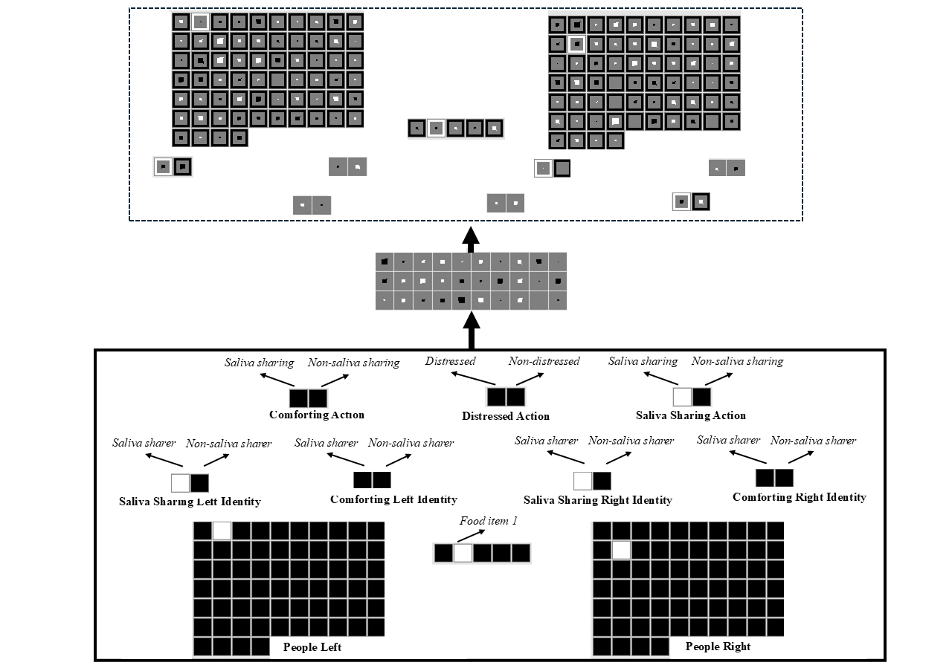Figure 1. Schematic of an untrained model architecture used in the current simulations. The input and output groups are identical. The input groups are written in bold. The model consisted of 10 structurally identical input and output groups: People Left/Right, Saliva Sharing Left/Right Identity, Comforting Left/Right Identity, Comforting Action, Distressed Action, Food Item, and Saliva Sharing Action. The specific feature that a given unit coded for is shown in italics within each group.

The model consisted of three layers (Figure 1). There were 147 input units, 30 hidden units, and 147 output units. The 147 input and output units were divided into 10 groups of units—the output groups were identical to the input groups. These groups—along with the number of units that comprised them—are shown in Figure 1. A few things are worth noting about the model architecture. The first is that the Saliva Sharing Identity and Comforting Identity groups captured the property of being a saliva sharer or comforter; the Saliva Sharing Action and Comforting Action groups captured the action of engaging in saliva sharing or comforting. By separating an individual’s property from its action, it was possible for the model to represent situations in which a former comforter engages in saliva sharing or a former saliva sharer engages in comforting. The second is that for each input group, the model’s task was to activate in the output layer exactly those units that were active in the input layer. The third is that localist representations—in which a single unit represented a single concept—were adopted for each group to simplify the interpretation and analysis of the model. The fourth is that although the names of the groups and features were conceptually laden (e.g., Distressed Action), we do not intend to suggest that infants see these features in a semantically meaningful or rich way. We use these terms simply to make it easier to understand the structure of the model. The final comment is that because saliva/non-saliva sharing and comforting/non-comforting necessarily occur between two people, it was always the case in the current simulation that the model saw two people (i.e., at all points a single unit was turned on in the People Left/Right groups).

Pretraining
Table 1. Eight pretraining events used to approximate infants’ everyday experience with saliva sharing, comforting, and distress, including events that link these actions.
Event Type | Key Action(s) | Purpose of Pretraining
Saliva Sharing Only | Two individuals sharing saliva via different foods | Encode representation of saliva sharing
Saliva Sharing + Comfort + Distress | One individual comforts their saliva-sharing partner when distressed | Establish a common representation linking saliva sharing and comfort via shared individual
Non-Saliva Sharing Only | Two individuals share something other than saliva | Encode representation of non-saliva sharing
Non-Saliva Sharing + Non-Comfort + Distress | One individual does not comfort their non-saliva-sharing partner when distressed | Establish a common representation linking non-saliva sharing and non-comfort via shared individual
Comfort + Distress | One individual comforts their distressed partner | Encode representation of comforting
Comfort + Saliva Sharing | A former comforter shares saliva with their previously distressed partner via different foods | Establish common representation linking comforting and saliva sharing via a shared individual
Non-Comfort + Distress | One individual fails to comfort a distressed partner | Encode representation of non-comforting
Non-Comfort + Non-Saliva Sharing | One individual does not share saliva with a non-distressed partner | Establish common representation linking non-comforting and non-saliva sharing via a shared individual

The pretraining phase—which approximated infants’ real-world experience—lasted from anywhere between 600 and 800 epochs, in increments of 100. Different numbers of epochs were used to ensure that the network’s performance was not idiosyncratic to the length of the pretraining phase, and different food items were used in each saliva sharing event to instantiate the idea that the crucial link is between saliva sharing and comforting rather than between food sharing and comforting. Networks experienced eight kinds of events during training (Table 1). Each event was shown 10 different times. A unique combination of people was shown in each instance. These events instantiated our assumptions about the kinds of real-world, saliva sharing and comforting experience that influenced infants’ looking behaviors in Thomas et al. (2022). Each event was implemented by activating the relevant units in the Person, Saliva Sharing/Comforting Identity groups, Distressed Action, Saliva Sharing/Comforting Action groups (see the Appendix for details about which features were turned on for each event type).

Familiarization
Following the pretraining phase, networks were randomly assigned to 1 of 3 conditions (20 networks per condition). The conditions corresponded, respectively, to Experiments 2B, 2D, and 3B in Thomas et al. (2022). A “participant” corresponded to an untrained model whose weights were initialized to small random values (sampled uniformly between ±0.1). Note that Condition 3 was identical to Conditions 1 and 2 except that food information was missing (as was the case in Thomas et al., 2022). The familiarization phase for networks in all three conditions involved an event in which food sharing occurred between a central character and one of two individuals and an event in which non-food sharing occurred between the same central and the second individual. Because our theory does not specify whether the critical link between saliva sharing and comfort depends on who shared versus received saliva, we did not model the direction of sharing. This explains why we describe the events in general terms rather than in terms of who shared and received saliva. All events used novel people and were implemented in a similar manner to the pretraining events (see the Appendix). Finally, the familiarization phase could last for either 5 or 10 epochs. Different values ensured that the model’s performance was robust to the length of the familiarization phase.
Test
Following the familiarization phase, networks participated in a test phase. The nature of this test phase depended on the condition to which the networks were assigned. Networks in Conditions 1 and 3 were shown an event in which the same central character expressed distress. In contrast, networks in Condition 2 were shown the same event except that the character that was in distress was different from that shown during the familiarization phase.
The dependent measure used in the present simulations was cross-entropy error. Typically, greater error corresponds to longer looking. However, because the looking times in Thomas et al. (2022) were reported in terms of expectations rather than surprise, we applied a simple numerical transformation to make the present error values more comparable to those data. Specifically, we subtracted a given network’s error score produced by a test event from the maximum error for that test event. This transformation means that lower network error corresponded to longer looking or greater expectation.

Results
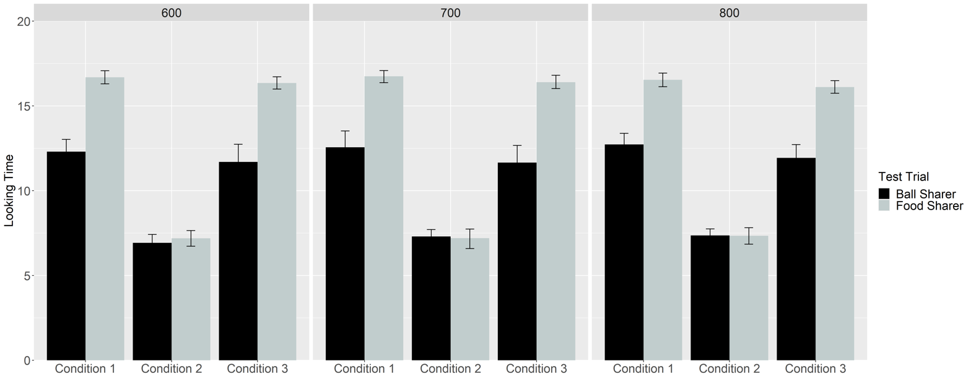
Figure 2. Networks’ mean looking time to the Ball Sharer and Food Sharer test events across Conditions and Pretraining Epochs.

Figure 2 shows networks’ looking times to the Food and Ball Sharers across Conditions 1-3 and Pretraining Epochs. Data were entered into a linear mixed-effects model with Test Trial as the within-subjects fixed effect (Ball Sharer vs. Food Sharer), Condition (Condition 1 vs. Condition 2 vs. Condition 3) and Pretraining Epochs (600 vs. 700 vs. 800) as between-subjects fixed effects, and participants as the random effect. The number of familiarization epochs was not included as an additional effect because it was colinear with Pretraining Epochs and created singularity issues for the model. The results revealed main effects of Test Trial and Condition, which were qualified by an interaction between the two, F(2, 351) = 91.46, p = 0. Follow-up analyses were conducted for each Condition to assess the nature of this interaction. A paired t-test for Conditions 1 and 3 showed that networks looked longer at the Food Sharer (Condition 1: M = 16.66, SD = 1.24; Condition 3: M = 16.29, SD = 1.21) than at the Ball Sharer (Condition 1: M = 12.53, SD = 2.79; Condition 3: M = 11.76, SD = 3.18), both t’s > 15.28, both p’s = 0. In contrast, networks in Condition 2 looked equally long at the Food Sharer (M = 7.25, SD = 1.69) and Ball Sharer (M = 7.19, SD = 1.55) test events, t(119) = 0.24, p = .81.

Discussion
The simulation was carried out to test whether infants’ looking behaviors in Thomas et al. (2022) could be explained by a domain-general learning mechanism that links of the acts of saliva sharing and comforting to a shared representation, particularly when those experiences involve the same individuals. The results indicated that infants’ responses could be explained by such a mechanism. Yet, if our account that a common representation supports bidirectional expectations in which saliva sharing and comfort predict one another, it is important to show that a model that implements our account predicts saliva sharing from comfort. Simulation 2 addressed this issue.

Simulation 2
Network Architecture and Familiarization
The architecture used in Simulation 2 was identical to that in Simulation 1. The pretraining phase was also identical.

Familiarization and Test
Following pretraining, networks (N = 20) were familiarized to an event in which the central character was comforted by one of two individuals, but not the other. Networks were then tested on an event in which the central character from the familiarization phase engaged in saliva sharing with the former comforter and non-comforter. A separate group of networks (N = 20) in a Control condition were familiarized to the same event as the first group and tested on an identical event except that the central character was replaced with a new one.

Results
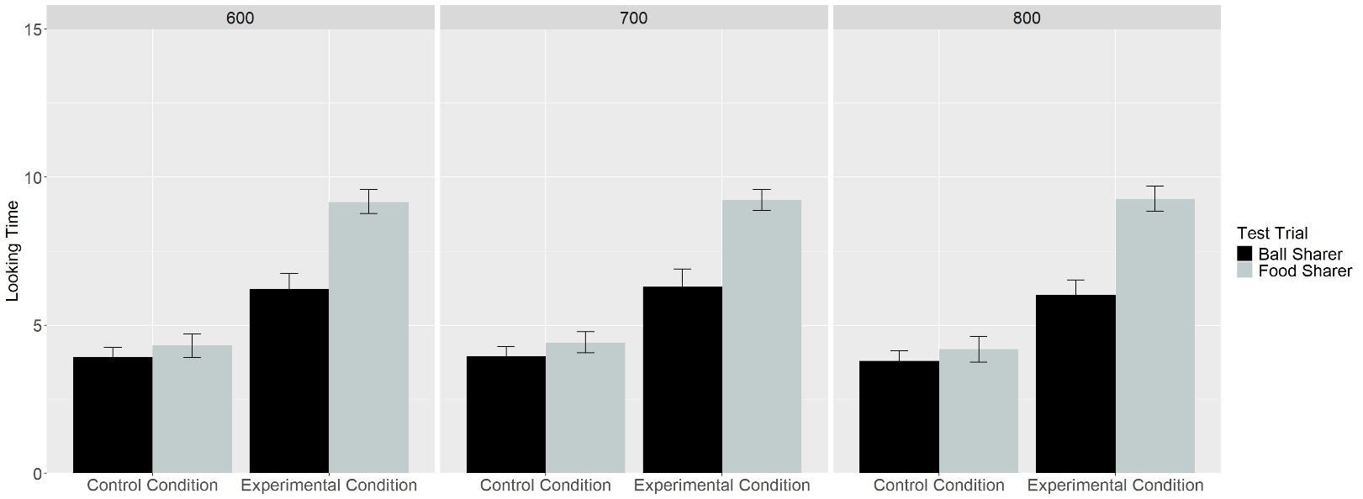
Figure 3. Networks’ mean expectation or looking time to the Ball Sharer and Food Sharer test events across Conditions and Pretraining Epochs.

Figure 3 shows networks’ looking times to the Food and Ball Sharers across the Experimental and Control Conditions and Pretraining Epochs. Data for networks in these conditions were entered into a linear mixed-effects model with Test Trial as the within-subjects fixed effect (Ball Sharer vs. Food Sharer), Condition (Experimental vs. Control) and Pretraining Epoch (600 vs. 700 vs. 800) as the between-subjects fixed effects, and participants as the random effect. The results revealed main effects for Condition and Test trial, both of which were qualified by an interaction between Condition and Test Trial, F(1, 234) = 115.24, p = 0. Follow-up analyses were conducted for each Condition. A paired t-test for the Experimental Condition showed that networks looked longer at the Food Sharer (M = 18.44, SD = 1.28) than the Ball Sharer (M = 14.47, SD = 3.31), both t(119) = 13.45, p = 0. Although networks in the Control Condition also looked longer at the Food Sharer (M = 6.73, SD = 1.39) than at the Ball Sharer (M = 6.23, SD = 1.26), t(119) = 3.80, p < 0.05, the difference in looking time was greater for networks in the Experimental Condition (M = 3.97, SD = 3.24) than networks in the Control Condition (M = 0.49, SD = 1.43), t(163.92) = 10.76, p = 0. It should be noted that although the difference in looking between the two test events for networks in the Control condition is numerically small, the difference is nonetheless significant because the model’s predicted looking times across simulated networks is minimal. The consequence of this is that small differences can reach statistical significance.

Discussion
Simulation 2 demonstrates that a common representation supports bidirectional expectations about saliva-sharing and comforting. Critically, this result generates a novel, testable prediction for future behavioral research: If infants rely on associative learning, then not only should they expect comforting following saliva sharing but also saliva sharing following comforting.

General Discussion
A recent study by Thomas et al. (2022) in Science showed that 8- to 10-month-old infants expect saliva-sharers to comfort each other during moments of distress. The goal of the current paper was to offer a mechanistic explanation for these findings and then to test whether a computational instantiation of this account could explain them. The crux of our proposal is that infants build separate representations of saliva sharing and comforting based on repeated, real-world experience seeing these events. Crucially, if the same individual participates in both events, those representations become integrated into a common representation. Two consequences follow from this process. First, activating one feature (e.g., saliva sharing) will trigger the other (e.g., comforting). Second, this common representation may support bidirectional expectations: Infants may expect comforting following saliva sharing and saliva sharing following comforting. Crucially, no notion of thick relationships is needed to capture Thomas et al.’s (2022) findings.
Simulation 1 demonstrated that this account was sufficient to explain infants’ looking behavior in Thomas et al. (2022). Simulation 2 extended this simulation by showing that expectations of saliva sharing and comforting could be bidirectional. Taken together, these results provide a mechanistic explanation of how preverbal infants learn to use saliva as a cue for comfort.
The current findings add to a broader tradition in the developmental cognitive sciences that use connectionist models to demonstrate the sufficiency of domain-general processes for capturing infants’ behavior in tasks that rely on looking time (e.g., Benton, 2024, Benton & Lapan, 2021; Christiansen & Curtin, 1999; Cohen et al., 2002; Munakata et al., 1997; Schlesinger & Casey, 2003; Vong et al., 2024). At the same time, the current simulations extend this extensive body of evidence by demonstrating that the basis of infants’ expectation of comfort following saliva sharing may be associative learning.
Although our model demonstrates that associative learning is sufficient to explain how infants come to see saliva sharing as having social significance, it does not rule out the possibility—as suggested by Thomas et al. (2022)—that this expectation has an evolutionary basis. Additionally, the current simulations do not show that infants’ knowledge about the social meaning of saliva sharing derives from associative processes. Addressing both questions will require behavioral experiments. For example, if infants, like the networks in Simulation 2, use saliva sharing as a predictor of comforting, this would suggest that they relied on associative learning. A promising avenue for future research will be to test this prediction directly and to pit the current proposal against alternatives. Beyond these issues, our model could be critiqued by its use of localist, semantically neutral input representations. Such representations—which are neither rich nor multimodal—likely poorly approximate infants’ real-world experience with saliva sharing and comfort. Future modeling work should instantiate the current proposal into neural networks with richer representations that better capture infants’ natural experiences.
In sum, by demonstrating that a shared mental representation that arises from associative learning is sufficient to explain infants’ responses in Thomas et al. (2022), we show mechanistically how abstract social expectations can emerge from simple learning mechanisms and experience. More broadly, these findings underscore the value of computational modeling for elucidating potential mechanisms of early social reasoning.
References
Benton, D. T. (2024). An associative-learning account of how infants learn about causal action in animates and inanimates: A critical reexamination of four classic studies. Journal of Experimental Psychology: General, 154(2), 497–521. https://doi.org/10.1037/xge0001656
Benton, D. T., & Lapan, C. (2022). Moral masters or moral apprentices? A connectionist account of sociomoral evaluation in preverbal infants. Cognitive Development, 62, 101164. https://doi.org/10.1016/j.cogdev.2022.101164
Christiansen, M. H., & Curtin, S. (1999). Transfer of learning: rule acquisition or statistical learning?. Trends in Cognitive Sciences, 3(8), 289-290. https://doi.org/10.1016/S1364-6613(99)01356-X
Ciftci, B. G., Kominsky, J. F., & Csibra, G. (2025). Do infants use cues of saliva-sharing to infer close relationships? A replication of Thomas et al.(2022). Royal Society Open Science, 12(4), 240229. https://doi.org/10.1098/rsos.240229
Cohen, L. B., Chaput, H. H., & Cashon, C. H. (2002). A constructivist model of infant cognition. Cognitive Development, 17(3-4), 1323-1343. https://doi.org/10.1016/S0885-2014(02)00124-7
Káldy, Z., & Leslie, A. M. (2003). Identification of objects in 9‐month‐old infants: integrating ‘what’and ‘where’information. Developmental Science, 6(3), 360-373. https://doi.org/10.1111/1467-7687.00290
Káldy, Z., & Leslie, A. M. (2005). A memory span of one? Object identification in 6.5-month-old infants. Cognition, 97(2), 153-177. https://doi.org/10.1016/j.cognition.2004.09.009
Kibbe, M. M., & Leslie, A. M. (2011). What do infants remember when they forget? Location and identity in 6-month-olds’ memory for objects. Psychological science, 22(12), 1500-1505. https://doi.org/10.1177/0956797611420165
Kibbe, M. M., & Leslie, A. M. (2013). What’s the object of object working memory in infancy? Unraveling ‘what’and ‘how many’. Cognitive Psychology, 66(4), 380-404. https://doi.org/10.1016/j.cogpsych.2013.05.001
Kibbe, M. M., & Leslie, A. M. (2016). The ring that does not bind: Topological class in infants’ working memory for objects. Cognitive Development, 38, 1-9. https://doi.org/10.1016/j.cogdev.2015.12.001
Mareschal, D., French, R. M., & Quinn, P. C. (2000). A connectionist account of asymmetric category learning in early infancy. Developmental Psychology, 36(5), 635–645. https://doi.org/10.1037/0012-1649.36.5.635
Munakata, Y., McClelland, J. L., Johnson, M. H., & Siegler, R. S. (1997). Rethinking infant knowledge: Toward an adaptive process account of successes and failures in object permanence tasks. Psychological Review, 104(4), 686–713. https://doi.org/10.1037/0033-295X.104.4.686
Rumelhart, D. E., Hinton, G. E., & Williams, R. J. (1986). Learning representations by back-propagating errors. nature, 323(6088), 533-536. https://doi.org/10.1038/323533a0
Schlesinger, M., & Casey, P. (2003). Where infants look when impossible things happen: Simulating and testing a gaze-direction model. Connection Science, 15(4), 271-280. https://doi.org/10.1080/09540090310001655093
Thomas, A. J. (2024). Cognitive representations of social relationships and their developmental origins. Behavioral and Brain Sciences, 1-53. https://doi.org/10.1017/S0140525X24001328
Thomas, A. J., Woo, B., Nettle, D., Spelke, E., & Saxe, R. (2022). Early concepts of intimacy: Young humans use saliva sharing to infer close relationships. Science, 375(6578), 311-315. https://doi.org/10.1126/science.abh1054
Vong, W. K., Wang, W., Orhan, A. E., & Lake, B. M. (2024). Grounded language acquisition through the eyes and ears of a single child. Science, 383(6682), 504-511. https://doi.org/10.1126/science.adi1374

