Figure 1.
Schematic of an untrained model architecture used in the current simulations.
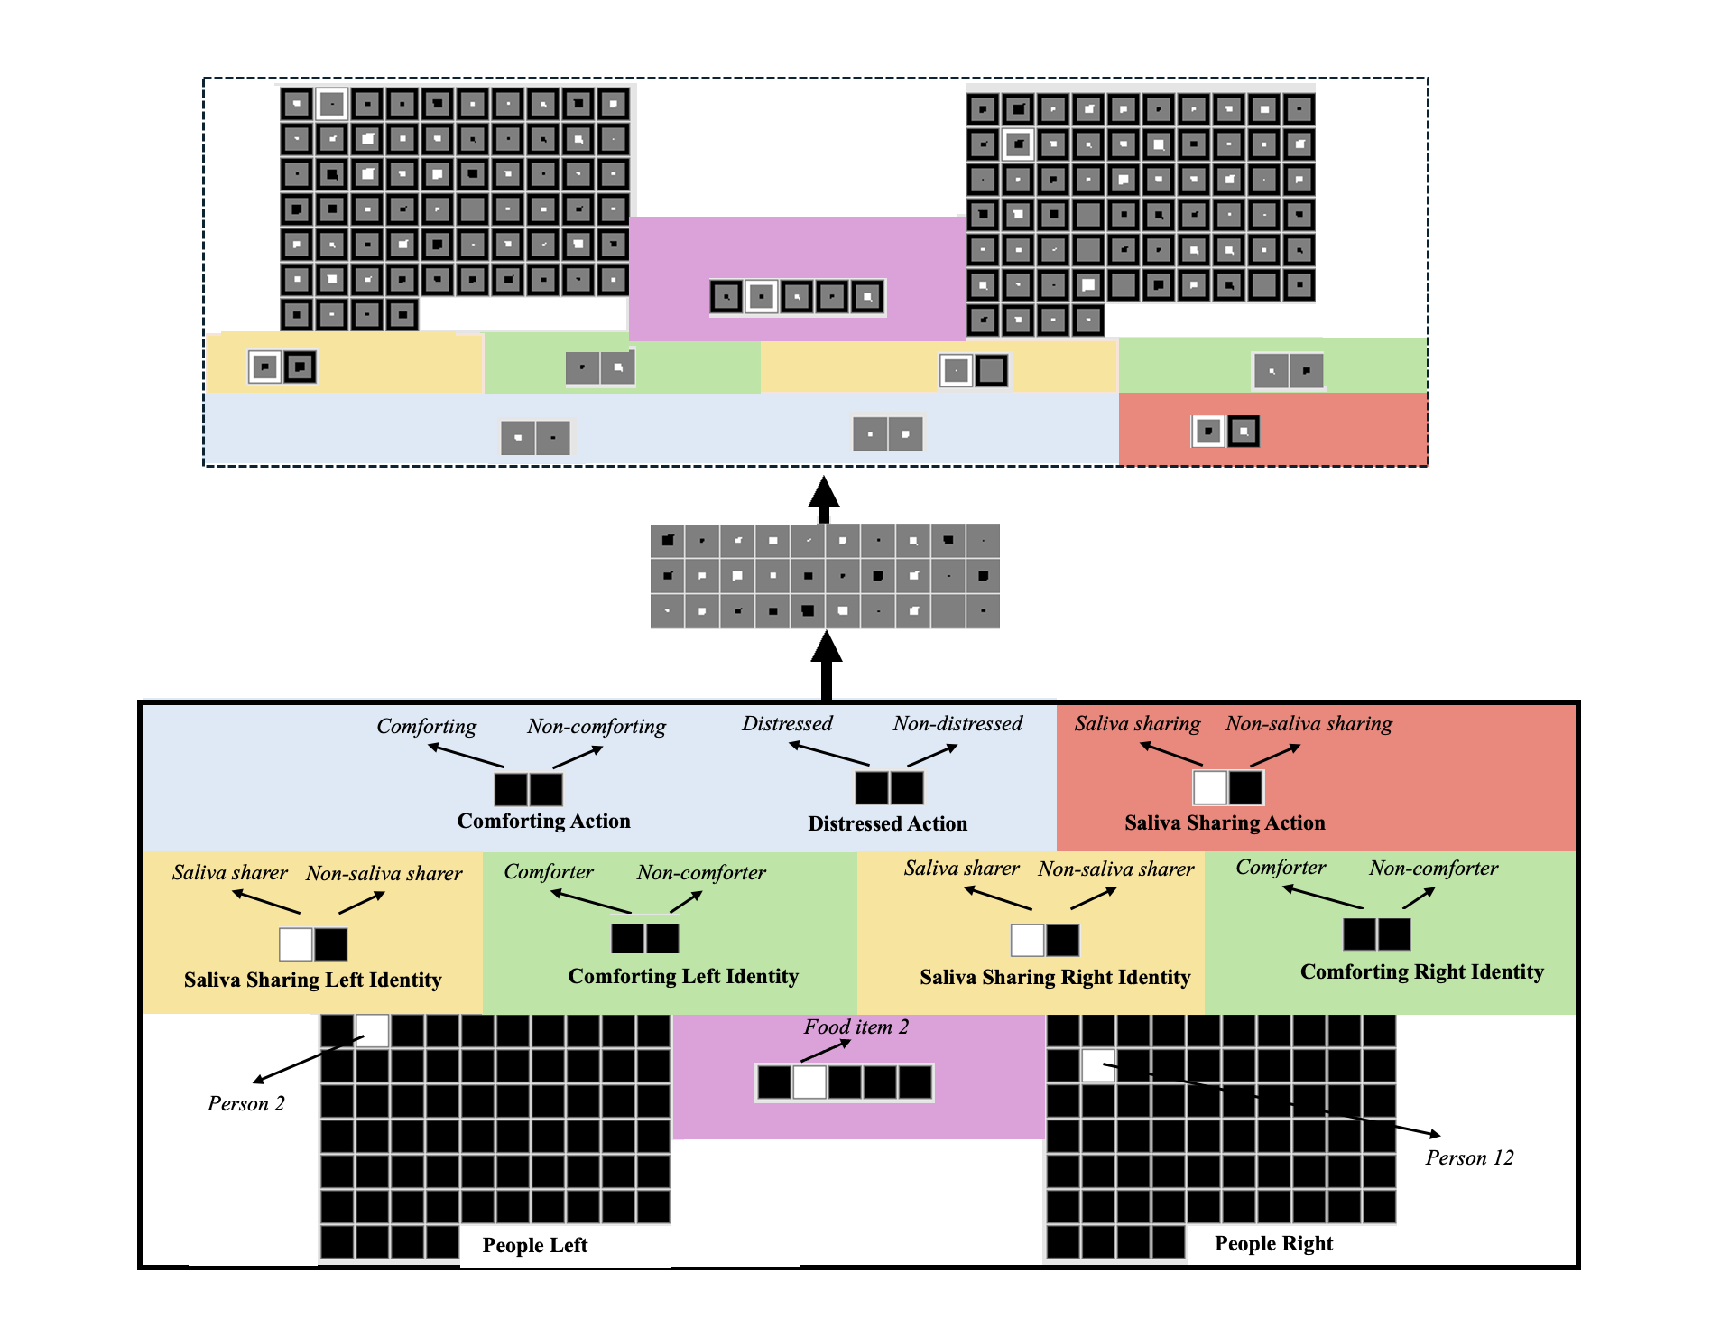Note. Depicted here is a saliva-sharing event. The input and output groups are identical. The names of the input groups are in bold. The model consisted of 10 structurally identical input and output groups: People Left/Right, Saliva Sharing Left/Right Identity, Comforting Left/Right Identity, Comforting Action, Distressed Action, Food Item, and Saliva Sharing Action. The specific feature that a given unit in a group coded for is shown above that unit in italics. Note that the figure is color-coded to make it easier to connect what networks were trained on (shown in Tables 1 and 2) and the model architecture. The borders around each output unit correspond to that unit’s target activation value. Black borders correspond to target activations of “0” (i.e., the unit should be “off”); white borders correspond to target activations of “1” (i.e., the unit should be “on”). The size of a given output unit’s inner region corresponds to that unit's actual activation value. Larger inner regions correspond to greater activations. Darker inner regions for the output units correspond to activation values ≤ 0.5, whereas lighter inner regions correspond to activation values > 0.5.

Alt text: Diagram of the three-layer neural network used in all simulations. The model contains input, hidden, and output layers that represent people, saliva-sharing identities and actions, comforting identities and actions, distress, and food items. The architecture supports learning associations between saliva sharing and comforting through experience.

Table 1.
Training events depicting saliva and non-saliva sharers engaging in different actions and their model instantiation.
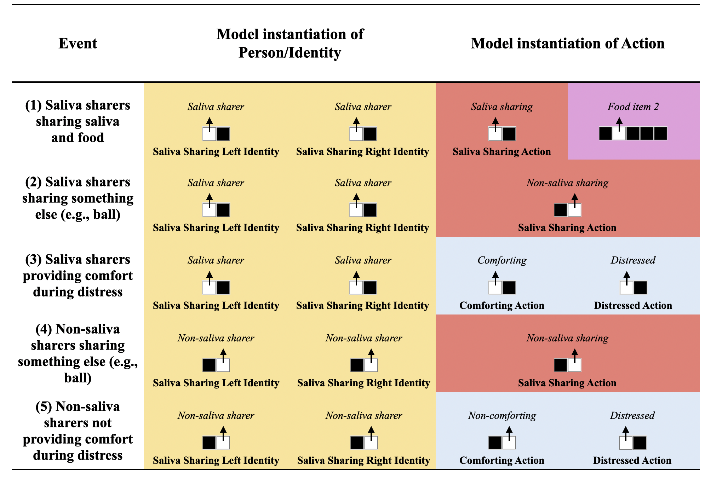
Note. Colors correspond to network architecture in Figure 1.

Alt text: Table showing five pretraining events involving saliva sharers and non-saliva sharers. Events include saliva sharing, non-saliva sharing, comforting during distress, and failing to comfort during distress. The table specifies how each event was represented in the model and as well as the training experiences that facilitated the model’s ability to learn associations between saliva sharing and comfort.

Table 2.
Training events depicting comforters and non-comforters engaging in different actions and their model instantiation.

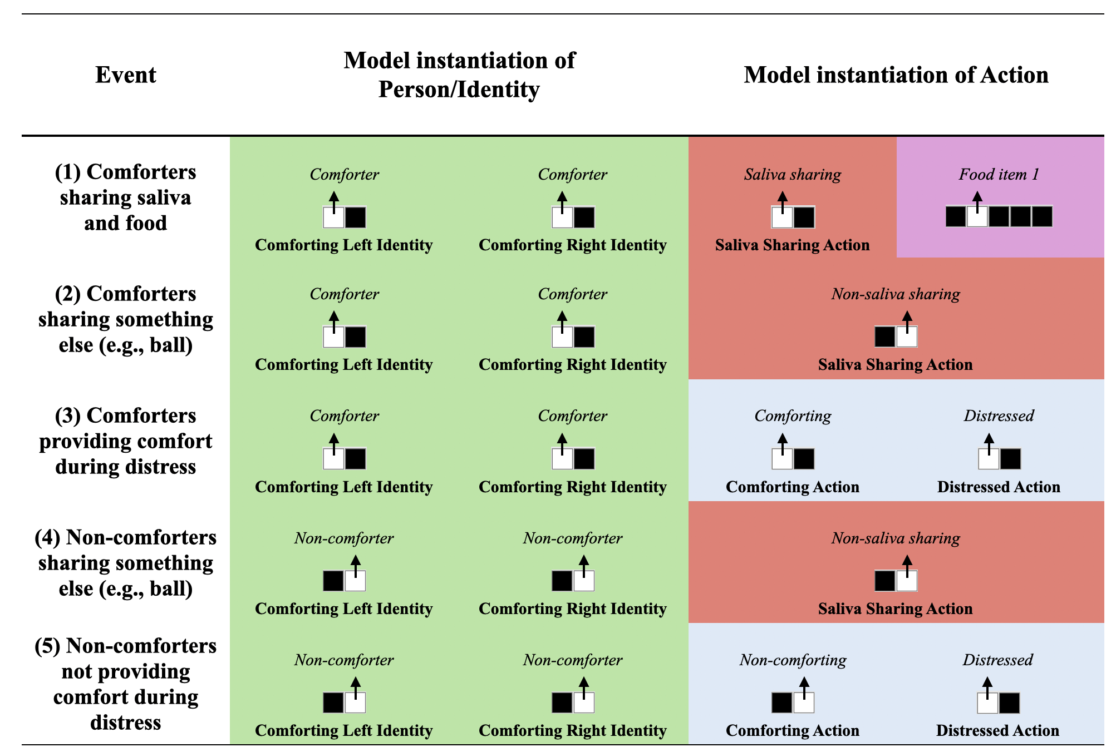
Note. Colors correspond to network architecture in Figure 1.

Alt text: Table showing five pretraining events involving comforters and non-comforters. Events include saliva sharing, non-saliva sharing, comforting distressed individuals, and failing to provide comfort during distress. The table specifies how each event was represented in the model and provides the training experiences that support learning associations between comforting and saliva sharing.

Figure 2.
Simulation 1:Networks’ mean expectations of comfort from the Saliva and Non-Saliva sharers across Conditions and Pretraining Epochs.

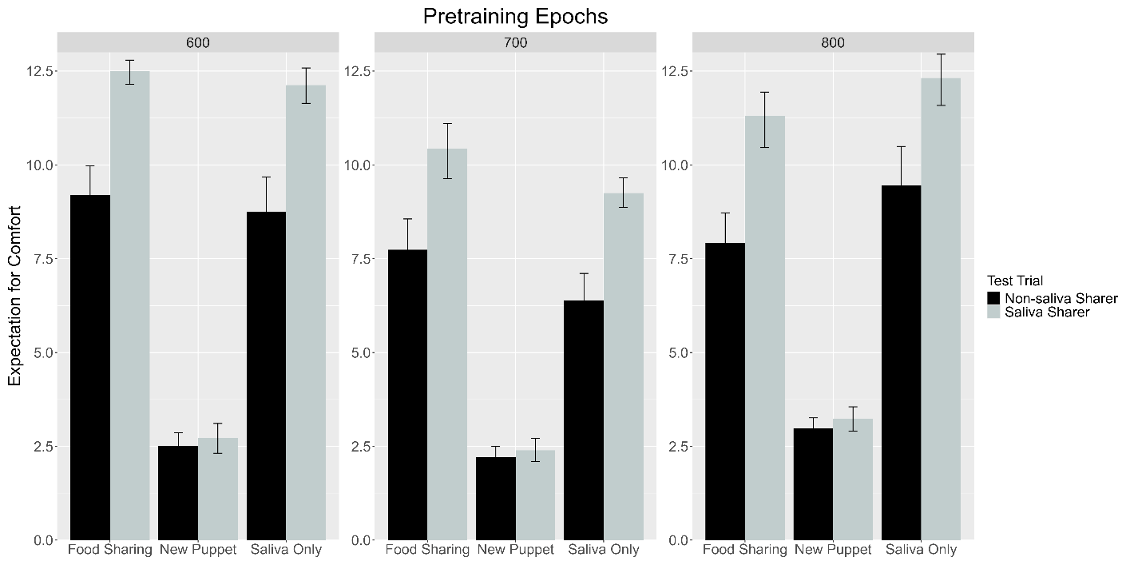
Note. Food Sharing, New Puppet, and Saliva Only conditions correspond, respectively, to Experiments 2B, 2D, and 3B in Thomas et al. (2022).

Alt text: Bar graphs showing expectations of comfort from saliva sharers and non-saliva sharers across three experimental conditions and levels of pretraining. Networks expected greater comfort from saliva sharers in the Food Sharing and Saliva Only conditions but not in the New Puppet condition. The pattern reproduces infants’ responses in Thomas et al. (2022).

Figure 3.
Simulation 2:Networks’ mean expectations of peek-a-boo from former Saliva and former Non-Saliva Sharers across Pretraining Epochs.

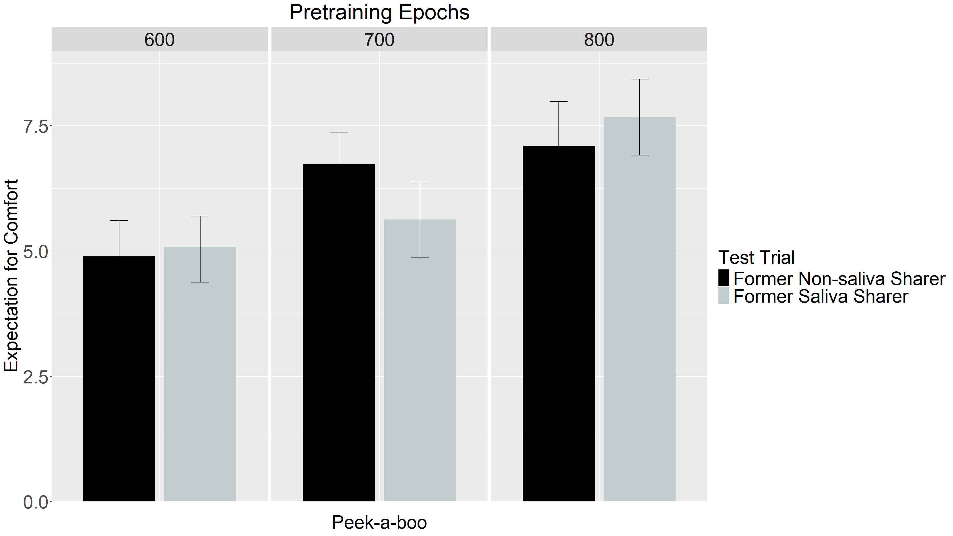Note. The peek-a-boo condition corresponds to a non-distressed, non-comfort giving event and mirrors the preferential looking test following experiments 2B and 2D in Thomas et al. (2022)

Alt text: Bar graphs showing expectations during a non-distress, non-comfort event involving former saliva sharers and non-saliva sharers. Networks showed similar expectations for both individuals across all levels of pretraining. This finding indicates that the preference observed in Simulation 1 was specific to comfort-related situations rather than a general preference for saliva sharers.

Figure 4.
Simulation 3: Networks’ mean expectations of saliva sharing from the Comforter and Non-Comforter across Conditions and Pretraining Epochs.
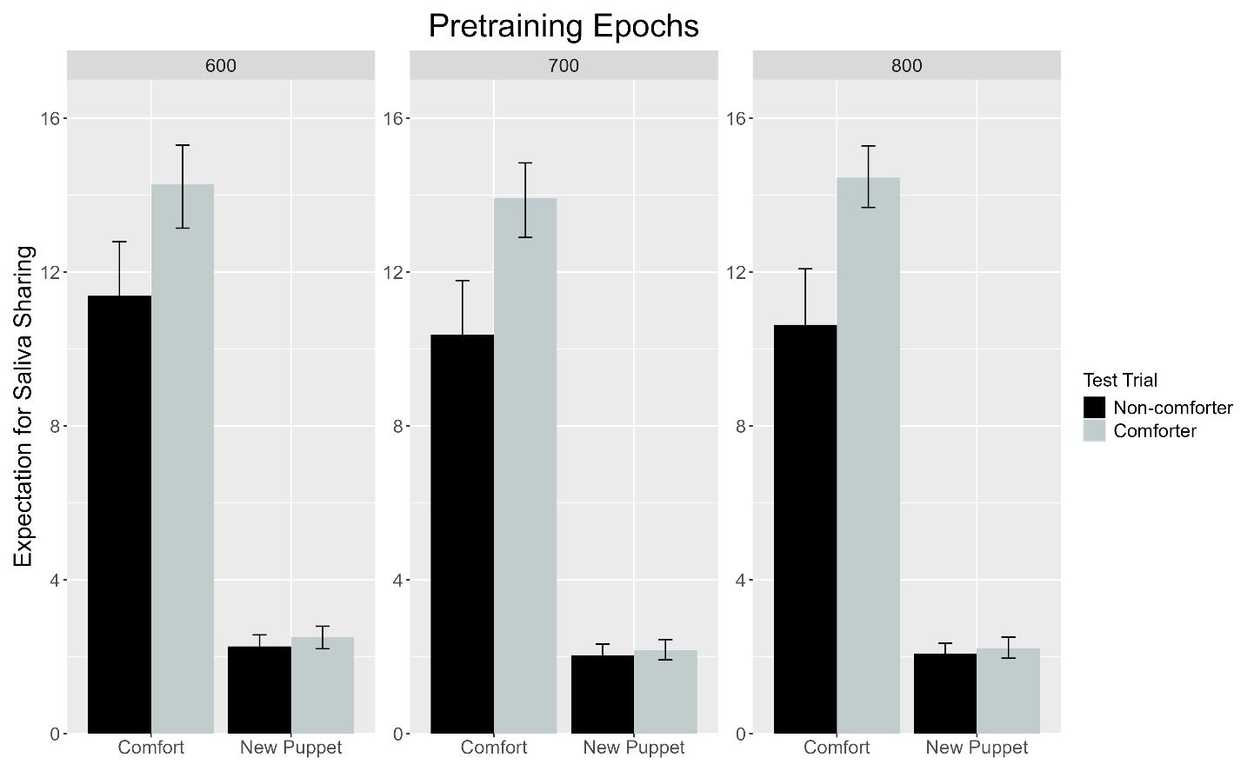
Note. In the Comfort condition, comforting occurs before saliva sharing; the same central character appears in both events. In the New Puppet condition, comforting occurs before saliva sharing; a different central character appears in each event.
Alt text: Bar graphs showing expectations of saliva sharing from a former comforter and a former non-comforter. Networks expected more saliva sharing from former comforters when the same central character appeared across events, but not when a new character was introduced. The results demonstrate bidirectional expectations linking comforting and saliva sharing.

Figure 5.
Simulation 4: Networks’ mean expectations of comfort from the Saliva and Non-Saliva Sharers across Conditions, and Model Age.
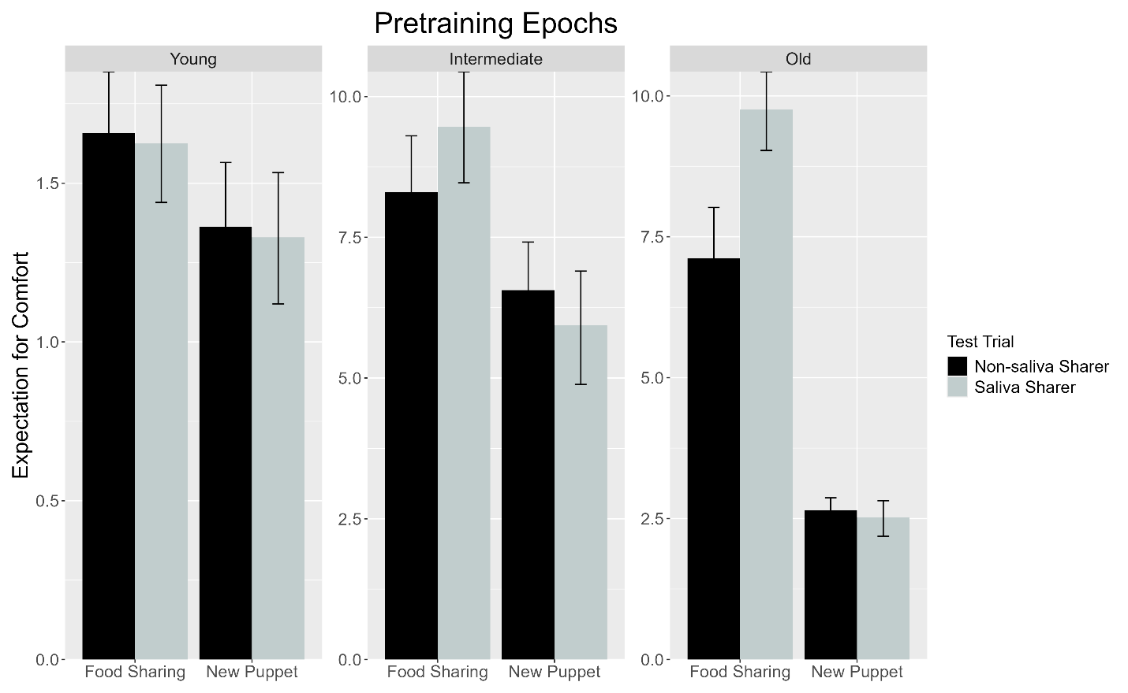Note. Food Sharing and New Puppet conditions correspond, respectively, to Experiments 2B and 2D in Thomas et al. (2022).
Alt text: Bar graphs showing expectations of comfort from saliva sharers and non-saliva sharers as a function of simulated age. Differences between the two groups increased from young to old networks in the Food Sharing condition but remained absent in the New Puppet condition. The results suggest that comfort-related expectations strengthen with experience.
Figure 6.
Simulation 5: Networks’ mean expectations of comfort from the Saliva and Non-Saliva Sharers across Conditions and Pretraining Ratios.
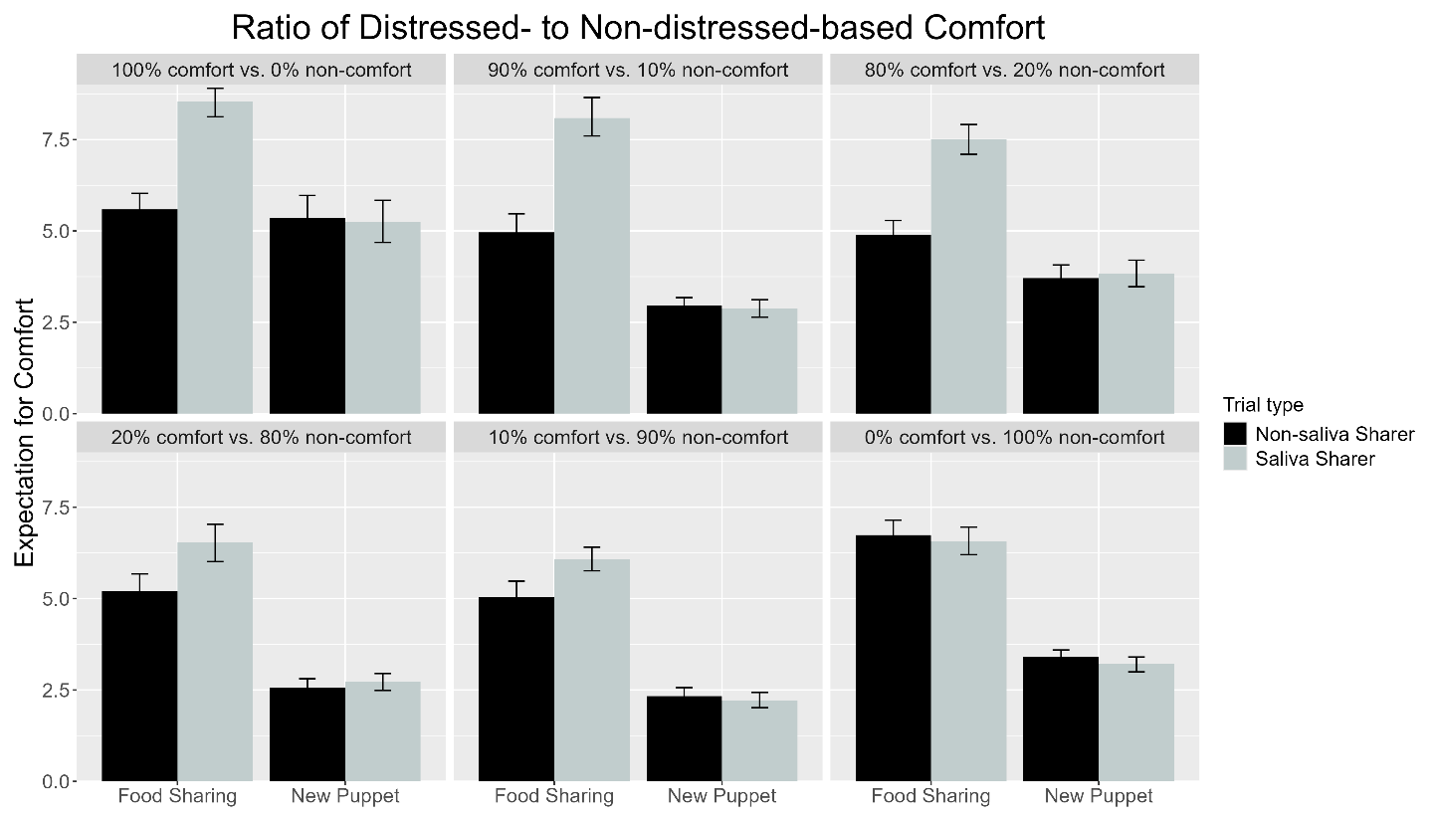Note. Food Sharing and New Puppet conditions correspond, respectively, to Experiments 2B and 2D in Thomas et al. (2022).

Alt text: Bar graphs showing expectations of comfort from saliva sharers and non-saliva sharers across different ratios of comfort and non-comfort experiences. Expectations of comfort from saliva sharers declined as comforting became less frequent and could eventually reverse. The results demonstrate that social expectations are shaped by the statistical structure of experience.

