Joshua Lyons & Conner Turnbull
CS361
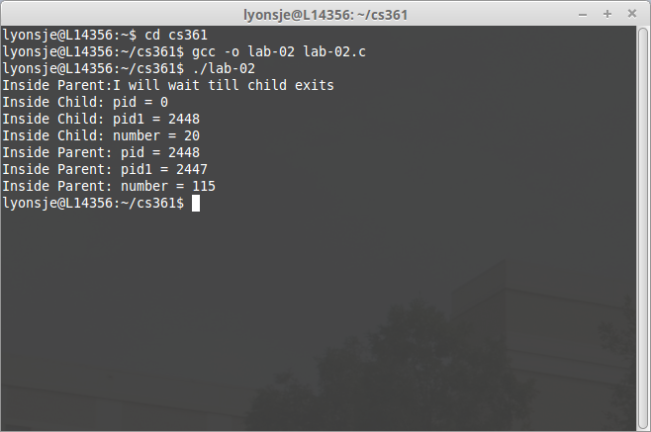
September 24, 2015

1.) Process ID of grand parent: 2447
parent: 2448
child: 0

2.) The parent code was next dispatched by the OS after forking, however you can force it to wait until the child has completed by adding a wait statement.

3.) Value of “Number” on line C: 20
Value of “Number” on line F: 115
When the process forks, the variable “number” (at the time storing the number 15) gets sent to both the child and the parent. Therefore, when 5 is added in the child it becomes 20, and when 100 is added in parent it becomes 115 – not 120.

