Chaikin’s Algorithm of Curves
- Based on corner cutting
- Geometric algorithm

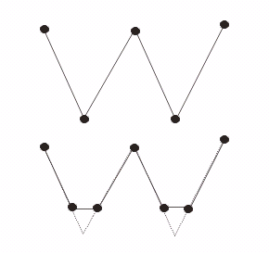

- Take the new control polygon and repeat steps.

The Method:
- Chaikin uses fixed ratio on cutting corner. (All corners are cut the same.)

Example:
Given a control polygon 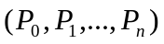.
We define this control polygon by generating a new sequence of control points:
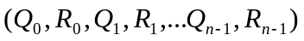
where each pair 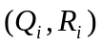are to be taken to be a ratio of ¼ and ¾ between the endpoints of the line segment 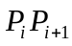.
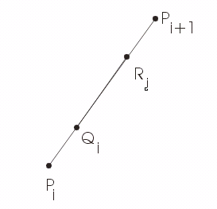

meaning:
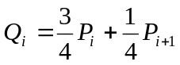
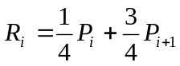

We generated 2n new points are a new control polygon: A refinement of the original

Example 1:
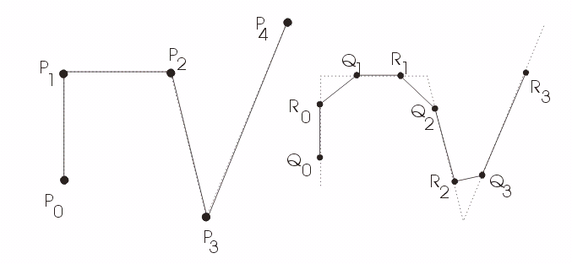

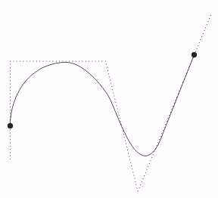
The final curve

Example 2: Closed curve:
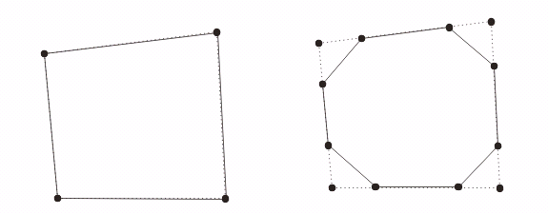

Original Polygon First Refinement

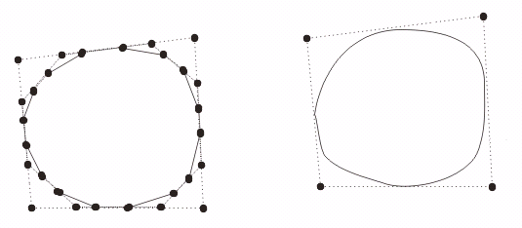
Second Refinement Final Curve

