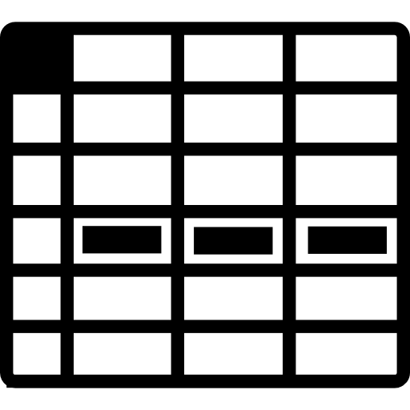

Stage 1

Stage 2

map

filter

join,

groupBy

filter

map