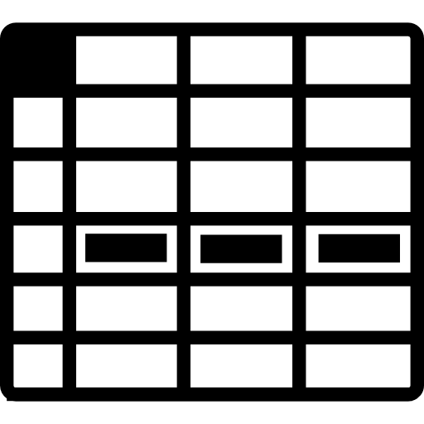

map

filter

map



join,

groupBy

filter

