SJ Guillaume

Part One:
2. Tilde Notation: expect ~n^4/24. (but n^4/12 gives much closer approximations, that is what I used for calculations)
Big O Notation: expect O(n^4).

4. We expect it to take 6.128 seconds for 512ints.txt based off our experiment for 256ints.txt.

6. We expect 1Kints.txt to take 100.97 seconds based off our experiment for 512ints.txt.

8. We expect 2Kints.txt to take 1457.5 seconds based off our experiment for 1Kints.txt.
We expect 4Kints to take 23320 seconds based off our experiment for 1Kints.txt.
We expect 1Mints to take 1108687500 seconds based off our experiment for 1Kints.txt
The pattern we see is that the time it takes for the programs to run is consistent with our tilde notation, and also by multiplying by 15 for each doubling.

FourSumWithTiming.java
Trial | 256ints.txt | 512ints.txt | 1Kints.txt | 2Kints.txt | 4Kints.txt
1 | 0.383 | 6.266 | 91.416 | 1460.674 | 23747.382
2 | 0.383 | 6.307 | 91.931 | 1482.551 | 23734.764
3 | 0.383 | 6.236 | 91.602 | 1482.573 | 2996.671
4 | 0.382 | 6.289 | 90.944 | 1481.244 | x
5 | 0.381 | 6.306 | 91.177 | 1485.871 | x
Average | 0.3824 | 6.2808 | 91.414 | 1478.5826 | x
Standard Deviation | 0.000894 | 0.03006 | 0.38069 | 10.156 | x

11. Tables
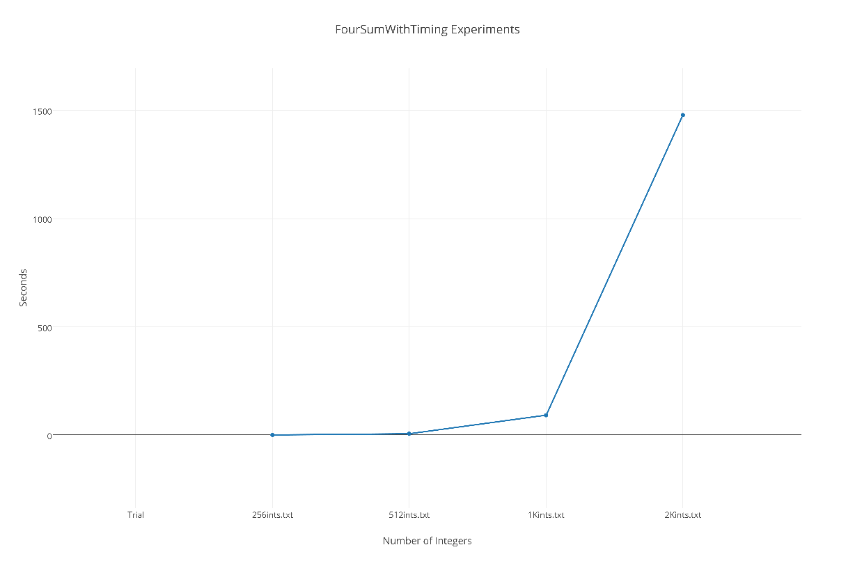
Linear Table

Logarithmic Table

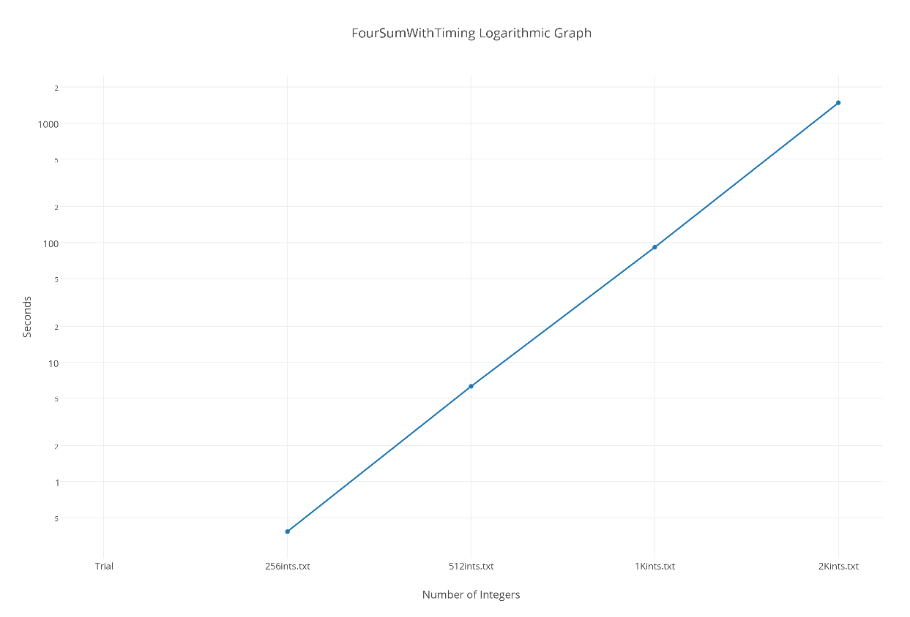
Part Two:
2. Big O Notation: On^3
3. Due to the lower Big O notation we would expect 256 integers to run faster on FourSumFast by at least half, and as our results below show, FourSumFast 's algorithm is .31 seconds faster. We expect it to take 0.2218 seconds based off our results for 256ints.txt in the last experiment.
5. We expect the experiment to take .748 seconds based on the 256 ints.txt in the last experiment.
7. We expect the experiment to take 1.51 seconds based on the 512 ints.txt in the last experiment.
9.2Kints.txt : 3.08
4Kints.txt: ?
1Mints.txt: ?
My answers are clearly not working out, so I will spare myself from documenting the 4K and 1M guesses.
FourSumFast.java
Trial | 256ints.txt | 512ints.txt | 1Kints.txt | 2Kints.txt | 4Kints.txt
1 | 0.07 | 0.582 | 4.95 | 43.54 | x
2 | 0.08 | 0.578 | 4.92 | 43.865 | x
3 | 0.07 | 0.588 | 4.93 | 43.586 | x
4 | 0.071 | 0.586 | 4.964 | 43.862 | x
5 | 0.072 | 0.579 | 4.981 | 43.833 | x
Average | 0.0726 | 0.5826 | 4.949 | 43.7372 | x
Standard Deviation | 0.004219 | 0.004335 | 0.02475 | 0.1603 | x

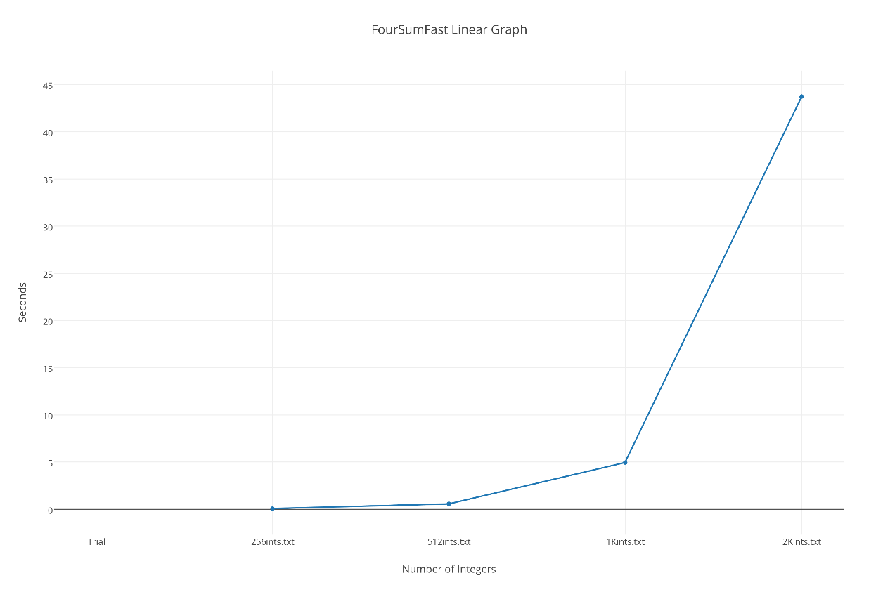

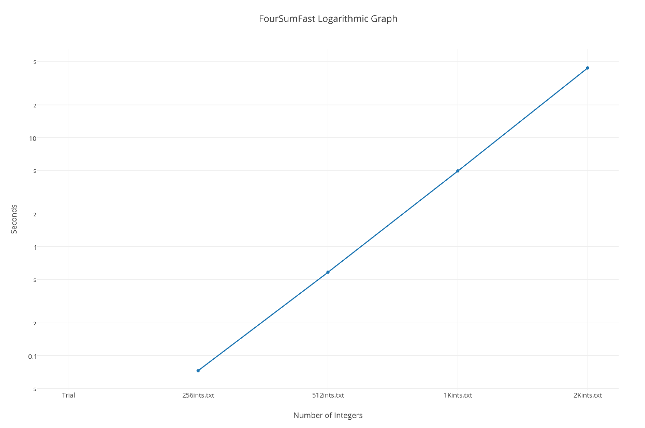

Part 3:
1. Big O(n^2)
Tilde Notation: ~(n^2)/2
2.
begin java code:
z = a.length();
y = b.length();
while(z < a.length() || y<b.length()){
if( a(z)<= b(y)){
System.out.println(a(z));
z++;
}
else (){
System.out.println(b(y));
y++;
}
}
There is only O(n) run time complexity because the while loop will run once for every n, because the number from a or b must satisfy one of two conditions: <=, or >.

3. The purpose of the algorithm is to make a reverse sorted array. The mystery function takes one string, divides it an half and puts the second half first, and the first half second in the new string. This continues until the base case is reached and the string can not be split any more.

