Experiment 1:
2. It is still the case that Selection Sort is running faster than Insertion Sort, evidenced in the graph under column 1.1, where it is shown that Selection runs 1.6x faster.

3. The average ration is 1.6x, the standard deviation is .016. The difference of run time is significantly better for doubles, for integers Selection Sort runs significantly faster than Insertion Sort.

4. Selection sort is still running significantly faster than Insertion Sort on integers.

5. See the graph file to veiw averages and standard deviations for each experiment. The Difference with integers is less dramatic than the results with doubles. This makes sense since fewer bits are being compared, and thus the trials can be executed faster.

Experiment 2:
2. Yes, Selection Sort is still running faster than insertion sort with a Gaussian distribution.

4. The average ratio increased slightly for the more broad distribution of Gaussian values. My guess is that with a more broad distribution, the sorting algorithms is less strict and thus takes more moves to sort all the values.

7. Yes, a smaller lambda caused the average of Selection vs. Insertion to run slower on average.

Experiment 3:
1. The results are fairly consistent. The average ratio is 1.25, and the standard deviation is .13.

2. The average ratio was 2.55, with the standard deviation at .48, so the results on this trial were more inconsistent.

3. There is a noticeable difference between 1000 and 10000 array sizes. The average for 1000 is 2.55, and 10000 is 33.49, quite a sizable difference, which shows the advantage of Selection sort on arrays of larger size.

4. There is a large difference between 10000 and 1000000, with 33x vs 379x faster respectively.

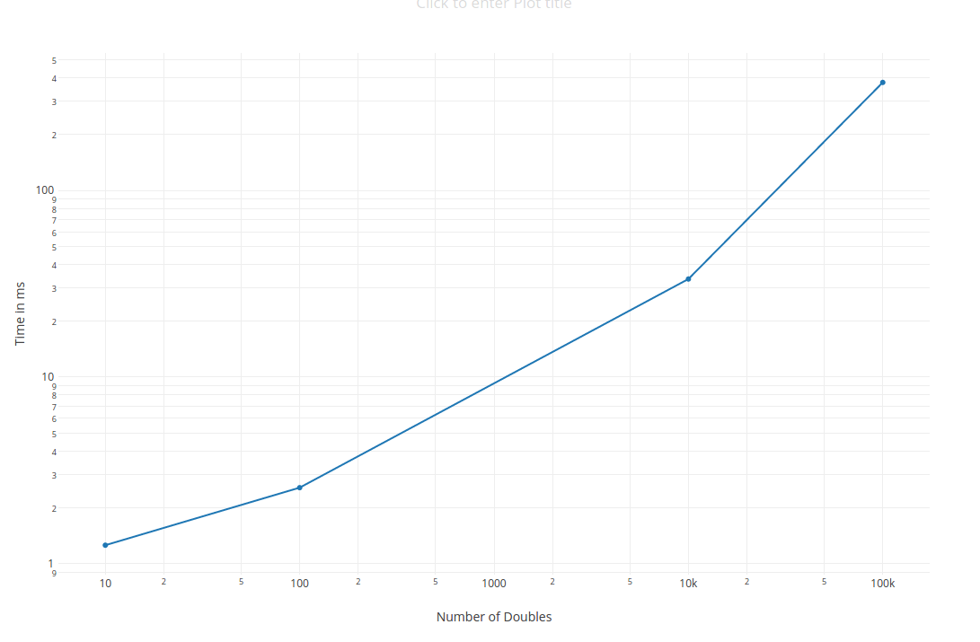
5. The graphs are interesting, but the distribution is what I would expect it to look like based on the results of the experiments.

Part Two:
1. 1Kints.txt took 4024 bytes of memory to store.
1Mints.txt took 4000024 bytes of memory.
1Kints.txt doubles would take 8024 bytes of memory to store.
1Mints.txt doubles would take 8000024 bytes of memory.
1000 ints in a 100x10 array would take 6424 bytes of memory.
1000000 ints in a 100x10000 array would take 4002424 bytes of memory.

2.
S | E | L | E | C | T | I | O | N | S | O | R | T
C | E | L | E | S | T | I | O | N | S | O | R | T
C | E | E | L | S | T | I | O | N | S | O | R | T
C | E | E | I | S | T | L | O | N | S | O | R | T
C | E | E | I | L | T | S | O | N | S | O | R | T
C | E | E | I | L | N | S | O | T | S | O | R | T
C | E | E | I | L | N | O | S | T | S | O | R | T
C | E | E | I | L | N | O | O | T | S | S | R | T
C | E | E | I | L | N | O | O | R | S | S | T | T

D | E | P | E | N | D | S | O | N | I | N | P | U | T
D | E | E | P | N | D | S | O | N | I | N | P | U | T
D | E | E | N | P | D | S | O | N | I | N | P | U | T
D | D | E | E | N | P | S | O | N | I | N | P | U | T
D | D | E | E | N | O | P | S | N | I | N | P | U | T
D | D | E | E | N | N | O | P | S | I | N | P | U | T
D | D | E | E | I | N | N | O | P | S | N | P | U | T
D | D | E | E | I | N | N | N | O | P | S | P | U | T
D | D | E | E | I | N | N | N | O | P | P | S | U | T
D | D | E | E | I | N | N | N | O | P | P | S | T | U

S | H | E | L | L | S | O | R | T | I | S | S | O | M | U | C | H | F | U | N | Y | O | U | G | U | Y | S
M

MHELLSORTISSOSUCHFUNYOUGUYS
MHCLLSORTISSOSUEHFUNYOUGUYS
MHCHLSORTISSOSUELFUNYOUGUYS
MHCHFSORTISSOSUELLUNYOUGUYS

3. Insertion Sort if one before is less than it, it will go to the next iterations. Selection Sort checks all indexes for the minimum value.

4. Insertion sort runs faster than Selection for the same reason as above.

5. The best case input for shell sort is a randomized input.

