SJ Guillaume
CS250
Lab 4

Part One:
 | 1,000 | 10,000 | 100,000
Experiment 1 | 1.343 | 0.531 | 0.691
Experiment 2 | 1.321 | 0.526 | 0.676
Experiment 3 | 1.485 | 0.522 | 0.681
Experiment 4 | 1.389 | 0.523 | 0.690
Experiment 5 | 1.288 | 0.514 | 0.695
Avg | 1.365 | 0.5232 | 0.6866
Std. Dev. | 0.0763 | 0.0062 | 0.0078
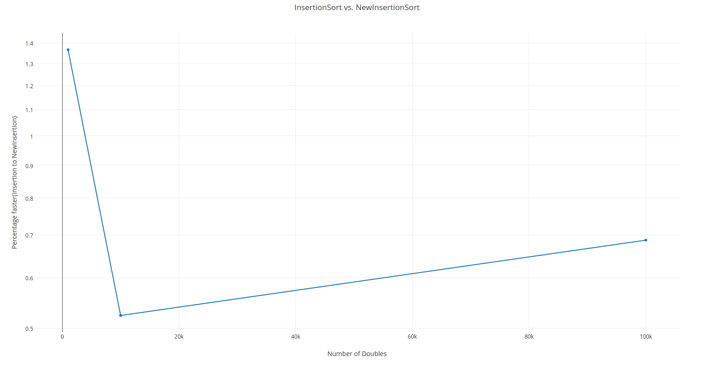
The improvement of NewInsertionSort was significant when considering input size. The NewInsertionSort was not faster for the experiments of 1,000. We saw a substantial difference with the 10,000 experiment where the NewInsertionSort took about half the time to run as InsertionSort. When running larger experiments we see that the NewInsertionSort is trending upwards, and we can hypothesize the time improvement will continue to decline for larger inputs.

Part Two:
 | 5 | 10 | 25 | 100
Experiment 1 | 1.301 | 0.952 | 0.864 | 1.381
Experiment 2 | 1.102 | 1.209 | 1.077 | 1.091
Experiment 3 | 1.604 | 1.135 | 0.901 | 1.347
Experiment 4 | 1.029 | 1.205 | 1.057 | 1.096
Experiment 5 | 1.123 | 0.955 | 0.922 | 1.227
Avg | 1.2318 | 1.0912 | 0.9642 | 1.2284
Std. Dev. | 0.2308 | 0.12910 | 0.0963 | 0.1357
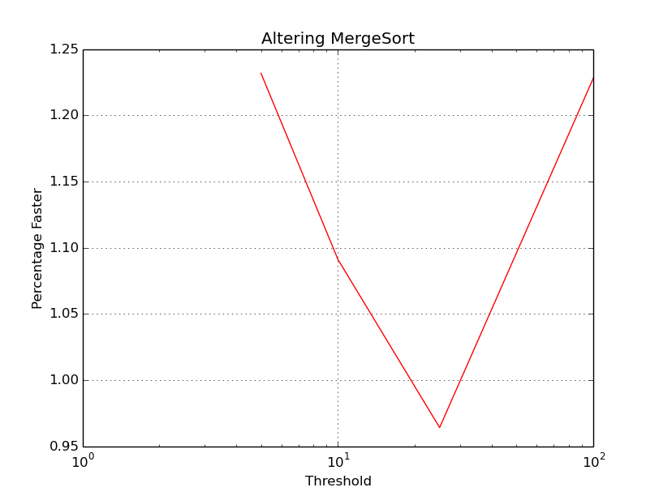
The threshold value of 25 gave the best boost by approximately 4% over the original mergesort algorithm.

Part Three:
 | 10,000 | 100,000 | 1,000,000
Experiment 1 | 0.216 | 0.416 | 0.622
Experiment 2 | 0.150 | 0.479 | 0.628
Experiment 3 | 0.184 | 0.540 | 0.675
Experiment 4 | 0.257 | 0.443 | 0.674
Experiment 5 | 0.209 | 0.613 | 0.597
Avg | 0.2032 | 0.4982 | 0.6392
Std. Dev. | 0.0396 | 0.07921 | 0.0342
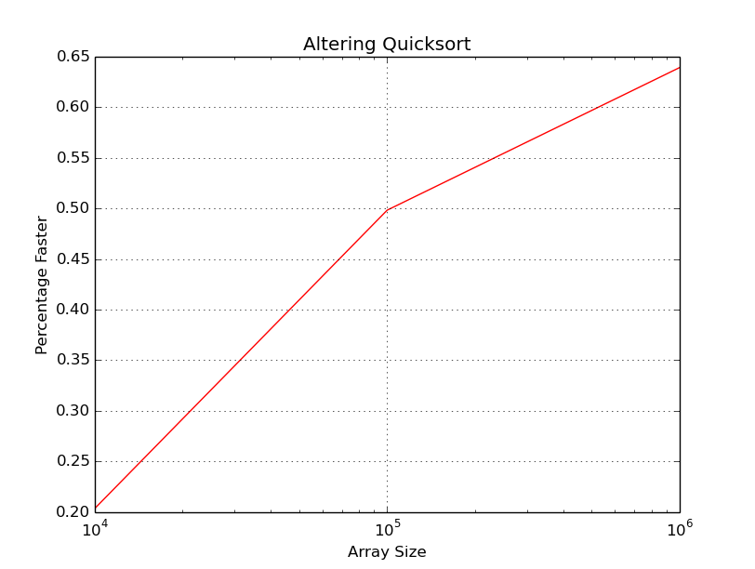
QuickSort was improved significantly, we see in the graph that the new version takes under 65% of the time it takes the original quicksort algorithm to run for the largest array size. The improvement decreased as array size increased.

Part Four:
1.
A | L | G | O | R | I | T | H | M | S
A | G | L | O | R | I | T | H | M | S
A | G | L | O | R | I | T | H | M | S
A | G | L | O | R | I | H | T | M | S
A | G | L | O | R | H | I | T | M | S
A | G | L | O | R | H | I | M | T | S
A | G | L | O | R | H | I | M | S | T
A | G | H | I | L | M | O | R | S | T

2.

H | O | T | M | A | R | S | G | I | L
H | G | T | M | A | R | S | O | I | L
H | G | A | M | T | R | S | O | I | L
A | G | H | M | T | R | S | O | I | L
A | G | H | I | T | R | S | O | M | L
A | G | H | I | L | R | S | O | M | T
A | G | H | I | L | M | S | O | R | T
A | G | H | I | L | M | O | S | R | T
A | G | H | I | L | M | O | R | S | T

