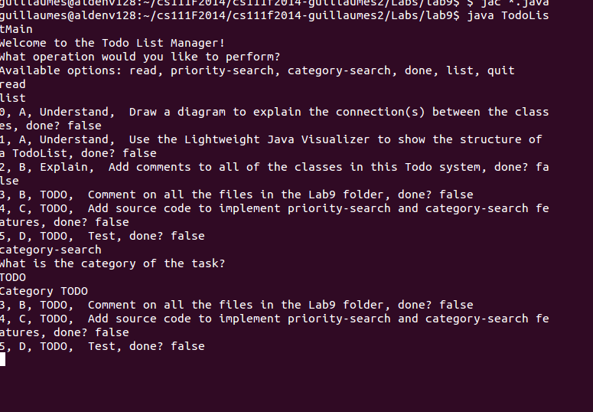

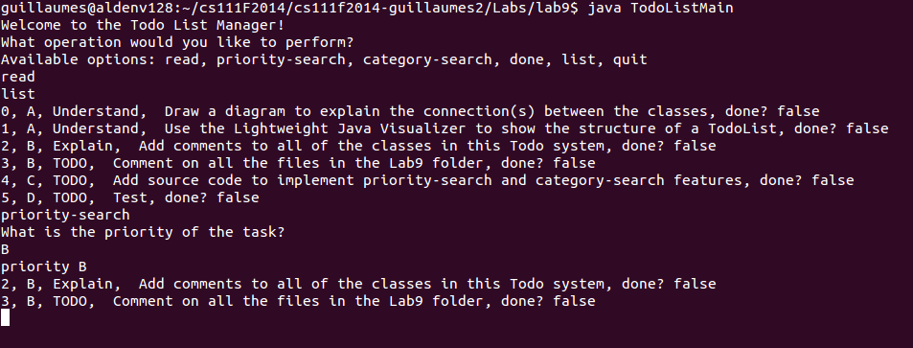

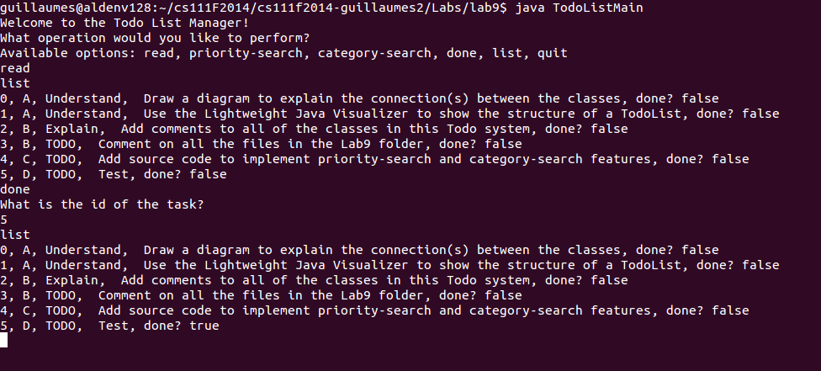

guillaumes@aldenv128:~/cs111F2014/cs111f2014-guillaumes2/Labs/lab9$ java TodoListMain
Welcome to the Todo List Manager!
What operation would you like to perform?
Available options: read, priority-search, category-search, done, list, quit
read
list
0, A, Understand, Draw a diagram to explain the connection(s) between the classes, done? false
1, A, Understand, Use the Lightweight Java Visualizer to show the structure of a TodoList, done? false
2, B, Explain, Add comments to all of the classes in this Todo system, done? false
3, B, TODO, Comment on all the files in the Lab9 folder, done? false
4, C, TODO, Add source code to implement priority-search and category-search features, done? false
5, D, TODO, Test, done? false
category-search
What is the category of the task?
TODO
Category TODO
3, B, TODO, Comment on all the files in the Lab9 folder, done? false
4, C, TODO, Add source code to implement priority-search and category-search features, done? false
5, D, TODO, Test, done? false
quit
guillaumes@aldenv128:~/cs111F2014/cs111f2014-guillaumes2/Labs/lab9$

guillaumes@aldenv128:~/cs111F2014/cs111f2014-guillaumes2/Labs/lab9$ java TodoListMain
Welcome to the Todo List Manager!
What operation would you like to perform?
Available options: read, priority-search, category-search, done, list, quit
read
list
0, A, Understand, Draw a diagram to explain the connection(s) between the classes, done? false
1, A, Understand, Use the Lightweight Java Visualizer to show the structure of a TodoList, done? false
2, B, Explain, Add comments to all of the classes in this Todo system, done? false
3, B, TODO, Comment on all the files in the Lab9 folder, done? false
4, C, TODO, Add source code to implement priority-search and category-search features, done? false
5, D, TODO, Test, done? false
priority-search
What is the priority of the task?
A
priority A
0, A, Understand, Draw a diagram to explain the connection(s) between the classes, done? false
1, A, Understand, Use the Lightweight Java Visualizer to show the structure of a TodoList, done? false
quit
guillaumes@aldenv128:~/cs111F2014/cs111f2014-guillaumes2/Labs/lab9$

****for the last two outputs the screenshot application would not launch

