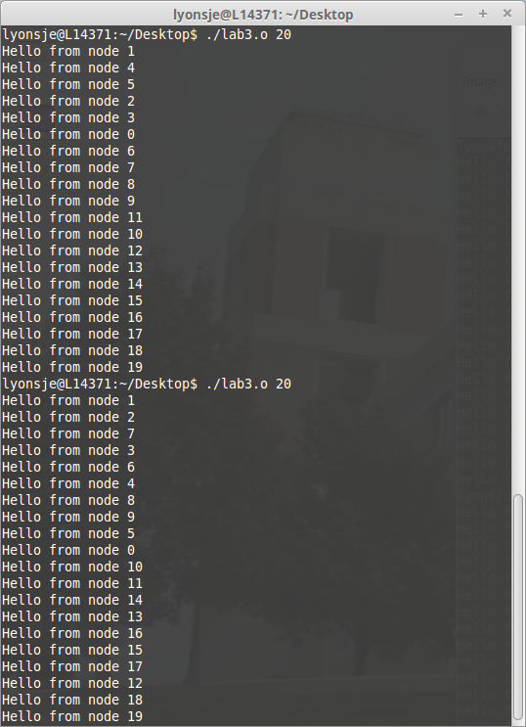
1.)
2.)
3.)

4.) The threads do not always run in the same order. There is no way to tell what order each thread will finish running, but when each finishes, it prints “Hello from node xx”.

5.)

