ECEn 425
Jae Lee
HW#2

1.
#include <stdio.h>  int main(){  int a = 5;  int b = 5;  if (a != b)  if (a < b)  printf("nested if\n");  else  printf("else\n");  return 0;  }  If 'else' statement is paired with the first 'if' statement, this would have printed out “else”, but it didn't. So I concluded that 'else' statement is paired with the second 'if' statement. | #include <stdio.h>  int main(){  int a = 5;  int b = 4;  if (a != b)  if (a < b)  printf("nested if\n");  else  printf("else\n");  return 0;  }  This code printed out “else” which I verified that 'else' statement is paried with the second 'if' statement.

2.
The program execute like nothing went wrong. The compiler doesn't indicate anything when I tried to modify beyond the actual length of the array.

Memory layout for 7 consecative elements in an array
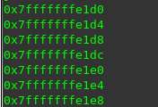

#include <stdio.h>

int main(){

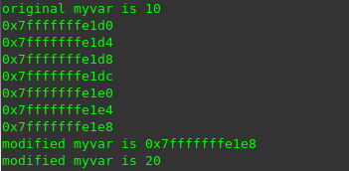
int myvar = 10;
int myarray[5] = {0, 1, 2, 3, 4};

printf("original myvar is %d\n", myvar);

int i;
for(i=0;i < 7; i++){
myarray[i] = myarray[i]*2;
printf("%p\n", &myarray[i]);
}
printf("modified myvar is %p\n", &myvar);
printf("modified myvar is %d\n", myvar);
return 0;
}

In 64-bit ISA, there is an extra memory space between the addresses of the array and the variable. In this case, 0x7fffffffele4 is unused memory location. That's why the for loop has to go up to 7th iteration to modify the value of myvar.

#include <stdio.h>

int main(){

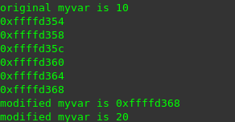
int myvar = 10;
int myarray[5] = {0, 1, 2, 3, 4};

printf("original myvar is %d\n", myvar);

int i;
for(i=0;i < 6; i++){

myarray[i] = myarray[i]*2;
printf("%p\n", &myarray[i]);
}
printf("modified myvar is %p\n", &myvar);
printf("modified myvar is %d\n", myvar);
return 0;
}

When I ran under 32-bit ISA, the extra memory space was removed, and successfully modified the value of myvar by writing to a memory location right after the array.

3.
a.
For the number of parameters, both gcc and cc compilers gave error messages.

#include <stdio.h>

void addition(int x, int y, int z);

int main(){
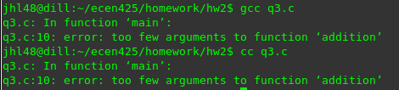
int x = 10;
int y = 20;

addition(x, y);

return 0;
}

void addition(int x, int y, int z){
printf("the sum is %d\n", x+y+z);

}
For the type of parameters, both gcc and cc compilers didn't give any error message.

#include <stdio.h>

void addition(int x, int y, int z);

int main(){

double x = 10;

char y = 20;
float z = 100;

addition(x, y, z);

return 0;
}

void addition(int x, int y, int z){
printf("the sum is %d\n", x+y+z);

}

b.
#include <stdio.h>

int main(){

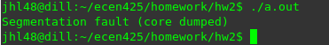
int x = 10;

printf("%s\n", x);

return 0;
}

For not matching parameter type in printf, this program compiles fine with gcc compiler, but it can't be executed with the message shown above.
#include <stdio.h>

int main(){

int x = 10;
int y = 20;
int z = 30;

printf("%d, %d\n", x, y, z);

return 0;
}

For not matching the number of parameters in printf, this program compiles fine with gcc compiler, and it executes fine as well by ignoring the last argument.
#include <stdio.h>
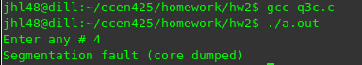
int main(){

int i;
printf("Enter any # ");
scanf("%d", i); /* The '&' was "accidentally" left out before the i */

printf("Entered # is %d\n", i);

return 0;
}

This program compiles fine, but unable to be executed.
Compilers usually don't give many clues about discrepancies of parameters type and number except for not matching the number of arguments for function calls.

4.
The final values of the registers will be

ax = 0x1514
bx = 0x1502
cx = 0x0100
dc = 0x2524

