ECEn 425
Jae Lee
HW #4

1. I would choose Round-robin. The traffic lights need to be able to sensor anything that needs service in real-time. So, if not specified, whoever comes first will be sensed, then serviced. If I had any priority information, I would use Round-robin with interrupts instead.

2. Function-queue-scheduling.

3.
#define max(A,B) ((A) > (B) ? (A) : (B))
a. This macro compares to number and picks bigger number.

b. Macro executes faster, and it is useful where small code appears many time. It's short and handy.
Macro doesn't do type checking and doesn't check compile errors. Since macro doesn't do a memory reference(functions do memory references), memory can run out quick.

c. max(i++,j++)
This macro doens't work very well because whichever bigger number is added twice. It is because macro is just text-replacement.
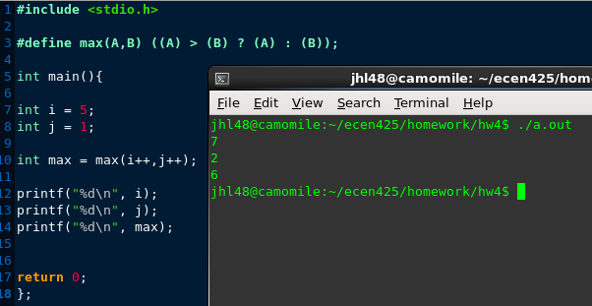

d. This macro will be same as this following text.
y+1*y+1
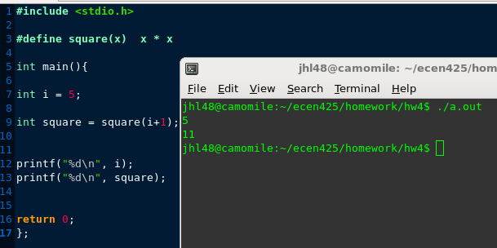
e. #define square(x) (x) * (x) will be more appropriate.

4.
a. argWord: 0x1243
argByte: 0x20
localWord: 0x0321
localByte: 0x02

b. 0x02EA

c. 0xFFF6

