ECEn 483

HW 10

Jae Lee

IV.14

(a)

function tau=UUV_ctrl(in,P)

theta_c = in(1);

theta = in(2);

theta_dot = in(3);

x = [theta; theta_dot];

tau = -K*x;

(b)

P = [-1.2-1.8j -1.2+1.8j];

(c)

C = [G F*G];

if rank(C) ~= 2

display('NOT CONTROLLABLE');

end

(d)

P = [-1.2-1.8j -1.2+1.8j];

K = place(F,G,P)  
K = 103.0000, 151.8000

It is because without tacking the reference input, it acts like PD controller.

(e)

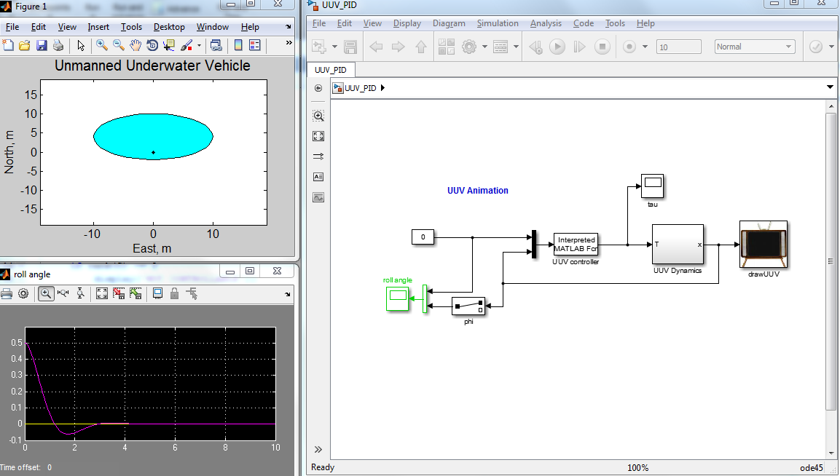

(f)

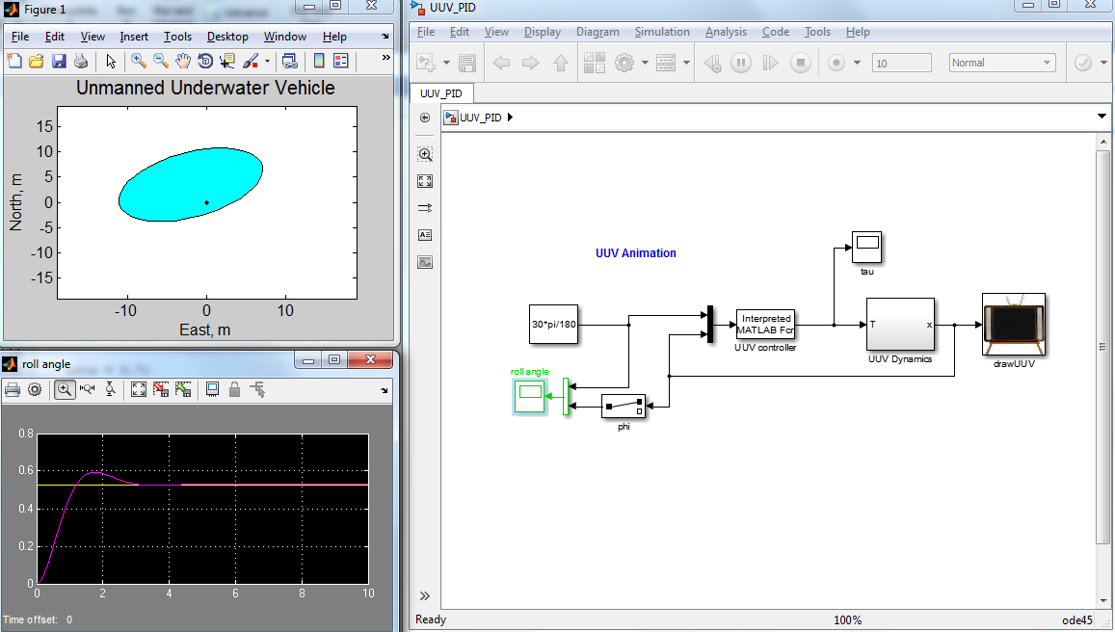

Nbar = 210.6000

V.14

(a)

function Force=ballbeam_ctrl(in,AP)

z_d = in(1);

z = in(2);

theta = in(3);

zdot = in(4);

thetadot = in(5);

t = in(6);

x = [z;theta;zdot;thetadot];

Force = -K*x;

(b)

C = [G F*G F^2*G F^3*G];

if rank(C) ~= 4

display('NOT CONTROLLABLE');

end

(c)

P = [-4.5-4.5j; -4.5+4.5j; -6-1.5j; -6+1.5j];

K = place(F,G,P)

K = -90.3099 70.4203 -44.7248 7.9188

(d)

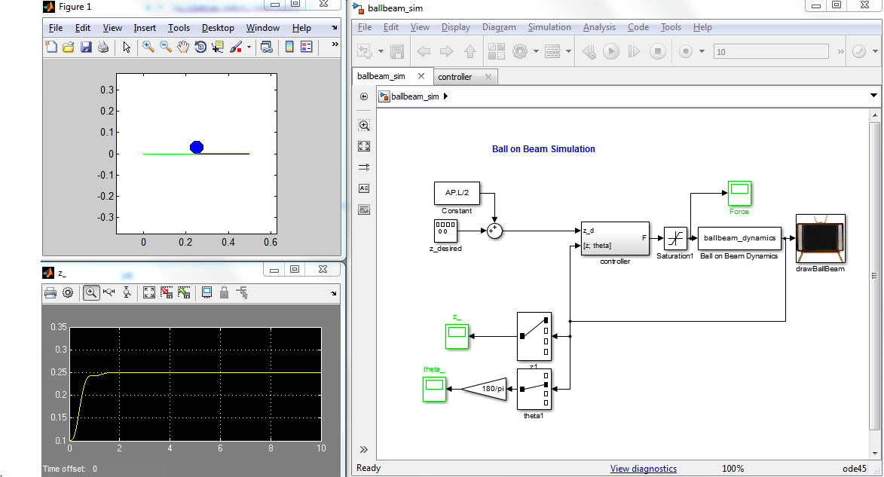

VI.14

(a)

function F = crane_ctrlss(in,P)

z_c = in(1);

zdot = in(2);

thetadot = in(3);

z = in(4);

theta = in(5);

x = [zdot thetadot z theta]';

x1 = [0 0 0 0]';

F = -P.K*x;

(b)

C = [G F*G F*F*G F*F*F*G];

if rank(C) == n

display('controllable');

end

(c)

Poles = [-.55+.75j -.55-.75j -.6 -1.5];

P.K = place(F,G,Poles)/5;

K = 1.0e+03 *(0.8180 -1.0197 0.2381 -5.9199)

(d)

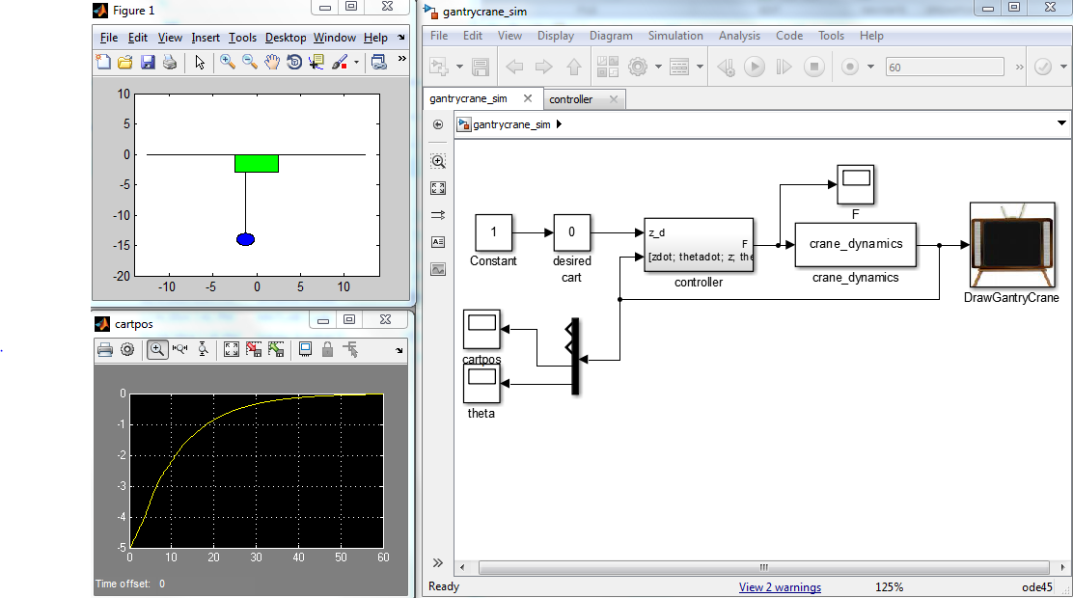

(e)

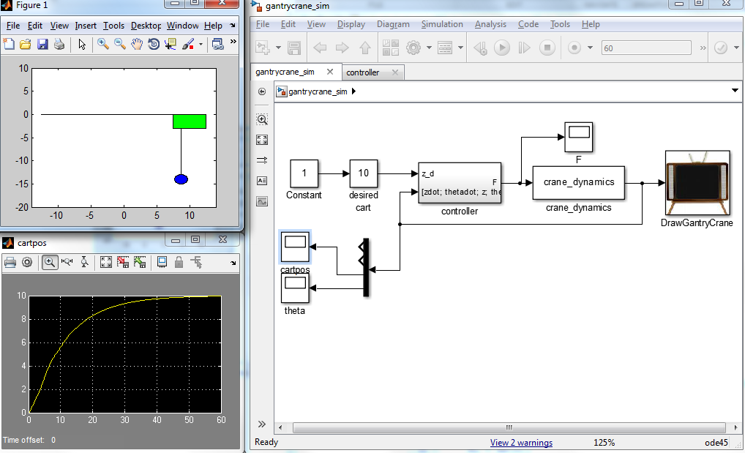 Nbar = 238.0722