IV 11

(a)

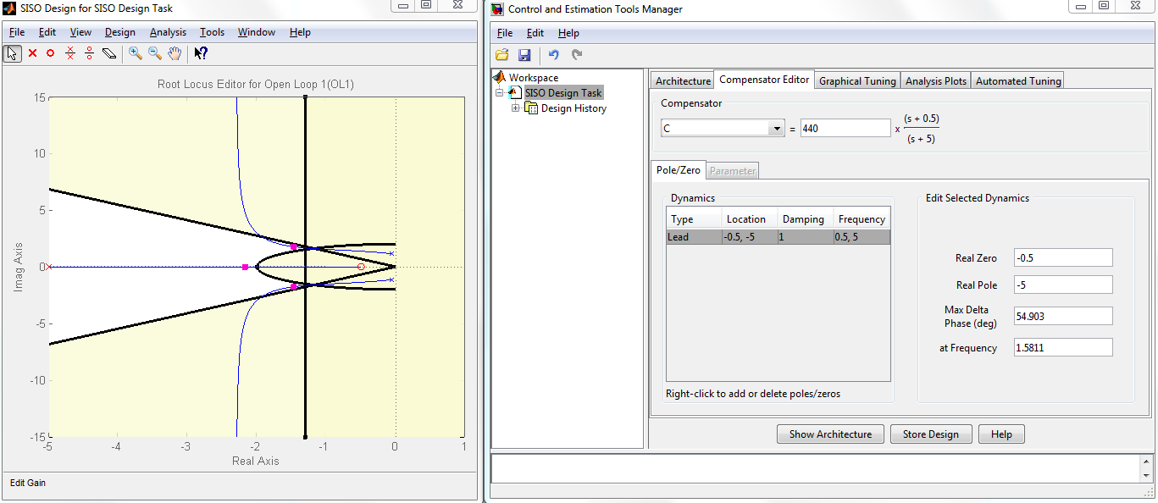

LEAD Gain: 440, zero: -0.5, pole: -5

(b)

Steady-state error = 0.299, about 57 % from the desired angle (30 degree)

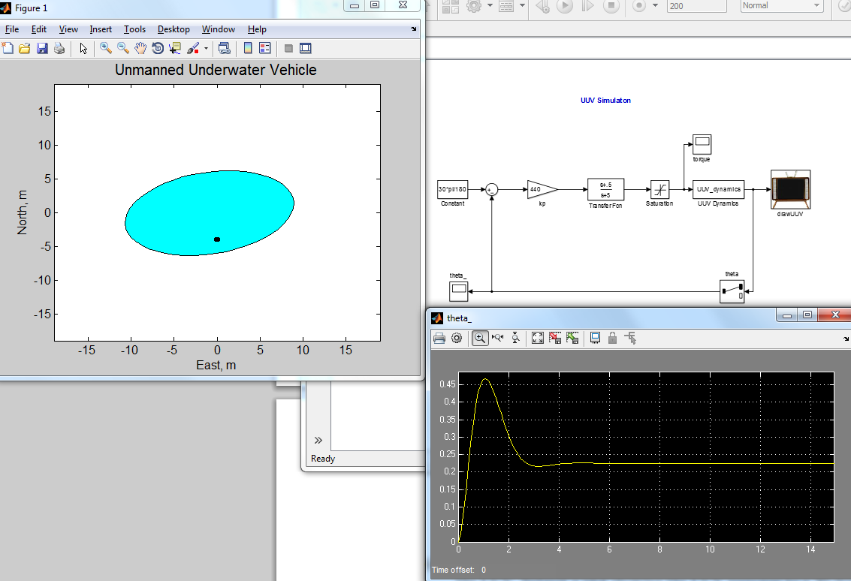

(c)

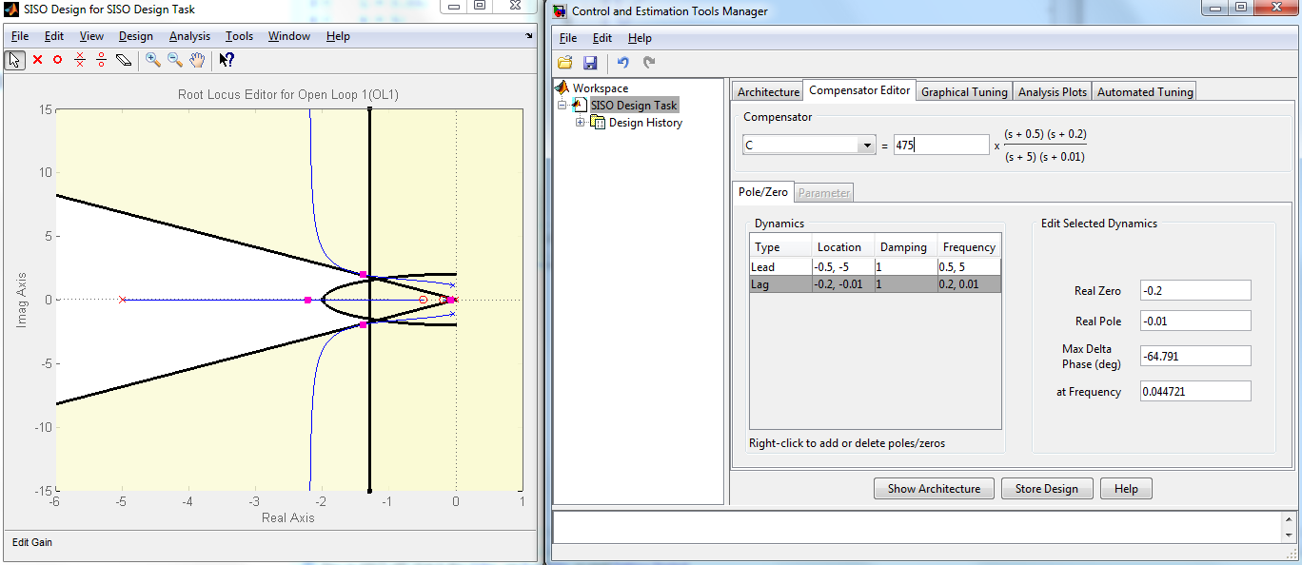

Lead-Lag gain: 475, Lag zero: -0.2, pole: -0.01

(d)

Settling time is way off with only Lead-Lag compensator. We need something else(feed forward)

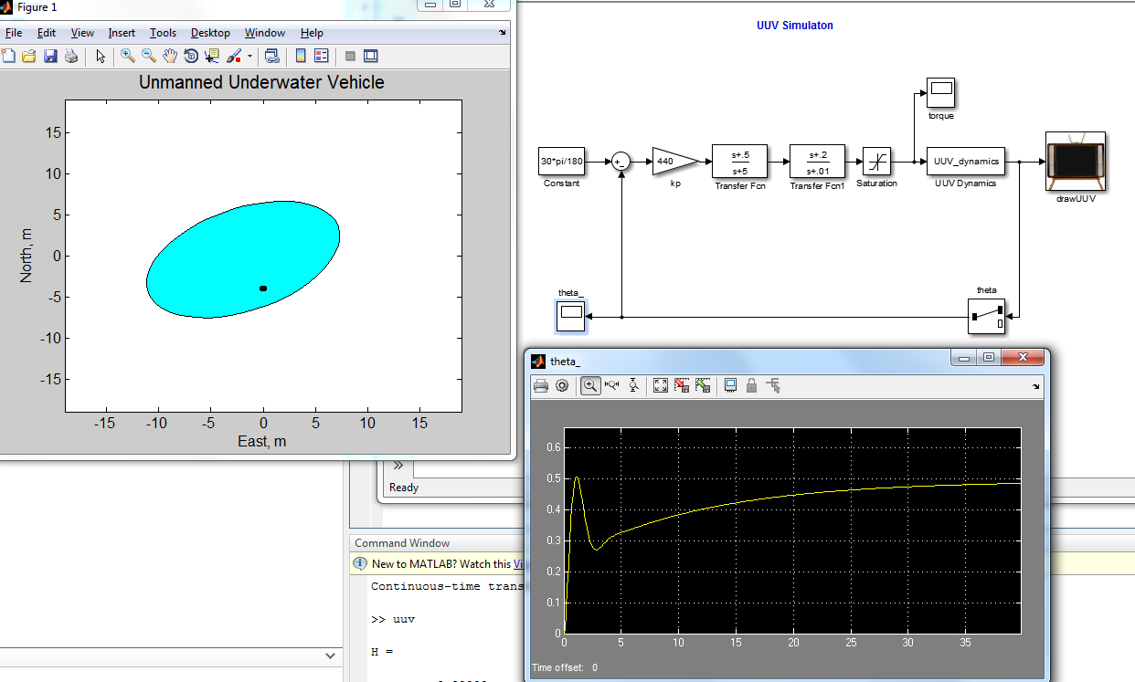

(e)

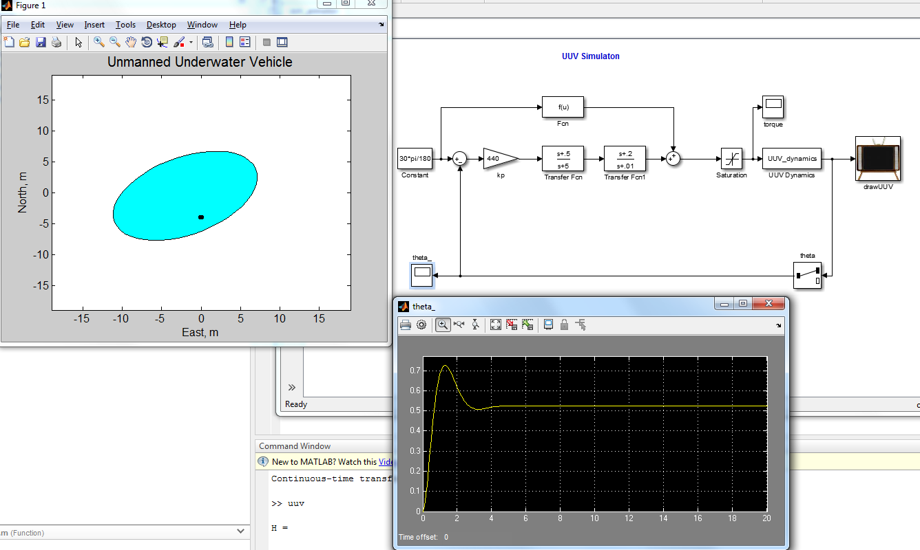

V 11

(a)

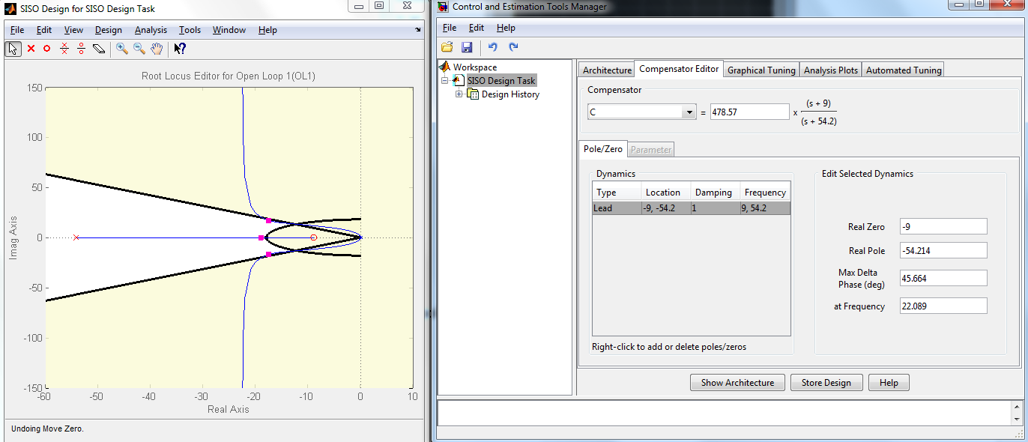

Lead Gain: 478.57, zero: -9, pole: -54.214

(b)

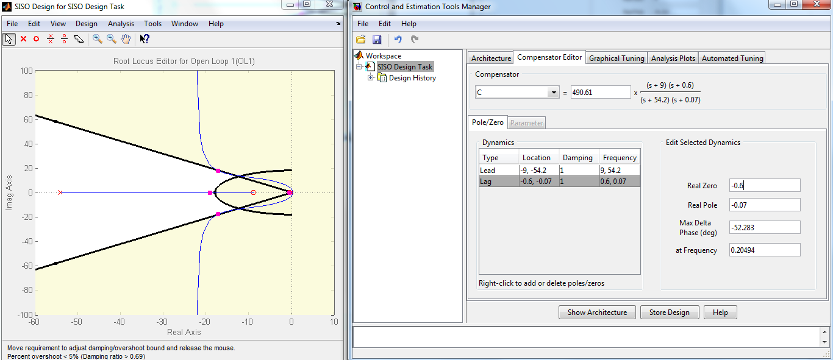

Lead-Lag gain: 490.61, Lag zero: -0.6, pole: -0.07

(c)

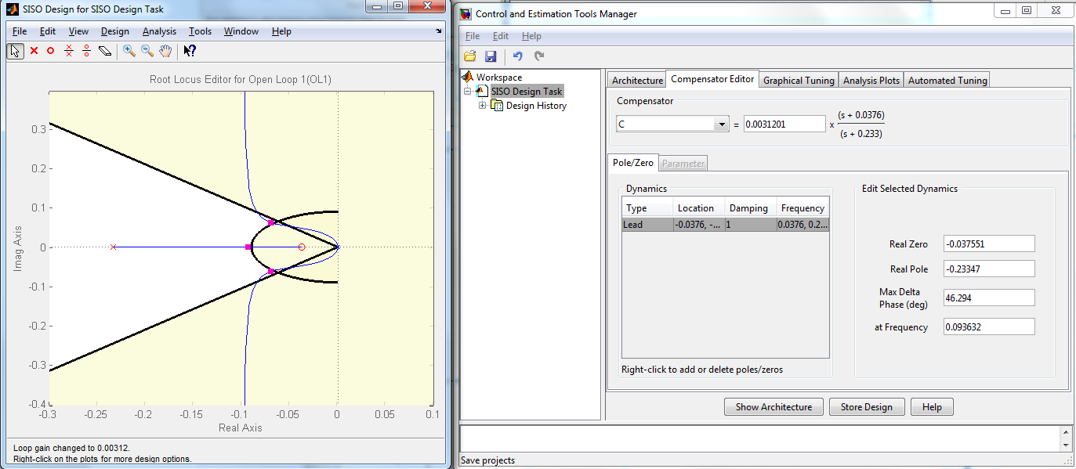

Lead Gain: 0.00312, zero: -0.03755, pole: -0.233

(d)

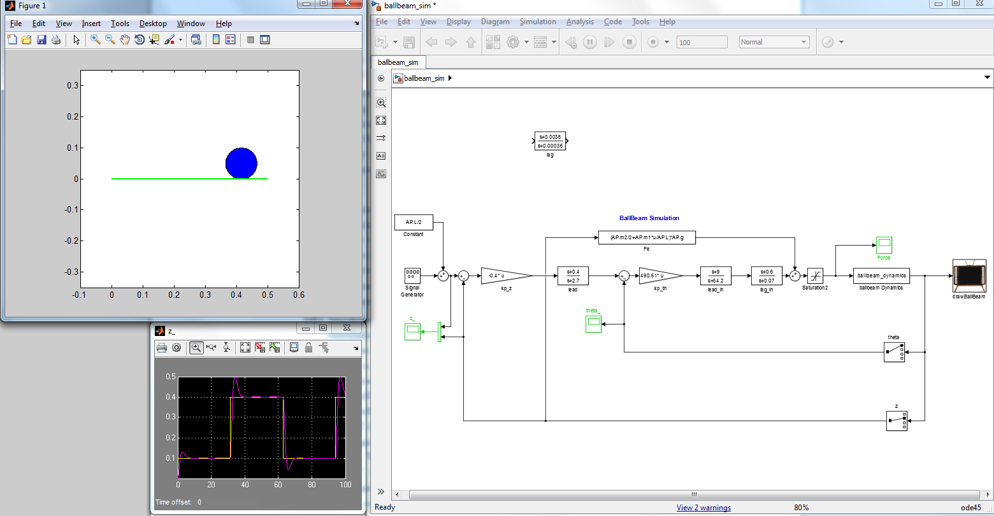

I had to adjust the outer loop gain and lead compensator zero and pole because my simulation never worked with the value I got from the RLtool.