3c) The solution for Part i is shown below, where w0 = 0.01 is shown in red, w0 = 0.1 is shown in green, w0 = 1 is shown in black, and w0 = 10 is shown in yellow.

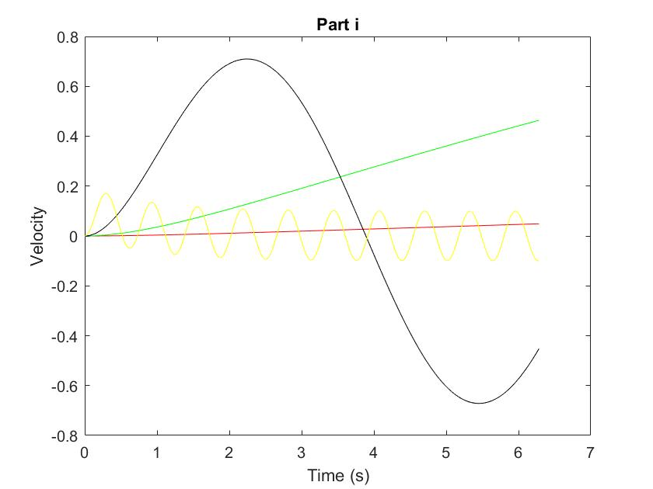

I was unable to succeed in producing this graph for parts ii and iii.

The code I used is shown below:

**ode45_solver.m**

% v' = (-a/m) + u + w

time_period = linspace(0, 2*pi, 1000);

initial = 0;

[t, v] = ode45(@pi_function, time_period, initial);

**pi_function.m**

function [ dv_dt ] = pi_function( t, v )

%PI_FUNCTION Proportional-integral control law

% Detailed explanation goes here

% Defining constants

m = 1;

a = 0.1;

w = 0;

% Defining u

w0 = 1;

v_ref = sin(w0 * t);

kp = 1;

ki = 1;

u = -kp * (v - v_ref) - ki * integral( @(t) v_ref - v, 0, t, 'ArrayValued', 1);

dv_dt = (-a/m) * v + (1/m) * u + w;

end