Intelligent Algorithms – EN 525.770  
Homework 2  
Tim Cardenuto, [timcardenuto@gmail.com](mailto:timcardenuto@gmail.com)

2) Verify identities are satisfied for $∪ =S_{max}(A,B)$, $∩ = T_{min}(A,B)$, $A= μ_{A}\left(x\right)$, $μ_{\overline{A}}\left(x\right)=1-μ_{A}\left(x\right)$

a) Law of Contradiction $A∩\overline{A}=∅$

$μ_{A}\left(x\right) Λ \left(1-μ_{A}\left(x\right)\right) ≠ ∅$

**Not satisfied**

b) Law of Excluded Middle $A∪\overline{A}=X$

$μ_{A}\left(x\right) V \left(1-μ_{A}\left(x\right)\right) ≠ X$

**Not satisfied**

c) Idempotency $A∪A=A$,

$$A∩A=A$$

$$S_{max}(A,A)= μ_{A}\left(x\right) V μ_{A}\left(x\right)= μ_{A}\left(x\right)$$

$$T_{min}\left(A,A\right)= μ_{A}\left(x\right) Λ μ_{A}\left(x\right)= μ_{A}\left(x\right)$$

**Satisfied**

d) Involution $\overline{\overline{A}}=A$

$1-μ_{\overline{A}}\left(x\right)=1-\left(1-μ_{A}\left(x\right)\right)=1-1+μ_{A}\left(x\right)= μ_{A}\left(x\right)$

**Satisfied**

e) Commutativity $A∪B=B∪A$

$A∩B=B∩A$

$μ_{A}\left(x\right) V μ_{B}\left(x\right)= μ_{B}\left(x\right) V μ_{A}\left(x\right)$

$$μ_{A}\left(x\right) Λ μ_{B}\left(x\right)= μ_{B}\left(x\right) Λ μ_{A}\left(x\right)$$

**Satisfied**

f) Absorption of Compliment $A∪(\overline{A}∩B)=A∪B$

$$A∩(\overline{A}∪B)=A∩B$$

$μ_{A}\left(x\right) V \left(\left(1-μ_{A}\left(x\right)\right) Λ μ_{B}\left(x\right)\right) ≠ μ_{A}\left(x\right) V μ_{B}\left(x\right)$

$μ_{A}\left(x\right) Λ \left(\left(1-μ_{A}\left(x\right)\right) V μ_{B}\left(x\right)\right) ≠ μ_{A}\left(x\right) Λ { μ}_{B}\left(x\right)$

**Not satisfied**

g) Demorgans Law $\overline{A∪B}=\overline{A}∩\overline{B}$

$\overline{A∩B}=\overline{A}∪\overline{B}$

$1-\left(μ_{A}\left(x\right) V μ_{B}\left(x\right)\right)=\left(1-μ_{A}\left(x\right)\right) Λ \left(1-μ_{B}\left(x\right)\right)$

$$1-\left(μ_{A}\left(x\right) Λ μ_{B}\left(x\right)\right)=\left(1-μ_{A}\left(x\right)\right) V \left(1-μ_{B}\left(x\right)\right)$$

**Satisfied**

3) Prove *if* Idempotency identity holds with the Algebraic Sum $S_{as}\left(a,b\right)=a+b-a*b$

Algebraic Product $T_{ap}\left(a,b\right)=a*b$

$$T_{ap}\left(A,A\right)= μ_{A}\left(x\right)*μ_{A}\left(x\right)= {μ_{A}\left(x\right)}^{2}≠ μ_{A}\left(x\right)$$

$$S_{as}\left(A,A\right)= μ_{A}\left(x\right)+μ_{A}\left(x\right)- μ_{A}\left(x\right)*μ_{A}\left(x\right)= {2μ}_{A}\left(x\right)-{μ_{A}\left(x\right)}^{2}≠ μ_{A}\left(x\right)$$

**Not Satisfied**

4) Prove that Sugeno and Yager Complements satisfy $N\left(N\left(a\right)\right)=a$

Sugeno $N_{s}\left(a\right)=\frac{1-a}{1+sa}$

$$N_{s}\left(N_{s}\left(a\right)\right)=\frac{1-\frac{1-a}{1+sa}}{1+s\left(\frac{1-a}{1+sa}\right)}= \frac{\frac{\left(1+sa\right)-(1-a)}{1+sa}}{\frac{\left(1+sa\right)+s-sa}{1+sa}}=\left(\frac{a(1+s)}{1+sa}\right)\left(\frac{1+sa}{1+s}\right)=a$$

**Sugeno Satisfied**

Yager $N_{w}\left(a\right)={(1-a^{w})}^{\frac{1}{w}}$

$$N_{w}\left(N_{w}\left(a\right)\right)=a={\left(1-{\left({\left(1-a^{w}\right)}^{\frac{1}{w}}\right)}^{w}\right)}^{\frac{1}{w}}$$

$${\left(1-{\left({\left(1-a^{w}\right)}^{\frac{1}{w}}\right)}^{w}\right)}^{\frac{1}{w}}$$

$$\log_{\left(1-{\left({\left(1-a^{w}\right)}^{\frac{1}{w}}\right)}^{w}\right)}{(a)}=\frac{1}{w}$$

$$\frac{\log_{10}{(a)}}{\log_{10}\left(1-{\left({\left(1-a^{w}\right)}^{\frac{1}{w}}\right)}^{w}\right)}=\frac{1}{w}$$

….

When w=1, ${\left(1-{\left({\left(1-a^{1}\right)}^{\frac{1}{1}}\right)}^{1}\right)}^{\frac{1}{1}}=1-1+a=a$

**Satisfied**

5) Cartesian Product of two Gaussian MF’s

c1 = [6];

sigma1 = [6];

c2 = [-6];

sigma2 = [4];

x = [-20:1:20];

ua = exp(-0.5 * (((x-c1)/sigma1).^2));

ub = exp(-0.5 * (((x-c2)/sigma2).^2));

ua_cross_ub = zeros(length(x),length(x));

for i=1:length(x),

for j=1:length(x),

ua_cross_ub(i,j) = min([ua(i),ub(j)]);

end

end

% hold on

% plot(x,ua)

% plot(x,ub)

mesh(x,x,ua_cross_ub);

xlabel('A Fuzzy Set');

ylabel('B Fuzzy Set');

zlabel('Cartesian Product AxB');

title('Tnorm min, Cartesian Product');

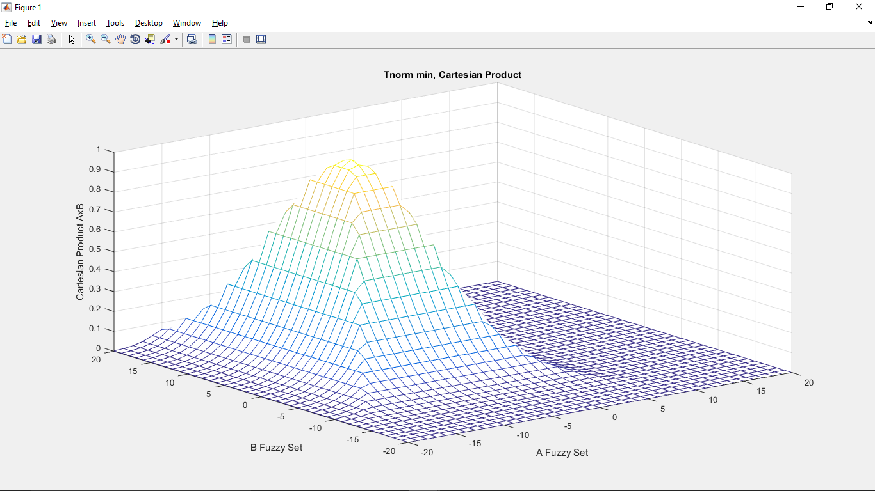

6) Non-primary terms for membership functions “young” and “old”

x = [0:1:100]; %age

uyoung = exp(-(x/20).^2);

uold = exp(-((x-100)/30).^2);

hold on

plot(x,uyoung)

plot(x,uold)

% not very young and not very old

a = min((1-(uyoung.^2)),(1-(uold.^2)));

plot(x,a)

% very young or very old

b = max((uyoung.^2),(uold.^2));

plot(x,b)

xlabel('X - Universe of Discourse (Age)');

ylabel('Membership Grade');

title('Non-primary Calculations for Age Groups');

legend('young', 'old', 'not very young and not very old', 'very young or very old')

