**Problem 3 part 1**

x = [0:1:20];

y = x;

% triangle MF

ua1 = trimf(x,[5 10 15]);

ub1 = trimf(y,[5 10 15]);

% trapezoid MF

ua2 = trapmf(x,[3 8 12 17]);

ub2 = trapmf(y,[3 8 12 17]);

% min (mamdani)

mamdani1 = zeros(length(x),length(y));

for i=1:length(x),

for j=1:length(y),

mamdani1(i,j) = min([ua1(i),ub1(j)]);

end

end

subplot(2,4,1);

mesh(x,y,mamdani1);

xlabel('A');

ylabel('B');

title('triangle min');

mamdani2 = zeros(length(x),length(y));

for i=1:length(x),

for j=1:length(y),

mamdani2(i,j) = min([ua2(i),ub2(j)]);

end

end

subplot(2,4,5);

mesh(x,y,mamdani2);

xlabel('A');

ylabel('B');

title('trapezoid min');

% algebraic product

algebraic1 = zeros(length(x),length(y));

for i=1:length(x),

for j=1:length(y),

algebraic1(i,j) = ua1(i)*ub1(j);

end

end

subplot(2,4,2);

mesh(x,y,algebraic1);

xlabel('A');

ylabel('B');

title('triangle algebraic product');

algebraic2 = zeros(length(x),length(y));

for i=1:length(x),

for j=1:length(y),

algebraic2(i,j) = ua2(i)*ub2(j);

end

end

subplot(2,4,6);

mesh(x,y,algebraic2);

xlabel('A');

ylabel('B');

title('trapezoid algebraic product');

% bounded product

bounded1 = zeros(length(x),length(y));

for i=1:length(x),

for j=1:length(y),

bounded1(i,j) = max(0,(ua1(i)+ub1(j)-1));

end

end

subplot(2,4,3);

mesh(x,y,bounded1);

xlabel('A');

ylabel('B');

title('triangle bounded product');

bounded2 = zeros(length(x),length(y));

for i=1:length(x),

for j=1:length(y),

bounded2(i,j) = max(0,(ua2(i)+ub2(j)-1));

end

end

subplot(2,4,7);

mesh(x,y,bounded2);

xlabel('A');

ylabel('B');

title('trapezoid bounded product');

% drastic product

drastic1 = zeros(length(x),length(y));

for i=1:length(x),

for j=1:length(y),

if(ub1(j)==1)

drastic1(i,j) = ua1(i);

elseif(ua1(i)==1)

drastic1(i,j) = ub1(j);

else

drastic1(i,j) = 0;

end

end

end

subplot(2,4,4);

mesh(x,y,drastic1);

xlabel('A');

ylabel('B');

title('triangle drastic product');

drastic2 = zeros(length(x),length(y));

for i=1:length(x),

for j=1:length(y),

if(ub2(j)==1)

drastic2(i,j) = ua2(i);

elseif(ua2(i)==1)

drastic2(i,j) = ub2(j);

else

drastic2(i,j) = 0;

end

end

end

subplot(2,4,8);

mesh(x,y,drastic2);

xlabel('A');

ylabel('B');

title('trapezoid drastic product');

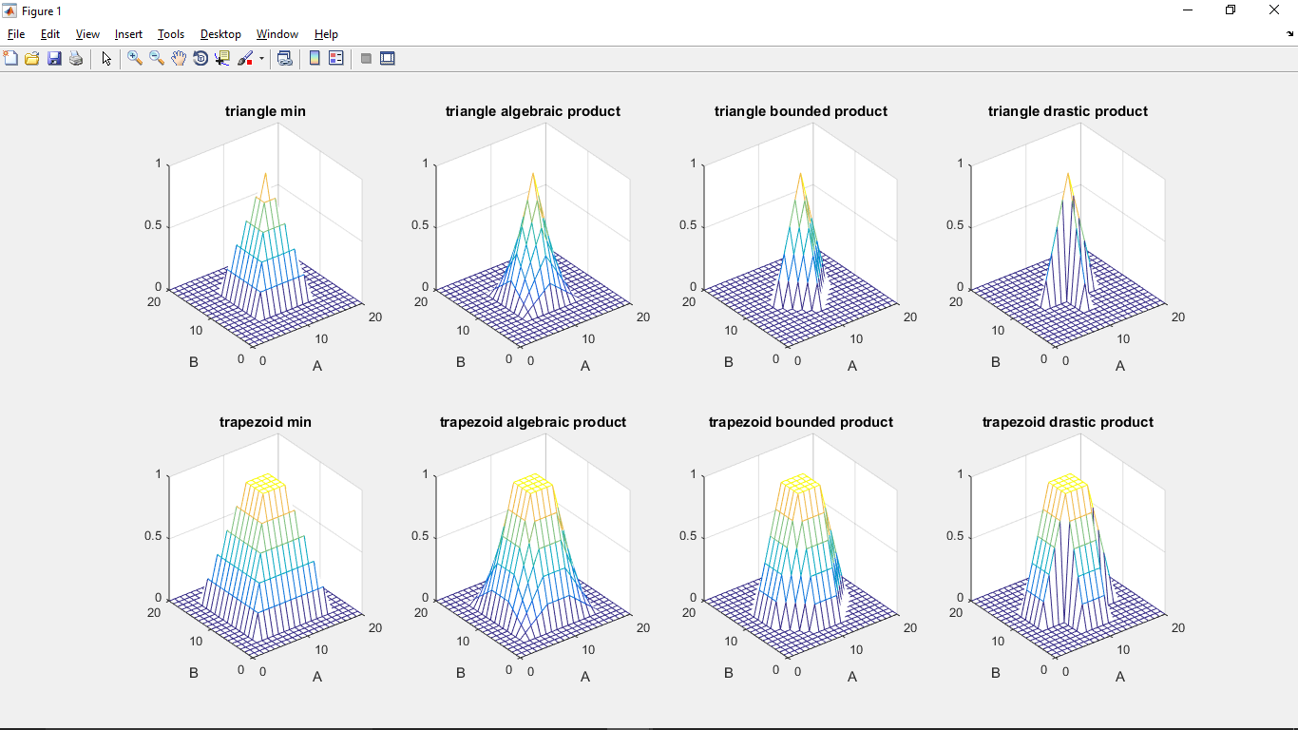

**Problem 3 part 2**

x = [0:1:20];

y = x;

% triangle MF

ua1 = trimf(x,[5 10 15]);

ub1 = trimf(y,[5 10 15]);

% trapezoid MF

ua2 = trapmf(x,[3 8 12 17]);

ub2 = trapmf(y,[3 8 12 17]);

% Zadeh's arithmetic rule

arithmetic1 = zeros(length(x),length(y));

for i=1:length(x),

for j=1:length(y),

arithmetic1(j,i) = min(1,(1-ua1(i)+ub1(j)));

end

end

subplot(2,4,1);

mesh(x,y,arithmetic1);

xlabel('A');

ylabel('B');

title('Zadeh arithmetic rule - triangle');

arithmetic2 = zeros(length(x),length(y));

for i=1:length(x),

for j=1:length(y),

arithmetic2(j,i) = min(1,(1-ua2(i)+ub2(j)));

end

end

subplot(2,4,5);

mesh(x,y,arithmetic2);

xlabel('A');

ylabel('B');

title('Zadeh arithmetic rule - trapezoid');

% Zadeh min-max rule

minmax1 = zeros(length(x),length(y));

for i=1:length(x),

for j=1:length(y),

minmax1(j,i) = max((1-ua1(i)),min(ua1(i),ub1(j)));

end

end

subplot(2,4,2);

mesh(x,y,minmax1);

xlabel('A');

ylabel('B');

title('Zadeh min-max rule - triangle');

minmax2 = zeros(length(x),length(y));

for i=1:length(x),

for j=1:length(y),

minmax2(j,i) = max((1-ua2(i)),min(ua2(i),ub2(j)));

end

end

subplot(2,4,6);

mesh(x,y,minmax2);

xlabel('A');

ylabel('B');

title('Zadeh min-max rule - trapezoid');

% Boolean implication

boolean1 = zeros(length(x),length(y));

for i=1:length(x),

for j=1:length(y),

boolean1(j,i) = max((1-ua1(i)),ub1(j));

end

end

subplot(2,4,3);

mesh(x,y,boolean1);

xlabel('A');

ylabel('B');

title('Boolean implication - triangle');

boolean2 = zeros(length(x),length(y));

for i=1:length(x),

for j=1:length(y),

boolean2(j,i) = max((1-ua2(i)),ub2(j));

end

end

subplot(2,4,7);

mesh(x,y,boolean2);

xlabel('A');

ylabel('B');

title('Boolean implication - trapezoid');

% Goguen's implication

goguen1 = zeros(length(x),length(y));

for i=1:length(x),

for j=1:length(y),

if(ua1(i)<=ub1(j))

goguen1(j,i) = 1;

else

goguen1(j,i) = ub1(j)/ua1(i);

end

end

end

subplot(2,4,4);

mesh(x,y,goguen1);

xlabel('A');

ylabel('B');

title('Goguens implication - triangle');

goguen2 = zeros(length(x),length(y));

for i=1:length(x),

for j=1:length(y),

if(ua2(i)<=ub2(j))

goguen2(j,i) = 1;

else

goguen2(j,i) = ub2(j)/ua2(i);

end

end

end

subplot(2,4,8);

mesh(x,y,goguen2);

xlabel('A');

ylabel('B');

title('Goguens implication - trapezoid');

