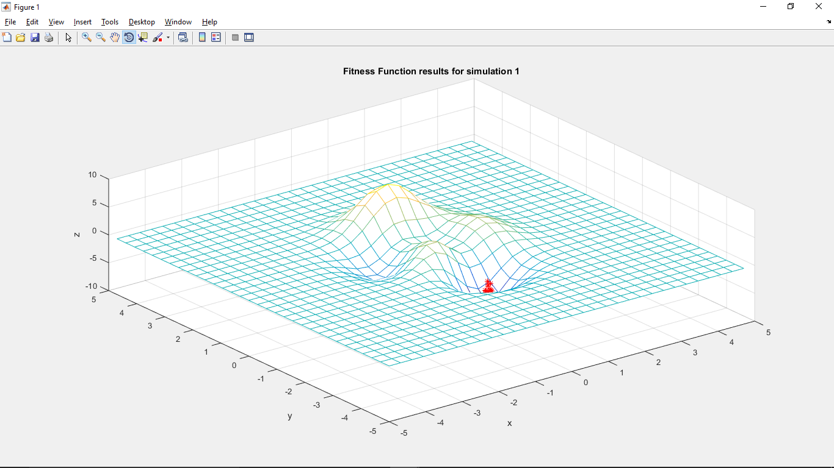

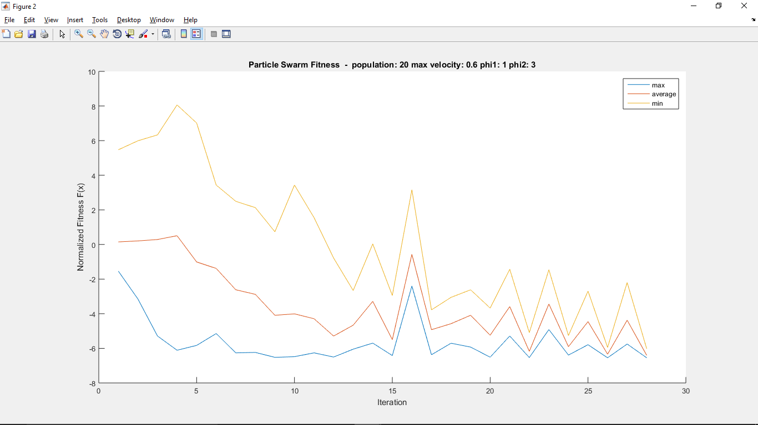

|  |  |  |
| --- | --- | --- |
| **maximum** | **average** | **minimum** |
| -6.5479 | -3.4985 | 8.0626 |

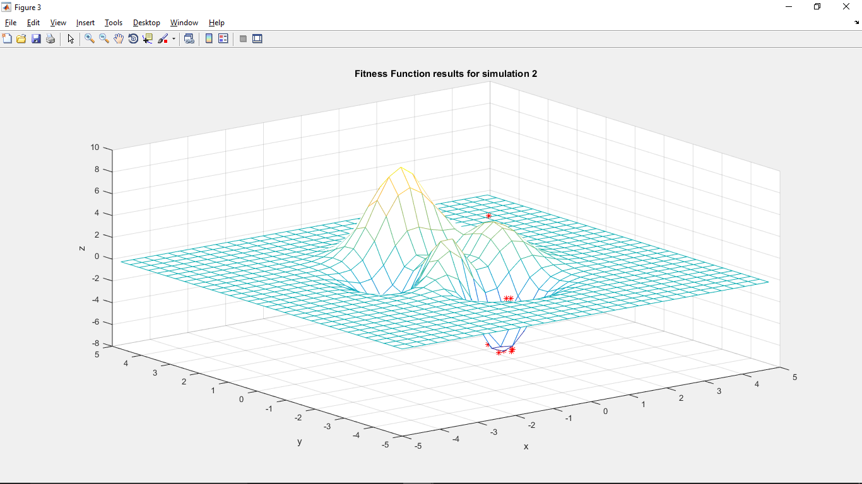

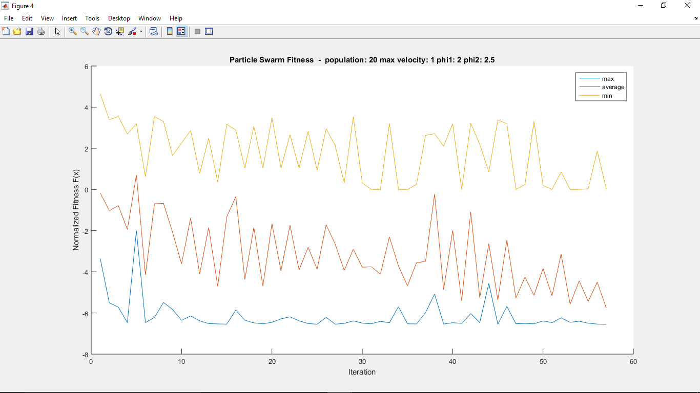

|  |  |  |
| --- | --- | --- |
| **maximum** | **average** | **minimum** |
| -6.5488 | -3.1489 | 4.6445 |

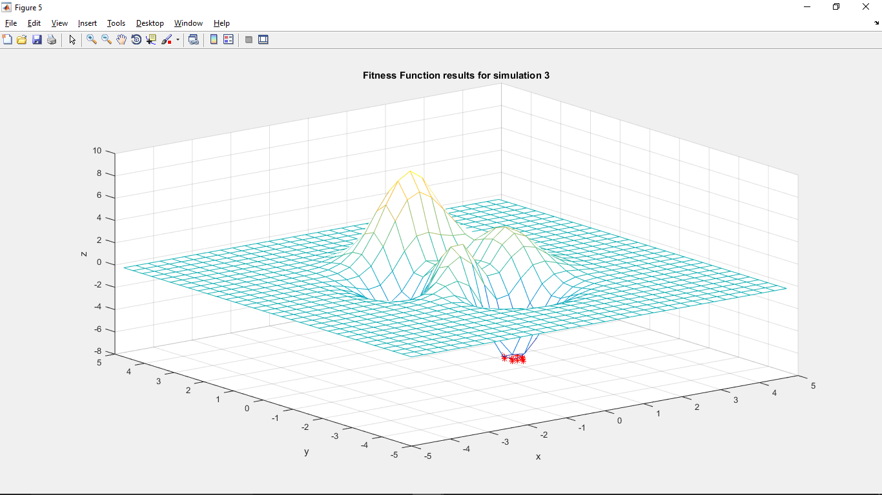

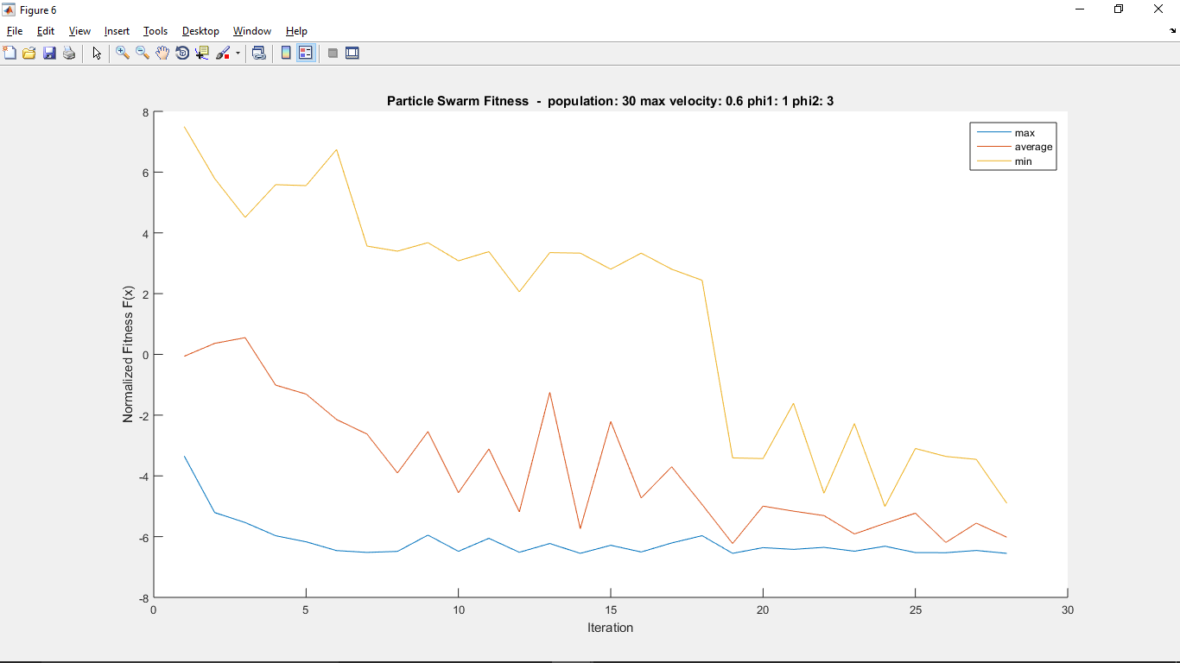

|  |  |  |
| --- | --- | --- |
| **maximum** | **average** | **minimum** |
| -6.5505 | -3.7236 | 7.4976 |

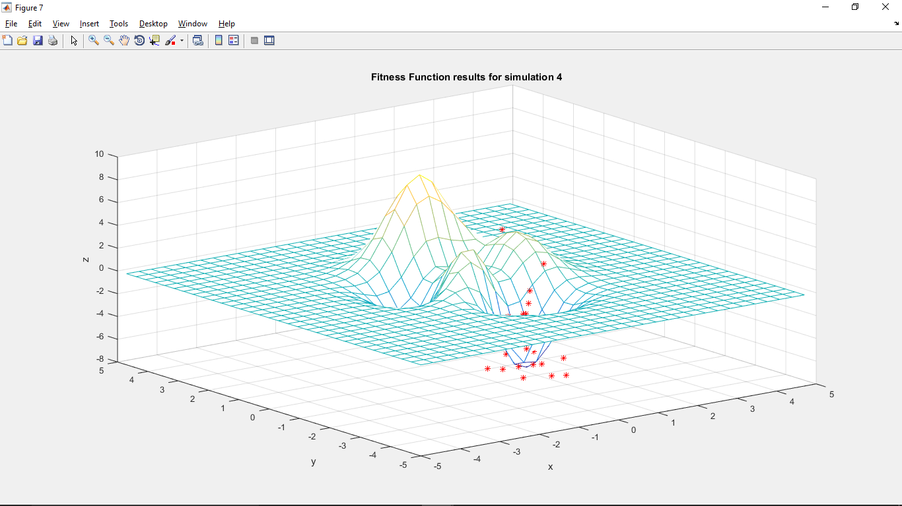

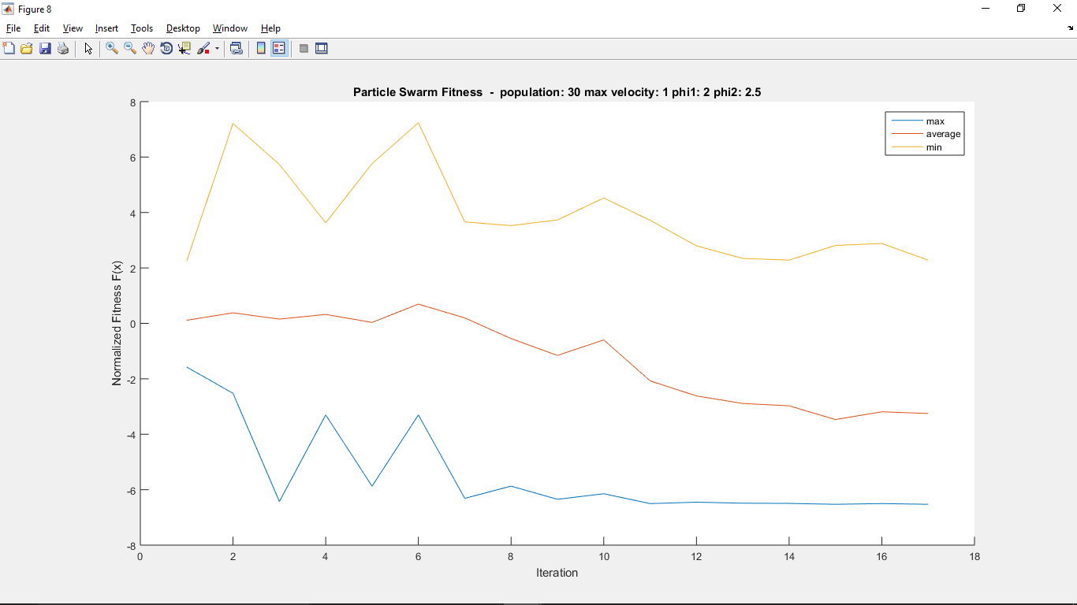

|  |  |  |
| --- | --- | --- |
| **maximum** | **average** | **minimum** |
| -6.5275 | -1.2276 | 7.2395 |