The problems are as follows:

1. In PathFollwingWithMaps/PathFollowingWithMap15PRM when I ues inflate(mapInflated,robotRadius); the range of the obstacles change to too big as it should be:

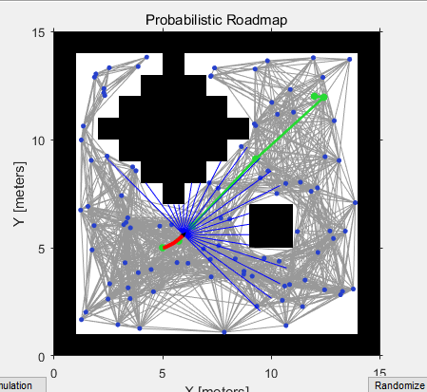 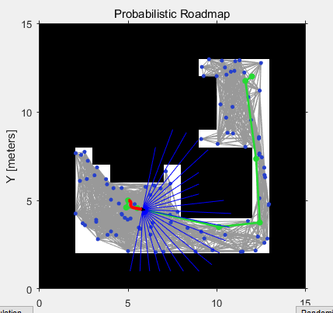

Figure 1 without inflate Figure 2 with inflate

1. In AstarDijCreatedMapImageImage/TestImageMap, when I run the program, there will generate a line connect the start point and the robot current point.

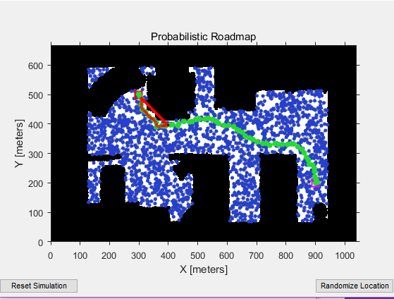

1. In PathFollowingAstarDijsktraWithMaps

First the input map in A star Algoruthm is logical array:

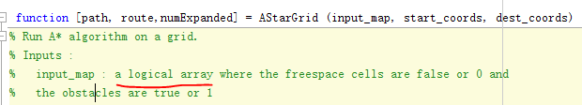

From the example: PathFollowingControllerExample.m, we know that the map we give to robot is a logical array, but after we inflate the map, the map type change to binaryOccupancyGrid:

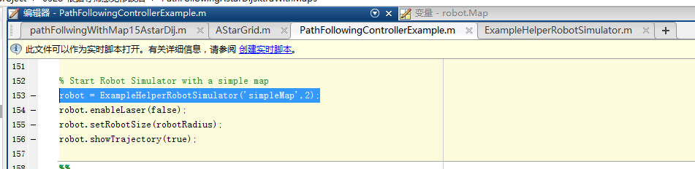

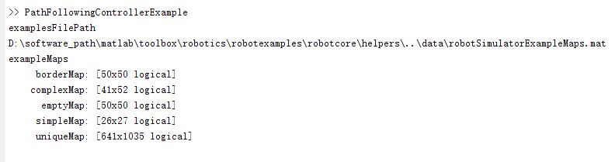

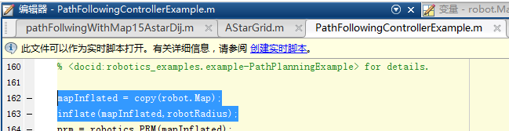

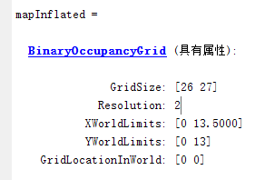

So I have to use getOccupancy() method to get the map and change the type to logil array again

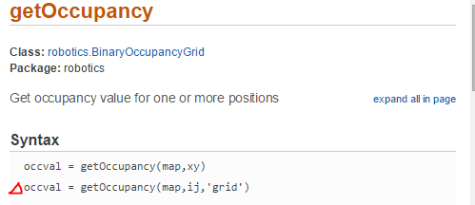



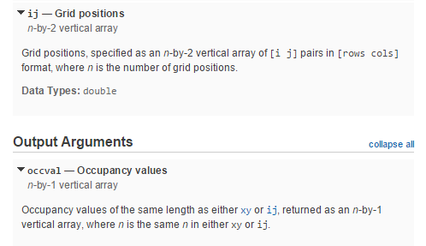

In this case, I use the map 15-by-15, which created by myself, so I know the size, and I have to create an array “ij”, which is {[1 1],[1 2],……[1 15],[2 1 ],….[2 15],…..[15 15]} ,

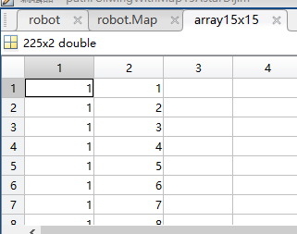

but if I give the smart home map to the robot, then I don’t know the size of the map , I can’t create another array “ij”. Also output is 225-by-1 array, so I have to change it to 15-by15 again, after change it to 15-by-15 array, I have to use Transpose matrix to get the same map I give to the robot at the beginning.(In my case, it is “MapSize15”)

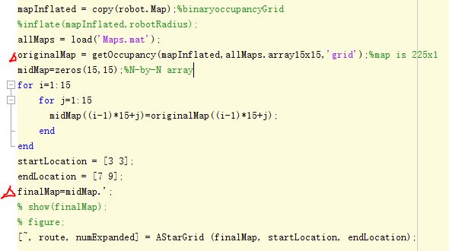

Then I run the PathFollowingAstarDijsktraWithMaps/pathFollowingWithMap15AstarDij.m

The output looks like this: the yellow points are start point and goal point, the blue line is the path, the red line is the route the robot runs. The problem is that I can’t see the map, it becomes shallow map, and robot stops half of the path, it can’t go further.

