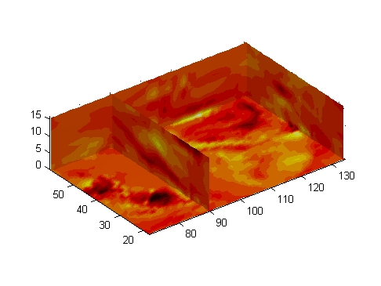
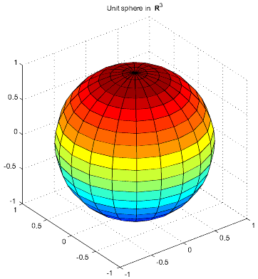
A b c d ef f g g g g hf th gfd dfg dfgdg dfg

