# HOSTEL PORTAL

##### **Rishi Raj Saxena, Mayukh Majhi, Dattatraya Deb, Avinab Sen, Supriyo Nandi, Nabankur Dey, Prof. N. Biraja Isac**

School of Computer Engineering, Kalinga Institute of Industrial Technology, D.U. Odisha, India [1705353@kiit.ac.in,](mailto:1705353@kiit.ac.in,) [1705323@kiit.ac.in,](mailto:1705323@kiit.ac.in,) [1705304@kiit.ac.in](mailto:1514059@kiit.ac.in), [1705298@kiit.ac.in](mailto:1514058@kiit.ac.in), [1705470@kiit.ac.in, 1705418@kiit.ac.in](mailto:1514028@kiit.ac.in,1514065@kiit.ac.in), [nbiraja.isacfcs@kiit.ac.in](mailto:ganaraj.psfet@kiit.ac.in)

**ABSTRACT**

As the name specifies “HOSTEL PORTAL” is a software developed for managing various activities in the hostel. For the past few years the number of educational institutions are increasing rapidly. Thereby the number of hostels are also increasing for the accommodation of the students studying in this institution. And hence there is a lot of strain on the person who are running the hostel and software’s are not usually used in this context. This particular project deals with the problems on managing a hostel and avoids the problems which occur when carried manually. Identification of the drawbacks of the existing system leads to the designing of computerized system that will be compatible to the existing system with the system Which is more user friendly and more GUI oriented. We can improve the efficiency of the system, thus overcome the drawbacks of the existing system.

* Less human error
* Strength and strain of manual labour can be reduced
* High security
* Data redundancy can be avoided to some extent
* Data consistency
* Easy to handle

***Index Terms***- Hostel Portal, Management, Student Allocation, Data Consistency, Upcoming events, Chat bot, Contact us.

1. **INTRODUCTION**

The purpose of this project to make an automated system to carry out different operations of a hostel. The system will provide the ease, comfort of use to the staff of the hostel by performing all work on computer system rather than following a paper pen approach. This approach helps improving the reliability of data maintained and provides a fast and efficient for the users of the website.

We have got seventeen hostels in our university, which consist of eleven boy’s hostel and six girl’s hostel. All these hostels at present are managed manually by the hostel office. The Registration form verification to the different data processing are done manually.

Thus there are a lot of repetitions which can be easily avoided. And hence there is a lot of Hostel Management Portal is a customized and user friendly website for hostel which provide Hostel information, Hostel room information and Hostel accounts information.It helps admin to manage Student record, staff record generating report of students, etc.

1. **RELATED WORKS**

Hostel management system development using PHP program has lots of codes. Using Internet in gathering information partially contributed to the success of this project. Due to the fact that PHP is an open source program, development of hostel management system was not too difficult. However, thanks to the cyber world (Internet) that makes it possible to study and make comparison in needs of some code function. A number of hostel portal system documents were examined and compared to the need of KIIT’s proposed hostel portal system. Among other web site that was used in my research is “ http://freesourcecode.com/ ”. It provided me with various lines of codes which I used in the developmental process of this project.

a. “A review of PHP Compilers and Outputs” Favre, Nicolas (2010-02-16) - gave a good layout of product design.

b. Personal Home Page Tools (PHP Tools) Lerdorf, Rasmus (1995-06-08), was very helpful and insightful in the product development of this project.

c. W3schools have prototypes that helped building interfaces for the pro

**III. TECHNOLOGY USED**

The software is developed with all the basic controls and class provided in JAVA and SQL, Windows XP or above installed on the system. Application package must be installed. The other technologies used are mentioned below :-

HTML (Hyper-Text Markup Language) : HTML elements forms the building blocks of all websites, allows Image sand objects to be embedded and can to be used to create interactive forms.

CSS (Cascading Style Sheets) : CSS is a style sheet language used for describing the look and formatting of a document written in a markup language.

Bootstrap : Bootstrap is a web framework that focuses on simplifying the development of informative web pages (as opposed to web apps).

PHP (Hypertext Preprocessor) : PHP is a popular general-purpose scripting language that is especially suited to web development.

SQL (Structured Query Language) : To work with data in a database, you must use a set of commands and statements (language) defined by the DBMS software.

JavaScript : JavaScript, often abbreviated as JS, is a programming language that conforms to the ECMAScript specification.

XAMPP Server : XAMPP is a free and open-source cross-platform web server solution stack package developed by Apache Friends, consisting mainly of the Apache HTTP Server, MariaDB database, and interpreters for scripts written in the PHP and Perl programming languages.

**IV. PROPOSED MODEL**

DETAIL DESIGN

The design of our implemented system is discussed here. The Design phase involves planning different stages for implementing the Software. In a system, result of a process can be seen in the output. The design of our output specification is carried out with much user friendliness. The Hostel Portal System Design is simple and efficient and is just made of a login page where users can login as per their respective id which leads them to their respective homepage,further where they can process their complaint through the complain window and wardens can access them through the complaint box.

ARCHITECTURE OF THE PROPOSED SYSTEM

The shown below is the system architecture and how the system is implemented and how their functions are being achieved.

The system design is divided in two portions: the *Administrator* section and the *User* (student’s) section.

STUDENT USER

The student has to login to register a complaint.The complaint given by the student of the respective hostels' will be taken care of by their respective wardens.

ADMINISTRATOR

1. The Administrator can allot different students to the different hostels.
2. He can vacate the students for the hostels.
3. He can change their rooms, edit and delete the student recor

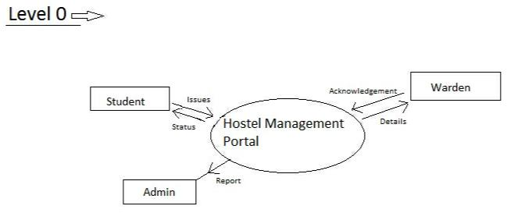

Figure 5.1: Level - 0 DFD

PROCESS DESIGN

Process design plays an important role in project development. In order to understand the working procedure, process design is necessary. Data Flow Diagram and System Flow chart are the tools used for process design. Data Flow Diagram is the logical representation of the data flow of the project. The DFD is drawn using various symbols. It has a source and a destination. The process is represented using circles and source and destination are represented using squares. The data flow is represented using arrows. One reader can easily get the idea about the project through Data Flow Diagram.

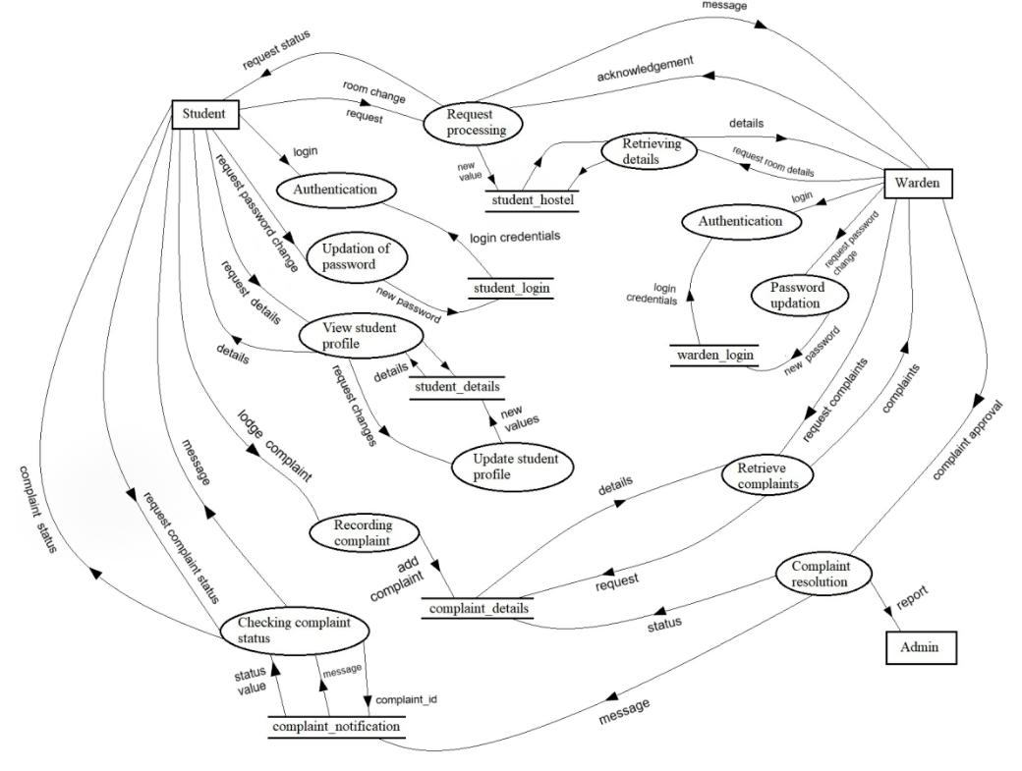

Figure 5.2: Level-1 DFD

STUDENT LOGIN

A UML use case diagram is the primary form of system/software requirements for a new software program underdeveloped.here the use case diagram shows the students can login and register their complaints.

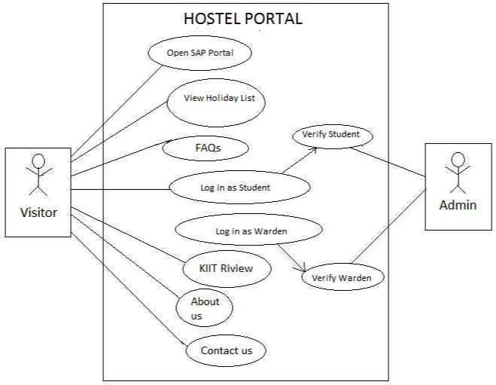

Figure 5.3: Hostel Portal for Student Login

WARDEN LOGIN

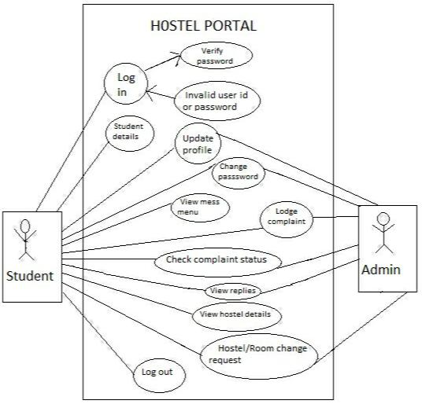Now comes the part where the warden logins first to see all the complaints submitted which is shown in the dashboard.

Figure 5.4: Hostel Portal for Warden Login

COMPLAINT STATUS

The wardens can give a suitable reply to the students after checking the complaints and can arrange possible solutions to their problems which will be notified to students.

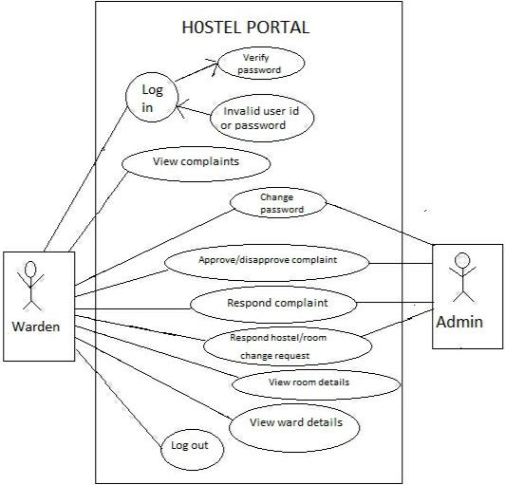

Figure 5.5: Hostel Portal for Complaint Status

DATABASE DESIGN

The data in the system has to be stored and retrieved from database. Designing the database is part of system design. Data elements and data structures to be stored have been identified at analysis stage. They are structured and put together to design the data storage and retrieval system. A database is a collection of interrelated data stored with minimum redundancy to serve many users quickly and efficiently. The general objective is to make database access easy, quick, inexpensive and flexible for the user. Relationships are established between the data items and unnecessary data items are removed.

STUDENT DETAILS DATABASE

|  |  |  |  |  |  |  |
| --- | --- | --- | --- | --- | --- | --- |
| **student_rollno** | **student_name** | **student_gender** | **student_age** | **student_contact** | **student_dob** |  |
|  |  |  |  | **_number** |  |  |
|  |  |  |  |  |  |  |
|  | SUPRIYO | M | 20 | 9549636258 | 1999-06-10 |  |
| 1705291 | NANDI |  |  |  |  |  |
| 1705298 | AVINAB SEN | M | 21 | 6270536552 | 1999-01-19 |  |
|  |  |  |  |  |  |
|  | RISHI RAJ | M | 21 | 9556901757 | 1999-02-14 |  |
| 1705353 | SAXENA |  |  |  |  |  |
|  |  |  |  |  |  |  |
|  | MAYUKH | M | 21 | 9126457829 | 1999-10-23 |  |
| 1705323 | MAJHI |  |  |  |  |  |
|  | NABANKUR | M | 20 | 8787438080 | 1999-05-18 |  |
| 1705418 | DEY |  |  |  |  |  |
|  |  |  |  |  |  |  |

LOGIN DETAILS DATABASE

|  |  |  |
| --- | --- | --- |
| **student_id** | **student_rollno** | **student_password** |
|  |  |  |
| 1 | 1705353 | Rishiraj |
|  |  |  |
| 2 | 1705323 | Mayukh |
|  |  |  |
| 3 | 1705298 | Avinab |
| 4 | 1705470 | Supriyo |
| 5 | 1705418 | Nabankur |

WARDEN LOGIN DATABASE

|  |  |  |
| --- | --- | --- |
| **hostel_id** | **hostel_name** | **hostel_password** |
|  |  |  |
| KP9A | KP-9A | KP9A |
|  |  |  |
| KP9C | KP-9C | KP9C |
|  |  |  |

HOSTEL DETAILS DATABASE

|  |  |  |  |  |
| --- | --- | --- | --- | --- |
| **student_rollno** | **student_roomno** | **student_hostelname** | **student_name** | **student_contact** |
|  |  |  |  |  |
| 1705298 | B-104 | KP-9C | Avinab | 6370536552 |
|  |  |  |  |  |
| 1705353 | B-104 | KP-9C | Mayukh | 9126157829 |
|  |  |  |  |  |
| 1705323 | B-104 | KP-9C | Rishiraj | 9556901757 |
|  |  |  |  |  |

**V. IMPLEMENTATION AND RESULTS**

In this Application we have two types of user: *Student* and *Warden*. Student and Warden can Login to portal by their UserId and Password. The Student can see their profile, hostel details and they can complain to warden via app to respective hostel wardens. And warden basically review that complain can take required actions.

CODE FOR LOGIN

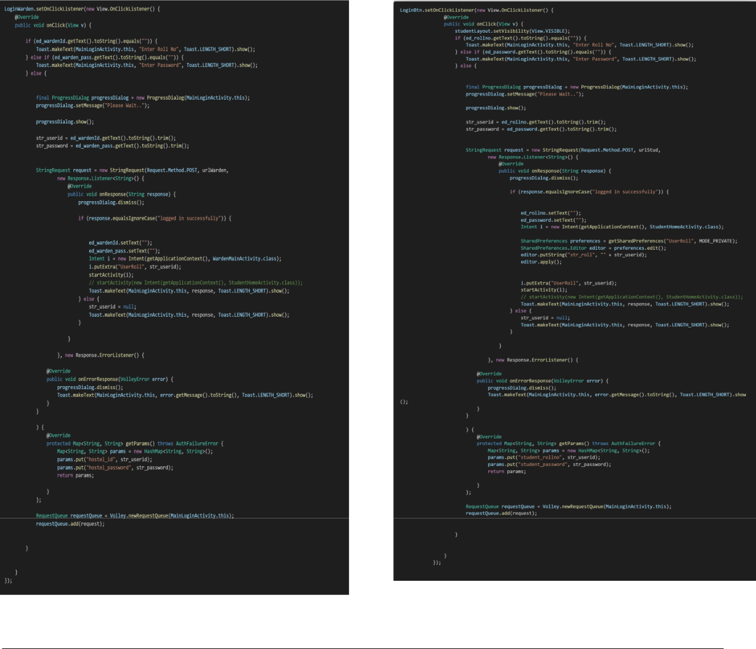

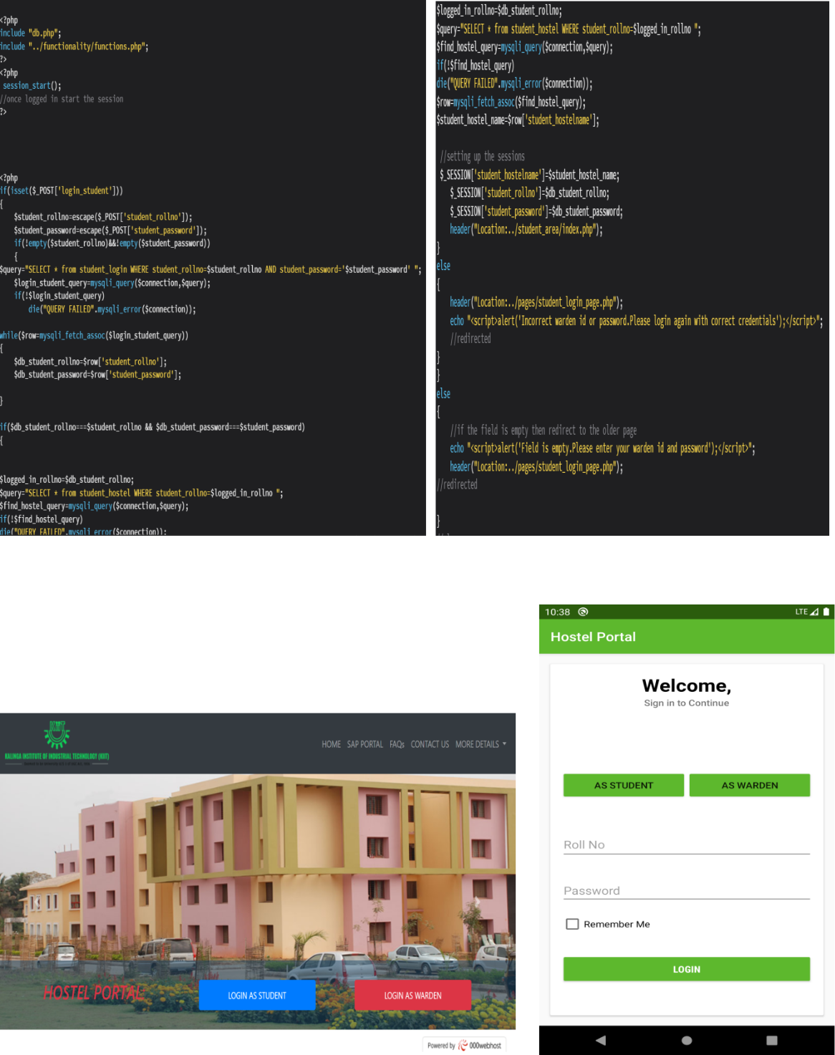

CODE FOR COMPLAINT

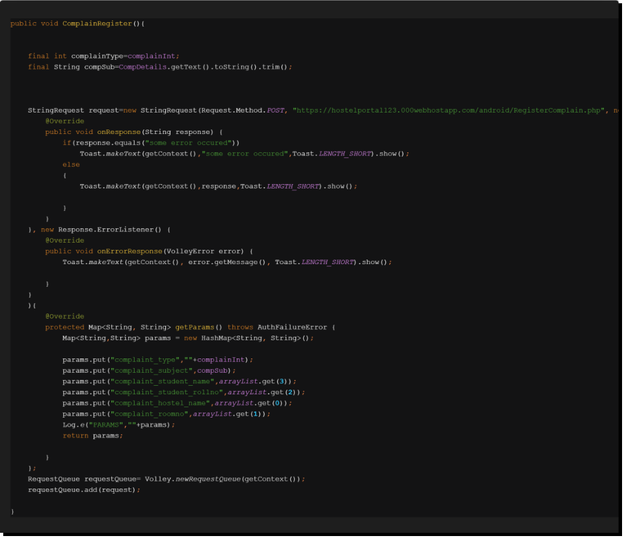

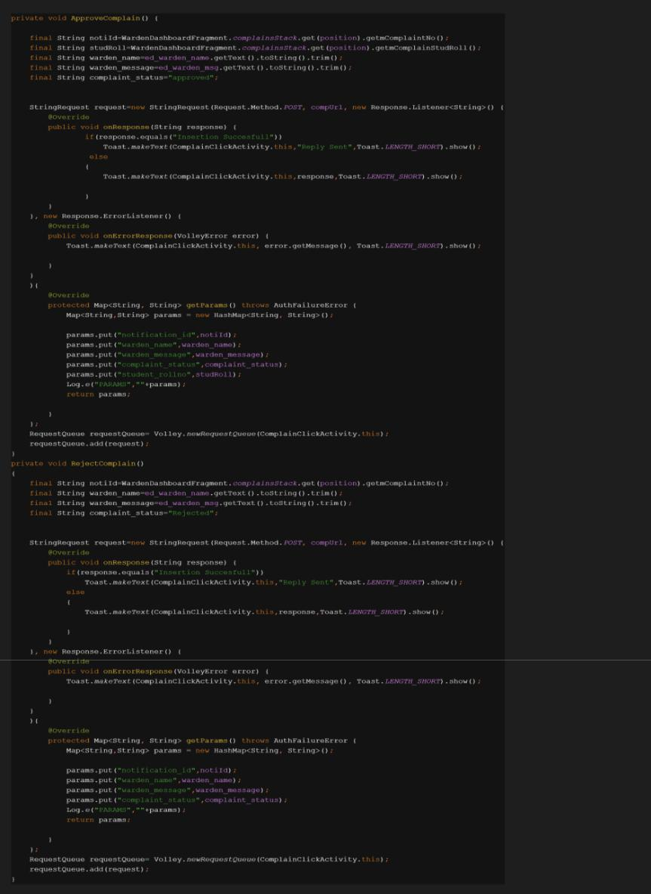CODE FOR APPROVAL AND REJECTION OF COMPLAINTS (BY WARDENS)

CODE FOR CONTACT US

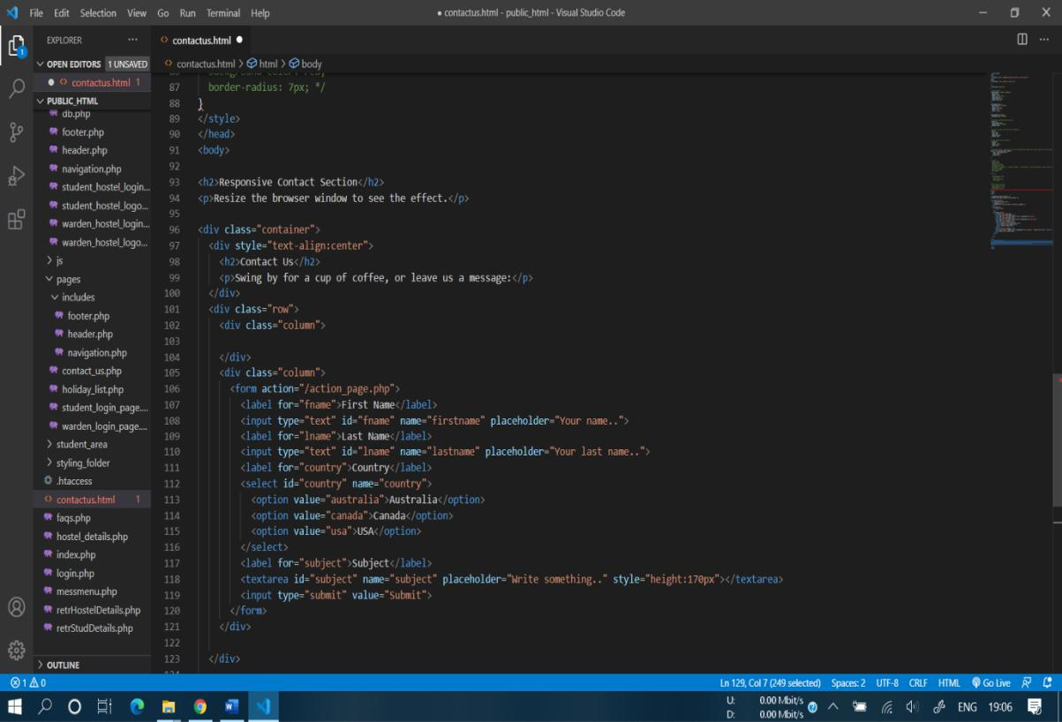

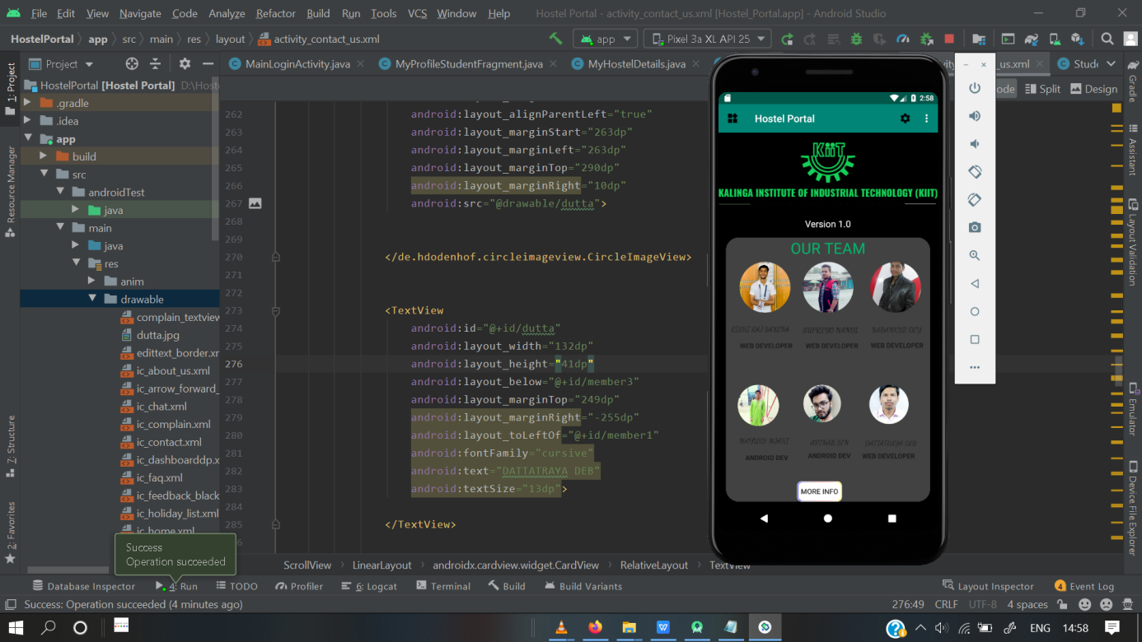CODE FOR DARK MODE

LOGIN SCREEN

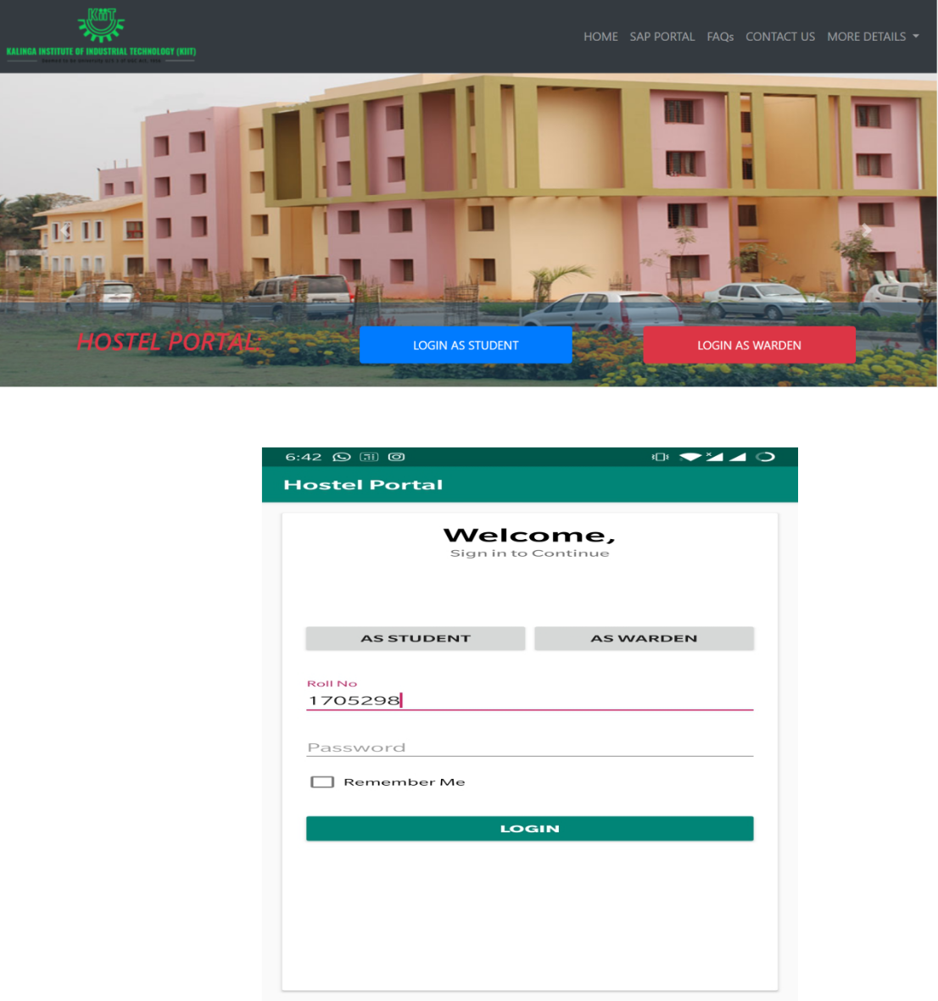

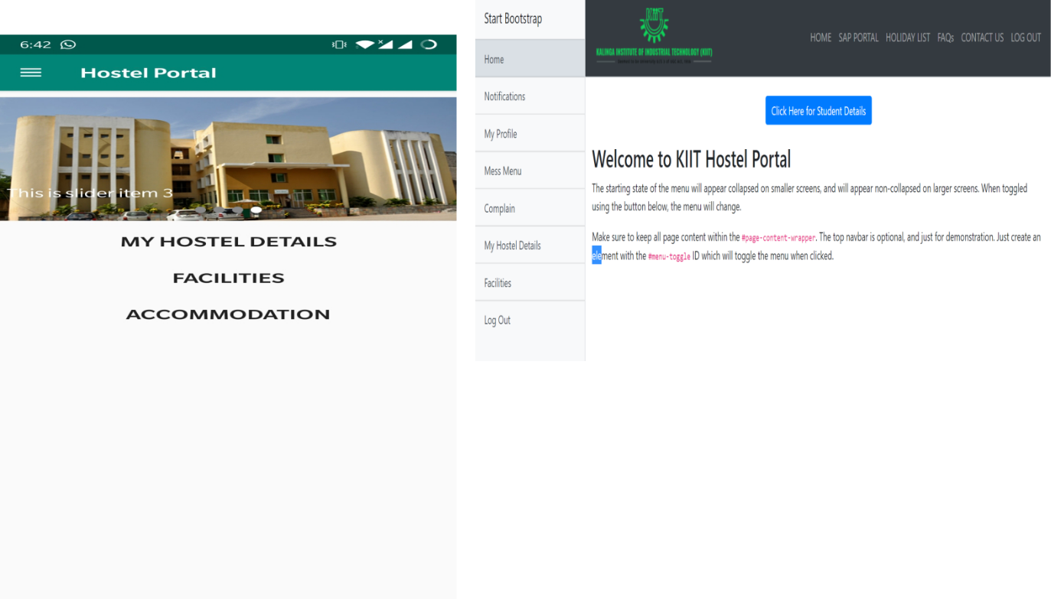HOME PAGE

COMPLAINT BOX

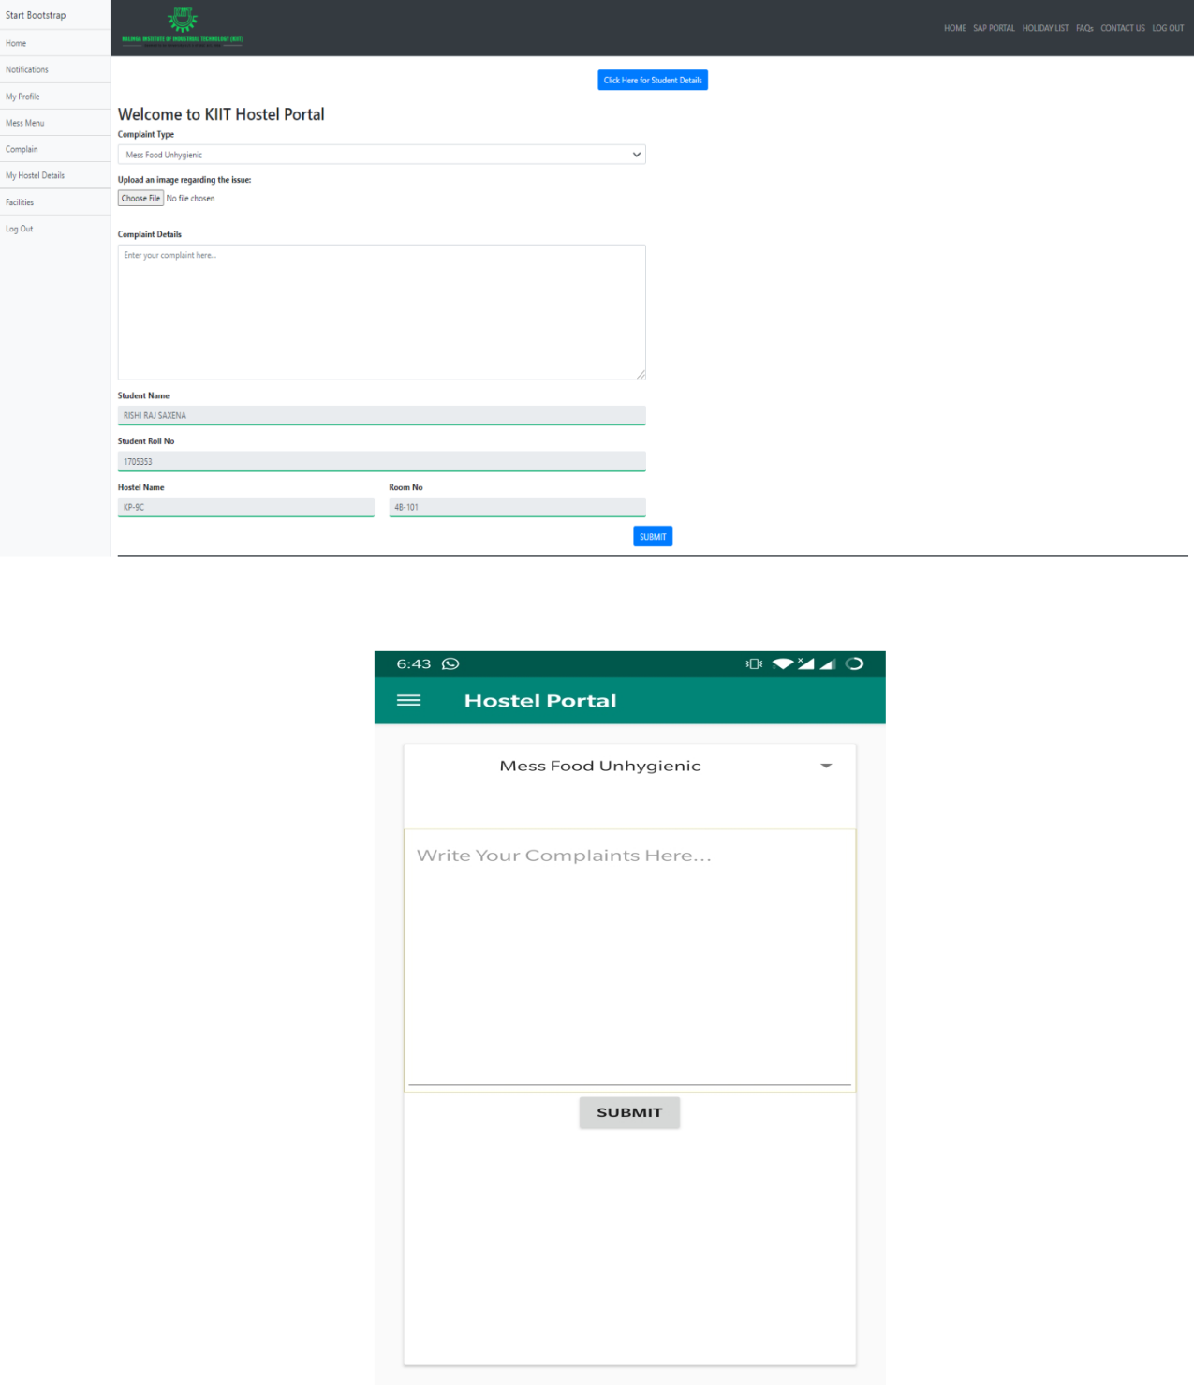

DASHBOARD

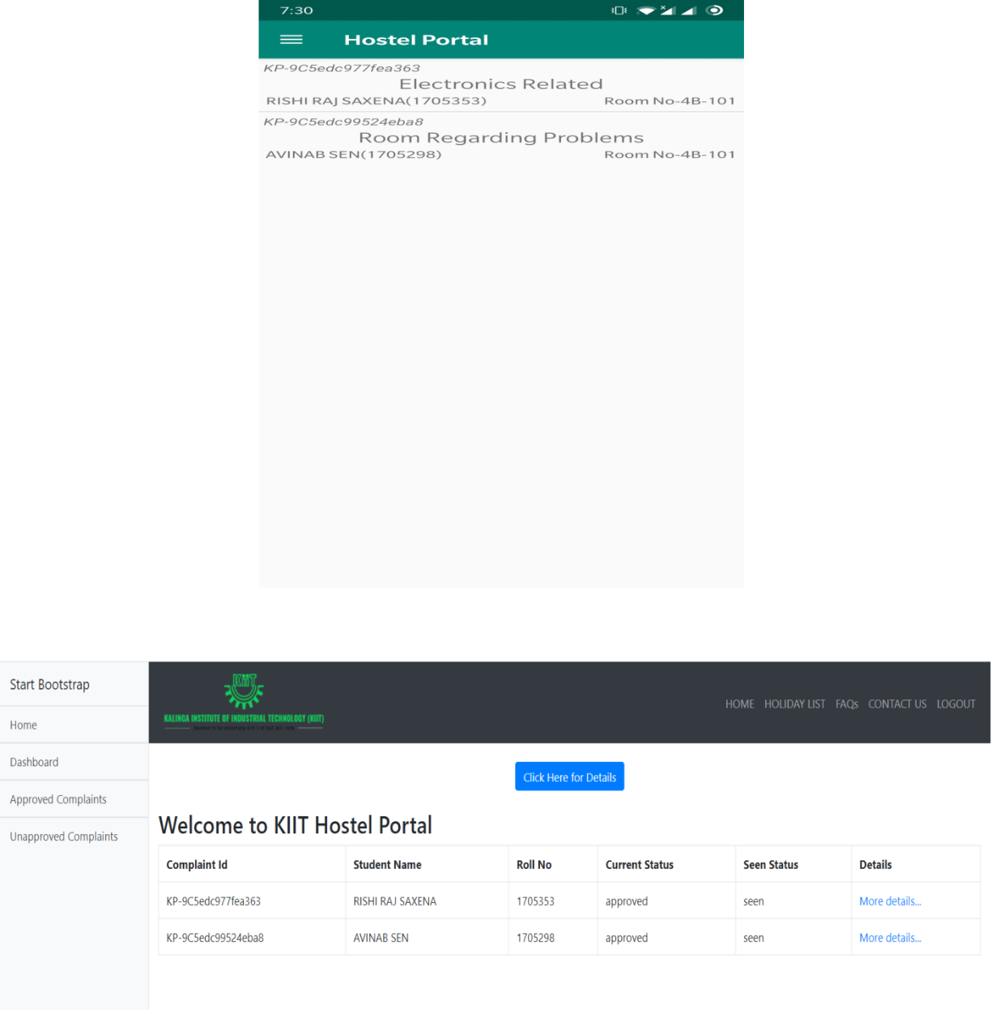

STUDENT PROFILE

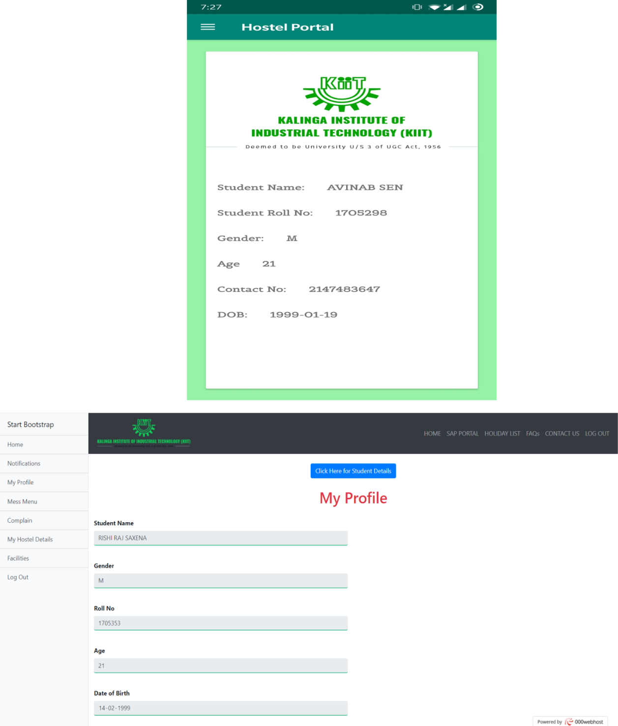

HOSTEL DETAILS

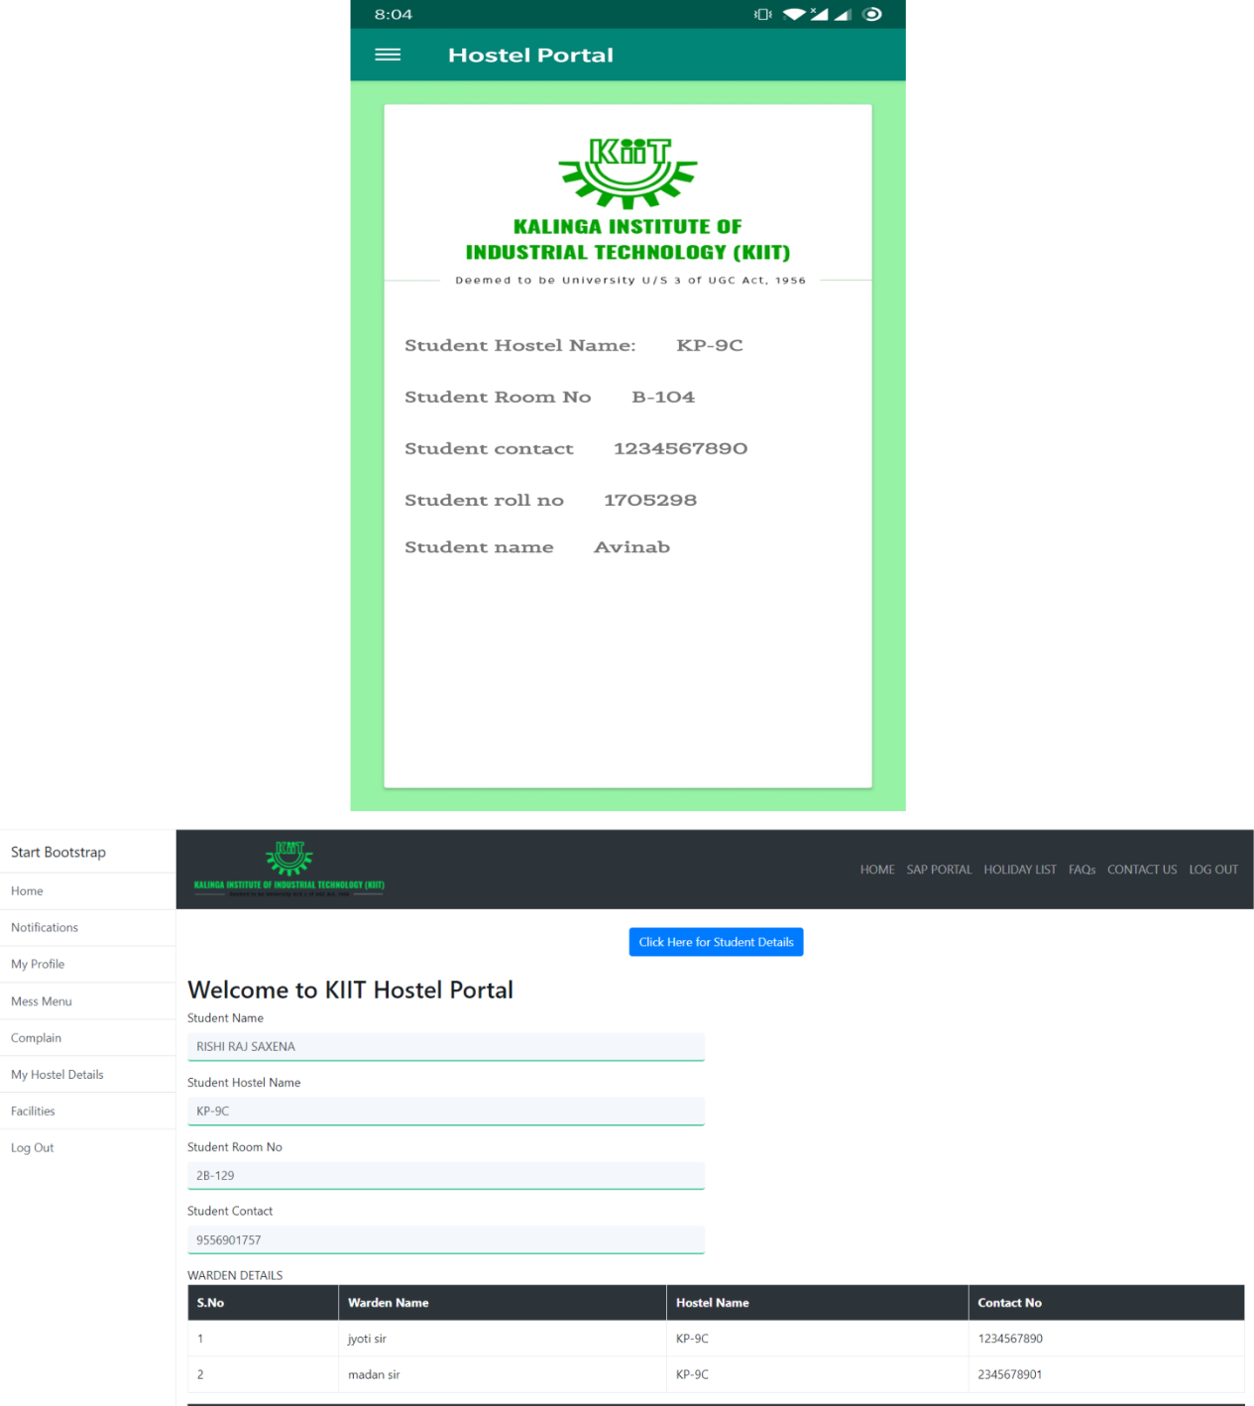

UPCOMING EVENTS

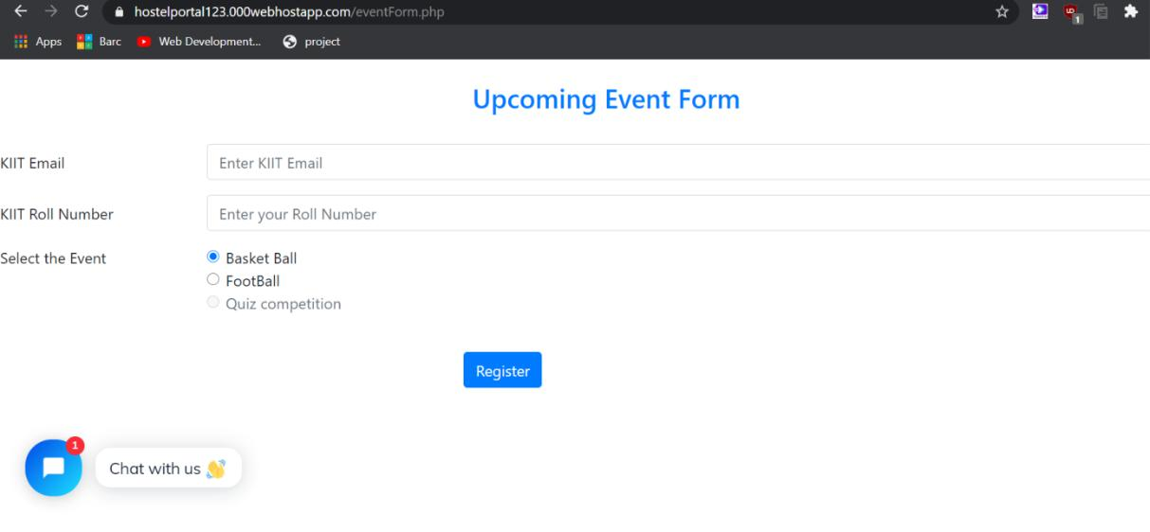

DARK MODE

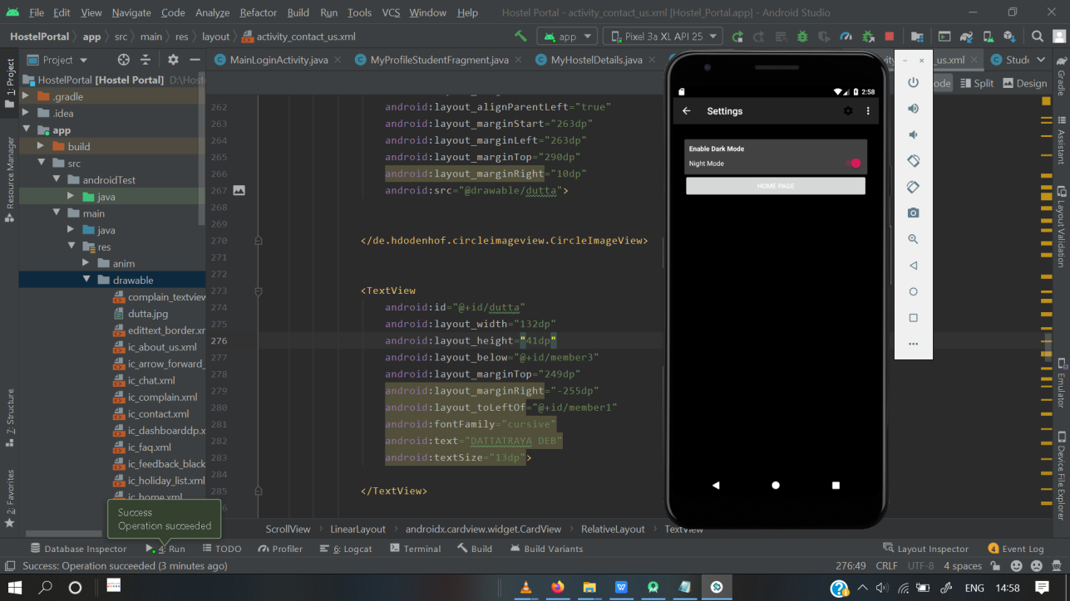

CHAT BOT

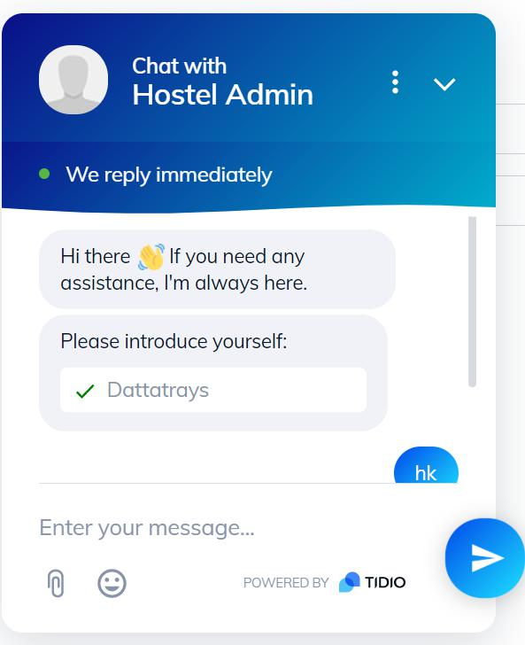

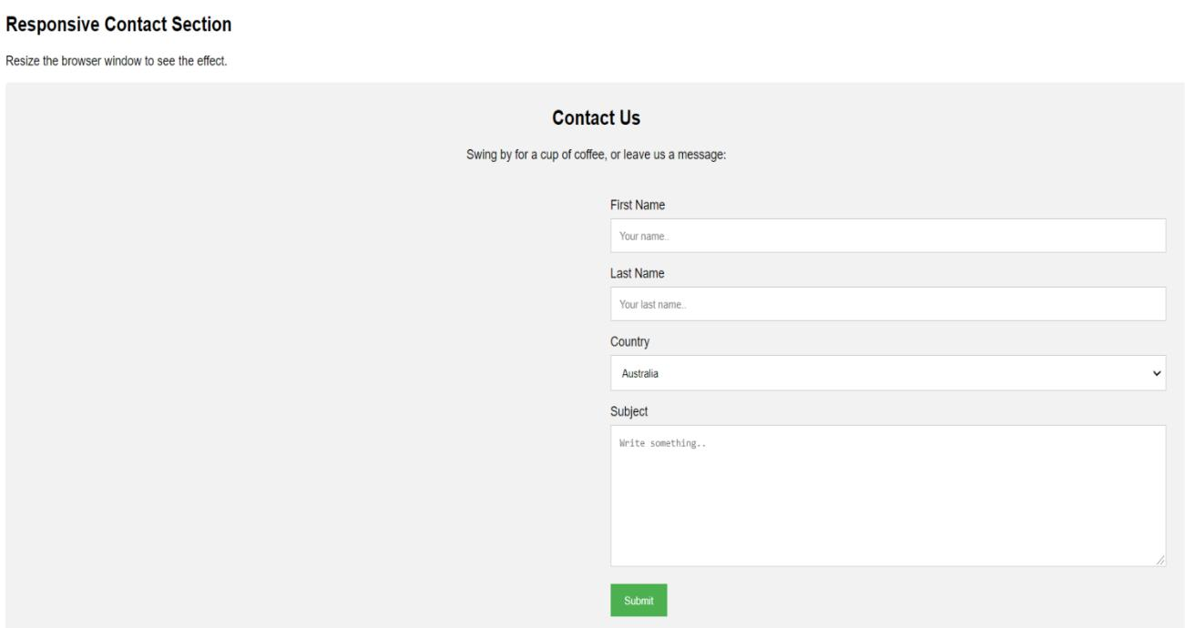CONTACT US

**VI. CONCLUSION**

The project, developed using PHP with SQL Server and various front end tools technologies which is based on the software’s requirement specification of the user and the analysis of the existing system, with flexibility for future enhancement. The online “Hostel Portal” is very helpful for hostel allotment and mess fee calculation and information regarding pupils accessing the premises. This hostel management software is designed for people who want to manage various activities in the hostel perspective. In past few years the number of educational institutions are increasing rapidly which resulted in number of hostels are also increasing for the accommodation of the students studying in a particular institution, hence there is a lot of strain on the person who is running the hostel since software’s or websites are not usually used in this context. This particular project deals with the problems on managing a hostel resulting in eradicating the problems that occur when carried manually. Identification of the drawbacks of the existing system leads to the designing of computerized system that will be compatible to the existing system with the system which is more user friendly and more GUI oriented.

**REFERENCES**

1. Fundamentals of Database Systems, Ramez Elmarsi and Shamkant B.Navathe.
2. <https://www.php.net/manual/en/index.php>
3. <https://www.w3schools.com>
4. <https://www.tutorialspoint.com>
5. Wikipedia
6. https://www.google.com