**ELEC4700: Assignment 4**

**Circuit Modeling**

**Name: David Talson**

**Student no: 101022690**

**Introduction**

In this assignment, an simple electrical circuit was modelled and simulated to study its properties. The circuit is shown below:

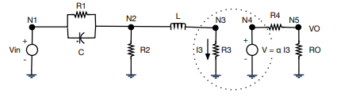

**Figure 1: Circuit diagram**

As can be seen from figure 1 above, the circuit can be modelled and solved using software techniques.

**Part 1 and 2: Voltage Sweep to Determine R3**

Using techniques from assignment 3, a voltage sweep of the device was performed and the current in the x direction was plotted in each case. A linear fit of the current vs Voltage gave a resistance to be used as R3.

A plot of the current in the x direction for an applied voltage of 10 V is shown below:

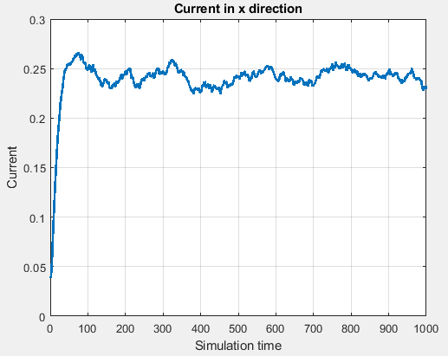

**Figure 2: Current in x direction for 10V applied voltage**

Using this idea a voltage for 0.1 – 10 V was applied and the average current for each case was taken. Plotting these average current values and using a linear fit, gives an equation in the form:

Y = mx + b, where m = resistance

The current and linear fit plot for the voltage sweep is shown below:

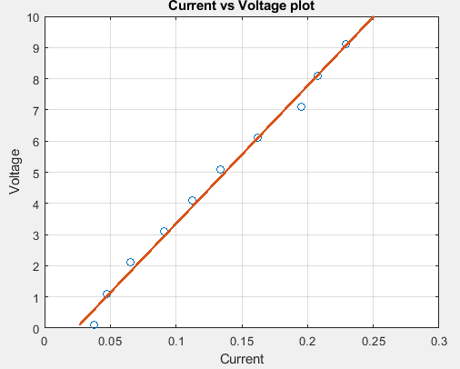

**Figure 3: Current values for voltage sweep**

The slope of this line which was used as resistance for R3 was gotten to be 44.23Ω

Please Note: Most of the code used for this was gotten from assignment 3. As per assignment 3, the current in the x direction was supposed to approach a steady state. As can be seen from figure 2, the current was not very steady. Another option could have been to assume R3 to be 10Ω but 44.3 Ω is not exactly close but it not so huge that it would totally inaccurate results.

**Part 3: Circuit Simulation**

Work done on PA 9: In PA 9, a free source mode solver was used to investigate modes in a ridge waveguide and study the effect of geometry and index changes.

The C matrix for the circuit in figure 1 is shown below:

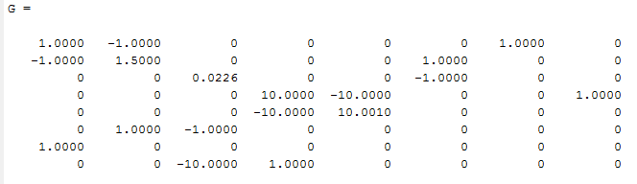

The C matrix is shown below:

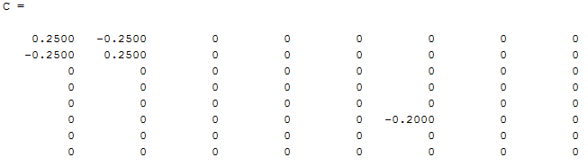

DC Sweep

A DC sweep was performed for the input voltage and the output voltage was solved for each. The plot of the DC sweep is shown below:

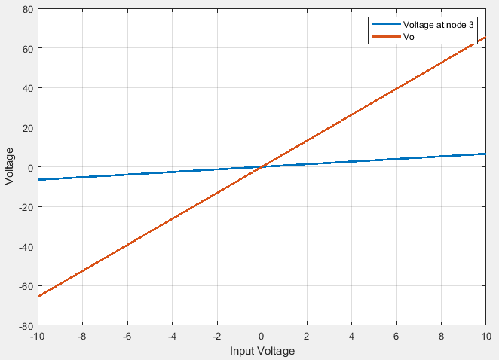

**Figure 4: Input voltage sweep**

As can be seen from figure 4 above the output voltage is more sensitive to a change in the input voltage when compared to the voltage at node 3.

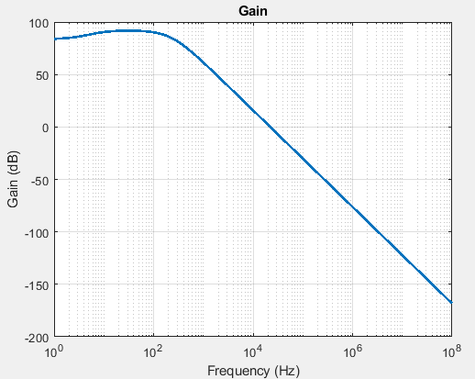**AC Case:**  
The output voltage and gain for the AC case for a 10V input voltage is shown below:

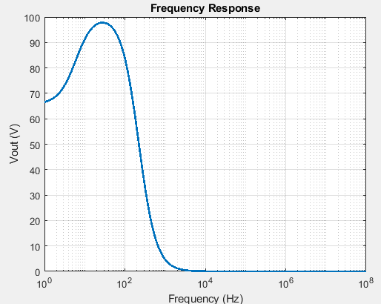 **Figure 5: AC response Figure 6: Gain**

Figures 5 and 6 we can draw more conclusions on the AC behavior of the circuit. From figure 5 we can see the output voltages at various frequencies and from figure 6 we can determine the 3dB point, filter type etc.

**Histogram of Gain with Random Perturbations on C using a Normal Distribution with std = .05 at ω = π:**

A histogram of the gain is shown below:

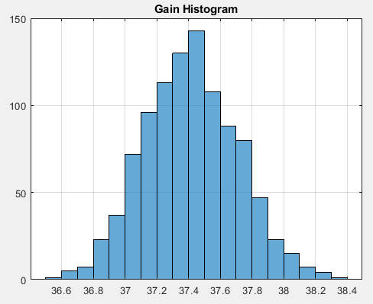

**Figure 7: Histogram of Gain**

From figure 7 above we see that the gain is centered around 37.4 the standard deviation which was added put a distribution on the gain.

**Part 4: Transient Circuit Simulation**

a) By inspection, this circuit is a low pass filter because continual increase in the frequency will get to a point where the inductor starts to inhibit the current and the capacitor on the other hand will create a parallel resistance with the resistor.

b) The expected frequency response is similar to the figure 6 where above a certain frequency (fc) attenuation occurs.

**Output for various signals**

The output for a step function at 0.03s is shown below:

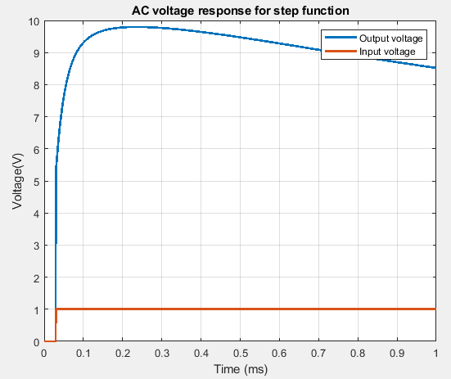

**Figure 8: AC voltage for step function**

As can be seen from figure 8 above, the output is 0 until the step function goes to 1:

**Output for sine signal: sin(2πft)**

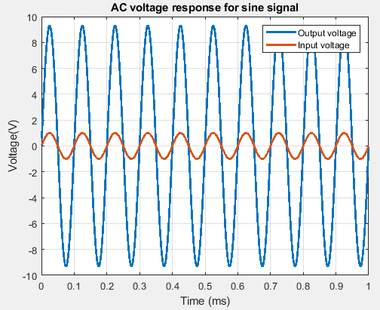

**Figure 9: AC response for sine signal**

As can be seen from figure 9 above, the output voltage is an amplified version of the input.

**Output for Gaussian pulse delayed by 0.06s**