JVector Installation Guide

This document provides help and information on how to install JVector. Please note that all of the following screenshots were taken under Windows XP, and so Installing JVector might appear slightly different for you.

Contents
- System Requirements
- Installing JVector
- Running JVector
- Trouble Shooting

System Requirements
All computers need the Sun Java VM (JRE), Version 1.4.2 or higher to run JVector, and its installation program. For information on how to check if you have Java installed on your computer, or on how to install it, see the trouble shooting located at the end.

Minimum
- 800 x 600 screen resolution.
- 16 Bit screen depth.
- 5MB of hard drive space.
- 128MB of Ram.
- CPU: PC (x86) - Pentium 3 450 MHz or Equivalent.
Mac (PowerPC) – G3

Recommended
- 1024 x 768 screen resolution.
- 32 Bit screen depth.
- 10MB of hard drive space.
- 256MB of Ram.
- CPU: PC (x86) - Pentium 3 800 MHz or Equivalent.
Mac (PowerPC) – G4

Installing JVector
- Firstly, you must get the JVector installation program, called JVector-install.jar. If you already have this, then skip to step 4
Open up your web browser and head to http://sourceforge.net/project/showfiles.php?group_id=106356&package_id=118502.

- Once there, under the top heading (which should be the latest version of JVector), click on the JVector-install.jar link. (The screenshot below shows this, taken when JVector 0.19pre1 was the latest version).

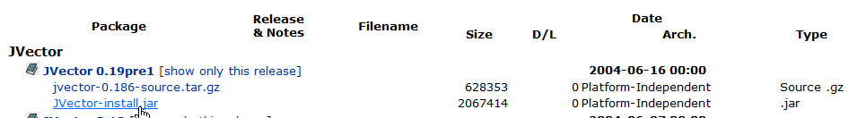

- Wait a few seconds or so for the next page to load, once it has, a download window should pop up asking you where to save JVector-install.jar. Save it anywhere you would like.

- Now locate and double click on JVector-install.jar to begin installing JVector.

- Now the following window should appear;

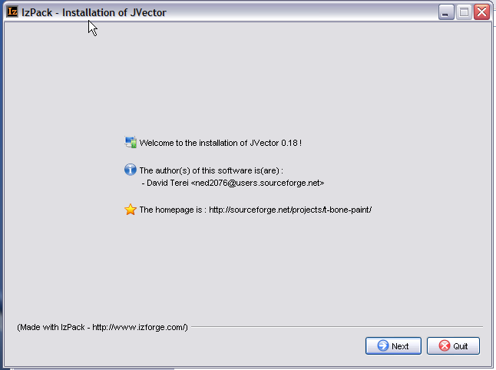

If it does not appear, then please go to trouble shooting, as your system fails the requirements.

- At this window, just press the next button located in the bottom right corner.
(7 Continued Next Page).

- The next window is the information window, that displays some information about JVector, read it for your own interest, but it is not important. Once you have done reading, or decided not to, click the next button in the bottom right corner.

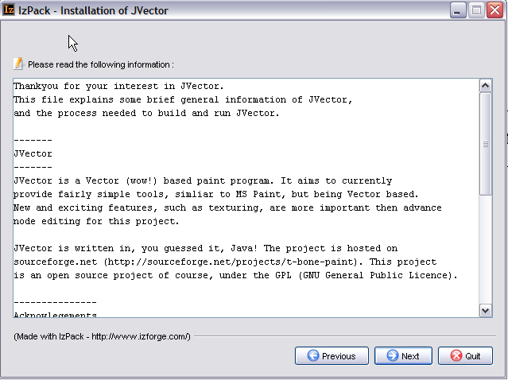

- Next, the license agreement for JVector will appear, please read this carefully. To install JVector you must agree to the terms of the license, if you don’t agree, then you won’t be allowed to install JVector.

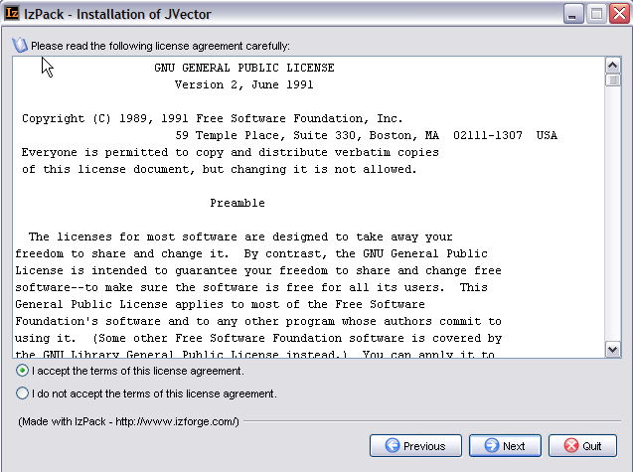

- The next window is very important, and might require your input. Here you decide where you would like to install JVector. If you don’t really know where you should install it, then ether ask someone, like an administrator, who does, or just accept the default installation path. Once you have chosen the path, press next.

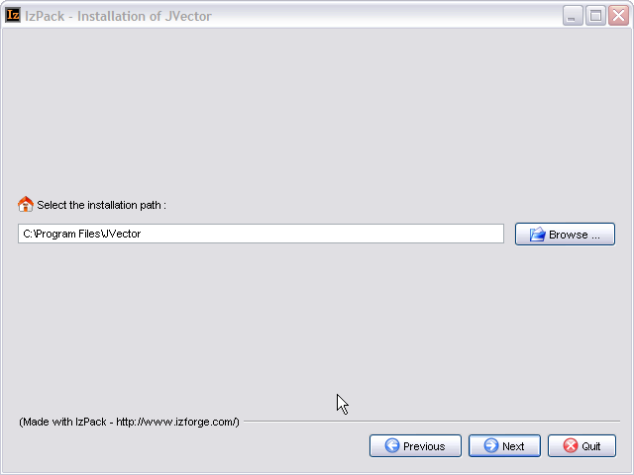

When you press next, the following box will appear, unless you are installing into a pre-existing directory.
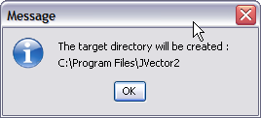
Just click Ok here. If You are installing into a pre-existing directory, a window will come up warning you that this is the case and that the installer will overwrite any files.

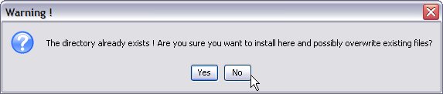

If you understand that the files in the directory you are installing into will be destroyed, then click Yes. Otherwise, install into a new directory by clicking No.

- Now you need to choose which components of JVector you whish to install. Select an item from the list to find out more information on what it does. Components that are needed for JVector to work are greyed out and cannot be deselected

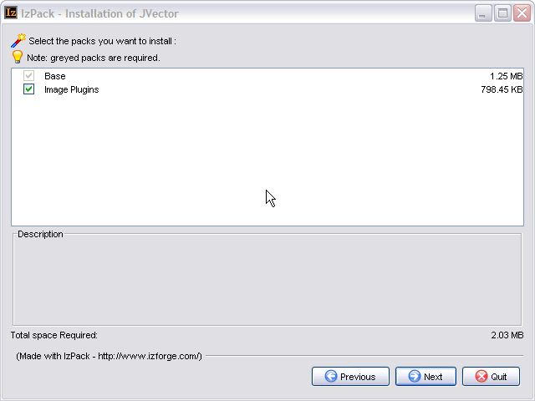

It is recommended tat you select all the components to install. Once you have selected all the components you want installed, click next. (Step 11 continues on the next page).

- Now JVector will be installed, this shouldn’t take more then a minute, and on any modern computer, will only take around 5 seconds. When it is finished installing, as it is below, click next.

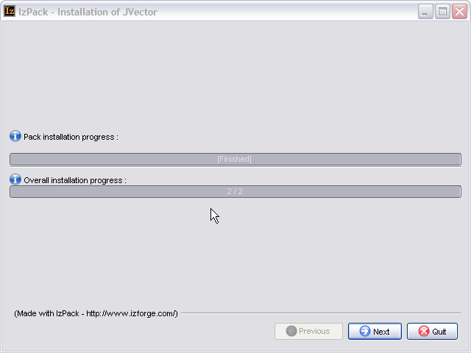
- This Step only occurs if you are on a Windows Operating System. If you are running a Windows Operating System, the following panel will appear, if you are not running a Windows Operating System, skip to step 13.

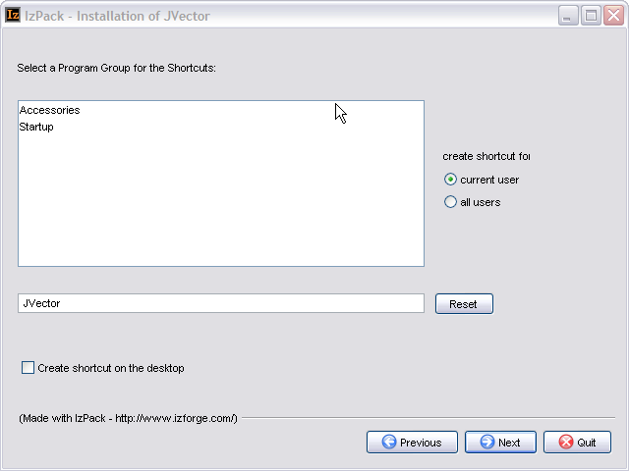

Here you select where you would like to place the shortcuts to launch the program in the start menu, there is also an option to create a shortcut on the desktop. These shortcuts provide quick easy ways to launch JVector. Once you have decided, click next.

(Step 14 Follows on the next Page).

- This is the final screen of the installation program, informing you that JVector installed successfully. It does have one option though, a button that allows you to Generate an Automatic Installation Script. See the Advanced Section at the end of this section, for more details. Press Quit now to finish the installation of JVector.

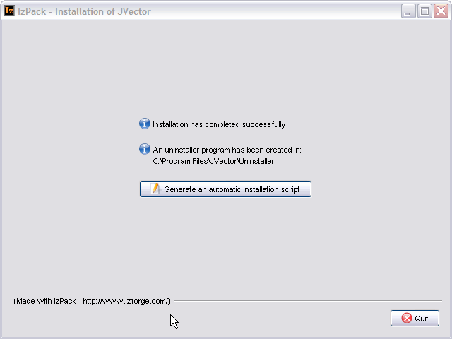

Advanced Installation Help
An Automatic Installation script allows you to install JVector with the installer, using the same settings, as you just used then. This saves a lot of time if you need to install JVector on multiple computers that are similar to each other. See the Advanced Section at the end of this for more information. This feature will probably only be useful to you if you are an administrator.

Running JVector
Windows
To launch JVector under a Windows Operating System, just use the shortcut from the start
menu, called JVector, or use the one on the desktop if you selected the option to create one
there during the installation.

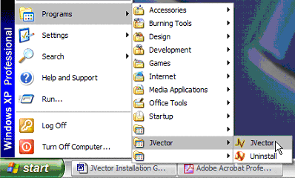
Launching JVector from the start menu under Windows XP

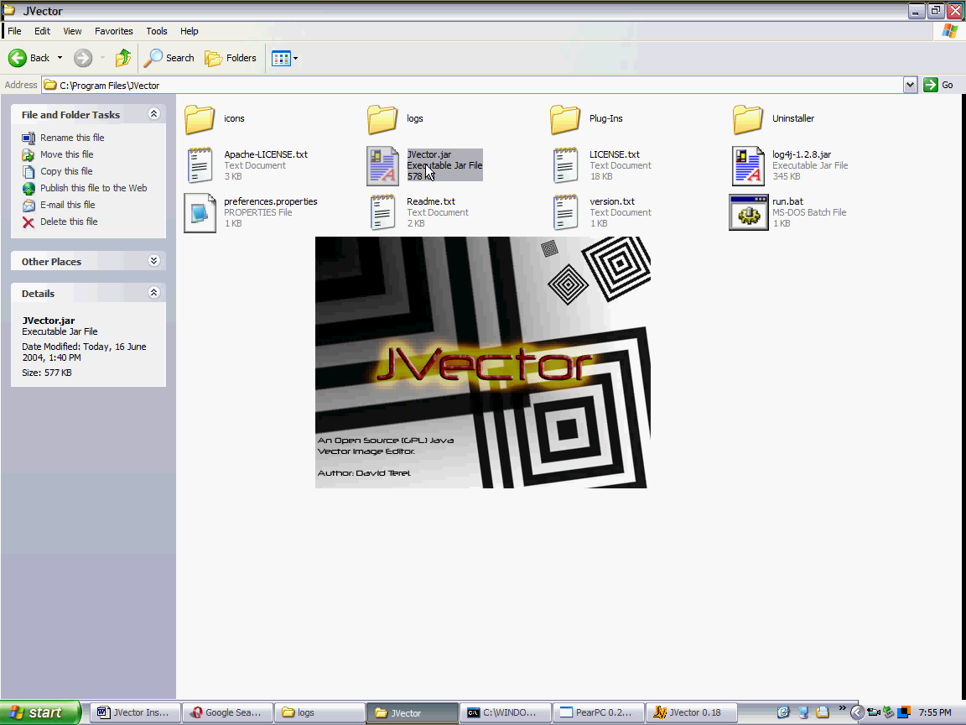
JVector Loading
On Windows XP.

Mac OS X and Linux
To Launch JVector in Mac OS X or Linux, go to the installation Directory of JVector, and
double click on the file JVector.jar. If JVector fails to launch, see the trouble shooting.

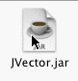

Troubleshooting

System Requirements

Do I have a Java VM?
To check if you have a Java VM, open up your web browser, and head to this page, http://java.com/en/download/help/testvm.jsp, if under the heading Test your JVM™ you can see a box that displays some information in it and has a dancing triangle man with a red nose, then Java is installed on your computer.

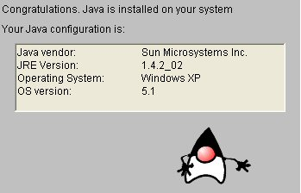

What Version of Java do I have installed? Is this Good enough?
To check this, go to the same site as in 1, and see what JRE Version it says you have. (circled in red above). If it is above 1.4.2 or equal, then your computer should be ready to run JVector, as long as it meets the other requirements.

How do I install Java?
Open up your web browser and head to http://www.java.com:80/en/download/manual.jsp. From there download the correct version of Java that is for your Operating System.

Installation

The Installation Program Will Not Launch
If this occurs, the first, follow the steps above in the System Requirements trouble shooting section to make sure you have Java and a recent enough version of it installed. If you fail this, then follow the steps in the same section to install one.

If you do have a Java VM of version higher or equal to 1.4.2, and you are running on Windows, or Mac OS X, then you should update it to the latest version, and if you already have the latest version, then you should reinstall it. If this fails, then you can follow the steps below that are for Linux (this requires some technical knowledge), or contact us for support through our web site. (http://t-bone-paint.sourceforge.net/).

If you are running Linux, or the above steps for Windows and Mac OS X fail, then try to install JVector through the console as follows;

- Open up the console.
- Change the current directory to where the JVector-install.jar is located.
- Now type the following command;
$ java –jar JVector-install.jar

Hopefully, this should launch the JVector installer program. If it doesn’t, then please contact us for support through our web site. (http://t-bone-paint.sourceforge.net/). Please note that if this does work, then you will need to also launch JVector itself in the following manner, although it would be best to write a simple command script to do this. See the Running JVector trouble shooting section for more information.

Running JVector

Nothing Happens When the JVector.jar File is Double Clicked
If you managed to run the JVector installer by just double clicking JVector-installer.jar, but double click JVector.jar fails to launch the program then most likely you have a Program error. Firstly, reinstall your Java VM. If this fails, then please contact us for support through our web site. (http://t-bone-paint.sourceforge.net/). When asking for help, please send us the log file for JVector located in the JVector installation directory, logs/logfile.log.

If you had to launch the JVector Installer through the consol, then you can use the same method here. Open up the consol to the JVector installation directory, and run the following command;

$ java –jar JVector.jar

If this works, then please contact us for further support, or just use the above method each time.

