JVector User Manual

Introduction
JVector is a vector Image editing program, distributed for free. It runs on numerous platforms, with the officially supported ones being Windows 2000 & XP, Linux (Kernel 2.4 and higher), and Mac OS X.

The official website of JVector is located at, http://t-bone-paint.sourceforge.net/, here you can download the most recent versions of JVector, any new plug-in's, and acquire technical support.

Technical Information
JVector is written in the Java Programming Language. It is an open source project, hosted on http://sourceforge.net, and distributed under a GNU General Public Licence (GPL). It has been in development for only a short while, 2 months. It is written by David Terei.

Contents
- System Requirements
- Installing JVector
- Running JVector
- Using JVector
- Trouble Shooting

System Requirements

All computers need the Sun Java VM (JRE), Version 1.4.2 or higher to run JVector, and its installation program. For information on how to check if you have Java installed on your computer, or on how to install it, see the trouble shooting located at the end.

Minimum
- 800 x 600 screen resolution.
- 16 Bit screen depth.
- 5MB of hard drive space.
- 128MB of Ram.
- CPU: PC (x86) - Pentium 3 450 MHz or Equivalent.
Mac (PowerPC) – G3

Recommended
- 1024 x 768 screen resolution.
- 32 Bit screen depth.
- 10MB of hard drive space.
- 256MB of Ram.
- CPU: PC (x86) - Pentium 3 800 MHz or Equivalent.
Mac (PowerPC) – G4

Installing JVector

- Firstly, you must get the JVector installation program, called JVector-install.jar. If you already have this, then skip to step 4
Open up your web browser and head to http://sourceforge.net/project/showfiles.php?group_id=106356&package_id=118502.

- Once there, under the top heading (which should be the latest version of JVector), click on the JVector-install.jar link. (The screenshot below shows this, taken when JVector 0.19pre1 was the latest version).

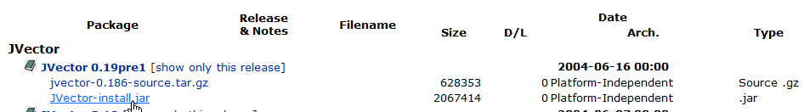

- Wait a few seconds or so for the next page to load, once it has, a download window should pop up asking you where to save JVector-install.jar. Save it anywhere you would like.

- Now locate and double click on JVector-install.jar to begin installing JVector.

- Now the following window should appear;

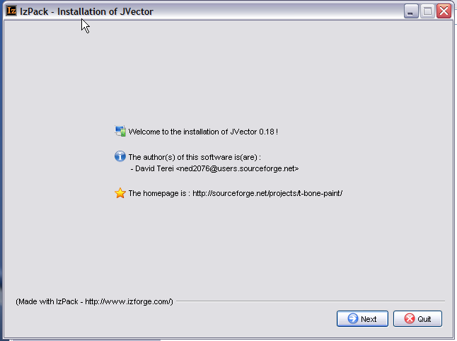

If it does not appear, then please go to trouble shooting, as your system fails the requirements.

- At this window, just press the next button located in the bottom right corner.

- The next window is the information window, that displays some information about JVector, read it for your own interest, but it is not important. Once you have done reading, or decided not to, click the next button in the bottom right corner.

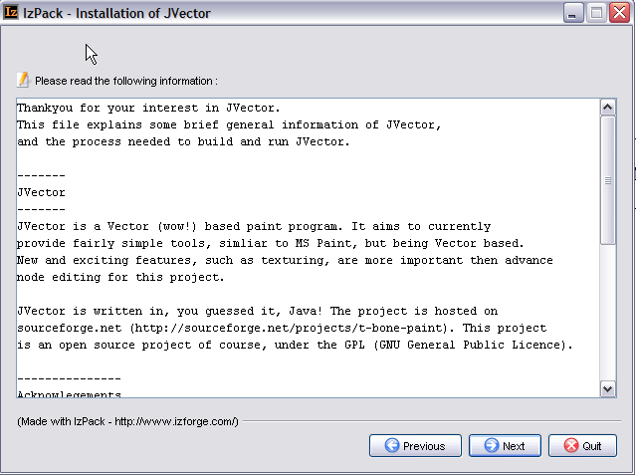

- Next, the license agreement for JVector will appear, please read this carefully. To install JVector you must agree to the terms of the license, if you don’t agree, then you won’t be allowed to install JVector.

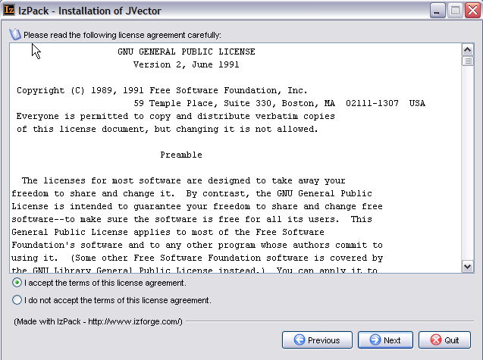

- The next window is very important, and might require your input. Here you decide where you would like to install JVector. If you don’t really know where you should install it, then ether ask someone, like an administrator, who does, or just accept the default installation path. Once you have chosen the path, press next.

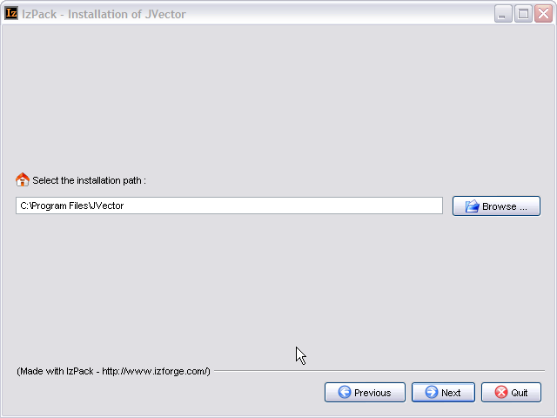

When you press next, the following box will appear, unless you are installing into a pre-existing directory.
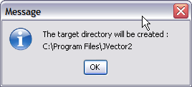
Just click Ok here. If You are installing into a pre-existing directory, a window will come up warning you that this is the case and that the installer will overwrite any files.

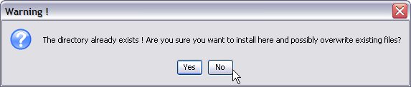

If you understand that the files in the directory you are installing into will be destroyed, then click Yes. Otherwise, install into a new directory by clicking No.

- Now you need to choose which components of JVector you whish to install. Select an item from the list to find out more information on what it does. Components that are needed for JVector to work are greyed out and cannot be deselected

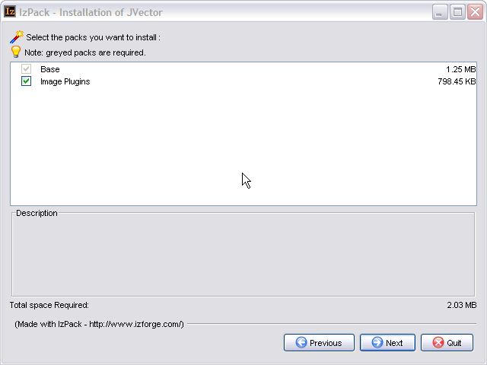

It is recommended tat you select all the components to install. Once you have selected all the components you want installed, click next. (Step 11 continues on the next page).

- Now JVector will be installed, this shouldn’t take more then a minute, and on any modern computer, will only take around 5 seconds. When it is finished installing, as it is below, click next.

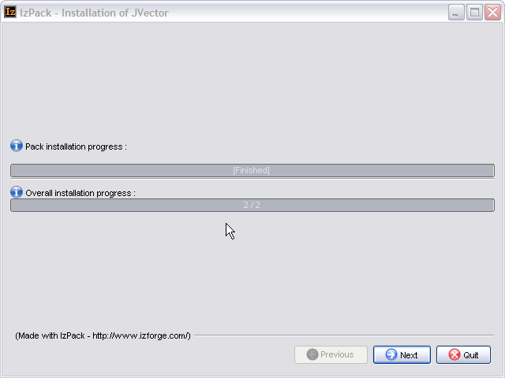
- This Step only occurs if you are on a Windows Operating System. If you are running a Windows Operating System, the following panel will appear, if you are not running a Windows Operating System, skip to step 13.

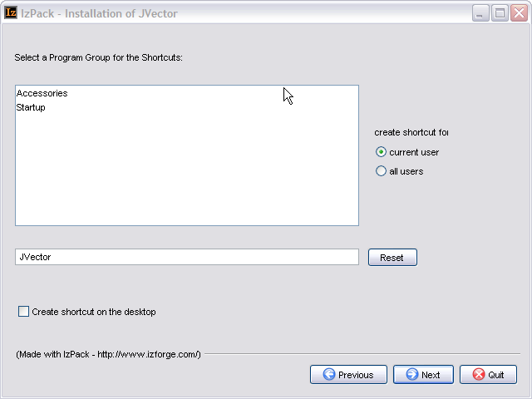

Here you select where you would like to place the shortcuts to launch the program in the start menu, there is also an option to create a shortcut on the desktop. These shortcuts provide quick easy ways to launch JVector. Once you have decided, click next.

(Step 14 Follows on the next Page).

- This is the final screen of the installation program, informing you that JVector installed successfully. It does have one option though, a button that allows you to Generate an Automatic Installation Script. See the Advanced Section at the end of this section, for more details. Press Quit now to finish the installation of JVector.

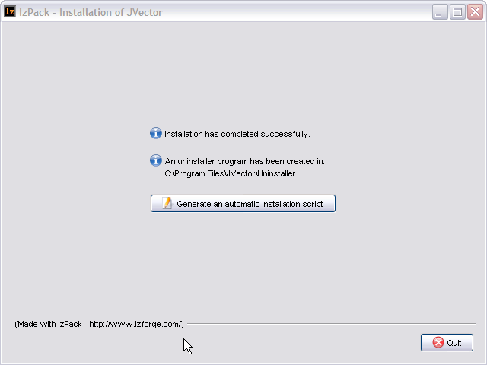

Advanced Installation Help
An Automatic Installation script allows you to install JVector with the installer, using the same settings, as you just used then. This saves a lot of time if you need to install JVector on multiple computers that are similar to each other. See the Advanced Section at the end of this for more information. This feature will probably only be useful to you if you are an administrator.

Running JVector
Windows
To launch JVector under a Windows Operating System, just use the shortcut from the start
menu, called JVector, or use the one on the desktop if you selected the option to create one
there during the installation.

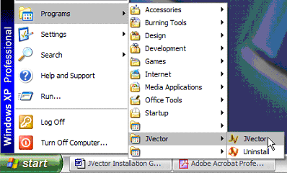
Launching JVector from the start menu under Windows XP

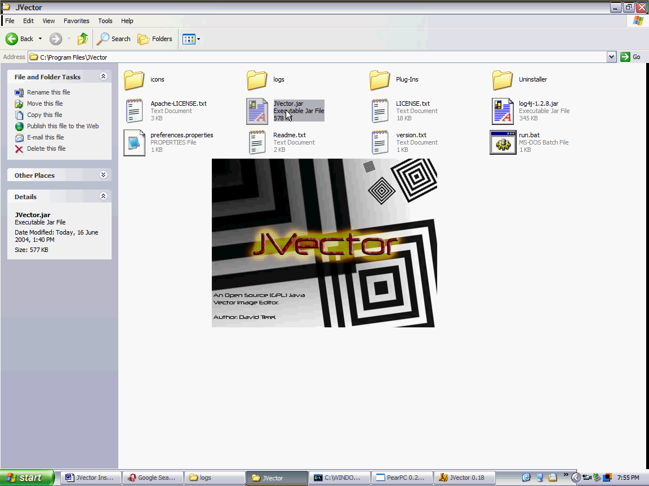
JVector Loading
On Windows XP.

Mac OS X and Linux
To Launch JVector in Mac OS X or Linux, go to the installation Directory of JVector, and
double click on the file JVector.jar. If JVector fails to launch, see the trouble shooting.

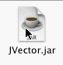

Using JVector

Understanding The Interface
1
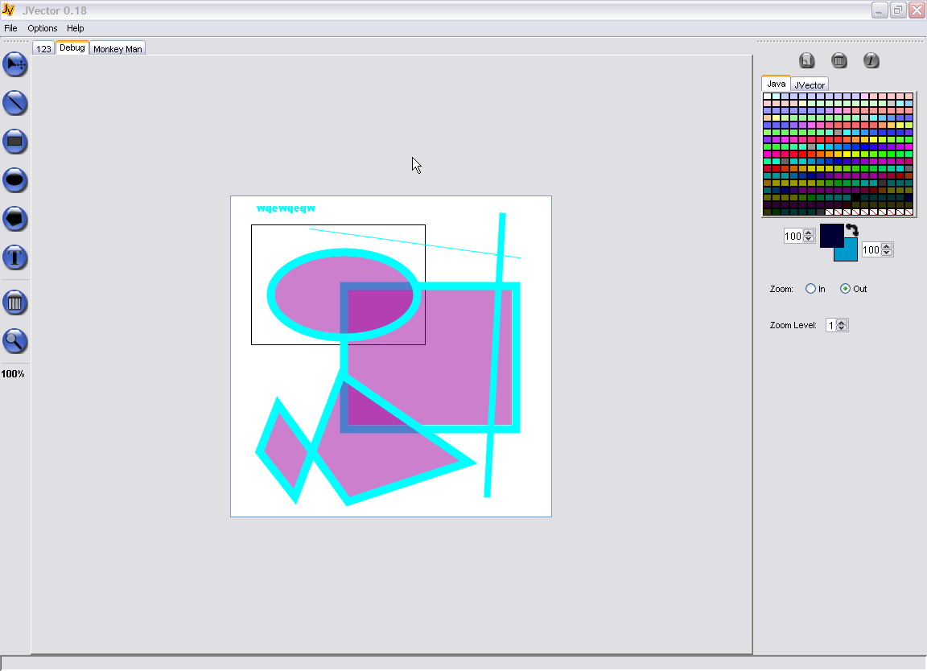
2
3
4
5
6
7
8
9
10

- Menu Bar – The menu bar stores the various commands for operating the program.
(See the reference manual for a detailed explanation of each command).
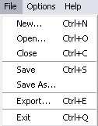
File – Stores the commands to do with the image File’s. Opening them, closing them…ect

Options – Stores the commands to do with JVector program options. So far only contains one item, Preferences.

Help – Stores commands to do with Helping you.

- Image Tabs – This strip of Tabs provides access to all the open images. Each open image has a tab on the strip, with there name on it, and clicking on a tab, changes to that image.

- Drawing Tool Bar – Provides access to all the various drawing tools, used to actually draw and manipulate images.

The tools are in order from left to right; Select Tool, Line Tool, Rectangle Tool, Oval Tool, Polygon Tool, Text Tool, Delete Tool, Zoom Tool, Zoom Display.

See there individual description below for further details on them.

- Image Editing Area – This is the area in which the actual image drawing and editing is done. It is done through the tools and the mouse.

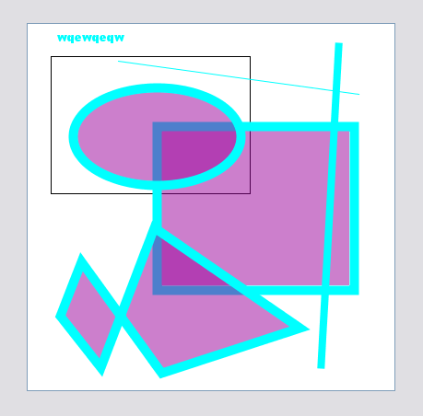

- Status Bar – This Bar down the bottom displays helpful information about features of JVector when you place your mouse over them.

- Colour Swatch - Colour Swatches provide a grid of colours to choose from for your convenience. If the colour you desire is not there, then clicking on the foreground or background colour displays, will allow you to create your own colour. Clicking on a colour in a swatch, sets the foreground colour to the colour clicked. See Colour Displayers for information on how to set the background Colour.

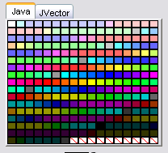

- Colour Swatch Selector – This is similar to the Image Tabs, but for Colour Swatches. It allows you to change between multiple Colour Swatches with ease by clicking on there tab.

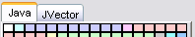

- Colour Displayers – This Displays the currently selected background and foreground colours, which are used when drawing. It also displays next to each colour, the current opacity of that colour, which can be changed by you. The black bent double arrow allows you to swap the foreground and background colour, so that you can set both using the colour swatches, by flipping them.
Colour Swapper

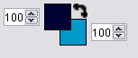
Foreground Colour

Foreground Opacity
Background Colour

Background Opacity

Clicking on either the background or foreground colour will bring up a colour selector so that you can choose any colour you need, and are not limited to the swatches.

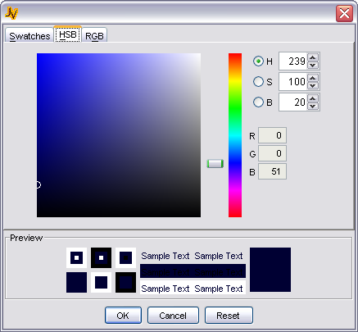
Custom Colour Chooser

- Current Tool Options – This area displays the options for the currently selected tool. See each tools Option section below for more details.

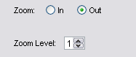
Screenshot of the Zoom Tool Options

- Tool Bar Handle – Both Tool bars, the drawing and the one that contains the colour selection tools and tool options, have Handles. These Handles allow the Tool Bars to be moved to any side of the screen, or even floated. To Do this, click and drag the handle to the destination desired.
Tool Bar Handle

Draw Tool bar in Floating Mode

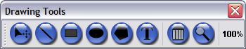

Image File Operations

Creating a New Image
To create a New Image in JVector, go to the File menu, and then click on the New… menu item. Alternatively you can use the shortcut, Ctrl + N.

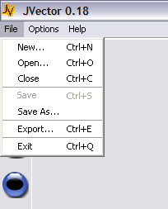

A dialog Box will then appear which requires that you set some of the image properties first.

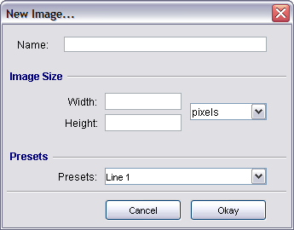

- Name – This is what you would like to call your image. You can use any letters you would like here.
- Width – This is the Width/length that you would like the image to be. You can only enter numbers here, and it must be between 0 - 5000
- Height – This is the Height that you would like the image to be. You can only enter numbers here, and it must be between 0 - 5000
- Pixels – This is the units of length that you are specifying the image size in. Other units include cm (metric) and inches (imperial).
- Presets – (At the moment this box does nothing, future development planned for it) This box provides a list of typical image sizes, so that you don’t have to enter the most common ones manually.
Opening an Image
To Open an image in JVector, go to the File menu, and then click on the Open… menu item. Alternatively you can use the shortcut, Ctrl + O. A dialog box then opens that allows you to choose an image to open. JVector images have the extension .jvi.

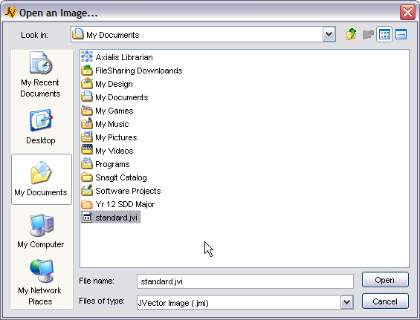

Saving an Image
When you have done creating your beautiful image in ease, you will want to save it. JVector allows you to save it to its own native Vector format, preserving all the information so you can come back and improve it another day. There are two different ways to save an Image, through the Save (Ctrl + S) option, or the Save As… option. The difference is this;

Save - saves the image to its previous location, that is, if you have already saved the image, it saves it back to that image. This option is unavailable to images that are new and haven’t been saved, as no file already exist to save to.

Save As… - Saves the image to a new file and location of your choice.

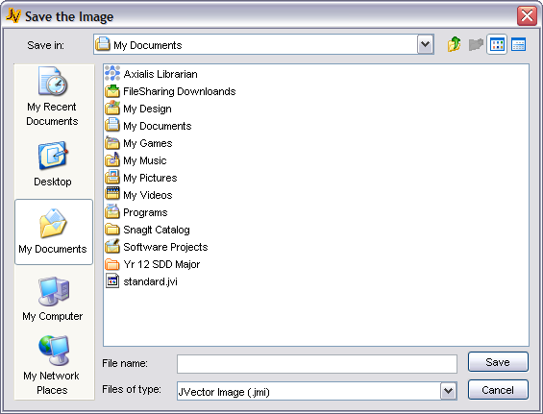

Exporting an Image
Exporting an image, allows you to save an image to different image formats, such as PNG, JPG…
This allows you to share them with other people easier, and use them on the web and with other programs. The supported file formats you can export to are done through plugins. See the section on Image Output Plug-ins for more detail. To export an image;

- Go to File > Export or Ctrl + E.
- When the dialog comes up, select where you would like to export the image to.
- Then select the output format you want from the list at the bottom of the dialog.
- Press Save.

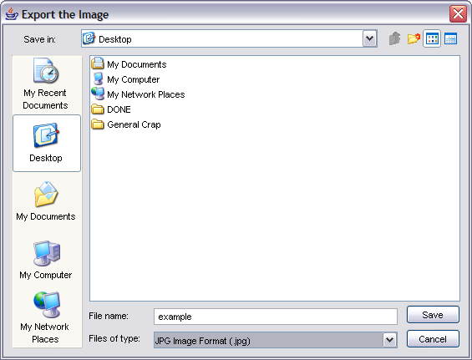
2
3
2
4
JVector Commands

Menu Commands
Command | Short-Cut | Description
About JVector |  | Displays information about JVector in a dialog. (eg Version).
Close | Ctrl + C | Closes the current image.
Exit | Ctrl + Q | Quits JVector.
Export… | Ctrl + E | Export The current image to an external image format.
JVector Homepage |  | Launches your default web browser and takes you to the JVector homepage
New… | Ctrl + N | Launches the dialog to create a new JVector image.
Open… | Ctrl + O | Launches the dialog to open a JVector image.
Preferences… | Ctrl + P | Opens up the preferences dialog.
Save | Ctrl + S | Saves the current image to its last saved location, or the location it was opened from.
Save As… |  | Launches the dialog to save the current image to a new location.

Button Commands
The following description of the buttons in JVector apply for all the buttons in JVector, so buttons that have the same name, but are used in different places, still perform the same task (in essence).
Button | Short-Cut | References | Description
 | Escape | Export Image Dialog | Cancel the exporting of the current image.
 | Escape | New Image Dialog | Cancel the creation of a new image.
 | Escape | Open Image Dialog | Cancel the opening of an image.
 |  | Preferences Dialog | Close the preferences dialog box, without saving the changes you made.
 | Escape | Save Image As Dialog | Cancel the saving of the current image.
 | Enter | New Image Dialog | Confirm the settings and Create the image with them.
 |  | Preferences Dialog | Save the changes you just made to the preferences, and close the dialog.
 | Enter | Open Image Dialog | Try to open the currently selected file as an image.
 | Enter | Export Image Dialog | Export the current image to the file specified in the dialog.
 | Enter | Save Image As Dialog | Save the current image to the file specified in the dialog.

Tool Commands (Mouse)
These are the commands to change to the different tools, done by clicking on there button found in the draw tool bar, with the mouse.
Button | Tool | Description
 | Select | Change the current tool to the select tool.
 | Line | Change the current tool to the line tool.
 | Rectangle | Change the current tool to the rectangle tool.
 | Oval | Change the current tool to the oval tool.
 | Polygon | Change the current tool to the polygon tool.
 | Text | Change the current tool to the text tool.
 | Delete | Change the current tool to the delete tool.
 | Zoom | Change the current tool to the zoom tool.

Colour Commands (Mouse)
These are commands to do with the colour tools, accessed through the mouse.
Button | Tool | Description
 | Colour Swatches | Click on a colour swatch to change the foreground colour to the colour clicked on.
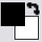 | Foreground Colour | Clicking on the foreground colour launches a dialog to choose a new foreground colour.
 | Background Colour | Clicking on the background colour launches a dialog to choose a new background colour.
 | Colour Swapper | Click on the colour Swapper to swap the foreground and background colours.
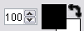 | Foreground Opacity | Uses this spinner to change the opacity of the foreground colour.
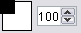 | Background Opacity | Uses this spinner to change the opacity of the background colour.
 | Add Swatch | Add a new Swatch to the swatch panel. (Not Functional at moment).
 | Remove Swatch | Remove the current swatch from the swatch panel. (Not Functional at moment).
 | Swatch Info | Display some information about the current swatch.

Using The Tools

 Using the Line Tool
The Line tool is used to draw lines. To use the line tool, select it, and then follow these steps;

- Click and hold down the primary mouse button at the point you wish to start the line.
- Keep holding and drag the mouse to the point where you wish the line to end.
- Release at that Point.


Line Tool Options/Properties
The colour of lines is dependent on the currently set foreground colour, as is the line opacity. See Setting Shape’s Colour’s for more details.

- Weight – The Weight is the thickness of the line. So increasing the weight will result in a thicker line been drawn.

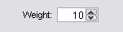
 Using the Rectangle Tool
The Rectangle tool is used to draw rectangles. To use the rectangle tool, select it, and then follow these steps;

- Click and hold down the primary mouse button at the point you wish to start the Rectangle.
- Keep holding and drag the mouse to the point where you wish the Rectangle to end.
- Release at that Point.
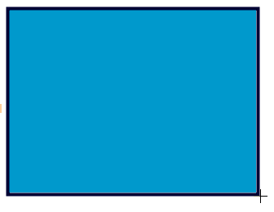
Line Tool Options/Properties
The outline colour of rectangle is dependent on the foreground colour, while the fill is dependent on the background colour.

- Outline Weight – The Weight/Thickness of the outline of the rectangle. Increasing this value increase the thickness of the outline of the rectangle.

 Using the Oval Tool
The Oval tool is used to draw ovals. To use the oval tool, select it, and then follow these steps;

- Click and hold down the primary mouse button at the point you wish to start the Oval.
- Keep holding and drag the mouse to the point where you wish the Oval to end.
- Release at that Point.

Oval Tool Options/Properties
The outline colour of oval is dependent on the foreground colour, while the fill is dependent on the background colour.

- Outline Weight – The Weight/Thickness of the outline of the oval. Increasing this value increase the thickness of the outline of the oval.

Using the Polygon Tool
The Polygon tool is used to draw polygons. A polygon is any shape with straight edges. To use the polygon tool, select it, and then follow these steps;

- Click, but don’t hold it, the primary mouse button on a point you wish to be a point of the polygon.
- Move the mouse to the next spot where you want to add a point to the polygon, and click on the spot.
- Keep repeating step two until you only have one more point you wish to add to the polygon.
- Now for the last point, double click to add it, and also to end the polygon. Please note that the speed of a double click required to end a polygon can be change under Options > Preferences > General. See The Preferences Section for more information.



Polygon Tool Options/Properties
The outline colour of polygon is dependent on the foreground colour, while the fill is dependent on the background colour.

- Outline Weight – The Weight/Thickness of the outline of the polygon. Increasing this value increase the thickness of the outline of the polygon.

 Using the Text Tool
The Text tool is very easy to use, but requires you to set all the options to do anything useful. To actually draw the text though, you just use the one following step.

- Click at the point where you want the left side of the text to be at. The text will start from there, see the screenshot.

Text Tool Options/Properties
The colour of the text is dependent on the foreground colour.

- Text – The text to draw.
- Font – The Font to draw it in.
- Style – The style to draw the text in, Plain, Bold, Italic, Bold & Italic.
- Size – The size to draw the text in.

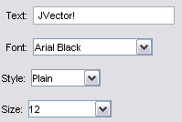
 Using the Select Tool
The Select tool allows you to select and move shapes. Selected Shapes can also deleted and (coming later) modified. To use the select tool, firstly you must select a shape, then once selected, you can move that shape.

- Select a Shape to manipulate by clicking on the shape.
- To move the shape, click on it again, but this time hold down the primary mouse button, and drag the mouse to move the shape.
- Releasing the mouse button stops the move operation.

The select tool has no special options.

 Using the Delete Tool
The Delete tool allows you to delete the current selected shape (selected by the select tool). This is done as follows;

- Select the shape you wish to delete with the Select Tool.
- Click on the button for this tool in the tool bar, to delete the shape.

 Using The Zoom Tool
The zoom tool allows you to zoom in and out of the image, from a range of 10% of its original size, to 1600% of its original size. This is done as follows;

- Select the Zoom tool
- Setup the options, explained below.
- Click on the spot you wish to zoom in on.



The current zoom level is displayed just below the zoom tool.

Zoom Tool Options/Properties
- Zoom: In or Out – Only one of these options can be selected, not both.
In – Select this option to Zoom ‘in’ on the image, increase its size.
Out – Select this option to Zoom ‘out’ of the image, decrease its size.
- Zoom Level: Zoom level can be set between 1 & 5. It determines how much the image is zoomed in or out of with each click. A zoom level of 1 means the image zoom increases or decreases by 10% each click, while a zoom level of 5 will be 50% each click.

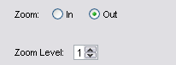

Understanding Colour

Colour Swatches
To use colour swatches, you just click with your mouse, on the colour you want to set the foreground colour to. Swatches can only change the foreground colour, to change the background colour; you must use the flipping tool in the Colour Display Area.

Selected Colours Display – Foreground/Background Colour
This Area Provides a display for the currently selected foreground and background colour. See below how foreground and background colour affects each shape. To set the background colour, follow these steps;

- Set the Foreground colour to the colour you desire for the background.
- Flip the foreground and background colours, now the background colour is the one you desire.
- Set the foreground colour to the one you desire.

Foreground Colour

Foreground Opacity
Background Colour

Background Opacity
Colour Swapper

Foreground/Background Colour and Shapes
This is a table of how foreground and background colour affect each shape.

Shape | Foreground Colour | Background Colour
Line | Fill
Rectangle | Outline | Fill
Oval | Outline | Fill
Polygon | Outline | Fill
Text | Fill

JVector Preferences

JVector has a few options that you can set for the program, located at Options Menu > Preferences… (Ctrl + P). These options allow you to change some of the ways in which JVector runs and performs its operations. The Options are broken into two categories, as follows;

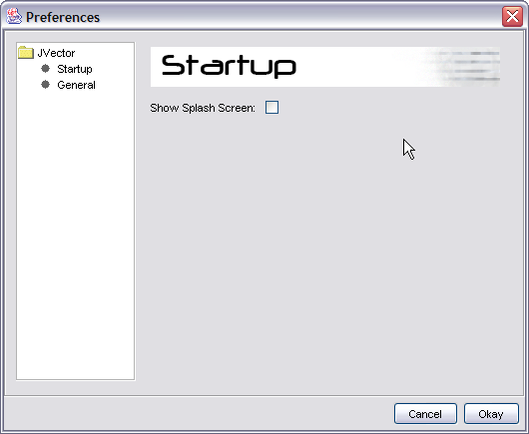

Start-up
These are options that are related to the way in which JVector starts up, and it contains the following options. (See above screenshot).

- Show Splash Screen: When JVector is loading, it displays a splash screen (screen shot below) to notify you that it is still loading. However, this splash screen does very slightly; slow down the loading of JVector, and because of this, many users, especially power users, like to disable the splash screen to speed up the loading of JVector.

The JVector Splash Screen showing while JVector loads.
General
These are general options to do with JVector, that don’t specifically fit into any of the other option categories.

- Double Click Speed: This is the time in milliseconds, in which you must click twice, for a double click to be registered. That is, the shorter this time, the harder it is to double click, while the larger it is, the easier it is to double click. This timer only matters for when you are drawing polygons, and need to double click to finish the polygon, as this is the only time double clicks are used in JVector.

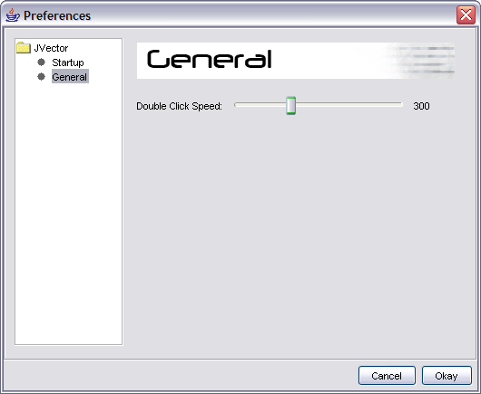
JVector Plugins

JVector can use plugins to provide additional image formats to export to. Plugins are stored in the JVector Installation directory under, Plug-Ins\File Formats. Plugins are accessed through the export feature for images.

You can find and download additional plugins if you would like, from the JVector homepage.

http://t-bone-paint.sourceforge.net/

Installing Plugins
To install plugins, firstly locate and download them from the internet. Pay close attention to any documents that come with them, as they might tell you how to install that plug-in. However, most plugins are installed in the exact same simple way, and if no documents are included telling you how to install the plug-in, then follow this guide.

- Download the plug-in; a plug-in should be one file, of extension .jar.
- Place the plug-in in the Plug-Ins\File Formats directory in the JVector installation directory.
- Restart JVector if it is currently open, if not, launch JVector.
- Done!

A new Image export type should now appear when you export an image.

Writing Plugins
If you are a keen developer, and would like to write your own image output plug-in for JVector, then first make sure you can program Java, as this is the programming language you will need to use to write a plug-in.

For the information and resources required to write a plug-in, head over to the JVector homepage.

http://t-bone-paint.sourceforge.net/
Error Reporting

If in the unlikely circumstance, you come across an error when trying to use JVector, or just a problem or difficulty, then please contact us at the JVector website.’

http://t-bone-paint.sourceforge.net/

If you do email us about any problems, especially ones which you believe relate to an error in JVector itself, please include the JVector log file. Please, when the error occurs, send us the log file straight away, as it is over written each time you run JVector, so if you run JVector before sending us the log file, we could loose valuable information.

The JVector log file is located in the JVector installation directory under, logs\logfile.log.

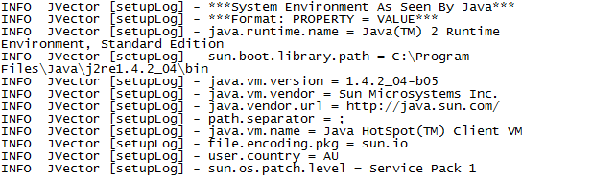
An example log file.

Re-occurring Errors
If the error you are planning to report reoccurs each time you perform a particular action, then you can help us out more, by changing the level that JVector logs at, to be higher, so that we can more easily discover and fix the error. To do this, follow these steps;

- Open up the file, log.properties, with a text editor program
- The Second line of the file should read, “log4j.rootCategory=INFO, A1”
- Change this line to, “log4j.rootCategory=DEBUG, A1”
- Now run JVector again, reproducing the error.
- Now, send us the log file please, making sure not to run JVector again.

Thank you for your help and support in making JVector more stable.
Troubleshooting

System Requirements

Do I have a Java VM?
To check if you have a Java VM, open up your web browser, and head to this page, http://java.com/en/download/help/testvm.jsp, if under the heading Test your JVM™ you can see a box that displays some information in it and has a dancing triangle man with a red nose, then Java is installed on your computer.

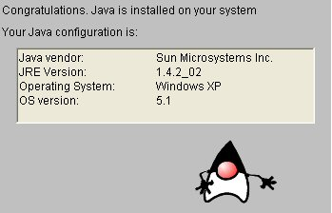

What Version of Java do I have installed? Is this Good enough?
To check this, go to the same site as in 1, and see what JRE Version it says you have. (circled in red above). If it is above 1.4.2 or equal, then your computer should be ready to run JVector, as long as it meets the other requirements.

How do I install Java?
Open up your web browser and head to http://www.java.com:80/en/download/manual.jsp. From there download the correct version of Java that is for your Operating System.

Installation

The Installation Program Will Not Launch
If this occurs, the first, follow the steps above in the System Requirements trouble shooting section to make sure you have Java and a recent enough version of it installed. If you fail this, then follow the steps in the same section to install one.

If you do have a Java VM of version higher or equal to 1.4.2, and you are running on Windows, or Mac OS X, then you should update it to the latest version, and if you already have the latest version, then you should reinstall it. If this fails, then you can follow the steps below that are for Linux (this requires some technical knowledge), or contact us for support through our web site. (http://t-bone-paint.sourceforge.net/).

If you are running Linux, or the above steps for Windows and Mac OS X fail, then try to install JVector through the console as follows;

- Open up the console.
- Change the current directory to where the JVector-install.jar is located.
- Now type the following command;
$ java –jar JVector-install.jar

Hopefully, this should launch the JVector installer program. If it doesn’t, then please contact us for support through our web site. (http://t-bone-paint.sourceforge.net/). Please see the error reporting section on how to ask for support first.

Please note that if this does work, then you will need to also launch JVector itself in the following manner, although it would be best to write a simple command script to do this. See the Running JVector trouble shooting section for more information.

Running JVector

Nothing Happens When the JVector.jar File is Double Clicked
If you managed to run the JVector installer by just double clicking JVector-installer.jar, but double click JVector.jar fails to launch the program then most likely you have a Program error. Firstly, reinstall your Java VM. If this fails, then please contact us for support through our web site. (http://t-bone-paint.sourceforge.net/). Please see the error reporting section on how to ask for support first.

If you had to launch the JVector Installer through the consol, then you can use the same method here. Open up the consol to the JVector installation directory, and run the following command;

$ java –jar JVector.jar

If this works, then please contact us for further support, or just use the above method each time.

Using JVector

When trying to export an image / plug-ins are reported to be corrupt.
If this occurs, then one or more of your output plugins is/are corrupted. Please follow these steps to fix the problem.

- Go to your JVector installation directory.
- Go to the folder Plug-Ins and then File Formats (Plug-Ins\File Formats).
- Remove all the files from that directory to a temporary directory that you have created, outside the JVector installation directory.
- Add back to the File Formats directory, one plug-in.
- Run JVector, and try to export an Image, if an error is reported, then you know that that plug-in is corrupt. So delete it, recording which one it was so that you can download it again off the internet. If JVector successfully exports the image, you know the plug-in is okay, so leave it in the directory.
- Repeat steps 4 – 5 for each plug-in to remove the corrupt ones.
- Now that your plugins should all be working, go to the JVector homepage, and download the plugins that were corrupted.
- Place them back in the File Formats directory, and JVector and all the plugins should now be working.

If this doesn’t fix your problem, please contact us through JVector’s website, to receive technical support. Please see the error reporting section on how to ask for support first.

