JVector Tutorials

Tutorial One
This tutorial teaches the basics of creating a new image, and saving it.

- Start up JVector.

- Click on the File Menu, and then New… or press Ctrl + N.

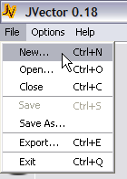

- When the New Image… window comes up, enter in Name, Tutorial One, and for image width, 400, and height, 400. Make sure that the box on the right has pixels selected. Now press Okay.

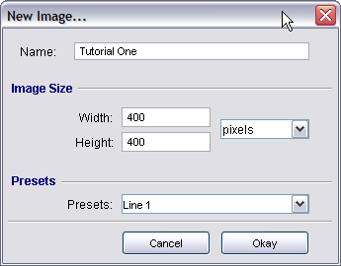

- A new image should be created of 400 x 400 pixels.

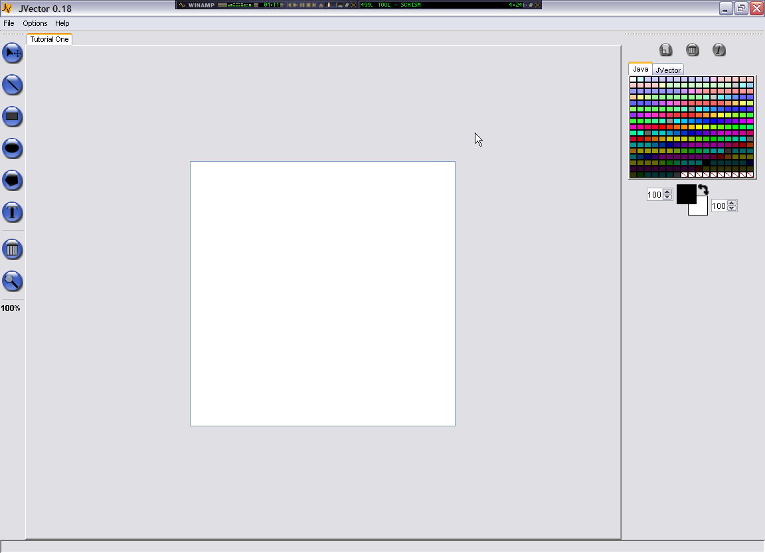

5.
- Now Select the line tool by clicking once on its button with your mouse.

- With your primary mouse button (usually the left button), press your mouse button down in the top left of the image editing area, making sure you continue to hold the mouse button down. This will create the starting point of a line.

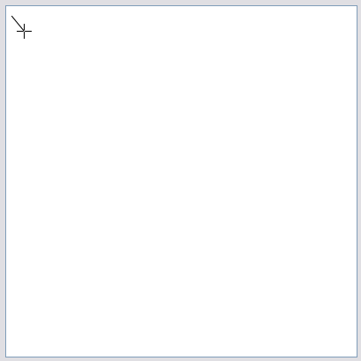

- Now, still holding the primary mouse button down, drag the mouse to the bottom right corner of the image editing area, notice how the end of the line follows your mouse. When you mouse is in the bottom right corner, release the primary button. This sets the end point of the line, finishing its drawing operation.

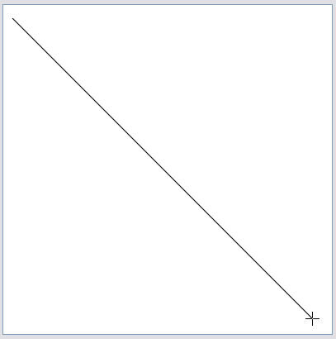

You have now draw your first line!

- Now go to File > Save As… This will bring up the Save Image window. Use this window to browse to a location where you want to save this image. I suggest you create a folder on your desktop called “JVector Tutorial Files” and save it here, as well as future tutorial image files.

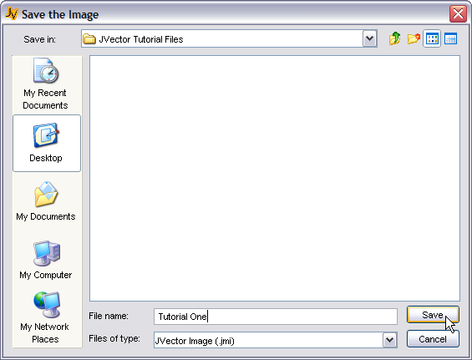

Name the file Tutorial One, and then click the Save button to save it. You now have this image saved to a file so that you can open it up latter, or transport it. JVector Image Files have the extension jvi.

- Now that we have done editing the image and saved it, lets close it. Go to File > Close or press Ctrl + C. This should close the image and leave the image editing area blank.

- Now let’s make sure it saved correctly by opening it up again. So go to File > Open… or press Ctrl + O. A window very similar to the Save As window should now pop up. Browse to where you just saved the file, select it, and then press the Open button to open it back up.

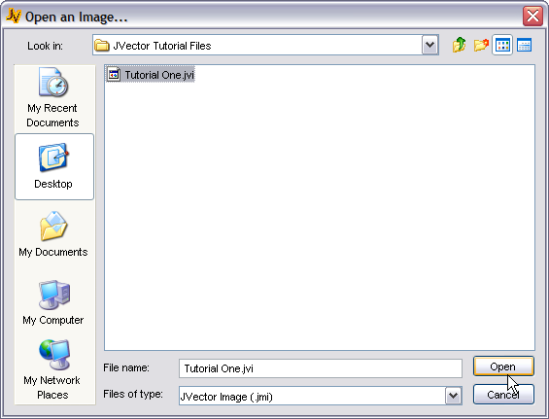

- This ends tutorial one, yo now have the basic skills of being able to create a new image, save it, close it, and open it. The next tutorial will actually teach you how to draw.

Tutorial Two
In this tutorial you will learn how to use all the drawing tools, and become familiar with the MDI (Multiple Document Interface) of JVector.

- Before you start this tutorial, make sure you have now images open. If you do, close them how you were shown in tutorial one.

- You need to open up a pre-existing image for this tutorial. So go to File > Open… or press Ctrl + O. Then browse to the JVector Installation directory, and go to Tutorials\Images\ and in that directory, open the image file called, Tutorial Two.jvi. That image should now open and look like below;

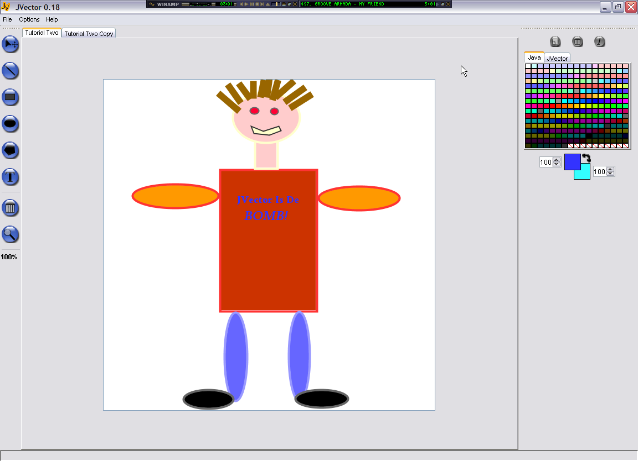

- In this tutorial, you will attempt to create an as close copy of this image as possible. Firstly we need to create an image, so create a new image with Name Tutorial Two Copy, and of Size 600 x 600, making sure the units are pixels once again.

- When the new image appears, notice at the top of the image editing pane, that there a re now two tabs, Tutorial Two and Tutorial Two Copy. You can click on these tabs to change between the two images very easily.

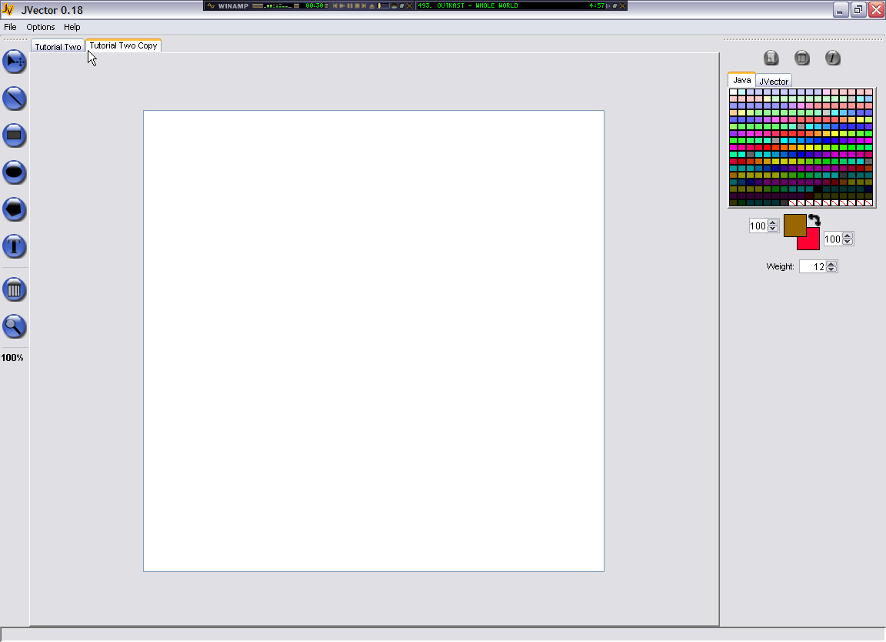

- First, we will draw the body, so select the rectangle tool. The rectangle tool works just like the line tool. Click down for the starting point, then drag and release for the end point. However, we also need to consider colours, and try to get them as close as possible, although don’t worry too much.

- Firslty, we need to select the colour that will be the fill of the rectangle. A rectangle fill is determined by the colour of the background when the rectangle is draw. So firstly, click on a colour in the Java colour swatch that is closest to the fill colour of the body of the man in Tutorial Two.

- This however sets the foreground colour to the colour clicked, to set that colour to the background, we click on the colour flipper.

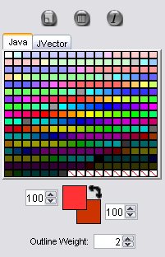
6.
7
- Now also set the foreground colour to one that is close to the outline of the body of the man, as the foreground colour determines the outline of a rectangle.

- This skill of setting colours through flipping is vital, and should be practiced a few times to get used to the idea.

- Now lets draw the actual body of the man, so click, hold, drag and then release, just like with the line tool to draw it.

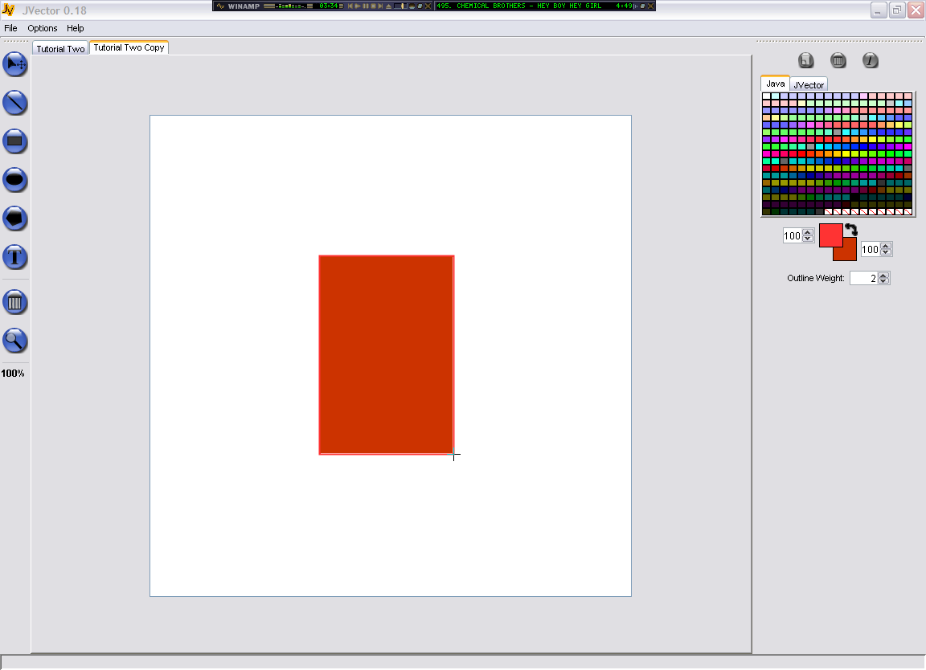

- You can now draw rectangle, lines and change the colour. Now we will draw the legs of the man, which are ovals. Ovals are drawn exactly the same way as rectangles. So change the colour appropriately, by flicking back to the Tutorial Two image using its tab, and then back to Tutorial Two Copy.

- Now draw the legs, Click, hold, drag, and release.

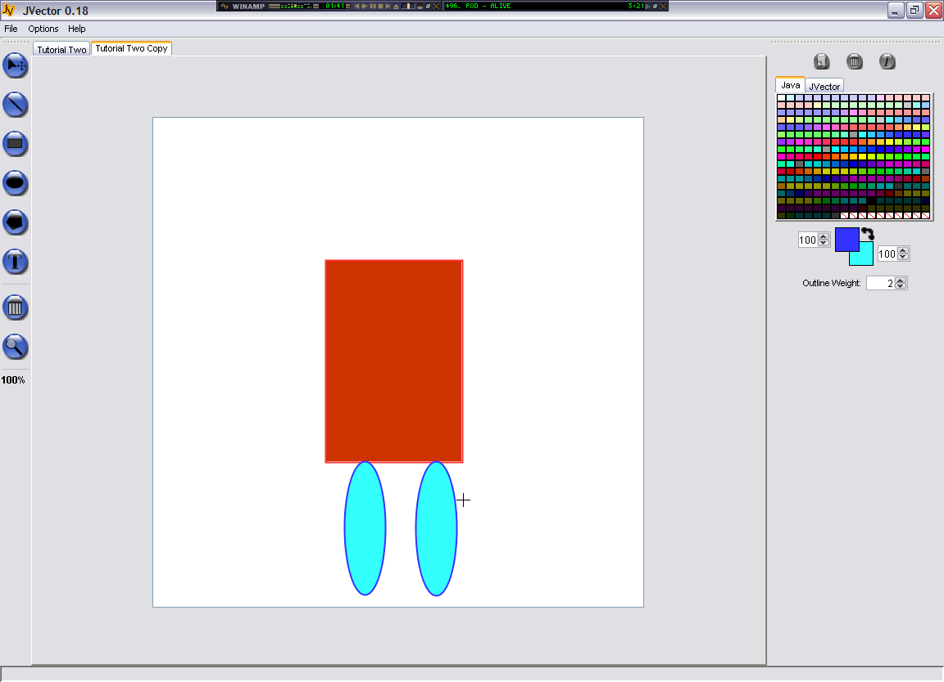

- Okay, now you can draw Ovals, but notice in mine how I stuffed up the colours of the legs. This can easily be corrected by deleting these two ovals and starting them again.

- To delete the left oval, change to the Select tool, and click on it. Now press the deleted tool, and it should be deleted. Do the same for the right Oval.
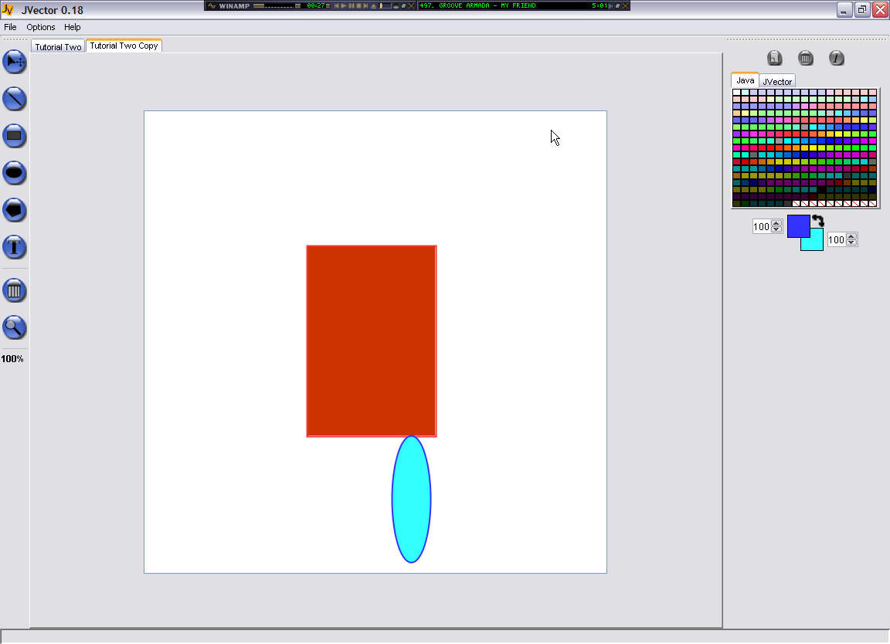
- So we will now draw the ovals again, hopefully getting the colours a little closer.

- You now can use all the image tools of JVector except for zooming, the text tool, and the polygon tool. Finish of all of the rest of the image you are able to, you wont be able to do the text or the mouth (which is a polygon).

- Here’s where you should now be up to.

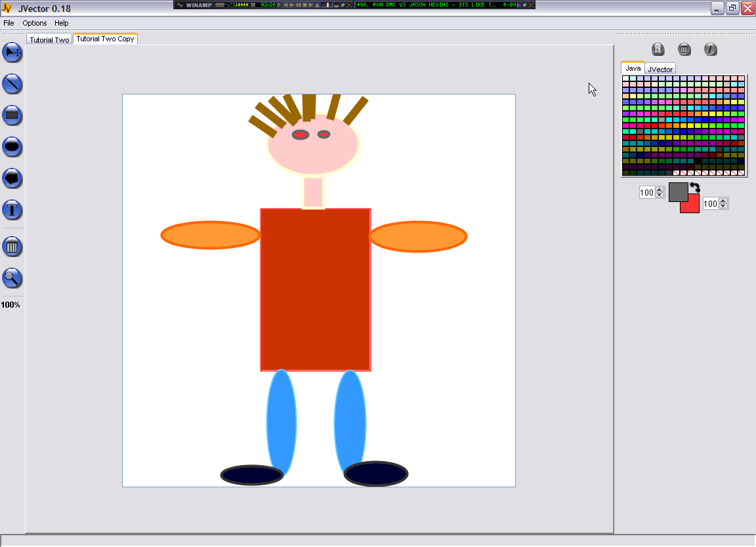

- Hopefully yours will be even closer to the original then mine. Now we will draw the mouth.

- The mouth is done with a polygon, but first, setup your colours.

- Now select the polygon tool. . We will start the polygon from the top left point. So at that point on your copy of the image, click the mouse button. DO NOT HOLD IT DOWN. Now just move the mouse, without holding it to the next point, and click once again, making sure you don’t hold down the mouse button. Do this process till one have one point left. On the last point, instead of just a single click, you must use a double click, as this adds the point, and ends the polygon as well. So perform this double click. Hopefully you now have a beautiful mouth.

My Copy so Far.

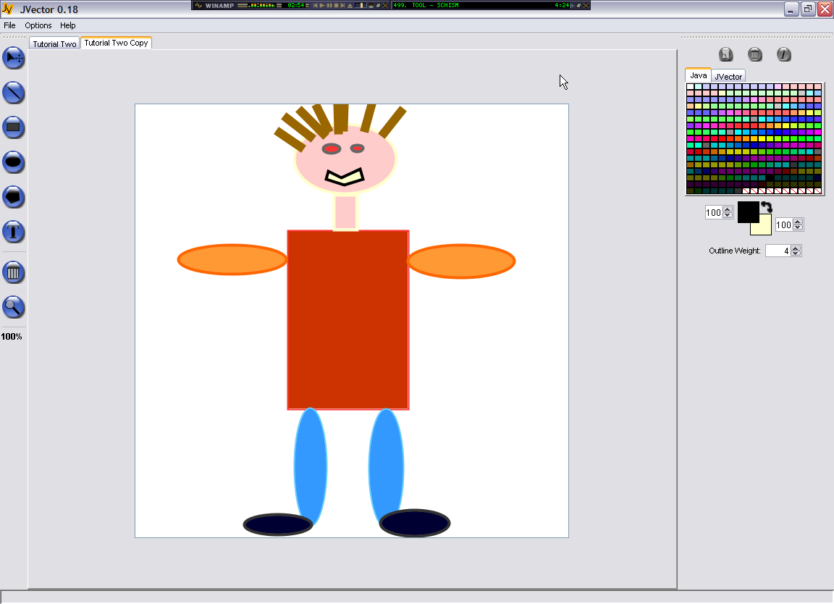

- Now the final step, to add the text in. First, select the text tool. Now setup your colours. The text tool is only affected by the foreground colour.

- Using the text tool invlolves setting a lot of options compared to other tools. On the right hand side, we must set all the font, size, style options before we write the text. We even have to set the text to write, by typing it into the Text, text box. Here are my text options I used for the first line of writing.

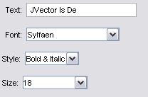

- Now you have all the options and the text to write set, you are ready to actually draw it. To draw it, just click on the image where you want the left side of the text to start.

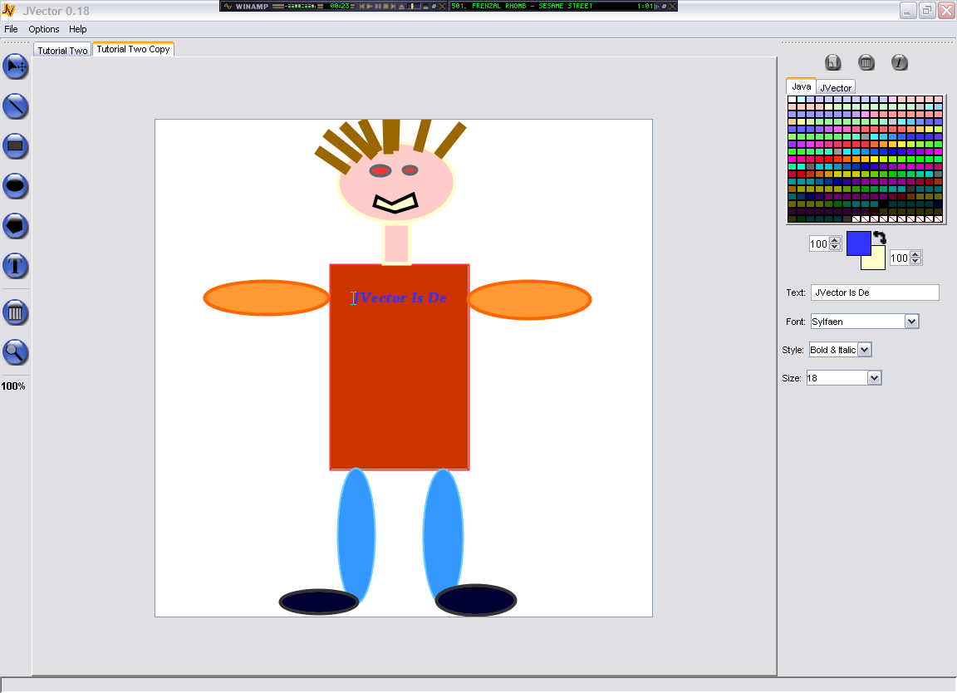

- For the second line of text, the options are the same, but size 24 text. Finish this off now.

- Hooray! You have now completed the second tutorial of JVector and can now use all the tools. Good future drawing young artist, abstract art is your oyster!

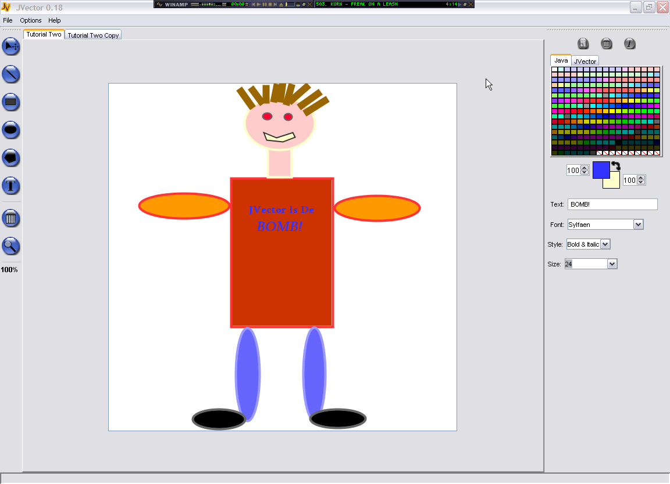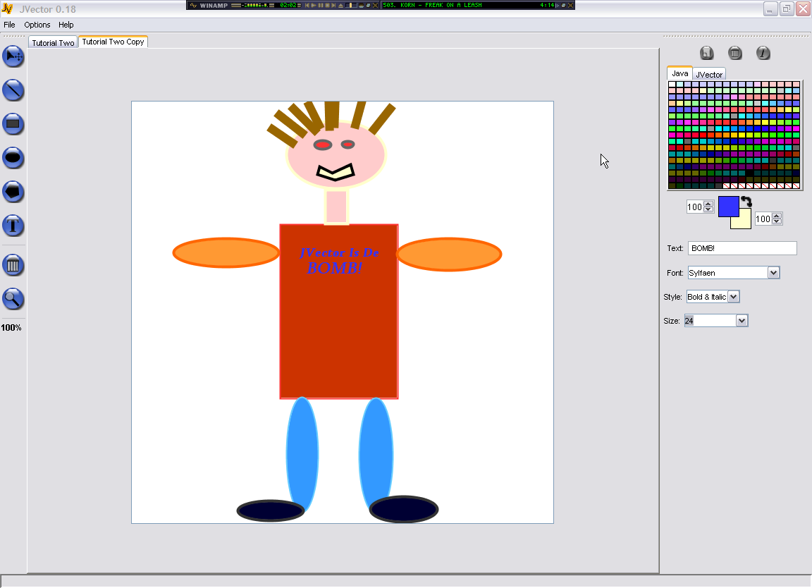
Original Copy

