Tutorial

Welcome to Paddle Wars: Paddle’s Of Fury! This is a step by step guide to our program and it’s functions.
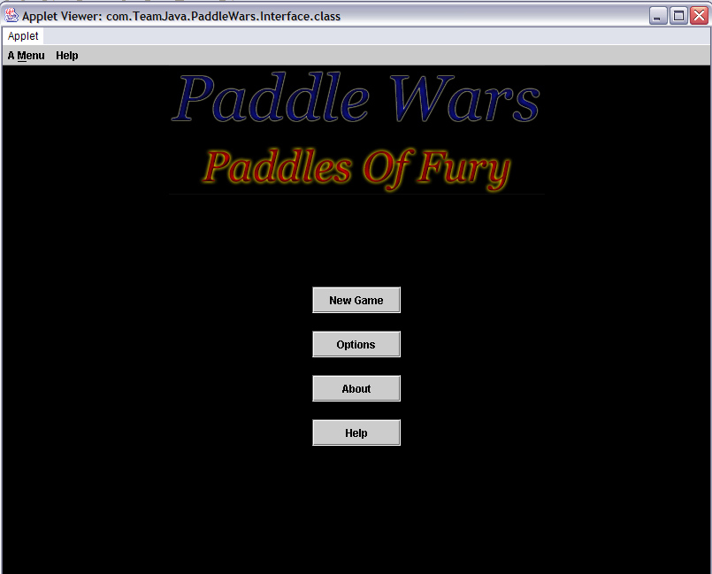
Here is the Main Screen of our program. It offers a choice of New Game, Options, About and Help.

New Game – After clicking this you are presented with another prompt.
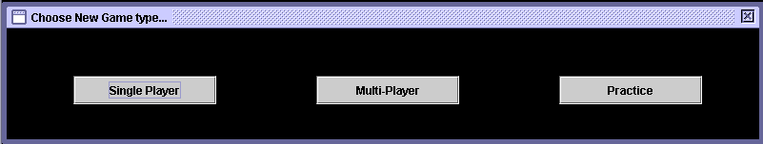
Single Player offers you a chance to play against the computer. In Multi-Player, bring a friend along and verse your friend. If you aren’t ready for the computer or have no friends you can play against a wall in Practice.

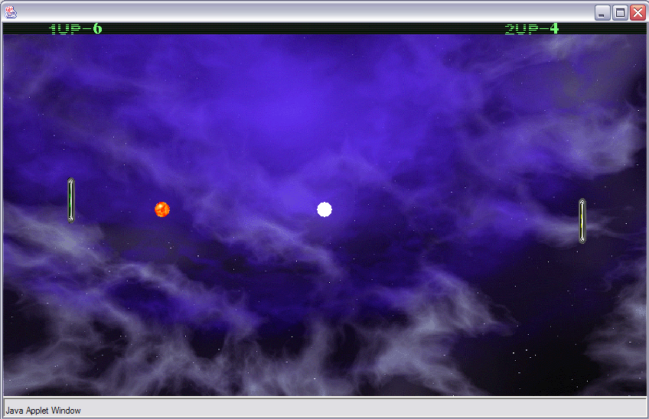
Here is our actual game. It consists of hitting the fire ball which can be customised to two extra types and outsmarting your opponent. Here, Player 1 is the computer and is leading 6-4.

Options – In this section of the program, you can change the ball used and the paddle colour to one of 3 you want.
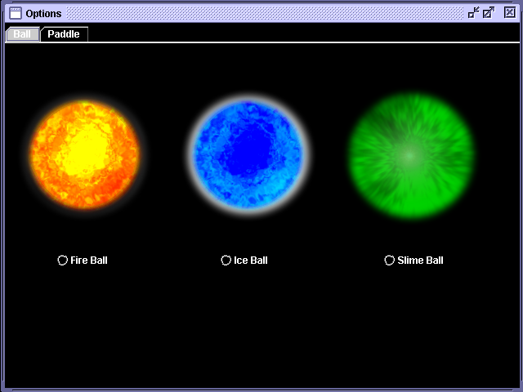
A choice of three game balls to use in our game is available in Paddle’s Of Fury. To select which ball you would like to use, just click on the text of that ball.

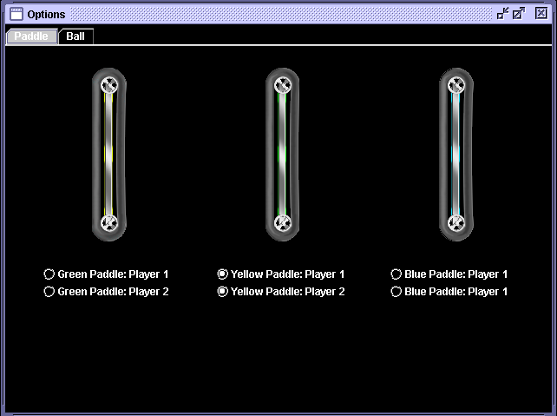
The same functionality is available here but you are able to choose the paddle. Both Player 1 and Player 2 are able to select one of 3 paddles, including both players being the same colour.

About and Help buttons – Directly linked to http://www.members.optusnet.com.au/otta2
