FOUNDATION &
ENVIRONMENT SETUP
Cybersecurity Practical Lab Report

Program / Organization | ApexPlanet
Participant Name | Dake Teresa Leeser
Task | Foundation & Environment Setup
Submission Date | 04-11-2026

Completion Report

1. Objective
The objective of this task was to establish a safe, isolated cybersecurity practice environment and strengthen foundational knowledge in cybersecurity, Linux, networking, cryptography, and commonly used security tools. The lab was intended for controlled learning and authorized testing.

2. Scope of Work
The task covered the following areas:
- Cybersecurity fundamentals: CIA Triad (Confidentiality, Integrity, and Availability), common threats, and attack-vector awareness.
- Lab environment setup: VirtualBox or VMware, Kali Linux as the testing machine, a vulnerable practice target such as Metasploitable2 or DVWA, and Host-Only networking.
- Linux fundamentals: Directory navigation, file operations, permissions, package management, and basic network commands.
- Networking fundamentals: OSI model, TCP/IP, DNS, HTTP/HTTPS, IP addressing, subnetting concepts, and NAT.
- Cryptography basics: Symmetric and asymmetric encryption, hashing, digital certificates, SSL/TLS, and introductory OpenSSL exercises.
- Security tools: Wireshark, Nmap, Burp Suite, and Netcat for introductory packet analysis, network discovery, web-proxy familiarization, and network troubleshooting.

3. Work Completed

3.1 Cybersecurity Basics
Reviewed the CIA Triad and its role in protecting information. Studied common threat categories including phishing, malware, DDoS, SQL injection, brute-force attempts, and ransomware. Also reviewed social engineering, wireless attacks, and insider threats at a conceptual level.

3.2 Lab Environment Setup
Prepared a virtual lab using a virtualization platform. The intended lab design uses Kali Linux as the security-testing machine and Metasploitable2 or DVWA as a deliberately vulnerable target. A Host-Only network provides an isolated communication environment for practice without exposing the target directly to a public network.

3.3 Linux Fundamentals
Practised basic command-line operations, including navigating directories, listing files, creating and managing files or folders, viewing file contents, changing permissions, and working with software packages. Introductory commands included cd, ls, pwd, chmod, chown, apt, and dpkg.

3.4 Networking Basics
Reviewed the purpose of the OSI layers and the TCP/IP protocol suite. Studied how DNS resolves domain names, how HTTP and HTTPS support web communication, and the basic concepts of IP addressing, subnetting, and NAT. Practised or reviewed common diagnostic commands such as ipconfig/ifconfig, ping, netstat, and traceroute.

3.5 Cryptography Basics
Compared symmetric and asymmetric encryption and reviewed the purpose of hashing. Studied MD5 and SHA-256 as hash algorithms, the role of digital certificates, and how SSL/TLS helps protect data in transit. The task also included introductory encryption and decryption practice using OpenSSL.

3.6 Tool Familiarization
Became familiar with Wireshark for packet capture and protocol inspection, Nmap for authorized network discovery, Burp Suite as an intercepting web proxy, and Netcat for basic network connection and troubleshooting exercises.

4. Tools and Technologies
Category | Tools / Concepts
Virtualization & lab | VirtualBox / VMware, Kali Linux, Metasploitable2 / DVWA, Host-Only Adapter
Linux | cd, ls, pwd, chmod, chown, apt, dpkg
Networking | OSI, TCP/IP, DNS, HTTP/HTTPS, IP addressing, subnetting, NAT
Cryptography | Symmetric and asymmetric encryption, MD5, SHA-256, SSL/TLS, OpenSSL
Security tools | Wireshark, Nmap, Burp Suite, Netcat

5. Key Learning Outcomes
- Developed a clearer understanding of core cybersecurity principles and common threat categories.
- Understood the purpose of an isolated virtual lab and the role of Host-Only networking in controlled practice.
- Improved familiarity with essential Linux navigation, file-management, permission, and package commands.
- Strengthened foundational understanding of network communication, addressing, and common protocols.
- Learned the differences between encryption and hashing and the purpose of certificates and TLS.
- Gained introductory familiarity with widely used network and security analysis tools.

6. Evidence and Screenshots
Insert screenshots captured from your own completed lab below. Each screenshot should be clear, readable, and accompanied by a short caption describing what it demonstrates. The two images provided with the task appear to be task-instruction slides, so they should not be used as proof of lab completion.

Figure 1 – Virtualization platform and virtual machines
Insert a screenshot showing VirtualBox/VMware and the configured Kali Linux and target virtual machines.
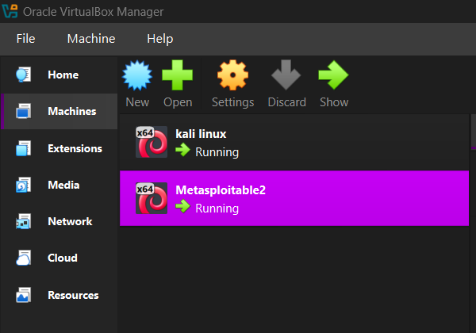

Figure 2 – Kali Linux running
Insert a screenshot of the Kali Linux desktop or terminal showing the environment is operational.
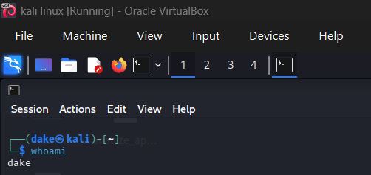

Figure 3 – Target machine running
Insert a screenshot showing Metasploitable2 or DVWA running in the isolated lab.
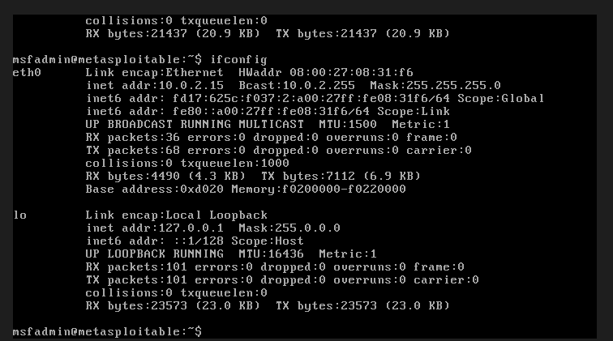

Figure 4 – Host-Only network configuration
Insert a screenshot of the virtual network settings showing the Host-Only adapter configuration.
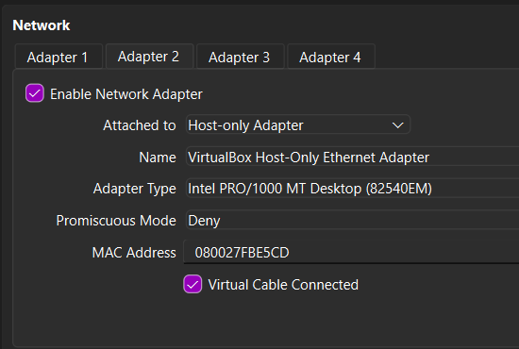

Figure 5 – Linux command-line practice
Insert a screenshot showing a few basic Linux commands and their outputs.
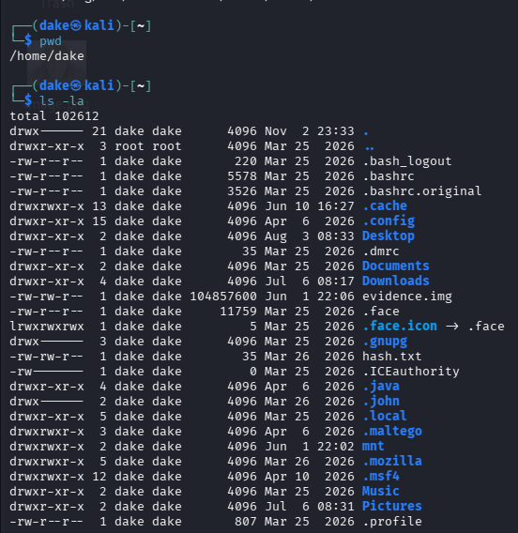
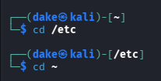
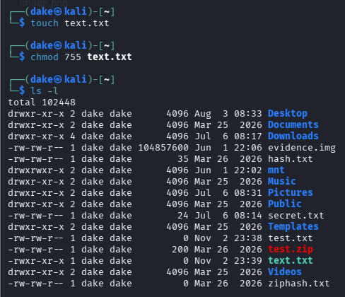
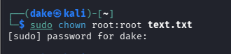
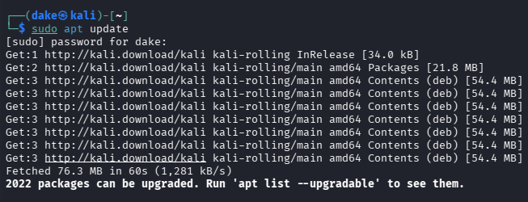
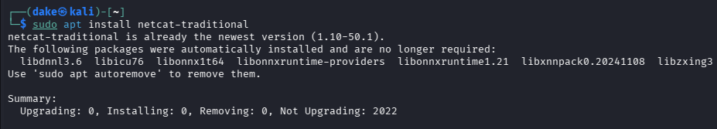

Figure 6 – Networking / packet capture
Insert a screenshot of a permitted lab connectivity test or Wireshark capture.
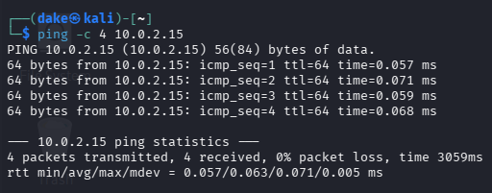
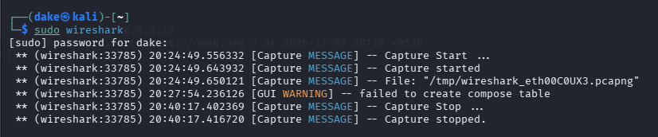

Figure 7 – Cryptography / OpenSSL exercise
Insert a screenshot showing a basic hash, encryption, or decryption exercise using sample data.
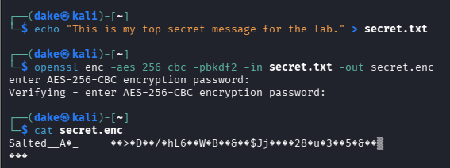
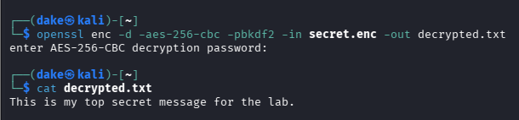
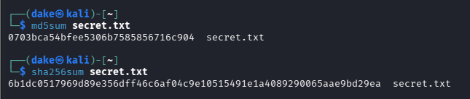

Figure 8 – Security tool familiarization
Insert a screenshot of an introductory Wireshark, Nmap, Burp Suite, or Netcat exercise in the lab.
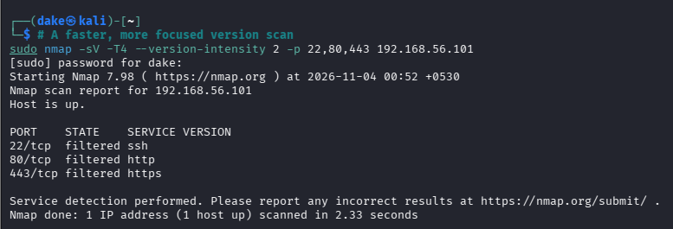
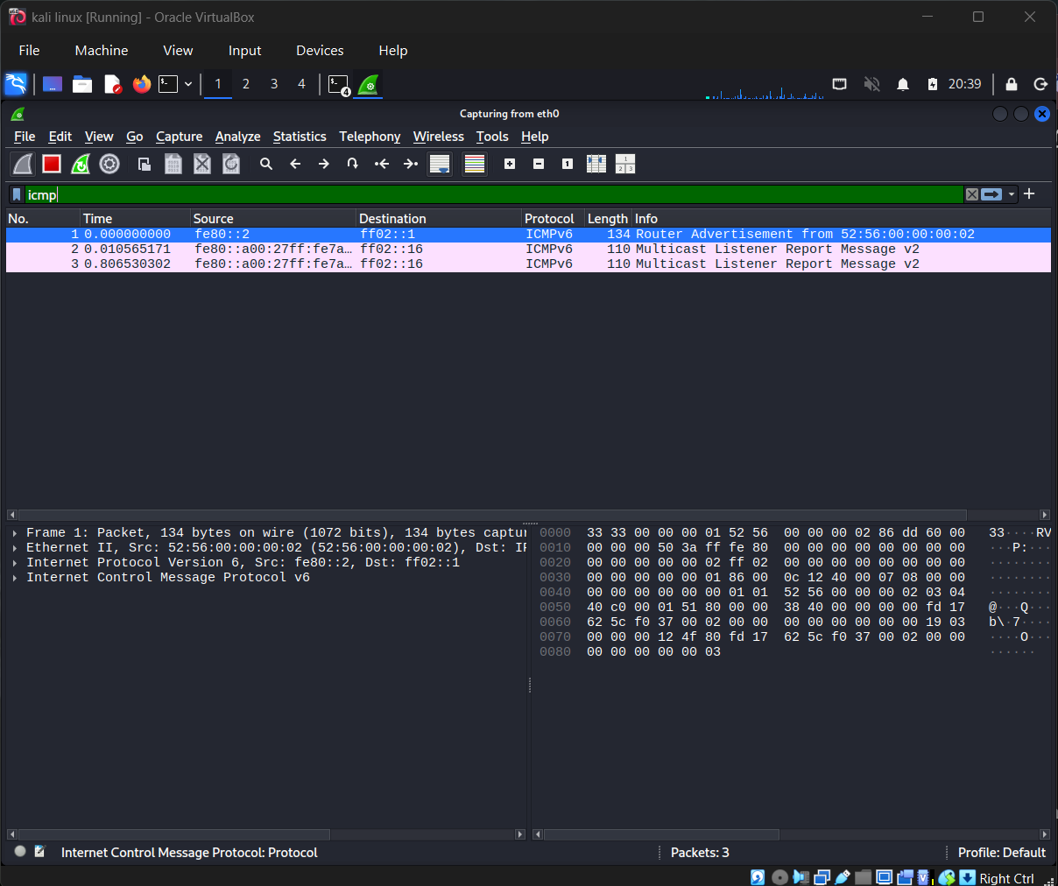
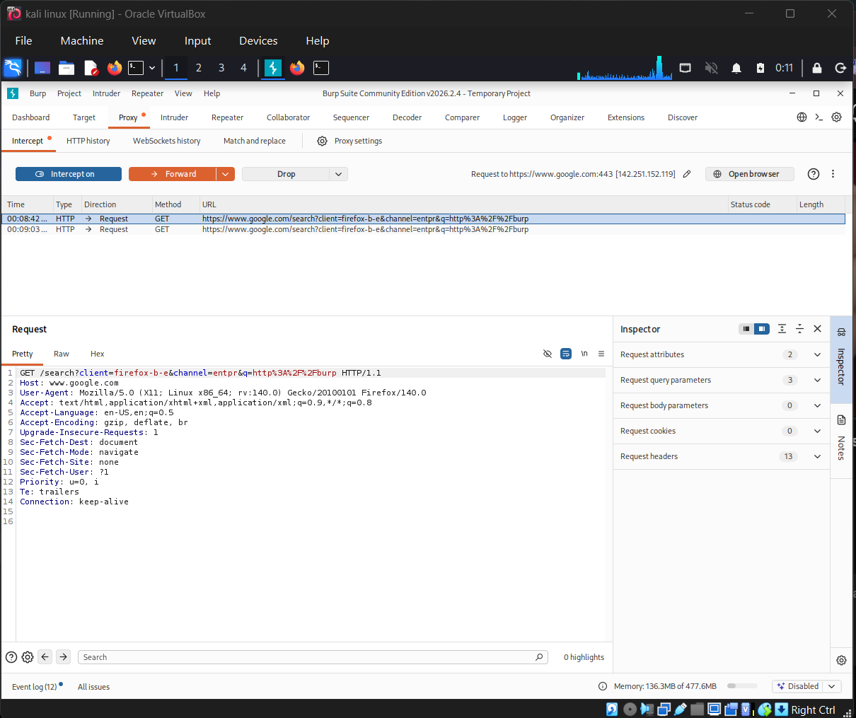
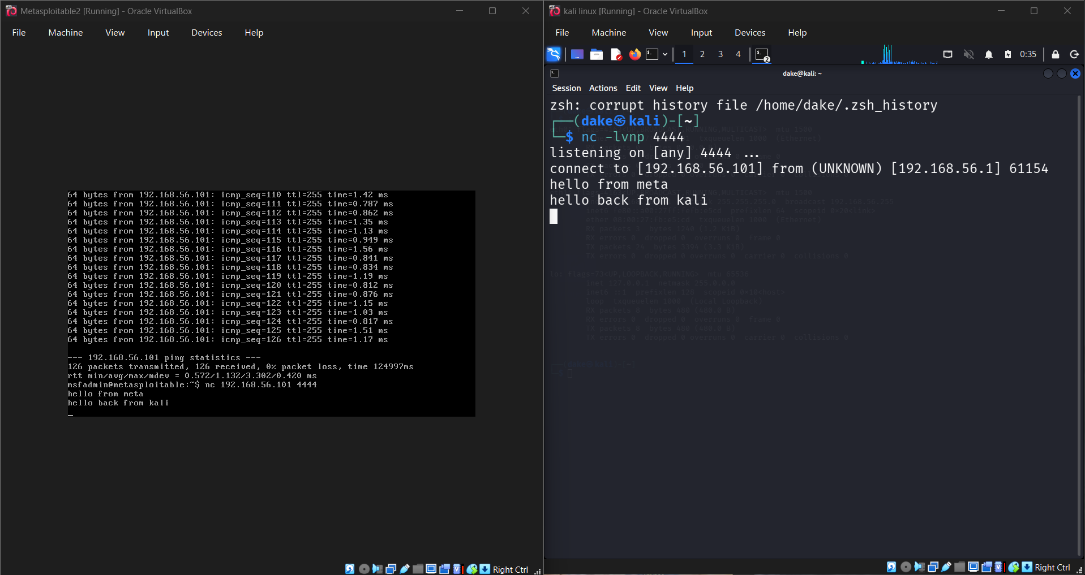

7. Conclusion
This task provided a structured introduction to cybersecurity foundations and the setup of a controlled virtual practice environment. It connected core concepts in security, Linux, networking, and cryptography with introductory exposure to commonly used tools. The completed work establishes a foundation for further hands-on learning in vulnerability assessment, network analysis, and defensive security.

8. Lab Safety and Responsible Use
All practical activities should be performed only on systems owned by the learner or where explicit authorization has been granted. Deliberately vulnerable machines should remain isolated from public networks and should not be exposed to the internet. Use sample data for demonstrations and avoid testing against third-party systems.

— End of Report —

