Title:
Incorporation of water-derived hydrogen into methane during artificial maturation of kerogen under hydrothermal conditions

A manuscript prepared for submission to Organic Geochemistry on 15 February 2022

Authors and affiliations:
David T. Wang^{a,b,c}*, Jeffrey S. Seewald^{b}, Eoghan P. Reeves^{d}, Shuhei Onoª, and Sean P. Sylva^{b}
ªDepartment of Earth, Atmospheric and Planetary Sciences, Massachusetts Institute of Technology, Cambridge, Massachusetts 02139, USA.
^{b}Marine Chemistry and Geochemistry Department, Woods Hole Oceanographic Institution, Woods Hole, Massachusetts 02543, USA.
^{c}ExxonMobil Upstream Research Company, Spring, Texas 77389, USA.
^{d}Department of Earth Science and Centre for Geobiology, University of Bergen, Bergen N-5020, Norway.

* Corresponding author at: Esso Exploration and Production Guyana Ltd, 86 Duke Street, Georgetown, Guyana. E-mail address: dtw@alum.mit.edu or david.t.wang@exxonmobil.com (D.T. Wang).

Keywords:
methane, natural gas generation kinetics, D/H ratios, kerogen, clumped isotopologues, hydrogen isotope exchange, water isotopes

Abstract
To investigate the origin of H in thermogenic methane, a sample of organic-rich Eagle Ford shale was reacted with D₂O under hydrothermal conditions in a flexible Au-Ti cell hydrothermal apparatus in a water-to-rock ratio of approximately 5:1. Temperatures were increased from 200 to 350 °C over the course of one month, maintaining pressure at 350 bar, and the concentrations of aqueous species and methane isotopologues produced were quantified. Production of H₂, CO₂, alkanes, and alkenes was observed. Methane formed during the early stages of the experiment at 200 °C was primarily CH₄ with some CH₃D, whereas at higher temperatures, increasing proportions of deuterated isotopologues were produced. Near the end of the experiment, the concentration of CD₄ exceeded that of all other isotopologues combined. These results suggest that competition between rates of kerogen-water isotopic exchange and natural gas generation may govern the D/H ratio of thermogenic gases.

Abstract: 147 words
Main Text: 5697 words

Potential reviewers: Katherine L. French, Justin Birdwell, Arndt Schimmelmann, Alex Sessions, Michael Lewan

Introduction
Variation in δD values of thermogenic natural gases is often attributed to kinetically-controlled fractionation during pyrolysis of kerogen or oils. A number of studies have investigated how D/H ratios of methane and other hydrocarbons evolve with increasing maturity (Sackett, 1978; Berner et al., 1995; Sackett and Conkright, 1997; Tang et al., 2005; Ni et al., 2011). However, kinetic isotope effects involving hydrogen addition or abstraction are often large and by themselves do not explain the geologically-reasonable apparent equilibrium temperatures of ~150 to 220 °C obtained for reservoir gases that have been studied for their clumped isotopologue compositions (Stolper et al., 2014, 2015; Wang et al., 2015; Douglas et al., 2017; Young et al., 2017; Shuai et al., 2018; Giunta et al., 2019; Labidi et al., 2020; Thiagarajan et al., 2020). There is also evidence that δD values of CH₄ approach values expected for isotopic equilibrium between CH₄ and H₂O in formation waters at temperatures characterizing reservoirs and/or mature source rocks (~150 to 250 °C) (Clayton, 2003; Wang et al., 2015; Xie et al., 2021), although findings of insignificant hydrogen exchange occurring under these conditions also exist (Yeh and Epstein, 1981). In order for methane samples to have approached or attained equilibrium values of Δ¹³CH₃D and Δ¹²CH₂D₂—parameters that describe the abundance of clumped isotopologues relative to a population of molecules containing isotopes randomly distributed amongst them [e.g., Young et al. (2017)]—there must be a pathway by which either (i) isotopes can be exchanged amongst methane isotopologues alone, (ii) methane isotopologues exchange hydrogen with water or organic molecules, or (iii) methane isotopologues are derived from methyl moieties which contain C–H bonds that have pre-exchanged with water prior to forming methane (Hoering, 1984; Smith et al., 1985; Schimmelmann et al., 1999, 2006; Lis et al., 2006).
Here, we study the origin of C–H bonds in thermogenic methane by heating kerogen in the presence of D₂O and examining the degree of deuteration in the generated methane. This experiment is conceptually very similar to those conducted by Hoering (1984), Lewan (1997), and Schimmelmann et al. (2001). However, none of these workers quantified the extent of deuteration in the produced natural gases, though Lewan mentioned that methane formed in his experiments contained deuterium [Lewan (1997) and M. D. Lewan (pers. comm.)].

Methods

Experimental methods
Experiments were conducted in a gold-titanium reaction cell housed within a flexible cell hydrothermal apparatus (Seyfried et al., 1987) at WHOI. The reaction cell was pre-treated prior to loading by soaking in concentrated HCl for 4 hours, followed by rinsing with water to pH neutral and drying in the oven. The exit tube of the apparatus was cleaned by forcing ~20 ml of MilliQ deionized water (18.2 MΩ) through, followed by ~20 ml conc. HCl, ~100 ml water, ~20 ml conc. HNO₃, and then ~100 ml of water until the pH tested 7 using pH paper.
The source material for this experiment was a hand sample of Upper Cretaceous Eagle Ford Shale taken from an outcrop in Uvalde County, Texas, USA (Hentz and Ruppel, 2010). The sample was kindly provided to J. Seewald by Keith F. M. Thompson (PetroSurveys, Inc.). There is no known oil or gas production from the Eagle Ford in Uvalde County [(Tian et al., 2013); and IHS (2019)]. The Eagle Ford here is thermally-immature [R_{o} = 0.40–0.55%, Cardneaux (2012); Cardneaux and Nunn (2013); and Harbor (2011)]. The sample was powdered to <250 μm and Soxhlet-extracted (by Carl Johnson, WHOI) to remove bitumen and free hydrocarbons. In a subsequent step, the solvent-extracted residue was subjected to hydrochloric acid treatment to remove carbonate minerals. Elemental analysis (Table 1) of the original rock sample (UNEX), the Soxhlet-extracted rock sample (EX), and the decalcified+extracted rock sample (DECA) indicates a total organic carbon (TOC) content of ~2.5% and a carbonate content of ~80% by weight. The H/C atomic ratio of the decalcified rock is 2.4. This value is probably several tens of percent higher than the actual H/C ratio of isolated kerogen (not determined) given that substantial amounts of H are likely borne by clays and other minerals that were not removed (Whelan and Thompson-Rizer, 1993; Baskin, 1997). The reaction cell was loaded with 10.03 grams of the EX powder.
Geochemical data for the Eagle Ford sample can be drawn from neighboring Kinney County, Texas, where complete sections of immature Eagle Ford have been recovered by the USGS (drill core GC-3; French et al., 2020) and Shell (Iona-1 drill core; Eldrett et al., 2014, 2015; Sun et al., 2016); there, the Eagle Ford also crops out, is immature, and is presumed to be geochemically similar. The high calcium carbonate content and relatively lower organic enrichment is consistent with data from the Upper Eagle Ford in the Shell Iona-1 core from neighboring Kinney County, Texas (Eldrett et al., 2015).
The starting fluid was heavy water (D₂O, 99% purity, Cambridge Isotope Laboratories, Inc.) containing some NaCl (0.497 mol/kg). The added NaCl allows for detection of dilution of the fluid by deionized water from the pressure vessel in the case of a leak in the reaction cell. The reaction cell was loaded with 55.03 g of this starting fluid. The pressure vessel was sealed and the reaction brought to initial condition (200 °C, 350 bar) rapidly. Several milliliters of fluid were bled during heat-up to prevent overpressurization, leaving an estimated 52.6 g of fluid in the cell at the beginning of the experiment (Table 2).

Analytical methods
To monitor the fluid composition and the extent of deuteration, sample aliquots of fluid were withdrawn through the capillary exit tube into gastight glass/PTFE syringes. Immediately prior to a sampling event, a small amount (~0.5 g) of fluid was removed and discarded in order to flush the exit tube of any residues. The concentration of molecular hydrogen (H₂) was determined after headspace extraction using a gas chromatograph supplied with nitrogen carrier gas, and equipped with a molecular sieve 5Å column and thermal conductivity detector. Analytical reproducibility of H₂ data is ±10% or better (2σ). However, accuracy of reported concentrations is unknown, because the relative responses of H₂, HD, and D₂ (the latter likely to be the main form of molecular hydrogen) in the GC-TCD were not determined. Residual liquid after headspace extraction was diluted with MilliQ water and saved for analysis of major cations and anions, or stored with dichloromethane in the fridge in a screw capped vial for analysis of non-volatile organic compounds.
Concentrations of total dissolved inorganic carbon (ΣCO₂) and C₁ to C₆ alkanes and alkenes were determined using a purge-and-trap cryofocusing device coupled to a gas chromatograph equipped with a Porapak Q column and serially-connected thermal conductivity and flame ionization detectors. Analytical procedures were as described in Reeves et al. (2012). Analytical reproducibility on duplicate samples was ±5% or better (2σ). The C₅ and C₆ compounds could not be quantified accurately due to their semi-volatile nature; however, C₅ and C₆ were detected at all sampling points.
At each sampling, a separate ~1 to 2 ml aliquot was injected directly into a pre-weighed, evacuated serum vial capped with boiled blue butyl rubber stoppers, for analysis of the extent of deuteration of methane. A Hewlett-Packard (HP) 6890 gas chromatography-mass spectrometry (GC-MS) system equipped with a 5Å molecular sieve column (HP-PLOT 30 m × 0.32 mm × 12.0 μm) and HP 5973 mass selective detector was used to determine the amount of deuteration in CH₄. Ion currents were monitored at integral masses between m/z 10 and 50. Extracted ion currents were quantified at m/z 14 through 20 for methane. Expected fragmentation patterns of the five methane-d isotopologues (C¹H₄, CH₃D, CH₂D₂, CHD₃, and CD₄) were determined by analysis of commercial synthetic standards (>98% purity, Cambridge Isotope Laboratories, Inc.). Note to reader: We will refer to the protiated methane isotopologue as C¹H₄ in the text when it is necessary to specifically distinguish it from bulk CH₄.

Results

Temperature and thermal maturity
Temperatures logged during the experiment are shown in Fig. 1A. A fluid sample was taken at the beginning and end of each temperature stage. One additional sample (#4) was drawn in the middle of the second temperature stage (300 °C).
Estimated thermal maturity as a function of time was calculated using EASY%Ro (Sweeney and Burnham, 1990), and is shown in Fig. 1B. Maturities encountered in the experiment spanned the entire range of the oil window (ca. 0.5% to 1.3% R_{o}-equivalent; Burnham, 2019).

Concentrations of aqueous species

Inorganic species
Measured concentrations of aqueous species are shown in Fig. 2. Concentrations of H₂ increased from undetectable (<10 μmol/kg) to up to 0.8 mmol/kg at the end of the experiment. Increasing concentrations of H₂ within temperature stages of the experiment suggests that generation of petroleum, as opposed to a mineral redox buffer, is influencing the H₂ concentration. H₂ increased much more slowly during the >300 °C stages compared to heating at 300 °C and below.
The concentration of ΣCO₂ increased during the early stages of the experiment, and leveled off at ~50 mmol/kg at 350 °C. The plateauing inorganic carbon concentration might indicate that carbonate reached saturation and began to precipitate (Seewald et al., 1998). Measurements of major cations may be used to validate this interpretation. Production of CO₂ as the most abundant product of hydrothermal alteration of kerogen is also consistent with prior experimental work (Seewald, 2003). Alternatively, carbonate could have been released from the rock as it had not been decalcified prior to heating.

Alkanes and alkenes
Concentrations of methane increased in every successive time step, as did concentrations of detected n-alkanes. Except for the beginning of the experiment, molar concentrations of C₁ and ΣC_{2–4} were very similar and increased in near lock step.
Alkenes (ethylene and propylene, Fig. 2D–E) rose in concentration with every increase in temperature, indicating generation of unsaturated hydrocarbons via thermolytic processes. While concentrations of n-alkanes increased monotonically from the beginning to end of each temperature stage, the concentrations of alkenes were flat—or in the 350 °C stage, trended downwards—with time during each stage. Concentrations of alkenes consistent with thermodynamic equilibrium at measured H₂ concentrations are on the order of ~10^{−7.3} and ~10^{−6.5} mol/kg for ethylene and propylene, respectively, at 350 °C (Reeves et al., 2012). These equilibrium concentrations are ~2 orders of magnitude lower than the observed alkene concentrations.
Evidence from hydrothermal experiments suggests that metastable alkane/alkene equilibrium should be attained under hydrothermal conditions with half-equilibration times of several hundred hours or less at temperatures of 325 to 350 °C (Seewald, 1994). Failure to achieve thermodynamic equilibrium within these timescales indicates that generation of thermogenic alkenes occurs concurrently with alkane/alkene hydrogen exchange. Various pyrolysis experiments have reported alkene production (Huizinga et al., 1987; Leif and Simoneit, 2000), lending further support to the hypothesis that continued production of alkenes competes with their conversion into alkanes via hydrogenation at these temperatures and timescales and under the redox conditions characterizing hydrothermal maturation of organic-rich mudrocks.
Unlike the C₂₊ alkanes, methane cannot dehydrogenate to form an alkene. Hence, hydrogen exchange of methane requires that the very stable C–H bond be broken. Under appropriate, generally water-absent conditions, methane exchanges hydrogen with certain catalytic materials such as γ-alumina at room temperature over hours to days (Sattler, 2018, and refs. therein) [or with organometallic catalysts under even colder conditions (Golden et al., 2001)]. However, such catalysts in their active forms are not known to occur naturally in aqueous environments. Experiments conducted by Reeves et al. (2012) with aqueous methane in the presence of iron-bearing minerals in flexible-cell Au-Ti reaction vessels revealed little-to-no observable exchange even over several months at temperatures as high as 323 °C (Reeves et al., 2012). Recently, Turner et al. (under review) conducted a set of experiments in flexible gold-cell hydrothermal reactors with CH₄ dissolved in supercritical water at 376 to 420 °C to constrain the rate of CH₄–H₂O hydrogen isotope exchange. Their results confirm that exchange occurs over timescales of hundreds of years at 300 °C and tens of years at 350 °C (half-exchange, τ_{1/2}), much longer than the duration of our experiment. Therefore, hydrogen exchange of methane during our experiment was limited or insignificant, and the hydrogen isotopic composition of the generated CH₄ is controlled primarily by the processes of source rock-water hydrogen exchange and kinetic isotope fractionation during methane generation.
As discussed in the following section, this conclusion regarding the lack of significant CH₄–H₂O hydrogen exchange in our experiment is supported by the selective production of deuterated methane isotopologues.

Production of deuterated methane isotopologues
Mass spectra collected for standards are shown in Fig. 4. Fragment intensities were very similar to those determined by Dibeler and Mohler (1950). Mass spectra of samples are shown in Fig. 3. No methane peaks of usable size could be obtained for time point #1. All other time points yielded quantifiable extracted ion chromatogram peaks.
The mass spectra of commercial standards were used to fit the sample data using a constrained linear least-squares solver (lsqnonneg) implemented in MATLAB. Estimated relative abundances of methane-d isotopologues are shown in Fig. 5A. Relative abundances were converted into absolute abundances (Fig. 5B) by multiplying by the methane concentration. The proportion of D in methane-bound hydrogen, calculated from the isotopologue abundances, is shown in Fig. 6.
Methane formed during the early stages of the experiment at 200 °C was primarily C¹H₄ with some CH₃D, whereas at higher temperatures, the isotopologues produced consist almost exclusively of CD₄, CHD₃, and CH₃D (Fig. 5A and Fig. 6). These results suggest that at relatively lower temperatures of ~200 °C, the rate of methane generation approaches or exceeds the rate of D/H exchange between water and kerogen, whereas at higher temperatures, extensive D/H exchange between kerogen (or oils, if they are also precursors of methane) and water occurs prior to methane generation. CD₄ became the dominant methane species at temperatures of 300 °C and above, suggesting that more than 50% of all labile, methane-generating sites on kerogen were fully deuterated. Alternatively, the dominance of CD₄ might be explained by direct CH₄–H₂O isotopic exchange occurring after the generation of primarily non-deuterated methane. This is unlikely given the sluggish pace at which D/H exchange occurs for methane (Reeves et al., 2012; Wang et al., 2018). Experiments in which normal water is heated in the presence of CD₄ while the D/H of water is monitored may yield a more sensitive determination of the rate of CH₄–H₂O exchange.
Production of C¹H₄ in the first stage of the experiment (200 °C) indicates that the earliest “capping” hydrogen derives from kerogen or other H-containing species in the rock as opposed to from the H atoms of water. This can only be the case if kerogen has not yet undergone D/H exchange. While constraints on timescales of D/H exchange at 200 °C are sparse, the available literature supports this assertion. Experiments conducted with model hydrocarbons indicate that D/H exchange of carbon-bound hydrogen takes at least several decades, much longer than the heating time in our experiment (Sessions et al., 2004; Schimmelmann et al., 2006; Sessions, 2016; and refs. therein).
Production of C¹H₄ and CH₃D appeared to cease by midway through the 300 °C stage (time point #4, 284 hours), or was overshadowed by the generation of much larger quantities of the higher isotopologues. Continued (though relatively minor) production of methane that was not fully-deuterated (CHD₃ and CH₃D, Fig. 5B) suggests that kerogen or oil from which methane was generated still did not fully exchange before methane formed.
If significant exchange were to occur, either between water and kerogen, or between water and generated methane after cracking, and this exchange occurs sequentially, the predominant isotopologue would be expected to follow the progression C¹H₄ → CH₃D → CH₂D₂ → CHD₃ → CD₄. Instead, CH₂D₂ represents a smaller fraction of the methane isotopologues than either CH₃D or CHD₃ at all times, and calculated proportions of CH₂D₂ do not exceed 10% at any point in the experiment (Fig. 5A). A possible explanation is that various CH_{x} moieties (e.g., aromatic C vs. methylene C vs. heteroatom-bound C) may have significantly different propensities to exchange and hydrogenation (cracking). Cracking that occurs much faster or slower than exchange may yield either fully-deuterated kerogen (e.g., –CD₃) or singly-deuterated methane, respectively, hence leading to an absence of CH₂D₂. Alternatively or additionally, D/H exchange of partially-deuterated longer-chain hydrocarbon molecules with water may be faster than cracking, such that the production of CH₂D₂ is “skipped”. The absence of CH₂D₂ is additional evidence that exchange between water and methane or methane and methane at temperatures of 200 to 350 °C is slow on the timescales relevant to these experiments, consistent with a prior set of experiments (Reeves et al., 2012). Rates of methane isotopic exchange could potentially be better constrained by heating normal water in the presence of CD₄ and monitoring the rate of increase in the δD value of water.
Fig. 6A shows the percentage of water-derived hydrogen in CH₄ vs. estimated maturity (EASY%Ro). Small symbols are from Wei et al. (2019). Thermal maturity for the Wei et al. data were calculated from a time-temperature curve reconstructed from their described experimental procedures. Both studies yielded methane with an increasing percentage of water-derived hydrogen as thermal maturity increased. The deuteration vs. maturity trends are sub-parallel to each other. The observed offset between the Wei et al. experimental results and ours is probably due to the different source rocks and experimental conditions, including the use of D₂O instead of normal water as the aqueous medium in our experiments. By the middle of the oil window (EASY%Ro = 0.75–0.9%), methane in both studies contained more than 50% of its hydrogen content derived from water.
Fig. 6B is a graph of cumulative CH₄ generated plotted against percentage of methane deuteration. Because approximately 100 µmol of CH₄ was generated in total, the x-axis of this panel can be read as % of cumulative methane generation. At 50% deuteration, only less than 10% of methane has been generated; stated another way, for 90% of the total methane generated in the experiment, more than half of the hydrogen content is derived from water. From Fig. 5A, the fully-deuterated isotopologue CD₄ predominates towards the end of the experiment (time points #7–9). These late time points mark the end of the oil window (EASY%Ro between 0.9 and 1.3%) (Fig. 6A), suggesting that the immediate precursors of methane have already fully-exchanged their hydrogens with water. The fourth (capping) H in methane may come directly from water or may be abstracted from deuterated kerogen (Dong et al., 2021).

Discussion

Interpretation of D/H and clumped isotope signatures of CH₄
Efforts to understand the D/H ratios of natural gas hydrocarbons have generally been centered around determining the influence of thermal maturity, organic-inorganic interactions, catalysts, and/or biological processes on the fractionation of hydrogen isotopes in these molecules during their generation, alteration, and/or destruction in source rocks and reservoirs of sedimentary basins. Examples of quantitatively-based numerical models are those of (Sackett, 1978; Berner et al., 1995; Clayton, 2003; Tang et al., 2005; Lu et al., 2011, 2021; Ni et al., 2011, 2012).
Correct interpretation of δD values and clumped isotope signatures of CH₄ depends on understanding the relative kinetics of (a) methane generation from kerogen maturation or cracking of high-molecular weight hydrocarbons; (b) hydrogen exchange of methane precursor molecules with other organic molecules and/or water; and (c) direct or indirect hydrogen exchange between CH₄ and H₂O. Timescales of all of these processes range between years to tens of billions of years at the peak hydrocarbon-generating temperatures of 100 to 200 °C, hence the relative importance of these three processes broadly governs the amount of organic-derived and water-derived H in CH₄. These three processes are discussed separately here with respect to the experimental results and how they apply to the interpretation of isotope and isotopologue ratios of CH₄.

Methane generation
Methane is generated directly during catagenesis via cleavage of methyl groups from kerogen. It is also generated via cracking of high- and low-molecular weight hydrocarbons, low-molecular weight organic acids, and other organic molecules in source rocks and/or high-temperature reservoirs. Thermogenic methane production occurs over a very wide range of temperatures, with some reports of commercial volumes of thermogenic natural gas generated at temperatures lower than 86 °C (Laplante, 1974), perhaps even lower than 62 °C (Rowe and Muehlenbachs, 1999). Thermal maturities of corresponding source rocks of putative low-temperature hydrocarbon gases and condensates were estimated to be as low as ~0.25 to 0.4% R_{o} (Laplante, 1974; Stahl, 1977; Purcell et al., 1979; Connan and Cassou, 1980; Snowdon, 1980; Jenden et al., 1993; Muscio et al., 1994; Rowe and Muehlenbachs, 1999; Ramaswamy, 2002). Kerogen moieties will not have undergone much D/H exchange at these low thermal maturities (Dawson et al., 2005; Maslen et al., 2012; Vinnichenko et al., 2021), and thus CH₄ generated from immature or marginally-mature source rocks will partially inherit its hydrogen and their corresponding C–H linkages from the precursor organic matter. Since methyl groups of wood (and presumably other naturally-occurring organic matter) carry clumped isotope values that deviate from equilibrium (Lloyd et al., 2021), and because equilibrium methyl group clumping values [Δ(¹³CH₂D–R) values] are quite similar to Δ¹³CH₃D values of CH₄ at these temperatures (within several tenths of a permil; Wang et al., 2015; Lloyd et al., 2021), CH₄ generated from sedimentary organic matter at low levels of thermal stress will likely also carry non-equilibrated clumping values inherited from methane precursors (Fig. 7A). Under hydrothermal conditions, water is known to provide hydrogen to methane via a free radical mechanism (He et al., 2019). The process of terminating the CH₃⋅ with a H⋅ may be an additional source of disequilibrated clumped methane signatures (Dong et al., 2021; Xie et al., 2021).

D/H exchange in precursor molecules
In maturing and thermally-mature source rocks, kerogens can be expected to have exchanged part of their organic hydrogen pool with ambient waters. In experiments on source rocks heated with deuterium-enriched and deuterium-depleted waters, Schimmelmann et al. (1999) found that 45 to 79% of carbon-bound hydrogen was derived from water after pyrolysis to equivalent maturities as high as ~1.3% (as EASY%Ro). Aliphatic Type I kerogen, containing large amounts of alkyl groups, were noted to be more isotopically-conservative than kerogens with greater amounts of NSO-containing moieties such as Type IIS kerogen.
Exchange of n-alkyl hydrogens is slow relative to hydrogen exchange at other positions such as at the α-carbons of C=O groups (Sessions et al., 2004). However, exchange rates for aliphatic hydrogens are not zero. Exchange may proceed via hydrogen transfer to a relatively stable tertiary carbocation-containing intermediate from adjacent methyl or methylene groups (Alexander et al., 1984), or via the reversible dehydration of alkanes to form alkenes under conditions of metastable equilibrium (Seewald, 1994). In the absence of significant direct CH₄–H₂O exchange, the formation of large amounts of CD₄ during our experiment suggest that hydrogen at methyl groups of kerogen (or other methane precursors) exchange with water under thermal conditions compatible with the generation of petroleum (Fig. 7B–C). Water is abundant within most source rocks, with even source rocks with very low water saturation containing up to several percent water by weight (Kazak and Kazak, 2019). Hence, substantial incorporation of water-derived H into CH₄ is likely to occur in actively-generating source rocks so long as water is in contact with sedimentary organic matter (see §4.2). Equilibrium D/H fractionation between organics and water is likely to be attained in at least several functional groups during kerogen maturation. While different equilibrium fractionation factors characterize the various H positions in different n- and branched alkanes, the average D/H fractionation trends for n-alkanes in the same direction as methane (i.e., alkane δD lower than water) (Wang et al., 2009). The progressive incorporation of pre-equilibrated alkyl H into thermogenic methane during natural gas generation may explain in part the approach towards apparent equilibrium with formation water seen in CH₄ of increasing thermal maturity (Clayton, 2003; Wang et al., 2018; Turner et al., 2021).

D/H exchange between methane and water
Timescales of direct hydrogen exchange between CH₄ and ambient H₂O in the absence of catalyst range from hundreds of thousands of years at temperatures around 200 °C, up to hundreds of millions of years at temperatures below 150 °C. The reader is referred to Koepp et al. (1978), Reeves et al. (2012), Wang et al. (2018), Beaudry et al. (2021), and Turner et al. (under review) for further discussion on experimental determinations of uncatalyzed hydrogen exchange rates between water and methane.
There is a possibility of direct exchange of CH₄ with itself or with D₂O being catalyzed by minerals on the surfaces of the source rock powder used in the experiment. We cannot rule this possibility out given the setup of our experiment. However, given the minimal degree of isotopic exchange observed by Reeves et al. (2012) at temperatures of 323 °C and timescales of ~1 year in the presence of minerals (pyrite, pyrrhotite, and magnetite), direct exchange of CH₄ with D₂O in our experiment is probably unimportant.

Generation potential of natural gas
The evidence from our study and other studies discussed above suggest that hydrocarbon generation in source rocks may not be limited by the HI of the rocks. Hence, if organic H is not limiting, the next logical upper bounds on the amount of hydrocarbons able to be generated are either TOC or the availability of water to petroleum-generating reactions. This has been suggested by several authors in years past (Seewald, 2003; Helgeson et al., 2009), and if true, then kinetic models of petroleum formation employed in basin modeling (Hantschel and Kauerauf, 2009) may significantly underpredict the true natural gas resource potential in many of the world's sedimentary basins (Fig. 8).
Several important differences between experimental hydrothermal pyrolysis of source rock powder and maturation of source rocks in nature bear discussing. Most obviously, source rocks in nature typically generate hydrocarbons over much longer timescales and at much lower temperatures than can be achieved in laboratory experiments. Hence, for extrapolation from laboratory to geologic conditions, it is implicitly assumed that the same chemical reactions occur in the same proportions at high and low temperatures. Experiments indicate that this is not often the case, particularly for individual compositional groups (Snowdon, 1979; Dieckmann et al., 2000; Schenk and Dieckmann, 2004). Experimental results, including ours, must be interpreted with this in mind.
The availability of water to petroleum-generating reactions may also differ between experiment and nature. Our experiment was set up with a comparatively high water:rock ratio (5:1) to allow ease of sampling, to maintain single-phase conditions, and to prevent dilution of the deuterium content of the water by exchange with rock. Grinding the Eagle Ford rock sample to rock powder allowed water to access sedimentary organic matter with ease. By contrast, petrophysical studies of the structure of pore systems within clay-rich, organic-rich, overmature gas shales suggest that much of the water is bound to the surfaces of clay minerals and contained predominantly in interstices between clay mineral grains (see Figure 30 in Passey et al., 2010). This clay-adsorbed "irreducible water" is considered immobile and cannot be produced during extraction of hydrocarbons, whereas free or capillary-bound water is mobile and comes comingled with gas and oil during production. Using a rastering scanning electron microscopy (SEM) technique, Passey et al. (2010) imaged overmature shale source rocks in 3D, finding abundant small (<0.1 µm) bubble-shaped pore spaces within the organic matter and observing that this intra-organic porosity tended to be interconnected yet isolated from the water-bearing intergranular matrices. While the physical separation of gas-containing pockets from water-bearing interstitial spaces alone might suggest that contact between water and organic material is limited, two processes must be considered. Firstly, much of the oil and gas generated at or near grain boundaries probably underwent primary migration and was expelled out of the source rock long before the present day (Mackenzie et al., 1983; Cooles et al., 1986; Sandvik et al., 1992). Hence, the absence of gas in contact with water does not necessarily indicate that water was unavailable during oil and gas generation. The second consideration is that trapped water may have been initially present and was consumed during the generation of the gas now present in the organic porosity. This is analogous to water trapped within mineral interstices in partially-serpentinized peridotitic rock at mid-ocean ridges reacting with the olivine minerals that surround it, resulting in dry (waterless), H₂- and CH₄-rich gas secondary fluid inclusions (Klein et al., 2019; Grozeva et al., 2020). Each individual fluid inclusion (or gas-filled shale pore space), then, is a remnant micro-reactor within which all water initially present was consumed in generating the gases now present.

Conclusions
Four features in the dataset are notable: (i) the production of undeuterated C¹H₄ under incipient catagenic conditions; (ii) the predominance of CD₄ towards the end of the experiment, coinciding with the late oil window; (iii) the lack of direct methane-water isotopic exchange even at 350 °C; and (iv) the near-absence of CH₂D₂ during the experiment. These observations suggest that while some –CH_{x} moieties in kerogen or longer-chain hydrocarbons undergo exchange more readily than cracking, some other moieties or compound classes are much less prone to exchange.
Carefully-controlled, temperature-programmed hydrous deuteration (deuterous pyrolysis or deuterothermal pyrolysis) experiments on additional source rocks and kerogen types may reveal systematic differences in the kinetics of exchangability vs. hydrocarbon generation. Such experiments have the potential of improving prediction of generative yields and oil compositions in basins where timing and quality of hydrocarbon charge are key uncertainties.
In general, the volumetric significance of the water hydrogen reservoir hence may be underappreciated in estimations of the natural gas resource potential on Earth.

Acknowledgments
Financial support from the U.S. National Science Foundation (NSF awards EAR-1250394 to S.O.), the Alfred P. Sloan Foundation via the Deep Carbon Observatory (to S.O. and J.S.S.), a Shell-MIT Energy Initiative Fellowship, and the Kerr-McGee Professorship at MIT (to S.O.) is acknowledged. We thank Aaron Sattler (ExxonMobil Research and Engineering) for advice on inverting mass spectral data, Keith F. M. Thompson for providing the Eagle Ford rock sample, and Chris Clayton for an email exchange that inspired this work. Comments by Michael Lewan on an earlier draft of this paper are gratefully acknowledged.

References
Alexander, R., Kagi, R.I., Larcher, A.V., 1984. Clay catalysis of alkyl hydrogen exchange reactions—reaction mechanisms. Organic Geochemistry 6, 755–760.
Baskin, D.K., 1997. Atomic H/C ratio of kerogen as an estimate of thermal maturity and organic matter conversion. AAPG bulletin 81, 1437–1450.
Beaudry, P., Stefánsson, A., Fiebig, J., Rhim, J.H., Ono, S., 2021. High temperature generation and equilibration of methane in terrestrial geothermal systems: Evidence from clumped isotopologues. Geochimica et Cosmochimica Acta 309, 209–234.
Berner, U., Faber, E., Scheeder, G., Panten, D., 1995. Primary cracking of algal and landplant kerogens: kinetic models of isotope variations in methane, ethane and propane. Chemical Geology 126, 233–245.
Burnham, A.K., 2019. Kinetic models of vitrinite, kerogen, and bitumen reflectance. Organic Geochemistry 131, 50–59.
Cardneaux, A., Nunn, J.A., 2013. Estimates of maturation and TOC from log data in the Eagle Ford Shale, Maverick Basin of South Texas. Gulf Coast Association of Geological Societies Transactions 63, 111–124.
Cardneaux, A.P., 2012. Mapping of the oil window in the Eagle Ford shale play of southwest Texas using thermal modeling and log overlay analysis (Masters Thesis). Louisiana State University.
Clayton, C., 2003. Hydrogen isotope systematics of thermally generated natural gas. International Meeting on Organic Geochemistry, 21st, Kraków, Poland, Book Abstr. Part I 51–52.
Connan, J., Cassou, A.M., 1980. Properties of gases and petroleum liquids derived from terrestrial kerogen at various maturation levels. Geochimica et Cosmochimica Acta 44, 1–23.
Cooles, G., Mackenzie, A., Quigley, T., 1986. Calculation of petroleum masses generated and expelled from source rocks. Organic Geochemistry 10, 235–245.
Dawson, D., Grice, K., Alexander, R., 2005. Effect of maturation on the indigenous δD signatures of individual hydrocarbons in sediments and crude oils from the Perth Basin (Western Australia). Organic Geochemistry 36, 95–104.
Dibeler, V.H., Mohler, F.L., 1950. Mass spectra of the deuteromethanes. J. Research Nat. Bur. Standards 45, 441–444.
Dieckmann, V., Horsfield, B., Schenk, H.J., 2000. Heating rate dependency of petroleum-forming reactions: implications for compositional kinetic predictions. Organic Geochemistry 31, 1333–1348.
Dong, G., Xie, H., Formolo, M., Lawson, M., Sessions, A., Eiler, J., 2021. Clumped isotope effects of thermogenic methane formation: insights from pyrolysis of hydrocarbons. Geochimica et Cosmochimica Acta. doi:10.1016/j.gca.2021.03.009
Douglas, P.M., Stolper, D.A., Eiler, J.M., Sessions, A.L., Lawson, M., Shuai, Y., Bishop, A., Podlaha, O.G., Ferreira, A.A., Neto, E.V.S., others, 2017. Methane clumped isotopes: Progress and potential for a new isotopic tracer. Organic Geochemistry 113, 262–282.
Eldrett, J.S., Ma, C., Bergman, S.C., Lutz, B., Gregory, F.J., Dodsworth, P., Phipps, M., Hardas, P., Minisini, D., Ozkan, A., Ramezani, J., Bowring, S.A., Kamo, S.L., Ferguson, K., Macaulay, C., Kelly, A.E., 2015. An astronomically calibrated stratigraphy of the Cenomanian, Turonian and earliest Coniacian from the Cretaceous Western Interior Seaway, USA: Implications for global chronostratigraphy. Cretaceous Research 56, 316–344.
Eldrett, J.S., Minisini, D., Bergman, S.C., 2014. Decoupling of the carbon cycle during Ocean Anoxic Event 2. Geology 42, 567–570.
French, K.L., Birdwell, J.E., Lewan, M.D., 2020. Trends in thermal maturity indicators for the organic sulfur-rich Eagle Ford Shale. Marine and Petroleum Geology 118, 104459.
Giunta, T., Young, E.D., Warr, O., Kohl, I., Ash, J.L., Martini, A., Mundle, S.O., Rumble, D., Pérez-Rodríguez, I., Wasley, M., others, 2019. Methane sources and sinks in continental sedimentary systems: New insights from paired clumped isotopologues 13CH3D and 12CH2D2. Geochimica et Cosmochimica Acta 245, 327–351.
Glasoe, P.K., Long, F.A., 1960. Use of glass electrodes to measure acidites in deuterium oxide. The Journal of Physical Chemistry 64, 188–190.
Golden, J.T., Andersen, R.A., Bergman, R.G., 2001. Exceptionally low-temperature carbon–hydrogen/carbon–deuterium exchange reactions of organic and organometallic compounds catalyzed by the Cp*(PMe₃)IrH(ClCH₂Cl)⁺ cation. Journal of the American Chemical Society 123, 5837–5838.
Grozeva, N.G., Klein, F., Seewald, J.S., Sylva, S.P., 2020. Chemical and isotopic analyses of hydrocarbon-bearing fluid inclusions in olivine-rich rocks. Philosophical Transactions of the Royal Society A: Mathematical, Physical and Engineering Sciences 378, 20180431.
Hantschel, T., Kauerauf, A.I., 2009. Petroleum Generation, in: Fundamentals of Basin and Petroleum Systems Modeling, Springer Berlin Heidelberg, Berlin, Heidelberg, p. 151–198.
Harbor, R.L., 2011. Facies characterization and stratigraphic architecture of organic-rich mudrocks, Upper Cretaceous Eagle Ford Formation, South Texas (Masters Thesis). University of Texas at Austin.
He, K., Zhang, S., Mi, J., Fang, Y., Zhang, W., 2019. Carbon and hydrogen isotope fractionation for methane from non-isothermal pyrolysis of oil in anhydrous and hydrothermal conditions. Energy Exploration & Exploitation 37, 1558–1576.
Helgeson, H.C., Richard, L., McKenzie, W.F., Norton, D.L., Schmitt, A., 2009. A chemical and thermodynamic model of oil generation in hydrocarbon source rocks. Geochimica et Cosmochimica Acta 73, 594–695.
Hentz, T.F., Ruppel, S.C., 2010. Regional lithostratigraphy of the Eagle Ford Shale: Maverick Basin to East Texas Basin. Gulf Coast Association of Geological Societies Transactions 60, 325–337.
Hoering, T., 1984. Thermal reactions of kerogen with added water, heavy water and pure organic substances. Organic Geochemistry 5, 267–278.
Huizinga, B.J., Tannenbaum, E., Kaplan, I.R., 1987. The role of minerals in the thermal alteration of organic matter—IV. Generation of n-alkanes, acyclic isoprenoids, and alkenes in laboratory experiments. Geochimica et Cosmochimica Acta 51, 1083–1097.
Hunt, J.M., 1996. Petroleum geochemistry and geology, 2nd ed.
IHS Markit Well Database, 2019.
Jenden, P.D., Drazan, D.J., Kaplan, I.R., 1993. Mixing of Thermogenic Natural Gases in Northern Appalachian Basin. AAPG Bulletin 77, 980–998.
Kazak, E.S., Kazak, A.V., 2019. A novel laboratory method for reliable water content determination of shale reservoir rocks. Journal of Petroleum Science and Engineering 183, 106301.
Klein, F., Grozeva, N.G., Seewald, J.S., 2019. Abiotic methane synthesis and serpentinization in olivine-hosted fluid inclusions. Proceedings of the National Academy of Sciences 116, 17666.
Koepp, M., 1978. D/H isotope exchange reaction between petroleum and water: a contributory determinant for D/H-isotope ratios in crude oils, in: The Fourth International Conference, Geochronology, Cosmochronology, Isotope Geology USGS Open-File Report 78-701, p. 221–222.
Labidi, J., Young, E.D., Giunta, T., Kohl, I.E., Seewald, J., Tang, H., Lilley, M.D., Früh-Green, G.L., 2020. Methane thermometry in deep-sea hydrothermal systems: Evidence for re-ordering of doubly-substituted isotopologues during fluid cooling. Geochimica et Cosmochimica Acta 288, 248–261.
Laplante, R.E., 1974. Hydrocarbon Generation in Gulf Coast Tertiary Sediments. AAPG Bulletin 58, 1281–1289.
Leif, R.N., Simoneit, B.R., 2000. The role of alkenes produced during hydrous pyrolysis of a shale. Organic Geochemistry 31, 1189–1208.
Lewan, M., 1997. Experiments on the role of water in petroleum formation. Geochimica et Cosmochimica Acta 61, 3691–3723.
Lis, G.P., Schimmelmann, A., Mastalerz, M., 2006. D/H ratios and hydrogen exchangeability of type-II kerogens with increasing thermal maturity. Organic Geochemistry 37, 342–353.
Lloyd, M.K., Eldridge, D.L., Stolper, D.A., 2021. Clumped 13CH2D and 12CHD2 compositions of methyl groups from wood and synthetic monomers: Methods, experimental and theoretical calibrations, and initial results. Geochimica et Cosmochimica Acta 297, 233–275.
Lu, S., Wang, M., Xue, H., Li, J., Chen, F., Xu, Q., 2011. The Impact of Aqueous Medium on Gas Yields and Kinetic Behaviors of Hydrogen Isotope Fractionation during Organic Matter Thermal Degradation. Acta Geologica Sinica - English Edition 85, 1466–1477.
Lu, S.-F., Feng, G.-Q., Shao, M.-L., Li, J.-J., Xue, H.-T., Wang, M., Chen, F.-W., Li, W.-B., Pang, X.-T., 2021. Kinetics and fractionation of hydrogen isotopes during gas formation from representative functional groups. Petroleum Science 18, 1021–1032.
Mackenzie, A.S., Leythaeuser, D., Schaefer, R.G., Bjorøy, M., 1983. Expulsion of petroleum hydrocarbons from shale source rocks. Nature 301, 506–509.
Maslen, E., Grice, K., Dawson, D., Wang, S., Horsfield, B., 2012. Stable Hydrogen Isotopes of Isoprenoids and N-Alkanes as a Proxy for Estimating the Thermal History of Sediments Through Geological Time:, in: Harris, N.B., Peters, K.E. (Eds.), Analyzing the Thermal History of Sedimentary Basins: Methods and Case Studies, SEPM Society for Sedimentary Geology, p. 0.
Muscio, G.P.A., Horsfield, B., Welte, D.H., 1994. Occurrence of thermogenic gas in the immature zone—implications from the Bakken in-source reservoir system. Organic Geochemistry 22, 461–476.
Ni, Y., Liao, F., Dai, J., Zou, C., Zhu, G., Zhang, B., Liu, Q., 2012. Using Carbon and Hydrogen Isotopes to Quantify Gas Maturity, Formation Temperature, and Formation Age — Specific Applications for Gas Fields from the Tarim Basin, China. Energy Exploration & Exploitation 30, 273–293.
Ni, Y., Ma, Q., Ellis, G.S., Dai, J., Katz, B., Zhang, S., Tang, Y., 2011. Fundamental studies on kinetic isotope effect (KIE) of hydrogen isotope fractionation in natural gas systems. Geochimica et Cosmochimica Acta 75, 2696–2707.
Passey, Q.R., Bohacs, K., Esch, W.L., Klimentidis, R., Sinha, S., 2010. From Oil-Prone Source Rock to Gas-Producing Shale Reservoir - Geologic and Petrophysical Characterization of Unconventional Shale Gas Reservoirs, in: SPE-131350-MS, Presented at the International Oil and Gas Conference and Exhibition in China, Society of Petroleum Engineers, Beijing, China, p. 29.
Purcell, L.P., Rashid, M.A., Hardy, I.A., 1979. Geochemical Characteristics of Sedimentary Rocks in Scotian Basin. AAPG Bulletin 63, 87–105.
Ramaswamy, G., 2002. A field evidence for mineral-catalyzed formation of gas during coal maturation. Oil & gas journal 100, 32–36.
Reeves, E.P., Seewald, J.S., Sylva, S.P., 2012. Hydrogen isotope exchange between \emphn-alkanes and water under hydrothermal conditions. Geochimica et Cosmochimica Acta 77, 582–599.
Rowe, D., Muehlenbachs, K., 1999. Low-temperature thermal generation of hydrocarbon gases in shallow shales. Nature 398, 61–63.
Sackett, W.M., 1978. Carbon and hydrogen isotope effects during the thermocatalytic production of hydrocarbons in laboratory simulation experiments. Geochimica et Cosmochimica Acta 42, 571–580.
Sackett, W.M., Conkright, M., 1997. Summary and re-evaluation of the high-temperature isotope geochemistry of methane. Geochimica et Cosmochimica Acta 61, 1941–1952.
Sandvik, E.I., Young, W.A., Curry, D.J., 1992. Expulsion from hydrocarbon sources: the role of organic absorption. Organic Geochemistry 19, 77–87.
Sattler, A., 2018. Hydrogen/Deuterium (H/D) exchange catalysis in alkanes. ACS Catalysis 8, 2296–2312.
Schenk, H.J., Dieckmann, V., 2004. Prediction of petroleum formation: the influence of laboratory heating rates on kinetic parameters and geological extrapolations. Marine and Petroleum Geology 21, 79–95.
Schimmelmann, A., Boudou, J.-P., Lewan, M.D., Wintsch, R.P., 2001. Experimental controls on D/H and \textsuperscript13C/\textsuperscript12C ratios of kerogen, bitumen and oil during hydrous pyrolysis. Organic Geochemistry 32, 1009–1018.
Schimmelmann, A., Lewan, M.D., Wintsch, R.P., 1999. D/H isotope ratios of kerogen, bitumen, oil, and water in hydrous pyrolysis of source rocks containing kerogen types I, II, IIS, and III. Geochimica et Cosmochimica Acta 63, 3751–3766.
Schimmelmann, A., Sessions, A.L., Mastalerz, M., 2006. Hydrogen isotopic (D/H) composition of organic matter during diagenesis and thermal maturation. Annual Review of Earth and Planetary Sciences 34, 501–533.
Seewald, J.S., 1994. Evidence for metastable equilibrium between hydrocarbons under hydrothermal conditions. Nature 370, 285–287.
Seewald, J.S., 2003. Organic–inorganic interactions in petroleum-producing sedimentary basins. Nature 426, 327–333.
Seewald, J.S., Benitez-Nelson, B.C., Whelan, J.K., 1998. Laboratory and theoretical constraints on the generation and composition of natural gas. Geochimica et Cosmochimica Acta 62, 1599–1617.
Sessions, A.L., 2016. Factors controlling the deuterium contents of sedimentary hydrocarbons. Organic Geochemistry 96, 43–64.
Sessions, A.L., Sylva, S.P., Summons, R.E., Hayes, J.M., 2004. Isotopic exchange of carbon-bound hydrogen over geologic timescales. Geochimica et Cosmochimica Acta 68, 1545–1559.
Seyfried, W.E., Jr., Janecky, D.R., Berndt, M.E., 1987. Rocking autoclaves for hydrothermal experiments, II. The flexible reaction-cell system. Hydrothermal Experimental Techniques 9, 216–239.
Shuai, Y., Etiope, G., Zhang, S., Douglas, P.M., Huang, L., Eiler, J.M., 2018. Methane clumped isotopes in the Songliao Basin (China): New insights into abiotic vs. biotic hydrocarbon formation. Earth and Planetary Science Letters 482, 213–221.
Smith, J., Rigby, D., Gould, K., Hart, G., Hargraves, A., 1985. An isotopic study of hydrocarbon generation processes. Organic Geochemistry 8, 341–347.
Snowdon, L., 1980. Resinite—A potential petroleum source in the upper Cretaceous/Tertiary of the Beaufort-Mackenzie Basin, in: Miall, A.D. (Ed.), Facts and Principles of World Petroleum Occurrence, CSPG Special Publications Memoir 6, p. 509–521.
Snowdon, L.R., 1979. Errors in Extrapolation of Experimental Kinetic Parameters to Organic Geochemical Systems: GEOLOGIC NOTES1. AAPG Bulletin 63, 1128–1134.
Stahl, W.J., 1977. Carbon and nitrogen isotopes in hydrocarbon research and exploration. Chemical Geology 20, 121–149.
Stolper, D., Martini, A., Clog, M., Douglas, P., Shusta, S., Valentine, D., Sessions, A., Eiler, J., 2015. Distinguishing and understanding thermogenic and biogenic sources of methane using multiply substituted isotopologues. Geochimica et Cosmochimica Acta 161, 219–247.
Stolper, D.A., Lawson, M., Davis, C.L., Ferreira, A.A., Santos Neto, E.V., Ellis, G.S., Lewan, M.D., Martini, A.M., Tang, Y., Schoell, M., Sessions, A.L., Eiler, J.M., 2014. Formation temperatures of thermogenic and biogenic methane. Science 344, 1500–1503.
Sun, X., Zhang, T., Sun, Y., Milliken, K.L., Sun, D., 2016. Geochemical evidence of organic matter source input and depositional environments in the lower and upper Eagle Ford Formation, south Texas. Organic Geochemistry 98, 66–81.
Sweeney, J.J., Burnham, A.K., 1990. Evaluation of a Simple Model of Vitrinite Reflectance Based on Chemical Kinetics (1). AAPG Bulletin 74, 1559–1570.
Tang, Y., Huang, Y., Ellis, G.S., Wang, Y., Kralert, P.G., Gillaizeau, B., Ma, Q., Hwang, R., 2005. A kinetic model for thermally induced hydrogen and carbon isotope fractionation of individual n-alkanes in crude oil. Geochimica et Cosmochimica Acta 69, 4505–4520.
Thiagarajan, N., Xie, H., Ponton, C., Kitchen, N., Peterson, B., Lawson, M., Formolo, M., Xiao, Y., Eiler, J., 2020. Isotopic evidence for quasi-equilibrium chemistry in thermally mature natural gases. Proceedings of the National Academy of Sciences 117, 3989–3995.
Tian, Y., Ayers, W.B., McCain Jr, D., 2013. The Eagle Ford Shale play, south Texas: regional variations in fluid types, hydrocarbon production and reservoir properties, in: IPTC 2013: International Petroleum Technology Conference, European Association of Geoscientists & Engineers, p. IPTC 16808.
Turner, A.C., Korol, R., Eldridge, D.L., Bill, M., Conrad, M.E., Miller, T.F., Stolper, D.A., 2021. Experimental and theoretical determinations of hydrogen isotopic equilibrium in the system CH4-H2-H2O from 3 to 200 °C. Geochimica et Cosmochimica Acta. doi:10.1016/j.gca.2021.04.026
Turner, A.C., Pester, N.J., Bill, M., Conrad, M.E., Knauss, K.G., Stolper, D.A., under review. Experimental determination of hydrogen isotope exchange rates between methane and water under hydrothermal conditions. Geochimica et Cosmochimica Acta.
Vinnichenko, G., Jarrett, A.J.M., van Maldegem, L.M., Brocks, J.J., 2021. Substantial maturity influence on carbon and hydrogen isotopic composition of n-alkanes in sedimentary rocks. Organic Geochemistry 152, 104171.
Wang, D.T., 2017. The geochemistry of methane isotopologues (PhD Thesis). Massachusetts Institute of Technology and Woods Hole Oceanographic Institution. doi:10.1575/1912/9052
Wang, D.T., Gruen, D.S., Lollar, B.S., Hinrichs, K.-U., Stewart, L.C., Holden, J.F., Hristov, A.N., Pohlman, J.W., Morrill, P.L., Könneke, M., Delwiche, K.B., Reeves, E.P., Sutcliffe, C.N., Ritter, D.J., Seewald, J.S., McIntosh, J.C., Hemond, H.F., Kubo, M.D., Cardace, D., Hoehler, T.M., Ono, S., 2015. Nonequilibrium clumped isotope signals in microbial methane. Science 348, 428–431.
Wang, D.T., Reeves, E.P., McDermott, J.M., Seewald, J.S., Ono, S., 2018. Clumped isotopologue constraints on the origin of methane at seafloor hot springs. Geochimica et Cosmochimica Acta 223, 141–158.
Wang, Y., Sessions, A.L., Nielsen, R.J., Goddard III, W.A., 2009. Equilibrium< sup> 2</sup> H/< sup> 1</sup> H fractionations in organic molecules. II: Linear alkanes, alkenes, ketones, carboxylic acids, esters, alcohols and ethers. Geochimica et Cosmochimica Acta 73, 7076–7086.
Wei, L., Gao, Z., Mastalerz, M., Schimmelmann, A., Gao, L., Wang, X., Liu, X., Wang, Y., Qiu, Z., 2019. Influence of water hydrogen on the hydrogen stable isotope ratio of methane at low versus high temperatures of methanogenesis. Organic Geochemistry 128, 137–147.
Whelan, J.K., Thompson-Rizer, C.L., 1993. Chemical Methods for Assessing Kerogen and Protokerogen Types and Maturity, in: Engel, M.H., Macko, S.A. (Eds.), Organic Geochemistry: Principles and Applications, Springer US, Boston, MA, p. 289–353.
Xie, H., Dong, G., Formolo, M., Lawson, M., Liu, J., Cong, F., Mangenot, X., Shuai, Y., Ponton, C., Eiler, J., 2021. The evolution of intra- and inter-molecular isotope equilibria in natural gases with thermal maturation. Geochimica et Cosmochimica Acta. doi:10.1016/j.gca.2021.05.012
Yeh, H.-W., Epstein, S., 1981. Hydrogen and carbon isotopes of petroleum and related organic matter. Geochimica et Cosmochimica Acta 45, 753–762.
Young, E.D., Kohl, I.E., Lollar, B.S., Etiope, G., Rumble, D., Li, S., Haghnegahdar, M.A., Schauble, E.A., McCain, K.A., Foustoukos, D.I., Sutclife, C., Warr, O., Ballentine, C.J., Onstott, T.C., Hosgormez, H., Neubeck, A., Marques, J.M., Pérez-Rodríguez, I., Rowe, A.R., LaRowe, D.E., Magnabosco, C., Yeung, L.Y., Ash, J.L., Bryndzia, L.T., 2017. The relative abundances of resolved ¹²CH₂D₂ and ¹³CH₃D and mechanisms controlling isotopic bond ordering in abiotic and biotic methane gases. Geochimica et Cosmochimica Acta 203, 235–264.

Figures
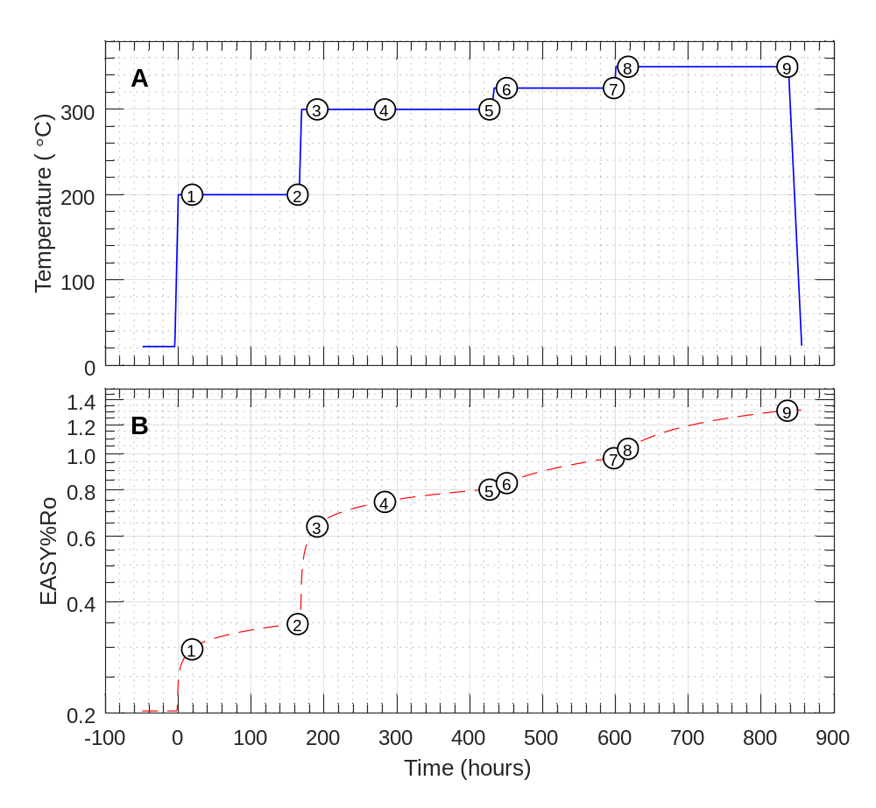
Fig. 1. Profiles of (A) temperature and (B) estimated maturity (as EASY%Ro) vs. time. Time zero (t = 0) is the time at which the experiment was brought to initial conditions (200 °C and 350 bar). Numbers in circles represent sampling points (Table 2).

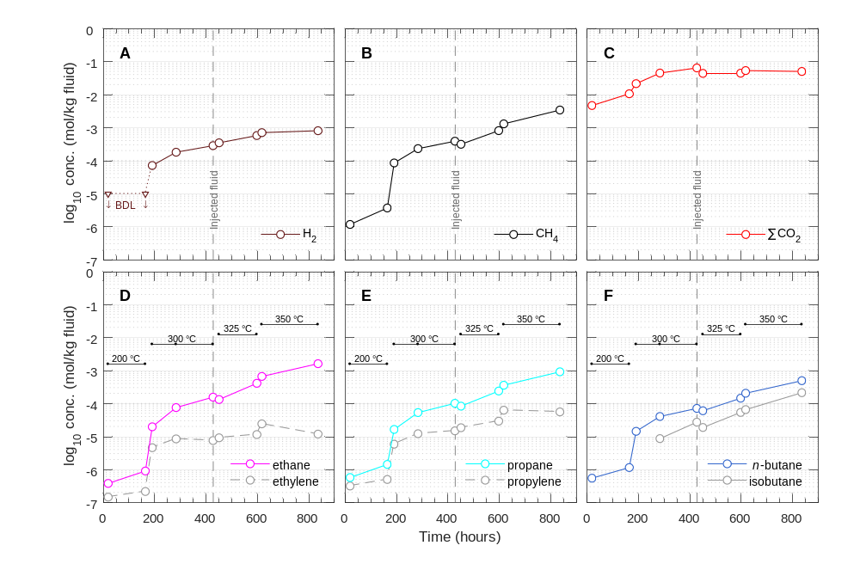
Fig. 2. Concentrations of aqueous species over time during the experiment. (A) Hydrogen (measured as H₂); (B) methane; (C) total inorganic carbon (∑CO₂); (D) ethane and ethylene; (E) propane and propylene; and (F) n-butane and isobutane. Note that injection of additional saline D₂O at 430 hours diluted the concentration of all aqueous species by ~50%. BDL, below detection limit (<10 µmol/kg for H₂).
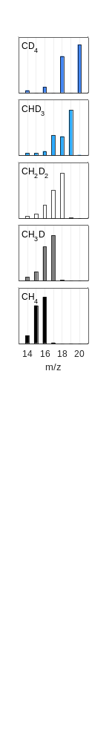
Fig. 3. Mass spectra of standards. Isotopologue is indicated in the upper left corner of each plot. Intensities were normalized such that the m/z 14 to 20 signals sum to unity.
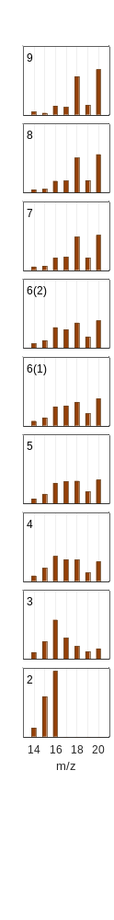
Fig. 4. Mass spectra of samples. Time point is indicated in the upper left corner of each plot. Intensities were normalized such that the m/z 14 to 20 signals sum to unity. Two samples were taken for time point #6, hence there are two plots. No GC-MS data was obtained for time point #1.

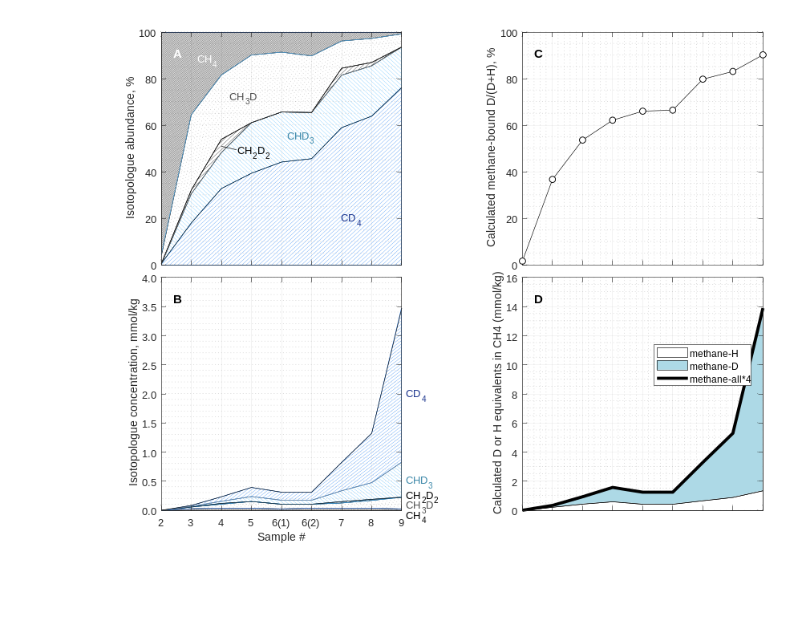
Fig. 5. Calculated (A) relative and (B) absolute abundances of methane isotopologues.
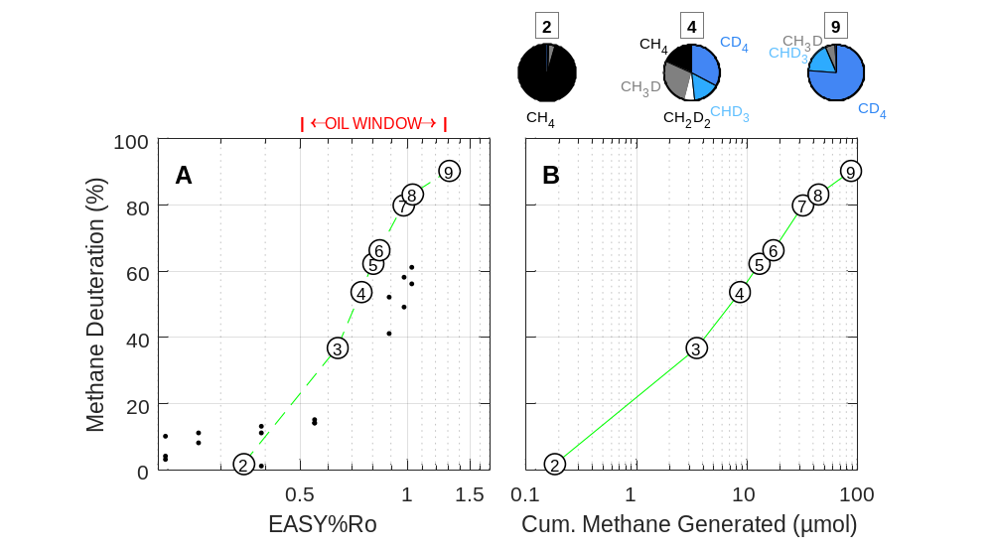
Fig. 6. Extent of methane deuteration [methane-bound D/(D+H)] vs. (A) estimated maturity (EASY%Ro) and (B) cumulative methane generated. The data shown for time point #6 is the average of the two replicate samples. Small symbols in (A) are data from Wei et al. (2019) representing percentage of water-derived H in CH₄ (see text). Pie charts above (B) represent relative abundances of isotopologues before, during, and after peak oil generation (time points #2, 4, and 9, respectively).

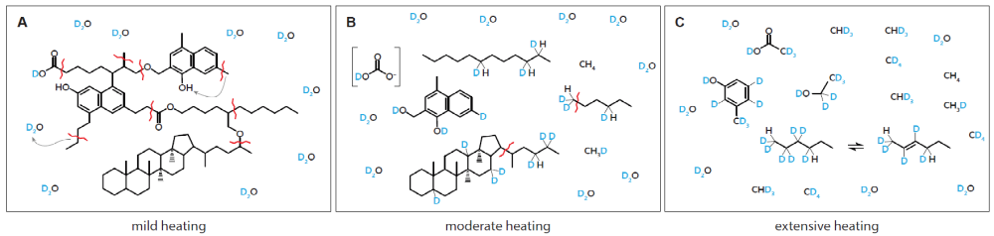
Fig. 7. Cartoon showing process of sequential deuteration of kerogen and oil along with generation of deuterated methane. Snapshots shown represent stages of (A) mild heating (incipient catagenesis); (B) moderate heating (oil generation); and (C) extensive heating (gas window).
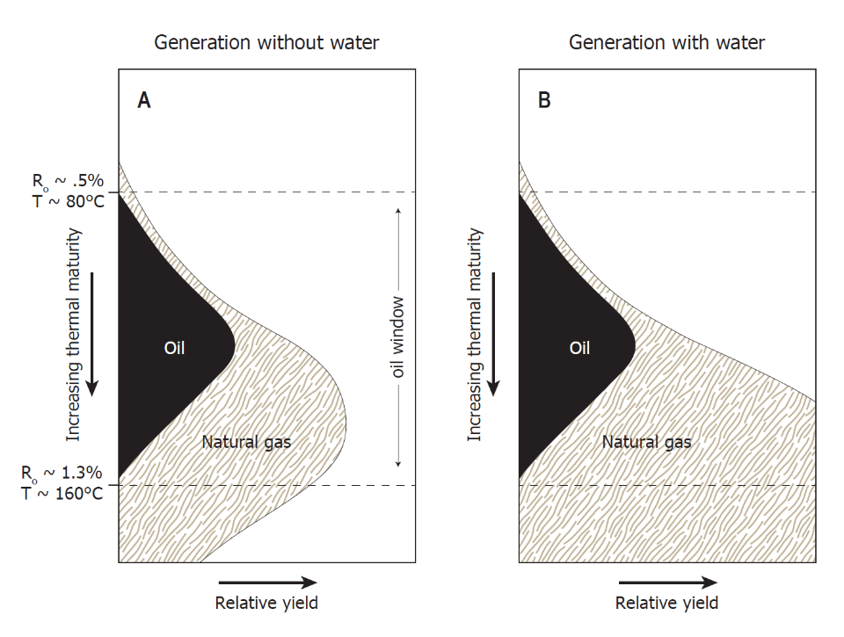
Fig. 8. Schematic yields of oil and natural gas when generation occurs from source rock in the absence (A) and presence (B) of water as a source of hydrogen. (A) Traditional model of the amount and timing of organic alteration products generated during progressive burial in sedimentary basins that assumes hydrogen in organic alteration products are derived only from kerogen. The form of this figure is constrained by the maturation trends shown in the Van Krevelen diagram. (B) Schematic illustration of the amount and timing of organic alteration products generated if water and minerals are allowed to contribute the requisite hydrogen for the formation of hydrocarbons. Illustration is after Seewald (2003) and Hunt (1996). Listed values of %R_{o} and temperature are from an EASY%Ro calculation with a heating rate of ~0.4 °C per Myr.

Tables

Table 1
Elemental analysis of Eagle Ford shale powder that was either: dried but otherwise untreated (UNEX), Soxhlet-extracted (EX), or extracted + decarbonated (DECA). Data from C. Johnson, WHOI, 1996.
(wt%) | UNEX | EX* | DECA
C | 12.1 | 11.0 | 6.23
H | 0.38 | 0.25 | 1.24
N | 0.18 | 0.17 | 0.74
S | 0.37 | <0.2 | 2.3
*Used in the experiment.

Table 2
Concentration of aqueous species during heating of Soxhlet-extracted Eagle Ford shale at 200 to 350 °C and 350 bar in the presence of saline D₂O fluid.
Time Pt # | Time (h) | H₂ (µmol/kg)ª | CH₄ (µmol/kg) | ∑CO₂ (mmol/kg) | CH₄/∑C_{2–4} ^{b} | ∑H₂S (mmol/kg) | pD (25 °C)^{c}
Experiment begun with 52.6 g of fluid at temperature of 200 °C
1 | 19 | BDL (<10) | 1.2 | 4.8 | 0.78
2 | 164 | BDL (<10) | 3.8 | 10.8 | 1.06
Temperature raised to 300 °C
3 | 191 | 773 | 8.7 | 21.9 | 1.68
4 | 284 | 183 | 235 | 45.8 | 1.30
5 | 427 | 290 | 396 | 65.5 | 1.09
Injected ~18.3 g starting fluid and raised temperature to 325 °C
6 | 451 | 353 | 319 | 44.7 | 1.06
7 | 598 | 586 | 825 | 45.3 | 0.96
Raised temperature to 350 °C
8 | 617 | 718 | 1.32 × 10³ | 54.4 | 1.01
9 | 836 | 821 | 3.47 × 10³ | 51.2 | 1.06 | 18.0 | 5.90

Analytical uncertainties (2s) are ±2 °C for T; ±5% for H₂, ∑CO₂, CH₄, and C₂ to C₄ hydrocarbons, ±2% for ∑H₂S; and ±0.05 units for pD. Concentrations are molar quantities per kg fluid.

ª Determined from thermal conductivity response calibrated against a known H₂ standard. As discussed in the text, the listed hydrogen concentration was estimated as if all hydrogen were in the form of H₂. In reality, differences in the TCD response of H₂ and D₂ mean that the actual concentration of molecular hydrogen (likely primarily D₂) are somewhat different than those listed.
^{b} Calculated as the molar ratio of methane to the sum of ethane, propane, isobutane, and n-butane.
^{c} The listed pD value was calculated from pH measured with a glass electrode: pD = pH_{measured} + 0.41 (Glasoe and Long, 1960).

Results of this experiment were first presented by one of us in the appendix of a Ph.D. thesis (Wang, 2017). That earlier analysis contained a mathematical error (neglected to divide by the relative peak areas of the pure isotopologue standards). As a result, Fig. B.3 of that thesis appears different than Fig. 5 in this paper.
It is conceivable that the C¹H₄ observed at time point #2 may have been gas originally present but sorbed to a solid phase at the start of the experiment and later leached into the fluid, but we consider this unlikely because the concentration of methane tripled between time points #1 (19 h) and #2 (164 h). Release of sorbed gases was probably nearly complete by 19 h.
Calculated as [CH₄] × V_{remaining} + ∑( [CH₄] × V_{withdrawn} ).
While Lewan (1997) did not quantify the abundance of deuterated methane isotopologues, we understand that these analyses have been conducted in follow-up, and revealed production of deuterated and perdeuterated isotoplogues of methane (M.D. Lewan, personal correspondence).
This could be confirmed with an experiment initially seeded with a large initial amount of CD₄ dissolved in deuterium-depleted water and heated in contact with rock powder. Hydrogen exchange of methane (whether catalyzed or uncatalyzed) should result in transfer of D to water, yielding elevated δD(H₂O) values over time.

