Dylan Graham SQA Project

|  |  |
| --- | --- |
| **Company 1** |  |
| 1. Name: | Repros Therapeutics |
| 2. Description of company: | Biopharmaceutical company that markets there creations |
| 3. Website URL: | http://www.reprosrx.com/ |
| 4. Web Tech Used: | Javascript, CSS, HTML |
| 5. Login Required: | No |
| 6. Mobile App: | No |
| 7. Describe the Defect: | Contact Page Accepts Anything |
| 8. Steps to Reproduce: | Go to Contact Page – Fill in anything – Note Lack of Restrictions |
| 9. Who verified the Defect: | Digital Signature – Michael R Conley |
| 10. Selenium Test Case: | Included with file – Input also in steps |
|  |  |

========== ENVIRONMENT ==========  
Test Case ID: 01

Author: Dylan Graham  
OS: Windows 7

Browser: Firefox

URL: http://www.reprosrx.com/

========== ITEM UNDER TEST ==========  
Identify the screen/Fields

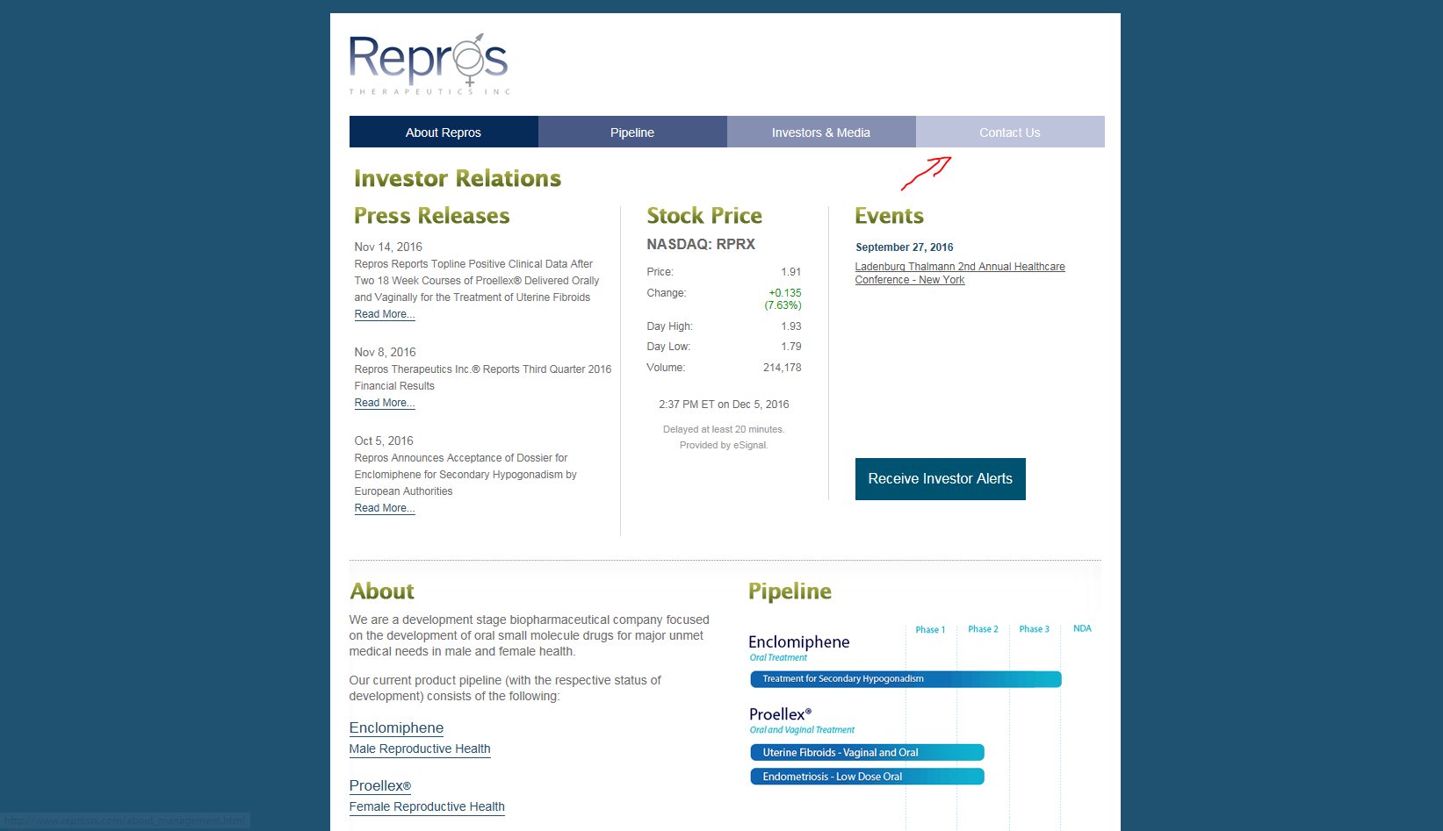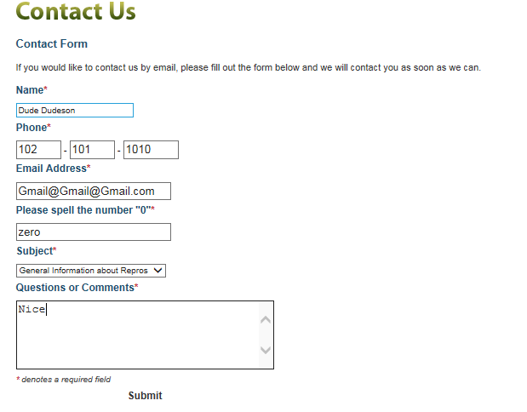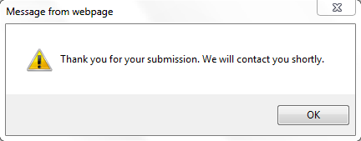

========== STEPS ==========

1. Redirect your browser to <http://www.reprosrx.com/>
2. Go to the upper right corner of the page and go to Contact Us.
3. Fill all fields, but email, with garbage information.
4. Into the email field enter “gmail@gmail@gmail.com”
5. Make sure to select an option in the drop down box and complete the captcha
6. Type in a user message to the company to tell them this is a test.
7. Hit Submit

========== EXPECTED/DESIRED BEHAVIOR ==========

The website will throw back an error, because it is unable to verify any of this information. (Email, Phone Number)

========== ACTUAL BEHAVIOR ==========

It believes my invalid input, and fills there contact email full of spam and allows bots to flood their website.

========== PASS/FAIL ==========

Fail

========== REPRODUCIBILITY ==========

It does not throw back an error unless you put in non-alphanumeric characters.

==========COMMENTS ==========

This error probably would not jeopardize their website or their company, but it might allow there contact page to be filled with fake requests and in turn slow down the IT department of their company by out numbering real requests.

==========VERIFICATION=========

Digital Signature – Michael R Conley

|  |  |
| --- | --- |
| **Company 2** |  |
| 1. Name: | ABX Air |
| 2. Description of company: | ABX Air is a air fare service. |
| 3. Website URL: | https://www.abxair.com/contact/index.cfm |
| 4. Web Tech Used: | Javascript, CSS, HTML |
| 5. Login Required: | No |
| 6. Mobile App: | No |
| 7. Describe the Defect: | Contact Page Accepts Anything |
| 8. Steps to Reproduce: | Go to Contact Page – Fill in anything – Note Lack of Restrictions |
| 9. Who verified the Defect: | Digital Signature – Brandon L. Conklin |
| 10. Selenium Test Case: | Included with file – Input also in steps |
|  |  |

========== ENVIRONMENT ==========  
Test Case ID: 02

Author: Dylan Graham  
OS: Windows 7

Application:   
(or)

Browser: Firefox

URL:

========== ITEM UNDER TEST ==========  
Identify the screen/Fields



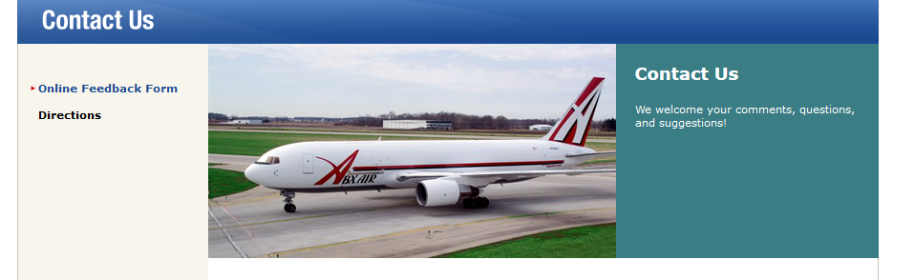

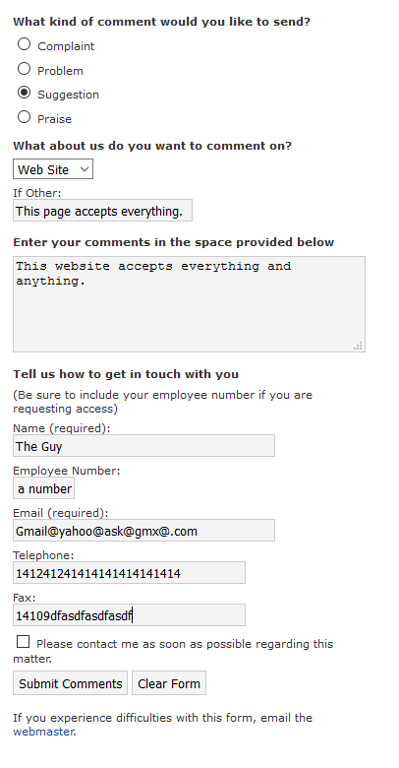



========== STEPS ==========

1. Go to the ABX Air webpage <https://www.abxair.com/>
2. Click the contact us page and let it load.
3. Fill in the page with the following test data

Suggestion

Web Site

If other: this page accepts everything

Name: The Giy

Employee Number: This is not a number:

Email: [Gmail@yahoo@ask@gmx@.com](mailto:Gmail@yahoo@ask@gmx@.com)

Telephone: 141241241414141414141414

FAX: 14109dfasdfasdfasdf

1. Hit the submit button and look at the confirmation message

========== EXPECTED/DESIRED BEHAVIOR ==========

A regex statement should catch all of these errors and not bog down their system. There is not a single field that is being checked. Meaning you could pull in letters in fields that need numbers and someone’s name could be 153.

========== ACTUAL BEHAVIOR ==========

It accepts all and any data that is being put into the fields, which could bog down there servers if someone decided to flood the server with requests.

========== PASS/FAIL ==========

Fail

========== REPRODUCIBILITY ==========

As of 12/21/2016 it is still working.

==========COMMENTS ==========

This is a very simple error that could fixed with a number of verifiers and some C#.

==========VERIFICATION=========

Brandon L. Conklin