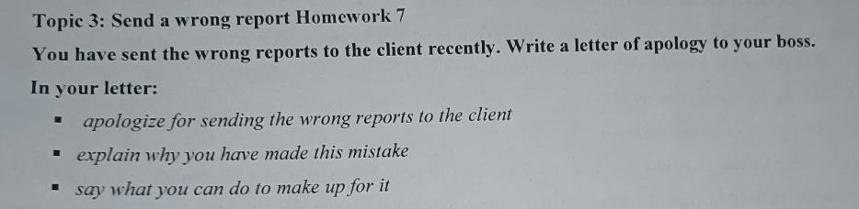

Dear Nagatsuka,

I am writing this letter to apologize for this situation that I have sent wrong reports to you.

The first thing I want to tell you is that I am so sorry because this problem taken place, I have sent the wrong reports to you.

The second thing I would like to mention is that I want to explain why I made this mistake because I have many orders, and they are not arrange so I sent wrong to you.

The final thing I want to talk about is that I will take responsibility about I made. Besides, I will return the reports to you in the next day. Moreover, I will give you a vouchers discount in the next booking. I hope you will satisfied with this solve. One more time, I really apologize to you.

I am looking forward to hearing from you soon.

Best regards,

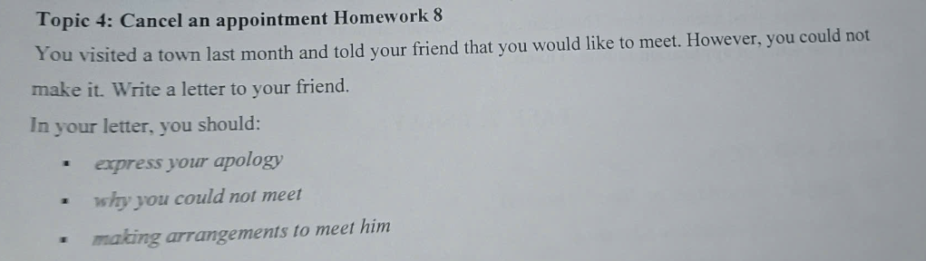

Dear Peter,

I hope this letter finds you well. How are you doing? I am so good. I hope you and your family are well.

I am writing this letter to apologize for missing meet of me and you.

The first thing I want to tell you is I want to say sorry with you because I did not go to meetingin last month.

The second thing I would like to mention is that this day I could not meet you because I saw the wrong timetable. I have to solve my personal job at seven o’clock am and three o’clock pm so I can not meet you in the town.

The final thing I want to talk about is that I promise I will arrange to meet you in the shortest time. I really want to meet you to talking some vital. I hope you will not angry me.

I am looking forward to hearing from you soon.

Best regards,