Safer Streets NI: A Data Visualisation Study of PSNI Collision Records 2017 – Team Barchart
Executive Summary
Northern Ireland recorded more than six thousand injury collisions in 2017. Our analysis focuses on where collisions were concentrated, when they tended to occur and which groups were most affected. We worked with PSNI collision, vehicle and casualty data and produced visualisations to support planning and operational decisions for DfI NI and PSNI Road Policing.
Belfast recorded 1,478 collisions which was far higher than any other district. Half of all collisions happened on 30 mph roads. Cars were involved in 83 percent of all incidents and casualties were most common among people aged 25 to 34. Clear temporal patterns appeared throughout the dataset. The strongest hourly spike happened around 5 pm. Fridays had the highest daily collision count and September had the highest monthly total.
These findings support several practical recommendations for both stakeholders such as focusing enforcement during evening peaks and reviewing busy 30 mph corridors. There are also opportunities for targeted campaigns for young adult drivers. While the dataset includes missing values and only covers one year it provides a detailed and useful overview of risk patterns across Northern Ireland.

Problem Statement and Stakeholder Context
Northern Ireland’s road network contains dense urban zones, rural roads and a wide mixture of commuter and local traffic. More than six thousand injury collisions were recorded in 2017 which represents a significant burden for both infrastructure planners and frontline police teams. To make effective decisions they need a clear understanding of when and where collisions occur and which factors appear most influential.
DfI NI is responsible for infrastructure planning and policy. They work with long term considerations such as road design, signage and pedestrian safety. PSNI Road Policing works at ground level with enforcement and incident response. Their planning depends on understanding high risk locations and time windows so that officer deployment is aligned with predictable patterns of collision activity.
Our project aims to provide these insights through a structured analysis of the 2017 dataset. The work highlights patterns in geography, time and road users while providing evidence that can inform both operational response and longer-term planning.

Success Metrics
We defined a small set of success criteria to guide the project. The analysis is considered successful when it:
- Identifies high collision districts and hotspot locations.
- Describes clear time-based patterns such as hourly, daily and monthly peaks.
- Highlights key road user groups and environmental contexts that show elevated risk.
These metrics help ensure that the findings support stakeholder decisions and can be directly linked to actionable improvements.

Data Description
The data came from PSNI records for 2017 and consisted of three related components: collision data, vehicle data and casualty data. The collision file included location in Irish Grid format, severity, date, time, lighting, weather, road type and speed limit. The vehicle file listed the type of vehicle involved and related behavioural details. The casualty file contained information on age and injury level.
The combined data covered more than six thousand collisions. Some fields had missing values such as weather and lighting. Only injury collisions were included which means the dataset does not represent all incidents on the road network. The coordinates were converted from Irish Grid to WGS84 so that the collision points could be mapped accurately. The files were structured with consistent identifiers which made merging possible once column names were cleaned.

Methods
Ingestion
We imported the three CSV files into pandas dataframes and inspected each one to confirm variable types and verify that identifiers matched across tables. Simple naming adjustments were applied so that joins would be consistent.
Cleaning
Cleaning steps included removing duplicate collision IDs. We converted dates and times into standard formats and ensured that speed limits were numeric. We retained records with partial information because they still contained useful fields even when some details were missing. Coordinates were reprojected into WGS84 using the standard transformation formula for OSNI data.
Integration
We loaded the collision, vehicle and casualty files into separate dataframes and analysed each one independently. The collision dataset was used for all spatial, temporal and severity patterns. The vehicle file was explored on its own to calculate the distribution of vehicle types involved in incidents. The casualty file was also examined separately to identify age patterns and injury levels. Although the datasets share common identifiers, we did not merge or join them in the notebook. Instead, we interpreted insights across the three datasets in parallel without creating a combined table.
Exploratory Data Analysis
We conducted exploratory work across spatial, temporal and demographic dimensions. This involved generating counts per district, summarising hourly, daily and monthly frequencies and examining severity distributions. We also analysed vehicle involvement and casualty age groups. Visualisations were produced throughout this process to highlight structure in the dataset.

Results and Visualisations
Geographic Patterns
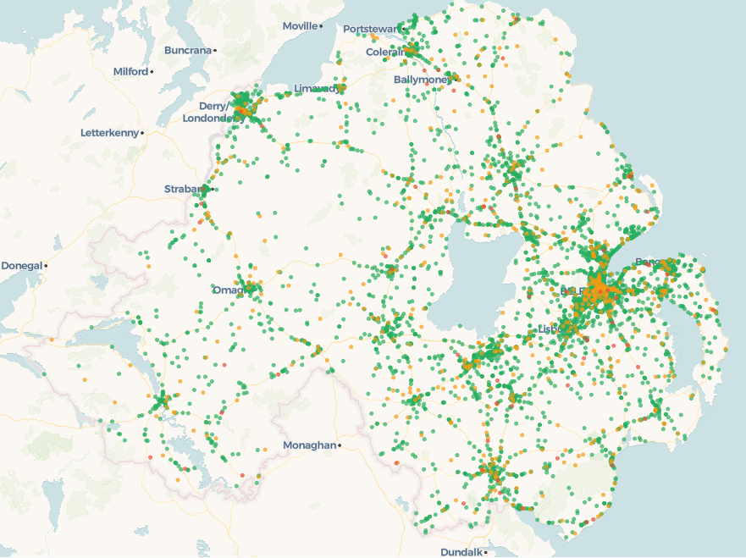
Figure 1. A geographic point map of all collisions using WGS84 coordinates. Points are coloured by severity.
Belfast had a far higher collision count than any other district. The 1,478 collisions recorded in 2017 created a very clear hotspot across the city centre and along major arterial routes. Other districts showed lower totals and much broader spatial spreads. The Belfast pattern indicates sustained pressure on its city network and highlights priority zones for both infrastructure review and enforcement.
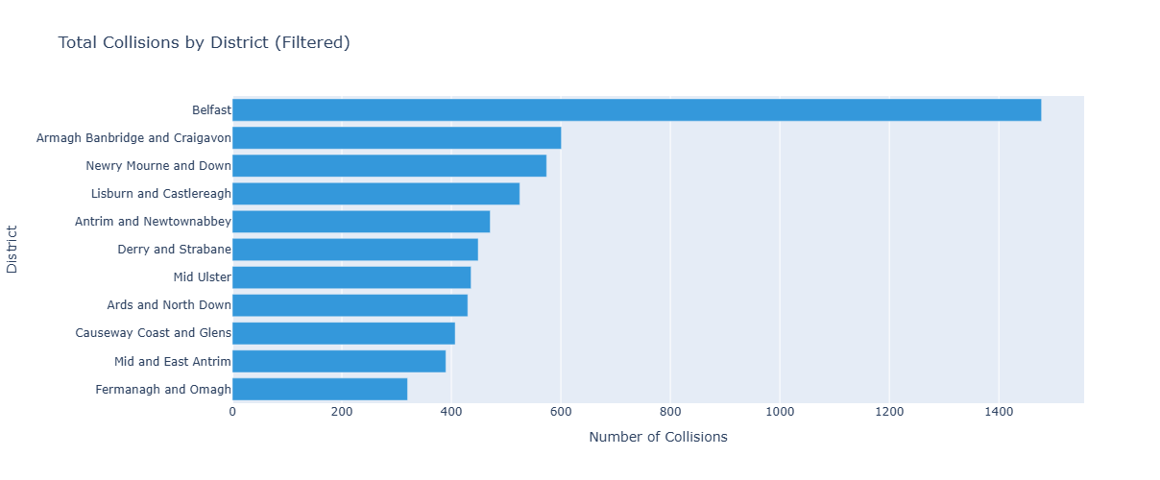
Figure 2 description. A bar chart showing collision totals for each district
Severity distributions also varied across districts. Belfast recorded 1,352 slight collisions and 123 serious ones. Newry and Mourne recorded 13 fatal collisions which was the highest fatal count despite having a lower overall total. This points to different types of risk across rural and urban environments.
Temporal Patterns
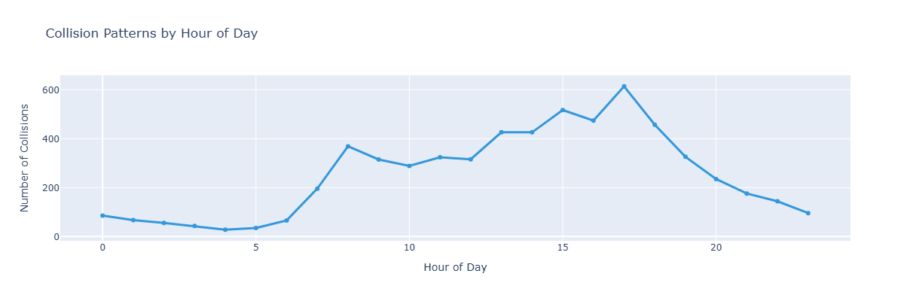
Figure 3. A line chart showing collisions by hour of day.
The hourly analysis revealed a clear evening peak around 5 pm. This aligns with end of workday traffic and heavier congestion on key routes into and out of cities. The pattern was stable across the full year and suggests a predictable window of heightened collision risk.

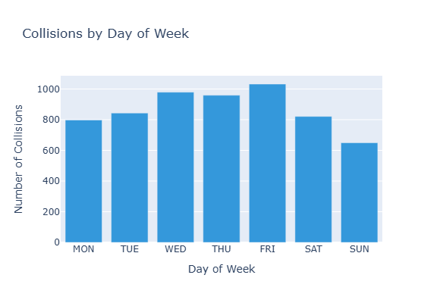
Figure 4. A barchart showing collisions by day of week.
Fridays recorded the most collisions across the week. The combination of commuter traffic, leisure travel and end of week behaviour could all contribute to this pattern. It offers a specific opportunity for PSNI to align enforcement resources with known peaks.

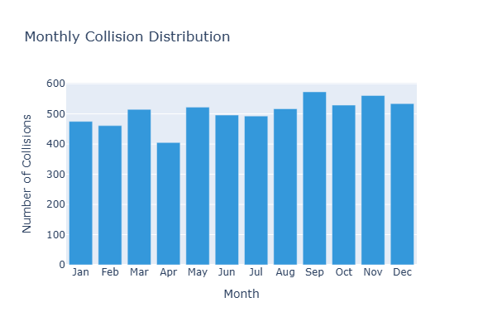
Figure 5. A barchart showing monthly collision totals.
On a monthly scale September had the highest number of collisions. This coincides with the return to schools and universities and generally heavier traffic after summer. It also marks the point in the year when daylight hours begin to shorten which may contribute to the observed pattern.
Vehicles and Demographics
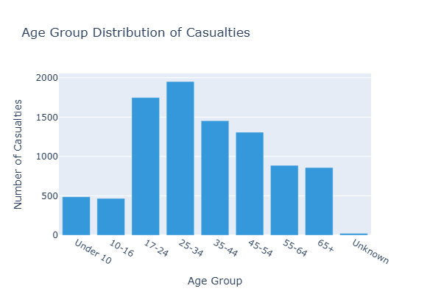
Figure 6. A chart showing casualty counts by age group.
Casualties were highest among people aged 25 to 34. This pattern likely reflects higher exposure levels among younger adult drivers and the types of journeys they take. Other age groups appear at lower frequencies and show a more gradual decline across older categories.

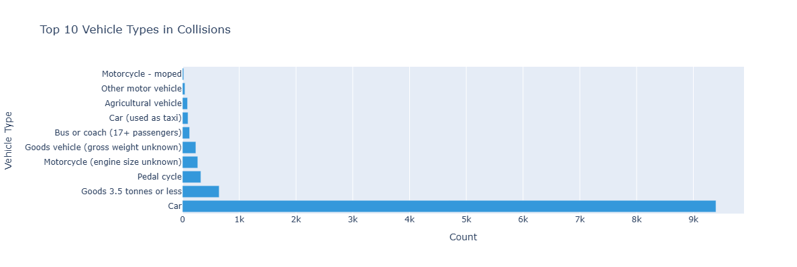
Figure 7 . A chart showing involvement by vehicle type. Cars were involved in 83 percent of all recorded collisions.
Cars accounted for 83 percent of vehicles involved in collisions. Other vehicle types such as motorcycles, bicycles and buses made up the remainder but none came close to the dominance of cars. This distribution aligns with overall vehicle usage across Northern Ireland and the typical composition of traffic on urban roads.

Recommendations and Impact
Reinforce Evening and Friday Enforcement
Since collision counts rise sharply around 5 pm and peak on Fridays, PSNI could schedule more units during these windows. Doing this would directly match enforcement activity to a well-established risk pattern. Routes leading into Belfast and other large towns are especially relevant for this adjustment.
Review Urban 30 mph Roads
Half of all collisions occurred on 30 mph roads which suggests a need for focused infrastructure review. DfI NI could examine busy corridors in Belfast to assess junction quality, pedestrian crossing design and signage clarity. Improvements in these areas would likely reduce collision frequency given the volume of exposure.
Targeted Messaging for Young Adult Drivers
People aged 25 to 34 were involved in the highest number of casualties. A targeted safety campaign aimed at workplaces, colleges and universities could address common behaviours such as speeding or distraction. The data suggests this age group represents a practical starting point for awareness efforts.
Establish a September Road Safety Initiative
September showed the highest monthly collision count. Running a sustained campaign at the beginning of each academic year could help focus attention on increased traffic levels and encourage safer behaviour. PSNI visibility during this period could reinforce the message.
Use Mapping Insights for Resource and Infrastructure Planning
The strong clustering in Belfast indicates where upgrades or specific interventions could have the greatest effect. Combining spatial insights with temporal patterns can help stakeholders make more strategic choices about investment and deployment.

Ethics, Bias and Limitations
The dataset only covers injury collisions and excludes non injury events which means it does not reflect the complete set of incidents across the network. Urban areas tend to have higher reporting rates which can exaggerate the contrast with rural districts. Missing values are present in some fields particularly lighting and weather which limits the depth of environmental analysis.
The dataset also only represents one year. Long term trends cannot be inferred without additional years of data. Despite these limitations the dataset follows consistent coding standards and provides enough breadth to support meaningful analysis.

Future Work
A multiyear analysis that includes data from 2016 to 2020 would help confirm whether the 2017 patterns are stable or unusual. Multiyear data would also allow the development of forecasting models that could predict high risk periods and support proactive planning.
Another promising direction is the creation of an interactive dashboard. This could combine maps, time trend views and demographic breakdowns for PSNI officers or DfI NI planners. A live or regularly updated dashboard would support ongoing situational awareness.

Reproduction Notes
To reproduce the analysis, follow these steps.
- Download the folder from Github and locate the notebook file.
- Run the notebook from top to bottom in Jupyter notebook. The coordinate transformation and cleaning steps occur automatically.
- Figures and summary statistics will be generated as the notebook executes.
All file paths and parameters are stored within the project structure.

Appendix
AI Assistance Log
AI tools were used for guidance and debugging during the development process. This included checking code logic, exploring alternative approaches for data cleaning and receiving support when resolving technical issues. All analysis work, interpretations and visual design decisions were carried out by the team.

Team Contributions
All team members contributed to ingestion, cleaning, exploratory analysis and visualisation. Some focused more on pipeline structure while others focused on spatial and temporal analysis. Everyone reviewed findings and contributed to the final recommendations.

