**Talend Open Studio (DATA INTEGRATION)-**

**tDBSCD component-**

Reflects and tracks changes in a dedicated database SCD table.

This component works with a variety of databases depending on your selection.

We can do SCD type 0,SCD type 1,SCD type 2 and SCD type 3

You can drag the **tDBSCD** from palette or simply start typing “**tDBSCD**” on workspace and select the **tDBSCD** component from the appeared components.

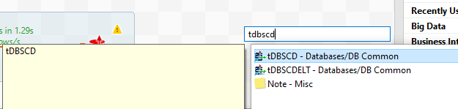

Now connect the source table to **tDBSCD** component.

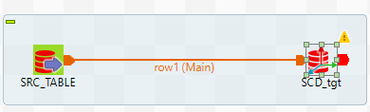

**Basic Setting –**

First select the database type and then give databse parameters. Or you can use existing connection from repository.

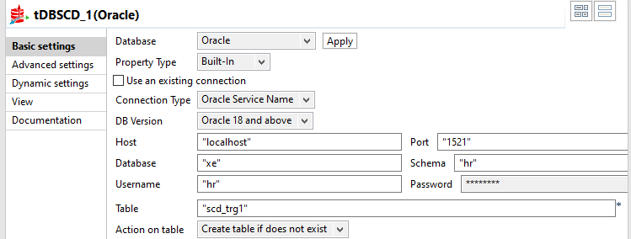

* In the schema you can create columns .
* You can check die on error property.

**SCD EDITOR-**

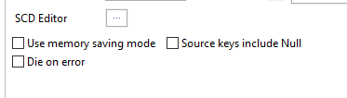

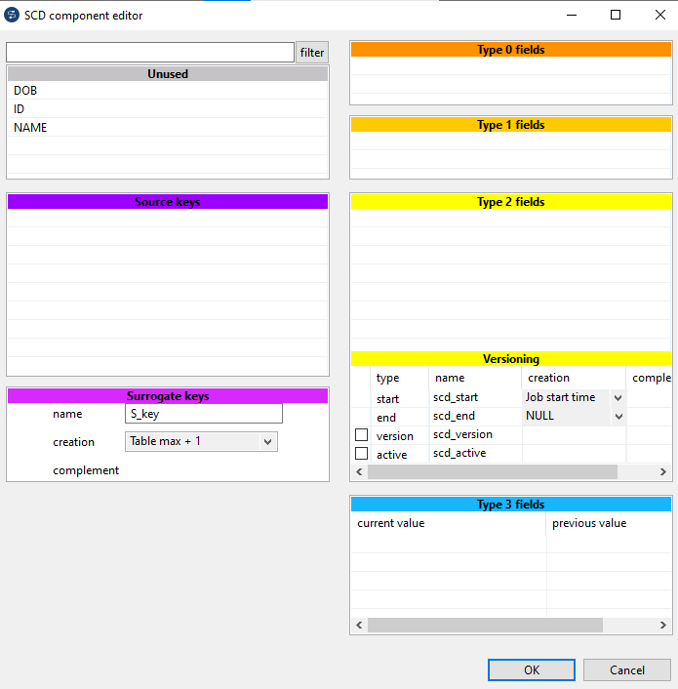

* **Now select & drag the source column in the source keys from the unused (like primary keys)**

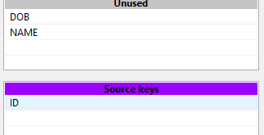

* **Now select the SCD type for particular columns and drag and drop that columns in scd section.**

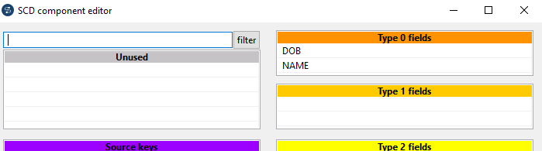

* **Surrogate Keys**

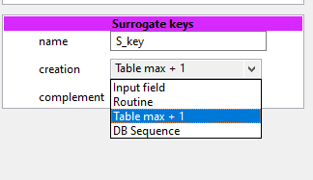

Give a **surrogate Key** name and Its value like Source Input field or routine.

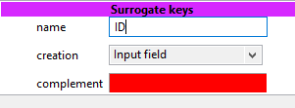

Also You can give Table max+1 or any DB Sequence (Here you have to mention that DB sequence.)

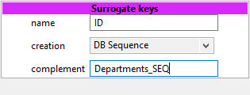

**SCD1-**

Now to do SCD1 drag the source columns to type 1 section.

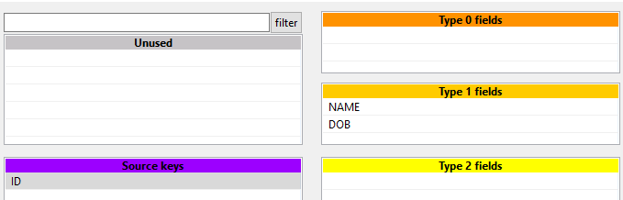

**And run the job.**

**Sorce data for SCD1- OUTPUT-**

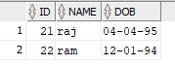 

**SCD2-**

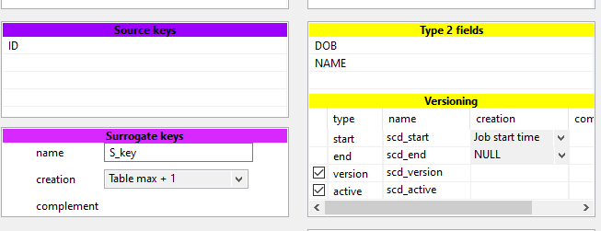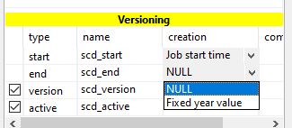

For scd2 drag the source fields to type2 fields .

You can do this by Start-End date method/SCD_version or Active flag(i.e. 1/0) or all these methods.

**Source Data-**

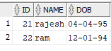

**Output SCD_2 data-**

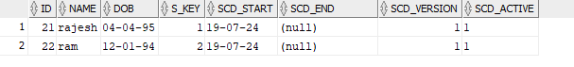

**After Updating first record**

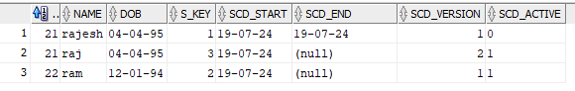

**SCD3-**

**For scd3 drag and drop source fields to the type3 fields.**

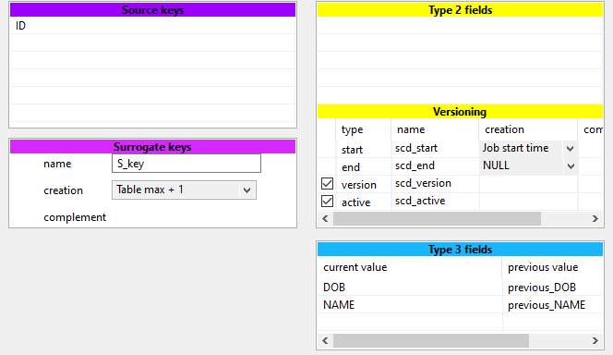

**Source Data-**

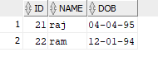

**Output data SCD3 –**

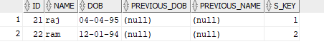

**After updating any source column-**

