**CS 766: Computer Vision**

**Project Final Report:** Framework for 3D Bone Marrow Segmentation on 18F-FDG PET/CT Images

**Daniel Huff**

[dthuff@wisc.edu](mailto:dthuff@wisc.edu)

**Background**

Computed Tomography (CT) and Positron Emission Tomography (PET) are two commonly utilized medical imaging modalities used to characterize disease and monitor response to therapy of oncology patients. CT scanners use a rotating x-ray source and array of detector elements to produce a 3-D image of a patient's anatomy. A CT scan therefore provides an oncologist with structural information about a patient. The units of CT scans are called Hounsfield Units (HU), which represent the density of material in a given image voxel referenced to the density of water, which is defined to have HU = 0. PET scanners capture signal produced by the radioactive decay of an injected radionuclide. This radionuclide is attached to a molecule, called a radiotracer, which is used by a regular physiological process in the body so that when it is injected into the patient, the radionuclide spreads through the body and maps the distribution of that physiological process. The most commonly used radiotracer is 18F-FDG, which is an analog of glucose - a sugar commonly metabolized by the body to produce energy. Because hypermetabolism is a hallmark of many cancers, tumors take up much more FDG than surrounding healthy tissue, and so can appear as bright spots on an 18F-FDG PET image. The units of a PET image are called Standardized Uptake Values (SUV), which are proportional to the concentration of radioactivity in a given image voxel.

**Motivation**

The goal of this project was to develop a simple and robust framework for segmenting the bone marrow compartment of the human skeleton on clinical 18F-FDG PET/CT images. Several diseases can impact patient bone marrow including myeloma^1^, leukemia^2^, and lymphoma^3-5^. Oncology patients with bone marrow disease involvement often exhibit diffuse increased FDG uptake in the marrow, which presents a segmentation challenge different from more typical, high uptake disease foci found in FDG PET scans of other cancers. Additionally, because bone marrow plays a role in the immune system, there is interest in investigating bone marrow FDG uptake as an imaging biomarker of response to immunotherapies - novel cancer therapies designed to stimulate the patient's own immune system^6,7^. FDG uptake of bone marrow may be a useful biomarker in both of these settings, therefore clinical applications of an automated bone marrow segmentation tool may include disease staging, treatment selection and management, and treatment response assessment.

**Approach**

The product of this project was a set of scripts written in MATLAB that begin with a raw patient whole body PET/CT image set in DICOM format and end with a binary image volume representing a whole body bone marrow mask. The segmentation process proceeds in two steps: 1. whole bone segmentation and 2. bone marrow segmentation.

1. Whole bone segmentation is performed using the patient CT scan. Because bone exhibits higher density than other structures in the body, a high density threshold of HU > 150 is used to first give a rough whole bone mask. This mask is cleaned up with simple morphological opening and closing operations, and the patient table is removed from the image by finding and zeroing out the largest connected component outside the patient.
2. Bone marrow segmentation occurs in two substeps: 2a. vertebral marrow segmentation in the spine and 2b. segmentation of other large marrow volumes in the body.

2a. Vertebral marrow segmentation is performed using the whole bone mask acquired in step 1 and the patient PET scan. First, the patient pelvis and shoulders must be localized to serve as endpoints for the spine. This is done by finding locations where the patient body cross-sectional area is changing most rapidly. This process is shown in Figure 1. Next, the whole bone mask is applied to the PET data, and minima in the axial distribution of mean SUV values in the bone are found. The locations of these minima correspond to locations of inter-vertebral disks, because inter-vertebral disks are less physiologically active than the vertebra themselves. The detected minima are then used as endpoints for individual vertebra, and the final vertebral marrow segmentation is obtained by eroding whole-bone mask segments between adjacent minima.

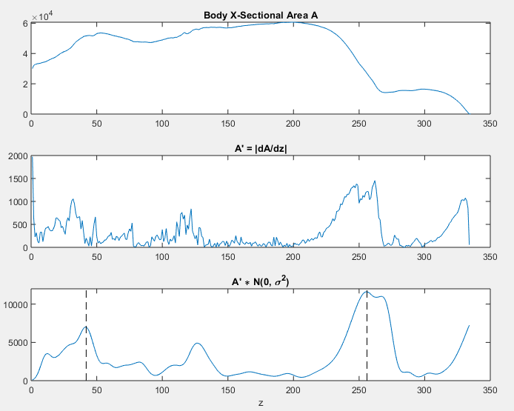Figure 1: Localization of pelvis and shoulders. Whole body cross sectional area is found by binarizing the patient PET image with a low threshold (SUV > 0.1 g/mL) and summing over each axial slice (top). A spatial derivative of this distibution is taken (middle), and then smoothed (bottom) to find axial locations where the body's cross sectional area is changing most rapidly (dashed lines). These locations correspond to the patient's shoulders and pelvis, which serve as bounds for vertebral marrow segmentation.

2b. Other large marrow volumes of interest include the pelvis, femurs, and humeri. These volumes are segmented using the vertebral marrow and whole bone mask acquired previously. The vertebral marrow mask is first subtracted from the whole bone mask to prevent doubly segmented the vertebral marrow, and then this difference mask is eroded to remove hard surface bone voxels. The largest connected components of this eroded difference mask are taken as the other marrow volumes of interest.

Finally, the union of the vertebral marrow mask and the other marrow mask is taken to be the final whole body marrow segmentation. The size of this mask is the same as the original PET image volume, so the mask can easily be applied to the patient data to quantify the total marrow FDG PET uptake.

**Results**

Two example results can be seen in Figures 2 and 3 below. While the current method is far from perfect, it performs reasonably in a majority of a cohort of 30 patients in which it was tested. The entire process takes between 2 and 3 minutes per patient, depending on the resolution of the PET and CT data.

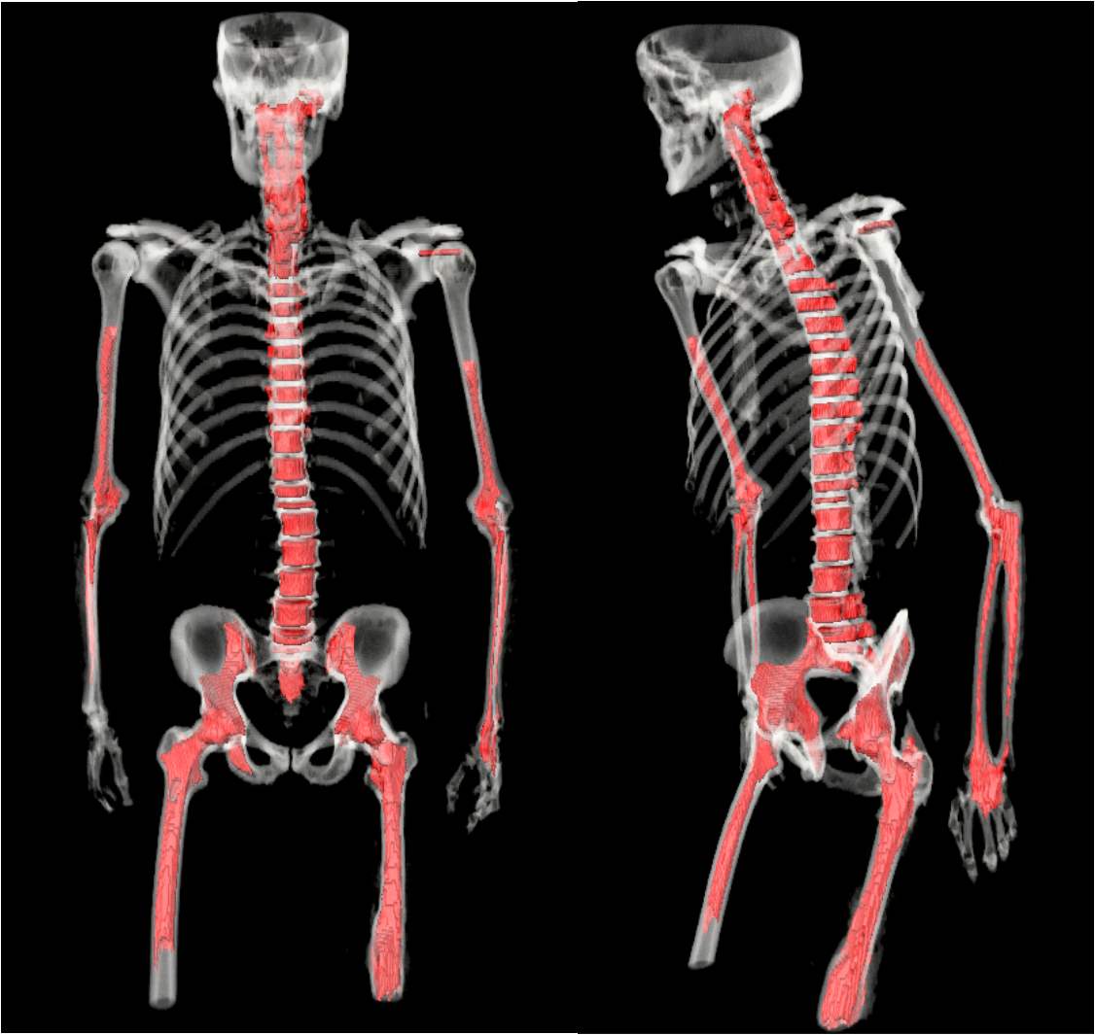Figure 2: Example result showing good algorithm performance. Coronal (left) and oblique (right) views of patient CT rendering (white) overlaid with final whole body marrow segmentation (red) show successful segmentation of marrow in the spine, pelvis, proximal femora, humeri, radii, and ulnae.

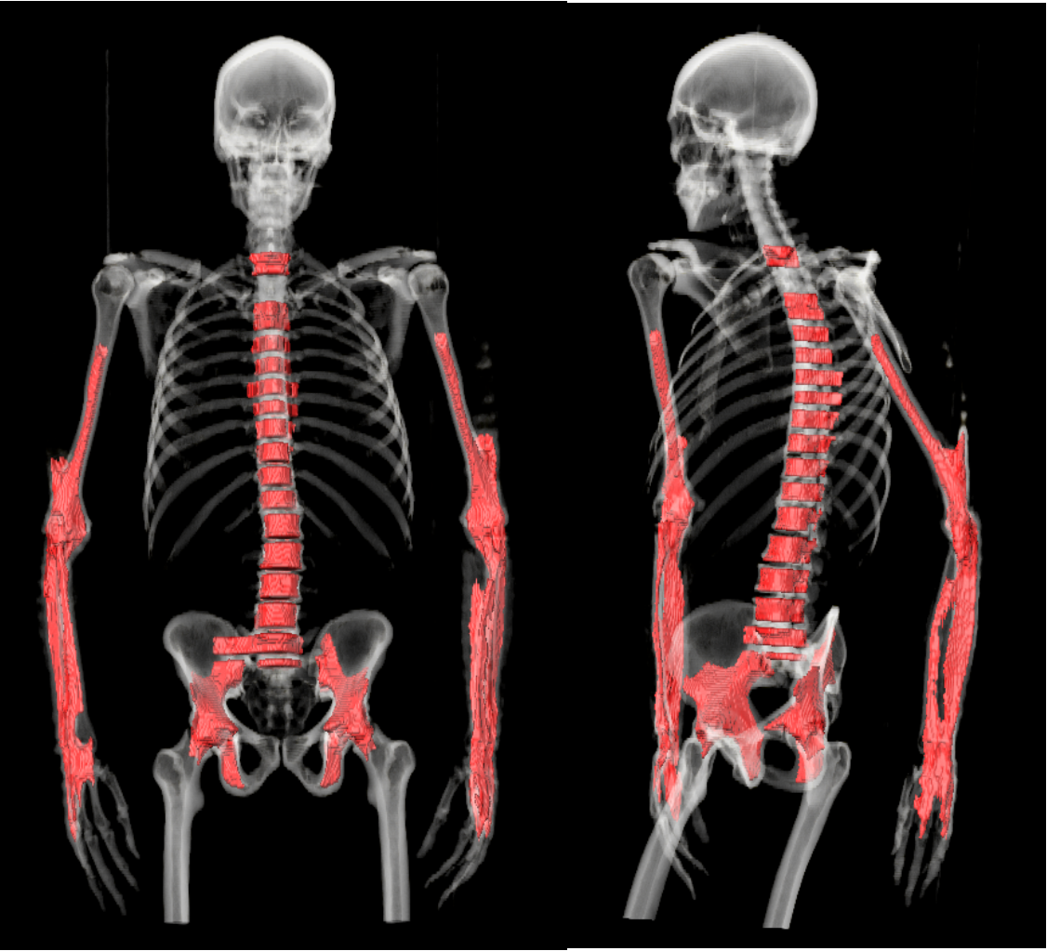Figure 3: Example result showing poor algorithm performance. Coronal (left) and oblique (right) views of patient CT rendering (white) are overlaid with final whole body marrow segmentation (red). Oversegmentation in several vertebrae and lower arms is evident, and marrow in the femora is unsegmented.

I've also compared my results to those presented by Nguyen et al^8^. Figure 4 shows axial distributions of mean HU value used by Nguyen, and mean SUV used in my approach. Also evident is the difference in axial resolution as seen by the difference in the number of axial pixels (x axis). Figure 5 compares performance in vertebral segmentation between Nguyen and my approach. Nguyen's implementation of a search over a vertebra tilt angle is evident in the non-flat vertebra boundaries, and the their higher resolution scans allow them to perform well up into the cervical spine as well.

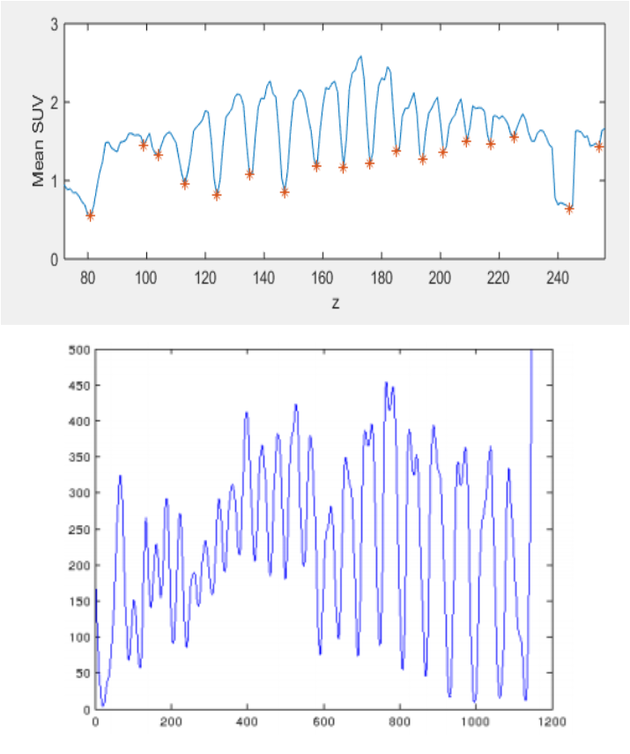  
Figure 4: Comparison of axial distributions for intervertebral minima detection by this work (PET minima, top) and Nguyen et al (CT minima, bottom). Note the difference in x-axis scales, indicating Nguyen et al performed segmentation on much higher resolution CT scans.

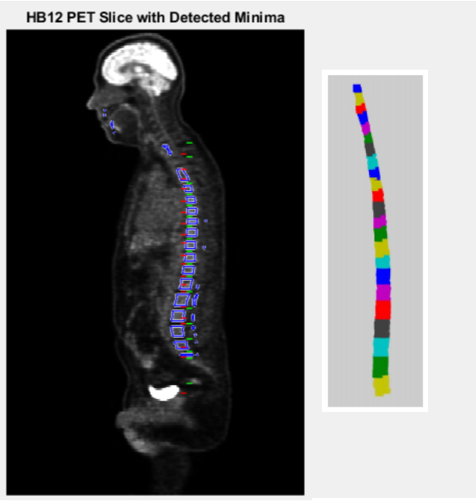 Figure 5: Comparison of vertebrae segmentation by this work (left, blue overlay) and Nguyen et al (right).

**Discussion**

A future improvement I would like to make to this framework is a transition to a atlas-based approach to the whole-bone segmentation and other marrow segmentation steps. Instead of using an engineered threshold value to do whole-bone segmentation, I would register generic skeletal segments to my CT data, and use the mask created by the registered segments as a starting point for marrow segmentation. This would allow me to do away with my current solution for finding the pelvis and shoulders, which can break the entire segmentation workflow if it performs poorly. Instead, I could just use the bottom of the registered lumbar spine segment as a lower bound, and the top of the registered cervical spine segment as an upper bound for intervertebral disk detection. Additionally, instead of blindly selecting the largest connected components during the other marrow segmentation, I could just erode the registered pelvis, femora, and humeri skeletal segments. This would ensure that I segment all the other marrow volumes I am interested in.

Two additional steps were implemented, but did not improve results, and so were cut from the final scripts. First, Nguyen et al used a graphcut method for initial whole bone segmentation. I implemented this, but found little improvement in results for a large increase in run time. Perhaps with further optimization, this could provide an improved whole-bone segmentation, but I was content with the performance of the simple thresholding approach described in my approach section. Second, Nguyen et al also implemented Kalman filtering for false positive rejection of spurious inter-vertebral disk locations. The ideas behind applying Kalman filtering to this problem is that there is some expectation for intervertebral disks to be regularly spaced, and for the spacing to decrease as you move up the spine from the lumbar to the cervical vertebrae, but I was not able to reproduce Nguyen's success. Two reasons why this may be are: (1) the other researchers were detecting minima on CT, which I found to be a much noisier signal containing "easier" false positives to reject, and (2) it is possible that their CT scans were higher resolution than mine, giving them a larger number of voxels to play with in the axial direction, allowing them to more precisely localize intervertebral disk locations. In my scans, cervical vertebrae were often only 2-4 voxels tall, meaning the difference in location between a true disk location and a spurious disk location may only be a single voxel. I also found that the low resolution of my data lead to noisy vertebra spacing, meaning the constant velocity model of Nguyen's Kalman filter was not sufficient. My Kalman filtering implementation is present in bm_segment.m, but is not used to reject any detected minima.

Overall, I felt that this project was fruitful not only in terms of the final product being potentially useful in my research, but also in applying computer vision knowledge I gained over the semester to a problem I needed to solve. While my implementation was not highly sophisticated, I did learn some new things, and look forward to expanding on them in the future.

**References**

1 Sachpekidis, C., et al. "Assessment of glucose metabolism and cellular proliferation in multiple myeloma: a first report on combined 18 F-FDG and 18 F-5 FLT PET/CT imaging." EJNMMI research 8.1 (2018): 28.

2 Stölzel, Friedrich, et al. "18F-FDG-PET/CT for detection of extramedullary acute myeloid leukemia." Haematologica 96.10 (2011): 1552-1556.

3 Barrington, Sally F., et al. "Role of imaging in the staging and response assessment of lymphoma: consensus of the International Conference on Malignant Lymphomas Imaging Working Group." Journal of clinical oncology 32.27 (2014): 3048.

4 Berthet, Louis, et al. "In newly diagnosed diffuse large B-cell lymphoma, determination of bone marrow involvement with 18F-FDG PET/CT provides better diagnostic performance and prognostic stratification than does biopsy." Journal of Nuclear Medicine 54.8 (2013): 1244-1250.

5 Herrmann, Ken, et al. "Early response assessment using 3′-deoxy-3′-[18F] fluorothymidine-positron emission tomography in high-grade non-Hodgkin's lymphoma." Clinical Cancer Research 13.12 (2007): 3552-3558.

6 Ferté, Charles, and Aurélien Marabelle. "iRECIST: A clarification of tumour response assessment in the immunotherapy era." European Journal of Cancer 77 (2017): 165-167.

7 Seymour, Lesley, et al. "iRECIST: guidelines for response criteria for use in trials testing immunotherapeutics." The Lancet Oncology 18.3 (2017): e143-e152.

8 Nguyen, Chuong, et al. "An automatic 3D CT/PET segmentation framework for bone marrow proliferation assessment." Image Processing (ICIP), 2016 IEEE International Conference on. IEEE, 2016.